INFLUENCE OF PROPAGATION CONDITIONS ON THE STAR-UP PHASE OF IMMOBILISED YEAST REACTORS

MARQUES A. C.¹, LUDWIG A.², VICENTE, I.¹

¹ Escola Superior Agrária de Coimbra, Instituto Politécnico de Coimbra, Bencanta, 3040-316 Coimbra, Portugal. E-mail: catarina_mq@yahoo.com

²Technische Universität Berlin, Forschungsinstitut für Technologie der Brauerei Seestr. 13, D-13353 Berlin, Germany.

ABSTRACT

Main fermentation with yeast immobilised on a carrier material has been a subject of research for many years. Immobilisation technology permits continuous beer fermentation. The whole process has been carried out in a continuously operated bioreactor with a residence time of approximately one day.
There is an intention to apply immobilisation in an industrial scale and substitute the traditional batch fermentation system.
Until now, primary fermentation with immobilised cells was only applied on a pilot-scale. Although it brings several improvements on volumetric productivity, cell densities, hygiene and continuous operation, the final product has a different taste and aroma, which influences quality and consequently consumer acceptance.
To achieve a constant beer quality more information is required about propagation conditions, immobilisation and continuous mode of reactor operation, in order to know how this factors affect yeast cell metabolism and the viability which influences flavour production.
The aim of this research was to find an optimal condition of propagation with a high yeast growth rate in a reduced time and a short period of adaptation in the immo-reactor. Temperature and aeration-scheme were the main parameters studied during propagation. Four test series were performed, shifting these parameters in the pilot-brewery of Versuchs – und Lehranstalt für Brauerei (VLB) in Berlin. Yeast was immobilised by adsorption on the DEAE-cellulose (diethylaminoethyl-cellulose) carrier material in a fixed-bed reactor. Samples of beer were taken daily to evaluate the “start-up” phase of the reactor.
Analyses showed that propagation with an interrupted aeration at 10ºC was the best method. The results were regular and an acceptable content of diacetyl and acetaldehyde (the main compounds responsible for an off-flavour) was reached, even though the extract reduction was quite slow and the desired pH of 4,5 was not obtained.
Furthermore, investigation about yeast physiology is needed to accomplish a beer with an unaltered flavour profile; a resource to genetically modified brewers yeast is a possible way. Probably, the approach to implement this technology in brewing industry within a relatively short period of time is limit future research to support matrices with industrial potential and reactors with lower mass transfer restrictions.

1. INTRODUCTION

Traditional beer fermentation technology uses freely suspended yeast cells in batch bioreactors to ferment wort. This process lasts from 3 to 20 days, depending on the type of yeast, wort composition and temperature.
Continuous fermentation systems are still in stage of research. In a continuously operated fermentation wort flows into the bioreactor permanently. The yeast is immobilised on a carrier material and remains in the reactor. The immobilisation takes about one day to be done.
The main advantages of immo-technology are a very high cell density and a high bioreactor volumetric productivity which leads to an accelerated processing time, high fermentation rates and a reduced bioreactor volume, resulting in a decrease risk of contamination and less process supervision. Although all the efforts, the product quality is still not as uniform as desired and remains questionable that the quality of beer in a “Immo”- main – fermentation will match the required specifications over a long period of time. To achieve a constant quality of beer leaving the immo-reactor for weeks and months was one target of this project.
To use this technology in an economical and useful way, a long period of operation is indispensable. The problem is that it lasts up to 10 days until a constant product quality is adjusted after yeast immobilisation: this first phase is recognised as the “start-up” phase of the immo-reactor.
For a successful immobilisation it is necessary to promote yeast growth in a sufficient amount: the oxygen supply is of major importance for yeast multiplication producing a range of by-products like higher alcohols, diacetyl or organic acids, but also higher temperature lead to an increase metabolism of the compounds.
After propagation, yeast is transferred to the immo-reactor, where the conditions are anaerobic. It takes a few days until yeast gets used to the new conditions. During this period, it produces an imbalanced spectrum of by-products, which influences the taste of the produced beer.
The aim of this research was to find an optimal condition of propagation, which means producing a lot of yeast in a short time with a short period of adaptation in the immo-reactor.

1.1 Yeast propagation

The aim of yeast propagation is to grow sufficient amounts of pure culture yeast, free from any contamination and in correct metabolic state to ferment normally and produce good beer quality.
The major steps of propagation are the maintenance of a stock culture, followed with small-scale batch propagation in the laboratory and, finally, large batch propagation in the plant.
The main parameters, which play a role on yeast growth, are oxygen supply which influences flavour formation and appears to be useful for yeast viability, higher temperatures and a certain lack of free amino acids.

1.2 Fermentation

Yeast obtains the energy needed in the presence of oxygen (aerobic) by respiration, and in the absence of oxygen (anaerobic) by fermentation.
During fermentation, yeast consumes the sugars from malt and converts them into alcohol (ethanol, which contributes to the palate fullness of beer) and carbon dioxide, which add effervescence to the beverage.
The by-products of yeast metabolism like higher alcohols, vicinal diketones, aldehydes, esters, glicerol and fatty acids characterize the beer profile. Due to the formation of acids, the pH decreases about one unit during fermentation.
Fermentation by-products together with the hop components have a decisive influence on taste and aroma of the beer and also on foam stability. The major abundant organoleptic compounds in beer are higher alcohols, contributing with the related acetate esters to the overall flavour of beer. On the other hand, carbonyl compounds are known to have a negative impact on beer flavour stability.
When speeding up fermentation rates, care must be taken in respect to flavour changes or a detioration of beer quality may occur.

1.3 Immobilisation

Immobilisation can be used as a tool to confine intact yeast cells to an inert carrier within a bioreactor increasing the efficiency of a continuous fermentation system.
Some “Immo”- systems are already applied in industrial scale, resembling accelerated maturation, production of alcohol free beer, vinegar, organic and amino acid production and water treatment.
An industrial carrier for food fermentation should be inexpensive, stable and robust, reusable, non-toxic and allow for high yeast cell concentration with a minimum internal mass transfer barrier.
The immobilisation technique applied on this project was the attachment or adsorption to a perform carrier. Adsorption involves the reversible attachment of biomass to a solid support mainly by electrostatic, ionic and hydrogen bonding interactions. Yeast cells have a net negative surface charge, thus a positively charged support will be appropriate for immobilisation. DEAE-cellulose was the support matrix utilised. It uses ionic attraction to immobilise yeast cells, has a non-uniform granular shape that provides a large binding area for colonisation. Changes in environment ionic strength, pH, temperature, along with physical stresses such as agitation and abrasion can induce cell desorption. It exists also the possibility of non-specific binding of charged materials within the fermentation medium. The immobilisation-principle of DEAE-cellulose is presented in the following figures.
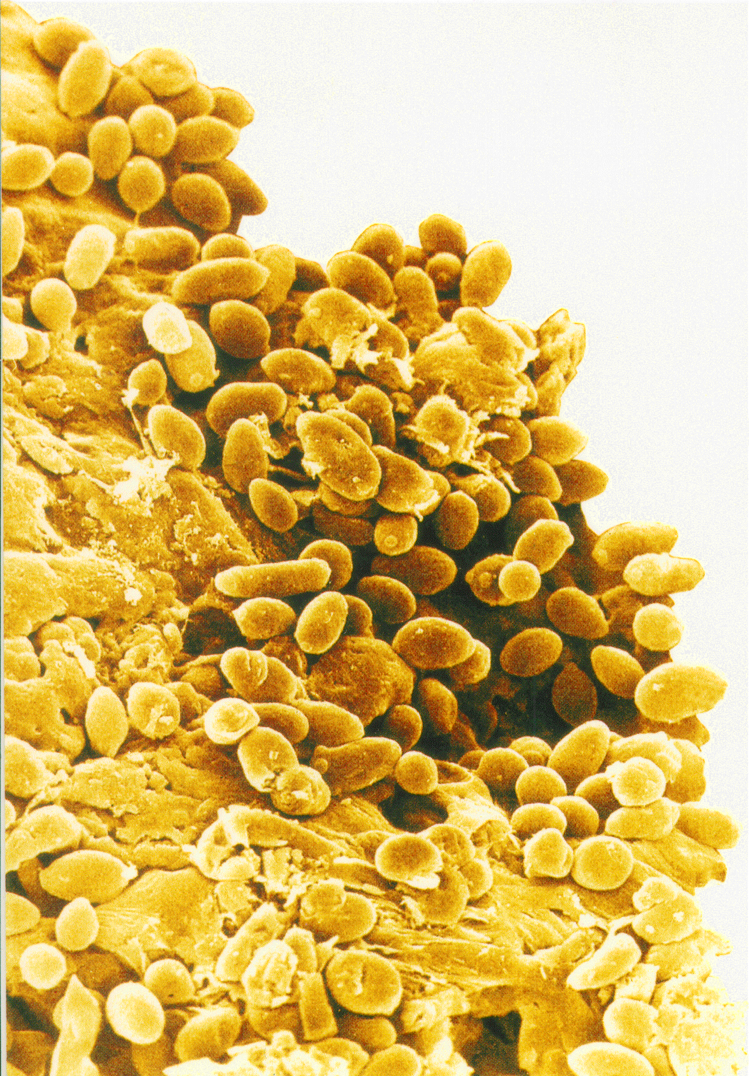
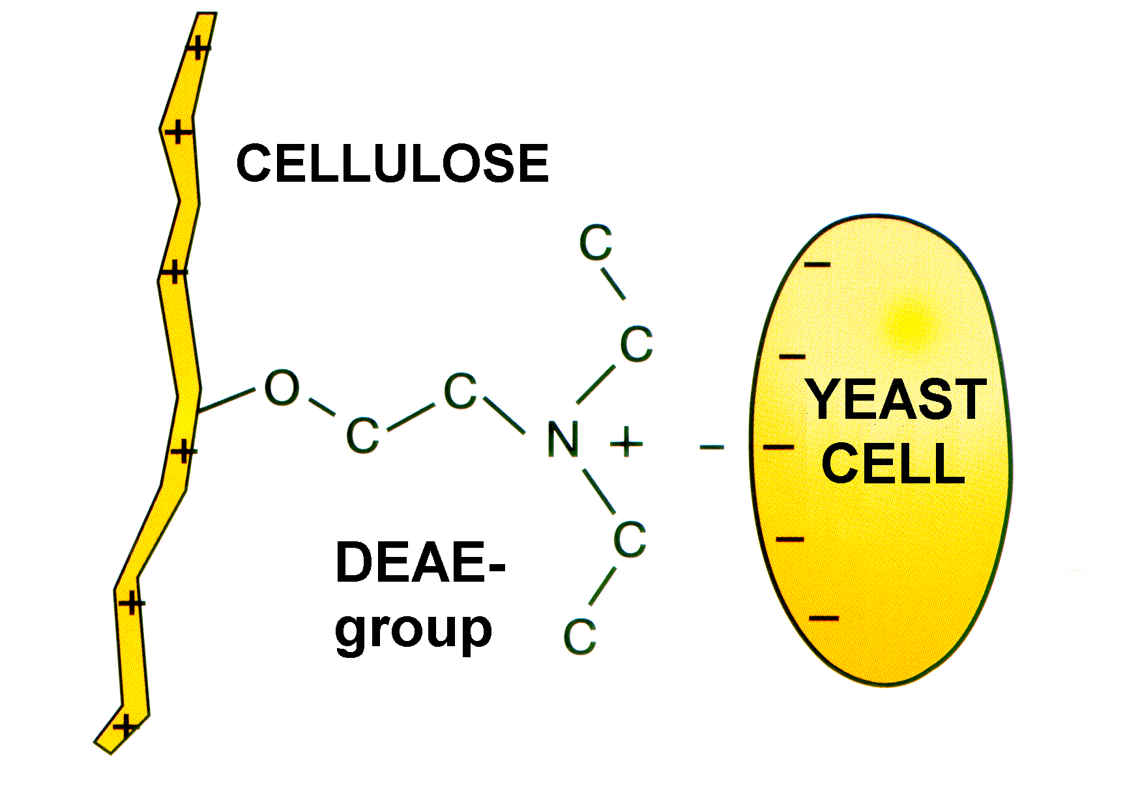

Figure 1: Yeast attached to DEAE-cellulose Figure 2: Immobilisation-principle of
DEAE-cellulose

The bioreactor used in this project was a packed bed reactor with immobilised yeast through which the fermentation medium is passed either upward or downward. The main advantage of this reactor type are the simple design and a low energy requirements, nevertheless there are some disadvantages like poor liquid mixing, accumulation of gas pockets, difficulty with scale up, larger bead sizes needed to maintain pressure drop and compaction of carrier material limits reactor height.

2. MATERIALS AND METHODS

In order to find an optimal condition of propagation (which means producing a lot of yeast in a short time, with a short period of adaptation in the reactor), four propagation tests with different temperature and aeration-scheme were done in the pilot brewery.
Yeast was immobilised in a fixed-bed reactor filled with the carrier material (DEAE-cellulose) and it was maintained in operation for one week, with samples of beer taken daily, in order to evaluate the “start-up” phase. The following picture presents the immo-reactor used during all trials.
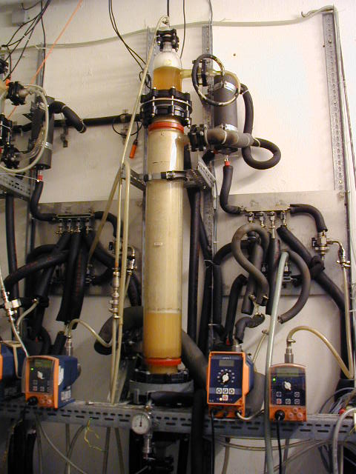

Figure 3: Immo-reactor

Each trial included the following steps: inoculation of the flask culture with the preculture, sterilisation of the propagation plant, preparation of the sterile wort and inoculation of propagation with the flask culture, process control of propagation, harvesting of yeast suspension and cleaning, immobilisation of yeast and connection of wort and beer tanks, sampling of beer, maintenance and troubleshooting.
The propagation parameters, temperature and aeration-scheme are presented in table 1.

Table 1: Propagation conditions during all test series
Trial | Aeration-scheme | Temperature (ºC)
1st | Conventional | 20
2nd | Conventional | 10
3rd | Interrupted | 20
4th | Interrupted | 10

The conventional aeration-scheme comprises an intermitting aeration: 1 minute with aeration, and 4 minutes without aeration.
In order to evaluate the effect of oxygen supply the aeration was interrupted in the last two trials when a sufficient amount of yeast was reached (around 150 × 10⁶ UFC/ml).
The test conditions in the immo-reactor during all trials were a wort throughput of 0,5Kg/h and a fermentation temperature of 15ºC with a pressure of approximately 1 bar. A bottom fermenting brewer’s yeast was used in the bioreactor.
During all test series the following analyses were performed:

- Wort analyses: extract, colour, pH, bitter units and free amino nitrogen (FAN);
- Propagation tank analyses: extract, pH and cell count;
- Beer analyses: original gravity, extract, alcohol, apparent attenuation (fermentation rate), colour, pH, bitter units, FAN, higher alcohols, esters, vicinal diketones and cell count.

Table 2 presents the analyses realized during all test series.

Table 2: Analyses realized during all test series
Analyses | Instrument
Original Gravity (% w/w) | Beer analyser
Alcohol (%w/v) | Beer analyser
Apparent attenuation (%) | Beer analyser
Colour (ºEBU) | Spectrophotometer
pH-value | pH measure
Free amino nitrogen (mg/L) | Scalar ¹
Bitter units ² (EBU) | Spectrophotometer
Higher alcohols (ppm) | Gas chromatography
Esters (ppm) | Gas chromatography
Vicinal diketones (ppm) | Gas chromatography
Fatty acids (ppm) | Gas chromatography
Cell count (UFC/ml) | Thoma-chamber

¹The scalar is an automatic analyser; it works by fluorimetric detection.
² Method: the bitter substances, mainly iso-α-acids, were extracted from beer with iso-octane. The absorbance of the iso-octane layer was measured at 275nm, against a reference of pure iso-octane.

The extracts from wort analyses and propagation tank analyses were measured with the density meter.

3. RESULTS AND DISCUSSION

As mentioned above, an optimal condition of propagation means the promotion of a fast yeast growth in sufficient amounts of pure culture yeast.
The propagation conditions during all test series and the respected results are presented in table 3.

Table 3: Propagation analyses during all test series
Trial | Aeration-scheme | Temperature  (ºC) | Time  (h) | Cell count  (UFC/ml) | Extract  (ºBrix)
1st | Conventional | 20 | 44 | 174×10⁶ | 2,75
2nd | Conventional | 10 | 116 | 65×10⁶ | 3,32
3rd | Interrupted | 20 | 43 | 158×10⁶ | 3,52
4th | Interrupted | 10 | 90 | 146×10⁶ | 6,61

As the results in table 3 show that at 20ºC it was observed a higher yeast multiplication and, consequently, a faster reduction of the extract.
In the last two trials the aeration was interrupted to promote a yeast adaptation, then the immobilisation conditions are anaerobic.

3.1 Propagation with a conventional aeration at 20ºC (1st trial)

The beer analyses presented a final pH of 4,13.
In respect to flavour formation it was observed that a higher temperature increases the formation of higher alcohols (HAA), but at a relatively low level.
As can be seen in figure 4, the vicinal diketones (VDK) content that includes diacetyl (responsible for a buttery flavour associate to “green beer”) was very high during reactor operation (it should be < 1ppm). The total concentration of higher alcohols, esters and acetaldehyde is also presented.

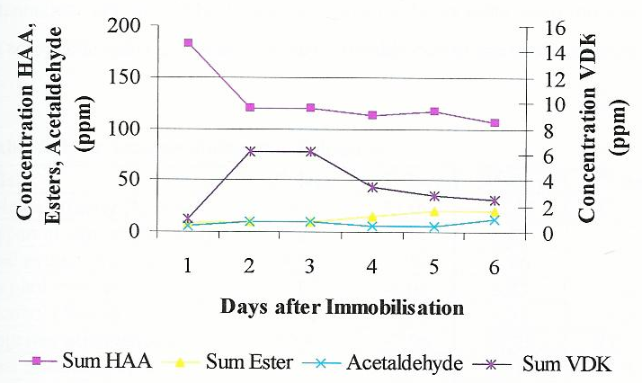
Figure 4: Selected fermentation by-products

3.2 Propagation with a conventional aeration at 10ºC (2nd trial)

The beer analyses during immobilisation showed a high fermentation rate relatively constant during reactor operation and it reached a final pH of 4,22.
In figure 5 the concentration of fermentation by-products are exhibited. The vicinal diketones concentration was still higher, especially on the second day.

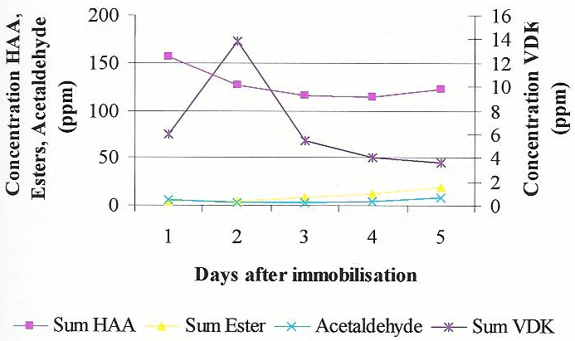
Figure 5: Selected fermentation by-products

3.3 Propagation with an interrupted aeration at 20ºC (3rd trial)

The desired pH of approximately 4,5 was reached.
The acetaldehyde content was not constant during reactor operation as can be seen in figure 6. It was observed a significant improvement, with an interrupted aeration, on total diacetyl (VDK) reduction; it reached a final value below 1 ppm.
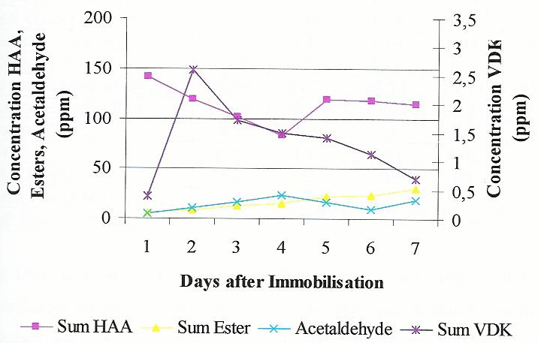
Figure 6: Selected fermentation by-products

3.4 Propagation with an interrupted aeration at 10ºC (3rd trial)

The results from beer analyser showed the higher fermentation rate, which means that the immobilisation was performed optimally. It reached a final pH of 4,28.
As can be observed in figure 7, it was reached the lowest values of acetaldehyde and vicinal diketones.
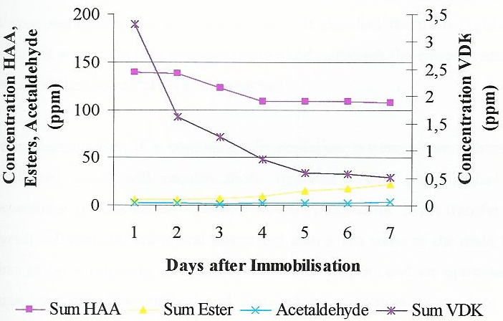
Figure 7: Selected fermentation by-products

4. CONCLUSION

In summary, the beer leaving the immo-reactor still does not match all the required specifications.
A regard to fermentation by-products showed that higher temperatures and a conventional aeration increases the formation of higher alcohols. The acetate esters content was relatively constant during all test series. Acetaldehyde concentration revealed inconstant values with higher temperatures.
An interrupted aeration promoted higher contents of fatty acids, but a significant reduction in total diacetyl concentration.
The fourth trial had the lower content of total diacetyl (vicinal diketone) and acetaldehyde: were both the main responsible for the “green flavour”. It also had the most regular results in the analyses. It seems the best propagation method, although the extract reduction was quite slower and the desired pH was not reached.
The implementation of a continuous fermentation system on an industrial scale using immobilised yeast will require more investigation. Yeast physiological state and its biochemistry are associated with beer flavour production. Mass transfer limitations due to yeast cell immobilisation and associated matrix are some main topics of study. It has to be a selection of appropriate matrix support and an optimisation of reactor design, immobilisation method and fermentation conditions to produce a beer with an acceptable flavour and quality for the consumer.
Researchers should perhaps concentrate their efforts in the best-immobilised cell system and technique applying the actual global knowledge of immobilisation. This is a possible direction, which could result in the implementation of this technology in brewing industry within a relatively short period of time.

REFERENCES

PILKINGTON, P. H.; MARGARITIS, A.; MENSOUR, N. A.; RUSSELL, L.1998. Fundamentals of immobilised yeast cells for continuous beer fermentation: a review. J. Inst. Brewing. 104: 19-23.
LINKO, M.; KRONLÖF, J. 1991. Main fermentation with immobilised yeast. Proceeding 23rd EBC-Congress: 353-360.
WACKERBAUER, K; LUDWIG, A. Improvement of a long-term stability in main fermentations with immobilised yeast. Berlin. Forschungsinstitut für Technologie der Brauerei und Malzerei der VLB, pp. 1-3.
MASSCHELEIN, C. A. ; ANDRIES, M.1995. Future scenario of immobilised systems: promises and limitations. EBC-Monograph: 223-237.
VIRKAJÄRVI, I.; LINDBORG, K.; KRONLÖF, J.; PAJUNEN, E.1999. Effects of aeration on flavour compounds in immobilised primary fermentation. Monatsschrift für Brauwissenschaft. 52: 9-11, 26-28.
KRONLÖF, J.; VIRKAJÄRVI, I. 1999. Primary fermentation with immobilised yeast. Proceeding 27th EBC-Congress: 661-663.
1999. Brewing technology seminar. Asia Pacific Breweries Limited, Singapore, vol. 2, pp. 66-130.

