Comparison of the Yearly Power Generation of a Pumping Cycle Kite Power System and a Traditional Wind Turbine in Aberdeen Scotland UK

Zhihui Ye, Issa Chaer, Rusdy Hartungi, Harry Lawner, Marcus Ross

School of the Built Environment and Architecture, London South Bank University, 103 Borough Road, London SE1 0AA UK

Abstract
In the UK, the Climate Change Act (2008) set a target for reduction of 80% of carbon emissions by 2050. Total power generation in the UK from renewable resources was 110 TWh in 2018. Of this, 56.9 TWh was wind-generated. The UK is located in a windy area and is one of the top locations in the world for wind power, often considered to be the best in Europe. Scotland is the most suitable location for the implementation of Airborne Wind Energy (AWE) systems in the UK. Over the last three decades, the number of wind farms has increased greatly. Wind turbines extract wind energy from 100 m above the ground. AWE systems enable the extraction of more energy from wind at elevated altitudes beyond 150 m. A pumping cycle kite power (shorted as kite) system is the most popular AWE. In this work, the annual power production of a kite system and a turbine system with a 30 kW generator were analysed by applying the annual wind profile in Aberdeen to the performance models of these two systems. The annual power production of the kite system was found to be two times higher than the turbine system.

Keywords: Airborne Wind Energy, Pumping Cycle Kite Power System, Wind Turbine.

1. Introduction

Airborne Wind Energy (AWE) systems are an innovative technique to harvest wind energy at higher elevations, normally beyond 150 m. At a greater altitude, AWE systems are expected to capture more wind energy to produce more electrical energy due to the higher and steadier wind speed. AWE systems are generally made of two main components (i) a ground system and (ii) at least one aircraft that is mechanically and electrically connected by tethers [1]. Among various AWE systems, the pumping cycle kite power (shorted as kite) systems are the most developed technique [2]. During the last decade, kite systems have been greatly developed by a number of companies and research groups. The concept of kite systems is that of utilising a kite to capture wind energy and transmit it to a ground station by tether cables. Inside the ground station, the tether cables are connected to drums which are fixed to generator motors.
The aim of contrasting a kite system to a traditional wind turbine system is to examine how the annual wind energy generation profiles differ between the two systems throughout the year and to review whether a change in altitude height has any influence on the power performances of the systems.
Scotland is the most favourable location in the UK for the application of AWE systems [3]. The energy produced by the kite system has been investigated for five locations in Scotland [4]. However, how much more power the kite systems can generate compare to traditional turbine systems has not yet been investigated. In the study, firstly, wind data was obtained from Energy Plus Simulation Software and analysed using the Weibull distributions and Hellman power law to develop the wind speed profile. Secondly, the equations of predicted power generation were obtained by fitting a polynomial curve to the generator manufacturer specification power curves. Finally, the predicated power generation of both systems were calculated by inputting the wind speed to the predicted power generation equations. It was found that the annual power generation of the kite systems is two times higher than that of the turbine system. The difference of the power generation for these two system is at its maximum in September, when the pumping cycle kite power system produces three times more power than the turbine system.

2. Methodology

In order to accurately estimate the annual energy production of both the kite system and turbine system, Energy Plus Simulation Software weather data [5] were used to acquire the hourly wind direction and wind speed data between the years 1982-1994 in Aberdeen, Scotland.
The wind energy potential in Aberdeen can be evaluated by analysing the wind data using Microsoft Excel. The wind simulation models created in Excel allow for the prediction of the hourly cumulative frequency of different wind speeds as well as how the wind speed profile varies with altitude, orientation and surrounding terrain characteristics.
In the development of the wind model, the main elements examined were the turbine rotor or airborne kite altitude height which changes the wind speed, as well as the direction of wind travel which is known to alter the wind speed, given that the friction coefficient varies with different types of terrain.
2.1. Wind Speed Distribution Analysis Model

The variation and frequency of wind speeds at a specified location during the course of a year can be expressed by a probability density function. The Weibull and Rayleigh distributions are well suited to fitting wind speed frequency distributions. Compare to the Rayleigh distribution, the Weibull distribution has the advantage of providing a more accurate probability density function because corrections for landscape, vegetation, and structures can be modelled through the scaling factor that represents the wind velocity, and the shape factor that portrays the form of the distribution [6, 7]. Wind speed and installation height above the ground affect the power generation of the kite systems and turbine systems.
2.2. Kite and Turbine System Performances

The Wind Power Program database [8] comprises of a variety of different generator wind performance power curves and was used to determine the generator performance of the kite and wind turbine systems. To determine and compare the annual performances of each system at non-standard wind conditions, the generators were chosen out of a range of similar ratings at 30 kW as well as the same wind extraction cross-sectional areas of 80 m².
Wind turbines have rotor blades and therefore the generator wind characteristics in regards to these systems tend to have cut-in and cut-out winds speeds that range between 3.5-24 m/s, whereas the a kite system features an aerofoil design which means that the generator wind characteristics allow this style of system to be capable of generating power at lower and higher wind speeds between the scope of 1-45 m/s [8]. This allowed the generators for both systems to be individually selected based on the corresponding wind characteristics of the different systems.
In this study, the Joliet Cyclone 30 kW generator was selected for the turbine system and the Fortis Montana 30 kW generator for the kite system. Each generator’s power and efficiency was modelled in relation to the weather conditions of the site location of Aberdeen, Scotland using Microsoft Excel.
2.3. Kite and Turbine System Power Predication

The actual hourly power profiles of the kite system and turbine system were estimated by fitting a polynomial curve to the generator manufacturer specification power curves. The acquired equations were used with the new hourly wind speed profiles obtained from the Hellman power law to calculate the power generation for both systems.

3. Results

The wind speed obtained from the Energy Plus Simulation Software weather data was analysed by using the Weibull distribution function and Hellman power law to create a wind model. The analysed wind speed profile was inputted to the power prediction equations to obtain the power generation for both the pumping cycle kite power system and turbine system
The Weibull distribution is modelled to convert the hourly wind information into frequency distributions to investigate and measure the wind potential in Aberdeen, Scotland. The Weibull distribution analysis shows that the mean wind speed is 5.3 m/s.
To evaluate the power generation of the kite system, a lift coefficient of 1.6, a drag coefficient of 0.16 and a kite area of 80 m² were used to analyse the system. The generator was set at 30 kW and the tether angle of the kite held constant at 10°. The kite system at an altitude of 100 m has a remarkable total yearly power generation of 108,000 kW with an average annual power coefficient of 0.75. In comparison, the turbine system produces a total yearly power generation of 51,000 kW and has an average annual power coefficient of 0.32.

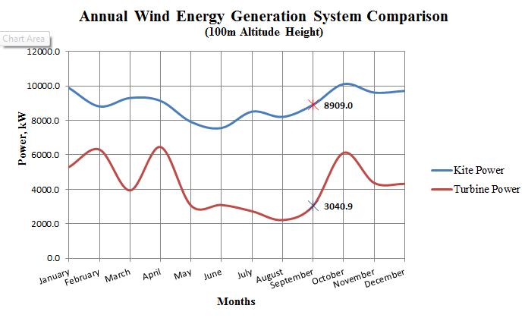
Fig. 1. Annual wind energy generation system comparison.

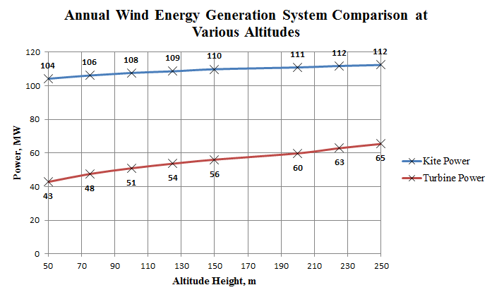
Fig. 2. Annual wind energy generation system comparison at various altitudes.

Studying the two wind power generation profiles in Figure 1 shows that there is less fluctuation in the power generation of the kite system and the power production is much more uniform annually in comparison to the turbine system. It is also evident that the kite system can generate double the amount of power than the turbine system throughout the year. In the month of September it is visibly shown that the kite system can even produce an incredible three times more power than the turbine system.
Figure 2 shows the increase in annual power generation for both systems in relation to an increase in altitude height. It is also noticed that the rate of power generation by the kite system starts to slow down and level out as the altitude height is enlarged. In comparison to the kite system, the annual pace of power production by the turbine system also reduces, however, just not as fast.

3. Conclusion

The UK is located in a windy area and is one of the top locations in the world for wind power, often considered to be the best location in Europe. Since the 1980’s, the number of both onshore and offshore wind farms have increased greatly. This study has investigated the annual wind power generation profiles of the kite system throughout the year in comparison to the turbine system, it was found that the kite system noticeably generates two times more power annually than the turbine system. The power generation difference between these two systems peaks in September. It was also found out that power generation for both systems increased with greater installation height. This is presumably due to the cut-in and cut-out characteristics of wind turbine blades, in contrast to the aerofoil design of a kite which allows for more generation of power at lower and higher wind speeds. In addition, the power coefficient of the design is also another influence on the kite system’s power output.
In relation to self-reliance on nationwide energy and security, kite systems can deliver a reliable and steady source of local renewable energy to the Scotland region. Therefore, implementing the kite system would clearly help the UK in reaching the greenhouse gas emissions targets set by the UK government and satisfy the essential objectives of the EU.

References

[1] Diehl M. Airborne wind energy: basic concepts and physical foundations. In: Ahrens U, Diehl M, Schmehl R, editors. Airborne wind energy, Berlin: Springer; 2013:3–22.
[2] Cherubini A, Papini A, Vertechy R, Fontana M. Airborne wind energy systems: a review of the technologies. Renewable and Sustainable Energy Reviews, 2015; 51:1461–1476.
[3] Ye Z, Lawner H, Chaer I, Ross M. Viability of airborne wind energy in the Unite Kingdom. Eleven International Conference on Thermal Engineering: Theory and Applications. Dohar, Qatar, 2018.
[4] Ye Z, Lawner H, Chaer I, Ross M. Feasibility study of pumping cycle power system implication in Scotland UK. The 3rd International Conference on Renewable Energy and Conservation. Sydney, Australia, 2018.
[5] Energy Plus Simulation Software Weather Data. https://energyplus.net/weather.
[6] Jha A. R. Design aspects and performance requirements. In: Wind turbine technology, Boca Raton: CRC Press, Taylor & Francis Group ; 2011: 31-78.
[7] Dunn, A. Wind power: lecture notes, London: London South Bank University. 2016.
[8] Wind Power Program, 2018.

