Digital Twins for Smart Building at the Facility Management Stage: A Systematic Review of Enablers, Applications, and Challenges

Frank Ato Ghansah
Division of Construction, Property and Surveying; School of the Built Environment and Architecture, London South Bank University; London; United Kingdom.

Abstract
Purpose: Despite the opportunities of digital twins (DTs) for smart buildings, limited research has been conducted regarding the facility management stage, and this is explained by the high complexity of accurately representing and modelling the physics behind the DTs process. This study thus organises and consolidates the fragmented literature on the DTs implementation for smart buildings at the facility management stage by exploring the enablers, applications, and challenges, and examines the interrelationships among them.
Methodology: A systematic literature review approach is adopted to analyse and synthesise the existing literature relating to the subject topic.
Findings: The study revealed six main categories of enablers of DTs for smart budling at the facility management stage, namely perception technologies, network technologies, storage technologies, application technologies, knowledge building, and design processes. Three substantial categories of DTs application for smart buildings were revealed at the facility management stage: efficient operation and service monitoring, efficient building energy management, and effective smart building maintenance. Subsequently, the top four major challenges were identified as being “lack of a systematic and comprehensive reference model”, “real-time data integration”, “the complexity and uncertainty nature of real-time data”, and “real-time data visualisation”. An integrative framework is finally proposed by examining the interactive relationship among the enablers, the applications, and the challenges.
Practical implication: The findings could guide facility managers/engineers to fairly understand the enablers, applications, and challenges when DTs is being implemented to improve smart building performance and achieve user satisfaction at the facility management stage.
Originality: This study contributes to the knowledge body on DTs by extending the scope of the existing studies to identify the enablers and applications of DTs for smart buildings at the facility management stage and the specific challenges.

Keywords: Challenges, Digital twins, Enablers, Facility Management, Intelligent buildings, Smart buildings.

1 Introduction
Buildings account for 40% of global energy consumption and emit 33% of greenhouse gases (World Economic Forum, 2021). This situational awareness in buildings has caused the building design, construction, and operations to understand the resources utilised, the emissions, and interactions with users: from energy efficiency to sustainability, to automated, to intelligent, and finally smart (Buckman et al., 2014). The significance of this awareness via digitisation has evolved into the concept of a smart building, which has its markets estimated to reach USD 141.71 billion by 2028 at a revenue compound annual growth rate of 9.9% over the forecasted period (Emergen research, 2021). This results from the higher demands for energy-efficient systems, increased usage of advanced building management systems (BMS), and rising industry standards and regulations in addressing sustainability challenges and meeting users’ need for intelligence. Thus, the smart building concept is gaining popularity in academia and industry due to its capability to improve building efficiency and support life intelligently, especially in the facility management phase.

Despite that, there is no consensus on smart building, sometimes called intelligent building, which has been closely related to the facility management stage (Pašek and Sojková, 2018), where people, places, and processes within the built environment are integrated with the purpose of improving the quality of life of people and the productivity of core businesses (International Organization for Standardization [ISO)]- 41011:2017[en]). The European Committee [EC] (2009) describes a smart building as a building empowered by information and communication technologies (ICT) in the context of the emerging ubiquitous computing and the Internet of Things (IoT): the generalisation in instrumenting buildings with sensors, actuators, micro-chips, micro and nano-embedded systems will allow to collect, filter, and produce more and more information locally, to be further consolidated and managed globally according to business functions and services. This acknowledges that the smart building notion evolves primarily with the advancement of supporting technologies (e.g., artificial intelligence [AI], IoT, 5G, cloud and edge computing), and this allows effective monitoring and operation in buildings, including achieving interactivity and sustainability (Jia et al., 2019). This paper follows the EC’s (2009) definition of smart buildings and primarily focuses on the facility management stage with which smart buildings have been associated. This stage integrates people, places, and processes within the built environment with the purpose of improving the quality of life of people and the productivity of the core business. Hence, a proper management system could ensure building functionality, comfort, safety, sustainability, and efficiency in the built environment.

Admitting the global trend of achieving smart building, the digital twins (DTs) concept has gained momentum in research due to its ability to accelerate digital transformation initiatives for product development across industries. It creates high-fidelity virtual model objects in virtual space to simulate physical assets’ behaviours and provide feedback (Tao et al., 2019). Grieves (2005) introduced DTs as a real-time digital footprint of a product system from the design and development to the end of its life cycle. This has gained applications across different industries due to its ability to hasten digital transformations in addressing fault detection, space management, and carbon emissions (Liu et al., 2021a; Lu et al., 2020a). Jiang et al. (2021a) explained DTs in the civil engineering sector as a real-time virtual representation of facilities to express the current condition of the physical counterpart. This constitutes the physical part, the digital model, the connection between the physical and digital model, and the twin relationship between the physical and digital model. Jiang et al.’s (2021a) definition is adopted for this study, as it has potential applications for smart buildings (Ghansah and Lu, 2023a).

The DTs concept is gaining traction in the built environment, and current studies have reviewed DT technology in this setting. For example, Boje et al. (2020) examined the multi-faceted applications of Building Information Modelling (BIM) during the construction stage and highlighted limits and requirements to pave the way for the DTs’ construction. Due to the research methodology design used, several trails were left out surrounding the issue of DTs when their findings, including the significant applications and enablers. Jiang et al. (2021a) reviewed the DTs in civil engineering and defined the DTs concept that has been confused with the cyber-physical system (CPS) and BIM. Their work was limited to civil engineering work that may slightly differ from building work in smart buildings. Ozturk (2021) conducted a scientometric analysis to identify five main research fields: virtual-physical building integration, building lifecycle management, information-integrated production, information-based predictive management, and virtual-based information utilisation. The sole use of scientometric analysis made their work susceptible to the issue of data duplication can affect their results. Opoku et al. (2021) examined the status of DTs applications with less focus on the enablers and the challenges of the state-of-the-art DTs applications across areas in the building industry. Ghansah and Lu (2023a) identified the major opportunities of DTs for smart building, with a limited focus on only the prospects. Existing reviews have shown substantial contributions to DTs knowledge in the built environment. Considering the vast potential of DTs for smart buildings, significant challenges are faced upon deciding to implement DTs for smart buildings at the facility management stage due to the originality of the concept (Rasheed et al., 2019). Little research on DTs has been conducted for smart buildings at the facility management stage (Stojanovic et al., 2018; Seghezzi et al., 2021; Bujari et al., 2021), which may be explained by the high complexity of accurately representing and modelling the physics behind the DTs processes. There is also a clear lack of studies as smart buildings have been associated more closely with the facility management stage (Pašek and Sojková, 2018). However, understanding these could contribute to realising the full potential of DTs for facility management in smart buildings.

This study thus conducts a comprehensive overview of DTs for smart buildings at the facility management stage of buildings via a systematic literature review approach. The objectives are (1) to explore the enablers, the significant applications, and the associated challenges of DTs for smart buildings at the facility management stage and (2) to examine the interactive relationships between the enablers and the challenges considering the applications. The principal contribution is knowledge extension, which is by highlighting and examining the interactive relationship among the enablers and challenges of DTs for smart buildings at the facility management stage to assist practitioners (facility managers), policymakers, and other related stakeholders in making decisions on effective applications.

2 Brief overview of DTs for smart building at the facility management stage
According to the ISO - 41011:2017(en), as adopted by the International Facility Management Association (IFMA), facility management exists as an organisational function integrating people, places and processes within the built environment with the purpose of improving the quality of life of people and productivity of the core business. This ensures the functionality, comfort, safety, sustainability, and efficiency of the built environment. The emergence of technology has placed facility management at a different level, making related activities simpler and more efficient. Traditional facility management is evolving toward a new digital facility management model, allowing owners and operators to turn portfolio data into actionable insight using technology (Rake, 2019). A massive amount of building data is generated and collected at a central place and analysed to help make informed decisions on efficient building management. Digital facility management could drive proactive maintenance, bringing data from disconnected systems together and enabling building operators to extract actionable insight, hence leading to smart facility management via smart building (Ghansah et al., 2022a). This evolution has advanced to a level where there is the possibility of creating a twin version of facilities to enable a real-time analysis, testing, and actioning of building environments toward efficient decision-making by adopting the concept of DTs. This motivates the study to understand and identify the enablers and the possible challenges of implementing DTs for smart buildings at the facility management stage, specifically for completed buildings. Incorporating DTs for smart buildings at the facility management stage could act as a virtual platform, which will provide real-time analysis, testing and actioning of the smart building environment. The DTs could act as a node for improved workflow and an optimisation management system to boost the operativity performance of buildings (Sepasgozar et al., 2020). The DTs could provide both a granular and holistic view of the built environment, answering the need for efficient facility management for both engineers and maintenance teams. The DTs could also collect data from different sources into one single pane of glass for a single source of truth of all building systems, as well as provide a clear real-time view of the smart building data.

As the smart building is discussed in detail in section 2.1 as the physical counterpart of DTs in construction, the DTs was introduced by Grieves (2005) as a real-time digital footprint of a product system from the design and development to the end of its life cycle. The DTs concept has gained attention from different industries, including smart manufacturing (Liu et al., 2021a) and the building industry (Lu et al., 2020a) due to its ability to assist in testing and validating a product before it even exists in the real world. In the context of the Centre for Digital Built Britain, it realistically represents an asset, process or system in the virtual space (Bolton et al., 2018). In the civil engineering sector, Jiang et al. (2018) defined DTs as a digital platform that expresses the real-time conditions of the physical counterpart of facilities, and this is facilitated by its constituents, including the physical part, the digital part, the connection between them, and the twin relationship between them. This study then follows the precise definition by Jiang et al. (2021a), as was used in the civil engineering works and can be likened to buildings.

DTs has shown significant prospects in solving existing building issues in the architecture, engineering, construction and operations (AECO) industry. For instance, DTs approach could improve the energy efficiency of indoor lighting based on computer vision and dynamic BIM (Tan et al., 2022). The limited sensing environment with sensor absences, faulty sensors, low redundancy, and less dense deployment due to the inherent building characteristics have been tackled with novel virtual sensing-enabled DTs, using in-situ observation virtual sensors in building operations (Choi and Yoon, 2023). Other current studies have considered solving issues in relevant areas such as fault detection and diagnosis for building HVAC systems (Xie et al., 2023), intelligent control of building fire protection (Jiang et al., 2023), shaping the full life cycle digital transformation for bridge engineering (Honghong et al., 2023), and intelligent operation and maintenance systems (Zhao et al., 2022). DTs has numerous opportunities in the AECO industry, and this could be achieved by enhancing the smartness of building infrastructures.

DTs for smart buildings emerge from integrating the physical and digital worlds of a smart building by leveraging IoT systems via the digitisation of building systems to collect real-time data about the building. Combined with context, data is utilised to understand better, analyse, alter, and optimise processes in smart buildings to improve efficiency in buildings and achieve user satisfaction. It bridges the gap between the physical and the digital worlds, serving as a contextual model of an entire smart building environment (Tao et al., 2019). Based on Jiang et al.’s (2021a) definition of DTs, the working definition of “DTs for smart building” by this study can be attributed to “the real-time virtual representation of smart buildings that realistically shows the current state, behaviour, and processes across the lifecycle phases of the smart building, and also portrays a one-to-one mapping and bi-directional relationship with the physical world leveraging the technology advancements to address an intended purpose”. The concept of DTs for smart buildings” exists threefold: the physical smart building, the digital model, and the twin relationship between the physical model and the digital model, as seen in Figure 1.

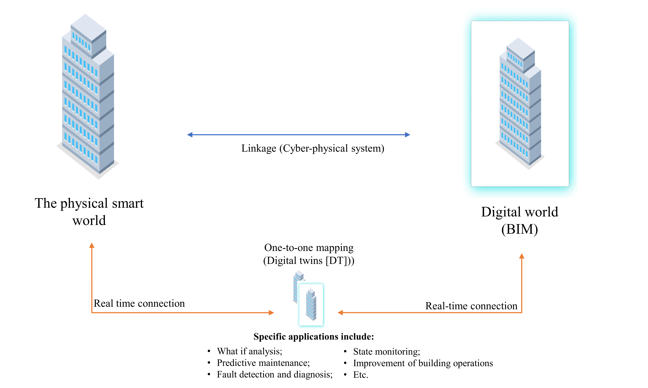

Figure 1: Conceptual framework for understanding DT for smart building at the facility management stage of buildings (Source: Author’s own work)

2.1 Smart Building – the physical world
Smart building, in this study, is regarded as the physical counterpart of the concept of DTs for smart building. The smart building concept, over the decades, has not been well-defined by researchers due to a lack of literature addressing the concept. “Smart building” is interchangeably used with “intelligent buildings” or “automated buildings” and the most recent “cognitive building” (Cushman and Wakefield, 2019). EC (2009) defined a smart building as a building empowered by ICT in the context of merging ubiquitous computing and the IoT: the generalisation in instrumenting buildings with sensors, actuators, micro-chips, micro- and nano-embedded systems will allow to collect, filter, and produce more and more information locally, to be further consolidated and managed globally according to business functions and services. This definition is precise by considering the concept, performance, and the associated technologies, compared to other definitions that consider only the concept and its performance (Buckmann et al., 2014; Xu et al., 2019). Smart building evolves primarily with the advancement of supporting technologies, which allows buildings to be monitored effectively and operate efficiently, interactively, and sustainably. This contributes to improving buildings at the facility management stage, where people, places, and processes within the built environment are integrated with the purpose of improving the quality of life and the productivity of core businesses. Regarding this, the EC’s (2009) definition was adopted for this study, as it denotes the advanced technologies for the smart building concept, making it an enabler of DTs in the AECO industry.

Smart buildings collect data about their usage and state and provide a real-time picture of their status. These include the number of occupants at any given period, building usage, user interactions, plumbing leaks, and unclosed doors in buildings via sensors and cameras (Sinopoli, 2014). The data is combined into a single interface to provide information to users through BMS facilitated by advanced technologies integrated into smart buildings. As such, smart buildings may have the potential to improve energy efficiency in buildings ensuring efficient maintenance systems (Jia et al., 2019) and efficient monitoring systems (Yu et al., 2020).

Various technologies exist in smart buildings, and the key to their effective implementation is to connect them using advanced BMS. For instance, pervasive sensing technologies are adopted in buildings to facilitate facility management services, and each sensing technology has its advantages for specific applications (Xu et al., 2020). IoT is the core of the smart building avenue due to its ability to perceive different situational awareness in buildings, and this can be conceptualised as smart building architecture (Noonari, 2020) (Figure 2) to be integrated into the BMS. The smart building technology architecture could include a complex system of varying smart technologies (IoT systems, cloud and fog computing, big data analytics and engineering, and human-computer interaction algorithms [Jia et al., 2019; Lu et al., 2023]) as shown in Figure 1, and it is purported to maximise the efficiency of a building facility’s operation while improving the well-being of its occupants. This is geared toward gathering massive amounts of data in building facilities that can further be analysed to inform decisions on facility management.

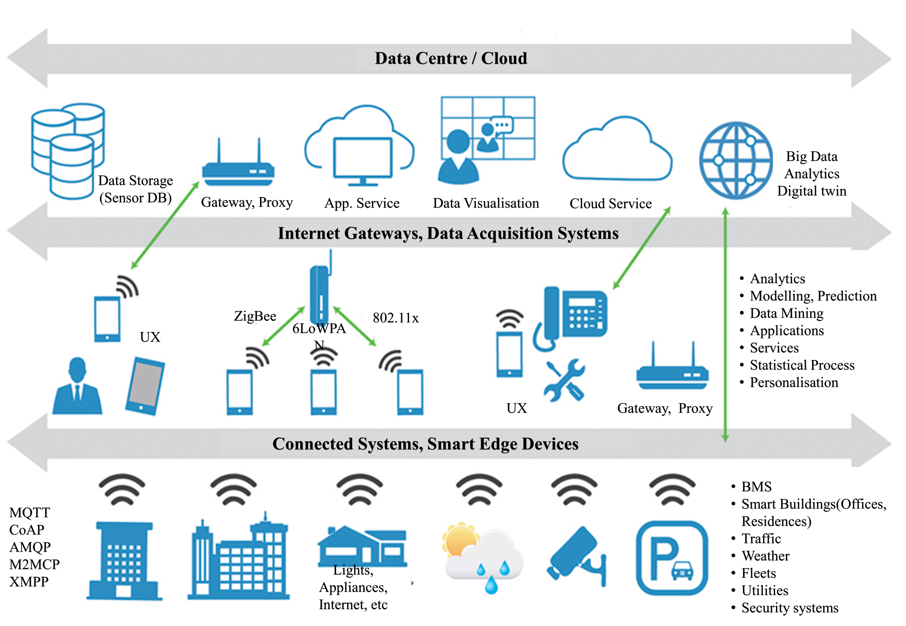

Figure 2: Smart building architecture (Noonari, 2020)

2.2 The digital counterpart
The digital world of a smart building is a digital, computational model of a building facility (Brilakis et al., 2019), and it serves as a recording and communication mechanism to facilitate the interpretation and prediction of its environment and user behaviour based on real-time data, business logic, and objectives about corresponding objects. Developing digital models for DTs is critical, and these exist as either semantic or physical models. Physical models require a detailed grasp of their physical qualities and existing linkages, whereas semantic models are created using AI approaches with known inputs and outputs (Liu et al., 2021b). Digital modelling of a physical smart building exists in two forms: the initial digital design before the construction of the physical building and the digital design from existing buildings (also known as the as-built model). For the latter, the digital model stands as a very coarse approximation of an existing physical smart building but can be precise depending on the data source and the methodology, whereas the former initial digital design is created to stand in for the smart building in simulations long before construction begins (Johnson Controls, 2018). These two modelling approaches produce high-fidelity models depending on the software used. Also, among various digital models for DTs, there may be a need for high-fidelity, which requires a multi-physics approach to create context-rich datasets in buildings at the facility management stage.

In the built environment, one concept cannot be ignored: BIM. Most researchers have likened the BIM concept to the digital model. BIM represents an existing physical object that does not automate real-time data exchange between the physical object and the virtual counterpart (Kritzinger et al., 2018). However, information/data exchange is key to digital models, including BIM (Lu et al., 2018), and this could be facilitated by the enabling technologies incorporated in smart buildings. BIM could, therefore, be a semantically rich digital model for setting up DTs to automate real-time data transactions between physical smart buildings and their virtual counterpart.

2.3 Real-time twin relationship between the physical and digital worlds
The twin linkage between the physical and the digital world realises the DTs concept for smart building. Both the physical components and virtual counterparts are integrated using sensors, controllers, and computer algorithms such that the physical space can be real-time monitored by the virtual side in a seamless manner (Tao et al., 2019). With this, a bi-directional automatic data flow is realised, such that automatic real-time adjustment in the physical system can occur due to simulation in the virtual counterpart (see Figure 3). This feature makes DTs distinctive from the BIM concept (Jiang et al., 2021a).
Figure 3: DTs for smart buildings with the associated technologies (Ghansah and Lu., 2023a)
The DTs concept differs slightly but emphasises bi-directional coordination, bringing it closer to the cyber-physical systems (CPS) concept (Ghansah and Lu, 2023b). The BIM model in the DTs gathers real-time data and puts it back, effectively closing the information loop with a one-to-one mapping to create a bi-directional relationship. Alternatively, integrating BIM with IoT technology could achieve a real-time seamless data transition from the physical world to the digital model, realising DTs’ concept (Brilakis et al., 2019) for facility management in smart buildings.

Given the background, DTs has opportunities for smart buildings at the facility management stage, which have been associated more closely. These include occupancy-related benefits (Seghezzi et al., 2021) and decision support systems (Stojanovic et al., 2018; Bujari et al., 2021). Previous studies, including Boje et al. (2020), examined the multi-faceted applications of Building Information Modelling (BIM) during the construction stage and highlighted limits and requirements to pave the way for the DTs’ construction. However, several trails in the research methodology design were left out surrounding the issue of DTs when analysed their findings, including the significant applications and enablers. Jiang et al. (2021a) examined digital technologies (DTs) in civil engineering and clarified the notion of DTs, which has been misunderstood for BIM and (CPS). Their scope of work was restricted to civil engineering projects, which may differ slightly from building projects in intelligent buildings. Five primary study areas were identified by Ozturk (2021) through a scientometric analysis: building lifecycle management, virtual-physical building integration, information-integrated manufacturing, information-based predictive management, and virtual-based information utilisation. The sole use of scientometric analysis made their work susceptible to the issue of data duplication can affect their results. Opoku et al. (2021) examined the status of DTs applications with less focus on the enablers and the challenges of the state-of-the-art DTs applications across areas in the building industry. Ghansah and Lu (2023a) also identified the major opportunities of DTs for smart building, with a limited focus on only the prospects. Previous reviews have shown substantial contributions to DTs knowledge in the built environment, especially for smart buildings. However, significant challenges are faced upon deciding to implement DTs for facility management due to the originality of the concept (Rasheed et al., 2019). Few studies have been conducted on smart facility management (Stojanovic et al., 2018; Seghezzi et al., 2021; Bujari et al., 2021), which may be explained by the high complexity of accurately representing and modelling the physics behind the DTs processes. Meanwhile, understanding this could contribute to realising the full potential of DTs for facility management, especially in smart buildings. Significant challenges are faced upon deciding to implement DTs at the facility management stage due to the novelty of the concept. Simply put, the study investigates the potential of DTs for facility management in smart buildings.

This study, therefore, aims to explore the enablers of DTs for smart buildings at the facility management stage, the significant applications, and the associated challenges and further examine the available interactive relationship among them. This is achieved with a systematic literature review by engaging qualitative content analysis (QCA). This could help understand the high complexity of accurately representing and modelling the physics behind the processes to realise the full potential of DTs for facility management. The study focuses on the facility management stage, where there is a clear lack of studies and with which smart buildings have been associated more closely.

3 Research Methods
A two-step systematic literature review approach was adopted to meet the objectives of this study by collecting and analysing relevant literature published since 2015 due to the newness of the concept (Dixit et al., 2019; Akomea-Frimpong et al., 2022). The two-step approach is illustrated in Figure 4.

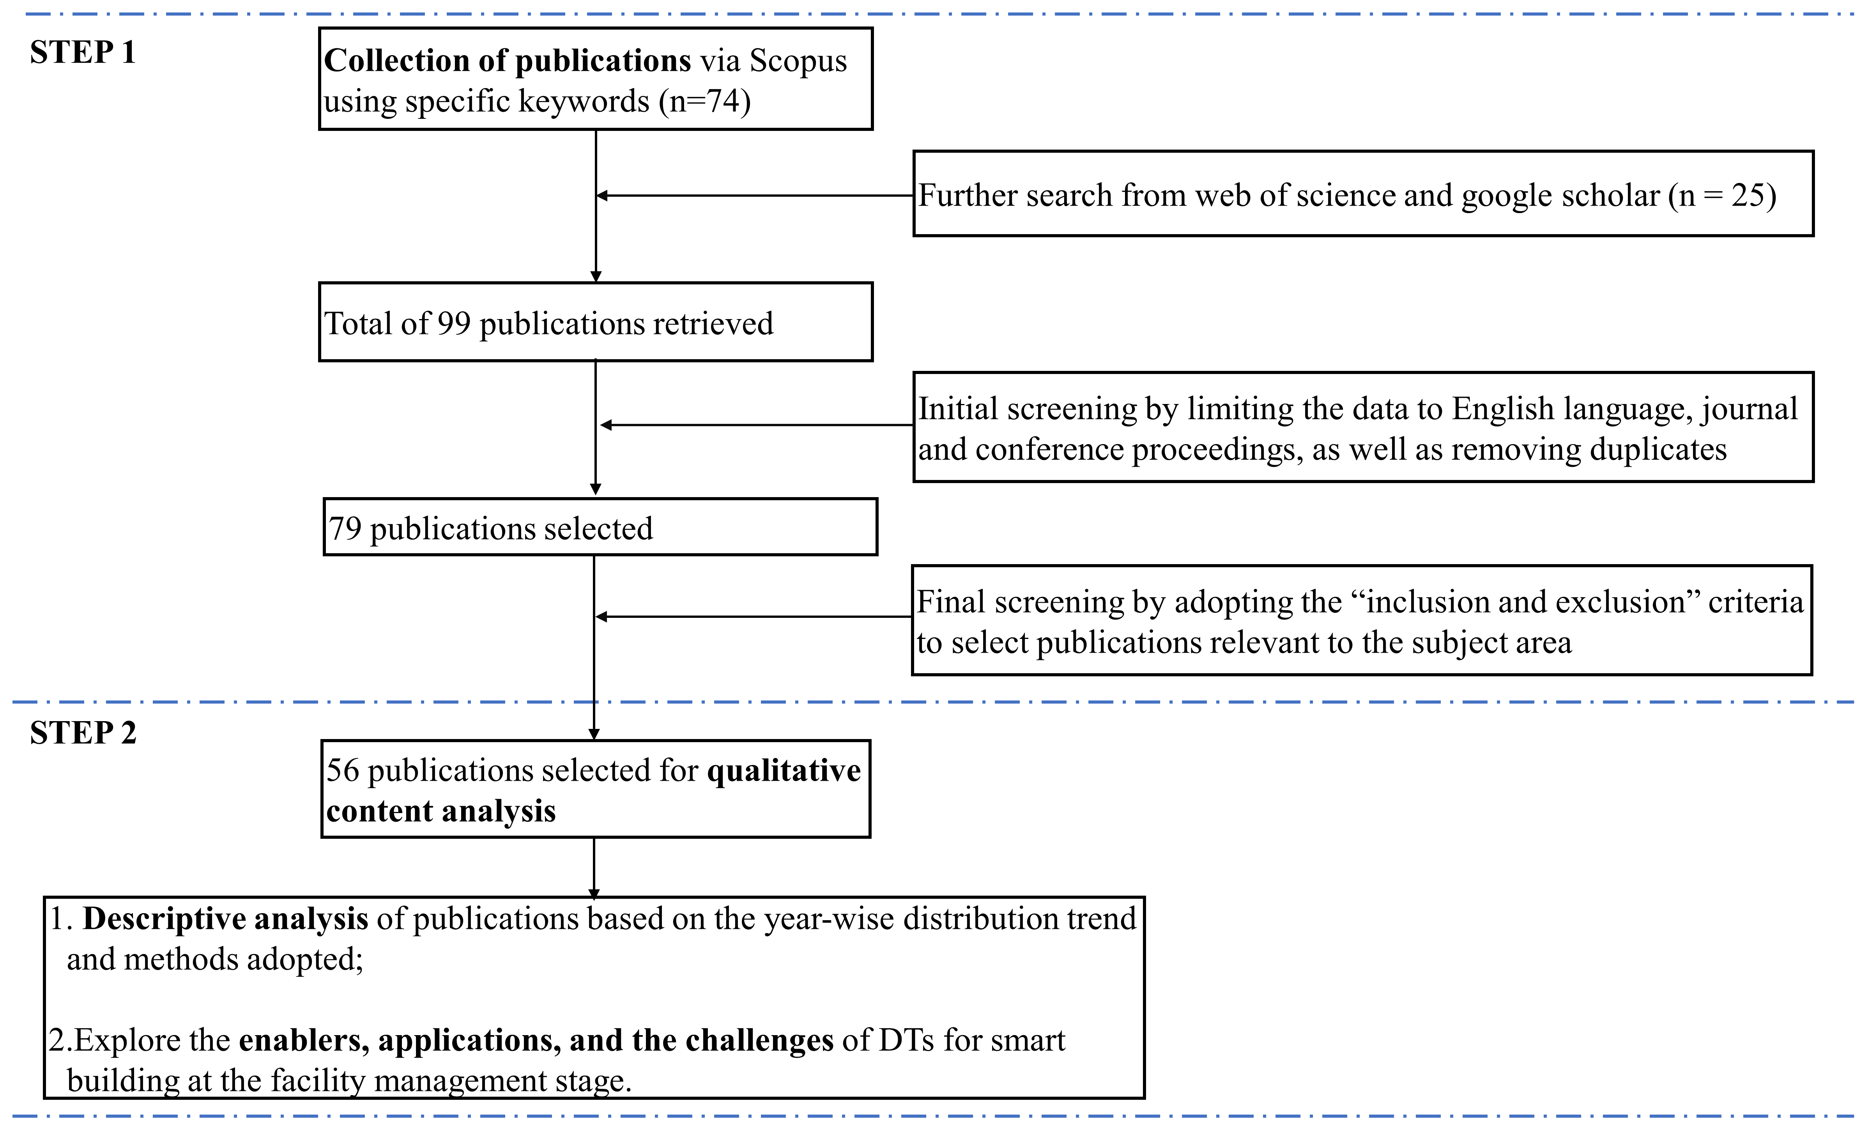

Figure 4: Study Workflow (Source: Author’s own work)

3.1 Step 1: Collection of Publications
Publications were retrieved from the Scopus database based on a query string due to its fast-indexing process compared to other databases (Li et al., 2014). Critical keywords on the subject were searched and chosen with the help of “Google search”. The keywords were then inserted into the search engine of Scopus. The first part constituted related keywords such as “digital twin” OR “digital twins” OR “virtual counterpart” OR “digital replica” OR “virtual twin”. The second keyword section consisted of related keywords such as “construction engineering and management” OR “construction” OR “construction engineering” OR “construction management” OR “facility management” OR “Building management”. Lastly, the third section comprised of related keywords, including “smart building” OR “smart buildings” OR “cyber physical systems” OR “cyber-physical systems” OR “CPS” AND “BIM” OR “building information model” OR “building information modelling” OR “building information modelling.” The fourth part included “barriers” OR “drivers” OR “challenges”. The search was facilitated by the Booleans “AND” and “OR”. However, close attention was granted to the keywords as they were used to generate relevant related studies concerning the purpose of this study (Paul and Barari, 2022).

Seventy-four (74) publications were initially retrieved. Considering the relatively small number of publications from Scopus, the authors further searched the Web of Science (18) and Google Scholar (7) (Jacso, 2005), making a total of 99 publications. Subsequently, the results were limited to the English language, journal, and conference proceedings. The search period was unrestricted until 2023. Removing duplicates, filtering, and restricting the search reduced the 99 publications to 79. A final round of searches was carried out to ensure all academic databases were searched, including PubMed, ABI/Inform, JSTOR, EBSCOHost, and Mendeley. The search yielded no extra documents, thereby affirming the exhaustion of all relevant search engines. Hence, 79 publications were selected for further review.

The 79 selected publications were examined rigorously by applying the “inclusion and exclusion” criteria (Meline, 2006). Similar studies in construction engineering and management (CEM) research have applied the inclusion and exclusion criteria (Ershadi and Goodarzi, 2021; Akomea-Frimpong et al., 2022). The two main “inclusion and exclusion” criteria are applied to this study. Firstly, the article must be published in a rigorously peer-reviewed reputable journal or conference. Articles published in reputable journals and conferences contribute significantly to further research and practice (Mingers and Yang, 2017). Second, the article must extensively cover DTs and smart building separately but with a significant relationship. Hence, the article must contain enough information to address the study’s objectives. Articles that failed to meet the above-stated criteria were excluded. After meeting the criteria, 56 publications were considered adequate for this study (refer to supplementary material, Table S1).

3.2 Step 2: Qualitative Content Analysis (QCA)
At this step, the 56 relevant studies were read and examined by adopting QCA. This categorises the test data to identify the common themes and statements through coding and classification, as illustrated in Figure 5 (Braun and Clarke, 2006; Ghansah and Lu, 2023c). Firstly, the authors browsed the 56 documents thoroughly by reading the publications and taking notes on the topics, the key findings, and the limitations. Secondly, the authors coded the data by highlighting sections of the individual publications and came out with short labels to describe the contents. Thirdly, the authors reviewed the created codes, identified patterns among them, and started generating themes. In the fourth step, the authors ensured that the themes were useful and accurate in representing the data. In the fifth step, the authors had a final list of themes, ready to name and define each succinctly to make them understandable. Lastly, the authors decided to produce a report based on the defined themes. For this study, the reliability of the codes and themes generated was ensured based on the researcher consistently identifying patterns and recoding to classify key elements based on their meanings and explanations from literature (Elo et al., 2014).

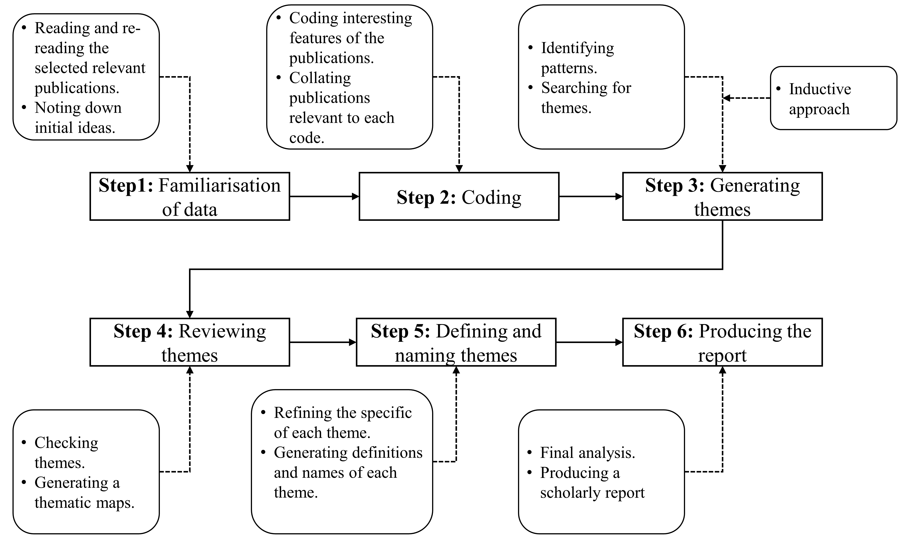
Figure 5: A qualitative content analysis adopted for the study (Ghansah and Lu, 2023c)

4. Findings and discussions

4.1 Descriptive Analysis

4.1.1 Articles per year
Figure 6 illustrates the annual publication ranging from 2018 to 2023. The first two articles on DTs for smart buildings were identified in 2018. Since then, the topic has gained attention among researchers. The year 2022 was noted with 19 publications. It can be seen that the last five years have seen an increase in publications. This is attributed to the fact that organisations and professionals are beginning to understand the benefits of DTs application in the construction industry, for instance, its ability to expedite product development and support innovations. This is not surprising as the implementation of DTs enables distributed remote control of assets and provides data about the asset’s status and disposition in real-time. Due to the benefits, DTs in smart buildings will reach $4.8 billion by 2027; hence up to 93% of all IoT platforms will contain some form of digital twinning capability by 2027 (Research and Market, 2022). It is worth noting that DTs is occasionally emerging and maturing in the AECO industry and, therefore, can benefit facility management of smart buildings.

Figure 6: Year-wise distribution trend of the selected studies (Source: Author’s own work)

4.1.2 Methods adopted
The methods adopted by the 56 studies were reviewed in this section. The review identified six main research methods: quantitative model, qualitative model, User-centric design (UCD), mixed research, laboratory, and case study (Figure 7). The case study was adopted by 33 articles with a percentage of 58.92%. This is consistent with the study by Yeboah-Asiamah et al. (2017), who posited that case studies help recognise the unique characteristics and impacts of specific projects within a research scope, such as the concept of digital technologies, including DTs. This is also convenient for researchers to make deductions using real case projects compared to other methods (Agarchand and Laishram, 2017). “Laboratory experiment” was ranked second, accounting for nine articles with 23.21%. This creates an atmosphere to test the prototype of DTs in a laboratory to save time and resources (Karve et al., 2020). Laboratory experiments provide several distinct advantages to researchers as a means of deriving causal relations from controlled manipulations of specific conditions while controlling all sounding factors (Brüggemann et al., 2016). Mixed research popped out to be adopted by two articles with a percentage of 7.14%. This approach in the article consisted of a combination of different methods, including surveys, interviews, etc., to evaluate the key issues on DTs application for smart buildings and its technologies. The next set of methods included the quantitative model, qualitative model and UCD.

Figure 7: Research methods adopted by selected studies (Source: Author’s own work)

4.2 Critical themes
Three critical themes were revealed for this study, including the enablers, the applications, and the challenges to DTs application for smart building at the facility management stage. The study further examined the interactive relationship among the critical themes toward an integrative framework development for a better understanding to realise DTs for facility management.

4.2.1 Enablers of DTs for Smart Building at the Facility Management Stage
The study identified and categorised the enablers in the literature review into six main groups, as illustrated in Table 1. These are subsequently discussed.

Table 1: List and categorisation of DT enablers for smart building at the facility management stage (Source: Author’s own work)
Category | Enablers | References (#)
Perception technologies | QR code and RFID tag, UWB tag, GPS, laser scanner | 1,3,4,5,9,10,15,16,17,19,21,22,23,24,26,28,29,30,31,36,37,38,39,40,52,53,54,55,56
 | Camera | 18,27
 | Temperature sensors, humidity sensors | 14
 | Colour sensors, Grove light sensors, Grove ultrasonic ranger | 13
 | OPCUA | 1,6,7,20
 | Terrestrial Laser Scanner (TLS), Mobile Light Detection and Ranging (LIDAR) System (MLS) | 12
Network technologies | WAN, LAN, 5G cellular network, WSN | 6,7,10,21,23,24,25,45,50,56
 | Wi-Fi | 2,14,21
 | XBee ZB | 13
Storage technologies | Raspberry board storage | 11,24
 | Cloud service | 1,21,25,30
 | Edge service | 23,24,
Application technologies | Rhino 3D, Unity 3D, other Web-based GUI | 1,2,18
 | Accelerometer, Gyroscopic sensor (MPU-6050), HC-SR04 sensor | 2
 | VICO, Visilean, Artificial intelligence, cognitive computing, Computer vision, Bigdata | 1,3,4,6,8,11,21,29,32,34,35,42,45,48,51
 | 3D BIM, AutoCAD, risk, ANSYS, inspection mode for 3D model | 7,8,9,12,15,16,17,19,20,21,22,24,25,26,27,28,29,31,33,34,41,42,43,44,46,47,49,51
 | Structured query language | 20
 | Object-oriented programming, GUI | 5
 | Arduino, Excel VBA program, EasyComm | 13
 | Energy power meter | 14
 | Excel file | 27
 | ifcOWL, openModica software, SOSA Ontology | 30
Knowledge building | Reskilling and upskilling of labour force | 3,29
 | Implementation of industry 4.0 standards | 31
 | Asset modelling | 2,18
Design process | Ensuring autonomy and decentralisation of DTs | 7,8,9,12
 | Simulation | 1
Note: (#) Refer to serial number in the supplementary material, Table S1 for the references

4.2.1.1 Perception technologies
Perception technologies are enablers for DTs for facility management, and these perceive situations and contexts in smart buildings (Zheng et al., 2019; Sacks et al., 2020; Alizadehsalehi and Yitmen, 2021; Jiang et al., 2021b), and they include IoT systems. The perception technologies could enable communication between devices within the same system and collect large volumes of data from building operations or activities in smart buildings. As a result, a significant application could include predictive maintenance to enhance fault detection in facilities (Lu et al., 2020b). The data collected by perception technologies in smart facilities are analysed to generate actionable insights to inform decision-making throughout the smart building to enhance activities of facility management such as monitoring of energy consumption, fault detection prediction, building state monitoring and improvement of building operations.

4.2.1.2 Network technologies
Network technologies draw the actual meaning of DTs via real-time data transmission for prompt analysis (Xu et al., 2019; Tan et al., 2019). These facilitate the data exchange between devices of the IoT and input signals to perform specific tasks based on the input from the DT. Although a wide variety of network technologies (WAN, LAN, 5G cellular network, WSN and Wi-Fi) is available, the most efficient one allows faster real-time data transmission for DTs. This is attributed to the 5G cellular network (Jiang, 2021b; Liu et al., 2021c), and it is currently receiving attention for further research. In smart buildings at the facility management phase, network technologies could ensure effective communication among device systems to collect real-time data toward realising the potential of DTs.

4.2.1.3 Storage technologies
Storage technologies make the data available for analysis to inform decisions on facility management. With DTs reference architecture, storage is facilitated by cloud and edge technologies (Zheng et al., 2019). While edge technology is used to process time-sensitive data, cloud computing is used to process data that is not time-driven (Arora, 2022). Besides latency, edge technology is preferred over cloud technology in remote locations, where there is limited or no connectivity to a centralised location (Arora, 2022). Currently, the potential benefits of the use of cloud/edge technologies as storage are the subject of extensive research. The built industry has promoted other technologies, such as blockchain and other decentralised storage like InterPlanetary file systems, for data availability, immutability, and transparency.

4.2.1.4 Application technologies
Application technologies aid in gaining actionable insight into transmitted large volumes of data to inform decisions on facility management. Among the application technologies, 3D BIM applications appeared to be critical, as they facilitate simulation, which is at the core of the DTs concept for smart buildings at the facility management stage (Zhang et al., 2017). Though many applications software (see Table 1) exists to facilitate DTs development, an important topic of debate in the literature is the advantages and disadvantages of building DTs using expensive software platforms provided by large software providers (e.g., Honeywell, Microsoft, Autodesk, etc.) as opposed to open-source software (Perno et al., 2022). DTs can be developed using entirely open-source software architecture. This avoids the risk of vendor lock-in and the need to purchase expensive third-party software (Weber et al., 2017). Furthermore, the potential of DTs can be enhanced with the integration of AI to derive deep insight into real-time data to inform decisions (Xu et al., 2020; Peng et al., 2020; Alizadehsalehi and Yitmen, 2021) to improve facility management activities via predictive maintenance.

4.2.1.5 Knowledge building
The knowledge building category constitutes the ability to generate new knowledge from the analysis based on asset modelling. This could be through troubleshooting, planned shutdown and maintenance reports, production data, bill of materials, and scale data (Perno et al., 2022). This knowledge extends to optimising production schedules, maintenance planning of activities and operation optimisations in smart buildings at the facility management stage. For instance, knowledge can be built by simulating to understand the status of smart buildings, which is a key enabler of DTs (Zhang et al., 2017; Sacks et al., 2020). Thus, upskilling and reskilling of the labour force to better understand the analysis and gain insight from the result of DTs is a key enabler to ensuring successful DT implementation at the facility management phase of smart buildings (Sacks et al., 2020).

4.2.1.6 Design process
Understanding the design process is a key consideration in developing DTs for smart buildings at the facility management stage. With this, reference models must be developed as a base for DTs development (Zhang et al., 2017). To do so, the focus should be on the important properties of the model and the line of authority, including the scalability, expansibility, fidelity, interoperability, autonomy and decentralisation of the DTs (Zhang et al., 2017; Zhuang et al., 2018; Peng et al., 2020). This could facilitate bringing project stakeholders up-front when the cost of making “building” changes is relatively lower, and the ability to impact the building outcomes is relatively higher.

4.2.2 Applications of DTs for facility management
This section discusses the DTs application in smart buildings focusing on the facility management stage, also known as the services phase, as illustrated in Table 2. The study revealed that there is a clear lack of studies on the DTs implementation in smart buildings at the facility management stage, where smart buildings have been associated more closely. However, three main categories of DTs application were discovered at the facility management stage, as shown in Table 2.

Table 2: Applications of DTs for smart buildings at the facility management stage (Source: Author’s own work)
Code | Categories | Applications | References (#)
AP1 | Efficient operation and service monitoring | - Efficient Gesture control  - Human-computer/machine collaboration  - Emergency evacuation  - Improve occupants’ comfort  - Real-time building management systems  - Remote control of the building to ensure security via virtual reality  - Systems thinking for aiding sustainable decision makings | 7,8,11, 13, 6,28,40,47,48,50,52,53,54
AP2 | Efficient building energy management | - Real-time monitoring of energy consumption and utilisation  - Real-time monitoring, control, and minimisation of energy consumption  - Real-time tracking and understanding of energy consumption | 14,15,16,32,34,42,56
AP3 | Effective smart building maintenance | - Building maintenance and performance monitoring  - Accident prevention and effective fault detection capability  - Real-time connection and information for risk assessment in buildings | 24,25,48
Note: (#) Refer to serial number in the supplementary material, Table S1 for the references

4.2.2.1 Efficient operation and service monitoring
During the service phase, smart building projects are out of the contractor’s control and left to users’ management, including facility managers and occupants. Deploying DTs technology allows users to make critical decisions regarding the operations and management of smart buildings (Peng et al., 2020). For example, a “what-if” analysis can be performed by facility managers to improve occupants’ comfort, safety, emergency evacuation, energy consumption and utilisation in smart buildings by integrating DTs and big data technologies (Zhuang et al., 2018). Hence, providing predictive services to improve operations in smart buildings. Also, with the integration of smart contracts into a facility management plan, effective and secured integration of occupants and facility management plans can be achieved (Antonino et al., 2019).

4.2.2.2 Efficient building energy management
With DTs technology for smart buildings at the facility management stage, building energy can be tracked and measured in real-time efficiently in smart buildings through synchronising the physical and virtual worlds. This is facilitated by advanced supporting technologies such as BIM to give clear visualisation, IoT and WSN to enhance real-time data transmission, and big data analytics to draw patterns in understanding energy performance and consumption (Tan et al., 2019). Thus, an effective DTs application assists in real-time tracking and understanding of energy consumption in buildings. In managing and building energy efficiency system platforms, DTs could offer smart buildings the capability to improve and enrich available data, receive inputs and signals from sensors that constantly monitor them, and develop self-learning capabilities and predictivity via AI integration (Agostinelli et al., 2021). Also, improving the interoperability between DTs-BIM and building energy models could effectively transfer data between modelling software and energy consumption simulation software (Porsani et al., 2021; Agostinelli et al., 2021). Thus, DTs can improve the energy performance of smart buildings via effective simulation with real-time synchronisations.

4.2.2.3 Effective smart building maintenance
Integrating facility management with advanced technologies, including DTs with AI, enables the potential of human-like cognition, which enhances the value of facilities (Xu et al., 2019) by unleashing efficiency in applications. Using a set of monitoring data, Lu et al. (2020b) established a DT-enabled anomaly detection system to detect building asset anomalies in their daily operational conditions, thereby detecting faults during services. A fully automated DTs-integrated framework provides a reliable and practical tool for real-time data acquisition for the maintenance management of smart buildings (Torrecilla-García et al., 2021). Hence, smart building conditions are continuously monitored in real-time to support various maintenance decisions in smart buildings at the facility management stage using DTs.

4.2.3 Challenges of DTs for smart building at the facility management stage
The study identified nine challenges focussing on DTs for smart buildings at the facility management stage. As seen in Table 3, the four major challenges to DTs implementation for facility management in the smart building are the lack of a systematic and comprehensive reference model, followed by real-time data integration, the complexity and uncertainty nature of real-time data, and real-time data visualisation. These major challenges appeared more than five times in the previous studies. Also, the challenges can be categorised into two main issues, namely, social issues and technical issues. Hence, following the socio-technical framework (Shin, 2014) since DTs is to be situated in society. The social issues were noted to consist of four challenges, with the major challenge being the “high cost of involving digital technologies (CH9)”, whilst the technical issues consisted of five challenges, with the major challenge being “Lack of a systematic and comprehensive reference model (CH1)”, as shown in Table 3. According to the result, the major challenges of DTs application for smart building at the facility management stage are mainly considered technical in nature. Hence, engaging skilled and technical experts to design and develop DTs for smart buildings is encouraged to ensure smooth implementation of the state-of-the-art at the facility management stage.

Table 3: Challenges to DTs for smart buildings at the facility management stage (Source: Author’s own work)
Category | Code | Challenges | References (#) | Total
Technical issues | CH1 | Lack of a systematic and comprehensive reference model | 1,2,4,7,16,18,20,23,24,27,32,33,45,46,50 | 15
 | CH2 | Real-time data integration | 10,11,12,14,15,17,19,25,26,34,35,49 | 12
 | CH3 | Complexity and uncertainty nature of real-time data | 9,13,21,22,28,29,30,37,38,47,48 | 11
 | CH4 | Real-time data visualisation | 8,14,16,31,39,40,41 | 7
 | CH5 | Real-time data collection | 25,42,43,44 | 4
Social issues | CH6 | Lack of consensus among researchers and practitioners | 3,55 | 2
 | CH7 | Changing requirements of smart building occupants/users | 6,54 | 2
 | CH8 | Data safety and security | 10,53 | 2
 | CH9 | High cost of involving digital technologies | 12,17,51,52 | 4
Note: (#) Refer to serial number in the supplementary material, Table S1 for the references

4.2.3.1 Technical issues
Technical issues arise from technical matters concerning DTs application at the facility management stage for smart building, including the uncertainty and complexity of real-time data, real-time data collection, real-time data integration, real-time data visualisation and lack of a systematic and comprehensive reference model. The technical issues are discussed further following their operational occurrence in a smart building at the facility management stage.

The complexity and uncertain nature of real-time data are bottlenecks in implementing DT technology as there is a need to efficiently input huge and fragmented data into DT’s simulation model (Tan et al., 2019; Liu et al., 2021c). For instance, the need to simplify the complexity of maintenance schedule deviation risks data in the maintenance process of modular buildings (Lee and Lee, 2021), as well as the integration with data on the suppliers and subcontractors, could be a challenge. As a result, the fragmented real-time data in the DT simulation model could remain a roadblock to DT implementation for facility management.

Real-time data collection has also been regarded as a problem, and today, researchers and practitioners are wondering about the problems of calibrating models based on the real-time data collected on real assets. This is due to the unavailability of efficient IoT systems, a core of the smart building to collect real-time data from various data types within smart buildings, including occupant behaviours, indoor or outdoor environments, and the building structure (Jia et al., 2019; Torrecilla-García et al., 2021). IoT systems are delimited in terms of optimising decision-making in the safety management of buildings due to data duplication and inconsistencies (Jia et al., 2019). Thus, making real-time data gathering difficult and requiring more conscious effort and processes during facility management of buildings.

Real-time data integration is positioned as a technical issue, as huge real-time data exist in a different format, making it onerous to integrate into the DT’s data platform (Peng et al., 2020). The issue surfaces due to the inefficient real-time visual management and measurement data, which could enable managers to grasp the detailed status of the whole smart building (Kaewunruen et al., 2020). For instance, real-time data on the relationship between building users and appliance usage may be collected from humans containing images and voices and from appliances containing textual content. Thus, real-time data must undergo efficient and effective re-formatting to allow its integration to avoid outdated data during decision-making on facility management.

Real-time data visualisation to understand the current situation in smart buildings also emerges as a challenge in DT implementation. Meanwhile, real-time visual management could have enabled managers or users to grasp the detailed status of a whole smart building during DTs implementation (Porsani et al., 2020). The existing BIM software focuses on checking business data with a 3D model but not a mass analysis with real-time data. Hence, an intelligent DTs diagnosis function, i.e., a professional AI model assembled as a diagnosis engine to visualise and understand data seamlessly, is necessary. There is also an existing problem of creating and visualising real-time energy models from the existing semi-automated workflow from BIM to building energy models to impact decisions concerning facility management (Porsani et al., 2020; Agostinelli et al., 2021).

There is a need to systematise the construction process of DTs to achieve a high degree of digitalisation. This causes little progress in achieving the full potential of DTs application considering the complexity of smart buildings (Zhuang et al., 2018). The DTs research of lifecycle management is still in the theoretical stage, and therefore the application methods are unclear on the real grounds concerning its systematisation (Zheng et al., 2019; Lu et al., 2020a; Alizadehsalehi and Yitmen, 2021). Hence, its applicability is being questioned in the building industry, particularly in construction machinery testing and working processes. As a result, cyber-physical interoperation in smart buildings is fragmented and out-of-date because different criticalities must be considered to streamline the organisation of DTs technology to collect real-time data.

Along with the systematisation of DTs technology, there is a need to consider data interoperability with technologies (Porsani et al., 2021). For instance, there is a need to improve the compatibility between the model exchange format and BIM to promote the interoperability of the BIM-Building energy model. Rocca et al. (2020) and O’Grady et al. (2021) also emphasised the challenge of integrating DTs into circular economy principles. This enhances the applicability of circular economy strategies, but there is a limited understanding of effective integration using smart technologies such as virtual reality and other technologies. Insight shows that technology integration is a key solution to most individual technology problems, and this improves efficiency in workflows and applicability at the facility management stage in smart buildings.

4.2.3.2 Social issues
As DTs work in a society among humans, social issues were also identified among the challenges and were given limited attention in the literature. This raises the issues of fault detection and optimal control, which are mobilising part of the community’s thinking. These comprise the lack of consensus among researchers and practitioners, changing requirements of smart building occupants, data safety and security, and the high cost of involving digital technologies. These are further discussed.

Effective collaboration between the building researchers and technical teams is required to advance the DTs application for smart buildings at the facility management stage. One pertinent issue reported is the changing requirements of users (Xu et al., 2019), which has created tension among designers and practitioners to develop a system to meet their satisfaction. This may include the clients’ demands relating to the functionalities required from the DTs in smart buildings, which are associated with the cost. Researchers and practitioners lack consensus on how DTs processes and data-centric technologies can support design and construction (Sacks et al., 2020), considering the changing demands of the client and the incurring cost. Hence, collaboration among the technical and building research stakeholders remains challenging for DTs implementations in smart buildings.

The lack of experienced and well-trained personnel is a social issue for DTs implementation in smart buildings since using and monitoring data scientifically and effectively is critical (Kaewunruen et al., 2021). A skilled workforce is required to enable the interoperability, integration and linking of real-time data and models across all the systems in a smart building (Plummer, 2021). Hence, key skills and capabilities to drive the DTs intervention and its implementation in smart buildings, including the users in a closed loop, are problems.

Personal data safety, protection, and accountability in smart buildings is an issue that needs to be considered. This also includes the government rules and regulations regarding using digital technologies concerning energy usage, radiation emissions, and information security. The need for accountable data sharing among construction stakeholders amid digitalisation is a critical social issue with DTs implementation (Lee et al., 2021; Jiang et al., 2021b). DTs’ vulnerability lies with the IoT systems, including network services, backend systems, web interfaces, physical hardware, and software (Li et al., 2020). The traditional network of IoT systems encompasses various entities, services, and networks, making it challenging to implement pre-existing security systems directly (Jia et al., 2019). An insecure system may create concerns that prevent people from adopting the technology. For security and issues, advanced technologies, including the blockchain (Lee et al., 2021; Li et al., 2022), can be integrated into the DTs to detect third-party interference in personal data. This permits one party to have exclusive access to their data required data. The key enabling technologies of DTs must follow the current practices and updates in security and regulations, especially the government policy regarding information security and digital technologies.

The cost of developing a DTs platform is an issue to overcome, but the returns on investment (ROI) are well-defined. At the initial stage, there is a high cost of involving various digital technologies (i.e., huge upfront investment) to realise successful DTs adoption and implementation in smart buildings, and this has become challenging in the AECO community. The benefits of the DTs functionality in the long term may exceed the drawbacks (Sharon, 2022). However, leveraging on the prospects could increase the rate of adoption and implementation of DTs for smart buildings to solve solutions to existing building issues (Wu et al., 2021).

4.2.3.3 Socio-technical concept underpinning the challenges
As proposed by Emery and Trist in 1960, the socio-technical concept describes systems that involve a complex interaction between the technical and the social aspects of a work system (Baxter and Sommerville, 2011). This has been adopted in construction management research in fields such as improvement of construction industrialisation practices (Jin et al., 2021), construction project management competencies (Ahmadi Eftekhari et al., 2022), management of refurbishment projects (Saurin et al., 2013), and modular construction of cognitive buildings (Ghansah et al., 2022b).

For this study, the identified challenges exist as the interrelatedness of social and technical aspects of the concepts; hence taken from the perspective of the socio-technical system (Shin, 2014). Scholars argue that the technical aspect traditionally has been the major focus when investigating technological systems and their applications (Shin and Jung, 2012; Sony and Naik, 2020). Meanwhile, the social and technical aspects must be considered to understand the holistic nature of the challenges impeding the DTs implementation, including its interactions. Hence, the challenges to DTs implementation must be considered in a cross-disciplinary framework (Figure 8), representing all aspects of technical issues and the social aspect (Sommerville and Dewsbury, 2007), as discussed in sections 4.2.3.1 and 4.2.3.2. However, it can be inferred from Table 3 that there is a high focus on addressing the technical challenges, while the social aspects have been given little attention. Meanwhile, socio-technical theory attests that taking a holistic perspective of both the social and technical aspects of the challenges can help to achieve effective implementation of DTs in smart buildings.

The socio-technical framework comprises the DTs’ technological system, the users, and the society the system is adopted, not forgetting the interactions between them. If all the aspect of the system has not been adequately considered, the DTs design runs the risk of being a failure. Despite the influx of benefits and considerable enthusiasm around DTs in smart buildings, a blank slate moment still exists from a design and technology perspective. Obviously, the connected system for DTs exists, but we are not exactly sure why we need them. This exists as a question from a socio-technical perspective, and it is rarely addressed in the development and research projects on the DTs for smart buildings as a human-centred system and in the public discourses surrounding it (Shin, 2014).

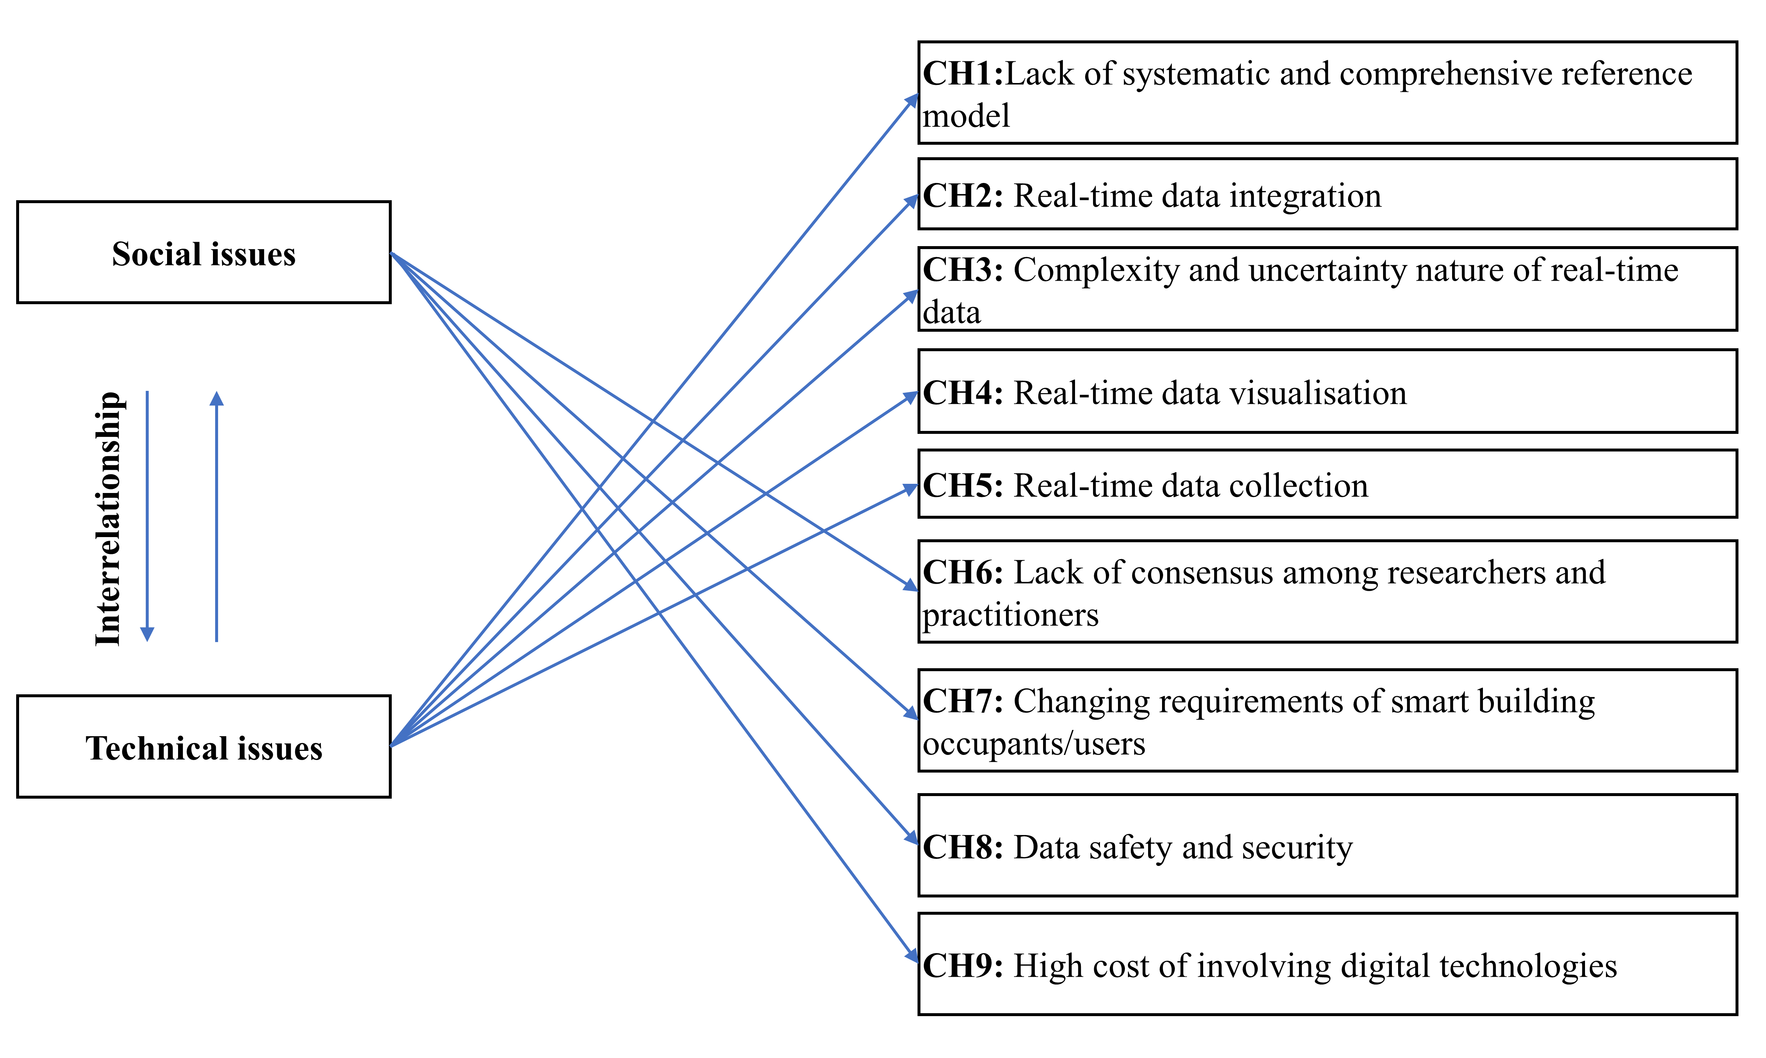
Figure 8: Socio-technical-based framework of the challenges of DTs for smart buildings at the facility management stage (Source: Author’s own work)

4.3 Interactive Relationship Among the Enablers, the applications, and the challenges
Following the method by Akomea-Frimpong et al. (2022), the interactive relationships between the enablers, challenges, and applications were examined, as shown in Figure 9. In the figure, the arrows define the relationship among the applications, enablers, and challenges to the DTs implementation in smart buildings at the facility management stage. The figure shows the case of theorising the principal themes of the research that shared light on interrelating DTs for smart building. The framework’s ontological foundation resolves and establishes the common grounds for achieving successful implementation of DTs for facility management by providing the appropriate enablers whilst catering for the challenges.

The conceptual framework proposes threefold outcomes from the main construct and subconstructs, expecting to affect the application or the implementation of DTs in smart buildings at the facility management stage. First, the enablers are expected to positively affect DTs implementation towards successful applications. Second, the nine categorised challenges are also anticipated to negatively affect the implementation of DTs in achieving successful applications in facility management. Lastly, there will be an interrelationship effect which could be positive or negative, between the challenges and the enablers of DTs for smart building at the facility management stage. The proposed outcomes are further discussed.

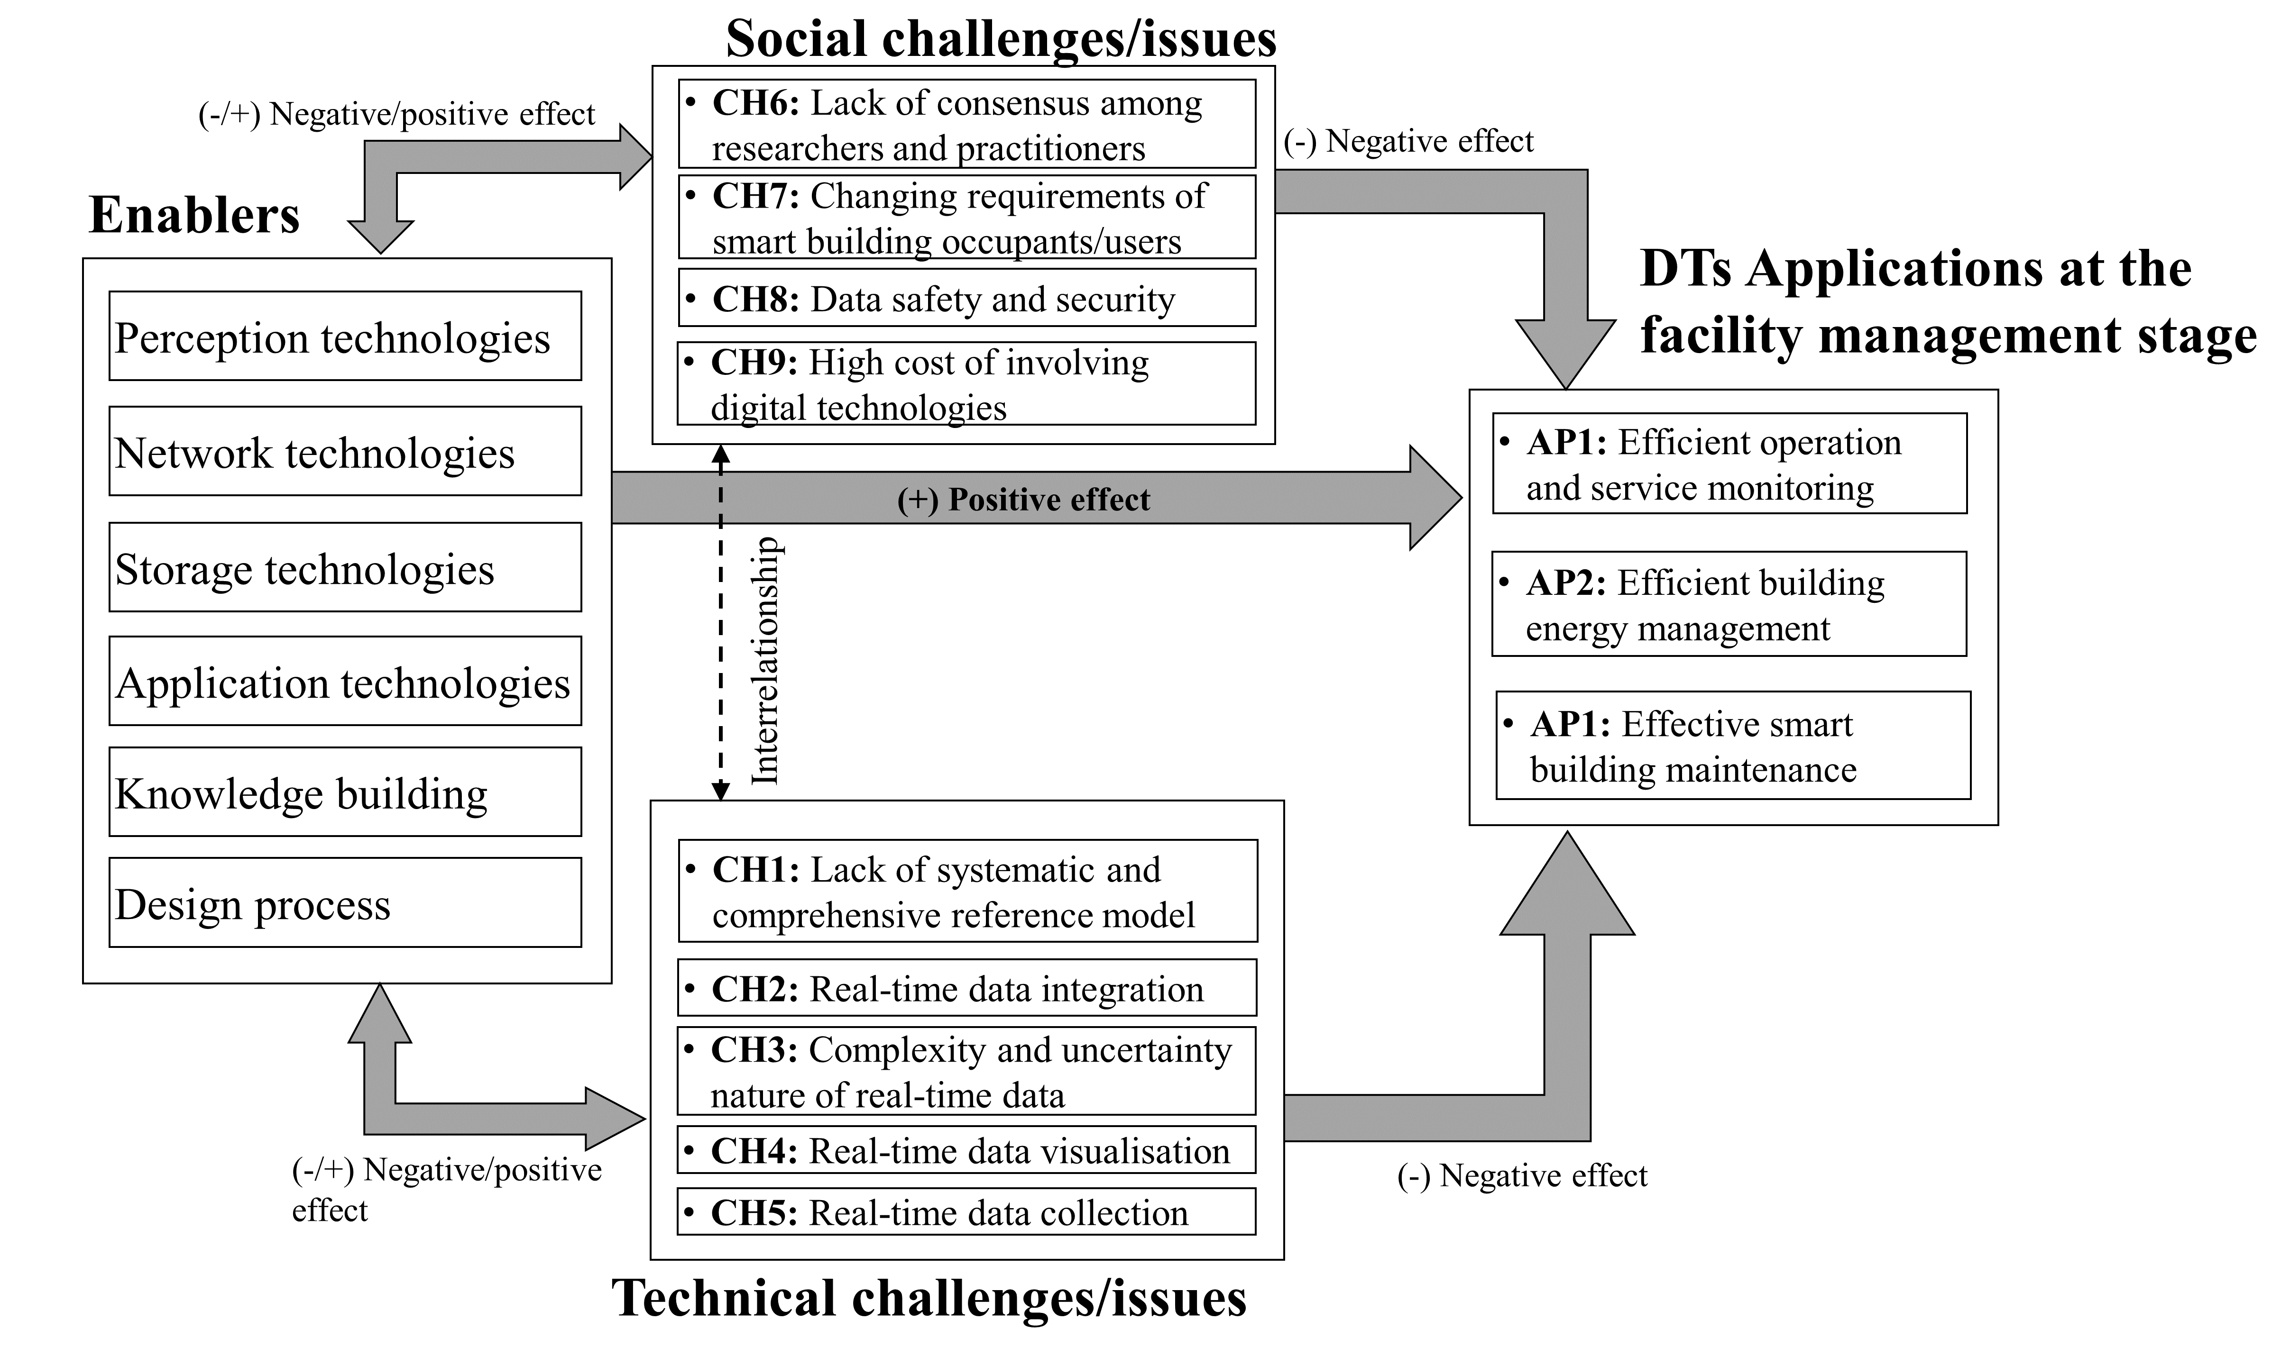
Figure 9: An integrative framework for the DTs for smart building at the facility management stage of buildings (Source: Author’s own work)

4.3.1 Enablers positively affect the DTs applications in smart buildings
Within the framework, the enablers represent the facilitators capable of driving the successful development and implementation of DTs in smart buildings at the facility management stage. For instance, perception technologies, network technologies, storage technologies, and application technologies contribute to the systemic formation of DTs in smart buildings. As perception technologies collect a large volume of data from smart buildings, storage technologies store the data and make it available for analysis. The analysis is facilitated by integrating AI and other application software to derive actionable insight from the technology (Sacks et al., 2020; Jiang, 2021b; Liu et al., 2021c). In all, knowledge-building and design considerations are essential in understanding the data retrieved from smart buildings, and this is facilitated by upskilling the workers toward the appropriate application software (Perno et al., 2022). Therefore, the study proposes that the effects of the identified enablers on the DT applications in smart buildings at the facility management stage will be significantly positive.

4.3.2 Challenges negatively affect the DTs applications in smart buildings
The relationship between the challenges and the DTs applications is proposed to produce negative outcomes. This radiates from the ambiguous understanding of the DTs concept, being the technical issues and the social issues of implementing DTs for facility management. For instance, the technical challenge of the complexity and fragmented real-time data in the DT simulation model can negatively influence the DTs implementation in smart buildings at the facility management stage (Lee and Lee, 2021). Real-time data integration is positioned as a technical issue, as huge real-time data exist in a different format, making it onerous to integrate into the DT’s data platform (Peng et al., 2020). Moreover, the lack of experienced and well-trained personnel exists as a social issue for the DTs implementation in facility management since using and monitoring data scientifically and effectively is critical (Kaewunruen et al., 2021).

4.3.3 Interrelationship between the enablers and the challenges
It is proposed that challenges to the DTs for the smart building at the facility management stage could negatively or positively affect the enablers. The interactions between the nine challenges and the six categories of enablers of DTs for smart building are suggested to overlap and affect each other’s outcomes (Akomea-Frimpong et al., 2022). It is worth knowing that addressing the challenges may serve as an enabler to implementing DTs to achieve successful applications. This simply denotes that potential effective enablers could help mitigate the challenges, whilst ineffective enablers could add up to challenging the DTs implementation at the facility management stage of buildings. For instance, training workers with the right skilled training platform toward the appropriate DTs technologies could mitigate all the challenges as proposed (CH1-CH9). However, vice versa could be true if the training is not sufficient with the appropriate DTs technologies.

5. Implication of the findings
5.1 Policy
The result of this study informs decision-making and policy formulation regarding DTs for smart buildings at the facility management stage by identifying the enablers and challenges when applied to a real-life case study with possible main applications. The study’s findings would impact current and future policies adopted by facility management professionals and engineers to improve building performance and satisfy smart building users considering the application of DTs. As DTs technology is emerging in the construction industry, this study reveals the enablers, applications, and challenges to consider in smart buildings at the facility management stage where DTs can be implemented. This happens by understanding the interactive effects of the enablers and the technical and social issues/challenges with respect to clients’ requirements and government policies. For example, to ensure personal data safety and security, DTs must be developed to comply with the security and privacy rules governing smart buildings’ usage. Related stakeholders need to understand the effect of the enabling technologies in DTs, including the blockchain, cameras, etc., whilst addressing the social issues on safety and privacy. Overall, the findings can stimulate policies to help successfully implement DTs for facility management, which could ensure positive and effective sustainability outcomes for building users via data modelling scenarios, including energy consumption, CO₂ emissions, and reducing waste and resource use. This could also help ensure proper maintenance of buildings via real-time analysis, testing and actioning of the smart building environment with respect to the occupants’ usage. This will boost the operativity performance of buildings.

5.2 Practice
The findings of this study will assist practitioners, including facility managers, engineers, designers, and developers, to successfully implement DTs for smart buildings to enhance facility management, knowing the enablers, applications, and challenges. Specifically, the enablers explored may guide the practitioner to successfully implement and achieve the perceived prospects of DTs for smart buildings. Hence, such enablers may help improve compliance activities and complement effective strategies, including proper management support to realise the concepts of DTs for smart buildings to augment the activities of facility management. Also, all practitioners may benefit from the findings of the study by gaining an in-depth understanding of the opportunities DTs could offer smart buildings in the field of AECO. This allows practitioners to implement DTs for smart buildings to produce solutions that more closely match the requirements of when and what the users need, hence, achieving the specific purpose of DTs for smart buildings. Awareness of the associated challenges may also assist practitioners in effectively implementing DTs for smart buildings by considering the related social issues (e.g., government policies, client demands, and data information security) and the technical issues relating to systematic structure/framework. Hence, the ability to overcome the challenges brings forth a sense of confidence in the DTs for smart buildings. The proposed integrative framework has the potential to direct practitioners to pay special attention to the interactive relationship among the enablers and challenges in influencing real-world DTs implementations in smart buildings toward successful applications. Finally, the findings can help organisations achieve efficient facility management from both facility engineers and maintenance teams, leveraging the potential of DTs to provide a granular and holistic real-time view of the built environment.

5.3 Theoretical implication
The findings make a significant contribution to the knowledge of the smart building concept by organising and synthesising the existing studies on DTs for smart buildings at the facility management stage by exploring the enablers, applications, and challenges. A substantial contribution is also made through the proposal of an integrative framework considering the interrelationships among the enablers, challenges, and significant applications towards realising the full potential of DTs for facility management in the built environment. Again, the findings could contribute to the socio-technical concept by clearly proposing the technical and social challenges regarding DTs implementation for facility management, and showing their interrelationships with enablers and possible applications.

6. Limitations of existing studies and future research
Due to the rapidly expanding interest in DTs in the construction sector, many publications focusing on smart buildings are expected to skyrocket. Therefore, there is the possibility that certain enablers, applications, and challenges have yet to be explored, and this will extend the classifications developed by this study. As a result, further research is encouraged to extend this study by exploring the list of enablers, new applications, and challenges with new cases to develop the proposed model. As this study makes a hypothesis on the interactive relationship among the enablers, applications, and challenges without testing on a real-life case study, it poses a limitation. Hence, future study is encouraged to conduct a test acknowledging the hypothesis set in this study to identify the critical enablers and challenges while validating the integrative framework to demonstrate its usefulness and efficiency in a real-world context.

Also, the significantly increased rate of reports on DTs applications, as demonstrated by the literature review, suggests the DTs concept is reaching the maturity level, hence supporting widespread use in the future throughout a building lifecycle. To sustain this momentum, future research should expand the conceptual framework described in this paper through actual investigations to demonstrate the model’s application to smart building operations and processes, including its environmental coupling. Furthermore, the publication analysis results revealed that the case study had been highly adopted as a method by previous studies, and there is less emphasis on the user-centric design of DTs implementation in smart buildings at the facility management stage. However, it is important to be given equal priority. Hence, future research should consider the user-centric nature of DTs as a high priority when implementing them in smart buildings to ensure seamless and efficient facility management. This allows the notion of DTs to be properly integrated into society. Also, the result indicated that previous studies mostly focused on addressing the technical aspects of the challenges of DTs for smart building, while the social aspects were largely overlooked. Hence, it is worthwhile for future studies to start giving considerable attention to the social aspect of the challenges since DTs will be situated in the community. Finally, it is useful to know that DTs is developed to aggregate, manage, analyse, visualise, and predict information for facility management. This can be successfully repurposed to provide a unique information management solution to unforeseen circumstances, such as the COVID-19 crisis now and later, at any scale in smart buildings at the facility management stage.

7. Conclusion
Despite the enormous prospects of DTs for smart buildings, challenges are faced upon deciding to implement DTs in smart buildings at the facility management stage. Furthermore, limited studies on DTs have been conducted for smart buildings regarding the facility management stage, and this may be explained by the high complexity of accurately representing and modelling the physics behind the process. Thus, this study organises and consolidates the fragmented literature on the DTs implementation for smart buildings at the facility management stage by exploring the enablers, applications, and challenges and examining the interrelationships among them. Simply put, the study investigates the potential of DTs for facility management in smart buildings.

The study revealed and categorised the enablers of DTs for smart buildings at the facility management stage into six main groups: perception technologies, network technologies, storage technologies, application technologies, knowledge building and design processes. Three substantial categories of DTs applications in smart buildings were revealed at the facility management stage, including efficient operation and service monitoring, efficient building energy management, and effective smart building maintenance. The study revealed that there is a clear lack of studies on the DTs implementation in smart buildings at the facility management stage, where smart buildings have been associated more closely. The study further revealed nine challenges associated with DTs for smart buildings at the facility management stage, with the top four major challenges being the lack of a systematic and comprehensive reference model, real-time data integration, the complexity and uncertainty nature of real-time data, and real-time data visualisation. From the perspective of the socio-technical concept, the challenges were categorised into two main issues that are interdependent: social and technical issues. The social issue consists of four challenges, with the major being “high cost of involving technologies”, whilst the technical issue consists of five challenges, with the major being “lack of a systematic and comprehensive reference model”. Overall, the major challenges of DTs application for smart building at the facility management stage are mainly considered technical in nature. Finally, the study examined the interactive relationship among the critical themes and established a hypothesis that can be tested in real-life cases, hence, proposing an integrative framework. Specifically, the enablers and the challenges may provide practitioners with guidance through the DTs implementation processes, whilst the applications will show the potential benefits/prospects of DTs for smart buildings. The integrative framework proposed could direct practitioners to pay special attention to the interactive relationship among the enablers and challenges in influencing real-world DTs implementations in smart buildings toward successful applications to ensure effective facility management. Research directions were further proposed to address the identified limitations of existing studies to envision the ideal state of DTs for smart buildings.

Despite the significant implication of the results, the outcomes show that contradictions exist in various policies and decision-making processes on applying DTs in smart buildings to improve building performance and satisfy smart building users. For instance, regarding safety and privacy issues, DTs must be designed to follow the security and privacy regulations governing technology-integrated facilities, including smart buildings. The enablers and challenges give practitioners information on how to successfully implement DTs for smart buildings, while the applications demonstrate the potential benefits of DTs for smart buildings. This is not enough, as the established hypothesis has not been tested in real-life projects. Hence, future study is encouraged to test the proposed interactive relationship among the enablers, the applications and the significant challenges using a real-life case. Also, future studies can consider identifying solutions to the proposed challenges to uptake the DTs implementation for facility management in smart buildings.

References
Agarchand, N. and Laishram, B. (2017), “Sustainable infrastructure development challenges through PPP procurement process: Indian perspective”, International Journal of Managing Projects in Business, Vol. 10, No. 3, pp. 642-662, doi.org/10.1108/IJMPB-10-2016-0078.
Agostinelli, S., Cumo, F., Guidi, G. and Tomazzoli, C. (2021), “Cyber-physical systems improving building energy management: DT and artificial intelligence”. Energies, Vol. 14 No. 8, pp.2338. doi.org/10.3390/en14082338.
Ahmadi Eftekhari, N., Mani, S., Bakhshi, J. and Mani, S. (2022), “Project Manager Competencies for Dealing with Socio-Technical Complexity: A Grounded Theory Construction”. Systems, Vol. 10, No. 5, pp.161, doi.org/10.3390/systems10050161.
Akanmu, A.A., Anumba, C.J. and Ogunseiju, O.O. (2021), “Towards next generation cyber-physical systems and digital twins for construction”. Journal Information Technology in Construction, Vol. 26, pp.505-525, doi.org/10.36680/j.itcon.2021.027.
Akomea-Frimpong, I., Kukah, A.S., Jin, X., Osei-Kyei, R. and Pariafsai, F. (2022), “Green finance for green buildings: A systematic review and conceptual foundation”. Journal of Cleaner Production, Vol. 356, pp.131869, doi.org/10.1016/j.jclepro.2022.131869.
Alizadehsalehi, S. and Yitmen, I. (2021), “Digital twin-based progress monitoring management model through reality capture to extended reality technologies (DRX)”, Smart and Sustainable Built Environment, Vol. 12., No. 1, pp. 200-236, doi.org/10.1108/SASBE-01-2021-0016.
Antonino, M., Nicola, M., Claudio, D.M., Luciano, B. and Fulvio, R.C. (2019), “Office building occupancy monitoring through image recognition sensors”. International Journal of Safety and Security Engineering, Vol. 9, No. 4, pp.371-380, doi.org/10.2495/SAFE-V9-N4-371-380.
Arora, S. (2022), “Edge Computing Vs. Cloud Computing: What are the Differences”, available at: https://www.simplilearn.com/edge-computing-vs-cloud-computing-article#:~:text=Edge%20computing%20is%20used%20to,connectivity%20to%20a%20centralized%20location (accessed: 08/05/2022).
Baxter, G. and Sommerville, I. (2011), “Socio-technical systems: From design methods to systems engineering”. Interacting with computers, Vol. 23, No. 1, pp.4-17. doi.org/10.1016/j.intcom.2010.07.003.
Boje, C., Guerriero, A., Kubicki, S. and Rezgui, Y. (2020), “Towards a semantic Construction DT: Directions for future research”. Automation in Construction, Vol. 114, pp.103179, doi.org/10.1016/j.autcon.2020.103179.
Bolton, A., Butler, L., Dabson, I., Enzer, M., Evans, M., Fenemore, T., Harradence, F., Keaney, E., Kemp, A., Luck, A. and Pawsey, N. (2018), “Gemini principles”. available at: https://www.repository.cam.ac.uk/bitstream/handle/1810/284889/The%20Gemini%20Principles%202019.pdf?sequence=7 (accessed: 09/01/2022).
Braun, V., and Clarke, V. (2006), “Using thematic analysis in psychology”. Qualitative Research in Psychology, Vol. 3, No. 2, pp. 77–101, doi.org/10.1191/1478088706qp063oa.
Brilakis, I., Pan, Y., Borrmann, A., Mayer, H., Rhein, F., Vos, C., Pettinato, E. and Wagner, S. (2019), “Built Environment Digital twinning”, available at: https://publications.cms.bgu.tum.de/reports/2020_Brilakis_BuiltEnvDT.pdf (accessed: 09/01/2022).
Brüggemann, J. and Bizer, K. (2016), “Laboratory experiments in innovation research: a methodological overview and a review of the current literature”. Journal of Innovation and Entrepreneurship, Vol. 5, No. 1, pp.1-13, doi.org/10.1186/s13731-016-0053-9.
Buckman, A.H., Mayfield, M. and B.M. Beck, S. (2014), “What is a Smart Building?”, Smart and Sustainable Built Environment, Vol. 3 No. 2, pp. 92-109., doi.org/10.1108/SASBE-01-2014-0003.
Bujari, A., Calvio, A., Foschini, L., Sabbioni, A. and Corradi, A. (2021), “A digital twin decision support system for the urban facility management process”. Sensors, Vol. 21, No. 24, pp.8460, doi.org/10.3390/s21248460.
Choi, Y. and Yoon, S. (2023), “In-situ observation of virtual sensors in building systems toward virtual sensing-enabled digital twins”. Energy and Buildings, Vol. 281, pp.112766, doi.org/10.1016/j.enbuild.2022.112766.
Cushman and Wakefield (2019), “The Evolution of Smart Buildings: Are Cognitive Buildings Fact or Fantasy?” https://tinyurl.com/33p6y4dd, Accessed: 30/09/2021.
Dixit, S., Mandal, S.N., Thanikal, J.V. and Saurabh, K. (2019), “Evolution of studies in construction productivity: A systematic literature review (2006–2017)”. Ain Shams Engineering Journal, Vol. 10, No. 3, pp.555-564, doi.org/10.1016/j.asej.2018.10.010.
EC (2009), “ICT for a Low Carbon Economy Smart Electricity Distribution Network”. European Commission: Brussels, Belgium, available at: https://www.ctc-n.org/sites/default/files/resources/pub_smart_edn_web.pdf (accessed: 15/03/2022).
Elo, S., Kääriäinen, M., Kanste, O., Pölkki, T., Utriainen, K. and Kyngäs, H. (2014), “Qualitative content analysis: A focus on trustworthiness”. SAGE Open, Vol. 4, No. 1, pp.2158244014522633, doi.org/10.1177/2158244014522633.
Emergen research (2021), “Smart Buildings Market Size”, available at: https://www.emergenresearch.com/industry-report/smart-buildings-market (accessed: 09/03/2021).
Ershadi, M. and Goodarzi, F. (2021), “Core capabilities for achieving sustainable construction project management”. Sustainable Production and Consumption, Vol. 28, pp.1396-1410, doi.org/10.1016/j.spc.2021.08.020.
Ghansah, F.A. and Lu, W. (2023b), "Cyber-physical systems and digital twins for “cognitive building” in the construction industry", Construction Innovation, Vol. ahead-of-print No. ahead-of-print. doi.org/10.1108/CI-07-2022-0164.
Ghansah, F.A. and Lu, W. (2023a), “Major opportunities of digital twins for smart buildings: a scientometric and content analysis”, Smart and Sustainable Built Environment, doi.org/10.1108/SASBE-09-2022-0192.
Ghansah, F.A. and Lu, W. (2023c), “Responses to the COVID-19 pandemic in the construction industry: a literature review of academic research”, Construction Management and Economics, Vol. 41, No. 9, pp. 781-803, doi.org/10.1080/01446193.2023.2205159.
Ghansah, F.A., Lu, W., Chen, J. and Peng, Z. (2022b), November. “A Socio-Technical System (STS) Framework for Modular Construction of Cognitive Buildings”. In IOP Conference Series: Earth and Environmental Science, Vol. 1101, No. 7, pp. 072012, IOP Publishing, doi.org/10.1088/1755-1315/1101/7/072012.
Ghansah, F.A., Chen, J. and Lu, W. (2022a). “Developing a user perception model for smart living: A partial least squares structural equation modelling approach”. Building and Environment, Vol. 222, p.109399. doi.org/10.1016/j.buildenv.2022.109399.
Grieves, M.W. (2005), “Product lifecycle management: the new paradigm for enterprises”. International Journal of Product Development, Vol. 2, No. 1-2, pp. 71-84, doi.org/10.1504/IJPD.2005.006669.
Honghong, S., Gang, Y., Haijiang, L., Tian, Z. and Annan, J. (2023), “Digital twin enhanced BIM to shape full life cycle digital transformation for bridge engineering”. Automation in Construction, Vol. 147, pp.104736, doi.org/10.1016/j.autcon.2022.104736.
ISO - 41011:2017(en), “Facility management — Vocabulary”, available at: https://www.iso.org/obp/ui/#iso:std:iso:41011:ed-1:v1:en (accessed: 02/12/2023).
Jacso, P. (2005), “As we may search—comparison of major features of the Web of Science, Scopus, and Google Scholar citation-based and citation-enhanced databases”. Current Science, Vol. 89, No. 9, pp.1537-1547, available at: https://www.jstor.org/stable/24110924, (accessed: 02/12/2023).
Jia, M., Komeily, A., Wang, Y., and Srinivasan, R.S. (2019), “Adopting Internet of Things for the development of smart buildings: A review of enabling technologies and applications”. Automation in Construction, Vol. 101, pp.111-126, doi.org/10.1016/j.autcon.2019.01.023.
Jiang, F., Ma, L., Broyd, T. and Chen, K. (2021a), “DT and its implementations in the civil engineering sector”. Automation in Construction, Vol. 130, pp.103838, doi.org/10.1016/j.autcon.2021.103838.
Jiang, L., Shi, J., Wang, C. and Pan, Z. (2023), “Intelligent control of building fire protection system using digital twins and semantic web technologies”. Automation in Construction, Vol. 147, pp.104728, doi.org/10.1016/j.autcon.2022.104728.
Jiang, Y. (2021), “Intelligent Building Construction Management Based on BIM DT”. Computational Intelligence and Neuroscience, doi.org/10.1155/2021/4979249.
Jiang, Y., Liu, X., Kang, K., Wang, Z., Zhong, R.Y. and Huang, G.Q. (2021b), “Blockchain-enabled cyber-physical smart modular integrated construction”. Computers in Industry, Vol. 133, pp.103553, doi.org/10.1016/j.compind.2021.103553.
Jin, X., Shen, G.Q. and Ekanayake, E.M.A.C., (2021). “Improving construction industrialisation practices from a socio-technical system perspective: A Hong Kong case”. International Journal of Environmental Research and Public Health, Vol. 18, No. 17, pp. 9017, doi.org/10.3390/ijerph18179017.
Johnson Controls (2018), “Applying DTs to the Built Environment”, available at: https://www.johnsoncontrols.com/-/media/jci/insights/2019/bts/jci-661_dv_digital_twin_white_paper_020819_6p_f3.pdf, (accessed: 09/03/2021).
Kaewunruen, S., Peng, S. and Phil-Ebosie, O. (2020), “DT aided sustainability and vulnerability audit for subway stations”. Sustainability, Vol. 12, No. 9, pp.7873, doi.org/10.3390/su12197873.
Kaewunruen, S., Sresakoolchai, J., Ma, W. and Phil-Ebosie, O. (2021), “DT aided vulnerability assessment and risk-based maintenance planning of bridge infrastructures exposed to extreme conditions”. Sustainability, Vol. 13, No. 4, pp. 2051, doi.org/10.3390/su13042051.
Karve, P.M., Guo, Y., Kapusuzoglu, B., Mahadevan, S. and Haile, M.A. (2020), “Digital twin approach for damage-tolerant mission planning under uncertainty”. Engineering Fracture Mechanics, Vol. 225, pp.106766, doi.org/10.1016/j.engfracmech.2019.106766.
Kritzinger, W., Karner, M., Traar, G., Henjes, J. and Sihn, W. (2018), “DT in manufacturing: A categorical literature review and classification”. IFAC-PapersOnLine, Vol. 51, No. 11, pp.1016-1022, doi.org/10.1016/j.ifacol.2018.08.474.
Lee, D. and Lee, S. (2021), “DT for supply chain coordination in modular construction”. Applied Sciences, Vol. 11, No. 13, pp.5909, doi.org/10.3390/app11135909.
Lee, D., Lee, S.H., Masoud, N., Krishnan, M.S., and Li, V.C. (2021). “Integrated DT and blockchain framework to support accountable information sharing in construction projects”. Automation in construction, Vol.127, pp.103688, doi.org/10.1016/j.autcon.2021.103688.
Li, X., Cao, J., Liu, Z. and Luo, X. (2020), “Sustainable business model based on DT platform network: The inspiration from Haier’s case study in China”. Sustainability, Vol. 12, No. 3, pp.936, doi.org/10.3390/su12030936.
Li, X., Lu, W., Xue, F., Wu, L., Zhao, R., Lou, J. and Xu, J. (2022), “Blockchain-Enabled IoT-BIM Platform for Supply Chain Management in Modular Construction”. Journal of Construction Engineering and Management, Vol. 148, No. 2, p.04021195, doi.org/10.1061/(ASCE)CO.1943-7862.0002229.
Li, Z., Shen, G.Q. and Xue, X. (2014), “Critical review of the research on the management of prefabricated construction”. Habitat International, Vol. 43, pp.240-249, doi.org/10.1016/j.habitatint.2014.04.001.
Liu, M., Fang, S., Dong, H. and Xu, C. (2021b), “Review of digital twin about concepts, technologies, and industrial applications”. Journal of Manufacturing Systems, Vol. 58, pp.346-361, doi.org/10.1016/j.jmsy.2020.06.017.
Liu, Q., Leng, J., Yan, D., Zhang, D., Wei, L., Yu, A., Zhao, R., Zhang, H. and Chen, X. (2021a), “Digital twin-based designing of the configuration, motion, control, and optimisation model of a flow-type smart manufacturing system”. Journal of Manufacturing Systems, Vol. 58, pp.52-64, doi.org/10.1016/j.jmsy.2020.04.012.
Liu, Z., Meng, X., Xing, Z. and Jiang, A. (2021c), “DT-Based Safety Risk Coupling of Prefabricated Building Hoisting”. Sensors, Vol. 21, No. 11, pp.3583, doi.org/10.3390/s21113583.
Lu, Q., Chen, L., Li, S. and Pitt, M. (2020a), “Semi-automatic geometric digital twining for existing buildings based on images and CAD drawings”. Automation in Construction, Vol. 115, pp.103183, doi.org/10.1016/j.autcon.2020.103183.
Lu, Q., Xie, X., Parlikad, A.K. and Schooling, J.M. (2020b), “Digital twin-enabled anomaly detection for built asset monitoring in operation and maintenance”. Automation in Construction, Vol. 118, pp.103277, doi.org/10.1016/j.autcon.2020.103277.
Lu, W., Chen, J., Fu, Y., Pan, Y. and Ghansah, F.A., (2023). “Digital twin-enabled human-robot collaborative teaming towards sustainable and healthy built environments”. Journal of Cleaner Production, Vol. 412, p.137412, doi.org/10.1016/j.jclepro.2023.137412.
Lu, W., Lai, C. C., and Tse, T. (2018), “BIM and Big Data for Construction Cost Management”. Routledge, London, ISBN: 978-0-8153-9094-7, doi.org/10.1201/9781351172325.
Meline, T. (2006), “Selecting studies for systemic review: Inclusion and exclusion criteria”. Contemporary issues in communication science and disorders, Spring, Vol. 33, pp.21-27, doi.org/10.1044/cicsd_33_S_21.
Mingers, J. and Yang, L. (2017), “Evaluating journal quality: A review of journal citation indicators and ranking in business and management”, European Journal of Operational Research, Vol. 257, No. 1, pp.323-337, doi.org/10.1016/j.ejor.2016.07.058.
Noonari, J. (2020), “The Essential Technologies That Make a Building Smart”, available at: https://www.powersystemsdesign.com/articles/the-essential-technologies-that-make-a-building-smart/34/17001, (accessed: 09/03/2021).
O’Grady, T.M., Brajkovich, N., Minunno, R., Chong, H. Y. and Morrison, G.M. (2021), “Circular Economy and Virtual Reality in Advanced BIM-Based Prefabricated Construction”. Energies, Vol. 14, No. 13, pp.4065, doi.org/10.3390/en14134065.
Opoku, D.G.J., Perera, S., Osei-Kyei, R. and Rashidi, M. (2021), “DT application in the construction industry: A literature review”. Journal of Building Engineering, Vol. 40, pp.102726, doi.org/10.1016/j.jobe.2021.102726.
Ozturk, G.B. (2021), “DT Research in the AECO-FM Industry”. Journal of Building Engineering, Vol. 40, pp.102730, doi.org/10.1016/j.jobe.2021.102730.
Pašek, J. and Sojková, V. (2018), “Facility management of smart buildings”. International Review of Applied Sciences and Engineering, Vol. 9, No. 2, pp.181-187, doi.org/10.1556/1848.2018.9.2.15.
Paul, J. and Barari, M. (2022), “Meta‐analysis and traditional systematic literature reviews—What, why, when, where, and how?” Psychology & Marketing, 39(6), pp.1099-1115, doi.org/10.1002/mar.21657.
Peng, Y., Zhang, M., Yu, F., Xu, J. and Gao, S. (2020), “DT hospital buildings: an exemplary case study through continuous lifecycle integration”. Advances in Civil Engineering, Vol. 2020, pp.1-13, doi.org/10.1155/2020/8846667.
Perno, M., Hvam, L. and Haug, A. (2022), “Implementation of digital twins in the process industry: A systematic literature review of enablers and barriers”. Computers in Industry, Vol. 134, pp.103558, doi.org/10.1016/j.compind.2021.103558.
Plummer, D. (2021), “Workforce of the future – developing the skills to support the National Digital Twin”, available at: https://tinyurl.com/4bu3bn4w (accessed:18/12/2021).
Porsani, G. B., Del Valle de Lersundi, K., Sánchez-Ostiz Gutiérrez, A. and Fernández Bandera, C. (2021), “Interoperability between BIM and building energy model (BEM)”. Applied Sciences, Vol. 11, No. 5, pp.2167, doi.org/10.3390/app11052167.
Rake (2019), “Digital Facilities Management: How to Optimize Building Performance Across Your Portfolio”, available at: https://automatedbuildings.com/news/may19/articles/switch/190423102002switch.html#:~:text=Digital%20facilities%20management%20drives%20proactive,Hierarchy%20of%20building%20management%20needs (accessed: 02/12/2023).
Rasheed, A., San, O. and Kvamsdal, T. (2019), “Digital twin: Values, challenges and enablers”. arXiv preprint, arXiv:1910.01719, doi.org/10.48550/arXiv.1910.01719.
Research and Market (2022), “Global Digital Twins Market Report 2022: Digital Twin Supported Solutions in Smart Cities to Reach $4.8 billion by 2027”, available at: https://www.globenewswire.com/news-release/2022/03/18/2405965/28124/en/Global-Digital-Twins-Market-Report-2022-Digital-Twin-Supported-Solutions-in-Smart-Cities-to-Reach-4-8-billion-by-2027.html, (accessed: 05/05/2022).
Rocca, R., Rosa, P., Sassanelli, C., Fumagalli, L. and Terzi, S. (2020), “Integrating virtual reality and DT in circular economy practices: A laboratory application case”. Sustainability, Vol. 12, No. 6, pp.2286, doi.org/10.3390/su12062286.
Sacks, R., Brilakis, I., Pikas, E., Xie, H.S. and Girolami, M. (2020), “Construction with DT information systems”. Data-Centric Engineering, pp.1, doi.org/10.1017/dce.2020.16.
Saurin, T.A., Rooke, J., Koskela, L. and Kemmer, S. (2013), “Guidelines for the management of complex socio-technical systems: an exploratory study of a refurbishment project”. 21st Annual Summit of the International Group for Lean Construction, Vol. 1, pp.13-22, available at: https://citeseerx.ist.psu.edu/document?repid=rep1&type=pdf&doi=dfe258a2a9e71d751b42fec4860baf289cf3ff8d, (accessed: 03/12/2023).
Seghezzi, E., Locatelli, M., Pellegrini, L., Pattini, G., Di Giuda, G.M., Tagliabue, L.C. and Boella, G. (2021), “Towards an occupancy-oriented digital twin for facility management: Test campaign and sensors assessment”. Applied Sciences, Vol. 11, No. 7, p.3108, doi.org/10.3390/app11073108.
Sepasgozar, S., Karimi, R., Farahzadi, L., Moezzi, F., Shirowzhan, S., M. Ebrahimzadeh, S., Hui, F. and Aye, L. (2020), “A systematic content review of artificial intelligence and the internet of things applications in smart home”. Applied Sciences, Vol. 10, No. 9, pp.3074, doi.org/10.3390/app10093074.
Sharon (2022), “Digital Twins for 5G: Pros, Cons, and How to Get Started”, available at: https://www.vhive.ai/digital-twins-for-5g-pros-cons-and-how-to-get-started/, (accessed: o4/03/ 2023).
Shin, D. (2014), “A socio-technical framework for Internet-of-Things design: A human-centred design for the Internet of Things”. Telematics and Informatics, Vol. 31, No. 4, pp.519-531, doi.org/10.1016/j.tele.2014.02.003.
Shin, D. and Jung, J. (2012), “Socio-technical analysis of Korea’s broadband convergence network: big plans, big projects, big prospects?” Telecommunications Policy, Vol. 36, No. 7, 579–593, doi.org/10.1016/j.telpol.2012.03.003.
Sinopoli, J. (2014), “Defining a Smart Building: Part Five”, available at: http://www.automatedbuildings.com/news/jan14/articles/sinopoli2/131228012101sinopoli.htm (accessed: 09/03/2021).
Sommerville, I., Dewsbury, G. (2007), “Dependable domestic system design: a socio-technical approach”. Interacting with Computers, Vol. 19, pp. 438–456, doi.org/10.1016/j.intcom.2007.05.002.
Sony, M. and Naik, S. (2020), “Industry 4.0 integration with socio-technical systems theory: A systematic review and proposed theoretical model”. Technology in society, Vol. 61, pp.101248, doi.org/10.1016/j.techsoc.2020.101248.
Stojanovic, V., Trapp, M., Richter, R., Hagedorn, B. and Döllner, J. (2018), “Towards the generation of digital twins for facility management based on 3D point clouds”. Management, Vol. 270, pp.279, available at: https://www.arcom.ac.uk/-docs/proceedings/b65e593d342a8de045cf05698677e600.pdf, (accessed: 15/07/2023).
Tan, Y., Chen, P., Shou, W. and Sadick, A.M. (2022), “Digital Twin-driven approach to improving the energy efficiency of indoor lighting based on computer vision and dynamic BIM”. Energy and Buildings, Vol. 270, pp.112271, doi.org/10.1016/j.enbuild.2022.112271.
Tao, F., Qi, Q., Wang, L. and Nee, A.Y.C. (2019), “DTs and cyber-physical systems toward smart manufacturing and industry 4.0: Correlation and comparison”. Engineering, Vol. 5, No. 4, pp. 653-661, doi.org/10.1016/j.eng.2019.01.014.
Torrecilla-García, J.A., Pardo-Ferreira, M.C. And Rubio-Romero, J.C. (2021), “Overall Introduction to the Framework Of BIM-Based Digital Twining in Decision-Making in Safety Management in Building Construction Industry”, Direccion y Organizacion, No. 74, pp. 31-38, doi.org/10.37610/dyo.v0i74.600.
World Economic Forum (2021), “Buildings are the foundation o u energy-efficient future”, available at: https://www.weforum.org/agenda/2021/02/why-the-buildings-of-the-future-are-key-to-an-efficient-energy-ecosystem/, (accessed: 30/01/2024).
Weber, C., Königsberger, J., Kassner, L., Mitschang, B. (2017), “M2DDM − a maturity model for data-driven manufacturing”. Procedia CIRP, Vol. 63, pp. 173–178. doi.org/10.1016/j.procir.2017.03.309.
Wu, Y., Shang, J. and Xue, F. (2021), “RegARD: symmetry-based coarse registration of smartphone’s colourful point clouds with CAD drawings for low-cost DT buildings”. Remote Sensing, Vol. 13, No. 10, p.1882, doi.org/10.3390/rs13101882.
Xie, X., Merino, J., Moretti, N., Pauwels, P., Chang, J.Y. and Parlikad, A. (2023), “Digital twin enabled fault detection and diagnosis process for building HVAC systems”. Automation in Construction, Vol. 146, pp.104695, doi.org/10.1016/j.autcon.2022.104695.
Xu, J., Chen, K., Zetkulic, A.E., Xue, F., Lu, W. and Niu, Y. (2020), “Pervasive sensing technologies for facility management: a critical review”, Facilities, Vol. 38 No. 1/2, pp. 161-180. doi.org/10.1108/F-02-2019-0024.
Xu, J., Lu, W., Xue, F. and Chen, K. (2019), “‘Cognitive facility management’: Definition, system architecture, and example scenario”. Automation in Construction, Vol. 107, pp.102922, doi.org/10.1016/j.autcon.2019.102922.
Yeboah-Assiamah, E., Asamoah, K., Kyeremeh, T.A. (2017), “Decades of public-private partnership in solid waste management”. Management of Environmental Quality, Vol. 28, No. 1, pp. 78–93. doi.org/10.1108/MEQ-05-2015-0098.
Yu, L., Nazir, B. and Wang, Y. (2020), “Intelligent power monitoring of building equipment based on Internet of Things technology”. Computer Communications, Vol. 157, pp.76-84, doi.org/10.1016/j.comcom.2020.04.016.
Zhang, H., Liu, Q., Chen, X., Zhang, D., Leng, J. (2017), “A Digital Twin-based approach for designing and multi-objective optimisation of hollow glass production line”. IEEE Access, Vol. 5, pp. 26901–26911, doi.org/10.1109/ACCESS.2017.2766453.
Zhao, Y., Wang, N., Liu, Z. and Mu, E. (2022), “Construction theory for a building intelligent operation and maintenance system based on digital twins and machine learning”. Buildings, Vol. 12, No. 2, pp.87, doi.org/10.3390/buildings12020087.
Zheng, Y., Yang, S. and Cheng, H. (2019), “An application framework of DT and its case study”. Journal of Ambient Intelligence and Humanized Computing, Vol. 10, No. 3, pp.1141-1153, doi.org/10.1007/s12652-018-0911-3.
Zhuang, C., Liu, J. and Xiong, H. (2018), “DT-based smart production management and control framework for the complex product assembly shop-floor”. The International Journal of Advanced Manufacturing Technology, Vol. 96, No. 1, pp.1149-1163, doi.org/10.1007/s00170-018-1617-6.

