Waste heat from the London Underground: an investigation of the potential benefits of integrating heating and cooling

Henrique Lagoeiro^{(a*)}, Gareth Davies^{(a)}, Akos Revesz^{(a)}, Daniel Curry^{(b)}, Josh Vivian^{(b)}, Gareth Faulks^{(b)}, Ken Gysin^{(b)}, Declan Murphy^{(b)} and Graeme Maidment^{(a)}
^{(a)}London South Bank University, London, United Kingdom, *roscoeh2@lsbu.ac.uk
^{(b)}London Underground Limited, London, United Kingdom

Abstract
Waste or recoverable heat is a resource that could be cost-effectively exploited by district heating (DH) systems to increase the efficiency of heat supply in buildings. This paper introduces the Bunhill waste heat recovery (WHR) system, a novel scheme that recovers waste energy from a ventilation shaft of the London Underground (LU) transport network. The system is based upon the installation of a heat recovery heat exchanger consisting of cooling coils and a reversible fan; the coils are connected to a heat pump that supplies low-carbon thermal energy to the Bunhill DH network in central London. One particularly important aspect of the Bunhill WHR system is its ability to operate in a way that not only provides heating to the local heat network, but can also simultaneously supply cooled air to the LU tunnels depending on the operation of the reversible fan. The current paper presents the results from an investigation into the benefits of integrating heating and cooling from the perspective of reducing carbon emissions and the levelised costs of energy from the WHR system, whilst also alleviating peak temperatures at nearby LU stations through the cooling provided. The findings of the investigation are presented together with recommendations for further development and future deployment of WHR systems, which not only apply to underground railways but also to other sources of recoverable heat.

Keywords Heating and cooling, heat pumps, waste heat, heat networks, district energy, London Underground, railway tunnels, modelling

- Introduction
  - Background
Climate change represents an existential threat to mankind that has prompted many countries worldwide to commit to achieving carbon neutrality by the middle of this century. In many cases, net-zero targets have been influenced by the remarkable progress made by the electricity sector; for instance, over the last decade, the UK has experienced a rapid decarbonisation of the electricity grid, with renewables accounting for a record high of 43.1% of the electricity generated in 2020 [1]. This led to a fall in national GHG emissions to 48.7% of their 1990 level [2]. Despite this great progress, recent crises have emphasised some of the vulnerabilities with our energy system, which must be addressed as we start to tackle hard-to-abate areas, such as the built environment.
For example, the post-pandemic economic recovery and the war in Ukraine have triggered a cost-of-living crisis in the UK due to a surge in natural gas prices, with inflation reaching its highest rate in 40 years [3]. This also affected the electricity market, as the principle of marginal cost pricing makes fossil fuels predominant in setting the wholesale price of electricity [4]. It has been estimated that the 2021/22 energy crisis has increased the number of fuel-poor households in the UK by around 68% [5]. This scenario has highlighted the key role of energy efficiency, which can help to drive down demand and reduce our reliance on fossil fuels. Even as we move towards electrification, energy efficiency will remain instrumental, particularly in terms of reducing grid upgrading and reinforcement costs. Modelling from DESNZ projects that peak electricity demand will increase from 58 GW in 2020 to 190 GW in 2050. In a net-zero scenario, the necessary grid investment to meet that demand in 2050 varies from £270-350bn, meaning that each GW of additional demand increases network investment costs by £2-2.65bn [6].
A recent review has gathered evidence on the unsuitability of hydrogen as an alternative for natural gas for heating homes, with electrification being highlighted as an already available solution for decarbonising heat in buildings [7]. The electrification of heat remains, however, a significant challenge; a 2018 report showed how the peak gas demand in that year was 214 GW, nearly 4 times higher than the electricity demand of 53 GW at the same time [8]. This also reinforces the relevance of energy efficiency in the transition to low-carbon heating. When it comes to buildings, energy efficiency is often discussed from the perspective of improving the building stock, but efficient heat supply is equally important. One opportunity for enhancing system-wide efficiency is to capture and reuse waste (recoverable) heat, which is normally dissipated to the environment. This wasted thermal energy can be recovered and delivered to end users through district heating (DH), effectively reducing primary energy demand, thus tackling issues around both carbon emissions and energy security.
  - Waste heat from the London Underground
DH networks have been increasingly identified as a key technology for the decarbonisation of buildings at scale. DH is best suited for densely populated urban areas, being particularly competitive when waste or renewable heat is available nearby. The opportunity for integrating waste heat and large-scale heat pumps has been predominant in recent generations of DH. The earliest DH generations used high-temperature (i.e. 100°C and above) steam and water, e.g. 1st and 2nd generation (1G and 2G) DH networks [9]. However, operating temperatures have steadily decreased for successive generations of DH i.e. 3G, 4G and 5G networks, with the latest (5G) networks operating at close to ambient temperature [10]. Typically, 4G networks operate with supply temperatures of 50-60°C, whilst 5G systems operate at a lower supply temperature range (15-25°C). The lower distribution temperatures associated with the 4th and 5th generations increase the economic potential for using waste heat, which can be either used directly or after upgrade by a heat pump.
For this reason, opportunities for WHR at low temperatures (<100°C) have been increasingly reported in the literature in recent years, particularly with the advent of 4G and 5G networks. There are many sites in urban settings from which it is possible to capture waste heat, such as industrial plants, data centres, electricity distribution systems, sewers and supermarkets. As discussed in [11], another source of great potential is underground railways, particularly for large cities like London, where public transportation relies heavily on a metro system. The LU network has a total length of 402 km, of which 45% is in tunnels, and carries around 1.35 billion passengers annually [12]. In 2016/2017, the Underground consumed over 1,700 GWh of electricity, with around 500 GWh of energy ending up degraded and released as waste heat [13]. These conditions lead to tunnel temperatures typically varying between 18 and 28°C throughout the year. The current thermal environment of the LU means that there is significant potential for recovering waste heat from the tunnels, while cooling solutions are expected to gain importance as air temperatures rise in the future due to climate change.
  - Critical infrastructure and cooling in a warming world
The cooling requirements of critical urban infrastructure is expected to grow massively in the coming decades. UNEP estimates that a business-as-usual scenario with current policies is likely to lead to an increase of 2.8°C in average surface temperatures by the end of the century [14]. The UK is already experiencing extreme heat waves, with temperatures exceeding 40°C [15], which pose significant challenges to the operation of services such as mass transport systems. The Birmingham Energy Institute ​argues that there is a compelling case for a formal designation of cooling systems as critical infrastructure [16]. A recent investigation has highlighted climate-related risks to the operation of LU’s services, which include issues like asset failure and exposure of passengers and staff to heat-related illnesses. This is likely to increase maintenance requirements and train service delays in the future [17]. With a growing need for sustainable heating and cooling in cities, solutions like the Bunhill WHR system represent an efficient way of tackling both challenges with the same infrastructure.
- The Bunhill waste heat recovery (WHR) system
The WHR system was introduced into the existing Bunhill DH network as part of an extension project known as Bunhill 2. The system recovers waste heat from the City Road ventilation shaft, located on the Northern Line between Angel and Old Street stations in central London. The main components of the WHR system are a reversible fan, heat recovery coils with a nominal capacity of 780 kW, a 1 MW two-stage ammonia heat pump, and a coolant loop that connects the coils to the heat pump. The WHR system was constructed within a new energy centre, which also houses a 50 m³ thermal energy store and two 237kW_{e}/372kW_{th} combined heat and power (CHP) units. These additional heat sources, together with the energy centre from the initial network, enable the system to operate flexibly while meeting a heat demand associated with 1,350 dwellings, two leisure centres and a local primary school. The heat network operates with flow and return temperatures of 75 and 55°C, respectively.
An essential feature of the Bunhill WHR system is its ability to supply cooled air to the LU tunnels whilst simultaneously delivering heat to the local heat network, depending on the direction in which the reversible fan operates. If operating in extract mode, the system utilises tunnel air as the heat source and no cooling is provided to the LU network. However, when operating in supply mode, the system recovers heat from ambient air, which is cooled down in the process before being supplied to the tunnels. Both extract and supply modes are illustrated in Figure 1.
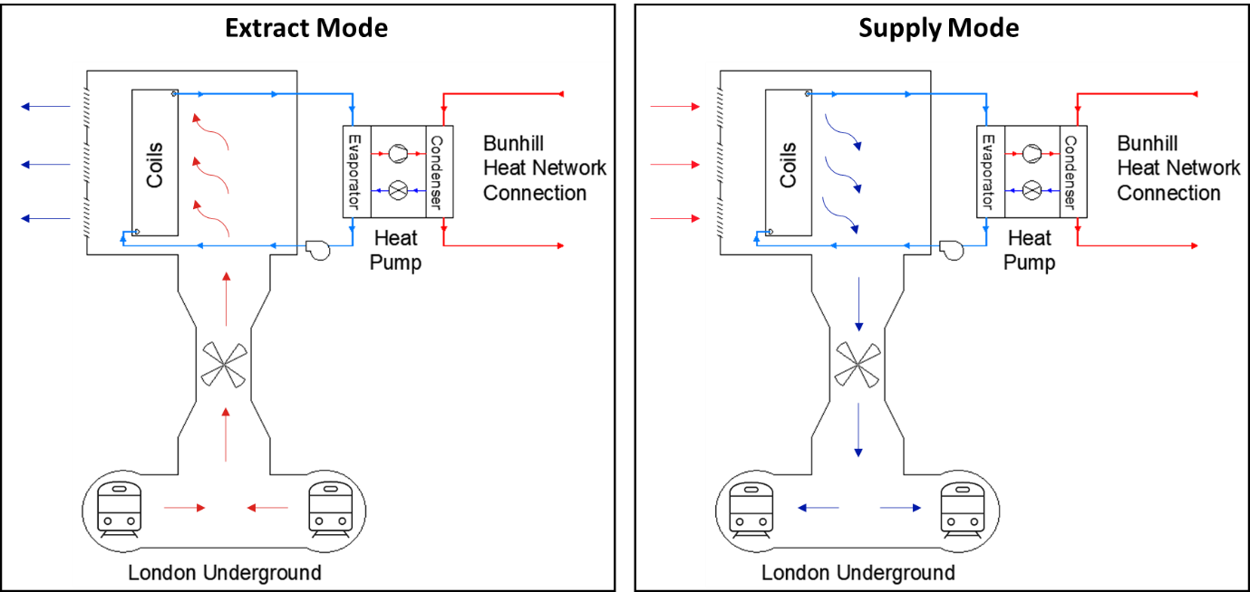
Figure 1 – Conceptual schematics of the WHR system operating in extract and supply modes.
As the main novelty of Bunhill 2 is associated with WHR from the LU, this paper focuses on investigating how a large-scale heat pump utilising waste heat would perform against conventional technologies, namely communal gas boilers and a low-carbon alternative of individual air-source heat pumps (ASHPs). In order to realise the full benefits behind the WHR system, the impacts of cooling will also be evaluated. This includes calculating overall cost and carbon benefits when operating in supply mode, as well as investigating platform temperature reductions that could be achieved at nearby stations in 2030.
- Modelling of the WHR system
The performance of the WHR system was simulated using a mathematical model developed with the commercial software tool Engineering Equation Solver (EES). The WHR model was introduced in [18] and is capable of iteratively solving thermodynamic balance equations across the system, being used to determine its energy consumption, as well as heating and cooling outputs. The energy consumption calculations are associated with the electricity used to run the reversible fan ($W_{F}$), the coolant circulation pump ($W_{P}$) and the heat pump ($W_{HP}$) when delivering a heat output of $Q_{out}$. Based upon design specifications, as well as inputs for air temperature and humidity, the model is able to calculate the heat recovered by the heat exchanger ($Q_{rec}$), which is assumed to be equal to that absorbed by the heat pump’s evaporator ($Q_{in}$ = $Q_{rec}$). When operating in supply mode, the heat recovered is also equal to the cooling that is delivered by the WHR system. A schematic of the main energy inputs and outputs of the model is shown in Figure 2.
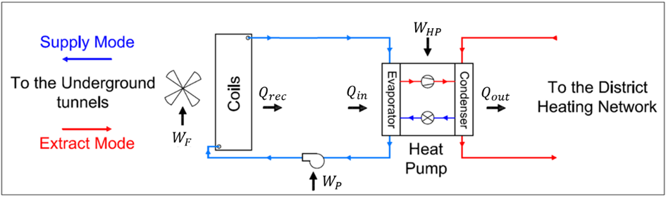
Figure 2 – Schematic highlighting energy inputs and outputs associated with the WHR model.
Each of the components illustrated in Figure 2 together with its outputs were modelled by solving the mass and energy balance between the coils and the heat pump. These outputs are illustrated in Figure 3, along with the main inputs and connections between the different model components. The calculations were carried out on an hourly basis, using temperature and relative humidity recordings from the ventilation shaft and the nearest available weather station, which were provided by Transport for London (TfL) and the UK’s Meteorological Office, respectively, for the period from January 2013 to January 2014. The two-stage heat pump was modelled according to the design specifications for its compressors and heat exchangers, and the coils were simulated considering the latent and sensible heat transfers that take place when heat is recovered from humid air. The WHR model also calculates the energy consumption for the pump and fan based on the expected pressure drops that they must overcome. The model was validated against manufacturer’s data and a detailed description of each modelled component can be found in [18]. By modelling each component, the coefficient of system performance ($COSP$) can be calculated, as shown in Equation 1.
$COSP= \frac{Q_{out}}{W_{HP}+W_{F}+W_{P}}$ [1]
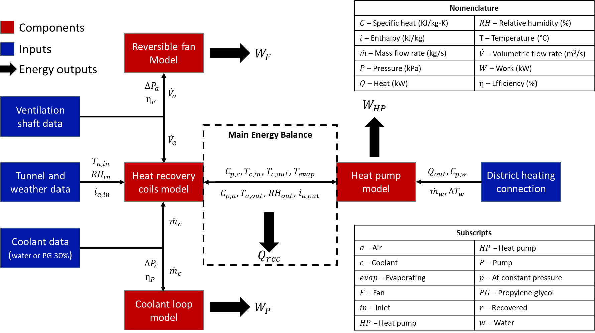
Figure 3 – Framework for the WHR model, highlighting components, inputs and outputs.
- The case study
The Bunhill DH network has been used as a case study for evaluating the benefits of recovering and reusing waste heat from the London Underground. This involved an analysis of how the WHR system could meet the heat demands of the buildings connected to the DH network, which are illustrated in Figure 4. For this purpose, hourly heat demand profiles for the residential buildings connected to the network were provided by Islington Council and used to assess the levelised costs of meeting part of the network heat demand with a 1 MW heat pump utilising waste heat from the London Underground.
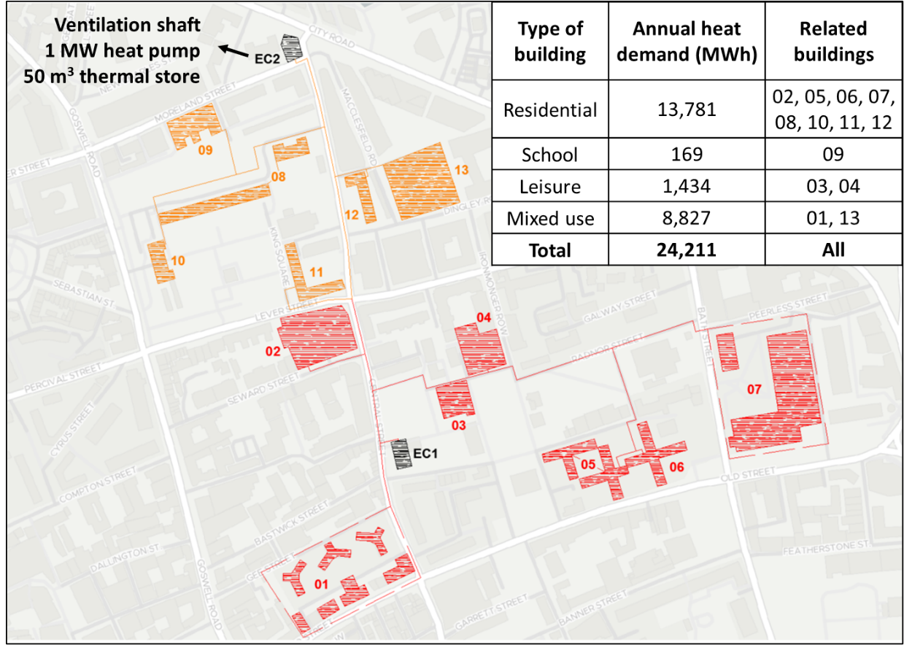
Figure 4 – The DH network used as a case study in this investigation and its connected buildings.
The council estates connected to the network have a combined heat load of 13,781 MWh per annum. The hourly heat demand profiles were matched against the potential heat output from the WHR system, which enables analysing how much of the network demand could be met with the 1 MW heat pump. As the two-stage heat pump has variable speed compressors, it was assumed that it was able to vary its thermal output from 30% to 100% of its capacity (300 kW to 1 MW) without affecting the $COSP$. The 50 m³ thermal store was also modelled to provide additional flexibility to the WHR system’s operation. A heat loss rate of 0.6% per hour was assumed for the thermal storage tank [19]. The DH network was assumed to have heat distribution losses of 10%, which is in accordance with the maximum expected loss rate for new systems [20].
As for the cooling benefit, it was modelled by considering that cooling would be delivered when the system operates in supply mode, and five scenarios involving different combinations of extract and supply modes were modelled, as shown in Table 1. For scenarios when the fan was running exclusively in extract mode, the WHR system was modelled with water as the coolant. However, when supply mode operation was also required, an anti-freeze mixture needed to be utilised and a 30% mixture of propylene glycol (PG) and water was considered. Propylene glycol was chosen due to its extremely low environmental, health, fire and corrosion risks [21].
Table 1 – Different modelling scenarios for the WHR model, based upon fan operation mode.
Scenario | Operation mode | Description
1 | 12E/0S | Fan operating in extract mode for the entire year (12 months).
2 | 9E/3S | Fan operating in supply mode during meteorological summer (Jun/Jul/Aug), and in extract for the rest of the year.
3 | 6E/6S | Fan operating in supply mode for half the year, from May to October, and in extract for the remaining 6 months.
4 | 3E/9S | Fan operating in extract mode only during meteorological winter (Dec/Jan/Feb), and in supply for the rest of the year.
5 | 0E/12S | Fan operating in supply mode for the entire year

- Modelled operation of the DH network
The model was first applied to evaluate how much of the heat generated by the WHR system could be effectively used by the local DH network, and the results of this analysis are shown in Table 2. The modelled scenarios reflect the operation modes described in Table 1. Due to data availability, only the residential heat demand of the Bunhill DH network was considered in the modelled scenarios. Based on the hourly heat demand profiles, the WHR system would produce 7,773 MWh of heat annually, meeting a demand of 6,996 MWh per annum after losses, which is equivalent to 50.8% of the total heat demand considered. In this case, the thermal store would play a minor role, storing only 1% of the total heat produced by the WHR system. Throughout the year, the WHR system would be meeting the base load of the DH network, and the thermal store would mainly be used by the heat pump in summer months, when demand on the network is low. However, storage capacity can still be useful to manage heat production from CHP or if the heat pump is operated with time-of-use tariffs, as investigated in [22].
As it can be observed from Table 2, the outputs and efficiency of the WHR system vary significantly depending on the mode of operation considered. In scenarios predominantly running on extract mode, more waste heat is used and higher heating efficiencies are obtained. While scenario 1 obtained the highest heating $COSP$ of 3.36 and a waste heat utilisation rate of 89%, scenario 5 would only use ambient air as its heat source (waste heat utilisation rate of 0%), therefore achieving a heating $COSP$ of 2.65. However, when cooling outputs are also considered, the efficiency of the WHR system is higher for scenarios where supply mode is used for most of the year. A combined heating and cooling $COSP$ of 4.30 was obtained for scenario 5, when the cooling output would be 62% of the total heating output from the WHR system. On the other hand, the combined heating and cooling efficiency of scenario 1 would be the same as its heating only efficiency, as no cooling is provided when the WHR system operates only in extract mode.
Table 2 – Modelled operational parameters for the WHR system in the different scenarios described in Table 1.
WHR system and DH network parameters | Scenarios
 | 1 | 2 | 3 | 4 | 5
Heat generated by WHR system annually (MWh) | 7,773 | 7,773 | 7,773 | 7,773 | 7,773
Heat delivered annually, excl. distribution losses (MWh) | 6,996 | 6,996 | 6,996 | 6,996 | 6,996
LU waste heat recovered and reused annually (MWh) | 5,457 | 4,468 | 2,966 | 1,483 | 0
Cooling delivered annually by WHR system (MWh) | 0 | 896 | 2,314 | 3,583 | 4,842
Annual WHR system energy consumption (MWh) | 2,316 | 2,410 | 2,494 | 2,708 | 2,931
Seasonal COSP for WHR system (heating only) | 3.36 | 3.23 | 3.12 | 2.87 | 2.65
Seasonal COSP for WHR system (heating and cooling) | 3.36 | 3.60 | 4.04 | 4.19 | 4.30
Ratio of cooling to heating production | 0.00 | 0.12 | 0.30 | 0.46 | 0.62
Share of available waste heat reused annually (%) | 89% | 74% | 50% | 26% | 0%
Share of annual heat demand met with waste heat (%) | 40% | 32% | 22% | 11% | 0%

- Integrated benefit analysis
The integrated heating and cooling benefits of the WHR system were investigated by applying two key metrics. The first one is the levelised cost of energy (LCOE), which is commonly used to express the full costs of energy supply in unitary terms, and is applied in this investigation by considering both heating and cooling supplies. The second metric is the carbon abatement cost (CAC), which represents the cost-effectiveness of a mitigation measure and can be applied to compare different technologies in terms of the cost per metric tonne of CO₂ equivalent (tCO₂e) avoided over a given period [23].
  - Levelised cost of energy (LCOE)
The LCOE can be calculated as shown in Equation 2, where $Q_{a}$ and $C_{a}$ represent, respectively, the annual heating and cooling delivered by the WHR system, excluding losses. ${CAPEX}_{a}$ and ${OPEX}_{a}$ are the annualised capital and operational expenditure associated with the system. The ${CAPEX}_{a}$ was calculated separately for each system component (i.e. WHR system, TES and DH connection), considering infrastructure design life ($L$), as well as an assumed loan repayment period ($t$) and annual interest rate ($i_{a}$), as shown in Equation 3. As for ${OPEX}_{a}$, it combines annual variable (${O\&M}_{v}$) and fixed (${O\&M}_{f}$) operational and maintenance costs, as shown in Equation 4.
$LCOE=\frac{{CAPEX}_{a}+{OPEX}_{a}}{Q_{a}+C_{a}}$ [2]
${CAPEX}_{a}=\frac{CAPEX {(1+i_{a})}^{t}}{L}$ [3]
${OPEX}_{a}={O\&M}_{v}+{O\&M}_{f}$ [4]
${CAPEX}_{TES}=8357×V_{TES}^{-0.47}$ [5]
In all scenarios, the loan period for the investment costs was assumed to be 10 years with an interest rate of 3.5% [24], and all the assumptions used in LCOE calculations are listed in Table 3. In order to reflect economies of scale, the CAPEX benchmark for the thermal store (${CAPEX}_{TES}$), in GBP/m³, was correlated to its volume ($V_{TES}$), in m³, using Equation 5, obtained from the Danish Energy Agency [25] and corrected to account for inflation. The cost benchmarks were mainly obtained from the Danish Energy Agency’s technology catalogue [25], and values shown in Table 3 are the final benchmarks in GBP after conversion from EUR, considering the inflation and exchange rates also shown in Table 3. LCOE values were then calculated for each of the scenarios listed in Table 1. The results obtained were then compared to the operational costs of meeting the same heat demand with either communal gas boilers or individual ASHPs. The calculations consider both O&M and energy costs for communal boilers and only the energy costs for running ASHPs. These were calculated by considering an 85% efficiency for gas boilers and a seasonal COP of 2.68 for ASHPs [26], and the latest energy tariffs published by DESNZ [27]. In the case of communal gas boilers, non-domestic prices would apply as the heating plant would be operated by the local council, but individual ASHPs were assumed to run on domestic electricity prices, whereas the WHR system would be able to take advantage of lower tariffs for non-domestic electricity.
Table 3 – List of assumptions used in levelised cost of energy calculations and their references.
Capital costs
Assumption | Value | Unit | Reference
Heat recovery equipment for ventilation shaft | 975,780 | GBP/MW | [28]
District-scale heat pump using waste heat | 1,390,957 | GBP/MW | [25]
Heat exchanger substation | 115,043 | GBP/MW
Pumping station | 103,538 | GBP/MW
Pipework for DH connection | 1,170 | GBP/m | [29]
Operational costs
Assumption | Value | Unit | Reference
Annual district heating O&M fixed costs | N/A | GBP/MWh | [25]
Annual district heating O&M variable costs | 1.62 | GBP/MWh
Annual thermal storage tank O&M fixed costs | 56 | GBP/unit
Annual thermal storage tank O&M variable costs | 0.79 | GBP/MWh
Annual gas boiler O&M fixed costs | 2,110 | GBP/MW
Annual gas boiler O&M variable costs | 1.19 | GBP/MWh
Non-domestic price of natural gas | 65.50 | GBP/MWh | [27]
Non-domestic price for electricity | 248.1 | GBP/MWh
Domestic price for electricity | 336.2 | GBP/MWh
Financial figures
Assumption | Value | Unit | Reference
Inflation coefficient from 2015 to 2023 | 129 | % | [3]
Inflation coefficient from 2020 to 2023 | 117 | %
Loan repayment period | 10 | years | N/A
Loan interest rate | 3.5 | % p.a. | [24]
Technology design life
Assumption | Value | Unit | Reference
Waste heat recovery system | 25 | years | [25]
District-scale heat pump | 25 | years
Small-scale thermal storage tank (steel) | 30 | years
District heating network | 50 | years

A comparison of the levelised costs for the WHR system against the operational costs for gas boilers and ASHPs is shown in Figure 5. The contributions of different costs to the final levelised figure of each scenario are also indicated. As it can be observed, an increase in the amount of cooling delivered would achieve significant reductions in the LCOE, as the useful energy outputs from the system increase considerably when both heating and cooling are exploited, with scenario 5 obtaining the lowest LCOE value of £76.7 per MWh, which is 2% and 39% lower than the operational costs of communal gas boilers and ASHPs, respectively. Scenario 1, which corresponds to year-round operation in extract mode, uses less energy due to its higher seasonal COSP, as shown in Table 2, but its lack of cooling provision led to the highest LCOE (37% higher than the OPEX for gas boilers). However, the LCOE was still 14% lower than the running costs of an ASHP.
Despite these results indicating a benefit of running the system in supply mode throughout the year, one potential issue is that the recipient of the cooling benefit would be the railway operator, whilst the DH operator would be the stakeholder having to bear the higher costs of producing low-carbon heat using electricity as fuel. This might pose a challenge to long-term cooling delivery, but the results from Table 2 still indicate how it is possible to deliver cooling when it is most needed with a small impact on the annual energy consumption of the WHR system. Furthermore, the high CAPEX associated with DH networks still leads to long payback periods, meaning public policy must play a role as an enabler for WHR projects, especially as there is a significant disparity between gas and electricity prices in the UK. The higher levies and taxes applied to electricity bills represent a risk for the electrification of heat supply and for the exploitation of low-grade waste heat sources in the UK. Government plans to rebalance gas and electricity costs can be key in accelerating the rollout of DH networks using waste heat, together with policies such as the Green Heat Network Fund [22], which can cover up to 50% of the total commercialisation and construction costs for low-carbon DH projects.
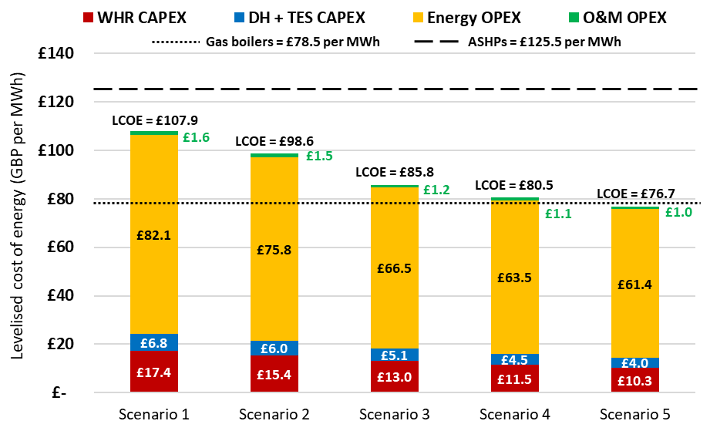
Figure 5 – Levelised cost of energy comparison between each modelled scenario and conventional technologies.
  - Emissions savings and carbon abatement cost (CAC)
The environmental benefits of reusing recovered waste heat were assessed using the CAC metric, which can be interpreted as an indication of the decarbonisation costs associated with a given low-carbon technology. The CAC values were calculated for both the WHR system and individual ASHPs using communal gas boilers as the business-as-usual reference case. The CAC can be calculated as shown in Equation 6, which includes the net annual cost, i.e. the difference between the annualised costs for the low-carbon alternative ($C_{low,carb}$) and the operating costs of the displaced incumbent technology ($C_{inch,tech}$), as well as the carbon emission savings ($S_{{CO}_{2}}$) achieved after the low-carbon technology is introduced. These were calculated considering carbon intensity factors for electricity and natural gas of 0.129 and 0.183 tCO₂e per MWh, respectively [29].
$CAC=\frac{C_{low,carb} -{ C}_{inc,tech}}{S_{{CO}_{2}}}$ [6]
The carbon emissions savings and CAC values for each modelled scenario are illustrated in Figure 6. The carbon savings for WHR include both heating and cooling and are shown in Figure 6(a). Cooling emission savings were estimated by considering that the WHR system would displace a chiller with a COP of 2.70, which is based on an existing system installed at a ventilation shaft on the Victoria Line. In general, carbon emission savings increase for higher shares of supply mode operation, when greater amounts of cooling are delivered, increasing by 242% for scenario 5 (2,920 tCO₂e) when compared to scenario 1 (1,206 tCO₂e). However, it is unlikely that vent shaft chiller systems would operate for the entire year, so the savings in scenario 5 must be interpreted as an upper limit rather than the actual savings that would be achieved in practice. If only heating is considered, carbon savings would be 7% lower for scenario 5 in comparison to scenario 1, being 4% lower than the savings achieved with ASHPs. For a year-round operation in extract mode, the WHR system would require 13% less energy than individual ASHPs due to its higher COPs, equally impacting operational carbon emissions.
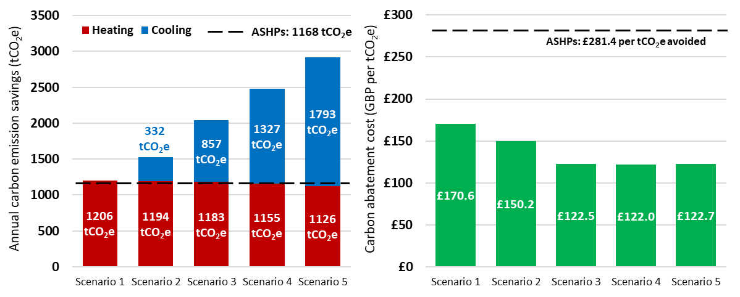
(a) (b)
Figure 6 – Annual carbon emission savings (a) and CAC values (b) for all modelled scenarios, compared against ASHPs.
The results from the CAC analysis are illustrated in Figure 7(b). The WHR system was able to achieve much lower CAC values when compared to ASHPs (from 43% to 61% of the ASHP value), which is due to the higher efficiencies and greater carbon savings of WHR across all scenarios. It is interesting to note that, despite the highest emission savings for scenario 5, its high annual costs (20% greater than scenario 1, see Table 2) meant it would not achieve the best results in terms of CAC, which was obtained for scenario 4 (£122 per tCO₂e). CAC values were only marginally different for scenarios 3, 4 and 5, indicating how scenario 3, which involves operating for only half the year in supply mode, would achieve a low decarbonisation cost without overburdening the DH network operator with a lower system efficiency. The results from this analysis highlight how WHR systems can lead to significant benefits in terms of reducing the costs of decarbonisation, particularly when additional value streams such as cooling are also considered.
- Cooling the London Underground
The cooling benefits behind the WHR system are also assessed in terms of the potential reduction in platform temperatures that can be achieved at the nearest stations to the ventilation shaft. This investigation was carried out in collaboration with the engineering team at TfL in order to simulate how future network temperatures would be affected by the WHR system, utilising a bespoke modelling tool based upon the Subway Environment Simulation (SES) platform. SES is able to perform 1D simulations of the operation of trains in tunnels, being suited to model many different aspects of a subway environment, such as airflows, temperatures and humidity throughout stations, tunnels and ventilation shafts [32]. The thermodynamic simulations in SES consist of breaking down the network into smaller components of constant temperature and humidity. The heat generated within each component over time, based upon train profiles and airflow patterns, is then used to calculate energy and mass balances at nodes connecting subsequent components, whilst also taking into account the conductive heat transfer between tunnel walls and the surrounding soil [33]. This approach is used for both aerodynamic and thermodynamic calculations, and an example of how different network sections are modelled is shown in Figure 7.
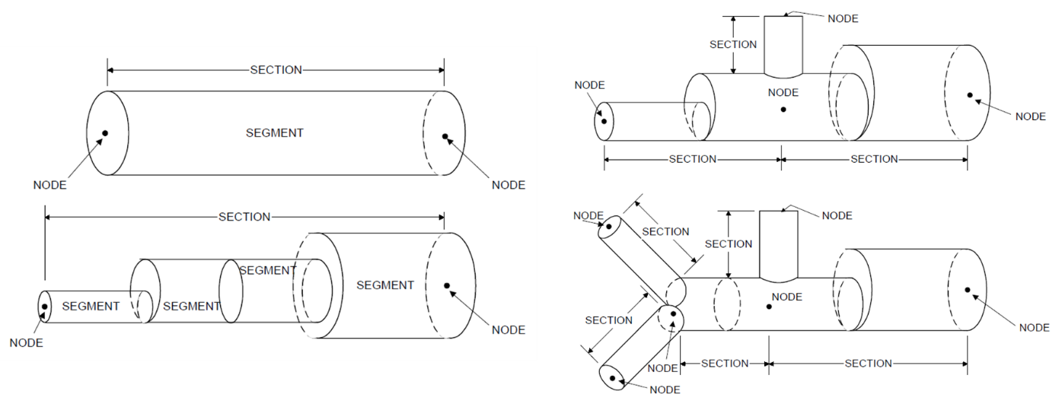
Figure 7 – Examples of network sections and their components as simulated in SES [33].
The results from the WHR model were used as inputs for SES, enabling the analysis of how the stations of Angel, Old Street, King’s Cross and Moorgate would be influenced by the provision of cooling for the Table 1 scenarios over the long term, considering 2030 as the target year. The simulations work by adjusting the dry and wet-bulb temperatures of the air that is supplied at the ventilation shaft node to the conditions predicted by the WHR model. The novelty behind this approach is enabling the use of an accurate representation of the cooling process, which is achieved with the WHR model, to investigate the impacts of cooling coils on the LU environment.
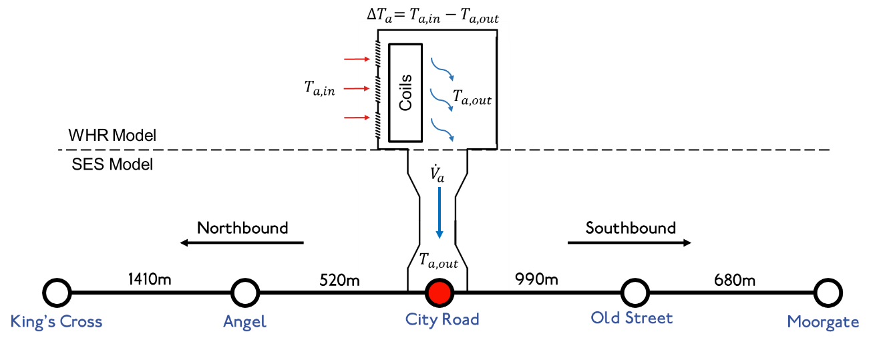
Figure 8 – Schematic highlighting the inputs from the WHR model to the SES simulations.
The SES model developed by TfL is calibrated to utilise 2006 weather data as the basis for simulations, and the UK climate projections (UKCP) from 2009, along with train frequency profiles, are utilised to yield future platform temperatures. Therefore, the WHR model had to be run with 2006 weather data in order to provide the necessary inputs for this investigation, and the link between the WHR and SES models are provided in Figure 8. The cooling effect calculated by the WHR model considers both sensible and latent cooling loads associated with the heat recovery process in supply mode, as discussed in [18], and the data used for simulation are summarised in Figure 9.
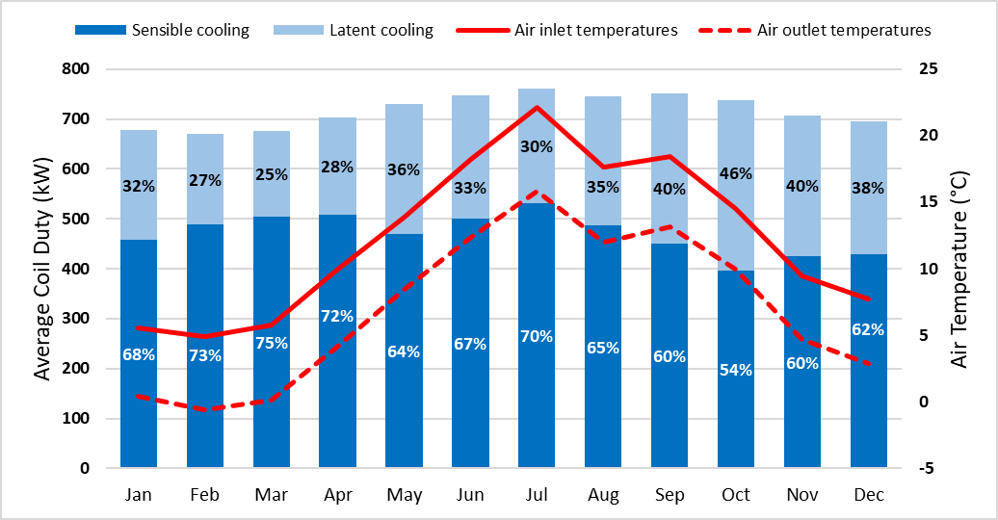
Figure 9 – Monthly average sensible and latent cooling outputs, as well as air inlet and outlet temperatures calculated by the WHR model in supply mode.
As shown in Figure 9, supply mode operation results in significant proportions of latent cooling, with an average of 34% of the total coil duty annually. This leads to a lower air temperature reduction ($∆T_{a}$) than would be achieved if no condensation took place. Overall, the annual average $∆T_{a}$ was calculated as 5.4°C, although values as high as 9.6°C were predicted for an entirely sensible cooling process, highlighting the relevance of considering latent loads when analysing the cooling potential of the WHR system. For each scenario from Table 1, supply mode operation was modelled using the air outlet temperatures corresponding to the months the system would be operating in supply mode. Extract mode was modelled with no air supply through the vent shaft, and a mixed operation was simulated by combining the results from both extract and supply simulations. The results are expressed in terms of average evening peak temperatures for the hottest week of the year. This corresponds to the worst-case scenario the stations would be exposed to, representing how the cooling provided can alleviate temperatures during critical periods. The results from the SES analysis are illustrated in Figure 10.
The results show how the scenarios involving cooling provision would lead to significant reductions in platform temperatures as opposed to year-round extract mode operation, particularly for the stations adjacent to the ventilation shaft (Angel and Old Street), as negligible reductions were observed at King’s Cross and Moorgate. The highest reductions were estimated for scenario 5, where the year-round supply of cooling could potentially reduce peak temperatures by 7.2 K at Angel and 6.3 K at Old Street. For scenarios 2, 3 and 4, which involve a combination of extract and supply modes, the average ΔTs, considering both adjacent stations, were of 1.1, 2.6 and 4.5 K, respectively, highlighting how the cooling benefit can be increased if the system operates for longer periods in supply mode. These temperature reductions might lead to several tangible benefits for LU, such as increasing the wellbeing of passengers and staff [34], reducing risk of train delays caused by high temperatures [17], as well as unlocking potential for service frequency and ridership to be increased.
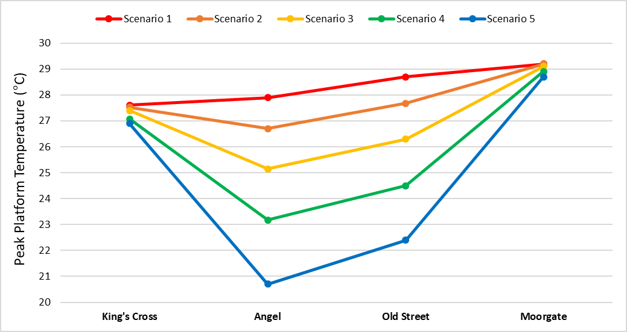
Figure 10 – Peak platform temperatures for 2030 based upon a combination of extract and supply mode SES simulations.
- Wider opportunities for waste heat recovery
This investigation is part of the broader work from the Heating and Cooling Research Group at LSBU in the field of heat recovery, e.g. through projects LoT-NET [35] and GreenSCIES [36]. Our research group has been involved in several investigations of opportunities to recover and reuse waste and renewable heat. Underground railways represent only a small proportion of the overall low-temperature WHR potential we have estimated for the UK [37], as shown in Figure 11, which compares different unconventional heat sources that could be efficiently exploited by low-carbon DH networks using large-scale heat pumps. Although a relative small heat source, underground railways could still be used to reduce carbon emissions and energy costs locally, as shown in this study.
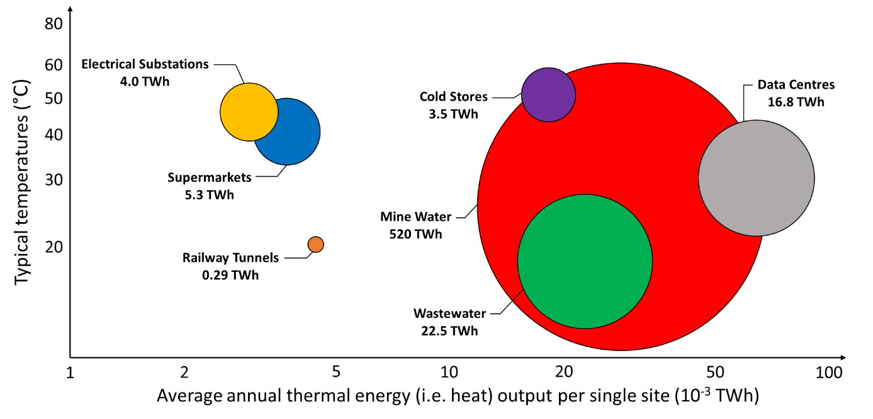
Figure 11 – Summary of total annual waste heat potential for the low-temperature heat sources considered in [37].
Overall, we have quantified the UK’s waste heat potential, i.e. excluding mine water, to be 53 TWh from low-temperature sources only. This value represents 65% of the projected increase of the heat network market by 2050, which is expected to grow from meeting 14 TWh to 95 TWh of the UK’s heat demand annually [38]. This indicates how waste heat and large-scale heat pumps are likely to play a key role in decarbonising the built environment as the UK moves towards net zero.
- Conclusions
This paper presented an investigation into the potential of integrating heating and cooling as part of a heat pump system that recovers waste heat from the London Underground metro system. A mathematical model has been developed and utilised to demonstrate how the delivery of both heating and cooling through a WHR system could achieve significant benefits in terms of reducing the levelised cost of energy and maximising carbon savings. The results have indicated how the exploitation of cooling could be crucial in making WHR projects a feasible investment. The combination of both heating and cooling benefits could lead to reductions of up to 39% in the levelised cost of energy and 57% in the carbon abatement cost against ASHPs. This highlights how exploring additional benefits and the higher energy efficiencies of waste heat can compensate for its typically higher capital costs.
The provision of cooling through the WHR system also has significant impacts on the local tunnel environment, with peak temperature reductions of up to 7.2 K being estimated for adjacent stations in 2030. When operating for half the year in supply mode (i.e. when cooling is delivered), the WHR system would be able to reduce peak temperatures at adjacent stations by an average of 2.6 K compared to a do-nothing scenario. One risk identified regarding supply mode operation is the reduction of system efficiency, as lower temperature air is used as the heat source. This could increase running costs for system operators, and a balance between cooling and heating benefits must be sought. Furthermore, it is still important to highlight how the price disparity between electricity and natural gas in the UK is a major barrier to the development of WHR systems, particularly from a heating perspective. It is expected that future policy can provide much-needed support for low-carbon heat networks, allowing waste heat to play its role as an essential resource for minimising the costs of decarbonisation as the UK moves towards a clean energy future.
Acknowledgements
The authors would like to express their gratitude for the support received from Transport for London, London South Bank University, and the Engineering and Physical Science Research Council (EPSRC) through project LoT-NET - Low Temperature Heat Recovery and Distribution Network Technologies [EP/R045496/1]. The authors are also grateful to the London Borough of Islington for their support in providing valuable information for this project.
References
- National Grid, 2023. Energy explained - How much of the UK’s energy is renewable? Available online: https://www.nationalgrid.com/stories/energy-explained/how-much-uks-energy-renewable [Accessed 14/11/2023].

- Department of Energy Security and Net Zero (DESNZ), 2023. UK greenhouse gas emissions, provisional figures. Available online: https://assets.publishing.service.gov.uk/media/642 4b8b83d885d000fdade9b/2022_Provisional_emissions_statistics_report.pdf [Accessed 08/12/2023].

- Bank of England, 2022. When will inflation come down? Available online: https://www.bankofengland.co.uk/knowledgebank/will-inflation-in-the-uk-keep-rising [accessed 30/09/2022].

- Grubb, M., Ferguson, T., Musat, A., Maximov, S., Zhang, Z., Price, J. & Drummond, P., 2022. Navigating the crises in European energy: Price Inflation, Marginal Cost Pricing, and principles for electricity market redesign in an era of low-carbon transition. UCL Institute for Sustainable Resources – Series Navigating the Energy-Climate Crises. WP #3.

- National Energy Action, 2022. The hardest hit: Impact of the energy crisis. Available online: https://www.nea.org.uk/wp-content/uploads/2023/01/3830_NEA_Fuel-Poverty-Monitor-Report-2022_V2-1.pdf [Accessed 13/10/2023].

- Department for Energy Security & Net Zero (DESNZ), 2022. Electricity networks strategic framework. Available online: https://www.gov.uk/government/publications/electricity-networks-strategic-framework [Accessed 14/11/2023].

- Rosenow, J., 2022. Is heating homes with hydrogen all but a pipe dream? An evidence review. Joule 6(10), 2225-2228.

- Rowley, P., Wilson, G. & Taylor, R., 2018. Heat decarbonisation challenges: local gas vs electricity supply. Available online: https://ukerc.ac.uk/publications/local-gas-demand-vs-electricity-supply/ [Accessed 14/11/2023].

- Lund, H., Werner, S., Wiltshire, R., Svendsen, S., Thorsen, J. E., Hvelplund, F. & Mathiesen, B. V., 2014. 4th Generation District Heating (4GDH): Integrating smart thermal grids into future sustainable energy systems. Energy 68, 1-11.

- Revesz, A., Jones, P., Dunham, C., Davies, G., Marques, C., Matabuena, R., Scott, J. & Maidment, G., 2020. Developing novel 5th generation district energy networks. Energy 201, 117389.

- Lagoeiro, H., Revesz, A., Davies, G., Maidment, G., Curry, D., Faulks, G. & Murawa, M., 2019. Opportunities for Integrating Underground Railways into Low Carbon Urban Energy Networks: A Review. Applied Sciences 9(16), 3332.

- Transport for London (TfL), 2019. Facts & Figures. Available from: https://tfl.gov.uk/corporate/about-tfl/what-we-do/london-underground/facts-and-figures [14/01/2019].

- Duffy, S., 2018. Opportunities to Utilise Transport for London’s Secondary Heat Sources. CIBSE Technical Symposium, London, UK.

- United Nations Environment Programme (UNEP). 2022. Emissions Gap Report 2022. Available online: https://www.unep.org/events/publication-launch/emissions-gap-report-2022 [Accessed 12/12/2023].

- Met Office. 2022. Unprecedented extreme heatwave, July 2022. Available online: https://www.metoffice.gov.uk/binaries/content/assets/metofficegovuk/pdf/weather/learn-about/uk-past-events/interesting/2022/2022_03_july_heatwave_v1.pdf [Accessed 12/12/2023].

- Birmingham Energy Institute. 2023. The Hot Reality: Living in a +50°C World. Available online: https://www.sustainablecooling.org/wp-content/uploads/2023/11/Hot-Reality-Living-in-a-50C-World.pdf [Accessed 12/12/2023].

- Greenham, S., Ferranti, E., Powell, R., Drayson, K. & Quinn, A., 2023. The impact of heat on London Underground infrastructure in a changing climate. Weather 78, 170-175.

- Lagoeiro, H., Revesz, A., Davies, G., Gysin, K., Curry, D., Faulks, G., Murphy, D., Vivian, J. & Maidment, G., 2022. Investigating the opportunity for cooling the London underground through waste heat recovery. Building Services Engineering Research and Technology 43(3), 347-359.

- Energy Systems Catapult, 2020. Thermal Energy Storage for Heat Networks. Available online: https://es.catapult.org.uk/report/storage-and-flexibility-thermal-energy-storage-for-heat-networks/ [Accessed 16/11/2023].

- Chartered Institution of Building Services Engineers. 2020. CP1 – Heat Networks Code of Practice for the UK.

- Heinonen, E. W., Wildin, M. W., Beall, A. N. & Tapscott, R. E., 1997. Assessment of Antifreeze Solutions for Ground-Source Heat Pump Systems. ASHRAE Transactions 103(2), 747-56.

- Lagoeiro, H., Revesz, A., Davies, G., Gysin, K., Curry, D., Faulks, G., Murphy, D., Vivian, J. & Maidment, G. 2022. Integrating Waste Heat Recovery from Railway Tunnels into Flexible Heat Networks. Proceedings of the ASHRAE Winter Conference, USA, 29 Jan – 2 Feb, 2022.

- Ibrahim, N. & Kennedy, C. 2016. A Methodology for Constructing Marginal Abatement Cost Curves for Climate Action in Cities. Energies 9(4): 227.

- European Commission. 2023. Reference and discount rates (in %) since 01.08.1997. Available online: https://competition-policy.ec.europa.eu/state-aid/legislation/reference-discount-rates-and-recovery-interest-rates/reference-and-discount-rates_en [Accessed 31 July 2023].

- Danish Energy Agency, 2023. Technology Data. Available online: https://ens.dk/en/our-services/projections-and-models/technology-data [Accessed 23/11/2023].

- Energy Saving Trust, 2013. The heat is on: heat pump field trials: phase 2. Available online: https://www.energysavingtrust.org.uk/sites/default/files/reports/TheHeatisOnweb%281%29.pdf [Accessed 13/04/2021].

- Department for Energy Security & Net Zero (DESNZ), 2023. Quarterly Energy Prices. Available online: https://www.gov.uk/government/collections/quarterly-energy-prices [Accessed 18/12/2023].

- Hamilton, J., 2022. Institute of Refrigeration SIRACH Event: Decarbonising heat using secondary sources and Government policy - Waste Heat. Available online: https:// ior.org.uk/public/downloads/HD2mP/Dr-Joel-Hamilton-June-22.pdf [Accessed 01/12/2023].

- Revesz, A., Dunham, C., Jones, P., Bond, C., Fenner, R., Mody, S., Nijjhar, R., Marques, C. & Maidment, G. 2022. A holistic design approach for 5th generation smart local energy systems: Project GreenSCIES. Energy 242, 122885.

- Department for Energy Security & Net Zero (DESNZ), 2023. Green Book supplementary guidance: valuation of energy use and greenhouse gas emissions for appraisal. Available online: https://www.gov.uk/government/publications/valuation-of-energy-use-and-greenhouse-gas-emissions-for-appraisal [Accessed 30/07/2023].

- Department for Energy Security & Net Zero (DESNZ), 2022. Green Heat Network Development Fund Round 1: Guidance for Applicants, March 2022, Available online: https:// www.gov.uk/government/publications/green-heat-network-fund-ghnf [Accessed 15/11/2022].

- Thompson, J.A., Maidment, G.G. & Missenden, J.F., 2006. Modelling low-energy cooling strategies for underground railways. Applied Energy 83, 1152-62.

- U.S. Department of Transportation, 2002. Subway Environmental Design Handbook, Volume II. Subway Environmental Simulation Computer Program, Version 4.1.

- Wen, Y., Leng, J., Shen, X., Han, G., Lijun, S. & Yu, F., 2020. Environmental and Health Effects of Ventilation in Subway Stations: A Literature Review. International Journal of Environmental Research and Public Health 17, 1084.

- Low Temperature Heat Recovery and Distribution Network Technologies (LoT-NET), 2023. Project website. Available online: https://lot-net.org/ [Accessed 19/12/2023].

- Green Smart Community Integrated Energy Systems (GreenSCIES), 2023. A Centre of Excellence in SLES. Available online: https://greenscies.com/ [Accessed 19/12/2023].

- Davies, G., Lagoeiro, H., Turnell, H., Wegner, M., Foster, A., Evans, J., Revesz, A., Leiper, A., Smyth, K., Hamilton, J., Cooke, H. & Maidment, G., 2023.Evaluation of low temperature waste heat as a low carbon heat resource in the UK. Applied Thermal Engineering 235, 121283.

