Electrooxidation of Hydrazine Utilizing High Entropy Alloys: Assisting Oxygen Evolution Reaction at the Thermodynamic Voltage
Nirmal Kumar Katiyar†‖‡, Shikha Dhakar§‡, Arko Parui#, Pooja Gakhad#, Abhishek Kumar Singh#*, Krishanu Biswas†*, Chandra Sekhar Tiwary^{δ*}, Sudhanshu Sharma§*
†Departmental of Materials Science and Engineering, Indian Institute of Technology Kanpur, Uttar Pradesh-208016;
§Department of Chemistry, Indian Institute of Technology Gandhinagar, Gujarat-382355
^{δ}Department of Metallurgical and Materials Engineering, Indian Institute of Technology Kharagpur, West Bengal-721302;
‖School of Engineering, London South Bank University, 103 Borough Road, London, SE10 AA, UK.
# Materials Research Centre, Indian Institute of Science, Bangalore, Karnataka 560012, India

‡ Equal contribution

ABSTRACT
Hydrazine electrooxidation is an important reaction as it assists in decreasing the OER overvoltage. Herein, we report the utilization of high entropy nano-catalyst alloy for the electrooxidation of hydrazine. High entropy nano-catalyst comprising five elements (Ag, Au, Pt, Pd, Cu) shows profound activity towards this molecule at low overvoltage. An intriguingly high entropy nano-catalyst prepared by the casting-cum-cryomilling method is endowed with unique catalytic activity for HzOR. Detailed analysis of gaseous product points to the formation of nitrogen as well as oxygen as the oxidation product, a sign of accompanying oxygen evolution reaction (OER). Interestingly, significant oxygen is detected at 1.13 V (RHE) in a neutral buffered medium, confirming that OER is functional at a voltage near to the thermodynamic voltage of 1.23V (RHE). The quantitative contribution of each hydrazine and OER reaction is ascertained which explains a vital insight into this reaction. Density functional theory calculations showed that both HzOR and OER assist each other where the electron-donating effect of H₂O to the surface can reduce the endothermicity of the HzOR. Whereas, the electron acceptance of *NHNH₂ helps in the favorable overlap of the HEA Fermi level and vacant states with the HOMO of H₂O.

KEYWORDS: High entropy alloy, Nanoparticles, Nano-catalysis, Hydrazine Oxidation, Microscopy analysis, Oxygen Evolution Reaction

INTRODUCTION
Fossil fuels are the foremost energy sources as well as energy carriers in the present-day scenario and supposed to rule for at least until 2050¹. The combustion of fossil fuels leads to the generation of large volumes of CO₂, contributing significantly to climate change. Hence, there is an urgent need to explore green and renewable energy resources to effectively reduce CO₂ emissions and replace fossil fuels thus, reducing their over dependency. Among the various alternative energy strategies, the construction of an energy infrastructure that has high energy efficiency and environmental benignity is the need of the hour for a clean and sustainable energy future².
In this context, fuel cells are considered the key player in the field of energy sector due to their excellent properties, viz., eco-friendly, renewable and economical. Accordingly, a significant number of small molecules, namely ethanol³⁻⁵, methanol⁶, urea⁷⁻⁸ and hydrazine⁹⁻¹² have been considered the ideal fuel candidates¹³. Among these fuels, hydrazine and its derivatives have been extensively studied as an ideal fuel cell due to its remarkable properties¹⁴. Direct hydrazine fuel cells operate on the principle of the oxidation of hydrazine, a fuel that has many notable advantages compared to other hydrocarbon-based fuels. Hydrazine is a carbon-free energy carrier, which does not exhaust environmentally harmful chemicals such as CO₂, CO. Additionally, the liquid state of hydrazine makes it safer to handle. Also, it can be electro-oxidized at much lower potential compare to water. Hydrazine oxidation is always accompanied with oxygen evolution reaction^{15-17,} making the latter happening at lower voltage¹⁸. This concept has been used as a tool to generate hydrogen at a lower voltage^{12, 19}. This combination of reactions generates a significant number of protons at a much lower voltage which can be utilized in the cathode side of the fuel cell to generate electricity^{16-17, 20}. Among the well-known liquid fuels such as methanol, hydrazine is advantageous as its oxidation kinetics are substantially faster and releases environmentally benign N₂ as the oxidation product.
Literature suggests a number of different catalytic formulations for this reaction. Among alloys, Ni, Co, and Cu based ternary alloys have been utilized for this reaction, and the activity was reported to be good²¹. In the same way, core-shell type iron copper-based material²², copper–nickel-based nitride²³, CuO nanoflowers²⁴, bifunctional cobalt perselenide nano-sheets²⁴, NiS₂ nanosheets²⁵, NiFe₂O₄²⁶, CoS₂ nanoarrays²³, Ni₂P nanoarrays²⁷ grown in situ on nickel foam and graphene supported Ni@Pt, Pd, Ru nano particles²⁸ were also reported to be exhibit reasonably good catalytic response.
Evidently, high entropy alloys have never been used for this reaction which is an emerging class of catalysts²⁹⁻³². These multicomponent alloys with a simple crystal structure (FCC, BCC, or HCP) can effectively be utilized for numerous catalytic applications, as their composition and constituents can be tuned for specific applications. As mentioned earlier, hydrazine oxidation is often coupled to oxygen evolution reaction³³⁻³⁴. Thus, it is vital to know the contribution of each reaction in the overall oxidation process. We are specifically focusing on hydrazine oxidation to address some fundamental questions; (a) how this molecule behaves in the neutral medium where the catalyst’s surface is more exposed than in the basic medium, (b) what are the various gases that form during the reaction and (c) what is the quantitative contribution of OER in the hydrazine oxidation reaction?

Result and discussion

Materials Characterization:

The nanocrystalline high entropy alloy (HEA) materials were successfully synthesized by ball milling at an extreme low (cryogenic) temperature of the cast and homogenized ingot³⁵. The crystal structure of the nanocrystalline powder has been confirmed by X-ray diffraction as shown in Figure 1(b), revealing peaks corresponding to single-phase material having FCC (face centred cubic) structure with a lattice parameter of 3.9363 Å. In general, the metallic nanoparticles have natural characteristics to show surface plasmon resonance³⁶. The present multicomponent alloy nanoparticles exhibit an absorption band at 284 nm when dispersed in the HPLC grade methanol demonstrated in Figure 1(c). The TEM bright field image illustrates an average particle size of 10±4 nm and inset shows TEM diffraction pattern corresponding to single-phase FCC. The nanoparticles also exhibit chemistry, homogeneous in nature. Figure 1(d) shows by energy dispersive X-ray (EDAX) elemental maps obtained with SUPER EDS detectors (4 EDS detectors attached to TEM) with no other impurities as proved via maps and EDAX spectrum. Figure 1(f) reveals high resolution TEM (HRTEM) image of the one of the nanoparticles, showing atomic columns of (111) plans of the nanoparticle.
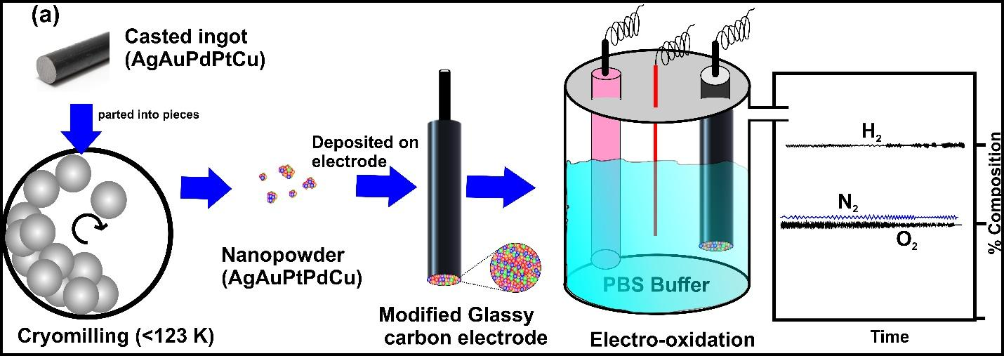
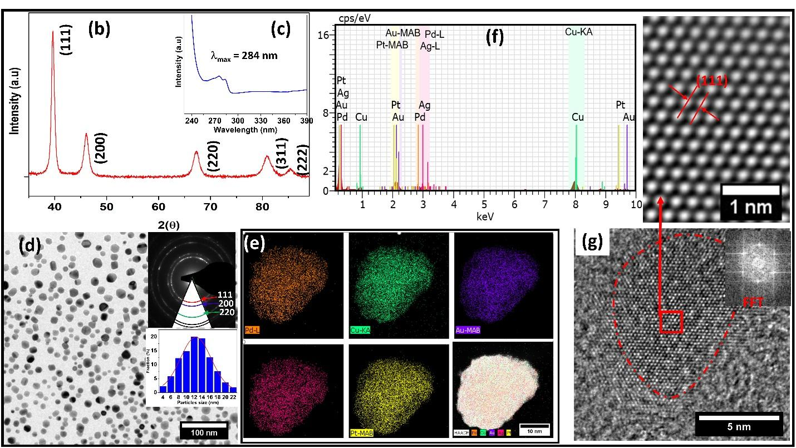
Figure 1: (a) Schematic illustration. (b) X-ray diffraction pattern of AgAuCuPtPd nanoparticles (c) UV absorption spectra of AgAuCuPtPd nanoparticles in methanol (d) TEM bright field image nanoaparticles (inset shows corresponding ring diffraction pattern, and particles size distribution) (e) elemental edax mapping of nanoaparticles (f) EDAX pattern (g) HRTEM image of single nanoparticles inset shows FFT and FFT filtered image.

The chemical state of elements in the single-phase alloy nano powder have been determined using surface sensitive technique XPS (penetration depth few atomic layers). The Pt 4f_{7/2} and Pt 4f _{5/2} peak at 71.1 and 74.4 respectively are consistent with metallic character of platinum³⁷. Similarly, Au 4f_{7/2} (84.0 eV), Au 4f_{5/2} (88.0 eV), and Pd 3d_{5/2} (335.1 eV) binding energy are consistent with the metallic state. However, the minute Cu⁺² formation observed and the shifting of Ag peak 0.4 eV to lower binding energy is consistent with Au-Ag charge transfer interaction³⁴. Therefore, XPS reveals the metallic character of alloy elements. The composition of the nanoparticles surface to inside core estimation were found quite consistent with the XPS (surface estimation) and EDAX (over all estimation) as seen in Figure 2(f), which reveal the homogeneous chemical composition of alloy nanoparticles. Similarly, it has been proven through elemental mapping in Figure 1(e).
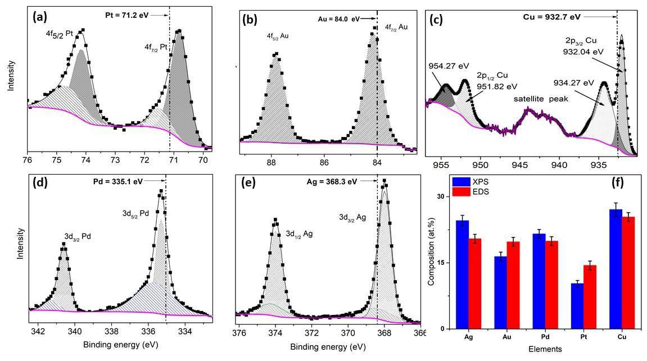
Figure 2: X-ray photoelectron spectroscopy spectra of AgAuPdPtCu HEA alloy nano powder (a) Pt 4f (b) Au 4f (c) Cu 2p (d) Pd 3d (e) Ag 3d (f) composition estimation comparison EDS vs XPS.

Electrocatalytic Study of Hydrazine electrooxidation on HEA Catalyst:

Electrocatalytic activity of HEA.

The Cyclic Voltammetry (CV) experiments were performed with HEA in 0.5 M PBS as the supporting electrolyte. Further 250 µL, 500 µL and 1000 µL hydrazine hydrate solution (80%) was introduced into the electrolyte solution to examine its oxidation. The concentration of the hydrazine in the final solution is 0.16 M, 0.32 M and 0.64 M, respectively.
It can be observed from Figure 3(a) that the Hydrazine Oxidation Reaction (HzOR) gives rise to a typical electrocatalytic response in the chosen potential range of 0.0 to 0.8 V in comparison to the response without hydrazine. A sharp anodic current with bubble formation in the presence of 250 µL hydrazine [red trace in Figure 3(a)] in comparison to HEA without hydrazine [marked as a black trace in Figure 3(a)] is observed. Clearly, about 22 times increase at 0.8 V is observed after adding 250 µL hydrazine compared to the pure electrolyte. Here, the current of 4.2 mA/cm² at 0.8 V increases to 88.7 mA/cm² corroborating the high activity of HEA. Upon increasing the amount of hydrazine hydrate to 1000 µL, a further increase in the anodic peak is observed where the current increases from 88.65 mA/cm² to around 180 mA/cm² at 0.8 V [Figure 3(a)]. Severe bubbling can be seen on the electrodes after increasing the amount of hydrazine hydrate from 250 µL to 1000 µL, which further distorts the CV response. Cyclic Voltammetry study in higher potential range 0.0 to 1.0 V and -1 V to 1 V were also performed where similar trends are observed [Figure S1 (a,b)].
As a confirmation study showing that HEA is the true entity that performs towards HzOR, CV of bare GCE with and without 250 µL hydrazine in the potential range 0.0 V to 1.0 V was carried out [Figure S2 (a)]. HEA under the same hydrazine concentration is also given for comparison. One can see that GCE is not very active for this reaction, and the current rises from ~ 0.30 mA/cm² in the pure electrolyte to 7.75 mA/cm² in the hydrazine mixed electrolyte.
Activity and the stability of HEA is probed by a fixed potential study (chronoamperometry) at 0.3 V in PBS medium for 1000 seconds (Figure 3b). The experiment is carried out at three different concentrations. Since the bubble formation during the oxidation distorts the response, the experiment was performed with continuous stirring to provide an active surface area for the reaction. On the addition of hydrazine, the obtained current density is still noisy due to bubbles on the surface, indicating the hydrazine electrooxidation is occurring with significant kinetics. Chronoamperometry shows a typical response where the current first rises and drops reaching a steady state. It takes about 100 seconds to reach the steady-state. The current after 1000 seconds are 17.70 mA/cm², 37 mA/cm² and 74 mA/cm² at 250, 500 and 1000 µL of hydrazine.

Gaseous product analysis

To corroborate that oxidation current is indeed due to HzOR, an analysis of product gases resulting from the chronoamperometry experiment (0.3 V for 1000 seconds) is carried out. During the chronoamperometry experiment, the evolved gases are collected and subjected to gas chromatography. The collected gas was monitored for three different concentrations of hydrazine (250 µL, 500 µL and 1000 µL) after 1000 second at the applied fixed potential of 0.3 V. Gas chromatographic (GC) analysis of gas generated at headspace of a closed electrochemical cell (1 ml taken) following the bulk electrolysis at 0.3 V for 1000 second indicated that evolution of gas increased on increasing the concentration of hydrazine hydrate [Figure 3(c)].

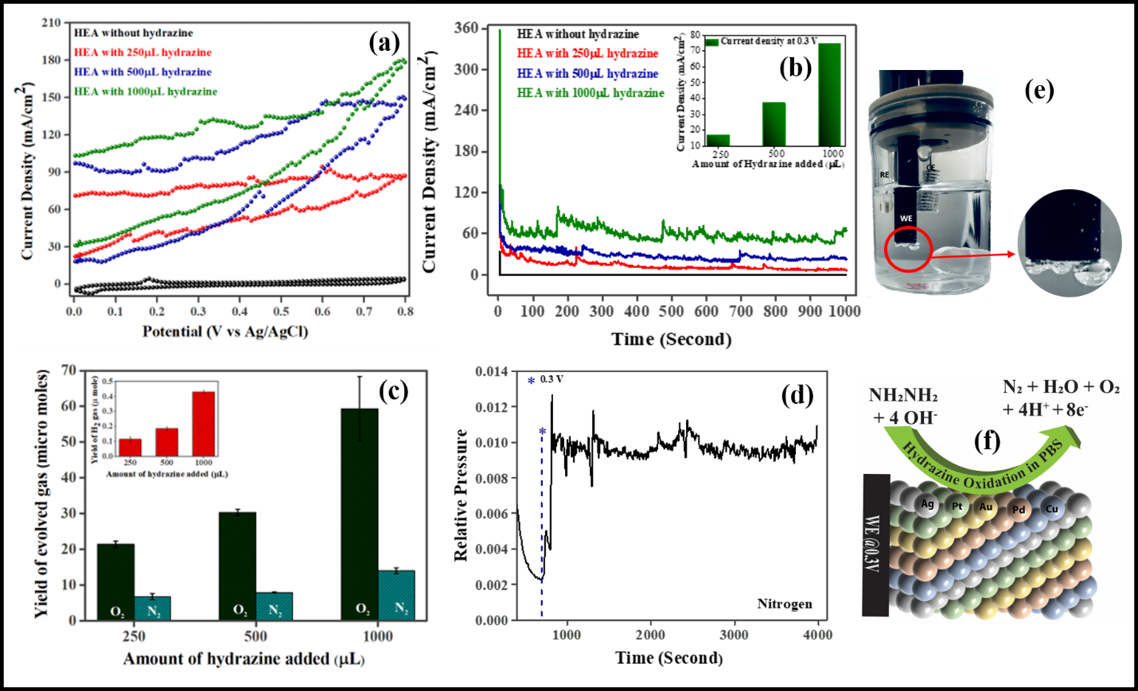
Figure 3. Electrocatalytic measurements: (a) Cyclic voltammetric responses of hydrazine electrooxidation (HzOR) catalyzed by HEA in 0.5M phosphate buffer solution containing different concentrations of hydrazine: 250 µL (Red trace), 500 µL (Blue trace), 1000 µL (Olive trace) and HEA without hydrazine (Black trace) in 0.5 M PBS medium. The chosen potential range is 0 to 0.8 V with the scan rate of 40 mV s^{–1}. (b) Chronoamperometric response of hydrazine electrooxidation at an applied potential of 0.3V for 1000 HEA in 0.5M phosphate buffer solution containing different concentrations of hydrazine. (c) The trend of N₂, O₂ accumulation in the headspace of the air-tight container detected by gas chromatography during the chronoamperometry experiment at an applied potential of 0.3 V and inset depicts the trend of Hydrogen production on the counter electrode (The standard deviations are shown as vertical lines). (d) Mass-spectrometer U.G.A. response during chronoamperometric measurement. (e) Image is taken during the Chronoamperometric experiment. (f) Schematic illustration of HzOR over HEA via electrochemical route.

It can be seen from Figure 3(c) that along with nitrogen, oxygen is also detected in the GC, indicating that OER is also taking place simultaneously along with Hydrazine electrooxidation. The reaction rate is estimated as 75.12, 102.06, 195.57 µ mole s⁻¹ gm⁻¹ for 250, 500 and 1000 µL of hydrazine, respectively. The bar diagram for the rate of reaction can be seen in Figure S3.
The evolution of oxygen is also a function of hydrazine concentration, and its concentration also increases with the hydrazine concentration. These observations give proof that hydrazine electrooxidation can tune the kinetics of OER and it can happen at as low as 0.3V (Ag/AgCl). This voltage corresponds to 1.13 V (RHE). Considering a 10% error in the measurement, this voltage is equal to 1.23 V, the thermodynamic voltage of OER This is a remarkable observation, and the reason is possibly the involvement of water molecules during the hydrazine oxidation. Water reacts with hydrazine to produce N₂ and protons, and as a result, H₂O gets reduced to give oxygen and additional protons. This phenomenon can be confirmed by analyzing hydrogen gas in the counter electrode chamber inset image of Figure 3(c). A strong signal of hydrogen signifies the large number of protons generating during hydrazine oxidation, confirming our observation. A linear relationship is observed between the moles of N₂/O₂ and the hydrazine concentration, which is evidence of a diffusion-controlled process or in other words, HEA has excellent electron transfer properties. The performance of HEA catalyst is also compared with commercial Pt/C catalyst having one weight percent of Pt nanoparticles. CV studies [Figure S2 (b)] shows the Pt/C is inferior to HEA catalyst in terms of the obtained current density within 0.0 to 0.8V.

Plausible reaction mechanism

GC shows that out of the total gaseous molecules during the oxidation, 75-80% is oxygen and 20-25% is nitrogen at all three hydrazine concentrations. This is an interesting behaviour that suggests that there are more water molecules available to react with a single hydrazine molecule over the HEA’s surface. Considering the hydrazine concentration 250 µL, there are about 21 micromoles of O₂ and 7 micromoles of N₂ in the oxidation product [Figure 3(c)], giving a ratio of 1:3 approximately. Considering this product ratio, the faradaic efficiency greatly underestimates the number of micromoles of the product. Thus, it is certain that hydrazine oxidation is occurring via chemical as well as electrochemical routes. This is confirmed by adding HEA nanoparticles in the mixture of hydrazine and buffer, followed by the analysis of the gaseous product. Interestingly, the formation of hydrogen, oxygen and nitrogen are detected, asserting the role of a heterogeneous chemical reaction. The overall reactions happening in the process are:
$$NH_{2}NH_{2}{.H}_{2}O + H_{2}O→N_{2}+{8H}_{2}+O_{2}$$
$$NH_{2}NH_{2}+ 4{OH}^{-}⇌N_{2}+{2H}_{2}O+O_{2}+4H^{+}+8e^{-}$$
Bare HEA does not show any oxygen at this lower voltage in the buffer medium signifying no OER in the absence of hydrazine.
To shed light on the favourable reaction mechanism for hydrazine (NH₂NH₂) oxidation and the role of a particular active site over the HEA surface, density functional theory calculations were performed. The procedure of forming HEA surface through ATAT was described in our previous literature³². Comparison of three differently oriented surfaces, namely (100), (110) and (111), was done by calculating their surface energy. This shows the favourable formation of (111) surface with surface energy of 0.1 eV/Å² in comparison with the (100) and (110) surfaces, having surface energies 0.14 eV/Å² and 0.15 eV/Å², respectively (Figure S5).
During the oxidation reaction of NH₂NH₂, the catalyst should be able to accept the electron favorably. This requires finding an active surface over HEA surface. However, having large number of possible active sites over the chosen HEA, consideration of each active sites for the reaction is time extensive. Therefore, possible most active site was chosen that has a considerable number of vacant orbitals and the adsorption orientation of NH₂NH₂. The highest occupied molecular orbital (HOMO) of NH₂NH₂ is Π* and can overlap easily with the d_{xz} and d_{yz} orbital of the active site atom³⁸. Moreover, the nature of HOMO allows NH₂NH₂ to be adsorbed in a side-on manner. This was further confirmed from the previous literature which also pointed out about the favorability of bridge site adsorption of NH₂NH₂³⁹. Hence, the number of vacant d_{xz} and d_{yz} orbitals of the bridging positions of HEA surface within 0 eV and 5 eV was calculated where the Fermi level is pinned at 0 eV as the HEA accept electrons in the states near the Fermi level (Figure S4). Accordingly, Pt-Pt bridge site was chosen as an active site for the side-on adsorption of NH₂NH₂ and further calculations (Figure S6 – S10).
Ideally, oxidation of NH₂NH₂ is a 4e⁻ transfer process, containing four intermediates and can follow two different mechanism, namely alternating and distal. The favorability is determined by the adsorption energies of the intermediates, *NHNH₂, *NHNH (only in alternating mechanism), *NNH₂ (only in distal mechanism), *NNH. For this purpose, they were completely optimized on the catalytic site. Subsequently, adsorption energies were then calculated using the formula
∆E_{ads}(NH₂NH₂) = E(*NH₂NH₂) – [E* + E(NH₂NH₂)] (1)
∆E_{ads}(NHNH₂) = E(*NHNH₂) – [E* + E(NH₂NH₂) – 0.5 E(H₂)] (2)
∆E_{ads}(NHNH) = E(*NHNH) – [E* + E(NH₂NH₂) – E(H₂)] (3)
∆E_{ads}(NNH₂) = E(*NNH₂) – [E* + E(NH₂NH₂) – E(H₂)] (4)
∆E_{ads}(NNH) = E(*NNH) – [E* + E(NH₂NH₂) – 1.5 E(H₂)] (5)
∆E_{ads}(N₂) = E(*N₂) – [E* + E(N₂)] (6)
Where * represents the catalyst surface. These adsorption energies were then converted into free energies (∆G) of any concerned reaction, using the following expression
∆G = ∆E_{ads} + ∆ZPE -T∆S + ∆G_{U} + ∆G_{pH} (7)
Here, ∆ZPE and T∆S are the differences in zero-point energies of the species and in entropies due to contribution from the vibrational motions only, respectively. ∆G_{U} (∆G_{U} = -eU; e is the number of electrons transferred) and ∆G_{pH} (∆G_{pH} = 2.303k_{B}T × pH) represents the free-energy corrections due to electrode potentials and pH, respectively. The value of T and pH were taken to be 298 K and 0, respectively, in this study. Using this values, free energy profiles have been plotted for both alternating and distal mechanism of oxidation of hydrazine (Figure 4)

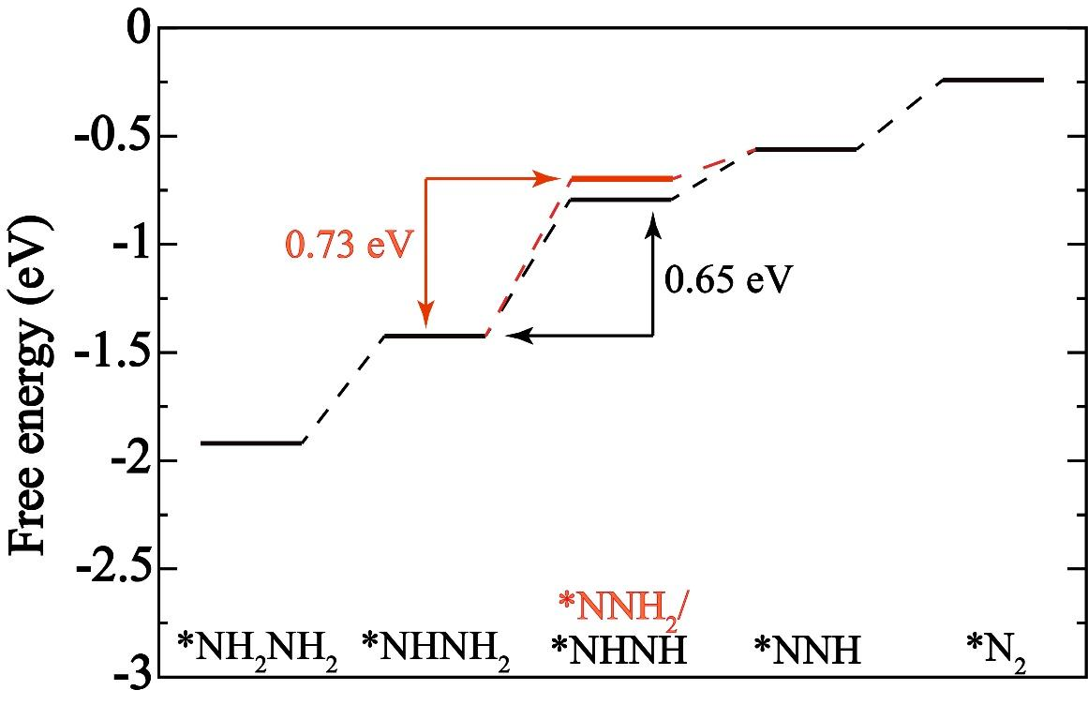
Figure 4: Free energy diagram of NH₂NH₂ oxidation reaction containing both alternating and distal mechanism.

At U = 0V, all the elementary steps are uphill for both distal and alternating mechanism. However, for alternating mechanism formation of *NHNH intermediate from *NHNH₂ intermediate is the rate determining step with endothermicity of 0.65 eV, and, for distal mechanism formation of *NNH₂ intermediate from *NHNH₂ intermediate is the rate determining step with endothermicity of 0. 73 eV. This is because, in *NHNH, there is N=N, however, only N-N in *NNH₂ as indicated by their bond lengths which makes *NHNH more stable intermediate on the surface in the absence of other extra stability for *NNH₂ intermediate. Therefore, alternating mechanism of oxidation of hydrazine is more favorable than the distal mechanism over the (111) surface of HEA.
To understand the assistance of oxygen evolution reaction (OER) towards the oxidation of hydrazine, partial density of states for gaseous initial reactant molecules H₂O and NH₂NH₂ was calculated along with the bader charge of *NH₂NH₂ oxidation intermediates. Adsorbed *NH₂NH₂ donates electron back to the surface as evident from the antibonding nature of its HOMO³² and its bader charge of 0.32. Moreover, for H₂O the HOMO is non-bonding in nature⁴⁰. Therefore, both H₂O and NH₂NH₂ donates electrons to the HEA surface. According to the DOS calculations, the HOMO of H₂O and NH₂NH₂ is situated at -6.63 eV and -2.43 respectively and the Fermi level of HEA is at -1.69 eV (Figure 5). Due to small energy gap, NH₂NH₂ can easily transfer electrons in comparison with H₂O. However, after the adsorption of NH₂NH₂, it forms *NHNH₂ which accepts electron from the surface according to negative bader charge (-0.02 eV). Due to which, The electron density from the surface decreases and the energy of Fermi level and its gap with the HOMO of H₂O decreases. Therefore, in the experiment, OER is not observed in the absence of NH₂NH₂ oxidation.
After the formation of *NHNH₂, it further forms *NHNH, which has larger negative bader charge (-0.05). Having higher electron pulling capacity, *NHNH becomes more stabilized on the surface in comparison with the *NHNH₂ by the electron donating effect of H₂O. Therefore, the endothermicity of the rate determining step in the alternating mechanism of NH₂NH₂ oxidation decreases and both OER and NH₂NH₂ oxidation assist each other on the HEA surface.

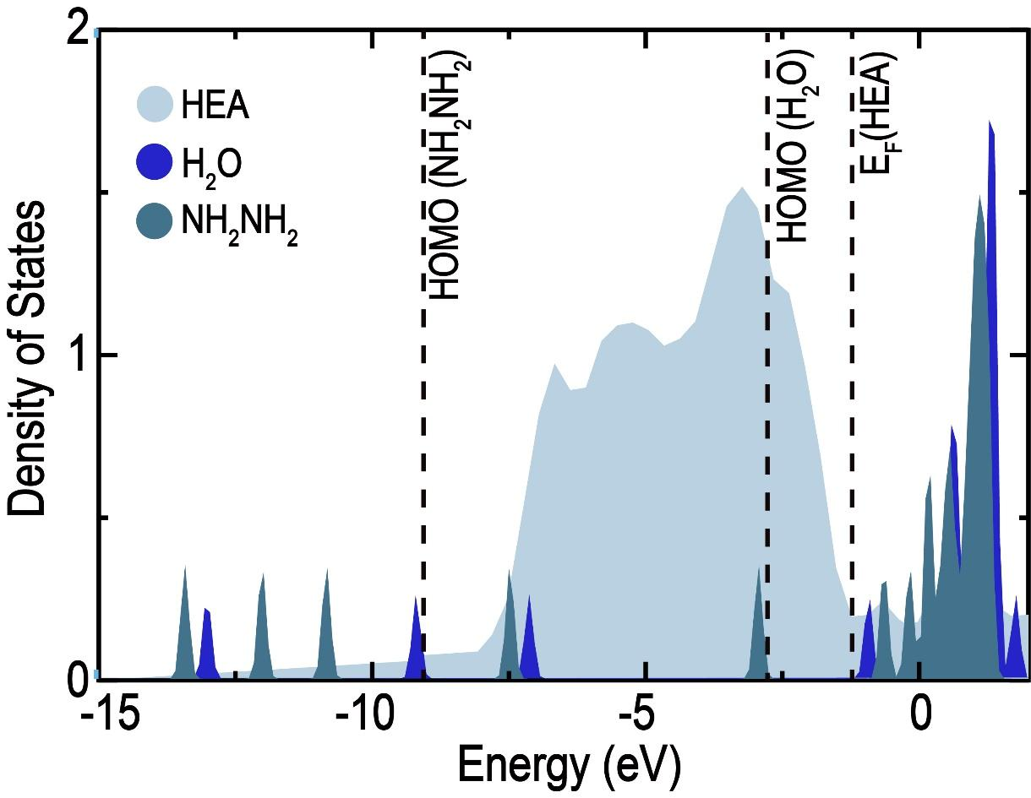
Figure 5: Density of states comparative plot of the initial reactants

Continuous monitoring of the product
It is essential to measure the continuous real-time monitoring of the gases generated during hydrazine oxidation. This monitoring is important to rule out any ammonia formation as a side reaction⁴¹⁻⁴³ or any activity loss transiently. Hence, analysis of the output gases was carried out using an online mass spectrometer connected to the electrochemical cell. The working electrode was prepared in the form of a thin film by spin coating slurry onto an FTO to obtain a large surface area. Figure 3(d) shows the mass spectrometer response during the chronoamperometry at 0.3 V. Here, N₂ is visible, discarding any possibility of gaseous ammonia formation during the electrooxidation process. Further, the signal remains constant for more than an hour, confirming the stability of the HEA catalyst. Stability is further tested by analyzing the electrolyte after long duration of chronoamperometry. This is to ensure that there is minimal to no dissolution and the current is indeed due to the electrochemical processes. ICP analysis (Table S1) showed that there is only 0.23% dissolution of all the metal components collectively. Thus, the HEA catalyst is stable, and the activity is indeed due to the electrochemical processes. To assess the morphological, bulk and surface stability, HRTEM, XRD and XPS are carried out after 2.0 hours of continuous HzOR in 500 µL of hydrazine added buffer medium. Here the working electrode is prepared by depositing HEA nanoparticles over the FTO substrate. After the reaction, the HEA materials still exist in FCC crystal structure as revealed by HRTEM and SADP [Figure S11(a-d)] with no extra or separated phase confirming minimal to no change in the morphology. The X-ray diffraction pattern also confirmed similar observations thus, there were no bulk changes in the materials. An additional peak around 52º is due to the fluorine-doped tin oxide (FTO) substrate [Figure S11(e)]. As catalysis is a surface phenomenon, surface characterization is essential. Therefore, surface-sensitive X-ray photoelectron spectroscopy analysis is also performed and compared with as-prepared catalyst materials. While the as prepared material shows the metallic character of the elements with small broadening in the peaks due to alloying (Figure 2), significant changes are observed after the reaction for all the constituent metals. The peaks related to Pt, Au, Pd, Cu and Ag show the shoulder peak towards higher binding energy [Figure S12 (a-e)] due to the formation of hydroxide over the surface. The formation of hydroxide is expected under the oxidizing conditions used in the HzOR. Thus, the HEA catalyst is durable within all measurable characteristics.
A comparison table consisting of the detailed performance of various catalysts available in the literature is given in the supporting information (Table S2). There are very few studies that use the PBS buffer or neutral electrolyte as the reaction medium similar to the present work. It is clear from the table that HEA is far superior to all the catalysts compared. It is worth noticing that, universally, no study has attempted to quantify the gaseous products to identify the contributions from HzOR and OER, which is a unique perspective in this work.

Conclusion
HEA nanoparticles are excellent catalysts for HzOR at low overpotential, along with OER as the accompanying reaction. Current densities of the order of 17.7 mA/cm² (for 250 µL hydrazine added) are obtained at 0.3 V, demonstrating the very high activity of HEAs in the buffer medium. An increase in hydrazine concentration leads to the linear increase in the current density suggesting the excellent electro-transfer properties of HEA or the oxidation process is mass transfer controlled. Gas chromatography analysis illustrates the formation of nitrogen and oxygen. Production of oxygen at 0.3 V is due to the OER reaction, which is activated at potentials as low as 0.3 V (Ag/AgCl) or 1.13 V (RHE) closer to the thermodynamic voltage of OER. The contribution of HzOR and OER in the overall oxidation process is 75% and 25% confirming the major contribution of OER in the presence of HzOR. Hydrogen as the counter product is also detected. Faradaic efficiency significantly underestimates the product quantification; therefore, there must be an occurrence of chemical reaction along with the electrochemical reactions. Mass spectrometry analysis displays the continuous formation of N₂ for over an hour without any transient loss of activity, explaining the unique stability of the HEA catalyst. Further, ICP and post-reaction characterization confirms that the metallic components in HEA are stable during catalysis as well as against any dissolution. Density functional theory calculations showed the favourable HzOR with endothermicity of 0.65 eV in an alternating mechanism at Pt-Pt bridge site over HEA. This can further be reduced by the assistance of OER, where the electron-donating effect of H₂O stabilises the reactant, *NHNH₂ less than the product, *NHNH in the rate-determining elementary step. Moreover, electron acceptance of *NHNH₂ from the surface decreases the energy gap between the Fermi level of HEA and the highest occupied molecular orbital (HOMO) of H₂O that helps in favourable OER.

ASSOCIATED CONTENT
Supporting information
Cyclic voltammetry results supporting the main articles, Figure S1, S2 and Figure S3. The DFT supporting result and atomic visualization Figure S4-S10. The post-reaction materials characterizations Figure S11-S12 and a schematic of proceeding reaction on the catalyst surface, Figure S13.
The materials and methods like HEA nanoparticles preparation, materials characterizations techniques and electrochemical characterizations process.
AUTHOR INFORMATION
Corresponding authors
Krishanu Biswas--Departmental of Materials Science and Engineering, Indian Institute of Technology Kanpur, Uttar Pradesh; orcid.org/0000-0001-5382-9195; Email: kbiswas@iitk.ac.in
Abhishek Kumar Singh- Materials Research Centre, Indian Institute of Science, Bangalore, Karnataka 560012, India
orcid.org/0000-0002-7631-6744, Email: abhishek@iisc.ac.in
Chandra Sekhar Tiwary-Departmental of Metallurgical and Materials Engineering, Indian Institute of Technology Kharagpur, West Bengal-721302; orcid.org/0000-0001-9760-9768; Email: Chandra.tiwary@metal.iitkgp.ac.in
Sudhanshu Sharma- Department of Chemistry, Indian Institute of Technology Gandhinagar, Gujarat-382355
orcid.org/0000-0002-5217-9941; Email: ssharma@iitgn.ac.in
Notes
The authors declare no competing financial interest.
ACKNOWLEDGEMENTS
KB acknowledges financial support from DST-SERB (EMR/2016/006217/MMM). SS acknowledges DST-SERB (EMR/2016/000806) and MHRD (STARS/APR2019/CS/215/FS) projects for the funding and fellowship. CST is thankful for the support by AOARD Grant no. FA2386-19-1-4039. CST acknowledges Ramanujan fellowship. NKK acknowledges the Newton International Fellowship Royal Society UK (NIF\R1\191571). AKS thank Material Research Centre and Supercomputer Educational and Research Centre, Indian Institute of Science, Bangalore, for the computational facilities.
Reference:
(1) Brockway, P. E.; Owen, A.; Brand-Correa, L. I.; Hardt, L., Estimation of global final-stage energy-return-on-investment for fossil fuels with comparison to renewable energy sources. Nat. Energy 2019, 4 (7), 612-621.
(2) Kumar. J, C. R.; Majid, M. A., Renewable energy for sustainable development in India: current status, future prospects, challenges, employment, and investment opportunities. Energy Sustain. Soc. 2020, 10 (1), 2.
(3) Andreadis, G.; Stergiopoulos, V.; Song, S.; Tsiakaras, P., Direct ethanol fuel cells: The effect of the cell discharge current on the products distribution. Appl. Catal. B-Environ. 2010, 100 (1), 157-164.
(4) Bender, M. T.; Lam, Y. C.; Hammes-Schiffer, S.; Choi, K.-S., Unraveling Two Pathways for Electrochemical Alcohol and Aldehyde Oxidation on NiOOH. J. Am. Chem. Soc. 2020, 142 (51), 21538-21547.
(5) Kowal, A.; Port, S. N.; Nichols, R. J., Nickel hydroxide electrocatalysts for alcohol oxidation reactions: An evaluation by infrared spectroscopy and electrochemical methods. Catal. Today 1997, 38 (4), 483-492.
(6) Lin, L.; Zhou, W.; Gao, R.; Yao, S.; Zhang, X.; Xu, W.; Zheng, S.; Jiang, Z.; Yu, Q.; Li, Y.-W.; Shi, C.; Wen, X.-D.; Ma, D., Low-temperature hydrogen production from water and methanol using Pt/α-MoC catalysts. Nature 2017, 544 (7648), 80-83.
(7) Boggs, B. K.; King, R. L.; Botte, G. G., Urea electrolysis: direct hydrogen production from urine. Chem Comm 2009, (32), 4859-4861.
(8) Cataldo Hernández, M.; Russo, N.; Panizza, M.; Spinelli, P.; Fino, D., Electrochemical oxidation of urea in aqueous solutions using a boron-doped thin-film diamond electrode. Diam. Relat. Mater. 2014, 44, 109-116.
(9) Lu, Z.; Sun, M.; Xu, T.; Li, Y.; Xu, W.; Chang, Z.; Ding, Y.; Sun, X.; Jiang, L., Superaerophobic Electrodes for Direct Hydrazine Fuel Cells. Adv. Mater. 2015, 27 (14), 2361-2366.
(10) Asazawa, K.; Yamada, K.; Tanaka, H.; Oka, A.; Taniguchi, M.; Kobayashi, T., A Platinum-Free Zero-Carbon-Emission Easy Fuelling Direct Hydrazine Fuel Cell for Vehicles. Angew. Chem. Int. Ed. 2007, 46 (42), 8024-8027.
(11) Babar, P.; Lokhande, A.; Karade, V.; Lee, I. J.; Lee, D.; Pawar, S.; Kim, J. H., Trifunctional layered electrodeposited nickel iron hydroxide electrocatalyst with enhanced performance towards the oxidation of water, urea and hydrazine. J. Colloid Interface Sci. 2019, 557, 10-17.
(12) Wang, J.; Kong, R.; Asiri, A. M.; Sun, X., Replacing Oxygen Evolution with Hydrazine Oxidation at the Anode for Energy-Saving Electrolytic Hydrogen Production. ChemElectroChem 2017, 4 (3), 481-484.
(13) Petrii, O. A., Pt–Ru electrocatalysts for fuel cells: a representative review. J Solid State Electrochem 2008, 12 (5), 609.
(14) Serov, A.; Kwak, C., Direct hydrazine fuel cells: A review. Appl. Catal. B-Environ. 2010, 98 (1), 1-9.
(15) Kim, H.; Oh, S.; Cho, E.; Kwon, H., 3D Porous Cobalt–Iron–Phosphorus Bifunctional Electrocatalyst for the Oxygen and Hydrogen Evolution Reactions. ACS Sustain. Chem. Eng. 2018, 6 (5), 6305-6311.
(16) May, K. J.; Carlton, C. E.; Stoerzinger, K. A.; Risch, M.; Suntivich, J.; Lee, Y.-L.; Grimaud, A.; Shao-Horn, Y., Influence of Oxygen Evolution during Water Oxidation on the Surface of Perovskite Oxide Catalysts. J. Phys. Chem. Lett. 2012, 3 (22), 3264-3270.
(17) McCrory, C. C.; Jung, S.; Peters, J. C.; Jaramillo, T. F., Benchmarking heterogeneous electrocatalysts for the oxygen evolution reaction. J. Am. Chem. Soc. 2013, 135 (45), 16977-16987.
(18) Liu, H.; Liu, Y.; Li, M.; Liu, X.; Luo, J., Transition-metal-based electrocatalysts for hydrazine-assisted hydrogen production. Mater. Today Adv. 2020, 7, 100083.
(19) Sakamoto, T.; Kishi, H.; Yamaguchi, S.; Matsumura, D.; Tamura, K.; Hori, A.; Horiuchi, Y.; Serov, A.; Artyushkova, K.; Atanassov, P.; Tanaka, H., Mechanism Study of Hydrazine Electrooxidation Reaction on Nickel Oxide Surface in Alkaline Electrolyte by In Situ XAFS. J. Electrochem. Soc. 2016, 163 (10), H951-H957.
(20) Eisenberg, R.; Gray, H. B., Preface on Making Oxygen. Inorg. Chem. 2008, 47 (6), 1697-1699.
(21) Jafarian, M.; Rostami, T.; Mahjani, M. G.; Gobal, F., A low cost and highly active non-noble alloy electrocatalyst for hydrazine oxidation based on nickel ternary alloy at the surface of graphite electrode. J. Electroanal. Chem 2016, 763, 134-140.
(22) Wang, Y.; Liu, X.; Tan, T.; Ren, Z.; Lei, Z.; Wang, W., A phosphatized pseudo-core-shell Fe@Cu-P/C electrocatalyst for efficient hydrazine oxidation reaction. J. Alloy Compd. 2019, 787, 104-111.
(23) Wang, Z.; Xu, L.; Huang, F.; Qu, L.; Li, J.; Owusu, K. A.; Liu, Z.; Lin, Z.; Xiang, B.; Liu, X.; Zhao, K.; Liao, X.; Yang, W.; Cheng, Y.-B.; Mai, L., Copper–Nickel Nitride Nanosheets as Efficient Bifunctional Catalysts for Hydrazine-Assisted Electrolytic Hydrogen Production. Adv. Eng. Mater. 2019, 9 (21), 1900390.
(24) Zhang, J.-Y.; Wang, H.; Tian, Y.; Yan, Y.; Xue, Q.; He, T.; Liu, H.; Wang, C.; Chen, Y.; Xia, B. Y., Anodic Hydrazine Oxidation Assists Energy-Efficient Hydrogen Evolution over a Bifunctional Cobalt Perselenide Nanosheet Electrode. Angew. Chem. Int. Ed. 2018, 57 (26), 7649-7653.
(25) Wang, J.; Ma, X.; Liu, T.; Liu, D.; Hao, S.; Du, G.; Kong, R.; Asiri, A. M.; Sun, X., NiS2 nanosheet array: A high-active bifunctional electrocatalyst for hydrazine oxidation and water reduction toward energy-efficient hydrogen production. Mater. Today Eng. 2017, 3, 9-14.
(26) Uddin, M. E.; Kim, N. H.; Kuila, T.; Lee, S. H.; Hui, D.; Lee, J. H., Preparation of reduced graphene oxide-NiFe2O4 nanocomposites for the electrocatalytic oxidation of hydrazine. Compos. Part B-Eng. 2015, 79, 649-659.
(27) Tang, C.; Zhang, R.; Lu, W.; Wang, Z.; Liu, D.; Hao, S.; Du, G.; Asiri, A. M.; Sun, X., Energy-Saving Electrolytic Hydrogen Generation: Ni2P Nanoarray as a High-Performance Non-Noble-Metal Electrocatalyst. Angew. Chem. Int. Ed. 2017, 56 (3), 842-846.
(28) Hosseini, M. G.; Mahmoodi, R.; Abdolmaleki, M., High performance direct hydrazine–hydrogen peroxide fuel cell using reduced graphene oxide supported Ni@M (M = Pt, Pd, Ru) nanoparticles as novel anodic electrocatalysts. New J. Chem. 2018, 42 (14), 12222-12233.
(29) Miracle, D. B.; Senkov, O. N., A critical review of high entropy alloys and related concepts. Acta Materialia 2017, 122 (Supplement C), 448-511.
(30) Wang, Z.; Zhang, L.; Li, W.; Qin, Z.; Wang, Z.; Li, Z.; Tan, L.; Zhu, L.; Liu, F.; Han, H.; Jiang, L., A high-throughput approach to explore the multicomponent alloy space: A case study of nickel-based superalloys. J. Alloy Compd. 2021, 858, 158100.
(31) Katiyar, N. K.; Nellaiappan, S.; Kumar, R.; Malviya, K. D.; Pradeep, K. G.; Singh, A. K.; Sharma, S.; Tiwary, C. S.; Biswas, K., Formic acid and methanol electro-oxidation and counter hydrogen production using nano high entropy catalyst. Mater. Today Eng. 2020, 16, 100393.
(32) Nellaiappan, S.; Katiyar, N. K.; Kumar, R.; Parui, A.; Malviya, K. D.; Pradeep, K. G.; Singh, A. K.; Sharma, S.; Tiwary, C. S.; Biswas, K., High-Entropy Alloys as Catalysts for the CO₂ and CO Reduction Reactions: Experimental Realization. ACS Catal. 2020, 10 (6), 3658-3663.
(33) Liu, W.; Xie, J.; Guo, Y.; Lou, S.; Gao, L.; Tang, B., Sulfurization-induced edge amorphization in copper–nickel–cobalt layered double hydroxide nanosheets promoting hydrazine electro-oxidation. J. Mater. Chem. A 2019, 7 (42), 24437-24444.
(34) Wang, A.-Q.; Chang, C.-M.; Mou, C.-Y., Evolution of Catalytic Activity of Au−Ag Bimetallic Nanoparticles on Mesoporous Support for CO Oxidation. J. Phys. Chem. B 2005, 109 (40), 18860-18867.
(35) Kumar, N.; Tiwary, C. S.; Biswas, K., Preparation of nanocrystalline high-entropy alloys via cryomilling of cast ingots. J. Mater. Sci. 2018, 53 (19), 13411-13423.
(36) Rao, C. N. R.; Ramakrishna Matte, H. S. S.; Voggu, R.; Govindaraj, A., Recent progress in the synthesis of inorganic nanoparticles. Dalton Transactions 2012, 41 (17), 5089-5120.
(37) Shyu, J. Z.; Otto, K., Identification of platinum phases on γ-alumina by XPS. Appl. Surf. Sci. 1988, 32 (1), 246-252.
(38) Nelsen, S. F.; Blackstock, S. C.; Yumibe, N. P.; Frigo, T. B.; Carpenter, J. E.; Weinhold, F., Syn and anti bent hydrazine radical cations. Effect of .sigma.,.pi. mixing on spectral properties. J. Am. Chem. Soc. 1985, 107 (1), 143-149.
(39) Herron, J. A.; Ferrin, P.; Mavrikakis, M., Electrocatalytic Oxidation of Ammonia on Transition-Metal Surfaces: A First-Principles Study. J. Phy. Chem. C 2015, 119 (26), 14692-14701.
(40) Ayed, T.; Hernández Lamoneda, R.; Janda, K. C., Theoretical Study of the Potential Energy Surfaces of the Van Der Waals H2O−X2+ (X = Cl or Br) Complexes. The Journal of Physical Chemistry A 2008, 112 (4), 722-727.
(41) Zheng, M.; Cheng, R.; Chen, X.; Li, N.; Li, L.; Wang, X.; Zhang, T., A novel approach for CO-free H2 production via catalytic decomposition of hydrazine. Int. J. Hydrog. Energy 2005, 30 (10), 1081-1089.
(42) Oliaee, S. N.; Zhang, C.; Hwang, S. Y.; Cheung, H. M.; Peng, Z., Hydrogen Production via Hydrazine Decomposition on Model Platinum–Nickel Nanocatalyst with a Single (111) Facet. J. Phy. Chem. C 2016, 120 (18), 9764-9772.
(43) Yamada, K.; Yasuda, K.; Tanaka, H.; Miyazaki, Y.; Kobayashi, T., Effect of anode electrocatalyst for direct hydrazine fuel cell using proton exchange membrane. J. Power Sources 2003, 122 (2), 132-137.
TOC

