**Strength, durability and leaching properties of concrete paving blocks incorporating GGBS and SF**

Vireen Limbachiya*, Eshmaiel Ganjian, Peter Claisse *Coventry University, Faculty of Engineering and Computing, Civil Engineering, Architecture and Building, Coventry, UK * Corresponding Author, Email:* [limbachv@uni.coventry.ac.uk](mailto:limbachv@uni.coventry.ac.uk)

**Abstract**

Ternary blends are a response to the economic and environmental pressure to reduce the cement content of concrete paving blocks. The cementitios materials used to replace Ordinary Portland cement (OPC) were Ground Granulated Blast Furnace Slag (GGBS) and Silica fume (SF).The study reported on the optimised mix from analysis of cement paste cubes. Thereafter the two mixes with the greatest strength were produced in the factory. The study successfully reduced the cement content of concrete paving blocks by 40% and managed to achieve greater strengths than the control mix. The leaching analysis reported that the higher permeability of mixes containing cement replacements resulted in these mixes absorbing less leachate, however gave satisfying performance for protection of leachate to ground sources.

1. **Introduction**

Concrete provides many advantages for the construction industry and especially in the application of concrete paving blocks. These advantages include enhanced durability, low maintenance requirements and being aesthetically pleasing to the consumer. By reducing the cement content, this work aims to retain those advantages while reducing the high economic and environmental cost.

Cementitios constituents allow for cement reduction in concrete mixes, while maintaining and in some cases enhancing the strength and durability properties. The pozzolanic materials produce strength primarily through the reaction between the Ca(OH)2 from initial cement hydration and SiO2 in the pozzolanic materials. This leads to a greater quantity of CaO–SiO2–H2O (C–S–H) formulation [1], which allows for the development of strength and durability properties.

Ground granulated blast furnace slag (GGBS) and Silica fume (SF) are two cement replacements which have grown in popularity. GGBS is a by-product from blast furnaces used to make iron. Advantages of GGBS are: greater compressive and flexible strengths, greater workability and the ability to produce a denser matrix [2] [3]. GGBS provides greater mechanical and durability properties as it significantly decreases both the content and the size of Ca(OH)2 crystals in the aggregate-paste interface, which makes the microstructure of the transition zone aggregate/binder dense and strong [4].The effect of GGBS as a cement replacement was examined on concrete interlocking paving blocks [2]. GGBS was used to replace cement by up to 60% in increments of 10% and the blocks were tested on 3, 7, 28, 90 and 180 days. Results showed that as curing period increases the compressive and splitting tensile strength increases. The splitting tensile strength required meeting the standards (BS EN 1338:2003) [5] and therefore the best strengths were obtained for mixes containing between 20-60% GGBS replacement [2]

SF is a by-product of induction arc furnaces in the silicon metal and ferrosilicon alloy industries [6]. It has been reported that in a cement based system, SF not only works as a micro-filler that refines the pore structure, but also effectively consumes the calcium hydroxide (Ca(OH)2) which leads to the formation of extra hydrated gels; resulting in enhanced strength properties [7] Therefore the three roles that describe the mechanism of SF in concrete are pore size refinement/matrix densification, reaction with free lime and cement paste-aggregate interfacial refinement [8]. Freeze thaw resistance, abrasion resistance and water absorption of concrete incorporating SF has been reviewed [9] [10] [11]. All studies concluded that the inclusion of SF improved the durability properties. The studies attributed it to the improved bond between the aggregate particles and paste, due to its chemical and physical effects that resulted in greater matrix densification.

Sustainable urban drainage systems (SUDs) are one of the reasons for the growing application of concrete paving blocks. The schematic of the system allows for oil and other contaminates to be biodegraded and therefore not cause harm to the soil beneath. If paving blocks are used without this system on driveways and roads then these harmful contaminants have the potential to contaminate the soil beneath. Therefore as well as determining mechanical and durability properties it is important for the purpose of this study to examine the leaching properties of the blocks. This will allow the study to conclude that if SUDs technology is not implemented then the blocks containing cementitious replacements have the potential to absorb a greater quantity of contaminants in comparison to the control mix.

The aim of this study was to find the optimum OPC/GGBS/SF blend for concrete paving blocks using a statistical program. Thereafter examine the two best mixes for the mechanical/durability properties stated in BS EN 1338:2003 [5] as well as the leaching properties of blocks produced in factory settings.

1. **Materials**

**2.1 Original Portland cement**

The OPC fulfilled the requirements of BS EN 197-1 CEM I [12] and was supplied by Hanson Heidelberg Cement group. Table 1 shows the chemical composition of OPC. The average particle size was around 38µm.

**2.2 Silica Fume**

SF used in this study had a typical bulk density of 200-350 Kg/m3. The quality assurance of the SF is covered by BS EN ISO 9001 [13] and complies with ASTM C-1240 [14] and CAN/CSA-A23.5 [15] standards for SF and with new European standards BS EN 13263[16]. Table 1 shows the chemical composition of SF. The average particle size was around 0.7µm.

**2.3 Ground granulated blast furnace slag**

Hanson provided the GGBS for this study from the Port Talbot plant that is situated near the Port Talbot docks. The material was obtained from this plant because if this material was to be successful then this is closest source to the manufacturing plant and the GGBS from this plant is likely to be the one being used. Table 1 shows the chemical composition of GGBS. The average particle size was around 20µm

**Table 1 Chemical composition of OPC, GGBS and SF**

|  |  |  |  |  |  |  |  |  |  |  |  |
| --- | --- | --- | --- | --- | --- | --- | --- | --- | --- | --- | --- |
| Composition | SiO2 | TiO2 | Al2O3 | Fe2O3 | MnO | MgO | CaO | Na2O | K2O | P2O5 | SO3 |
| OPC (%) | 19.42 | 0.36 | 4.55 | 2.49 | 0.02 | 1.03 | 60.60 | 0.22 | 0.57 | 0.20 | 3.62 |
| SF (%) | 94.21 | 0.01 | 0.48 | 0.71 | 0.01 | 0.55 | 0.37 | 0.35 | 1.15 | 0.04 | 0.17 |
| GGBS (%) | 33.28 | 0.57 | 13.12 | 0.32 | 0.32 | 7.74 | 37.16 | 0.33 | 0.48 | 0.01 | 2.21 |

**2.4Aggregates**

Three different types of aggregates were used in this study and the sieve analysis and density are shown in Table 2.

**Table 2 Sieve analysis and density of aggregates**

|  |  |  |  |  |  |  |  |  |
| --- | --- | --- | --- | --- | --- | --- | --- | --- |
| Aggregate | Sieve size | | | | | |  | Density  (Kg/m3) |
|  | **10mm** | **5mm** | **2.35mm** | **1.18mm** | **600µm** | **600µm** | **600µm** |  |
| 4mm-dust | 100 | 100 | 71 | 42 | 8 | 3 | 0 | 2718 |
| 6mm | 100 | 54 | 20 | 17 | 16 | 14 | 8 | 2691 |
| Sand | 100 | 100 | 99 | 96 | 88 | 33 | 3 | 2021 |

1. **Experimental program**

Concrete paving blocks differ from normal concrete products. The main difference between regular concrete products and concrete paving blocks is the cement/aggregate ratio. The high aggregate content in concrete paving blocks results in a semi dry concrete mix. Secondly, when paving blocks are produced they are simultaneously vibrated and powerfully compacted into the shape of the block in order to reduce voids and increase the density. As this manufacturing process could not be replicated in the laboratory the blocks were produced using a technique that was developed at Coventry University [17]. The technique developed involved solely compaction of the blocks.

The experiment was split into two phases. First phase involved producing samples in the laboratory. They were initially semi-dry cement pastes, which were designed and analysed using a statistical program, the 4 best mixes from these were then used to produce concrete blocks. When introducing cement replacements to concrete paving blocks the most difficult and critical property to obtain is the splitting tensile strength, which is the only mechanical property required in BS EN 1338:2003[5]. Therefore in the preliminary phase, the study solely focused on analysing this property.

For cement pastes the statistical program (Minitab)[18] generated the vertices of the constrained design space (Lower Limit < Material < Upper Limit) and then calculated the centroid point up to the specified degree using Piepel’s CONAEV algorithm. As the main aim was to have high levels of cement replacement the upper boundaries for OPC, GGBS and SF were 60%, 80% and 15% respectively and all lower boundaries were 0%. Table 3 and Figure 1 show the mix design and simplex plot design respectively.

The two mixes with the greatest strength progressed to the second phase of the program in which the blocks were produced in a paving block factory. These mixes were tested for the strength and durability properties stated in BS EN 1338:2003 [5]. As well as this the blocks were tested for their leaching properties.

**Table 3 Mix design for cement pastes**

|  |  |  |  |
| --- | --- | --- | --- |
| Mix | OPC (%wt) | GGBS  (%wt) | SF (%wt) |
| 1 | 60 | 25 | 15 |
| 2 | 12.5 | 80 | 7.5 |
| 3 | 28.13 | 68.12 | 3.75 |
| 4 | 20.63 | 68.12 | 11.25 |
| 5 | 20 | 80 | 0 |
| 6 | 60 | 40 | 0 |
| 7 | 48.13 | 40.62 | 11.25 |
| 8 | 36.25 | 56..25 | 7.5 |
| 9 | 5 | 80 | 15 |
| 10 | 60 | 32.5 | 7.5 |
| 11 | 48.13 | 48.12 | 3.75 |

**Figure 1 Simplex plot design (OPC-GGBS-SF)**

**3.1 Casting, Curing and Testing**

The splitting tensile strength was obtained for concrete blocks following the procedure stated in BS EN 1338:2003[5] and for the paste cubes the same procedure was scaled down and replicated. The paste cubes had a dimension of 50 x 50 x 50mm. The compaction load for the cubes was 52KN and the loading rate for the compressive and splitting tensile strength was 2KN/s and 0.248 KN/s respectively. The pastes were tested at 14 days and had a w/cm ratio of 0.15. The standards state no specific date on when the minimum strength should be achieved and from an industry perspective, the mix with the greatest early age strength would be preferred. The paving blocks produced had dimensions of 190 x 100 x 75 m and a w/cm ratio of 0.25. The compaction load for the blocks produced in the laboratory was 400KN and the loading rate for the splitting tensile strength was 1.157 KN/s. The paving blocks were tested at 14 and 28 days.

The durability properties measured were abrasion resistance, water absorption, freeze thaw resistance and slip/skid resistance. The abrasion resistance was determined using the principle of wide wheel abrasion test. The test was carried out under conditions stated in BS EN 1338:2003[5] and as stated was carried out by abrading the upper face of a paving block with an abrasive material under standard conditions. To obtain water absorption, after 28 days the blocks were placed for 3 days in a water tank with a temperature of 20±5oC. Thereafter for 3 days in the oven with a temperature of 105±5oC, until they reached their constant mass. Freeze thaw resistance of blocks was carried out under conditions stated in BS EN 1338:2003[5]. As stated, the freezing medium consisted of 97% by mass of potable water and 3% by mass of NaCl. After 28 cycles the mass loss per unit area of the specimen was calculated based on the mass (Kg) of the total quantity material scaled after 28 cycles and the area of the test surface (m2). To obtain slip/skid resistance the study used pendulum friction test equipment to evaluate the frictional properties of the specimen on the upper face.

The curing procedure replicated the procedure developed at Coventry University [17]. As stated, once cast, the specimens were covered with a polythene sheet so that there would be no loss of water. On the next day, all samples were de-moulded and stored in curing chambers at a constant air temperature of 22 ± 2oC and 98%RH until they were ready to be tested.

The leachate used in this study was derived from used oil concentrations rather than new oil concentrations, as they had a greater concentration of heavy metals therefore greater potential to contaminate the soil below. These concentrations are shown in Table 4 and were obtained from a study conducted to analyse the effect of used oil in permeable paving systems [19]. Once produced from salts and solutions the leachate was passed through the blocks and analysed using inductive coupled plasma (ICP). This was in order to determine if any blocks with replacement materials had the potential to be greater absorbents of the leachate.

**Table 4 Properties of synthetic leachate [16]**

|  |  |  |  |  |  |  |  |  |
| --- | --- | --- | --- | --- | --- | --- | --- | --- |
| Component | Al  mg/L | Cr  mg/L | Cu  mg/L | Mg  mg/L | Mo  mg/L | P  mg/L | Pb  mg/L | Zn  mg/L |
| Used engine oil | 14.54 | 1.825 | 32.81 | 481.1 | 149.9 | 935.6 | 1.836 | 1200 |

1. **Results and discussion**

**4.1 First Phase**

|  |  |
| --- | --- |
| Mix | Splitting Tensile Strength (MPa) |
| 1 | 4.09 |
| 2 | 1.06 |
| 3 | 0.00 |
| 4 | 1.82 |
| 5 | 3.15 |
| 6 | 2.61 |
| 7 | 2.91 |
| 8 | 3.02 |
| 9 | 2.49 |
| 10 | 2.87 |
| 11 | 0.00 |

**Table 5 Splitting Tensile Strength at 14 days**



**Figure 2 14 day splitting tensile strength contour plot**

Figure 2 and Table 5 show the contour plot and splitting tensile strength for OPC-GGBS-SF semi-dry paste mixes respectively. When analysing the contour plots it is important to note that the accuracy of these plots and the analysis of the plots can only be conducted within the boundaries set. The mix that produced the greatest compressive strength (39.21 MPa) and splitting tensile strength (8.52 MPa) consisted of 60% OPC, 25% GGBS and 15% SF. The results showed that as SF replacement increases so did the strength. It is assumed that this is due to SF having two different effects on development property. The first of these is its high specific surface area that provides potential for greater reaction to occur and secondly, the micro-filler affect which results in strength enhancement from 7 days onwards [20]. As well as the particle distribution of SF having positive effects on strength, the chemical composition of SF also provides its own advantages. SF produces excess Calcium-Silicate- Hydrate (CSH) gel through the reaction of SiO2 in the SF and the calcium hydroxide (CH) after initial hydration as well as the CaO in the GGBS. In order to determine the accuracy of the model the regression value was used to determine the difference between actual results and predicted results. The P-value was obtained at a 95% confidence level and a limit of 0.05 was used to help decide whether to reject or fail to reject a null hypothesis. The equations that predicted the splitting tensile strength F(x) and produced the contour plots was:

*F(x) = 9.1(OPC) + 2.3(GGBS) + 145.4(SF) + 7.7(OPC*GGBS) – 142.2(OPC*SF) – 194.8(GGBS*SF)*

The r2 value for splitting tensile strength was 0.96. As it was above 0.9 it could be assumed that the contour plots gave an accurate representation for trends to be reported and validated. The p-value with a 95% confidence level for splitting tensile strength was 0.00. As this values was below 0.05 it could be assumed that the hypothesis determined from the contour plots can confidently be assured.

The four best mixes (OPC60/GGBS25/SF15, OPC60/GGBS30/SF10, OPC50/ GGBS40/SF10 and OC60/GGBS32.5/SF7.5) from the analysis of semi-dry paste were then used to produce concrete paving blocks in the laboratory. Table 6 reports on the splitting tensile strength at 14 and 28 days for these mixes. The results show that no mix achieved the minimum strength of 3.6MPa that is required by BS EN 1338:2003 [5]. The two mixes with the greatest strength consisted of OPC60/GGBS25/SF15 and OPC60/GGBS30/SF10. These two mixes were known as the candidate mixes and were produced in factory settings.

**Table 6 Splitting tensile strength of concrete paving blocks (Produced in laboratory)**

|  |  |  |  |  |
| --- | --- | --- | --- | --- |
| Days | Splitting Tensile Strength (MPa) | | | |
|  | **OPC50/ GGBS40/SF10** | **OPC60/**  **GGBS30/SF10** | **OPC60/**  **GGBS25/SF15** | **OC60/**  **GGBS32.5/SF7.5** |
| 14 | 1.8 | 2 | 2.5 | 2 |
| 28 | 2.3 | 2.8 | 3.2 | 2.4 |

* 1. **Chemical analysis**

Table 7 provides the oxide composition of the three ternary blends that produced the greatest strength. Samples were used to produce fusion beads in order to determine the concentrations of the major element using X-ray fluorescence analysis (XRF). XRF was determined using a PW2400 instrument. Results show that as SF levels increased, as did the SiO2 content. As SiO2 levels increased it is assumed that strengths increased primarily through SF producing excess Calcium-Silicate- Hydrate (CSH) gel through the reaction of SiO2 in the SF and the calcium hydroxide (CH) after initial hydration as well as the CaO in the GGBS.

|  |  |  |  |  |  |  |  |  |  |  |  |
| --- | --- | --- | --- | --- | --- | --- | --- | --- | --- | --- | --- |
| Composition | SiO2 (%) | TiO2 (%) | Al2O3 (%) | Fe2O3 (%) | MnO (%) | MgO (%) | CaO (%) | Na2O (%) | K2O (%) | P2O5 (%) | SO3 (%) |
| OC60/GGBS25/SF15 | 33.91 | 0.45 | 5.76 | 1.56 | 0.12 | 3.10 | 44.82 | 0.25 | 0.59 | 0.1 | 2.39 |
| OPC60/GGBS30/SF10 | 31.60 | 0.45 | 5.72 | 1.63 | 0.11 | 3.02 | 46.25 | 0.25 | 0.58 | 0.11 | 2.45 |
| OPC60/GGBS32.5/SF7.5 | 28.94 | 0.47 | 5.94 | 1.7 | 0.11 | 3.14 | 48.75 | 0.25 | 0.59 | 0.11 | 2.6 |

**Table 7 XRF analysis of paste mixes**

Figure 3 reports on the results of the X-ray diffraction (XRD) analysis. Samples were crushed and grinded to provide adequate fineness for XRD analysis to occur using a Philips 1820 diffractometer with a 20-position sample changer. The phases reported are Ettringite (calcium sulfoaluminate), Portlandite ((Ca(OH)2), Calcium Silicate (C3S) andLarnite(C2S). The lowest intensities were found for Ettringite, which is the mineral name for calcium sulfoaluminate (3CaO•Al2O3• 3CaSO4•32H2O).

Portlandite is (Ca(OH)2) a by-product from the formation of di-calcium silicate and tri-calcium silicate. In order to create a higher quantity of CSH, the SiO2 content within the cementitious constituent should produce this hydrate by reacting with the Portlandite. The lowest intensity of Portlandite can be seen in mix PC60/GGBS25/SF15. The reason for this is assumed to be due to the silica fume having fine particles as well as a high %wt. of SiO2 that would maximise the reaction with portlandite to create CSH.

Calcium silicate (Ca3SiO5) also known as tricalcium silicate is the most abundant phase that was reported. It is responsible for initial and early stage strength development. High intensities of calcium silicate was found in all mixes and this is assumed to be due to the combination, of the initial hydration process of OPC as well as the hydration products produced from the high levels of CaO in GGBS and SiO2 in SF.

Larnite (Ca2SiO4) also known as Dicalcium silicate is responsible for later stage strength development and hydrates and hardens over time. High intensities were once again assumed to be due to a combination of the initial hydration process of OPC as well as the hydration products produced from the high levels of CaO in GGBS and SiO2 in silica fume.

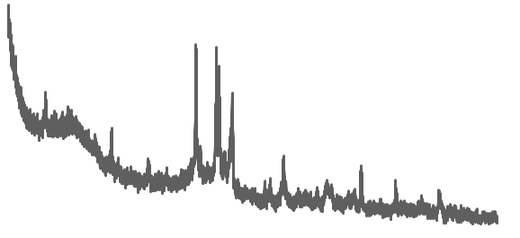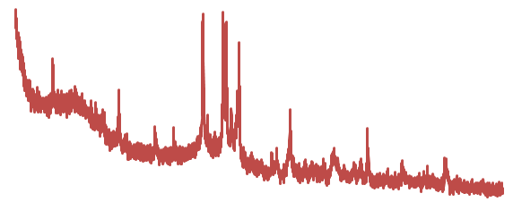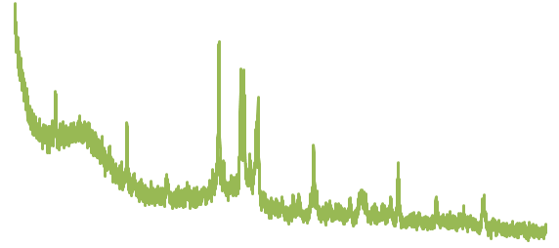

**Intensity (Lin-Counts)**

E

E

E

P

P

P

C

C

C

P C

P C

P C

L

L

L

C

C

C

C

C

C

P

P

**KEY**

**E= Ettringite Ca6Al2(SO4)3(OH)12(H2O)26 P= Portlandite Ca(OH)2 C= Calcium Silicate Ca3SiO5**

**L =Larnite Ca2SiO4**

**OPC60/GGBS25/SF15**

**OPC60/GGBS30/SF10**

**OPC60/GGBS32.5/SF7.5**

L C

L C

L C

**Figure 3 XRD analysis of paste mixes**

**4.3 Second phase**

**Splitting Tensile Strength**

Table 8 shows the splitting tensile strength for the 2 candidate mixes that were produced at the Hanson Formpave factory and tested at 2, 7, 14 and 28 days. The results show that the production differences between laboratory and factory make a noticeable difference to the strength of the blocks. For OPC60/GGBS30/SF10 the difference between laboratory and factory results at 14 and 28 days was 1 MPa and 0.63 MPa respectively. For OPC60/GGBS25/SF15 the difference between laboratory and factory results at 14 and 28 days was 1.01 MPa and 0.7 MPa respectively. The reason for the difference between the two results is because the specialist/designated equipment and curing conditions that the factory implements cannot be replicated in the laboratory. However it can be assumed based on these mixes that at 14 days the strength between laboratory and factory would be on average greater by 1.005MPa and at 28 days on average greater by 0.665 MPa. The results showed that OPC can successfully be reduced by 40% if it was to be replaced by 25% GGBS and 15% SF and at 28 days the results for this mix produces greater strengths than a mix containing 100%OPC.

**Table 8 Splitting tensile strength of concrete paving blocks (Produced in factory)**

|  |  |  |  |
| --- | --- | --- | --- |
| Days | Splitting Tensile Strength (MPa) | | |
|  | **Control** | **OPC60/GGBS30/SF10** | **OPC60/GGBS25/SF15** |
| 2 | 2.95 (Fail) | 2.35 (Fail) | 2.4 (Fail) |
| 7 | 3.3 (Fail) | 2.87 (Fail) | 3.17 (Fail) |
| 14 | 3.63 (Pass) | 3.01 (Fail) | 3.5 (Fail) |
| 28 | 3.7 (Pass) | 3.5 (Fail) | 3.83 (Pass) |

**Durability**

Table 9 reports on the water absorption rate of the two candidate mixes and the control mix.BS EN 1338:2003[5] states that no block shall have a water absorption rate of greater than 6%. All blocks achieved this minimum requirement. The two candidate mixes produced lower absorption rates than the control mix, with the mix containing OPC60/GGBS25/SF15 producing the lowest results (average of 3 blocks) of 3.43%. The reason for the lower absorption rate in comparison to the control mix is assumed to be due the greater particle packing as well as a greater interface between the aggregate and cement paste which allows for less pores to be available to store water. The difference in water absorption between OPC60/GGBS25/SF15 and OPC60/GGBS30/SF10 is assumed to be due to a greater pozzolanic reaction occurring from the increase in SF in OPC60/GGBS25/SF15. The higher level of fineness and greater quantity of SiO2 within SF results in a greater formation of CSH gel therefore, providing greater matrix densification and decrease in water absorption.

Testing of freeze thaw resistance showed that the quantity of scaled material for all blocks tested was minimal-zero and was well below the 1.0kg/m3 limit that was stated by BS EN 1338:2003 [5]. SF has a positive effect due it having a quicker hydration time and its greater pozzolanic reactivity, which comes from the finer particles and very high amorphous silicon dioxide content [21]. It is assumed that the positive effects of SF were achieved in combination with the CaO content in GGBS, resulting in high freeze thaw resistance.

The measurement of the unpolished slip resistance value (USRV) on the blocks was made using a pendulum friction tester and tested in accordance to the method stated in BS EN 1338:2003 [5]. There was a slight variability in results, however the slip/skid resistance is influenced greater by the finish of the block than the mix design itself. BS EN 1338:2003[5] states that any value above 75 results in a potential for slip being extremely low, it can be seen from Table 9 that all values were above this value therefore had extremely low possibilities for potential slipping.

The abrasion resistance of the blocks was measured in accordance in the test method described in annex G of BS EN 1338:2003 [5]. Table 8 shows the abrasion resistance of the two candidate mixes and control. The results showed all blocks fell within class 1 and should be used in areas of light pedestrian and vehicular use.

**Table 9 Durability properties of concrete paving blocks (Produced in factory)**

|  |  |  |  |  |
| --- | --- | --- | --- | --- |
| **Mix** | **Abrasion resistance (mm)** | **Average Slip/Skid resistance** | **Water absorption rate (%)** | **Freeze thaw resistance (kg/m3)** |
| **OPC60/GGBS30/SF10 *Sample 1*** | 24.5 | 120.4 | 3.47 | All blocks  < 1.0 |
| *Sample 2* | 23.5 | 116.2 | 3.83 |
| *Sample 3* | 23.5 | 121.8 | 3.22 |
| **OPC60/GGBS25/SF15 *Sample 1*** | 23 | 115.6 | 3.22 | All blocks  < 1.0 |
| *Sample 2* | 24 | 117.2 | 3.21 |
| *Sample 3* | 24 | 119 | 3.86 |
| Control  *Sample 1* | 23.5 | 111 | 3.50 | All blocks  < 1.0 |
| *Sample 2* | 23.5 | 112.6 | 3.52 |
| *Sample 3* | 23 | 114.4 | 3.80 |

**Leaching**

The leachate was created from salts and solutions. Salts were used to obtain Zn ( Zn (NO3)2 6H2O), Cu ( Cu (NO3)2 3H2O), P ( K H2 PO4) and Mg ( Mg SO4 7H2O) and the solutions were used for Pb, Cr, Al and Mo.

Once the solution was prepared, 50mm cores were drilled from the blocks at 28 days and tested. Figure 4 shows the setup of the experimental program for the high pressure permeability test. The test allowed for the core sample to be sealed within the chamber, allowing for leachate to solely pass through and not around the block. The duration of the test was based on one sample volume passing through the core. As well as this the pressure, volume sample and time taken for leachate to pass through was recorded in order to determine permeability.

The leachate was placed in a jug (**1**) and by applying pressure the leachate was forced through the core, which was in the test chamber (**2**). For each sample the quantity of leachate that passed through was equal to the volume of the core. In the final step (**3**) the last 25ml of leachate to pass through the block was collected as also timed in order to determine the permeability of the blocks.

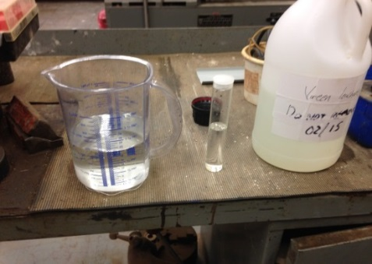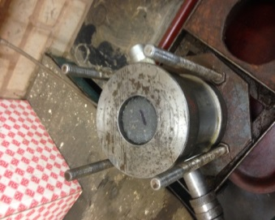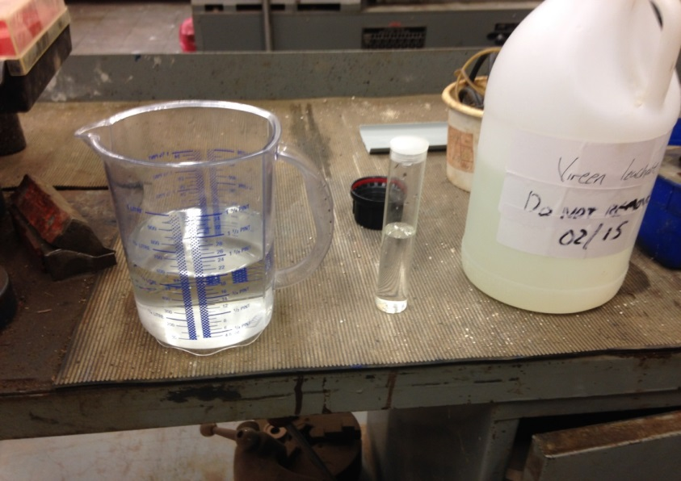

1

2

3

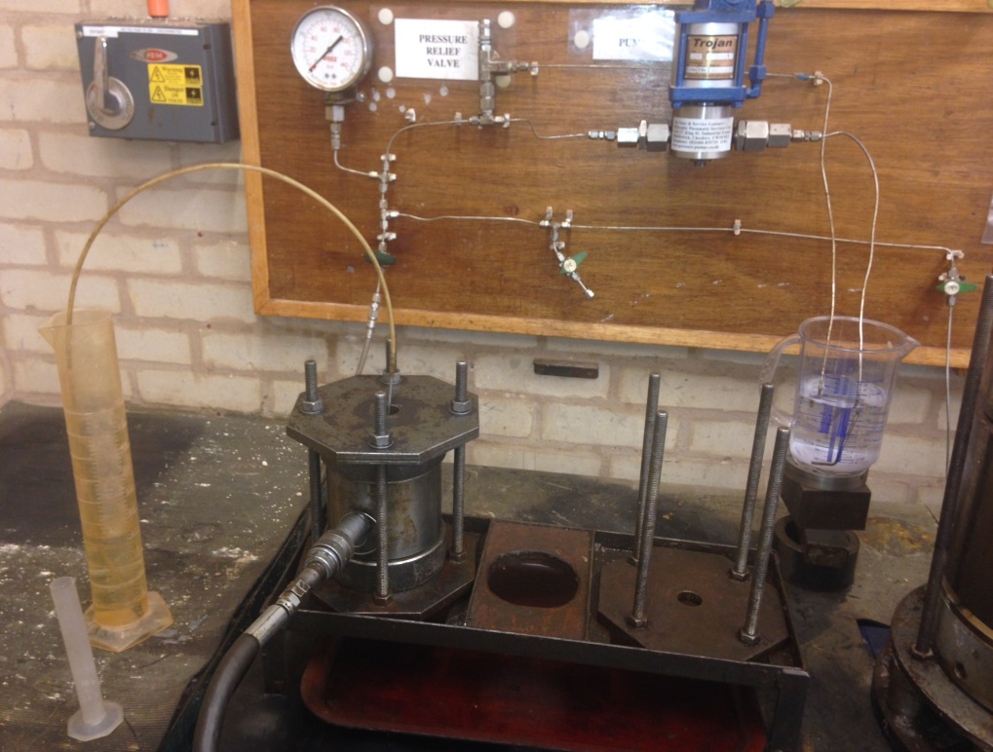

**Figure 4 Set up of leachate analysis**

Once leachate was passed through the blocks the samples were analysed using Inductively Coupled Plasma (ICP). The main analytical advantages of the ICP over other excitation sources originate from its capability for efficient and reproducible vaporization, atomization, excitation, and ionization for a wide range of elements in various sample matrices [22]. From the calibration solution, ICP produces a linear chart which plots light emission (EM) vs concentration (mg/l), after this the samples being tested are analysed. The concentration of each element is than dependent on the EM value that is measured.

Table 10 reports on the concentrations values for the different elements in the original sample (leachate developed) and the concentration that was in the leachate after a volume sample had been passed through the control mix, mix containing OPC60/GGBS25/SF15 and mix containing OPC60/GGBS30/SF10. The leachate was derived from mean used oil concentrations [19]. When comparing the leachate produced to the values that were stated, Table 9 shows the differences between the two for Al, Cr, Cu, Mg, Mo, P, Pb and Zn was 3%, 9%, 4%, 2%, 6%, 6%, 8% and 8% respectively.

The control mix absorbed 82%, 19%, 15%, 4%, 7%, 18%, 100% and 12% of Al, Cr, Cu, Mg, Mo, P, Pb and Zn respectively. OPC60/GGBS25/SF15 absorbed 78%, 18%, 8%, 2%, 6%, 15%, 100% and 8% of Al, Cr, Cu, Mg, Mo, P, Pb and Zn respectively. OPC60/GGBS30/SF10 absorbed 68%, 16%, 7%, 2%, 6%, 14%, 100% and 6% of Al, Cr, Cu, Mg, Mo, P, Pb and Zn respectively.

**Table 10 Leachate concentrations of original sample and samples once passed through blocks**

|  |  |  |  |  |  |  |  |  |
| --- | --- | --- | --- | --- | --- | --- | --- | --- |
|  | **Al**  **396.153** | **Cr 267.716** | **Cu 327.393** | **Mg 285.213** | **Mo 202.031** | **P 213.617** | **Pb 220.353** | **Zn 206.200** |
|  | **mg/L** | **mg/L** | **mg/L** | **mg/L** | **mg/L** | **mg/L** | **mg/L** | **mg/L** |
| **Original sample** | 14.54 | 1.825 | 32.81 | 481.1 | 149.9 | 935.6 | 1.836 | 1200 |
| **Control mix** | 2.575 | 1.480 | 27.75 | 462.34 | 139.1 | 767.9 | -0.313 | 1061 |
| **OPC60/GGBS25/SF15** | 3.263 | 1.489 | 30.35 | 417.14 | 140.7 | 795.5 | -.0307 | 1103 |
| **OPC60/GGBS30/SF10** | 4.723 | 1.524 | 30.61 | 471.32 | 140.8 | 803.8 | -0.229 | 1125 |

The reason for such low absorption rates of concrete paving blocks is due to its high permeability. The permeability rates for the control mix, OPC60/GGBS25/SF15 and OPC60/GGBS30/SF10 were 1.05x10-7m/s, 6x10-7m/s and 6.65x10-7m/s respectively. Permeability results show that the increase in SF from 10% to 15% resulted in a lower permeability rate, which is assumed to be due to the greater refinement of the microstructure and reduction in Portlandite. However, the results show that the introduction of GGBS and SF resulted in an increase in permeability. Although the water absorption decreased with the introduction of these cementitious constituents, it is not known why the permeability did not also decrease. A possible reason for this could be that although there are fewer pores that lead to a reduction in water absorption, the pore structure within the GGBS and SF mixes allowed for water to be transported quicker through the matrix. Another possible reason for the difference between permeability rate and water absorption results could be due to the fine un-hydrated SF and GGBS particles. These particles fill up voids therefore reduce water absorption rate, however as water is passed through at high pressure, these particles are assumed to be transported out of the matrix thereby increasing permeability.

From review of figures the most absorbed metals were Al and Pb, the metals that had similar concentrations both before and after testing were Cu, Mg, Mo, P, Cr and Zn. The absorption of leachate was assumed to be generally low for all mixes as it was transported through the cementitious barriers /stabilizing matrices due to the higher permeability that was reported. As well as this the addition of SF has been reported [23] to increase the heat of hydration, therefore micro cracks that may form during the early stages have the potential to expand as the leachate is passed through the sample at a high pressure. Therefore the cementitious barriers that were present prior to the test could be removed, resulting in increased permeability and decreased absorption. It is also assumed that the absorption rate of these materials is dependent of the properties of the individual elements The high absorption rate of Al and Pb is assumed to be due it having the lowest element radius (118pm) which allows the metal to infiltrate finer voids and lowest hardness (38.3MPa) which at higher pressures deforms the metal enhancing the absorption properties, respectively.

In order to put concentration values into perspective the topsoil (between 51-203mm of the outmost layer of soil) concentrations for the elements, for England and Wales reported by UK Soil Observatory (UKSO) were analysed [24]. These concentrations were determined using wavelength X-ray fluorescence spectrometry with the lower limit of detection (mg/kg) being specific to each element. Table 11 shows the percentile scale each element falls within for each mix and original sample.

**Table 11 Percentile scale of elements in relation to top soil concentrations**

|  |  |  |  |  |  |  |  |  |
| --- | --- | --- | --- | --- | --- | --- | --- | --- |
|  | **Al** | **Cr** | **Cu** | **Mg** | **Mo** | **P** | **Pb** | **Zn** |
|  | **Percentile scale (%)** | | | | | | | |
| **Original sample** | >90% | 0-10% | 70-80% | >90% | >90% | >90% | <0% | >90% |
| **Control mix** | 0-10% | 0-10% | 60-70% | >90% | >90% | >90% | <0% | >90% |
| **OPC60/GGBS25/SF15** | 0-10% | 0-10% | 70-80% | >90% | >90% | >90% | <0% | >90% |
| **OPC60/GGBS30/SF10** | 20-30% | 0-10% | 70-80% | >90% | >90% | >90% | <0% | >90% |

Table 11 allows us to report that in comparison to current top soil concentrations, concrete paving blocks help reduce Al concentrations and that Cr and Pb concentrations are low in the used oil samples. However the results show that when analysing Cu, Mg, Mo, P and Zn concentrations are relatively high. The high concentrations of elements allows the study conclude that in locations where exposure to such contaminants may occur, the use of SUDs systems would be recommended to avoid heavy metals concentrations increasing in the soil below. At minimum it would be recommended that some form of membrane that halts the flow of used oil be used.

**Conclusion**

* When considering the relative merit of optimisation methods, in this study Minitab was successfully used to detect trends in ternary cement paste blends
* The two candidate mixes were successfully produced in the Hanson Formpave factory and the mix containing OPC60/GGBS25/SF15 at 28 days produced greater strengths than the control mix (100% OPC).
* All blocks produced were within the durability requirements stated in BS EN 1338:2003 and over the winter period the blocks laid on site showed no sign of deterioration.
* Results showed that the control mix absorbed a greater quantity of the leachate in comparison to mix 1 and 2. This is assumed to be due the permeability of the blocks being nearly 6 times greater for the candidate mixes.
* For all blocks it was concluded that in areas of vehicle use where such contaminates will be present the use of SUDs and at minimum some type of membrane be used.

**References**

1. Çiçek T, Çinçin Y. Use of fly ash in production of light-weight building bricks. Constr Build Mater 2015;94:521-7.
2. Atici, U. and Ersoy, A. (2008) 'Evaluation of Destruction Specific Energy of Fly Ash and Slag Admixed Concrete Interlocking Paving Blocks (CIPB)'. Construction and Building Materials 22 (7), 1507-1514
3. Nazari, A. and Riahi, S. (2011) 'Splitting Tensile Strength of Concrete using Ground Granulated Blast Furnace Slag and SiO2 Nanoparticles as Binder'*. Energy and Buildings* 43 (4), 864-872
4. Pavía, S. and Condren, E. (2008). ”Study of the Durability of PC versus GGBS Concrete on Exposure to Silage Effluent.” J. Mater. Civ. Eng., 20(4), 313–320
5. (British Standards Institutions. BS EN 1338:2003 Concrete paving blocks – Requirements and test methods, BSI, London, 2003
6. Li, Z. (2011) 'Advanced Cementitious Composites'. in *Advanced Concrete Technology*. ed. by Anon: John Wiley & Sons, Inc., 251-325
7. *Gao X, Yu QL, Brouwers HJH. Characterization of alkali activated slag–fly ash blends containing nano-silica. Constr Build Mater 2015;98:397-406.*
8. Siddique, R. (2011) 'Utilization of Silica Fume in Concrete: Review of Hardened Properties'*. Resources, Conservation and Recycling* 55 (11), 923-932
9. Hassan, A. A. A., Lachemi, M., and Hossain, K. M. A. (2012) 'Effect of Metakaolin and Silica Fume on the Durability of Self-Consolidating Concrete'*. Cement and Concrete Composites* 34 (6), 801-807
10. Turk, K. and Karatas, M.(2011) ‘ Abrasion resistance and mechanical properties of self-compacting concrete with different dosages of fly ash/silica fume’. *Indian Journal of Engineering and materials sciences* 18(0), 49-60
11. Sabet, F. A., Libre, N. A., and Shekarchi, M. (2013) 'Mechanical and Durability Properties of Self Consolidating High Performance Concrete Incorporating Natural Zeolite, Silica Fume and Fly Ash'*. Construction and Building Materials* 44 (0), 175-184
12. British Standard Institution, BS EN 197-1 Cement Composition, specifications and conformity criteria for common cements, BSI, London (2011)
13. (British Standard Institution, BS EN ISO 9001:2008 Quality management systems. Requirements, BSI, London (2011)
14. ASTM C 1240-03a; Standard Specification for Silica Fume Used in Cementitious Mixtures; Annu. Book ASTM Stand., Vol. 04.02 (2003).
15. Canadian Specification CAN/CSA-A23.5-98. “ Supplementary Cementing Materials,” Canadian Standards Association, Etobicoke, Ontario, Canada (1998).
16. British Standard Institution, BS EN 13263-2 Silica Fume for Concrete Conformity Evaluation, , BSI, London (209)
17. Jallul, G.AB. (2014). *The Use of Waste and By-Product Materials to Reduce Cement content in Paving Blocks.*Ph.D. Thesis. Coventry University:U.K
18. Minitab, (2010). "Minitab." 16.2.2.
19. Coupe, S.J., Lowe, T., Smith, H.G., Eastwood, W.I. The Effect of Nutrients on the Biodegradation of Used and Unused oils in Permeable Paving Systmes. 2005;1:222-231.
20. Bagheri, A., Zanganeh, H., Alizadeh, H., Shakerinia, M., and Marian, M. A. S. (2013) 'Comparing the Performance of Fine Fly Ash and Silica Fume in Enhancing the Properties of Concretes Containing Fly Ash'*. Construction and Building Materials* 47 (0), 1402-1408
21. Barbhuiya, S. A., Gbagbo, J. K., Russell, M. I., and Basheer, P. A. M. (2009) 'Properties of Fly Ash Concrete Modified with Hydrated Lime and Silica Fume'*. Construction and Building Materials* 23 (10), 3233-3239
22. Hou,X. and Jones, B. (2000). Inductive Coupled Plasme/Optical Emission Spectrometry. In: Encyclopedia of Analytical Chemistry, 1st ed. Chichester; John Wiley & Sons Ltd, pp. 9468-9485
23. Shi C, Wang D, Wu L, Wu Z. The hydration and microstructure of ultra high-strength concrete with cement–silica fume–slag binder. Cement and Concrete Composites 2015;61:44-52.
24. UK Soil observatory- *Advanced Soil Geochemical Atlas of England and Wales (National Soil Inventory)*[online] available from <http://www.ukso.org/nsi/home.html> [27/06/2015]

**Acknowledgements**

The authors gratefully appreciate and acknowledge the financial support from the Engineering and Physical Sciences Research Council and Hanson Formpave who have sponsored the PhD programme. The authors also acknowledge the support and facilities that were provided at Coventry University.