The MAKEWAVES tsunami collaboration
K Adams¹, T Rossetto², I Chandler³, A Antonini⁴,
W Allsop⁵, M Baiguera⁶, D Istrati⁷, S Roberts⁸,
¹ School of The Built Environment and Architecture, London South Bank University, UK
²Dept. of Civil, Environmental and Geomatic Eng., University College London, UK
³HR Wallingford, Howbery Park, Wallingford, Oxfordshire, OX10 8BA, UK
⁴Faculty of Civil Eng. and Geosciences, Delft University of Technology, 2628CD, NL
5William Allsop Consulting Ltd, Abingdon, OX14 5TL, UK
⁶Dept. of Civil Eng., University of Southampton, S017 1BJ, UK
⁷ School of Civil Eng., National Technical University of Athens, 15773, Greece and Dept. Civil and Environmental Eng., University of Nevada, Reno, NV, USA
⁸Faculty of Science and Eng., University of Plymouth, PL4 8AA, UK
ABSTRACT MAKEWAVES is an international multi-partner collaborative project bringing together six academic institutions and two commercial consultancies. Their objective is to overcome the inherent problems for long term research projects that don’t naturally attract significant domestic funding, but which may ultimately lead to internationally accepted guidance for structural codes or standards.

1. Introduction
Using a pneumatic tsunami simulator (TS) developed jointly by HR Wallingford and UCL (Rossetto et al., 2011; McGovern et al., 2018; McGovern et al. 2022, Chandler et al., 2021) the team are investigating long period wave interactions on coastal structures and morphology. The experimental campaign is subdivided into discrete research areas, each aimed at furthering knowledge of tsunami wave characteristics and their interaction with manmade and natural structures.
2. Wave generation and characterisation
HR Wallingford are experts in how water moves, behaves and influences communities and industries. Using internal research funds, they have reinstalled the TS (Figure 1) and undertaken research to understand the wave generation method more fully. Waves are generated in a 100m flume, with the TS capable of generating long and short period waves. The simulator can also reproduce scaled waves from real life events such as the Mercator trace from the 2004 Indian Ocean event and the 2011 Tohoku tsunami. The team led by Dr. Ian Chandler and Dr. Ignacio Barranco have extended the capability of the TS to include tsunami like bore-waves. The force and length of these waves are controlled by adjusting the flow rate and total volume of water discharged from the TS.
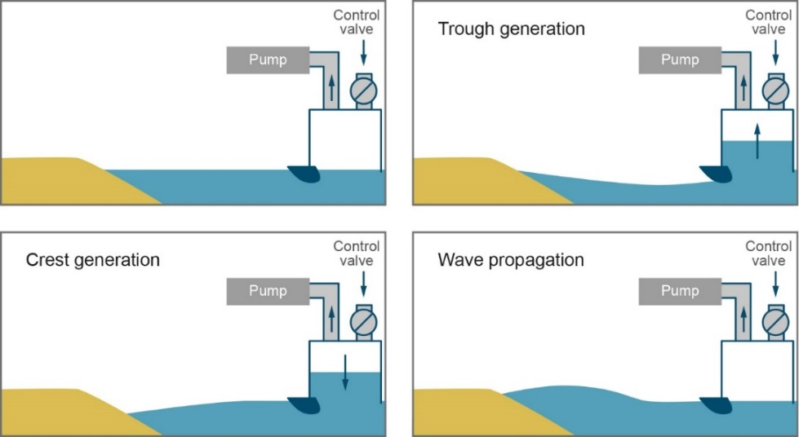
Figure 1 Tsunami simulator wave generation sequence for a trough led wave
3. Caisson breakwater performance under tsunami action
Breakwaters, whether they are rubble mounds or composite construction, are typically designed to protect harbours and coastlines from sea and swell waves. Their design relies on well-known and worldwide accepted design methods. However, many locations around the world are threatened by the unpredictable formation of tsunami.
Inspired by the Kamaishi breakwater trunk cross-section (Arikawa et al., 2012) the 1:50 scale experimental set-up considered a composite vertical wall breakwater composed of wood caisson 560 mm height and 460 mm wide installed on top of a rubble mound foundation for the entire width of the wave flume (Figure 2). Three different grading and concrete toe protection blocks were used to properly reproduce the foundation. The water depth at the toe of the structure is equal to 1000 mm, the rubble mound foundation extends from the bottom to 460 mm below the still water level, the caisson has a freeboard of 60 mm and is installed 40 mm below the top surface of the foundation. 12 pressure sensors are installed along the 4 sides of the caisson, wave gauges are placed in front of, above and behind the caisson, while a Nortek Vectrino is positioned close to the rear side toe of the caisson to capture the hydrodynamic load due to the overflow.
Preliminary results highlight the effectiveness of the breakwater to minimise wave transmission, however, an interesting finding emerged in this regard. Transmission is not only caused by the expected overtopping, but also by transmission through the porous foundation. Pressure on the offshore side of the caisson appears to resemble the hydrostatic distribution after the first impact, however, slightly larger values have been preliminarily observed. Larger peak pressure values are recorded on the rear side and at the bottom of the caisson at the moment of the overflow impact with the still water level.
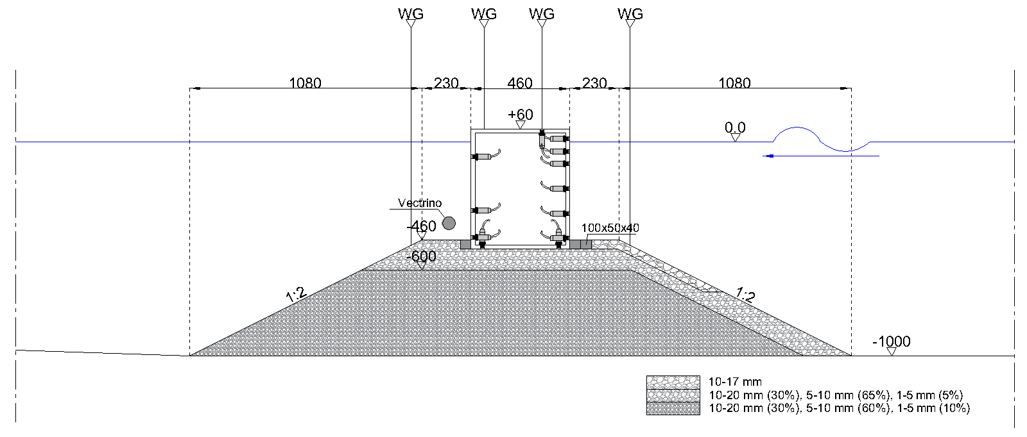
Figure 2 Caisson Breakwater following Kamaishi design with instrumentation
4. The influence of coastal forests in coastal protection to tsunami
Following the 2004 Indian Ocean Tsunami, the effectiveness of coastal forests, particularly mangrove forests which are widespread in coastal environments across tropical and sub-tropical regions, has been investigated for resilience to coastal flooding. It is widely assumed that coastal forests can protect against some coastal hazards, including storm surges and tsunami (Mazda et al., 2006; Kibler et al., 2019). In the latter case, the level of such protection is however conditioned by many factors, such as forest density, forest width, and local bathymetry (Kaiser et al., 2011; Kelty et al., 2022). Hence, it remains challenging to quantify the actual degree of protection offered by coastal forests to tsunami.
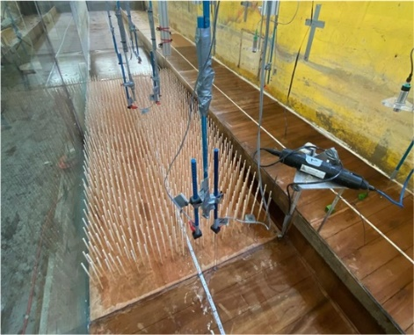
The MAKEWAVES project aims to fill this gap by conducting a series of tsunami runup tests using three different coastal forest models. The experiments are performed at a scale of 1:50. The forest model is made of wooden dowels and integrated into a bathymetry made of plywood having a slope of 1:30, see Figure 3. Three dowel diameters 5mm, 8mm and 10mm are used and arranged with two different densities, providing a wide range of equivalent Manning’s roughness coefficients. The long-term aim is to develop a bespoke engineering framework to inform the degree of protection of coastal forests against tsunami, both in terms of tsunami inundation and evacuation time.
Figure 3 Roughness and smooth runup bathymetry installed in flume

5. Structural porosity and sacrificial components
Previous inundation tests conducted under the project URBANWAVES of tsunami interacting with impermeable building models were adopted to develop tsunami force equations and confirm the quasi-steady nature of the loads (Foster et al. 2017). MAKEWAVES are conducting a series of experiments on impermeable buildings to validate these equations. However, in recognition that in real life most coastal buildings have openings (door, windows, foyers, etc.) and/or elements that are designed to break away during the initial phases of the tsunami impact, the testing programme also includes an investigation of the effect of structural permeability on tsunami loads.
Structural permeability has already been shown to highly affect the loads on structures and their structural performance in previous studies (Wüthrich et al. 2018 , Del Zoppo et al. 2021). Here we look to expand the role of opening ratios and building orientation on the overall horizontal and vertical loads on structures, and to locally measured vertical loads on horizontal slabs (i.e. floors), as well as horizonal loads on exterior and interior structural components.
Overall, these tests are expected to provide some relevant information for a better understanding of impact process, leading to a safer and more optimized design of coastal structures and tsunami evacuation buildings.
6. Observations on the effects of different tsunami waves on cuboid and irregular shaped boulder models
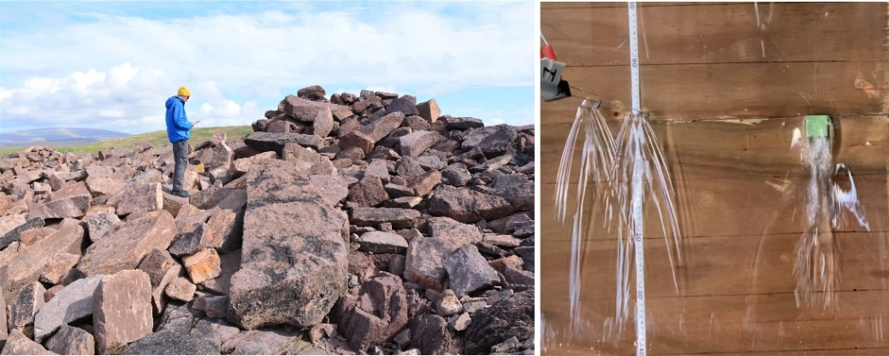
Figure 4 Storm Roberts surveying boulders in the Shetlands (left) and cubic boulder model - coloured green - under tsunami loading in the flume with wake turbulence (far right) – note the additional streamlined turbulence associated with the wave gauges to the left.

This study aims to observe how different tsunami style waves influence boulder models when they are impacted on a 1:30 slope. Two model boulder types are used, a cuboid boulder with dimensions 3.4 x 3.3 x 2.7 cm (Figure 4) and an irregular boulder (a shape more likely to be found in nature) with approximate dimensions of 7.5 x 3.0 x 2.5 cm. Both boulder models are limestone with a density of 2.75 g/m³. The waves generated by the TS will be compared in terms of velocity as well as dimensionless representation of wave amplitude and period.
The smallest wave velocity to initiate motion of the boulders will also be investigated and compared with Nandasena et al. (2022) equations. The wave amplitude associated with the initiation of motion of each boulder will also be studied to see the applicability of other ‘Nott Approach’ equations commonly used in Earth science for identifying past storm/tsunami deposits (Nott, 2003). Therefore, the validation of these equations has implications for coastal hazard mapping for both storm and tsunami events.
7. Experimental testing of debris transport and debris-structure-interaction
Following the 2004 Indian Ocean Tsunami and the 2011 Great East Japan Tsunami, on-site surveys documented the failure of many coastal buildings due to the impact or damming of water-borne debris, such as, shipping containers. These observations attracted the interest of the research community worldwide leading to extremely valuable progress made in the last decade towards advancing the understanding of the debris motion and the potential loading on structures, mainly for the case of single containers. More recently, some studies investigated the effect of multiple debris using either dam-break bores or solitary waves, identifying existing challenges and knowledge gaps, and highlighting the need for more research in this field.
In an attempt to cover some of these gaps, the MAKEWAVES project plans to test different configurations of multiple containers arranged in stacks as seen in actual ports, under different tsunami waves, in order to quantify the effect of the container layout and the tsunami characteristics on the debris dynamics, the travel distance inland and the spreading angle. Such parameters are essential for evaluating the probability of impact on structures near the coast.
8. Participating Investigators
The MAKEWAVES team are an integrated collaboration of researchers, with equal status and our members contributing but not stated as authors are D. McGovern¹, I. Van Balen⁴, I. Barranco³, E. Buldakov², J. Cels², I. Eames², A. Raby⁸, D. Wüthrich³ and M. del Zoppo².
9. References
Arikawa, T. et al., (2012). Failure mechanism of kamaishi breakwaters due to the great east japan earthquake tsunami. Coastal Engineering Proceedings, 1(33): structures.16.
Chandler I, Allsop W, Robinson D & Rossetto T (2021) Evolution of Pneumatic Tsunami Simulators – From Concept to Proven Experimental Technique. Frontiers in Built Environment, June 2021, Volume 7, DOI: 10.3389/fbuil.2021.674659.
Del Zoppo, M., Di Ludovico, M., and Prota, A., (2022). Methodology for assessing the performance of RC structures with breakaway infill walls under tsunami inundation. Journal of Structural Engineering, 147(2), 04020330.
Foster, ASJ, Rossetto, T and Allsop, W, (2017). An experimentally validated approach for evaluating tsunami inundation forces on rectangular buildings. Coastal Engineering, 128, pp.44-57.
Kaiser, G., Scheele, L., Kortenhaus, A., Løvholt, F., Römer, H. and Leschka, S. (2011). The influence of land cover roughness on the results of high resolution tsunami inundation modeling. Natural Hazards and Earth System Sciences, 11(9), pp.2521-2540.
Kelty, K., Tomiczek, T., Cox, D.T., Lomonaco, P. and Mitchell, W. (2022). Prototype-Scale Physical Model of Wave Attenuation Through a Mangrove Forest of Moderate Cross-Shore Thickness: LiDAR-Based Characterization and Reynolds Scaling for Engineering With Nature. Frontiers in Marine Science, 8, p.2044.
Kibler, K. M., Kitsikoudis, V., Donnelly, M., Spiering, D. W., and Walters, L. (2019). Flow-vegetation interaction in a living shoreline restoration and potential effect to Mangrove recruitment. Sustainability 11:3215. doi: 10.3390/su111
Mazda, Y., Magi, M., Ikeda, Y., Kurokawa, T., and Asano, T. (2006). Wave reduction in a mangrove forest dominated by Sonneratia sp. Wetl. Ecol.Manag. 14, 365–378. doi: 10.1007/s11273-005-5388-0
McGovern D, Robinson T, Chandler ID, Allsop W & Rossetto T (2018) Pneumatic long-wave generation of tsunami-length waveforms and their runup, Coastal Engineering, Vol. 138, pp 80–97, Elsevier.
McGovern DJ, Allsop W, Rossetto T & Chandler I, (2022) Large-scale experiments on tsunami inundation and overtopping forces at vertical sea walls. Coastal Engineering (2022), https://doi.org/10.1016/j.coastaleng.2022.104222.
Nandasena NA, Scicchitano G, Scardino G, Milella M, Piscitelli A, Mastronuzzi G. (2022) Boulder displacements along rocky coasts: A new deterministic and theoretical approach to improve incipient motion formulas. Geomorphology. 2022 Jun 15;407:108217.
Nott, J. (2003). Waves, coastal boulder deposits and the importance of the pre-transport setting. Earth and Planetary Science Letters, 210(1-2), 269-276.
Rossetto T., Allsop N.W.H., Charvet I & Robinson D, (2011) Physical modelling of tsunami using a new pneumatic wave generator, Coastal Engineering Vol 58, pp517-527.
Wüthrich, D., Pfister, M., Nistor, I. and Schleiss, AJ, (2018). Experimental study on forces exerted on buildings with openings due to extreme hydrodynamic events. Coastal Engineering, 140, pp.72-86.

