Direct Growth of Vertically Aligned Carbon Nanotubes onto Transparent Conductive Oxide Glass for Enhanced Charge Extraction in Perovskite Solar Cells

Victoria Ferguson, Bowei Li, Mehmet O. Tas, Thomas Webb, Muhammad T. Sajjad, Stuart A. J. Thomson, Zhiheng Wu, Yonglong Shen, Guosheng Shao, José V. Anguita, S. Ravi P. Silva* and Wei Zhang*

Victoria Ferguson, Bowei Li, Dr Mehmet O. Tas, Thomas Webb, Dr José V. Anguita, Prof. S. Ravi P Silva and Dr Wei Zhang

Advanced Technology Institute (ATI), University of Surrey, Guildford, Surrey, GU2 7XH, UK
E-mail: wz0003@surrey.ac.uk (W.Zhang), s.silva@surrey.ac.uk (S.R.P.Silva)

Dr Muhammad T. Sajjad

London Centre for Energy Engineering, School of Engineering, London South Bank University, 103 Borough Road, London, SE1 0AA, UK

Dr. S. A. J. Thomson
Edinburgh Instruments Ltd., 2 Bain Square, Livingston, EH54 7DQ, UK

Zhiheng Wu, Dr Yonglong Shen, Prof. Guosheng Shao
State Centre for International Cooperation on Designer Low-Carbon and Environmental Material (SCICDLCEM), School of Materials Science and Engineering, Zhengzhou University, Zhengzhou 450001, P. R. China

Keywords: carbon nanotubes, vertically aligned, perovskite solar cells, low temperature growth, transparent conductive oxide

Vertically aligned carbon nanotubes (VACNTs) present an exciting avenue for nanoelectronics due to their pre-determined orientation and exceptional transport capabilities along the tube length, with the potential to employ in a variety of optoelectronic applications. However, growth of VACNTs using conventional chemical vapour deposition (CVD) methods requires elevated temperatures (>720°C) and therefore, the suitability of commonly used transparent conductive oxide (TCO) glasses, such as fluorine-tin oxide (FTO) and indium-tin oxide (ITO), as the substrates for nanotube growth are limited by their temperature-sensitive nature. Here, the successful growth of multi-walled VACNTs directly onto commonly used TCO glasses, FTO and ITO, using the photo-thermal chemical vapour deposition (PTCVD) growth method is reported. The benefit of reflection, within the infrared region, of the TCO substrate and the effect of surface roughness on the growth of VACNTs is investigated. The application of VACNTs on ITO in inverted planar perovskite solar cells is investigated, which show superior charge transfer, larger grain sizes in the perovskite film, and a champion device efficiency approaching 16%.

1.Introduction
Vertically aligned carbon nanotubes (VACNTs) have shown to be a promising candidate for numerous applications, such as thermal interface materials,^{[1]} sensors,^{[2]} LEDs,^{[3]} beam collimators,^{[4]} and solar cells.^{[5,6]} The growth of VACNTs required high temperatures (> 700°C)^{[7–12]}, therefore thermally stable substrates such as silicon, copper, or steel had been mainly used to obtain VACNTs. For optoelectronic applications, transparent conductive oxide (TCO) coated glass substrates are commonly used due to their excellent conductivity and high transparency, with indium-tin-oxide (ITO) and fluorine-tin oxide (FTO) glass substrates being the most popular. However, the use of TCOs for CNT growth is limited due to their temperature-sensitive nature. In the case of ITO glass, as the temperature increases >350°C^{[13,14]}, the electrical conductivity of the ITO becomes severely degraded, and similarly for FTO at >550°C^{[14]}. By combining VACNTs and TCOs for optoelectronic applications, there is the potential to obtain samples with superior electrical conductivity along both the vertical and horizontal axis, enabled by a strong connection between these two, by means of direct growth of CNTs on the TCO glass. Previous attempts to grow CNTs directly on ITO or FTO have either resulted in small randomly orientated growth^{[12,15,16]} or have deteriorated the underlying substrate due to the high-temperature requirements of CNT growth.^{[5]} A dry-transfer technique for VACNTs onto various substrates at low temperature has been reported,^{[17]} however, the suitability of this technique is limited as the transfer process itself can result in the compression and irreversible degradation of the VACNT forests, resulting in poorer contact with the target substrates when compared to direct growth on the substrate. Photo-thermal chemical vapour deposition (PTCVD) is a top-down optical heating method which back-cools the substrate and allows CNT growth at lower substrate temperatures whilst benefitting from orientated growth and maintaining good contact with the underlying substrate.^{[18]} However, in previous reports, the temperature used to grow CNT forests still exceeds the point of degradation for electrical conductivity of commonly used TCOs, which needs to be addressed for their use in photovoltaic applications.
Perovskite solar cells (PSCs) are an extremely popular area of research due to the perovskite light absorbing layer benefitting from tuneable bandgaps, large absorption coefficients, long charge diffusion lengths, and high carrier mobilities.^{[19–22]} They have seen a rapid development in the last decade, improving their power conversion efficiency (PCE) from 3.8% to 25.2%.^{[23]} CNTs were first introduced into the PSC architecture in 2014 by Li et al. where they replaced the metal counter electrode with a laminated CNT and obtained a PCE of 6.87% without an additional Spiro-OMeTAD layer and 9.87% with Spiro-OMeTAD layer.^{[24]} CNTs have since been incorporated in PSC architecture as perovskite layer additives, hole transporting layers (HTLs), and back contacts though maximizing the electronic conductivity of CNTs, a good contact with the substrate and orientation of the CNTs are paramount.^{[25–28]}
In this paper, we take the advantage of the high reflectivity of the ITO and FTO in the infrared region and report the successful growth of multi-walled VACNTs directly on temperature-sensitive transparent conductive oxide substrates using a PTCVD with aluminum (Al) and iron (Fe) catalyst layers. We also investigate the effect of surface roughness and substrate reflection on the growth of VACNTs, looking at the correlation to the substrate characteristics and co-catalyst thickness. Following this, the application of CNT arrays on TCO substrates in inverted planar PSCs is demonstrated and the effect on the perovskite film formation, charge transfer and device performance are evaluated.

2. Results and Discussion
The optical nature of the photo-thermal chemical vapour deposition (PTCVD) is a key element in the growth of VACNTs on ITO and FTO. Figure 1a depicts the layout of the growth chamber in which the samples were placed on top of a silicon carrier wafer on a water-cooled (10°C) sample stage. To promote growth, aluminum (Al) and iron (Fe) co-catalyst layers were deposited on top of the TCO glass, as shown in Figure 1b. Modelling the temperature of the TCO sample at steady-state conditions (Figure 1c) reveals the bulk of the glass sample remains at relatively low temperatures (~ 310 – 330°C) by virtue of the reflectivity within the infrared region of the TCOs, thus allowing processing of such substrates at temperatures below the point of thermal degradation. This ensures the integrity of the substrate material during processing. Furthermore, in the case of ITO, the reflectivity of the samples, after catalyst deposition, allows the temperature of this layer to remain relatively low (~ 355°C) thereby not significantly exceeding the temperature at which significant detrimental degradation of the ITO takes place (usually >350°C). To test this further pristine ITO was exposed to the growth conditions in the PTCVD, without the additional catalyst and co-catalyst layers, and on a small degradation of approximately 5% for the peak optical transmission was observed (Figure S1). As this result reflects the degradation without the additional protection of the increase reflectivity of the substrate surface, with the additional catalyst layers, we expect the degradation of samples used for CNT films lies within this range.
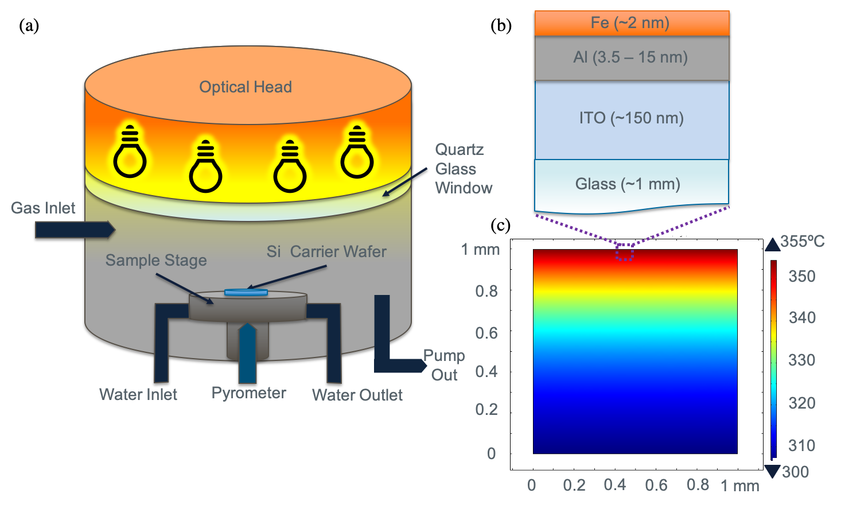
Figure 1. a) Schematic illustration of the photo-thermal chemical vapour deposition (PTCVD) system. b) Schematic of catalyst structure on indium-tin oxide (ITO), and c) thermal model showing the temperature in the bulk of the substrate.

2.1 The growth of VACNT on TCO
Using the PTCVD method described, we are able to successfully grow VACNTs on both ITO and FTO while causing negligible degradation to the underlying transparent conductive oxide layers. Figure 2a and b showcases VACNTs grown on both ITO and FTO. VACNT growth is observed on most sample configurations (Figure S2), except when using a 7 nm thin layer of aluminum co-catalyst, in that case, the CNT height is not sufficient to establish vertical alignment. The growth of CNTs through PTCVD can be impacted by various parameters including temperature, catalyst thickness, ratio of reactant gases, and surface roughness of the substrate.
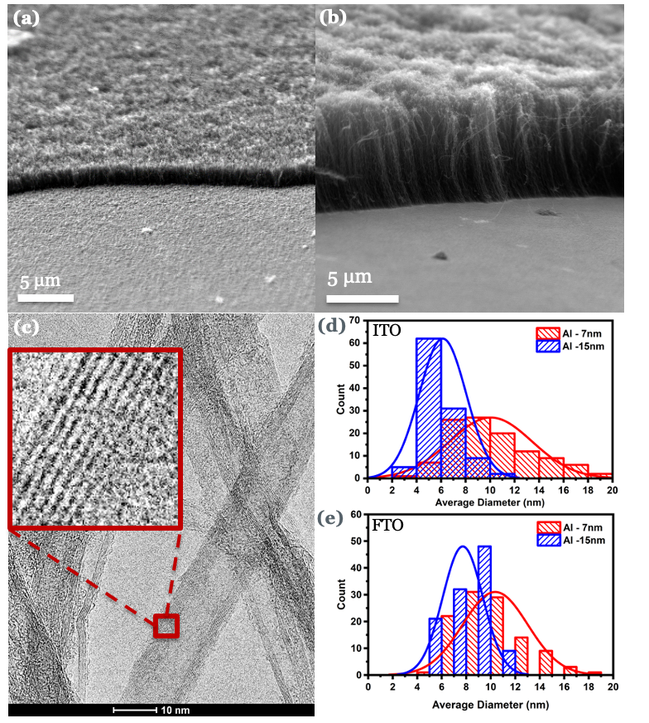
Figure 2. SEM images obtained using a tilt-angle of 45°, using a top down viewpoint of a) FTO with 15nm thick aluminum co-catalyst layer, and b) ITO with 15nm thick aluminum co-catalyst layer. c) Typical TEM image taken to determine average carbon nanotube diameter with inset highlighting multi-walled nature (red box). Average carbon nanotube diameters for d) FTO and e) ITO with varying aluminum co-catalyst thicknesses.

Aluminum is often used as a buffer layer when growing CNTs on silicon.^{[7,11,29–33]} It has demonstrated effectiveness not only as a diffusion barrier between the catalyst and silicon, but also to support vertically aligned CNT growth.^{[31]} In addition, aluminum has also been shown to increase the surface roughness and therefore provide more active nucleation sites for growth.^{[34]} Aluminum is observed to play a vital role in VACNT growth on FTO and ITO, which is in agreement with previous observations using a conventional hot-walled CVD system to grow VACNTs directly on FTO glass, reported by Anwar et al.,^{[5]} in which the tin-oxide reduced, and formed metallic tin island on the underlying glass substrate.
Transmission electron microscopy (TEM) was used to analyze the average diameter of the CNTs and confirm their multi-walled nature, as we show in Figure 2c. For Al co-catalyst thicknesses of 7 nm, the average diameters of CNTs on ITO and on FTO substrates are 8.6±3.1 nm and 11.8±2.7nm, respectively. Whereas, for Al co-catalyst thicknesses of 15 nm, the average diameter decreases to 5.9±1.6 nm and 7.4±1.7 nm for ITO and FTO substrates respectively (Figure 2d and 2e).

2.2 The optical and electronic properties of VACNT on TCO
For applications within optoelectronics, the optical transmission of the resulting samples is a key parameter to consider. There was a clear inverse relationship between peak optical transmission and CNT height for ITO with a full coverage of CNTs, which agrees with previous research (Figure S3).^{[18]} The transmission data within the visible range of light, which encompasses the peak transmission, can be found for FTO and ITO with aluminum thickness of 7 and 15nm in Figure S4. Following this, the average sheet resistance of ITO with CNTs was measured using a four-point probe method and found a relatively consistent value of ~20 ± 4Ω/sq. In comparison, the sheet resistance of the pristine ITO used in this work was 14 ± 4Ω/sq. This indicates that the resistance is not significantly affected after CNT growth. The quality of CNTs was evaluated by the I_{D}/I_{G} ratios using the characteristic D-peak (~1350cm⁻¹) and G-peak (~1580cm⁻¹) of Raman spectra, there was an average I_{D}/I_{G} of 1.04±0.06. The I_{D}/I_{G} intensity ratio is widely used to evaluate the quality of CNTs, in which a smaller value denotes less defects.^{[35]} Figures S5 and S6 depict the Raman spectrum from which the intensity of the D-peak and G-peaks. A summary of the CNT height, diameter, I_{D}/I_{G} ratio, peak transmission, and sheet resistance are given in Table S1.
The reflectivity of the sample surface greatly impacts the resulting growth.^{[4,11]} The more reflective the substrate, the more power is concentrated on the top layer of iron catalyst, thereby facilitating the preferred conditions for highly crystalline, densely-packed, VACNT growth. Pristine FTO and ITO initially have relatively similar transmission and reflectance spectra (Figure S7). After the catalyst deposition, ITO becomes significantly more reflective than FTO and the increase in reflection allows the ITO to facilitate longer growth of CNTs than FTO. However, it is noted that the reflection measurements utilize an integrating sphere and are therefore a better representation of how much light was reflected, the transmission measurements are unlikely to have collected the light that was scattered when passing through the samples. Consequently, the seemingly large absorption exhibited by the samples, especially after the catalyst deposition, could be influenced by the loss of some scattered light during transmission.
The root-mean-square (RMS) roughness of typical FTO and ITO substrates used in this work are approximately 20 and 4 nm, respectively (Figure S8). From TEM, it is observed that the typical catalyst particle diameter is ~5nm (Figure S9). This indicates that the surface roughness is on the same scale as the typical catalyst particle size for ITO after annealing, however, for FTO it is considerably larger. Based on previous research,^{[9]} the surface roughness of ITO should inhibit the catalyst particle mobility given that it is closer to the particles size. However, the roughness of FTO is significantly greater than that of a typical catalyst particle size hence we propose that the catalyst particles may coalesce along the sloped sides of the FTO crystals, subsequently forming larger diameter nanotubes. Given the difference in surface roughness between ITO and FTO, this theory agrees with the TEM results (Figure 2d and e), which show ITO hinders catalyst particle mobility more effectively than FTO. The observed decrease in the diameter with increasing Al thickness is not fully understood and requires further investigation, however, it is likely due to the increase in small nucleation sites based on work by Delzeit et al.^{[34]}
In summary, we found that transmission is inversely proportional to CNT forest height and the sheet resistance of the CNT films, whilst correlated to I_{D}/I_{G} ratios, do not significantly change. With these results in mind, very short and patterned forests were fabricated onto ITO for inverted planar PSCs. Using optical lithography, patterned tower features, which consisted of 9 pixels with arrays of 50 µm × 50 µm towers of CNTs with 50 µm gaps between each tower, were fabricated to maximize transmission, increase the potential surface area in contact with the carbon nanotube forests, and consequently benefit from the superior charge transfer of the CNT forest without compromising the potential light absorption and PCEs of the PSCs.

2.3 The properties of perovskite films on CNT/ITO substrates
To determine the suitability of the CNT layer as a potential charge transport layer, we deposited the perovskite layer on top to verify whether the CNT could change the film morphology or bulk properties of the perovskite film. SEM images (Figure 3a and d) show pinhole-free morphologies for both the perovskite films (with and without the additional CNT layer) with higher average grain size for films with CNT layer (Figure 3b and e), therefore indicating higher quality of perovskite film as defects unavoidably exist in the grain boundaries (GBs).^{[36]} AFM images show a slight decrease of the RMS roughness from 17.9±0.5 to 16.4±0.5 nm for the perovskite thin films with and without the CNT underlayer, respectively (Figure 3 c and f). This smoother surface is beneficial for the following device fabrication process as it allows better contact between the perovskite and top layer. The XRD patterns shown in Figure 3g confirm that the bulk properties of perovskites are similar after introducing CNT. The higher peak intensity of (100) facet at ~ 14.05º implies that the CNT layer helped the crystallization and subsequently to enlarge the grain size of perovskites, consistent with the observation in Figure 3b and e. Furthermore, promoting the (100) peak could inhibit the trap-state density and influence the carrier transport in the perovskite film.^{[37]} To investigate the charge carrier dynamics, steady-state photoluminescence (PL) spectroscopy and time-resolved photoluminescence (TRPL) measurements were performed on the perovskite films, with and without the CNT layer. The steady-state PL shows a large decrease of the PL intensity (by a factor of ~6) (see Figure 3h). The significant PL quenching indicates a faster charge transfer between the perovskite and the CNTs. It is consistent with the trend observed in the steady-state PL, TRPL spectra also shows a reduced PL lifetime when depositing the perovskite film on CNT layer, suggesting an efficient charge transfer at CNT/perovskite interface. ^{[38]} The charge transfer efficiency between the perovskite and CNT can be quantified by the following equation: ^{[39,40]}
$η_{t}=\left(1-\frac{{PLQY}_{with CNT}}{{PLQY}_{without CNT}}\right)×100\%$ (Equation 1)
The photoluminescence quantum yield (PLQY) of the perovskite film on CNT is 0.02% and without CNT is 0.14%. From Equation 1, the calculated transfer efficiency, η_{t}, is 85.7%. The high charge transfer efficiency confirmed a smooth charge transport from perovskite to CNT-patterned substrate. Therefore, the growth of CNT on ITO has a superior charge extraction effect and this should be favorable for the derived solar cells.

Figure 3. Morphologies and optical properties of perovskite films with or without CNT. a), d) Top-view SEM images. b), e) corresponding grain size distribution. c), f) AFM images. g) XRD patterns. h) Steady-state PL spectra. i) Time-resolved PL spectra.

2.4 The device performance based on CNT
To evaluate the effect of the patterned CNT layer on device performance, we fabricated the PSCs with a structure of ITO Glass/CNTs/perovskite/PC₆₁BM/BCP/Ag (Figure 4a). For a comparison, we also fabricated the control devices without the CNT layer. Herein, we have purposely simplified the device structure so that it does not include an additional hole transporting layer. As such, we can unambiguously correlate the improvement in charge extraction due to the inclusion of the patterned CNT layer as we show earlier to the potential device performance enhancement. As expected, the devices with CNTs showed a superior performance compared to control devices without a CNT layer (Table S2). The champion device (with CNTs) achieved an PCE of 9.01%, with a fill factor (FF) of 76.44%, an open-circuit voltage (V_{oc}) of 0.86V and a short circuit current density (J_{sc}) of 13.69 mA/cm². The current density-voltage (J-V) curves of the champion device (Figure 4b) show little hysteresis confirming the reliability of the parameters. To accurately quantify the impact of the CNT, we fabricated and measured 22 devices under the same condition. Figure 4c-f shows the detailed distribution of device performance, on average devices achieved an average PCE of 6.83±0.45 %, FF of 0.73±0.02 %, V_{OC} of 0.70±0.02 V, and J_{SC} of 13.17±0.15 mA/cm². The narrow range of the photovoltaic parameters exhibit an excellent reproducibility of CNT devices, indicating the uniformity and stability of the CNT layer in the current device structure including its consistent high performance. To further demonstrate the potential of this work, we conducted a preliminary study by including a poly [N,N0-bis(4-butylphenyl)-N,N0-bis(phenyl)benzidine (poly-TPD) HTL between the CNT and perovskite layers in the device architecture, achieving a champion efficiency approaching 16% (Figure S10).

Figure 4. Device structure and performance of CNT-based devices. a) Schematic illustration of device architecture with SEM image of patterned CNT forests (red box). b) J-V curve for champion device with inset table of forward and backwards scan performance. c-f) Statistics of photovoltaic parameters. Distribution of (c) V_{OC}, (d) J_{SC}, (e) FF, and (f) PCE. Note that each spot represents one independent device obtained from the average of the forward scan (– 0.2 to 1.2 V) and reverse scan (1.2 to – 0.2 V).

Conclusions
Using the PTCVD growth method, we have shown, we believe for the first time, successful growth of vertically aligned carbon nanotubes directly on transparent conductive oxide substrates, ITO and FTO, with the use of Al and Fe catalyst layers. We observe that after catalyst deposition, ITO is significantly more reflective that FTO, leading to the increase in height for the resulting CNTs. Due to the lower surface roughness, ITO hinders catalyst mobility more than FTO resulting in smaller diameter CNTs and subsequently better quality. Following the optimization of CNT growth on TCO substrates, we successfully fabricated patterned CNT layers and used them in the inverted planar perovskite solar cells. The CNT layers enhance the quality of perovskite thin films crystals and promote efficient charge extraction, thus leading to an efficient device with PCE of 9.01%. By incorporating poly-TPD as the HTL in the device architecture, we achieved a champion efficiency approaching 16%, showing great potential of patterned CNT layer in fabricating efficient PSCs. We envisage that the device performance could be further enhanced by optimizing the patterning of the CNT layers to maximize their optical transmission and charge extraction within the resulting devices.

Conflicts of interest
There are no conflicts to declare

Experimental Section
Sample Preparation
ITO (Xiang Science & Technology) and FTO (CSG Holding Co.) glass substrates were cleaned using decon-90 under ultrasonication and subsequent oxygen plasma cleaning using an Emitech K1050X plasma asher, operated at full power of 100W (RF of 13.56 MHz). The substrates were placed in the chamber and pumped down to base pressures of approximately 0.10 Torr. 15 sccm of O₂ was bled into the chamber with a constant flow for 1 minute before the process was started, and then the substrates were ashed for 5 minutes. Aluminum (Al) and iron (Fe), as the co-catalyst and catalyst layers were sequentially deposited using electron-beam evaporation with varying thicknesses of Al, and a constant thickness of ~2 nm for Fe. Two batches of the FTO and ITO samples were produced and will be denoted as batch 1 and batch 2 going forward.
Photolithography Patterning
To prepare substrates for photolithography, a cleaning protocol of 15 min bath sonication in acetone, 15 min in IPA, and 15 min in methanol was used, which were dried with a nitrogen air gun, followed by 5 min plasma ashing. The mask used had 50 µm ×50 µm square features and can be used for both regular patterning or image reversal, creating towers or wells respectively. AZ5214 was spin-coated at 4000 rpm for 45 secs. The substrate was then immediately transferred to a hotplate and baked at 110°C for 1 min. Following this, the sample was exposed in a Mask Aligner Suss MA1006 for 7 secs under the patterned mask. After exposure the sample was developed in a mixture of AZ 3210 B and di-water at a 1:4 ratio for 28 secs. Finally, the sample was transferred to a hotplate and baked at 110°C for 1 min. After patterning, the metal catalyst layers were deposited onto the samples as previously described. To ‘lift-off’ the remaining photoresist and superfluous catalyst layers after deposition, the substrates were placed in acetone and left overnight. Afterwards, the samples were agitated using a stream of acetone, ensuring that the sample always remains wet, and transferred to a new beaker of acetone for further agitation. For difficult lift-off, samples were sonicated for no longer than 1 min to assist removal. Once the photoresist and redundant catalyst were removed, the samples were slowly taken out of the acetone beaker, using a stream of acetone to ensure there were no additional metal particles attached to the surface. Samples were then dried using a nitrogen gun. Once dry any metal catalyst remaining on the sample was then permanent.
Photo-thermal Chemical Vapour Deposition (PTCVD) Process
VACNT growth was performed using PTCVD with a Surrey Nanosystems 1000N system. The PTCVD chamber comprises of an optical head, a reaction chamber, and a water-cooled substrate holder chuck. The optical head contains eight halogen lamps that illuminate the sample at a distance of 15 cm, as described elsewhere.^{[15,41,42]} The samples were placed on top of a silicon wafer shield on the water-cooled chuck, which was cooled to a temperature of 10°C using a closed-circuit water chiller. This acted as a heat sink to decrease the substrate temperature during growth. Hydrogen (100 sccm) and acetylene (10 sccm) were subsequently fed into the reaction chamber at a combined pressure of 2 Torr. All samples were grown using 35% lamp power which equates to approximately 2.8 kW, this equated to a bulk temperature of ~310 °C. The temperature of the substrates was measured from the bottom using a pyrometer, as previously shown here^{[41,42]}. The growth process consisted of an annealing step in hydrogen at the set optical power for 10 mins, followed by the introduction of acetylene gas for a further 5 mins. The chamber was left to cool for 10mins and was then purged using nitrogen before retrieving the samples.
Solar Cell Fabrication
After CNT growth, the ITO/CNT substrates were transferred into a nitrogen-filled glovebox. The CNT layer was treated with poly[(9,9-bis(30-((N,N-dimethyl)-N-ethylammonium)-propyl)-2,7-fluorene)-alt-2,7-(9,9-di-octylfluorene)]dibromide (PFN-Br) which was dynamically spin-coated at 5000 rpm (2500 rpm s⁻¹) for 30 secs before the perovskite was deposited on top. The device fabrication process can be found in previous publication.^{[43]}
Sample Characterization
The cross-section morphologies of the samples were observed by field-emission scanning electron microscopy (SEM) with a ZEISS SIGMA 500 operating at 5 kV. The samples were cut into 5 mm × 5 mm pieces and attached on a sample stage through conductive paste before loading into the chamber. High resolution transmission electron microscopy (TEM) was conducted using a FEI Tecnai G2 F20, operating at 200 kV. The samples were scratched off and ultrasonically dispersed in 1mL of ethanol for 30mins to obtain a homogeneous solution. After which 10µl of the solution was dropped onto a copper grid with carbon support film, and the TEM specimen was loaded into the chamber. The heights and diameters of the CNTs were measured using NIH’s ImageJ software from the SEM and TEM images, respectively. Raman measurements were obtained from the center of the VACNT forests using an Xplora Plus from Horiba with a 532nm laser. Foil was placed underneath the sample to increase the intensity of the resulting Raman spectra. I_{D}/I_{G} ratios were used to denote quality of nanotubes and were found by comparing the intensity of the characteristic D-peak (~1350 cm⁻¹) and G-peak (~1580 cm⁻¹) from the spectra using OriginLab’s Lorentz peak fitting functionality. UV–vis–NIR spectroscopy was obtained using a Cary 5000 from Varian in which the transmission was measured using a standard split beam set up with reference to air, and the reflection was measured using an integrating sphere. Sheet resistance measurements were obtained growth using a Keithley 4200SCS four-point probe set-up with the probes pressed in the center of the samples through the VACNT forests to the TCO substrates beneath. An NT-Solver AFM equipped with an NSG 01 Si cantilever tip in semi-contact (tapping) mode was used to analyze the substrate surfaces before growth. The X-ray diffraction crystallographic data for the samples was collected using a PANalytical X’Pert Pro powder diffractometer in a Bragg-Brentano geometry (step size 0.004o) using a Cu Kα target (45 kV).The J–V characteristics of the photovoltaic cells were obtained in air using a Keysight 2400 Source Meter under simulated one-sun AM 1.5G illumination (100 mW cm⁻²) with a solar simulator (Enlitech, SS-F5-3A). The light intensity was calibrated by means of a KG-5 Si diode. Devices were measured both in reverse scan (1.2 → − 0.2 V, step 0.02 V) and forward scan (− 0.2 → 1.2 V, step 0.02 V) using a mask with an aperture area of 0.09 cm².

Supporting Information
Supporting Information is available from the Wiley Online Library or from the author.

Acknowledgements
V.F. thanks the financial support provided by the doctoral collage studentship at the University of Surrey. W.Z. thanks the financial support from EPSRC New Investigator Award (2018; EP/R043272/1) and H2020-EU grant (2018; CORNET 760949). R.S thanks the financial support provided by the Nano-OPS Printer for High Rate Nano-Manufacturing and Support Equipment grant (2018; EP/R025304/1).

Received: ((will be filled in by the editorial staff))
Revised: ((will be filled in by the editorial staff))
Published online: ((will be filled in by the editorial staff))

References
[1] L. Ping, P.-X. Hou, C. Liu, H.-M. Cheng, APL Mater. 2019, 7, 020902.
[2] J. J. Schneider, Adv. Biosyst. 2017, 1, 1700101.
[3] P. Andričević, X. Mettan, M. Kollár, B. Náfrádi, A. Sienkiewicz, T. Garma, L. Rossi, L. Forró, E. Horváth, ACS Photonics 2019, 6, 967.
[4] J. Clark, J. V. Anguita, Y. Chen, S. R. P. Silva, Sci. Rep. 2016, 6, 18767.
[5] H. Anwar, A. E. George, I. G. Hill, Sol. Energy 2013, 88, 129.
[6] V. Ferguson, S. R. P. Silva, W. Zhang, Energy Environ. Mater. 2019, 2, 107.
[7] T. Ohashi, R. Kato, T. Tokune, H. Kawarada, Carbon N. Y. 2013, 57, 401.
[8] E. Roumeli, M. Diamantopoulou, M. Serra-Garcia, P. Johanns, G. Parcianello, C. Daraio, E. Roumeli, M. Diamantopoulou, M. Serra-Garcia, P. Johanns, G. Parcianello, C. Daraio, Nanomaterials 2019, 9, 444.
[9] S. Fan, M. G. Chapline, N. R. Franklin, T. W. Tombler, A. M. Cassell, H. Dai, Science (80-. ). 1999, 283, 512.
[10] M. J. Behr, E. A. Gaulding, K. A. Mkhoyan, E. S. Aydil, J. Appl. Phys 2010, 108, 53303.
[11] J.-S. Chen, V. Stolojan, S. R. P. Silva, Carbon N. Y. 2015, 84, 409.
[12] H. T. Ng, B. Chen, J. E. Koehne, A. M. Cassell, J. Li, J. Han, M. Meyyappan, J. Phys. Chem. B 2003, 107, 8484.
[13] D. J. Kwak, B. H. Moon, D. K. Lee, C. S. Park, Y. M. Sung, J. Electr. Eng. Technol. 2011, 6, 684.
[14] K. Goto, T. Kawashima, N. Tanabe, Sol. Energy Mater. Sol. Cells 2006, 90, 3251.
[15] A. J. Miller, R. A. Hatton, G. Y. Chen, S. R. P. Silva, Appl. Phys. Lett. 2007, 90, 23105.
[16] A. Capasso, L. Salamandra, A. Chou, A. Di Carlo, N. Motta, Sol. Energy Mater. Sol. Cells 2014, DOI 10.1016/j.solmat.2013.10.022.
[17] L. Ping, P.-X. Hou, H. Wang, M. Chen, Y. Zhao, H. Cong, C. Liu, H.-M. Cheng, Carbon N. Y. 2018, 133, 275.
[18] J. V. Anguita, D. C. Cox, M. Ahmad, Y. Y. Tan, J. Allam, S. R. P. Silva, Adv. Funct. Mater. 2013, 23, 5502.
[19] J. Hong Noh, S. Hyuk Im, J. Hyuck Heo, T. N. Mandal, S. Il Seok, Nano Lett. 2013, 13, 1764.
[20] S. De Wolf, J. Holovsky, S.-J. Moon, P. Lö, B. Niesen, M. Ledinsky, F.-J. Haug, J.-H. Yum, C. Ballif, J. Phys. Chem. Lett 2014, 5, 1035.
[21] S. D. Stranks, G. E. Eperon, G. Grancini, C. Menelaou, M. J. P. Alcocer, T. Leijtens, L. M. Herz, A. Petrozza, H. J. Snaith, Science (80-. ). 2013, 342, 341.
[22] L. M. Herz, ACS Energy Lett. 2017, 2, 1539.
[23] A. Kojima, K. Teshima, Y. Shirai, T. Miyasaka, J. Am. Chem. Soc. 2009, 131, 6050.
[24] Z. Li, S. A. Kulkarni, P. P. Boix, E. Shi, A. Cao, K. Fu, S. K. Batabyal, J. Zhang, Q. Xiong, L. H. Wong, N. Mathews, S. G. Mhaisalkar, ACS Nano 2014, 8, 6797.
[25] S. N. Habisreutinger, B. Wenger, H. J. Snaith, R. J. Nicholas, ACS Energy Lett. 2017, 2, 622.
[26] X. Zheng, H. Chen, Q. Li, Y. Yang, Z. Wei, Y. Bai, Y. Qiu, D. Zhou, K. S. Wong, S. Yang, Nano Lett. 2017, 17, 2496.
[27] V. T. Tiong, D. Pham, T. Wang, T. Zhu, X. Zhao, Y. Zhang, Q. Shen, J. Bell, L. Hu, S. Dai, H. Wang, Adv. Funct. Mater. 2018, 28, 1705545.
[28] K. Aitola, K. Domanski, J. P. Correa-Baena, K. Sveinbjörnsson, M. Saliba, A. Abate, M. Grätzel, E. Kauppinen, E. M. J. Johansson, W. Tress, A. Hagfeldt, G. Boschloo, Adv. Mater. 2017, 29, 1606398.
[29] I. T. Han, B. K. Kim, H. J. Kim, M. Yang, Y. W. Jin, S. Jung, N. Lee, S. K. Kim, J. M. Kim, Chem. Phys. Lett. 2004, 400, 139.
[30] B. H. Choi, H. Yoo, Y. B. Kim, J. H. Lee, Microelectron. Eng. 2010, 87, 1500.
[31] M. Ahmad, J. V. Anguita, V. Stolojan, T. Corless, J. S. Chen, J. D. Carey, S. R. P. Silva, Adv. Funct. Mater. 2015, 25, 4419.
[32] M. Ahmad, J. V. Anguita, V. Stolojan, J. D. Carey, S. R. P. Silva, ACS Appl. Mater. Interfaces 2013, 5, 3861.
[33] D. J. Babu, M. Bruns, J. J. Schneider, Carbon N. Y. 2017, 125, 327.
[34] L. Delzeit, B. Chen, A. Cassell, R. Stevens, C. Nguyen, M. Meyyappan, Chem. Phys. Lett. 2001, 348, 368.
[35] M. S. Dresselhaus, G. Dresselhaus, R. Saito, A. Jorio, Phys. Rep. 2005, 409, 47.
[36] C. Bi, Q. Wang, Y. Shao, Y. Yuan, Z. Xiao, J. Huang, Nat. Commun. 2015, 6, 1.
[37] X. Zheng, Y. Hou, C. Bao, J. Yin, F. Yuan, Z. Huang, K. Song, J. Liu, J. Troughton, N. Gasparini, C. Zhou, Y. Lin, D.-J. Xue, B. Chen, A. K. Johnston, N. Wei, M. N. Hedhili, M. Wei, A. Y. Alsalloum, P. Maity, B. Turedi, C. Yang, D. Baran, T. D. Anthopoulos, Y. Han, Z.-H. Lu, O. F. Mohammed, F. Gao, E. H. Sargent, O. M. Bakr, Nat. Energy 2020, 5, 131.
[38] Q. Jiang, L. Zhang, H. Wang, X. Yang, J. Meng, H. Liu, Z. Yin, J. Wu, X. Zhang, J. You, Nat. Energy 2017, 2, 1.
[39] D. Aldakov, M. T. Sajjad, V. Ivanova, A. K. Bansal, J. Park, P. Reiss, I. D. W. Samuel, J. Mater. Chem. A 2015, 3, 19050.
[40] M. Raissi, M. T. Sajjad, Y. Pellegrin, T. J. Roland, S. Jobic, M. Boujtita, A. Ruseckas, I. D. W. Samuel, F. Odobel, Nanoscale 2017, 9, 15566.
[41] M. O. Tas, M. A. Baker, V. Musaramthota, H. Uppal, M. G. Masteghin, J. Bentz, K. Boxshall, V. Stolojan, Carbon N. Y. 2019, 150, 117.
[42] N. G. Shang, Y. Y. Tan, V. Stolojan, P. Papakonstantinou, S. R. P. Silva, Nanotechnology 2010, 21, 505604.
[43] B. Li, Y. Xiang, K. D. G. I. Jayawardena, D. Luo, J. F. Watts, S. Hinder, H. Li, V. Ferguson, H. Luo, R. Zhu, S. R. P. Silva, W. Zhang, Sol. RRL 2020, 2000060.

Keyword carbon nanotubes, perovskite solar cells, growth, low temperature, transparent conductive oxide glass

Victoria Ferguson, Bowei Li, Mehmet O. Tas, Thomas Webb, Muhammad T. Sajjad, Stuart A. J. Thomson, Zhiheng Wu, Yonglong Shen, Guosheng Shao, José V. Anguita, S. Ravi P. Silva* and Wei Zhang*

Direct Growth of Vertically Aligned Carbon Nanotubes onto Transparent Conductive Oxide Glass for Enhanced Charge Extraction in Perovskite Solar Cells

Vertically aligned carbon nanotubes are grown directly onto temperature-sensitive transparent conductive oxide glass, the morphology, quality and electrical properties are analyzed and used to fabricate optimized patterned carbon nanotube forest films which are used perovskite solar cells to improve charge extraction resulting in a champion efficiency approaching 16%.

