 

ORIGINAL ARTICLE

Fire performance of connections between high-strength steel tubular members

Finian McCann, Di Wang

**Correspondence**

Dr Finian McCann

Email: mccannf@lsbu.ac.uk

Di Wang

Email: wangd5@lsbu.ac.uk

School of the Built Environment and Architecture

London South Bank University

103 Borough Rd

London SE1 0AA

United Kingdom

**Abstract**

An investigation is conducted into the behaviour of bolted endplate connections between high-strength steel tubular members at elevated temperatures. Experiments are described where assemblies comprising Grade S460 steel square hollow sections connected via bolted endplates are heated to a target temperature between 150°C and 750°C using ceramic heating pads. The assembly, which is inclined at 45° to the horizontal, is then loaded vertically, thus generating combined bending and axial thrust in the members. The in-plane vertical deflection, the applied load and temperatures at various points were measured. Results for the ultimate loads, equilibrium paths and the observed failure modes are discussed along with the influence of temperature on these features. A complementary nonlinear finite element analysis of the experimental assemblies is also described. Material models incorporating temperature-dependent strengths, stiffnesses and strain hardening relationships available from the literature are employed, with temperature fields calibrated using steel temperatures recorded during the experiments applied to the models. It is shown that good agreement exists between the ultimate loads, equilibrium paths and failure modes predicted by the numerical models and those observed in the experiments, thus validating the modelling approach. It is found that, at lower temperatures, buckling of the endplate was the governing mode of failure. With increasing temperature, the mode of failure transitions to flexure in the beam and column stubs, thus suggesting that a relative degree of fixity is offered by the connections at the higher temperatures.

**Keywords**

High-strength steels, fire resistance of steel, connections, elevated temperature testing, finite element modelling.

# Introduction

High-strength steels (HSS), i.e., those with a yield strength fy greater than or equal to 460 N/mm2 as classified by European structural standard EN 1993-1-1 [1], are continually finding increased use in structural design. Although marginally more expensive per ton, the increased strength of HSS compared to conventional mild steels such as S235 to S355 reduces material usage and overall structural weight, thus increasing the sustainability of an entire building project. For example, S460 steel is 30% stronger than S355 while only 10% more expensive per unit weight [2]. While savings in material usage tend to lead to structural elements with more slender cross-sections and hence increased requirements in terms of stability, specifying HSS restraints can offset these potential increased costs [2]. The economy offered to structural designers by HSS has seen its use steadily increase in recent years, which in turn has led to further increases in cost effectiveness. Reflecting this increased interest from the industry, structural design codes such as EN 1993-1-1 [1] have extended their treatment of HSS to include grades up to S690, with a potential to include grades above S700 in future [1].

The body of previous research regarding HSS members is extensive; a thorough review of testing of HSS tubulars members has been compiled by [3]. In brief, experiments have been conducted on HSS tubular members of varying cross-sectional geometries, including rectangular hollow sections (RHS) [4–6], square hollow sections (SHS) [4,7], circular hollow sections (CHS) [8] and elliptical hollow sections (EHS) [9-11]. These studies include testing in a variety of loading modes, including compression [5,10], bending [7,11,12,13], localized bearing [6] and combined bending and compression [4]. Research into the behaviour of HSS connections includes experimental and numerical analysis of bolted endplate connections [14–16] and of welded connections [17,18].

The reduction in the stiffness and strength of steel at elevated temperatures is well-documented and material testing of HSS at elevated temperatures has a number of precedents [19-25]. Based on such tensile testing, constitutive relationships for HSS at elevated temperatures have been proposed and validated for hot-rolled [19-21,26] and cold-formed [23] HSS sections. The diminished stiffness of steel at elevated temperatures has a significant influence on the development of large deformations and buckling phenomena in structural steel frames in fire scenarios. These effects can be more pronounced in HSS structural frames, where members tend to be more slender than their mild strength steel counterparts. In a fire scenario, the relative fixity of the connections compared to the weakened members can invalidate the assumption of ductile failure at the connections, thus modifying the overall mode of failure of the frame.

Previous testing of HSS bolted endplate connections at elevated temperatures has been conducted using ceramic heating pads applied directly to the steel [27] and in a furnace [28]. It was found [28] that the rotational capacity required at a connection is better ensured by specifying HSS endplates with optimized thicknesses as opposed to thicker mild steel endplates which tended to lead to overly-stiff connections. In the present study, the connections have been designed so that the overall mode of failure at room temperature involves ductile failure of the endplate.

With increasing steel temperature in a fire scenario, the interaction of local losses of stiffness with decreased rotational rigidity at the connections between members can precipitate an overall loss of lateral stability within a structural frame. In order to investigate the interaction between endplate buckling and overall resistance of a frame in the vicinity of a connection, the influence of temperature on the behaviour of HSS tubular beam-to-column connections is examined in the present study. Tensile testing of material samples is described in order to determine the mechanical properties of S460 steel at room temperature. Next, a series of experiments conducted on full HSS beam-to-column connection assemblies at temperatures up to 750°C is described. A complementary numerical analysis of the assemblies is discussed, with comparisons made between the experimental and numerical results.

# Experimental investigations

In this section, two experimental investigations are described: tensile testing of S460 coupons at room temperature and elevated temperature testing of beam-to-column stub assemblies. Results from the tensile tests for the modulus of elasticity *E*, the yield strength *f*y and the ultimate strength *f*­­u are presented; results from the full-scale connection testing for the equilibrium paths, failure modes and ultimate loads are also discussed.

## Tensile testing of coupons

Three coupons cut from the mid-flange and mid-web portions of an S460 40×40×2.9 SHS tube were tested in tension in the Strengths of Materials laboratory at London South Bank University in order to determine the mechanical properties of the material; the nominal dimensions of the specimens are shown in Figure 1.

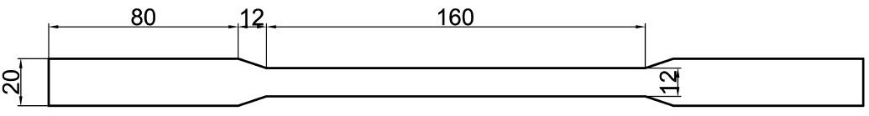

Figure 1 Nominal tensile coupon dimensions.

The coupons were positioned in a Zwick/Roell 100 kN Universal Testing Machine and loaded in tension. Initially, an extensometer with a gauge length of 50 mm was attached to the central section of the coupon and the specimen loaded within its elastic range. After a sufficient amount of elastic deformation had occurred, the test was paused and the extensometer was removed; the test was then continued until failure of the specimen occurred (see Figure 2). The average values obtained from the experiments for the mechanical properties of the S460 steel at room temperature are *E* = 203,000 N/mm2, *f*y = 487 N/mm2 and *f*u = 648 N/mm2.

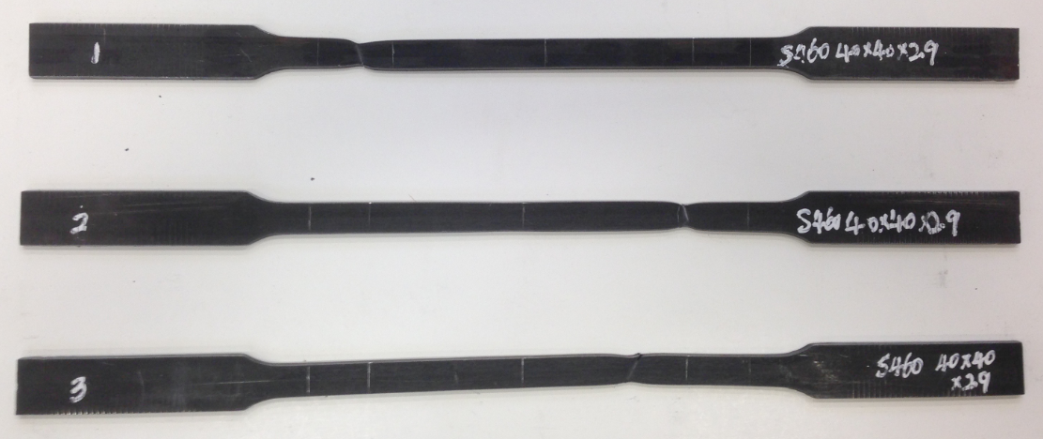

Figure 2 Tensile coupons after testing and fracture.

## Testing of beam-to-column connection assemblies

Five beam-to-column connection assemblies were tested in the Strengths of Materials Laboratory at London South Bank University. As shown in Figure 3, the assemblies comprised a 40×40×2.9 SHS beam stub in S460 steel, a 40×40×2.9 SHS S460 column stub and a 40×80×4.5 S460 endplate; the configuration is in keeping with that used in previous elevated temperature testing of endplate connections [27].

The beam and column stubs were nominally 500 mm in length prior to preparation and the addition of the loading plates, which were 10 mm in thickness. The endplate was butt-welded to the beam stub and 8 mm boltholes were drilled through both it and the upper face of the column stub. Four Class 8.8 M6 bolts were used to fasten the plates together, thus creating a typical partially-rigid bolted endplate connection.

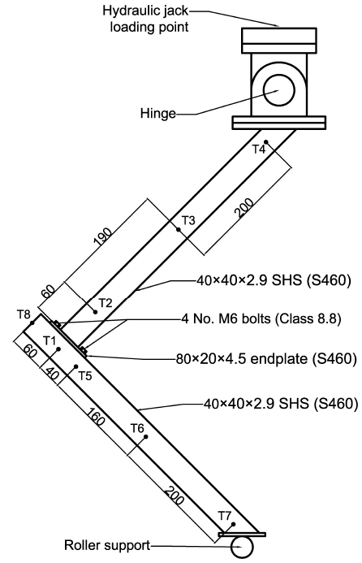

Figure 3 Schematic of beam-to-column connection assembly with thermocouple locations indicated.

In order to recreate pin-ended conditions, a bespoke hinge was fabricated to be bolted to the top loading plate of the assembly, as shown in Figure 3; this ensured rotation about the out-of-plane axis while restricting rotation about the other two axes. A roller support was provided at the base of the assembly.

### Heating of specimens

The assemblies were tested at a range of nominal temperatures: 20°C, 150°C, 350°C, 550°C, 750°C. For the specimens tested above room temperature (which is taken to be 20°C in the present study), ceramic heating pads were attached around the four sides of the beam and columns stubs along their central portions, as shown in Figure 4. The assembly was then wrapped in rockwool insulation in order to maintain steady-state temperature conditions in the specimens throughout loading. Nominal temperatures above room temperature (20°C) refer to the target set point of the inverter control unit; the actual temperature of the steel was recorded by a number of thermocouples positioned at the points indicated in Figure 3.

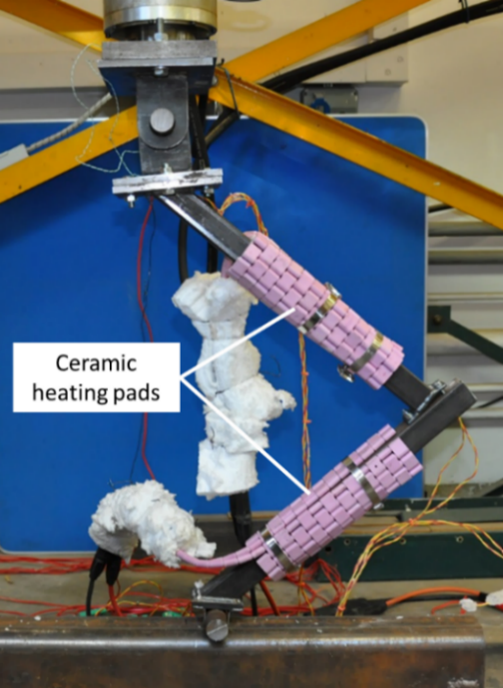

Figure 4 Typical beam-to-column assembly with ceramic heating pads exposed.

The inverter heating rate was set so that the target temperature was attained after 30–45 minutes of steady heating. A typical thermal evolution is shown in Figure 5, giving the values recorded at the thermocouples during testing of the 350°C specimen; owing to their relative proximity, the temperatures recorded at thermocouples T1 and T8 are almost identical. It can be seen that after the heating phase, the temperatures are maintained steadily throughout the mechanical loading phase.

Figure 5 Temperatures recorded at thermocouples during testing of the 350°C specimen.

## .Mechanical loading

A vertical downwards load was applied to the assemblies by a Zwick/Roell 500 kN hydraulic jack under displacement control. The applied load and downward vertical displacement were measured by the internal load cell and displacement transducer, respectively, and were transmitted via a datalogger; a linear variable displacement transducer (LVDT) was positioned at the roller in order to measure the lateral displacement at that location. Given the alignment of the assembly at 45° to the horizontal, a combination of cross-sectional bending and axial thrust was generated in the beam and column stubs. The displacement was increased steadily at a constant rate of 0.5 mm/min until a noticeable decrease in load-carrying capacity was observed, thus indicating failure of the connection.

## Results of connection testing

In the current section, the equilibrium paths, failure modes and ultimate loads obtained from the experiments are presented and discussed.

### Equilibrium paths

In Figure 6, the equilibrium paths observed for each specimen is shown; owing to a software malfunction, data for the test conducted at room temperature is only available up to a load of approximately 2.0 kN. In general, it can be seen that the load resistance and stiffness decreased with increasing temperature, while ductility increased, especially in the specimen tested at 750°C.

Figure 6 Equilibrium paths recorded in the connection tests.

### Failure modes

The failure mode in every specimen apart from that tested at 750°C involved a process of initial yielding and plastic deformation of the endplate, followed by failure of the two upper bolts, as shown in Figure 7a-d. In the specimen tested at 750°C, the failure mode involved the formation of plastic hinges in the centre of the beam and column stubs (see Figure 7e), with the connection remaining intact. While such a failure mode can be readily attributed to there being higher temperatures at the centres of the stubs than at the connection, it should be noted that similar differences in temperature were also recorded in the 150°C, 350°C and 550°C specimens, but with failure occurring at the relatively-cooler connections. This transition in failure mode can be attributed to the considerable loss of strength in the steel around 600°C. Thus, in fire scenarios where gains in temperature tend to be more pronounced at the centre of members rather than at the joints, a degree of relative fixity can be assumed to exist at the connections.

### Ultimate loads

The ultimate loads, vertical deflections at failure and lateral deflections at failure observed in the experiments are shown in Table 1; as mentioned in Section 2.4.1, data at failure is unavailable for the specimen tested at room temperature. Overall, it can be seen that load resistance reduced while ductility increased with increasing temperature, although the ultimate load of the 350°C is slightly higher than would be expected.

Table 1 Ultimate loads and displacements at failure obtained from experiments.

|  |  |  |  |
| --- | --- | --- | --- |
| Reference temperature | Ultimate load (kN) | Vertical deflection at failure (mm) | Lateral deflection at failure (mm) |
| 150°C | 4.29 | 32.0 | - |
| 350°C | 4.78 | 40.7 | 4.01 |
| 550°C | 2.59 | 30.3 | 1.72 |
| 750°C | 0.75 | 107.2 | 6.01 |

|  |  |
| --- | --- |
| a) | b) |
| c) | d) |
| e) | |

Figure 7 Failure modes observed in connection test specimens a) 20°C; b) 150°C; c) 350°C; d) 550°C; e) 750°C.

# Numerical analysis

In the current section, a numerical model developed using the finite element analysis software Abaqus 2020 [29] is discussed, including the modelling strategy, material modelling, boundary conditions and meshing. Previous numerical studies of HSS members at elevated temperatures are extensive and include investigations into the behaviour of I-section members [30], SHS and RHS members [23], bolted endplate connections [27,31] and welded connections [17]. The geometrically nonlinear analysis was conducted in two steps, namely heating and mechanical loading, in keeping with previous numerical analysis of hot steel pipelines in bending [35].

## Geometric modelling

The nominal dimensions of the stubs and the plates were employed in the numerical model; in keeping with standard dimensions given by EN 10210 [32,33], the outer radius of the fillets was set equal to 1.5*t* = 4.35 mm while the inner radius was set equal to 1.0*t* = 2.9 mm, as shown in Figure 8. Imperfections were not included in the model; however, convergence was achieved owing to the analysis being displacement-controlled. The bolts, nuts and washers were modelled as single contiguous parts.

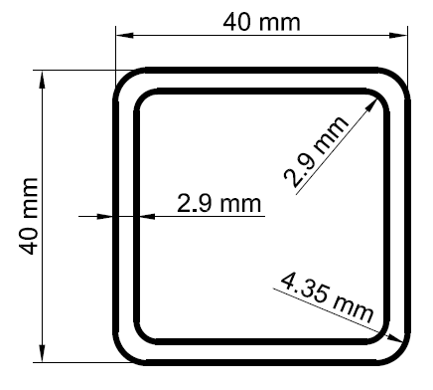

Figure 8 Nominal cross-sectional dimensions of 40×40×2.9 SHS.

## Mesh

The beam and column stubs and the endplate were meshed using C3DHI 8-noded solid elements with a characteristic element size of 1.5 mm; along the central portion of the beam and column stubs, the element dimension in the longitudinal direction was increased to 8 mm in order to improve computational efficiency. The bolt assemblies were meshed using C3D10 10-node tetrahedral elements, again with a characteristic element size of 1.5 mm. The resulting mesh is shown in Figure 9 in the neighbourhood of the bolted endplate connection.

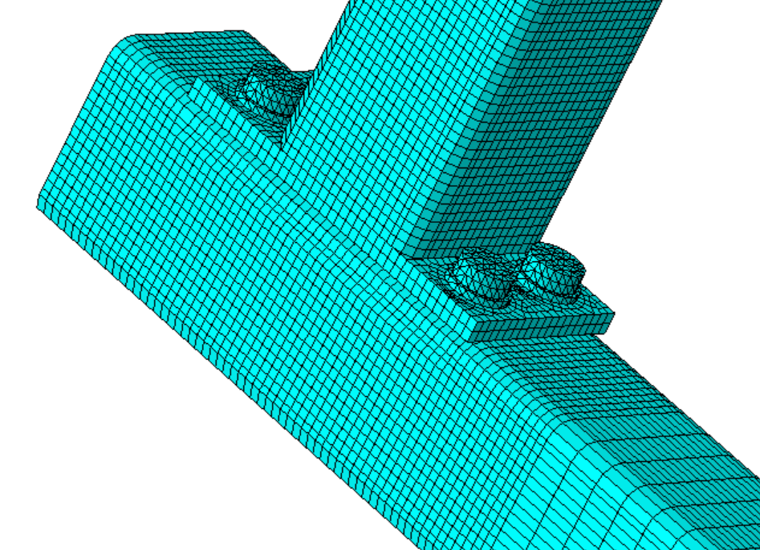

Figure 9 Mesh in the neighbourhood of the bolted endplate connection.

## Material modelling

Material models were formulated for the S460 material and for the Class 8.8 bolt material. Both materials were assumed to behave in an elasto-plastic manner with isotropic hardening, with the coefficient of thermal expansion  = 13 × 10-6 K-1. Since hot-rolled sections were under consideration in the present analysis, residual cross-sectional stresses were assumed to be negligible.

### S460 steel material model

The results for *f*y, *f*u and *E* obtained from the tensile testing were used as a basis to model the material behaviour at room temperature. The constitutive relationship at elevated temperatures was adapted from a Ramberg–Osgood model proposed by [26]; it should be noted that such relationships are offered only up to 700°C and thus the curve for 800°C is based on extrapolation. The constitutive relationships are based on the room temperature values obtained from the tensile testing discussed in Section 2.1. The values of *f*y, *f*u and *E* for S460 steel at elevated temperatures have been de-rated based on reduction factors determined by [19,21] and are shown in Table 2. The curves, which have been converted to true stress–true strain for inclusion in Abaqus [29], are shown in Figure 10.

Table 2 Mechanical properties of S460 steel used to formulate constitutive relationships at elevated temperatures.

|  |  |  |  |
| --- | --- | --- | --- |
| Temperature (°C) | *E* (N/mm2) | *f*y (N/mm2) | *f*u (N/mm2) |
| 20 | 203000 | 487 | 648 |
| 100 | 199770 | 481 | 612 |
| 200 | 178677 | 484 | 628 |
| 300 | 161974 | 487 | 663 |
| 350 | 144372 | 479 | 664 |
| 400 | 135621 | 462 | 570 |
| 450 | 117225 | 427 | 486 |
| 500 | 103205 | 360 | 389 |
| 550 | 75852 | 272 | 287 |
| 600 | 59019 | 202 | 213 |
| 650 | 50390 | 152 | 161 |
| 700 | 31008 | 75 | 102 |
| 800 | 15504 | 25 | 38 |

Figure 10 True stress–true strain curves applied in S460 material model.

### Class 8.8 bolt material model

A blinear stress–strain relationship was used to model the mechanical behaviour of the Class 8.8 bolts. At room temperature, the nominal yield strength *f*yb = 640 N/mm2, the nominal ultimate strength *f*ub = 800 N/mm2while the elastic modulus *E* is assumed to be 210,000 N/mm2 [1]. Stiffness and strength reduction factors given in EN 1993-1-2 [34] were applied in order to formulate the stress–strain relationship at elevated temperatures (strength reduction factors specific to bolts are available in Annex D of EN 1993-1-2 – more detailed descriptions of the elevated temperature properties of Class 8.8 bolts are provided by [36]). The values of *f*yb, *f*ub and *E* applied in the bolt material model are shown in Table 3.

Table 3 Nominal mechanical properties of Class 8.8 bolts at elevated temperatures.

|  |  |  |  |
| --- | --- | --- | --- |
| Temperature  (°C) | *E*  (N/mm2) | *f*yb  (N/mm2) | *f*ub  (N/mm2) |
| 20 | 210000 | 640 | 800 |
| 100 | 210000 | 620 | 774 |
| 200 | 168000 | 598 | 748 |
| 300 | 147000 | 578 | 722 |
| 400 | 126000 | 496 | 620 |
| 500 | 65100 | 352 | 440 |
| 600 | 27300 | 141 | 176 |
| 700 | 18900 | 64.0 | 80.0 |
| 800 | 10500 | 42.9 | 53.6 |

## Temperature fields

When defining the heating step, the temperature distributions in the beam and column stubs were represented by third-order polynomial functions in the longitudinal coordinates of the stubs that were fitted to the thermocouple temperatures shown in Table 4; for the room temperature specimen, a temperature of 20°C was applied uniformly throughout the model.

Table 4 Temperatures (in °C) at thermocouple positions used to calibrate analytical temperature fields in numerical models.

|  |  |  |  |  |
| --- | --- | --- | --- | --- |
| Thermocouple position | Model reference temperature | | | |
| 150°C | 350°C | 550°C | 750°C |
| T1 | 105 | 270 | 421 | 497 |
| T2 | 131 | 325 | 484 | 558 |
| T3 | 164 | 394 | 579 | 771 |
| T4 | 98 | 219 | 354 | 416 |
| T5 | 114 | 266 | 445 | 530 |
| T6 | 145 | 337 | 538 | 743 |
| T7 | 73 | 138 | 262 | 362 |
| T8 | 112 | 285 | 423 | 507 |

The polynomial field provides a good approximation of the smooth steady-state thermal distribution expected after gradual heating of the beam and column stubs, especially the concentration of heat underneath the ceramic heating pads. An example of the resulting temperature field is shown in Figure 11 for the 550°C specimen; it can be seen that concentrations of maximum temperature coincide with the positioning of the ceramic pads.

## Surface interactions

The weld between the beam stub and the endplate was simulated using a tie constraint. Contact between the bottom surface of the endplate and the corresponding surface atop the column stub was simulated using a hard contact interaction with a coefficient of friction = 0.3.

The interaction between the bolts and the plates was modelled using a friction-penalty hard contact between the top surface of the end plate and the underside of the nut, and a tie constraint between inside surface of the column stub and the bolthead. Defining a tie constraint along this surface rather than a contact interaction was found to aid convergence while also representing the deformation of the plates observed during the experiments accurately (see Section 4).

### 

Figure 11 Temperature distribution applied in model of 550°C specimen.

## Boundary conditions

A pin support was defined at the top loading plate that allowed rotation about the out-of-plane axis with the other degrees of freedom restrained. During the heating step, the vertical displacement was restrained; during the loading step, displacement-controlled loading was simulated by imposing a downwards vertical displacement of 50 mm at the pin support (in the 750°C model, this was increased to 110 mm). Roller conditions were defined at the bottom support that allowed free rotation about the out-of-plane axis, with all other degrees of freedom restrained. The lateral displacements shown in Table 1 were imposed on the degree-of-freedom in the horizontal in-plane direction.

# Comparison of results

In this section, the results obtained from the numerical analysis are discussed and compared with those obtained from the experiments, namely the equilibrium paths, the ultimate loads and the failure modes.

## Equilibrium paths

The equilibrium paths obtained from the experiments and the numerical analysis for the five specimens considered in the present study are compared in Figures 12 to 16, respectively.

Although the experimental curve for the room temperature specimen is truncated, it can be seen in Figure 12 that there is good agreement between the initial stiffness predicted by the numerical model and that observed in the experiment.

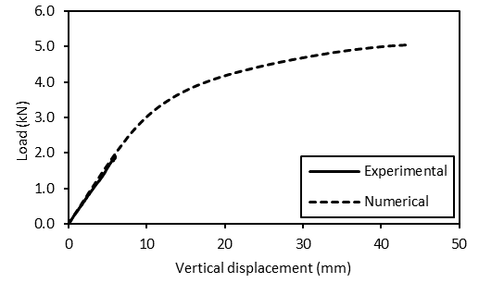

Figure 12 Comparison of equilibrium paths obtained from experiments and numerical analysis for the room temperature specimen.

In Figures 13 to 15 for the 150°C, 350°C and 550°C specimens, respectively, it can be seen that good agreement exists between the initial stiffnesses, the ultimate loads and the equilibrium paths observed during the experiments and those predicted by the numerical model. As noted in Section 2.4.3, the experimental ultimate load of the 350°C specimen appears to be anomalously high, thus leading to the discrepancy seen in Figure 14. Overall, it can be said that the reduction factors proposed by [21] in conjunction with the constitutive relationships proposed by [26] provide an accurate representation of the behaviour of S460 at elevated temperatures.

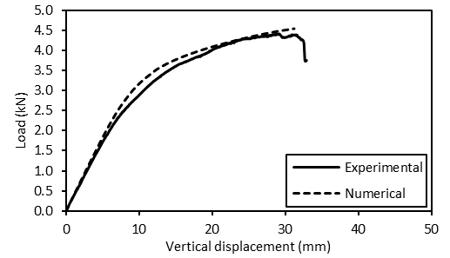

Figure 13 Comparison of equilibrium paths obtained from experiments and numerical analysis for the 150°C specimen.

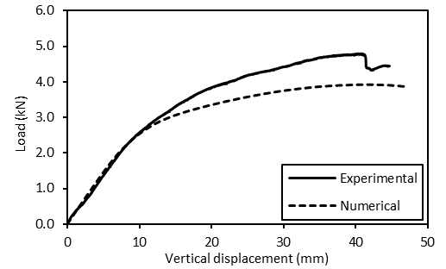

Figure 14 Comparison of equilibrium paths obtained from experiments and numerical analysis for the 350°C specimen.

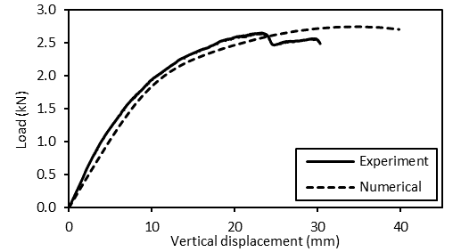

Figure 15 Comparison of equilibrium paths obtained from experiments and numerical analysis for the 550°C specimen.

In the case of the 750°C specimen shown in Figure 16, although the numerical prediction for the initial linear stiffness is accurate, the model over-predicted the resistance of the assembly. This is likely a consequence of the material behaviour at temperatures above 700°C being based on extrapolation; more testing of S460 at such elevated temperatures is thus required in order to develop a more accurate material model.

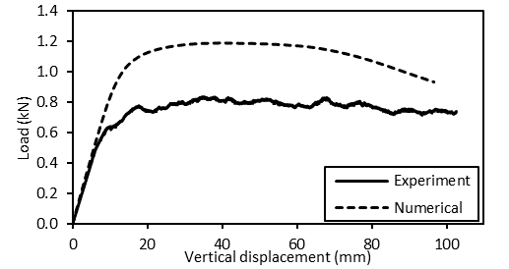

Figure 16 Comparison of equilibrium paths obtained from experiments and numerical analysis for the 750°C specimen.

## Failure modes

The failure modes predicted by the numerical model for the specimens tested at nominal temperatures up to 550°C all failed via buckling of the endplate; this is in agreement with the failure modes observed in the experiments. Comparison is made between the experimental and numerical failure mode in Figure 17 for the 350°C specimen (which is representative of the 20°C, 150°C and 550°C specimens); in Figure 18, the experimental and numerical failure modes for the 750°C specimen are compared at a deflection of 100 mm.

|  |  |
| --- | --- |
| a) | b) |

Figure 17 Comparison of deformation at the connection for the 350°C specimen (at a vertical displacement of 45 mm); a) experiment; b) numerical prediction.

|  |  |
| --- | --- |
| a) | b) |

Figure 18 Comparison of failure modes for the 750°C specimen; a) experiment; b) numerical prediction.

## Ultimate loads

In Table 5, the ultimate loads predicted by the numerical analysis, *P*u,FE, are compared with those observed during the experiments. *P*u,exp. The discrepancy between the ultimate loads for the 350°C specimen can be attributed to the experimental load being higher than expected, as discussed in Section 2, while the discrepancy in ultimate loads for the 750°C specimen can be attributed to the extrapolation of the material models discussed in Section 4.1.

Table 5 Comparison of experimental and numerical ultimate loads.

|  |  |  |  |
| --- | --- | --- | --- |
| Specimen | *P*u,exp (kN) | *P*u,FE (kN) | *P*u,exp / *P*u,FE |
| 150°C | 4.41 | 4.54 | 0.97 |
| 350°C | 4.71 | 3.92 | 1.20 |
| 550°C | 2.61 | 2.75 | 0.95 |
| 750°C | 0.79 | 1.09 | 0.73 |

# Conclusions

An investigation has been conducted into the behaviour of bolted endplate connections between S460 square hollow section beam and column stubs heated to a range of temperatures up to 750°C. Tensile testing of S460 coupons was conducted at room temperature in order to determine the mechanical properties of the material. Experiments were described whereby S460 bolted endplate assemblies were heated using ceramic pads to a range of target temperatures and then loaded in combined compression and bending. It was found that for nominal temperatures up to 550°C, the failure mode involved buckling of the endplate, but at 750°C, the failure mode involved plastic hinges forming in the beam and column stubs with the connection remaining intact. It was noted that, although there were differences in strength and stiffness between the connection and the centres of the stubs associated with temperature differentials in each specimen, it was only at the highest temperatures that this difference led to failure initiating in the stubs rather than the connections. Thus, it can be assumed that a degree of relative fixity exists at the ends of members at high temperatures, which shift the point of initiation of failure towards the members themselves.

A numerical model complementary to the experimental analysis was developed in Abaqus [29]. Based on the mechanical properties obtained from tensile testing, constitutive relationships from the literature were used to formulate temperature-dependent material models. Appropriate contact and tie constraints were defined in the model in order to simulate the interaction between the endplate, the column stub and the bolts in the connection. The temperature field was formulated by fitting polynomial functions in the longitudinal coordinates of the stubs to the temperatures recorded at the thermocouples. It was found that, overall, the initial linear stiffness and ultimate loads predicted by the numerical model were in reasonably good agreement with the experimental results, thus providing additional validation to the material models used. Overall, the numerical approach employed in the present study is appropriate for modelling the behaviour of bolted endplate connections in fire scenarios.

Acknowledgements

The authors wish to express their gratitude to Mr Paul Elsdon and Mr Graham Bird of the Strengths of Materials Laboratory at London South Bank University for their expertise in conducting the experiments. The authors are also very grateful to Professor Leroy Gardner of Imperial College London for supplying the hollow section members for the tests.

References

1. Comité Européen de Normalisation. (2018) *prEN 1993-1-1:2018 Final Draft - Eurocode 3 - Design of steel structures, Part 1.1: General rules and rules for buildings*, CEN.
2. Bhadoo, N.; Chan, T.-M. (2017) *Super Structures: an update on high-strength steel design*. Institution of Civil Engineers: The Civil Engineering Blog (www.ice.org.uk), 31 August 2017.
3. Ma, J.-L.; Chan, T.-M.; Young, B. (2017) Tests on high-strength steel hollow sections: a review. *Proceedings of the Institution of Civil Engineers – Structures and Buildings* **170**(9), 621–630.
4. Meng, X.; Gardner, L. (2019) Testing of hot-finished high strength steel SHS and RHS under combined compression and bending. *Thin-Walled Structures* **146**.
5. Wang, J.; Afshan, S.; Schillo, N.; Theofanous, M.; Feldmann, M.; Gardner, L. (2017) Material properties and compressive local buckling response of high strength steel square and rectangular hollow sections. *Engineering Stuctures* **130**, 297–315.
6. Li, H.-T.; Young, B. (2019) Behaviour of cold-formed high strength steel RHS under localised bearing forces. *Engineering Structures* **183**, 1049–1058.
7. Müller, T.; Straetmans, B. (2015) High strength seamless tubes and steel hollow sections for crane and machine building applications, *Stahlbau*, **84**(9), 650–654.
8. Pournara, A. E.; Karamanos, S. A.; Mecozzi, E.; Lucci, A. (2017) Structural resistance of high-strength steel CHS members. *Journal of Constructional Steel Research*, **128**, 152–165.
9. Gardner, L.; Chan, T.-M. (2007) Cross-section classification of elliptical hollow sections. *Steel and Composite Structures* 7(3):185–200.
10. Chan, T.-M.; Gardner, L. (2008) Compressive resistance of hot-rolled elliptical hollow sections. *Engineering Structures*, **30**(2):522–532.
11. Chan, T.-M,; Gardner, L. (2008) Bending strength of hot-rolled elliptical hollow sections, *Journal of Constructional Steel Research,* **64**(9), 971–986.
12. Zhang, L.; Wang, F.; Liang, Y.; Zhao, O. (2020) Experimental and numerical studies of press-braked S690 high strength steel channel section beams, *Thin-Walled Structures* [article accepted; online version available].
13. Sun, Y.; He, A; Yating, L.; Zhao, O. (2019) In-plane bending behaviour and capacities of S690 high strength steel welded I-section beams, *Journal of Constructional Steel Research*, **162**.
14. Coelho, A.M.G.; Bijlaard, F.S.K. (2007) Experimental behaviour of high strength steel end-plate connections, *Journal of Constructional Steel Research*, **63**, 1228–1240.
15. Hongchao, G.; Xiao, F.; Liu, Y.; Liang, G. (2018) Experimental behaviour of high strength steel end-plate connections, *Journal of Constructional Steel Research*, **151**, 108–121.
16. Wang, Y.-B.; Lyu, Y.-F.; Li, G.-Q.; Liew, J.Y.R. (2019) Bearing strength of high strength steel plates in two-bolt connections, *Journal of Constructional Steel Research*, **155**, 205–218.
17. Varelis, G.E.; Papatheocharis, T.; Karamanos, S.A.; Perdikaras, P.C. (2020) Structural behavior and design of high-strength steel welded tubular connections under extreme loading, *Marine Structures*, **71**.
18. Yang, Y.; Wang, Y.; Yang, F.; An, Q.. (2019) Influence of weld details on fracture behavior of connections using high-strength steel, *Journal of Constructional Steel Research,* **153**, 578–587.
19. Schneider, R.; Lange, J. (2009) Constitutive equations of structural steel S460 at high temperatures. *Proceedings of Nordic Steel Construction Conference 2009*, 204–211.
20. Winful, D.; Cashell, K.A.; Afshan, S.; Barnes, A.M.; Pargeter, R.J. (2017) Elevated temperature material behaviour of high-strength steel. *Proceedings of the Institution of Civil Engineers – Structures and Buildings*, special issue on High Strength Steel Structures.
21. Qiang, X.; Bijlaard, F.S.K.; Kolstein, H. (2013) Elevated-temperature mechanical properties of high strength structural steel S460N: Experimental study and recommendations for fire-resistance design, *Fire Safety Journal*, **55**, 15–21.
22. Kodur, V.; Dwaikat, M.; Fike, R. (2010) High-temperature properties of steel for fire resistance modelling of structures, *Journal of Materials in Civil Engineering ASCE,* **22**, 423–434.
23. Li, H.-T.; Young, B. (2019) Cold-formed high strength steel SHS and RHS beams at elevated temperatures. *Journal of Constructional Steel Research*, **158**, 475–485.
24. Xiong, M.-Y.; Liew, J.Y.R. (2020) Experimental study to differentiate mechanical behaviours of TMCP and QT high strength steel at elevated temperatures. *Construction and Building Materials*, **242**.
25. Cadoni, E.; Forni, D. (2019) Mechanical behaviour of a very-high strength steel (S960QL) under extreme conditions of high strain rates and elevated temperatures. *Fire Safety Journal*, **109**.
26. Fang, H.; Chan, T.-M. (2018) Axial compressive strength of welded S460 steel columns at elevated temperatures. *Thin-Walled Structures*, **129**, 213–224.
27. Strejček, M.; Řezníček, J. Tan, K.-H.; Wald, F. (2011) Behaviour of column web component of steel beam-to-column joints at elevated temperatures. *Journal of Constructional Steel Research*, **67**, 1890–1899.
28. Qiang, X.; Bijlaard, F.S.K.; Kolstein, H.; Jiang, X. (2014) Behaviour of beam-to-column high strength steel endplate connections under fire conditions – Part 1: Experimental study. *Engineering Structures*, **64**, 23–38.
29. ABAQUS (2020) *ABAQUS* *Analysis User’s manual, 2020*, USA: Dassault Systems Simulia Corp., Providence; 2020.
30. Varol, H.; Cashell, K.A. (2017) Numerical modelling of high strength steel beams at elevated temperature. *Fire Safety Journal,* **89**, 41–50.
31. Qiang, X.; Bijlaard, F.S.K.; Kolstein, H.; Jiang, X. (2014) Behaviour of beam-to-column high strength steel endplate connections under fire conditions – Part 2: Numerical study. *Engineering Structures*, **64**, 39–51.
32. Comité Européen de Normalisation. (2006) EN 10210-1:2006 Hot finished structural hollow sections of non-alloy and fine grain steels – Part 1: Technical delivery conditions. British Standards Institute.
33. Comité Européen de Normalisation. (2006) BS EN 10210-2: 2006 *Tolerances, dimensions and sectional properties* (Hot finished structural hollow sections), British Standards Institute.
34. Comité Européen de Normalisation. (2005) *EN 1993-1-2:2005 Eurocode 3 - Design of steel structures, Part 1.2: General rules – Structural fire design*, CEN.
35. McCann, F.; Ridolfi, G.; Karjadi, E.; Demmink, H.; Boyd, H. (2018). Numerical modelling of hot polymer-coated steel pipeline joints in bending. *Ocean Engineering*, **160**, 354–367.
36. Kirby, B.R. (1995). The behaviour of high-strength grade 8.8 bolts in fire. *Journal of Constructional Steel Research*, **33**, 3–38.