A Degenerate Birdcage with Integrated Tx/Rx Switches and Butler Matrix for the Human Limbs at 7 T

Riccardo Stara^{1,2,3} • Gianluigi Tiberi⁴ •
Fabio Morsani² • Mark Symms⁵ • Maria Evelina Fantacci¹ •
Massimo Marletta⁶ • Virna Zampa⁶ •
Mihir Pendse³ • Alessandra Retico² • Brian K. Rutt³ •
Michela Tosetti^{4,7}

Abstract The theoretically known degeneracy condition of the band-pass birdcage coil has rarely been exploited in transmit coil designs. We have created an eight-channel degenerate birdcage for the human limbs at 7 T, with dedicated Tx/Rx switches and a Butler matrix. The coil can be split into two half cylinders, as required for its application to patients with limited mobility. The design of the coil, the Butler matrix, and Tx/Rx switches relied on a combination of analytical, circuital, and numerical simulations. The birdcage theory was extended to the degenerate case. The theoretical and practical aspects of the design and construction of the coil are presented. The performance of the coil was demonstrated by simulations, workbench, and scanner measurements. The fully assembled prototype presents good performance in terms of efficiency, B₁ homogeneity, and signal-to-noise ratio, despite the asymmetry introduced by the splittable design. The first in vivo images of the knee are also shown. A novel RF coil design consisting of an eight-channel splittable degenerate birdcage has been developed, and it is now available for 7 T MRI applications of the human lower limbs, including high-resolution imaging of the knee cartilages and of the patellar trabecular structure.

& Riccardo Stara rstara@stanford.edu

¹ Physics Department, University of Pisa, Largo B. Pontecorvo 3, 56127 Pisa, Italy
² Pisa Division, National Institute for Nuclear Physics (INFN), Largo B. Pontecorvo 3, 56127 Pisa, Italy
³ Department of Radiology, Stanford University, 1201 Welch Road, Stanford, CA 94305, USA
⁴ IMAGO7 Foundation, Viale Del Tirreno 331, 56018 Calambrone, Pisa, Italy
⁵ GE Applied Science Laboratory, Viale del Tirreno 331, 56018 Calambrone, Pisa, Italy
⁶ Department of Diagnostic and Interventional Radiology, Azienda Ospedaliero-Universitaria Pisana (AOUP), Via Paradisa 2, 56124 Pisa, Italy
⁷ IRCCS Stella Maris Foundation, Viale del Tirreno, 331, 56018 Calambrone, Pisa, Italy

Introduction

Magnetic resonance imaging (MRI) has benefited from arrival of ultra-high field scanners (UHF) and improvements in radio frequency (RF) technology. Because of the greater signal-to-noise ratio and contrast-to-noise ratio, UHF MRI permits imaging with greater spatial resolution, with a better delineation of anatomical structures and a stronger contrast. In particular, a dedicated coil for the knee at 7 T represents a fascinating opportunity for improving the morphological and physi- ological study of the cartilage with incomparable imaging details, also able to understand the changes due to the aging of the cartilage.
The theoretical improvement in image quality from ultra-high magnetic fields in MRI has been limited by several factors, such as the inhomogeneity of the RF field. Over the last 10 years, this problem has been addressed by techniques, such as RF shimming and parallel transmission (pTx), that require the use of dedicated multichannel transmit arrays. The design possibilities for a multichannel transmit array are many and can be classified in the following categories, each one with its own advantages and drawbacks: designs based on microstrip technologies [1–4], with [3–5] or without [1, 2, 6–8] inter-element decoupling; designs based on loops, with different types of inter-element decoupling [6, 9, 10]; designs based on dipoles [11, 12]; combinations of more than one of these designs [13, 14].
The choice of the appropriate multichannel transmit array design must consider both theoretical considerations and practical constraints imposed by the target applications. For our target application—the MR study of human limbs at UHF (7 T)—we proceed as follows. First of all, the radius of the coil is limited by the bore diameter of the 7 T MRI scanner (60 cm) and the need to comfortably accommodate the knee or thigh while still leaving enough bore space for the other leg. To allow easy positioning and comfort for patients with reduced mobility, the coil must be capable of being separated into two halves (upper and lower); in other words, the coil should be ‘‘splittable’’. Microstrip coils are known to offer several advantages at UHF, such as improved decoupling under particular circumstances, as described in [5]. However, this intrinsic decoupling is difficult to achieve for microstrip lines shortened by shunt capacitors [15]. Therefore, additional decou- pling may be needed, especially for a coil that needs to be used with a broad range of loading. No suitable decoupling strategy is available for dipoles and, therefore, despite the scientific interest in this type of coil, we did not further consider a dipole design for this application. For loop coil array designs, those without overlap between resonant elements are generally preferable for parallel imaging applica- tions, due to the better separation between sensitivity profiles and consequent improvement in parallel imaging performances. For this reason, all designs requiring overlap between elements, such as those reported in [6, 9], have been discarded. In addition, a capacitive decoupling scheme without a shared conductor path, such as in [6], is problematic to implement on a splittable coil. For all of the above reasons, we chose to build a degenerate birdcage [16–18], a special case of band-pass birdcage in which the capacitor values are chosen to collapse all resonant modes to a single (degenerate) frequency. One hypothesized feature of a birdcage-

like design is that it is intrinsically more efficient due to the shared conductors between adjacent meshes. In a non-birdcage loop coil, there is current flow in both directions of the two loop conductors, whereas, in a birdcage coil, those currents are combined, resulting in a lower current on the shared path constituted by the legs of the birdcage and hence higher coil efficiency (resulting B₁ for unit current).
The degenerate birdcage, in which the decoupling is given by the choice of the ratio between the end-ring and the leg capacitors, is, therefore, hypothesized to be an appropriate design for the lower limb application. It can be easily built in a splittable version by appropriate electrical connections between the two semi- cylindrical halves at two points for each end ring (plus the required connections on the shield). In addition, to the best of our knowledge, an accurate description of the theoretical and practical aspects of building a 7 T degenerate birdcage in an openable shape has not been covered by the literature at present.

Materials and Methods

  - Degenerate Birdcage Theory

The theory of the birdcage resonator was developed nearly 30 years ago [19–21], and provides a complete and formal description of the problem. We have rewritten the birdcage equations [20–22] in terms of variables more suitable to the degenerate case, obtaining a mode equation dependent only on the mutual inductances, the ratio R, and the series combination T of leg and end-ring capacitance values. With reference to the circuit in Fig. 1, the birdcage equations can be expressed as follows:
1 — 1 cos 2pk
T

x² ¼
P
Tð1þRÞ N
ð1Þ

k N—1 M
m¼0 m
cos 2pkm
N

N—1 1 1 2pk

M ¼ 1 X T — TðRþ1Þ cos N ei2pkm
x
m
N
2
k
N

k¼0
ð2Þ

where N is the number of meshes in the coil, k is the resonant mode number, and:

T 1 C_{R}C_{L}
¼
2 C_{R} þ C_{L}
R C_{L} C_{R}
¼
<8 2ðL þ MÞ m ¼ 0
ð3Þ ð4Þ

M_{m} ¼
: M m [ 1
M_{n;nþ1} — M m ¼ 1 : ð5Þ
n;nþm

M_{n,n?m} is the mutual inductance between mesh n and mesh n ? m. Therefore, M_{m} contains all the information about mutual and self inductances. In the special case, m = 0, M_{m} correspond to the self-inductance of the single mesh, which comprise a term L given by the inductance segment of the end ring between two legs, and a

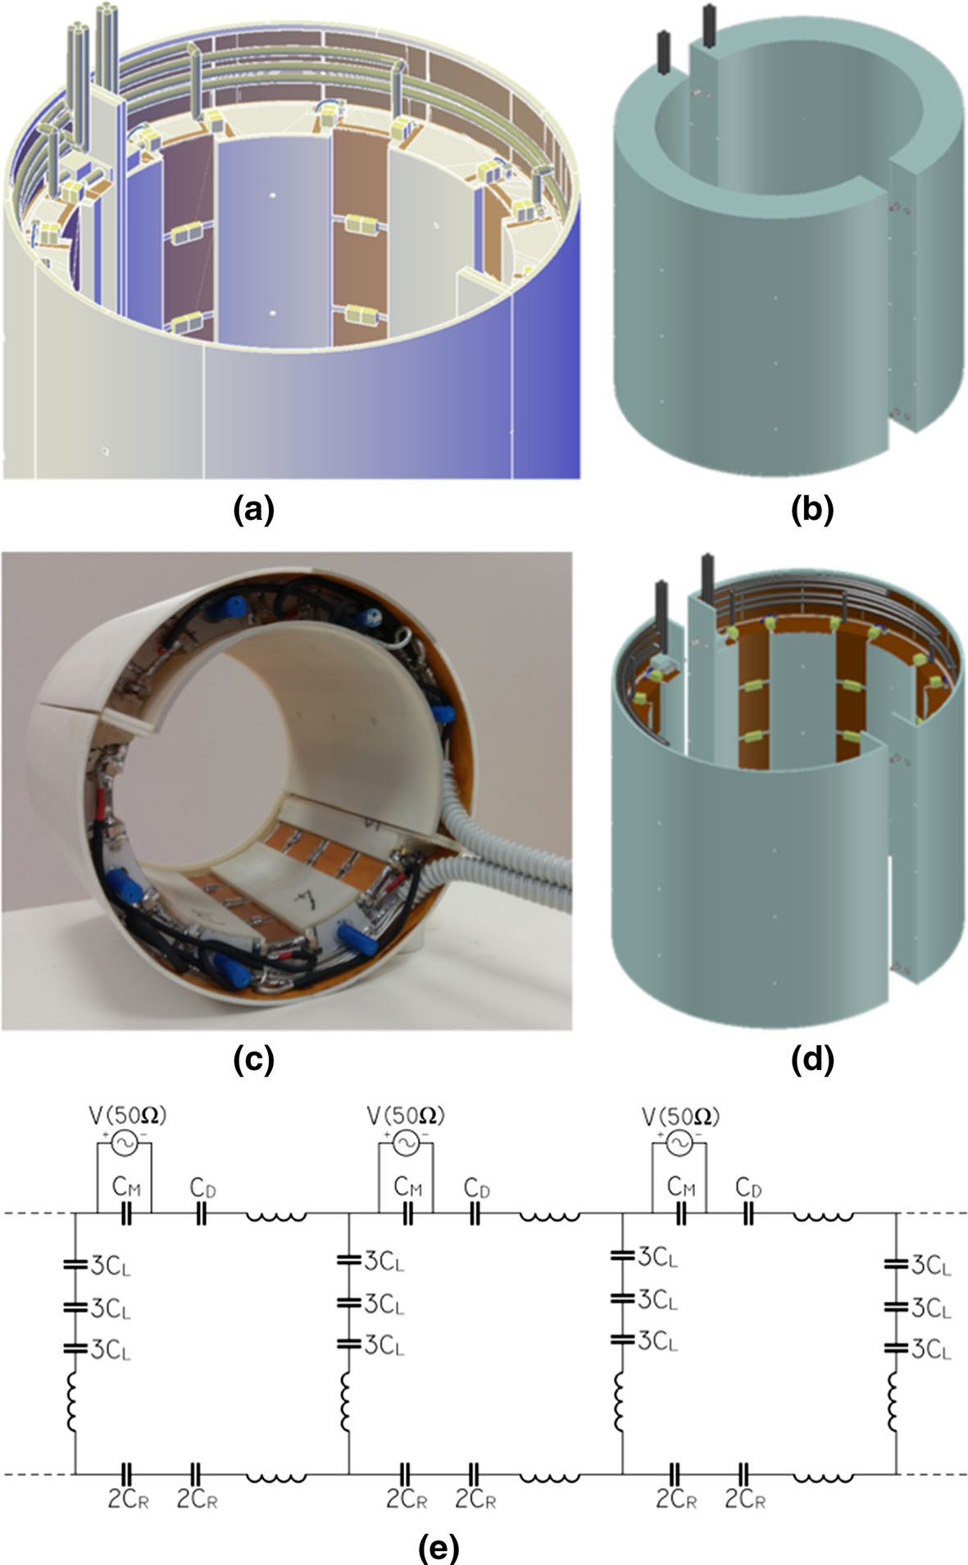

Fig. 1 Coil model (a, b, d) and prototype (c). Equivalent circuit for the birdcage (e). For the analytical simulations and all the simulation neglecting losses, both the capacitors CD and CM are replaced with 2CR, while the voltage port is removed. Therefore, for the sake of those simulations, the upper and lower end rings are symmetric

term M due to the inductance of the legs, which is shared between two meshes. The first equation is used to calculate the resonant frequencies for a given value of R and T once the mutual inductances are known. The second equation is used to estimate the mutual inductance from a measurement of the resonant frequency on the coil built with an initial guess of R and T. The procedure can then be repeated iteratively until convergence to a degenerate spectrum is achieved.

  - Degenerate Birdcage Coil Design

The design adopted in our study was an 8-leg degenerate birdcage, whose dimensions were chosen according to the target application, aiming to maximize both the patient’s comfort and the coil signal-to-noise ratio (SNR). The chosen birdcage dimensions were: length 183.2 mm, diameter 196 mm, distance between RF shield and legs 19 mm, and strip width 27 mm. The coil was supported by a 3D-printed cylindrical ABS frame of inner diameter 180 mm (supporting the birdcage structure), outer diameter 240 mm (supporting the shield) and total length 236 mm. ABS thickness is, therefore, 3 mm. The electrical connection between the two haves was achieved using four pairs of high-power, non-magnetic contacts from Phoenix of Chicago (P.N. 1500200001J/1510200001J) located on the end ring at the splitting point. The shield was also electrically connected between the two halves using four pairs of the same type of contacts located in correspondence of the end-ring splitting.
The end rings were printed on a 1.6-mm-thick ARLON 25FR substrate, while the legs were printed on a 50-lm-thick Kapton substrate. The copper thickness was 35 lm in both cases. The shield was printed on a double-sided 50-lm-thick Kapton substrate; copper thickness was 18 lm in this case. The shield consisted of 16 strips of size 45 9 226 mm² on each side of the substrate; the strips on the two sides overlapped forming a capacitance equal to 8 nF for each overlap segment.
The end-ring and leg strips sections have two and three break points for capacitors, respectively. This segmentation, in addition to avoiding radiation and phase shifting from long conductors, is important for the degenerate birdcage, since it allows more freedom in the choice of end ring and leg capacitance, resulting from a series combination of capacitors in two or three points, respectively, each of them possibly resulting from a parallel combination.
The process of tuning/matching the degenerate birdcage used a combination of:
(1) the previously described analytical model; (2) numerical simulations with the Method of Moments (MoM) implemented in the commercial software FEKO (Altair, Troy, Michigan, USA); (3) circuit simulations using ADS (Advanced Design Systems, Keysight, Santa Rosa, California, USA); simulations on human models with the Finite Integration Technique (FIT) implemented in Microwave Studio (CST, Darmstadt, Germany). The analytical model was used to estimate the theoretical values of capacitors. The MoM was used for the design phase, to calculate the EM fields in phantoms and, together with the circuit simulator, the S- matrix to estimate the capacitor values. FIT was used to estimate the EM fields and SAR in a human model.
The MoM simulation model was constructed starting from the high-pass birdcage (R = ?), in which all the leg capacitors are replaced with a short, and measuring

the resonant frequencies. The inverse formula Eq. (2) then provided an estimate of the mutual inductance that was then fed into Eq. (1) to obtain a prediction for R and T that would lead to a degenerate spectrum. The numerical simulation with these capacitance values then provided a more accurate set of resonant frequencies and, therefore, mutual inductances. The procedure was repeated until convergence was achieved, i.e., until either the spread between resonant peaks was minimal or the maximum decoupling was achieved between adjacent meshes. This procedure assumed an unloaded, lossless, and ideally matched coil. Including the losses, the load, and the matching network into the model, a co-circuit simulation was run between FEKO and ADS replacing all capacitors with 50 X ports in the FEKO model and importing the resulting S-matrix into ADS for fine-tuning. The load was a cylinder with outer diameter 12 cm, length 20 cm, r = 0.6 S/m, and e_{r} = 80. The EM fields were then computed in FEKO with the set of capacitors obtained from the co-circuit simulation, to evaluate the field homogeneity and efficiency on a phantom. Finally, the coil model was imported into the CST simulator which implements the FIT, since CST is better suited than FEKO for simulating a realistic human model [23, 24]. In all numerical simulations, the RF shield is modeled as a continuous copper conductor, neglecting, therefore, any effect from the real shield structure. The results in terms of SAR are compared to [24], in which a commercial quadrature birdcage coil for the head is simulated with the same load used in our simulations (Ella from the Virtual Family). pTx performance was analyzed using the IMPULSE [25, 26] method starting from the CST simulation.
After the simulation phase, the coil was physically constructed, tuning and matching each coil element to the Larmor frequency by adjusting the ratio R and the total capacitance T for each pair of adjacent coil elements iteratively, until the best possible decoupling was achieved. The capacitors used in the prototype were ATC100C series. The coil mesh along the end-ring element that spanned the split required a slightly different value of capacitance due to slightly different shielding performance. Q factors for each single mesh and the whole coil in loaded and unloaded conditions were measured on the bench. To check the range of loading for which this coil is suitable, the S-matrix was measured in four loading conditions: with a cylindrical phantom of diameter 12 cm and length 20 cm filled with NaCl
0.05 M (e_{r} = 79.95, r = 0.54 S/m according to [28]) positioned in the center of the
coil (condition 1) or on one side, touching the inner surface of the coil (condition 2); with the same size of phantom positioned on one side but filled with NaCl 0.1 M (condition 3) and without any loading (condition 4).
The coil was tested on the scanner (7 T Discovery MR950MR, GE Healthcare). connecting a standard Tx/Rx switch to one of the channels at a time, while the others were terminated to 50 X. B₁? maps were acquired using the Bloch–Siegert shift method [27], using a 2D-GRE sequence (128 averages). Several imaging sequences were acquired to test for eddy currents, susceptibility artifacts, and SNR.

  - Butler Matrix

To use this coil on a 2-ch transmit MR system, a Butler matrix was built. The prototype consisted of three PCB boards on 3-mm RO3010 substrates containing

four quad hybrids each and microstrip phase shift lines. The size of each single board was 205 9 185 mm². The connection between the board layers was made using carefully calibrated 0.141⁰⁰ solid coax cables (UT-141C, Microcoax). The calibration of cable length was carried out using the VNA, equalizing the relative phase. The length of connection cables was kept to a minimum to reduce all losses. The cables were directly soldered, so as to avoid losses from connectors. Tests and comparisons with simulations were carried out for three stages of the design: the single hybrid, the first stage of Butler matrix and the full matrix. Due to RAM limitations, a full numerical simulation of the Butler matrix was not possible. However, the three layers, each containing four hybrids, can be considered non- interacting, since the boards were stacked and carefully shielded from each other. Therefore, we simulated with FEKO each board independently and combined them in ADS. The input, output, and connection cables were modeled in ADS and included in the simulation.
The Butler matrix output and input are standard BNC connectors. The connection to the switch Tx ports was made through carefully calibrated short (*20 cm) RG58 cables.

  - Transmit Receive Switches

Eight Tx/Rx switches were constructed on a 3-mm-thick RO5880 substrate. The design used one diode in series on the Tx path and two shunt PIN diodes with k/4 lines on the Rx path. The PIN diodes were Microsemi UM4906. A low impedance WMA7RA preamplifier (WanTcom Inc.) was used. The bias driver provided a maximum of 200 mA during the Tx phase and -8 V during Rx. The S-matrix for the switch was measured with and without the preamp, as well as the switching time when the diodes were biased using the bias from the MRI scanner.
Connection to the coil was made using eight 1.5k RG58 cables, directly soldered across the matching capacitor on the degenerate birdcage and the coil port of the switch.

Results

  - Degenerate Birdcage Coil Simulation

The results for the iterative procedure using FEKO numerical simulations and the analytical theory are shown in Table 1. The values T = 1.296 pF and R = 0.608 are the starting point for the following simulations that also include the matching network. The ADS simulation of the unloaded coil showed that degeneracy was achieved with R = 0.63 and T = 1.32 pF, corresponding to CL = 4.3 pF, CR = 6.8 pF, CM = 24.60 pF, and CD = 9.34 pF. The degenerate birdcage spectrum is hidden within the peak bandwidth, while the end-ring mode is still visible at 312 MHz. The coil was tuned to 298.03 MHz and correctly matched, with a worst case S11 of -25 dB. Nearest-neighbor mesh decoupling was better than -22 dB, while some coupling existed between next-neighbor meshes (-9 dB) and face-to-

Table 1 Results of the initial analytical calculation

Hybrid 1
T = 1.3106 pF
R = 5
Hybrid 2
T = 1.1511 pF 0.8167
Hybrid 3
T = 1.2893 pF
R = 0.6301
Hybrid 4
T = 1.2963 pF
R = 0.6164
Hybrid 5
T = 1.2964 pF
R = 0.6083

x_{k}/2p (MHz)

k = 0 | 457.70 | 359.02 | 315.53 | 312.42 | 311.15
k = 1 | 335.66 | 327.59 | 299.81 | 298.63 | 298.09
k = 2 | 279.08 | 315.67 | 298.59 | 297.80 | 297.78
k = 3 | 254.40 | 312.80 | 300.65 | 300.15 | 298.28
k = 4 | 247.48 | 312.58 | 301.45 | 301.11 | 300.33
M_{m} (MHz)  m = 0 | 238.84 | 217.95 | 216.98 | 216.90 | 218.39
m = 1 | -68.66 | -67.14 | -67.27 | -67.39 | -68.48
m = 2 | -6.30 | -2.06 | -1.86 | -1.81 | -1.63
m = 3 | -4.41 | -0.96 | -0.85 | -0.74 | -0.26
m = 4 | -3.71 | -0.88 | -0.72 | -0.62 | -0.13
The values for x_{k} in the Hybrid 1 case are obtained from an FEKO simulation of the unloaded coil. Those frequency values are then fed into the equation for the mutual inductances, obtaining the values of M_{m} in the Hybrid 1 case. Using those M_{m} values is possible to estimate the frequency spectrum, using the equation for the frequencies, at different values of R and T. We iterated this procedure five times (running new FEKO simulations) to account for the variation in M_{m} from the second-order effects, such as the dependency on frequency and on the other values of M_{m}

face meshes at distance 4 (-9 dB). This residual coupling, which arises as a result of optimizing nearest-neighbor decoupling, is expected to be lowered by the insertion of the load. The B₁? field for the circularly polarized mode (k = 1) of the unloaded coil was very homogeneous, shopwﬃﬃiﬃnﬃﬃgﬃﬃ a variation of about 5% within a
central slice and a central value of 53 lT/
kW.
The simulation of the coil in the loaded condition provided the following values:
R_{L} = 0.55, T_{L} = 1.32 pF, and CM_{L} = 19.75 pF from which CL_{L} = 4.1 pF,
CR_{L} = 7.4 pF, and CD_{L} = 11.78 pF. The coil was correctly matched (\-30 dB) and decoupled (\-27 dB) from the point of view of nearest-neighbor elements. Regarding the next-nearest-neighbor element decoupling, as reported in Fig. 2, the decoupling was improved with respect to the unloaded case to -11 dB. The decoupling between meshes n,n ? 4 was improved to -16 dB, due to the presence
the simulated maps, and show a CP mode efficiency of 44 lT/
kW at the center of
the coil. Figure 3e shows an example of the result achievable with B₁? shimming on
a human body model using modes k = 1 and k = 2 of the Butler matrix. Those modes are combined with a phase difference of 74°, 1-kW input power on the homogeneous mode and 800 W input power on the gradient modes. This shim setting was found by optimizing the B₁? homogeneity over the region of the knee cartilage. The result was an average B₁? of 26.3 lT with 7% RMSD (16% peak-to- peak) calculated in the knee cartilage ROI. This should be compared to a mean B₁?
of the load. The single-channel and birdcage-like field maps qupalﬃiﬃtﬃaﬃﬃtﬃﬃively agree with

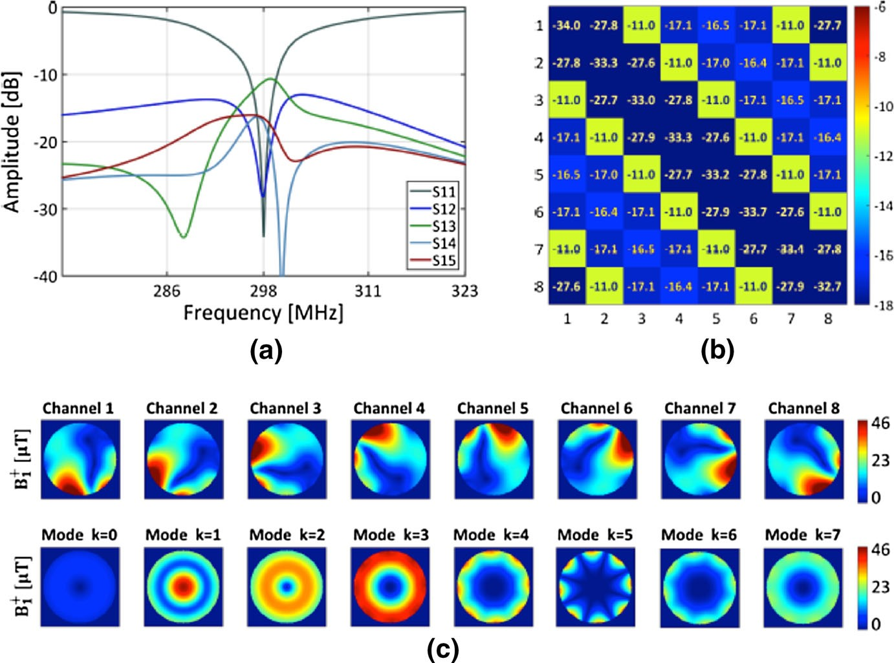

Fig. 2 FEKO results for the loaded degenerate birdcage. a Plot of the reflection coefficient and coupling coefficients for port 1. b Full S-matrix simulated with a cylindrical load (OD = 12 cm, r = 0.6 S/m, e_{r} = 80) in the center of the coil for a frequency of 298.03 MHz. c B ? fields relative to the configuration in b for the phase setting on the eight ports corresponding to the standard birdcage modes (total input power was 1 kW)
1

of 16.1 lT with maximum variation equal to 17% RMSD (33% peak-to-peak) obtained for the CP mode (k = 1).
We report, in Fig. 3d, an SAR map showing a 10-g-averaged SAR for 1 kW continuous input power on the CP mode phase setting. As discussed in [24], to assess compliance of a specific MRI sequence with legal requirements, a 6-min time average has to be considered, as specified in regulation number IEC 60601-2-33 (6). Legal requirements are average SAR \3.2 W/kg; maximum local SAR in the extremities \20 W/kg. The input power and duty cycle of the sequence, therefore, have to be considered. Since SAR depends on characteristics of the pulse-sequence adopted during MRI acquisition, all parameters related to the sequence itself must be considered in the calculation, including number, shape, and length of RF pulses that generate desired flip angles. The duty cycle considers the type of sequence and the type of pulse. In Ref. [24], the maximum local SAR corresponding to a 1 lT average B₁? was 2 W/kg. In the case of our proposed prototype, this value was
1.05 W/kg. Since this value is lower than that obtained with the comparison coil, the proposed prototype can be considered safe from the SAR point of view. Moreover, as discussed previously, the safety regulations for human extremities are much less stringent than those for the human head.

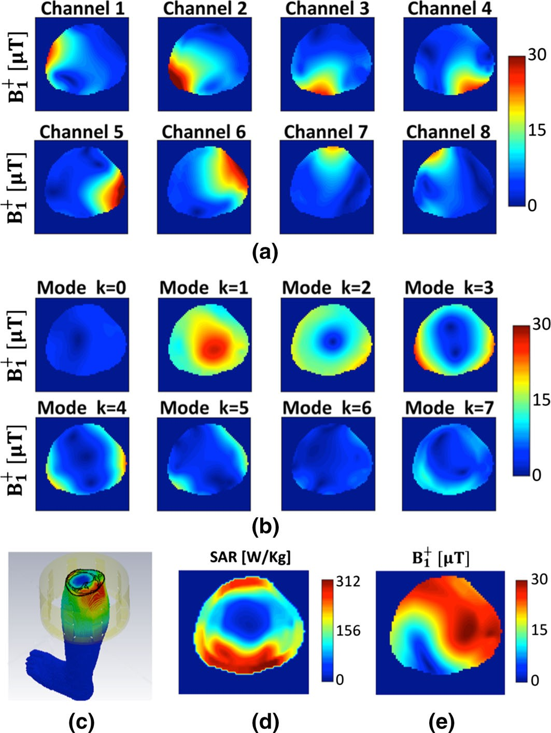

Fig. 3 CST simulation in time domain with FIT method using a human calf model. a Single-channel modes for 1-kW input power; b the birdcage-like modes for 1-kW input power. c Coil model and the phantom. d A 10-g-averaged SAR map for a central slice and 1-kW (continuous wave) total input power calculated for the k = 1 mode of b. e Example of B₁? using modes k = 1 and k = 2 with 1-kW and 800-W input power, respectively, and phase difference of 74°

We investigated the pTx performance of the coil prototype by assessing the ability to achieve both flip angle homogeneity and mitigation of local SAR hotspots. Figure 4 shows the results obtained with the IMPULSE method in comparison with the standard CP mode excitation and RF shimming. As reported in Fig. 4a, operating the coil in CP mode results in 19.4% Flip Angle Inhomogeneity (FAI) and a peak SAR of 2.26 W/kg for the input power corresponding to an average 20° flip angle. This result serves as a baseline value that can be improved using RF shimming or pTx. Before performing complete pTx, the effect of RF shimming can be assessed using either two channels of the Butler matrix or an eight-channel direct connection to the coil. As shown in Fig. 4b, two-channel shimming (even using a Butler matrix for optimal Tx channel compression) does not allow for much

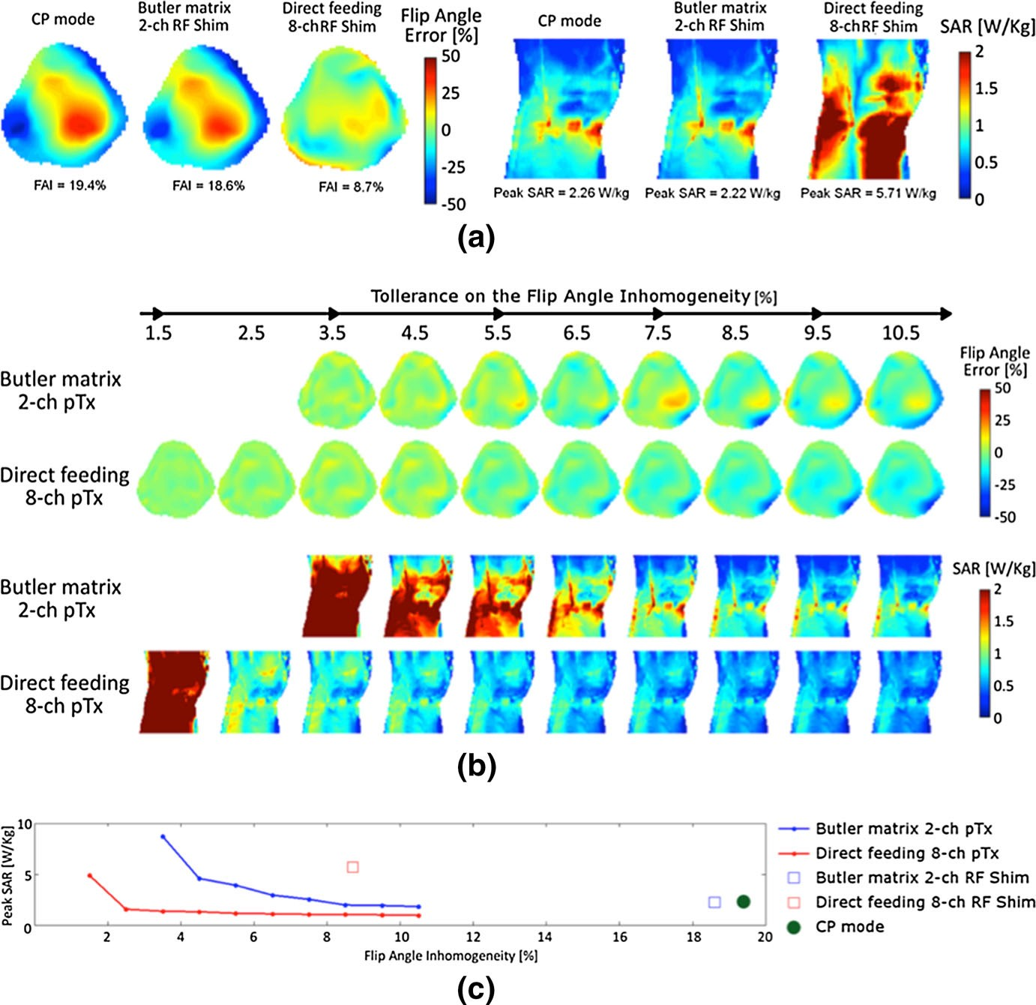

Fig. 4 Summary of the pTx results. a Results for RF shimming using two channels of the Butler matrix and eight channels direct feeding compared with CP mode. b Flip angle and SAR maps for pTx pulse design for a range of RMS Flip Angle Inhomogeneity tolerances from 1.5 to 10.5%. c Comparison between the full pTx at different tolerances of the FAI and the RF shimming for both two-channel Butler matrix and eight-channel pTx

improvement in FAI when the entire volume is considered (differently from Fig. 3, where only the patella region was optimized). RF shimming with eight-channel direct connection results in reasonably good FAI (8.7%) but at the expense of a substantial increase in SAR. With eight channels, the trade-off between FAI and SAR can be controlled with a parameter in the RF shimming optimization, so that lower SAR can be achieved at the expense of worse homogeneity ([8.7%). Significantly, better performance can be obtained using pTx where the channel amplitudes and spoke locations are determined with a local-SAR-aware algorithm [25, 26]. This algorithm takes as input the desired FAI tolerance and seeks to find the channel amplitudes and spoke locations that achieve that FAI tolerance while minimizing SAR. The results of this algorithm for a range of FAI tolerance values in both two-channel Butler matrix and eight-channel direct connection modes are shown in Fig. 4b. All the SAR values on Fig. 4 are scaled to the input power

required to achieve a 20° mean flip angle across the slice. The number of spokes is different for each FAI tolerance point, ranging from 2 to 7 spokes. The total pulse length, however, was fixed at 8 ms. The algorithm chooses the number of spokes that achieve the FAI tolerance with minimum SAR.

  - Degenerate Birdcage Coil Construction

To construct the degenerate birdcage coil prototype, initially, each mesh was separately tuned and matched to the Larmor frequency, using the result of the simulations as a starting point for the capacitor values. Then, two adjacent loops were made to resonate together and the total leg capacitance was adjusted until the two modes collapsed to a single frequency, resulting in decoupling of the two meshes. At this point, all the other meshes were added to the coil one at the time, always looking at the coupling between adjacent meshes on the VNA. After the last mesh was connected, some small adjustments on the leg and end-ring capacitors were required. As result, the following values of optimized capacitors were found: CM = 33 pF (22 pF), CD = 13.6 pF, CR1 = 15.1pF(11pF), CR2 = 22pF,
CL1 = 13.3pF(13pF), CL2 = 15pF, and CL3 = 15pF. The values for the meshes lying under the gap on the shield are reported in brackets. These values were obtained through parallel combination of two capacitors (ATC100C). Since no variable capacitor was used in the circuit, it is necessary to address the performance of the coil with different loading conditions, since the capacitor values cannot be changed from patient to patient. This choice was motivated by the fact that variable capacitors are usually mechanically larger, more expensive, and lossier than standard fixed capacitors. Moreover, even if variable capacitors where installed, it would be very difficult to know how to adjust them once the coil was built.
The Q factor was estimated by measuring the -3-dB bandwidth with a double decoupled pick-up loop, obtaining Q_{U} = 300, for the single unloaded mesh. For the ‘‘splittable’’ meshes, the measured Q_{U} factor was lower, i.e., Q = 215. Loading the coil with a NaCl 0.1-M cylindrical phantom of diameter 12 cm and length 20 cm, the loaded Q factor was calculated, measuring half of the -3-dB bandwidth of the peak of the reflection coefficient for the coil matched at -40 dB. A Q_{L} factor of 33 was obtained in this case.
In condition 1, the reflection coefficient was -20 dB on average and -14.6 dB maximum. The nearest-neighbor decoupling was -22 dB on average and -15.6 dB in the worst case. Some residual coupling was still present between next-nearest- neighbor meshes, with -8.87 dB in the worst case and -11.2 dB on average. In condition 2, which is mimicking a misplaced leg or a strongly inhomogeneous phantom, the S-matrix was degraded compared to the previous case. The nearest mesh to the phantom was over-matched (i.e., the coil element is over-loaded) to
-8 dB, while the one in the opposite position was under-matched to -14.6 dB (i.e. the coil element is under-loaded). The next-nearest-neighbor coupling coefficient was the same as before, on average (-11.9 dB), whereas more channels had worse performance, around -8.5 dB. In the case of a heavily loading 0.1-M phantom (reported in Fig. 5), the matching improved compared to the 0.05-M case, with reflection coefficients of -16.8 dB on average, -13.1 dB as the worst case, and

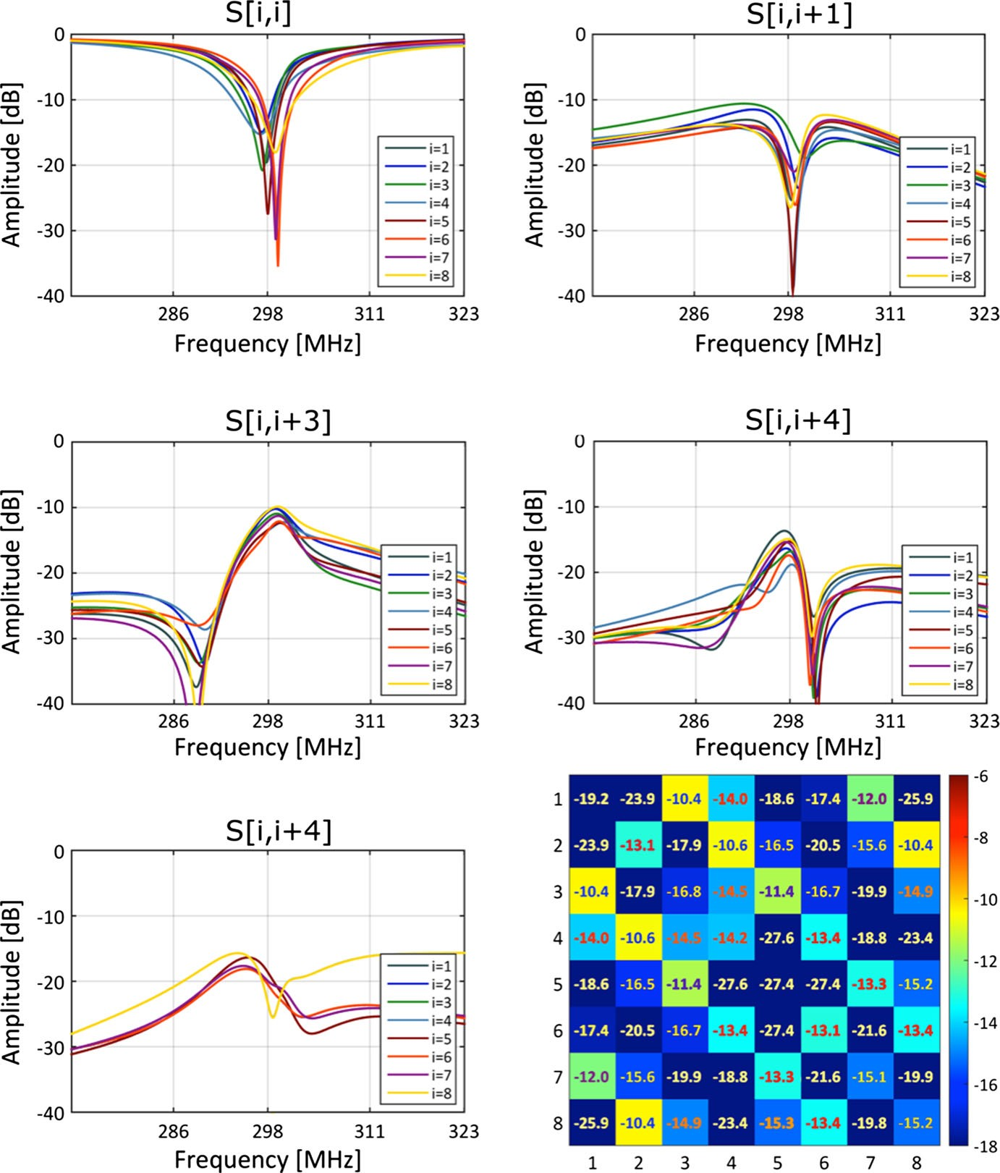

Fig. 5 S matrix measured on the bench with a cylindrical phantom of diameter 120 mm filled with 0.1-M NaCl solution placed on the coil center. Both the frequency behavior for all channels and the values at 298 MHz are shown

coupling coefficients always better than -10.4 dB. In the unloaded configuration, the worst reflection coefficient was -8.2 dB and the worst coupling coefficient was
-8.5 dB.
The results for the B₁ maps are shown in Fig. 6, with comparison to FEKO simulation. The single-channel experimental B₁? maps match the simulations fairly well. The mean values (referred to 1 kW input power) at the center of the single- channel maps are: 19.8 lT (measurement) and 15.7 lT (simulation). At the edge of the phantom, this comparison is 42.7 lT (measurement) and 59.1 lT (simulation). Therefore, simulation predicts a higher value at the periphery and lower value at the

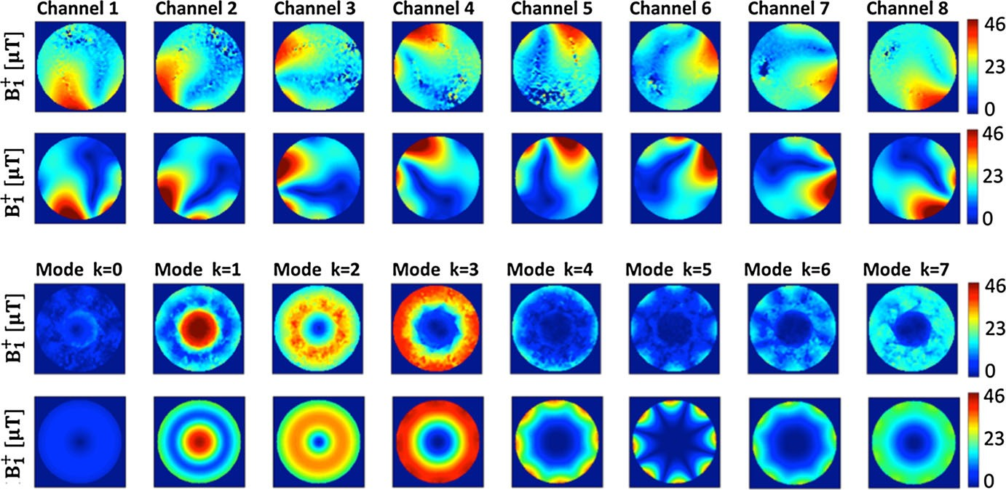

Fig. 6 Comparison between the measurement on a cylindrical phantom for the single-channel map (first row) and the birdcage-like modes (third row) against the FEKO results reported here in the second row and fourth row. All the maps are scaled to 1-kW input power. The birdcage-like maps for the measured coil are obtained from the single-channel maps combined with the simulated phase

center of the phantom compared to experimental measurements. A possible interpretation of this finding is that the values of permittivity and conductivity in the simulation are different from those of the real phantom. A similar behavior is obtained for the CP (birdcage) mode. In this case, the value at the center is 56.5 lT (measurement) and 44.4 lT (simulation).

  - Butler Matrix

The phase differences between output channel for the quad hybrid were -90.36° and -89.45° when fed from the transmit and isolated port, respectively. This compares well with the simulation where -90.36° and -88.88° were obtained, respectively. The S12 measurement resulted in a power splitting of 51.97 and 45.13% for the two output ports. The resulting total power loss was 2.9%. The simulation predicted 48.16 and 48.06% transmitted power, for a total power loss of 3.72%. The port matching was always better than -20 dB for both measurement and simulations. The isolation between input and output ports was better than
-25 dB.
The next step was the construction of a first-stage board, including 4 quad hybrids, a 67.5° line, a 22.5° line and connection lines. With the aid of numerical simulations (using ADS Momentum), the connection line was estimated to be 9.35°. The mean phase error was ±1.4° with respect to the ideal case. The simulation correctly reproduced this result, giving a mean phase error of ±0.97°. The measured average power loss was 7.82%, in good agreement with the simulation that predicted 7.35%. The amplitude balance was 15% in the measurements, while the simulation predicted a better value of 7%.

Regarding the full Butler matrix simulation and measurements, the results are summarized in Fig. 7. The mean phase errors were ±3.8° for the measurement and
±1.4° for the simulation. Moreover, the measured mean phase errors were lower for the 1R mode (±2.2°) compared to the other modes and especially to the 4R mode (±7.9°). The maximum deviation from ideal behavior in measurement was -7.4°, while for the simulation, it was -4.7°. Comparing the simulated phase with the result of the measurements, a mean phase error of 3.5° was obtained. Considering the single modes, for the 1R channel, the mean difference between measurement and simulation was ±2.2°. The worst agreement was obtained for mode 4L, for which it was ±7.4°. Measured and simulated average power losses were in very good agreement, 14.64 and 14.86, respectively. In the simulations, all channels transmitted approximately the same power, with the maximum variations equal to 2.09%, while in the measurements, this difference was equal to 4.89%. Regarding the power balance, in simulations, the transmitted power levels showed a maximum variation of 11.7% between the output channels of all the modes. However, in the measurements, this value increased to 30.4%, the worst case being for the 2R mode. The 1R homogeneous mode presented a better amplitude balance of 21.8%.

  - Transmit–Receive Switches

The insertion loss during receive for the prototype TR switches was -0.219 dB, corresponding to a 4.7% degradation in SNR. The insertion loss between Tx port and coil port during Tx was -0.161 dB corresponding to 3.6% power dissipation on each switch. The isolation between the input of the preamp and the Tx port was better than -50 dB, corresponding to 40 mW of power at the preamp when the Tx port was fed with a maximum power of 4 kW. After the insertion of the preamp, the average gain was 27 dB, while the average reverse gain was -48.28 dB. The phase balance between the 1R input of the Butler matrix and the matching capacitor on the coil was 0.245° on average with 1.13° as maximum. The total transmitted power (between the 1R channel of the Butler Matrix and the matching capacitors) was 70.8%. The switching time between Rx and Tx was 8.8 ls, while between Tx and Rx was 14.8 ls. Regarding the power rating test, the scan ran successfully for 30 min and, removing the switch immediately from the bore, no perceptible heating of the diodes was detected.

  - In Vivo Validation

The fully integrated splittable coil prototype, including the degenerate birdcage resonator, the Butler matrix, and the Tx/Rx switches, underwent feasibility tests in vivo on a 7 T MR scanner. Potential applications range from preclinical studies on medium-sized animals to clinical pediatric patients, and adult human lower limb studies. The latter is the application for which the coil design has been optimized, focusing on knee imaging. Figure 8 shows sample images of the leg of a healthy human volunteer: a sagittal view of the knee shows different muscle bundles, the femur, tibia and patella bones, cartilage, fat, connective tissues, and the sciatic nerve (Fig. 8a). The high resolution achieved allows the visualization of trabecular bone

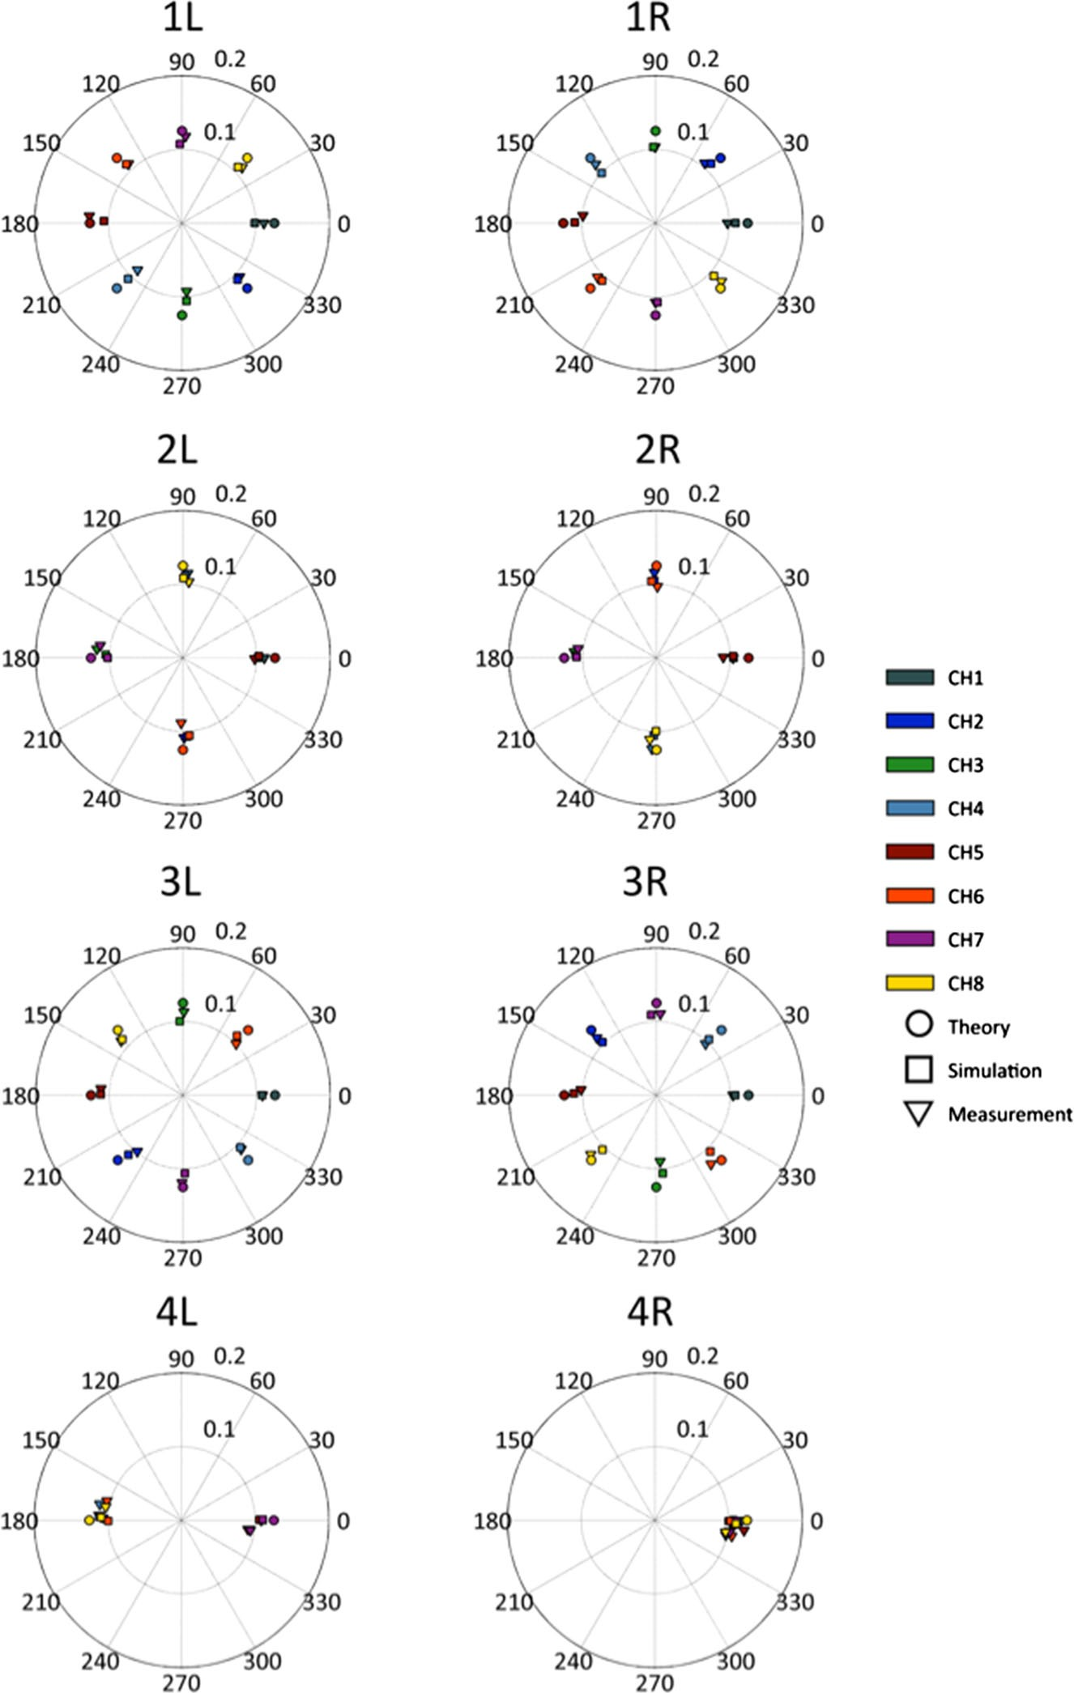

Fig. 7 Polar plot of the results for the 8 9 8 Butler matrix. Each plot corresponds to a Butler matrix input mode; each color corresponds to an output channel. The theoretical expectation is displayed with circles, the triangles are for the measurement, and the squares are for the simulation result (color figure online)

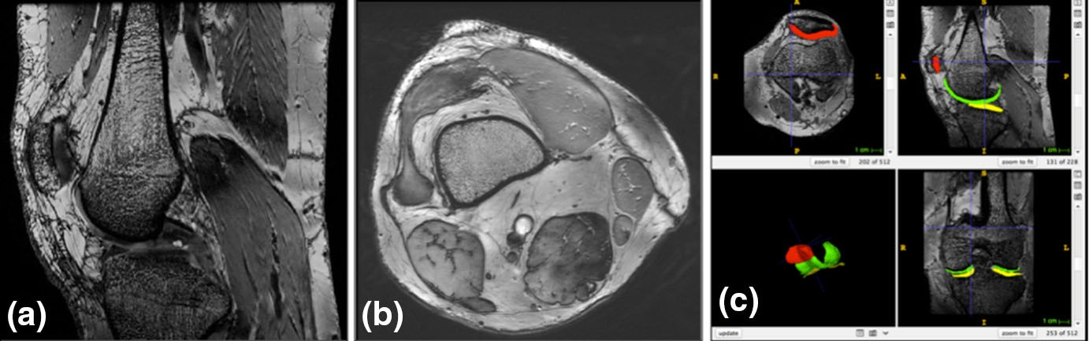

Fig. 8 Images of the knee of a healthy human volunteer: a sagittal view acquired with a 3D FIESTA sequence (FA = 20°, TR = 8.3 ms, TE = 3.1 ms, isotropic voxel size = 1 mm); b axial view acquired with a 3D COSMIC sequence (slice thickness = 600 lm, TE = 1.8 ms, TR = 6 ms. Field of view (FOV) 14 cm 9 14 cm, matrix 512 9 512, interpolated to 1024 9 1024; in-plane resolution = 137 lm 9 137 lm; c axial view acquired with a 3D COSMIC sequence (TR = 5.9 ms, TE = 1.8 ms, NEX = 0.7, acquisition matrix = 416 9 384, FOV 15 9 15 cm², FA = 14, slice thickness = 1 mm. In- plane res: 360 9 390 lm²), where the cartilages of the patella (red), femur (green), and tibia (yellow) are segmented with the itk-snap semiautomatic software tool (color figure online)

structure (Fig. 8b). The different components of the patellar cartilage become visible (Fig. 8c) with the possibility of segmenting them with semiautomatic software tools, such as itk-snap (http://www.itksnap.org). This coil, therefore, allows evaluating the early signs of alteration in cartilage at UHF, from different body districts: except for the tailored application on the knee, the cartilage could be evaluated also in the foot–ankle or hand–wrist junction. It is possible to explore physiological alterations due to aging and, thanks to the high SNR, evaluate structures in the 100–150 lm range.

Discussion

Following the procedures developed here, the degenerate birdcage coil was well matched and tuned, and nearest-neighbor decoupling was adequate. Despite some residual coupling between next-nearest-neighbor meshes, the decoupling was still sufficient for good imaging performance, resulting in a maximum coupling of power (or noise) between channels of 12%. With an asymmetrically placed phantom, the worst-case reflection coefficient still corresponds to 87% of power going to the respective channel, affecting, therefore, only minimally the coil efficiency and power balance. The coil is, therefore, usable even in the worst-case scenario. Since the S-matrix improves with the 0.1-M phantom from both the reflection coefficient and coupling points of view, the coil is expected to work better with larger loads such as the thigh than with smaller loads, such as the calf. The B₁? efficiency of the coil is excellent, as expected for a birdcage-like coil. This, together with sufficient element decoupling, allows excellent imaging performance as proven both in phantoms and human volunteers.
Among all the birdcage modes, most of the B₁? are generated by the homogeneous and linear modes, which show complementary patterns inside a high-permittivity load. The result in Fig. 3e also proves the utility of combining

those modes when B₁? homogeneity is required over a smaller area; using this most basic setup of two-channel Butler RF shimming, the efficiency and B₁? homogeneity have both nearly doubled (even if only on a small ROI). Much better results could be obtained incorporating more than two channels for RF shimming or (even more) using pTx. In the pTx case, the coil can achieve very good homogeneity (\5%) using either two-channel drive or eight-channel drive. Two- channel pTx incurs a cost of increased SAR, although this may not be a safety concern in the knee. With eight-channel pTx, an FAI tolerance of 2.5% is possible with a lower SAR than the birdcage mode. pTx with the first two Butler modes is, therefore, able to achieve similar values of FAI to what is obtained using all eight channels of the coil (without Butler matrix). However, the ability to manipulate SAR is strongly diminished if the high order modes and the counter-rotating modes are not used. For this reason, a pulse optimization minimizing the peak local SAR under a FAI constraint would perform significantly better using all eight channels, or at least four channels including two counter-rotating modes [29], compared to using two channels. On the other hand, if SAR is not a particular concern (as for human extremity applications), then the two-channel Butler matrix operation may be perfectly adequate.
The overall pTx performance of this coil is excellent: it is possible to manipulate both B ? and electric fields to reduce both flip angle inhomogeneity and peak local SAR. It is possible to achieve this excellent combination of sustainable SAR and very homogeneous B₁?, either using eight channels directly connected to the coil or two channels of the Butler matrix. It is worth mentioning that the pTx performance of the Butler matrix feeding all eight channels was proved in phantom simulations to be equivalent to those obtained with eight channels directly connected to the system. It was also shown in [29] that using four channels of the Butler matrix, the performance of the eight-channel direct connection in terms of both FAI and SAR could be almost perfectly matched, thereby doubling the number of usable coil elements without substantial imaging compromises.
1

Conclusions

We designed and constructed an innovative RF volume coil prototype for MRI acquisition of the human knee with a 7-T MR whole-body scanner. The RF coil prototype consists of an eight-channel degenerate birdcage coil, driven by a Butler matrix. It has been validated in vivo on healthy volunteers, demonstrating the feasibility of clinical research studies on trabecular bones and cartilage, whose quantitative characterization can take advantage of UHF MR with dedicated coils. RF shimming and pTx techniques can be exploited using the proposed coil, allowing the control of either the FAI or SAR exposure or both. Musculoskeletal research studies spanning the spectrum from neuromuscular diseases to osteoarthri- tis and osteoporosis could greatly benefit from UHF MR with this new coil.

Acknowledgements This work was partly funded by the National Institute for Nuclear Physics (INFN) within the TESLA project (INFN-CNS5). The authors are grateful to Tommaso Napolitano (INFN,

Frascati National Laboratory) for 3D printing the coil support. The authors also thank all GE Healthcare employees who contributed to this work.

Author contribution RS, GT, AR, and MT designed the study; RS, GT, and FM performed simulations and coil construction; MS contributed to the in vivo protocol, as well as with scanning assistance and coil interface/troubleshooting; MEF, MM, VZ, and MT developed the image acquisition protocol for in vivo imaging tests; BR and MP tested the coil performance for pTx on simulations. AR and MT raised funds for this project and managed the study; RS, GT, and AR drafted the manuscript; all authors revised and improved the manuscript.

Compliance with ethical standards

Conflict of interest Mark Symms is currently employed at GE Healthcare. Brian Rutt receives research support from GE Healthcare. All other authors have no conflict of interest to disclose.

Ethical approval All procedures performed in studies involving human participants were in accordance with the ethical standards of the institutional and/or national research committee and with the 1964 Helsinki declaration and its later amendments or comparable ethical standards.

Informed consent Informed consent was obtained from all individual participants included in the study.

References

- G. Adriany, E.J. Auerbach, C.J. Snyder, A. Go¨zu¨bu¨yu¨k, S. Moeller, J. Ritter, V. de Moortele, T. Vaughan, K. Ug˘urbil, Magn. Reson. Med. 63, 1478–1485 (2010)
- G. Adriany, V. de Moortele, F. Wiesinger, S. Moeller, J.P. Strupp, P. Andersen, C. Snyder, X. Zhang,
W. Chen, K.P. Pruessmann, P. Boesiger, J.T. Vaughan, K. Ugurbil, Magn. Reson. Med. 53, 434–445 (2005)
- S. Orzada, A. Bahr, T. Bolz, in Proceedings of the 16th Scientific Meeting (International Society for Magnetic Resonance in Medicine, Toronto, 2008), p. 2979
- B. Wu, X. Zhang, P. Qu, G.X. Shen, Magn. Reson. Imaging 25, 418–424 (2007)
- R.F. Lee, C.R. Westgate, R.G. Weiss, D.C. Newman, P.A. Bottomley, Magn. Reson. Med. 45, 673–683 (2001)
- K.M. Gilbert, A.T. Curtis, J.S. Gati, L.M. Klassen, R.S. Menon, NMR Biomed. 24, 815–823 (2011)
- N. Avdievich, J.W. Pan, H.P. Hetherington, NMR Biomed. 26, 1547–1554 (2013)
- M. Kozlov, R. Turner, in Proceeding of the Microwave Conference APMC 2011 (Asia-Pac. IEEE, 2011), pp. 1190–1193
- N. Avdievich, Appl. Magn. Reson. 41, 483–506 (2011)
- G. Shajan, M. Kozlov, J. Hoffmann, R. Turner, K. Scheffler, R. Pohmann, Magn. Reson. Med. 71, 870–879 (2014)
- A. Raaijmakers, O. Ipek, D. Klomp, C. Possanzini, P. Harvey, J. Lagendijk, C. van den Berg, Magn. Reson. Med. 66, 1488–1497 (2011)
- A.J.E. Raaijmakers, M. Italiaander, I.J. Voogt, P.R. Luijten, J.M. Hoogduin, D.W.J. Klomp, C.A.T. van den Berg, Magn. Reson. Med. 75, 1366–1374 (2015)
- G. Wiggins, B. Zhang, M. Cloos, R. Lattanzi, C. Chen, K. Lakshmanan, G. Haemer, D. Sodickson, in Proceedings of the 21st Scientific Meeting (International Society for Magnetic Resonance in Medi- cine, Salt Lake City, 2013), p. 2737
- Y. Eryaman, B. Guerin, B. Keil, A. Mareyam, J.L. Herraiz, R.K. Kosior, A. Martin, A. Torrado- Carvajal, N. Malpica, J. Hernandez-Tamames, E. Schiavi, E. Adalsteinsson, L.L. Wald, Magn. Reson. Med. 73, 1533–1539 (2014)
- R.F. Lee, C.J. Hardy, D.K. Sodickson, P.A. Bottomley, Magn. Reson. Med. 51, 172–183 (2004)

- V. Alagappan, J. Nistler, E. Adalsteinsson, K. Setsompop, U. Fontius, A. Zelinski, M. Vester, G. Wiggins, F. Hebrank, W. Renz, F. Schmitt, in Proceedings of the 15th Scientific Meeting (Interna- tional Society for Magnetic Resonance in Medicine, Berlin, 2007), p. 1028
- V. Alagappan, J. Nistler, E. Adalsteinsson, K. Setsompop, U. Fontius, A. Zelinski, M. Vester, G.C. Wiggins, F. Hebrank, W. Renz, F. Schmitt, L.L. Wald, Magn. Reson. Med. 57, 1148–1158 (2007). doi:10.1002/mrm.21247
- E.B. Boskamp, Degenerate birdcage resonator for magnetic resonance imaging. Patent Number US6825660B2 (2004)
19. J. Tropp, J. Magn. Reson. 1969(82), 51–62 (1989)
20. J. Tropp, J. Magn. Reson. 126, 9–17 (1997)
21. M.C. Leifer, J. Magn. Reson. 124, 51–60 (1997)
- Y.-C. Cheng, T. Eagan, T. Chmielewski, J. Flock, M.-C. Kang, T. Kidane, S.M. Shvartsman, R. Brown, Magn. Reson. Mater. Phys. Biol. Med. 16, 103–111 (2003)
- R. Stara, N. Fontana, G. Tiberi, A. Monorchio, G. Manara, M. Alfonsetti, A. Galante, A. Vitacolonna,
M. Alecci, A. Retico, M. Tosetti, Progr. Electromagn. Res. M 29, 121–136 (2013)
- G. Tiberi, N. Fontana, M. Costagli, R. Stara, L. Biagi, M.R. Symms, A. Monorchio, A. Retico, M. Cosottini, M. Tosetti, Bioelectromagnetics 36(5), 358–366 (2015)
- M. Pendse, B.K. Rutt, in Proceedings of the 23rd Scientific Meeting (International Society for Magnetic Resonance in Medicine, Toronto, 2015), p. 543
- M. Pendse, B. Rutt, Iterative minimization procedure with uncompressed local SAR estimate. Patent Number: 20160128574 (2014)
- L.I. Sacolick, F. Wiesinger, I. Hancu, M.W. Vogel, Magn. Reson. Med. 63, 1315–1322 (2010)
- Q. Duan, J.H. Duyn, N. Gudino, J.A. de Zwart, P. van Gelderen, D.K. Sodickson, R. Brown, Med. Phys. 41, 102303 (2014)
- M. Pendse, R. Stara, G. Tiberi, A. Retico, M. Tosetti, B. Rutt, in Proceedings of the 24th Scientific Meeting (International Society for Magnetic Resonance in Medicine, Singapore, 2016), p. 350

