Lessons for specifying the system boundaries of an asset management plan from four case studies of failure
Oluwagbenga S Tade, Ken Smith, Amer Ali, Alex Opoku
School of the Built Environment and Architecture, London South Bank University, England UK.
Abstract. Managing knowledge is important to the construction industry because of the expense and duration of its projects. However, it is difficult to decide the scope of the knowledge base required for a design when sustainable ecosystem issues, which may originally appear to be tangential, become in the longer term primary negative influences. In such cases, how do we manage the risk of under-specifying the scope of a new asset management system at the design stage? And how do we justify the increased cost of a larger geographical or disciplinary catchment for the asset management plan? This paper gives a route to an answer by reporting four cases of failure of a project outside its original system boundaries that was otherwise successful within them. An implication of the low carbon agenda is that design lives will be longer and the likelihood of unforeseen ecosystem interactions will increase. And that the designer will need prompts in terms of new knowledge. Accordingly this paper reports on current R&D by the authors to create a computer package that addresses whole-life AMP issues at the design stage. This will be of significant impact in addressing the low carbon upgrade issues in urban buildings and infrastructure. Currently we call this Snake Eye.
Keywords: asset management, environmental, design, risk management, sustainability
Introduction
The major purpose of creating a sustainable Asset Management Plan (AMP) is to give optimal value to asset owners, the end users and most importantly fulfil the triple bottom line of sustainability. The ecosystem is a complex one. This complexity has made it difficult to decide the knowledge base scope required for engineering designs. Designs are in most cases based on the available information, technology and resources. The knock on effect of underspecifying the scope of design is sometimes catastrophic. More often than not, sustainability is inadvertently made the opportunity cost. We find that even before accounting for negative impacts on human, society and environment, the real construction costs of large dams are too high to yield a positive return (Ansar et al, 2014). Asset management (AM) can help reduce the risks of catastrophic failures of the system as well as surprises in the budget (Vinnari and Hukka, 2009). There are lessons to be learnt from some case studies around the world. These lessons are very crucial to be considered in future designs. This is an application of Wood's forensic cycle. Designs have been improved over the years, nevertheless with the available technologies for sophisticated designs, case studies has showed often times that oversight does occur in deciding the knowledge base scope required. The will to improve and sustain the level of performance of assets in our dynamic world has made necessary to review our AMP. To achieve this, AMP must be considered in the initial design draft because AMP and the asset management cost (AMC) is a function of the design. Opportunity cost is inherent in all asset creation and one of the problems in design is identifying the real cost from the opportunity cost. In a bid to creating our built environment, the balance of our ecosystem which is naturally in a state of equilibrium has been disturbed. Designers try as much as possible to minimize upsetting the equilibrium which is sometimes impossible because of the complex system in the built environment.

It is high time we built not only a sustainable asset but also in a sustainable way. It is worth knowing that two sustainability issues arise in our built environment:
- Impact of the assets introduction on the sustainability of the community.
- Sustaining the asset throughout its life cycle.

Asset failure goes beyond structural defects or asset not fit for its intended purpose, but when an otherwise beneficial asset create a negative knock on effect, the asset has failed in terms of sustainability. Understanding the system dynamics of our environment is the key to avert some costly oversight in specifying the system boundaries of an AMP. System dynamics as defined by (Wolstenholme, 1990) is a rigorous method for qualitative description, exploration and analysis of complex systems in terms of their processes, information, organisational boundaries and strategies which facilitates qualitative simulation modelling and analysis for the design of their structure and control (Thurlby, 2013).
This paper conducts a literature review across a range of disciplines and international data bases for induced failures in adjacent assets outside the primary design’s system boundary, and then examines the impact on the external ecosystem’s sustainability. The cases discovered indicate there is a question to be addressed in future projects.

1. An otherwise beneficial dam, inducing Schistosomiasis in a river basin population by disturbing the prey-predator balance in microscopic river life.

2. Coastal land reclamation causing habitat loss for migratory birds as well as other intertidal biodiversity, and impacting the livelihoods of thousands of people who depend on the intertidal ecosystem beyond the national boundary.

3. The mismanagement of an intra-continental lake such that its capacity reduced by over 90% with consequent profound implications for biodiversity and food production

4. The mining of tar sands for oil in one region that resulted in significant pollution and health issues outside the project’s boundary.

Case studies
An otherwise beneficial dam for the people of Senegal induced Schistosomiasis in their river basin population by disturbing the Snail-Prawn balance in microscopic river life. The disease cause an annual loss of between 1.7 and 4.5 million disability (Steinmann et al, 2006). A critical look at this project indicated that it was not economically sustainable. The dam design had to be revisited and retrofitted to balance the disturbed Snail-Prawn balance. Apart from the environmental and social impact, the project also became unsustainable economically. The cost of drugs and vaccines for this pervasive disease treatment as reported by The Guardians was $20m and the project to restore the disturbed ecosystem was estimated to cost $500,000.

Recent analysis calculated that china and South Korea had reclaimed 51% to 60% respectively of their coastal wetlands since 1980 (An et al .2007). This coastal land reclamation caused habitat loss for migratory birds as well as other intertidal biodiversity, and impacting the livelihoods of thousands of people who depend on the intertidal ecosystem beyond the national boundary. It became evident that regional reclamation construction on coastal area induced drastic land cover changes which led to changes in water quality (Choi 2013). The economic driven purpose of the reclamation resulted into social and environmental instability making the project socially and environmentally unsustainable.

The mismanagement of Lake Chad reduced its capacity by over 90% with consequent profound implications for biodiversity and food production (Odada et al, 2006). Lake Chad lies between the boundary of Chad, Nigeria, Niger and Cameroun in West Africa. The Lake experience this drastic changes due to poor water management practices during the last 50 years (Li et al, 2007). The combined effects of climate variability and increased human unsustainable water projects led to significant shrinkage of the lake (Coe and Foley 2001).
This problem of drought and water shortage has a devastating implication on the natural resources of the LCB with great consequence on food security, poverty reduction and quality of life of the inhabitants (Babamaaji and Lee, 2013).
As much as the project was created to satisfy the economic need of the community, the problem created also requires economic intervention. Apart from the environmental issue that would have occurred, the social problem on the community cannot be overemphasized as made evident on their quality of life making this project unsustainable socially and economically.
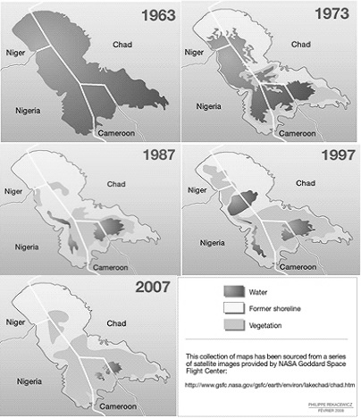
Figure 1: A collection of image map showing shrinkage of the lake (Source: Sierra Club 2015 report)

In Canada, Tar sands production, wastes and contaminates tremendous amounts of water. Every barrel of oil produced requires four barrels of water. In this process, water is pumped into toxic waste reservoirs large enough to be seen from space. This mega project which consists of network of refineries and pipelines is creating a catastrophic impact on human health. The mercury, lead and arsenic in tar sands waste threaten human health, even at small levels of exposure (Sierra, 2015). The economic driven motive of oil exploration created an unsustainable environment. This could cost the government lot of money to fix and in turn defeating the initial economic motive.
The major purpose of asset creation is to satisfy the economic need of the asset owner.
This vested interest in most cases is the major cause of the unsustainability problem we face in our built environment today. No designer in his right frame of mind would create a time bomb in a bid to create an asset. A review of all the cases aforementioned indicated an oversight in the design stage. The cost of exploring outside the system boundary is high but the long term cost of managing the consequences of not exploring is higher. For assets to be economically sustainable, it is crucial to identify the asset design that requires exploring outside the boundary before doing so, hence the need for risk management assessment.

Risk Management
In the management of these risks, the system boundary must first and foremost be defined and the key potential risks outside this boundary must be identified, their potent impacts analyzed and eventually outlining the most appropriate procedures that can be applied in response to their occurrence in the design. Analysis of risks form a very basic component of management of such risks as it defines as well as dissolves them, whereas the risk management seeks to establish the solution to such shortcomings that may be caused.

aPPROACH TO SYSTEM ANALYSIS
In an approach to analyze the asset and identify if there is need to carry out a very intensive theoretical and conceptual study.
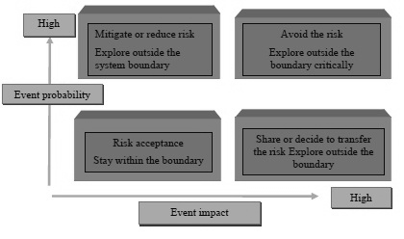
Figure 2: Approach to system analysis (Source: Author’s own creation)

RELATIONSHIP BETWEEN DESIGN, AMP AND AM COST
It is important to take advantage of the relationship existing between design and AMC to either reduce the construction cost or the AMC. In the initial design of the aforementioned cases, it was not envisaged that the asset would require retrofitting to be sustainable. On the cost side, it is advantageous to consider the AMP with the initial design to achieve the sustainability target rather than considering after design. This in most cases requires retrofitting of the asset to achieve the sustainability target which increases the construction cost which could sometimes be a costly retrofitting.
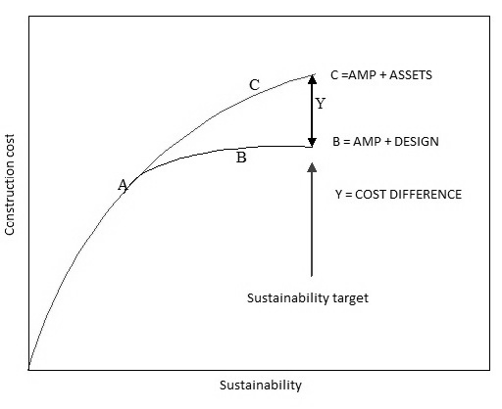

Figure 3: Annotation showing the relationship between design, asset and AMP (Source: Author’s creation)

Figure 3 shows the relationship between design, asset and AMP. Y is the construction cost difference between the curve B and C. This difference occurred because AMP wasn't considered in the design phase resulting in an additional cost to achieve the same sustainability target.

Role of environmental impact assesment (eia)
According to the EIA classification all the aforementioned cases fall under SCHEDULE 1. This implies that EIA is required. The purpose of EIA as stated in paragraph: 002 Reference ID: 4-002-20140306 is to identify projects which is likely to have significant impact on the environment. However, literature review conducted across some case studies has indicated that failure still occur in some projects after EIA has been carried out. EIA identifies the impact or consequences of the proposed asset within the boundary of the proposed design whereas literature review showed the failure occurred outside the proposed design boundary.
Role of construction design and management REgulations (cdm)
The role of designer as stated in the CDM regulation manual 2015 No. 51, Part 3, and Regulation 9(CDM, 2015) are:
To make sure identified health and safety risk is reduced to the possible minimum and where it is not possible to eliminate the risk the designer must try as much as possible to reduce the risk in the subsequent design and communicate the risk information to the contractor.
In order to achieve the low carbon targets of cities such as London for both buildings and infrastructure, it will be necessary to up-skill existing designers and asset managers with knowledge at a detail level and across discipline and space boundaries to avoid the style of mistakes identified in the four case studies described. Using a BIM based model, incorporating photographic or 3D rendered representations as routine, and linked to a Knowledge based system (KBS) with design rules identifying concept clashes in the way current BIM identifies space clashes, we are investigating how to optimise a design and an AMP.
To do this we are using SNAKE software to compute local parametric values of interest, and link to an open source database holding concept rules. The assembly is described in the block diagram as presented in Figure 4.
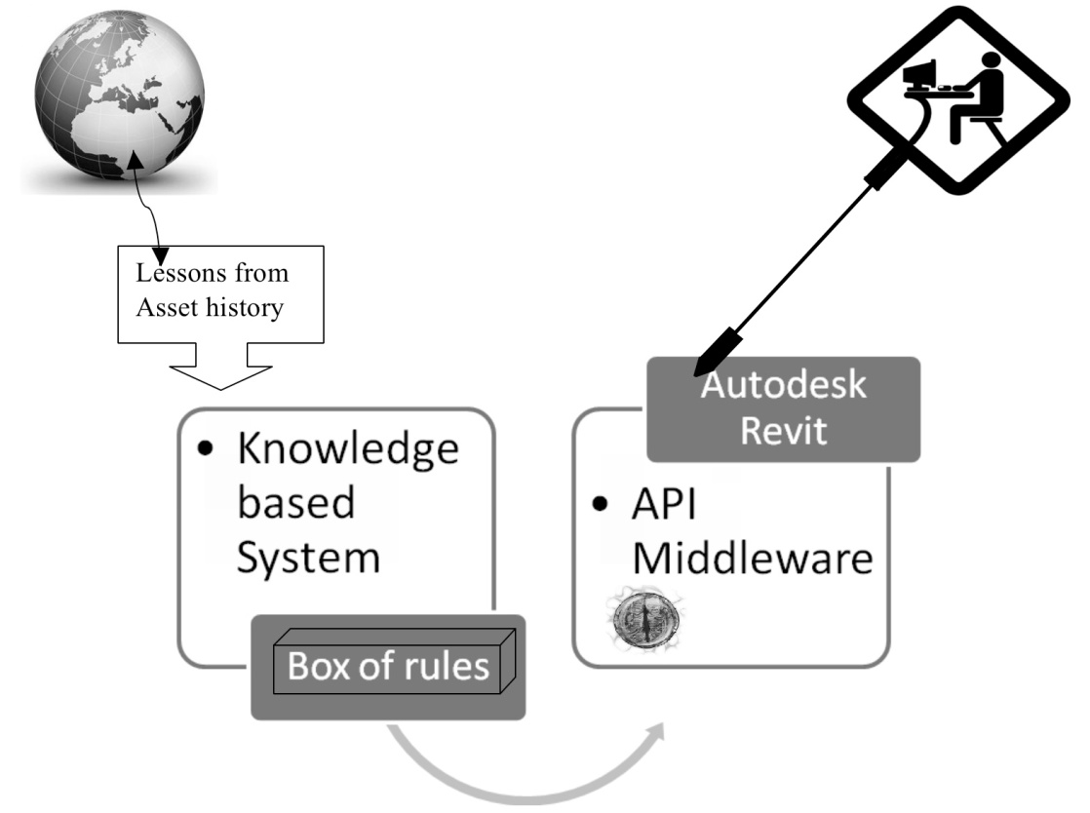
Figure 4: Annotation showing the building block diagram for the snake eye (Source: Author’s creation)
The lessons learnt from asset history are feed into a knowledge based system (KBS). This KBS is filtered with a set of rules into Autodesk Revit via the application program interface (API). Currently there are over 150 add-on software applications that access the Revit platform building information model using API (Revit BIM, 2008). It identifies concept clash the same way Revit identify geometry clash. The API sits at the designers elbow and uses AM analytics to inform design rules, which pop up with cold bridge identified such as dissimilar metals identified warnings for a repetition of past mistakes from asset failure for the detail to be updated or designed afresh. This API creates a form of leadership for designers, a relationship through which one person influences the behaviour or actions of other people (Egbu, 2013).
The analytics available at the moment lets us see the big data and what matters in a big system. It looks at failure rates but fails to close the cycle.
The snake eye is looking at the new build and major maintenance intervention as a seamless link and the necessary improvement. It fills the gap by closing the forensic cycle control loop at the BIM operator’s level. It creates meaningful engineering rules from the data. It is focusing on the low carbon objective and knowledge gap by improving the KBS-BIM interface.
The major challenge facing systems like this is the lack of rigorous validation and verification (V&V). Although there have been vast improvements in the field of V & V methodology, studies indicates that KBS industry still lacks rigorous validation methods (Batarseh & Gonzalez, 2015).
Most end users believe they are not novices and that they have more practical experience than systems like the SnakeEye that is not taken into account by knowledge engineers. As a consequence, end users preferred to consult other people or any other conventional help rather than rely on the Expert systems (Brezillon, 1997).
The authors will identify all possible implementation challenges and perceived weaknesses of the SnakeEye such as identified above and use a similar approach to system analysis shown in figure 2 to profound a solution.

Conclusions
The review conducted across a range of disciplines and international data base has indicated the need to assess assets at the design phase for failures that could occur outside the boundary and act accordingly. The scope of knowledge base required should be widened where required by considering the system dynamics of our ecosystem in relation to the design. This would meet the low carbon agenda as a result of longer design lives.
The benefit of adopting this method is impressing as it does not only reduce the risk of catastrophic sustainability issue but also eliminates the need for additional construction cost or a high AMC.
The comparison of these cases establishes the need for the question of the asset system boundary to be revisited by designers and the scope of the Asset Management Plan to be developed alongside the initial design brief in the same way that site safety issues are considered under CDM Regulations. These research observations have led us to commence the development of Snake based modules as add-ons to BIM packages to assist inexperienced designers upgrading existing assets or designing new ones from a sustainable viewpoint.
ACKNOWLEDGMENT
The authors want to thank Andy Ford of LSBU, Dr Hwee See and Richard Shennan of Mott Macdonald, Prof Gbenga Aribisala of University of Ado Ekiti for useful discussions. We wish to thank Engr Tunde Ajanaku of TUNS Consult, Nigeria, for matched funding support within the research development programme initiated by Prof Paul Ivey, PVC for Research at LSBU.
References
ALJAZERA MEDIA NETWORK. (19 November 2014, 10:13 GMT). River of Hope: Can prawns stop a massive outbreak of the killer schistosomiasis (bilharzia) parasite in Senegal?.
AN, S., LI, H., GUAN, B. ZHOU, C. WANG, Z. DENG, Z. ZHI, Y. LIU, Y. XU, C. FANG, S. JIANG, J. and HONGLi, H. (2007) China’s Natural Wetlands: Past problems, current status and future challenges. Ambio, 34 (4): 335-342.
BABANAAJI, R. A., LEE, J. (2013) Land use/Land cover classification of the vicinity of Lake Chad using NigeriaSat-1 and Landsat data. Environmental Earth Sciences.
BATARSEH, F. and GONZALEZ, A. (2015). Validation of knowledge-based systems: a reassessment of the field. Artificial Intelligence Review, 43(4), pp. 485-500
BIRDLIFE INTERNATIONAL (2014) Habitat destruction in the Yellow Sea is impacting migratory waterbirds. Presented as part of the BirdLife State of the world's birds website. Available from: http://www.birdlife.org/datazone/sowb/casestudy/606. (Accessed: 8th April 2015).
BREZILLON, P (1997) Successes and failures of KBSs in real-world applications: Report on the international conference.
CHOI, M., HAN, S. (2013) Remote sensing imageries for land cover and water quality dynamics on the west coast of Korea.
EGBU, C. (2013) The Role of Leadership in Improved Knowledge Management Practices in Complex Construction Projects: University of Salford.
H. GAO, T. J. BOHN, E. PODEST, K. C. MCDONALD, and D. P. LETTENMAIERL. (2011) “On the causes of the shrinking of Lake Chad,” Environmental Research Letters, vol. 6, no. 3, Article ID 034021, 2011
LAND USE. (2013) Land cover classification of the vicinity of Lake Chad using NigeriaSat-1 and Landsat data Rakiya A. Babamaaji • Jejung Lee Received: 31 January 2013 / Accepted: 23 September 2013 / Published online: 11 October 2013 Springer-Verlag Berlin Heidelberg 2013
LI KY, COE MT, RAMANKUTTY N, DE JONG R (2007). Modelling the hydrological impact of land-use change in West Africa. J Hydrol 337:258–268
MACKINNON, J., YVONNE, I., VERKUIL, M., NICHOLAS, M. (2012) IUCN situation analysis on East and Southeast Asian intertidal habitats, with particular reference to the Yellow Sea (including the Bohaisea). IUCN Species survival commission Report No 47
ODADA, E O., OYEBADE, L. OGUNTOLA, J A. (2006). Lake Chad.Experience and Lessons Learned Brief. Lake Basin Management Initiative (LBMI).
PETER BOSSHARD., BERNE DECLARATION. (1999) A case study on the Manatali Dam Project (Mali, Mauritania. Senegal).
REVIT BUILDING INFORMATION MODELING. (2008) A white paper: BIM and API Extensions. (Online) Available from: http://images.autodesk.com/latin_am_main/files/revit_bim_and_api_extensions_mar08.pdf . (Accessed:14th July 2015).
Sierra Club. (2015) Toxic Tar Sands: Profiles from the front line. Available from: http://vault.sierraclub.org/dirtyfuels/tar-sands/faces/TarSands.pdf . [Accessed: 16th May 2015].
SOUTHGATE, V.R. (1997) Schistosomiasis in the Senegal River Basin: before and after the construction of the dams at Diama, Senegal and Manantali, Mali and future prospects. Journal of Helminthology (1997) 71,125-132.
STEINMANN, P., KEISER, J. BOS, R. TANNER, M. (2006) Schistosomiasis and water resources development systematic review, meter-analysis, and estimates of people.
THE CONSTRUCTION (DESIGN AND MANAGEMENT) REGULATIONS 2015 and come into force on the 6th April 2015 immediately after the Mines Regulations 2014(e).Available from: http://www.legislation.gov.uk/uksi/2015/51/pdfs/uksi_20150051_en.pdf
THURLBY, R. (2012). R. (2012) Managing the asset time bomb: a system dynamics approach?Proceedings of the institute of civil engineers Forensic Engineering volume 166 Issue FE3.
VINNARI, J., and HUKKA, J. (2009). An International Comparison of the Institutional Governance of Water Utility Asset Management and Its Implications for Finland. Water Policy, 1-18.
WORLD HEALTH ORGANISATION (2001). Water-related Diseases Prepared for World Water Day 2001. Reviewed by staff and experts from the cluster on Communicable Diseases (CDS), and Water, Sanitation and Health unit (WSH),World Health Organization (WHO).

