Local roots / global routes: the legacies of British slavery in Hackney

Face to face with a culture, an economy and a set of histories which seem to be written or inscribed elsewhere, and which are so immense, transmitted from one continent to another with such extraordinary speed, the subjects of the local, of the margin, can only come into representation by, as it were, recovering their own hidden histories.

The local and the global have never seemed more interconnected than in the present moment. The 2007 financial crash, the war on terror and the humanitarian refugee crisis have highlighted our global dependency, exposing the limits of national sovereignty. As Stuart Hall suggests, when confronted by globalisation and the decline of the national one possible response is a turn to the local. The comfort of recognition, the predictability of the knowable, offers a stable identity with which to cloak oneself. Local history – conceptualised as parochial, amateurish, inward-looking – would certainly seem to offer an image of familiarity, of permanence. But local areas do not operate in isolation, they were and are places that reach out and connect to different geographic locations. People, goods and ideas constantly circulate leaving traces of themselves behind. Local communities and identities are not necessarily unchanging and immutable, particularly in the context of the multiple locales that make up Britain’s cities. As Michael Ignatieff has written

we think of belonging as rootedness in a small familiar place yet home for most of us is the convulsive arteries of a great city. Our belonging is no longer to something fixed, known and familiar but to an electric and heartless creature eternally in motion.

During the eighteenth and nineteenth centuries Britain increasingly understood itself as an imperial global power. Trade, colonisation and the ‘civilising mission’ required mobility and interconnectedness. Slavery was a system that inextricably linked Britain to Africa, the Caribbean and the Americas. At a more intimate level it enmeshed men and women living in places as varied as London, Sheffield, the Channel Islands and the rural Highlands with the Atlantic world. In cities, towns, hamlets and villages across Britain ordinary people became embroiled in the business of slavery and its attendant industries. If, as Hall argues, ‘Global and local are the two faces of the same movement’ then slavery was a Janus like figure that embodied this duality. Its processes were simultaneously local, national and global – its impacts and legacies felt by individuals, communities and nations.

Local history is a valuable way of engaging people with the history of slavery. In making linkages between local sites and people involved with the Atlantic trade, slavery can be brought home. Examining different histories allows us to see familiar locations with new eyes. It can change our perspective on both our local history and identity by challenging traditional, sometime insular narratives of place. The past has sometimes been described as a ‘foreign country’ but it can become knowable when we put it in the context of the streets we walk down or the buildings we inhabit. Slavery has too often been considered to be a distant phenomenon. For the most part enslaved people laboured on plantations across the Atlantic and this geographic distance has enabled a distancing of the mind. The slavery business was not so easily contained. The profits amassed through the sales of Caribbean goods, colonial finance, insurance, shipping, slave trading and plantation ownership impacted on Britain. People who made their money in the colonies often returned home to spend it, some profited from a distance and never left Britain. Since 2007 and the bicentenary of the abolition of the slave trade there has been a flurry of both academic and public scholarship that has unearthed these stories. Using a variety of interdisciplinary methods these projects have examined the relationship between specific sites and their transatlantic connections. Several projects have used mapping techniques to track the geographic spread of local connections to both slavery and the wider empire. Whilst others have considered the impact of colonialism on that most intimate of familiar spaces – the home itself. The focus on local history has allowed these projects to connect with diverse public audiences and in particular schools. Whilst the teaching of the history of slavery is no longer a compulsory part of the national curriculum, local history is a mandatory requirement. Producing educational resources that blend the local with the global has allowed these projects to develop meaningful outputs beyond academia, enabling the communities of the multicultural present to see themselves and their heritage reflected in local and national histories.

This chapter is based on research undertaken as part of an Arts Council England funded project ‘Local roots / global routes: the legacies of British slavery in Hackney.’ The project was a partnership between the Legacies of British Slave-ownership project (LBS) and Hackney Museum and Archives. It aimed to connect a variety of Hackney-based audiences with the history of transatlantic slavery, abolition and the historic black presence by using a local lens to engage the borough’s diverse residents. It developed an exhibition, educational resources for local schools, ran archive workshops for local communities and a youth programme based on Hackney’s historic ties to the system of enslavement and its dismantling. The project took as its starting point the online database of slave-owners developed by the LBS team. The database is a digital repository of the records of the Slavery Compensation Commission. As part of the measures taken by the British government to end slavery in 1833 twenty million pounds of compensation was paid to the slave-owners. Claimants were required to give their names, where they were resident, as well as details of how many people they claimed ownership in and where those people were located. Approximately ten million pounds of the compensation money was paid to people who lived in Britain with the rest going back to the colonies. The initial findings have revealed the geographical spread of metropolitan slave-owners. The individuals included in the records represent diverse local encounters with slavery that pose a challenge to our understanding of the institution as a colonial aberration. The localisation of slavery through these records fragments the national story providing an academic impetus for returning to the local as a site in which national and transnational narratives of history are (re)negotiated.

The port cities traditionally associated with the slavery business – London, Bristol, Liverpool and Glasgow – have acted in many ways as what Toni Morrison has described as ‘sites of memory.’ In recognition of their disturbing histories, it was in these places that many of the large-scale efforts to commemorate the bicentenary of the abolition of the slave trade took place in 2007. These specific sites were, for that brief period, saturated with the memory of slavery, haunted by it in a way that other places were not. Controlled and contained within these spaces the geographic boundaries set on the memory of slavery enabled a denial of its importance to both national history and local experience outside of these designated areas.
London is a vast space with distinctive local areas within its boundaries. Whilst the City and the docksides have long been implicated within a history of slavery, its residential parts have escaped relatively untarnished. The Legacies of British Slave-ownership project has been working alongside local historians, museums, libraries and archivists to uncover these stories. This has resulted in the production of detailed work on the histories of slavery, slave-ownership, abolition and the historic African presence in Croyden, Clapham, Blackheath, Bloomsbury, Wandsworth, and Hackney. In many cases demand for this kind of work has arisen from the local community, particularly those with links to the Caribbean. Stuart Hall once said that those who do not see themselves reflected in the national heritage are excluded from it. The same could also be said for local history – an historic relationship or presence creates a sense of belonging, an anchor to identity. The history is there but in most cases it has required a process of historical palimpsest in order to reveal what has been forgotten.
The London Borough of Hackney is well known for the diversity of its inhabitants which includes a significant minority population of African and Caribbean people and their descendants, as well as a notable Jewish population – Stamford Hill is home to the largest number of Hasidic Jewish people in Europe. The history of slavery speaks directly to Hackney’s living communities; it is part of a shared past that connects them together across both space and time. In collaboration with Hackney Museum and Archives it has been possible to trace the borough’s connections to slavery through archival documents, images, material culture and the built environment. The process has involved shifting between local, national and global archives to follow the stories of transatlantic individuals as they traversed the British imperial world.
Abolition, Non-Conformity and the Politics of Memory

Tracking the long arc of Hackney’s local history provides interesting insights into its present. Formerly an area renowned for crime and deprivation, more recently it has become synonymous with London’s housing crisis and the seemingly unstoppable march of inner city gentrification. In 1774 Hackney was described as ‘a very large and populous village, on the north of London, inhabited by such numbers of merchants and wealthy persons, that it is said there are near a hundred gentlemen's coaches kept.’ Situated so close to the City of London, then as now, the area appealed to the commercial classes. Hackney has long been identified with both London’s literary circles and as a centre of dissent. Built in 1708, the Newington Green Unitarian Church is the oldest place of non-conformist worship still in use today. Several dissenting academies including New College Hackney were established in the area. A distinct group of non-conformist literary luminaries formed in the area including Samuel Rogers, Joseph Priestly, Richard Price and Anna Laetitia Barbauld. For centuries Hackney has attracted and sustained a community of political, literary and religious radicals. Today as you pass through Newington Green a banner proudly announces that this was the ‘birthplace of feminism’ owing to its famous former resident Mary Wollstonecraft. As Iain Sinclair knowingly articulated in his love note to the area Hackney, That Rose-Red Empire, the borough’s inhabitants (or at least the residents who have shaped his experiences) have consistently identified themselves as ‘intelligent, focused, aggrieved... conforming in nonconformity.’

It was through the community of non-conformists that the abolitionist movement took root in Hackney. Two of the founding members of the Society for Effecting the Abolition of the Slave Trade lived in the area. Joseph Wood Senior (1738-1812) and Samuel Hoare Junior (1751-1825) were both Quakers residents of Stoke Newington. The Quakers had played an early and notable role in the abolition campaign, with nine of the twelve founders of the Society identified as such. Many Rational Dissenters were also involved with the movement with Richard Price, a minister at the Newington Green Unitarian Church, an early critic of the system of slavery in his 1785 work Observations on the Importance of the American Revolution. In 1791 Stoke Newington resident Anna Laetitia Barbauld, whose husband Rochemont Barbauld was also a minister at the Newington Green, published an Epistle to William Wilberforce Esq. On the Rejection of the Bill for Abolishing the Slave Trade, following the defeat of his Bill. In it she warned of the moral disintegration of the nation should it persist in the inhumane practice of slave trading. Anna’s brother John Aiken was another Hackney resident who supported abolition. In a letter to his sister in 1791 he proclaimed ‘I am at length become a practical anti-saccharist. I could not continue to be the only person in the family who used a luxury which grows less and less sweet from the suffering mingled with it.’ He also revealed some fascinating details about the involvement of young people in the sugar boycotts of the early 1790s. He remarked that ‘the young people and even children who have entirely on their own accord resigned an indulgence important to them, I triumph and admire! Nothing is to be despaired of if many of the rising generation are capable of such conduct.’ Anna Laetitia is remembered in Hackney by the street Barbauld Road, close to the Newington Green Unitarian Church that also holds a memorial stone praising her contribution to the causes of ‘humanity, peace and justice.’

Abney Park, a non-denominational cemetery in Stoke Newington, is the resting place of a number of abolitionist figures; William Allen (1770-1843), Rev. James Sherman (1796-1862), Rev. Dr. Thomas Binney (1798-1874), Rev. Thomas Burchell (1799-1846), Rev. Samuel Oughton (1803- 1881) Rev. Joseph Kelley (1802-1875). A walking tour ‘Abolition: Voices from Abney Park’ was developed for the 2007 commemorations of the bicentenary of the abolition of the slave trade, reviving the memory of some of these long-forgotten figures of the movement. Although not himself a non-conformist, Stoke Newington was also home to James Stephen and his wife Sarah, William Wilberforce’s sister. Stephen was instrumental in the passage of both the act to abolish the slave trade and later slavery. Hackney’s abolitionist credentials are certainly notable and they chime in with the impression of Sinclair’s characterisation of the area as a ‘scrappy, combustible and pluralistic borough whose real heroes are its inhabitants.’
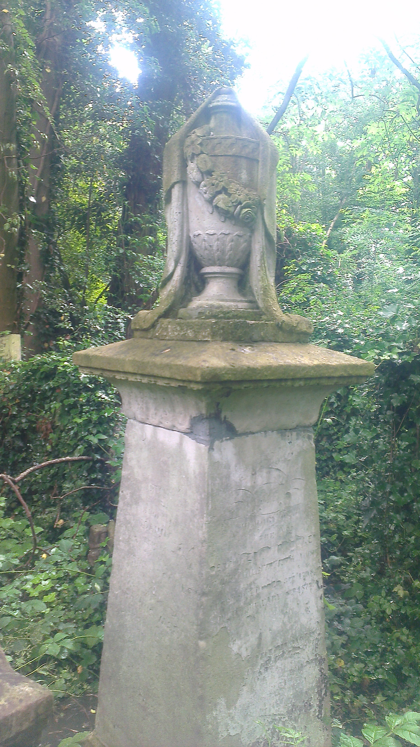
Joanna Vassa’s grave in Abney Park Cemetery, Hackney. Image © Michael Watson.

During 2007 the links between Hackney and the abolition of the slave trade were commemorated, celebrated and embedded within local history and memory. Abolitionist sites of memory were identified and the grave of Joanna Vassa, the daughter of Olaudah Equiano, was restored by Hackney Council. Hackney Museum curated an exhibition and in 2009 a tree was planted on Stoke Newington Common dedicated to the memory of ‘all the people who fought and campaigned for the abolition of African enslavement.’ Zoe Norridge has suggested that whilst these efforts ‘encouraged positive identifications with local abolitionists and former slave residents in the borough’ they ‘did little to explore the more complex ways in which Hackney residents profited from the slave trade.’ Given its proximity to the City of London, the financial centre for the organisation of both slavery and the commerce in slave-produced commodities, it is not surprising that Hackney was also home to a number of residents who engaged in and profited from the slave economy. The absence of this narrative during 2007 is indicative of a wider urge to forget the discomforting history of participation that preceded the abolition movement. Hackney residents’ involvement in benefitting from, but also abolishing slavery, is demonstrative of the complexity of Britain’s wider history and the difficulties of representing these nuances in the narrative, especially when they complicate long-held beliefs about local and national identities. From memorials, to street names, to the fragmentary archival glimpses of lives touched by slavery, their stories represent some of the diverse ways in which the institution returned home, creating legacies in Hackney - some of which continue today.

A Hackney Philanthropist? John Cass and the Royal African Company

The Royal African Company was awarded its chartered monopoly from Charles II in 1672. The monopoly granted the Company the sole right to trade with Africa including the right to trade in enslaved people and establish slave forts on the coast. Sir John Cass (1661-1718) was a powerful merchant who became an Alderman, Sheriff and then represented the City as its Member of Parliament. His family had moved to Grove Street in South Hackney in 1665. Cass was involved in slave-trading through his membership of the Royal African Company Court of Assistants between 1705 and 1708. He was a director and a member of the committee of correspondence, which meant he had direct dealings with both the Company’s representative in the slave forts in West Africa as well as with its agents in the Caribbean. As his will testified, Cass retained shares in the Company up until his death.

Cass was determined to leave a philanthropic legacy and he set up a school at St. Boltoph’s Aldgate in 1709. In 1748, following legal wrangling over his will, the Sir John Cass Foundation was established. The Foundation continues to provide support to the only state primary school in the City and a secondary school in Stepney Green in east London. The Sir John Cass Faculty of Art, Architecture and Design within London Metropolitan University, the Sir John Cass School of Education at the University of East London and the Cass Business School at City University are all named for him. The Sir John Cass halls of residence, belonging to the University of the Arts, is located on Well Street in Hackney. Cassland Road, also in Hackney, remembers his family’s former land-ownership in the area. As Madge Dresser has pointed out, he left his imprint in stone – his statue was carved by Louis François Roubiliac and valued at in excess of one and a quarter million pounds in 1999. It was formerly placed on the outside of the old Cass Foundation on Jewry Street but was replaced by a replica in 1899. It is now housed in the Guildhall.

Thomas King – an Independent Slave Trader

In 1698 the Royal African Company lost its monopoly on the slave trade. As William Pettigrew has recently argued, ironically it was as a result of independent traders clamouring for their right as freeborn Englishmen to participate in the profitable practice of enslaving Africans. The deregulation of the trade caused an explosion in the number of slave trading voyages, catapulting the British into becoming the leading slaving nation during the eighteenth century. One of the most profitable of the independent slave trading partnerships was Camden, Calvert and King. Thomas King (1748-1824) became a partner in the firm in 1783 and was a resident of Stamford Hill in Hackney. His household was documented in the Parish Return of 1821 as being made up of five men and five women, an indication of the comfortable domestic existence King enjoyed in his twilight years.

King had started his career in the business as a slave ship captain for the Royal African Company and then for his later partner William Camden. He gave evidence to the select committee of the whole house of Parliament on the subject of the slave trade in 1789. This evidence gave a detailed outline of the voyages he had been involved in between 1766 and 1780. He spoke about the mortality rate on board the ships, the condition and treatment of the enslaved as well as instances of on board insurrections which he knew to have taken place. His final voyage as a slave ship captain saw him carry 580 enslaved people to Jamaica, he noted that ‘50 or 51 slaves in all’ had died on the coast from diarrhoea. During his time at sea King was accused of the murder of one of his crew – John Warren. Emma Christopher has noted that King was accused of calling Warren an ‘Irish son of a Bitch’ before kicking him to death on board the Surry in 1771 as the ship lay off the coast of Africa on a slave trading voyage. In his evidence to Parliament King remembered this journey. He recalled that the expedition had resulted in 255 enslaved Africans being carried to Grenada. Over the course of an eight week middle passage ten of the Africans died, alongside the ship’s surgeon and three seamen – including presumably the unfortunate Warren, although he made no mention of the circumstances surrounding his death. King was eventually acquitted but the story featured in the Annual Register of World Events in 1776 and was repeated in subsequent years to come.

By the time he was called to give evidence, King had ‘been settled in London as a merchant.’ The partnership of William Camden, Anthony Calvert and Thomas King became one of the most prolific and profitable slave trading businesses of the eighteenth and early nineteenth century. Kenneth Cozens’s research documents that the partners were involved in 77 slave voyages between 1781 and 1808, forcibly transporting approximately 22,000 enslaved Africans to the Caribbean. The partners were not only involved with the trade in enslaved people but also with ‘provisioning, brewing, sugar refining, convict transportation and Pacific whaling’ and following the death of Camden in 1796 they added insurance and finance to their interests. King was a founding subscriber of Lloyd’s in 1771 and Cozens has suggested he was responsible for directing the partnership towards this lucrative corner of the slave economy. King also owned plantations and enslaved people across the Caribbean. He died before the abolition of slavery; therefore it was his son William King who was awarded approximately £53,352 for 1087 enslaved people held on plantations in British Guiana, Trinidad and Dominica.

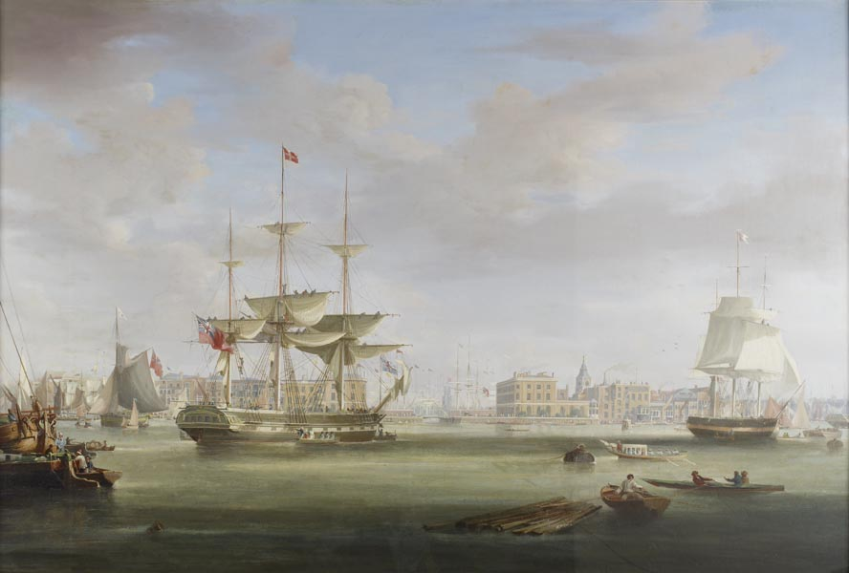

The Thomas King entering London Docks, 1827, by William John Huggins. Image © Museum of London, Museum of London, PLA Collection PLA75. The ship was named for King and was involved in the transportation of sugar and rum from Demerara in British Guiana.

Thomas King has been identified by William D. Rubenstein as amongst the elite of wealth-holders of the early-nineteenth century. He left behind a probate of £120,000 and his will contained bequests that totalled over £84,000. Like Cass, King also invested in respectable philanthropic institutions; he was a Governor of the Foundling Hospital, leaving £100 donation to it in his will. He was heavily involved with the building of the London Docks at Wapping and acted as the London Dock Company Treasurer and Director. In this endeavour he was joined by a notable number of individuals with interests in the Caribbean including Samuel Boddington, a West India merchant and fellow Hackney resident. The new dock system transformed this part of London and can be regarded as, in part, a physical legacy of its investors’ involvement with slavery.

John Ward ‘The Hackney Miser’ and Plantation Ownership

Plantation ownership was a direct way in which people became involved with the slavery business. Not all slave-owners were resident in the colonies, this group, known as ‘absentees’, were able to accumulate wealth through the exploitation of the labour of the enslaved, sometimes without ever visiting their plantations. John Ward (1682-1755) was a wealthy, ambitious and unscrupulous merchant whose meteoric rise through the ranks of society was accompanied by an equally spectacular fall. Ward had numerous business dealings, not all of them legal. He was a Member of Parliament between 1710 and 1715, and again between 1722 and 1726. At the height of his powers he built a ‘commodious house’ in Hackney at the upper end of Mare Street close to Dalston Lane. The area was still known as Ward’s Corner in the 1870s.

In 1718 Ward signed a bargain and sale for ‘the plantation of between 400 and 500 acres on St. Kitts called Pensez y bien with all the goods and chattels, working slaves, sugar canes and equipment.’ He did so in partnership with the equally dissolute Sir Basil Firebrace of St. Margaret's, Westminster, who himself was imprisoned by Parliament for bribery and forgery. The two men acquired the property from Alexander Baxter who had claimed it in forfeiture of a debt owed to him by Walter Douglas, the Captain General of St. Kitts who had been found guilty of extortion and bribery. Having previously been removed from Parliament in 1726 and put in the pillory for forgery, Ward was also prosecuted for embezzling £50,000 from the South Sea Company in 1732. The South Sea Company had been awarded the Asiento (the right to sell enslaved people to Spain) following the Treaty of Utrecht in 1713. The Company were able to recoup their losses from Ward by claiming all of his furniture and personal effects from his house in Hackney.

Despite his criminal activities and the loss of money he suffered as a result he died a very wealthy man. His scandalous conduct earned him two mentions in Alexander Pope’s poetry including a couplet in the Epistle to Bathurst ‘Given to the fool, the mad, the vain, the evil / To Ward, to Waters, Chartres, and the Devil’ and a further mention in The Dunciad. He was remembered in John Timbs’s English Eccentrics and Eccentricities (1866) in which he was described as ‘The Hackney Miser’. Self-interested to the very end, a prayer was found amongst Ward’s papers when he died. In it he prayed for ‘the bank to answer their bills, and make all my debtors good men. Give a prosperous voyage and return to the Mermaid sloop, because I have insured it; and, as thou hast said the days of the wicked are but short, I trust in thee that thou wilt not forget thy promise, as I have purchased an estate in reversion, which will be mine on the death of that profligate young man, Sir JL.’

The Boddington Family – a West India Merchant House

Examining the compensation process has revealed the degree to which the figure of the West India merchant was key to the maintenance of the slave economy during the period. The merchant provided numerous services to his clients in the colonies including shipping, insuring, warehousing and distributing slave-produced commodities such as sugar, rum, coffee and cotton. The merchant was also a key source of finance, lending his correspondents substantial sums of money to invest in the plantation complex. Planters could use both their plantations and the enslaved as a form of guarantee against the debt. If a planter failed then his merchant could foreclose and claim the property, including property in the enslaved as forfeiture. As some colonies, like Jamaica, became more heavily indebted merchants increasingly became the de facto owners of both plantations and the enslaved. When compensation claims were filed by slave-owners they could be contested by their creditors, leading to many commercial partnerships in Britain receiving large sums of the compensation money.

The Boddingtons were a Hackney family that had been involved in West India commerce for three generations. Brothers Benjamin (1730-91) and Thomas Boddington (1735-1821) were both West India merchants. Benjamin was also a Director of the South Sea Company whose links to slave trading have already been discussed. Benjamin’s son Samuel (1766-1843) and Thomas’s son Benjamin (1766-1855) were also part of the family merchant firm at 17 Mark Lane, taking over from their fathers. The Boddingtons were regular attendees at the meetings of the Society of West India Planters and Merchants, the mouthpiece of the proslavery lobby in London. The younger Boddington’s commercial partnership broke down abruptly when Benjamin eloped with Samuel’s wife in 1797. That year the partnership of Boddington and Co. had a turnover of half a million pounds – a vast sum of money at the time. Samuel later went into partnership with his nephew Thomas (1807-81) to whom he also bequeathed his entire fortune. Samuel and Thomas the younger were eventually awarded between them £39,712 in compensation for 2100 enslaved people in Antigua, St. Kitts, Nevis, St. Vincent and Jamaica.

In 1766 the senior Boddingtons were residing in Hackney; Benjamin was living in Clapton and Thomas in Upper Homerton. Whilst Benjamin eventually moved to Enfield, Thomas remained settling in a property called Five Houses on Lower Clapton Road. Thomas’s attachment to the area was lifelong; several of his children were married at St. John-at-Hackney and his will describes him as ‘Thomas Boddington of Clapton’. The Boddingtons were a dissenting family, Hackney with its thriving non-conformist community was an ideal place to make a home. In this respect the Boddington story reveals some of the ways that abolitionist and proslavery opponents coexisted within particular spaces. New College Hackney was a dissenting academy set up in 1786, its staff included both Joseph Priestley and Richard Price, both of whom spoke out against the slave trade and slavery. Both Benjamin and Thomas Boddington were at the same time Governors of the College. When the institution closed in c.1796 the building and land was sold to Thomas Boddington and Timothy Curtis. Anthony Page has suggested that Richard Price’s ability to speak out more fully in support of abolition may have been impeded by his congregation at Newington Green Unitarian Church in Hackney, which included a number of prominent West India merchant families as well as abolitionists. Whilst Price was an early critic of American slavery, it did not stop him from writing a letter of recommendation in 1791 for Samuel Boddington, in which he described him as both ‘amiable and worthy’ and ‘the son of one of our first West India Merchants.’ Incidents such as these remind us that involvement in slavery was no bar to respectability, indeed for some it was the means to achieve integration in polite society.

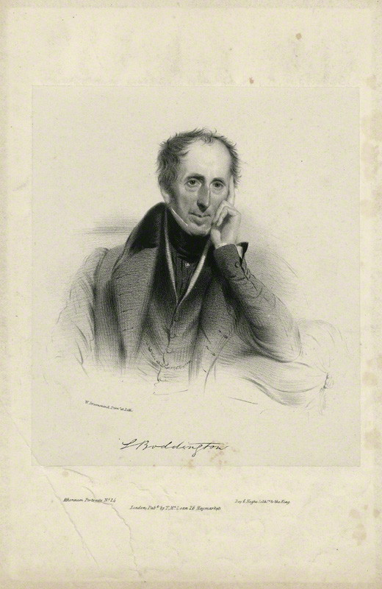
Samuel Boddington by William Drummond, printed by Day & Haghe, published by Thomas McLean lithograph, circa 1835. Purchased, 1966. NPG D31925. Image © National Portrait Gallery.

The Boddingtons, like John Cass and Thomas King, were also enthusiastic philanthropists. Both Benjamin and Thomas Senior were subscribers to the Society for Promoting Religious Knowledge Among the Poor. Both men were also Governors for life of the London Hospital in Whitechapel and Benjamin also left a bequest to St. Thomas Hospital. They supported dissenting causes as well as those linked to their work as merchants including the Marine Society. Samuel Boddington was a notable collector of art and his portrait is kept at the National Portrait Gallery, although his links to the slavery business remain obscured in the catalogue entry for the work.

Anna Maria Lucas and Female Slave-ownership

One of the most surprising results of the analysis of the compensation records was the fact that of the 46,000 claimants approximately 40 per cent of those were women. The practice of using enslaved people in settling annuities on unmarried women, as part of marriage settlements and direct inheritance meant female slave-ownership was common. Hackney Archive holds just one such document – the marriage settlement of Ann Harvey and Charles Allmond which gives details of a property in Kingston in Jamaica left to Ann by her brother as well as the enslaved people on the estate. In contrast to the image we have of the white linen clad male slave-owner on a plantation in the Caribbean, the compensation records present us with Sarah Grey (1758-1841), a widow of Hackney. Sarah was awarded the bulk of the compensation money of £5,235 6S 1D for 304 enslaved people held on the Friendship estate in Hanover, Jamaica. She had inherited the plantation when her husband Patrick died. Sarah was not alone; in total so far there have been thirteen women in the database identified as having some connection to Hackney.

The issue of female and child slave-owners had been used extensively by the proslavery lobby in order to justify the continuation of the system. Women and orphans represented the ‘sympathetic’ face of slave-holding - helpless dependents who would be left ruined without compensation for their loss of income. Indeed in the case of Mary Burnan, a widow living at 3 St. George’s Terrace in Hackney, there was letter attached to her claim from James Walker of the Colonial Office in which he gave details of ‘A poor lady of the name of Burman, a Widow, whose claim to one slave has been recognised and returned from Barbadoes, is now at a loss as to what course she should adopt to obtain her compensation.’ Despite the representation of female slave-ownership as benign, women could be just as cruel as men, as the case of Henry and Helen Moss of Crooked Island in the Bahamas demonstrated. Although escaping a conviction for murder, Helen Moss was found guilty alongside her husband of a misdemeanour. This so called ‘misdemeanour’ resulted in the death of an enslaved female called Kate who had been tortured over a period of seventeen days. A witness in the case John Delancy, overseer and godson of Henry Moss, claimed that he had been ordered by Helen Moss to rub capsicum into Kate’s eyes. The couple were sentenced to five months in the prison in Nassau, although the government was afterwards petitioned for the early release of the ‘respectable’ Helen Moss.

Of the Hackney women who received compensation Anna Maria Lucas (1809-1846) was awarded the greatest sum of money. She was the daughter of Philip Monoux Lucas (1778-1830) a slave trader in St. Vincent. After the abolition of the slave trade in 1807, he became a partner in the West India merchant house Chauncy, Lang and Lucas. Lucas’s on-going ownership of enslaved people in St. Vincent was documented in the slave registers, which also contain a reference to Lucas’s ‘coloured children’ Jeanette Robert and Phillip Lucas for whose ‘use’ he kept seven enslaved people. Neither Jeanette Robert nor Phillip Lucas appear in the compensation records indicating that unlike their legitimate counterparts in England, they did not benefit through inheritance of their father’s compensation money or own enslaved people on their own account. The partnership of Chauncy, Lang and Lucas received £57,970 in compensation for 1121 enslaved people on estates in St. Vincent and British Guiana. Alongside her siblings Anna Maria received compensation as a beneficiary of her father’s will. As a wealthy woman she was able to marry into the Austrian aristocracy – in 1842 she was wed to Joseph Ferdinand Count de Taaffe. Her sister and fellow compensation recipient Harriet Fraser Lucas had previously married Count Samuel Ernest Alexander Konarski in 1839. Anna Maria lived at Navarino Terrace in Hackney and was buried at St. John-at-Hackney having died at the age of thirty-seven. The family vault can still be seen today in the church grounds.

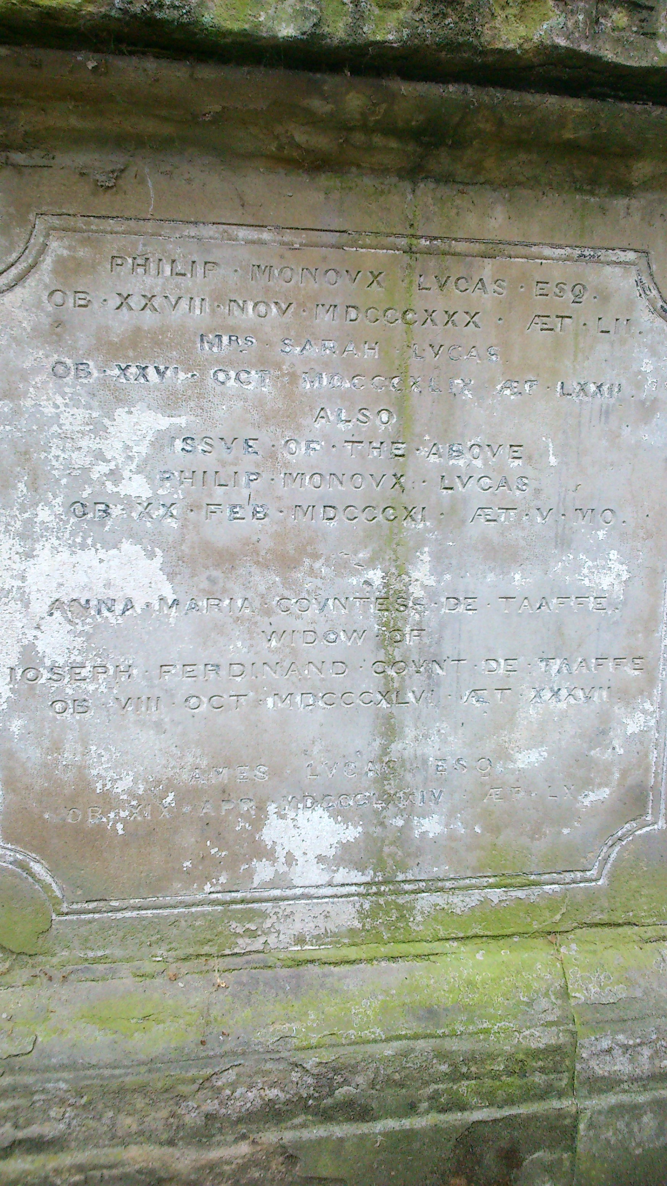
The Lucas family vault at St. John-at-Hackney. The inscription documents that Philip Monoux Lucas, Sarah his wife, Philip their son and Anna Maria their daughter were all buried there.

The Historic African Presence in Hackney

The impact of slavery on Britain cannot be conceived purely in monetary terms - its implications were far greater. As Stuart Hall once said in relation to Britain’s multicultural population ‘we are here because you were there.’ This was certainly true of some of Hackney’s residents of African descent during the nineteenth century. It was Britain’s involvement with the business of slavery that shaped these individual’s lives, altered their family structures, re-orientated the trajectory of their existence. Their stories highlight the complexities that arose from the intermingling of British, African and Caribbean histories. These people formed the nascent beginnings of what would become one of London’s most vibrant and diverse multi-cultural societies.

As mentioned, Joanna Vassa was the daughter of the African abolitionist and writer Olaudah Equiano (c.1745-1797). Equiano’s autobiography The Interesting Narrative of the Life of Olaudah Equiano, published in 1789, made him an important voice in the abolitionist movement. His story introduced many readers to the horror of slavery. Joanna’s mother Susannah Cullen (?-1796) had been a subscriber to Equiano’s Narrative. The couple were married in Soham, Cambridgeshire in 1792. Joanna’s parents and sister died within a year of each other – Susannah in 1796, and Olaudah and Anna Maria in 1797. As her father’s only heir Joanna inherited his estate, which was valued at £950, as well as a silver watch – a small fortune in today’s money. Joanna married the Congregational Minister Reverend Henry Bromley in 1821. The couple lived in Devon and later Essex before moving to 12 Benyon Terrace, Buckingham Road in De Beauvoir Town, Hackney. It was here that she died aged 61 of ‘uterine disease’.

The inscription on her grave reads ‘In memory of Joanna, beloved wife of Henry Bromley, daughter of Gustavus Vassa, the African. Born April 11, 1795 and died March 1857.’ The proud acknowledgment of her father’s identity etched the memory of Africa, Caribbean slavery and its abolition into the very stone of her funerary monument. Although historians have tried, they have been unable to find any evidence of Joanna’s own involvement in the abolitionist movement – a reflection perhaps of her relatively humble position as not only (despite her extraordinary family history) an ordinary middle-class woman, but a woman of mixed heritage. Joanna has left behind virtually no archival trace and frustratingly none that might indicate her own feelings towards the campaign her father fought so hard for. Whether a final declaration of familial loyalty and love, a political statement in support of emancipation, or both, Joanna’s grave is a commemoration not only of her, but of her truly remarkable father and the transatlantic passage that finally bought her to rest in Hackney.

In comparison John Casper Mais (1800-51) was born in Kingston in Jamaica in 1800. He was the son of John Mais and Phillippina Weise, both of whom were described as ‘free people of colour.’ Family historian Howard Mais has suggested that John Mais was an illegitimate son of John Mais Senior, a member of one of Jamaica’s powerful plantocratic families. Phillipina was the daughter of Johann Casper Weise a slave and plantation owner in Port Royal for whom John Mais acted as trustee and administrator. It was a common practice for European men to have what became known as ‘outside families’ with women of colour in the colonies. Despite the rigid colour lines of a society based on slavery, the existence of a significant mixed heritage population in the Caribbean was demonstrative of the ways in which those boundaries were routinely transgressed. Slave-ownership by people of mixed heritage did occur in the Caribbean, although it was never on the scale of European slave-ownership. The Jamaica Assembly – the colonial legislature - placed restrictions on property ownership by free people of colour and their political and civil rights were likewise limited. Despite this, by the late 1820s there was a significant population of free people of colour, some of whom were active in their attempts to gain equal rights. John Caspar appeared in the slave compensation register as an unsuccessful claimant. He had lodged his claim on 76 enslaved people held on York Castle plantation in St. Ann, Jamaica as a result of his role as the trustee and executor to Jacques Sicard. In the end his claim was unsuccessful following a counterclaim by his ‘reputed uncle’ the Hon. John Mais as mortgagee in fee and judgement creditor.

John Caspar was referred to as a ‘gentleman and attorney of Kingston’ in an indenture of 1828 which relinquished the Hon. John Mais of his executorship and trusteeship responsibilities arising from the will of John Caspar’s father. John Caspar married Sarah Evena Mclachlin and the couple had five children, four of whom were born in Middlesex. By the baptism of their second child Laura Ellen in 1835, their address was Rectory Place, Hackney. They were at the same address for the baptism of Phillippina in 1836 and at Palatine Houses, Stoke Newington, for the baptism of Caspar in 1838. John Caspar had attempted several different business ventures but was unsuccessful. He spent time in gaol for debt in Dover in the late 1840s. On his death he left behind the not inconsiderable sum of £800.

Alongside the children of abolitionists and slave-owners can also be found the story of Joseph Jackson Fuller (1825-1908). Fuller had been born into slavery in 1825 in Spanish Town, St. Catherine, Jamaica. His father Alexander McCloud Fuller and his mother were enslaved to two different families and could not marry. The Fullers became part of the congregation of Reverend James Phillippo, an anti-slavery campaigner and member of the Baptist Missionary Society. When slavery was abolished in 1833 Joseph stated that he became immediately free. Unlike Joanna Vassa, Joseph left behind a distinctive archival trace - he wrote an autobiography and some of his papers can be found amongst those of the Baptist Missionary Society. His role as a missionary was the key factor in getting his memoir and indeed his memory preserved. In a deeply moving passage he recounted the moment of emancipation; ‘The scene on the night I believe all over the island will never be forgotten by all of us who witness it… to see the upturned eyes of the thousands as they waited around the grave which was to receive the coffin which contained the implements of slavery and as the last stroke of the clock tolled the hour of twelve, the coffin lowered and doxology was sung, the morning dawn[ed] on us a free people.’

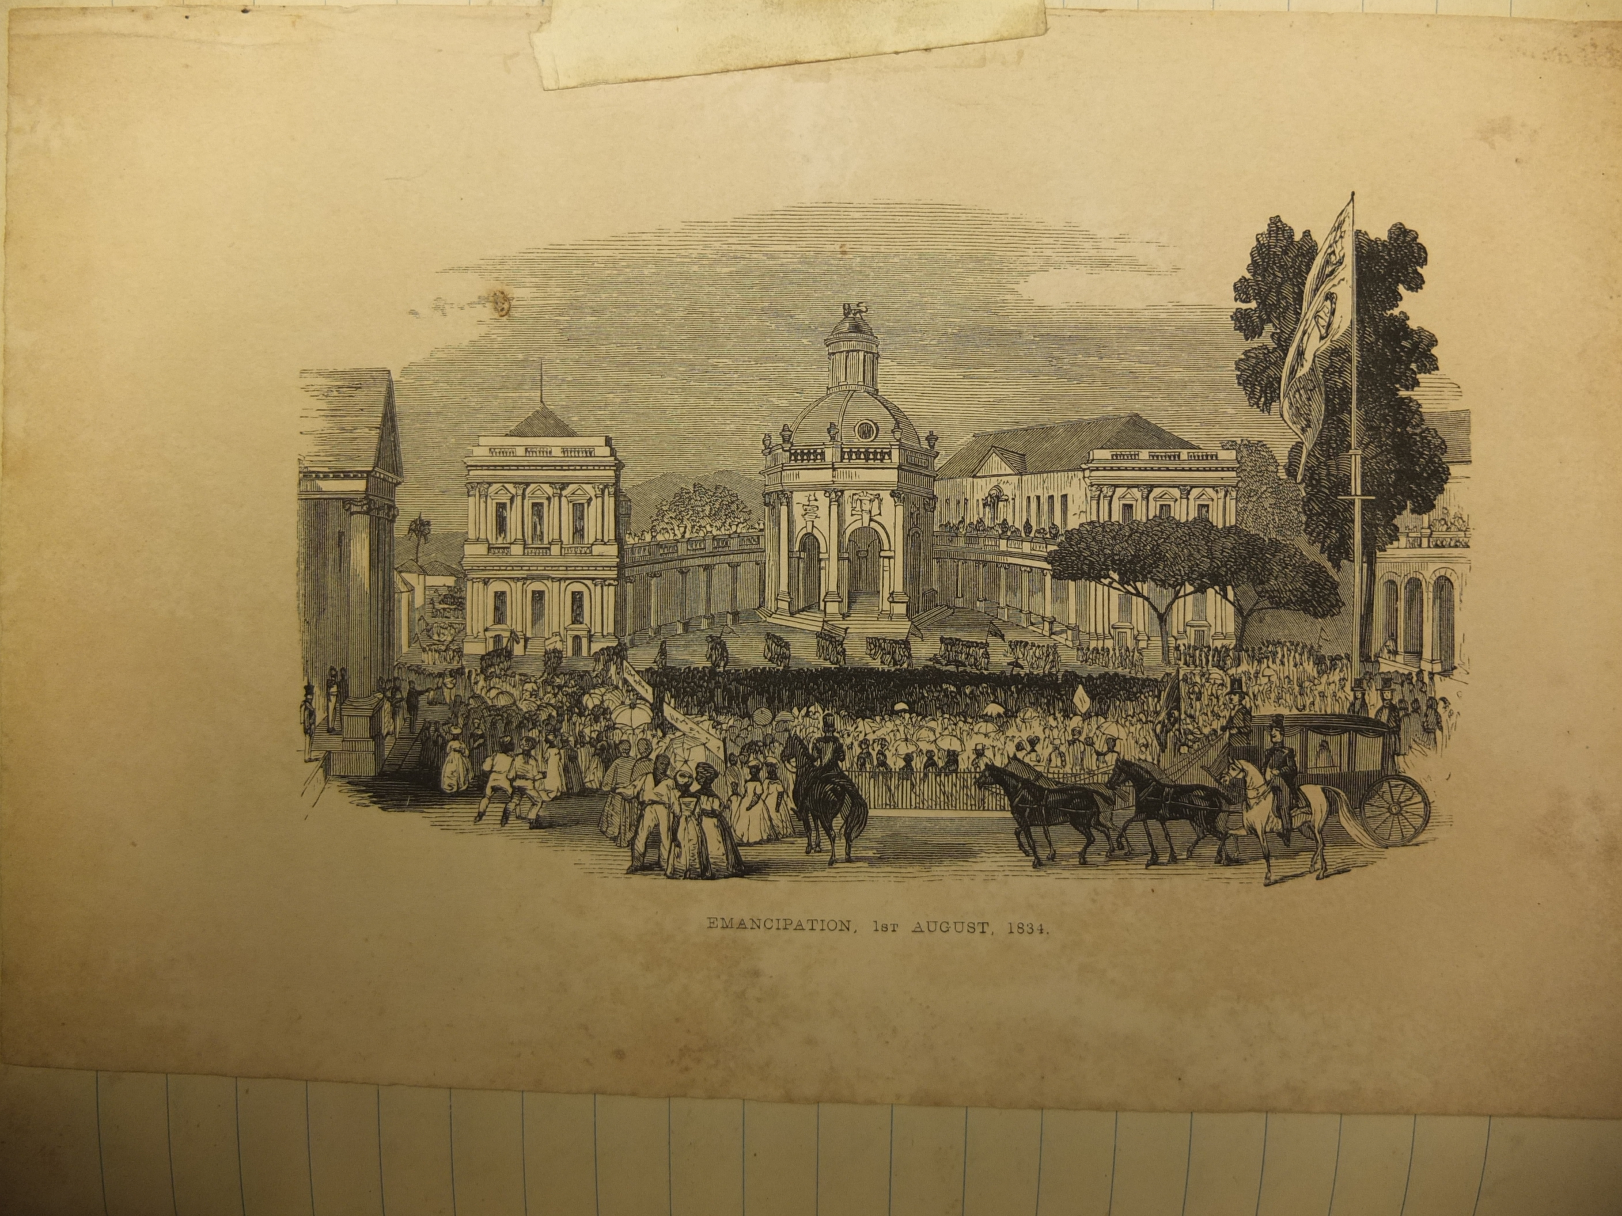
Emancipation, 1st August 1834, image pasted into Fuller’s autobiography. Image © Michael Watson.

Joseph was educated at Phillippo’s Mission House and in 1843 at the age of 18 he left Jamaica to become a Baptist Missionary in West Africa. He spent 30 years in West Africa preaching the Gospel. Whilst in Fernando Po Joseph married an ‘Elizabeth Johnson of Sierra Leone’, a Jamaican school teacher. The couple had three children before Elizabeth’s death in 1859. His second marriage was to Norfolk-born Charlotte Diboll, the daughter of missionaries who was herself active in the movement. In 1869 Fuller was given leave to visit his wife’s home in Norfolk where he preached and spoke of his memories of emancipation. In 1872 he returned to Jamaica where he was welcomed by huge crowds – 3,000 people went to the Phillipo Baptist Church in Spanish Town to hear him preach.

After settling in England, Joseph and his family travelled around the country and he delivered sermons at different Baptist churches. In Birmingham in 1889 he addressed an audience of 4000. Although there had been African communities in some of the large port cities in Britain for a long time many people had not encountered people of African descent before. Joseph wrote that when he visited a church in Norwich ‘my appearance with wife and children caused a little sensation as we entered.’ Joseph clearly maintained an interest in the continued struggles of African people after emancipation in the Caribbean as indicated by his subscription in 1891 to Anti-Caste – a publication that reported on racial prejudice and injustice in both the British empire and America. Eventually he made a permanent home in Hackney on Sydner Road in Stoke Newington. An advertisement found in Hackney Archives announced that Joseph would be preaching a sermon and recounting details of his 40 year missionary service in Fernando Po at a meeting at Salem Chapel which was located on Bouverie Road. He died in 1908 and was buried in Abney Park Cemetery. From Jamaica to Africa to England, Fuller’s journey retraced the Atlantic passage of the ships that had once brought his ancestors into slavery.

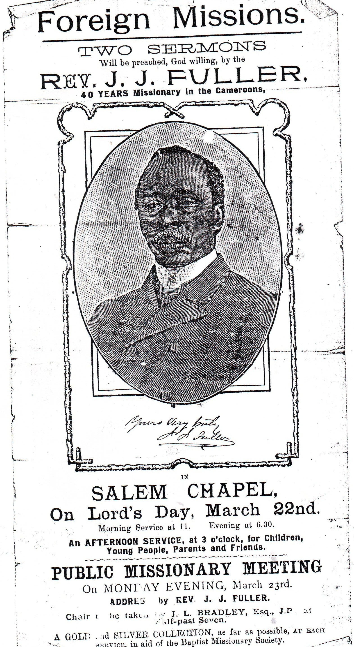
Poster advertising Joseph Jackson Fuller’s preaching at Salem Chapel which was located on Bouverie Road. Image © Hackney Archive.

Conclusion

In 1948, forty years after Fuller’s death, the S.S. Empire Windrush arrived at Tilbury Docks carrying 492 passengers from Jamaica to start a life in Britain. Some of those people settled in Hackney; like Anna Laetitia Barbauld and John Cass they are remembered with a street named to memorialise their presence. It takes twenty minutes to walk between Windrush Close and Cassland Road. The distance travelled by British society in terms of what these street names signify is at the same time so much further and yet in many ways these histories are so intimately linked that their entangled nature makes them almost inseparable.

Large numbers of the enslaved laboured on the plantations in the Caribbean and this geographic distance has enabled a distancing of the mind. The slavery business was not so easily contained. The profits amassed through the sales of Caribbean goods, colonial finance, insurance, shipping, slave trading and plantation ownership filtered into Britain. In examining the ways in which this wealth shaped British society the Legacies of British Slave-ownership project has contributed towards establishing an empirical basis for understanding the impact of slavery on Britain. As Nicholas Draper has commented, the research generated by the project has attempted to ‘fill the gaps between those who deny slavery’s role and those who believe Britain was built entirely on the blood of slaves.’ When this work is built upon with the stories of Hackney residents who made the abolition of colonial slavery their cause, as well as those residents who had experienced enslavement themselves, we begin to gain a sense of the interconnectedness of the local and the global during the period. Localised studies of slavery and its legacies offer a window into the history that begins with a sense of rootedness in the present. In doing so it challenges the notion that history is something that happened in the past – instead it is something that can be found inscribed into the very streets we walk down and the fabric of the places we call home.

As Britain turns toward a more insular small-island politics – exemplified by the rise of the United Kingdom Independence Party, the potential for the break-up of the United Kingdom and an exit from the European Union – it remains of vital importance to recognise Britain’s historic and on-going relationship to the wider world. Commerce and politics, and more intimately family and kinship networks, spread across the globe during the period of slavery and abolition. For the residents of Hackney who were associated in some form with the slavery business the local was never parochial, the national was always bound up with the global. The citizens of Hackney were, and indeed still are, citizens of the world.

Looks good! I think the pluralistic, patchwork nature of Hackney’s investment in slavery itself is well served by these short accounts; it makes perfect sense. One quick thought, though: the introduction seems to be almost entirely about the LBS project – I don’t think there’s a single mention of Hackney in there. Maybe re-frame it to explain why you’re focusing on Hackney, pulling some stuff up from the next section? I also think some of the material from the intro to this chapter is mentioned in the Introduction to the book.

Stuart Hall, ‘The local and the global: globalization and ethnicities’ in (ed.) Anthony D. King, Culture, Globalization and the World-System: Contemporary Conditions for the Representation of Identity (Columbia, Missouri and London: University of Minnesota Press, 1997), p.35.
Michael Ignatieff, The needs of strangers: an essay on privacy, solidarity and the politics of being human (New York: Viking Adult, 1985), p.141.
David Lowenthal, The past is a foreign country (Cambridge: Cambridge University Press, 1985).
See for example the AHRC funded ‘Reconnecting Diverse Rural Communities: Black presences and the legacies of slavery and colonialism in rural Britain, c.1600-1939’ project’s interactive map: http://www.maptive.com/ver3/fc423153d95a02fdb8551c82b05c0241 [Accessed 7 September 2015]. Also the ESCR funded Legacies of British Slave-ownership project’s map of slave-owners in Fitzrovia: https://www.google.com/maps/d/viewer?mid=z3xjAjqzNby4.kxz5K7uJpdCY&hl=en [Accessed 7 September 2015]
See the AHRC funded East India Company at Home project http://blogs.ucl.ac.uk/eicah/about/ [Accessed 7 September 2015]
See for example the Arts Council England funded ‘Local Roots / Global Routes’ educational resources developed by the Legacies of British Slave-ownership project and Hackney Museum and Archives: https://lrgr14.wordpress.com/resources/teaching-resources/ [Accessed 7 September 2015]
For more about the project see https://lrgr14.wordpress.com/about/project-overview/ [Accessed 7 September 2015]
http://www.ucl.ac.uk/lbs/ [Accessed 7 September 2015]
Toni Morrison, ‘The Site of Memory’, in ed. William Zinsser, Inventing the Truth: the Art and Craft of Memoir (Houghton Mifflin, 1995), pp.83-102.
Stuart Hall, Whose Heritage?, Arts Council of England conference, Manchester 1999.
'The northern suburbs: Haggerston and Hackney', Old and New London: Volume 5 (1878), pp. 505-524. URL: http://www.british-history.ac.uk
Iain Sinclair, Hackney, That Red-Rose Empire (Penguin, 2010), p.35.
M1777, Hackney Archive, Letter from John Aiken to Anna Laetitia Barbauld, dated 28 November 1791.
Charlie Morgan, ‘Abney Park and Abolition: Agency and Memory in the Fight Against Slavery’, Local Roots / Global Routes Website https://lrgr14.wordpress.com/2014/06/27/abney-park-cemetery-and-abolitionists-agency-and-memory-in-the-fight-against-african-enslavement/ Accessed 11 May 2015.
Sukhdev Sandhu, ‘Review: Hackney, That Rose-Red Empire by Iain Sinclair’, The Telegraph, 14 February 2009.
Zoe Norridge, ‘Finding a home in Hackney? Reimagining narratives of slavery through a multicultural community museum space’ in Ed. Dominic Thomas, Museums in Postcolonial Europe (Routledge, 2009), p.48.
Madge Dresser, ‘Set in Stone? Statues and Slavery in London’, History Workshop Journal, Vol.64, No.1, pp.172-3.
William Pettigrew, Freedom’s Debt: The Royal African Company and the Politics of the Atlantic Slave Trade, 1672-1752 (University of North Carolina Press, 2013), Appendix 4, p.237.
Kenneth Cozens, ‘Politics, patronage and profit: a case study of three eighteenth century merchants’, unpublished MA dissertation, University of Greenwich, p.26.
Abridgment of the Minutes of the Evidence Taken Before a Committee of the Whole House to Whom it was Referred to Consider the Slave Trade (House of Commons, 1789), pp.66-77.
Emma Christopher, ‘“The Slave Trade is Merciful Compared to [This]”: Slave Traders, Convict Transport and the Abolitionists’, in eds. Emma Christopher, Cassandra Pybus and Marcus Rediker, Many Middle Passages: Forced Migration and the Making of the Modern World (University of California, 2007), p.111.
The Annual Register of World Events: A Review of the Year (J. Dodsley, 1776), p.170.
Abridgement, p.69.
Cozens, ‘Politics, patronage and profit’, p.76.
Cozens, ‘Politics, patronage and profit’, p.3.
http://www.ucl.ac.uk/lbs/person/view/28107
William D. Rubenstein, Who were the rich? A biographical directory of British wealth-holders 1809-39, Vol.1, p.212.
Nicholas Draper, ‘The City of London and slavery: evidence from the first London dock companies, 1795-1800’, Economic History Review, Vol.6, No.2 (2008), p.442.
Circulator of Useful Knowledge, Amusement, Literature, Science and General Information (T. Boys, 1825), p.319.
Declaration of bargain and sale CR2017/D300, Warwickshire County Record Office.
John Timbs, English Eccentrics and Eccentricities (R. Bentley, 1866), p.75.
Paul Baines, ‘Crime and Punishment’, in ed. Pat Rogers, The Cambridge Companion to Alexander Pope (Cambridge University Press, 2007), p.115.
Timbs, English Eccentrics, p.80.
http://www.ucl.ac.uk/lbs/person/view/772
http://www.ucl.ac.uk/lbs/person/view/40938 and http://www.ucl.ac.uk/lbs/person/view/772
An Account of the Society for Promoting Religious Knowledge Among the Poor (T. Field, 1779), p.12.
Stephen Burley, New College Hackney (1786-96) a Selection of Printed and Archival Sources. http://www.english.qmul.ac.uk/drwilliams/pubs/Burley/Column%20Right%20%28PDFs%29/3%29%20College%20Members/3.5%20Governors.pdf
Daniel and Samuel Lysons, The Environs of London: Being an Historical Account of the Towns, Villages, and Hamlets, Within Twelve Miles of that Capital : Interspersed with Biographical Anecdotes, Volume 1, Part 2 (T. Cadell and W. Davies, 1811), p.313.
Anthony Page, ‘“A Species of Slavery”: Richard Price’s Rational Dissent and Antislavery’, Slavery and Abolition: A Journal of Slave and Post-Slave Studies, Vol.32, No.1, p.55.
Donna Andrews, Philanthropy and police: London charity in the eighteenth century (Princeton University Press, 1989), p.113, p.214.
http://www.npg.org.uk/collections/search/person/mp88180/samuel-boddington
M4050, Marriage Settlement dated 10 April 1776, Hackney Archives. My thanks to Michael Watson for transcribing this document.
http://www.ucl.ac.uk/lbs/person/view/13189
Society of West India Planters and Merchants resolutions, Crown and Anchor Tavern, 24 Nov 1823, M915, Reel 4, Senate House Library.
http://www.ucl.ac.uk/lbs/person/view/2868
Anti-Slavery Monthly Reporter, Vol.2, No.47 (April, 1829) pp.462-8.
http://www.ucl.ac.uk/lbs/person/view/2146631106
http://www.ucl.ac.uk/lbs/firm/view/1856607367
T71/493, p.248. My thanks to Kristy Warren for providing me with images of the registers and bringing this detail to my attention.
Zoe Williams, ‘The Saturday Interview: Stuart Hall’, The Guardian, 11 February 2012.
Angelina Osborne, Equiano’s Daughter: the Life of Joanna Vassa (Krik Krak, 2007),
http://www.hackney.gov.uk/hackney-archives-abolition.htm#.VFZoz4cpQ0o
http://www.ucl.ac.uk/lbs/person/view/2146631826
T71/122, p.47. 1826 Slave Register for Port Royal.
Autobiography of the Rev. J.J. Fuller of Cameroon, West Africa, A/3/19, Angus Library, Oxford. My thanks to Michael Watson for his transcription of this material.
Fuller, Autobiography.
Jeffrey Green, ‘Fuller, Joseph Jackson (1825–1908)’, Oxford Dictionary of National Biography, Oxford University Press, 2004 [http://www.oxforddnb.com/view/article/57698, accessed 2 Nov 2014]
Las Newman, ‘A West Indian Contribution to Christian Mission in Africa: The Career of Joseph Jackson Fuller (1845-1888)’, Transformation, Vol. 18, No. 4, Degree of Intercontinental Partnership Concerning Mission and Development in Africa (October 2001), p.230.
Caroline Bressey, Empire, Race and the Politics of Anti-Caste (Bloomsbury, 2013), p.138.
Fuller, Autobiography.
Bressey, Anti-Caste, p.138.
Jeffrey Green, ‘Fuller, Joseph Jackson (1825–1908)’, Oxford Dictionary of National Biography, Oxford University Press, 2004 [http://www.oxforddnb.com/view/article/57698, accessed 2 Nov 2014]
Nick Draper quoted in Carola Hoyos, ‘Rothschild and Freshfields founders linked to slavery’, Financial Times, 26 June 2009.

