Evaluating the variation characteristics of ecological resilience along expressways in developing countries: The case of the Phnom Penh-Sihanoukville Expressway in Cambodia
Jingxiao Zhang^{1,}*, Xin Gao², Feiye Zhao¹, Simon P. Philbin³, Yan Li⁴, Xu Yang⁴
¹ School of Economic and Management, Chang’an University, Shaanxi Xi’an 710061, China
² China Road & Bridge Engineering Company Limited Cambodia Office, Beijing 100011, China
³ School of Engineering, London South Bank University, London SE1 0AA, UK
⁴ School of Geography, Harbin Normal University, Heilongjiang Harbin 150500, China
* Correspondence: zhangjingxiao964@126.com (Jingxiao Zhang)
Abstract: Expressway construction has caused a significant threat to the ecological environment in developing countries, and therefore the variation characteristics of ecological resilience along the expressway in developing countries are of major importance. This empirical study focuses on a typical area within a 2-km range of the Phnom Penh-Sihanoukville Expressway in Cambodia and uses remote sensing and geographic information systems (GIS) technology to analyze the variation characteristics of ecological resilience along the expressway. The results of the study reveal that due to the construction of expressways, the land use types transferred into or out of the land use types increase and furthermore the land use types show a trend of decreasing natural attributes and increasing human attributes. It is found that expressway construction has an observed effect on the transfer rate of the center of gravity of land use type, and the direction of the center of gravity shifts in the direction of expressway construction. The impact of construction on the ecological resilience of the western region with higher vegetation coverage was higher than that of the eastern region with higher urbanization. The research develops a theoretical evaluation model based on land use type of the variation characteristics of ecological resilience along the expressway, which can be used to enable the sustainability of expressway construction and maintain the regional ecological environment.
Keywords: Land use type; Variation characteristics; Ecological resistance; Ecological resilience; Phnom Penh-Sihanoukville Expressway; Remote sensing; Geographic information systems (GIS)

1. Introduction
Expressways are a crucial enabler for connecting cities and towns. Indeed, expanding expressway networks reduces the distances between cities and towns, which promotes economic growth in developing countries (Kasraian et al., 2016). However, the environment is now facing serious disturbance issues as a result of the intensifying level of expressway development. Expressway construction has a significant effect on the local climate (Nedbal &Brom 2018), air quality (Alshetty &Nagendra 2022), and soil contamination (Jullien &François 2006). When these stresses are combined, the socio-ecological system becomes more vulnerable to change (Folke 2006). Moreover, the more complex the ecosystem along the expressway, the higher the vegetation coverage rate and the longer the construction time, and consequently the greater the impact and level of arising damage (Xu et al. 2022). According to several studies, “the Belt and Road” Initiative focuses on the development of transportation infrastructure, such as expressways, so the construction of Chinese Silk Road Economic Belt involves many expressways, and its impact on the ecological environment cannot be ignored. It is envisaged that the impact will vary along the route of this major expressway system (Meng &Wang 2020) and will result in certain problems that need to be addressed, such as a decline in air quality (Hussain &Zhou 2022, Jiang et al. 2021), water pollution (Zhang et al. 2019), and soil erosion (Teo et al. 2019). Ecosystems have always undergone cyclical and ongoing change but recent environmental change brought about by human activity is unprecedented (Trenberth 2018). Consequently, there is a need for further care for the ecological environment along this planned route. According to studies, ecosystems may heal and regulate themselves when they are subjected to shocks or perturbations from outside sources (Holling 1973). The capacity of an ecosystem to preserve stability and integrity through feedback is known as ecological resilience. Therefore, according to different ecological conditions, monitoring and evaluating the changing characteristics of ecological resilience along the international infrastructure construction route of the Belt and Road Expressway is of great importance for ecological environmental protection.
As an important index to evaluate the variation of ecological environment, ecological resilience has drawn the attention of many researchers and it is now being used to manage and safeguard ecosystems (Desjardins et al. 2015). With the introduction of Holling's concept of ecological resilience, the focus of ecological resilience research has shifted from one equilibrium state to several equilibrium states, where the quality of resilience is crucial to mediating the transitions between different states (Dakos &Kéfi 2022). The capacity of ecosystems to withstand or restore from environmental disturbances at a socially acceptable level is incorporated in the latest definition of ecological resilience (Xu et al. 2015). Ecological resilience is promoted as a measure to accurately evaluate how regional ecosystems may be impacted by different types of disturbances (Lyu et al. 2022). Moreover, researchers have proposed the concept of measuring ecological resilience through ecological resistance and ecological restoration (Tracy et al. 2017), and this research draws on this idea. In terms of research scale, current studies on ecological resilience mainly focus on national (Li et al. 2023), regional (Wang et al. 2022), urban agglomeration (Shi et al. 2022) and metropolitan area (Zhou et al. 2022), and most of them are surface projects. There are few researches on isolinear engineering along expressway construction. In terms of research content, the existing researches mainly focus on the quantitative measurement and influencing factors of resilience. The quantitative measurement of ecological resilience mainly involves numerical assessment through the establishment of an index system. Largely based on the "Driving force - Pressure - State - Impact - Response" (DPSIR) framework (Zhao et al. 2021) and the Resistance-Adaptive-Recovery model of pressure-state-response (PSR) method (Xie et al. 2023), the countermeasures against ecological disturbance are proposed. Whereas the model of dynamic Bayesian networks (DBN) has been examined for the evaluation and modeling of the structure and function of socio-ecological resilience, which is used to develop an adaptable framework for this application (Franco-Gaviria et al. 2022). In terms of the influencing factors of ecological resilience, the research study focuses on natural factors such as climate, hydrology, vegetation and topography (Zhang et al. 2023b), as well as human activities such as urbanization, population agglomeration and scientific and technological innovation (Cui et al. 2023, Wang et al. 2022), which characterize the ecosystem itself. In order to understand the uncertainty of the natural environment and reduce its vulnerability, researchers have proposed combining the environment and human activities; and observing the interconnections and common evolution of natural and social subsystems to foresee the emergence of resilience (Berkes 2007, Fikret 2017). In addition, through natural and human activities, constraints on ecological resilience can be identified, which is conducive to explaining the internal causes of regional differences in ecological resilience (Li &Wang 2023). However, in the existing quantitative measurement of ecological resilience, the index system is mostly used for evaluation, and the reliability of the research results remains to be adequately investigated. However, there is a lack of research on using comparative analysis methods to measure and evaluate the actual level of ecological resilience based on empirical studies of land data to ensure unnecessary factors are accommodated. In terms of influencing factors, existing studies focus on human activities, such as natural factors and urban agglomeration, but pay insufficient attention to exploring the impact of expressway construction on ecological resilience. Furthermore, previous research has identified that expressway construction has a negative impacts on the ecosystem, such as the deterioration of the natural environment (Zhang et al. 2023a) and the change of land use (Liang et al. 2014).
Many studies on the earth's atmosphere, hydrosphere, geosphere, and biosphere have been carried out to evaluate the environmental impact of the expressway development. In regard to evaluating the ecological impact of expressways, significant advancements have been made in theoretical development, evaluation systems, and evaluation models. For instance, an ecological integration measurement model was created based on the pressure-state-response (PSR) framework, which utilized a comprehensive evaluation technique to quantify the ecological integration of the expressway domain ecosystem (Shi et al. 2013). With the help of data mining and grey correlation theory, a thorough evaluation model was proposed for the ecological environment of the Qinghai-Tibet Plateau expressway area (Jia et al. 2020). The model utilized various indicators, including terrain slope, vegetation coverage, desertification index, and land use type. To evaluate the impact of expressways on the ecological environment, a new model integrating the enhanced analytic hierarchy process (AHP) and fuzzy comprehensive evaluation method (FCE) was developed and an indicator system was established from the perspectives of social, ecological, and the natural environment (Zhang et al. 2020). Conversely and through the use of camera traps and Bayesian hierarchical modeling, the effects of the distance from expressways, housing and population density, normalized differential vegetation index (NDVI), and human footprint index on changes in mammal community composition and species-specific habitat use were compared and it has been suggested that the influence of expressways was more obvious. Along with the formation of the expressway network, these effects will continue to expand. However, in the face of such impacts, the ecosystem will automatically return to this state (Larson & Rew 2022), and there are studies exploring compensatory measures (Liu et al. 2018). However, existing studies on the environmental consequences of expressway construction have focused on areas less impacted by human intervention, such as forests (Nikinmaa et al. 2020), oceans (Jozaei et al. 2022) and high-altitude pastures (Nettier et al. 2017). Rather than regional ecosystems that are heavily affected by human intervention. While other researchers have started looking at the relationship between socio-ecological systems and urban resilience (Stroink 2020), insufficient attention has been paid in the extant literature on the ecological resilience of natural ecosystems.
Developing countries are also actively promoting the construction of expressways. Expressway construction contributes to regional planning and growth as well as the establishment of economic zones, thereby making it a significant infrastructure undertaking for any country (Huang &Yeh 2008). However, the impact of expressways on the environment varies according to the location along the route. This is especially the case in vulnerable areas along the Belt and Road, where the ecological environment is often vulnerable, the climate and geology are complicated, and there are insufficient protections in place Therefore, it is particularly important to pay attention to the changes of ecological environment along the expressway and strengthen its protection (Yin et al. 2022).. However, there is a lack of research on the ecological environment along the "Belt and Road" international infrastructure construction route originating from China, and even less scientifically rigorous studies on the environmental impact of expressway construction in areas with complex geological environment and fragile environment. Although ecological resilience theory has been incorporated into policy and forward-looking international environmental assessment systems, few studies to date have been conducted to assess the impact of international transport infrastructure from the perspective of ecological resilience.
The Phnom Penh-Sihanoukville Expressway is an illustration of how “the Belt and Road” initiative and Cambodia's Four Corners Plan have successfully combined. Indeed, the Belt and Road Plan from China promotes industrial and socio-economic development along the route, which benefits from the intensity of construction activities. The expressway connects Sihanoukville, home of Cambodia's largest deepwater port, with Phnom Penh, covering five provinces and a quarter of the country's population. The vegetation along the route is flourishing, and the land use type is mainly forest land and grassland. At the same time, the route is an ecologically sensitive area, passing the Tenau River, Sre Ambel River, Kiriirom National Park, Bokor Mountain National Park, Kep National Park, KBAL Chhay Forest Reserve and other ecological forms. Among them, Kiriirom National Park is the main activity area of Asian elephants, but the construction of the project through the Kiriirom National Park road blocks the passage of wildlife. Various ecological types are disturbed to varying degrees. Given the strategic value of this infrastructure to the regional economy, it is critical to monitor and evaluate any changes to the environment and ecology along the Phnom Penh-Sihanoukville Expressway construction zone. To monitor and assess the environment, the most commonly used methods all use GIS as a tool to study the ecological environment, such as ecological risk assessment of land restoration engineering (Wang 2023); applied environmental assessment of physical geography (Zhang et al. 2022); ecological environment quality prediction (Yan et al. 2023); ecological vulnerability assessment (Ma et al. 2023); the impact degree of landslides (Saha et al. 2023); and the treatment of municipal solid waste (Durlevic et al. 2023). Therefore, this research study utilizes GIS to assess the variation characteristics of ecological resilience along the expressway. The Phnom Penh-Sihanoukville Expressway runs through a number of protected areas, thereby giving each area a recovery trajectory of its own character. In order to effectively manage and restore regional ecological resilience, and considering the length of the route as well as notable topographical variations and other complexities (Alberti &Marzluff 2004), this research analyzes land use types through the monitored remote sensing data. The study also explores the characteristics of their temporal and spatial variation; establishes a theoretical model based on ecological resilience development by integrating ecological resistance and ecological restoration indicators; and studies how to protect key functions and processes along the expressway under changing environmental conditions.
This research aims to evaluate the impact of expressway construction on regional ecosystems in developing countries through investigating the case of the Phnom Penh-Sihanoukville Expressway in Cambodia. The research places a strong emphasis on the stability of system structure and function, which has been expanded to take into account the ongoing non-equilibrium change of the ecosystem. On this basis, a theoretical evaluation model of ecological resilience variation characteristics along the expressway based on land use types is proposed, which accommodates the characteristics and influencing variables of land use change along the expressway and underscores a continuous change and development process.
The research provides a scientific basis for the development of regional ecological resilience theory and macro level management of land use along the expressway. The Geographic Spatial Data Cloud is introduced to analyze regional ecological resilience characteristics, thereby illustrating the fusion and penetration of information science and resource environment research. In this research, ecological spatial resilience is expanded by, the use of a multidisciplinary approach and ecological environment evaluation techniques, as well as ecological improvement of resource management systems. The findings of this empirical study will be helpful in encouraging the protection and utilization of ecological space along expressways, which will also facilitate the collaborative development of social economy and environmental resources.
- Research design

2.1 Theoretical model and research framework
Based on the above analysis, in order to fill the research gap, this research study establishes a theoretical evaluation model of ecological resilience variation characteristics based on land use types (as shown in Figure 1), and theoretically explains the impact of construction interference along the expressway on ecological resilience. After comparing the classification results of land use types in different buffer zones along the Phnom Penh-Sihanoukville Expressway, it is found that the most significant changes in land use occurred inside the study areas when the buffer zone stretches 2 kilometers. Therefore, the evaluation unit of this research is determined, that is, two typical areas within the buffer area of 2km long along the Phnom Penh-Sihanoukville Expressway as the study areas. Thereafter, remote sensing and geographic information system (GIS) are used to obtain and process the relevant land use data; based on which the corresponding index system is constructed with ecological resistance and ecological restoration as indicators, and the variables affecting regional ecological resilience are studied. Then, the entropy weight method is used to assign weights to the indicators, so as to realize the measurement and classification of ecological resilience, and thus achieve the purpose of evaluating resilience in this research.
This research also establishes a corresponding research framework (as shown in Figure 2). The framework identifies the need to use remote sensing and GIS techniques to record long-term spatio-temporal scales associated with the dynamic systems under investigation in order to track changes in regional ecological resilience. Moreover through the two study areas before and after the construction, comparative case study analysis allows the variation characteristics of ecological resilience to be determined. In this study, the elasticity, adaptability and convertibility of regional ecological resilience model are tested by using ecological resilience theory. In order to understand how different disturbance sources interact with the ecological environment, land use change studies have also been carried out.

Fig. 1. Theoretical evaluation model
Fig. 2. Research framework

2.2 Research methods

3.2.1 Analysis of land use change
The land use transfer matrix is a tool used to quantitatevely analyze the transformation of land use types, which provides insights into the process of land use types transitioning from T to T+1. The matrix can be established mathematically using equation. (1):
$S_{ij}=\left[\begin{aligned}S_{11}{ S}_{12} ⋯ S_{1n} \\ S_{21} S_{22 }⋯{ S}_{2n} \\ ⋮ ⋮ ⋱ ⋮ \\ S_{n1} S_{n2} ⋯{ S}_{nn}\end{aligned}\right]$ (1)
where $S_{ij}$ represents the state of land use at the beginning and end of the study period, and n is the number of types of land use.
The land use transfer matrix of the study area during 2017-2018 and 2019-2021 is computed in this research using ENVI5.3 software. The matrix records the change of land use over time, thereby making it easier to compare the spatio-temporal change of land use in the area around Phnom Penh-Sihanoukville Expressway in Cambodia in different time periods.

3.2.2 Ecological resistance calculation
Ecological resistance is the capacity of an ecosystem to withstand external disturbances. Studies have shown that ecosystem resistance is closely related to the value of ecosystem services (Xia et al. 2022). The value of ecosystem services refers to the value of the products and services provided by the ecosystem of a country or region for the whole society through its functions, which is used to measure the output of ecological services of the ecosystem (Xie et al. 2015b). To evaluate the value of ecological services, global ecosystem types and service functions are divided into 17 categories (Costanza et al. 1997). Referring to the previous results, this research characterizes the ecosystem service value from four aspects of ecological control, support, and other services (Xia et al. 2022, Yang &Liu 2021)( as shown in Table 1). Among them, the supply service refers to the ecosystem provides tradable ecological products, which is the direct utilization value. Regulatory services refer to the utility of non-tradable ecological functions and processes to human beings. Support service is the important connotation of sustainable development of ecosystem. Cultural services are the aesthetic and spiritual benefits of ecosystems.
Table 1. Classification of ecological service types
First level type | second level type | Definition of ecosystem service system
Supply service | Food production | Convert solar energy into plants and animals that can be eaten by humans
 | Raw material production | The conversion of solar energy into buildings and their attachments or other uses for humans
 | Water resources supply | Water resources used for residents' living and industrial development
Regulating service | Gas regulation | Maintain the balance of atmospheric chemical composition and absorb SO, fluoride and nitrogen oxides
 | Climate regulation | Increase precipitation, reduce temperature and other regulatory functions
 | Clean the environment | The purification of water quality, soil and air, that is, the removal and decomposition of excess nutrients, compounds and residual dust
 | Hydrologic regulation | The function of filtering, conserving, storing and supplying fresh water
Support service | Soil conservation | Organic matter accumulation, vegetation root exudates and soil organisms cycling and accumulating soil nutrients
 | Maintain nutrient circulation | Storage, internal circulation, treatment and acquisition of elements and nutrients such as nitrogen and phosphorus
 | biodiversity | Provide a place for the origin and evolution of wild animals and plants, and also provide habitat for their life
Cultural service | Aesthetic landscape | Provide (potential) entertainment and artistic value
However, due to the impact of China's environmental conditions on the value of ecological services, a correction to the coefficient has been made previously (Xie et al. 2015a, Xie et al. 2015b). As the study area has spatial differences, this research adopts Xu's regional correction method based on cultivated land for secondary correction, adjusts the equivalent benchmark of the national average grain output value to the output value of the study area, and overcomes this problem by revising the equivalent coefficient of ecological service value. The specific correction formula can be established using equation. (2), (3).
$θ=\frac{Q}{Q_{0}}$ (2)
$E_{i}=θ*E_{i0}$ (3)
where $θ$ represents the coefficient for the ecological service equivalent's regional correction, Q and $Q_{0}$ refers to the average grain yield per unit area in the study area and Cambodia, respectively. $E_{i}$ and $E_{i0}$ is the ecological service function equivalent of the ith land use type after correction and without correction. i represents land use type, where i= 1,2,..., 6, corresponding to cultivated land, forest land, grassland, residential land, unused land and water areas in this research respectively.
It is therefore possible to determine the ecosystem service value coefficient by employing the aforementioned modified equivalent coefficient of the ecosystem service value. After comprehensive comparative analysis, the ecosystem service value equivalent coefficient, which is equal to one-seventh of the annual grain value per hectare, shows the relative contribution rate of the ecosystem potential service value (Zhang et al. 2021). The calculation formula is shown in (4).
$E_{i0}=\frac{1}{7}×\sum_{i=1}^{n}{\frac{m_{i}p_{i}q_{i}}{M}}$(i=1，2，$⋯，6$) (4)
where $E_{i0}$ represents the i-th land use type's ecological service function equivalent, i is the crop species, $P_{i}$ is the average crop price, $q_{i}$ refers to the yield of crop per unit area of i, $m_{i}$ refers to area of i, and M refers to the total area of grain crops.
Using the above data, the ecosystem service value per unit area of the two study areas can finally be calculated. In light of this, the ecosystem service value from the two study areas can be calculated.using equation (5):
$ESV=\sum_{i=1}^{n}{S_{k}}*{VC}_{fk}$ (5)
Where ESV indicates the ecosystem service value in riel, $S_{k}$ indicates the area of land use type k of ecosystem in the study area in hectare, and ${VC}_{fk}$ indicates the ecological service function equivalent of item f of the Kth land use type in riel/hectare. To sum up, the ecological resistance is calculated using equation (6):
$P=ESV$ (6)
Where P indicates the ecological resistance.

3.2.3 Ecological restoration calculation
Ecological resilience is an ecosystem's capacity to recover from harm and restore to its pre-damage form. Ecological resilience is related to the degree of development, and the more complex the ecosystem is under external pressure, the weaker the degree of recovery. To evaluate the level of ecological restoration, this research adopts the ecological elastic model and coefficients (Peng et al. 2015) (As shown in Table 2). Ecological restoration can be calculated using equation (7):
$R=\sum_{i=1}^{n}{S_{k}}*{RC}_{i}$ (7)
Where R refers to ecological restoration, while $S_{k}$ indicates the area of the land use type. ${RC}_{i}$ is the ecosystem restoration coefficient of the land use type i; and n is the number of land use types.
Table 2. Coefficient of ecological restoration
Land use type | Cultivated land | Forest land | Water areas | Unused land | Residential land | Grassland
Coefficient | 0.3 | 0.8 | 0.8 | 1.0 | 0.2 | 0.6
Note: The coefficient of ecological restoration is used to represent the degree of difficulty of ecosystem recovery in the face of external pressure. Land use types close to natural ecosystems are more likely to recover from external disturbances, while human-dominated land use types have lower resilience. The water areas and unused land are basically unchanged because they can be restored by water circulation. Unused land is robust to natural disasters and can be automatically renewed when the disturbance disappears, so it has the highest resilience potential.

3.2.4 The level of ecological resilience calculation

The level of ecological resilience is based on an ecosystem's capacity for both resistance and restoration, so these two traits can be used as indicators to measure. However, ecological resistance and restoration use distinct units of calculation, thus before thorough calculation they are normalized to the range [0, 1]. Ecological resilience can be calculated using equation (8) :
$Resilience=\sqrt{P*R}$ (8)
Where P refers to the ecological resistance in riel, R refers to ecological restoration in hectare, $Resilience$ refers to ecological resilience. 0$≤Resilience≤1$, the more $Resilience$ converges to 0, the lower the level of ecological resilience.

2.3 Case selection

2.3.1 Study area
The Phnom Penh-Sihanoukville Expressway is situated in the southwest of Cambodia, which connects Phnom Penh City and Sihanoukville City, with a total length of 190.365km, passing through two cities and three provinces. The expressway contruction began on March 22, 2019 and opened to traffic on October 1, 2022. In this research, two typical areas in Koh Kong Province and Kampong Speu Province are selected as representative areas. By comparing the land use change and ecological resilience before and after expressway construction, the impact of expressway construction on ecological resilience along the expressway is comprehensively evaluated. Figure 3 depicts the positions of the two study areas. Almost 50% of the area where Koh Kong Province is situated is covered in forests, while natural reserves like Kiriirom National Park are widely distributed in this area. Despite the low population density, the region boasts abundant tourism resources. Taking into account the needs of economic development, the expressway passes through two forest lands, which can be examined as a representative of the area with strong natural attributes along the route. As one of Cambodia's key grain producing areas in the country, the area where Kampong Speu Province is situated is rich in natural resources and has a developed agricultural economy. It is also ideally situated for launching new enterprises and engaging in trade in Cambodia. With a high population density and a wide urban region, the area can be considered as a model area with strong human characteristics and corresponding level of socio-economic activities. These two study areas are selected to initially investigate the impact of the construction of the Cambodia Phnom Penh-Sihanoukville Expressway on the ecological resilience in various geographical environments due to their significant differences in geographic environments along the route.
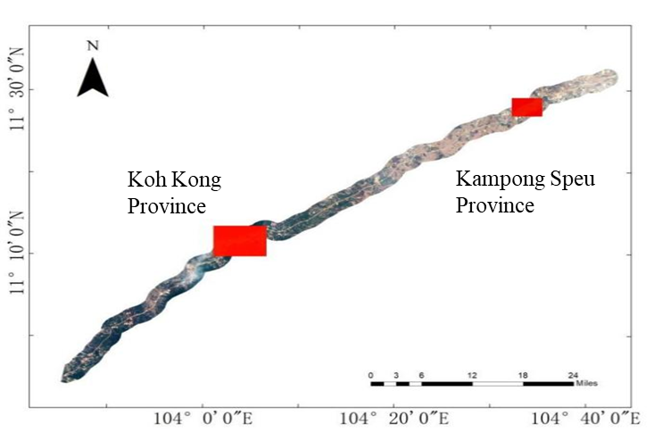
Fig. 3. Geographical location map of the two study areas

2.3.2 Data source and processing
The Geographic Spatial Data Cloud (http:/www.gscloud.cn) contributed the remote sensing image data for this investigation. Considering the image quality, remote sensing image data from December 2017, December 2018, December 2019, and January 2021 were selected to compare and analyse the changes in the area before and after the expressway construction. Each remote sensing image was preprocessed by atmospheric correction and radiation calibration, and then visually interpreted to obtain the classification results of land use types; namely six categories: forest land, cultivated land, grassland, water areas, residential land, and unused land (as shown in Table 3). Each image had a resolution of 30 by 30 meters, which was utilized to calculate changes in land use types.The study area's grain yield and other relevant data were provided by the Cambodia Statistical Yearbook, which were utilized to estimate ecosystem service values in the later analysis and calculate ecological resistance and resilience.
Table 3. Classification and connotation of land use types
 | Primary type | connotation
1 | Cultivated land | refers to the land where crops are planted, including cultivated land, newly opened wasteland, leisure land, rest land and grass field crop land; Agricultural fruit, mulberry and land for agriculture and forestry, mainly for planting crops; Cultivated beaches and beaches for more than three years.
2 | Forest land | refers to the growth of trees, shrubs, bamboo, and coastal mangrove land and other forestry land.
3 | Grassland | It refers to all kinds of grasslands with herbaceous plants as the main growth and coverage above 5%, including shrub grassland with grazing as the main and sparse grassland with canopy density below 10%.
4 | Water areas | refers to natural land waters and land for water conservancy facilities.
5 | Residential land | refers to urban and rural residential areas and other industrial, mining, transportation and other land.
6 | Unused land | refers to Land that has not been used at present, including land that is difficult to use.
- Results and analysis

3.1 Temporal-spatial variation characteristics of land use types along the Phnom Penh-Sihanoukville Expressway
By comparing two representative regions within the 2km buffer zone of the Phnom Penh-Sihanoukville Expressway, namely Koh Kong Province and Kampong Speu Province, the impact of the expressway on the ecological environment before and after construction was obtained and the variation characteristics of its ecological resilience were assessed. For the convenience of comparison, Koh Kong Province is set as Study area I, Kampong Speu Province is set as Study area II. The two study areas are 25,393 hectares and 13,760 hectares respectively. The total area of the study areas is 39,153 hectares. Specific land use data are shown in Table 4.
Table 4. Statistical table of land use type area in study areas
 |  | Land use type | Forest land | Grassland | Water areas | Unused land | Cultivated land | Residential land
Time periods
Study area  I | 2017 |  | 13333 | 1054 | 20 | 723 | 9819 | 444
 | 2018 |  | 12596 | 1091 | 30 | 861 | 10281 | 534
 | 2019 |  | 12600 | 1159 | 25 | 913 | 10145 | 551
 | 2021 |  | 10520 | 3987 | 0 | 1463 | 8521 | 902
Study area  II | 2017 |  | 1563 | 2367 | 707 | 771 | 5826 | 2526
 | 2018 |  | 1570 | 2070 | 525 | 717 | 6035 | 2843
 | 2019 |  | 913 | 1660 | 566 | 989 | 5826 | 3519
 | 2021 |  | 846 | 459 | 973 | 1536 | 5986 | 3960

3.1.1 Temporal variation characteristics of land use types
Figure 4 displays the percentage of each land use type in the two study areas during 2017-2018 and 2019-2021. During 2017-2018, the two main land types in Study area I were forest land and cultivated land. In 2017, forest land accounted for 53% and cultivated land accounted for 38%, and the total of which accounted for 91%. The remaining 9% of the area was accounted by unused land, grassland and residential land. However, water areas were too small to count for negligible proportion. From the perspective of changes in the proportion of land use types, compared with the previous year, the proportion of forest land area decreased by 2% in 2018, while the proportion of cultivated land area increased by 2%. Further, only the proportion of these two main land use types changed, while the proportion of other land use types did not change. During 2019-2021, the two main land use types in Study area I remained forest land and cultivated land. However, all land use types changed in their proportions over this time, with forest land declining by 9% and cultivated land declining by 6%, respectively. While unused land and residential land increased by 2% and 1%, respectively, the extent of grassland increased by 12%. In Study area II, the two main land types were cultivated land and residential land during 2017-2018. In 2017, cultivated land and residential land respectively accounted for 42% and 18% of the area, thereby indicating a total of 60%. The remaining 40% of the area was accounted by forest land, unused land, grassland, and water areas. All land use types changed slightly and the proportion of change was about 2% over this time. During 2019-2021, the two main land types in Study area II remained cultivated land and residential land. In 2019, the two main land types accounted for 70% of the total area. Compared with the previous year, all land use types changed over this time from the perspective of changes proportion of each land use type, with residential land and unused land increasing by 4% and the area of cultivated land and water areas increasing slightly. While grassland declined by 9%, and forest land declined slightly.
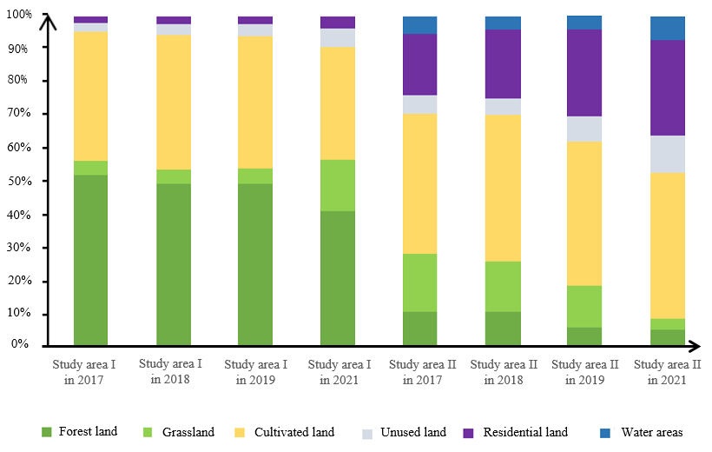
Fig. 4. Percentage of land use type map
Table 5 displays the land use type transfer matrix of the two study areas during 2017-2018 and 2019-2021. In Study area I, cultivated land was the main type of land transfer in, mainly from forest land, unused land and grassland during 2017-2018. Forest land underwent the most transfer to another type, and was generally converted into cultivated land. Other land use types changed slightly. During 2019-2021, grassland, cultivated land and unused land were the main types of transferred land, while forest land and residential land were the main types of transferred land. In general, the area transfer of different land types increased significantly compared with that of 2017-2018, but the direction of transfer did not change. However, in 2021, these water areas “appeared” to have disappeared altogether. This may of course be due to the small width of the river, which is not recognized in satellite images. Since the water areas were not large, this had little effect on the proportion of the area of different land use types. In Study area II, the mutual transfer between grassland and cultivated land was more significant than other land use types during 2017-2018. The transfer degree of other land types was not large, cultivated land and residential land were mainly transferred to land types. During 2019-2021, grassland and forest land were the main types of transferred land, the main destination was residential land and cultivated land. Residential land and unused land were the main types of transferred land, and the main source was grassland and cultivated land. In general, the transfer and transfer of different land types were significantly more than that of 2017-2018. The change of grassland transfer was the most significant.
Table 5. Study area transfer matrix
Time periods | Land Use Type | Forest land | Grassland | Water areas | Unused land | Cultivated land | Residential land
2017-2018  Study area I | Forest land | 1014.21 | 20.07 | 0.00 | 0.63 | 98.37 | 0.36
 | Grassland | 40.6 | 13.41 | 0.00 | 0.27 | 43.47 | 0.45
 | Water areas | 0.00 | 0.00 | 1.8 | 0.00 | 0.18 | 0.72
 | Unused land | 1.53 | 3.51 | 0.00 | 26.64 | 44.28 | 1.53
 | Cultivated land | 141.75 | 54.54 | 0.00 | 29.34 | 688.68 | 10.98
 | Residential land | 1.89 | 3.33 | 0.00 | 8.19 | 8.73 | 25.92
2019-2021  Study area I | Forest land | 866.79 | 1.8 | 0.00 | 2.16 | 71.55 | 1.89
 | Grassland | 87.3 | 47.07 | 0.00 | 7.11 | 208.08 | 9.27
 | Water areas | 0.00 | 0.00 | 0.00 | 0.00 | 0.00 | 0.00
 | Unused land | 10.44 | 21.24 | 0.00 | 23.31 | 72.09 | 4.59
 | Cultivated land | 166.95 | 32.13 | 0.00 | 43.74 | 518.04 | 6.03
 | Residential land | 2.52 | 2.07 | 0.00 | 5.49 | 43.29 | 27.81
2017-2018  Study area II | Forest land | 101.34 | 11.07 | 3.51 | 1.8 | 12.06 | 11.52
 | Grassland | 18.99 | 39.15 | 15.3 | 8.19 | 93.15 | 11.52
 | Water areas | 2.07 | 2.7 | 36.72 | 3.42 | 1.44 | 0.9
 | Unused land | 1.08 | 0.99 | 3.33 | 38.34 | 13.86 | 6.93
 | Cultivated land | 2.43 | 142.02 | 0.18 | 9.27 | 383.49 | 5.76
 | Residential land | 14.76 | 17.1 | 4.59 | 8.37 | 20.34 | 190.71
2019-2021  Study area II | Forest land | 44.55 | 18.81 | 1.26 | 0.63 | 1.44 | 5.94
 | Grassland | 0.00 | 2.61 | 0.00 | 0.27 | 38.61 | 0.00
 | Water areas | 0.18 | 5.58 | 32.58 | 0.00 | 5.4 | 1.8
 | Unused land | 2.88 | 6.84 | 2.79 | 26.64 | 36.72 | 47.88
 | Cultivated land | 1.62 | 39.24 | 6.21 | 29.34 | 443.16 | 55.8
 | Residential land | 32.94 | 76.32 | 8.1 | 8.19 | 24.84 | 205.29
According to the above description, it can be found that during 2017-2018, decreased land use types in the two study areas included forest land and grassland with high natural attributes. While increased land use types in the two study areas included unused land and residential land, and with high human attributes. During 2019-2021, increased the land use type in the two study areas was unused land, and the increase or decrease in land area of other types varied greatly due to different environmental conditions. Compared with changes of land use types during 2017-2018, it can be found that the total area of land use types with high natural attributes still showed a downward trend, while the total area of land use types with high human attributes showed an upward trend. However, the change in area of different land use types was significantly more complicated.

3.1.2 Spatial variation characteristics of land use types
Figure 5 displays the spatial distribution of different land use categories of the two study areas during 2017-2018 and 2019-2021. Study area I was dominated by agriculture and sparsely populated with vast vegetation coverage. The forest land was distributed in large areas on the edge of the study area, the cultivated land was distributed in a linear manner between the upper and lower two forests, and the grassland was mostly located around the forest land. While the residential land and unused land were randomly distributed in the right and middle parts of the study area. In contrast, Study area II was a relatively densely populated, highly urbanized and it was also an agriculturally developed region. There was clearly a river meandering through the study area, and on either side of the river was a major distribution area of forest land and residential land. Furthermore, grassland and cultivated land spread outward around residential land, and unused land was distributed randomly.
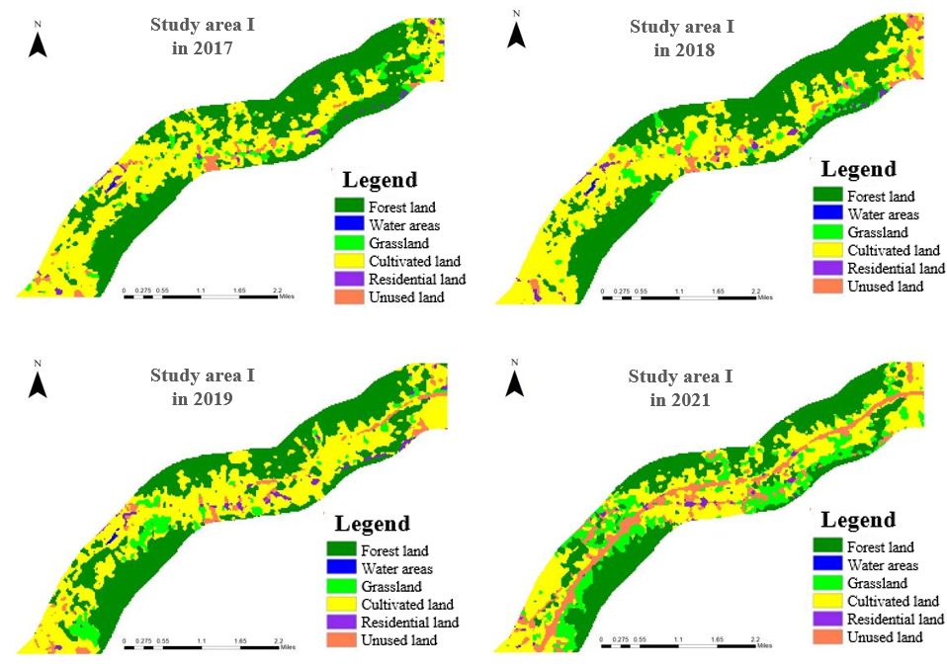
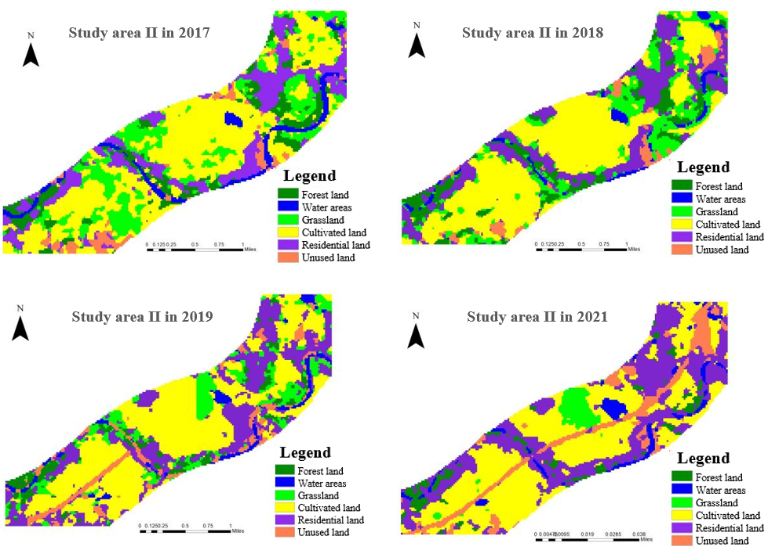
Fig. 5. Land use type map.
Similarly, Figure 5 shows how the two study areas changed in land use over time. It can be seen that during 2017-2018, the distribution of grassland in Study area I shifted from the right area to the left; while the distribution locations of other land types did not change, but only increased or decreased on the basis of the original locations. During 2019-2021, in Study area I, the forest land near the construction road was degraded to grassland, and the most serious degradation was in the center left. The construction road developed from a small section to a major part of the road. During 2017-2018, there were also large changes in land use in the Study area II. In the left area, a large area of grassland and unused land was reclaimed for cultivated land, and the central area along the river was more densely inhabited, while the right area remained basically unchanged. During 2019-2021, in the Study area II, the construction road changed from a small section to an obvious one. Scattered grasslands along the route were transferred to other types, and large grasslands in the middle were shifted to the left.

3.1.3 Characteristics of center of gravity shift of land use types
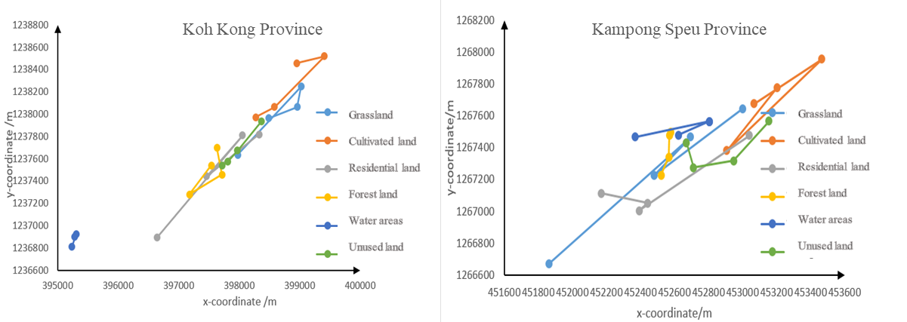
The center of gravity of different land use types is actually the geographiocal center of the area. The distribution of Study area I and 2 is shown in Figure 6. According to the data, in Study area I, the center of gravity of most land use types shifted to the southwest, which is consistent with the direction of expressway construction. It mainly includes cultivated land, grassland, residential land, and unused land. Among them, the land use type with the smallest deviation distance in this direction is grassland, which is 607 meters. The largest deviation distance is the residential area, which is 1926 meters. In view of the unused land and cultivated land between them, the deviation is 765 meters and 849 meters, respectively. For a small number of land use types, the center of gravity shifted in the opposite direction, including forest land and water areas. It was offset to the northeast by 181 meters and 101 meters, respectively.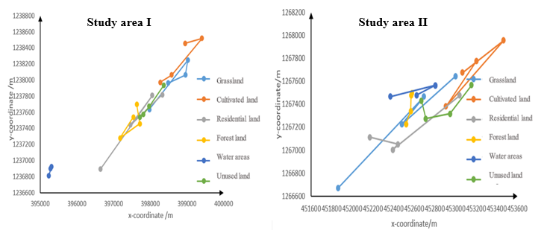
Study area I
Study area II
Fig. 6. Distribution map of center of gravity of land use types
For Study area II, the center of gravity of most land use types shifted to the northeast, which was consistent with the direction of expressway construction. It mainly includes cultivated land, water areas, unused land and residential land. Among them, the land use type with the smallest deviation distance in this direction is cultivated land, which is 107 meters. The largest deviation distance is 943 meters in the residential area. In view of the water areas and unused land between them, the deviation is 253 and 503 meters respectively. For a small number of land use types, the center of gravity shifted in the opposite direction, including woodland and grassland. It was offset to the southwest by 287 meters and 1508 meters, respectively.
Through the above analysis, the deviation distance of the center of gravity of each land use type was determined. In order to more intuitively reflect the spatio-temporal dynamic changes of land use types in the two study areas, the center of gravity migration rate for each land use type in the two study areas can be calculated and is shown in Table 6. It can be concluded from this data that the center of gravity migration rate for grassland and residential land in the Study area I was slower during 2017-2018 than it was during 2019-2021. In Study area II, apart from water areas, the center of gravity migration rate was similarly lower during 2017-2018 than it was during 2019-2021.

Table 6. The center of gravity migration rate of land use type in the study area（m·y⁻¹）.
 | Grassland | Cultivated land | Residential land | Forest land | Water areas | Unused land
2017-2018  Study area I | 122 | 114 | 236 | 112 | 32 | 24
2019-2021  Study area II | 303 | 81 | 421 | 63 | 0 | 121
2017-2018  Study area I | 167 | 121 | 70 | 6 | 112 | 40
2019-2021  Study area II | 287 | 124 | 200 | 29 | 50 | 81
In general, analysis in this research identified that there was significant variance in both degree and direction for the interannual center of gravity shift for each land type in the two study areas. This suggests that impacted by environmental factors and other comparable circumstances, the geographical location of each land use type showed an unbalanced expansion trend toward the surrounding areas, and the overall planar spatial center of gravity shift was large. In Study area I, the center of gravity of each land type mainly shifted towards the northeast. While in Study area II, the center of gravity mainly shifted towards the southwest. The center of gravity of each land type in the two study areas mainly moved along the direction of expressway construction. Although it was found that in the two study areas, the center of gravity of the forest land was in the opposite direction to the route. According to the findings of the land use center of gravity migration rate analysis, expressway construction had a substantial impact on the center of gravity migration rate for residential and grassland areas. Also, it was identified that in Study area I, the center of gravity migration rate had been substantially more affected than for Study area II.

4.2 Variation characteristics of ecological resilience along the expressway
Since ecological resilience is composed of ecological resistance and ecological resilience, the changes of the two indexes are analyzed in this research. Figure 7 depicts the changes in ecological resistance and ecological restoration over four years in the two study areas. In Study area I, ecological resistance specifically declined by 53.361 million Riels and ecological restoration declined by 23.832 hectares during 2017-2018. In contrast, in Study area II, ecological resistance declined by 67.558 million Riels and ecological restoration declined by 22.149 hectares during 2017-2018. In Study area I, ecological resistance specifically declined by 239.238 million Riels and ecological restoration declined by 98.919 hectares during 2019-2021. In contrast, in Study area II, ecological resistance declined by 19.474 million Riels and ecological restoration declined by 4.986 hectares during 2019-2021. It is clear that ecological resistance and ecological restoration were declining in the two study areas. In Study area I, there was a greater change in ecological resistance and ecological restoration levels during 2019-2021 than during 2017-2018, whereas the changes in the l.evels of ecological resistance and ecological restoration during 2017-2018 were higher than those during 2019-2021 in Study area II.
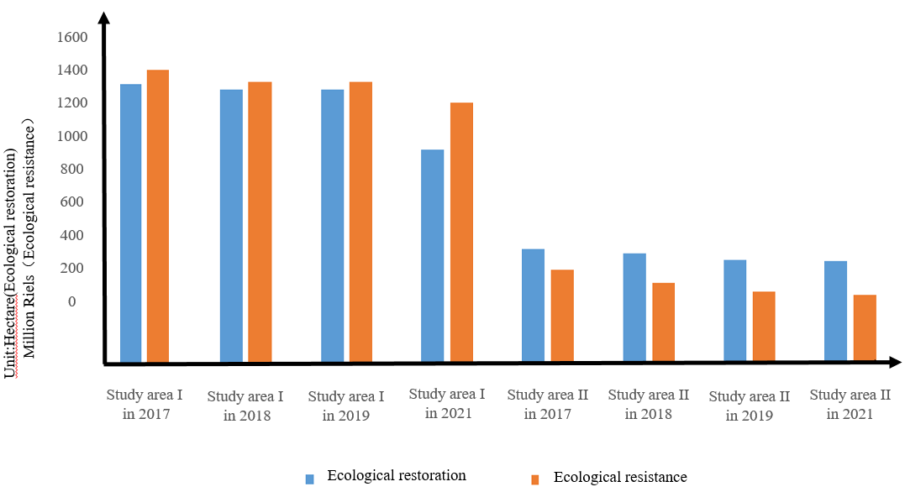
Fig. 7. Change of ecological resistance and ecological restoration
Table 7 shows the changes of ecological resilience over four years calculated from ecological resistance and ecological restoration in the two study areas through the process of entropy method weighting and classification. In Study area I, ecological resilience was at a high level in 2017, reasonably high in 2018 and 2019, and at a medium level in 2021. In Study area II, ecological resilience was generally low in 2018, low in 2019, and low in both 2019 and 2021. Overall, it can be observed that there was significant variance in ecological resilience of both Study areas. In Study area I, the ecological resilience decreased most significantly during 2019-2021. In Study area II, the ecological resilience decreased most significantly during 2017-2018.
Table. 7. Change of ecological resilience.
Year | Ecological resilience level of Study area I | Ecological resilience level of Study area II
2017 | High resilience | Comparatively high resilience
2018 | Comparatively high resilience | Comparatively low resilience
2019 | Comparatively high resilience | Low resilience
2021 | Medium resilience | Low resilience
- Discussion
Expressway construction has an inevitable impact on ecological environment. As an important representation of the interaction between human and nature, land use change is an important topic for sustainable development (Lambin et al. 2003). In 2017-2018, various land use types had changed to a certain extent, and the residential land was increasing. This shows that the ecological environment was not static, even if no expressway was built, it would have certain changes, but the overall level was relatively stable. According to the data of the statistical yearbook, due to the rapid economic development of Cambodia, economic activities have increased throughout the country, which has led to the above non-construction factors, namely human factors, on the ecological environment along the route (Zalles et al. 2021). In 2019-2021, a greater degree of land transfer occurred in all land use types. Under the disturbance of construction activities, the transformation mode of land use type changed, and the disturbance degree was different under different environments, which had significant regional spatio-temporal variation characteristics. The impact degree of the area with higher urbanization degree was lower than that of the area with higher vegetation coverage degree, which is consistent with previous studies (Wheeler et al. 2005). During the expressway construction period, due to the initial land expropriation and demolition and excavation, the forest, cultivated land and residential land near the expressway area are reduced, while the grassland is greatly increased. According to the theory of succession, the transfer of forest land to grassland is a reverse succession process of ecosystem, which indicates that the forest ecosystem is destroyed by construction and then degraded to grassland. Further, the, transfer of forest land to land shows the level of human disturbance to the natural ecological system. The construction of Penh-Sihanoukville Expressway passes through this part, destroying the surface vegetation, which is also the main reason for the reduction of forestland and grassland and the increase of unused land. This is consistent with prevoous research (Zhu et al. 2006). However, this study also finds that the shift in direction of land use type caused by expressway construction is consistent with the construction direction, but the forest land moved in the opposite direction. Compared with Xu 's previous conclusion that construction caused the arable land to move in the opposite direction of construction (Xu et al. 2014), this has a significant contribution. This may be caused by the spatial heterogeneity of the two.
Through the analysis of the variation characteristics of ecological resilience, it can be clearly be observed that from 2017 to 2021, the ecological resilience of the two typical areas along the Penh-Sihanoukville Expressway showed a downward trend; due to the different ecological environment of the two research areas, the impact of construction on the Expressway is quite different. In areas with strong natural properties, the change of ecological resilience is concentrated after the construction. Due to the high vegetation coverage and sparse population, the area has strong resilience before construction, strong adaptability and adjustment ability to uncertain damage, and is not prominent in ecological environmental problems. The area has a certain anti-damage ability in the face of internal and external environmental changes. The construction increased the external pressure of the area to a large extent, thereby making it resistance to external damage weakened, the ecological resilience significantly reduced, and the construction effect was obvious (Lin et al. 2022). However, the change of resilience in the area with strong man-made attributes is concentrated before construction, and the characteristics of higher urbanization and intensive human activities make the resilience level of this area significantly lower than that of the former. Before the construction, the large expansion of residential land seriously damaged the ecology, thereby resulting in a low level of ecological resilience. However, the existence of construction factors makes the already fragile research area even more fragile, which further reduces the ecological resilience on this basis. This results in the ecological resilience remaining at a low resilience level, thereby resulting in its weak adaptability and adjustment ability. Further, the ecological environment is extremely vulnerable to destruction and the ecological environment problems are more serious (Froese et al. 2022).
In addition, since ecological resilience is characterized by ecological resistance and ecological restoration, both of which are calculated based on land use type data, their changes are closely related to the results of land type area changes. Therefore, based on land data, this study established an index system by measuring ecological resistance and ecological restoration indicators to evaluate the change characteristics of ecological resilience. Through the comparative analysis of the two study areas before and after the construction of the expressway, the impact and assessment of the expressway construction on the ecological environment are explored. Some researchers also used comparative analysis to analyze land use change, mostly focusing on urban types (Wu et al. 2022), policy backgrounds (Jiang et al. 2023), development scenarios (Shi et al. 2023)and other contexts. In this study, comparative data is used to ascertain the regional difference characteristics along the expressway. This approach expands the application scope of this method and shields the impact of unnecessary factors on the environment, which has a strong reference for related research.
In view of the above analysis, expressway construction has an impact on the ecological environment and this empirical study generates the following key findings: (1) Socio-economic factors are the main reasons for land use change along the expressway, population growth is the root of land use change, and economic structure changes and policy implementation are the driving forces of land use change. (2) In the planning and construction of expressways, the impact on the surrounding environment should be fully taken into account, and environmental protection measures should be strengthened according to local conditions to reduce the damage to the ecological environment. (3) Effective land use policies should be formulated to guide the rational transfer of land use types, so as to ensure the sustainable use of land resources and the stable development of ecological environment.
- Conclusions
Expressway construction plays an important role as a bridge in regional economic and cultural exchanges, but its impact on the ecological environment is often more harmful than beneficial. Therefore, monitoring and evaluating the ecological environment along the expressway construction is a necessary part of environmental protection planning. The Cambodian government is actively encouraging expressway construction. This study analyzes the impact of expressway construction on the natural environment from the perspective of ecological resilience, and explores its actual impact mechanism, so as to establish the necessity of environmental protection law in Cambodia's road transport strategy. Through comparative study, it is found that:
(1). In this study, an evaluation model of ecological resilience based on land use change is established according to ecological resistance and ecological restoration.
(1). The study proposes variation characteristics of land use type. Ecological resilience is evaluated in order to provide a theoretical framework for evaluating the impact of the expressway on the ecological environment.
(2). The area of each land use type changed before and after construction. Construction results in a large number of land types with high nature attributes, such as forest land and grassland being transformed into unused land types with high human attributes.
(3). Before and after construction, the inter-annual migration of the center of gravity of most land use types was large, and the migration direction was mainly toward the expressway construction, while the forest land was away from the expressway construction. Expressway construction has an effect on the transfer rate of the center of gravity of land use type.
(4). Both ecological resistance and ecological resilience showed a downward trend before and after construction, so the ecological resilience also showed a downward trend. Construction did not change the characteristics of the study areas (the relationship between resistance and resilience).
(5). Under the background of similar construction, ecological resilience was affected differently in different geographical environments. The impact of construction on the ecological resilience of the western area with higher vegetation coverage is higher than that of the eastern area with higher urbanization. The decrease of ecological resilience caused by expressway construction can be attributed to the change of land use type.

There are certain limitations to this study. In terms of research objects, this research mainly focuses on the ecological resilience along the expressway consruction, without considering the impact of other environmental factors, such as climate change and policy management, on the ecological resilience. Further, there may also be limitations in the source of data. The data used in this study is mainly based on remote sensing image data of engineering construction, and the selected research period is limited considering the image clarity. Therefore, further studies are recommended to address these points through capturing additional data, for example, through use of a suitable survey instrument. Future work on this topic may broaden the focus of research along expressways to explore the geographical and temporal variation of ecological resilience in the areas with more ecological species. In the long-term, further research should also focus on enhancing the ecosystem's total resilience and consequently there is a need to encourage research on the impact of expressways and other forms of transportation infrastructure on ecological resilience and wider sustainable development.

Funding
This research is supported by Sichuan Tibet Railway Major Fundamental Science Problems Special Fund (No.71942006); Scientific Research Project of China Road and Bridge Engineering Co., Ltd（No.2020-zlkj-04）; The National Social Science Fund projects (No.20BJY010); List of Key Science and Technology Projects in China’s Transportation Industry in 2018-International Science and Technology Cooperation Project (No.2018-GH 006 and No.2019-MS5-100); Open Fund of China Academy of Railway Sciences Group Corporation (2021YJ049); Fundamental Research for Funds for the Central Universities (Humanities and Social Sciences) (No.300102282601).

Author contributions
Jingxiao Zhang contributed to the conception of the study; Feiye Zhao contributed significantly to the analysis and manuscript preparation; Xin Gao wrote the manuscript together with Feiye Zhao and Simon P. Philbin; Yan Li and Xu Yang performed the experiment analysis; and Jingxiao Zhang and Simon P. Philbin helped perform the analysis with constructive discussions.

Availability of data and materials
Data and materials can be accessed by contacting the corresponding author.

Declarations
Ethics approval and consent to participate
Not applicable
Consent for publication
Not applicable
Competing Interests
The authors declare that they have no competing interests.

References
Alberti M, Marzluff JM (2004): Ecological resilience in urban ecosystems: Linking urban patterns to human and ecological functions. Urban ecosystems 7, 241-265
Alshetty D, Nagendra S (2022): Impact of vehicular movement on road dust resuspension and spatiotemporal distribution of particulate matter during construction activities. Atmospheric Pollution Research 13, 101256
Berkes F (2007): Understanding uncertainty and reducing vulnerability: lessons from resilience thinking. Natural Hazards 41, 283-295
Costanza R, d'Arge R, De Groot R, Farber S, Grasso M, Hannon B, Limburg K, Naeem S, O'neill RV, Paruelo J (1997): The value of the world's ecosystem services and natural capital. nature 387, 253-260
Cui M, Guo QJ, Wei YJ, Yu XN, Hu J, Tian LY, Kong J (2023): Variations and its driven factors of anthropogenic nitrogen loads in the Yangtze River Economic Belt during 2000-2019. Environmental Science and Pollution Research 30, 2450-2468
Dakos V, Kéfi S (2022): Ecological resilience: what to measure and how. Environmental Research Letters 17, 043003
Desjardins E, Barker G, Lindo Z, Dieleman C, Dussault AC (2015): PROMOTING RESILIENCE. Quarterly Review of Biology 90, 147-165
Durlevic U, Novkovic I, Carevic I, Valjarevic D, Marjanovic A, Batocanin N, Krstic F, Stojanovic L, Valjarevic A (2023): Sanitary landfill site selection using GIS-based on a fuzzy multi-criteria evaluation technique: a case study of the City of Kraljevo, Serbia. Environmental Science and Pollution Research 30, 37961-37980
Fikret B (2017): Environmental Governance for the Anthropocene? Social-Ecological Systems, Resilience, and Collaborative Learning. Sustainability 9, 1232
Folke C (2006): Resilience: The emergence of a perspective for social-ecological systems analyses. Global Environmental Change-Human and Policy Dimensions 16, 253-267
Franco-Gaviria F, Amador-Jiménez M, Millner N, Durden C, Urrego DH (2022): Quantifying resilience of socio-ecological systems through dynamic Bayesian networks. Frontiers in Forests and Global Change 5, 889274
Froese R, Pinzón C, Aceitón L, Argentim T, Arteaga M, Navas-Guzmán JS, Pismel G, Scherer SF, Reutter J, Schilling J, Schönenberg R (2022): Conflicts over Land as a Risk for Social-Ecological Resilience: A Transnational Comparative Analysis in the Southwestern Amazon. Sustainability 14, 6520
Holling CS (1973): Holling CS. Resilience and stability of ecological systems. Ann Rev Ecol Syst 4: 1-23. Annual Review of Ecology and Systematics 4, 1-23
Huang RY, Yeh CH (2008): Development of an assessment framework for green highway construction. Journal of the Chinese Institute of Engineers 31, 573-585
Hussain J, Zhou K (2022): Globalization, industrialization, and urbanization in Belt and Road Initiative countries: implications for environmental sustainability and energy demand. Environmental Science and Pollution Research 29, 80549-80567
Jia XL, Wang D, Liu FB, Dai QM (2020): EVALUATION OF HIGHWAY CONSTRUCTION IMPACT ON ECOLOGICAL ENVIRONMENT OF QINGHAI-TIBET PLATEAU. Environmental Engineering and Management Journal 19, 1157-1166
Jiang L, Zhou HF, He SX, Cui YZ, Wang JH (2021): Identifying the driving factors of NO<sub>2</sub> pollution of One Belt One Road countries: satellite observation technique and dynamic spatial panel data analysis. Environmental Science and Pollution Research 28, 20393-20407
Jiang L, Wang Z, Zuo Q, Du H (2023): Simulating the impact of land use change on ecosystem services in agricultural production areas with multiple scenarios considering ecosystem service richness. Journal of Cleaner Production 397, 136485
Jozaei J, Chuang W-C, Allen CR, Garmestani A (2022): Social vulnerability, social-ecological resilience and coastal governance. Global Sustainability 5, e12
Jullien A, François D (2006): Soil indicators used in road environmental impact assessments. Resources, Conservation and Recycling 48, 101-124
Kasraian D, Maat K, Stead D, Wee BV (2016): Long-term impacts of transport infrastructure networks on land-use change: an international review of empirical studies. Transport Reviews 36, 1-21
Lambin EF, Geist HJ, Lepers E (2003): Dynamics of land-use and land-cover change in tropical regions. Annual review of environment and resources 28, 205-241
Larson CD, Rew LJ (2022): Restoration intensity shapes floristic recovery after forest road decommissioning. Journal of Environmental Management 319, 115729
Li D, Yang WP, Huang RY (2023): The multidimensional differences and driving forces of ecological environment resilience in China. Environmental Impact Assessment Review 98, 106954
Li GZ, Wang LQ (2023): Study of regional variations and convergence in ecological resilience of Chinese cities. Ecological Indicators 154, 110667
Liang J, Liu Y, Ying LX, Li P, Xu Y, Shen ZH (2014): Road impacts on spatial patterns of land use and landscape fragmentation in three parallel rivers region, Yunnan Province, China. Chinese Geographical Science 24, 15-27
Lin Y, Peng C, Chen P, Zhang M (2022): Conflict or synergy? Analysis of economic-social-infrastructure-ecological resilience and their coupling coordination in the Yangtze River economic Belt, China. Ecological Indicators 142, 109194
Liu ZM, Wang LY, Sheng ZH, Gao XL (2018): Social responsibility in infrastructure mega-projects: A case study of ecological compensation for <i>Sousa chinensis</i> during the construction of the Hong Kong-Zhuhai-Macao Bridge. Frontiers of Engineering Management 5, 98-108
Lyu RF, Zhao WP, Pang JL, Tian XL, Zhang JM, Wang NA (2022): Towards a sustainable nature reserve management: Using Bayesian network to quantify the threat of disturbance to ecosystem services. Ecosystem Services 58, 101483
Ma Y, Jiang CB, Li SS, Liu YZ, Wen XF, Long YN, Yuan S, Kang YT, Wang YJ, Wu RX (2023): Ecological vulnerability assessment of coral islands and reefs in the South China Sea based on remote sensing and reanalysis data. Frontiers in Ecology and Evolution 11, 1066961
Meng FL, Wang WP (2020): Analysis of Eco-Efficiency in China's Key Provinces along the "Belt and Road" Based on Grey TOPSIS-DEA. Journal of Grey System 32, 60-79
Nedbal V, Brom J (2018): Impact of highway construction on land surface energy balance and local climate derived from LANDSAT satellite data. Science of the Total Environment 633, 658-667
Nettier B, Dobremez L, Lavorel S, Brunschwig G (2017): Resilience as a framework for analyzing the adaptation of mountain summer pasture systems to climate change. Ecology and Society 22, 25
Nikinmaa L, Lindner M, Cantarello E, Jump AS, Seidl R, Winkel G, Muys B (2020): Reviewing the Use of Resilience Concepts in Forest Sciences. Current Forestry Reports 6, 61-80
Peng J, Liu Y, Wu J, Lv H, Hu X (2015): Linking ecosystem services and landscape patterns to assess urban ecosystem health: A case study in Shenzhen City, China. Landscape and Urban Planning 143, 56-68
Saha A, Villuri VGK, Bhardwaj A, Kumar S (2023): A Multi-Criteria Decision Analysis (MCDA) Approach for Landslide Susceptibility Mapping of a Part of Darjeeling District in North-East Himalaya, India. Applied Sciences-Basel 13, 5062
Shi CC, Zhu XP, Wu HW, Li ZH (2022): Assessment of Urban Ecological Resilience and Its Influencing Factors: A Case Study of the Beijing-Tianjin-Hebei Urban Agglomeration of China. Land 11, 921
Shi JS, Hu B, Sun HC, Wang QT (2013): Research on Ecological Integration of Mountain Highway Domain Ecosystems, 2nd International Conference on Energy and Environmental Protection (ICEEP 2013). Advanced Materials Research, Guilin, PEOPLES R CHINA, pp. 4109-+
Shi Y, Zhou L, Guo X, Li J (2023): The Multidimensional Measurement Method of Urban Sprawl and Its Empirical Analysis in Shanghai Metropolitan Area. Sustainability 15, 1020
Stroink ML (2020): The Dynamics of Psycho-Social-Ecological Resilience in the Urban Environment: A Complex Adaptive Systems Theory Perspective. Frontiers in Sustainable Cities 2, 31
Teo HC, Lechner AM, Walton GW, Chan FKS, Cheshmehzangi A, Tan-Mullins M, Chan HK, Sternberg T, Campos-Arceiz A (2019): Environmental Impacts of Infrastructure Development under the Belt and Road Initiative. Environments 6, 72
Tracy EF, Shvarts E, Simonov E, Babenko M (2017): China's new Eurasian ambitions: the environmental risks of the Silk Road Economic Belt. Eurasian Geography & Economics 58, 56-88
Trenberth KE (2018): Climate change caused by human activities is happening and it already has major consequences. Journal of Energy & Natural Resources Law 36, 463-481
Wang SJ, Cui ZT, Lin JJ, Xie JY, Su K (2022): The coupling relationship between urbanization and ecological resilience in the Pearl River Delta. Journal of Geographical Sciences 32, 44-64
Wang YB (2023): Ecological risk identification and assessment of land remediation project based on GIS technology. Environmental Science and Pollution Research 30, 70493-70505
Wheeler AP, Angermeier PL, Rosenberger AE (2005): Impacts of new highways and subsequent landscape urbanization on stream habitat and biota. Reviews in fisheries science 13, 141-164
Wu R, Li Y, Wang S (2022): Will the construction of high-speed rail accelerate urban land expansion? Evidences from Chinese cities. Land Use Policy 114, 105920
Xia C, Dong Z, Chen B (2022): Spatio-temporal analysis and simulation of urban ecological resilience: A Case study of Hangzhou. Acta Ecol. Sin 42, 116-126
Xie G, Zhang C-X, Zhang L-M, Chen W, Li S (2015a): Improvement of the evaluation method for ecosystem service value based on per unit area. J. Nat. Resour 30, 1243
Xie G, Zhang C, Zhang C, Xiao Y, Lu C (2015b): The value of ecosystem services in China. Resour. Sci 37, 1740-1746
Xie XL, Zhou GA, Yu SB (2023): Study on Rural Ecological Resilience Measurement and Optimization Strategy Based on PSR-"Taking Weiyuan in Gansu Province as an Example". Sustainability 15, 5462
Xu BN, Li JJ, Luo ZY, Wu JH, Liu YG, Yang HL, Pei XJ (2022): Analyzing the Spatiotemporal Vegetation Dynamics and Their Responses to Climate Change along the Ya'an-Linzhi Section of the Sichuan-Tibet Railway. Remote Sensing 14, 3584
Xu L, Wang H, Zhang J, Yue W (2014): Spatial-temporal dynamics of land use in the hangzhou city during the recent 15 years. Econ. Geogr 34, 135-142
Xu L, Marinova D, Guo XM (2015): Resilience thinking: a renewed system approach for sustainability science. Sustainability Science 10, 123-138
Yan YB, Chai ZY, Simayi Z, Yan HB, Yang XD, Yang ST (2023): Dynamic evaluation and prediction of the ecological environment quality of the urban agglomeration on the northern slope of Tianshan Mountains. Environmental Science and Pollution Research 30, 25817-25835
Yang Z, Liu X (2021): Research on ecosystem service value and spatial evolution in Urumqi City. Environ. Sci. Technol 44, 226-236
Yin NN, Wang KL, Yao Z, Ding LL, Miao Z (2022): Total-factor air environmental efficiency and its influencing factors in the areas along the Belt and Road in China: A spatial spillover perspective. Energy & Environment 33, 663-695
Zalles V, Hansen MC, Potapov PV, Parker D, Stehman SV, Pickens AH, Parente LL, Ferreira LG, Song X-P, Hernandez-Serna A (2021): Rapid expansion of human impact on natural land in South America since 1985. Science advances 7, eabg1620
Zhang D, Yang SK, Wang ZZ, Yang CY, Chen YY (2020): Assessment of ecological environment impact in highway construction activities with improved group AHP-FCE approach in China. Environmental Monitoring and Assessment 192, 451
Zhang FH, Ji GB, Zhang XL, Gao WH, Zhang N, Zhou CX, Liu GH (2022): Research and application of GIS and data mining technology in monitoring and assessment of natural geography environment. Soft Computing 26, 7781-7787
Zhang J, Li Q, Wu X, Zhang C, Wang J, Wu G (2021): Evolution of the ecosystem services value and carrying capacity in the Guangdong-Hong Kong-Macao Greater Bay Area based on land use changes. Acta Ecol. Sin 41, 8375-8386
Zhang JX, Hu RZ, Cheng XL, Christos V, Philbin SP, Zhao R, Zhao XW (2023a): Assessing the landscape ecological risk of road construction: The case of the Phnom Penh-Sihanoukville Expressway in Cambodia. Ecological Indicators 154, 110582
Zhang SB, Lei J, Tong YJ, Zhang XL, Lu DN, Fan LQ, Duan ZL (2023b): Temporal and spatial responses of ecological resilience to climate change and human activities in the economic belt on the northern slope of the Tianshan Mountains, China. Journal of Arid Land 15, 1245-1268
Zhang ZF, He WJ, An M, Degefu DM, Yuan L, Shen JQ, Liao ZY, Wu X (2019): Water Security Assessment of China's One Belt and One Road Region. Water 11, 607
Zhao RD, Fang CL, Liu HM, Liu XX (2021): Evaluating urban ecosystem resilience using the DPSIR framework and the ENA model: A case study of 35 cities in China. Sustainable Cities and Society 72, 102997
Zhou Y, Chen Y, Li ZL, Jiang WL (2022): Ecological Resilience Assessment of an Emerging Urban Agglomeration: A Case Study of Chengdu-Chongqing Economic Circle, China. Polish Journal of Environmental Studies 31, 2381-2395
Zhu J, Cui B, Yao H, Dong S (2006): Landuse changes and expansion effects caused by road construction in longitudinal range-gorge region. Journal of Natural Resources 21, 507-514

