Chapter 1. Introduction
Key points:
- The traces left by contact between the hands and other surfaces are an essential tool in forensic investigations
- Such traces can be used in several ways; to provide contextual information about the contact event and for identification of individuals
- All potential forensic applications of such contact traces rely on them being visualised by some means

There are several books that deal with how latent fingermarks, and to some level the visualisation thereof, are used for identification purposes. To a great extent, the comparison and identification of latent fingermarks in criminal investigations remains their principal application.
In this book we will describe the chemistry (and other properties) of fingermarks in more depth and describe how fingermarks can be used for more than just identification purposes. We will describe how fingermarks may be deposited, the chemical and biological composition of the fingermark and its physical properties, the chemical and physical techniques used to visualise latent fingermarks and the importance of combining fingermark visualisation with recovery of other forensic evidence. Consideration is also given to the importance of communication between individuals visualising fingermarks and those responsible for their comparison and identification.
The traces that may be left by the contact between the palmar regions of hands and a surface are potentially the most informative forms of evidence available to the forensic scientist. The skin on the inside of the hands can flex and adapt to perform a wide range of manipulative tasks, and there are few actions (legal or illegal) that can be carried out without holding objects and/or touching surfaces. The nature of each of these contacts will be different, but in all cases Locard’s exchange principle (Locard, 1934) applies and there is the potential for the transfer of material between the hand and the surface.
In the context of crime investigation, there are many levels of information that can potentially be extracted from these areas of contact if it is possible for a forensic scientist to first locate and then enhance and analyse them.
At the coarsest level, the configuration of the palm and fingers during the contact with the surface and their position on it can provide useful contextual information about how the surface was touched or gripped. This can be particularly useful in corroborating or disproving particular accounts of events. Figure 1.1 illustrates a situation where the one individual claimed that an assailant had grasped his shirt, whilst the other individual claimed that he had merely pushed the wearer of the shirt away.
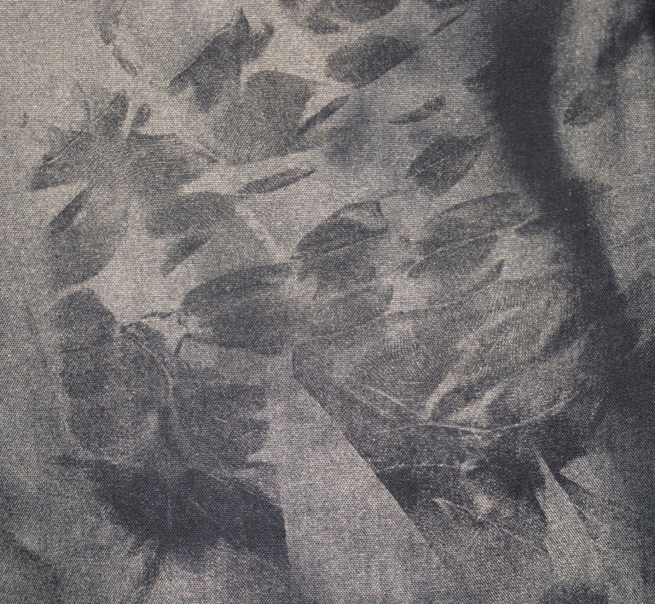
Figure 1.1. A contact (grab) mark on a black cotton shirt developed using vacuum metal deposition. Reproduced courtesy of the Home Office.
The mark that has been revealed suggests that the fabric of the shirt has been gathered together by the hand, and therefore the account of the shirt being grasped by an assailant is more likely than a push with an open hand. Figure 1.2 shows two different orientations of fingermarks on a glass bottle.
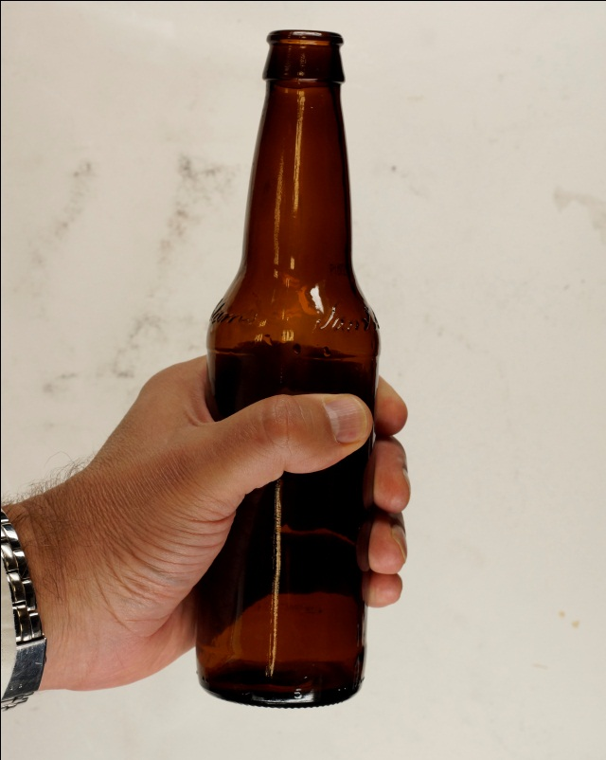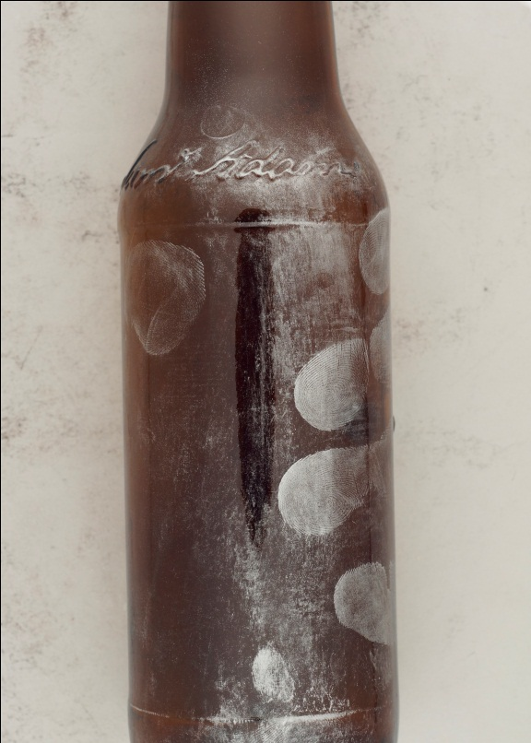
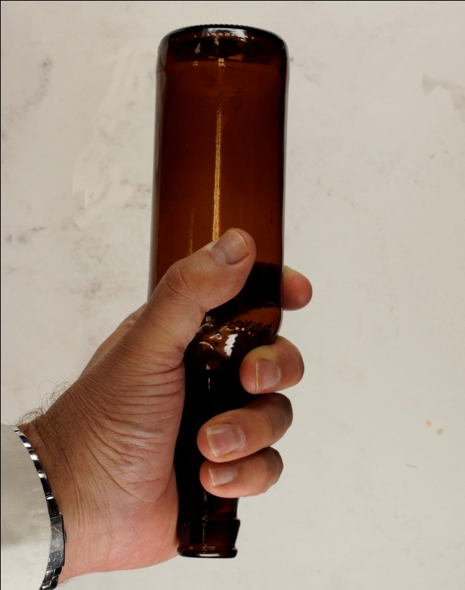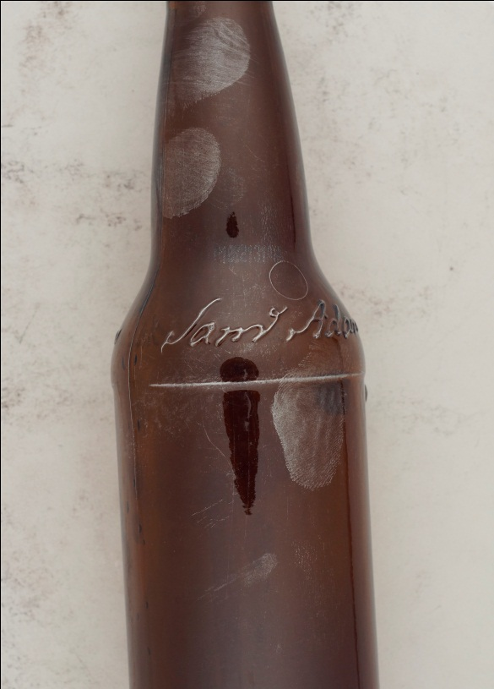
Figure 1.2. The orientation of fingermarks on a glass bottle originating from different actions, a) bottle being held to drink from, b) fingermarks developed using aluminium powder after drinking, c) bottle being held as if to strike, d) fingermarks developed using aluminium powder after use as a weapon
In the first case, the bottle has been held whilst drinking from the neck of the bottle. In the second case, the bottle has been gripped as if the bottle has been picked up for use as a weapon. Again, by examination of the configuration of the marks, it may be possible to infer how an item was handled and this may become evidentially important.
Obviously, there are many more possible scenarios than the two examples presented here and it should be noted that these are merely illustrative examples. In real casework the propositions (hypotheses) and subsequent examinations are likely to be more complex.
Revealing the distribution of a contaminant (an exogenous material) on the hand may also provide useful information that can be indicative of certain actions. In a further example, the firing of a gun will result in the transfer of gunshot residue onto the hands, Figure 1.3. Although the hands can be swabbed to reveal the presence of gunshot residue, if its distribution across the hand can be shown this may be far more useful in showing that it was much more likely that the gun was held and fired rather than the residue coming from accidental contact. This distribution of contaminant may also be subsequently reproduced in any marks left by the hand.
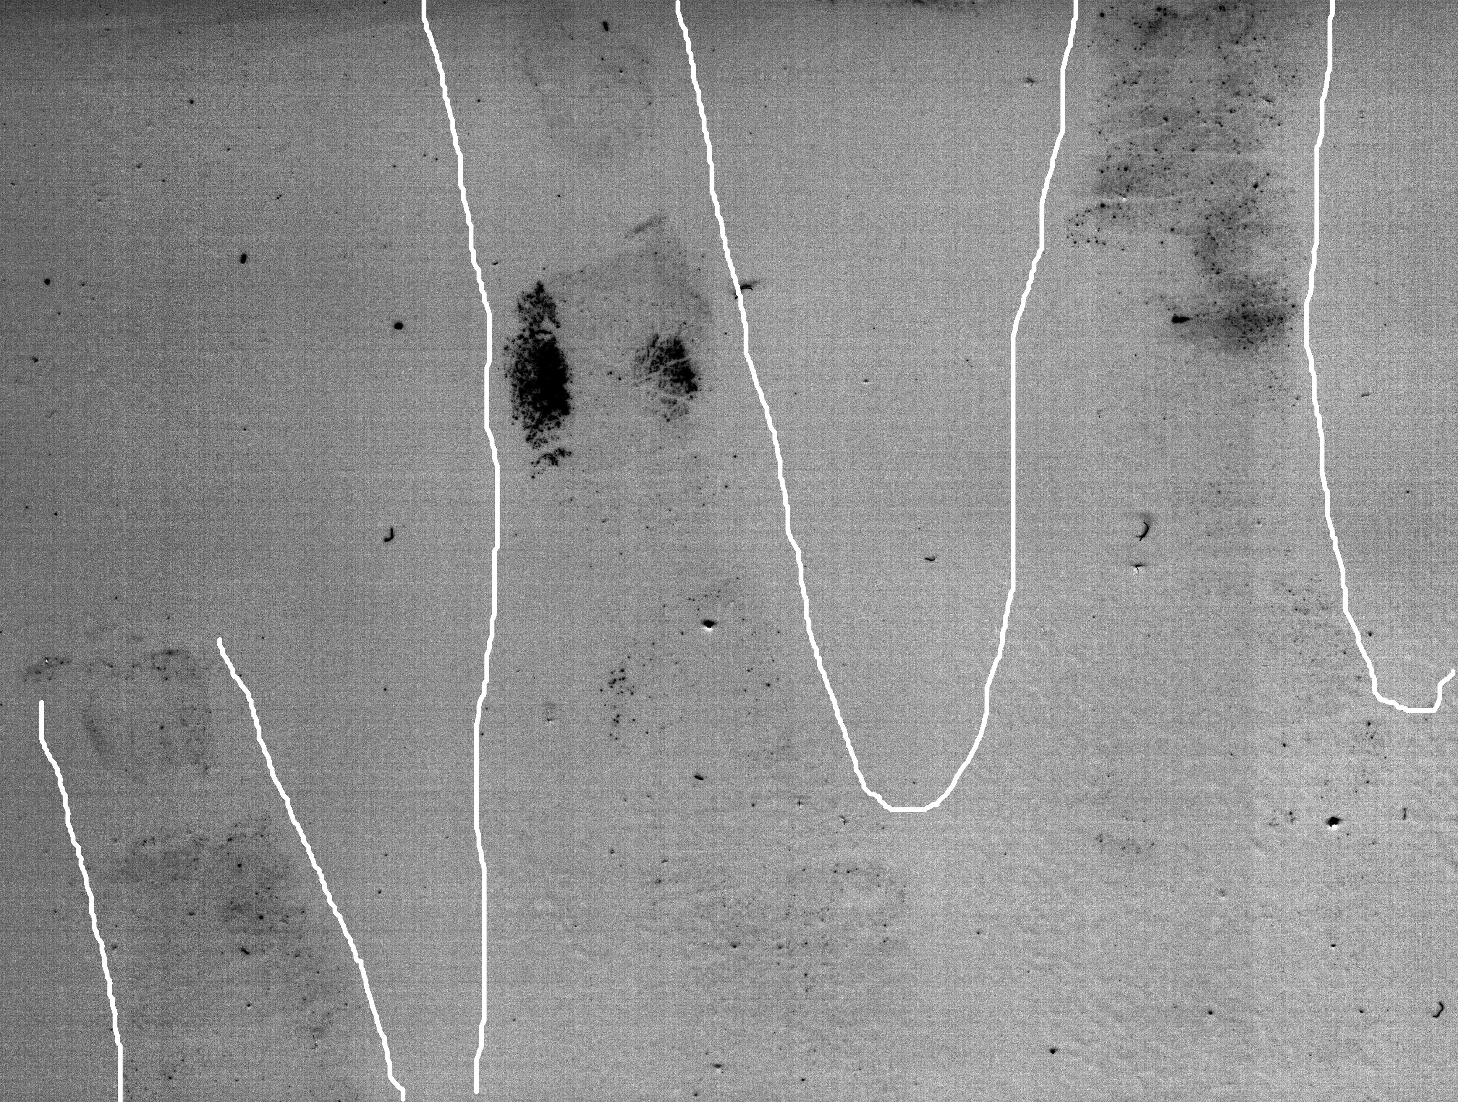
Figure 1.3. A white gelatin lift taken from the back of the hand taken after firing a gun and enhanced using a chemical selectively targeting traces of lead. Reproduced courtesy of the Home Office.
At a slightly finer level, a closer analysis of the areas of palm and finger contact can also reveal information about the events during the time of contact. Although many of these events may consist of single, light contacts, others may be of longer duration, and may include movement of the hand or multiple contacts, for example as a grip on an object is readjusted. By analysis of the traces left by the contacts, it is possible to obtain information about factors including the pressure applied during contact, slippage of the hand across the surface and whether multiple contacts have occurred, Figures 1.4 and 1.5. All of this information can add context to the case being investigated.
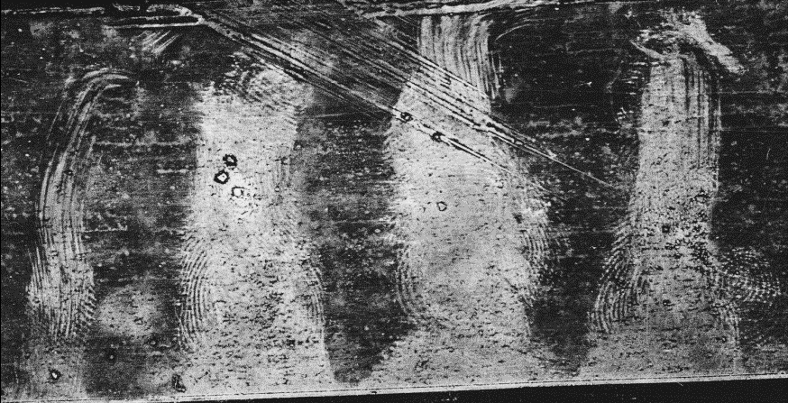
Figure 1.4. A sequence of fingermarks developed using aluminium powder showing evidence of slippage on the surface. Reproduced courtesy of the Home Office.
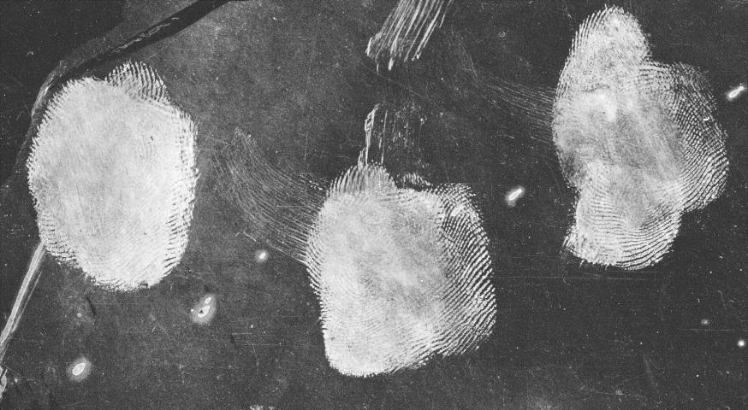
Figure 1.5. A sequence of fingermarks developed using aluminium powder showing evidence of multiple contacts on the surface. Reproduced courtesy of the Home Office.
At a finer level of analysis is the examination of the ridge detail that may be reproduced within the fingers and palmar regions of the contact area. These are the features that have traditionally been the primary source of information for identification of individuals. The information available has been described in terms of ‘levels’ of detail (SWGFAST, 2013), although in practice all of these levels are utilised by identification specialists whilst drawing conclusions about the identity of the donor of a mark.
‘Level 1 detail’ describes the pattern formed by the flow of the ridges, and three general patterns are generally used to define marks, these being the arch, loop and arch, Figure 1.6. Further detailed definitions of the general patterns and variations of them have been previously described in specialist texts on fingerprint comparison and identification, this information is however beyond the scope of this book.
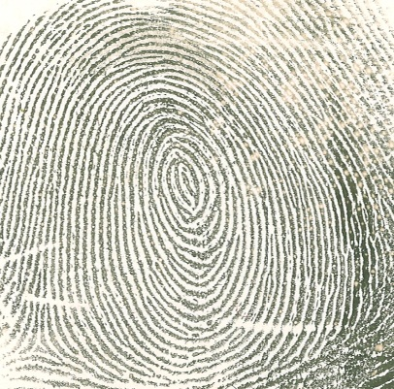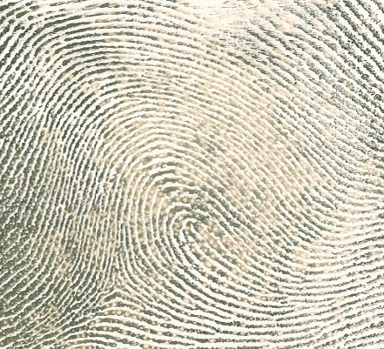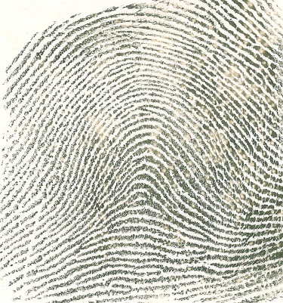
Figure 1.6. Examples of the principal types of fingerprint pattern, a) the whorl, b) the loop, and c) the arch
‘Level 2 detail’ describes the features that arise due to disruptions in the flow of the ridges, which include ridge endings and bifurcations where a single ridge forks into two. Other features that can be described in terms of combinations of ridge endings and bifurcations, Figure 1.7. These features are sometimes also described as ‘minutiae’ or ‘Galton details’. Level 2 details are those that are most used by identification specialists during comparison and that are automatically marked up by fingerprint database algorithms for automated searching of fingerprints.
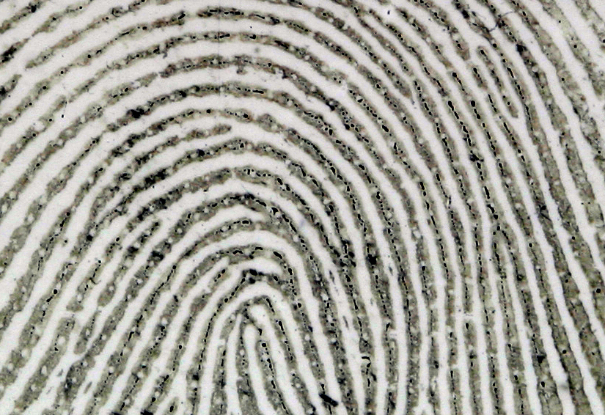
Figure 1.7. An area of a fingerprint showing a number of second level details
‘Level 3 detail’ includes features associated with friction ridges that may also exist within a fingermark and can be used in conjunction with first and second level detail to infer identity. These features may include pores, the shape of ridge edges, and discontinuities within the ridge, Figure 1.8. Permanent scars and creases within the mark may also sometimes be included in this category. The use of fingermarks in identification has been extensively covered in other publications and it is not the intention of this book to deal further with the comparison and identification process. However, the second level and third level details in fingerprints do play a crucial role in the chemistry and other properties of the fingermarks they produce. They are, respectively, responsible for the distribution and the excretion of sweat over and from the skin.
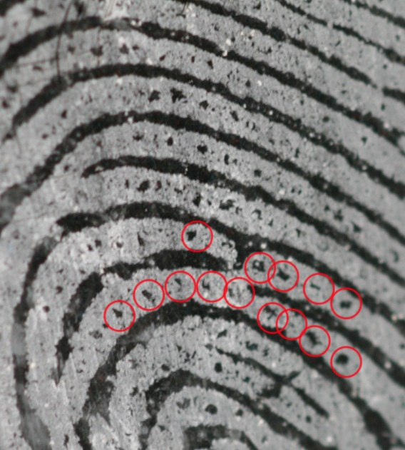
Figure 1.8. A fingermark enhanced using white powder suspension, showing level 3 details (in this case pores, illustrated using red circles) in the ridges.
Even in cases where the hands and palms are protected with gloves, it may still be possible to obtain useful evidence from the contact area. Not all gloves are totally impervious and migration of sweat through certain types of glove has been recorded (Willinski, 1980). Similarly, natural deposits may build up on the outside of gloves, and where gloves are thin the pattern of the fingerprint may still be left on the surface. For thicker gloves, the pattern of the surface of the glove may be left on the surface, Figure 1.9. The resultant glovemarks may still contain sufficient features for the glove to be matched to the mark left on the surface (Lambourne, 1984, Sawyer, 2008).
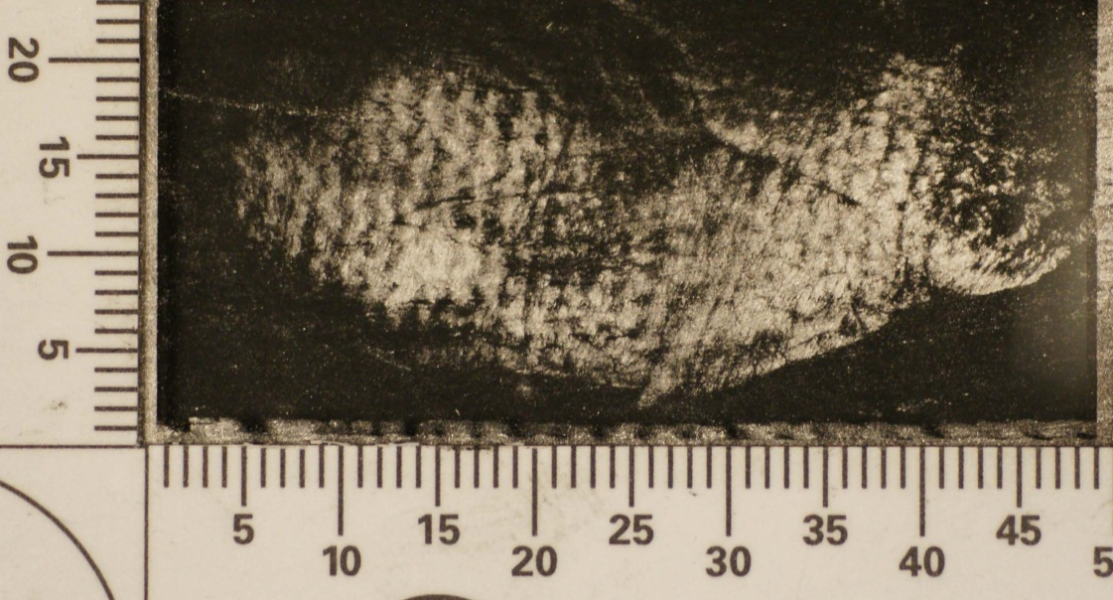
Figure 1.9. An example of a glovemark left by a knitted woollen glove and enhanced with aluminium powder. Reproduced courtesy of the Home Office.
More recently, it has become possible to obtain additional contextual information to that provided by the ridge detail, including information about the donor of the mark, regardless of whether they can be identified from the ridge detail.
Fingermarks often contain shed skin cells, Figure 1.10. It has been recognised for several years that DNA can be extracted from shed skin cells in fingermarks, and cell-free nucleic acids have also shown to be present in sweat (Quinones and Daniel, 2012). This gives the scientist another opportunity to establish identity from a contact area, even in situations where there is insufficient ridge detail present for identification. Indeed, the knowledge that a particular area has been touched enables DNA recovery to be targeted, thus giving an increased likelihood of obtaining a profile compared to speculative swabbing over a wider area.
Figure 1.10. Skin cells present within ridges of a mark on an adhesive surface, a) low magnification, and b) high magnification. Reproduced courtesy of the Home Office.
Advanced analytical techniques can be employed to establish both the chemical species present in a fingermark and to map their distribution, both of which can be extremely valuable pieces of information. From a chemical analysis it may be possible to establish:
- the sex of an unknown donor (e.g. Ferguson et al 2012),
- whether they are taking illicit or medication drugs (and the nature of those drugs) (e.g. Hazarika et al 2008, Rowell et al 2009),
- the nature of the contaminants (e.g. drugs, explosives) (e.g. Tripathi et al 2011, Rowell et al 2012) that may have been handled by the donor.
The full range of publications in this area is far more extensive than the examples provided above. Mapping the distribution of these contaminants may also be able to establish whether the contaminant is present as individual particles that may have been picked up by an accidental contact, or are intimately and uniformly associated with the ridges, implying a more direct handling of the substance, Figure 1.11.
Figure 1.11. MALDI MS images of a condom lubricant- contaminated fingermark. The mark was subjected to gelatin primary lift for analysis via ATR-FTIR. Subsequently a secondary lift of the mark residue was analysed by MALDI MSI enabling imaging of PEG (one of the polymers in the condom lubricant, represented here by the 28-mer) and of endogenous compounds. Here images of 13-aminotridecanoic acid (m/z 230.2) and oleic acid (m/z 283.2) are reported. The mass image of the 3 total ion currents yielded the complete ridge pattern of the mark (TIC). Reproduced and adapted from Bradshaw et al (2013) with permission from the Royal Society of Chemistry.
It is apparent that although there is a wealth of information in these contact traces that could be utilised by the forensic scientist, none of them will be available if they cannot be made visible to the human eye or a detection system. The aim of this book is to describe the wide variety of processes by which marks can be visualised and how they are selected, how the effectiveness of these processes can be established, and how they can be used in sequence with each other and other forensic recovery processes.

References
Bradshaw, R, Wolstenholme, R, Ferguson, L S, Sammon, C, Mader, K, Claude, E, Blackledge, R D, Clench, M R, Francese, S. ‘Spectroscopic imaging based approach for condom identification in condom contaminated fingermarks’, Analyst, vol 138, (2013), p 2546-2557
Ferguson, L S, Wulfert, F, Wolstenholme, R , Fonville J M, Clench M R, Carolan V A, Francese S, ‘Direct detection of peptides and small proteins in fingermarks and determination of sex by MALDI mass spectrometry profiling’, Analyst, vol 137, (2012), p4686-4692
Hazarika P, Jickells S M, Wolff K, Russell D A. ‘Imaging of latent fingerprints through the detection of drugs and metabolites’, Angewandte Chemie Int Ed, vol 47, (2008), p10167-10170
Lambourne G, ‘The Fingerprint Story’, Harrap, London, 1984
Locard E, ‘La police et les méthodes scientifiques’, Presses Universitaires de France, Paris, 1934
Quinones I, Daniel B. ‘Cell free DNA as a component of forensic evidence recovered from touched surfaces’. Forensic Sci. Int. Genet. vol 6, (2012), p26-30.
Rowell F, Hudson K, Seviour J, ‘Detection of drugs and their metabolites in dusted latent fingermarks by mass spectrometry’, Analyst, vol 134, (2009), p701-707
Rowell F, Seviour J, Lim A Y, Elumbaring-Salazar C G, Loke J, Ma J, ‘Detection of nitro-organic and peroxide explosives in latent fingermarks by DART- and SALDI-TOF-mass spectrometry’, Forens Sci Int. vol 221(1-3), (2012), p84-91
Sawyer P, ‘Police use glove prints to catch criminals’, Daily Telegraph, 13th December 2008 http://www.telegraph.co.uk/news/uknews/law-and-order/3740688/Police-use-glove-prints-to-catch-criminals.html (accessed 22nd April 2017)

Scientific Working Group on Friction Ridge Analysis, Study and Technology (SWGFAST), Document 19 ‘Standard Terminology of Friction Ridge Examination (Latent/Tenprint)’, Issued 14th March 2013
Tripathi A, Emmons E D, Wilcox P G, Guicheteau J A, Emge D K, Christesen S D, Fountain A W 3rd, ‘Semi-automated detection of trace explosives in fingerprints on strongly interfering surfaces with Raman chemical imaging’, Appl Spectrosc. vol 65(6), (2011), p611-9
Willinski G, ‘Permeation of fingerprints through laboratory gloves’, J Forensic Sci. vol 25(3), (1980), p682-5

