ASOCSA2022 – [ 11]
Construction Infrastructure Project Cost Overrun and Cost Control/Management Techniques.
Rafiu Dimeji Seidu(1), Maurisha Shani Allen (2), Jin Ruoyu(3), Yuting Chen(4), Bert Ediale Young(5) and Obas John Ebohon(6).
School of the Built Environment and Architecture, London South Bank University,
103 Borough Road, London, SE1 0AA, UK.
seidur@lsbu.ac.uk, allenm16@lsbu.ac.uk, jinr@lsbu.ac.uk, cheny22@lsbu.ac.uk, youngb6@lsbu.ac.uk, ebohono@lsbu.ac.uk.
ABSTRACT AND KEYWORDS
Purpose of this paper
The construction industry is distinct and different from other industries due to its multifaceted nature and the unpredictability it meets. Despite advancements in construction project management throughout the decades, cost overrun as proved to be a significant challenge for the industry with most of the construction and infrastructure projects encounter cost and schedule overruns due to challenges caused by inadequate cost management during the design and implementation stages. Hence, this research is set to identify and rate the elements that influence cost overruns and evaluate the cost management techniques in the UK construction sector.
Design/methodology/approach
The research was carried out using primary research, which takes the form of quantitative data collected through a questionnaire. This provides the required data for analysing cost overruns and determining the most effective cost management strategy. The Relative Importance Index (RII) rated the components.
Findings
Findings from the research show that erroneous estimating, unsuitable planned design standards, and information are the main militating factors influencing cost overruns in construction infrastructure projects (CIPs) with a relative important index (RII) of 0.938462 whilst budgeting ranked highest for all participants as a cost-control approach.
Original/value of paper.
This is to gauge the position of middle management on the various challenges posed by cost overrun and delays. It was deduced from the research outcome that an experience professional should oversee complex or mega project and innovative design technology can be used to enhance design consideration right from the outline design stages.

Keywords: Cost overrun, Cost management, Cost control, Construction, and Infrastructure projects.

1.0 INTRODUCTION.
The construction business is complicated because of the multiple parties involved, such as clients, contractors, consultants, end users, shareholders, regulators, and others whilst construction projects must meet three primary goals: they must finish on schedule, around budget, and to an acceptable standard of quality (Potts, 2013). Cost overruns have many issues. As reported in a study by UK Construction Media, less than 31 percent of projects were within the 10 percent threshold of the original project budget in the three years leading up to 2015 (UK Construction Media, 2017). The Department of Transport's (DfT) current estimate of the cost of HS2 (High-Speed Railway), an ongoing project in the UK, has spiralled even higher, from between £72- £98 billion, up roughly 120-200 per cent over the previous estimate of £32.7 billion in 2010. (BBC, 2018,2021). However, due to the construction and infrastructure industry's high costs and complexity, maintaining it in its current state has become unaffordable, despite its importance to the economy (McNulty,2011). This, combined with rising expenses and an unprecedented funding crisis, has increased the pressure on the sectors to save money through a financially organised and long-term growth platform (McNulty, 2011; Kelly, 2007). As a result, the industry's ability to reduce costs while growing capacity to match present and prospective national growth trends have been scrutinised more closely (McNulty, 2011; Allport et al, 2008; Seidu et al., 2020).
Cost control is critical in every industry to ensure that a business makes the maximum profit or that a program's expenditure somehow does not surpass its initial worth. Honouring Ashworth (2004), cost and schedule control are essential management roles once a project is established. Determining the most efficient control measures is critical to the entire cost control process. However, according to research by Olawale and Sun (2010), many companies base their systems on an individual's knowledge and the most successful approaches for a specific project. Therefore, various strategies are used in the industry, making it complicated to establish the most efficient. Hence, the research is to critically evaluate the cost control methods and aspects leading to project budget overruns in UK construction and infrastructural industry for the process of ascertaining construction project performance.
2.0 Literature Review
2.1 The UK Construction and Infrastructure Industry
The construction industry is a crucial component of the UK economy, encompassing various products, services, and technologies. Figure 1 shows the types of activities and goods carried out by each sub-sector and their scale in terms of gross value added (GVA) and employment.
Figure 1: Composition of the UK construction sector.
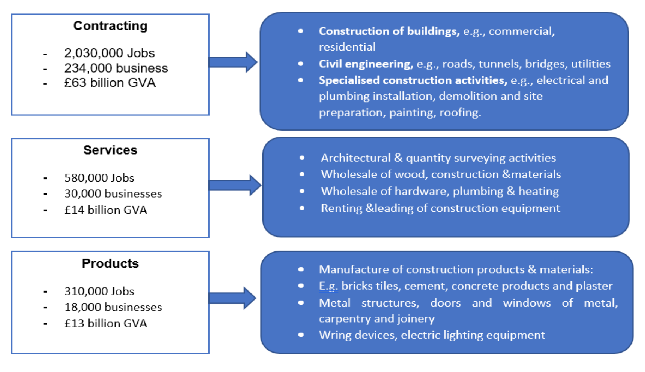
Source: GVA and no. of businesses: ONS Annual Business Survey (2011). Employment: BIS analysis of ONS Labour Force Survey micro-data.
Construction is one of the main sectors of the UK economy, contributing almost £90 billion in value-added to the UK economy (or 6.7 per cent), with over 280,000 enterprises covering 2.93 million workers or about 10% of total UK employment (ONS,2021). Civil engineering works, building roads, houses, bridges, house repairs, maintenance, refurbishing, and infrastructure works are all examples of business activity in the construction industry (Hussain et al., 2013; Szymanski, 2008). The UK government, contractors/consultants (architects, quantity surveyors, builders, civil engineers), suppliers, and the local community are the primary players in the construction in the United Kingdom.
Despite the presence of professional and experienced stakeholders and the industry's beneficial contribution to the UK economy, the UK construction industry faces significant challenges such as project delivery delays, cost overruns, and a shortage of skilled labour (Agapiou et al.,1995).
2.2 Experience and cause of Cost overruns in UK
According to Flyvbjerg et al. (2002), cost overrun is described as ‘cost increase’ Cantarelli et al (2010) term it ‘cost outturn’. Both Flyvbjerg et al. (2002); Cantarelli et al (2010a) define cost overrun as ‘increased amount of money established at the time of completing the project when compared to the estimated amount at the time of the decision to build a project’. According to Aljohani et al. (2017), construction and infrastructure industry has an issue when it comes to cost overrun with a consistently poor history of finishing under budget, is among the most prevalent concerns in construction performance measurement around the world. For example, The British Library, which first opened its doors in 1998, is one of the country's largest public structures cost £511 million (Harlow and Syal, 1995), which was three times the initial estimate. Politicians and the management team and government agency were to blame for constantly changing project employees and duties (Spring, 1997). There was also criticism to the contractual arrangement, which used a cost-reimbursement model, meant that the consultants and contractors had limited financial incentives to stay within the budget constraints. Other UK examples is the channel Tunnel linking England with France running underneath the English Channel, the project was overrun by 80% increasing from £2.6 billion to £4.65 billion due to change of scope, poor communication, contract framework was based on lowest tender rather than most advantageous and economic tender (Winch, 2013). Similarly, Edinburgh Tram overrun costing £776 million from the initial estimate of £320 million amounting to 58% cost overrun resulting from dispute, multi level decision, stakeholder pressure, utilities diversion, economic downturn, freezing temperature and lack of political support (Boateng et al., 2014).
The most common causes of cost overrun are frequent design changes during construction, contractors finance, payment delays, lack of contractors experience, poor cost estimation, poor tendering documents, poor materials management (Aljohani et al., 2017) whilst Proverbs et al., (2000); Jackson (2002); Olawale and Sun (2010) concur stating other causative factors include; scope changes, trust issues, a highly fragmented construction supply chain, poor communication, an old-fashioned procurement route, and poor cost estimations. Adjunct to that will have issues around procurement bottleneck due to border closure (Enshassi et al., 2009); security, political, labour disruptions and pandemic (Zafar, 2016); Project location, variations (addition, omission or changes in design, schedule and scope) are all contributing factors to cost overrun (Shane et al., 2009; Olawale and Sun, 2010; Seidu et al., 2021) Other factors identified recently by Zewdu and Aregaw (2015); Durdyev et al., 2017; Franca and Haddad (2018) comprise the impact of information technology is having on project management.
The most current influencing factor that causes cost overrun is the increase in construction cost. According to (RICS,2021) Building Cost Index rose to 10.2 per cent in September 2021 compared to the same month a year ago. The BCIS Materials Cost Index has contributed the most to this rise, with the overall cost of materials in the index growing by 19.7% during the same period. Steel and timber saw the highest rises between January and September 2021, with significant volatility in every material category. However, the industry is already having difficulty attracting employees with certain talents, and competent subcontractors are in short supply. According to the Office for National Statistics (ONS,2020), construction employment is expected to fall from 2.3 million in 2017 to 2.1 million by the end of 2020, which was exacerbated by the pandemic. The employment statistics constitute a 4% decrease in UK home workers but a far more considerable 42 % decrease among EU workers. In terms of Brexit, eliminating the right to free movement and implementing a points-based immigration system may result in construction companies no longer hiring EU workers. Experts believe that due to these developments, the cost of labour could rise by as much as 10%. At the same time, they are increased number of highly skilled migrants leaving the UK as the pound weakens, making the UK a less desirable work destination (Portes and Forte, 2017). Any limits on freedom of movement are also expected to impact recruiting (Wright et al., 2014), as firms will struggle to fill resource gaps produced by the limited free movement of workers (Portes and Forte, 2016; Young et al., 2019).
The UK Government VAT reverse charge policy that went into force in March 2021 is putting a significant burden on the cash flow of small and medium enterprises (SMEs) that operate as suppliers making cash flow among the most complex challenges for construction firms, while 1 in 5 construction companies believe cash flow is a persistent issue, with 84 per cent reporting cash flow issues. This policy, combined with growing material costs, will impact SMEs' bottom lines (UK Construction Media,2021).
2.3 Cost Control/Management Methods in the Construction Industry
According to Seidu et al., (2021), cost management must be utilised when dealing with project cost control in other to be able to manage all necessary cost associated with the project to ameliorate the effect of cost overruns. Potts (2008) and Potts & Ankrah (2013) suggested an integrated reporting system, a separate schedule and cost control system that focuses on and detect difficult area in the project so that the project team may take the necessary steps to resolve the issues as factors that must be considered while constructing a cost control system and recommend the following cost management options:
- Cost-Value Reconciliation (CVR) - This is the type of cost techniques implemented by construction firms; it aims to present a realistic and accurate picture of the company's financial status at any given time by projecting its profitability, they are dependent on the quantity surveyor's knowledge and judgment of the data collected (Potts & Ankrah, 2013).
- Contract Variance – This form the cost control report, like the cost-value reconciliation, they are applied when there are few high-value elements by civil engineering contractors. It includes a range of works that are separately (autonomously) accounted for and documented with unit costs for each component, such as concrete, steel, ground, and driving piles, may be compared to those in the tender. The distinction is determined by the difference between the cost of the job and the value of the work itself. The cost variance makes it easier for effective decision-making and forecasts the project's profit and loss.
- Earned Value Analysis (EVA) - According to Potts & Ankrah (2013), this approach (earned value management) is the most powerful tool/system/model for cost control because it offers a quick status of the project at any point in time and can forecast future circumstances. As defined by Howes (2000) it is "an established method for the evaluation and financial analysis of projects throughout their life cycle." It entails computing three key values for each activity in the work breakdown structure: The planned value (PV) also known as budgeted cost of work schedule (BCWS); Actual cost (AC) – actual cost of work performs (ACWP), and the earned value (EV) refer to as budgeted cost of work perform (BCWP).
- Digitalisation - Due to technical improvements, digitalisation has also played a role in changing how cost cutting strategies are implemented. Software programmes can help with financial budgeting, task scheduling, and activity costing, making tasks more accessible and time-efficient (Webb,2017). According to Jayaraman (2016), fine-grained cost monitoring and control have become practical and straightforward. While monitoring has been simplified, they both agree that the same amount of attention to detail is essential.
- Contract Standardisation - The Latham report (1994) allow for better cost reduction through effective cost management considering the current economic context and the government's infrastructure spending plans. The report outlined several flaws in present methods, emphasising mechanisms for improving construction practices such as bettering worker relationships, fair payment tools, contract standardisation, and lowering disputes. Using standard contract form is more effective at resolving issues that can lead to project delays, disruption of contracting parties' relationships, cost overruns, and other problems. Its clarity and flexibility make it easier to read and understand than any bespoke contract, which still contains interpretive words, unnecessary legal interpretations, clause cross referencing, and confusing expressions that could be misread and exploited by important unethical stakeholders (Lord, 2008; Forward,2002).
There are various applications of cost-control measures; however, the table below show the most important elements:
Table 1: Cost Control/Management Techniques
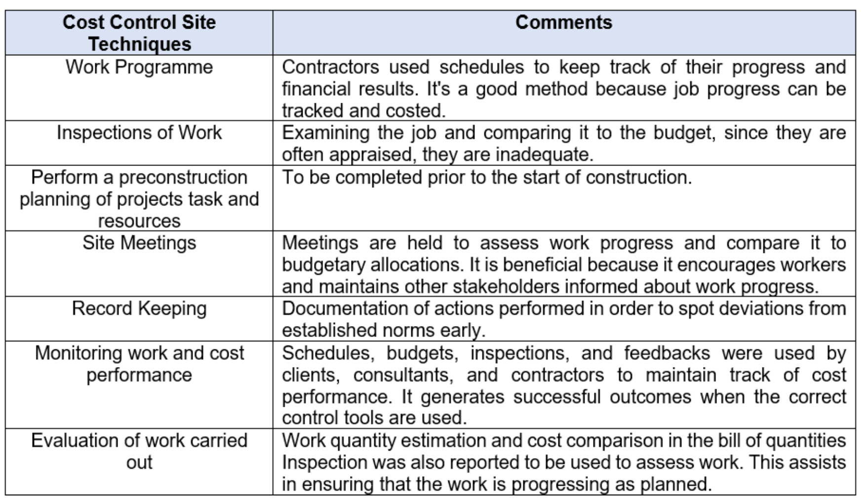
Source: Authors source.
Lewis (2007) stated that the most successful way to control project costs is for each responsible individual to control their components, accentuating cost reduction's "human factor". As a result, the personnel inside the organisation, not the procedures, are the most critical factor in cost reduction. It may be argued that the job definition of a cost consultant used to be confined to providing construction cost estimates (Designingbuildings,2022). As a result, the method would be reactive rather than proactive, rendering Lewis, (2007) claim reductive.
Research conducted by Olawale & Sun (2010) in UK with 250 construction project organisations which was following with 15 interviews among experienced professionals then proposed remedies to curtail cost overruns into four categories: preventative, anticipatory, remedial, and organisational initiatives (culture). Also, Case Cunningham (2017) conducted a case study into the causes of cost overruns and inadequate financial management in the construction sector also come up with the following recommendations for a Building Construction Project's Construction Phase details in the table below:

Table 2: Cost control for Building Construction Project's during Construction Phase.
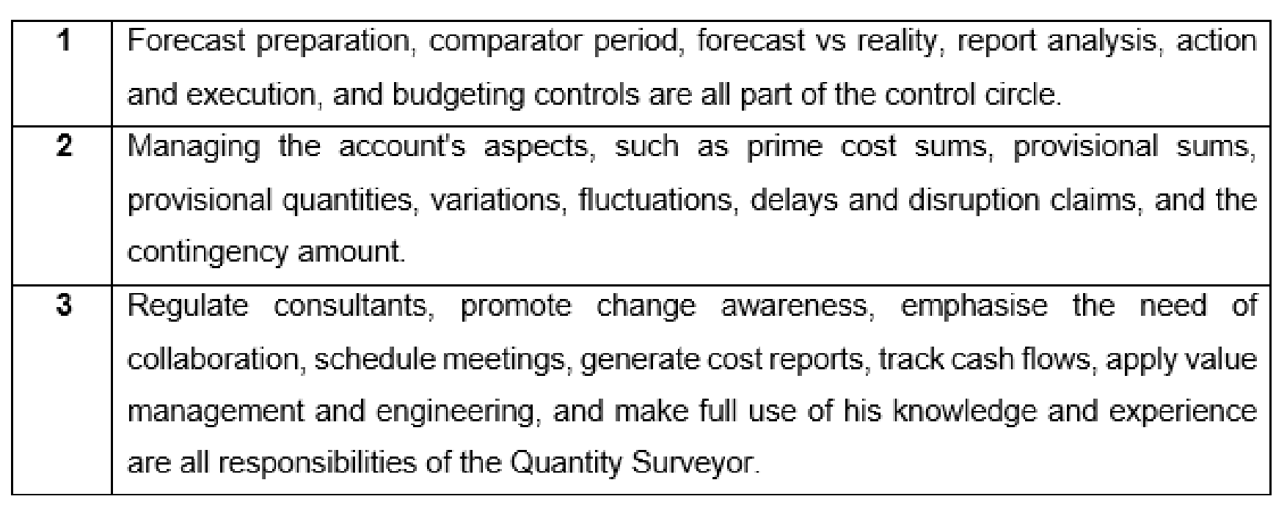
Source: Cost Control during The Construction Phase of the Building Project: - The Consultant Quantity Surveyor’s Perspective (Cunningham, 2017).

All the recommendation are beneficial to the industry, and more are currently being created. However, due to the intricacies of the construction industry, issues such as firms going out of business, budget overruns, and project failures, all of which suggest poor financial management, continue to exist (Varghese & Manacere, 2012; Aljohani et al, 2017). In the construction and infrastructure industry, there is need to involve or deploy new financial management paradigm/model/ procedures.
3.0 Methodology
The quantitative approach is used to collect data and study relationships between facts and how such facts and relationships correspond to theories and findings from previous research. In contrast, the qualitative approach is used to gain insights and understand people's perceptions of "the world," whether individuals or groups (Fellows and Liu, 2008). The researchers utilise quantitative research questions to frame and sharply focus the study's objective on quantitative investigations. Quantitative research questions inquire about the correlations between variables that the researcher is curious about within the selected research field. This study will solely incorporate research questions rather than hypotheses to prevent redundancy (Fellows, 2015).
The research data was capture with questionnaire which was available to the clients, consultants, and contractors, which ranks each question using (Likert Scale), ordinal scales and a Likert five-point scale was used to gauge the cost overrun factors in terms of importance and influence and evaluates cost-control solutions. Out of the 50 people who received the questionnaire, 26 responded, resulting in a 52 per cent response rate, which was a satisfactory response on this type of research (Fellow, 2015). The survey was structured around the primary 12 factors that influence cost overruns in construction infrastructure projects and cost management approaches/processes as detailed in table 5. The interviewers' professional experience was crucial to the record since the questionnaire would provide insight based on the participant's level of knowledge according to the study methodology. Therefore, Quantity surveyors, estimators, cost engineers and cost advicer/consultants working for the Clients, consultants and contractors in the construction infrastructure industry was proposed as significant participants due to their great deal of cost management experience with mega construction infrastructure projects. Given the research more credibility and authenticity base on respondents many years of experience in their various expertise area. Hence, shaping the research in meeting its dependability and validity requirements.
The questionnaire covered cost overruns influencing factors, cost-cutting methods and methods or systems for cost control. A pilot study was used to evaluate the topics among participants with 2-20 years of experience working in Senior position in mega construction projects to analyse the questions, detect any potential ambiguities, and assess the researchers' data gathering procedure (Naoum, 2013) with the prototype to improve the readability of the questions which was corrected before the survey questions was sent out to the participants. The participants have worked with different mega project,11 respondents experience in mayor construction project, following by 10 respondents in mega infrastructure and the rest 4 respondents worked in mayor residential project while ‘others’ type of mega project had one respondent.
The data from the questionnaire survey was examined using the " Relative Importance Index" (RII) technique (Nesan,1997). RII was calculated using the formula in table 3: The value of RII ranges from 0 to 1 when calculated using this formula, with 1 representing maximum strength and 0 representing minimum strength. The study's representative sample was n=26 participants; The research implemented a non-random sample approach known as convenience sampling. The participant is drawn from 42% (11) of consultants, 31% (8) of Contractors, and 27% (7) of Clients completed the questionnaire with various years of experience between them. 46% (12) of respondents have 5 - 10 years of experience in the construction sector, 35% (9) have more than 10 years of experience, and 19% (5) have 1 - 4 years of experience. They have work in different project which include major construction project with 11 respondents follow by infrastructure 10 respondents, thirdly was residential with 4 respondents and ‘other project’ had one respondent, occupying a middle management position in their respective organisation.
Table 3: Showing Relative Important Index formula.
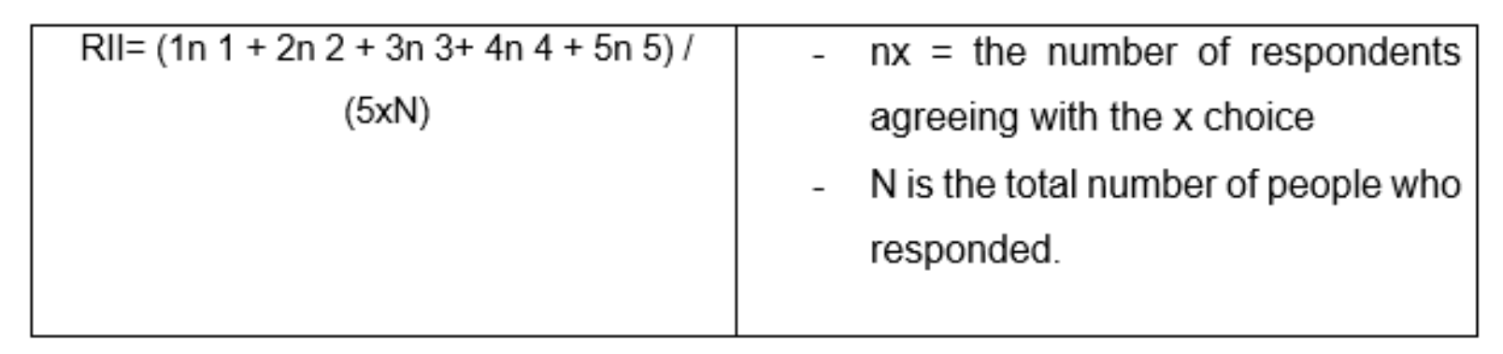
Kish (1965) demonstrated that the sample size can be calculated using the equation below with a 94 per cent confidence level (Moore et al., 2003). The study's representative sample was n=26 participants while the research implemented a non-random sample approach known as convenience sampling.
Table 4: Showing Sample size formula.
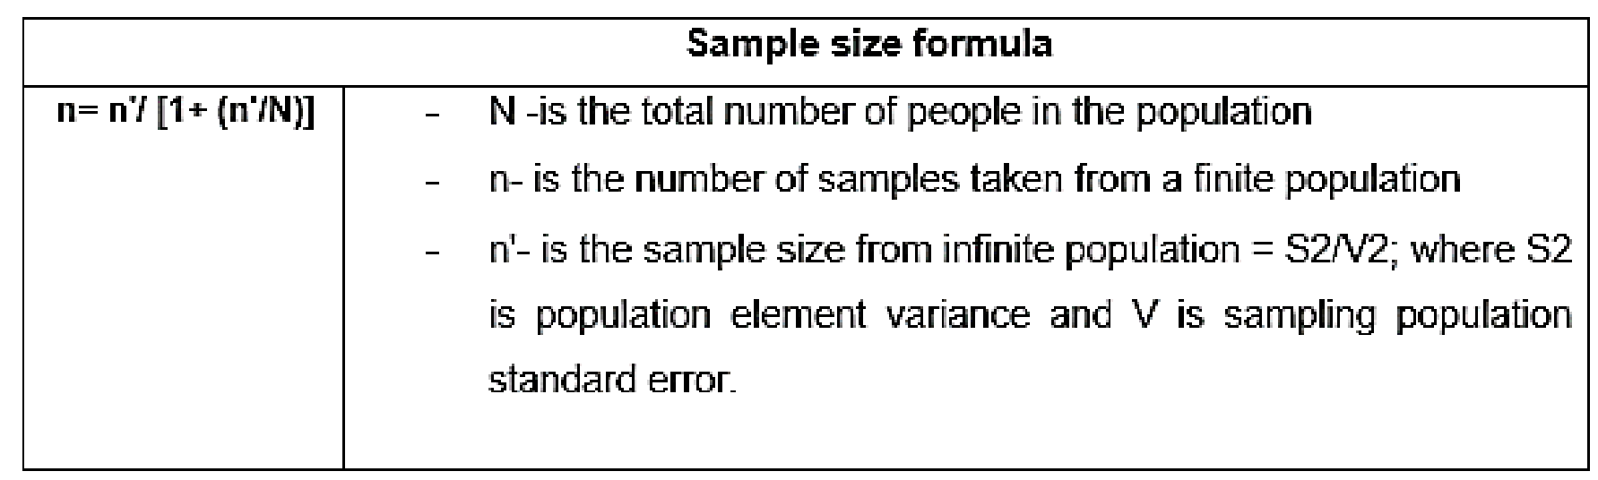
4.0 Research Findings and Analysis
The collected data has been analysed based on the result under the following subheading:
4.1 Factors that Influence Cost Overruns in Construction Projects.
The findings from this section of the research give an idea of the relative relevance index and ranking of factors impacting construction project cost overruns. The summary of variables ranking according to all respondents (Client, consultant, and contractors) is shown in Table 6.
Table 5: Factor influencing cost overruns.
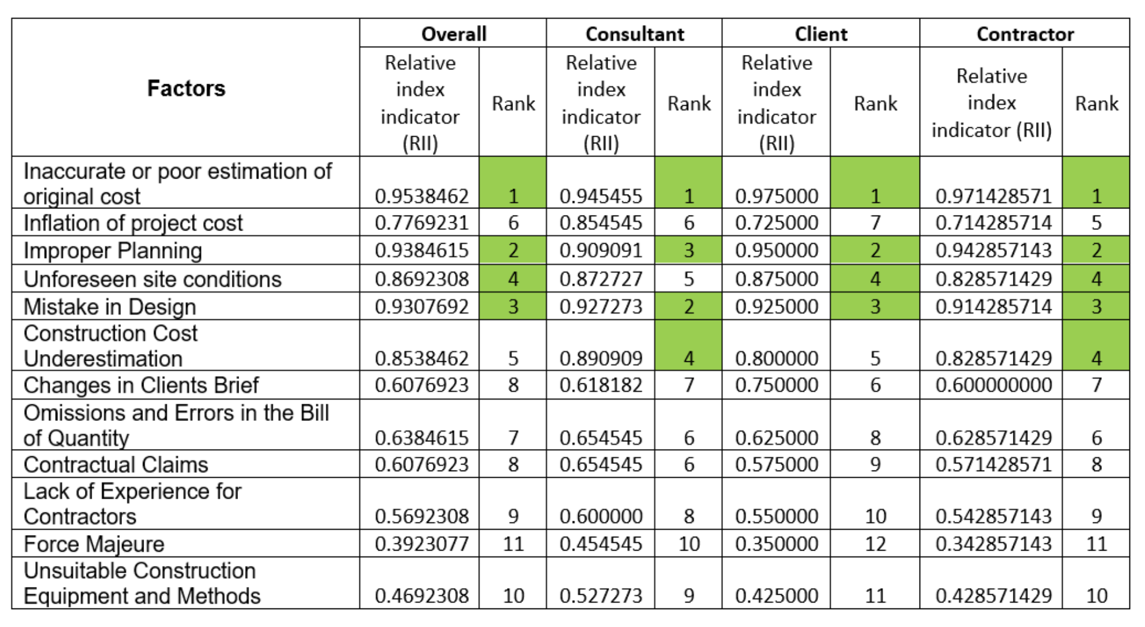
Results from the research indicate that the respondents (contractors, consultants, and clients) have a considerable agreement in ranking aspects resulting from poor estimation, inappropriate planning, design standards, and information. When determining the project budget, it is usual to refer to costs incurred in a similar project. Even though this is a well-established and straightforward method of assessing project costs, it has drawbacks. Each project is unique. As a result, using different costing methodologies for each project is a good idea. Furthermore, the costing method employed should produce precise and reliable results. As a result, inaccurate cost estimates have little bearing on project profitability. There was a slight lack of agreement between contractors and consultants on market conditions (external factors) and project features. Furthermore, the findings show that the top ten factors affecting the accuracy of cost estimates are clear. Not every team member receives proper costing training, many firms have a costing and estimating department during the bid phase of the project. In addition, the project team fulfils this duty at the expense of regular project operations. As a result, project costs may be overestimated if unskilled or inexperienced people do cost estimates. Nevertheless, not everyone has the knowledge and experience required to decipher a lengthy contract's refined vernacular. As a result, the costing team should be aware of the implications of their errors and omission. Reduced design complexity, fewer design modifications, and having the design as complete as possible at the pre-contract stage were all ways to contain budget, because design flaws have been recognised as one of the leading causes of cost overruns, effective design management is essential for cost control. If the design is complicated, little can be done after the contract is signed. Hence, cost consultants must be involved throughout the development phase to make cost recommendations.
4.2 Frequency of Cost overruns.
Table 6: Frequency of Cost overruns.
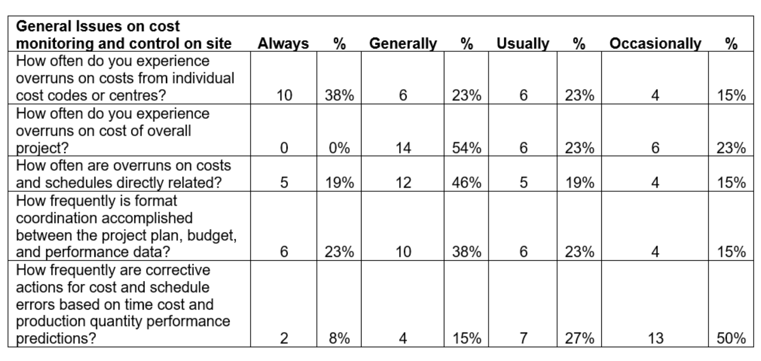
The construction industry's experience with the problem of cost overruns, as well as its evaluation of its causes and corrective factors, was deemed necessary for a proper evaluation of the theoretical model for and issues relating to cost monitoring and control presented in the review, as well as for proposing another approach to effective cost monitoring and control on sites. As a result, respondents were polled about the frequency of cost overruns at various levels of the project cost structure and their opinions on a variety of cost overrun causes. Cost overruns on cost codes were seen by 38 per cent of participants regularly, while cost overruns, in general, were experienced by 23 per cent. In other words, cost overruns on specified cost codes occurred in at least 100% of all cases. In addition, a comparable percentage (54%) of respondents reported budget overruns in their projects as detail in above table 6.
4.3 Categorising the most effective Cost control techniques.
Budgeting was regarded as the most efficient cost control strategy, based on the overall results from table 6a and 6b. Rank 1 had an RII of 0.938, cost forecasting was second with an RII of 0.876, cost reporting was third with an RII of 0.792, and cashflow monitoring was fourth with an RII of 0.753. If managed, Budgeting may assist in cost management by ensuring that costs do not exceed the budget (Kirkham, 2015). It is appropriate to carry corrective action when cost overruns are recognised early (Ashworth and Perera, 2015). Cost forecasting must be the most efficient tool for successfully controlled costs. It allows for the initial discovery of budget overruns and the implementation of measures to limit them. Another reason for their widespread use is that they are simple and easy to deploy. Professionals will have experience with them before and understand what they involve. The techniques' inexpensive implementation costs will enable them to deploy on any project since it is cost-efficient.
Table 7a: Classifying Effective Cost Control Techniques
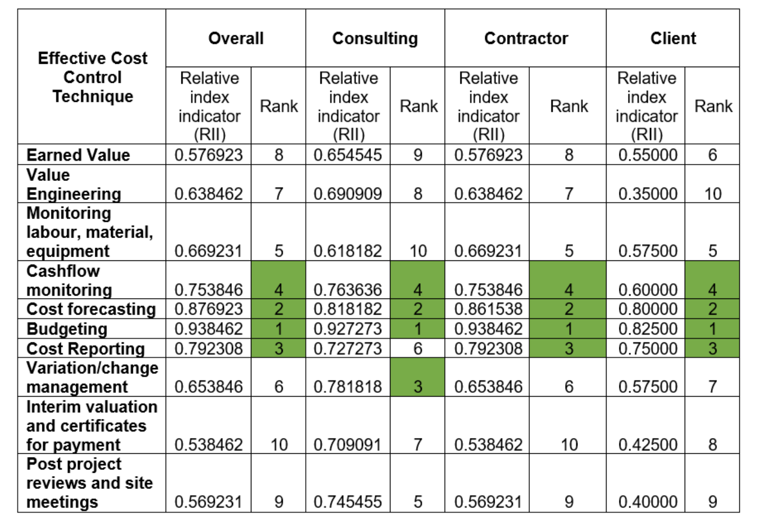
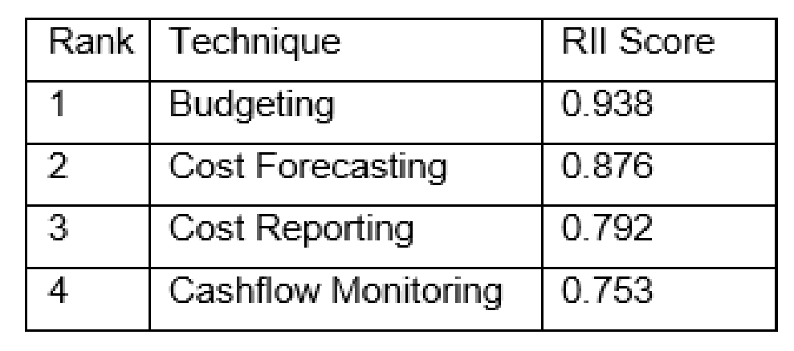
Table 7b: Most effective cost control techniques.
Earned value is ranked eighth with an RII of 0.576, labour, material, and equipment monitoring are rank fifth with an RII of 0.669, interim valuation and payment are rank tenth with an RII of 0.538, and value engineering is ranked seventh with an RII of 0.638, see table 7a. Because earned value is uncommon method, some participants may never have used it, appearing ineffective. According to Webb (2017), this method is more complex and needs specialised computer software, making it more expensive and limited to major schemes. Monitoring labour, elements, equipment, and overheads are the least effective way (costs). Potts (2013) highlights that simply monitoring costs is unproductive, there is little to what the cost consultants can do once the expenses has been incur, demonstrating a lack of control. Figure 2 depicts the application of cost-cutting strategies across many disciplines. With an RII of 0.927,0.763, cost forecasting and budgeting is rank first in consulting, followed by variation/change management. The least rated factors include interim assessment and certificates for disbursement (0.538 RII), post-project evaluations and site meetings (0.569), and Earned value (0.569) as shown below.
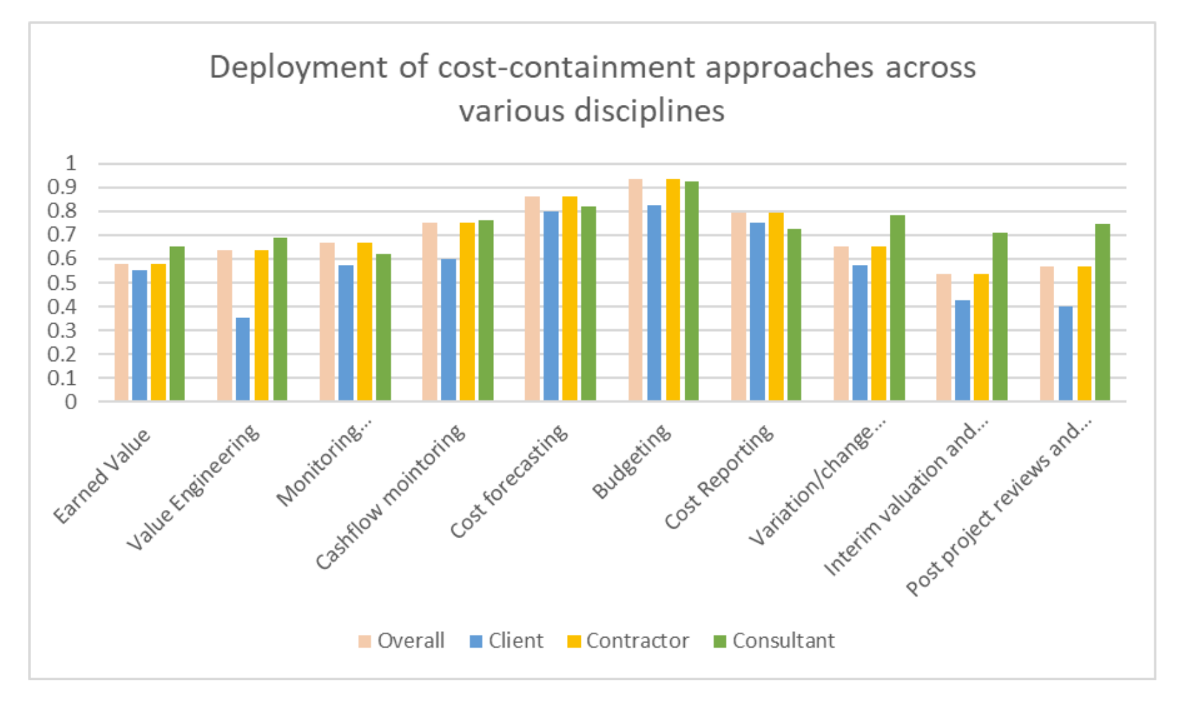
Figure 2: Cost cutting strategies across many disciplines.
The lowest scores are for interim valuations and payment certification (0.538 RII), post-project review, and site visits (0.569 RII). With an RII of 0.550, Earned value ranks among the lowest in all categories except the client. Although contractors are the most likely to use earned value (PMI, 2005), other industries are less likely to have done so and may be unaware of its value. Earned value is not a 'one size fits all' and may not apply to every project type but to those with specified characteristics (Webb, 2017). All projects received a low grade for interim valuations and payment certifications, indicating that they are ineffective at budgetary control.
5.0 Discussion
Construction and Infrastructure project cost overruns are inevitable, and efficient cost containment measures should be employed. Design management, comprehensive and detailed cost estimation, client engagement, and automation may all contribute to and eliminate several of the specific challenges that have resulted in increased expenses. However, more precise time and cost forecasts and increased cooperation among parties are required for reducing cost overruns. The project will remain within the initial cost allocation if budgetary control is effective and implemented by the project team.
Cost forecasting can indeed be significant since it offers an advanced warning of expenditure, permitting the identification of cost escalation and the application of controls to minimise them. A further practical and straightforward approach for maintaining project budget allocation in line with the original budget is variation, otherwise known as change management. The numerous factors revealed in this study will decide the use of various cost cutting strategies (project, size, and time). As a result, the nature and scope of the project, the funds accessible, and the program's timeline determine the optimal cost-cutting approach. Budget control and expenditure forecasting are highly excellent resources that should be used continuously. On the other hand, EVA can only be employed on some projects and is not cost-efficient on smaller monetary value initiatives. Therefore, they are ineffective on most projects. Moreover, each construction project is unique; an institution's budgetary control techniques must be adaptable and responsive to the project's demands. Information can be obtained, kept, and evaluated more quickly and efficiently, and technological advancements have enabled cost containment to be manageable.
Overall, this research project should indeed be considered as an enhancement of creating strategies for variables driving the adoption of efficient construction cost containment techniques in the UK, building on the research publications covering different area of project complexity like: time overrun (Chan and Kumaraswamy,1997), cost overrun and risk management (Jackson, 2002), time and cost control (Olawale and Sun, 2010), cost overrun causation factors (Memon et al., 2011), causes of cost overrun (Park and Papadopoulou, 2012), root cause of cost overrun (Rosenfeld, 2013), behavioral biases (Flyvbjerg et al., 2021), economic risk (Boateng et al., 2014), cost escalation (Winch, 2013), cost overrun (Cantarelli et al., 2010) with non of the research focusing on the middle management perspective. The divergent in causative factor is due to different data mining used by previous researcher whist this research explored the perspective of cost management expert with construction infrastructure experience and cost strategies is based on organisational level of exposure.
6.0 Conclusion
Cost overruns has become a common phenomenon that have eaten the backbone of the industry, despite all the research in this area, it is still occurring without knowing when it will become history. Hence, the industry major players need a new dimension in resolving this incessant problem. Contractor will need to have an established supply chain in place and monitored all procurement strategy by ensuring construction materials are available in advance, monitoring quality of workmanship, materials and labour are readily available when required. Planning and scheduling must be an ongoing process and coordinated with the resources within the stipulated time.
The use of lowest tender is not beneficiary instead the most economically advantageous tender should be use while payment to contractor is important to maintain adequate cashflow. Design changes should be control with innovative technology for complex design right from precontract stage with detail information made available and experience personnel who have perform similar roles should always be at the forefront of complex project, who can foresee any inherent risk on and applied the necessary contingency to cushion the effect and avoid possibility of cost overruns.
7.0 References
Agapiou, A., Price, A. and Mccaffer, R., 1995. Planning future construction skill requirements: understanding labour resource issues. Construction Management and Economics, 13(2), pp.149-422.
Aljohani, A., 2017. Construction Projects Cost Overrun: What Does the Literature Tell Us? International Journal of Innovation, Management and Technology, pp.137-143.
Allport, R., Brown, R., Glaister, S. and Travers, T., 2008. Success and failure in urban transport infrastructure projects. [online] imperial.ac.uk. Available at: https://www.imperial.ac.uk/media/imperial-college/research-centres-and-groups/centre-for transport-studies/Success-and-Failure-in-Urban-Transport-Infrastructure-Projects.pdf> [Accessed 8 December 2021].
Ashworth, A., 2004. Cost studies of buildings. Harlow: Pearson Prentice Hall.
Ashworth, A. and Perera, S. (2015) Cost Studies of Buildings. 6th edition, Routledge.
BBC News. 2021. 'No clear end to HS2 cost and delays' say MPs. [online] Available at: <https://www.bbc.co.uk/news/business-58638229> [Accessed 10 December 2021].
Boateng, P., Ahiaga-Dagbui, D., Chen, Z. and Ogunlana, S. 2015. Modelling economic risks in megaproject construction: a systemic approach. In Raiden, A. and Aboagye-Nimo, E. (eds.) Proceedings of the 31st Association of Researchers in Construction Management (ARCOM) annual conference, 7-9 September 2015, Lincoln, UK. Reading: ARCOM [online], pages 115-124.
Cantarelli, C. C., Flyvbjerg, B., Molin, E.J.E., and van Wee, B. 2010. “Cost Overruns in Large-Scale Transportation Infrastructure Projects: Explanations and Their Theoretical Embeddedness,” European Journal of Transport and Infrastructure Research,10 (1): 5-18.
Chan, D. and Kumaraswamy, M., 1997. A comparative study of causes of time overruns in Hong Kong construction projects. International Journal of Project Management,15(1), pp.55-63.
Cunningham, T., 2017. Cost Control during The Construction Phase of the Building Project: - The Consultant Quantity Surveyor’s Perspective. School of Surveying and Construction Management, pp.1-30.
Cunningham, T., 2017. What Causes Cost Overruns on Building Projects? – An Overview. Dublin Institute of Technology.
Designingbuildings.co.uk. 2022. Cost consultant. [online] Available at: <https://www.designingbuildings.co.uk/wiki/Cost_consultant?msclkid=bce4048cc64211ec8b3a69450b7b9a40> [Accessed 12 March 2022].
Durdyev. S, Omarov. M, Ismail. S (2017) Causes of delay in residential construction projects in Cambodia Cogent Engineering 4(1)
DOI: 10.1080/23311916.2017.1291117
Enshassi. A, Al-Najjar. J, Kumaraswamy. M (2009) Delays and cost overruns in the construction projects in the Gaza Strip. Journal of Financial Management of Property and Construction Vol. 14 No. 2, 2009pp. 126-151
Fellows, R. and Liu, A., 2008. Research methods for construction. Oxford: Wiley Blackwell.
Fellows, R., 2015. Research methods in construction. 4th edition. 4th ed. West Sussex: Blackwell.
Forward, F., 2002. The NEC compared. London: Thomas Telford.
Flyvbjerg.B, Holm, and Buh. S (2002) Underestimating Costs in Public Works Projects Error or Lie? Journal of the American Planning Association 68(3):279-295 Follow journal DOI: 10.1080/01944360208976269.
Flyvbjerg. B, (2021) Top Ten Behavioral Biases in Project Management: An Overview. Project Management Journal. https://doi.org/10.1177/87569728211049046
França. A, Haddad. A (2018) Causes of Construction Projects Cost Overrun in Brazil International Journal of Sustainable Construction Engineering & Technology (ISSN: 2180-3242) Vol 9, No 1, 2018
Harlow, J. and Syal, R., 1995. British Library not ready before 2000. The Sunday Times.
Howes, R., 2000. Improving the performance of Earned Value Analysis as a construction project management tool. Engineering, Construction and Architectural Management, 7(4), pp.399-411.
Hussin, J., Abdul Rahman, I. and Memon, A., 2013. The Way Forward in Sustainable Construction: Issues and Challenges. International Journal of Advances in Applied Sciences, 2(1), pp.31-42.
Institute, P. M. (2005). A guide to the project management body of knowledge: PMBOK® Guide.
Jackson, S., 2002. PROJECT COST OVERRUNS AND RISK MANAGEMENT. Reading, UK: University of Reading.
Jayaraman, R., 2016. Project cost control: a new method to plan and control costs in large projects. Business Process Management Journal, 22(6), pp.1247-1268.
Kelly, J., 2007. Value management of construction projects. oxford: Blackwell.
Kirkham, R. (2015) Ferry and Brandon's cost planning of buildings. 9th edition, Wiley Blackwell.
Kish, L., 1995. Survey sampling. New York: Wiley.
Latham, M (1994). “Constructing the team: The final report of the Government/Industry review of procurement and contractual arrangements in the UK construction industry. London. HSMO
Lewis, J., 2007. Fundamentals of project management. 3rd ed. New York: AMACOM.
Lord, W., 2008. Embracing a Modern Contract- Progression since Latham? In COBRA, the construction and building research conference of the Royal Institute of Chartered Surveyors. Royal Institute of Chartered Surveyors, 1(1).
McNulty, 2011. Realising the potential of rail in Great Britain. [online] GOV.UK. Available at:<https://www.gov.uk/government/publications/realising-the-potential-of-gb-rail> [Accessed 11 December 2021].
Memon, A., Rahman, I. and Azis, A., 2011. Preliminary Study on Causation Factors Leading to Construction cost overruns. International Journal of sustainable construction engineering & technology, 2(12), pp.56-69.
Naoum, S., 2013. Dissertation research & writing for construction students. 3rd ed. New York: Routledge.
Nesan, L., 1997. A Generic Model for Effective Implementation of Empowerment in Construction Contractor. UK: University of Wolverhampton.
Olawale, Y. and Sun, M., 2010. Cost and time control of construction projects: inhibiting factors and mitigating measures in practice. Construction Management and Economics, 28(5), pp.509-526.
Ons.gov.uk. 2021. Gross Value Added (GVA) - Office for National Statistics. [online] Availableat:<https://www.ons.gov.uk/economy/grossvalueaddedgva?aam=786196,861000,success1, [Accessed 11 December 2021].
Ons.gov.uk. 2022. construction skills shortage - Search publications - Office for National Statistics. [online]Available:<https://www.ons.gov.uk/searchpublication?q=construction+skils [Accessed 26 April 2022].
Park, Y. and Papadopoulou, T., 2012. Causes of cost overruns in transport infrastructure projects in Asia. Built Environment Project and Asset Management, 2(2), pp.195-216.
Portes, J. and Forte, G., 2017. The economic impact of Brexit-induced reductions in migration. Oxford Review of Economic Policy, 33(suppl_1), pp. S31-S44.
Portes, J., 2016. Immigration after Brexit. National Institute Economic Review, 238, pp. R13-R21.
Potts, K. and Ankrah, N., 2013. Construction Cost Management. 2nd ed. Abingdon, United Kingdom: Routledge.
Potts, K., 2008. Construction Cost Management: Learning from Case Studies. Construction Management and Economics, 28(5), pp.545-546.
Proverbs, D. G., Holt, G. D. & Cheok, H. Y., 2000. Construction Industry problems: the Views of UK Construction Directors. Association of Researchers in Construction Management, Volume 1, pp. 73-81.
Rics.org. 2022. [online] Available at: <https://www.rics.org/uk/news-insight/latestnews/news-opinion/construction-materials-cost-increases-reach-40-yearhigh/?msclkid=315509c0c64011ec956c335422c2e19d> [Accessed 12 February 2022].
Rosenfeld, Y., 2013. Root-Cause Analysis of Construction-Cost Overruns. Journal of Construction Engineering and Management, 140(1), p.04013039.
Seidu R.D, Young B.E, Robinson H and Ryan M (2020). The impact of infrastructure investment on economic growth in the United Kingdom. Journal of Infrastructure, Policy, and Development, 4(2): 217–227. Doi: 10.24294/jipd. v4i2.1206
Seidu, R.D, Ebohon, J.O, Kangwa. J, Ofori. G, Young. B.E (2021). Complexities Inherent in Mega Infrastructure: The Challenges of Accurate Estimating. Proceedings of Centre for the Integrated Delivery of the Built Environment (IDoBE) on Uncertainties in the Built Environment: How can we build a resilient future in the new normal? 22nd – 23rd November 2021, LSBU. London, UK.
Shane, A.M; Molenaar, K; Anderson, S; and Schexnayder, C (2009) Construction Project Cost Escalation Factors. Journal of Management in Engineering 25(4) DOI: 10.1061/(ASCE)0742-597X (2009)25:4(221)
Spring, M., 1997. Gentle giant. Building. pp.41-45.
Szymanski, S., 2008. What is construction industry? An economic fact books. [online] Esc.edu. Available at: <https://www.esc.edu/media/academic-affairs/harryvanarsdale/hvacls-publications/Construction-Industry-Fact [Accessed 14 December 2021].
UK Construction Online. 2021. Challenges for construction in 2021 - UK Construction Online. [online] Available at: <https://www.ukconstructionmedia.co.uk/news/challenges-for construction-in-2021/> [Accessed 9 February 2022].
Varghese, B. and Menacere, K., 2012. The Financial Health of Construction Companies in Qatar: A Case Study. International Journal of Engineering Research in Africa, 8, pp.55
Webb, A., 2017. Using earned value. Routledge.
Winch G (2013) Escalation in major projects: lesson from the channel fixed link. International Journal Project Management 31(5):724–734
Wright, A., Michielsens, E., Snijders, S., Kumarappan, L., Williamson, M., Clarke, L. and Urwin, P., 2014. Diversity in STEMM: establishing a business case. [online] Royal Society. Available at: <https://royalsociety.org/~/media/policy/projects/leading-the-way/diversitybusiness-case-june2014> [Accessed 16 March 2022].
Young, B. E., Seidu, D. R., James, D., Robinson, H. and O’Toole, J. (2019). Mind the Gap: Skill Shortages within the UK Construction Industry In: Proceedings of the International Conference on Innovation, Technology, Enterprise, and Entrepreneurship (ICITEE). Bahrain.
Zafar, I., Yousaf, T. and Ahmed, S., 2016. Evaluation of risk factors causing cost overrun in road projects in terrorism affected areas Pakistan–a case study. KSCE Journal of Civil Engineering, 20(5), pp.1613-1620
Zewdu, Z. T., & Aregaw, G. T. (2015). Causes of contractor cost overrun in construction projects: The case of Ethiopian construction sectors. International Journal of Business and Economics Research,4(4), 180-191

