CREATIVE AND INNOVATIVE FINANCING – AN APPROACH TO FINANCING A SUSTAINABLE REAL ESTATE PROJECT ENVIRONMENT
Authors: Lucy OGBENJUWA & Professor Charles EGBU
Institution: London South Bank University
Abstract
The aim of this study is to provide insight into how creative and innovative financing can be used to develop sustainable real estate project environment. Giving the fluid and dynamic nature of the built environment, the three (3) pillars of sustainability (social, environment and economics) are continually changing amidst a huge scale of challenges with accessing funding for real estate’s projects, especially in the emerging economies. This shortage in funding has created a need for some financial engineering to be able to provide sustainable projects for the society. Through comprehensive review of literatures, and a number of case studies. The findings show that in contemporary times, sustainable projects are realisable only through the usage of creative and innovative financing. Equity and debt instruments are often, no longer used in the traditional sense; instead they are structured to suit the characteristics of each project’s life cycle and asset /receivable cycle; this in effect could be termed a form of creative and innovative financing. The findings show that sustainable projects are more in existence in the developed economies because of their usage of creative and innovative financing in executing projects. This study contributes to the field by presenting one of the first studies of its kind focusing on creative and innovative finance as propellant for sustainable real estate projects. The study recommends more usage of creative and innovative financing in the real estate’s sector in both the developed and emerging economies as a means to provide sustainable projects. It also developed a, “project sustainability funding matrix”, which can be used as a guide by decision makers in financing decisions for sustainable real estate projects.
Keywords: creative finance, innovative finance, financial engineering, sustainable environment, project lifecycle.
Research Type: Conference Paper
- Introduction
Countries around the globe are faced with immense pressure from population growth, economic development and unfavourable events like wars and natural disasters. This has generated great demand for sustainable real estate’s projects (Zhang et al, 2014). To address these challenges of shortages in real estate projects, especially housing, the built environment must develop smart and sustainable projects (Huston et al, 2015). However, such an undertaking demands resources at a level almost untenable for real estate firms to afford. Furthermore, many economies around the globe are continually slashing infrastructure investment (Loh, 2010). Governments are reducing investments in this sector because of budgetary constraints while, financial institutions have also cut their infrastructure lending. This situation creates a need for creative and innovative financing as a platform to provide sustainable projects (Zang et al, 2014).
- Study Methodology
The fundamental aim of this study is to showcase the effectiveness of creative and innovative financing as a platform to develop sustainable real estate projects (Zhang et al, 2014).
The available option for collecting data is qualitative (Miles & Hubermann, 1999). The study did this by interrogating relevant and discerning variables using a mix of desk based study and review of case studies (Zittoun, 2017). The methodology used encompassed extensive review of literature on sustainability and different creative and innovative finance options from various journals. These journals are oxford academic journal; academic journal of business, law and social sciences; international journal on project management; international conference on global economy, commerce and service science; journal of financial management of property construction; journal of property investment and finance. They were sourced from different databases, which include Sprngerlink, Elsevier, Emerald and Science direct. A summary of the study concept is contained in figure 1.

Solution

Out put
Effect
Cause

Creative and Innovative financing
Smart and sustainable real estate sector

Population Boom, urban development, natural disasters, economic development
Increase need for real estate

Figure 1: Concept of the study.

- Sustainable environment
Sustainable development can be seen as finding better ways of doing things to improve both the future and the present (Dresner, 2008). Arguably, the steady flow of financial resources is a prerequisite for sustainable development and hence a sustainable environment. Sustainable construction is a process of creating buildings that that meets up with the defined purpose, is environmentally friendly, in operation and management of which is there is high efficiency of resources (Vanags & Butane, 2013). Sustainability is about the balance of harmony between economic, social and environmental sustainability. It is a combination of the ‘triple bottom line’ which is people, planet and profit (Silvus, et al, 2012; Edward and Turrent, 2000). This study defines sustainability as developments and projects whose outputs meets up with the United Nations seventeen (17) sustainable development goals.
Maintaining sustainability in the real estate sector requires a deep understanding of how projects in this sector can be financed. Financing real estate projects which for the purpose of this study are large-scale commercial housing, is usually of great concern because of the reduction in financing from the banking sector and the associated risk factors (Quercia & Riley, 2017). This has created a renewed appetite for creative and innovative financing. The world requires innovative financing to support sustainable development hence a sustainable environment (Medda et al, 2011).
  - What are the measures of a sustainable project?
To measure if a project is sustainable or not, you will have to determine if it had positive social, economic and environmental impact on humanity both in the short run and potentially long-run (Murray, 2011) see figure 2. This in other words encompasses the impact of the project on the three pillars of sustainability which are people, planet and profit (Silvus et al, 2012).

Figure 2: Pillars of a sustainable real estate project
This study adopts the United Nation’s seventeen (17) sustainable development goals as its measure of sustainability for real estate projects. These goals were adopted by countries on September25th 2015, as a measure to end poverty, protect the planet and ensure prosperity for all as part of a new sustainability development agenda. To attain these goals in order to make the world a better place, everyone needs to do their part: government, private sector and individual’s (United Nations, 2015). This study looks at how creative and innovative finance can support the built environment to create sustainable projects.
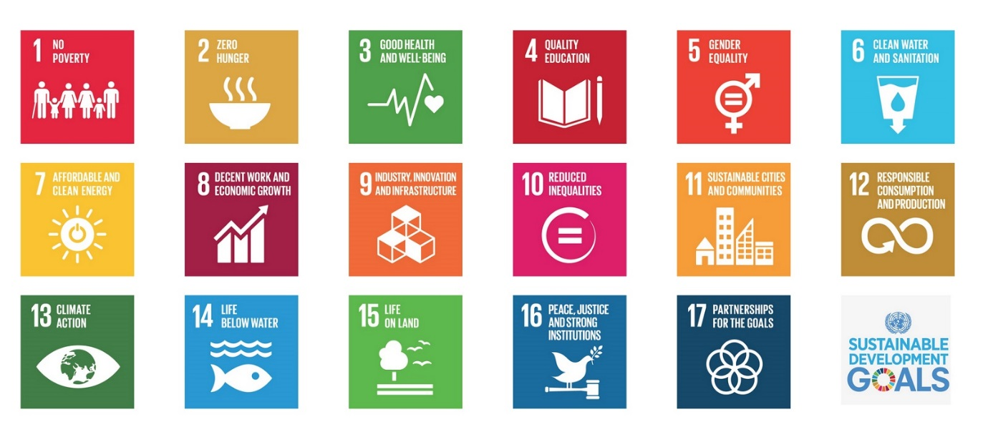

Figure 3: Seventeen (17) sustainable development goals. Source United Nations sustainable development platform.
This study will classify these 17 sustainable development goals into six and then use ten creative and innovative funding options to develop, “a sustainable project funding matrix”. However, the concept of creative and innovative financing has to be fully understood first.
- What is creative and innovative financing?
The terms innovative and creative financing can be said to be synonyms. The slim difference is that which relates to creativity, as a sense of creating capacity or ability to conceive something original and/ or uncommon. Innovative on the other hand is the inventiveness akin in the implementation process. For the purpose of this paper, despite the distinctive names of innovative financing and creative financing, they will be termed innovative financing.
There are various definitions of innovative financing. The World bank defines innovative finance for real estate development as involving non-traditional forms of funding through private mechanisms, solidarity mechanism, public-private partnership (PPP) mechanism and catalyst mechanism (Grishankar, 2009). Therefore, innovative financing hinges on the three headings as considered by the World Bank:
- Innovative finance is a way of generating additional development funds by tapping new funding sources beyond conventional machineries such as established traditional and international operations allied to financial institutions such as banks.
- Innovative financing is a platform to enhance efficiency of financial flows, by reducing delivery time and/or cost, especially for emergency needs and in crisis.
- Innovative financing enables financial flow to function on a result-oriented modus; it proffers a distinctive link between funding flows and measurable performance observed on the shop floor.
In real estate financing, innovative is best conceived as a hub, which encapsulate various novel ideas in real estate financing which could impact on another society. Consequently, it encompasses the bringing of existing options in readiness for a new market or in a market where their maximal effect is yet to be utilized.
“innovative financing is a mechanism to raise funds in addition to conventional methods as well as a mechanism to improve the use of the funds” (Gargasson & Salome (2010, pp 13)
The innovative real estate financing option that left a bitter taste on people’s tongues in the not distant past was the securitization and its commercial mortgage backed securities (CMBS) which was a major contributor to the 2007/2008 global financial crisis (Mamun, 2017). This was because it was abused in the sense that subprime mortgages where availed to the beneficiaries who could not make good their obligations (Yandle, 2010). This was because fundamental risk assessment reviews were not done or rather not enforced and loans were given to people who did not have the capacity to repay.
This study cogitates and reflects on the impact of creative and innovative financing that were used for large real estate projects in the past and how it contributed in making these projects sustainable. It will further show-case the need to develop greater interest in securitisation and other innovative finance options which, among portfolio asset managers, are widely received as strong sources of funding for a sustainable commercial real estate sector (figure 4).

FINANCE ENVIRONMENT
SUSTAINABLE PROJECTS/ENVIRONMEMT
TO FACILITATE
INNOVATIVE REAL ESTATE FINANCE

Figure 4: Innovative financing as a facilitator of a sustainable environment.
  - Why do we need creative and innovative finance?
Ratio of capital to loan: Most lenders across the globe are under pressure to improve the ratio of capital they hold to loans given. Consequently, the lenders are restrained from giving adequate financing to the likes of commercial real estate’s firms. The Federal Reserve and the bank of England low interest rates have kept interest rates historically low (Brunnhuber,2015). Despite this, the supply of credit is still very low because banks are giving top consideration to borrowers considered less risky (Guercia & Riley, 2017). However, creative and innovative real estate financing can reduce this pressure on investors and developers, thereby enhancing the development of sustainable projects.
Housing gaps: The global demand in the real estate market is higher than the supply.
This is evident in London and other big cities of the world (Tilford, 2015; Tustin, 2017).
McKinsey Global Institute (MGI) study (2014) suggests 1.6billion people across the world which is about one third of the urban population could be living in substandard housing or foregoing essentials to pay for their home by 2025. British Broadcasting Corporation (BBC) in 2015, while analysing the scale of housing shortage in England, explained that the Government wants a million homes built by 2025. Despite all that the government is doing to ameliorate the housing problem, it is still persistent. One of the very evident solutions is financing.
Creative and innovative financing is profitable for all stakeholders: Innovative financing is profitable for all the stakeholders if properly structured. A notably example is China which expanded their securitisation portfolio to $31.6Billion in December 2013 signifying how profitable it is (Ngwu & Cheng, 2016). Furthermore, lenders made $94billion from commercial mortgage backed securities which were sold off as bonds in 2014 (Wallace, 2015). This does not only enhance the investors but create jobs, activate economic growth there by making the environment as well as projects more sustainable.

  - How does creative and innovate finance create sustainable projects?
To understand how creative and innovate finance support and /or create a sustainable project. This study will develop a real estate project sustainability funding matrix. This will be done by classifying the seventeen (17) sustainable development goals into six (6) and matching then with ten (10) creative and innovative funding options that if used will develop a sustainable project and hence a sustainable environment.

Sustainability goals Innovative finance options
Securitisation
No poverty, zero hunger, good health, reduced inequality, gender equality, peace justice and strong institutions, partnership for the goal
Crowd Funding
Loan syndication
Quality education, clean water and sanitation, affordable and clean energy
Build then sell (BTS)
Sell the build (STB)

Decent work and economic growth
PPP/PFI (Private Public Partnership / Private Finance Initiative)
Infrastructure, climate action, life below water and life on land
Mezzanine Capital
Participating Mortgages
Industry innovation
Convertible mortgages
Sustainable cities and communities
Joint ventures

Figure 5: Project sustainability funding matrix

4.2:1. Justifications for the project sustainability funding matrix
- It provides funding over the life cycle of the project: The creation, operation and management of real estate’s projects especially ones as large as commercial real estate projects over its life cycle involves the owner (sponsors) and a wide range of professionals (Sing, 2002). It also involves firms in the architecture, engineering, constructions and facilities management (Kamara, 2012). The funding decision for these types of projects is what makes it successful and hence impactful (sustainable). Funding options like Public Private Partnership (PPP) if used will make these kinds of projects sustainable. This is because such projects are long-tenured and often needs very large sums, consequently PPP will adequately take care of materials, payment of salaries for both skilled and unskilled workers; the covenants could incorporate government policies such as bridging of inequalities by employment of minority indigenes, as well as bridging gender inequalities. This makes such projects socially sustainable because adequate funding is sourced to fulfil the mission of sustainability.
Public Private Partnership (PPP)/ Private Finance Initiates (PFI) do not only meet with the social needs of the society through projects. It also provides funding for large commercial real estate’s projects that will accommodate interactive economic nodes such as airports, highways and communication, ultimately making the aggregates of such projects, smart or intelligent cities (Gibson et al, 1992). This leads to decent work and economic growth, sustainable cities and communities, interdisplinary collaborations and ultimately reduced hunger and poverty.
PPP/PFI funding since it is a project lifecycle funding also takes care of environmental sustainability because it makes adequate provisions for clean water and sanitation as well as affordable clean energy.
- Provides funding for innovation and infrastructure: Crowd funding is a creative and innovative finance option that can be used at the start off a new project before other means of innovative funding such as venture capital is sourced. This type of financing enables developers to commence projects with some degree on independence that is commonly not considered for bank financing or investment by large financial institutions (Lam & Law, 2016). Crowd funding is relatively new as compared with most other types of innovative financing. The use of social media and the internet as a whole has enhanced its effectiveness and popularity in contemporary times. The risk is widely spread because it taps relatively small contribution from a large number of individuals using internets, without assistance of financial intermediaries. It is a relationship between the entrepreneurs, investors (crowd funders) and the intermediaries (crowd funding platforms).
Crowd funding can be used to develop more innovations in the contemporary developments in the real estate sector which are technological based innovations. This includes research and development (R & D) into lean, internet of things, cost effective and resource efficient technologies over a wide range that can be sold to real estate firms to enhance projects as well as protect returns to the investors. This kind of outputs through Crowd funding makes projects more sustainable.
- Provides decent work and economic growth: Securitisation is a good funding option that can facilitate decent work as well as economic growth. Securitisation is a finance technique where debts are sold to investors. Despite how profitable securitisation is to all the stakeholders, it could be very dangerous if backed by poor credits, inadequate valuation methods and insufficient regulatory oversight. This was the danger the world was thrown into because of actions and inactions of the rating agencies; regulatory agencies and financial institutions with large and unrestrained risks appetite (Smith, 2017). However, all of these excesses are now being contained by the regulatory authorities. The Bank of England wants to encourage investors and banks back in to the securitisation market. It expedient to provide long -term housing lending with long-term savings and loans through securitisation to avoid funding mis-match. This position by David Rule, was concurred to by former Chancellor, George Osborne when he welcomed the proposal to improve business funding through securitisation (Wallace, 2015)
Securitisation does not only provide funding for the real estate projects but makes good returns for the investors, provides funding for jobs for people in the construction and other associated sectors. The ripple-effect of securitisation improves economic growth and hence a more sustainable environment.
- Provides Sustainable cities and communities: Creative and innovative finance such as mezzanine finance , joint ventures , sell then build (STB), public private partnership (PPP), securitisation and loan syndication could facilitate the building of projects that will make up smart cities and communities.
Sustainable projects are integral parts of smart cities (Gibson et al, 1992). Smart cities are sometimes referred to as, “intelligent cities”. These are network cities of dispersed, highly interactive nodes linked by networks such as airports, highways and communications. These types of projects are highly capital intensive and can only be accommodated by a blend of different financing (Gargasson & Solome, 2010).
Mezzanine finance is very important for these kinds of large projects because it does not require highly liquid collateral like bank financing. It is accompanied by an increased rate of return for the investors. Mezzanine loan is different from Mezzanine finance. Mezzanine finance is broader and also includes financial instruments such as stocks, bonds and options used in securities market (Sazonov et al, 2016). Mezzanine finance is flexible and could take the form of bridge finance. Mezzanine finance can be sourced from a country and used in another for real estate’s projects. Especially in the emerging economies where there is shortages of sustainable projects (Jayanti and Gowda, 2014). The usage of Mezzanine finance could cover every phase of the project, from working capital requirement (payment of salaries and purchase of raw materials), business expansion and capital investment. Hedge funds, pension funds, private equity funds, insurance companies and banks with the relevant departments usually act as mezzanine investors (Sazonov et al, 2016).
Furthermore, Syndicated loans are also a very viable innovative finance option that can be used to finance the establishment of sustainable projects hence sustainable cities and communities. Syndicated loans are parcelled amongst a number of banks, ranging from two (2) lenders to more than thirty (30) in some cases (Berlin, 2007). Large real estate’s development firms that are involved in the building of sustainable communities can borrow very large sums at lower rates and longer tenures when no single lender is too heavily exposed.
Other sources of funding such as sell then build (STB), joint ventures, participating mortgages and convertible mortgages are innovative finance options that could support the creation of sustainable cities and communities. Sustainable cities are communities are usually well equipped with good infrastructure, quality education, clean water and sanitation and clean energy which are all indicators of a sustainable environment. All of these sustainable provisions are only feasible through the right choices of funding.
- An evaluation of empirical literature on case studies of sustainable projects that used creative and innovative financing
Research has showed that there is an increasing use of creative and innovative financing for large mix use properties in Europe (Iblher & Lucius, 2003). There is a great blend of equity and debt, which can be considered innovative finance
The Battersea project (figure 6) which is a mix of residential and commercial scheme used debt-equity from non- domestic investors and pension funds along with international banks (loan syndication). This project has 600 houses, as well as commercial space hence was to meet great need in the housing sector. However, the development took between 10 to 12 years with a gross development value of £8billion (Squires et al, 2016). . There were series of re-financings before the completion of this project. This project is economically viable because London where it is situated has a buoyant housing market
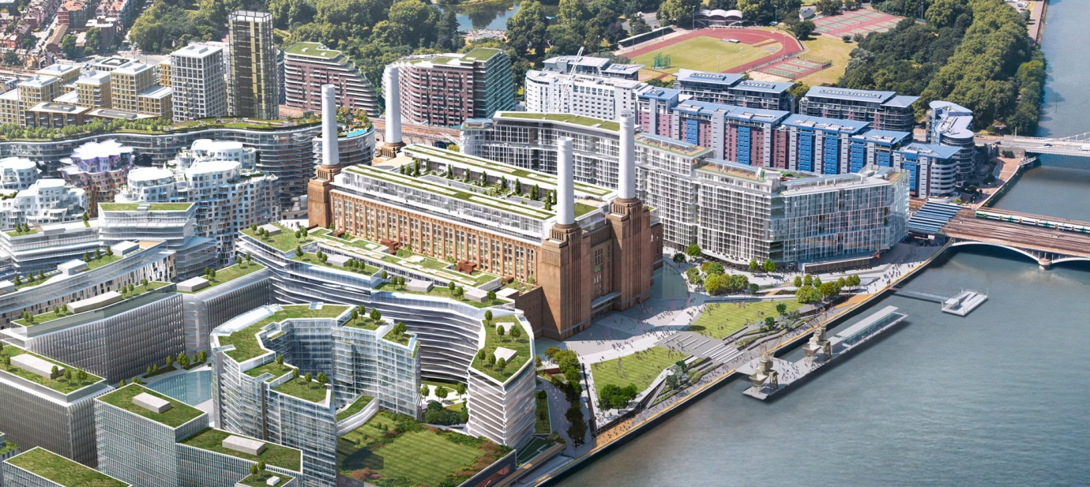
Figure 6: Battersea power station project. Source https://www.batterseapowerstation.co.uk
Another interesting project that used creative and innovative financing is the Leipziger Plaz, in Berlin (figure 7). It is a large residential development covering 76,000m² . It used a mixture of debt and equity financing and land assembly finance. This project also show- cased the flexibility in contemporary real estate financing. The debt finance was syndicated loan from a consortium of banks. There were also private investors and institutional investors who part-financed this project.
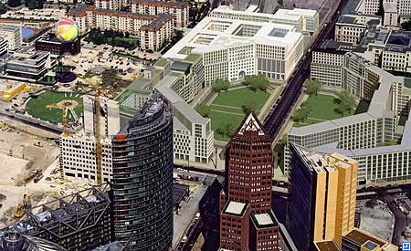
Figure 7: Leipziger Plaz. Source http://www.leipziger-platz-berlin.org
Build then Sell (BTS) and Sell then Build (STB) were used Malaysia where the Government intervened to tackle the problem of abandoned housing project. In the STB, the buyer often makes down payment of about 10% and makes further payments for the different phases of the projects as development continues. This is innovative as it is not conventional and provides the capital needed for project. In the BTS the government provides concessionary credit by waivers of deposit for developer’s license and provides fast track planning approval process (Yusof et al, 2011). This model of real estate financing is very effective for commercial real estate projects.
What made these projects sustainable?
These projects were all sustainable projects because they contributed individually to meeting some and sometimes all the United Nations sustainable development goals (see figure 3). This was possible because the developers and investors used different creative and innovative finance to actualise the projects (see figure 5)
- Conclusion and recommendation
This study shows that we can only say a project is sustainable when it meets some or all of the United Nation’s seventeen (17) sustainable development goals (see figure3). Furthermore, in contemporary times, it is only possible to achieve sustainability in real estate projects through the usage of creative and innovative financing. This is because the world is facing reduced real estate project funding from the financial markets and the governments. Despite this short-falls in funding, there is an increasing real estate’s projects shortage, especially in the emerging economies. This gap in the real estate’s sector must be met in a manner that will engender sustainability.
This study recommends more usage of creative and innovative financing for real estate projects in the developed economies where it is increasingly being used as well as replicating this best practise in the emerging economies. The study further developed a, “sustainable project funding matrix”, (see figure 5). This matrix can be used as a guide by decision makers with respect to project funding decisions that can enhance different areas of sustainability.

References:
- Ahvenniemi, H., Huovila, A., Pinto-Seppä, I. and Airaksinen, M. (2017) what are the differences between sustainable and smart cities? Cities, February 2017, 60, pp. 234-245. DOI: http://0-dx.doi.org.lispac.lsbu.ac.uk/10.1016/j.cities.2016.09.009.
- Ball, M., Lizieri, C., MacGregor, B. D. and MyiLibrary (2002) The economics of commercial property markets. London: Taylor & Francis e-Library.
- Battersea power station project. Available at https://www.batterseapowerstation.co.uk( Accessed on 31st July, 2017)
- Berlin, M. (2007) Dancing with Wolves: Syndicated Loans and the Economics of Multiple Lenders, Business Review (Federal Reserve Bank of Philadelphia), , pp. 1-8.
- Brunnhuber, S. (2015) How to Finance our Sustainable Development Goals (SDGs): Socioecological Quantitative Easing (QE) as a Parallel Currency to Make the World a Better Place, Cadmus, 2 (5), pp. 112-118.
- Dresner, S. (2008) The principles of sustainability. London; Sterling, VA: Earthscan.
- Edwards, B. and Turrent, D. (2000) Sustainable housing: principles & practice. London: E & FN Spon.
- Gargasson, J. and Salome, B. (2010) The role of innovative financing mechanism for health. Available at : www.who.int/healthsystems/topics/financing/healthreport/InnovativeBP12FINAL.pdf (Accessed 29th July, 2017)
- Gibson, D.V., Kozmetsky, G. & Smilor, R.W. (1992) The technopolis phenomenon: Smart cities, fast systems, global networks, Rowman & Littlefield. Urban studies (Routledge). Aug94, Vol. 31 issue 7, p1239
- Girishankar, N. (2009). Innovating development finance-from financing sources to financial solutions. Available at :
http://siteresources.worldbank.org/CFPEXT/Resources/CFP_Working_Paper_No1.pdf (Accessed 28th July, 2017)
- Gueye, K. (2002) Financing Sustainable Development: Trends and Emerging Policy Approaches in Asia and the Pacific, International Review for Environmental Strategies, 3 (1), pp. 153-163.
- Gup, B. E. (1992) The basics of investing. 5th ed. New York; Chichester: Wiley.
- Hui, E. C. M., Wang, Z. and Wong, H. (2014) Risk and credit change in Asian securitized real estate market, Habitat International, 43 , pp. 221-230.
- Huston, S., Rahimzad, R. and Parsa, A. (2015) ‘Smart’ sustainable urban regeneration: Institutions, quality and financial innovation, Cities, 48 , pp. 66-75.
- Engle, M. (1999) Qualitative Data Analysis: An Expanded Sourcebook (2nd Ed.), by Matthew B. Miles and A. Michael Huberman. Thousand Oaks, CA: Sage Publications, 1994, 336 pp, American Journal of Evaluation, 20 (1), pp. 159.
- Iblher, F., & Lucius, D. I. (2003). Innovative real estate financing in Germany – a financial desert? Property Management, 21(1), 82-96.
- Jayanti, R. K. and Rajeev Gowda, M. V. (2014) Sustainability dilemmas in emerging economies, IIMB Management Review, June 2014, 26 (2), pp. 130-142. DOI: http://dx.doi.org/10.1016/j.iimb.2014.03.004.
- Kamara, J.M. 2012, "Integration in the project development process of a Private Finance Initiative (PFI) project", Architectural Engineering & Design Management, vol. 8, no. 4, pp. 228-245.
- La Franchi, D. (2008), "Bridging the Financial Gap", Economic Development Journal, vol. 7, no. 4, pp. 5-11.
- Lam, P. T. I. and Law, A. O. K. (2016) Crowdfunding for renewable and sustainable energy projects: An exploratory case study approach, Renewable and Sustainable Energy Reviews, July 2016, 60, pp. 11-20. DOI: http://dx.doi.org/10.1016/j.rser.2016.01.046.
- Leipziger platz. Available at http://www.leipziger-platz-berlin.org (Accessed on 31st July, 2017)
- Lynn, D. J. and Wang, T. (2010) Emerging market real estate investment: investing in China, India, and Brazil. Hoboken, N.J.: Wiley.
- Loh, B. (2010) Public Infrastructure Financing in Southeast Asia, Regional Outlook, , pp. 92-96.
- Ngwu, F. N. and Chen, Z. (2016) Regulation of securitisation in China: Learning from the US experience, Research in International Business and Finance, 37 , pp. 477-488.
- McLean, A. J. and Eldred, G. W. (2003) Investing in real estate. 4th ed. New York; Chichester: Wiley.
- Medda, F.R. and Modelewska, M. (2009), Land Value Capture as a Funding Source for Urban. Available on : https://www.ucl.ac.uk/qaser/pdf/publications/ernst_young
- Murray, S (2011) Sustainable lessons from the board room: Financial times [Online] available from <http://lexicon.ft.com/Term?term=environmental-sustainability&mhq5j=e1> (Accessed 9/07/2017)
- MAMUN, A. (2017) An Investigation into the Factors Causing Financial Crisis: Lessons from Recent Overwhelming Episodes, Journal of Academic Research in Economics, 9 (1), pp. 7-18.
- Marsal-Llacuna, M. and Segal, M. E. (2016) The Intelligenter Method (I) for making “smarter” city projects and plans, Cities, 55 , pp. 127-138.
- Mckinsey Global Institution (2014), “ Tracking world’s affordable housing challenge. Available at: http://www.mckinsey.com/global-themes/urbanization/tackling-the-worlds-affordable-housing-challenge ( Accessed on 29th July, 2017)
- Nersisyan, Y . and Wray, L. (2010). Transformation of the financial system: financialisation, concentration, and the shift to shadow banking.
- O'Brien, R., Iverson, I. and Marjolin, R. (1990) Finance and the international economy 3 :the AMEX bank review prize essays, in memory of Robert Marjolin. Oxford, England; New York: Oxford University Press for the AMEX Bank Review.
- Orrick Jr., J. R. (2015) Financing Commercial Real Estate Projects, Probate & Property, 29 (6), pp. 28-32.
- QUERCIA, R. G. and RILEY, S. (2017) Expanding the Mortgage Credit Box: Lessons from the Community Advantage Program, Boston College Journal of Law & Social Justice, 37 (2), pp. 315-338.
- Randall Wray, L. and Nersisyan, Y. (2015) 3. Understanding Money and Macroeconomic Policy, Political Quarterly, 86 , pp. 47-65.
- Vanags, J. and Butane, I. (2013) Major Aspects of Development of Sustainable Investment Environment in Real Estate Industry, Procedia Engineering, 2013th, 57 , pp. 1223-1229. DOI: http://dx.doi.org/10.1016/j.proeng.2013.04.154.
- Wallace, T (2015). “Bank Of England Wants To Re-Start Mortgage Securitisation”, The Telegraph, 17 June, Available at: http://www.telegraph.co.uk/finance/11681597/Bank-of-England-wants-to-re-start-mortgage-securitisation.html (Accessed: 16 July, 2017)
- SMITH, D. K., CLARKE, T. and ROGERS, J. (2017) Banking and the Limits of Professionalism, University of New South Wales Law Journal, 40 (1), pp. 411-455.
- Singh, A.J. (2002), "The evolution of innovative debt and equity structures: The securitisation of US lodging real estate finance", Briefings in Real Estate Finance, vol. 2, no. 2, pp. 139.
- Silvius, A., Brink, J. and Kohler, A. ( 2012 ). The impact of sustainability on project management. 1st ed. (ebook) Available at: http://books.publishing.monash.edu/apps/
bookworm/view/The+Project+as+a+Social+System%3A+Asia-Pacific+Perspectives+on+Project+Management/171/OEBPS/ c11.htm ( Accessed 24th July,2014)
- Sun, Z., Li, X. and Xie, Y. (2014) A comparison of innovative financing and general fiscal investment strategies for second-class highways: Perspectives for building a sustainable financing strategy, Transport Policy, 35 , pp. 193-201.
- Sazonov, S. P., Ezangina, I. A., Makarova, E. A., Gorshkova, N. V. and Vaysbeyn, K. D. (2016) Alternative Sources of Business Development: Mezzanine Financing, Scientific Papers of the University of Pardubice.Series D, Faculty of Economics & Administration, 23 (37), pp. 143-155.
- Squires, G., Hutchison, N., Adair, A., Berry, J., McGreal, S., & Organ, S. (2016). Innovative real estate development finance – evidence from Europe. J of Fin Man of Prop and Cons, 21(1), 54-72.
- United nations sustainable development knowledge platform. Available at : https://sustainabledevelopment.un.org/(Accessed on 29th July, 2017)
- Tilford, S. (2015). "Britain, immigration and Brexit", CER Bulletin, vol. 30, pp. 64-162. Available at : http://www.cer.eu/publications/archive/bulletin-article/2015/britain-immigration-and-brexit
- Tustin, M. (2017) Legal Interventions to Meaningfully Increase Housing Supply in New Zealand Cities with Housing Shortages, Victoria University of Wellington Law Review, 48 (1), pp. 133-161.
- YANDLE, B. (2010) Lost Trust The Real Cause of the Financial Meltdown, Independent Review, 14 (3), pp. 341-361
- Zhang, W. and Wu, H. (2014) A Research on the Diversification of Financing Modes of Real Estate Enterprises in China, in: 2014 International Conference on Global Economy, Commerce and Service Science (GECSS-14), Atlantis Press.
- Zhang, X., Wu, Y., Shen, L. and Skitmore, M. (2014) A prototype system dynamic model for assessing the sustainability of construction projects, International Journal of Project Management, 32 (1), pp. 66-76.
- Zittoun, T. (2017) Modalities of generalization through single case studies, Integrative Psychological and Behavioral Science, 51 (2), pp. 171-194.

