A holistic design approach for 5th Generation Smart Local Energy systems: project GreenSCIES
Akos Revesz, Chris Dunham, Phil Jones, Carole Bond, Russell Fenner, Sagar Moody, Rajvant Nijjhar, Catarina Marques, Graeme Maidment

Abstract
This paper introduces a project called GreenSCIES; an InnovateUK funded detailed design project to develop a Smart Local Energy System (SLES) delivering a significant carbon saving for local residents, schools and businesses. The SLES is centred around a 5th Generation District Heating and Cooling (5DHC) network in the London Borough of Islington. The local energy system will deliver low carbon heating, cooling, power and e-mobility charging powered by renewable energy and waste heat, sourced from the local area. The proposed SLES will manage and balance the supply, storage (both thermal and electrical) and use of local energy across mobility, power and heat vectors. It will do so using smart control technologies, bringing significant energy efficiency and security as well as social, environmental and economic benefits to Islington.
The paper introduces the holistic SLES design approach developed by the GreenSCIES consortium, building upon an initial feasibility study previously published by the authors. The design methodology described takes technical and commercial aspects of a SLES design into account, whilst also explaining the importance of effective stakeholder engagement and co-design with local communities. The paper also provides a technical overview around the intended operation of ambient loop and heat pumps alongside long and short term thermal energy storage. A technical approach selected for integrating electric vehicles (EVs) and solar photovoltaic (PV) is also discussed in detail, alongside the control system architecture developed for the integrated SLES. The paper subsequently moves into demonstrating the benefits of the integrated SLES through a focused scheme design called New River, demonstrating integrated SLES performance compared to conventional systems in a real setting, through a comprehensive energy model. The results presented from a techno-economic analysis demonstrate that significant carbon savings and an attractive internal rate of return of (10%) can be achieved. The results presented show that even the smaller constructible “New River” scheme will save more 5,000 tons of CO₂e annually. This is a reduction in carbon emissions by 80% over conventional systems and, therefore a major decarbonisation solution in large cities across the world. The GreenSCIES approach presented in this paper is replicable worldwide and could become a central part of delivering nations’ net zero carbon strategy.

Abbreviations/Glossary
5DHC | 5th generation District Heating and Cooling
AAHEDC | Assistance for Areas with High Electricity Distribution Costs
A-loop | Ambient loop
ATES | Aquifer Thermal Energy Storage
BEIS | Department of Business Energy and Industrial Strategy
BTM | Behind the Meter
CAPEX | Capital expenditure
CCL | Climate Change Levy
CFD | Contracts for Difference
CMC | Capacity Market Charges
CO₂ | Carbon dioxide
CoP | Coefficient of Performance
DNO | Distribution Network Operator
DSR | Demand Side Response
DUoS | Distributed Use of System Charges
e-mobility | Electric mobility
ESCo | Energy Services Company
EV | Electric vehicle
FFR | Firm Frequency Response
FIT | Feed-in-tariff
ICEF | Islington Community Energy Fund
IIR | Internal Rate of Return
ISEP | Islington Sustainable Energy Partnership
JV | Joint Venture
kWe | Kilowatts electrical
kWh | Kilowatt-hour
LB | London Borough
LBI | London Borough of Islington
MPAN | Meter Point Administration Number
MPH | Mobility, Power and Heat
MWh | Megawatt-hour
NPV | Net Present Value
OPEX | Operational expenditure
Prosuming | “Prosuming” heat pumps consume heat (and upgrade it to a useful temperature) but in doing so produce cooling
PFER | Prospering from the energy revolution
RHI | Renewable Heat Incentive
RO | Renewable Obligation
SLES | Smart Local Energy System
STOR | Short-Term Operating Reserve
TE | Techno-economic
V2G | Vehicle to Grid
VPN | virtual private wire network

Highlights
- Ambient loops integrated with EV and PV could help decarbonise urban areas
- Aquifer Thermal Energy Storage provides a novel way of balancing the system
- The Behind the Meter electrical connection approach is cost-effective
- Significant carbon savings and an attractive internal rate of return
- The holistic SLES design approach is replicable and it can be used as a guide

1. Introduction
There is a growing consensus internationally, that the threats posed by climate change should now be treated as an emergency. In 2019, the United Kingdom (UK) became the first major economy to commit to a legally binding target of cutting greenhouse gas emissions (GHG) to net-zero by 2050. Later, in 2021, the government laid legislation for the UK’s sixth carbon budget, proposing a world-leading target which would reduce greenhouse gas emissions by 78% by 2035 compared to 1990 levels (BEIS, 2021a). As the UK aims to further reduce its contribution to climate change and deliver net-zero, decarbonising heat becomes one of its main challenges, as the sector is responsible for nearly half the energy consumption and a third of the carbon emissions (BEIS, 2018). With hydrogen for domestic heating looking unlikely anytime soon leads to the conclusion that electricity, coupled with heat pumps, is the most effective solution to provide low carbon heating, as recognised by the UK Government’s Heat and Buildings Strategy (BEIS, 2021b). Once a heat pump provides heating and hot water for a building, its carbon emissions will reduce as the grid decarbonises, which is a general trend in many nations. For example, the increased uptake of renewable energy sources for electricity production in the UK reached an all-time record of 37% of the power generated in 2019 (BEIS, 2020). Alongside of the encouragement of major heat pump deployment across the UK, the recent strategies published by the Government also acknowledge the vital role of heat networks, as well as the emphasis on the energy efficiency of buildings and a multi-vector system-wide approach to energy.
The energy system transition is also likely to create a more distributed energy system where local energy generation plays a much greater role in energy supply. A local approach is widely being acknowledged and in support of this, InnovateUK on behalf of the UK Government, have been supporting the development of Smart Local Energy Systems (SLES) through the Prospering from the Energy Revolution programme (PFER) (UKRI, 2019).
A typical SLES integrates mobility, power and heat energy vectors (MPH) into one common system, leveraging benefits and synergies. A central objective of the PFER programme is to understand how SLES could support prosperous communities across the United Kingdom, through means such as cutting energy bills, creating jobs and attracting investment (UKRI, 2019). This section provides a detailed review of the benefits of energy system integration and the lessons learnt from a detailed design exercise. It sets the scene for a focussed scheme design in the main body of the paper identifying how a SLES can be applied and how it can overcome the key challenges to its uptake.
1.1 Benefits of energy system integration
Smart integration of MPH energy vectors opens up flexibility and sharing opportunities within an energy system, resulting in carbon emission reductions and significant cost, with service and comfort benefits to end-users. The implementation of SLESs could provide a path and roadmap to help towns and cities worldwide to achieve net zero targets on time. However, energy system integration is a complex process presenting a number of technical, commercial and social challenges. Also the concept of energy system integration is at a stage of relative immaturity in the market and very few currently operational SLES schemes exist worldwide.
The thermal element of the proposed SLES concept presented in this paper formed around a 5th generation district heating and cooling (5DHC) network concept where customers can be producers and/or consumers (prosumers) of thermal energy flows within the network. 5DHC is a non-traditional topology with decentralised plant, usually electric heat pumps, supplying heat or coolth to the connected prosumers through an ambient loop. 5DHC networks are characterised by distribution temperatures in the ambient range of 15-25 °C, which not only reduces heat loss but also allows for integrating various kinds of low-temperature waste heat sources such as heat from urban data centres. The economic benefits of lower distribution temperatures have been estimated by Averfalk and Werner, (2020) and shown to be significant in comparison to the traditional higher temperature systems. Further benefits of 5DHC networks were investigated and discussed by a number of authors which all showed to be significant compared to the operation of previous generation networks. Jones (2019) and Revesz et al. (2020) both highlighted opportunities associated with prosuming of energy between applications, with the greater prosuming leading to greater carbon savings. Boesten et al. (2019), concluded that 5DHC systems provide a high level of flexibility as a result of their integration of heating, cooling and electricity infrastructures and the availability of storage facilities at different temperatures and time scales. The work of Buffa et al. (2019) assessed the drawbacks and benefits of 5DHC systems by the means of a SWOT and a statistical analysis of 40 existing systems. The study concluded that ultra-low temperature nature of the 5DHC concept allows recovering many kind of excess heat which is locally available. Moreover, it was highlighted that 5DHC systems are resilient to changes in boundary conditions like variations in building efficiency levels and user needs. This particular benefit is related to the decentralised nature of the 5DHC concept, where heat pumps at each user substation, can supply thermal energy at both low and high temperature satisfying the requirement of the building. The more recent work of Gudmundsson et al. (2021) suggested when discussing 4DH and 5DHC the focus should be on the overall system efficiency and the levelized cost of the heat rather than the efficiency of the distribution grid. Their initial results indicated that 4DH is the more competitive heat supply solution for the case studied case studied considered. However, the investigation of CO₂ emissions and the bi-directionality i.e. high shares of prosumers in the network have not been part of the authors’ analysis.
The integration of e-Mobility and PV systems with electrified heat pump based 5DHC networks could provide further flexibility, cost and carbon saving opportunity. The transition from conventional vehicles to low carbon emission Electric Vehicles (EV) is on the agenda on many country’s zero carbon strategy. For example, the UK has recently introduced “The 10 Point Plan” for delivering a green industrial revolution (GOV.UK, 2020). This plan sets out a programme of action to the meet the UK’s net-zero emission targets. One of the 10 points is related to phasing out sales of new petrol and diesel vehicles by 2030. The predicted growth in numbers of EVs and EV charging infrastructure provides a great opportunity for the integration of e-mobility into localised SLES. A number of studies have investigated the use of EVs within intelligently controlled energy systems. In particular, there is evidence for the economic benefits of using EVs to participate in the primary frequency regulation markets through demand side response mechanisms. For example, Vehicle-to-Grid technology (V2G), allows the provision of energy and ancillary storage services from an electric vehicle to the grid. This has the potential to offer financial benefits to EV owners and system benefits to utilities. For example, a recent report published by Piclo (2020) estimated that introducing flexibility via demand side response and smart charging can reduce overall electricity system costs by circa £4.55bn/year in the UK. The same report also highlighted that only innovative technologies such as V2G can deliver the full network benefit by maximising distributed energy storage.
The optimal integration of EVs in the electric power system and the associated potential benefits have been discussed by a number of researchers. For example, Lund and Kempton (2008) investigated the impact of V2G on national energy systems. The work concluded that EVs with night charging, and more so with increasing intelligence including V2G, will improve the efficiency of the electric power system and lower CO₂ emissions. The research of Lopes et al. (2011) around control strategies for EV integration also shows benefits for the wider energy system. The results showed that the adoption of advanced centralised EV charging control strategies allows the integration of a larger number of EVs in the system, without the need for grid reinforcement. The work of Sortomme and El-Sharkawi (2012) investigated the financial and system benefits of V2G and ancillary services. The study showed that optimal scheduling of the EVs can result in significant profits to the electricity aggregator while providing additional system flexibility and peak load shaving to the utility with low costs of EV charging to the customer. Similarly, the work of Høj et al. (2018) has identified that the introduction of V2G offers a range of attractive business models, which primarily focus on providing stability services to the energy grid and optimizing the economic benefits of owning an EV. Moreover, the research of Mouli et al. (2019) observed that a large portion of the V2G revenues came from increased regulation services offered rather than from V2G energy sales due to the battery degradation penalty. Assessment of economic benefits for EV owners participating in the primary frequency regulation markets has been carried out by Bañol Arias et al. (2020). It was demonstrated that even by bidding into the market with a low power capacity of 1 kW, EV owners are able to obtain an annual benefit of around €100.
All these studies concluded that smart integration of EVs, including V2G, improves the efficiency of the electric power system, lowering CO₂ emissions and improving the ability of the grid to utilise more renewable power. However, there are barriers of accessing all these potential benefits. For example, Gonzalez et al. (2019), highlighted that the main barriers come from economic and institutional aspects, such as the absence of frameworks for local flexibility trading, uncertain viable business models and the evolution of roles and responsibilities of DSOs as well as their interactions with other stakeholders. In particular, Sovacool et al. (2020), identified twelve distinct stakeholder types or business markets related to V2G, cutting across industrial firms, households, electricity suppliers, transmission operators, and other third party actors. The study highlighted that the role of aggregators, fleet operators, public transit operators and small-scale renewable energy power providers are important, though less explored to date in literature.
The role of Photovoltaic (PV) systems in combination with stationary batteries in communal smart energy systems is also a focal point in a number of research studies. It was shown within the Danish case study presented by Marczinkowski and Østergaard (2018) that large scale communal battery hubs can further create synergies with other sectors by offering the battery’s stored electricity to, for example, local EV charging stations or to the heating sector. The authors highlighted that in this way, a sectorial integration can be implemented, merging the electricity, heating and transport sector as suggested by Lund et al. ( 2012) and Lund et al. (2017).
The rise of electricity flexibility trading also opens up new markets in the power side of MPH. Flexibility includes demand turn-up and demand turn-down at particular times of the day when the local Distribution Network Operator (DNO) is facing a constraint on the system. Instead of investing in costly grid infrastructure reinforcement, they procure either long-term fixed or short-term (could be as short as the preceding half hour) dynamic contracts. These are based on a tender or bidding process that allows asset owners or third party Intermediaries (TPIs) to bid for an availability and a utilisation price. The summer of 2019, flex tender saw UK Power Networks (UKPN) award £14m of contracts to procure flexibility across 123MW across various regions (the energyst, 2020). The flex markets are not the only markets that assets can be traded into. In general, the terms Behind The Meter (BTM) refer to assets behind the building’s Meter Point Administration Number (MPAN) such as controllable non-critical assets (heat pumps, air handling units, refrigeration, generation and storage), and in front of the meter assets are anything that can include large Solar PV and combined battery storage facilities. In general, both behind and in front of the meter assets can be traded into several other markets, depending on size of the unit being traded. For example, taking the extreme end of a 50 MW solar PV farm in the UK– this would be considered as a generation asset like a power station and therefore can trade into the wholesale markets. Smaller units such as 1MW to 3MW can trade into the UK’s capacity markets, Firm Frequency Response (FFR) and balancing mechanism. Secondary markets also exist in the UK such as Short-Term Operating Reserve (STOR), black start and curtailment. This is a fast moving market and set to become a major advantage of SLES.
By integrating MPH technologies in an integrated system, the SLES approach has the potential to create more efficient and affordable solutions, although multi-sector/vector energy integration is complex. It is challenging to combine these technologies in a coherent objective and synergistic way to deliver the optimal system (Lund et al., 2017). Cao et al. (2019) proposed an optimal energy balance methodology for sizing the capacity and optimal operation strategy of mixed technologies such as fuel cell, CHP, gas boiler and PV to meet the electric and thermal load of a local energy system. The method presented aims to minimize the total annual cost and emissions of the whole system, based on hourly electrical and thermal load profile.
A similar, integrated energy system modelling approach was presented by Revesz et al. (2020) through a feasibility study developed in a central London location. The following section builds on the authors' previous feasibility work. It also sets out the key challenges of SLES design and then the paper introduces a holistic SLES design approach which is demonstrated through a focussed design exercise in the London Borough of Islington (LB Islington). Techno-economic viability is then demonstrated, showing the huge benefits integrated SLES can bring.

1.2. Building on previous work
The Authors previous work (Revesz et al. 2020) introduced a novel concept for a SLES that is based around a 5DHC network integrating thermal, power and mobility energy vectors. This earlier work introduced a step-by-step approach for the development of an integrated SLESs and demonstrated preliminary results from detailed techno-economic modelling of the concept scheme. The initial results highlighted that the proposed integrated concept offers significant costs and carbon savings.
Since that publication, a funding incentive called the Renewable Heat Incentive (RHI) came to an end which had a significant negative impact on the viability of the proposed SLES. Ideally, RHI would not be necessary to make schemes like GreenSCIES economic but the UK has one of the highest spark gaps – i.e. the difference between the price of gas and the price of electricity - in the industrialised world. This means that the cost of producing heat from gas boilers is around the same price as heat from heat pumps – despite the improved efficiency of heat pumps. The demise of RHI is a significant loss in the economics of GreenSCIES. In particular this is a major set-back against the viability shown in the feasibility study shown in Revesz et al. (2020).
The following section describes the new challenges that the GreenSCIES consortium faced following the loss of the RHI at the end of the first phase of the project. Following that, the paper introduces an holistic design approach developed in the second phase in order overcome of those challenges and with the overall aim to design a SLES that is clean, cost-effective and can provide wider benefits for the local community.

2. Key challenges of SLES design
The challenge to develop SLES around 5DHC networks requires an holistic approach from an integrated technical design team, commercial investigations and stakeholder engagement. Co-design of the network is also crucial and should be an integral part of the community engagement strategy, to ensure that the integrated energy system infrastructure provides maximum benefits for the local community. Currently there is a lack of holistic design approaches reported for SLESs in literature. The Authors of this paper suggest a combined framework for – technical design, - commercial models, and - stakeholder engagement. The following sub-sections discussing the challenges related to each of these design elements.

2.1. Technical challenges including energy system integration and controls
There are considerable challenges in integrating technologies, infrastructure and controls when designing a SLES. Heat pumps, large thermal stores, ambient loop pipework, boreholes etc. In particular, finding solutions to integration of EV charging/cables, PV and large stationary batteries require innovative solutions like shared trenching and AI controls. But there also needs to be some value for the SLES operator in combining Mobility, MPH energy vectors. The critical question is, where does the value lie and how can it be accessed. In the context of SLESs, revenue is typically generated by the use of renewable generation and flexing demand. In terms of the scale of the optimisation, typically three different options are considered. (1) Optimising own energy use, thus having to pay less for the energy use on-site or use less of the DNO network capacity; (2) Aggregating generation assets and providing them to market services; and (3) Energy wholesale markets services like spot electricity market and imbalance market. Some value streams would require an investment to access such as supplier licences; aggregation and control platforms, etc. so there should be a careful consideration around whether those investments are worth it by looking at the operational and economic targets of the proposed SLES. A whole system view needs to be considered to avoid assets competing for the same value streams and affecting the economic case for both (i.e. V2G and static battery storage). This paper will focus on evaluating the advantages and disadvantages of different energy system integration options and will demonstrate the applicability of one that was considered the most suitable one for the GreenSCIES SLES.

2.2. Commercial challenges
Low carbon energy producers and developers of decentralised SLESs face challenges in designing business models that enable the cost-efficient and competitive production for substituting fossil fuel based energy systems. Traditional business models in the energy industry consists of the bulk production of energy and delivery for a specific price. With the emerging trend of smart energy technologies, the traditional value chain undergoes several changes. For example, in SLES individual consumers can optimise their consumption and become prosumers by generating their own decentralised energy or feed their excess energy back to a network. To capitalise on this emerging trend, businesses, Local Authorities or any Energy Services Companies (ESCo) require an understanding of new business options and ways to exploit assets producing often-fluctuating generation combined with carefully planned consumption process through demand side management. In addition, the commercial challenges are exacerbated by a frequently changing energy market. In order to overcome these challenges the GreenSCIES consortium developed a tailored business model solution that works for LB Islington but with replicability potential elsewhere.
A very specific challenge in the UK is the very low price of gas as a counterfactual. Until recently, this was counteracted by a feed-in-tariff called the Renewable Heat Incentive. Unfortunately, this was effectively withdrawn at the end of the GreenSCIES feasibility study. Since then, detailed design and business modelling has been focussed on alternative ways to reach a scheme that is economic and constructable. This commercial challenge has resulted in a smaller scheme called ‘New River’ which is discussed below.

2.3. End-user and Stakeholder engagement involving co-design
End user participation is an essential condition for a SLES. Many possible activities could achieve this, including running a local billboard marketing campaign, introducing it as a default option for new social housing tenancies, or running town hall discussion and sign-up meetings (Fell et al., 2020). However, creating the opportunity for the users to participate in the project design requires careful planning from SLES developers ensuring SLES services planned with, not simply delivered to users. Currently, the literature lacks frameworks for stakeholder engagement and community co-design for SLES. This paper suggests a method for successful engagement of communities where a SLES type system are being considered.
The literature review identified that currently, SLES are relatively immature and there are no comprehensive approaches for their design. The integration of MPH energy vectors can result in reduced and flexible local demands. This can lead to better local energy balancing, reduction of carbon emissions and network costs, with lower end-user bills. There is a need for novel and replicable business models and scalable technological configurations. The design of such integrated solutions requires an holistic approach from an integrated technical design team, commercial investigations, and stakeholder engagement in order to tackle key challenges and enable SLES to develop, and for them to bring clear benefits. Local domestic and non-domestic end-user participation in SLES design is also necessary in order to maximise the value for the local community during SLES design. The following sections of the paper are introducing an holistic SLES design approach developed and implemented by the GreenSCIES consortium. This approach aims to be useful to SLES developers, National and Local Governments. It will also support more holistic local area planning which acknowledges how the different areas of SLES implementation (e.g. end-user engagement, financing, etc.) need to align to maximise local benefits.

3. An holistic design approach to overcome challenges: New River scheme
The loss of RHI subsidy forced the GreenSCIES consortium to focus on a smaller scheme called ‘New River’. This section discusses the resulting holistic design approach proposed by the GreenSCIES consortium. Figure 1 illustrates this approach. It can be seen in the figure that all three design elements, including key task related to technical design in green, business model elements in orange and community/stakeholder engagement activities in blue are closely linked from the start to the end of the design of the SLES.
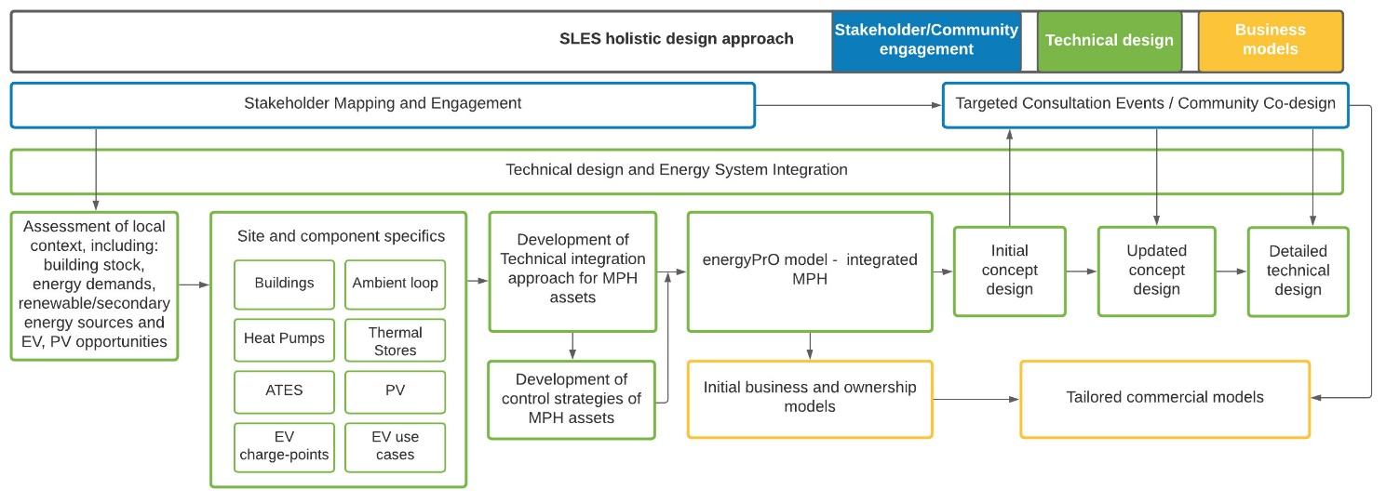
Figure 1. A holistic design approach developed by the GreenSCIES consortium
The technical design started in parallel with stakeholder mapping and engagement. Key stakeholders in the area including the local council provided useful information related for example to the local building stock, associated energy demands and both existing and planned EV charge posts in the local area. Following the collation and process of data, the site and component specifics have been defined to for the proposed SLES. Key design aspect has been related to the evaluation of the most suitable technical integration and control of the selected component. The next step of the design involved Techno-Economic (TE) modelling and optimisation of the New River scheme. The results generated through the TE optimisation of the scheme have been fed into both into the finalisation of the SLES concept design and into the development of novel business models. The initial concept developed has been shared with key stakeholders including the local community through targeted consolation events. The feedback collected from the stakeholders have been used to update the initial concept and led to the development of the detailed design. The stakeholder engagement process also allowed tailoring the business models reflecting the commercial requirements of all end-users. This approach was developed and implemented on the more focussed New River GreenSCIES sub-scheme. This sub-scheme is currently being taken to detailed design and is planned to be constructed by the London Borough of Islington after 2022. Each of these design elements are discussed in more detail in the subsequent sections of the paper.

4. Technical energy system integration for the New River Scheme
The proposed New River scheme integrates heat, power and mobility energy vectors. The following sub-sections discuss the proposed operation of the ambient-loop, the assessment method for EV and PV and the evaluation of the most suitable technical integration approach for the MPH assets proposed within the New River Scheme. This section also discusses the proposed control system architecture of the SLES.

4.1 New River Site Overview and a summary of the local context
The proposed New River scheme is a 5DHC network with an ultra-low temperature 'ambient loop' supplying 6 major energy centres with large decentralised heat pumps distributed across a range of buildings. The scheme is centred around a large data centre (waste heat source), connecting 402 domestic properties and 8 businesses (heat demands).
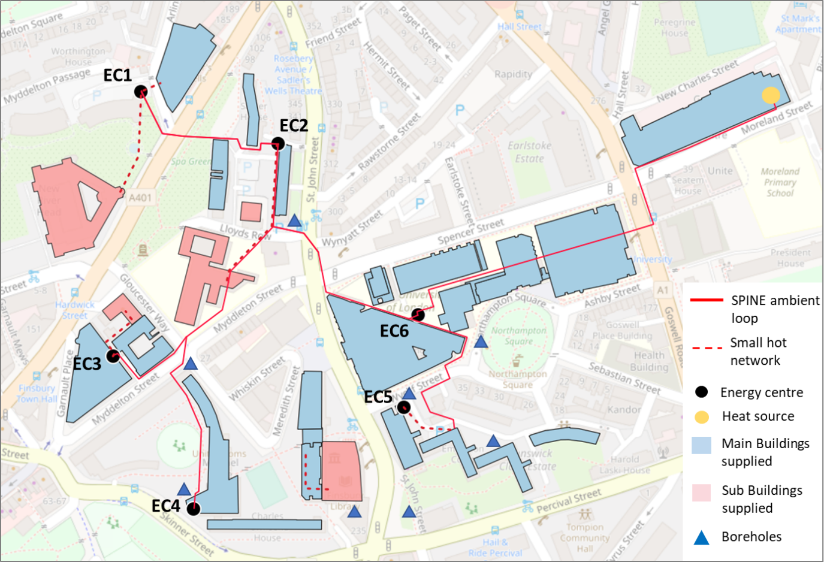
Figure 2 The New River Scheme layout
The key ‘anchor loads’ are housing estates managed by LB Islington, currently supplied by centralised gas boilers. The scheme also connects a university campus, a library and a theatre. The layout of the network, including the pipework route, connected buildings and the locations of the energy centres are shown in Figure 2.
The total heat demand of the network is 10,5 GWh/yr and the cooling demand is 9,3 GWh/yr with the data centre accounting for 95 % of the total cooling demand. The scheme connects six energy centres, fitted with individual heat pumps (capacities range between 600 and 2600 kWth), thermal storage (capacities range between 80 and 210 m³). Aquifer boreholes will also provide heating/cooling to the network to ensure a balance across the season using interseasonal Aquifer Thermal Energy Storage (ATES).
Integrating EV involved assessing parking spaces available in and around all the distributed energy centres were investigated. This has been done by taking the street views on google maps and counting the parking spaces available with relevant permits/restrictions listed. All the residential social housing estate blocks connected to scheme have parking spaces inside the estates whereby the numbers have been confirmed by the relevant Housing Associations. For each of the potential EV locations seven use cases were considered. V2G was only considered to be suitable for fleet, privately owned vehicles with parking off street and car clubs. Focusing on the New River Scheme area, locations were identified in terms of potential chargepoints by use case. Three scenarios were developed in terms of high, medium and low levels of uptake for EVs. Given the UK decision to ban the sale of new conventional petrol and diesel engines from 2030 and the increasingly buoyant market for EVs, the high electrification scenario was selected to go forward for detailed design. The numbers for this scenario have added 49 chargepoints. Of these 29 will be connected Behind the Meter (BTM) (BTM concept explained later) and 15 will work in V2G mode.
The integration of PV into the GreenSCIES project is being evaluated over several iterative steps and the process will continue until the project is fully designed. Local generation of electricity using photovoltaic panels is an integral part of the wider decarbonisation agenda of the project. Initial desktop studies identified roof tops across a number of buildings in each of the prospective Energy Centre areas. The area of each roof space was then estimated, using online aerial photography, and industry standard rates of watts per square metre used to get a preliminary indicative figure of the PV generation capacity. The PV capacity calculations were used in energy and financial modelling (discussed in the later section of this paper) to highlight the potential benefit to the wider GreenSCIES project. The next stages of design are more technical and involve detailed site surveys, with access to the roof spaces under safe systems of work, and in-depth consultations with PV installation experts. This will explore the limitations on particular roof spaces, possible shadowing from other structures and trees, also identifying other constraints such as electrical connections and cable risers. All of this data is being used to refine the estimate for potential PV capacity. Detailed designs of the engineering requirements will then finalise the configuration of the proposed installation.

4.2. Proposed operation of the ambient-loop
From a heating and cooling perspective, the scheme can essentially be summarised as using data centre heat recovery to supply heat demands in all the remaining buildings. Or to describe this in another way, sharing (prosuming) between the data centre cooling and the heat demands. Figure 3 illustrates this concept. It can be seen that the waste heat recovered from the data centre is distributed in the warm ambient loop header at approximately 13 °C.
The hydraulic concept is based on a two-pipe ambient loop network connecting to customers and energy sources through dedicated energy centres containing heat pumps or heat exchangers. The network is configured with a warm pipe and a cold pipe, consisting of a spine with branch connections linking individual customers and energy sources to the main spine. The warm and cold pipes are intended to operate as low loss headers, with modest flow velocities and pressure drops at the design condition. Design velocities are envisaged to be between 1.5 to 2 m/s in order to provide an optimal balance between investment and operating costs over the life of the project. The hydraulic design is subject to ongoing optimisation.
Standard operation - Each of the decentralised heat pumps (and above ground thermal storage) at the individual customer’s energy centres then supply low carbon heat to the end-users at between 65 and 75 °C. The cooling (which is the by-product of heating) from the heat pumps is transported back to the data centre through the cold header of the network at 5 °C. It can be seen that the data centre chilled water system circuits operate between temperatures of 9 °C and 14 °C.
Temperatures within the warm and cold pipes will vary according to the energy balance across the system. However, it is important to maintain a balanced heat and coolth flow across the network to maximise economic and carbon benefits. The introduction of interseasonal storage can then make use of the local aquifer achieving ATES providing a novel way of balancing the system. It can be seen in Figure 3 that the ATES system in GreenSCIES is being achieved through the formation of warm and cold borehole wells, forming warm/cold bubbles providing long-term thermal energy storage capacity. During periods when customer demand for high temperature heat is less than the data centre demand for cooling, heat recovered from the data centre will be injected into the aquifer warm store/bubble.
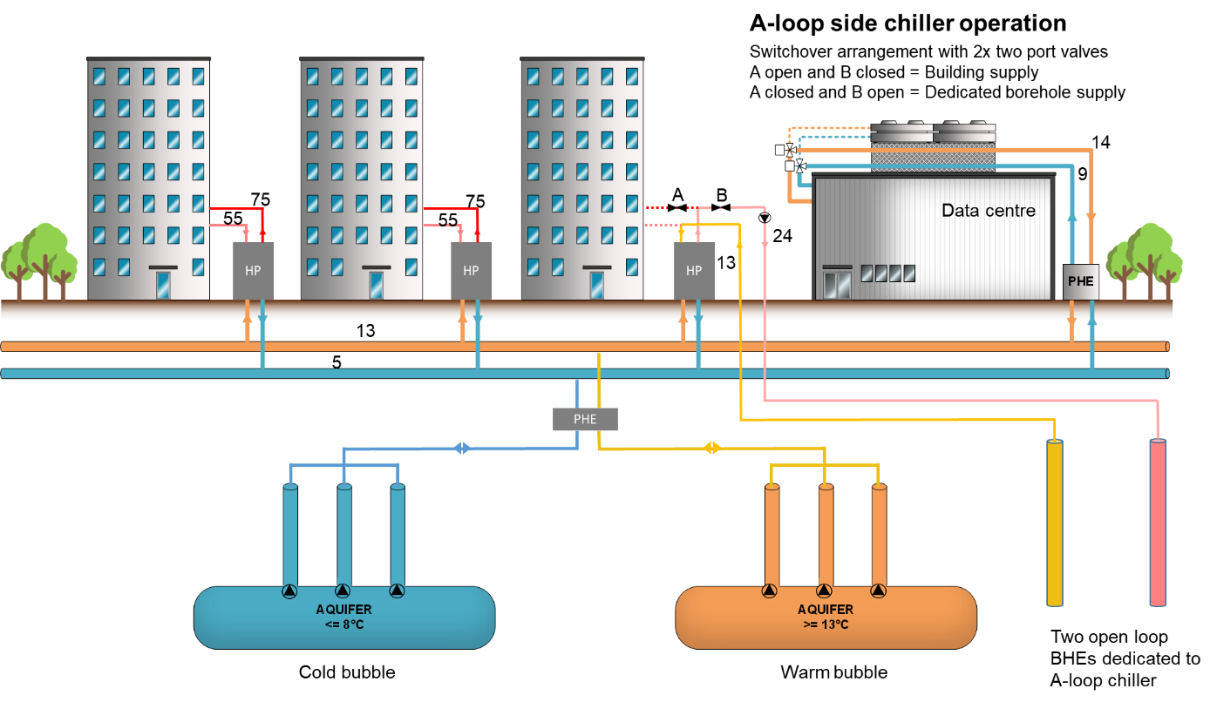
Figure 3. The ambient loop concept with interseasonal aquifer thermal energy storage
The provision of high value cooling to the data centre is the central part of the economic considerations. Therefore, the data centre heat exchanger will be configured as the primary cooling customer and will normally be given preferential access to coolth over the boreholes and other smaller cooling customers connected to the network. Daily imbalances between high temperature heat demand and data centre cooling demand require careful balancing. Above ground thermal storage at each energy centre helps smooth heat demands but the ambient loop is balanced by the borehole aquifer storage. Reversing flow through borehole wells to meet these short-term variations is not an option, since the thermal inertia of system is too large to make this effective.
Ambient Loop chiller operation - In order to maximise cooling revenue and ensure un-interrupted cooling supply to the data centre when there is no or insufficient customer demand for high grade heat, the GreenSCIES design proposes to configure the largest heat pump on the network to have the facility to operate as a water-cooled chiller (referred to as the ambient-loop or A-loop chiller in Figure 3). This is achieved by closing valve A and opening valve B. During these times, the heat pump (A-loop chiller) will condition the ambient loop cold side through the evaporator circuit and reject condenser heat into two dedicated unidirectional ground heat exchangers, which are directly connected to the A-loop chiller (and therefore operate independently from the ATES system). The switchover arrangement between the heat pump and A-loop chiller operation is also described in Figure 3.

4.3. Technical integration of MPH assets
As the GreenSCIES vision is to create a fully electrified MPH system, a few electrical connection approaches were considered for the integration of different energy vectors at each energy centre and across all energy centres. The approach taken for connecting MPH assets will determine how all the assets are monitored and controlled from the perspective of metering power flow. Ultimately, the choice of electrical connection affects the potential value streams gained from an integrated MPH system. The connection option determines whether the energy centres in GreenSCIES are electrically connected, and so their assets can be optimised together, or the assets of each energy centre are optimised separately. The choice of electrical connection will also determine the possibility of participation in different energy related value streams e.g. flexibility market. The scale at which various assets in the system can be combined to maximise value will also depend on the electrical connection approach.

4.3.1. Electrical connection choices
The three main choices explored were BTM, a private wire network and a virtual private network.

Behind the Meter
In the BTM approach, each site is behind a single meter to the distribution network and optimised behind this meter. The assets are optimised to generate revenue or savings for each site separately. This has several advantages and the main one being that it is relatively easy to deploy. The BTM optimisation can be significantly improved by using smart sub-metering and a good control system. The optimisation takes place behind the meter thus only registering the managed demand on the energy supplier meter. The difference between the unmanaged and managed demand will be the savings. All the assets like EV chargers, PV systems and heat pumps are connected and sub metered behind the main meter. Generation and consumption are optimised using a smart control system. The proposed model is that the scheme operators resell electricity to the customers at cost - but without the need for a supply licence as the electricity will be purchased from a licenced supplier and resold. LB Islington already uses this approach with schools for which it purchases electricity and gas as part of a centralised contract. Electricity will be passed on at cost but the benefits retained from PV production offsetting customer demand behind the meter.
However for the data centre this approach will not be used as they wish to maintain control of their chillers and purchasing generally.

Private Wire
In the private wire approach, all the energy centres would be connected on a private electricity network. A central point on the network would then be connected to the high voltage DNO network. This implies that the lower voltage supply is handled by the ESCo that runs GreenSCIES via the private wire and a series of step-down transformers are needed. In a simplistic comparison to the BTM approach the private wire network means putting all of the GreenSCIES scheme behind a single meter. The clear advantage of this approach is supply and demand across all the sites can be optimised and netted off before affecting the wider grid. It would also mean that energy levies applied by the DNO at the low voltage supply level do not need to be paid. This gives a chance to create an energy supply system that can provide a greater sense of engagement and tariffs, which could potentially be more affordable for them. Participation in aggregation and market services would be similar to the BTM approach. The site optimisation in this case changes to system optimisation, which means the potential revenue, and savings from flexibility and self-consumption can be more significant. While the potential of revenue and savings is larger, the private wire network requires a large-scale network installation. The cost implications of this are significant. Additionally, this approach requires the system operator to have an energy supplier licence to sell electricity to the consumers. This also implies that the consumers have to agree to buy electricity from the GreenSCIES system operator.

Virtual Private Wire
A virtual private wire network (VPN) approach would allow the optimisation across the entire GreenSCIES network without installing a private wire. There is no agreed definition of a VPN in the UK yet. There are several definitions based on research and feasibilities, which have been performed in the past. In such a system, a central point can control the sites where the assets are still connected on the DNO network, but with flexible assets on different sites. Their energy can then be shared across the system with a goal to maximise advantages from flexibility by using the distribution network more efficiently. To enable this many policy changes are required, including changes to the policy of ‘system of use charges’ at different levels of the network. There are small advantages to system optimisation using asset flexibility in a certain region without physical connection, but they do not make a strong enough economic case to encourage policy change.

Final selection of Electrical Connection for GreenSCIES – BTM
A BTM approach was chosen and is proposed for GreenSCIES. The selection criteria were cost, optimisation, flexibility, policy compliance, ability to deploy easily and replicability. These are in line with the GreenSCIES project goals and ambitions. Table 1 shows a qualitative appraisal of the different electrical connection options considered. It shows how the different approaches score against a simple good (green check), moderate (amber alert) and bad (red cross) decision system. It can be seen in the table that The BTM approach aligns with the project requirements of being deployable and replicable. Any approaches, which require policy change, can be difficult to replicate as policy relief or change might be only be granted as a ‘sandbox’ for a particular innovation by Ofgem. This means there is no guarantee that it will lead to a wider policy change. Additionally, the BTM approach is cost-effective and still has good potential for self-consumption, site-specific optimisation and participation in aggregation and market services.
Table 1 Qualitative appraisal of electrical connection options for SLES
Approach | Cost | Optimisation | Policy | Deployable | Replicability
Behind the Meter
Private Network
Virtual Private Network

The selected BTM approach is shown in Figure 4 i.e. all the assets like EV chargers, PV systems and heat pumps are sub metered behind the main meter. This approach allows the monitoring/control of assets from the perspective of metering power flow and enables generation of revenue from their flexible operation and energy service provision. It can also be seen in Figure 3 that the integration involves the physical sharing of infrastructure between the vectors i.e. using the same trench for the ambient loop and borehole pipes, EV charge post cables and power cables. Each energy centre is optimised separately, and the energy centres are not electrically linked. The control of the assets is described in the next section.

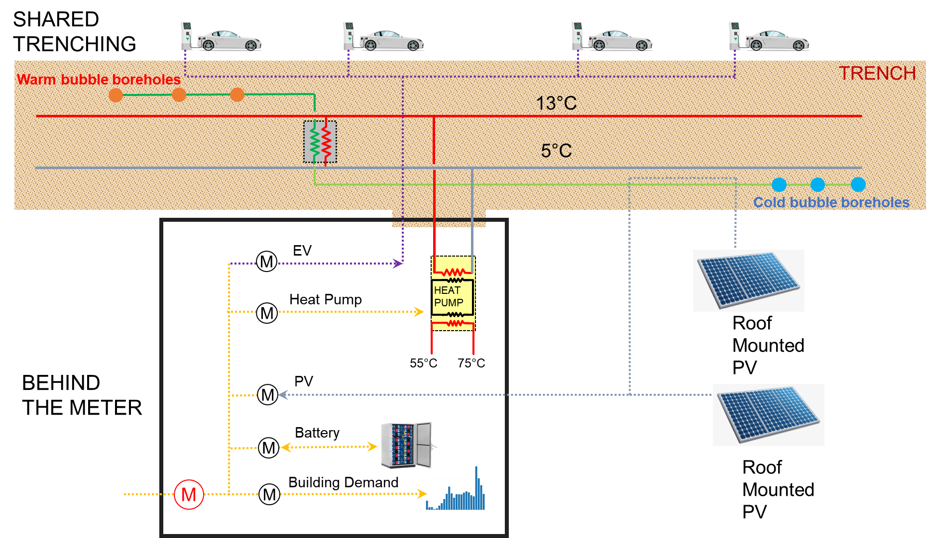
Figure 4 Mobility, Power, Heat integration Behind the Meter alongside shared infrastructure

4.3.2. Control of the integrated system
To enable all the control, analytics and visibility that is required to make such a distributed and complex system operate, a design for how data flows, access and is stored needs to be managed. The challenges faced can be described under the following categories: communications, historic data storage and access, live data access and communication, control commands.
For data communication a Supervisory Control and Data Acquisition (SCADA) system is often used in this type of control system but in the case of the NEW River scheme the use case stretched the capabilities of a traditional wired SCADA. Limitations of this approach were: Cabling would need to be run between energy centres and that this would likely need to be a fibre optic cable, bringing maintenance and capital costs. Any growth and expansion of the assets under control would have to be added to the existing network, due to the expected lifetime of the project in operation this could mean limiting future new connections and assets under control to legacy protocols and systems that were installed at build.
For data storage a conventional SCADA would also envisage an on network storage historian for all the data that is being used by the SCADA and for this to be specified at design/build stages and the data collection to be specified correctly first time. Releasing this database to other third parties, controlling local access and ensuring redundancy is properly achieved would therefore all rely upon the operating company's competency and ability to envision future requirements. Live data would only be available on the SCADA network without complex integration work and therefore limit innovation and access to third parties and limit the types of service that could consume this live status data to being those within the SCADA scope of influence.
Control of assets requires equipment and local controllers to be requested to change their normal behaviour by a higher level controller or optimisation system in order to ensure the safe and efficient operation of the whole system. Whilst a conventional approach would allow timely and accurate control and feedback, all systems coming into scope must comply with all the networking and protocol requirements of the SCADA. In the case of new build energy centres this would not be a problem but wherever legacy systems are being controlled such as for existing building or where siloed third party systems needed to be engaged, such as the EV back-office systems, a complex integration would be required.
For these reasons the industry and this project have moved away from conventional SCADA systems such as those found in production environments and towards more cloud based solutions that rely on the rapidly developing cloud infrastructure as a service models and reliable modern internet connectivity with redundancy. These solutions maintain a cloud based data warehouse which is then populated by data through high traffic volume streaming data pipelines allowing many data points to be logged at extremely low cost. Moving data to the cloud means that access can be granted and controlled in a very different environment compared to an on-site database, maintenance can be done remotely and third parties can be given specific access to certain views of data. For instance, data collected from meters can be provided to different service providers and the management of publicly available data is easier.
The New River scheme data domain consists of data extracted from legacy building controllers, data from EV back-office systems, data from energy centres and data from external services including the weather and energy markets. The designed system aims to allow for all these data sources to be captured to the cloud data warehouse in as standardised fashion as possible. The connectivity allows for control and feedback to be done in a timely manner. This approach is enabled by the prevalence of high speed and reliable communications over the internet.

5. Techno-economic investigations of the New River Scheme
A detailed techno-economic analysis was carried out to investigate the viability of the proposed SLES. This built on the results of modelling in the feasibility stage but with much greater focus on a smaller more constructable scheme, New River. The modelling methodology including the key financial figures, model components, scenarios are discussed in the following sub-sections.

5.1. Methodology
A commercial software modelling tool, energyPRO was utilised for the techno-economic investigation. Description of the software, its solver methodology and the approach of how it is applied for the design of SLES is described in details in the authors’ previous work (Revesz et al., 2020). The control strategy developed for all MPH assets (described in section 4.2.2) has been simulated in detail in the software. The following sub-sections discussing the cost inputs, key model components and results of the investigations in terms of carbon savings, OPEX and CAPEX.

5.1.1. Cost inputs
The TE analysis made use of half-hourly prices were developed for 2023 and 2030. This is a novel approach as the previous work presented an analysis based on current energy prices. For the current investigation, all price datasets were based on 2019 prices but updated with information for changes to levies that have already been set by the UK government, the UK energy regulator Ofgem or Distribution/Transmission System Operators. In the case of wholesale electricity prices, a more volatile price distribution was created for 2030 based on predictions provided by Cornwall Insight with 800 hrs of negative wholesale prices and 850 hours of prices above £120/MWh. Export and import market time periods are modelled separately to reflect the slight timing differences for Red, Amber, and Green charging periods. Import and export prices are assigned to these different periods. The price breakdown has been modelled in detail in a separate spreadsheet so that distribution and other charges can be inputted based on published charge data for the coming year. Triad payments, both as revenue to electricity generation and as expenditure for demands, have been assigned to the 20 coldest days in the 2012 temperature data. Although they are only paid or charged for three half hour periods, it is assumed that LB Islington will follow a TRIAD warning approach and will need to generate for two hours twenty times a year. The actual payment has been averaged over these 20 x two hour periods. This has the advantage of automatically affecting the simulated operation of the plant through energyPRO’s automatic operation strategy. Table 2 summarises all the charges considered in terms of price per unit (£/MWh). The FIT, CFD, CMC and AAHEDC were combined and modelled as a single charge as they do not have specific periods of application.

Table 2 Levies used to represent hourly electricity tariffs in energyPRO
Charge | Price per MWh | Period | Description
Red Distribution Use of System  (DUoS) | £47.44 | 11:00 – 14:00  16:00 – 19:00 | Applied to avoid the higher costs of distributing electricity during peak hours (weekdays only).
Renewable Obligation (RO) | £18.6 | All times | Penalty for the supply of non-renewable electricity (Depends on the grid % of renewable generation).
Feed-in-tariff (FIT) | £12.95 | All times | Charge to cover scheme that supports distributed generation of renewable electricity.
Contracts for Difference (CFD) |  |  | Charge to cover scheme that supports generation of low-carbon electricity.
Capacity Market Charges (CMC) |  |  | Charge to support capacity market investments.
Assistance for Areas with High  Electricity Distribution Costs  (AAHEDC) |  |  | Charge to replenish the costs of providing electricity in particularly remote areas.
Climate Change Levy | £8.47 | All times | Charge to incentivise reduction in energy consumption and associated emissions.
Triad Warning Periods | £874-£1,748 | 3-hour peaks | Applied during the 20 most intensive 3h periods of demand from November to February.

Existing heat demands have been created based on consumption data provided by Islington Energy Team and normalised to a standard degree day year. Where possible data was gathered from actual half-hourly gas and electricity data. Where this was not available annual consumption was used and profiled according to a combination of weather data and a typical profile shape for that building type developed from previous work.

For loads that have not been yet been built these have been simulated using either standard profile patterns or simulated data provided by consultants working on the development. Each demand is modelled as a separate site using the Region Module functionality of energyPRO. Heat prices are applied to each demand based on the cost of heat from a gas boiler. The application of Climate Change Levy (CCL) is included in the modelling where appropriate.

The overall model results in a half hourly or hourly simulation of the network with supply options prioritised by the cost of heat taking into account all variable costs and subsidies. This can be viewed within energyPRO in graphical form or exported into Excel in hourly, monthly or annual form. Economic outputs include Cashflow OPEX, NPV as well as CO₂ savings. The automatic operation strategy can be overridden to reflect prioritisation of certain units and this has generally been the case for the current network where the primary network has priority over the distributed boilers.

5.1.2. Model components
The modelling of the heat pumps and the above ground sensible thermal stores was carried out in the same way as it was described in an earlier work by Revesz et al. 2020.

Heat pump sizing was originally based on a strategy of the minimum size required to avoid the use of gas boilers (retained as back-up plant) – given the particular half-hourly profile of data used. Note this is not the same as the peak demand for each site because thermal stores allow the peak to be met at a much lower heat pump size than the peak seen in the half hour of highest heat demand. This strategy does not guarantee that gas boilers will not be used in practice. This is because a sustained future cold snap, which is worse than any experienced in the temperature year being used for the modelling, could produce a higher peak and/or any heat pump downtime, longer than the thermal store could provide for, would necessitate an alternative source of heat.

Within the model there is an allowance for large thermal stores, which can buffer both space heating and domestic hot water. This allows for a more optimised operation against half hourly electricity prices and this means that heat pumps can more easily follow wind and solar production – the contribution of which are reflected in half hourly electricity prices. In relation to the thermal storage sizing, an NPV analysis over 40 years was carried out to determine the optimal store volume. For this analysis, a linear capital cost of the store was used of £1,000 per m³.

Regarding the ATES, the earlier work presented was somewhat limited by not accounting for the subsurface performance of the system. The modelling work undertaken in the New River concept development made use of outputs of a detailed hydrogeological site investigation of the project area. The results of those investigations showed that an ATES with six open loop is the most optimal. Details of the hydrogeological investigations and the finite element modelling the thermal and hydraulic behaviour of the ATES system is outside of the scope of this paper, however it will be discussed in the Authors subsequent publication.

Mobility is incorporated into the New River scheme through the connection of EV chargepoints at the Energy Centres and along the 5DHC network route. Regarding the EV numbers in the model, a high, medium and a low chargepoint penetration scenario has been investigated at each energy centre. These approximate to 15 %, 35 % and 55 % electrification (in terms of number of parking bays) respectively and are provided to give install options compatible with additional on-site or CAPEX constraints. This offers an estimate of the number of chargepoints likely at each energy centre as well as the vehicles and chargepoints they are likely to facilitate. The results presented in the following sections assume the highest penetration scenarios of 49 EV charge posts across the 6 energy centres and 15 of those assumed to operate in V2G. It was assumed that V2G chargepoints (7kW bi-directional chargers) are located at sites with PV that export excess PV energy to the grid, as this provides additional optimisation potential. Overall, the model included 611 kWp of PV and used a weather profile (built in energyPRO) to simulate the hourly and annual PV contribution. Stationary batteries are added at 4 energy centres, where space allowed.

5.1.3. Model scenarios
Table 3 provides a summary of the TE modelling scenarios which were developed to allow investigation of the value of energy system integration.

Table 3 Techno-Economic modelling scenarios
No. | Scenario | Description
1 | Prosuming heat pumps only | Large distributed water source heat pumps connected on the source side to an ambient temperature loop. The heat pumps as a by-product of providing heating, provide cooling to a large data centre. Excess heat or coolth is stored in hot and cold wells in the aquifer – providing interseasonal storage. Additionally, above ground thermal stores collocated with the heat pumps enable short-term storage of heat.
2 | Prosuming heat pumps & Solar PV | As scenario 1 but with solar PV systems added behind the meter at each plant room
3 | Prosuming heat pumps, Solar PV & EVs | In addition to scenario 2 49 EV charge posts are added. 29 of these are connected behind the same meter as the heat pumps and PV, and 15 of these operate in V2G mode.
4 | Prosuming heat pumps, Solar PV & Batteries | In addition to scenario 2, stationary batteries are added at 4 energy centres, where space allowed. These are also connected behind the meter.

5.2. OPEX, revenues, carbon savings
A large part of SLES is a balance between heating and cooling. There are well balanced annual energy supplies/demands but not always at the same time through the year. The more prosuming (sharing) that can be achieved, the greater the cost/carbon savings. The simulated monthly heating and cooling demand and generation profiles are shown in Figure 5. It can be seen that a substantial amount of the cooling is produced to the ambient loop as the by-product of heating (heat production by the heat pumps are shown in light blue, and the cooling by-product is shown in yellow). It can be seen that between the period of May and October, there is a significant difference between the heating and cooling demand of the network (shown in the dotted and striped patterned columns, respectively). During those times, the cooling energy that the network generates as a by-product of heating is not sufficient to meet the cooling demand. It is clear that during those months, a supplementary cooling supply is being introduced from the aquifer coolth store (shown in dark blue). Figure 5 also shows that the heat pump CoPs are relatively constant throughout the year, approximately between 3.3 and 3.7 depending on the season.

Figure 5 Thermal demands and generations
Techno-economic results including carbon savings of each scenario are summarised in Table 4. It can be seen in the table that the OPEX costs are in the region of £500,000 per year in 2023 and slightly higher in 2030. This is because the GreenSCIES scheme is able to take advantage of more renewable energy in the future as it comes on stream. In addition, the cost of gas is predicted to increase slightly year by year. After the cost of capital and a discount rate of 3.5% was applied on the remaining private investment, this gave a good IRR in the region of 10%, which is attractive to investors. There is potential for a carbon tax on gas that might gradually increase over time but this potential advantage has not been included at this stage of the modelling. Important to note that the best IIR (9.5%) resulted for the Scenario 3 (Prosuming Heat Pumps, integrated with PV and EV). Therefore this scenario has been selected to taken forward to detailed design stage.
Table 4 TE results
GREENSCIES New River | Simple payback (Years) | IRR  (20 years) | NPV (£ x 1000)  (20 years) -Improvement Over Base Case | Operating Surplus 2023 (£ x 1000) | Operating Surplus 2030 (£ x1000) | CO₂ Saving (Tonnes/yr) IAG 20yr Average | INITIAL CAPEX  (£ x 1000)
BASE CASE Existing Boilers | 0 | 0.0 % |  | 0 | 0 | 0 | £0
- Prosuming Heat Pumps | 10 | 8.5 % | 2,576 | 441 | 571 | 5,120 | £4,980
- Prosuming Heat Pumps & PV | 10 | 8.5 % | 2,834 | 482 | 634 | 5,196 | £5,528
- Prosuming Heat Pumps, PV & EV | 10 | 9.5 % | 3,687 | 591 | 743 | 5,443 | £5,968
- Prosuming Heat Pumps, PV & Batteries | 16 | 3.1 % | -339 | 568 | 844 | 5,443 | £8,885

The results presented in Table 4 show that the scheme has very significant carbon savings of around 5,000 tonnes per year for all scenarios – which is around 80 % reduction over the base case. However, this will tend to 100 % savings as the electricity grid decarbonises further. It can also be seen that PV and EV add opex value to the project but batteries appear to make the scheme somewhat worse. The impact of changes to energy prices in 2030 are that the operational surplus improves for all scenarios. This is because of an assumption that the CCL continues to be increased on non-domestic gas use at a similar absolute annual increase (0.1p/kWh) whilst electricity CCL continues to be increased – and that heat prices are aligned with gas prices. The increase in the volatility of wholesale electricity prices has a particularly significant impact on the battery scenario. This is unsurprising reflecting the value of batteries with a much higher penetration of renewables on the grid. Figure 6 shows the undiscounted cash flow for the four scenarios, which clearly indicates a likely break-even point around 10 years for prosuming heat pumps, adding PV and EV but a longer period for the battery scenario.

Figure 6 Undiscounted cash flow during the 40 years operation

5.3. CAPEX
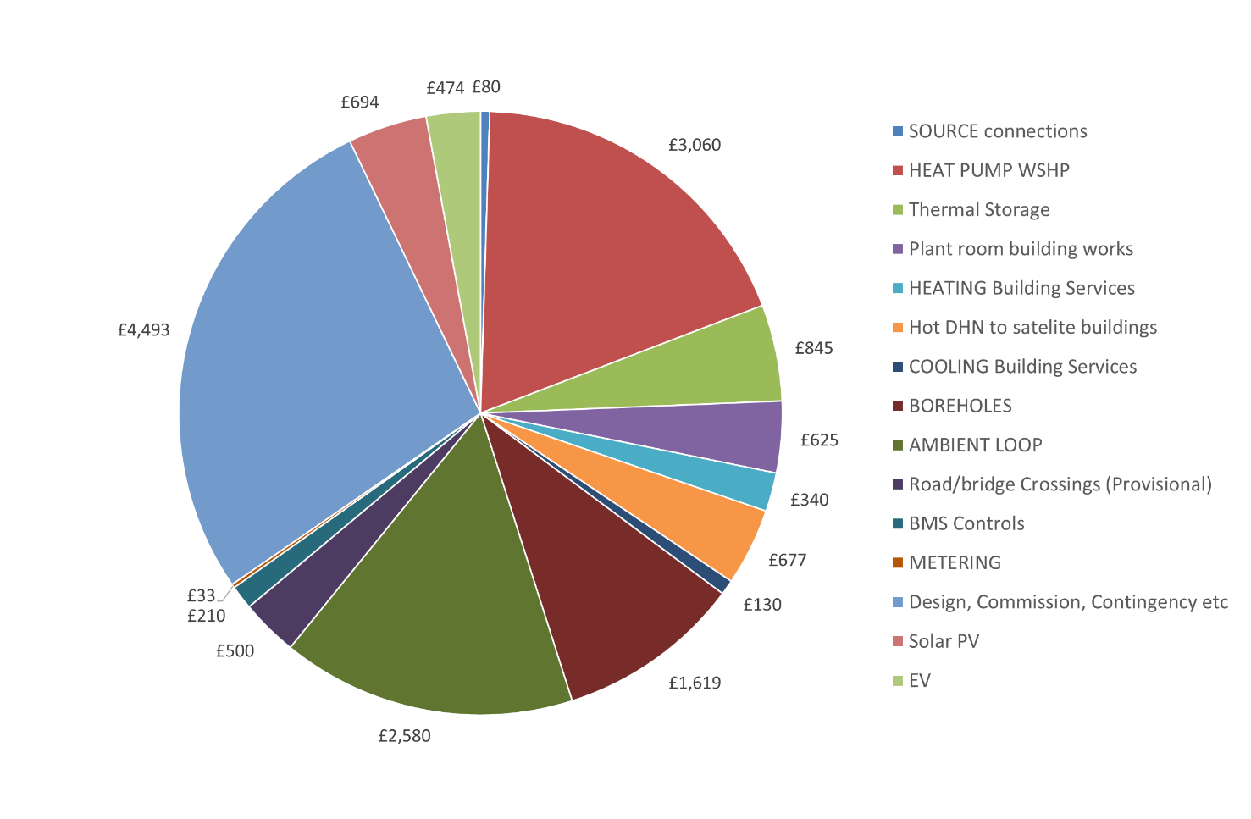
Figure 7 CAPEX breakdown of the GreenSCIES New River scheme (costs shown in £ x 1000)
The total investment costs for heating and cooling across six energy centres (including the source data centre), was ~£14, rising to ~£15M with PV and EV. Figure 7 above shows a breakdown of the whole New River scheme including heating and cooling, EV’s and PV. Clearly the cost of the heat pumps (22 % of total costs) and ambient loop pipework (18 % of total costs) dominate the overall capex but the boreholes are a very significant item at 11 %. Around 24 % of the total cost are allowances for design fees, commissioning costs and contingency which are all essential in a project of this scale and complexity. The EV charge points (3 % of total costs) are a combination of 49 on-street and off-street charging points of different sizes. The capex also includes solar PV (4 % of total costs). Batteries have been left out of the above figure as they are less economic, see earlier.
Key to the economic success of the proposed SLES are the following:
- The big value stream in the GreenSCIES concept is cooling offset
- The more prosuming, the better the economics
- Heat pump CoP's are critical
- ATES can significantly improve SLES economics
- Integrated infrastructure can reduce CAPEX: Heat network pipework is an enabling infrastructure and is often the largest cost in a project. Innovative ways to avoid or minimise trenching costs can help make these capex intensive schemes more cost effective. Innovative options for pipework design have been proposed and evaluated by Revesz et al. (2021).
- UK has one of the highest spark gaps (i.e. the difference between the price of gas and the price of electricity) in the industrialised world. Whilst the heat pump/ heat network combination is one of the leading carbon solutions, it is still challenging to make it economic. Therefore Grant funding is essential for early adopters.

6. Commercial proposition for the New River Scheme
The proposed commercial structure is that of a Joint Venture ESCO between an experienced contractor and the local Council – to support the Council with expertise in delivery of the New River scheme and its complex integration between MPH. The risk and capital raising duties will be split proportionally amongst all shareholders. The revenues are primarily heating and cooling led, followed by EV and Power. The investigation also considered the in-house delivery and concession model, as well as the ‘do nothing’ scenario (though only briefly in terms of the dis-benefit to the environment from doing nothing) and concluded that the best, less risk-free option would be the JV ESCo. The scheme is being supported by grant applications for UK government Green Heat Network Fund CAPEX funding, community shares up to the value of £1m, and the remainder through carbon offset funding and private investments. The heating and cooling value streams include: direct sale of heat, direct sale of cooling, flexibility in terms of switching large heat pumps to minimise operation in high cost red periods and maximise use of marginal electricity cost periods. Also, savings for the end user in terms of replacing high emissions equipment to low carbon alternatives. Some organisations have carbon targets which if not met can incur economic penalties. From an EV perspective, two revenue streams can be unlocked; (i) Revenue from the core value streams from the chargers (i.e. charging users for electricity for use in their vehicles) and (ii) Energy services from the vehicles i.e. using EV batteries as flexible assets.

7. Stakeholders in the local energy system
From the outset, the GreenSCIES project has adopted a systems based approach to the engagement process as a whole, which is underpinned by some key principles: (i) Collaborative inquiry – undertaking research with, rather than on people in order to reach; (ii) shared understanding, develop new and creative ways of looking at things, learn how to act to change things and discover how to do things better; (iii) Multiple perspectives – actively seeking viewpoints and perceptions from all parts of the system; (iv) Emergence – being mindful of the natural outcome of things coming together over time, non-linear and self-organising and (v) Opening of communicative spaces – actively creating the conditions and opportunities for communication, interconnection and synthesis within the system.

7.1. Wider Engagement processes
The wider engagement process was designed to engage with as many of the stakeholders identified across the different categories as practicable. It began early on at the project feasibility stage and has continued since. Since the project’s inception, approximately 160 local stakeholders, residents and businesses have been directly engaged in the process and that number continues to grow. The workshops, which have taken place online from early Summer 2020, and continue still, involve partners from across the project consortium working both on the design of the system and the commercial business and investment models. Activities encouraged wider stakeholders’ ideas to cross-fertilise and invited groups of attendees to visualise and then construct a model to illustrate how they thought smart, local energy systems might function and behave. Teams were invited to comment on what things, in their view, are helping to maintain the status quo and to identify points of leverage for change. Other activities invited participants to envision the future for local smart energy networks in 2050 and then share their stories of how their vision was achieved.

7.2. Customer engagement
Effective customer engagement and onboarding is central to development of an integrated, SLES with an appropriate balance of heat and coolth loads; whilst LB Islington buildings may serve as the anchor load, wider engagement and customer connections are required for GreenSCIES to be technically and commercially viable. The GreenSCIES consortium initially engaged with 26 private customers in relation to over 30 buildings, which now form part of the Future Plan. In line with optimisation of the GreenSCIES system, customer engagement activity has more recently been focussed on the New River Scheme, designed around three core stakeholders: LB of Islington; a University, and a data centre. Throughout the engagement process, the GreenSCIES consortium has sought to highlight the carbon and cost benefits to private organisations that opt to connect into the innovative system, whilst emphasising alignment with LBI’s Vision 2030 Net Zero Strategy.
The customer journey comprises a range of phases from preliminary engagement, to testing of commercial models and ultimately commercial agreement. The phases of the customer journey are chronologically detailed below:
- Introductory engagement – mapping and identification of potential leads for buildings in scope, as identified in the feasibility study. Preliminary business development activity and contact made via a range of channels (phone, email and LinkedIn) and using a variety of GreenSCIES materials including the website and video;
- Introductory meeting(s) – presentation of the GreenSCIES concept, objectives and potential benefits for private organisations and the wider Islington community associated with the transition to a smart, local energy system. The primary goal at this stage is to secure a willingness to collaborate and share data and buildings information, allowing GreenSCIES to validate the assumptions made during the feasibility phase and develop a robust system design;
- Data gathering – Request for Information (RFI) questionnaire with significant input from technical and commercial partners on data required, including half hourly energy data, floorplans and schematics of existing heating and cooling systems. This questionnaire serves as a starting point for collection of buildings data to support concept design.
- Site visit(s) – testing and validation of technical assumptions on whether a building is connectable and on the potential locations of low carbon technologies through site visits. The frequency of site visits increases as engagement progresses to the advanced dialogue stage, to facilitate development of the detailed design.
- Advanced dialogue – presentation of technical proposals and commercial principles and options to key decision makers to gain their buy-in and pave the way for securing a signed Letter of Intent (LOI). Key stage for testing and validation of GreenSCIES technical and commercial propositions;
- Letter of Intent (LOI) signing – LOIs are required by Triple Point and the Department for Business, Energy and Industrial Strategy (BEIS) prior to awarding heat networks grant funding. Prospective customers will need to sign a LOI with LB Islington, outlining high-level commitment to connecting to the system prior to submission of any funding application.
- Detailed design – ongoing collaboration with customers and their consultants to ensure that GreenSCIES design proposals align with existing development plans, grant funding availability and strategies and mitigate potential site risks through 2021. Eventual agreement on commercial terms.

7.3. Community participation and co-design
As GreenSCIES has moved into the detailed design phase, end-user and community participation activities have deepened, reflecting how end-user and community participation is an essential condition for any SLES and the particular community-led development imperative of the GreenSCIES project. The arrival of the first COVID-19 lockdown coincided with the launch of a series of co-design workshops, which were planned to be held with residents at community centres and spaces across the borough. In reality, the process needed to be adapted. The online community events have been promoted to the community through a growing web of local groups, networks and structures including the members of energy oriented groups such as the Islington Community Energy Fund (ICEF) and Islington Sustainable Energy Partnership (ISEP) and a range of other residential, charitable and faith based groups. Some of the online events, aimed at attracting a broader range of local residents, have combined discussions on GreenSCIES with energy saving workshops. Participants’ responses are informing key design and operational aspects of the project. Initially the events took three principal forms: one to one interviews, focus groups and workshops. Interviewees were invited to identify key issues and areas of interest concerning the development of the proposed GreenSCIES SLES. They were asked to state, the relative importance of each of these to them and to think about contextual barriers and enablers they saw or experienced to the development of SLESs. This line of questioning captured responses using a complementarities matrix (after Ballard et al., 2010) to record which sphere of influence each barrier and enabler was related to personal attitudes, professional life, organisational/community culture or was connected to wider societal influences. Group workshops sought to draw out the issues, ideas and insights around user requirements and customer tolerances, which the attendees brought with them, in relation to SLESs.

8. Replicability potential
Approximately three quarters of UK LAs have declared climate emergency and more than half of them have set a goal of reaching net-zero carbon emissions locally by 2030 or sooner, however, few are clear on how they will make the transition to net zero happen. The holistic design approach introduced in this paper is replicable, and therefore it can be used as a guide for SLES developers, LAs and stakeholders within an energy system. However, it is important to highlight that the integrated SLES solution developed for the New River Scheme have been designed for the given local context and cannot simply be copied and pasted into other localities with different local characteristics. A rich understanding of a local context and identification of the value that SLES could bring to that particular location should always be the first step when assessing opportunities. Using the GreenSCIES holistic start-to-end design approach presented in this paper, the consortium are currently developing schemes in two other areas that are showing promising SLES solutions; Smethwick and Barnsley. These localities offer different waste heat sources, heat demands and opportunities for EV and PV integration.
An additional future development will be the replication of the concept across a large area of LB Islington, the outcomes of which will feed directly into LB Islington’s Net-Zero Strategy. This wider area analysis in Islington will also focus on exploring and suggesting options for deploying New River type scheme(s) across the area (approximately 1/3 of the whole LB Islington). The vision is that GreenSCIES will be rolled out over a significant area of Islington so that it can supply low carbon heat to over 10,000 Islington residents living in 3,500 homes along with up to 70 local businesses.
This further analysis will also explore the technical and non-technical interventions required to make the concept feasible in a scaled up capacity, broadening replicability to large inner city regions. This will help to meet decarbonisation targets set by many national and local governments. These replication studies will be the subject of future papers.

9. Conclusions and next steps
GreenSCIES is an ambitious InnovateUK funded project to develop a Smart Local Energy System (SLES) centred around a 5th generation district heating and cooling (5DHC) network in the London Borough of Islington (LB Islington). GreenSCIES will contribute to London’s zero carbon ambition through decarbonising the energy system in the LB Islington as part of their Net Zero Carbon Vision 2030.
The proposed SLES aims to deliver significant carbon saving for local residents, schools and businesses. The network will deliver heating, cooling, power and e-mobility charging all powered by renewable energy and waste heat, sourced from the local area. This large energy scheme in LB Islington is intended to utilise locally available waste heat sources and to integrate grid power and e-mobility to help reduce carbon emissions by up to 80 % compared to current, conventional systems.
The paper built upon the Authors previous work which investigated the initial feasibility of the SLES. Since then, the GreenSCIES project consortium developed an approach for a detailed design of the integrated scheme taking a holistic design methodology. This paper discussed the subsequent works carried out following preliminary design.
The introduction section discussed that that there are significant benefits associated with the implementation SLES, including opportunities around (i) more efficient heating and cooling systems, (ii) effective options for e-mobility and renewable power integration, (iii) new energy markets and flexibility trading opportunities. However, it was highlighted that there are both technical and non-technical barriers which exist when developing integrated SLES. These require a new holistic approach from an integrated technical design team, commercial investigations, and stakeholder engagement. An approach to co-design with the local community was described, as part of a holistic design approach.
The paper set the scene for a focus case study in the LB Islington called New River. Fundamental to the scheme is a two-pipe ambient loop 5DHC network. This will allow low temperature waste heat to be used effectively by sharing it between buildings. An existing data centre will provide the primary source of waste heat for the New River Scheme. A series of six decentralised dedicated energy centres connect to the ambient loop. The technical integration of e-mobility, power and heat is achieved at each energy centres using a “behind the meter” approach (i.e. all the assets like EV chargers, PV systems and heat pumps are sub metered behind the main meter). It was discussed that this “behind the meter” approach was most suitable for implementation in Islington, due to its capacity for monitoring, control of assets and enabling of generation of revenue from flexible operations and energy service provision.
The details of the techno-economic model development, key technical and financial assumptions of the proposed commercial model and the approach implemented for effective stakeholder engagement for the New River scheme were described. Results from a detailed techno-economic analysis showed that the proposed integrated SLES is viable and investable with around 10 % IRR. The results also showed that even the smaller construction ready design of GreenSCIES (New River scheme) would result in more than 5,000 tons of CO₂e savings annually. This is a major decarbonisation solution in large cities across the world. Alongside carbon benefits, the implementation of schemes of this nature would result in improved air quality, the tackling of fuel poverty and support of individual energy use reduction.
The New River scheme must now complete a construction ready detailed design, and develop specifications to allow tendering for the JV/ESCo partner. In addition, a full application to Green Heat Network Funding CAPEX support will be submitted. Alongside finalising the New River construction ready detailed design, the GreenSCIES consortium will explore the applicability of the proposed SLES concept across a much wider area of Islington, supporting full decarbonisation within the Borough by 2030.
The replicability section of the paper discussed that the scaling up of this scheme could be applied to many urban areas, and by accessing an abundance of waste heat opportunities could deliver significant carbon emission savings in the UK and elsewhere.

Acknowledgments
The GreenSCIES project is being funded by InnovateUK, and gratefully acknowledge their support. Partners involved in the project are also acknowledged including the London Borough of Islington, Transport for London, EoN, SilverEMS, Grid Edge, Consortio, West Midlands Combined Authority, Carbon Data Resources, Carbon Descent, Cenex, Repowering London, Building Low Carbon Solutions, Cullinan Studio, Hanger 19 and London South Bank University. The input of Operational Intelligence Ltd is also acknowledged.

REFERENCES
Averfalk, H. and Werner, S. (2020) Economic benefits of fourth generation district heating, Energy, 193, pp. 116727.
Ballard, D., Reason, P. and Coleman, G. (2010) Using the AQAL framework to accelerate responses to climate change, Journal of Integral Theory and Practice, 5 (1), pp. 271–281.
Bañol Arias, N., Hashemi, S., Andersen, P. B., Træholt, C. and Romero, R. (2020) Assessment of economic benefits for EV owners participating in the primary frequency regulation markets, International Journal of Electrical Power & Energy Systems, 120, pp. 105985. DOI:10.1016/j.ijepes.2020.105985.
BEIS (2018), Heat Networks Investment Project, Introduction to the Scheme. Available from: https://www.gov.uk/government/publications/heat-networks-investment-project-hnip-scheme-overview [Accessed 06 December 2021].
BEIS (2020), Digest of UK Energy Statistics 2020. Available from: https://www.gov.uk/government/statistics/digest-of-uk-energy-statistics-dukes-2020 [Accessed 07 December 2021].
BEIS (2021 a), UK enshrines new target in law to slash emissions by 78% by 2035. Available from: https://www.gov.uk/government/news/uk-enshrines-new-target-in-law-to-slash-emissions-by-78-by-2035 [Accessed 06 December 2021].
BEIS (2021 b), Heat and Buildings Strategy: https://www.gov.uk/government/publications/heat-and-buildings-strategy [Accessed 07 December 2021].
Boesten, S., Ivens, W., Dekker, S. C. and Eijdems, H. (2019) 5th generation district heating and cooling systems as a solution for renewable urban thermal energy supply, Advances in Geosciences. Article. DOI:https://doi.org/10.5194/adgeo-49-129-2019.
Buffa, S., Cozzini, M., D’Antoni, M., Baratieri, M. and Fedrizzi, R. (2019) 5th generation district heating and cooling systems: A review of existing cases in Europe, Renewable and Sustainable Energy Reviews, 104, pp. 504–522. DOI:10.1016/j.rser.2018.12.059.
Cao, J., Crozier, C., McCulloch, M. and Fan, Z. (2019) Optimal Design and Operation of a Low Carbon Community Based Multi-Energy Systems Considering EV Integration, IEEE Transactions on Sustainable Energy, 10 (3), pp. 1217–1226. DOI:10.1109/TSTE.2018.2864123.
Fell, M., Maidment, C., Vigurs, C. and Shipworth, D. (2020). How do we create successful smart local energy systems, EnergyREV. Available from: https://www.energyrev.org.uk/media/1540/energyrev_organisingframework_worksheets_202005.pdf [Accessed 07 December 2021].
Gonzalez, F., Petit, M. and Perez, Y. (2019) Electric Vehicles as Flexibility Providers for Distribution Systems. A Techno-Economic Review. CIRED 2019 Conference. Available from: https://www.cired-repository.org/handle/20.500.12455/322 [Accessed 07 December 2021].
GOV.UK (2020) The Ten Point Plan for a Green Industrial Revolution (HTML version), GOV.UK. Available from: https://www.gov.uk/government/publications/the-ten-point-plan-for-a-green-industrial-revolution/title [Accessed 23 November 2020].
Gudmundsson, O., Schmidt, R.-R., Dyrelund, A. and Thorsen, J. E. (2022) Economic comparison of 4GDH and 5GDH systems – Using a case study, Energy, 238, pp. 121613. DOI:10.1016/j.energy.2021.121613.
Høj, J. C. M. L., Juhl, L. T. and Lindegaard, S. B. (2018) V2G—An Economic Gamechanger in E-Mobility?, World Electric Vehicle Journal, 9 (3), pp. 35.
Jones, P. (2019) A roadmap to achieve 5th generation heat networks in the UK, CIBSE Technical Symposium, Sheffield, UK 2019.
Lopes, J. A. P., Soares, F. J. and Almeida, P. M. R. (2011) Integration of Electric Vehicles in the Electric Power System, Proceedings of the IEEE, 99 (1), pp. 168–183. DOI:10.1109/JPROC.2010.2066250.
Lund, H., Andersen, A. N., Østergaard, P. A., Mathiesen, B. V. and Connolly, D. (2012) From electricity smart grids to smart energy systems – A market operation based approach and understanding, Energy, 42 (1), pp. 96–102. DOI:10.1016/j.energy.2012.04.003.
Lund, H. and Kempton, W. (2008) Integration of renewable energy into the transport and electricity sectors through V2G, Energy Policy, 36 (9), pp. 3578–3587. DOI:10.1016/j.enpol.2008.06.007.
Lund, H., Østergaard, P. A., Connolly, D. and Mathiesen, B. V. (2017) Smart energy and smart energy systems, Energy, 137, pp. 556–565. DOI:10.1016/j.energy.2017.05.123.
Marczinkowski, H. M. and Østergaard, P. A. (2018) Residential versus communal combination of photovoltaic and battery in smart energy systems, Energy, 152, pp. 466–475. DOI:10.1016/j.energy.2018.03.153.
Mouli, G. R. C., Kefayati, M., Baldick, R. and Bauer, P. (2019) Integrated PV Charging of EV Fleet Based on Energy Prices, V2G, and Offer of Reserves, IEEE Transactions on Smart Grid, 10 (2), pp. 1313–1325. DOI:10.1109/TSG.2017.2763683.
Piclo (2020) Modelling the GB Flexibility Market Part1: The value of Flexibility. Available from: https://piclo.energy/publications/Value+of+Flexibility.pdf [Accessed 23 November 2020].
Revesz, A., Jones, P., Dunham, C., Davies, G., Marques, C., Matabuena, R., Scott, J. and Maidment, G. (2020) Developing novel 5th generation district energy networks, Energy, 201, pp. 117389. DOI:10.1016/j.energy.2020.117389.
Revesz, A., Chadha, S., Roszynski, K., Fell, A., Jones, P., Fenner, R., Hampton, C. and Maidment, G. (2021) Engineering Value and Innovative Design Options for Smart Local Energy System. CIBSE Technical Symposium, UK 13-14 July 2021.
Sortomme, E. and El-Sharkawi, M. A. (2012) Optimal Scheduling of Vehicle-to-Grid Energy and Ancillary Services, IEEE Transactions on Smart Grid, 3 (1), pp. 351–359. DOI:10.1109/TSG.2011.2164099.
Sovacool, B. K., Kester, J., Noel, L. and Zarazua de Rubens, G. (2020) Actors, business models, and innovation activity systems for vehicle-to-grid (V2G) technology: A comprehensive review, Renewable and Sustainable Energy Reviews, 131, pp. 109963. DOI:10.1016/j.rser.2020.109963.
The energyst (2020) UK Power Networks awards 123MW of flex contracts - EVs included | theenergyst.com. Available from: https://theenergyst.com/uk-power-networks-awards-123mw-of-flex-contracts-evs-included/ [Accessed 14 December 2020].

