ALKALI-ACTIVATED CONCRETE MIXES WITH GROUND GRANULATED BLAST FURNACE SLAG AND PAPER SLUDGE ASH IN SEAWATER ENVIRONMENTS

MENGASINI, L., MAVROULIDOU, M*, GUNN, M. J.
London South Bank University, 103 Borough Road, London SE1 0AA, UK
*Corresponding Author : e-mail: mavroum@lsbu.ac.uk

ABSTRACT
Predicted sea level rise due to global warming will necessitate the construction of coastal defenses to protect the populations in the vicinity of the coasts. Large quantities of concrete will be required with consecutive increases in greenhouse emissions, hence an increasing need for alternative to Ordinary Portland Cement (OPC) cements. Feasible potential alternatives could be found in alkali-activated concretes, which also include industrial by-products or waste materials. This paper presents a laboratory study of concrete mixes based on the alkali-activation of an industrial by-product, ground granulated blast furnace slag (GGBFS) and includes an industrial waste, paper slugde ash (PSA) in the alkali-activator mixes. The use of seawater as mixing and curing water was also examined. The compressive strength and a number of durability-related properties of alkali-activated mixes in marine environment were investigated and compared to OPC systems. The incorporation of paper sludge ash led to high early strengths, a decrease in the effective porosity of alkali-activated slag concretes and generally a reduced water absorption and enhanced the performance against chloride ion attack in mixes with freshwater, as well as the resistance of the cements in sulphate attack especially when mixed with seawater. The addition of seawater in the mixes increased the resistance to sulphate attack and the compressive strength in alkali-activated systems, as opposed to OPC concretes in which mixing and curing in seawater had deleterious effects. The study gives promise for the suitability of the tested alkali-activated concrete mixes in seawater environments.

Keywords: alkali-activated cement concrete, seawater environment, durability, ground granulated blast furnace slag, green construction materials, solid waste management

1. INTRODUCTION
Approximately 40% of the world population lives within 100 km of a sea coast and 10% lives in the Low Elevation Coastal Zone (LECZ), at altitudes of less than 10 m above sea level (Kirezci et al, 2020). These coasts will soon be at greater risk due to the predicted global sea level rise, expected to be between 0.28 and 0.98 metres by 2100 (Field, 2014); recent studies found that without sea defences, population potentially exposed to episodic coastal flooding will increase from 128–171 million to 176–287 million in 2100 (Kirezci et al, 2020). There is thus an urgent need for action to address sea-level rise in terms of climate mitigation but also climate adaptation by the construction of coastal defences to protect the populations in the vicinity of the coasts. Large quantities of concrete will be used for coastal defence construction; however, the use of conventional Ordinary Portland Cement (OPC) concrete will lead to an increasing amount of greenhouse gas emissions and energy consumption. In addition, OPC concrete structures built in maritime environments, have high costs of operation, maintenance and repair (Gjørv, 2011); a number of severe problems are encountered during the life-time serviceability of these structures, amongst which corrosion of reinforcement steel due to chloride penetration and concrete deterioration due to sulphate attack, leading to expansive ettringite crystal formation (Mehta, 2003). The latter can be mitigated using low content of tricalcium aluminate (C₃A) cements, however direct attack on Ca(OH)₂ still remains a potential problem. There is therefore an increasing need for more sustainable concretes, capable of minimising the environmental impacts linked to OPC production and durable in coastal environments, without incurring very high costs (Grantham et al, 2009).

Amongst suitable and sustainable alternatives to OPC concretes, Alkali-Activated Cement (AAC) concretes have been extensively studied since 1930 (Shi et al 2006). AAC were reported to potentially reduce CO₂ emissions by up to 5-6 times (Davidovits, 2013). An additional advantage of these cements is that they most often incorporate industrial by-products or waste materials in the mixes as precursors, such as fly ash, ground granulated furnace slag, waste glass and incinerated municipal and feedstock solid waste, providing additional recycling routes for these waste materials (Luukkonen et al, 2018). Within an industry manufacturing over 25 billion tonnes of concrete each year, the use of these materials in commercial-scale applications can greatly alleviate landfilled waste (Imbabi et al, 2012).

AAC are binder systems produced by the reaction of an alkali metal source with a solid (alumino-) silicate; alkali metal ions raise the pH of the mix, accelerating the solid precursor dissolution. According to Provis et al (2015) and García-Lodeiro et al (2013) AAC may be grouped under two main categories with different respective activation models, namely (1) high-calcium (Ca+Si) and (2) low-calcium (Si+Al) activation model, based on the nature of the cementitious components (CaO–SiO₂–Al2O₃ system). An example of the former model, which is of relevance to the AAC systems of the presented paper, is the activation of blast furnace slag (with a CaO–SiO₂ >70%) to give a C-(A)-S-H (calcium (alumino-) silicate hydrate) gel as a main reaction product; this gel is similar to the gel obtained during OPC hydration (except here Al is also present).

There is now increasing evidence that AAC can show better performance in both physical and chemical deterioration (Krivenko, 2017; Criado and Provis, 2018; Ke et al, 2017a,b; Ma et al., 2016; Palomo et al, 2014, amongst many other). C-A-S-H binder (for which Al-tobermorite is a crystalline model) is extremely stable and resilient, thus linked in part to the good durability of AAC. In view of their composition, parallels were drawn between AAC and ancient cements, whose durability was proven over millennia (Tagnit-Hamou et al, 2015). Like ancient cements, AAC concretes have been recognised as highly efficient and durable in marine environments (Krivenko et al, 2016); recent research also indicated that substituting freshwater with seawater in the concrete mix can enhance the durability of concrete (Jun et al 2017). The substitution of seawater as mixing water also reduces the consumption of primary resources such as freshwater, fundamental for countries with limited freshwater resources. The durability of OPC relies on low porosity and minimal aggregate reactivity with interstitial fluids, (otherwise chemical attack results in deleterious expansions, increased permeability and disaggregation in time). Conversely, the durability of ancient cements was linked to considerably greater quantities of alkali metal compounds compared to OPC, and alkali-mediated dissolution and beneficial precipitation reactions through evolving alteration of reactive aggregates. In addition, post-pozzolanic reactions in pores of the cementing matrix due to evolving fluid interactions over time contributed to the durability. Furthermore, in Roman cements seawater use in the mix led to sequestration of seawater chloride and sulphate ions in discrete crystalline microstructures (Jackson et al, 2017).

Based on this recent evidence, this paper studies the performance of two AAC concrete systems in seawater environment. The two AAC concrete systems to be studied are a) a high-calcium system of ground granulated furnace slag activated by sodium silicate and b) the same system with the activator mix also containing paper sludge ash (PSA), a waste material from the incineration of paper sludge of the secondary stage of paper recycling process (Mavroulidou et al, 2019). The rationale for testing the latter system is based on the composition of Roman cements, which have been very durable in seawater environment, as massive concrete harbour piers and breakwaters (in seismically active environment) have been preserved for two millennia. The composition of these cements included amongst other lime and porous volcanic ash, a pozzolan (aluminosilicate material that reacts with lime in the presence of moisture to form cementitious hydrates). Romans used seawater in the mix instead of fresh water (the current practice). The pozzolanic reaction of volcanic ash with hydrated lime is thought to dominate the cementing fabric and durability of 2000-year-old Roman harbour concrete (Jackson et al, 2017). PSA particles are also porous and heterogeneous forming loosely bonded agglomerates due to combustion process (Spathi, 2015). Moreover, PSA contains lime (CaO) and reactive silica as well as calcium silicate/ aluminate/alumino-silicate phases (Mavroulidou, 2018). It has cementitious properties and a pH=12.3-12.4 due to its high free CaO content, typically 10% (Tagnit-Hamou et al 2015) but free CaO>20% was also reported (Doudart de la Grée, 2012). As in Roman cements, seawater will be used in some concrete mixes whose performance will be compared to those mixed with freshwater.

2. MATERIALS AND METHODS
2.1 Materials and mix design
The particle size distribution of the aggregates and cementing mix materials (used in powder form) is shown in Figure 1. Thames river fine aggregate of a maximum size of 5mm and a coarse aggregate of a maximum size of 10 mm were used in the concrete mix. The cement mix materials used and their chemical composition based on suppliers’ information and the literature (e.g. Spathi, 2015; Bernal et al, 2014; Mozaffari et al, 2009) are shown in Table 1. CEM-I 52.5 N from Hanson Regen was used as benchmark (regular cement). Sodium silicate (Na₂SiO₃) solution of a modulus M=SiO₂/NaO₂=2 was supplied by Fisher Scientific. GGBFS (supplied by Francis Flower), is a by-product of steel production, obtained from the slag (in the form of molten liquid) floating on top of iron in the furnace; for the manufacture of GGBFS, the slag has to be rapidly cooled in large volumes of water to optimise its cementitious properties. The coarse sand size glassy granules thus produced are then dried and ground to a fine powder, known as GGBFS. Slag needs to fulfill the follow requirements to be suitable for alkali activation: a) a vitreous content of ≥90%; b) a large specific surface of 400-600 m²/kg; c) to be preferably pH-basic (Garcia-Lodeiro et al, 2013). All these requirements were satisfied as according to information provided by the suppliers (the GGBFS had a vitreous content of 90-100%, a specific surface of 490-540m²/kg and pH>10). PSA from non-hazardous, plastic-free paper sludge was provided by a paper recycling factory in Kent UK, manufacturing newsprint for the newspaper industry. PSA was produced from the paper sludge incineration in combined heat and power (CHP) plants at approximately 850ºC for at least 2 seconds, so that dioxins and furans are kept to trace levels (EU Waste Incineration Directive, EC 2000). Incineration is done mainly to reduce the volume of paper sludge waste (80-90% reduction) which is predominantly landfilled. PSA is classified as waste in the UK and is equally going predominantly to landfill (e.g. in the UK 4 out 40 paper mills alone generate 140 ktonnes of PSA annually, which is mostly landfilled; Spathi, 2015). This has caused environmental concerns and high costs to industry, hence the need for more sustainable alternative management options.
Table 1 Typical oxide composition (reported as oxide wt.%) of cement mix materials
Chemical composition | PSA  (%) | GGBFS  (%) | CEM-I
 |  |  | (%)
SiO₂ | 25.70-16.43 | 36 | 20.62
Al₂O₃ | 18.86-9.05 | 12.5 | 4.81
CaO | 61.2-43.51 | 40 | 63.48
MgO | 5.15-2.72 | 7.74 | 1.07
Fe₂O₃ | 0.9-0.41 | 0.5 | 2.71
Na₂O | 1.56 -0.07 |  | 0.21
K₂O | 1.31-0.22 |  | 0.52
SO₃ | 1.05-0.2 | 0.1 | 3.10
P₂O₅ | 0.52-0.1
TiO₂ | 0.68-0.3 | 0.9
MnO | 0.04 | 0.5
Other | 1.03-0.01

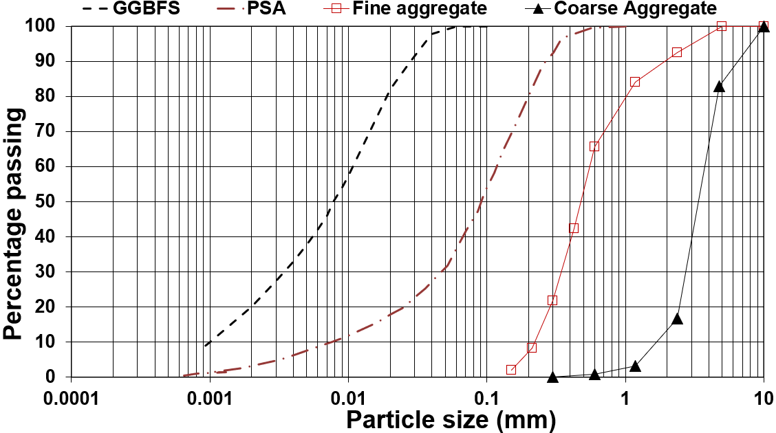
Figure 1: Particle size distribution of the aggregates, GGBFS & PSA

The concrete mix design used is shown in Table 2. For consistent comparisons, all mixes had the same liquid/solid ratio of 0.55 (the liquid/solid ratio includes water and solids in the activator solutions). Each mix was mixed and/or cured in three different ways namely: a) FF: mixed and cured in freshwater (conventional current practice); b) FS: mixed with freshwater (F) but cured in seawater (S) (to represent working conditions in seawater environment of freshwater mixed concrete, as per current practice) and c) SS: mixed and cured in seawater (a practice of Romans, who produced very durable cements in seawater environments). Artificial seawater was prepared according to ASTM D1141-98 with the chemical composition reported in Table 3. To prepare the mixes, first the dry ingredients were gradually introduced and mixed in the concrete mixer at 1-2 minute intervals at a time, in the following sequence: a) aggregates (coarse + fine); b) the GGBFS; c) the PSA (where applicable). Then the liquid part (i.e., water and waterglass) were thoroughly mixed for approximately two minutes; they were then slowly added to the dry ingredients (solid part) of the mix and mixed for another 4-5 minutes in the concrete mixer to avoid the formation of granules. The slump of fresh concrete was measured immediately after mixing (British Standards Institution [BSI], 2009a). All mixes with GGBFS only collapsed but within 15-20 minutes from mixing they became stiff and difficult to pour in moulds due to fast setting, which is reported in the results section (a suitable setting retarder as in Ma et al, 2016 could be used to control setting). This observation is consistent with Puertas et al., (2014) and Mavroulidou and Shah (2021). Mixes with PSA were generally stiff to very stiff (slumps of 30 mm), consistently with observations of fresh concrete slump where PSA is used as a supplementary cementitious material in Portland cement (e.g. Mavroulidou and Awoliyi, 2018 or Mavroulidou et al 2013). This can be attributed to the high water demand of PSA caused by its high porosity and free lime content (Doudart de la Grée et al., 2018). Workability could be improved by carefully selected superplasticisers (as it was shown that several types of common superplasticisers may not be effective or suitable for AAC concretes, RILEM, 2014). It was also shown that longer mixing can improve workability (see e.g. Mavroulidou and Shah, 2021).
Specimens were cast and demoulded after 24 hours; however, problems were encountered when demoulding and curing AAC mixes with freshwater as they had not fully hardened in the first 24 hours. This led to partial or complete disintegration of the samples upon immersion in water. It was thus subsequently decided to leave all mixes to harden in moulds under constant moisture content for four days prior to water curing, although seawater mixes did not present this problem.

Table 2 Details of mix design (kg per 1 m³)
Mix ID | CEM-I | GGBFS | PSA | Sand | Coarse aggregate | Na₂SiO₃ | Added Water
GGBFS_FF | 0 | 415 | 0 | 784 | 1039 | 112 | 186.4
GGBFS_FS | 0 | 415 | 0 | 784 | 1039 | 112 | 186.4
GGBFS_SS | 0 | 415 | 0 | 784 | 1039 | 112 | 186.4
GGBFS+PSA_FF | 0 | 415 | 16 | 784 | 1039 | 112 | 186.4
GGBFS+PSA_FS | 0 | 415 | 16 | 784 | 1039 | 112 | 186.4
GGBFS+PSA_SS | 0 | 415 | 16 | 784 | 1039 | 112 | 186.4
CEM-I_FF | 415 | 0 | 0 | 784 | 1039 | 0 | 230
CEM-I_FS | 415 | 0 | 0 | 784 | 1039 | 0 | 230
CEM-I_SS | 415 | 0 | 0 | 784 | 1039 | 0 | 230

Table 3 Chemical composition of artificial seawater
Compound | Concentration, g/L
Sodium chloride, NaCl | 24.53
Magnesium chloride, MgCl₂ | 5.20
Sodium sulphate, Na₂SO₄ | 4.09
Calcium chloride, CaCl₂ | 1.16
Potassium chloride, KCl | 0.695
Sodium hydrogen carbonate, NaHCO₃ | 0.201
Potassium bromide, KBr | 0.101
Boric acid, H₃BO₃ | 0.027
Strontium chloride, SrCl₂ | 0.025

2.2 Experimental Procedures
Cement tests were carried out to determine the setting time using the Vicat apparatus and the soundness (Le Châtelier test) of the different mixes according to BS EN 196-3: 2016 (BSI, 2016). Determining the soundness of the cements with PSA is of particular relevance, as the presence of CaO could potentially lead to delayed expansion of the samples. Setting time refers to the change in consistency of cement from fluid to solid. This should not be too rapid as to cause concrete to set before placement and compaction, neither should it be too slow, to delay works schedule. Initial setting times (during which concrete remains workable) of no less than 45 min and final setting times (for the hardening of concrete) of no more than 375 min are usually prescribed (Mavroulidou et al, 2015). SEM-EDS tests were also performed on the hardened cements to detect their microstructural features.

For concrete mixes, the cube compressive strength (100 mm cubes) of triplicate hardened concrete mixes at different curing times was determined according to BS EN 12390-3:2019 (BSI, 2019b) using a Zwick Roell ToniPACT II 2000kN compression test plant.

To address concrete durability in coastal environment, where the transport of deleterious ions occurs through water penetrating the pore structure of concrete, a number of relevant tests were performed on duplicate hardened concrete specimens, namely: (a) absorption of water by immersion and capillary rise respectively, (b) effective porosity of the specimens, (c) resistance to chloride attack and (d) resistance to sulphate attack. Here follows a brief explanation of the link of these quantities to concrete durability and a description of the respective experimental procedures.

In marine waters the transportation of deleterious ions (such as chlorides and sulphates) occurs through water, which penetrates in the pore structure of concrete. Therefore, the water absorption by immersion and capillary rise can be indicative of the transportation properties of the concretes. In this study, water absorption was determined using 100 mm cubes cured respectively for 28 and 56 days according to BS1881-122:2011 (BSI, 2011). Once removed from curing conditions, specimens were dried at 100°C for 72 ± 2 hours; after which they were weighted and stored in an air-tight vessel for 24 ± 0.5 hours to allow cooling. For water absorption by immersion the dried and cooled cubes were completely immersed in water for 30 min; the moisture absorption was calculated as the increase in the mass of the cube after immersion, expressed as a percentage of the mass of the dry cube. Absorption by capillary action was performed according to BS1881-122:2011 procedures with specimens dried and cooled at the same conditions as for the water absorption by immersion test. After the cooling period, the specimens were sealed with insulation tape at each side and allowed to absorb water by capillary rise action only from the bottom face of the specimen which was in contact with water at 2 ± 1 mm depth of immersion. Recordings of mass and water penetration height were then taken at regular intervals to determine the rate of capillary absorption in time.

The effective porosity of cylindrical concrete specimens of 38 mm diameter and 70 mm height specimens cured respectively for 28 and 56 days, was determined using a helium porosimeter apparatus, whose operating principle is Boyle’s law. Before porosity testing, the specimens were dried for 72 ± 2 h at a temperature of 105°C and then cooled for 24 h in an air pump vacuum container. It should be noted that low porosity is a requirement for the durability of modern Ordinary Portland Cements to ensure minimal fluid ingress and minimal aggregate reactivity with interstitial fluids (as chemical attack results in deleterious expansions, increased permeability & disaggregation in time). On the other hand, the durability of ancient cements with natural pozzolans was attributed to post-pozzolanic reactions in pores of the cementing matrix due to evolving fluid and aggregate interactions over time (alkali mediated dissolution and beneficial precipitation reactions through evolving alteration of reactive aggregates) and to the production of resilient C-A-S-H binder (extremely stable), for which the layered structure of Al-tobermorite is a crystalline model. Although in this study mineralogical analysis was not carried out, C-A-S-H are the basis of high calcium AAC systems (Garcia-Lodeiro et al, 2013) and have been detected in concretes containing PSA (e.g. Tignit-Hamou et al, 2015).

Corrosion of reinforcing steel is a leading cause of concrete deterioration, as the volume expansion due to rust causes tensile stresses to develop in the concrete, leading to cracking and spalling. In marine environment in particular, steel corrosion is the cause of the major part of the damage of in-service reinforced concrete structures (Malubela et al, 2012). Due to the alkaline environment of concrete (pH of 12-13) a thin oxide layer forms on the steel (passive layer) which reduces the corrosion rate to an insignificant level. However, when the alkalinity of the concrete is reduced or when the chloride ions concentration in concrete increases and chloride ions penetrate the protective oxide film, this passive layer can be destroyed. Thus, in seawater environment, chloride ions present in seawater, can permeate concrete or reach the steel through cracks, causing steel corrosion in the presence of oxygen and moisture. To assess steel corrosion, pH measurements and accelerated corrosion testing using an impressed current density methodology (see e.g., Malumbela et al, 2012) were performed. The apparatus consisted in a 10V DC power supply, a data logger, two stainless steel plates (marine grade) and a container with 3.5% of NaCl solution. 100mm cube samples were cast with a pre-weighed standard carbon steel rebar of an 8 mm diameter, which was fixed at the centre of the concrete cube specimens. The specimens were cured in a water tank for 7 days, consistently with the curing conditions mentioned above. They were subsequently subject to a constant immersion into the NaCl solution for 21 days. During the test, the steel bar was connected to the positive terminal whereas the negative terminal was connected to the stainless-steel plates. After 21 days, the specimens were removed, and the metal bars were separated from the concrete. The metal bars were cleaned according to ASTM G1-90 standard (ASTM 2000), using a solution of 500 ml of hydrochloric acid 5% with 3.5 g of hexamethylenetetramine in water to obtain a solution volume of 1000 ml. The percentage of the actual amount of steel lost in corrosion was then calculated gravimetrically by weighing the cleaned bars and assessing their mass loss compared to the original bar mass before testing. The corrosion rate was calculated by Equation (1):
𝐶𝑜𝑟𝑟𝑜𝑠𝑖𝑜𝑛 𝑟𝑎𝑡𝑒 = (𝐾 × 𝛥𝑊 )/(𝐴 × 𝑇 × 𝐷 ) (1)

Where: 𝐾 is a constant = 87.6; 𝛥𝑊 is the mass loss of the rebar (mg); 𝐴 is the area of the exposed surface of the metal bar (cm²); 𝑇 is the time in hours; 𝐷 is the density of the rebar (7.8 g/cm³).
It should be noted that accelerated corrosion tests are often viewed with some skepticism, and it is indeed acknowledged that laboratory tests may not give a full representation of the in-service performance of concrete, especially for AAC, where the pore solution chemistry and microstructure can lead to significant differences in the mechanisms controlling transport-related phenomena. However, these tests can still provide some useful information for the comparative performance of different cements in terms of durability (RILEM, 2014).
Sulphate attack is another major reason for poor concrete durability. Namely in OPC concrete, when a source of external sulphates, such as seawater, enters the hydrate cement paste matrix, calcium monosulfoaluminates revert into ettringite (calcium trisulfoaluminate), whose expansive crystals cause damage the concrete matrix. Portlandite (CaOH₂) is responsible for the deleterious sulphate attack, due to its high solubility (Rozière et al., 2009). To assess resistance to sulphate attack, 100mm cube samples were cast and cured for 28 days as required for each set of specimens (i.e., FF, FS, SS). They were then immersed in a sodium sulphate (Na₂SO₄) solution containing 50g of Na₂SO₄ per litre. The length of the specimens was measured at 0, 20, 40, 60, and 90 days, using Vernier callipers to determine the percent length change. At the end of the sulphate exposure period, the compressive strength of the specimens was determined to assess any effects of the sulphates on its value.

3. EXPERIMENTAL RESULTS
3.1 Cement testing
Table 4 reports the cement testing results in terms of setting times and soundness, as the average values of duplicate specimens. Both AAC mixes had flash setting times compared to the CEM-I control, consistent with observations of fast setting during the casting, creating some practical problems with the casting of the fast-setting AAC mixes, unless this was done promptly after mixing. Despite the slight increase in the initial setting times when seawater was used and a slight decrease in setting time upon the addition of PSA, practically there is very little difference in the setting times between the two AAC mixes (GGBFS only or GGBFS+PSA) to make a statement about improvement in setting times or otherwise upon addition of PSA; the final setting times of the AAC mixes practically coincided with the initial setting times (given the recommendation of the standards to record the final setting time to the nearest 15min). The results of the soundness test showed practically no expansion as all length changes were between -0.5mm -0.5 mm; in fact some AAC mix samples both in fresh and seawater shrank slightly rather than expanded in particular if mixed freshwater (whereas some CEM-I samples slightly expanded). Due to the small length changes and the accuracy of the test (the recommendation of the testing standards is to report the results to the nearest 0.5mm), it is difficult to ascertain if there is a pertinent trend. Overall, the tests showed no evidence of possible expansion of the resulting concrete due to the delayed hydration of uncombined calcium oxide (e.g. free lime in the PSA mixes), which gives confidence in its use.

Table 4 Cement testing results (setting times and soundness)
Mix ID* | Setting time test |  | Soundness test
 | Initial setting time (min) | Final setting time (min) | Length change (mm)
GGBFS_ F | 20 | 20 | -0.5
GGBFS_ S | 25 | 30 | 0.5
GGBFS+PSA_ F | 15 | 20 | -0.5
GGBFS+PSA_S | 20 | 25 | -0.5
CEM-I_ F | 90 | 150 | 0.5
CEM-I_ S | 90 | 150 | 0.5
*As there is no curing for the cement mix tests, the mix ID convention differs to that of the concrete test using one letter F or S only, to denote mixing with fresh or sea water respectively

3.2 Cube compressive strength
Figure 2 shows the average compressive strength results of triplicate specimens at different curing times. It can be seen that, overall, all AAC mixes had good compressive strengths, most of which comparable to CEM-I, especially when mixed with seawater. Note the much higher early compressive strengths of PSA-containing mixes compared to the respective AAC mixes without PSA, especially when mixed with freshwater; however, the strength gain of PSA-containing AAC mixes slowed down in later times. Conversely mixes with GGBFS only, kept evolving and eventually reached higher strengths compared to the CEM-I mix at 56 days of curing; this is consistent with findings of the recent RILEM TC 247-DTA round robin test, assessing the reproducibility of compressive strength of AAC across a total of ﬁfteen laboratories worldwide (Provis et al, 2019). These found mean strengths of alkali-activated slag concretes to increase consistently up to 56 days. For the CEM-I mixes, note that although the early strengths were not affected, there was a slight reduction in the longer term strengths (28 and 56-day curing) of the CEM-I mixes when exposed to seawater. Overall, as shown in Table 5, mixes with PSA had similar strength evolution in time as CEM-I mixes except when PSA was used in mixes with freshwater (for this mix the 7-day/28-day strength ratio was higher than that of CEM-I mixes but it should be noted that one set of replications of the 56 days tests of this mix showed high variability with strengths up to 63MPa). This early strength gain (which is adequate for structural concrete) can be of practical interest for precast concrete and for rapid construction projects.
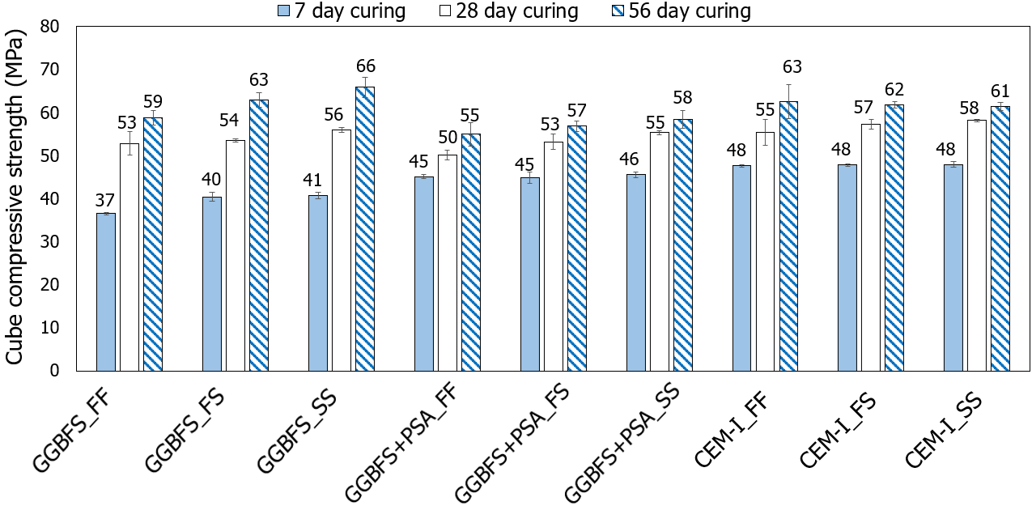
Figure 2: Compressive strength of mixes at different curing times
Mix ID | 7 day-strength/28-day strength ratio | 28 day-strength/56-day strength  ratio | 7 day-strength/56-day strength  ratio
GGBFS_FF | 0.69 | 0.9 | 0.62
GGBFS_FS | 0.76 | 0.85 | 0.64
GGBFS_SS | 0.73 | 0.85 | 0.62
GGBFS+PSA_FF | 0.9 | 0.91 | 0.82
GGBFS+PSA_FS | 0.84 | 0.93 | 0.79
GGBFS+PSA_SS | 0.82 | 0.95 | 0.78
CEM-I_FF | 0.86 | 0.89 | 0.76
CEM-I_FS | 0.83 | 0.93 | 0.77
CEM-I_SS | 0.83 | 0.95 | 0.78
Table 5: Strength evolution with curing time

3.3 Water absorption and effective porosity
Figure 3 summarises the average water absorption results of duplicate samples (both by immersion or capillary action) with the error bars showing maximum and minimum values. Figure 4 shows indicative results of water absorption in time (for 28-day cured samples). Table 6 shows the results of helium porosimetry tests in terms of effective porosity of the mixes (average values of duplicate samples).
The results in Figure 3 and 4 show a clear increase in water absorption of the AAC mixes compared to the CEM-I mixes. The higher water absorption of the AAC mixes is consistent with their generally higher effective porosity compared to the CEM-I_FF mix; note however the increase in porosity of the CEM-I mix when in seawater environment, which could be linked to its lower chloride and sulphate penetration resistance, as shown in sections 3.4 and 3.5 below, which also leads to the formation of cracks. Generally, an increase in porosity and water absorption would normally imply an increased vulnerability of concrete due to enhanced transport of deleterious ions (such as chlorides and sulphates). However, as the following sections will show, this did not affect adversely the durability of AAC mixes as opposed to the CEM-I mix when in seawater. This could be explained by the finer pore size distribution of alkali-activated slag cements compared to OPC, which has been documented in the literature (see e.g. Shi et al., 2006). PSA had a variable effect but generally it reduced the water absorption of the mixes consistent with the reduction of the effective porosity of the mixes; for samples mixed and cured in seawater for 56 days however, GGBFS only mixes showed a reduced absorption, although the porosity of the respective PSA containing mixes had reduced compared to 28-day curing mixes; this suggests that there is an evolution in the development of reaction products in time, refining or blocking the pores (note that interconnected pore refinement could be a factor linked to the increased absorption by capillary action).
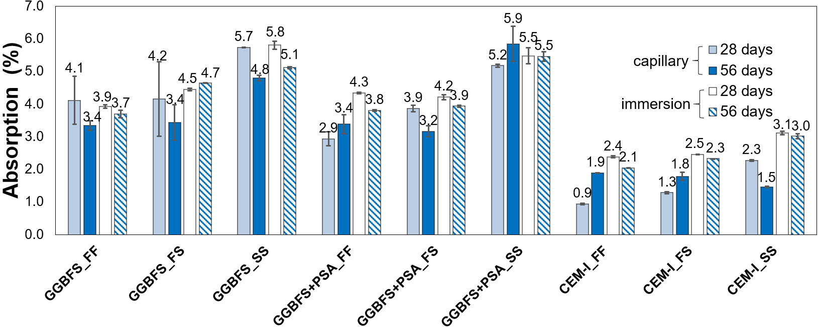
Figure 3. Water absorption by capillary action and immersion at different curing times

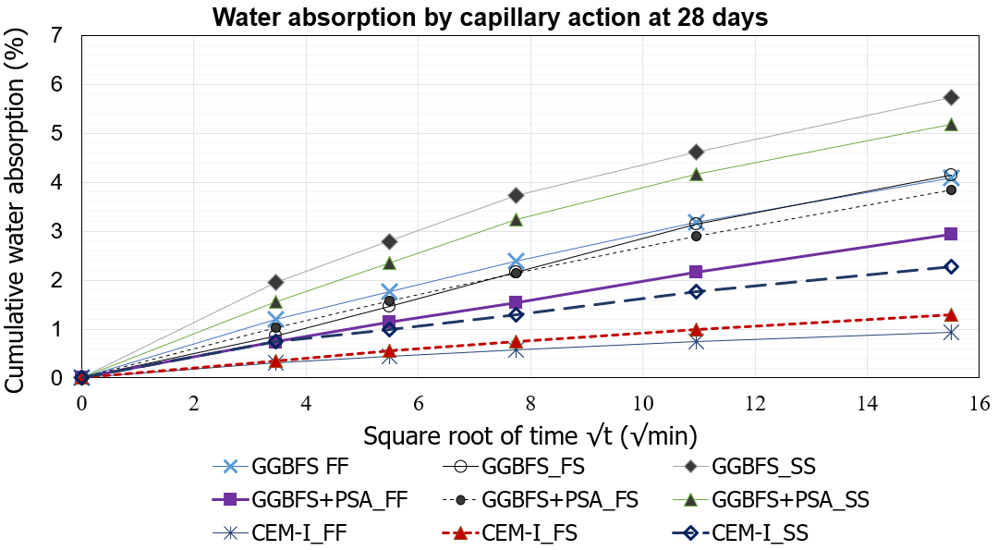
Figure 4. Indicative results of water absorption by capillary action evolution in time (28-day cured samples)

Table 6 Effective porosity results for different curing times
MIX ID | 28-day curing  (v/v %) | 56-day curing  (v/v %)
GGBFS _FF | 15.3 | 15.4
GGBFS_ FS | 14.8 | 13.1
GGBFS_ SS | 15.8 | 14.8
GGBFS+ PSA _FF | 13.7 | 13.3
GGBFS+ PSA _FS | 14.2 | 13.1
GGBFS+ PSA_ SS | 11.6 | 11.7
CEM-I _FF | 11.8 | 13.9
CEM-I _FS | 15.0 | 13.8
CEM-I _SS | 15.7 | 14.3

3.4 Corrosion resistance
Table 7 reports indicatively pH values obtained from crushed 28 day-cured specimens; 28 day curing of OPC concrete would reflect the progress of hydration reactions, with the pH of concrete reducing due to portlandite consumption to form with the C-S-H products. Thus, for OPC, the common usage for design strength is based on 28 days of curing, as there is limited strength evolution beyond this period. It is of course acknowledged that the pore fluid chemistry of AAC and hydration reaction products are not the same as OPC and that for AAC there can be considerable maturity gain through microstructural and physicochemical evolution beyond 28 days, which is essential in the durability development (RILEM, 2014).
The alkalinity of the AAC samples is shown to be satisfactory for steel reinforcement protection against corrosion (i.e. pH >11.5, Mehta and Monteiro, 2006), although lower than the pH values of the CEM-I concrete.
Table 7 pH values of 28-day cured specimens
Mix | Average pH values
CEM-I_FF | 12.2
CEM-I_FS | 12.0
CEM-I_SS | 12.4
GGBFS_FF | 11.9
GGBFS_FS | 11.9
GGBFS_SS | 11.9
GGBFS+PSA_FF | 11. 9
GGBFS+PSA_FS | 11.9
GGBFS+PSA_SS | 11.9

Figure 6 and Table 8 show respectively the corrosion rates of the embedded steel rebar and the mass loss of the steel rebar due to oxidation. Both indices demonstrate the clearly improved performance of AAC mixes in reducing the effect of chloride ions compared to OPC concretes–note in particular the complete disintegration of some of the rebars embedded in CEM (marked as N/A on the figure) that made measurements on them unfeasible. Where measurements were possible for steel rebars in CEM-I mixes, these had corrosion rates ca. 90% higher compared to the AAC mixes, despite the higher pH of the CEM-I mixes compared to the AAC mixes (note also the slight raise in the pH of the CEM-I_SS mix due to the seawater composition). All CEM-I samples displayed visible cracks along most of the surfaces, as shown in Figure 6: expansive red rust developed high internal pressures capable of breaking the specimens to accommodate its volume. The improved performance of the AAC mixes is in agreement with Krivenko et al. (2016), who reported reductions in chloride diffusion rates nearly 30 to 40 times slower in AA GGBFS pastes compared to OPC, as well as with Gluth et al (2020) who reported that blast furnace slag-based concretes were the most resistant to chloride ingress of all alkali-activated materials tested in the RILEM TC 247-DTA round robin tests programme. This improved performance was attributed to the mictrostructure/ﬁner pore structure (highly reﬁned pore network) of the alkali-activated slag concretes (Van Deventer et al, 2010; Ma et al., 2016) and/or their ability to bind substantial amounts of Cl⁻, via adsorption onto and incorporation into hydrotalcite-like phases (hydration products), thus restricting the ingress of chloride (Khan et al., 2016; Ke et al. 2017a,b).

Note that the performance of AAC mixes improved compared well to CEM-I_FF despite the higher effective porosity of the AAC samples (see Table 6), which would not have been normally expected. This is consistent with RILEM (2014), which notes that in AAC there are additional, still poorly understood effects (e.g. gel chemistry specific effects) that can combine with or mitigate the direct influence of porosity on permeability and hence durability of these materials. The freshwater mix with PSA cured in freshwater (GGBFS+PSA_FF) had a better performance in comparison with the respective mixes of CEM-I and the AAC mix without PSA. This mix shows overall the best performance with an overall corrosion rate of 1.023 mm/year and an average steel mass loss of 0.7%, followed by GGBFS_FF. On the other hand, there is some small improvement in the performance of GGBFS only mixes in/with seawater compared to the respective GGBFS+PSA mixes. AAC specimens containing seawater showed higher corrosion rates than the respective mixes with freshwater, presumably due to the initial chloride content, but still performed clearly better than the respective CEM-I mixes.
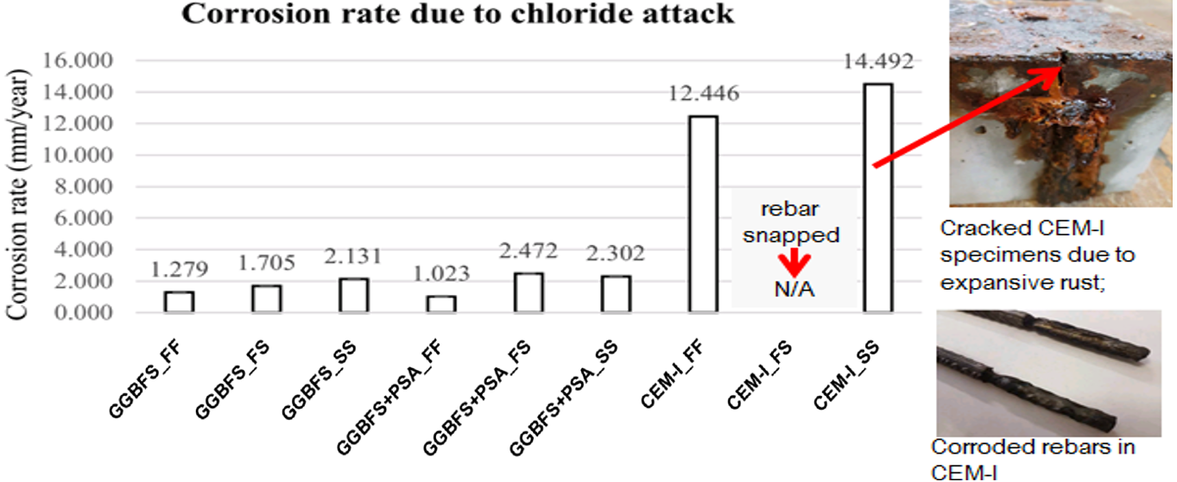
Figure 6 Accelerated corrosion test: Average corrosion rates of steel rebars and inspection of samples

Table 8 Accelerated corrosion test: Average mass loss (%) steel rebars
Mix ID | Average mass loss (%)
GGBFS_FF | 0.9
GGBFS_FS | 1.3
GGBFS_SS | 1.6
GGBFS + PSA_FF | 0.7
GGBFS+PSA_FS | 1.8
GGBFS+PSA_SS | 1.7
CEM-I_FF | >9% *
CEM-I_FS | N/A (steel rebars disintegrated)
CEM-I_SS | >10.7% *

*one of the duplicate samples had disintegrated making measurements unfeasible

3.5. Resistance to sulphate attack
Figure 7(a) shows the percent length change of concrete specimens immersed in sulphate solution recorded at 20, 40, 60 and 90 days. It is notable that AAC did not expand but instead shrank after exposure in sulphate. CEM-I_FF and CEM-SS showed some initial shrinkage but then expanded (the CEM-I_FS mix expanded throughout its exposure in sulphate). After exposure to sulphate all CEM-I concrete cubes showed visible cracks along the edges, which is consistent with the recorded expansion and possible ettringite formation; no cracks were observed in the AAC concrete mix cubes. This is consistent with Provis and Winnefeld (2018) who mention that during RILEM RILEM TC 247-DTA round robin tests of immersion in sodium sulfate solution did not cause significant expansion or damage to any of the alkali-activated materials tested under any of the standardized testing regimes applied. At the end of the sulphate exposure period, the cube compressive strength was measured (see Fig 7(b)). Overall, the sulphate environment enhanced the strengths of the AAC mixes, which kept curing to reach higher values than the strengths of CEM-I mixes (before sulphate exposure). The conventional CEM-I_FF mix strengths (mixing and curing in fresh water) were reduced after exposure to sulphate; a slight decrease was noted in the CEM-FS mix, whereas there was no obvious effect in the CEM-I_SS mix (mixed and cured in seawater). Conversely, for all AAC mixes the exposure in sulphate not only did not lower their 56-day strengths but in fact encouraged further strength gain, for all types of mixing and curing water. This finding is consistent with Komljenovic et al (2013), who observed some increase in alkali-activated slag mortars (mixed with and cured in freshwater) compared to reference CEM-II strengths after exposure in 5% sodium sulphate solution for 90 days. PSA-containing mixes in/with seawater had the higher strength gain in sulphate environment, whereas the GGBFS only mixes had a higher strength gain after sulphate exposure when mixed and cured in freshwater. Komljenovic et al (2013) attributed the continuous strength increase of alkali-activated slag mortars in sulphate medium to a probable porosity reduction, caused by the formation of reaction products between AAC and sulphate medium or from the extension of the alkali-activation reaction due to the high pH of the sulphate medium. Moreover, sodium sulphate can act as a slag activator (RILEM, 2014). The presented findings in this paper do show some reduction in porosity in most AAC mixes; however, for the GGBFS only mixes this is true mostly for mixes in/with seawater (GGBFS_FS and GGBFS_SS mixes), whereas for the PSA-containing mixes this is not the case (the GGBFS_PSA_SS mix does not show a reduction in porosity). Further chemical, mineralogical and microstructural investigation is required to understand the findings by studying the hydration products and mineral growth in the presence of sodium sulphates.
Figure 7. Resistance to sulphate attack: (a) length change of specimens; (b) compressive strength

3.6 Scanning electron microscopy (SEM)
Figure 8 shows indicative SEM-EDS results of tests on crushed samples from cement paste specimens used for Le Chȃtelier tests (one week after testing). CEM-I mixes show a dense honeycombed/reticular structure due to hydration product formation; some smooth uneroded particles as well as attacked/dissolved slag particles with formation of crystallised hydrates can be seen in the GGBFS AAC mixes; crystallisation is higher in the PSA containing mixes compared to the GGBFS only mixes. The GGBFS_PSA_S mix appears to have the densest structure of all AAC mixes, which concurs with its reduced porosity. Microcracks and interconnected voids are seen in the CEM-I_S seawater mix but not in the CEM-I_F freshwater mix, which could justify the increased porosity of the CEM-I seawater mix. Some occluded voids and microcracks are also visible in the AAC mixes; these are bridged by/filled with crystals/hydration gel networks especially in the PSA AAC mix with seawater, which can justify the low effective porosity of the latter mix. Compared to the CEM-I mixes, lower Ca/Si ratios and higher Al/Si ratios were found in AAC mixes, based on EDS spectra analysis; some Na and Mg peaks can be seen in the EDS spectra of the AAC mixes, which are absent from the CEM-I element spectra (which could denote possible presence of sodium hydroaluminosilicates and hydrotalcite) but the peaks are too low for any firm statements.

4. CONCLUSIONS
The presented work studied the performance of alkali-activated ground-granulated blast-furnace slag concrete mixes in seawater environment using seawater in the mixes (as in ancient Roman cements) and also including paper sludge ash waste in the AAC mixes. All AAC mixes showed good compressive strengths, adequate for structural concrete, which were generally evolving more favourably than those of conventional OPC (CEM-I) when exposed to, or mixed with seawater. AAC mixes were more durable in marine environments based on sulphate and chloride attack tests compared to the CEM-I mixes, as the latter showed some higher vulnerability when exposed to seawater. This gives promise for a more cost-effective and environmentally friendly alternative to regular cement for increased resilience and sustainability in seawater environment. The main advantages of the addition of PSA to the AAC mix were the early strength gain and the increase in strength when exposed to sodium sulphate for any water environment (fresh or seawater); otherwise, PSA did not appear to further enhance the durability performance of AAC mixes against chloride and sulphate attack and the later curing times strengths were lower than those of AAC concrete mixes with GGBFS only. On the other hand, the effective porosity and water absorption performance of the AAC mixes with PSA was overall better than those of the AAC mixes without PSA. This is consistent with the evolution of reaction products in time filling the pores of the resulting concrete, which is desirable in terms of fluid ingress and transport of deleterious ions. Further work on mix optimisation and mechanical and durability testing accompanied by material characterisation is required to establish the advantages of using this waste material in AAC concrete for marine environments. A more comprehensive characterisation of the composition of the concrete mixes (chemical and mineralogical) is also required to interpret the mechanical testing findings and elucidate the mechanisms of the observed phenomena. Further work should also address other potentially deleterious processes for the durability of concrete, such as alkali-silica reaction, magnesium sulphate attack, marine growth and pollutants etc., which are also important to evaluate in a marine environment when considering industrial application.

ACKNOWLEDGEMENT
This research was carried out using London South Bank University resources. Funding from the School of the Built Environment and Architecture (London South Bank University) internal research funds is gratefully acknowledged. The authors would like to thank Graham Bird, Christopher Gray and Paul Elsdon for their assistance with the testing.

Figure 8. Indicative SEM photos: (a) & (b) CEM-I mixes with fresh and seawater respectively; (c) & (d) GGBFS mixes with fresh and seawater respectively; (e) & (f) GGBFS+PSA mixes with fresh and seawater respectively.
REFERENCES
American Society of Testing and Materials (ASTM) (2000) Standard Practice for Preparing, Cleaning, and Evaluating Corrosion Test Specimens, ASTM G1-90, G01 Committee ASTM International, American Society for Testing and Materials, Designation G15-99b (Revised) 03.02.2000. ASTM, West Conshohocken
Bernal S, Ball R, Hussein O, Heath A & Provis J (2014) Paper sludge ash as a precursor for production of alkali-activated materials. 2nd International Conference on Advances in Chemically Activated Materials, June 1-3 2014, Changsha, China
British Standards Institution (BSI) (2016) BS EN 196 – 3:2016, Method of testing cement, Determination of setting time and soundness, BSI, London.
British Standards Institution (BSI) (2009a) BS EN 12350-2:2009: Testing Fresh Concrete, Part 2: Slump Test. London: BSI.
British Standards Institute (2019b), BS EN 12390-3:2019: Testing hardened concrete. Part 3: Compressive strength of test specimens, BSI, London.
British Standards Institution (2011) BS EN 1881-122:2011: Testing concrete Part 122: Method for determination of water absorption. BSI, London
Criado M. and Provis J.L. (2018) Alkali Activated Slag Mortars Provide High Resistance to Chloride-Induced Corrosion of Steel. Frontiers in Materials. 5, 34. doi: 10.3389/fmats.2018.00034
Davidovits, J. (2013) Geopolymer cement. A review 2013. Geopolymer Institute. [Online]. Available from: http://www.geopolymer.org/library/technical-papers/21-geopolymer-cement-review-2013. [Accessed 11 /08/13].
Doudart de la Grée GCH (2012). Physical-chemical upgrading and use of bio energy fly ashes as building material in the concrete industry. MSc Dissertation, Eindhoven Univ. of Technology, Eindhoven, Netherlands.
Doudart de la Grée GCH, Yu QL and Brouwers HJH (2018) Upgrading and evaluation of waste paper sludge ash in eco-lightweight cement composites. Journal of Materials in Civil Engineering 30: 04018021.
European Commission (EC) (2008) Directive 2008/98/EC: Waste Framework Directive. European Commission
García-Lodeiro A., Fernández-Jiménez, A., Palomo, E.T. (2013) Alkali-activated based concrete, In: Eco-efficient concrete, Pacheco -Torgal, F. et al (Eds) Woodhead Publishing, Oxford, 437-487
Gjørv, O. (2011). Durability of Concrete Structures. Arabian Journal for Science and Engineering, 36(2), pp.151-172.
Gluth G.J.G, Arbi K., Bernal S.A. et al (2020) RILEM TC 247-DTA round robin test: carbonation and chloride penetration testing of alkali-activated concretes Materials and Structures (2020) 53:21 https://doi.org/10.1617/s11527-020-1449-3
Grantham, M., Majorana, C. and Salomoni, V. (2009). Concrete solutions. Boca Raton, Fla: CRC Press.
Imbabi, M., Carrigan, C. and McKenna, S. (2012). Trends and developments in green cement and concrete technology. International Journal of Sustainable Built Environment, 1(2), pp.194-216.
Jackson M D., Mulcahy S. R., Chen H., Li Y., Li Q., Cappelletti P., and Wenk H.R. (2017) Phillipsite and Al-tobermorite mineral cements produced through low-temperature water-rock reactions in Roman marine concrete. American Mineralogist, 102, 1435–1450
Jun, Y., Yoon, S. and Oh, J. (2017). A Comparison Study for Chloride-Binding Capacity between Alkali-Activated Fly Ash and Slag in the Use of Seawater. Applied Sciences, 7(10), 971; doi:10.3390/app7100971
Ke, X., Bernal, S. A., Hussein, O. H., and Provis, J. L. (2017a). Chloride binding and mobility in sodium carbonate-activated slag pastes and mortars. Materials and Structures, 50, 252. doi: 10.1617/s11527-017-1121-8
Ke, X., Bernal, S. A., and Provis, J. L. (2017b). Uptake of chloride and carbonate by Mg-Al and Ca-Al layered double hydroxides in simulated pore solutions of alkali-activated slag cement. Cement and Concrete Research 100, 1–13. doi: 10.1016/j.cemconres.2017.05.015
Khan, M., Kayali, O. and Troitzsch, U. (2016). Chloride binding capacity of hydrotalcite and the competition with carbonates in ground granulated blast furnace slag concrete. Materials and Structures, 49(11), 4609-4619.
Kirezci, E., Young, I.R., Ranasinghe, R. , Muis S., Nicholls R.J., Lincke D. and Hinkel J. (2020) Projections of global-scale extreme sea levels and resulting episodic coastal flooding over the 21st Century. Scientific Reports 10, 11629. https://doi.org/10.1038/s41598-020-67736-6
Komljenović, M., Baščarević, Z., Marjanović, N. and Nikolić, V. (2013). External sulfate attack on alkali-activated slag. Construction and Building Materials, 49, pp.31-39.
Krivenko, P. (2017)Why Alkaline Activation – 60 Years of the Theory and Practice of Alkali-Activated Materials Journal of Ceramic Science and Technology, 8(3), 323-334 doi: 10.4416/JCST2017-00042
Krivenko, P., Cao, H., Weng, L. and Petropavlovskii, O. (2016). High-Performance Alkali-Activated Cement Concretes for Marine Engineering Applications. In: S. Yilmaz and H. Ozmen, ed., High Performance Concrete Technology and Applications. Intech, p. Chapter 8.
Luukkonen T., Abdollahnejad Z. Yliniemi J., Kinnunen P., Illikainen M. (2018) One-part alkali-activated materials: A review Cement and Concrete Research, 103: 21-34
Ma, Q., Nanukuttan, S. V., Basheer, P. A. M., Bai, Y., and Yang, C. (2016). Chloride transport and the resulting corrosion of steel bars in alkali activated slag concretes. Materials and Structures 49, 3663–3677. doi: 10.1617/s11527-015-0747-7
Malumbela, G., Moyo, P., Alexander, M. (2012) A step towards standardising accelerated corrosion tests on labo-ratory reinforced concrete specimens. Journal of the South African Institution of Civil Engineering 54 (2), 78–85
Mavroulidou, M. (2018) Use of paper sludge ash as a calcium-based stabiliser for clay soils Waste Management and Research, 36 (11): 1066–1072
Mavroulidou M. and Awoliyi S. (2018) A study on the potential use of paper sludge ash in concrete with glass aggregate, Waste Management and Research 36 (11):1061-1065
Mavroulidou M, Boulouki G and Unsworth C (2013) Incorporating waste paper sludge as partial cement replacement in concrete. In: 13th International Conference on Environmental Science & Technology, CEST2013, Athens, Greece, 5–7 September 2013.
Mavroulidou M., Garelick J., Gray C., Gunn MJ, Youssef A. & Hassan S. (2019). A study on the use of paper recycling waste streams for geotechnical applications, XVII ECSMGE European Conference on Soil Mechanics and Geotechnical Engineering, Reykjavik, Iceland 1st- 6th September 2019
https://www.ecsmge-2019.com/uploads/2/1/7/9/21790806/560-ecsmge-2019_mavroulidou.pdf [Accessed 14/07/2020]
Mavroulidou, M, Morrison, T., Unsworth C., Gunn, M. (2015) Properties of concrete made of multi-component mixes of low energy binders, Construction and Building Materials, 101 (1), pp 1122-1141, http://dx.doi.org/10.1016/j.conbuildmat.2015.10.091
Mavroulidou M. and Shah S. (2021) Alkali-activated slag concrete with paper industry waste. Waste Management & Research doi: 10.1177/0734242X20983890
Mehta, P. and Monteiro, P. (2006). Concrete. New York: McGraw-Hill.
Mozaffari E, Kinuthia JM, Bai J & Wild S (2009) An investigation into the strength development of Wastepaper Sludge Ash blended with Ground Granulated Blastfurnace Slag. Cement and Concrete Research 39, pp. 942–949
Palomo, A.; Krivenko, P.; Garcia-Lodeiro, I.; Kavalerova, E.; Maltseva, O.; Fernández-Jiménez, A. (2014) A review on alkaline activation: new analytical perspectives. Materiales de Construcción. 64 (315), e022 http://dx.doi.org/10.3989/mc.2014.00314.
Provis, J.L, Arbi K., Bernal S.A. et al (2019) RILEM TC 247-DTA round robin test: mix design and reproducibility of compressive strength of alkali-activated concretes Materials and Structures, 52:99 https://doi.org/10.1617/s11527-019-1396-z
Provis J.l., Palomo, A., Shi, C. (2015) Advances in understanding alkali-activated materials, Cement and Concrete Research, 78A, 110-125.
Provis, J.L. and Winnefeld, F. (2018) Outcomes of the round robin tests of RILEM TC 247-DTA on the durability of alkali-activated concrete. In: MATEC Web of Conferences. International Conference on Concrete Repair, Rehabilitation and Retrofitting (ICCRRR 2018), 19-21 Nov 2018, Cape Town, South Africa. EDP Sciences. https://doi.org/10.1051/matecconf/201819902024
Puertas F, Varga C and Alonso MM (2014) Rheology of alkali-activated slag pastes. Effect of the nature and concentration of the activating solution. Cement and Concrete Composites 53: 279–288.
RILEM (2014) Alkali Activated Materials. State-of-the-Art Report, RILEM TC 224-AAM Provis, J., van Deventer, J. (Eds.), Springer/RILEM Dordrecht
Rozière, E., Loukili, A., El Hachem, R. and Grondin, F. (2009). Durability of concrete exposed to leaching and external sulphate attacks. Cement and Concrete Research, 39(12), pp.1188-1198.
Shi C, Krivenko PV and Roy D. (2006) Alkali-Activated Cements and Concretes. Taylor & Francis, New York
Spathi C. (2015) Novel applications for paper sludge ash. PhD thesis, Imperial College, London
Tagnit-Hamou A Tognonvi MT Davidenko T Belkacemi DZ (2015) From ancient to modern sustainable concrete. In: Scrivener K Favier A (Eds) Calcined clays for sustainable concrete. Proceedings of the 1st International Conference on Calcined clays for sustainable concrete, RILEM Bookseries 10, pp. 75-82, Dordrecht, Springer

