The effects of an expected twofold perturbation on able-bodied gait: trunk flexion and uneven ground surface
Authors:
Soran AminiAghdam ª*, Reinhard Blickhan ª
ª Department of Motion Science, Institute of Sport Science, Friedrich Schiller University Jena, Seidelstraße 20, 07740 Jena, Germany
* corresponding author email: soran.aminiaghdam@uni-jena.de

Abstract
Background: Although alteration in trunk orientation and ground level potentially affects gait pattern individually, it is plausible to examine the interaction effects of such factors.
Objective: The interaction effects between trunk-flexed gait and uneven ground on able-bodied gait pattern.
Methods: For twelve able-bodied participants, we compared the adaptive mechanisms in kinematics, kinetics and spatial-temporal parameters of gait (STPG) with bent postures (30° and 50° of sagittal trunk flexion) across uneven surface (10-cm visible drop at the sight of the second ground contact) with that of upright posture on even ground surface.
Results: Significant between-posture changes on the uneven surface included a decreased peak ankle dorsiflexion angle and vertical ground reaction force (GRF) 2nd peak as trunk flexion increased. Moreover, significant between-ground surface changes for each individual gait posture were a decreased peak ankle dorsiflexion angle and ankle range of motion irrespective of trunk posture and a reduced trailing step duration and vertical GRF 2nd peak in upright walking. The spatial parameters of gait remained unchanged across uneven surface, but at the expense of pronounced adjustments in temporal parameters, i.e., a more conservative gait strategy, indicating a distinct contribution from spatial and temporal strategies in trunk-flexed gaits. This was associated with greater peak flexion angles across lower limb joints regardless of trunk posture, alongside with an exertion of greater forces at faster rates earlier in stance and attenuated forces at lower rates at the end of the stance (i.e., early-skewed vertical GRF). When considering the main effect of posture, a more crouched gait was executed with reduced temporal parameters (except for cadence) and an early-skewed vertical GRF patterns with increasing trunk flexion.
Significance: These results may have implications for understanding the nature of compensatory mechanisms in gait pattern of older adults and/or patients with altered trunk orientations while accommodating uneven ground.
Key words: Posture; Uneven walking; Trunk-flexion; Kinematics; Kinetics; Gait parameters

Introduction
From control perspective, the stability of human bipedal gait is inherently a challenging functional task, as nearly two-thirds of total body mass is centered at around two-thirds of body height above the ground [1]. In this framework, stabilizing the trunk — an unstable inverted-pendulum standing on the hips [2, 3] — is a key task in human locomotion. In experiments, the manipulation of this functional task by changing the geometry of the trunk and/or by predisposing the gait to the external disturbances would allow understanding of underlying principles governing human locomotion.
Indeed, a safe daily locomotion (e.g., walking and running) is required to continually cope with constantly changing ground surface properties and levels, likely owing to the threats to control of balance [4]. An uneven surface (US) has been proposed as one of the major environmental factors that contribute to fall [5-7]. Therefore, the ability to adjust the stepping pattern to meet environmental demands and task goals is key for a successful locomotion. When locomotion requires a great deal of both stability and adaptability [2], some adaptations in the spatial-temporal parameters of gait (STPG) — one of the most relevant biomechanical gait parameters [3] — such as a reduction in the step length and velocity [1] and increase in the step width [2] seem indispensable.
On the other hand, it would be of clinical interest to identify the impact of variation in postural alignment on gait dynamics, given the trunk orientation is often predisposed to sagittal inclination in presence of some pathological conditions or with age. Suzuki et al. [8] reported that the standing sternum inclination angles in a standing posture — as a measure of physical function — increase with age in both elderly male and female. A study by de Groot et al. [9] revealed that elderlies with a flexed posture demonstrate a less consistent gait pattern. The older adults exhibit a more conservative gait patterns than young counterparts, as they tend to walk with a lower gait velocity [10, 11]; a shorter step length [12] stride length [13]; higher cadence [10, 13] and double support time [10, 14] both on solid and irregular terrain. The changes in trunk kinematics influence the STPG. For asymptomatic level gait with imposed trunk-flexed postures, we [15] found that temporal parameters of step like stance and swing duration, cadence and velocity vary with an increase of trunk flexion, while step length remained unchanged. These adjustments in the STPG were accompanied by limitation of the overall lower limb joints’ range of motion. However, how lower limb joint kinematics perform under uneven ground surface with an altered trunk geometry is still unclear.
The control of dynamic stability of trunk-flexed gait requires more crouched lower limbs [15, 16], i.e. an increased hip and knee flexion and ankle plantarflexion throughout the stance phase, necessary to maintain a dynamic relationship between body center of mass (BCOM) and base of support [17]. Given the vertical ground reaction force (GRF) is proportional to the vertical position and acceleration of the BCOM, the changes in the dynamics of BCOM result in alteration in the GRF, as reflected e.g. in early-skewed patterns of the vertical GRF [15, 17, 18].
With an increase of forward lean of trunk, the stance intra-limb (i.e., touchdown-toe-off) kinematic and kinetic asymmetries increases: at toe-off, an effective leg length (connecting hip to center of pressure) and the second peak of the vertical GRF tends to reduce compared with touchdown [15]. An expanded ground contact-focused (i.e., the sequence of pre-perturbation, perturbation and post-perturbation contacts) analysis of trunk-flexed gaits reveals that accommodating uneven ground occurs at reduced between-contact variations in gait kinetic parameters in comparison with those of a regular upright walking [18]. However, these characteristics were maintained at the expense of pronounced adjustments in lower limb kinematics at touchdown and toe-off instants across investigated contacts [16].
Although there seems to be some evidence indicating that adaptations in gait patterns occur with changes in the sagittal plane trunk orientation and in ground level, little is known about the simultaneous effects these changes may have on gait dynamics. Understanding how able-bodied adults adapt to US walking while adopting bent postures may provide insight into challenges faced by older adults and/or patients with altered trunk orientation during daily ambulation. Thus, this study aimed to investigate how the STPG and gait kinematics and kinetics are modulated during a perturbed gait stride in able-bodied trunk-flexed gaits. We expect that alteration in trunk orientation and ground level would individually require more contribution from the temporal strategies rather than the spatial strategies of gait, given an awareness of the perturbation would facilitate voluntary stepping strategies that may lead to diminished spatial adaptations of the gait pattern. Based on our recent study [15] that a posterior shift of the hip, due to a forwardly bent posture, yields an asymmetric operation of the legs with respect to the BCOM [15, 19], we anticipate that the trunk-flexed gaits across US would require more pronounced lower limb compensatory kinematic adaptations with swifter temporal and greater spatial gait adjustments, resulting in altered vertical GRF parameters for the purpose of maintaining dynamic stability compared to those of walking on the ES.

Methods

Participants
Six males and six females (mean±SD; age=26±3.35 years, height=169.75±7.41 cm, mass=65.08±8.07 kg), free from health problems that could affect their walking pattern and trunk motion, were recruited for this study. A consent form was signed by each participant before participation. The experimental protocol was approved by the local Ethics Committee of the Friedrich Schiller University Jena (3532-08/12) and carried out in accordance with the Declaration of Helsinki.

Experimental design and measurements
All trials were recorded with eight cameras (240 Hz) by a 3D infrared system (MCU1000, Qualisys, Gothenburg, Sweden) and synchronized by using the trigger of Kistler soft- and hardware. Three force platforms (9285BA, 9281B, 9287BA, Kistler, Winterthur, Switzerland), at 22cm distance from each other, embedded in the middle portion of a 12 m-long walkway, sampled force at 1000 Hz. Kinematics and GRF data were synchronized by using the Kistler’s external trigger and BioWare data acquisition software (Kistler Instrument AG, Winterthur, Switzerland). We defined a thirteen-body segment model [15, 16, 18] using 21 markers. The International Society of Biomechanics joint coordinate standards [20] were applied. Participants were asked to walk at their self-selected normal walking speed under three trunk flexion conditions (with no restriction on the arm movements) (Fig. 1B) including self-selected regular erect trunk alignment (RE), 30° (TF1) and 50° (TF2) across two experimental ground conditions involving a level walkway and a walkway with a 10 cm drop (Fig. 1A). One height-variable force plate at the site of the second contact and two ground-level force plates at the site of the first and third contacts were set. After walking on the unperturbed uniform track, the variable-height force plate was lowered by 10 cm and participants walked along the uneven walkway (Fig. 1A). The trunk-flexion was achieved by bending from the hips, which allows the most consistent trunk posture among participants [15, 17]. The trunk angle was defined by the angle sustained by the line connecting the midpoint between the L5–S1 junction (L5) and the seventh cervical spinous process (C7) with respect to the vertical axis of the lab coordinate system [15, 21]. The trunk angles were compared visually with adjustable-height cardboard templates by a second examiner prior to performing of each trial and during gait along the walkway for TF1 and TF2. The templates, drawn with angles displaying target trunk flexion angles TF1 and TF2, were hung on a wall parallel to the walkway: one at the beginning and the other one in the middle of walkway [15]. Practice trials were permitted to allow participants to accommodate to the locomotion conditions and secure step onto the force plates. The participants accomplished eight trials per condition in which each foot stepped on a single force plate.

Data analysis and statistics
The STPG are listed as follows: velocity; cadence; stride length and duration; stance duration; single support; swing duration; leading step length, width and duration; trailing step length, width and duration. Spatial parameters were normalized to the leg length connecting the greater trochanter marker to the lateral malleoli marker at the instant of touchdown [15]. Additionally, the ensemble average lower limb joint peak flexion angle and range of motion (RoM) in sagittal plane throughout the gait cycle across both even surface (ES) and uneven surface (US) were determined. For the gait kinetic parameters, the vertical GRF 1st peak (VGRF 1st peak), the vertical GRF 2nd peak (VGRF 2nd peak), loading rate and unloading rate – as the slope of vertical GRF between initial heel strike and VGRF 1st peak and between the VGRF 2nd peak and toe-off, respectively – were compared between postures and ground conditions. The kinetic parameters were normalized to participants’ body weight (BW). A vertical GRF threshold of 0.03 BW was used to determine the instants of touchdown and toe-off at each contact. The raw coordinate data were filtered using a fourth-order low-pass, zero-lag Butterworth filter with 12 Hz cutoff frequency [15].
We analyzed all normally distributed data sets using a two-way repeated measures ANOVA to examine the effects of the posture (RE, TF1 and TF2) and ground level (ES and US) on above-mentioned the STPG, kinematic and kinetic parameters of gait. In case of a significant interaction, simple main effects were used for between-posture differences across each ground level using one-way ANOVA and post-hoc comparisons with Bonferroni adjustments for multiple comparisons. Paired t-tests were used for between-ground comparisons for each individual gait posture. In case of a non-significant interaction, the main effects of the posture and step were evaluated on each dependent variable of interest. The significance level was α = 0.05.

Results
Spatial-temporal parameters of gait (STPG)
A significant posture by ground surface interaction was found for the velocity and trailing step time (p<0.05) indicating that the ground-specific effect of posture on the velocity and trailing step time (Table 1). Compared with upright walking, post-hoc tests revealed significant increase and decrease of gait velocity and trailing step time, respectively during TF2 level walking and only significantly shorter trailing step time during TF1 gait over ES (Fig. 2). However, no between posture differences were found during walking over US (Fig. 2). As indicated by the analysis of simple main effects, except for a significant shorter trailing step time during RE gait on US relative to the ES, no other between ground differences were observed during TF1 and TF2 gaits (Fig. 2, Table 1).
Significant main effects of posture and ground on temporal gait parameters were detected. For posture factor, TF1 and TF2 gaits were associated with shorter stride, stance, swing and leading step durations, and a higher cadence than RE gait (Fig. 3). A shorter swing phase was only observed during TF2 gait as compared to RE gait (Fig. 3). Except for the leading step width and the trailing step length, no main effects of posture and ground on spatial parameters were found (Fig. 3). For ground factor, walking on US led to longer stride time, stance phase, leading step time, single support and a lower cadence than walking on ES (Fig. 4).
Kinematics and kinetics
Mean trunk angles across ES and US as well as the respective angles at the instants of stride onset and stride termination are represented in Figs. 1B and 1C. Fig. 5 shows mean hip, knee and ankle joint angles during the gait cycle and mean vertical GRF patterns during the stance for RE, TF1 and TF2 gaits across ES and US.
Table 1 summarizes posture×step interactions and the main effects of posture and ground on kinematic and kinetic parameters. The tests of simple main effects revealed that with increasing trunk flexion, the mean value of the peak ankle plantarflexion angle, ankle range of motion (RoM), VGRF 2nd peak and unloading rate tended to decrease on the ES (Figs. 2 and 5, Table 1). A significant decrease of those variable was observed for peak ankle plantarflexion angle and VGRF 2nd peak (only in TF2 gait) across US (Figs. 2 and 5, Table 1). In addition. the between-ground surface comparisons across each gait posture demonstrated a significant decrease in kinematic parameters on the US, whereas for kinetic parameters merely the VGRF 2nd peak was attenuated by ~ 8% on the US during walking with upright posture (Fig. 2, Table 1).
The significant main effects of posture and ground on kinematic and kinetic parameters were found (Table 1). When the main effect of trunk posture was considered, there were a significant increase in peak hip flexion and ankle dorsiflexion angles, but no change in peak knee flexion angle with increasing trunk flexion (Fig. 3). An increase of trunk flexion was associated with a significant decrease in hip RoM, while no changes were found in knee and ankle joints (Fig. 3). Furthermore, the VGRF 1st peak and loading rate exhibited an ascending trend with increasing trunk flexion (Fig. 3). For ground surface factor, walking across US showed an increased hip and knee joints’ RoM, a greater peak knee flexion and ankle dorsiflexion angles as well as a higher loading rate, as compared to those of walking on the ES (Fig. 4).

Discussion

The aim of this study was to explore the adaptive mechanisms in kinematics, kinetics and spatial-temporal parameters of gait (STPG) in able-bodied participants in response to an expected twofold perturbation, i.e. alteration in sagittal trunk orientation and ground level surface. Our expectation, that trunk-flexed gaits and uneven surface (US) walking individually require more contribution from the temporal strategies rather than the spatial strategies of gait, was supported. In fact, the gait spatial parameters during walking across US remained unchanged in comparison to those of walking on the ES with slight changes in trunk-flexed gaits compared with upright walking (RE). However, the temporal parameters underwent significant changes when individual effects of trunk posture and ground surface were considered. Furthermore, the hypothesis that the gait patterns exhibit accentuated adaptations in trunk-flexed gaits while walking on the US was poorly supported, as only peak ankle plantarflexion angle and VGRF 2nd peak demonstrated a reduction with an increase of trunk flexion. An observation of a reduced between-posture differences in kinematics, kinetics and STPG across US might be attributed to the capability of young, healthy individuals in successful converting the visual perception into a suitable plan, and eventually to appropriate motor strategies. However, for an individual main effect of posture and ground surface, we observed more kinematic adjustments than kinetic ones in gait patterns.
During level walking, with increasing trunk flexion participants tended to transit from stance to swing with a lower unloading rate, due to attenuated vertical GRF at the end of the stance, and to complete the strides with a reduced trailing step time and a restricted ankle range of motion, due to a sustained flexion, leading to a swifter gait velocity (Fig. 2, Table 1). In fact, during the voluntary stepping, as observed in able-bodied walkers, the anticipatory postural adjustments for the maintenance of stability [22] may allow modulations of the motor program. Moreover, the control of dynamic stability can be enhanced with customized feed-forward strategies [23]. In this study, the availability of visual perception of the perturbation may have facilitated adjustments in gait pattern of participants to an expected twofold perturbation. This can be judged from observing a few ground-surface related effects of posture on gait parameters (Fig. 2, Table 1).
When ignoring the effect of the ground (i.e. posture main effect), the duration of temporal parameters decreased, except for an increase of cadence (Fig. 3). This finding is in line with the results of our previous study [15] where we reported the similar adaptations during level walking whilst proceeding to a maximal sagittal trunk flexion (~ 70° trunk flexion). Alongside with observed kinematic and kinetic asymmetries in the axial leg function, walking with such a posture led to ∼10% greater gait velocity and cadence, and ∼5% shorter swing duration while the step length remained unchanged as compared to RE gait. As we argued there [15], with the equal step lengths and lower vertical impulse per step, the support of the body weight requires a higher cadence, which in turn enforces higher walking speeds. An increase of walking speed over ES with increasing trunk flexion was induced by a reduction in the stride duration while the stride length remained unchanged (Table 1). Previously, the study of the effects of walking velocity on stability of gait confirmed that walking at higher rates may lead to a more local dynamic stability (i.e. the trunk) [24]. The results of a study by Granacher et al. [25] examining the STPG in young and old adults in response to a muscle fatigue under concurrent performance of a cognitive interference revealed that older adults walk faster with longer strides in order to overcome the sense of physical pain caused by fatigue. The same findings have been reported by Barbieri et al. [26].
The control of the postural configuration with a forward situated BCOM necessitates some compensatory kinematic adjustments to maintain the BCOM in a situation similar to that of upright walking. In fact, the upright posture transforms increasingly into a zig-zag-like configuration (i.e., more crouched lower limb postures) with an increase of trunk flexion [15]. In trunk-flexed gait, an anterior displacement of the BCOM is offset by a posterior shift in hip leading to a flatter leg angle at touchdown [15, 17]. Despite this, which may contribute to a shorter step length by restricting a forward progress of the leading leg, the participants in our study were found to perform the walking tasks under almost unchanged stride and step lengths during both ES and US walking (Table 1). This is inconsistent with findings of a research by Saha et al. [17] who reported a reduction in the step length of able-bodied trunk-flexed posture while level walking with a normal velocity. Given achieving a stride length of the RE gait under trunk-flexed conditions may require more muscular effort, it is therefore reasonable to argue that participants strived to favor stability over gait energetics by increasing e.g. the anterior boundary of base of support. This finding has been supported by Barbieri et al. [26] whose study showed the same mechanism during both level and uneven walking, but with pronounced effects in older cohorts.
Here, an increase of degrees in trunk flexion angle was associated with a decreased hip range of motion and greater hip flexion and ankle dorsiflexion (Fig. 3), while knee joint kinematics remained nearly unchanged. The compensatory kinematics adaptations in lower limb in response to alteration in trunk orientation caused changes in the vertical GRF parameters accordingly. The greater downward acceleration of the body at initial contact must be controlled by increased hip muscle forces necessary to balance a forward-bent trunk. This, in turn, leads to an exertion of greater forces earlier in the stance which may be responsible for the higher loading rates observed during walking with bent postures (Fig. 3). In able-bodied walking with an imposed bent posture, Saha et al. [17] observed faster loading rates and an increased knee flexion. Although in our study the participants demonstrated faster loading rates across both ES and US during trunk-flexed gaits, alongside with increased hip and ankle flexion; however, the peak flexion and range of motion in knee joint were not significantly changed (Table 1).
Furthermore, when the effect of posture was ignored (i.e. ground surface main effect), some gait temporal parameters including stride, stance, single support and leading step durations across US increased compared with ES (Fig. 4). These adjustments in step parameters suggest that the negotiation of a 10cm drop at the sight of the second contact requires a distinct contribution from the spatial strategy and the temporal strategy, i.e. an unchanged placement of the foot, but an increased inter-limb timing. In walking over uneven terrain treadmill, subjects were found not to change their step width, while step length and width variability increased significantly [27]. Moreover, it seems that modulation of the BCOM to negotiate visible changes in ground level requires a longer time. In a recent study [18], it was shown that in preparation to stepdown across uneven ground, individuals increase the contact time in the pre-perturbation contact relative to the unperturbed contact, but this tended to decrease with increasing trunk flexion. Muller et al. [21] also found an increased contact time in preparatory step to accommodate a visible 10cm hole; however, such adjustment did not occur when participants were traversing a camouflaged drop. Furthermore, a more conservative strategy for accommodating a 10cm visible drop in ground level was associated with some compensatory adaptations in lower limb kinematics during gait stride and force generation patterns. The participants demonstrated an increased range of motion in hip and knee joints and a greater peak knee flexion and ankle dorsiflexion in comparison to level walking (Fig. 4). It seems that such a greater hip and knee joints’ range of motion is utilized to compensate for a diminished ankle range of motion to propel trailing limb forward. Meanwhile, the participants generated forces at higher rates possibly in response to placing the contralateral foot on the lowered elevation (Fig. 4). This might be seen as a predictive, feedforward adjustment in motor planning by able-bodied walkers. Voloshina et al. [27] showed that walking on uneven terrain is more energetically costly due to an increase in positive knee and hip work and mean muscle activity. The adaptive mechanisms in gait pattern over uneven ground surface has also been demonstrated during dysfunctional stiff-knee gait in children with cerebral palsy [28]. These patients exhibit a conservative locomotion on uneven surface ground by reducing speed and cadence, as well as increasing hip and knee flexion comparable to that of asymptomatic subjects.

Limitations and conclusion
First, to reduce the influence of the dominant leg [29], we instructed all participants (five participants were left leg dominant) to strike three equidistant force plates in left-right-left sequence [21]. This, at the same time, may have prompted the participants to maintain constant step lengths. Second, because of organizational reasons, level and uneven setups as well as repetitions of trunk orientations were fixed, but the sequence of flexed trunk orientations were randomized per participant. Third, our evaluations were made only based on three consecutive steps and the motor behavior of participants during the experiment was likely influenced by learning experience of practice trials prior to the data collection. Fourth, the trunk postures were pre-determined by the study protocol and, therefore, the observed adaptations in gait patterns may differ from those of patients who have age-related and/or disease-based altered trunk posture. Given above limitations, the generalization of the results should therefore be treated with caution.
In conclusion, we observed the distinct contribution from gait spatial and temporal strategies. Our findings suggest that because of a visual perception of the perturbation, the pre-adaptations in the motor control and posture during trunk-flexed gait e.g. using voluntary stepping strategies led to unchanged spatial parameters, but at the expense of substantial adaptations in temporal parameters of gait. Furthermore, while adaptive capacity of able-bodied gait represents a more posture- and ground-specific adaptations in kinematics and kinetics, on the uneven surface, the gait kinetic parameters during pre-swing phase (ground reaction force 2nd peak and unloading rate) and ankle joint kinematics (range of motion and peak plantar flexion) were affected as a function of increasing sagittal trunk flexion. These results based on young, able-bodied adults may serve as a baseline for future studies, aiming to elucidate the gait strategies in older adults and/or patients with altered trunk orientation in challenging environments.

Conflict of interest statement
The authors declare no conflicts of interest.

Acknowledgments
This work was partially supported by the Berufsgenossenschaft Nahrungsmittel und Gastgewerbe (BGN).
References
[1] Winter DA. Human balance and posture control during standing and walking. Gait & Posture. 1995;3:193-214.
[2] Maus HM, Lipfert SW, Gross M, Rummel J, Seyfarth A. Upright human gait did not provide a major mechanical challenge for our ancestors. Nat Commun. 2010;1:70.
[3] Müller R, Rode C, Aminiaghdam S, Vielemeyer J, Blickhan R. Force direction patterns promote whole body stability even in hip-flexed walking, but not upper body stability in human upright walking. Proc R Soc A: The Royal Society; 2017. p. 20170404.
[4] Marigold DS, Patla AE. Age-related changes in gait for multi-surface terrain. Gait & Posture. 2008;27:689-96.
[5] Fabre JM, Ellis R, Kosma M, Wood RH. Falls risk factors and a compendium of falls risk screening instruments. Journal of geriatric physical therapy. 2010;33:184-97.
[6] Mortaza N, Abu ON, Mehdikhani N. Are the spatio-temporal parameters of gait capable of distinguishing a faller from a non-faller elderly? European journal of physical and rehabilitation medicine. 2014;50:677-91.
[7] Zurales K, DeMott TK, Kim H, Allet L, Ashton-Miller JA, Richardson JK. Gait efficiency on an uneven surface is associated with falls and injury in older subjects with a spectrum of lower limb neuromuscular function: a prospective study. American journal of physical medicine & rehabilitation. 2016;95:83-90.
[8] Suzuki Y, Kawai H, Kojima M, Shiba Y, Yoshida H, Hirano H, et al. Construct validity of posture as a measure of physical function in elderly individuals: Use of a digitalized inclinometer to assess trunk inclination. Geriatrics & gerontology international. 2016;16:1068-73.
[9] de Groot MH, van der Jagt-Willems HC, van Campen JP, Lems WF, Beijnen JH, Lamoth CJ. A flexed posture in elderly patients is associated with impairments in postural control during walking. Gait Posture. 2014;39:767-72.
[10] Laufer Y. Effect of age on characteristics of forward and backward gait at preferred and accelerated walking speed. The Journals of Gerontology Series A: Biological Sciences and Medical Sciences. 2005;60:627-32.
[11] Petrofsky J, Bweir S, Andal A, Chavez J, Crane A, Saunders J, et al. Joint acceleration during gait in relation to age. European journal of applied physiology. 2004;92:254-62.
[12] Thies SB, Richardson JK, Ashton-Miller JA. Effects of surface irregularity and lighting on step variability during gait:: A study in healthy young and older women. Gait & Posture. 2005;22:26-31.
[13] DeVita P, Hortobagyi T. Age increases the skeletal versus muscular component of lower extremity stiffness during stepping down. The Journals of Gerontology Series A: Biological Sciences and Medical Sciences. 2000;55:B593-B600.
[14] Pijnappels M, Bobbert MF, van Dieen JH. Push-off reactions in recovery after tripping discriminate young subjects, older non-fallers and older fallers. Gait Posture. 2005;21:388-94.
[15] Aminiaghdam S, Rode C, Muller R, Blickhan R. Increasing trunk flexion transforms human leg function into that of birds despite different leg morphology. J Exp Biol. 2017;220:478-86.
[16] Aminiaghdam S, Blickhan R, Muller R, Rode C. Posture alteration as a measure to accommodate uneven ground in able-bodied gait. PLoS One. 2017;12:e0190135.
[17] Saha D, Gard S, Fatone S. The effect of trunk flexion on able-bodied gait. Gait Posture. 2008;27:653-60.
[18] Aminiaghdam S, Rode C. Effects of altered sagittal trunk orientation on kinetic pattern in able-bodied walking on uneven ground. Biology Open. 2017;6:1000-7.
[19] Blickhan R, Andrada E, Muller R, Rode C, Ogihara N. Positioning the hip with respect to the COM: Consequences for leg operation. J Theor Biol. 2015;382:187-97.
[20] Wu G, Siegler S, Allard P, Kirtley C, Leardini A, Rosenbaum D, et al. ISB recommendation on definitions of joint coordinate system of various joints for the reporting of human joint motion—part I: ankle, hip, and spine. Journal of biomechanics. 2002;35:543-8.
[21] Muller R, Tschiesche K, Blickhan R. Kinetic and kinematic adjustments during perturbed walking across visible and camouflaged drops in ground level. J Biomech. 2014;47:2286-91.
[22] Schoneburg B, Mancini M, Horak F, Nutt JG. Framework for understanding balance dysfunction in Parkinson's disease. Movement disorders. 2013;28:1474-82.
[23] Blickhan R, Ernst M, Koch M, Muller R. Coping with disturbances. Hum Mov Sci. 2013;32:971-83.
[24] Bruijn SM, van Dieën JH, Meijer OG, Beek PJ. Is slow walking more stable? Journal of biomechanics. 2009;42:1506-12.
[25] Granacher U, Wolf I, Wehrle A, Bridenbaugh S, Kressig RW. Effects of muscle fatigue on gait characteristics under single and dual-task conditions in young and older adults. Journal of neuroengineering and rehabilitation. 2010;7:56.
[26] Barbieri FA, dos Santos PC, Simieli L, Orcioli-Silva D, van Dieen JH, Gobbi LT. Interactions of age and leg muscle fatigue on unobstructed walking and obstacle crossing. Gait Posture. 2014;39:985-90.
[27] Voloshina AS. Biomechanics and Energetics of Bipedal Locomotion on Uneven Terrain. 2015.
[28] Böhm H, Hösl M, Schwameder H, Döderlein L. Stiff-knee gait in cerebral palsy: how do patients adapt to uneven ground? Gait & Posture. 2014;39:1028-33.
[29] Sadeghi H, Allard P, Prince F, Labelle H. Symmetry and limb dominance in able-bodied gait: a review. Gait Posture. 2000;12:34-45.

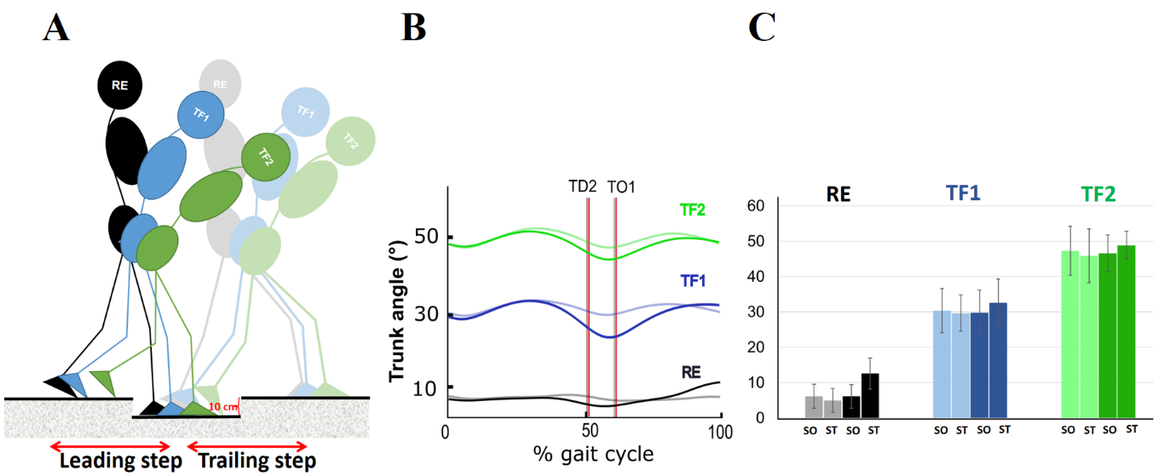
Fig. 1. Schematic diagram of human locomotion with altered trunk orientation. (A) Side view of the instrumented walkway with three consecutive force plates. The second force plate (drop) was lowered by 10 cm at the site of the second step to stimulate uneven surface (US) ground. (B) Mean trunk kinematics throughout gait cycle in the sagittal plane while walking over even surface (ES) (blurred curves) and US (solid curves) with regular erect (RE, black), 30° of trunk flexion (TF1, blue) and 50° of trunk flexion (TF2, green). (C) Mean trunk angle at the instants of stride onset (SO) and stride termination (ST) across ES (blurred columns) and US (solid columns). Error bars denote standard deviation. The vertical grey and red lines represent TD (touchdown) and TO (toe-off) instants over ES and US ground conditions, respectively.

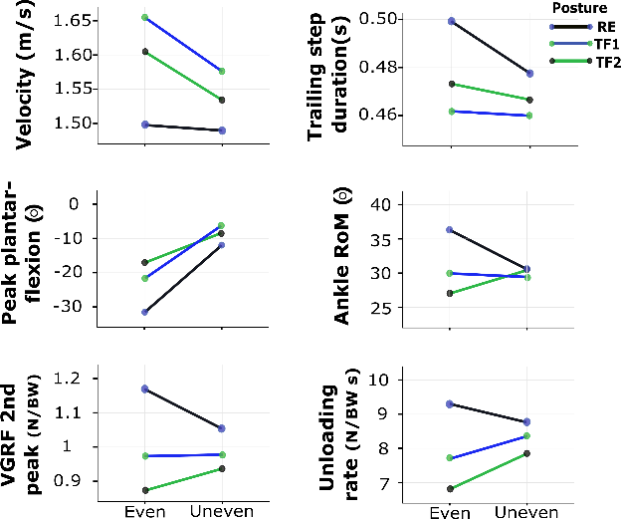
Fig. 2. posture×ground surface interaction for temporal, kinematic and kinetic parameters. BW, body weight; VGRF, vertical ground reaction force; RoM. Range of motion

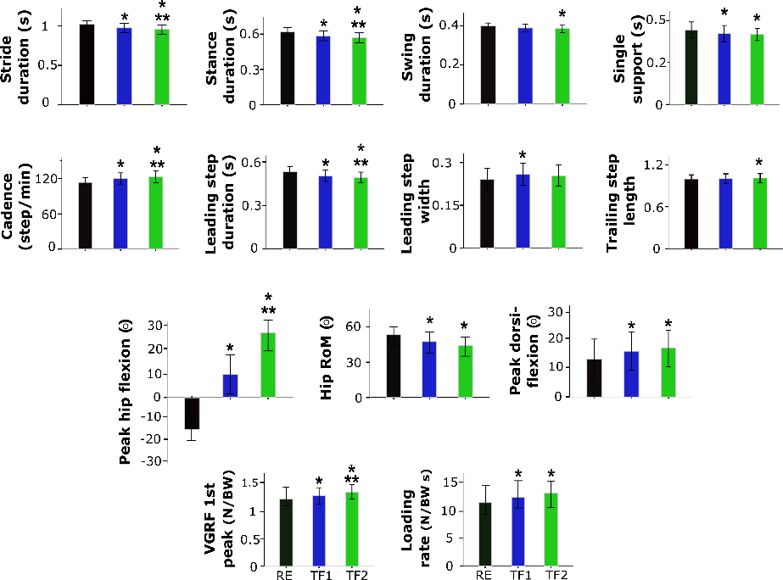
Fig. 3. Main effects of posture on spatial-temporal, kinematic and kinetic parameters. Error bars denote standard deviation. Significant differences from RE and TF1 are indicated with ‘*’, and ‘**’, respectively (P<0.05; one-way ANOVA). RE (black), regular erect trunk; TF1 (blue), ~30° trunk flexion; TF2 (green), ~50° trunk flexion. BW, body weight; VGRF, vertical ground reaction force; RoM. Range of motion

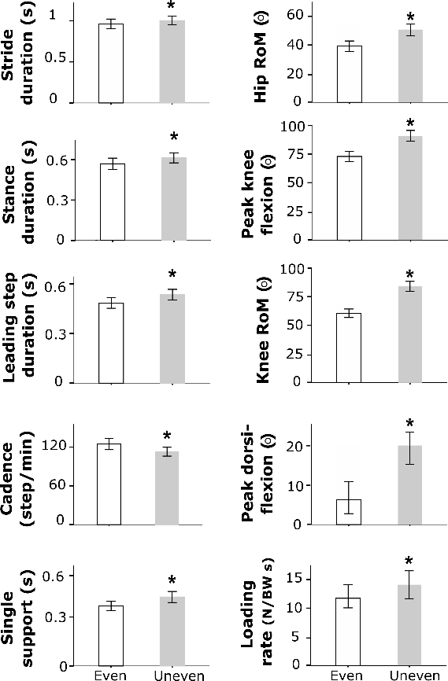
Fig. 4. Main effects of ground surface on temporal, kinematic and kinetic parameters. Error bars denote standard deviation. ‘*’ indicates significantly different from even surface (P<0.05; one-way ANOVA). BW, body weight; GRF, ground reaction force; RoM. Range of motion.

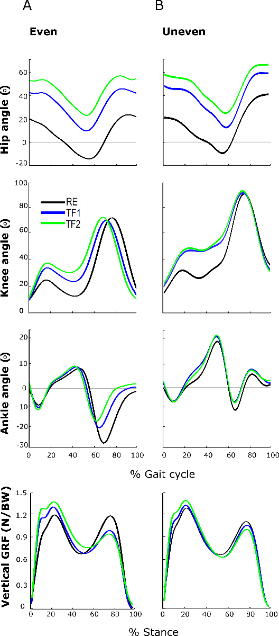
Fig. 5. Ensemble-averaged lower limb joint kinematics during gait cycle and vertical ground reaction forces (GRF) during stance phase on A) even surface and B) uneven surface. GRF, ground reaction force; BW, body weight.

Table 1. Means (standard deviations) of spatial-temporal, kinematic and kinetic parameters of able-bodied walkers (n = 12) when maintaining RE, TF1 and TF2 postures. For each variable, the first and second lines represent walking on even and uneven surface, respectively. The last three columns show the p-values/F-values for the main effects of posture and ground, and for the posture×ground surface interactions, respectively.
 | Posture |  |  | p-value/F-value
 | RE | TF1 | TF2 | Posture | Ground | Posture× Ground
Spatial-temporal
Stride duration (s) | 1.00 (0.03) | 0.95 (0.05) | 0.92 (0.05) | 0.00/32.3 | 0.00/24.8 | 0.18/1.80
 | 1.03 (0.04) | 0.99 (0.05) | 0.97 (0.04)
Stride length ^{ǂ} | 1.94 (0.15) | 1.96 (0.15) | 1.97 (0.15) | 0.24/1.51 | 0.17/2.14 | 0.19/1.79
 | 1.98 (0.13) | 1.97 (0.19) | 1.98 (0.15)
Stance duration (s) | 0.60 (0.02) | 0.56 (0.03) | 0.54 (0.03) | 0.00/38.3 | 0.00/64.7 | 0.31/1.21
 | 0.63 (0.03) | 0.60 (0.03) | 0.59 (0.03)
Swing duration (s) | 0.40 (0.01) | 0.39 (0.02) | 0.38 (0.02) | 0.00/6.02 | 0.32/1.05 | 0.18/1.82
 | 0.39 (0.01) | 0.38 (0.01) | 0.38 (0.01)
Single support (t) | 0.40 (0.03) | 0.38 (0.02) | 0.39 (0.03) | 0.00/15.1 | 0.00/98.3 | 0.09/2.58
 | 0.47 (0.03) | 0.45 (0.04) | 0.43 (0.02)
Velocity (m/s) | 1.49 (0.08) | 1.60 (0.10) | 1.65 (0.13) * | 0.00/29.1 | 0.00/15.6 | 0.04/7.01
 | 1.48 (0.08) | 1.53 (0.07) | 1.57 (0.10)
Cadence (step/m) | 118 (5.54) | 126 (7.86) | 129 (9.00) | 0.00/35.6 | 0.00/88.4 | 0.35/1.07
 | 108 (5.49) | 113 (6.35) | 116 (5.81)
Leading step duration (s) | 0.50 (0.02) | 0.47 (0.02) | 0.46 (0.03) | 0.00/33.3 | 0.00/113 | 0.81/0.21
 | 0.55 (0.02) | 0.52 (0.02) | 0.51 (0.02)
Leading step length ^{ǂ} | 0.95 (0.08) | 0.96 (0.08) | 0.97 (0.09) | 0.84/0.16 | 0.42/0.67 | 0.60/0.50
 | 0.97 (0.09) | 0.97 (0.12) | 0.97 (0.09)
Leading step width ^{ǂ} | 0.24 (0.04) | 0.25 (0.03) | 0.25 (0.03) | 0.00/7.03 | 0.86/0.03 | 0.47/0.77
 | 0.23 (0.04) | 0.25 (0.04) | 0.25 (0.03)
Trailing step duration (s) | 0.49 (0.01) | 0.47 (0.02) * | 0.46 (0.02) * | 0.00/19.7 | 0.02/6.69 | 0.00/6.59
 | 0.47 (0.01) | 0.46 (0.02) | 0.45 (0.02)
Trailing step length ^{ǂ} | 0.98 (0.06) | 0.99 (0.06) | 1.00 (0.06) | 0.01/5.33 | 0.21/1.74 | 0.05/3.23
 | 1.00 (0.06) | 0.99 (0.07) | 1.00 (0.07)
Trailing step width ^{ǂ} | 0.23 (0.03) | 0.24 (0.03) | 0.24 (0.02) | 0.49/0.72 | 0.73/0.12 | 0.46/0.78
 | 0.24 (0.04) | 0.24 (0.04) | 0.25 (0.04)
Kinematics
Peak hip flexion angle (°) | -16.4 (5.48) | 8.05 (7.98) | 23.0 (7.70) | 0.00/331 | 0.09/3.27 | 0.62/0.47
 | -15.1 (6.14) | 11.2 (9.26) | 26.2 (8.16)
Hip RoM (°) | 41.0 (3.07) | 36.8 (10.5) | 37.7 (3.22) | 0.00/13.2 | 0.00/162 | 0.06/3.11
 | 58.1 (5.95) | 50.4 (4.86) | 46.9 (4.86)
Peak knee flexion angle (°) | 74.8 (2.76) | 74.4 (3.62) | 75.5 (4.52) | 0.08/2.70 | 0.00/340 | 0.22/1.58
 | 93.4 (3.77) | 93.6 (4.80) | 95.2 (4.74)
Knee RoM (°) | 68.4 (3.23) | 67.1 (2.45) | 67.1 (1.97) | 0.02/4.47 | 0.00/197 | 0.90/0.10
 | 83.7 (4.54) | 82.2 (3.99) | 82.0 (5.44)
Peak ankle dorsi-  flexion angle (°) | 7.26 (4.40) | 8.61 (4.30) | 9.31 (4.26) | 0.00/9.21 | 0.00/123 | 0.48/0.74
 | 17.8 (5.24) | 20.7 (5.69) | 21.4 (4.10)
Peak ankle plantar-  flexion angle (°) | -29.2 (7.59) | -21.4 (6.12) * | -18.2 (4.26) * | 0.00/82.1 | 0.00/91.8 | 0.00/10.2
 | -13.3 (4.16) | -9.06 (2.88) * | -9.64 (2.78) *
Ankle RoM (°) | 36.5 (6.10) | 30.0 (4.07) * | 27.6 (3.68) * | 0.00/19.0 | 0.55/0.36 | 0.00/15.9
 | 31.2 (3.59) | 29.7 (5.09) | 31.3 (3.48)
Kinetics
VGRF 1st peak (N/BW) | 1.19 (0.08) | 1.33 (0.12) | 1.38 (0.13) | 0.00/25.8 | 0.16/2.26 | 0.23/1.54
 | 1.24 (0.08) | 1.34 (0.11) | 1.40 (0.14)
VGRF 2nd peak (N/BW) | 1.15 (0.06) | 0.96 (0.10) * | 0.89 (0.10) * | 0.00/54.2 | 0.46/0.56 | 0.00/12.2
 | 1.06 (0.07) | 0.96 (0.11) | 0.93 (0.13) *
Loading rate (N/BW s) | 10.6 (1.70) | 12.8 (1.91) | 13.5 (1.90) | 0.00/17.2 | 0.04/5.28 | 0.38/0.82
 | 12.3 (1.46) | 14.8 (2.11) | 14.4 (3.25)
Unloading rate (N/BW s) | 9.21 (1.25) | 7.87 (1.02) | 6.94 (1.16) * | 0.00/45.3 | 0.10/3.05 | 0.00/11.0
 | 8.89 (1.10) | 8.47 (1.44) | 7.95 (1.39)
In case of interaction effect, significant differences from RE and TF1 across each ground surface are indicated with ‘*’ and ‘**’, respectively (p<0.05). Accordingly, shaded value represents a significant difference from the level surface (p<0.05) for each walking posture (N=12). ^{ǂ} indicates a normalized variable (i.e., the spatial parameters) to the leg length. RE, regular erect trunk; TF1, ~30° trunk flexion; TF2, ~50° trunk flexion; RoM, range of motion; VGRF, vertical ground reaction force; BW, body weight.

