Received 00th January 20xx,
- School of Engineering and Materials Science and Materials Research Institute, Queen Mary University of London, Mile End Road, London E1 4NS, United Kingdom. *j.briscoe@qmul.ac.uk
- Department of Physics and Centre for Plastic Electronics, Imperial College London, South Kensington, London, SW7 2AZ, UK
- Department of Chemistry, Imperial College London, South Kensington Campus, London SW7 2AZ, United Kingdom
- Department of Materials and Centre for Plastic Electronics, Imperial College London, South Kensington, London, SW7 2AZ, UK
- School of Engineering, London South Bank University, 103 Borough Road, London, SE1 0AA, United Kingdom
† Electronic Supplementary Information (ESI) available: details of experimental procedures; Kelvin probe; UV-APS; SPV measurements; Faradaic efficiency additional data; Co-Pi deposition data. See DOI: 10.1039/x0xx00000x
Accepted 00th January 20xx
DOI: 10.1039/x0xx00000x
www.rsc.org/
Bi₂Fe₄O₉ thin films as novel visible-light-active photoanodes for solar water splitting
Yaqiong Wang,ª Matyas Daboczi,^{b} Camilo A. Mesa,^{c} Sinclair Ryley Ratnasingham,^{a,d} Ji-Seon Kim,^{b} James R. Durrant,^{c} Steve Dunn,^{e} Haixue Yan,ª and Joe Briscoe *ª
We report the chemical solution deposition (CSD) of a phase-pure Bi₂Fe₄O₉ thin film for use as a photoanode in photoelectrochemical (PEC) water splitting. The energy levels of Bi₂Fe₄O₉ films have been measured and n-type characteristics have been confirmed. With band gaps determined as 2.05 eV (indirect) and 2.80 eV (direct) and valence and conduction bands straddling the water oxidation and reduction potentials, this material is highly promising as a photocatalyst for solar water splitting. The photocurrent of a planar photoanode reached 0.1 mA/cm² at 1.23 V_{NHE} under AM1.5 G illumination. The addition of H₂O₂ as a hole scavenger increased the photocurrent to 0.25 mA/cm², indicating hole injection is one limiting factor to the performance. The performance was enhanced by nearly 5-fold when the Bi₂Fe₄O₉ photoanode is coupled to a Co-Pi surface co-catalyst. The photoanode also shows excellent stability with no change in photocurrent over three hours of continuous illumination. These results indicate that this material represents a promising addition to the growing selection of low-cost, stable photocatalysts for use in solar water splitting.
Novel materials for efficient solar-to-fuel conversion have been pursued extensively since the first report of water oxidation using TiO₂^{1, 2}. Along with TiO₂, other binary transition metal oxides such as Fe₂O₃³ and WO₃⁴, have been explored and found to show many desirable properties for the production of solar fuels. However, these materials usually have some limitations either from large optical band gaps or short carrier diffusion lengths^{5, 6}. For example, the application of TiO₂ is significantly limited by a large band gap of ca 3.2 eV, which means only 3 – 4% of solar light can be used to generate photoexcited carriers. Efforts have been made to address these challenges such as doping to reduce the band gap⁷ or nanostructuring to overcome the short carrier diffusion lengths⁸. Meanwhile, increasing research attention has been paid to the development of ternary metal oxides for application as photoanodes. The materials of interest include narrow-band-gap BiVO₄⁹ and CuWO₄¹⁰ as well as those with polar structures such as BaTiO₃¹¹ and PbZr_{x}Ti_{1-x}O₃¹².
It is worth noticing that many compounds containing Bi³⁺ have been found to be narrow-band-gap semiconductors. In addition these Bi³⁺ containing compounds can show high PEC activity under visible light due to the strong hybridization between O-2p and Bi-6s orbitals^{13, 14}. It has also been found that hybridized energy bands can increase the separation of photoexcited holes and electrons and further improve the PEC conversion efficiency¹⁵. Therefore, in addition to BiVO₄, other Bi-based compounds, CuBi₂O₄¹⁶, BiFeO₃¹⁷, and Bi₂WO₆¹⁸ have attracted interest as possible visible-light photocatalysts.
Bi₂Fe₄O₉ has attracted attention for a number of applications such as semiconductor gas sensors and catalyst for ammonia oxidation to NO¹⁹. Like many other Bi-based compounds, Bi₂Fe₄O₉ exhibits a narrow indirect band gap with reported values ranging from ca. 1.9 to ca. 2.1 eV^{20, 21}. Nanoparticles of Bi₂Fe₄O₉ have been reported to be highly visible-light-active photocatalysts with a near-infrared absorption. These particles show good photocatalytic activity for organic contaminant degradation²². However, to date there has been no reported studies on the use of Bi₂Fe₄O₉ thin films as photoelectrodes for PEC applications.
In this work, we prepare Bi₂Fe₄O₉ thin films using chemical solution deposition (CSD) and study the photoelectrochemical performance of the as-produced thin films. The Bi₂Fe₄O₉ electrode exhibits photoanodic behaviour with high PEC activity and good stability under simulated sunlight. A photocurrent density of 0.1 mA/cm² at 1.23 V_{NHE} was obtained under AM1.5G irradiation. A value of 0.05 mA/cm² was obtained when the UV light was blocked, demonstrating the ability of Bi₂Fe₄O₉ to harvest visible light for photochemical reactions. The addition of a hole scavenger (H₂O₂) in the PEC process increased the photocurrent to 0.25 mA/cm² at 1.23 V_{NHE} and lowered the onset potential. Based on these results, we propose that Bi₂Fe₄O₉ is a promising photoanode for PEC applications.
Bi₂Fe₄O₉ thin films were deposited using a simple CSD using a stoichiometric 1:2 molar ratio of bismuth nitrate and iron nitrate as precursors in a sol which also contained 2-methoxyethanol and acetic anhydride. Five layers of the sol were spin coated onto fluorine-doped tin oxide coated glass substrates, with staged drying and annealing up to a maximum of 650 ℃ (full methods in Supplementary Information). Figure 1a shows a typical surface scanning-electron microscope (SEM) micrograph for the Bi₂Fe₄O₉ thin films showing smooth films with grains from 50 – 200 nm. Figure 1b shows a cross-section of a typical film indicating that the film is ca. 150 nm thick and consists of several small crystallites. X-ray diffraction pattern of the as-produced film (Figure 1c) confirms that a phase-pure sample of Bi₂Fe₄O₉ has been produced with an orthorhombic structure (ICDD 74-1098; space group: Pbam) and lattice constants of a = 7.950 Å, b = 8.428 Å, and c = 6.005 Å. All additional peaks in the diffraction pattern can be attributed to the substrate.
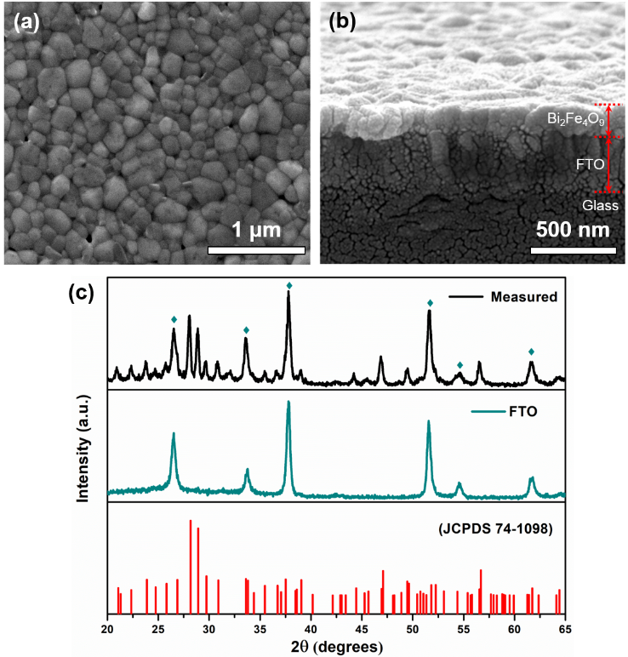
Figure 1. a) Top-down and b) cross-section SEM images of the Bi₂Fe₄O₉ film. c) XRD pattern of the Bi₂Fe₄O₉ film (measured), with the measured pattern of the FTO substrate, and reference spectrum for Bi₂Fe₄O₉ (JCPDS 74-1098) for comparison. Sample peaks corresponding to the FTO substrate are indicated. All other peaks index to Bi₂Fe₄O₉.
X-ray photoelectron spectroscopy (XPS) was undertaken to characterize the elemental composition and chemical states of the Bi₂Fe₄O₉ film. The XPS spectra of a typical sample is shown in Figure 2, with the XPS full survey spectrum shown in Figure 2a. All obtained binding energies were normalized using the C 1s peak at 284.6 eV. A detailed view of the bismuth 4f spectrum is given in Figure 2b and shows two distinct peaks: the Bi 4f_{7/2} peak at 158.9 eV and the Bi 4f_{5/2} peak at 164.2 eV. Both these peaks and their positions are characteristic of the presence of bismuth in the +3 oxidation state, as expected for Bi₂Fe₄O₉.
The Fe 2p core level, shown in Figure 2c, consists of two peaks located at 723.7 eV (Fe 2p_{1/2}) and 710 eV (Fe 2p_{3/2}). The Fe 2p_{3/2} peak was deconvoluted into two peaks located at 711.1 eV and 709.6 eV, corresponding to Fe³⁺ and Fe²⁺, respectively. The formation of Fe²⁺ is attributed to the presence of oxygen vacancies commonly occurring in the deposition processes of perovskite thin films^{23, 24}, which is further confirmed in the O 1s spectrum: the deconvolution of the O 1s line results in peaks at 529.5 eV and 531.5 eV. The peak at 529.5 eV belongs to M-O-M bonds and that at 531.5 eV is due to a high number of defect sites with a low oxygen coordination, i.e. due to the presence of oxygen vacancies in accordance with the presence of Fe²⁺.
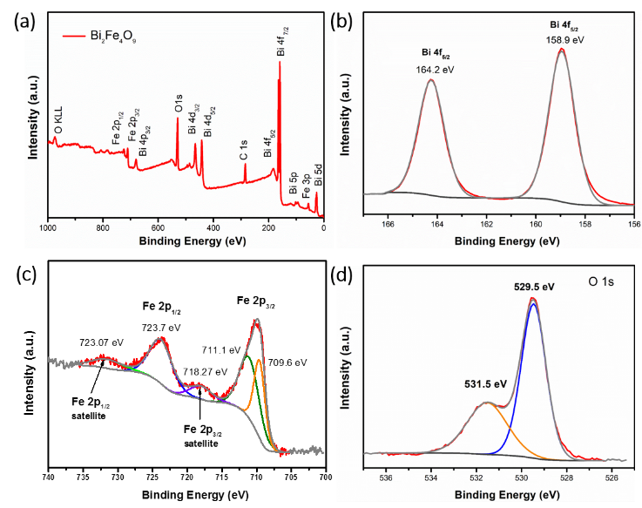
Figure 2. (a) Survey spectrum, (b) Bi 4f, (c) Fe 2p and (d) O 1s XPS spectra of Bi₂Fe₄O₉ film showing fitted peaks.
The UV-vis absorption spectrum of the Bi₂Fe₄O₉ films shown in Figure 3a demonstrates light absorption over a wide range of frequencies from the UV into the visible, consistent with the reported band gap of around 2 eV. It has been reported in previous studies that the Bi₂Fe₄O₉ nanoparticle samples had near-infrared light absorption, which was ascribed to the splitting of Fe 3d transitions²⁵. For our thin film samples a broad, shallow absorption peak can be observed between 650 nm to 800 nm, and a distinct absorption edge starts from ~ 600 nm and increases with the decreasing wavelength. The good visible light absorption of the material indicates the possibility of photoactivity under visible-light illumination.
The linear regions in the derived Tauc plots (Figure 3b) indicate indirect and direct band gaps of 2.05 and 2.80 eV respectively, in close agreement with the calculated band structure for Bi₂Fe₄O₉²⁶. The band gap associated with the indirect transition is close to ideal for solar water splitting²⁷, giving an indication that the material will be able to drive photochemical processes under visible light. However, the indirect transition means that there will be limited light absorption across the thin sample and gives some indication as to why nanoparticles have been of interest to date: the absorption cross section and scattering associated with nanoparticles can add to the effective pathlength and increase absorption. Despite this, the presence of a direct transition at an only slightly higher energy of 2.8 eV means that there is still strong absorption within the visible region, as seen in the absorption spectrum (Figure 3a).
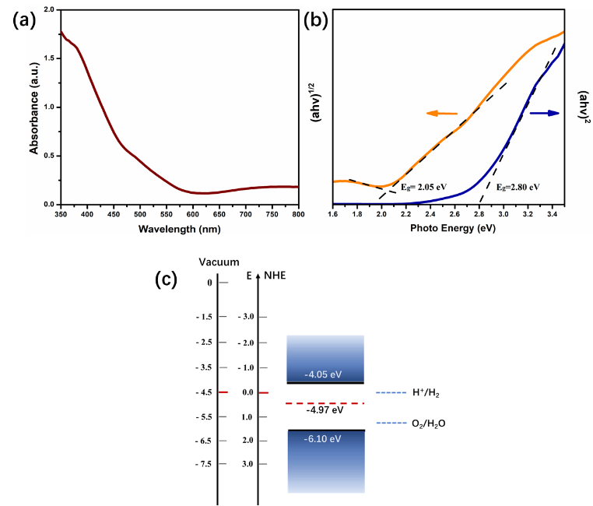
Figure 3. a) UV-vis absorbance spectra and b) derived Tauc plots corresponding to the allowed direct (right scale) or allowed indirect (left scale) band gap. c) Energy levels of Bi₂Fe₄O₉ electrode. Red dashed line shows the measured Fermi level. The redox potentials of water splitting are also shown
To understand the variety of photochemistry that can be driven on the surface of a photocatalyst the band structure of the system must be understood, particularly in the case of a relatively new material as reported here. In order to obtain the energy levels of the Bi₂Fe₄O₉ films, UV ambient pressure photoemission spectroscopy²⁸ (UV-APS) and Kelvin probe measurement have been carried out to determine the valence-band edge and the Fermi energy level (E_{F}). The measured valence-band edge by UV-APS is -6.10 eV and the measured E_{F} value is -4.97 eV. Note that the constant E_{F} value was measured over 100s indicating a stable electronic property of the Bi₂Fe₄O₉ films. Based on these values and the measured indirect optical band gap energy of 2.05 eV, a band diagram was constructed (shown in Figure 3c), indicating Bi₂Fe₄O₉ is slightly n-doped and has a valence band edge below the water oxidation potential, suitable for photocatalytic water oxidation. The n-type characteristic of the material was also confirmed by surface photovoltage measurements^{29, 30}, which show a negative shift in work function upon illumination (Fig. S3, ESI).
The photoanodic activity of Bi₂Fe₄O₉ films were investigated using PEC in a standard three electrode configuration. Figure 4a shows the photocurrent-voltage (I-V) curves of a Bi₂Fe₄O₉ photoelectrode illuminated using full AM1.5G and visible light only (λ > 420 nm) chopped irradiation. The data shows a steady increase in photocurrent with increasing applied anodic potential and the photocurrent at 1.23 V_{NHE} reached 0.1 mA/cm² under full sun illumination. Despite the large number of previous studies of PEC water oxidation using bismuth ferrite films with composition BiFeO₃, this has produced consistently lower photocurrent values than our Bi₂Fe₄O₉ thin films. For example, Yu et al.³¹ produced for BiFeO₃ films deposited by pulsed laser deposition (PLD) and obtained ~ 0.09 mA/cm² at 1.23 V_{NHE} under 1 sun, which was higher than that reported by Quynh³² who also prepared BiFeO₃ by PLD giving ~0.06 mA/cm² at 1.1 V_{NHE} under 1 sun. A BiFeO₃ film deposited on epitaxial SrRuO₃/SrTiO₃ substrate by sputtering has been reported to have a much lower value of ~0.01 mA at 1 V_{NHE}¹⁷. It is worth noting that the Bi₂Fe₄O₉ photoanode reported here was prepared by a low-cost deposition method and is a planar film without nanostructuring. It therefore offers a large scope to further optimise the synthesis and morphology of this material to produce improved photocurrent in the future, along similar lines as the well-studied photoanode material: Fe₂O₃. This has demonstrated photocurrents over 2 mA/cm² through the production of optimised nanostructured films, while planar films – more directly comparable to the Bi₂Fe₄O₉ photoanode reported herein – generally produce negligible photocurrents, or those in the low μA/cm² range³³.
To confirm the visible-light response of the Bi₂Fe₄O₉ thin films, photocurrent was measured with the UV portion filtered from the AM1.5G illumination (λ > 420 nm), which reached 0.05 mA/cm² at 1.23 V_{NHE}, confirming the potential for Bi₂Fe₄O₉ to be a visible-light-active catalyst indicated by the UV-Vis spectra.
It can be seen from Figure 4a that the chopped light linear sweep voltammetry (LSV) curves showed obvious transient photocurrent peaks upon light switching. Such peaks are known to be associated with a variation in the rates of carrier extraction across the semiconductor interface³⁴. To investigate this in more detail we have studied the impact of a hole-scavenger, H₂O₂, on the photocurrent of the system. Figure 4b shows a plot of current density vs applied potential under chopped illumination using two different electrolytes: 0.2 M Na₂SO₄ and 0.2 M Na₂SO₄-0.5 M H₂O₂. The onset potential for the photocurrent shifted negatively with the addition of H₂O₂ to the electrolyte solution (from 0.7 to 0.3 V_{NHE}). This agrees well with the expectation, since H₂O₂ has a more negative oxidation potential than H₂O (E⁰ = +0.68 V_{NHE} for O₂/H₂O₂ and E⁰ = +1.23 V_{NHE} for O₂/H₂O), which means that the E⁰_{redox} of the two electrolyte solutions are 0.34 V_{NHE} (with H₂O₂) and 0.615 V_{NHE} (without H₂O₂).
The transient photocurrents associated with the non-equilibrium extraction of holes and electrons have also been significantly reduced upon the addition of H₂O₂ and the photocurrent at 1.23 V_{NHE} increased to 0.25 mA/cm². Transient photocurrents under chopped illumination have been observed in a range of photoanode materials such as Fe₂O₃³⁴ and BiVO₄³⁵. This phenomenon has been associated with a characteristic signature of hole accumulation at the photoanode/electrolyte interface³⁶. The kinetics of the 4-hole oxidation of water to molecular oxygen means that there is an excess of generation of photoexcited holes over the rate of extraction to perform the electrochemical reaction. It is accepted that positive current transients upon turning the light on represent the accumulation of holes at the electrode/electrolyte interface. A negative current transient observed upon turning the light off represents the back reaction of electrons from the conduction band with the accumulated holes³⁴. The addition of H₂O₂ as a hole scavenger promotes the reaction of accumulated holes at the electrode/electrolyte interface and suppresses back electron-hole recombination. The addition of a hole scavenger demonstrates that the photocurrents of Bi₂Fe₄O₉ electrode can be further improved in the future by eliminating the hole injection barrier at the electrode/electrolyte interface, for example by combination with co-catalysts or reduction in surface trap states.
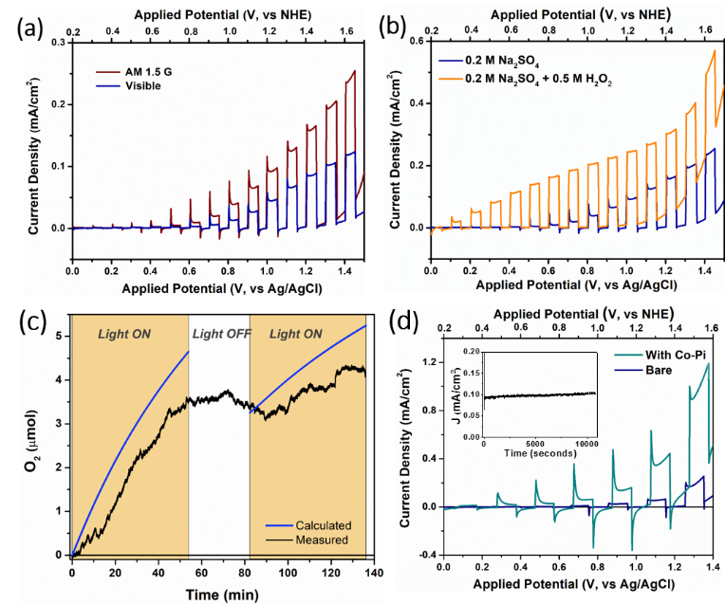
Figure 4. a) J-V curve for Bi₂Fe₄O₉ under both chopped 100 mW/cm² AM 1.5 G and visible light irradiation (λ > 420 nm) in Na₂SO₄ electrolyte (pH 6.5). b) J-V curve under chopped illumination (1 sun AM 1.5 G) for Bi₂Fe₄O₉ electrode without and with a hole scavenger (H₂O₂). c) Oxygen evolution measured by a Clark electrode in gas phase (black) and the amount of oxygen calculated (blue) from the chronoamperometry. d) Chopped J-V curve for Bi₂Fe₄O₉ electrode without and with Co-Pi co-catalyst deposition. Inset: Photocurrent density (J) – time curves of Bi₂Fe₄O₉ electrode measured at an applied potential of 1.2 V_{NHE} for 3h in 0.2 M Na₂SO₄ solution under 1 sun illumination indicating good stability.
The ability of the photoanode to produce oxygen under illumination was measured using a Clark electrode (full details in ESI). It can be seen from Figure 4c that the measured oxygen content clearly increases over the periods of illumination, indicating successful photoelectrocatalytic water oxidation. Furthermore, the Faradaic efficiency (FE) for oxygen evolution was calculated by comparing this measured oxygen evolution to the theoretical maximum oxygen production, derived from the chronoamperometry (at 1.2 V vs. Ag/AgCl; full details of the calculation method are given in the ESI). This gave a FE of 82.1 ± 5.9 %. This is remarkably high compared to other ferrites (BiFeO₃) that have shown FE close to 70%³⁷, again indicating the promise of this system as a potential high-efficiency photoanode material.
Considering the issues with hole accumulation and associated recombination discussed above, co-catalyst deposition was investigated as a route to enhance the performance of the Bi₂Fe₄O₉ photoanode. A CoO_{x} overlayer (Co-Pi) was deposited on the surface of the Bi₂Fe₄O₉ (details of method in ESI) and chopped light LSV was re-tested. As shown in Figure 4d, the deposition of the Co-Pi overlayer shifts the photocurrent onset potential ~ 200 mV to more negative potentials as well as the dark onset. Although transient photocurrent spikes are still present, indicating high levels of hole accumulation and recombination, the addition of the Co-Pi increases the photocurrent density by approximately a factor of 5, indicating it is a promising route to enhance the photoelectrocatalytic performance of this material, as found with other systems.
A key consideration for the use of photocatalytic materials is the stability of the system under illumination. We studied the stability of a Bi₂Fe₄O₉ electrode by measuring the photocurrent over time (chronoamperometry) under an applied potential of 1.2 V_{NHE} and full sunlight illumination in a 0.2 M Na₂SO₄ electrolyte, as shown in Figure 4d (inset). It can be seen from the I-t results that there is no loss of photocurrent during the 3-hour test, indicating the good stability of Bi₂Fe₄O₉ films under illumination for use as a photoanode.
Conclusions
We present the first report of the use of Bi₂Fe₄O₉ as a photoanode for photoelectrochemical water oxidation. Phase-pure Bi₂Fe₄O₉ films have been synthesized via a simple CSD method using a stoichiometric Bi/Fe molar ratio of 1:2 for the precursor preparation. The Bi₂Fe₄O₉ photoanode exhibits an indirect bandgap of 2.05 eV coupled with a direct transition at 2.8 eV leading to a strong visible light response. The measured band positions indicate suitability for water oxidation. PEC tests demonstrate high activity of the Bi₂Fe₄O₉ electrode under AM1.5G and visible light illumination. By adding a hole scavenger, we have demonstrated that a hole injection barrier exists at the surface of the Bi₂Fe₄O₉ electrode. This indicates that the PEC performance of the material can be further improved by combination with other photo- or electrocatalysts, or other tools such as modification of surface states to enhance carrier extraction, or nanostructuring to increase active surface area. We show that Bi₂Fe₄O₉ combines strong light absorption, easy fabrication and good stability under illumination, making it a promising candidate for photoanodes in application of practical solar energy-driven PEC water splitting.
Conflicts of interest
There are no conflicts to declare
Acknowledgements
Y.W. would like to acknowledge Chinese Scholarship Council for supporting this work. The authors acknowledge the UK EPSRC for the Plastic Electronics Centre for Doctoral Training (EP/G037515/1) and KP Technology for a CASE studentship. C.A.M. acknowledges COLCIENCIAS (call 568) for funding.
Notes and references
1. A. Fujishima and K. Honda, Nature, 1972, 238, 37.
2. C. X. Kronawitter, L. Vayssieres, S. Shen, L. Guo, D. A. Wheeler, J. Z. Zhang, B. R. Antoun and S. S. Mao, Energy & Environmental Science, 2011, 4, 3889-3899.
3. D. A. Wheeler, G. Wang, Y. Ling, Y. Li and J. Z. Zhang, Energy & Environmental Science, 2012, 5, 6682-6702.
4. J. A. Seabold and K.-S. Choi, Chemistry of Materials, 2011, 23, 1105-1112.
5. P. S. Bassi, Gurudayal, L. H. Wong and J. Barber, Physical Chemistry Chemical Physics, 2014, 16, 11834-11842.
6. K. Sivula and R. van de Krol, Nature Reviews Materials, 2016, 1, 15010.
7. R. Asahi, T. Morikawa, T. Ohwaki, K. Aoki and Y. Taga, science, 2001, 293, 269-271.
8. H.-J. Ahn, M.-J. Kwak, J.-S. Lee, K.-Y. Yoon and J.-H. Jang, Journal of Materials Chemistry A, 2014, 2, 19999-20003.
9. T. W. Kim and K.-S. Choi, Science, 2014, 343, 990-994.
10. H. Zhang, P. Yilmaz, J. O. Ansari, F. F. Khan, R. Binions, S. Krause and S. Dunn, Journal of Materials Chemistry A, 2015, 3, 9638-9644.
11. Y. Cui, J. Briscoe and S. Dunn, Chemistry of Materials, 2013, 25, 4215-4223.
12. C. Wang, D. Cao, F. Zheng, W. Dong, L. Fang, X. Su and M. Shen, Chem. Commun., 2013, 49, 3769-3771.
13. H. Kunioku, M. Higashi, O. Tomita, M. Yabuuchi, D. Kato, H. Fujito, H. Kageyama and R. Abe, Journal of Materials Chemistry A, 2018, 6, 3100-3107.
14. D. Kang, Y. Park, J. C. Hill and K.-S. Choi, The Journal of Physical Chemistry Letters, 2014, 5, 2994-2999.
15. E. Zahedi, B. Xiao and M. Shayestefar, Inorganic Chemistry, 2016, 55, 4824-4835.
16. H. S. Park, C.-Y. Lee and E. Reisner, Physical Chemistry Chemical Physics, 2014, 16, 22462-22465.
17. W. Ji, K. Yao, Y.-F. Lim, Y. C. Liang and A. Suwardi, Applied Physics Letters, 2013, 103, 062901.
18. L. Zhang, C. Baumanis, L. Robben, T. Kandiel and D. Bahnemann, Small, 2011, 7, 2714-2720.
19. A. S. Poghossian, H. V. Abovian, P. B. Avakian, S. H. Mkrtchian and V. M. Haroutunian, Sensors and Actuators B: Chemical, 1991, 4, 545-549.
20. Y. Li, Y. Zhang, W. Ye, J. Yu, C. Lu and L. Xia, New Journal of Chemistry, 2012, 36, 1297-1300.
21. Q.-J. Ruan and W.-D. Zhang, The Journal of Physical Chemistry C, 2009, 113, 4168-4173.
22. S. Sun, W. Wang, L. Zhang and M. Shang, The Journal of Physical Chemistry C, 2009, 113, 12826-12831.
23. C. Ederer and N. A. Spaldin, Physical Review B, 2005, 71, 224103.
24. E. Enriquez, A. Chen, Z. Harrell, P. Dowden, N. Koskelo, J. Roback, M. Janoschek, C. Chen and Q. Jia, Scientific Reports, 2017, 7, 46184.
25. A. Kirsch, M. M. Murshed, M. Schowalter, A. Rosenauer and T. M. Gesing, The Journal of Physical Chemistry C, 2016, 120, 18831-18840.
26. Z. Irshad, S. H. Shah, M. A. Rafiq and M. M. Hasan, Journal of Alloys and Compounds, 2015, 624, 131-136.
27. M. G. Walter, E. L. Warren, J. R. McKone, S. W. Boettcher, Q. Mi, E. A. Santori and N. S. Lewis, Chemical Reviews, 2010, 110, 6446-6473.
28. I. D. Baikie, A. C. Grain, J. Sutherland and J. Law, Energy Procedia, 2014, 60, 48-56.
29. D. Cavalcoli and A. Cavallini, physica status solidi c, 2010, 7, 1293-1300.
30. L. Kronik and Y. Shapira, Surface and Interface Analysis, 2001, 31, 954-965.
31. X. Y. Chen, T. Yu, F. Gao, H. T. Zhang, L. F. Liu, Y. M. Wang, Z. S. Li, Z. G. Zou and J.-M. Liu, Applied Physics Letters, 2007, 91, 022114.
32. L. T. Quynh, C. N. Van, Y. Bitla, J.-W. Chen, T. H. Do, W.-Y. Tzeng, S.-C. Liao, K.-A. Tsai, Y.-C. Chen, C.-L. Wu, C.-H. Lai, C.-W. Luo, Y.-J. Hsu and Y.-H. Chu, Advanced Energy Materials, 2016, 6, 1600686-n/a.
33. A. G. Tamirat, J. Rick, A. A. Dubale, W.-N. Su and B.-J. Hwang, Nanoscale Horizons, 2016, 1, 243-267.
34. H. Dotan, K. Sivula, M. Gratzel, A. Rothschild and S. C. Warren, Energy & Environmental Science, 2011, 4, 958-964.
35. Y. Ma, S. R. Pendlebury, A. Reynal, F. Le Formal and J. R. Durrant, Chemical Science, 2014, 5, 2964-2973.
36. F. Le Formal, K. Sivula and M. Grätzel, The Journal of Physical Chemistry C, 2012, 116, 26707-26720.
37. S. J. A. Moniz, C. S. Blackman, P. Southern, P. M. Weaver, J. Tang and C. J. Carmalt, Nanoscale, 2015, 7, 16343-16353.

