Kate Davies
Associate Professor, Paediatric Prescribing & Endocrinology
London South Bank University
Children's Advanced Nurse Practitioner
Fellow of the Higher Education Academy
Honorary Research Fellow in Paediatric Endocrinology
Queen Mary & Westfield College, University of London

Suzanne Bradley
Renal Clinical Nurse Specialist
Great Ormond Street Hospital

Doreen Crawford
Consultant Nurse Editor NCYP Journal
Nurse Advisor Crawford McKenzie Consultancy

Biological Basis of Child Health: The Renal System

Abstract
This article will introduce the embryology, the anatomy and physiology, some of the common pathology of the kidneys and the renal system and relate these to the management of child with a renal condition. The renal system is intertwined with other systems such as the cardiovascular system, endocrine system and the reproductive systems. The kidneys are complex structures with an important role in the homeostasis of the individual the impact of renal function impairment is multifaceted.

Keywords
Renal, kidney, embryology, renal function, renal failure, urine.
Aims and Intended Learning Outcomes
The aim of this article is to introduce the embryology the anatomy and physiology of the renal system, and to be able to relate these to the management of child with a renal condition. Its aim is to help you review how renal and urinay system insights might help shape relevant investigation alongside associated nursing care, benefiting parents’ understanding of their child’s conditions.
After reading this CPD article, and following completion of the Time Outs activities, you should be able to:
- Discuss the basic development of renal embryology and physiology.
- Explain the functions of the kidney.
- Describe the importance of electrolytes and detect an abnormal value
- Appreciate the importance of a visual inspection of urine and the urinalysis test.
- Outline some of the more common renal conditions.

Introduction
The kidneys are complex structures with an important role in the homeostasis of the individua, and the impact of renal function impairment is multifaceted. Regular renal function tests and urine sampling are carried out regularly in children in order to rule out acute and chronic disease, and understanding the implications of investigations is paramount in order to care for a child effectively. Chronic kidney disease is also recognised in children, caused by hereditary, nephrotic syndrome, or other systemic disease.

Time Out 1
Think now about the children that you have nursed and how frequently a problem associated with the urinary system has been an issue of concern.?

Embryology
The development of the kidney occurs in 3 distinct stages during foetal life with the origins of the blood supply and associated structures such as the bladder and the genital structures progressively changing (see Table 1).

Table 1 Summary of embryological development of the kidneys.
Focus | Timings | Function
Stage1  Pronephroi | Appear 21 days post fertilisation (PF) | - These are 2 non-functioning, structures which degenerate by day 25 (PF)  - Ducts are retained and are utilized by mesonephroi.
Stage 2  Mesonephroi | Appear 28 days (PF) | - Elongated structures that develop and contain primitive tubules and glomeruli.  - Foetal blood is delivered to these structures and urine is produced  - Functional and act as interim kidneys.  - Degenerate at 10 weeks gestation, but some tubules and ducts remain.  - Incorrect development at this stage can lead to a range of urorectal septum malformations, persistent urachus, abnormal kidney structure and lack of renal function.
Stage 3  Metanephroi | Starts development early in 5th week (PF). | - The final renal template originates from 2 embryonic sources which when developed form the functioning kidneys.  - Metanephroric diverticulum becomes the ureters, renal pelvis, calices, collecting tubules.  - Metanephric blastema creates the nephrons, (functional units of the kidney) the Glomerular apparatus, which is the capsule surrounding the glomeruli, the knot of blood capillaries, tubules and the collecting duct.  - During the latter stages of development, the Metanephroi ascend, from the initial appearance in the pelvis and migrate towards the diaphragm.  - By week 6 the kidneys have ascended, and are usually located each side of the spine from lumber vertebrae L1 to L3.  - As the nephrons continue to grow during foetal life, the tubules continue to elongate, forming the proximal tubule, the Loop of Henle (LoH) and the distal tubule.  - Deviations from normal development during this stage can lead to horseshoe kidney, ectopic kidney,.
Ongoing internal development | By week 15 (PF)  10-32 weeks | - Medulla and cortex are visible as 2 distinct regions.  - Collecting ducts + LOH extend into the medulla, the length increases after birth which increases kidney size.  - Deviations from normal during this stage can lead to renal dysplasia, renal hypoplasia, or polycystic kidney.
Ureters, bladder and urethra | Beginning during the 4th to 7th week (PF).  Structures complete by week 20. | - The early sinus which forms the cloaca is divided into two parts by the urorectal septum.  - The upper portion of this forms the bladder which is initially cigar shaped.  - The pelvic part of the urogenital sinus develops from the early urethra and some of the reproductive tract.  - Deviations from expected development during this stage can result in duplication of the ureters, congenital megalourethra, bladder exstrophy, urethral valves and some hypospadias
Dixon and Crawford, 2012; Fukuoka, Wilting Francisco 2018; Hill 2020, Yoham and Casadesus 2020.

Anatomy and Physiology of the Kidneys
The 2 kidneys are bean shaped (convex and concave) and approximately the size of the child’s clenched fist, they are positioned in the retroperitoneal space, in the lower back just below the ribcage. The kidneys have a rich blood supply from the renal artery which branches from the abdominal aorta. Other structures such as the renal vein, the ureter, nerves, and lymphatic vessels all enter at the concave side of the kidney, known as the hilum (Odya and Norris 2017).
Further maturation and growth result in the kidneys being positioned behind the peritoneum (between 6 – 9 weeks gestation), and are located between T12 and L3 of the vertebral column and reaching the size of 11cm in length and weighing approximately 150g (Chalmers 2014). The kidneys are enclosed in a protective, tough, fibrous capsule.
The renal anatomy can be divided into two, the cortex and the medulla (see fig 1). The cortex is the outermost region, it is perceptively darker in colour than the medulla. The cortex contains the capillary knot within the glomerular capsule (Chalmers 2014). The innermost section of the kidney is pale in colour (Chalmers 2014) and stripy in appearance, and is where the Loop of Henle (LOH) is located. At maturity there are approximately one million nephrons which are the functional units of the kidney they are responsible for filtration, reabsorption, secretion, production of urine and the regulation of fluids.
Fig 1 [the nephron will need to be redrawn, the arrows are OK but might need renaming].
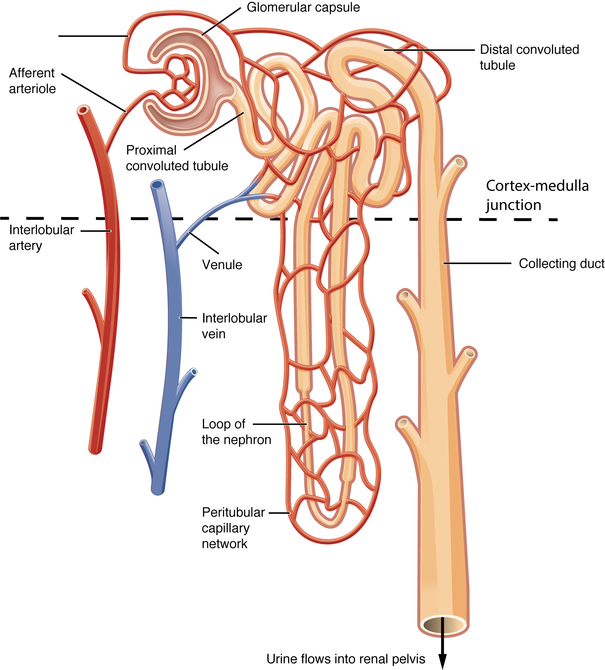

Nephron structure and function:
Bowman Capsules are cup shaped structures which enclose the glomerulus, a capillary knot branching from the renal artery arterioles (Odya and Norris 2017). Fluid in the glomerulus is under pressure and fluid containing waste is pushed out then retained in the capsule.
The Proximal Convoluted Tubule descends from the Bowman Capsule and functions to reabsorb useful electrolytes and materials and secretes organic acids and bases(Odya and Norris 2017), and has a role in maintaining the acid / base balanace in the body.
Loop of the Henle (LoH) are U shaped structures, leading away from the proximal convoluted tubules. The main function is to reabsorb water, and they also regulate electrolytes such as potassium, calcium and magnesium. The LoH also has a role in regulating extra cellular volume, and urinary protein, As water is reabsorbed - urine is concentrated (Odya and Norris 2017).
Distal Convoluted Tubules are continuous with the LoH, they complete the absorption and secretion of electrolytes and connect to the collecting ducts for further urinary concentration. The collecting ducts then transports the urine produced by the nephron to the renal pyramids and onto the renal pelvis (Odya and Norris 2017).

Time out 2
Look at the structure of the Nephron and use the structure to explain the functions of filtration, reabsorption, secretion and excretion in relation to blood homeostasis

Functions of the kidney and urine
The functions of the kidney include the excretion of metabolic waste. The urine produced is a result of the processes of filtration, absorption, and reabsorption (see table 2 below). Urine is transported into the ureters, which distend with the presence accumulated urine and urine is propelled to the bladder by peristaltic contraction (Pocock et al 2018). The ureters enter the bladder at an oblique angle to prevent back flow (Pocock et al 2018). The insert points are referred to as the trigone.
The kidneys also sustain the acid-base balance, pH regulation is supported by the excretion of acids into urine to maintain the homeostatic range of blood pH between 7.3 to 7.4. (Odya and Norris 2017).
The kidney has a role with the production of red blood cells (RBC) through the hormone erythropoietin which is produced in the kidney and stimulates the bone marrow to manufacture RBC.
The kidneys also influence bone growth and metabolism, with a role in calcium and phosphate homeostasis, with the kidney making calcitrol, the active form of Vitamin D.
The renal role in maintaining blood pressure includes complex interactions between circulatory fluid volume and the diameter of blood vessels. Specialized cells (macula densa) in the nephron monitor the level of sodium (Na) in the filtrate, and juxtaglomerular cells embedded in the arteriole walls monitor the blood pressure. If the blood pressure falls the amount of filtered sodium is reduced: the arterial cells respond to the fall in blood pressure, and the decrease in sodium concentration is then relayed by the macula densa cells. The juxtaglomerular cells then release an enzyme called renin, which is part of the Renin Angiotensin Aldosterone system, involving sodium and water absorption in the kidney (Samue, Francis and Anthony 2018).
Figure 2: The Renin Angiotensin Aldosterone System (this will need to be redrawn / permission sought) NB – definitely want this image in the article
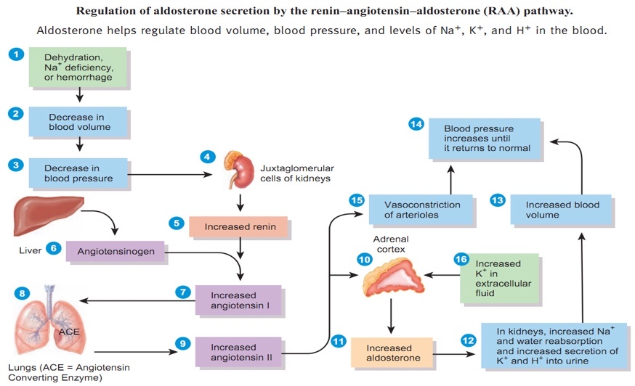
(Peate & Evans, 2020)
Renin is released, and converts angiotensinogen from the liver into angiotensin 1. Angiotensin-1 is then converted to angiotensin-2 by an angiotensin-converting enzyme (ACE), found in the endothelium of the lungs and kidneys. Angiotensin-2 acts in the proximal convoluted tubule, increasing sodium reabsorption: this increase in sodium increases the blood osmolarity, shifting fluid into the blood volume and extra cellular fluid. This increases blood vessel tone which elevate the blood pressure (Samue, Francis and Anthony 2018). .
Angiotensin-2 is a potent vasoactive peptide, causing blood vessels to constrict, resulting in increased blood pressure. Angiotensin-2 also stimulates the secretion of the hormone aldosterone from the adrenal cortex (Samue, Francis and Anthony 2018). Aldosterone, from the adrenal gland on top of the kidneys, stimulates the tubules of the kidneys to increase the reabsorption of sodium and water into the blood. This is known as the Renin Angiotensin Aldosterone System (see Figure 2)

Urea and Electrolytes
Measuring the levels of urea and electrolytes, are commonly requested profiles of blood chemistry, looking at kidney function, as well as excretion and homeostasis (Blann, 2014). Investigating levels of key electrolytes will guide the clinical management and care of children in many clinical scenarios, for example, in hypovolaemia, due to gastroenteritis (diarrhoea and vomiting), dehydration or sepsis (Lissauer & Carroll, 2017). Table 2 identifies the key waste and electrolyte values and interpretations.

Table 2 The components of filtrate / key electrolytes and normal plasma values.
Electrolyte | Main function | - Homeostasis Maintenance  - Daily requirements | Normal range values
Urea | A waste product from the breakdown of protein and excreted by the kidneys. Creatinine and urea blood levels reflect glomerular filtration rate (GFR) which represents the flow of plasma through the glomerulus into the Bowmans capsule. As such an elevated urea outside of normal values is an indicator of renal impairment, especially when associated with high creatinine. | - Appears in the filtrate and not reabsorbed by the kidney tubules back into the bloodstream.  - Excreted in urine. | Infant 1.7-6.7 mmol/L Child 2.5-6.5 mmol/L
Creatinine | A nitrogenous end product of muscle metabolism excreted by the kidneys. An elevated value is an indicator of renal impairment. | - Appears in the filtrate and not reabsorbed excreted in urine. | Infant 15-55 µmol/l  Child 25-60 µmol/l
Sodium | This is the main electrolyte in the extracellular fluid compartment of the body Na+ has a major effect on osmosis and osmolality. Sodium also important for muscle and nerve function.  Hyponatremia is classified as a Na level < 135 mmol/l. Low levels cause apathy and lethargy extreme deficits can cause convulsions, coma, and apnoea.  Hypernatremia is a sodium level > 145 mmol/l. It can be caused by excessive water loss, decreased water intake or excessive sodium intake. High or low sodium levels can be extremely serious for the child and requires careful adjustments in fluid management NICE (2015) Guidelines. | - Daily requirements 2-4 mmol/Kg  - Sodium is conserved by the kidney it appears in the filtrate and reabsorption takes place in the distal tubule and collecting duct. - Sodium regulation in the kidney is controlled by aldosterone | 135-145 mmol/L
Potassium | Potassium (K+) is the most common intracellular ion. Important for muscle and nerve function.  Hypokalaemia is a plasma potassium level < 3.5 mmol/l Hyperkalaemia is an increase in plasma potassium level > 5 mmol/l. any deviations from the normal value parameter requires urgent management and the child’s heart rate and rhythm would need to be monitored with ECG | - Daily requirements 1-2 mmol/Kg  - K+ levels are regulated by the kidney, which either conserves or eliminates K+, and by transcellular shifts between the intracellular and extracellular compartments which allow K+ to enter the cells when plasma levels are high and move out of cells when the plasma levels are low. | Premature 4.5-7.2mmol/L  Term infant 3.6-6.4mmol/L  Child 3.5-5 mmol/L
Magnesium | Magnesium (Mg) and Calcium (Ca) are closely linked to Phosphate (PO₄₎ levels. Magnesium is essential to all reactions that require adenosine triphosphate  (ATP) and is essential for replication and transcription of Deoxyribonucleic acid  (DNA) and for the translocation of messenger Ribonucleic Acid (RNA). It is required for cellular energy metabolism, functioning of the sodium−potassium membrane pump, nerve conduction and calcium channel activity | - Daily requirements 0.07-0.2 mmol/Kg  - Magnesium appears in the filtrate and 95% of this is reabsorbed leaving about 3–5 mmol to appear in the urine.  - Magnesium is actively reabsorbed in the proximal and distal convoluted tubes. | 0.6-1.0mmol/L
Calcium | Ca and Mg are closely linked to PO₄ levels. The skeleton provides an accessible store and is used to maintain extracellular levels. The small amount of extracellular calcium is either a protein-bound complex or is ionised. It is only the ionised form that is free to leave the vascular compartment and participate in cellular function. The function of ionised calcium includes participation in enzyme reaction, an effect on membrane potential, neuronal excitability, contraction of muscle including the myocardium. Severe hypocalcaemia with plasma Ca < 1.75 mmol/l may cause tetany, laryngospasm, and generalised seizures. | - Daily requirements 0.3mmol/Kg  - Calcium is present in the filtrate and the majority of it is reabsorbed actively in the proximal tubule, loop of Henle and the distal tubule. | 2.1-2.7 mmol/L  Total 2.1−2.7 mmol/l,  Ionised 1.2−1.3 mmol/l.
Chloride | Chloride predominantly exists in the extracellular space. It maintains cellular integrity, effects osmotic pressure and water balance and has a role in maintaining acid-base balance | - Daily requirements linked to Sodium.  - Chloride is present in the filtrate and reabsorption is coupled with sodium transport. | Infant 96-111mmol /L  Child 102-112 mmol/L
Phosphate | Most phosphate is found in the child’s bones which forms a reservoir of some electrolytes. Some is found intracellularly. Only a very small amount of phosphate is present within the extracellular fluid and this group of electrolytes are regulated by vitamin D, parathyroid hormone, and calcitonin production. | - Daily requirement 0.04-1.5 mmol/kg  - Phosphates are present in the filtrate and reabsorption actively takes place under the influence of hormonal and metabolic factors. | Premature 1-2.6mmol/L  Term infant and child 1-1.8 mmol/L
Local Laboratory norm Levels may differ slightly so refer to your employer’s guidance. Examples collated from selected Normal Pediatric Laboratory Values (see web links under Resources) NICE (2015) Blaine, Chonchol and Levi (2015) Dixon and Crawford (2012) Kaufman, Basit and Knohl (2020), Salazar (2014) Mahon (2014)
Normal urine output is calculated mls of urine per kilogram per hour, and decreases as age progresses.
- Neonates: 2-3mLs / kg/ hour
- Infant: 2mLs / kg / hour
- Child: 1 – 2mLs / kg/ hour
- Young person: 0.5 – 1mL / kg/ hour

Bladder capacity varies with age and can be calculated by a formula which uses the child’s age (Age + 2) 30 mL= bladder capacity. The volume of urine in a bladder in an infant will trigger the voiding reflex.

Components and constituents of Urine
Urine is 95% water which contains dissolved waste particles, such as urea, creatinine, ammonia, and uric acid along with electrolytes (see table 2). The normal colour of a child’s urine ranges from light yellow to gold and fluctuates over the course of a day depending on hydration. The colour of urine results from urobilin, produced as a result of bilirubin degradation. This urobilinogen is metabolized from bile by intestinal bacteria before being reabsorbed and oxidized, producing the urobilin that is excreted in urine. The odour of urine is usually secondary to the presence of ammonia (Odya and Norris 2017) but can be influenced by the presence of bacteria, the consumption of some foods such as asparagus and taking vitamin supplements. The normal urinary pH range is 5-6 (Chalmers 2014). Table 4 3 summarizes colour deviations within urine that you might observe.

Table 3 4 visual inspection of urine

Colour of urine | Possible reason for colour deviation
Orange – red hue | -Medical treatments such as rifampin, isoniazid, and phenazopyridine,or riboflavin, sulfasalazine, and warfarin have been implicated.  - An overconsumption of carrots can cause orange discolouration.  - Darker tones with food colourings and sweets which contain red pigments, such as large amounts of beetroots and rhubarb can discolour urine.  - Poisoning with mercury and lead can cause red discolouration.  - Haematuria should be suspected with all urine with an orange - red hue and should be tested for the presence of haeme.
Brown | - Antibiotics such as nitrofurantoin and metronidazole can cause brown urine.  - Antimalarial prevention with chloroquine and primaquine can affect urine colour.  - Dark urine can result from consumption of fava beans and aloe.  - Common in liver failure, and frequently seen in jaundiced children.  - Cloudy brown urine is rare, and urgent medical intervention would be required, as it could indicate acute tubular necrosis.
White | - White urine needs to be investigated as it may indicate the presence of mucous, or sediment from mineral crystals e.g., calcium or phosphate precipitation.  - Other causes of white urine include infection, with heavy contamination of fungus, bacteria, or puss (pyuria).  - Fistula formation and lymphatic drainage into the urinary tract is a serious condition.
Blue – green | - A blue - green shade to urine can indicate metabolic disorders with altered tryptophan pathways  - Drugs not commonly used in children can discolour urine such as methylene blue and amitriptyline, as well as Propofol.  - Food colourings and foods such as liquorice and asparagus can also have an effect.
Purple – black | - A range of purple shades can indicate metabolic disorders such as porphyria very dark urine tones can indicate alkaptonuria.  - The intensity of the shade related to state of hydration.  - The use of senna or cascara can darken urine and poisonings with iodine, copper and phenol can blacken urine.  - Paraphenylenediamine is a highly toxic ingredient of hair dye and with unusual hair colours being popular at present has been seem in young people.
Collated from Gill (2014) Roth and Descartes (2017) Atalla and Palka (2020)

Time Out 3
Reflect on the different methods on collecting a sample of urine from an infant in your practice (See Figure 3), and review the methods of each, and reflect on the strengths and weakenesses. What in your experience mandates a more invasive procedure?
Figure 3: Urine collection in an infant
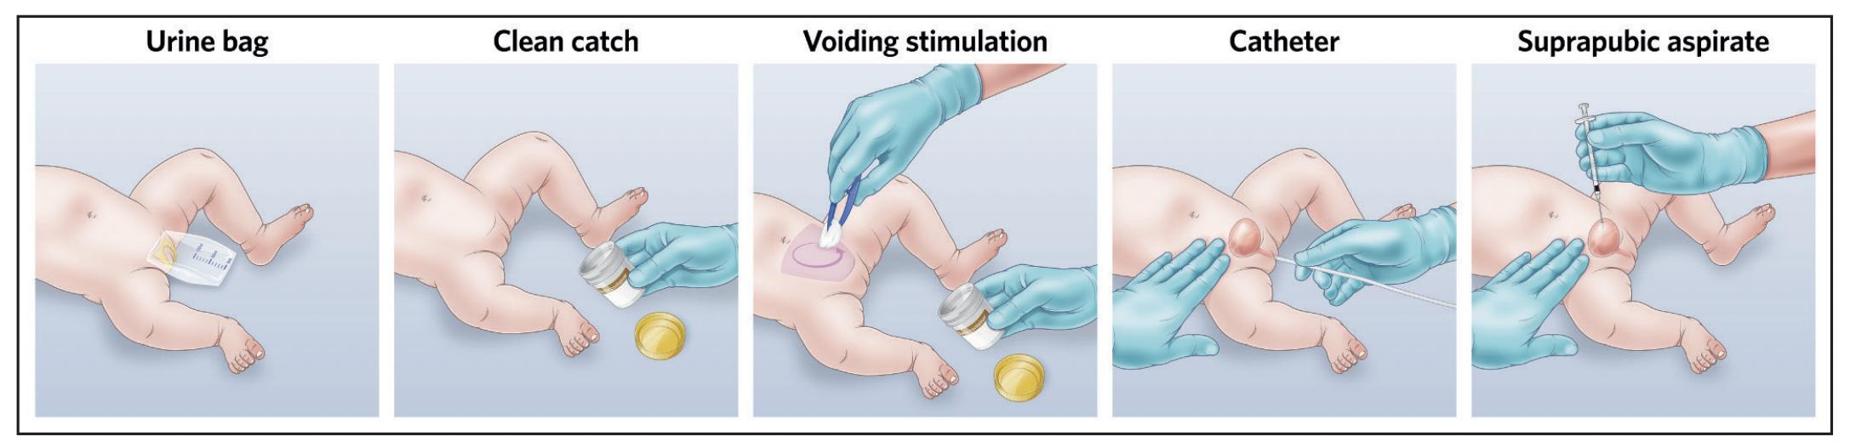
(Kaufman, Temple-Smith, & Sanci, 2020) – will need to be redrawn

Nursing challenges when collecting a urine sample.
A clean catch urine sample is the recommended method for urine collection (Morris and Mounsey), 2018. In older and co-operative children, a clean catch by the parent or the nurse when the child goes to the toilet might be possible. However, this is less successful with the very young, preverbal, or frightened sick child with limited mobility. One technique to obtain a sample in infants involves the ‘Quick Wee’ method, where the infant’s suprapubic cutaneous area (below the umbilicus) is cleaned with water, thereby triggering cutaneous voiding reflexes, resulting in a clean sample within minutes (Morris and Mounsey, 2018).
If a clean catch urine sample is unobtainable, other non-invasive methods such as urine collection pads can be used. It is important to follow the manufacturer's instructions when using urine collection pads. Cotton-wool balls, gauze and sanitary towels should not routinely be used to collect urine in infants and children, as they are not sterile.
In some circumstances a urine collection bag sample can be acceptable. These are best applied when the infant / young child are sleepy and positioned on their back, the skin of the genitals should be cleaned with warm water to remove sebum, soil and any oil or creams used, and the adhesive backing partly removed. Stick the bottom half of the bag placed on the perineum working outwards continue to press the adhesive patch firmly but smoothly, to avoid wrinkles that will leak in place. In boys around the scrotum before tucking the penis into the bag and sealing the top of the urine bag over the pubis. The same technique used for girls, so the vulva is contained.
When it is not possible or practical to collect urine by non-invasive methods, catheter samples or suprapubic aspiration (SPA) should be used.
Before SPA is attempted, ultrasound guidance should be used to demonstrate the presence of urine in the bladder (NICE 2017).
Whilst most parents will understand the rationale for the collection of urine samples (typically for searching for an infection) the assessment of changes urine markers (see Table 2) or changes to the colour (see Table 3) or odour of urine usually requires further explanation. It is important to help parents appreciate that many abnormal changes within urine values can be reversible and that what is tested for does not invariably signal long term damage to the system. Repeat urinalysis can indicate the extent to which treatment is proving beneficial. The key communication challenge is to reach beyond the abbreviations, the metabolic or urinary system implications and to contemplate what this means in terms of risk: that in the short term and that for the longer term wellbeing of the child. More common renal conditions will now be briefly summarised that you might need to consider.

Renal conditions in children
Urinary Tract Infection (UTI) / Pyelonephritis
Defined by NICE (2018) as illness due to micro-organisms in the urinary tract (NICE 2018). A UTI may involve the kidneys when there is fever and systemic involvement which is called Pyelonephritis. This contrasts with Cystitis predominantly located in the bladder. The child or young person may be afebrile or have a low-grade pyrexia. Untreated urinary infections can lead to chronic kidney disease where there is bilateral scarring of the kidneys and hypertension (Rees et al 2012). Signs and symptoms can include fever, lethargy and abdominal pain. Children’s nurses will have to obtain a clean urine sample and local analysis for leukocytes and nitrite. If positive commence antibiotics and then send urine for urgent microscopy and culture.
Nephrotic Syndrome occurs in 1:50,000 children usually between the ages 2-5 years (NHS 2019). Primary Nephrotic Syndrome is the most common: it begins in the kidneys only affects the kidneys. Secondary results from other diseases, such as diabetes. Because of the damage to the glomerulus causing more permeability, albumin leaks into the urine resulting in low serum albumin levels and characteristic oedema. Reduced circulating fluid in the circulation results in the kidney producing increased amounts of renin which activates salt retention, followed by water, resulting in further oedema. This oedema is secondary to reduced oncotic pressure, most often seen in the legs, feet, or ankles but it may also affect the hands and face. Children will also present with haematuria, fever, lethargy and abdominal pain, with anorexia, diarrhoea and hypertension. Treatment will involve steroids, antibiotics, diuretics, albumin infusions, and special low salt diets (Noone et al, 2018)
Haemolytic Uremic Syndrome (HUS)/ Acute Kidney Injury (AKI) is the abrupt onset of renal dysfunction resulting in electrolyte and fluid imbalance. The severity and onset of the acute kidney injury will normally determine the potential for recovery. Causes include Prerenal e.g. Sepsis; Intrarenal e.g., Hypertension, previous infections which has affected / damaged the kidney tissues. Postrenal e.g. Obstruction within the upper or lower urinary tract impacting on outflow from the kidneys. Children with HUS may present with a clinical picture similar to gastroenteritis with vomiting, bloody diarrhoea, abdominal pain, fever, chills, and headache as the condition progresses, they may present with anaemia, thrombocytopenia, purpura lethargy, and pallor. Anaemia is managed with blood transfusions. Haemodialysis is sometimes required as part of the management in Haemolytic Uraemic Syndrome where there is an acute deterioration in kidney function in the presence of active disease. Most children with HUS recover well other may have serious consequences blood-clotting problems that can lead to bleeding, stroke, and coma, seizures, heart problems, chronic, or long lasting, kidney disease (Davies, 2014).
Chronic Kidney Disease (CKD) is irreversible damage to the parenchyma of the kidney resulting in abnormal renal function (Rees et al 2012). It is described in staging using the GFR from 1-5: Grade 1 having normal results and function and Grades 2 -5 reflecting declining function with 5 representing Kidney Failure. Stage 5 indicates the need for renal replacement therapy. CKD usually follows on from a range of other conditions such as congenital abnormalities, hereditary diseases, untreated or unmanaged infections, Nephrotic syndrome, or trauma. Individual fluid plans will be a key aspect of the nursing care and management, alongside management of any infections, and treatment for anaemia. If the child is in end stage kidney disease blood filtering dialysis to remove waste and extra fluid from the child. Dialysis usually takes place in specialist centres, can last from 3-5 hours and may need to take place several times a week. Home dialysis is possible, but the optimal mode of management is usually renal transplantation (Kaspar et al, 2016).

Time Out 4
Reflect how each of the above renal conditions might register in parents in terms of risk. In your experience, how do parents conceive of risk in such circumstances. Do they for instance limit it to a body system or does the concern quickly centre on changes to lifestyle? Do parents find it easy to appreciate the wide ranging effects that a urinary system condition can have? Helping parents to understand test results may have a vital function over time beyond renal assessment, and they can help signal the scale of the health challenge that lies ahead.
This CPD has considered the embryology, the basic anatomy and physiology and some clinical conditions related to the renal system.’Routine’ blood testing for urea and electrolytes can often identify imbalances in the blood stream, and highlight kidney function. Collecting a urine sample is an essential component of nursing care and so much can be determined from the characteristics of urine which can help to support a diagnosis and the success of the management of the child. This CPD has explained common tests that the children’s nurse will have to undertake on their patients in everyday practice. Having an understanding of the routine investigations, whether for acute or chronic renal conditions, can not only give nurses and healthcare professionals an insight into the care that is required, but can also act as an aid to explain to parents and caregivers the details behind the care that may be required for their child.

Resources:
Kidney Care UK https://www.kidneycareuk.org/about-kidney-health/?gclid=CjwKCAiA6aSABhApEiwA6Cbm_4z85Kfr9LLbmSjWL4-vyA3qIiWyY5zJCllMC_14yLv6jfaz22dHxBoCHRcQAvD_BwE
Khan Academy https://www.khanacademy.org/test-prep/mcat/organ-systems/the-renal-system/a/tubular-reabsorption-article.
National Institute of diabetes, digestive and Kidney disease. https://www.niddk.nih.gov/health-information/kidney-disease

References:
Atalla C. and Palka J. (2020) 12 causes of discoloured urine. Medscape. https://reference.medscape.com/slideshow/discolored-urine-6008332#2
Blaine J. Chonchol M. and Levi M. (2015) Renal Control of Calcium, Phosphate, and Magnesium Homeostasis. Clinical Journal of Nephrology 10 (7) 1257-1272. https://www.ncbi.nlm.nih.gov/pmc/articles/PMC4491294/#:~:text
Blann, A. (2014). Why do we test for urea and electrolytes? Nursing Times, 110(5), 19 - 21.
Blyton, D. and Jepson, S. (2014) Renal Care in Infancy, Childhood and Early Adulthood in Thomas, N (ed). Renal Nursing 4th Edition, Wiley Blackwell, pp.321-338.
Chalmers, C. (2014) Applied Anatomy and Physiology and the Renal Disease Process in Thomas, N (ed). Renal Nursing 4th Edition, Wiley Blackwell, pp.20-58.
Davies, A. (2014) Acute Kidney Injury in Thomas, N (ed). Renal Nursing 4th Edition, Wiley Blackwell
Devitt, P. and Thain, J. (2011) Children and Young People’s Nursing made Incredibly Easy 1st Edition Lippincott, Williams and Wilkins
Fukuoka K. Wilting J. Francisco J. (2018) The Embryonic Ascent of the Kidney Revisited. The Anatomical Record. https://anatomypubs.onlinelibrary.wiley.com/doi/full/10.1002/ar.23930 accessed November 2020
Gill B. (2014) Discolouration Urine. Medscape. https://emedicine.medscape.com/article/2172371-overview
Hill (2020) Renal system development https://embryology.med.unsw.edu.au/embryology/index.php/Renal_System_Development#Embryonic_Kidney accessed November 2020
Kaspar, C. D. W.,Bholah, R. & Bunchman, T. E. (2016) A Review of Chronic Kidney Disease Blood Purification 41 pp. 211 - 217
Kaufman D. Basit H. and Knohl S. (2020) Physiology, Glomerular Filtration Rate. https://www.ncbi.nlm.nih.gov/books/NBK500032/ accessed November 2020
Kaufman, J., Temple-Smith, M., & Sanci, L. (2020). Urine sample collection from young pre-continent children: common methods and the new Quick-Wee technique. Br J Gen Pract, 70(690), 42-43. doi:10.3399/bjgp20X707705
Lissauer, T., & Carroll, W. (Eds.). (2017). Illustrated Textbook of Paediatrics (5th ed.). Edinburgh: Elsevier.
Mahon, A. (2014) Investigations in Kidney Disease in Thomas, N (ed). Renal Nursing 4th Edition, Wiley Blackwell, pp. 140
Morris, L. & Mounsey, A. (2018) An easy approach to obtaining clean-catch urine from infants The Journal of Family Practice Vol 67; No 3 pp. 166 - 169
NICE (2018) Urinary Tract Infection in under 16s diagnosis and management. https://www.nice.org.uk/guidance/cg54
NHS (2019) Nephrotic syndrome in children. https://www.nhs.uk/conditions/nephrotic-syndrome/
Noone, D. G., Iijima, L. & Parekh, R. (2018) Idiopathic nephrotic syndrome in children The Lancet Vol 392, July 7 pp. 61 - 74
Odya, E. and Norris, M. (2017) Anatomy and Physiology for Dummies 3rd Edition, A Wiley Brand
Peate, I., & Gormley-Fleming, E. (Eds.). (2015). Fundamentals of Children’s Anatomy and Physiology: A Textbook for Nursing and Healthcare Students. Wiley Blackwell: West Sussex.
Peate, I. & Evans, S (Eds) 2020 Fundamentals of Anatomy & Physiology for Nursing and Healthcare Students Wiley Blackwell: West Sussex
(Pocock et al 2018) Human Physiology Book ref needs adding
Rees, L, Brogan, P.A., Bockenhauer, D. and Webb, N.J.A. (2012) Paediatric Nephrology 2nd Edition
Roth K. and Descartes M. (2017) Alkaptonuria - Black Urine Disease. Medscape https://emedicine.medscape.com/article/941530-overview
Samue, Francis and Anthony (2018) Role of the Kidneys in the Regulation of Intra- and Extra-Renal Blood Pressure. Ann Clin Hypertens. 2: 048-058. DOI: 10.29328/journal.ach.1001011
Salazar J. (2014) Overview of Urea and Creatinine. 45 (1) 19-20 https://academic.oup.com/labmed/article/45/1/e19/2657879 accessed November 2020
Yoham A. and Casadesus D. (2020) Embryology, Urethral Folds https://www.ncbi.nlm.nih.gov/books/NBK560572/ accessed November 2020

