Third Nature
Embodiment of borders and thinking beyond: Surviving despite capitalism

Abstract:

In the wake of the COVID-19 pandemic and the subsequent era of social distancing, it has become imperative for many artists to maintain somatic embodied practices. This article will address the embodied nature of collaborative creative process at a distance. Using Walter Mignolo’s ‘pluriversal worlds’ as a starting point, the article will explore how artists can maintain collaborative migrant knowledge production across geographical and imaginary spaces. We will analyse the digital dialogue commission ‘Third nature’ and how it applied the Authentic Movement somatic dyadic technique in a digital format. The article will also reflect on how the ‘Third nature’ co-sharing and co-witnessing process allowed the artists to dwell in the imaginary and natural border territory and to still feel upheld by one another.

Key words: pluriverse; somatic practice; eco-humanities; borders; Authentic Movement;

Introduction

This article is an experiment in collaborative migrant knowledge production across geographical and imaginary spaces. It is shaped by slow passage of time, marked by planetary reverberations including the COVID pandemic, the Black Lives Matter movement and the realization that human and planetary breathing is inter-connected and severely restricted. Working creatively over a period of several months, with what the Senegalese poet and politician Senghor has called “rendez-vous du donner et du recevoir” (the meeting place of giving and receiving) (1977), we moved with clear intentions to nurture a somatic ‘witnessing’ practice, rather than only a product-oriented collaboration. This article analyses the development of our project ‘Third Nature’, a collaboration between Elena Marchevska (author of this article), Carolyn Defrin (author of this article), Syowia Kyambi and Sebastian Aguirre (both of whom kindly agreed to us using elements of the reflective writing they produced for the project). The project was curated and commissioned by performing.borders and Live Art Development Agency (LADA) for their ‘Digital Conversations 2020’.
As a reader, you will encounter multiple registers of writing voices in this article: personal, reflective and academic. We draw particular attention to the reflective, somatic voice that brings together parts of our project diaries, discussions and observations. These personal reflections are contextualised by, and interweave with, academic theories. We invite you to meander with these voices as they speak to experiential and practical knowledge about connections between migration and nature—with what Ayşe Güleç calls ‘migrant-situated knowledge’ of those directly affected by governmental anti-immigrant politics and racism (2018:3). This is an open-ended process that emphasises our working toward embodied eco-consciousness.

Winter turns into Spring

Elena

March 2020 – we enter a period that will define generations to come. We sleepwalk into a world-scale crisis. This will profoundly, to a cellular level, change what humanity needs: to reconnect with the more-than-human world. As a performance artist, I am trained to retreat to my body when presented with a challenge. I feel a strong need for a “somatic exploration of the complex web of relations between creative practice-led research, personal story and the bodily-felt and experienced implications of social and cultural location” (Bacon, 2010). I yearn to work with other people, almost in spite of all the man-imposed restrictions and common sense. On other hand, I am irritated by the pressure to continue labour as per normal. The capitalist pressure to remain productive and serve. I dream of parallel worlds, while tending my garden and observing the birds, reawakening after humanity felt silent. I reach out to people, across physical and virtual borders and decide to listen. To listen and dwell in the imaginary borders. An all too familiar territory for my migrant body. Territory regularly unexplored, regulated, tangled with complex human structures, unnatural and at the same time most naturalized in its existence.

Carloyn

I walk from Angel to Elephant and Castle, a first walk of many in the months to come. The numbers climb, fear clears the streets and unbeknownst to me I walk on this day, March 16th, 2020, to teach students in a building for the last time.

March, April, May. The work remains and I am grateful. I continue to teach and find connection with students on virtual platforms. Nothing replaces that ineffable energy of being with other people in other places, but it works. We make it work. And then the work inevitably slips. Institutions must make inevitable cuts in these hard times and I am that dispensable figure that happily lives indispensably in between.

In between institutions, sectors, art forms, homelands, I’ve trained for this time of uncertainty. Freelancer in freefall is a well-lived landscape for me. But while I dwell in the borders of capitalism, my work ethic cannot escape. Driven to create no matter the outcome, I work relentlessly. Looking back now from January 2021, I can see there are so few days I’ve let myself not work. I learn that somewhere deep within myself I might resent that. My body produces dry eyes and headaches. My ancestors hum to me in low, faraway tones:

Yes, you are trained for this time.
You know how to move from one land to the next.
But don’t forget to be with the lands.
Hold them and let them hold you.
There is symbiosis to be found.

Third nature: Border pluriverse of entanglement

In his foreword to Constructing the Pluriverse, Walter Mignolo introduces ‘border thinking’ or ‘dwelling’ as a method of decolonial praxis. Border thinking/ dwelling inhabits the interstices of a pluriversal world– one in which Western universalism is just one of many different cosmologies entangled through the colonial matrix of power (Mignolo, 2018). To dwell in the border is to exist within the pluriverse, whilst to look at the border from elsewhere merely acknowledges that there might be a pluriverse somewhere else. According to Mignolo, to be a border-dweller within a pluriversal entanglement is a status conferred upon those with often uncertain societal positions and/ or transcultural experiences, such as ‘migrants and queers, Chicanos and Chicanas’ (2018: xi).

As Gloria Anzaldúa writes about working-class people of colour (and it could be extended to the female artists working on this topic), “our psyches resemble the bordertowns and are populated by the same people“ (1987:82). One might think of border dwellers in binary terms: North vs South, body vs mind, home vs movement. However, Anzaldúa explains the complexity of this pluriverse position when she writes that “the U.S. – Mexican border es una herida abierta where the Third World grates against the First and bleeds. And before a scab forms it haemorrhages again, the lifeblood of two worlds merging to form a third country – a border culture”(1989:3). She continues: “Alienated from her mother culture, ‘alien’ in the dominant culture, the woman of colour does not feel safe within the inner life of her Self. Petrified, she can’t respond, her face caught between los intersticios, the spaces between the different worlds she inhabits” (1989:20). But Anzaldúa also highlights that borders are man-made, and that we need the role of nature to move us beyond the cultural border conception.

Anna Tsing observes that over the past few decades, scholars have shown that allowing solely human protagonists into our stories is not just human bias; it is a cultural agenda tied to dreams of constant progress and capitalist growth. Tsing suggests there are other ways of making worlds:

Anthropologists have become interested, for example, in how subsistence hunters recognize other living beings as ‘persons,’ that is, protagonists of stories. Indeed, how could it be otherwise? Yet expectations of progress block this insight: talking animals are for children and primitives. Their voices silent, we imagine well-being without them. We trample over them for our advancement; we forget that collaborative survival requires cross-species coordination (2015:155).

In asserting “humans cannot survive by stomping on all the others” (2015: vii) , Tsing proposes “third nature”:

Imagine “first nature” to mean ecological relations (including humans) and “second nature” to refer to capitalist transformations of the environment…My book then offers “third nature,” that is, what manages to live despite capitalism. (2015:viii)

According to Tsing, “to even notice third nature, we must evade assumptions that the future is that singular direction ahead. Like virtual particles in a quantum field, multiple futures pop in and out of possibility; third nature emerges within such temporal polyphony” (ibid). This links with Mignolo’s challenge:

Western universalism has the right to coexist in the pluriverse of meaning. Stripped of its pretended universality, Western cosmology would be one of many cosmologies, no longer the one that subsumes and regulates all the others (2018).

These ideas provoke a call to create within and outside of Western capitalist modes of progress: to embody the polyphony and multiple futures, despite the limitations of current modes of artistic production.

Spring becomes Summer (A call to create differently)

Having worked together for a year on a project about migrant artists,^{[1]} we yearn to continue an emerging idea. Tsing’s ‘Third Nature’ provokes consideration for how our own migratory patterns might contribute to a way of living in spite of a capitalist nature. How can we listen more closely to our homelands which, for both of, us carry intergenerational narratives of forced movement? (Directly for Elena having grown up during the Yugoslavian wars and indirectly for Carolyn whose grandparents fled Eastern Europe before and during World War II). What is the impact of such force on our relationships to nature? What happens if we stop moving and stay still? We lean into Güleç’s ‘migrant-situated knowledge,’ one that mediates between the fields of art and politics in order to expose practices of silencing on various societal levels and we aim to combat these by making them un-ignorable: form of ‘affirmative sabotage’(2018:6).

Working with fellow border dwellers– Chilean/ British artist and activist, Sebastian Aguirre, and Kenyan/ German mixed media artist Syowia Kwambe– we pursue this line of thinking for the project ‘Third Nature’. Feeling the planet reverberate from COVID, we note change is afoot, and question how we participate. ‘Open-ended’ being the goal, we simply meet each other where we are. The pandemic rolls on, Zoom strains us all, so we work in our allotted time together and alleviate the pressure to create beyond it. We ‘give’ and ‘receive;’ Tsing’s ‘Third Nature’ becomes our holding point, our inspiration for a collaborative, polyphonic, unfolding way of working that embraces what can flourish in troubled times and troubled lands. Agreeing to develop an open-ended series of digital discussions: a riot of short reflections on lived, precarious, migrant experience, we deliberately relinquish control over how we will get there.

Witnessing the borders of the body

In our early creative stages, we find our way into the ‘mover/ witness diad principle’. Intrinsic to Authentic Movement, this principle is centred in the development of embodied witness consciousness. Using the platform Milanote (2020), we post on different topics within domestic or natural landscapes, sharing articles, videos and images alongside our own writings, photographs and drawings. We witness each other’s explorations and respond if we choose or simply hold the embodied experience from a distance. This resembles the somatic process established by Jane Adler in Authentic Movement, where what is usually the inner witness, is externalized and embodied by a person who is then called the outer witness. The outer witness listens (and, in our case, watches/ observes) and then speaks their experience of the material that was offered. In this way language bridges experience from body to consciousness. For both the one who offers and the witness, the intention toward the practice of thoughtful speech is central. And for our working process, this becomes essential, especially as we share intimate and personal material. Our co-sharing and co-witnessing facilitates dwelling in border territory and feeling upheld by one another.

In one of our early sessions Carolyn offers a provocation:

Tasks for hidden work

1. Name your hidden collaborations (with people, place, things)
2. Develop one with someone or something you admire
3. Develop one with someone or something you despise

Elena takes this invitation to explore the endemic pine trees Pinus pinea, on the Croatian island of Vis. She is staying there with her family in their summer house and spends two weeks somatically exploring the trees, their structure, history, smell and relationship with the sea and land. This interactive process demonstrates what Tsing describes as an opportunity to shape different worlds and futures, to understand landscapes as sites for more-than-human dramas:

landscapes are radical tools for decentring human hubris. Landscapes are not backdrops for historical action: they are themselves active. Watching landscapes in formation shows humans joining other living beings in shaping worlds. (Tsing, 2015:152)

Elena observes and connects recent migration patterns from the region’s devastating civil war and the pine trees’ migration survival tendencies:

The local pine trees are spectacular. Adorned with pinecones, they lean against the rocks, kissing the sea. Like lovers, they embrace on high tide. They hold a secret pact.

Summer fires are a common blight on the island. They start suddenly and spread fast on the dry land. When the fire embraces the pine tree, in the height of the heat, the pine cones explode and launch high in the air. They can spread the seeds miles and miles away to the next land mass or they can float on the sea, until they reach land. While the tree burns slowly, its seeds migrate after an explosive firework of natural species protection.

We are not much different, when fire embraces our homes, we explode in multiple directions. We reach far lands or float on seas for days. Some perish and some survive, take root in unknown land, start all over again. (August 2020)

Elena, as a border-dweller herself, establishes Mignolo’s pluriversal entanglement with the surrounding pine trees. The trees and the artist share uncertain societal positions, due to their precarious existence: trees endanger human property, Elena is seen as a dangerous outsider because of her migrant status. Mbembe reminds that this entanglement is neither particularly new nor associated with Western modes of thinking. He observes that this entangled dynamic is what creates movement:

...people are unthinkable without what we call nature. So while the Anthropocene’s turn seems to be a novelty in parts of our world today, we have always lived in that. It is not new. Because you cannot think of people, without thinking of nonhumans (2018).

This entanglement is also present in Sebastian’s photographic response to the same provocation of ‘hidden collaborations.’ He observes birch and oak trees leaning on fences in South London forests. He listens to Mercedes Sosa (1984) and reflects on his upbringing as a child of Chilean refugees. He notes his embodiment of his parents’ longing and entanglement with a landscape that was stolen. He translates Sosa’s verses for us:
The plant changes and gets dressed in green during spring
The beast changes its fur
the hair of an old person changes
and just as everything changes
the fact that I change it's not in the least strange
But my love doesn't change
no matter how far away I find myself
neither the memory nor the pain
of my country and my people
What changed yesterday
will have to change tomorrow
Just as I change
in this foreign land.
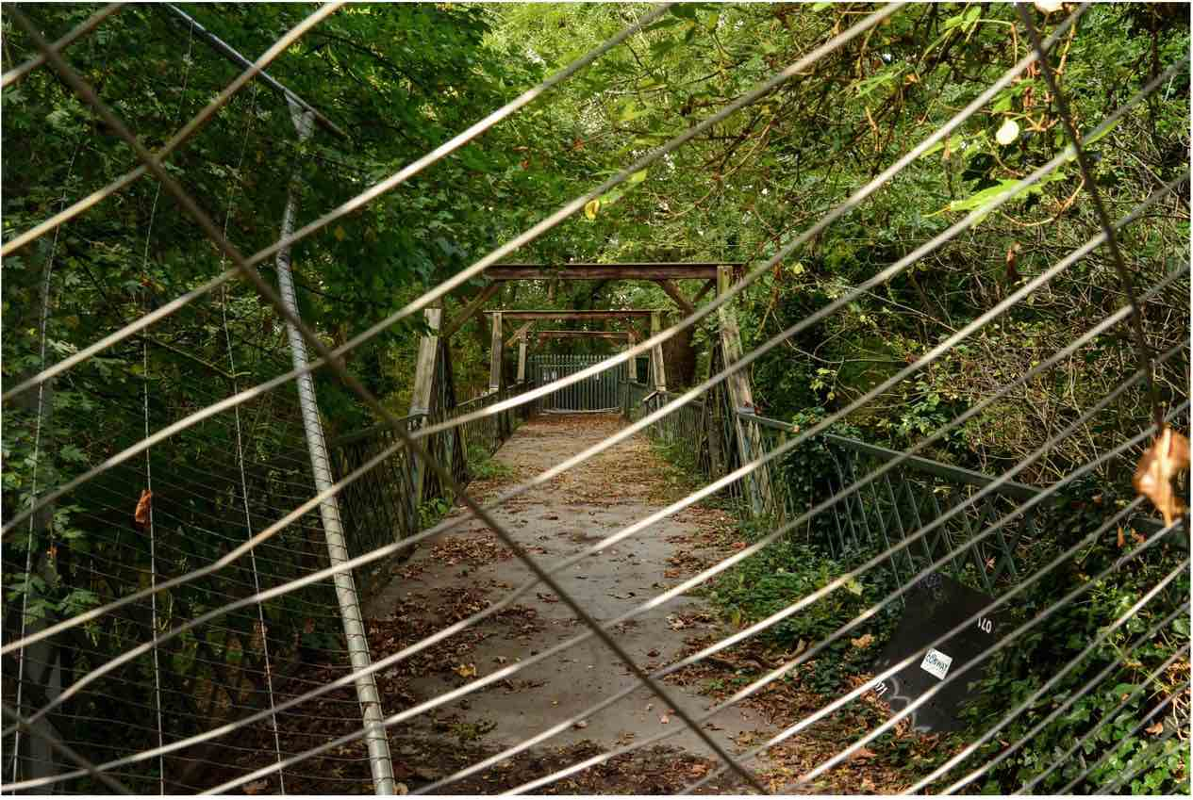
Fences; photo by Sebastian Aguirre for the project ‘Third Nature’ (2020)
Such recognition of changing, shattering, diffracting worlds reverberates as Carolyn reflects on her hidden collaborations within her heritage. As the granddaughter of immigrants who fled to the US seeking sanctuary between the two world wars, she has lived the benefits of safety and a perceived sensibility. The “American Dream.” But having moved to the UK in 2012, she has since witnessed the rapid decline of care towards that ‘other from another land.’ The rise of right wing xenophobia entangles with human behaviours and land entitlements. How does one take care and repair in such man-made destructions? She writes:

‘To Tend Dark Soil’
The amber waves are now ablaze
Burning an orange apocalypse of carelessness
Lighting up a homeland
So far away
From the home I remember growing up in.

Broken bodies, broken lands, broken country.

And yet you are my home.
You call me, long distance
Ringing through an ocean:
‘How will you tend from so far away?’
Roots that reach across a century of movement
From Europe to a United States to a United Kingdom
Echo so many false promises of union.

I walk through British countryside lanes.
More walks in more months of the pandemic.
I’m out looking for mushrooms growing in upturned trees
(inspired by Anna Tsing’s Matsuki mushroom that grew
in the ashen aftermath of Hiroshima)
Instead I find a child’s truck parked in the crevices of an up-turned tree stump–
A toy reminder of man’s persistent yearning to control and drive over, extract and profit.
Or perhaps a symbiotic hug?
Uprooted, both truck and tree hold tight to one another for now.

The America I am watching through phone and laptop portals
is one that has forgotten the land
Forgotten its entanglements and a balance of power
The blood of injustice spilling relentlessly an infertile poison

I think of my grandparents making their way by boats across the Atlantic to the US,
Entering through the pearly gates of Ellis Island in the early part of the 20th century.
What would they think now?
How would they rise up with the soil that comforts their long-ago bones
and whisper or RAGE:

‘We’ve been here before
In the wipe out,
in the weary wild game of human control.
Lie down
Let the earth speak
Then sing back and let your hands sink deep

(August-October, 2020)

Breathing and healing: With nature/ without border

In the second month of our process, the brutal execution of George Floyd happens and we witness the world reverberate again. We feel the suffocation. Mbembe extrapolates:

the question of a universal right to breathe- it begins probably with things like that, like witnessing all those small instances where some are, so to say, expropriated of their breath (2020).

Suddenly our internal explorations of lacking space as migrants transfers to a wider world. And it manifests deeply in our bodies. In a June meeting, we all talk about exhaustion and recurrences of chronic pain. Elena sends a video of her ailing back attempting relief, transformed into a landscape of struggle, overlaid with slivers of sky and tree tops. She spends days in bed, due to chronic lower back pain and watches the world shrink to a view from her window. The trees are blooming, birds are the only visitors. The city is unusually silent without airplanes or car traffic (due to travel restrictions) and Elena dwells deeper into why her pain is reawakened. She remembers a serious car accident from her childhood - one that happened simultaneously with the de-fractionation of her home country. Feeling her body as a child in bio-symbiosis with the war-shattered landscapes that surrounded her, she writes:

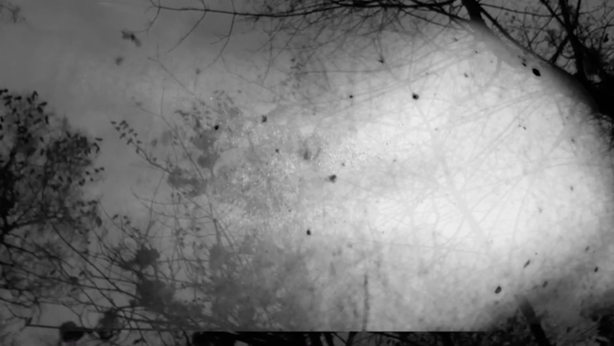
Backpain; video still by Elena Marchevska for the project ‘Third Nature’ (2020)

The back pain slows me down. The world moves and I lay still, pulsating pain grabbing my body. Memories of previous stillness emerge. My body hovering above. Just a child, broken… Many pieces, shattered. Someone had a drink, lost his reflexes. He didn’t want to do it. He cries. I watch. Broken. I don’t understand fully what happens, like my entire body and memory was taken away by someone. Someone who redraws each part anew.

My right side is battered. Blue and black. Deep scars, skin open wide.
Nobody really explains. They just say
‘We are so happy you are still with us!’
Like I went somewhere and returned after a century. From the beyond.

My right side still remembers.
When I allow, it takes over control.
It reminds me how broken my body can be.

Because someone was unhappy, they lost a job…
A job they had, in a country that was no more.
In a country that lost control, before the man lost his job.
The man lost his job, before he lost control of his vehicle.
The vehicle that damaged my body. In a city, on the margin, in the country that is no more.

We are all part of a bigger decision, made by the Man (with capital M). And someone needs to be left behind. The drunk man, the child with the broken body, the city on the brink of the collapsing country, the country that is no more.

My journey started then. In that moment. Surviving defyingly. Entangled with metal and organic tissue, I survived despite the odds. (July 2020)

Elena reflects on parallels between post-colonialism and post-socialism: there is a profound trauma in both types of situations that created the stasis where Elena’s body was trapped. Mbembe argues that the only way forward is ‘to find new ways of sharing the world, of caring, taking care of the world, of repairing the world in view of the profound damage we humans have inflicted upon it, one example being the ways in which it has been partitioned’ (2019). Mary Catherine Bateson proposes a similar way forward and believes in co-evolution and endosymbiosis, demonstrating this through biologist Lynn Margulis’ theory of the cellular nucleus:

...the cell with a nucleus actually came about by one single-cell organism taking up residence inside the other in a way that was mutually beneficial.

The cells in the green plants have little islands of chlorophyll in order to do photosynthesis that is the base of our entire food chain, right? And it is now understood that they were originally like algae — they took up residence inside these cells, because they needed a home that they didn’t have. And so for millions of years, every cell in every leaf is actually a cooperative enterprise (Bateson, 2015).
How can we begin to transmit this idea in terms not only of migrant cultures but of human and non-human worlds? How, like the parked toy truck of Capitalism, can we form new homes with our uprooted trees and work towards Tsing’s idea of surviving despite capitalism? In the last stages of our project we create stories of hope, of symbio-genetic bodies, of nature burying the human.
From her current home in London, UK, Carolyn observes the collapsing of so many systems in her North American homeland during the pandemic. Government, healthcare, social justice--these histories were never without deep flaws. But now this narrative of exceptionalism cannot hide its existential crisis. She records herself reading her own words as a mode to take up residence with the destruction in order to move towards healing:

How to Detonate:

Make a plan
Or don’t
Break the earth that you
or someone else thought was firm, secure, pleasurable, strong,
good for holding
Break it really well-
Split it, crack it, smash it, detonate it, explode it into a million pieces
Then let the dust and innards and wires and guts come flying out
So that it’s impossible not to see it, deal with it, eat it for breakfast lunch and dinner
So that there is no way to put it back together the same way
So that it hurts
So that it cuts deep down hard hardly there anymore and only stringy particles and atoms of breath offer
some
thing

How to Heal:

Slowly
Slowly
Slowly
If you want to do it right
Black blood takes times to rise to the surface, to lift the old and grow new cells

But you can get a bandaid right away
Something to hold it all in --keep it from spilling out
This can be made of cotton and sticky things
Care and glue
Soft and adhesive
Don’t be afraid to be cohesive with other things and people that are similar but not the same
Take your time
Give your time

Look at something/someone new
Lie down and look again, but from a different moment
Kiss your shoulders or let your shoulders kiss you
Cry
It’s okay

Summer becomes Fall

The time we have given each other to dwell in the borders and embody the space between us approaches an end. We prepare for the October discussion with the other commissioned artists, assembling different research into something that might (or might not) make sense to an external eye.

Syowia edits material in a prosaic film format with the help of video editor Kibe Wangunya. In the final section of the film, she performs a ceremonial return to earth: laying down in the botanical forest in Amani, Tanzania. She buries herself with dirt and leaves as a recognition of the destruction caused by mankind and a resignation to return humbly to the earth for a mutual healing, holding and resting.
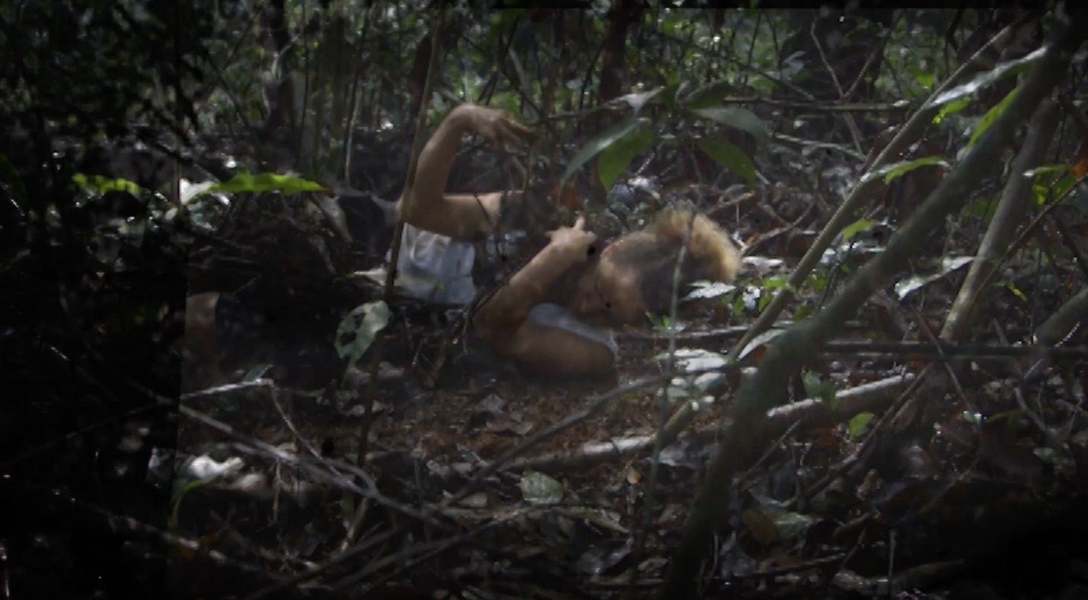

Forest; video still by Syowia Kwambe for the project ‘Third Nature’ (2020)

Syowia cites the destruction and ludic hopefulness of humanity, offering us a letter:

Dear Sansevieria Trifasciata,^{[2]}

We’ve never met, though I’ve seen you upon many a windowsill along my treks to wherever my work takes me. I believe my great, great grandmother knew you well. You must have come into contact when she was making her baskets and mats. I’m amazed at how far you’ve travelled and how comfortably you sit within their living rooms listening in on their stories of how their families moved across the lands. Does it feel strange to now be so common? Though your name still carries the weight of the past, as all our names tend to do. Your resilience is astounding. You don’t need much, I know, so easy to maintain you and tame you. I guess it's part of life, no, this constant shuffle and metamorphosis.

I wish you well.

Sincerely, Syowia

Our project ‘wraps up’ and in email correspondence, Sebastian reflects on the difference of this way of working to his usual practice: ‘Our approach to the project felt borderless – without boundaries, in a creatively nurturing way’ (2020). As a group, we decide to keep going, in our collaborative, polyphonic, unfolding way of working that embraces what can flourish in troubled times and troubled lands when capitalist measurements of time are not a factor. It will be in our ‘Third Nature’ to continue to be together beyond the initial project’s timeframes.

Fall becomes Winter

Carolyn
I lie down more. Mostly in the morning, I take my time between waking and placing my feet on the floor—giving myself time to just be. Then every so often I remember I can lie down on the floor of my office too–in the middle of the day! Look at my desk from below. Worm’s eye view.
Earth calls more regularly now. I pick up and just listen and I let the humans go to voicemail.

Elena
I have been asked to self-isolate by a phone app. I don’t know why, I don’t know when the human contact occurred, but I am marked. In four walls, trapped. And yet, I feel the earth reverberate anew and I can see my fellow humans wake with longer days and shorter nights. Hope emerges from the West. A new tree is planted by the Council in front of my house. I observe it standing by the gate, longing to touch its tree shoots. We will grow old together, his days outnumbering mine. And perhaps we will both be able to learn from each other the art of living on this damaged planet.

Bibliography:

Anzaldua, Gloria (1987), Borderlands/La frontera: The New Mestiza. San Francisco: Spinster/Aunt Lute.

Bacon, Jane (2010), ‘The voice of her body: somatic practices as a basis for creative research methodology’, Journal of Dance and Somatic Practices, 2:1, pp. 63-74.

Mignolo, Walter (2018), ‘Foreword. On Pluriversality and Multipolarity’, in
B.Reiter (ed.) Constructing the Pluriverse, Durham: Duke University Press
Books, pp.ix-xvi.

Güleç, Ayşe (2018), ‘The Society of Friends of Halit. Migrant-Situated Knowledge and Affirmative Sabotage’, documenta studies #0. https://documenta-studien.de/media/1/documenta_studien_1_AyseGuelec-EN.pdf Accessed 1 December 2020

Mbembe, Achille (2018), ‘The idea of a borderless world’. Africa is a Country. https://africasacountry.com/2018/11/the-idea-of-a-borderless-world Accessed 1 December 2020

Mbembe, Achille (2020a), ‘ Transcript: In conversation with Achille Mbembe’ https://www.ucl.ac.uk/racism-racialisation/transcript-conversation-achille-mbembe Accessed 10 January 2021

Mbembe, Achille (2020b), ‘ It might well be that the future of our planet will play out in Africa’. https://www.disenz.net/en/achille-mbembe-it-might-well-be-that-the-future-of-our-planet-will-play-out-in-africa/ Accessed 1 December 2020

On Being (2015), ‘Mary Catherine Bateson, Living as an improvisational art.’ 1, October 2015, https://onbeing.org/programs/mary-catherine-bateson-living-as-an-improvisational-art/ Accessed 15 January, 2021

Senghor, Léopold Sédar (1977), Liberté 3 : Négritude et Civilisation de l’Universel. Paris : Seuil.

Sosa, Mercedes (1984), ‘Todo Cambia’ , YouTube, 14 June, https://www.youtube.com/watch?v=0khKL3tTOTs
Accessed 10 April 2021

Third Nature Milanote (2020), https://app.milanote.com/1Kbf401EOxUgb4?p=a4Nc0phpsPk Accessed 10 April 2021

Tsing, Anna Lowenhaupt (2015), The mushroom at the end of the world: on the possibility of life in capitalist ruins. Princeton: Princeton University Press.

Tsing, Anna Lowenhaupt, Swanson, Heather Anne, Gan, Elaine, and Bubandt, Nils (eds) (2017), Arts of living on a damaged planet: ghosts of the anthropocene. Minneapolis: University of Minnesota Press.

^{[1]} https://www.projectfindinghome.net
^{[2]} Sansevieria trifasciata is a species of flowering plant in the family Asparagaceae, native to tropical West Africa from Nigeria east to the Congo. It is most commonly known as the snake plant, mother-in-law's tongue, and viper's bowstring hemp, among other names.

Author’s bios:

Dr. Elena Marchevska is a practitioner, academic and researcher interested in new historical discontinuities that have emerged in post-capitalist and post-socialist transition. She is researching and writing extensively on the issues of belonging, displacement, the border and intergenerational trauma. Her artistic work explores borders and stories that emerge from living in transition. She is an Associate Professor in Performance Studies at London South Bank University.

Dr. Carolyn Defrin is an artist and researcher currently focused on subject matter related to migration, intergenerational connection, feminism, nature and care. Originally from the US, and currently based in London, UK- she works across video installation and theatre practices. She holds an MA in performance and design from Central Saint Martins and has just completed a collaborative PhD with London South Bank University and Hammersmith United Charities which explored relationships between funders, artists and local vulnerable communities. She is the co-founder of Kissing Project (a multimedia platform for stories and experiences that celebrates diverse humanity) and an original founding member of The House Theatre of Chicago.

