ASTESJ
ISSN: 0000-xxxx

Building an online interactive 3D virtual world for AquaFlux and Epsilon
Omar Al Hashimi¹, Perry Xiao¹
¹London South Bank University, School of Engineering, SE1 0AE, UK

A R T I C L E I N F O |  | A B S T R A C T
Article history:  Received : 08 December, 2017  Revised : 09 February 2017  Accepted : 12 February 2017 |  | In today’s technology, 3D presentation is vital in conveying a realist and comprehensive understanding of a specific notion or demonstrating certain functionality for a specific device or a tool, especially on the World Wide Web. Therefore, the importance of this field and how its continuous enhancement has become one of the dominant topics in web development research. Virtual reality (VR) combined with the use of a 3D scene and 3D content is one of the best delivering mechanisms of this realist ambience to users. AquaFlux and Epsilon are medical devices that were built, designed, and developed at London South Bank University as research projects for medical and cosmetic purposes. They have now been marketed and used in more than 70 organisations worldwide. Nevertheless, due to the type of these tools, they often involve on-site thorough training, which is costly and time-consuming. There is a real necessity for a system or an application where the features and functionalities of these two instruments can be illustrated and comprehensively explained to clients or users. Virtual User Manual (VUM) environment would serve this purpose efficiently especially if it is introduced in 3D content. The newly created system consists of a detailed virtual guide that will assist users and direct them on how to use these tow devices step-by-step. Presenting this work in a VR immersed environment will benefit clients, user and trainees to fully understand all features and characteristics of AquaFlux and Epsilon and to master all their functionalities.
Keywords :
Key 1 3D modelling
Key 2 Virtual Reality(VR)
Key 3AquaFlux and Epsilon
Key 4 3ds Max
Key 5 Web 3D applications
Key 6 Virtual User Manual (VUM)

- Introduction
*Omar Al Hashimi, London South Bank University, alhashio@lsbu.ac.uk

This paper is an extension of work originally presented in Advances in Science and Engineering Technology International Conferences (ASET) 2018 [1]. This research paper presents the development process of a web-based interactive 3D virtual world that illustrates and covers all steps of how AquaFlux and Epsilon operate. VR collectively used with 3D objects presentation will efficiently serve the purpose of illustrating all features and functions of any newly purchased device in an immersed world that gives viewers a real feel of the experience. The popular change to Virtual Reality (VR) in online training or education is going to promote a new learning concept, where clients, trainees or even students not only gain knowledge but also communicate with each other by changing content in a variety of ways. The main feature of VR is the prospect of social interaction, providing the ability for immediate actions and reactions in real time. Virtual Reality environment has constantly been associated with 3D modelling, it is by far one of the best ways to illustrate and show any 3D content, object, picture, model etc. The term virtualisation generally depicts the separation of a resource or request for a service from the underlying physical delivery of that service. An additional factor that makes virtualisation very practical and useful is the interactive 3D multimedia applications that can be used in it particularly when the whole project displayed online via the Internet [2]. Moreover, users of the current Internet era are ready to shift from 2D online presentations to 3D. The arrival and the broad use of 3D web materials, 3D games and 3D movies on a fast operating system, big RAM size, and highly developed display capacities have amplified the necessity to acquire improved 3D technologies and generate an extremely sophisticated and realistic product. At this point in time, it is suitable to upgrade and improve the usage of those 3D technologies and interactive environments to other areas, such as e-learning, VLE (Virtual Learning Environment), museums, e-commerce, online training, LMS (Learning Management System), tourism, health and the government sector. Adapting those enhanced 3D virtual interactive apparatus into these new fields has improved and upgraded the user experience massively and became absolutely thrilling. Online 3D VR worlds and contents have amplified users’ perceptions as they deliver and comprise real-world features and characteristics to clients and allow them to interact with it resulting in immersing users into their environments. 3D VR world used remotely online would be as viable as using an application locally. Therefore, the concept of VR can be incorporated with social media to additionally increase its attraction. However, a recent VMware report states that the promising potential of 3D/VR technology in our daily applications can be entirely used. Only if accompanied by the improvement of a competent and a simple to use methods of creation, management, search and presentation of interactive 3D multimedia content, which could be used by both expert and novice users [3]. In this context, London South Bank University engineering lab has created and designed AquaFlux and Epsilon, which are medical devices. Displaying these medical instruments in VR environments approach would illustrate their functionality as being used in the real world. Xu (2015) describes AquaFlux as:
a novel condenser based, closed chamber technology for measuring water vapour flux density from arbitrary surfaces, including in-vivo measurements of transepidermal water loss (TEWL), skin surface water loss (SSWL) and perspiration. It uses a cylindrical measurement chamber, with one end open and attached to the sample surface, and another end closed and cooled down to below freezing point [4].
Comparing with other technologies, AquaFlux has higher sensitivity, higher repeatability, and above all, the measurement results are independent of the external environment. Biox (2014) describes Epsilon as:
a novel instrument for imaging dielectric permittivity (Ԑ) of a wide variety of soft materials, including animal and plant tissues, waxes, fats, gels, liquids, and powders. Its proprietary electronics and signal processing transform the sensor's native non-linear signals into a calibrated permittivity scale for imaging properties such as hydration or recording dynamic processes such as textile wetting or the permeation of liquids through membranes [5].
The Epsilon user manual states that “The system consists of a hand-held probe, a parking base, and an in-vitro stand, securely stored in a purpose-designed case” [6]. The two instruments are shown in Figure 1.

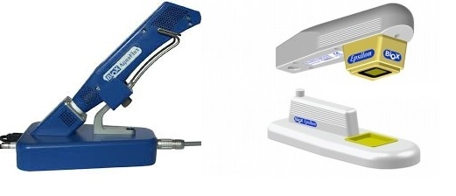

Fig. 1. Medical instruments AquaFlux (L), Epsilon (R)

The utilisation of 3D contents and related work
Since the arrival of Web 2.0, there has been a significant development in web applications. Web 2.0 supports and encompasses various activities, such as teamwork, communication, social networking, and the connection between computer and Internet users. The three-dimensional immersive virtual worlds (3DVW) are one of the essential applications of Web 2.0, which are computer-generated, virtual, online, graphics, multimedia and three- dimensional environments [7]. The main idea of creating such an object in three dimensions is to show users the reality of the object. 3D modelling is the most important element in the field of VR technology [8]. The process of creating a 3D object can be divided into three main stages:
- 3D modelling: it is the process of creating and developing a computer object in 3D.
- Layout and animation: it is the process of adding animation and creating a scene to the model.
- Rendering: it is the process of adding other effects to the scene, like lights, surface type, positioning the camera and other qualities.

Normally, 3D models are created using 3D modelling software, such as 3ds Max, or Maya, or their open source equivalents – though open source tends to be less complex with fewer advanced features. A 3D scene model is created from geometrical shape objects, such as rectangles, triangles, circles, cones, etc. e-learning contents are placed into hypermedia documents, causing difficulty in 3D integration into HTML files. Web browsers are not yet designed to deal with the (normally large) 3D data files which require a large number of computational resources. It takes time and efforts to digest such proposals. Therefore, readily available Mozilla and Google proposals can be adopted as standards. Mozilla and Google use the same technologies: OpenGL interfaced with JavaScript [9].
3D objects are widely used in the area of science, technology, engineering, health, education, cosmetics, simulation, e-learning and many more. It has been used in the disciplines mentioned above combined with a VR to stimulate the presented content as it is applied and practised in the real world. Another aspect that 3D contents and VR play a very active role in, is the Vocational Education System. It is a system that is specifically designed to support the industry and manufactures by offering vocational and technical courses delivered in VR ambience and PLE (Personal Learning Environment) which allows users, learners to control their learning and manage their own learning experience (distance learning). Kotsilieris, Dimopoulou (2013) point out:
The development of 3D Virtual Worlds plays an important role in e-learning and distance learning. Through three main features: I) creating the illusion of a 3D environment, II) support the application of avatars as virtual representations of human users, III) offer communication and interaction tools to their users. The evolution of virtual worlds is a result of a rapidly evolving field of electronic games. In brief, Virtual Worlds are designed to offer real-time communication tools, interaction capabilities and collaboration [10].
Some upcoming and emerging technologies will overcome some of the difficulties that are faced currently in the areas of science, technology, medical environments, tourism, e-learning and many more. These include computer graphics, augmented reality, computational dynamics and virtual worlds. Recently we have seen some new ideas appearing in the literature concerned with the future of education. As has been pointed out by Potkonjak, Gardner, Callaghan, Mattila, Guetl, Petrović, Jovanović (2016):
Technological examples most relevant are distance learning, e-learning, virtual laboratories, virtual reality and virtual worlds, avatars. Dynamics-based virtual systems, and the overall new concept of immersive education that integrates many of these ideas together [11].
Accordingly, the benefit of adopting VR in the medical and healthcare sectors is to teach and train medical students, trainees and clients on how to use medical devices and instruments and how to conduct some medical tasks. Web-based and online 3D objects used in medical training tools and environments showed to develop the educational process. This web-based virtual medical system of devices for cardiac diagnostic and monitoring functionalities has been created and built to assist in the process of training medical students, qualified health personnel and non-medical staff to carry out an Electrocardiogram (ECG), an Automatic External Defibrillator (AED) and a blood pressure device.
Those applications guarantee an interactive e-learning experience in the medical field. Also, considering the main objective to emulate real patients, anatomic regions, and clinical tasks and to represent real-life conditions in which this medical tool is built for. These virtual environments allow interaction between users and the system as well as manipulation with very sensitive reactions similar to that of real-life objects. This type of systems will promote learning by practising which makes the whole experience straightforward and enjoyable [12]. Using VR in such projects will help to achieve an extremely immersive experience [13].
Another related work in this regards is the ARCO project (Augmented Representation of Cultural Objects). ARCO project is specifically built for the tourism and heritage industry, its main objective is to build up an entire set of technologies to help museums to produce, change, control and deliver digitised cultural objects in virtual exhibitions reachable from within as well as from outside the museums [14].

The implementation of the interactive Virtual User Manual (VUM) of the medical instruments
The design process of AquaFlux and Epsilon medical devices was slightly complicated and faced different options for choosing the right 3D modelling software, in this project the software modelling tool used is 3D Studio Max (3ds Max). In Addition, adding interactivity between the user (client) and the instruments, the software Adobe Flash CS6 is used. Other modelling software products were used at the early stages of this project such as Google Sketchup, Blender and Unity as a final result of the research was to create, build and develop the objects and all 3D scenes in 3ds Max for its professionalism and the comprehensive set of functions and features that it had to offer.

AquaFlux and Epsilon are two medical instruments used for skin treatment, and they belong to the health and medical sector. Figure 2 shows the workflow digram that illustrates all steps of the AquaFlux and Epsilon 3D virtual enviroment system and describe the development processes of the Virtual User Manual (VUM).

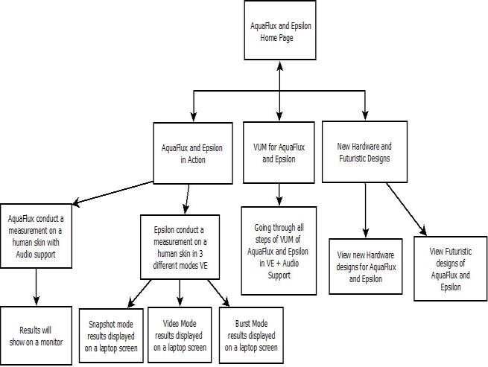
Fig. 2. Flowchart of AquaFlux and Epsilon online 3D Environment
The health sector is largely connected with the use of advanced technologies like 3 dimensional objects and virtual presentation for demonstration, education, testing and performing a number of medical operations and routines. 3DVWs (3D Virtual Worlds) have been used in a variety of applications in the medical sector and applied in health-related activities, falling under five main categories: education; treatment; simulation; evaluation; lifestyle [7].

The development and design of AquaFlux and Epsilon using 3ds Max modelling software
3ds Max modelling software can swiftly and professionally produce 3D scenes and objects [15]. As in any 3D modelling software, initially, we have to model the medical tools. AquaFlux and Epsilon contain a base part and a probe; on the base part, there are little modelling challenges, e.g. cabling input port and buttons that has to be switched left or right in AquaFlux case. The probe and the base have been measured with a real ruler to let us to build the models in a very realistic form. Additionally, considering some photos to seize the accurate proportion and size for each object, e.g. how big will the probe be in comparison to a human hand.

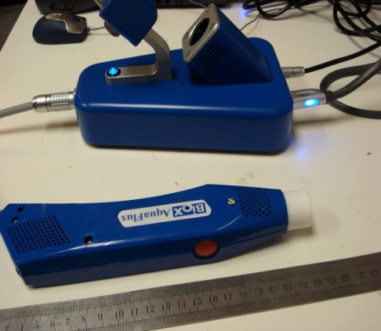
Fig. 3. AquaFlux probe measured by a ruler

Once the developer assesses the accurate size of each object, we use 3ds Max to design the medical devices, modelling tools are shown in the figures below for AquaFlux and Epsilon:
Modelling tools menu
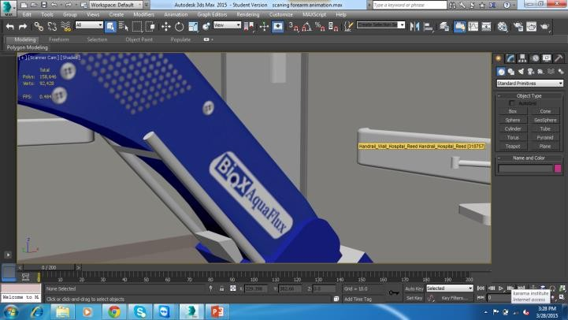
Fig. 4. Tools box menu 3ds Max software used to model objects

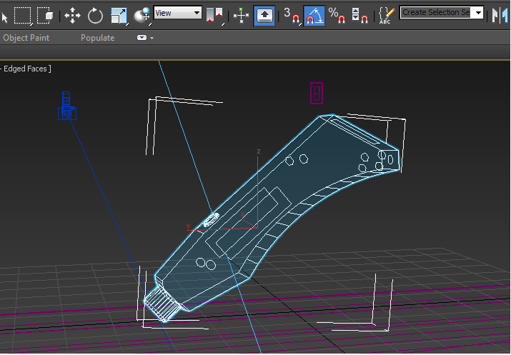
Fig. 5. AquaFlux probe modelling in 3ds Max

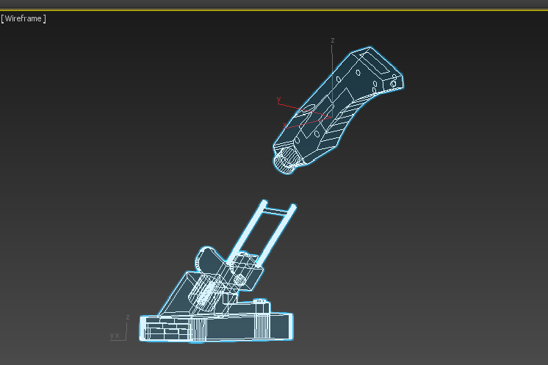
Fig. 6. Snapshot of AquaFlux probe and base design in 3ds Max

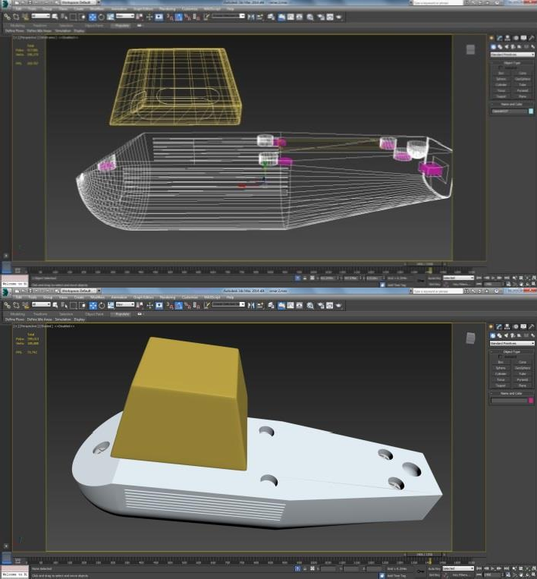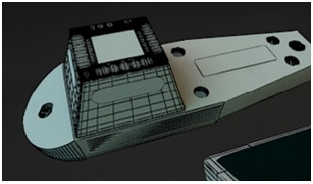
Fig. 7. Different stages of modelling Epsilon’s probe in 3ds Max
The designer can choose a diverse object types from the modelling menu e.g. a box, cone, and sphere, tube and cylinder and gives names for all parts. As the process of modelling is progressing, the developer has to construct a real reference to check how the recently created model is comparable to the real copy by placing the original object’s picture close to the newly designed one as shown below:
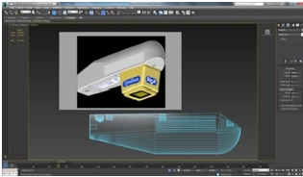
Fig. 8. Original picture of Epsilon compared to an Epsilon object.

Adding materials to AquaFlux and Epsilon
Materials and colours are considered early to befit the model reference if it is real enough to satisfy the client’s demands. The selection process of the material is closely examined to achieve a minimum rendering time and to present a very real product. Materials with high glossiness and reflection will take most of the rendering time, but without it, the object would be very unrealistic to viewers. Vray materials are used in this project, and the third-party renderer is Vray for the whole work. Vrar is one of the industry standards for producing professional images. For the Epsilon Probe and other objects, a semi-gloss with a whitish material is used. With 0.6 glossiness and a subdivision of 20. Those settings were chosen to reduce that time it usually takes during the rendering process, as rendering is a crucial part of any 3D creation projects.
In this project, High Definition Range Imaging (HDRI) is used for the background to make it slightly more practical for the lights and shadows. HDRI is absolutely valuable to emulate shadows and lightings of a real environment that will be projected on the objects in the 3D scene. Although using HDRI will add some extra time during rendering each scene, the glossiness and reflectivity of the object are turned slightly low, and that will compensate on the overall runtime process.
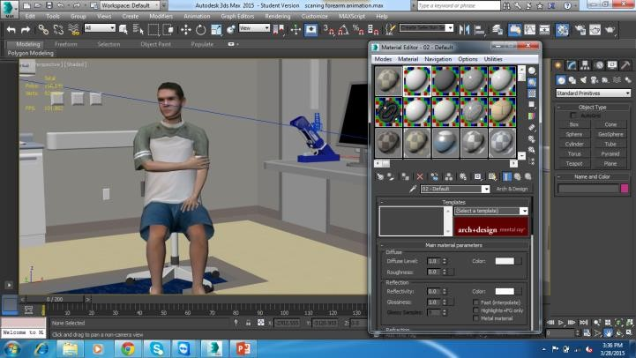
Fig. 9. Colours added to AquaFlux using the material box menu
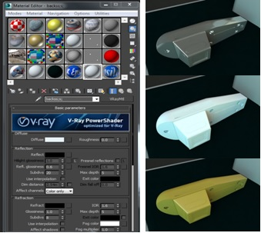
Fig. 10. Materials menu in 3sd Max (L), Materials added to Epsilon probe(R)
After the materials have been finally determined and added considering the time and quality of the project, we prepare the objects for the next process: Animation. In order for all the objects in our 3D scene to be animated correctly, then all objects in the selected scene must be grouped together via animation attach buttons in the command panel under edit geometry menu. This means all objects should be grouped, attached or sometimes called fused together. If any object for any reason has broken up and not been linked and left out of the attached objects group, the keyframes related to that object will disappear after this stage and the object will no longer be animated.

The process of animating AquaFlux and Epsilon
Animating 3D objects is an essential phase of our project’s design. Almost a third of the time of our work was spent on the animation process of our objects that were modelled and built earlier. Planning is essential at this stage for each planned scenario. Planning should be prepared and anticipated for each object in our scene: how the object will interact with other objects, the proposed movement and the direction of that motion that the individual object will experience in the virtual world. It is a somewhat time-consuming stage. Unlike character’s animation, this type of animation is slightly easier as it does not need bones and other complex rigging tools. Animating objects in this work has been accomplished in two ways: attaching an object into a group of objects and using the collapse utility to cave in multiple selected objects into a single object. The essential points for all motions should be considered before starting the animation phase. During the animation period, the Timeline is set to 1000 frames and 15 frames per second because this project is specifically designed for online environment only. The number of frames per second is decreased to suit the file size of the images that will be rendered for online purposes. Applying curve editor menu options for animating all objects and scenes. When modifying curve points, all animated models can be controlled via (speed, timing, and movements options).
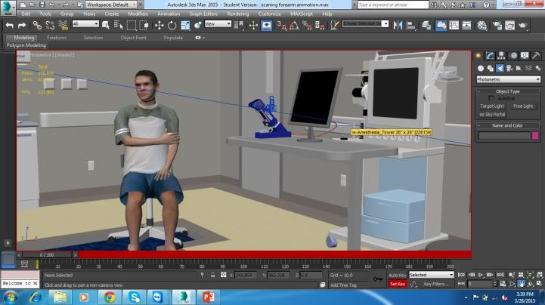
Fig. 11. Adding keyframes (redline) in 3ds Max
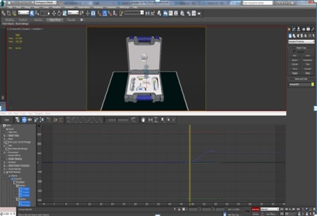
Fig. 12. Using the Curve editor in 3ds Max

The process of rendering AquaFlux and Epsilon
After the animation is completed and setting keyframes from a specific position into where we want our object to stop at a certian point. Currently all objects are now prepared for the last phase of the modelling process which is rendering. In rendering the developer can sit back and monitor all frames being rendered. Nevertheless, at this point in our work, it is extremely vital to monitor the speed and time that each object takes to complete rendering. Every frame is closely checked whether it is in the right place (number) and whether the objects have the exact shadows and lighting. Occasionally objects can be seen floating that are unnoticed during the animation process. In rendering, a small window will appear showing how rendering every square pixel of the object, calculating the objects materials, colours, shadows, light reflections, etc. In the rendering options menu, it is possible to select the format of the rendered images and their file locations that will be exported into Adobe Flash CS6 later on for adding interactivity via linking all rendered images, scenes and objects.
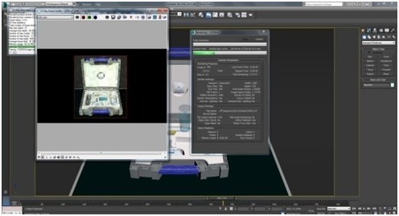
Fig. 13. Rendering window after all keyframes and files setup completed

Creating links and adding interactivity to AquaFlux and Epsilon
All rendered image sequences of the medical devices AquaFlux and Epsilon have to be exported from 3ds Max software into Adobe Flash CS6 in order to add interactivity to the project via creating interactive buttons. Steps as follow:
- Open flash file with the dimensions of 1920x1080HD in scene 1, each group of motions can be joined into a scene then enabled to interact to achieve their tasks.
- All image sequences animated earlier should be imported into the file library.
- Create a new symbol and start to drag images into that symbol frame by frame.
- Imported image sequences to Flash from 3ds Max are placed on the frames in Flash, each one on a specific frame point to form points of frame bar that is similar to the old cartoon flip book.
- To create a functioning button that will play or stop an event, we can use ActionScript that contains the word stop(); then attach it to the desired button.
- Several ActionScript built-in functions are already included in Adobe Flash under global functions submenu, e.g. movie clip control functions, timeline control, browse and printing control.
- Under timeline control, we can find common functions like (play, stop and goto). Some of those are used in this work.
- Any created button that has a script attached to it needed to be applied with its script and behavior in a another position, we only need to create a new layer in a new scene ten copy and paste that button into the new layer. New layer will have the precise function and feature as the original button. Besides adding interactivity functions and buttons to the devices, audio clips mp3 formats have been added to the interactive scenes. Audio files will play along the descriptive text once been clicked on by the user.
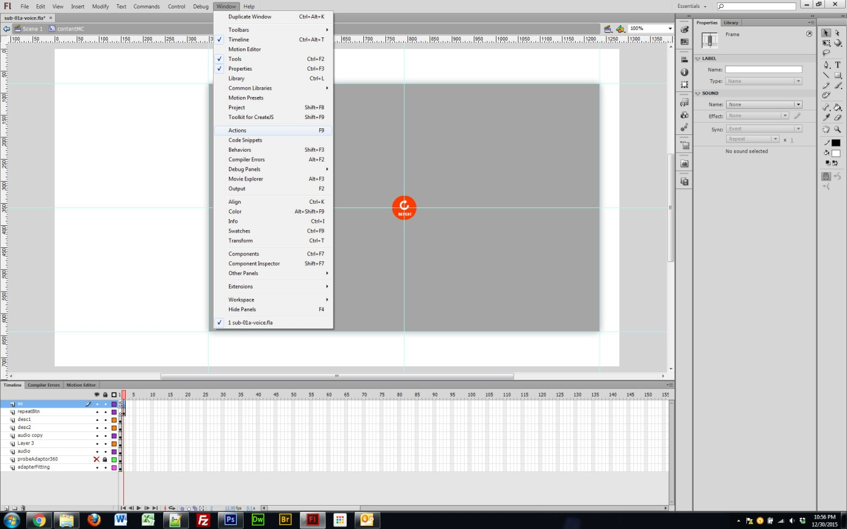
Fig. 14. Adding ActionScript into a scene in Flash CS6
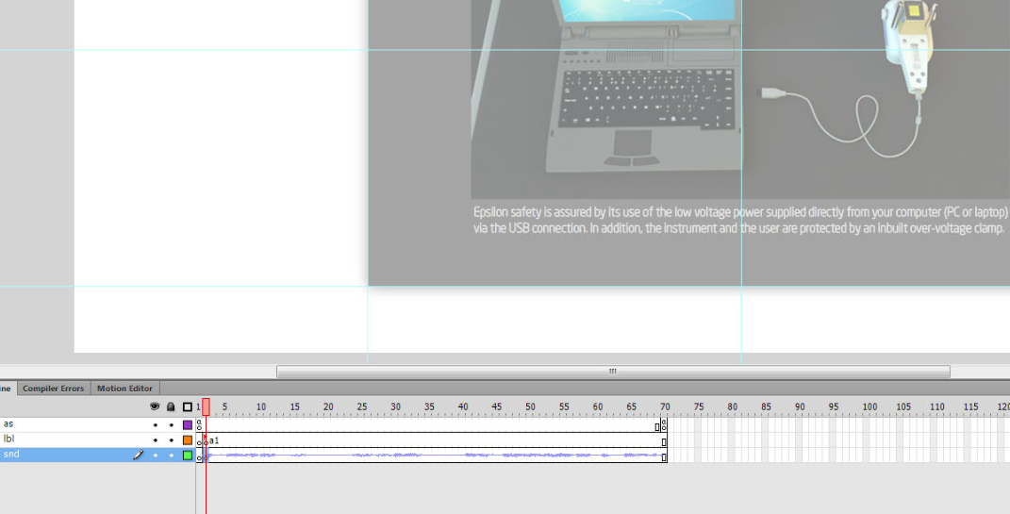
Fig. 15. Syncing a voice clip with the text frame in Epsilon scene

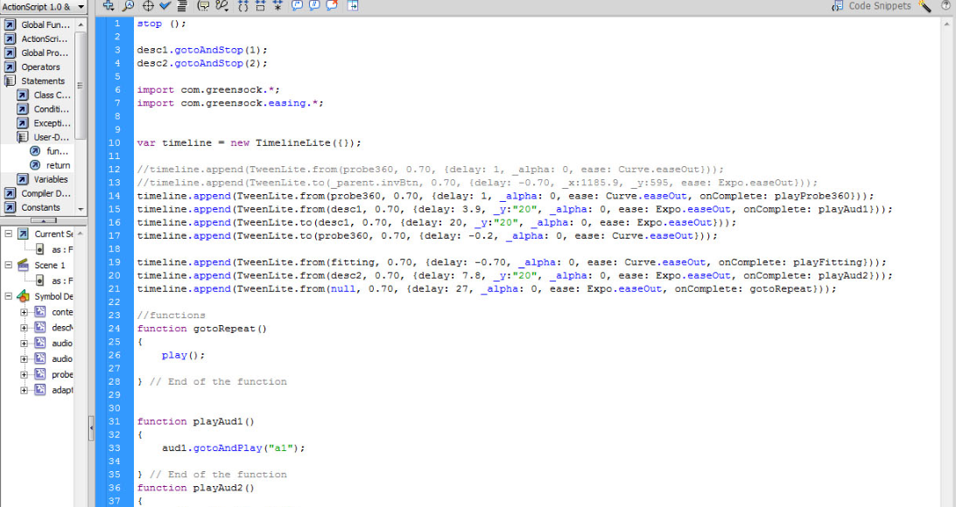
Fig. 16. ActionScript code for linking the button to play, replay and stop the audio clip
The above steps as being illustrated by the previous figures can all be repeated to the 3D scenes and objects that required be connecting and interacting with the user in a VR atmosphere by using buttons in Flash CS6.

AquaFlux VUM is a fully interactive website that demonstrates all functions, features and a sample skin measurement process conducted on a patient. Following figures present few steps of how to use the VUM.
The AquaFlux VUM is an interactive system. Users can click on the device’s probe to instruct it to move towards a patient’s forearm to conduct a sample skin measurement. Each step of this VUM is assisted with audio instructions recorded earlier to help exemplifying the operational process for this medical device.
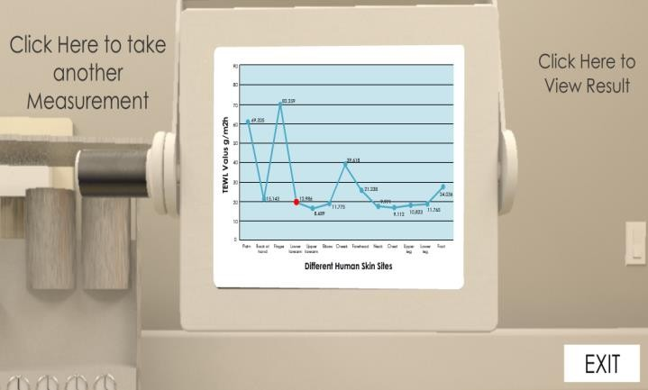
Fig. 17 Result of the process of skin measuring will be shown on a screen
Epsilon VUM follows similar approach to conduct a human skin measurement procedure for medical purposes. As previously described in a number of AquaFlux’s figures. Figure 18 shows Epsilon instrument in action.
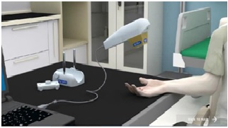
Fig. 18. Skin measurement process taking place on a patient using Epsilon
Once carrying out the measuring process, the scene’s camera will move towards the laptop’s screen to display the scan results as shown in Figure 19.
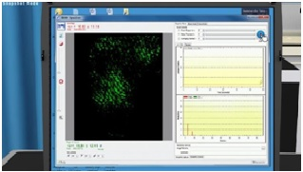
Fig. 19. The result of Epsilon scanning process is displayed after clicking on the blue button, top right corner.
In Epsilon VUM, users are able to perform human skin scanning in three different modes, snapshot, burst and video mode. All results of scans (images and videos) are stored in a folder on the machine hard drive. Scan buttons and tabs are interactive and clickable by users.

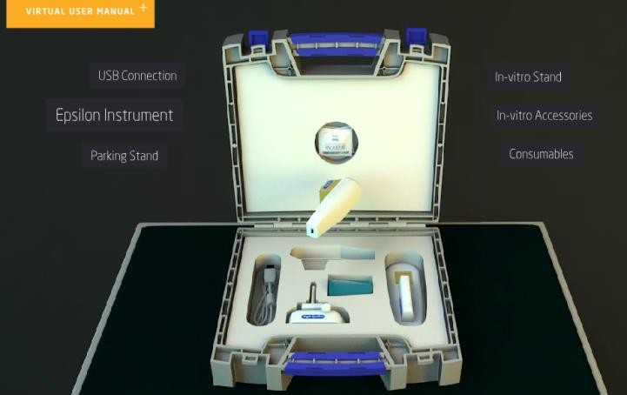
Fig. 20. Epsilon protective case and all its components shown in a 3 dimensional interactive atmosphere

Designing and introducing new accessory, hardware and holders of AquaFlux and Epsilon
During the final stages of this project, a fresh design plan came to light, and it contributes poistivaley to the entire skin measurnment process. Moreover, it will make a great addition to the practicality of the two devices. The notion was to develop and build a new accessory (holder) for both tools. It is going to add a massive benefit to the measuring process and more effective, efficient by allowing the measuring of several patients simultaneously. The holders created have been approved by the BIOX lab at London South Bank University. The newly designed holder for Epsilon was thoroughly considered and particularly designed to suit the Epsilon structure and patient’s relive. The material added to the newly developed holder was a cloth appearing material to emulate the real world object.
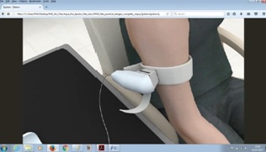
Fig. 21. Epsilon newly designed holder strap in action
In relation to Aquaflux, it was a bit craftier to create the new holder because of the shape probe. After a thorough analysis to the structure of the device, AquaFlux new accessory was completed. The new holder already considered both patient’s relive and client’s ease. AquaFlux probe is made of metal and fairly heavier in comparison to Epsilon. Thus, the black frame around the border of the holder is recommended to be manufactured of the magnet material providing AquaFlux with further stability, firm insertion and accurate reading.
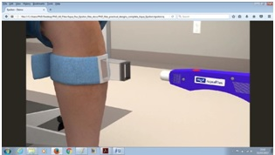
Fig. 22. AquaFlux newly designed holder strap with magnet head
Conclusively the novel ideas of designing and building new hardwares for these medical tools has utilised the functionality of both instrunments. Furthermore, to provide a broad number of people concurently with the service futurestic concepts and designs have evolved. The futuristic designs of AquaFlux allows it to rotate in all directions giving it extra flexibility and ease of use for all parties involved in the process as shown in Figure 23 below:

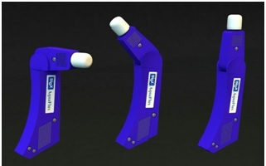
Fig. 23. Rotatable AquaFlux for further flexible positions

The AquaFlux arm-band is entirely fresh idea, extremely lightweight and it allows further ease of use. It is padded and soft that can be wrapped around different parts of the human’s body. It has a Blutooth capability to connect to a PC or laptop wirelessely and save the hassle of having cables that can be distracting.

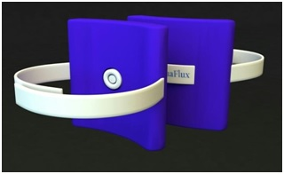
Fig. 24. AquaFlux wireless stripe, newly designed hardware
Epsilon turning head assists to carry out skin measurements in vertical/ horizontal positions. Newly added screen to the original probe for the purposes of accessibility, simplicity and comfort. Additionally, Functional buttons have been added to the top surface of the handle to provide on probe operations such as On/Off, Scan, Reset. Epsilon device can be totally portable.

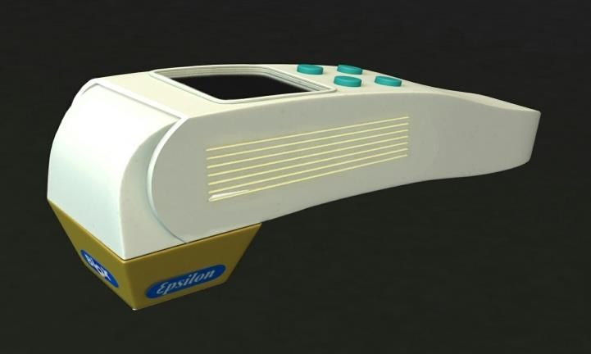
Fig. 25. Epsilon turning head, on probe monitor and operational buttons

Virtual Reality creation
Virtual Reality is a second world (simulated environment) accessed by various users, and it resembles our world in most of its characteristics depending on what is required from that virtual world to present. Users in virtual worlds can be presented by avatars or walkthrough scenes to conduct a variety of activities.
There are currently two methods to create a VR environment:
- Using a 360-degree video: this method is easier than the second one, as you can record real-life video footages and use those footages in building the content. This method needs another tool at the later stages to view the 3D content, HMD (Head Mounted Display) unit. With this HMD unit, users can experience the new world of computer simulated reality that imitates physical existence in the actual world.

- Using 3D animation: this method is when all selected objects will be created and developed in 3D modelling tool e.g. 3ds Max, Blender, Maya and many more. It is more expensive as it requires more tools and software to be involved in the construction process as well as requiring the expertise to develop, create, animate, render and subsequently publish the product online. Another way of creating VR is by using game engine software such as Unity. This method is mainly used for creating and developing games.
From the two methods mentioned above, it is clear that the second method does require a huge amount of effort and experience. All aspects of the second method need to be carefully and professionally designed and planned. No real images or footages that can help the creator to replace any physical existence in the virtual world; all have to be created, built and designed from scratch. In addition, it is the method that has been adopted in this work.

Results
7.1 AquaFlux interactive user manual
AquaFlux VUM online system is completely interactive website that displays a sample skin measurements conducted on a human and illustrates all functions and features of the medical tool. The following Figures 26, 27, 28, 29, 30, 31, 32 and 33 present few steps on how to use the VUM.

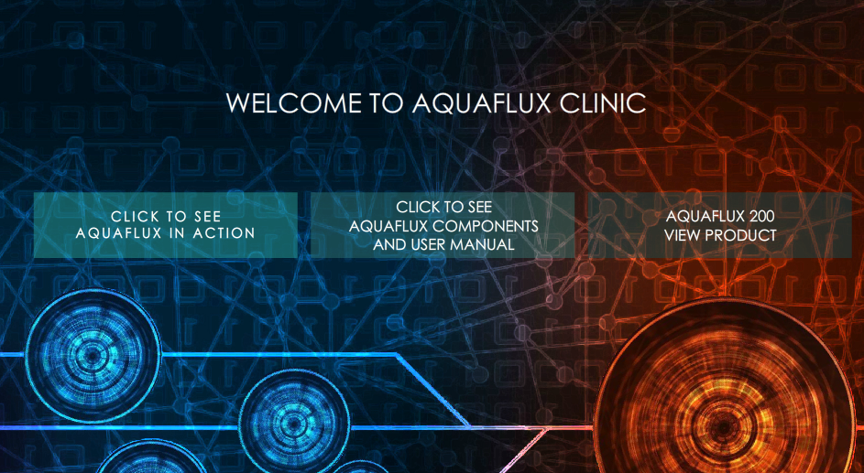
Fig. 26. AquaFlux interactive user manual website contains three links
By clicking on the button labeled Aquaflux in Action, will present a sample of skin measuring process conducted on a client at a clinic.

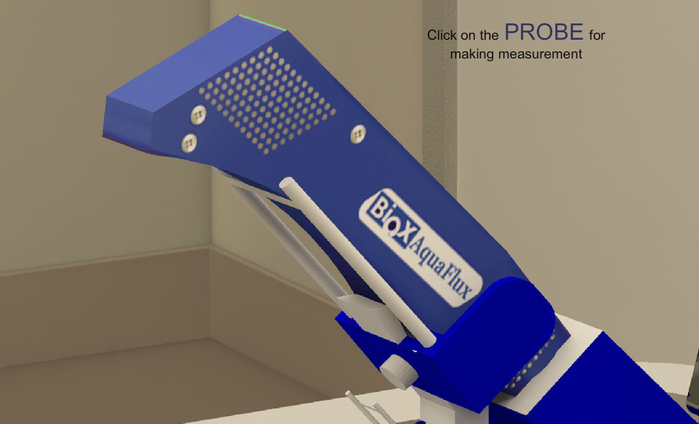
Fig. 27. AquaFlux in its base, waiting for a user to click the link above it

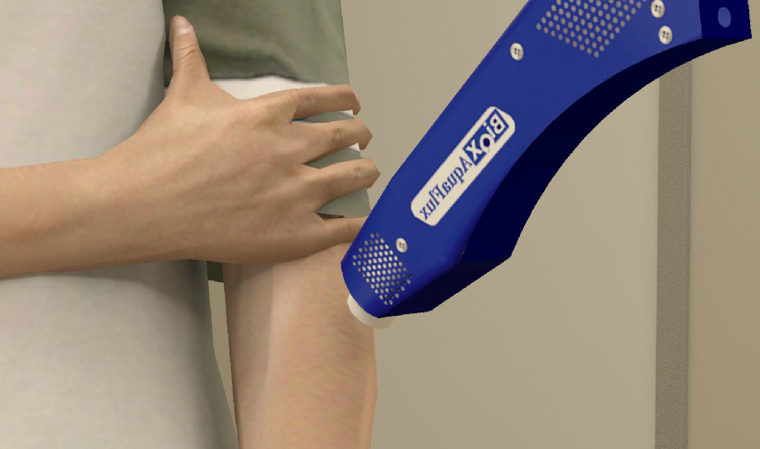
Fig. 28. AquaFlux in action, moving to a patient’s forearm for a measurement
After clicking on the link in Figure 28, the AquaFlux probe will move towards a patient’s forearm to conduct a sample skin measurement, by placing its head that has a cap into the patient’s skin.
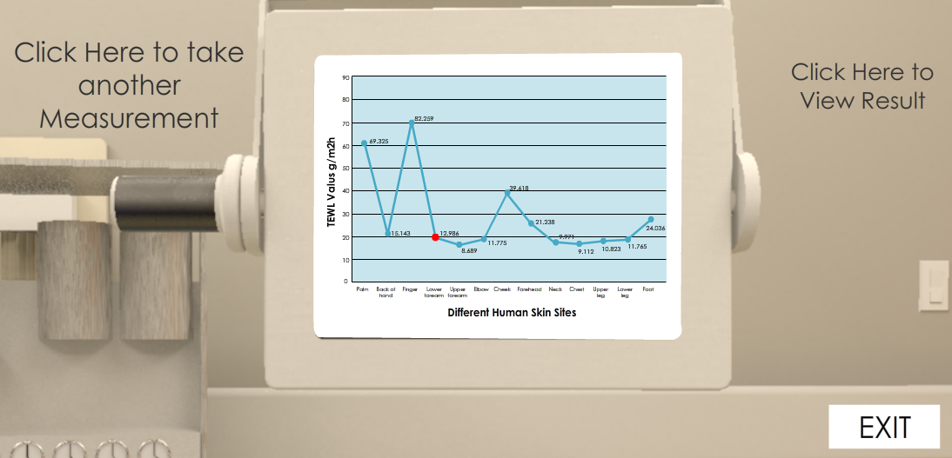
Fig. 29. AquaFlux monitor shows measurement results and other user’s options
Once clicked on view results link (top right corner), the reading will show on the screen with an accurate reading of human’s forearm. A user, a trainee or a client also has another option to take another measurement (top left) or to exit to the main page via the exit button (bottom right).
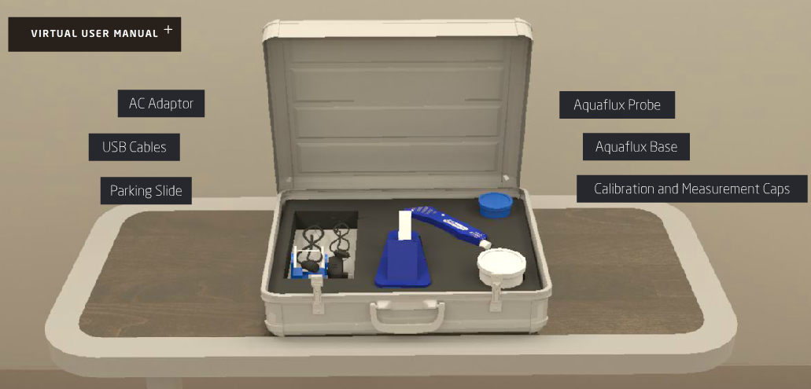
Fig. 30. The 2nd option link to view the VUM
From the main page, clicking the second option takes the user into the AquaFlux VUM page. In here, users can click on the VUM (top right) link to view AquaFlux setting up the process, calibration, caps, AC adaptors, connectors, probe parking, holding the probe, software familiarisation. Also, the process of how a user can fit and slide the probe into the parking base and an explanation of the AquaFlux rear panel unit.

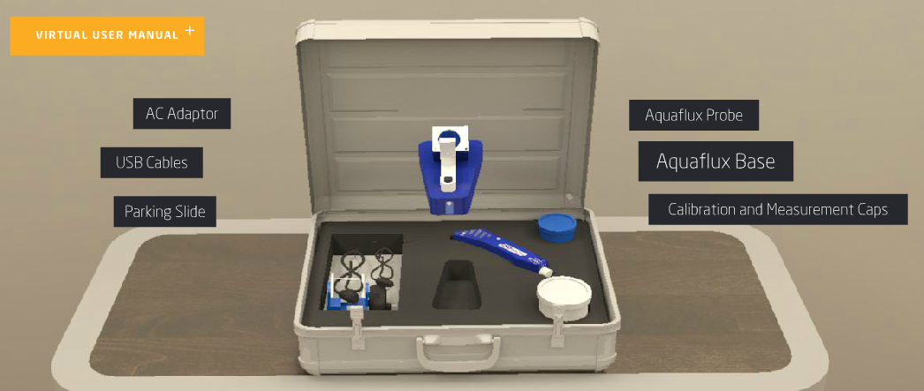
Fig. 31. AquaFlux 3D components illustrated in the protective case
As shown previously in Figure 31, once the mouse is placed over one of the other six links, it will popup the part and rotate it in 3D mode, this gives a chance to the user to know all the right names for the AquaFlux device components.
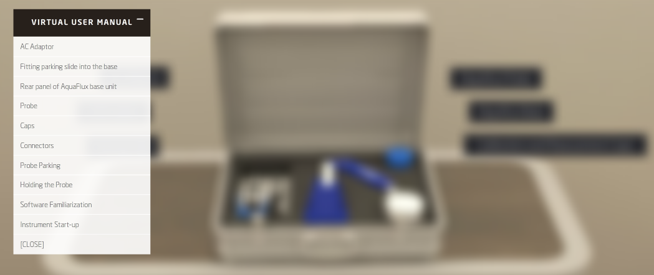
Fig. 32. Clicking on the VUM menu, the background becomes blurry

In Figure 38, users can click on VUM’s options’ menu to display all list items of AquaFlux components. The menu is designed to illustrate all parts of the medical device as well as demonstrating the role of each part in the measuring process displayed in 3D environment.
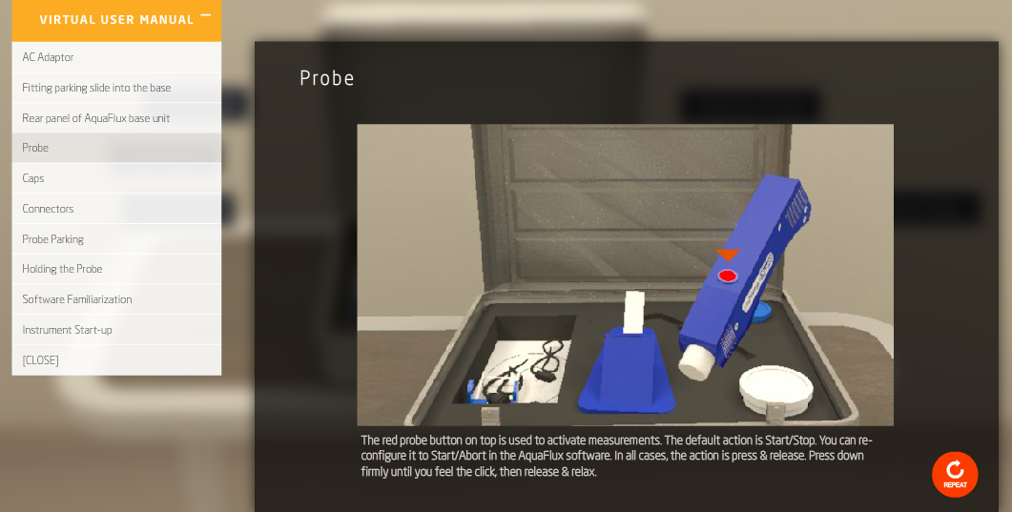
Fig. 33. Clicking on one of the options in the VUM menu (probe).

In Figure 33, the user clicked on probe item in the VUM’s drop options box, a popup window appearing to the right of the screen containing information about the AquaFlux’s probe with brief descriptions at the bottom of the page. Users can start again the step by clicking on the repeat button (bottom right corner). To go back, users need to click on the [CLOSE] link first then clicking on the link back to the home page.
7.2 Epsilon interactive user manual
Epsilon VUM online system is completely interactive website that displays a sample skin measurement conducted on a human and illustrates all functions and features of the device.

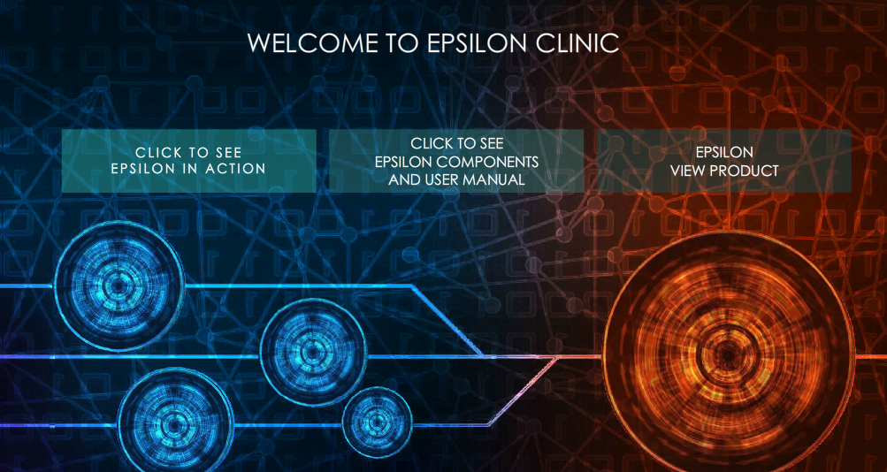
Fig. 34. Main page of Epsilon VUM contains three main links

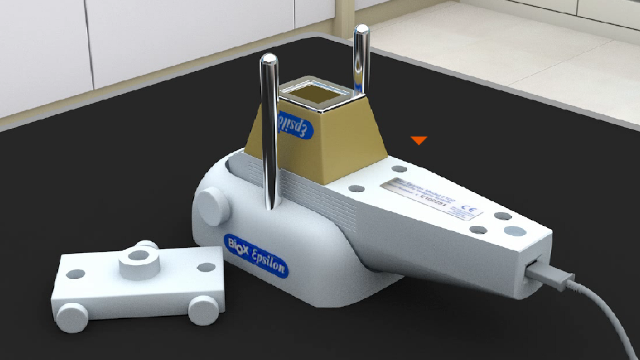
Fig. 35. Clicking on the 1st link to see Epsilon in action

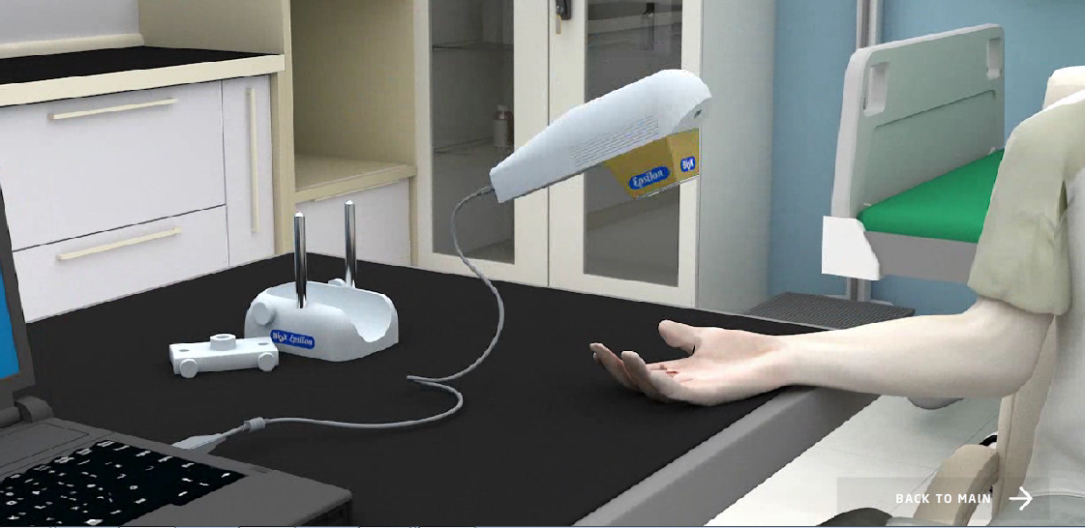
Fig. 36. Epsilon probe moving towards the patient’s hand for a measurement
After clicking on the Epsilon probe, see Figure 35, the probe will move towards the patient’s hand and placed in it. Then the scene will switch into the laptop. Then the camera moves towards the screen to see the result of skin measurement taken. All the above steps are conducted with the assistance of audio feature.

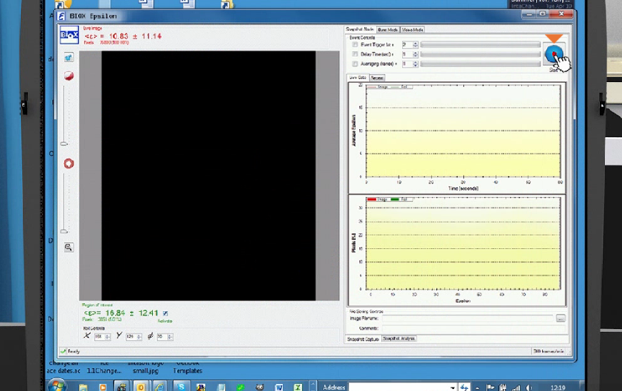
Fig. 37. Clicking on the button (top right) to start scanning human skin

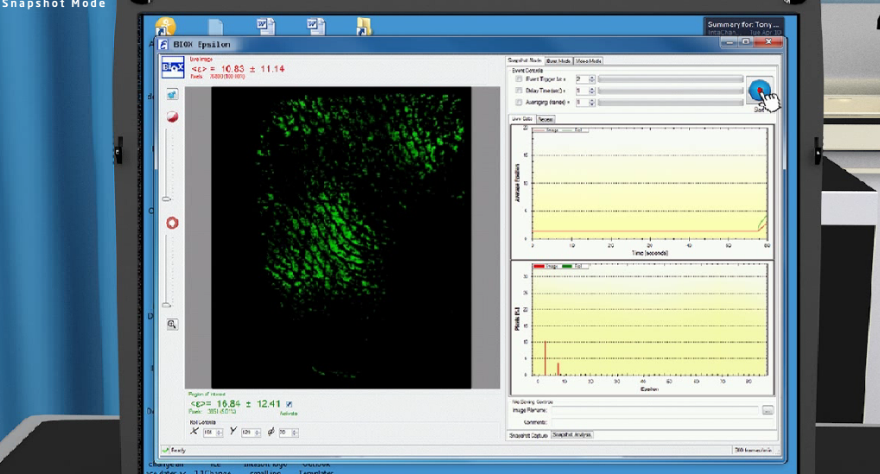
Fig. 38. Scanning in a snapshot mode
After clicking on the scan button, scanning will begin in a snapshot mode, in Epsilon users can scan in three different modes (snapshot mode, burst mode and video mode).

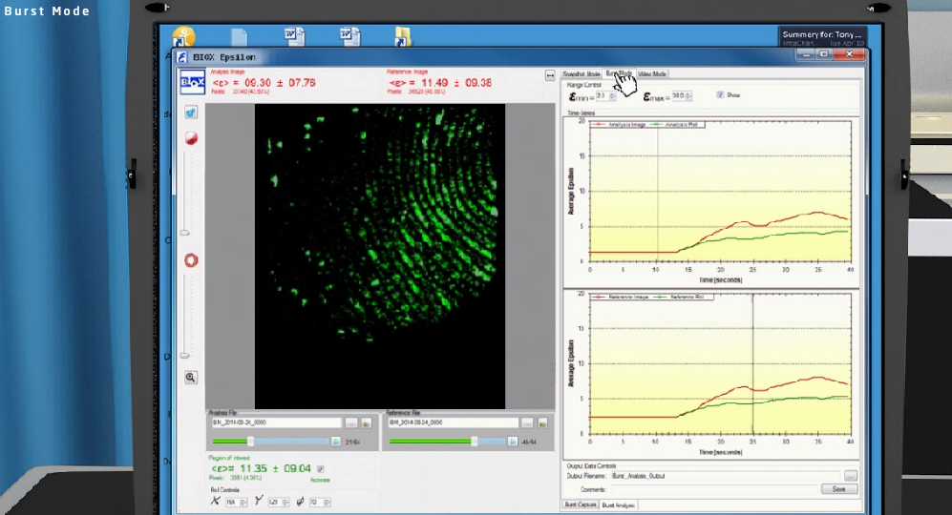
Fig. 39. Scanning in a burst mode (clicking the tab at the top to switch mode)

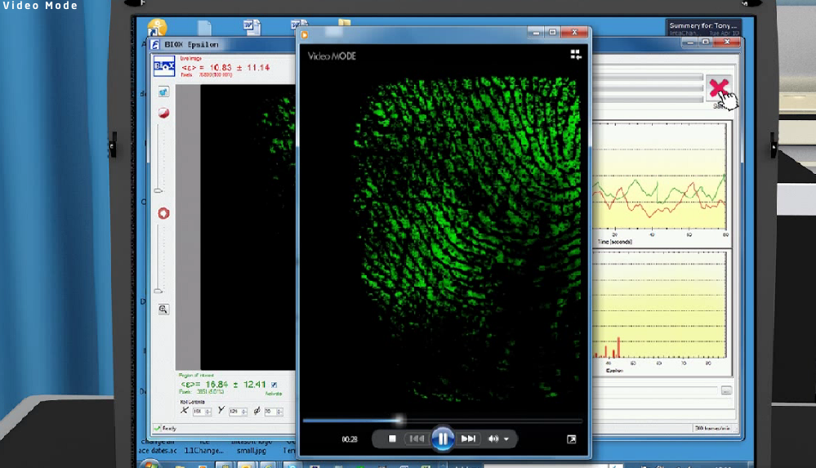
Fig. 40. Scanning in a video mode
All files, images and videos of the three different scanning modes saved in their respective folders, snapshot, burst and video folders, users can go to their folders and view, replay or send the captured files. This VUM is assisted with an audio feature to clarify any unclear steps throughout the demonstration process.

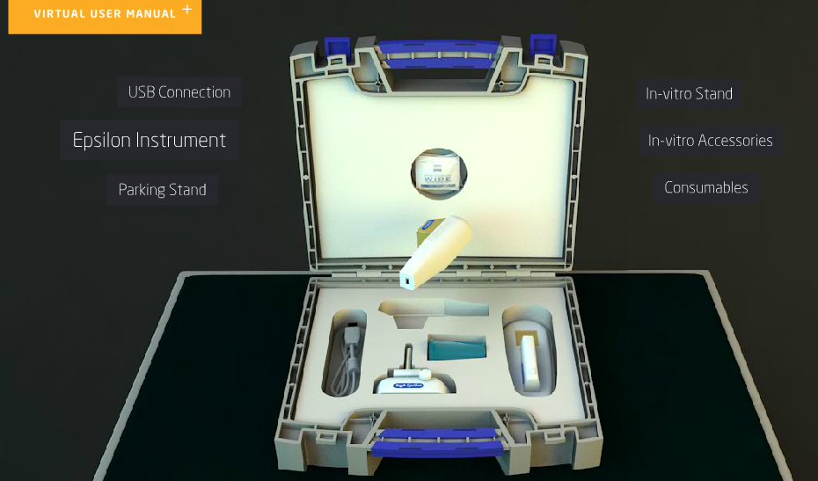
Fig. 41. Epsilon 3D components in a sturdy case

As previously explained in the AquaFlux VUM, the second link in Epsilon’s main page as shown in Figure 34, will take the user to the Epsilon’s VUM menu. Every part or component located in the protective case will pop up once the user places the mouse on it and start rotating in 3D 360 degree with a brief thumbnail defining that part. The use of mixed technologies of 3D designs and VR results in achieving an incredibly engulfing feeling, which is as being at the real location of the demonstration process [13].
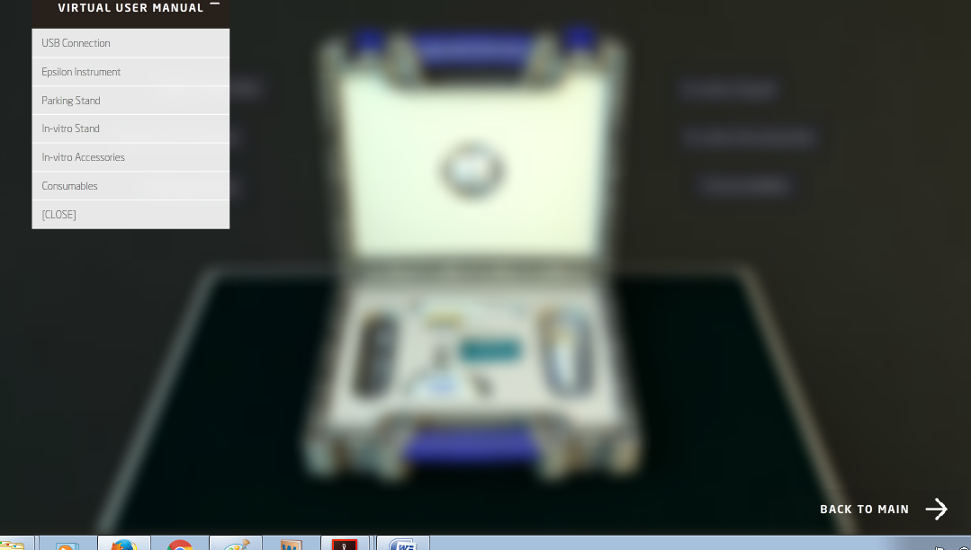
Fig. 42. Epsilon VUM drop down menu
In a similar manner to the AquaFlux pervious VUM, Epsilon’s VUM contains interactive links to demonstrate USB connection, Epsilon instrument, parking stand, in-vitro stand, in-vitro accessories and consumables.

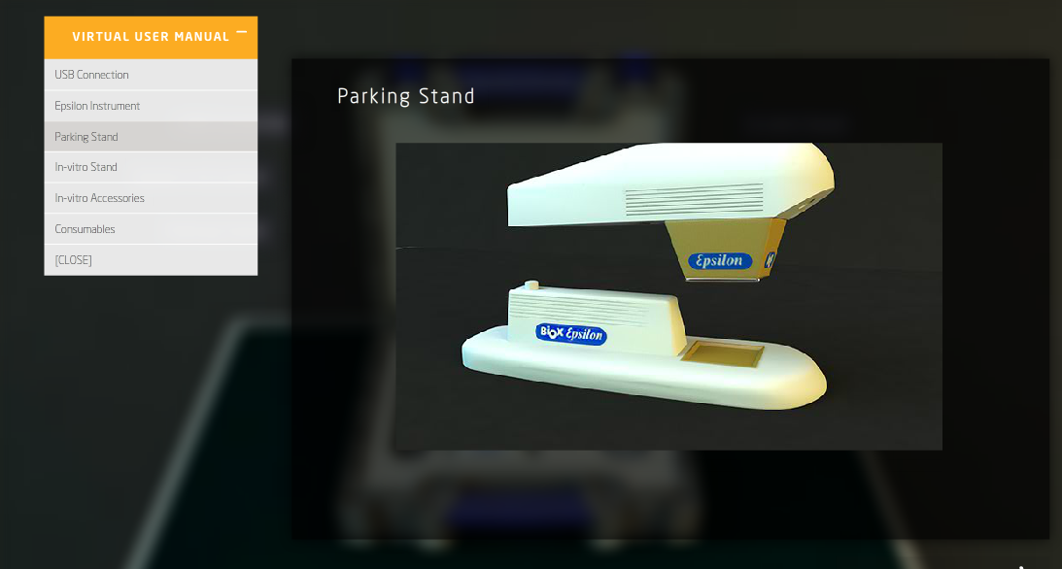
Fig. 43. Epsilon probe sliding into the stand in the VUM menu options
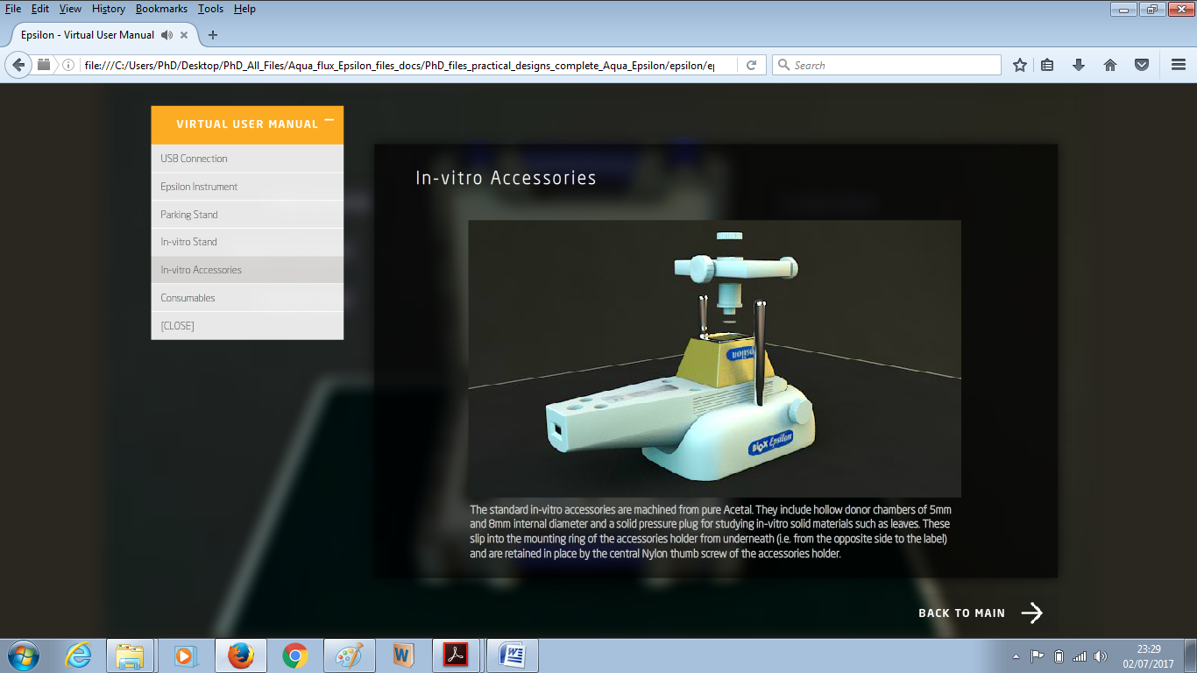
Fig. 44. Epsilon in-vitro stand and accessories demonstrated with the aid of audio feature and 3D ambience in the VUM menu options
Figure 44 shows the VUM of Epsilon in operation from the World Wide Web, with the help of audio and illustrative text displayed in a virtual environment and user interaction, the demonstration process will be very smooth, efficient and comprehensive for all users.
7.3 Epsilon and AquaFlux new holders
The third and final button on the AquaFlux and Epsilon main pages will take the user into the new addition that evolved during the process of working on this project, which is adding a new set of holders to each instrument (AquaFlux and Epsilon) that will certainly enhance the measurement process and will provide a more efficient and accurate reading.

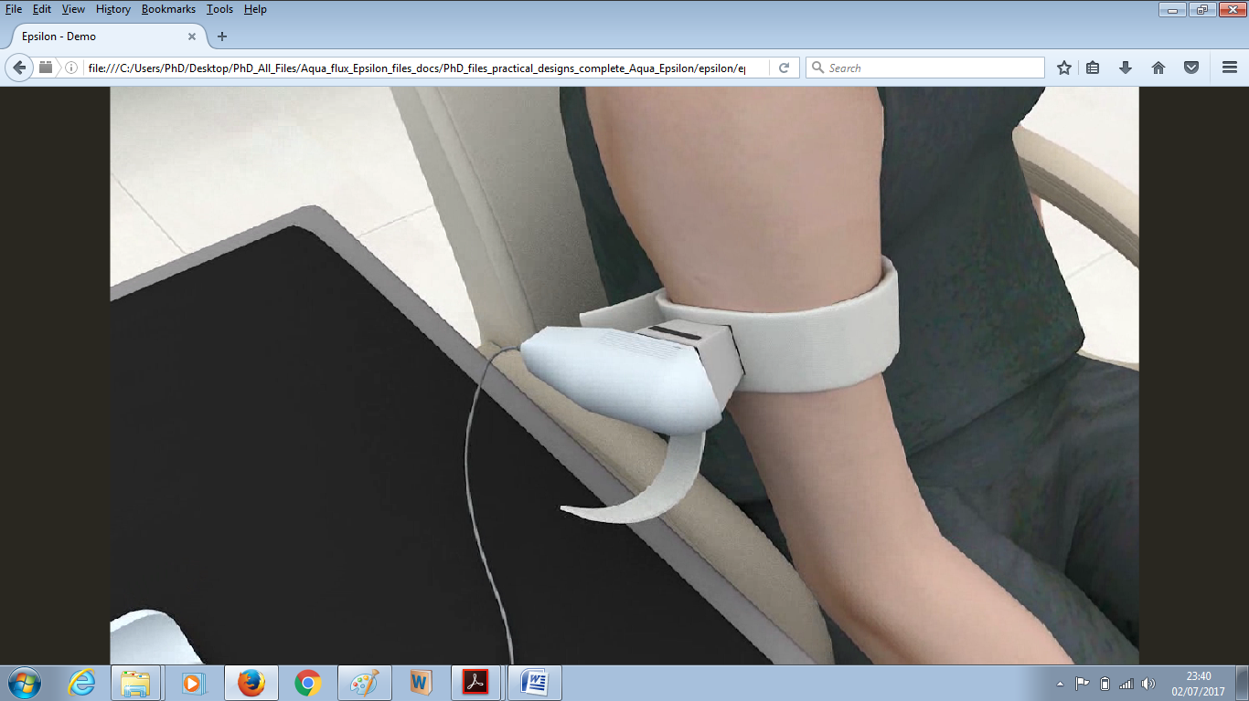
Fig. 45. Epsilon’s holder in operation

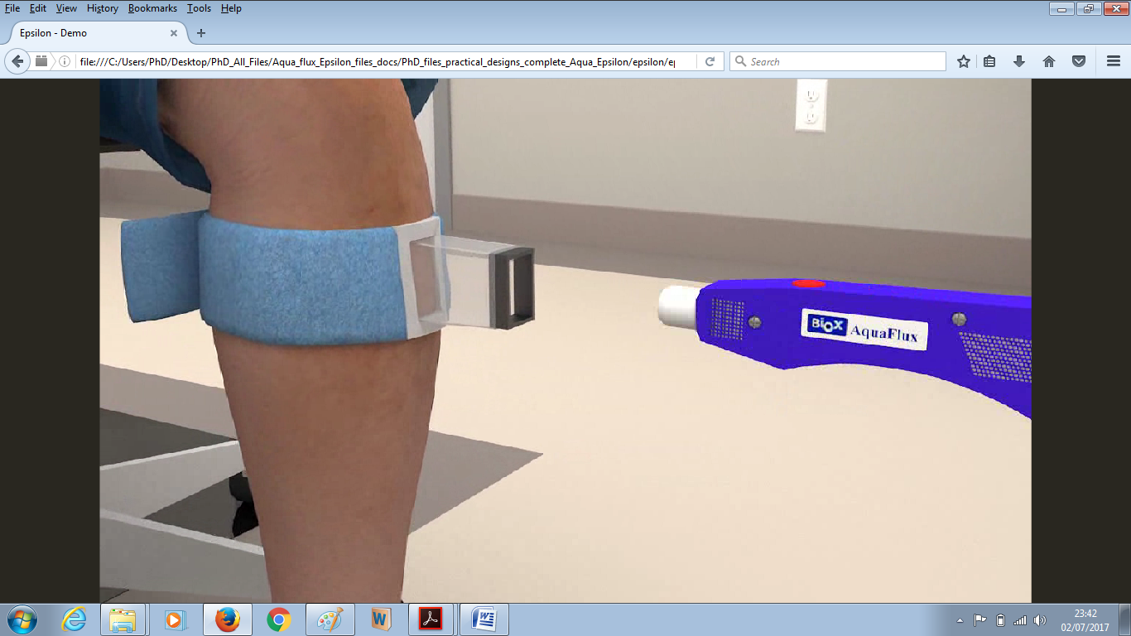
Fig. 46. AquaFlux’s holder in operation

Evaluating AquaFlux and Epsilon VUM
The VUM of AquaFlux and Epsilon was intended to serve clients, users, and trainees who are interested in purchasing AquaFlux and Epsilon medical instruments and wanted to have a clear and very detailed illustrative idea on how these two devices function, and what their features are. From a methodological and marketing point of view, it was vital to conduct a usability study that will show the products’ advantages, disadvantages, and point out any areas of excellence and parts that require further improvements.
The usability study was conducted by a variety of users, mainly people from a non-IT background. A questionnaire was designed to tackle the most obvious and fundamental questions that could arise while using such a system, moving on to more technical questions. The following table shows the user’s feedback on the survey questions that involved 12 independent participants:
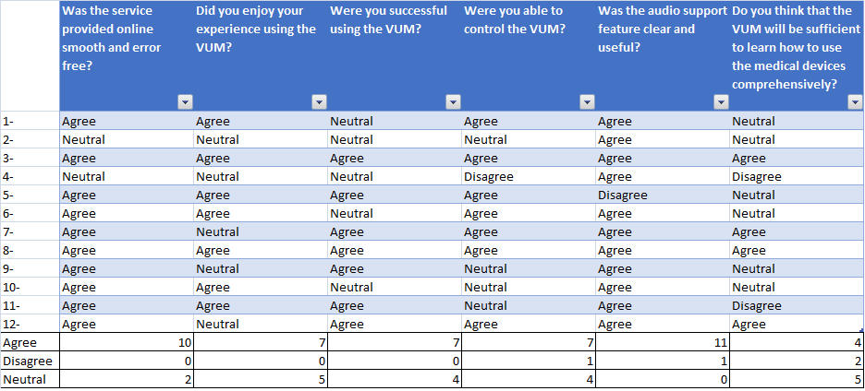
Fig. 47. Survey’s questions with user’s feedback. 12 users participated
The following illustrative charts show the results of the individual survey questions.

Fig. 48. Shows the success rate of the VUM system being smooth and error-free

The above chart shows that 83% of the participants found that the service provided online was smooth and error-free, whereas 17% were neutral. The result indicates the strength of the virtual system.

Fig. 49. Shows that the user experience of using VUM was enjoyable

Figure 49 Shows that 58% of the participants enjoyed their VUM experience, 42% were neutral, and 0% disagreed. The result suggests that the system provides an enjoyable experience.

Fig. 50. Shows the success rate of using the VUM

The above chart shows 64% of the participants were successful in using the VUM while 36% were impartial and non-disagreed. The chart illustrates that the VUM system is a success.

Fig. 51. Shows a high rate of users controlling the VUM

The chart demonstrates that 59% of the participants were able to control the VUM system, whereas 33% were neutral and 8% disagreed. This shows that although a high percentage was able to control it, a minority found it difficult. The result suggests more improvement is required to achieve a higher control success rate.

Fig. 52. Shows the success rate of applying the audio feature into VUM

Figure 52 shows that 92% of the participants found that using the support of the audio feature is clear and useful, whereas only 8% disagreed. This is strong evidence to support the excellence of audio feature.

Fig. 53. Shows some users agreed that VUM system is comprehensive

Figure 53 shows that 36% of the participants thought that the VUM system is sufficient and comprehensive, whereas 46% were neutral and 18% disagreed. Although there was a high percentage of neutral responses, a higher percentage agreed rather than disagreed. However, this suggests that there is room for further improvement perhaps by introducing further feature at a later stage.
From the previously illustrated charts and results in relation to all survey’s questions, there are two main issues to discuss:
- Aspects of excellence: presented by
- The service is smooth and free of errors.
- Users successfully used the VUM system.
- The audio feature provided was clear and useful.

- Aspects of improvements: presented by
- The VUM is a sufficient tool to teach users how to use the medical devices comprehensively.

The VUM or the interactive virtual environment of both AquaFlux and Epsilon showed great ease of use, efficiency and practicality. With this virtual environment demonstration at hand and its availability online, clients, trainees, and users who are interested in purchasing one of those skin measurement instruments or wanting to see how they operate by obtaining accurate results. In addition, the VUM demonstration process will help immensely in conveying an accurate thought and a precise sense and enjoyable experience of these two devices and how they operate and what are their main functions. Future ideas, improvements, and upgrades are well on the horizon, Augmented Reality (AR), for example, is incredibly interesting notion can challenge this research and enhance it further. Virtual reality and augmented reality are opening new ways of interactivity between users and the constructed environments [16]. Moreover, Holograms Technology (3D Hologram) provides a remarkable interactivity surface in team works ambiance [17].
The results of the survey strongly suggest that the system is operating effectively although there is room for slight improvements.

Conclusions
The objective of the research paper was to introduce a total understanding of an online 3D contents and utilising it in a very effective way and not limited to displaying it on a webpage. The main contribution to the field is using an interactive virtual environment to demonstrate the process of using a medical device in conducting a human skin measurement for medical purposes with the aid of audio feature. The new web-based 3D interactive VUM for AquaFlux and Epsilon will replace the old method of illustrating how these medical devices work and what are all their features and functionalities via providing each client with an accessible URL after purchasing the instruments. The web-based virtual system is self-explanatory and easy to use as well as the availability of audio support that guides users step by step throughout the process. Novel holders and futuristic concepts have been introduced to display the capabilities of the new addition and to utilize the marketing process using 3D contents with interactive virtual world to deliver novel notions realistically to the rest of the world particularly in the current time of social media and Internet are used on a high level.

Conflict of Interest
The authors declare no conflict of interest.

Acknowledgement
This research work is part of a postgraduate degree. I would like to take this opportunity to thank London South Bank University for their continuous support and giving me all access needed to use, test, and, experiment these two medical instruments. The authors would like to appreciate the invaluable constructive comments and recommendations received by the reviewers.

References
  - Al Hashimi, O. and Xiao, P. (2018). Developing a web-based interactive 3D virtual environment for novel skin measurement instruments. 2018 Advances in Science and Engineering Technology International Conferences (ASET), Abu Dhabi, 2018, pp. 1-8. doi: 10.1109/ICASET.2018.8376823
  - Cellary, W. and Walczak, K. (2012). Interactive 3D Multimedia Content. London: Springer London
  - VMware Inc, V. (2006). Virtualization Overview White Paper. Palo Alto CA: VMware.
  - Anon, Instrument Development and Digital Signal Processing in Skin Measurements Zhang Xu School of Engineering London South Bank University Supervisors, Oct 2015.
  - Xiao, P. (2014). Biox Epsilon Model E100: Contact Imaging System. Available at: www.biox.biz/home/brochures.php
  - Biox. (2013). Epsilon E100Manual. London: Biox.
  - Ghanbarzadeh, R., Ghapanchi, A.H. & Blumenstein, M., 2014. Application areas of multi-user virtual environments in the healthcare context. Studies in Health Technology and Informatics, 204, pp.38–46.
  - Shen, W. & Zeng, W., 2011. Research of VR Modeling Technology Based on VRML and 3DSMAX. , pp.487–490.
  - Neto, C., 2009. Developing Interaction 3D Models for E-Learning Applications.
  - Kotsilieris, T. & Dimopoulou, N., 2013. “ The Evolution of e-Learning in the Context of 3D Virtual Worlds ” Department of Health & Welfare Units Administration, Technological Educational. , 11(2), pp.147–167.
  - Potkonjak, V., Gardner, M., Callaghan, V., Mattila, P., Guetl, C., Petrović, V. and Jovanović, K. (2016). Virtual laboratories for education in science, technology, and engineering: A review. Computers & Education, 95, pp.309-327.
  - Violante, M.G. (2015). Politecnico di Torino Porto Institutional Repository Design and implementation of 3D Web-based interactive.
  - Naber, J., Krupitzer, C. and Becker, C. (2017). Transferring an Interactive Display Service to the Virtual Reality. Mannheim: IEEE, pp.1-4.
  - Walczak, K., White, M. & Cellary, W., 2004. Building Virtual and Augmented Reality Museum Exhibitions *. , 1(212), pp.135–145.
  - Yang, X. et al., 2008. Virtual Reality-Based Robotics Learning System. , (September), pp.859–864.
  - Voinea, A., Moldoveanu, F. and Moldoveanu, A. (2017). 3D Model Generation of Human Musculoskeletal System Based on Image Processing. In: 21st International Conference on Control Systems and Computer Science. Bucharest: IEEE, pp.1-3.
  - Wahab, N., Hasbullah, N., Ramli, S. and Zainuddin, N. (2016). Verification of A Battlefield Visualization Framework in Military Decision Making Using Holograms (3D) and Multi-Touch Technology. In: 2016 International Conference on Information and Communication Technology (ICICTM). Kuala Lumpur: IEEE, pp.1-2.

