Journal of Prescribing Practice
A-Z of Prescribing for children

Kate Davies
Associate Professor, Paediatric Prescribing & Endocrinology
London South Bank University

E - Excretion

Excretion is the final phase of the drug’s journey as it passes through the body, and this elimination – usually by the kidneys – depends on glomerular filtration, tubular excretion and also tubular reabsorption (van den Anker, Reed et al. 2018) However, the processes are clearly influenced by nephrogenesis – or, the kidney’s development – in an infant (Sage, Kulczar et al. 2014).

Normal nephrogenesis begins at 9 weeks gestation, and is complete by 36 weeks gestation, which is then followed by postnatal changes in the blood flow in the kidney (Kearns, Abdel-Rahman et al. 2003). Therefore, premature and low birthweight babies will have under-developed kidneys: lower birthweight babies will have fewer glomeruli per unit area in the cortex than normal birthweight babies (Manalich, Reyes et al. 2000). Nevertheless, term babies’ kidneys will be nephrogenetically complete, as there are no more nephrons formed after 36 weeks gestation (Bertram, Douglas-Denton et al. 2011). However, the kidney still does not reach full maturity until the child reaches puberty (Eidelman and Abdel-Rahman 2016), and structural differences are well described between neonate and adult kidneys (See Figure 1)

Figure 1 – Comparison of Neonate to Adult Kidney
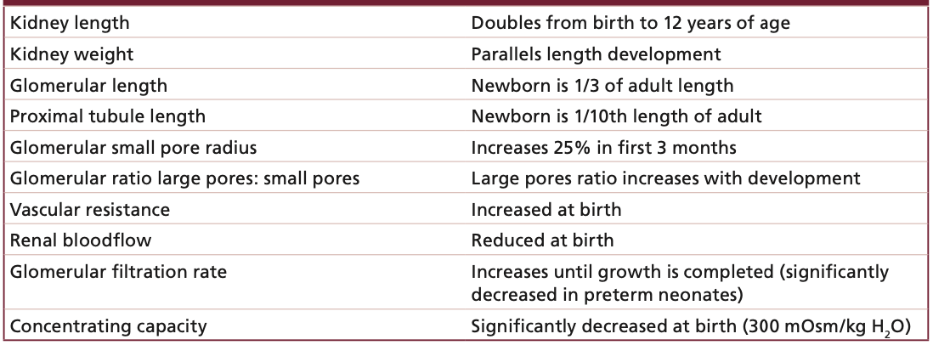
(Eidelman and Abdel-Rahman 2016)
Please can this be re-typed / formatted etc?

Due to these structural differences, the capacity for a newborn to eliminate drugs is reduced, so younger children / infants often require drug dosing less frequently for renally cleared medications (Eidelman and Abdel-Rahman 2016). There is immature glomerular filtration and tubular function in younger children (Hill, Allan et al. 2022). Glomerular filtration is where a large quantity of water soluble drugs and drug metabolites are eliminated, and the glomerular filtration rate (GFR) is often used to assess renal function (van den Anker, Reed et al. 2018). The GFR is approximately is approximately 10 to 20 mL / min / m² at birth (Lu and Rosenbaum 2014) and increases to 20 to 30 mL / min / m² during the first few weeks of life, and then reaching half of the normal adult values by 3 months of age (O'Hara, Wright et al. 2015): adult levels are reached by around age 2 years (O'Hara 2016). Drug doses will therefore need to be adjusted frequently during the first few weeks and months of life, either by increasing the dosing interval, or reducing the dose (van den Anker, Reed et al. 2018).

Creatinine clearance is often used to estimate GFR (Schwartz, Munoz et al. 2009). Creatinine is a type of chemical compound that is left over from specific energy producing processes in the muscles. From the age of one month, serum creatinine levels gradually increase due to the child’s increase in body size and muscle mass (Chuang, Tsai et al. 2021), so knowledge of GFR predictions and creatinine clearance levels at different ages is essential (Pierrat, Gravier et al. 2003).

Conversely, tubular secretion and reabsorption capacity mature at much slower rates than glomerular filtration, with tubular reabsorption not reaching adult levels until around two years of age (Lu and Rosenbaum 2014), which will evidently have an impact on particular drug clearance rates. It is clear that immature kidneys will result in inefficient elimination of some drugs, thus increasing the half life.

The pH of the urine can also affect the reabsorption of any weak acids or bases, which can then consequently affect the elimination. The urine pH in adults is higher than in infants, so this will affect the reabsorption of weakly acidic drugs (Batchelor and Marriott 2015).

It is clear that developmental changes in the kidney can have an impact on GFR, but it must be stressed that estimating GFR in neonates and young children remains a challenge (van den Anker, Reed et al. 2018). Age, weight and body surface area all need to be considered, alongside the potential of genetic differences, and all can contribute to a variability in pharmacokinetics: understanding this culmination can enhance the understanding of dosing of medications for neonates, infants and young children (Barker, Standing et al. 2018)

The next article in the series is F: Formulations

Word count: 641 words (excluding table)

References

Barker, C. I. S., J. F. Standing, L. E. Kelly, L. Hanly Faught, A. C. Needham, M. J. Rieder, S. N. de Wildt and M. Offringa (2018). "Pharmacokinetic studies in children: recommendations for practice and research." Arch Dis Child 103(7): 695-702.
Batchelor, H. K. and J. F. Marriott (2015). "Paediatric pharmacokinetics: key considerations." Br J Clin Pharmacol 79(3): 395-404.
Bertram, J. F., R. N. Douglas-Denton, B. Diouf, M. D. Hughson and W. E. Hoy (2011). "Human nephron number: implications for health and disease." Pediatr Nephrol 26(9): 1529-1533.
Chuang, G. T., I. J. Tsai and Y. K. Tsau (2021). "Serum Creatinine Reference Limits in Pediatric Population-A Single Center Electronic Health Record-Based Database in Taiwan." Front Pediatr 9: 793446.
Eidelman, C. and S. M. Abdel-Rahman (2016). "Pharmacokinetic considerations when prescribing for children." International Journal of Pharmacokinetics 1(1): 69 - 80.
Hill, B., J. Allan and C. Camara (2022). Pharmacodynamics and Pharmacokinetics. Fundamentals of Pharmacology for Children’s Nurses. I. Peate and P. Dryden. West Sussex, Wiley Blackwell.
Kearns, G. L., S. M. Abdel-Rahman, S. W. Alander, D. L. Blowey, J. S. Leeder and R. E. Kauffman (2003). "Developmental pharmacology - drug disposition, action and therapy in infants and children." The New England Journal of Medicine 349(12): 1157 - 1167.
Lu, H. and S. Rosenbaum (2014). "Developmental Pharmacokinetics in Pediatric Populations." J Pediatr Pharmacol Ther 19(4): 262 - 276.
Manalich, R., L. Reyes, M. Herrera, C. Melendi and I. Fundora (2000). "Relationship between weight at birth and the number and size of renal glomeruli in humans: a histomorphometric study." Kidney Int 58(2): 770-773.
O'Hara, K. (2016). "Paediatric pharmacokinetics and drug doses." Aust Prescr 39(6): 208-210.
O'Hara, K., I. M. Wright, J. J. Schneider, A. L. Jones and J. H. Martin (2015). "Pharmacokinetics in neonatal prescribing: evidence base, paradigms and the future." Br J Clin Pharmacol 80(6): 1281-1288.
Pierrat, A., E. Gravier, C. Saunders, M. V. Caira, Z. Ait-Djafer, B. Legras and J. P. Mallie (2003). "Predicting GFR in children and adults: a comparison of the Cockcroft-Gault, Schwartz, and modification of diet in renal disease formulas." Kidney Int 64(4): 1425-1436.
Sage, D. P., C. Kulczar, W. Roth, W. Liu and G. T. Knipp (2014). "Persistent pharmacokinetic challenges to pediatric drug development." Front Genet 5: 281.
Schwartz, G. J., A. Munoz, M. F. Schneider, R. H. Mak, F. Kaskel, B. A. Warady and S. L. Furth (2009). "New equations to estimate GFR in children with CKD." J Am Soc Nephrol 20(3): 629-637.
van den Anker, J., M. D. Reed, K. Allegaert and G. L. Kearns (2018). "Developmental Changes in Pharmacokinetics and Pharmacodynamics." The Journal of Clinical Pharmacology 58: S10-S25.

