MODELLING OF A THERMAL STORAGE REFRIGERATOR

MARQUES C.(a,c), DAVIES G.(a), EVANS J. A.(a,b), MAIDMENT, G.(a), WOOD, I.(c),
- Department of Engineering Systems, London South Bank University, 103 Borough Road, London, SE1 0AA, UK; E-mail: marquesc@lsbu.ac.uk
- Refrigeration Developments and Testing, Ltd. Food Processing Building, Langford,
Bristol, BS40 5DU, UK
- Adande Refrigeration, Units 5-11, Harvest Court, South Lowestoft Industrial Estate,
Lowestoft, Suffolk, NR33 7NB, UK

ABSTRACT
The paper investigates the effect of adding a phase change material in thermal contact with the evaporator in a natural convection domestic refrigerator. The enthalpy method has been applied to investigate the heat release and storage rate of encapsulated ice. The effect of three parameters was investigated by the numerical method: PCM thickness, ambient temperature and evaporating temperature. The results showed that the melting and freezing time increased proportionally with PCM thickness. The refrigerator autonomy was reduced by 48% when the ambient temperature was increased from 20°C to 43°C and the freezing time increased by 27% when the evaporating temperature was reduced from -10°C to -15°C.
A CFD simulation of the airflow and temperature distribution in the natural convection refrigerator was carried out to evaluate the most effective position to place the PCM (top or back wall). The predicted airflow patterns and temperature profiles were considerably different for the two PCM orientations. The predicted air temperature was above 5ºC, thus a eutectic PCM may be required to reduce the temperature in the refrigerator compartment.
- INTRODUCTION
Climate change caused by the excessive release of greenhouse gas emissions into atmosphere is threatening to deteriorate life conditions on Earth. Refrigeration and air-conditioning play a significant role in this picture since they are responsible for 15% of the total worldwide electricity consumption (IIR, 2003). Domestic refrigeration is one of the main contributors to the total global warming impact, representing 18% of the cooling sector (Heap, 2001). Although direct GHG emissions from domestic refrigerators have been greatly reduced by the introduction of hydrocarbon refrigerants their indirect emissions remain very high due to refrigerator continuous operation. Current mandatory energy standards and energy labelling programs provide some regulation to the domestic refrigeration market by setting targets to manufacturers.
However, numerous studies have shown that domestic refrigerators run at higher temperature than recommended by health and food safety legislation during real usage operation. In fact an analysis of various surveys reported in the last 30 years has shown that 61.2% of refrigerators throughout the world run at temperatures above 5°C (Laguerre et al., 2002; James et al., 2007).
There are currently three types of domestic refrigerators in the market: static, fan assisted and frost free; these distinctions indicate differences in the airflow and heat transfer mechanism within the refrigerated compartment. In static refrigerators heat is transferred by natural convection, which produces a buoyant airflow. The evaporator position within the compartment (horizontal/vertical) determinates the position of warm and cold zones. A more homogeneous temperature can be obtained by introducing a fan to the static refrigerator or by forcing air through the evaporator in a frost free model. According to an IPCC report (2005) 68% of the domestic refrigerators and freezers are frost free appliances. Although the temperature stability is better in forced convection refrigerators than in conventional static refrigerators their energy consumption is also considerably higher.
The energy consumption of refrigerators is affected by ambient temperature, product loading and number of door openings, thermostat setting position and refrigerant migration during the compressor off-cycle. As the main load to the cabinet results from conduction through the cabinet walls, replacing standard polyurethane foam by vacuum insulated panels (VIPs) can result in energy savings up to 25% (Manini et al., 2005). The compressor on the other hand consumes more than 80% of the total energy used by the appliance (Jähnig et al., 2000). Employing a variable speed compressor (VSC) that adjusts refrigeration capacity to the load can produce an energy reduction of 40% (Bansal, 2003). Although these two technologies, VIPs and VSCs are very promising they are also very expensive, which limits they application to premium appliances.
The use of phase change materials (PCMs) to accumulate thermal energy in domestic refrigerators is a new and cheap solution to improve the energy efficiency of these appliances. The cooling capacity stored in the PCM can be used to stabilize the temperature in the compartment, by reducing the effects of peak loads and cooling losses during periods when the door is open. Azzouz et al. (2009) have previously tested a natural convection domestic refrigerator with 5 and 10 × 10⁻³ m (i.e. 5 and 10 mm) ice slabs in contact with the evaporator. Their results showed that the refrigerator autonomy increased from 5 to 9 hours depending on the thermal load. It was observed that the 10 mm slab was never completely frozen, probably due to the low thermal conductivity of the PCM and low cooling capacity of the 5 × 10⁻⁶ m³ (i.e. 5 cm³) swept volume compressor employed.
Previous research demonstrated that for current single speed compressors, efficiency increases with compressor size. The compressor performance was analysed for different displacement models (4 to 11cm³) under typical refrigerator operating conditions to investigate the respective influence on the refrigerator efficiency. The operating conditions considered were an ambient temperature of 25°C, condensing temperature of 35°C, evaporator superheat of 1K and compressor suction temperature of 15°C. The isentropic efficiency for each compressor swept volume was calculated using the CoolPack software, version 1.46 (2001) and was found to increase from 0.4 to 0.6 as the displacement increased from 4 to 8cm³. Replacing the 4 cm³ compressor by an 8 cm³ model on a static refrigerator with external dimensions 0.85×0.55×0.56 m resulted in an energy reduction of 17% and the run time of the appliance decreased from 20% to 9% (Marques et al. 2010). An effective way to exploit this higher performance is to accumulate the excess cooling capacity in a PCM. A further advantage of a larger compressor is that the increased cooling capacity enables more rapid freezing of the PCM. This will permit the compressor off-cycle time to be increased, thereby saving energy.
The next section of the current paper investigates the heat release and storage rate of encapsulated ice, used as the thermal energy storage material in the refrigerator. The mathematical model for the phase change presented is based on the enthalpy method and the governing equations were discretized on a fixed grid using the finite difference method. The influence of PCM thicknesses (2, 3, 4 and 5 mm slabs), ambient temperature (20°C, 25°C, 30°C and 43°C) and evaporating temperature (-15°C and -10°C) have been investigated. Knowledge of the effects of these factors is a valuable aid in the design and operation of a thermal storage refrigerator.
The remainder of the paper describes a simulation of the airflow and temperature distribution in the natural convection refrigerator carried out using the commercial CFD code Fluent 12.0. The aim was to evaluate the most effective position to place the PCM (top or back wall) by studding the respective effect on the airflow patterns and temperature distribution within the refrigerator cavity.

2. PCM HEAT RELEASE AND STORAGE RATE MODEL

Phase change problems are transient in nature as the temperature within the material varies with time and position. During the melting and solidification processes the solid/liquid interface moves according to the speed at which the latent heat is absorbed or lost at the boundary. As a result the position of the boundary is not know and has to be determined as part of the solution (Verma et al., 2006).

2.1 Mathematical formulation
The phase change material employed was water due to its high latent heat content and sharp freezing/melting point. The top surface of the water container was placed in thermal contact with the refrigerator evaporator, while the bottom surface of the enclosure was subjected to natural convection from the refrigerator compartment. The side walls of the container were insulated, thus heat transfer within the PCM was assumed to be one dimensional. The following assumptions were considered to simplify the mathematical model:

- The thermophysical properties of the PCM (e.g. thermal conductivity and specific heat) were constant and different for each phase
- The latent heat was constant and released or absorbed at a fixed phase change temperature
- The density remained constant
- The convection in the melted regions was neglected
- Subcooling effects were assumed to be non-existent
- The PCM container was very thin and had a negligible effect on the rate of heat transfer between the refrigerated compartment and the PCM

It was assumed that conduction was the only heat transfer mechanism occurring inside the PCM. The conservation of energy in the solid and liquid phases is described by differential equations 1 and 2 respectively,

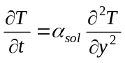 for 0 < y < s(t), t > 0 (1)

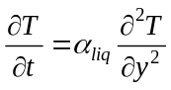 for s(t) < y < B, t > 0 (2)

Where T is temperature, t is time, α is the thermal diffusivity and s is the interface location in y direction. The subscripts sol and liq refer to the solid and liquid phases respectively. The energy balance at the interface is obtained from equation 3.

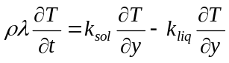 at y = s(t), t > 0 (3)

Where ρ is density, λ is the latent heat released during solidification and absorbed during melting and k is the thermal conductivity.
The boundary condition applied to the bottom surface of the PCM was a heat load. This heat load (Q_{fridge}) was calculated in a previous study for a refrigerator with external dimensions of 0.85×0.55×0.56 m at various ambient conditions (Marques et al. 2010). At the top boundary a cooling capacity (Q_{evaporator}) was applied during the freezing process. This cooling capacity was estimated for an 8cm³ compressor model evaporating at -10°C. It was assumed that the PCM was initially completely solid at the melting temperature (0°C) during the melting process and liquid at the refrigerator temperature (5°C) during the freezing process.

2.2 Numerical solution
The algebraic approximations normally used to solve differential equations 1 to 3 require the phase change boundary to be tracked within the PCM volume. The enthalpy method was applied to simplify the problem as it eliminates the necessity to trace the solid-liquid interface. The energy equations 1 and 2 were re-written by replacing temperature with total enthalpy. The problem was solved numerically using the explicit finite differences method (Alexiades and Solomon, 1993), where the PCM (0.46×0.45×x m) was divided into a number of equal layers and equation 4 was applied to each layer.

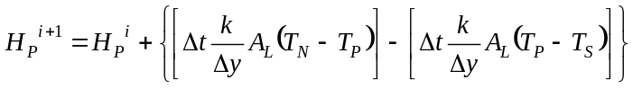 (4)

At the boundaries, either Δt × Q_{fridge} or Δt × Q_{evaporator} replaced one of the terms in equation 4. The thermal conductivity was defined in function of the enthalpy values: k_{sol} for H < (m_{L}λ)/2 and k_{liq} for H ≥ (m_{L}λ)/2.
The temperature was then obtained from the enthalpy values using one of the three relationships shown below, as appropriate.
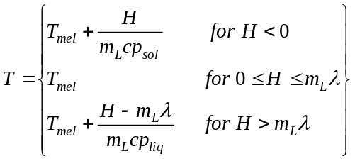 (5)
In order to ensure convergence the time step and layer thickness were selected to comply with the following criteria: (Δt/Δy²) < (ρcp/2k). The boundary conditions used to calculate the PCM charge and discharge time are shown in Table 1.

Table 1: Boundary conditions used during the freezing and melting processes
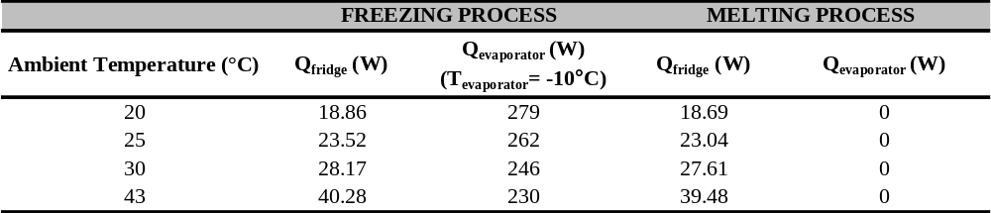

2.3 Effect of PCM thickness on the charge and discharge rate
The total storage capacity for the PCM considered varies between 127 kJ for 2mm slab and 316 kJ for a 5mm slab. For the analysis of the PCM charge and discharge rate with different thicknesses, a refrigerator heat load of 23.52W was assumed, which corresponded to an ambient temperature of 25°C. The compressor was off during the melting process but on with a cooling capacity of 262W during the freezing process, which corresponded to an evaporating temperature of -10°C. The influence of thickness on the PCM melting and freezing time is shown in Figures 1 and 2 respectively.
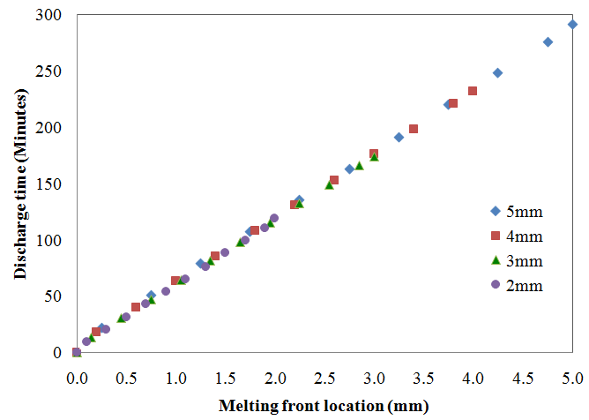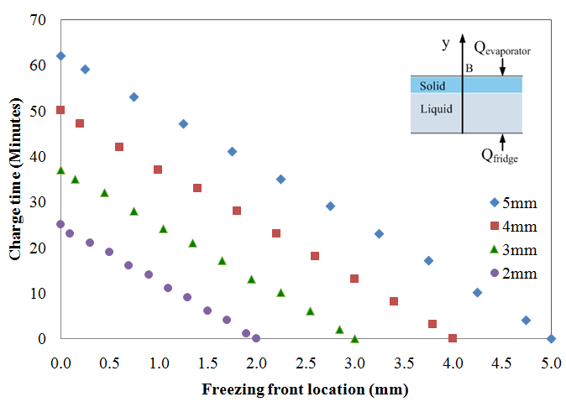

Figure 1: Effect of thickness on the PCM Figure 2: Effect of thickness on the PCM
melting time freezing time

From Figure 1 it can be seen that the melting time increased from 119 minutes (i.e. 7140 s) to 291 minutes (i.e. 17460 s) as the PCM thickness increased from 2 mm to 5 mm. The freezing time was 25 minutes for the 2 mm slab and 62 minutes for the 5 mm slab.

2.3 Effect of ambient temperature on the charge and discharge rate
The effect of ambient temperature on the PCM charge and discharge rate was evaluated for a 2 mm PCM slab. The fridge heat load and cooling capacity for the range of ambient temperatures considered are listed in Table 1. Figures 3 and 4 demonstrate the influence ambient temperature on the PCM melting and freezing times.
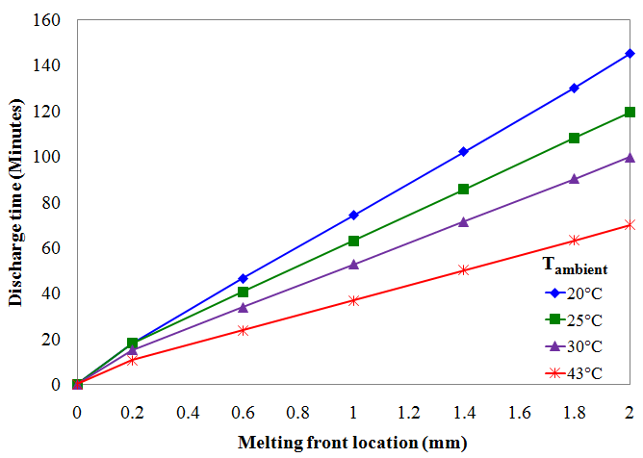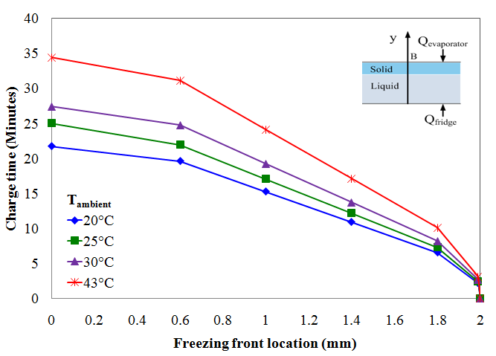

Figure 3: Effect of ambient temperature on the Figure 4: Effect of ambient temperature on
PCM melting time the PCM freezing time
The melting time decreased from 145 minutes to 70 minutes when the ambient temperature increased from 20°C to 43°C, which corresponds to a refrigerator autonomy reduction of 48%.
Figure 4 shows that the freezing time increases slightly with ambient temperature and it takes an additional 12 minutes to freeze the PCM at 43°C ambient rather than at 20°C.

2.4 Effect of evaporating temperature on the charge and discharge rate
The influence of evaporating temperature on the PCM freezing time was estimated using the cooling capacity of an 8 cm³ compressor operating at -10°C (262W) or -15°C (213W) under a constant ambient temperature of 25°C. The analysis was performed for a 2 mm PCM slab. The impact of evaporating temperature on the PCM freezing time is illustrated in Figure 5.
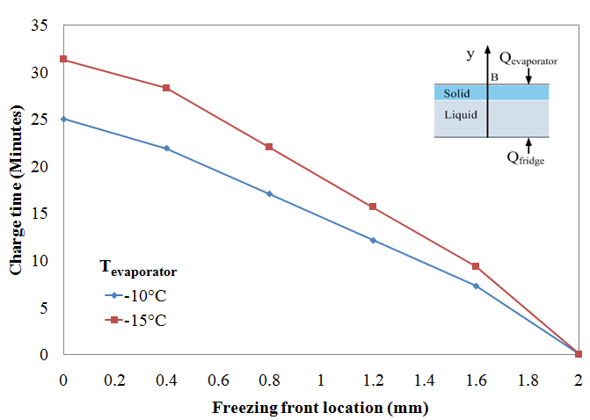

Figure 5: Effect of evaporating temperature on the PCM freezing time

The freezing time increased 6 minutes by reducing the evaporating temperature from -10°C to -15°C. This result is due to the fact that the compressor COP increases linearly with evaporating temperature.

3. CFD SIMULATION

The commercial software Fluent 12.0 was used to simulate the airflow and temperature distribution within the natural convection refrigerator. The aim was to model the effect of the PCM position (top or back wall) on the refrigerator airflow pattern and temperature profile.

3.1 Assumptions and boundary conditions
Only half of the refrigerator (internal dimensions: 0.75×0.45×0.23 m) was modelled due to the symmetry of the parallelepiped geometry. The resultant hexahedral mesh had 455,400 cells, which were made finer near the walls to account for the thermal boundary layers. In order to simplify the model the PCM was not physically modelled, instead was applied as a boundary condition of constant temperature (0°C) either to the top or back wall of the refrigerator. The thin wall approach was applied to the other walls, which were subjected to a constant external temperature of 25°C. The thin wall approach artificially models the thermal resistance of the wall in the normal direction using the material thermal conductivity and thickness. In this case the wall insulation was polyurethane with a thermal conductivity of 0.026Wm⁻¹K⁻¹, 50mm thick.

3.2. Natural convection and radiation models
The Rayleigh number was calculated for both PCM orientations (horizontal/vertical), based on the characteristic length of the PCM and the temperature difference between the PCM surface and the average internal air (assumed to be 5°C). The calculated Rayleigh number was 1×10⁶ for the horizontal PCM and 3×10⁸ for the vertical PCM, thus as a laminar flow model was applied for both cases since Ra < 10⁹.
All physical properties were assumed to be constant except for the air density that used the boussinesq approximation shown in equation 6.

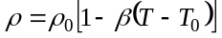 (6)

The Boussinesq approach assumes the air density is uniform except for the buoyancy term in the momentum equation, this approximation is valid when the variations in air temperature are small, which is the case.
Laguerre and Flick (2004) have shown that the radiation heat transfer coefficient in refrigerators is in the same order of magnitude of the natural convection heat transfer coefficient; hence radiation cannot be ignored in the domestic refrigerator. The radiation between the refrigerator surfaces was taken into account using the discrete ordinates radiation model (Colomer et al., 2004; Ben Amara et al., 2008).
For transparent media, air with negligible absorption and diffusion, the radiation transfer equation in the direction is obtained from equation 7.

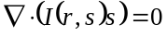 (7)

Where 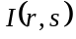is the radiative intensity in the direction at the position. The refrigerator walls were modelled as gray diffuse and the net radiative flux leaving the surface is given by equation 8.

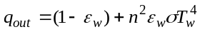 (8)

Where, n is the refractive index of the medium next to the wall, 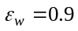 is the wall emissivity, is Boltzmann's constant and T_{w} is the wall temperature. An angular discretization analysis was carried out to ensure the results were not affected by the solid angle subdivisions.
The equations were solved in steady state using the finite volume method with a sequential solver. The solver employed the SIMPLE pressure-velocity coupling method. The pressure was discretized using the PRESTO scheme and the equations of momentum, energy and radiation were solved using second order upwind discretization.

3.3. Simulation results with the PCM in the back wall
The airflow and temperature distribution inside the refrigerator compartment with the PCM positioned in the back wall are shown in Figures 6 and 7 respectively.
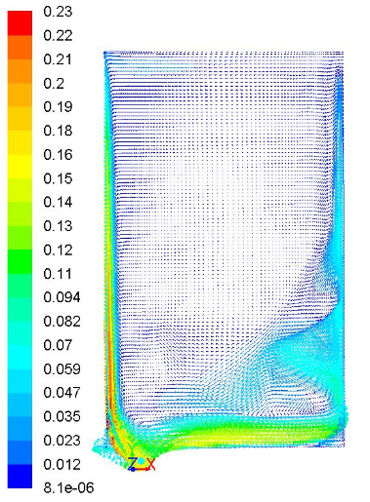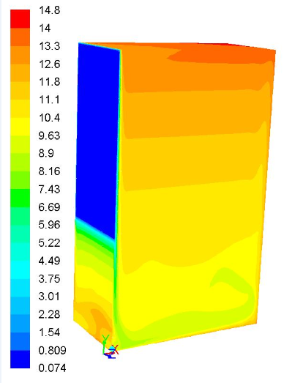

Figure 6: Velocity vectors (ms⁻¹) Figure 7: Contours of static temperature (°C)
with the PCM in the back wall with the PCM in the back wall

As can be observed in Figure 6 placing the PCM in the back wall produces a circular airflow pattern along the walls with recirculation in the right inferior corner. The air in the centre of the cavity is almost stagnant and the maximum velocity of 0.23 ms⁻¹ is achieved in the cold back wall. Figure 7 shows a stratified temperature profile with the cold zone at the bottom and the warm zone at the top, a maximum temperature of 14.8°C is obtained in the top right corner. The refrigerator air temperature is above 5°C, which the required temperature for domestic refrigerators according to the European standard.

3.4. Simulation results with the PCM in the top wall
The airflow circulation and temperature profile within the refrigerator cavity with the PCM positioned in the top wall are illustrated in Figures 8 and 9 respectively.
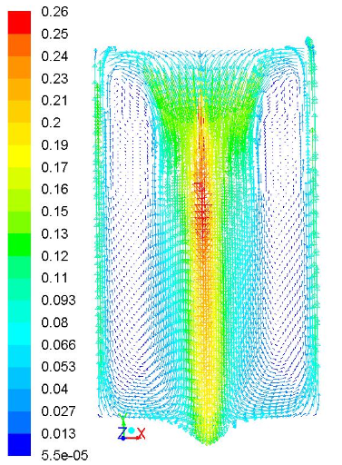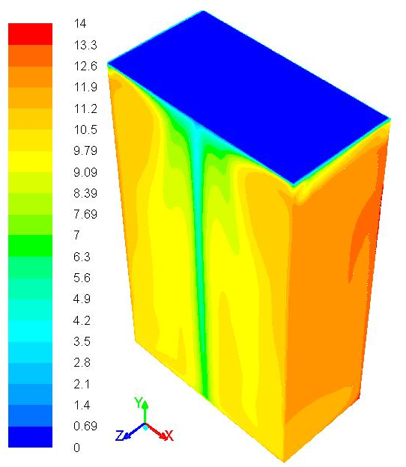

Figure 8: Velocity vectors (ms⁻¹) Figure 9: Contours of static temperature (°C)
with the PCM in the top wall with the PCM in the top wall

The velocity vectors coloured by velocity magnitude are presented in Figure 8. As can be seen the cold denser air flows along the PCM towards the its centre and then moves down to the bottom of the cavity producing recirculation in the bottom corners as the flow is directed upwards along the warm walls of the enclosure. The cold wall in the top of the refrigerator produces higher velocities and generates two vortices that circulate in opposite directions. The contours of static temperature illustrated in Figure 9 show more homogeneous temperature distribution than the one found with the PCM positioned on the back wall.
Overall the simulation results show that the air temperature within the natural convection refrigerator reaches values well above a 5°C. An option to reduce the temperature within the refrigerator compartment is to use a eutectic PCM with a phase change temperature below 0°C. This alternative has been tested by Azzouz et al. (2009) and resulted in lower temperature within the refrigerator enclosure.

4. CONCLUSION

The PCM heat release and storage model showed that the melting and freezing time increases proportionally with PCM thickness. The combination of a thin PCM slab (< 5 mm) with a large displacement compressor, enabled with an increased cooling capacity, enhances the refrigerator autonomy and efficiency. The numerical model has shown that the refrigerator autonomy was strongly affected by the refrigerator heat load and compressor cooling capacity. An increase in ambient temperature from 20°C to 43°C resulted in a 48% reduction in autonomy. The freezing time was found to increase by 27% when the evaporating temperature was reduced from -10°C to -15°C.
The CFD simulation has shown that placing the PCM in the refrigerator back wall produces a circular airflow pattern along the walls with a stagnant core in the centre of the cavity resulting in thermal stratification with a warmer zone at the top. Positioning the PCM in the refrigerator roof produced a more homogeneous temperature in the compartment than with the PCM placed in the back wall. The cold air flowed along the PCM towards the centre of the cavity, producing two vortices circulating in opposite directions. The predicted air temperature in the natural convection thermal storage refrigerator was above 5ºC and a eutectic PCM may be required to reduce the temperature in the compartment.
Future research will validate experimentally both the PCM heat release and storage rate model and the CFD airflow and temperature profile predictions.

Acknowledgements
The authors would like to thank the EPSRC and Adande Refrigeration for funding this project.
NOMENCLATURE

A_{L} m² Area of layer Greek symbols
B m PCM thickness α m²s⁻¹ Thermal diffusivity
H J Enthalpy change β K⁻¹ Thermal expansion coefficient
Wm⁻² Radiative intensity ε_{W} Wall Emissivity
k Wm⁻¹K⁻¹ Thermal conductivity λ Jkg⁻¹ Latent heat of fusion
m_{L} kg Mass of layer ρ kgm⁻³ Density
n Refractive index ρ₀ kgm⁻³ Operating Density
PCM Phase Change Material σ Stephan-Boltzmann constant
Q_{evaporator} W Cooling capacity Subscripts
Q_{fridge} W Refrigerator heat gain liq Liquid
q_{out} Wm⁻² Net radiative flux mel Melting point
T K Temperature N Node point at north of point P
T₀ K Operating temperature P Point P
t s Time S Node point at south of point P
Δt s Time step sol Solid
Δy m Layer thickness Superscripts
i Iteration

REFERENCES

Alexiades, V., Solomon, A. D. 1993, Mathematical modelling of melting and freezing processes, Hemisphere Publishing, Washington, 336p.
Azzouz, K., Leducq, D., Gobin, D. 2009, Enhancing the performance of household refrigerators with latent heat storage: an experimental investigation, Int. J. Refrig. 32: 1634-1644.
Bansal, P. K. 2003, Developing new test procedures for domestic refrigerators: harmonisation issues and future R&D needs - a review, Int. J. Refrig. 26(7): 735-748.
Ben Amara, S., Laguerre, O., Charrier-Mojtabi, M.-C., Lartigue, B., Flick, D. 2008, PIV measurement of the flow field in a domestic refrigerator model: Comparison with 3D simulations, Int. J. Refrig. 31(8): 1328-1340.
Colomer, G., Costa, M., Consul, R., Oliva, A. 2003, Three-dimensional numerical simulation of convection and radiation in a differentially heated cavity using the discrete ordinates method, Int. J. Heat Mass Transfer. 47: 257-269.
Coolpack Software 2001, Denmark Technical University, Department of Mechanical Engineering, Available: http://www.et.web.mek.dtu.dk/Coolpack/UK/download.html [Last accessed 03/11/ 2008].
Heap, R. D. 2001, Refrigeration and air-conditioning – the response to climate change, Bulletin of the International Institute of Refrigeration, No 2001-5.
International Institute of Refrigeration, 2003, How to improve energy efficiency in refrigerating equipment, IIF/IIR, Paris, Available: http://www.iifiir.org/en/doc/1015.pdf [Last accessed 28/01/2009].
Intergovernmental Panel on Climate Change, 2005, Safeguarding the ozone layer and the global climate system, Cambridge University Press, New York, 462p.
Jähnig, D. I., Reindl, D. T., Klein, S. A. 2000, A semi-empirical method for representing domestic refrigerator/freezer compressor calorimeter test data, ASHRAE Transactions, 106.
James, S. J., Evans, J., James, C. 2007, A review of the performance of domestic refrigerators, J. Food Eng. 87(1): 2-10.
Laguerre, O., Derens, E., Palagos, B. 2002, Study of domestic refrigerator temperature and analysis of factors affecting temperature: a French survey, Int. J. Refrig. 25(5): 653-659.
Laguerre, O., Flick, D. 2004, Heat transfer by natural convection in domestic refrigerators, J Food Eng. 62: 79-88.
Manini, P., Pastore, G., Di Gregorio, P. 2003, Vacuum insulated panels (VIPs) technology: a viable route to reduce energy consumption in domestic, industrial and civil applications. Available: http://www.eurocooling.com/public_html/articlesaesgetters.htm. [Last accessed: 28/06/2010].
Marques, C., Evans, J. A., Davies, G., Maidment, G., Wood, I. 2010, Novel design and performance of domestic refrigerators, Proc. Ist IIR Conference on Sustainability and the Cold Chain, Cambridge, UK.
Verma, P., Varum, Singal, S. K. 2008, Review of mathematical modeling on latent heat thermal energy storage systems using phase-change material, Renewable Sustainable Energy Reviews, 12: 999-1031.

