Heat transfer and pressure drop of ice slurries in plate heat exchangers

J. Bellas, I. Chaer, S.A. Tassou *

Department of Mechanical Engineering, Brunel University, Uxbridge, Middlesex UB8 3PH, UK

**Abstract**

Ice slurries can be used both for cold storage in place of chilled water or ice and as a secondary refrigerant since, up to certain concentrations, they can be pumped directly through distribution pipeworks and heat exchangers. For ice slurries to become more widely accepted, however, more engineering information is required on ﬂuid ﬂow and heat transfer characteristics.

This paper reports on the results of experimental investigations into the melting heat transfer and pressure drop of 5% propylene/water ice slurry ﬂowing in a commercial plate heat exchanger. Measurements were obtained for ice fractions between 0% and 25% by weight, and ﬂow rates between 1.0 and 3.7 m3 /h. In this ﬂow range, increasing the ice fractions from 0% to 20% caused around a 15% increase in the pressure drop over the ﬂow range tested. The overall heat transfer coeﬃcient, based on the logarithmic mean temperature diﬀerence, was found to remain fairly constant as the ice fraction increased from 5% to

20%. The heat transfer capacity of the heat exchanger was found to increase by more than 30% with melting ice slurry ﬂow compared to chilled water ﬂow.

In a practical application, for a given thermal load this would lead to greater than 60% reduction in ﬂow rate and pressure drop compared to chilled water cooling systems. © 2002 Elsevier Science Ltd. All rights reserved.

**Keywords:** Ice slurries; Plate heat exchangers; Pressure drop; Heat transfer

**Nomenclature**

*A* area, m2

*Ac* channel ﬂow area, m2

*cp* speciﬁc heat capacity, J/kg K

*Dh* hydraulic diameter, deﬁned as 2(h), m

*h* pressing depth of the corrugation, m

*i* ice fraction, kg/kg, or m3 /m3 in Eq. (7)

*L* length, m

*m_* mass ﬂow rate per channel, kg/s

*ΔP* pressure drop, kPa

Q cooling capacity, kW

*T* temperature, oC

LMTD log mean temperature diﬀerence, K

*U* overall heat transfer coeﬃcient, kW/m2 K

*W* width, m

Greeks

*μ* dynamic viscosity, kg/ms

*ρ* density, kg/m3

Subscripts

ave average c channel

c cold ﬂuid

cf carrier ﬂuid

h hydraulic

h hot ﬂuid

i heat exchanger inlet ﬂuid

o heat exchanger outlet ﬂuid

vol volume (refers to ice fraction by volume in Eq. (7))

**1. Introduction**

The drive for energy conservation and reduction of CO2 emissions to the environment in many industrial and commercial sectors has promoted new areas of research that focus on ﬁnding

alternative cooling technologies. One of these alternative technologies is the potential production and use of ice slurries in conventional cooling processes. Ice slurry is a mixture of ice crystals, water and an additive such as glycol, salt or alcohol to lower the freezing point. The size of these crystals can vary between 100 lm and 12 mm in diameter [1,2]. Ice slurries have very good thermophysical and transport properties. They behave almost like liquids and can be pumped through pipes or stored in tanks. The energy capacity of ice slurries per unit volume is greater than that for chilled water due to phase change of the ice particles. Because of their large energy ca- pacity, for a given cooling load, ice slurries can reduce the required cooling ﬂow rate signiﬁcantly compared to chilled water ﬂow [3]. Therefore, pipe dimensions, pumping energy, heat exchanger size and operating costs could be substantially reduced. Another advantage of ice slurry systems is

that the ﬂuid can be completely safe and harmless to the environment. These advantages make ice slurry systems very attractive from both the technical and economic view points.

To date, only very few investigations on the ﬂow and heat transfer characteristics of melting ice slurries in plate and tubular heat exchangers have been carried out.

Gupta and Frazer [4] carried out experimental investigations on the pressure drop and heat transfer for 6% ethylene glycol/water ice slurry at ice fractions between 0% and 20% and ﬂow rates between 0.180 and 2.16 m3 /h in a plate heat exchanger. The heat exchanger comprised of 12 copper plates with nominal gap of 2.1 mm and heat transfer area of 0.134 m2 . The size of the ice crystals was measured to be between 0.125 and 0.625mm in diameter. They reported an increase in the overall heat transfer coeﬃcient with increased ﬂow rate but a decrease in the overall heat transfer coeﬃcient with increased ice fraction. The pressure drop in the heat exchanger was reported to remain constant up to 20% ice fraction and increase rapidly at concentrations above this value. Results for the higher concentrations, however, were not presented but the authors attributed the rapid rise in pressure drop to the choking of the ﬂow by ice particles.

Norgard et al. [5] carried out investigations on pressure drop and heat transfer for a 16% propylene glycol/water mixture at ice fractions between 0% to 30% by weight and ﬂow rates between 0.05and 0.3 m3 /h in a small standard plate heat exchanger comprising 10 plates (300 mm length, 70 mm width and 4 mm hydraulic diameter). They did not state the size or shape of the ice crystal within the slurry mixture. At low ﬂows, 0.05m3 /h the results indicated an increase in the overall heat transfer coeﬃcient and pressure drop with increasing ice fraction. As the ﬂow increased, however, the eﬀect of ice fraction on the overall heat transfer coeﬃcient reduced.

Stamatiou et al. [6] investigated heat transfer in a specially designed plate heat exchanger of 533mm length, 305mm width, a ﬂow channel gap of 25mm and hydraulic diameter of 47 mm. Tests were performed for ice slurry ﬂows of between 1.7 and 3.6 m3 /h and Reynolds numbers between 1600 and 3350. Results were reported for average ice fractions in the heat exchanger between 0% and 8%. In this ice fraction range the results indicate increasing Nusselt numbers with increasing Reynolds numbers. The Nusselt number also increased as the ice fraction increased but the rate of increase reduced at ice fractions above 4%.

Heat transfer and pressure drop investigations of ice slurries in single cylindrical tubes and tubular heat exchangers also produced conﬂicting results with respect to the overall heat transfer coeﬃcient and pressure drop.

Jensen et al. [7] presented pressure drop and heat transfer data for 10% ethanol/water mixture at ice fractions between 0% and 30% by weight and ice sizes less than 0.2 mm. The tests were carried out in three pipes of 12, 16 and 20 mm respectively and velocities of 0.5, 1.0, 1.5 m/s. They reported an increase in the heat transfer coeﬃcient with increasing ice fraction and velocity.

Sari et al. [8] carried out investigations on heat transfer of a 10% talin/water mixture ice slurry ﬂowing in a tube of 23 mm inside diameter with an initial ice fraction of 16%. The results showed the Nusselt number to increase with the ice fraction for both laminar (*Re* = 780–1620) and turbulent ﬂow (Re = 3890–4840).

At higher Reynolds numbers, 35,000–80,000, Snoek and Bellamy [9] and Knodel et al. [10] showed both the heat transfer and pressure drop to decrease with increasing ice fraction. The reductions were attributed to the transition from turbulent to laminar plug ﬂow as the ice fraction increased.

The heat transfer and pressure drop results obtained by diﬀerent investigators indicate that the behaviour of ice slurries is a function of a number of parameters which include the mixture viscosity, Reynolds number, ice crystal size and ice fraction. The inﬂuence of these parameters, however, is not fully characterised and as yet there are no widely accepted correlations for the calculation of heat transfer coeﬃcients and pressure drop in tubular and plate heat exchangers.

This paper makes a contribution to the overall eﬀort to increase understanding of the behaviour of ice slurries in compact heat exchangers. Investigations were performed on a commercially available liquid to liquid plate heat exchanger and its performance was investigated for water to water, brine to water and ice slurry to water ﬂows.

**2. Experimental facility**

Fig. 1 shows a schematic diagram of the experimental facility, consisting mainly of two inde- pendent circuits. The ice slurry formation circuit and the ice ﬂow circuit.

**2.1. The ice formation circuit**

The ice formation circuit is a falling ﬁlm ice slurry generating system. The major components of this system are: a conventional vertically positioned ﬂooded type shell and tube heat exchanger with spinning rods inside the tubes, a condensing unit, pumps and a storage tank with a mixer. This system produces ﬁne ice crystals with diameters in the range between 170 and 600 μm.

**2.2. Ice ﬂow circuit**

The ice ﬂow circuit was designed and constructed to enable pressure drop and heat transfer measurements of ice slurry mixtures in pipes, bends and heat exchangers. A standard plate heat

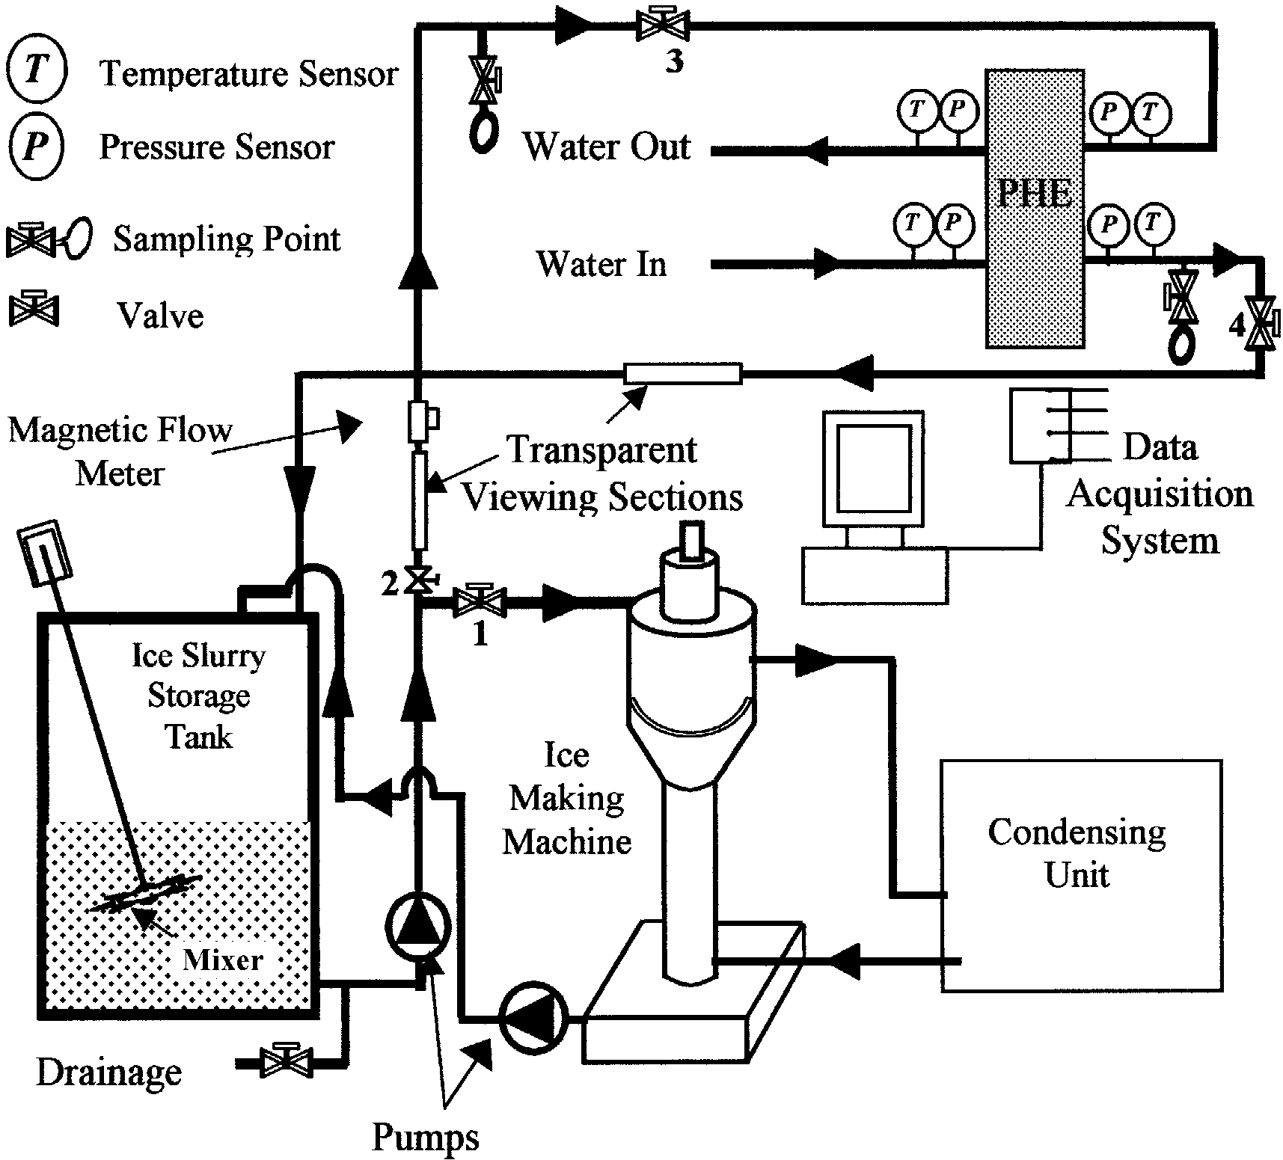

Fig. 1. Schematic diagram of the experimental facility.

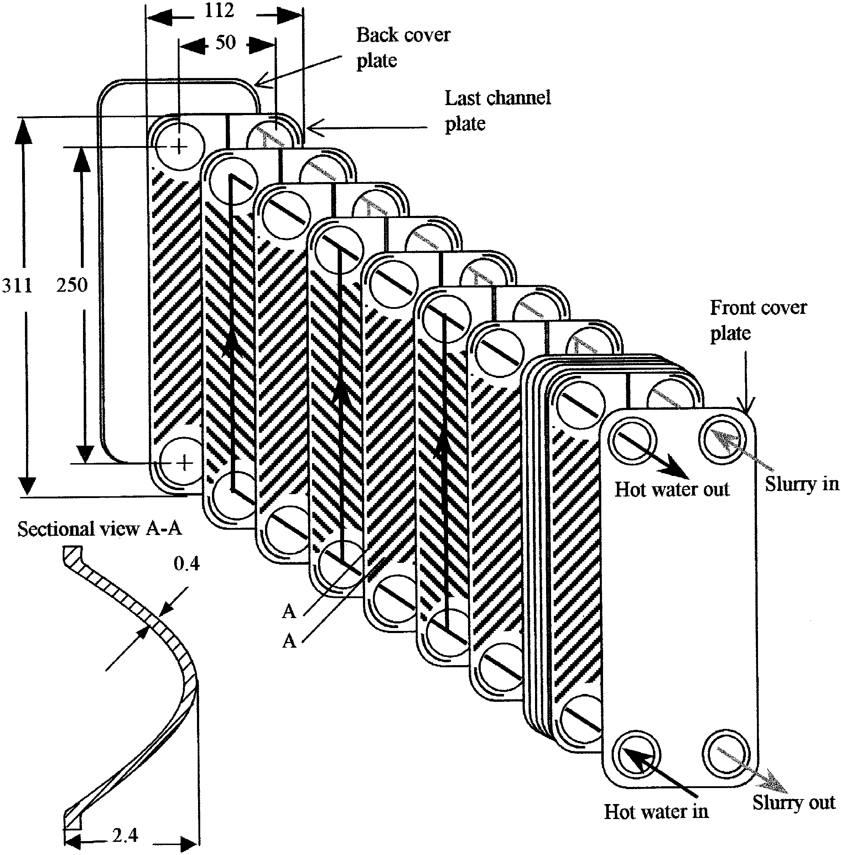

Fig. 2. Schematic diagram of the tested plate heat exchanger (all dimensions in mm).

exchanger (manufactured by Alfa Laval) normally used in traditional secondary loop systems was tested both thermodynamically and hydraulically with ice slurry. The heat exchanger has 24 plates with 11 channels on each side, see Fig. 2. Each plate is 310 mm in height and 112 mm wide. The hydraulic diameter is 4 mm. The entire pipe work and the storage tank are well insulated using Armaﬂex insulating foam.

**2.3. Instrumentation**

As mentioned above, the plate heat exchanger was tested for water to water ﬂow, brine to water ﬂow and ice slurry to water ﬂow. The hot (primary) ﬂuid in the heat exchanger was water obtained directly from the tap. The secondary ﬂuid was either chilled water, brine, or ice slurry. The sec- ondary ﬂuid ﬂow rate was measured upstream of the heat exchanger using an electromagnetic ﬂow meter while the mains water ﬂow rate was measured using a rotameter just before the inlet to the heat exchanger. The temperatures for both ﬂowing ﬂuids were measured at the inlet and the outlet of the heat exchanger using mineral insulated (type-T) thermocouples, see Fig. 1. Two more thermocouples were used to monitor the temperature of the mixture in the storage tank. Pressure drop in the heat exchanger was measured using two pre-calibrated pressure transducers. All the

temperature, pressure and ﬂow rate sensors were connected to a PC based data acquisition system.

**3. Experimental procedure**

Once the percentage of ice in the storage tank reached the desired value (approximately 40%), the slurry generation system was shut down and the mixer inside the tank was operated. This allowed good mixing of the ice/liquid solution, producing a homogeneous mixture throughout the tests. The hot water, at approximately 22 oC, was then allowed to ﬂow through the heat exchanger and the ﬂow rate was adjusted to obtain a 0.7 m3 /h of primary ﬂuid ﬂow. The secondary ﬂuid was then circulated through the heat exchanger and the ﬂow rate adjusted to the desired value using valve 3. Depending on the valve setting, it took between 20 and 60 min to melt all the ice in the system.

During each test the ice fraction was measured using the ﬁltration method. With this method,

the ﬂowing mixture was sampled near the inlet and outlet of the heat exchanger using two separate

3 litre containers. A ﬁlter cloth with 100 lm pores was used to ﬁlter out ice crystals from the

chilled liquid. The ice fraction was determined from the corresponding weight of the ice collected

with the cloth and the chilled solution passed through the ﬁlter. Prior to the sampling, the ﬁlter,

cloth and measuring container were immersed in a mixture of water and ice to keep their tem-

perature very near to the sample temperature so as to prevent ice from melting.

Experimental runs were also performed using chilled water (at approximately 4 oC) at diﬀerent

ﬂow rates. The pressure drop and heat transfer results from these runs would form the bases for

validating and comparing the ice slurry results.

**4. Data reduction**

As mentioned above, single-phase water to water heat transfer tests were initially performed to establish the performance of the heat exchanger with chilled water and validate the results against manufacturer’s published data. In data reduction, calculation of ﬂuid properties was based on the average ﬂuid temperature across each circuit of the heat exchanger. The heat exchanger was in- sulated using Armaﬂex insulation and heat transfer across the walls to the ambient was neglected. Heat balance between the hot and chilled water sides revealed less than 5% diﬀerence between the two values for the range of ﬂows tested i.e.

where

The overall heat transfer coeﬃcient between the two sides was calculated as follows:



where A is the heat transfer area of the heat exchanger and LMTD is the logarithmic mean temperature diﬀerence determined from the inlet and outlet ﬂow temperatures as follows:



The Reynolds number on the cold side is calculated from:



where Dh is the hydraulic diameter given as twice the passage depth, h [11]. Ac is the channel ﬂow area; u, the mean velocity in a single channel determined from the average ﬂow rate, the cross- sectional area and the number of channels in the ﬂow; m_ , the mass ﬂow rate per channel; W, the ﬂow channel width and *ρ* and *μ* are the ﬂuid density and dynamic viscosity based on the average inlet and outlet temperatures on that particular side.

The dynamic viscosity for ice slurry was calculated using the following equation [12]:



where, *i*vol , is the ice fraction in the slurry.

**5. Results and discussion**

**5.1. Pressure drop**

Fig. 3, shows a comparison between single-phase water-to-water heat transfer and the pressure drop results compared with manufacturer’s data.

A very good agreement can be observed between the two sets of results, validating the experimental method. It can also be observed that the overall heat transfer coeﬃcient increases rapidly with ﬂow rate up to 2.0 m3 /h after which the increase ﬂattens out. The pressure drop increases exponentially with ﬂow rate.

Fig. 4 shows the variation of ice slurry pressure drop with ﬂow rate for concentrations of 0%, 5% and 20% ice. The ice fraction in the ﬁgure is the mean of the inlet and outlet ice fractions across the heat exchanger. Also presented in the ﬁgure are pressure drop results for water to water ﬂows for comparison purposes. It can be seen that ice slurry pressure drop is slightly higher than pure water and brine pressure drop. The ice slurry pressure drop increases with ﬂow rate and ice fraction. Increasing the ice fraction from 0% to 20% produced between 15% and 20% increases in pressure drop over a range of ﬂow rates between 1.5and 3.0 m3 /h. The pressure drop results are in line with the ﬁndings of all other investigators apart from Knodel et al. [9] who carried out their experiments with much larger ice particles (average size of 5mm) and found the ﬂuid turbulence and drag eﬀect to reduce with increasing ice fractions.

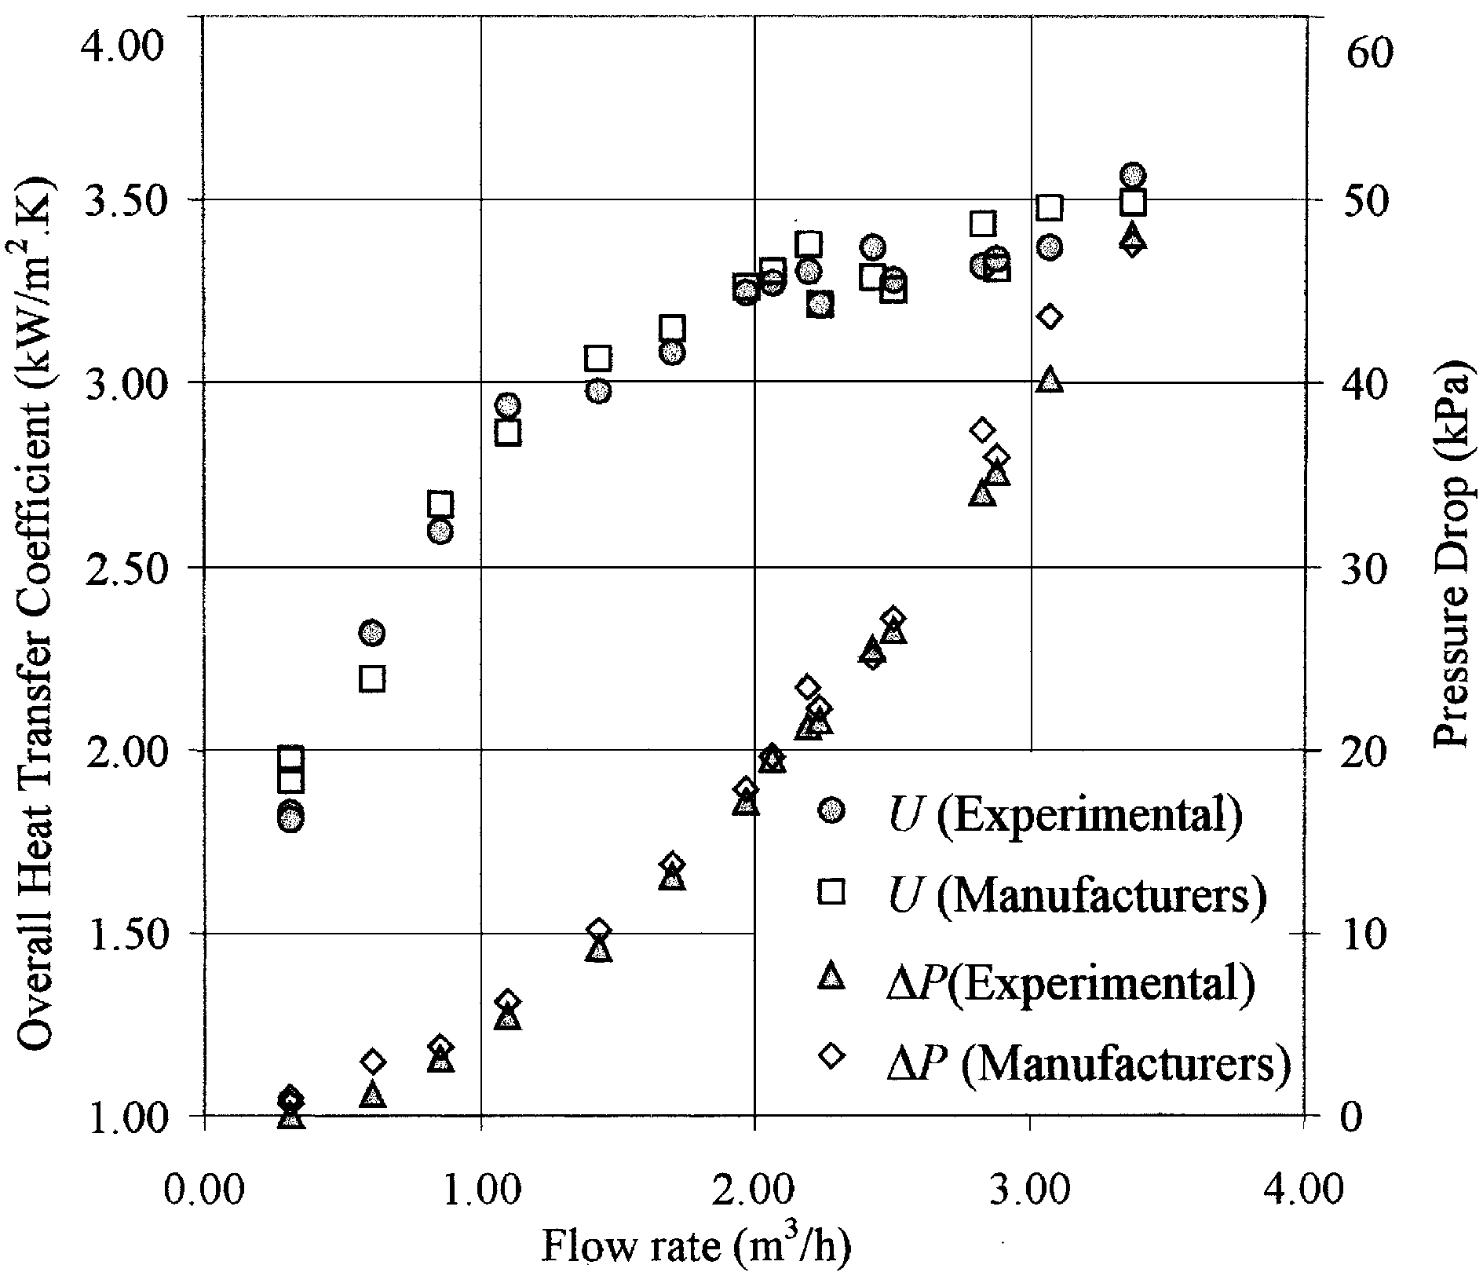

Fig. 3. Comparison between the manufacturer’s design and experimental data for water-to-water loop in the plate heat exchanger.

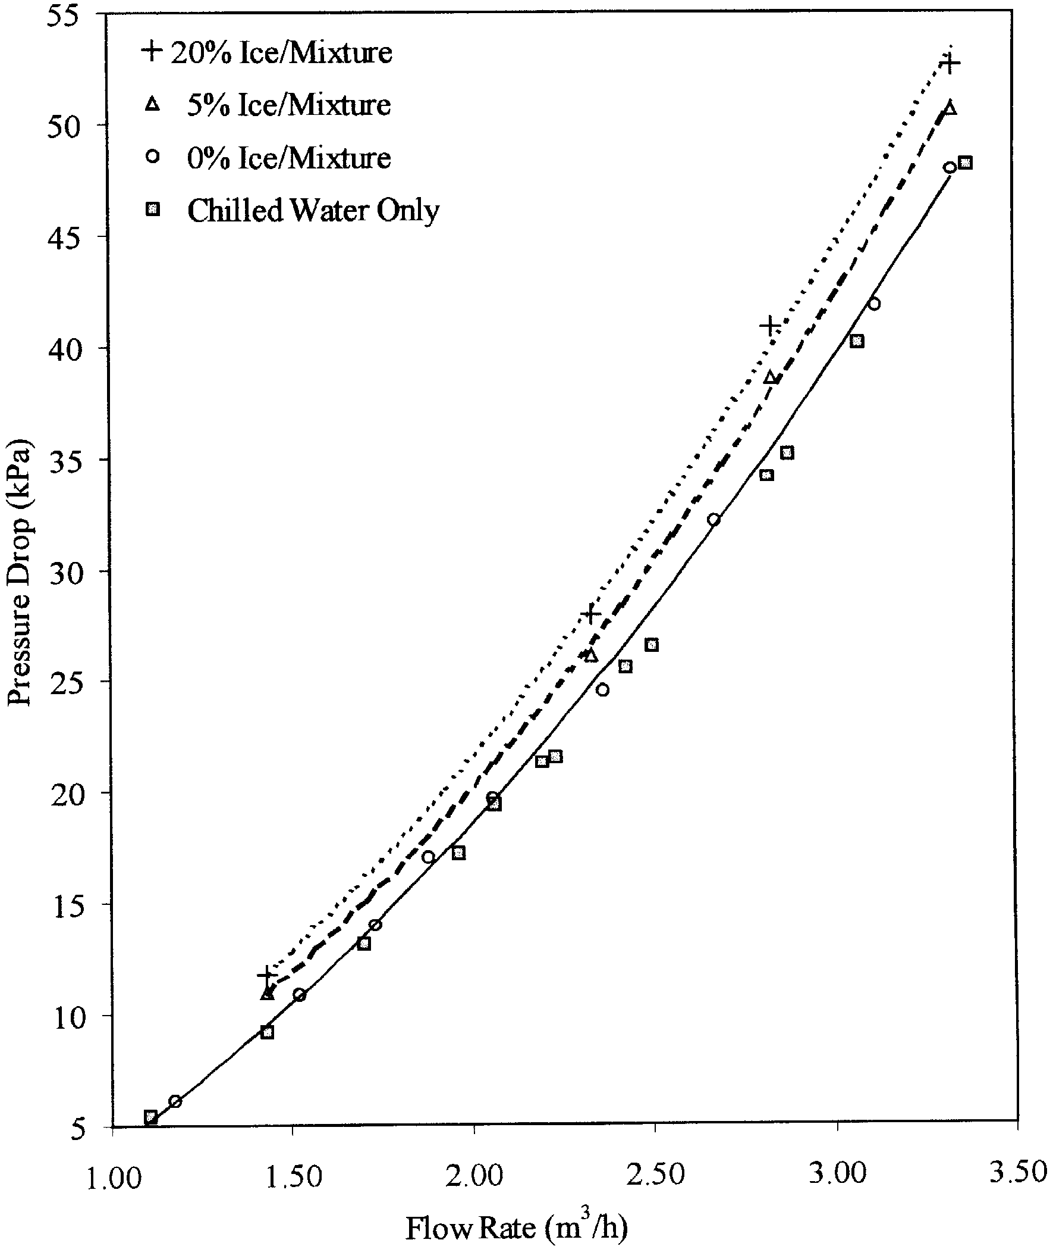

Fig. 4. Variation of pressure drop with ﬂow rate at diﬀerent ice fractions.

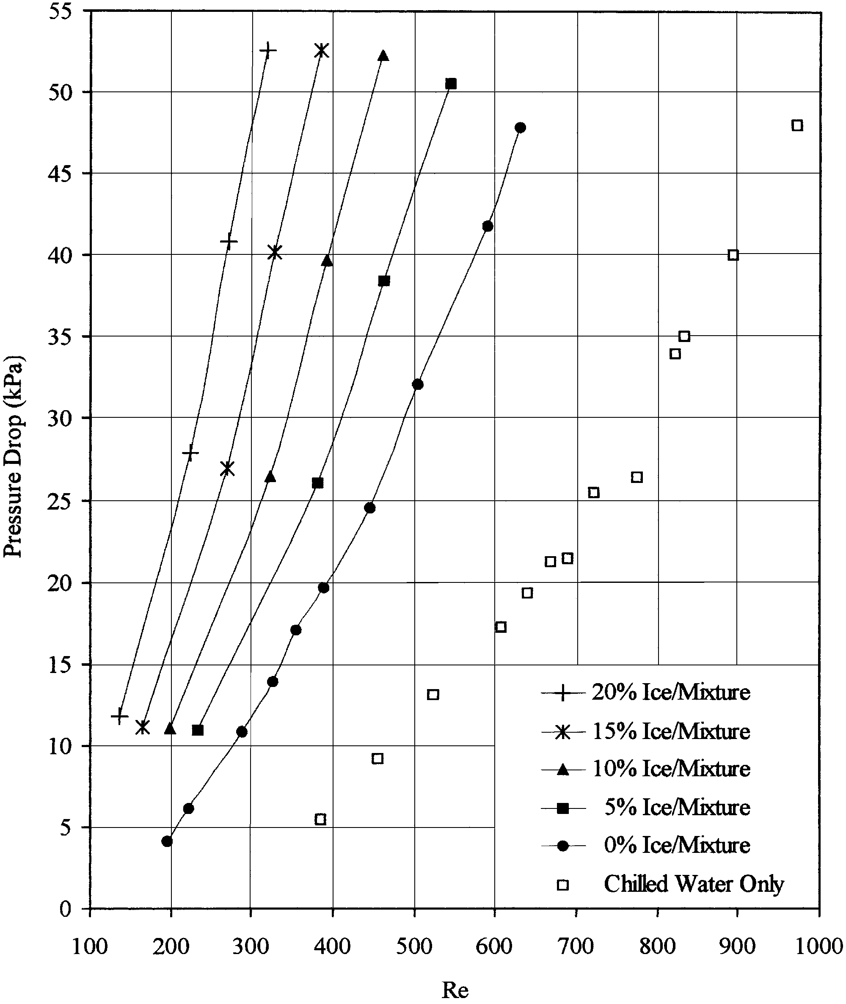

Fig. 5. Pressure drop versus Reynolds number at diﬀerent ice fractions.

Fig. 5, presents the pressure drop results plotted against the Reynolds number as opposed to ﬂow rate. It can be seen that for the same ﬂow rate, the Reynolds number is much lower for the propylene water mixture compared to pure water. The Reynolds number reduces even further as the ice fraction is increased. The reduction of the Reynolds number is mainly due to the increase of the viscosity of the ice slurry as the ice fraction is increased.

5.2. Heat transfer

The eﬀect of melting ice slurry on heat transfer in the heat exchanger is shown in Fig. 6. As can be seen, over the ﬂow rates tested, mean ice fractions between 5% and 20% can lead to a more than 30% increase in the heat transfer capacity of the heat exchange. This increase in the heat transfer capacity compared to single-phase ﬂow can lead to more than 60% reduction in the secondary ﬂuid ﬂow rate for the same load. This can lead to signiﬁcant reductions in both the size of the heat exchangers and pumping power.

Fig. 7 shows a comparison between the overall heat transfer coeﬃcient plotted against ice fraction for diﬀerent ﬂow rates. The results show the overall heat transfer coeﬃcient to increase signiﬁcantly with increasing ice slurry ﬂow rate. As the ice fraction is increased, however, the overall heat transfer coeﬃcient remains fairly constant.

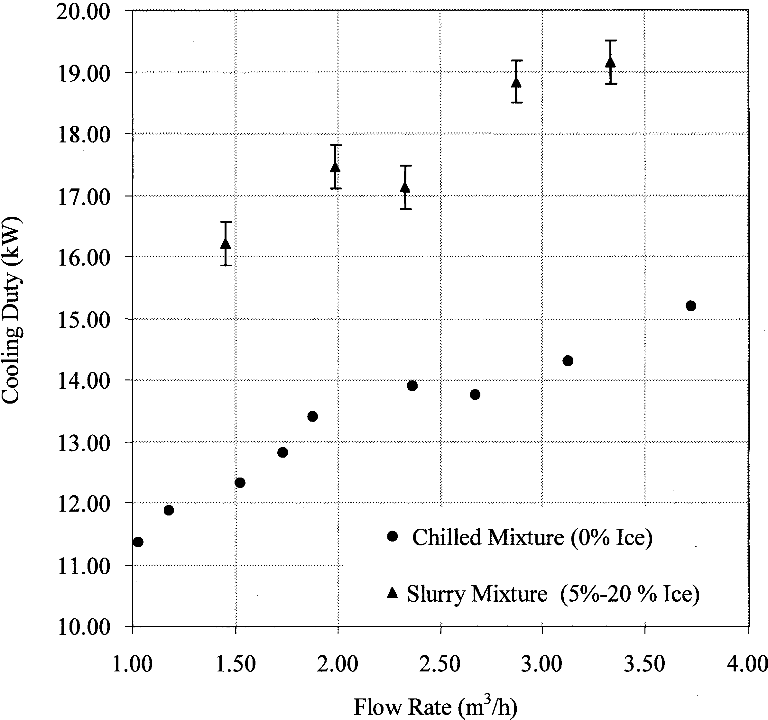

Fig. 6. Comparison between the cooling duty obtained using ice slurry with that obtained using chilled mixture.

**6. Conclusions**

The experiments performed produced several results speciﬁc to 5% propylene water slurries melting in a commercial plate heat exchanger with mean ice fractions between 5% and 20 %. These results can be summarised as follows:

1. The pressure drop was found to increase with increasing ﬂow rate and ice fraction. This is in line with the results of other investigators for ﬁne crystal ice slurries up to 0.6 mm in diameter.

2. With melting ice slurry ﬂow, the heat transfer capacity of the plate heat exchanger was found to increase by more than 30% compared to single-phase liquid ﬂow.

3. The overall heat transfer coeﬃcient of the heat exchanger was found to increase signiﬁcantly with increasing ﬂow rate.

4. For the ﬂow rates tested, variation of ice fraction from 5% to 20% did not have a signiﬁcant eﬀect on the overall heat transfer coeﬃcient. Other investigators have reported either increasing or decreasing heat transfer coeﬃcients with increasing ice fraction. This indicates that the inﬂuence of ice fraction on the overall heat transfer coeﬃcient is a function of the ice crystal size, the Reynolds number and the ﬂow geometry. Further work is required to quantify the eﬀect of these parameters on ice slurry heat transfer.

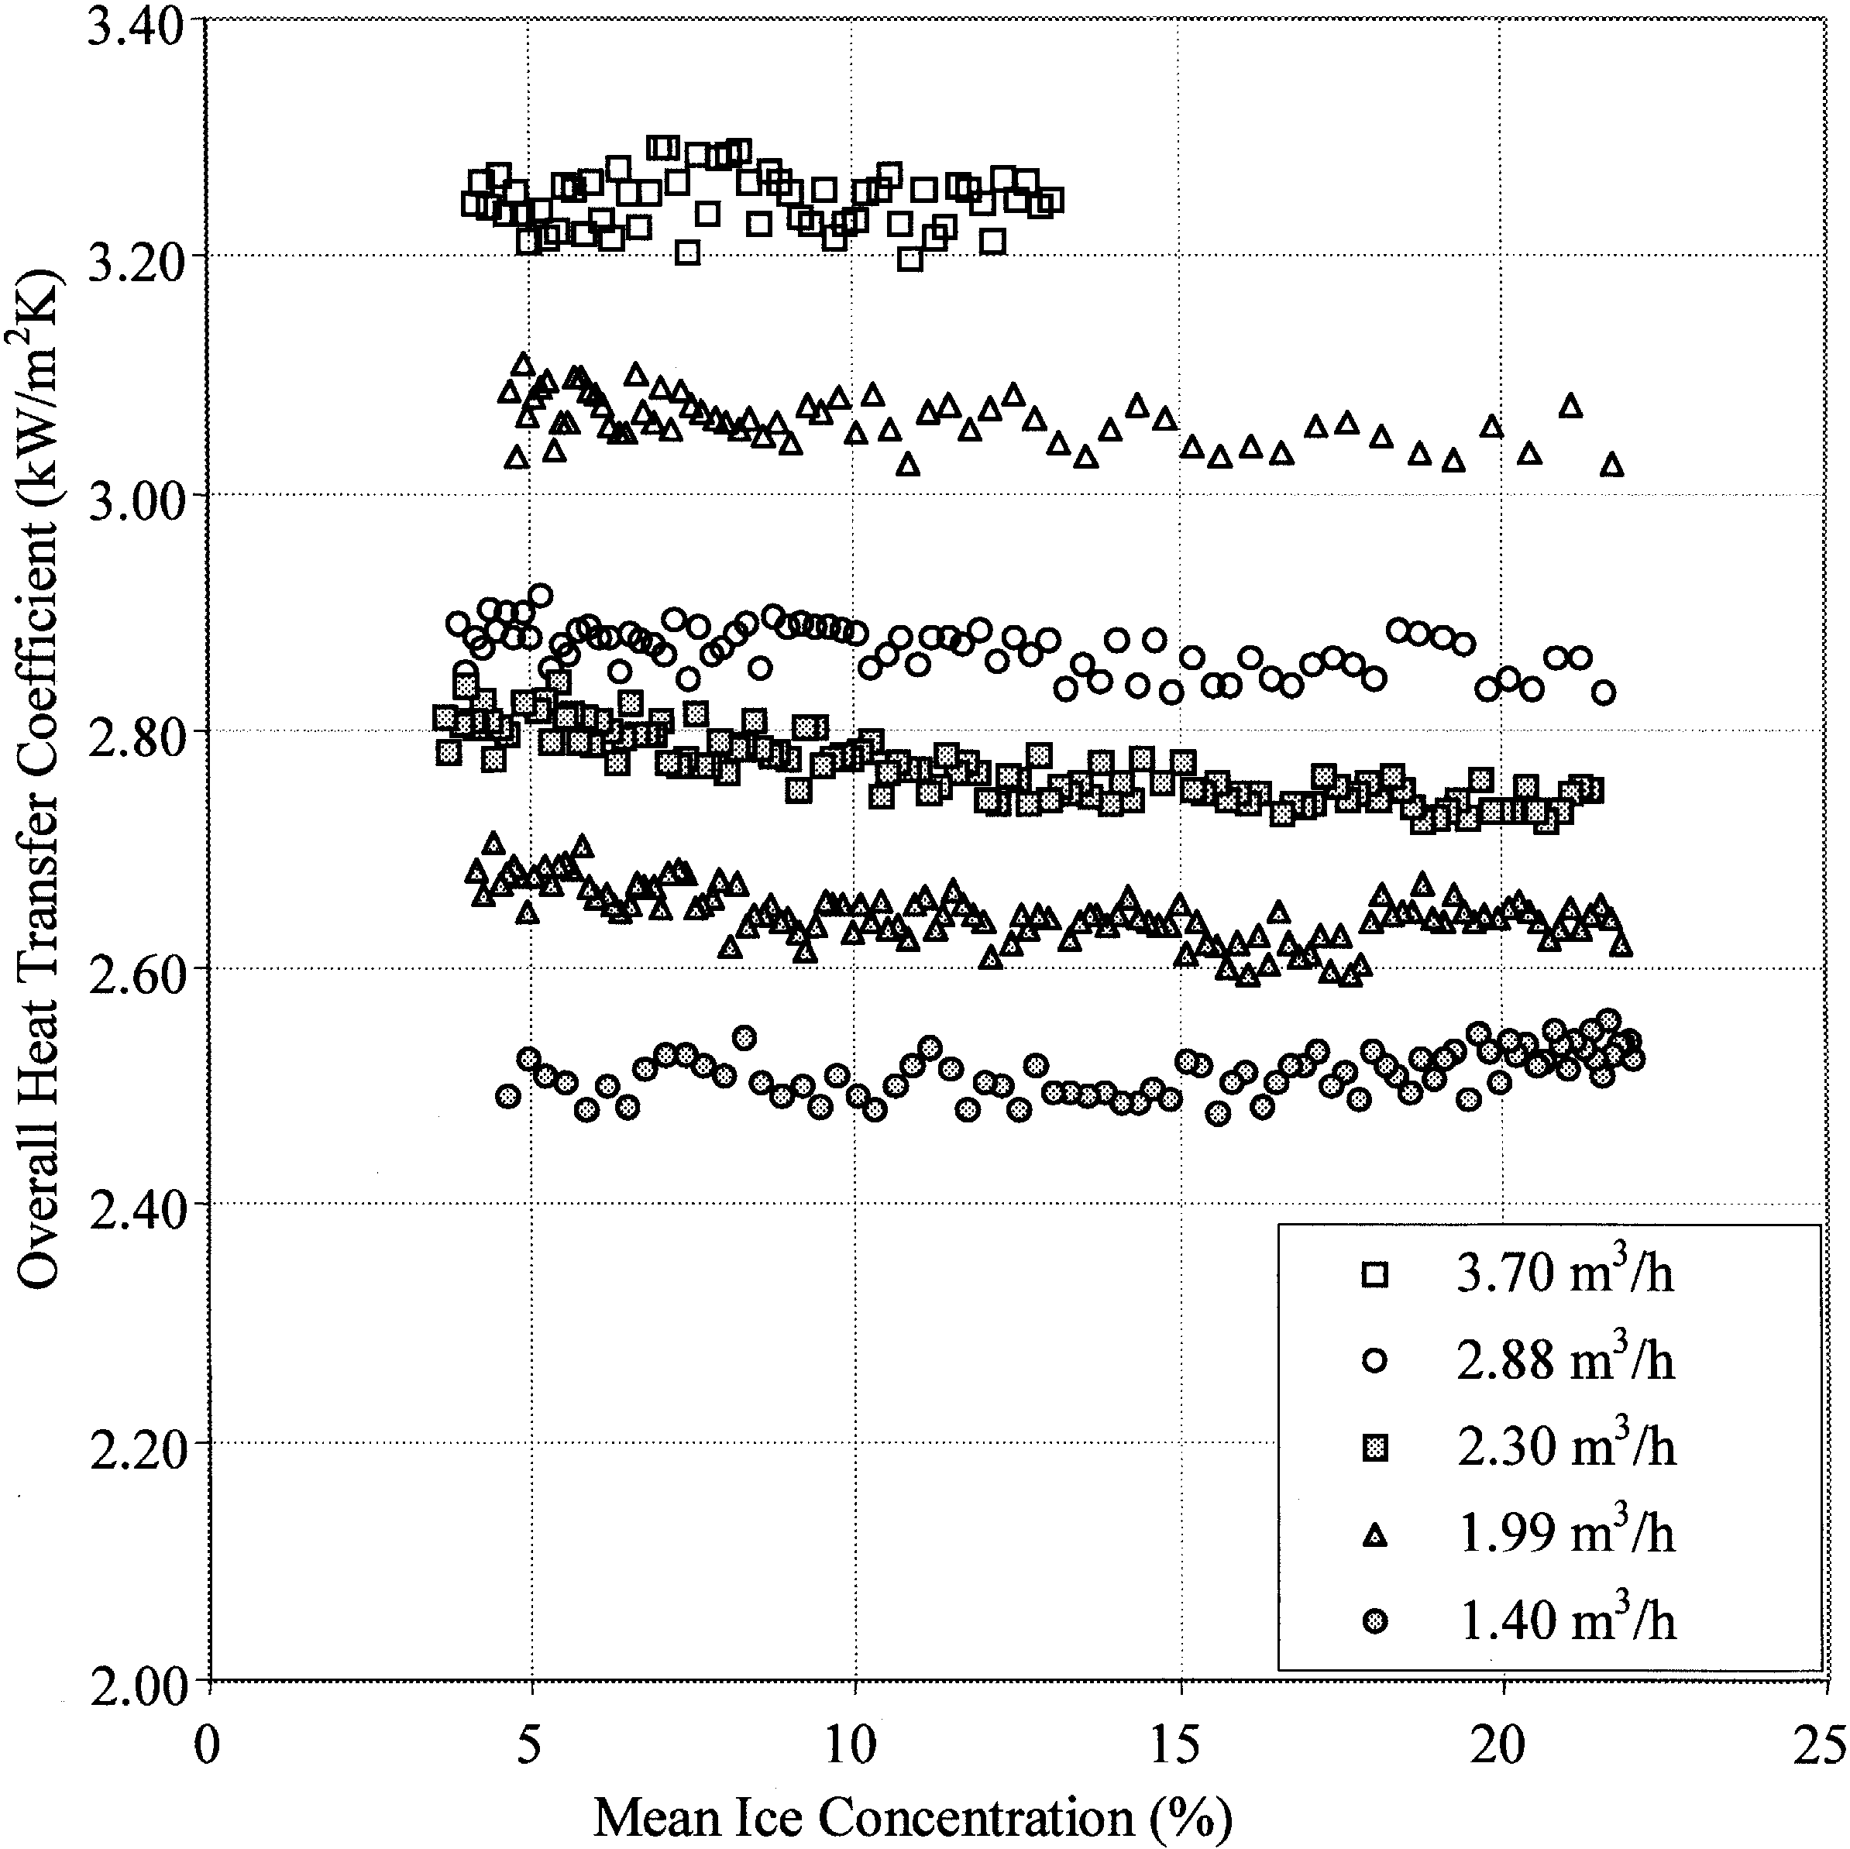

Fig. 7. Variation of overall heat transfer coeﬃcient with ﬂow rate and ice fraction.

**References**

[1] P.W. Egolf, O. Sari, Heat transfer of ice slurries in pipes, Proceedings of the 1st IIR Workshop on Ice Slurries, Yverdon-les-Bains, 27–28 May 1999, pp. 106–123.

[2] A. Sellgren, Paper F3, Proceedings of the 10th International Conference on the Hydraulic Transport of Solids in

Pipes, Innsbruck, Austria, 1986.

[3] P. Metz, P. Margen, The feasibility and economics of slush ice cooling systems, ASHRAE Transactions 932, Part 2

(1987) 1672–1686.

[4] R.P. Gupta, C.A. Fraser, Eﬀect of new friction reducing additive on sunwell ice slurry characteristics, National

Research Council of Canada, Institute of Mechanical Engineering, Low Temperature Laboratory, Report no. TR-

LT-023, NRC no. 32123, 1990.

[5] E. Norgard, A. Sorensen, T.M. Hansen, M. Kauﬀeld, Performance of components of ice slurry systems: pumps,

plate heat exchanger, ﬁttings. Proceedings of the 3rd IIR Workshop on Ice Slurries, Lucerne, 16–18 May 2001, pp.

129–136.

[6] E. Stamatiou, M. Kawaji, B. Lee, V. Goldctein, Experimental investigation of ice-slurry ﬂow and heat transfer in a

plate-type heat exchanger, Proceedings of the 3rd IIR Workshop on Ice Slurries, Lucerne, 16–18 May 2001, pp.

61–68.

[7] E.N. Jensen, K.G. Christensen, H.M. Torben, P. Schneidr, M. Kauﬀeld, Pressure drop and heat transfer with ice

slurry, IIF-IIR Commission B1, B2, E1 and E2 for Purdue University, USA., 2000.

[8] O. Sari, F. Meili, D. Vuarnoz, O.W. Egolf, Thermodynamics of moving and melting ice slurries, Proceedings of the

2nd IIR Workshop on Ice Slurries, Paris, 25–26 May 2000.

[9] C.W. Snoek, J. Bellamy, Heat transfer measurements of ice slurry in tube ﬂow, Experimental Heat Transfer, Fluid

Mechanics and Thermodynamics (1997) 1993–1997.

[10] B.D. Knodel, D.M. Frances, U.U. Choi, M.W. Wambsganss, Heat transfer and pressure drop in ice–water slurries,

Applied Thermal Engineering 20 (2000) 671–685.

[11] R.K. Shah, A.S. Wanniarachchi, Plate heat exchanger design theory, in: J.-M. Buchlin (Ed.), Industrial Heat

Exchangers, Lecture series No. 1991-04, Von Karman Institute for Fluid Dynamic, Belgium, 1992.

[12] D.G. Thomas, Transport characteristics of suspension. VIII. A note on the viscosity of Newtonian suspensions of

uniform spherical particles, Journal of Colloid Science 20 (1965) 267–277.