Journal of Prescribing Practice
A-Z of Prescribing for children

Kate Davies
Associate Professor, Paediatric Prescribing & Endocrinology
London South Bank University

D – Distribution

Distribution is the second part of the pharmacokinetic process after Absorption, and it is here where drugs pass from the bloodstream to the body’s organs and tissues. When prescribing for children, it is important to note that the specific properties of the drug have to be considered alongside the physiological aspects of the child or young person (Eidelman and Abdel-Rahman 2016). The key factor to note with children is the volume of distribution (Vd) to be considered.

The Vd is important as it governs the drug’s loading dose value, and also determines the drug’s half life (Lu and Rosenbaum 2014). The half life of a drug is the time taken for half of the administered drug to be eliminated from the body (Andrade 2022), and is important to consider when calculating when to stop taking medications, or when the next dose is due. However, the total volume of distribution is impacted by total body water percentages, and adipose tissue, which may not directly be related to the child’s weight (Sage, Kulczar et al. 2014). This is also related to whether drugs are water soluble (for example, gentamicin) or fat soluble, like diazepam.

There are great changes in body water components as a child grows (see Figure 1), as there is an increased volume of distribution for water soluble drugs in younger children, compared to older children, due to the increased percentage of total body water (Skinner 2014).

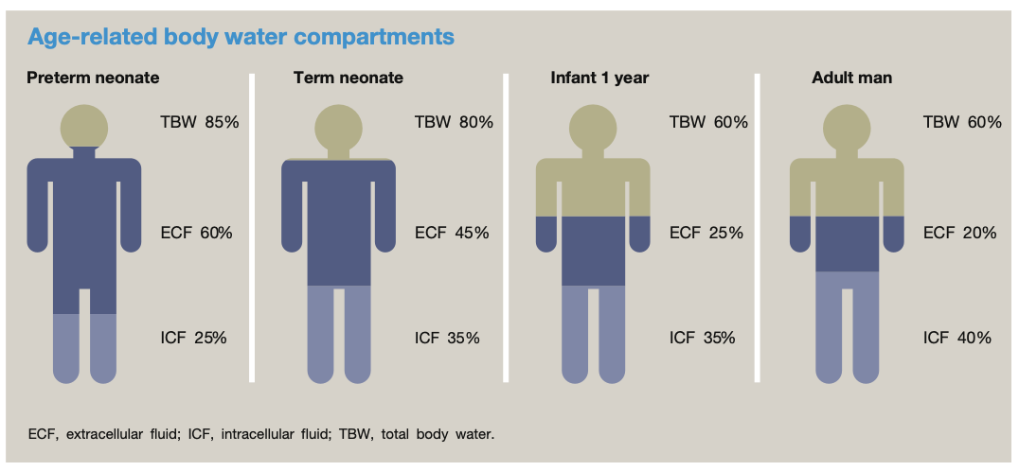
Figure 1: Age-related body water compartments

(Anderson 2017)
Please can this figure be re-drawn more simply, somehow?

This means that as the child gets older, lower doses of water soluble drugs have to be given to avoid toxicity, due to the decline in water as percentage of body weight. Conversely, smaller doses of fat soluble drugs are needed for neonates and infants, as they have much less adipose tissue. The reduced amount of distribution volume for such fat soluble drugs therefore result in lower doses.

It is therefore imperative to think before prescribing any medication as per age related guidelines, as the distribution of the drug that is administered wholly depends on the body composition. Knowledge on the different properties of drugs is also important, such as if drugs are protein binding.

Protein binding is when drugs may bind to plasma proteins, such as albumin, or free fatty acids in the body. The degree that a drug binds to a protein can either detract or enhance a drug’s actual performance (Scheife 1989). An increased level of plasma protein binding can limit a drug’s capability in leaving the bloodstream, therefore limiting the entry to the tissues. This then results in an increase of the half life. Conversely, if a drug is minimally protein bound, there is enhanced tissue penetration, resulting in a shorter half life. However – in paediatrics – physiological and age related variables need to be considered in relation to levels of plasma proteins: for example, newborn babies’ total plasma protein concentrations are 86% of adult values, with protein levels reaching adult values in infancy / early childhood (Batchelor and Marriott 2015), so aspects of protein binding need to be considered more carefully when prescribing for premature infants and newborns.

Disease and / or condition aspects may also have an impact on distribution. Infants with hypoalbuminemia (as seen in nephrotic syndrome), or hyperbilirubinemia can affect protein binding, as well as the presence of sepsis, or a patent ductus arteriosus (Van Overmeire 2001), which can be associated with an increase of volume distribution. Children also presenting with malnutrition or anorexia nervosa, and, conversely, obesity, will also be of importance, as it can be assumed that children with a higher proportion of fat mass can alter the distribution of fat soluble drugs (van den Anker, Reed et al. 2018).

It is therefore clear that aspects of body composition need to be considered when calculating drug doses and regimens, and the influence of a drug’s half life should not be dismissed when prescribing for children.

The next article in the series is E: Excretion

Word count: 641 words

References

Anderson, B. J. (2017). "Neonatal pharmacology." Anaesthesia & Intensive Care Medicine 18(2): 68-74.
Andrade, C. (2022). "The Practical Importance of Half-Life in Psychopharmacology." J Clin Psychiatry 83(4).
Batchelor, H. K. and J. F. Marriott (2015). "Paediatric pharmacokinetics: key considerations." Br J Clin Pharmacol 79(3): 395-404.
Eidelman, C. and S. M. Abdel-Rahman (2016). "Pharmacokinetic considerations when prescribing for children." International Journal of Pharmacokinetics 1(1): 69 - 80.
Lu, H. and S. Rosenbaum (2014). "Developmental Pharmacokinetics in Pediatric Populations." J Pediatr Pharmacol Ther 19(4): 262 - 276.
Sage, D. P., C. Kulczar, W. Roth, W. Liu and G. T. Knipp (2014). "Persistent pharmacokinetic challenges to pediatric drug development." Front Genet 5: 281.
Scheife, R. T. (1989). "Protein Binding: What does it mean?" DICP, The Annals of Pharmacotherapy 23: S27 - S31.
Skinner, A. (2014). "Neonatal pharmacology." Anaesthesia & Intensive Care Medicine 15(3): 96 - 102.
van den Anker, J., M. D. Reed, K. Allegaert and G. L. Kearns (2018). "Developmental Changes in Pharmacokinetics and Pharmacodynamics." The Journal of Clinical Pharmacology 58: S10-S25.
Van Overmeire, B. (2001). "Ibuprofen pharmacokinetics in preterm infants with patent ductus arteriosus." Clinical Pharmacology & Therapeutics 70(4): 336-343.

