Investigations into the thermal performance of a helically coiled closed loop oscillating heat pipe
Yeboah S. K.¹
Centre for Sustainable Energy Technologies (CSET), The University of Nottingham Ningbo China, 199Taikang East Road, Ningbo 315100, PR China
Darkwa J.²
The University of Nottingham, University Park, Nottingham, NG7 2RD, UK

A numerical and experimental investigation has been carried out to evaluate the thermal performance of a helically coiled closed loop oscillating heat pipe (OHP). The OHP was designed to have its condenser and evaporator sections helically coiled to fit around a cylindrical packed bed vessel to offer a wider surface area of contact for enhanced heat transfer via the walls. The numerical investigation was carried out using an explicit Eulerian Volume of Fluid (VOF) model in ANSYS Fluent R15.0. Three working fluids within the required operating temperature range having suitable properties and compatible with copper were used to fill the OHPs to a volume fraction of 0.6. User defined functions (UDFs) were developed for realistic boundary conditions. The numerical results show that the OHPs at different heat inputs were still able to maintain a good temperature difference between the evaporator and condenser sections. The numerical model overall was able to give indication of the internal working conditions of the OHPs. For the experimental study, prototypes of the numerical models were developed and tested under laboratory conditions. Here OMEGA k-type thermocouples were used to obtain temperature data from the evaporator and condenser sections. The experimental results showed that the OHPs had the ability to maintain evaporator – condenser temperature difference at varied heat inputs. Thermal performance was found to be significantly different at start-up for the three working fluids, however overtime only a slight variation in thermal performance was observed at the varied heat inputs. Overall, there was reasonable agreement between experimental and the numerical study.

Nomenclature

- A = tube cross sectional area, m²
- $D_{crit}$ = critical diameter (m)
- $d$ = cell volume
¹ Assistant Professor, Department of Architecture and Built Environment, The University of Nottingham Ningbo China, 199Taikang East Road, Ningbo 315100, PR China, siegfried.yeboah@nottingham.edu.cn.
² Professor of Energy Storage Technologies, Department of Architecture and Built Environment, The University of Nottingham, University Park, Nottingham, NG7 2RD, UK, J.Darkwa@nottingham.ac.uk, AIAA Member.

- g = acceleration due to gravity (m/s²)
- $h_{ext}$ = user specified external heat transfer coefficient
- $k$ = material thermal conductivity (W/mK)
- $L$ = length of the material (m)
- L = Laplace constant which represents the bubble diameter at departure for pool nucleate boiling
- ${\dot{m}}_{pq} and{\dot{ m}}_{qp}$ = the mass transfer between phase q and p
- ${\dot{m}}_{l→v}-{\dot{m}}_{v→l}$ = rates of mass transfer due to evaporation and condensation, respectively ($\frac{kg}{s}/m^{3}$)
- $n$ = local coordinate normal to the wall

- Q = heating power input (W)
- T = temperature (K or °C)
- $∆T$ = temperature difference (K)
- $u$ = velocity magnitude (m/s)
Greek Letters
- $α_{k}$ = volume fraction of phase k
- $α$ = vapour volume fraction
- $α_{q,f}$ = face value of the$q^{th }$ volume fraction, computed from the compressive scheme
- $β$ = slope limiter value
- $β\left|\vec{r}\right|$ = linearly varying pressure
- λ = heat of evaporation (kJ/kg)
- $φ_{f}$ = face VOF value
- $φ_{d}$ = donor cell VOF value
- $∇φ_{d}$ = donor cell VOF gradient value
- $ρ$ = density (kg m⁻³)
- $ρ_{m}$ = mixture density; $ρ_{m}=\sum_{k=1}^{n}{α_{k}ρ_{k}}$
- σ = surface tension (N/m)
- $μ$ = viscosity (kg m⁻¹ s⁻¹)
- $μ_{m}$ = viscosity of the mixture; $μ_{m}=\sum_{k=1}^{n}{α_{k}μ_{k}}$

Subscripts
- a = adiabatic
- c = condenser
- e = evaporator
- $coeff$ = coefficient that needs to be fine-tuned and can be interpreted as a relaxation time
- l = liquid
- v = vapour
- W = wall

Introduction
Oscillating/Pulsating heat pipes (PHP/OHP) are two phase heat transfer devices that offer enhanced heat transfer through oscillatory flow of liquid slug and vapour plug in a long wickless miniature tube (capillaries) bent into many turns. Developed by Akachi ¹ in the early 1990s, their basic operational principle involves the pulsating/oscillating movement of working fluid and phase change phenomena²⁻⁴. Surface tension predominate the two-phase flow, hence a critical diameter, $D_{crit}$ is required to be satisfied in their design to ensure that the surface tension forces dominates gravitational forces for distinct vapour bubbles and liquid slugs to form^{5,6}. Other than that the working fluid will settle down by gravity and the device will no longer be a pulsating/oscillating heat pipe but instead, it will function as an interconnected array of two-phase gravity assisted thermosyphons, with pool boiling dynamics primarily governing its performance ⁷.
Their wickless structure does not make them susceptible to entrainment limit, however boiling limit is likely and can manifest itself through overheating of the evaporator due to the lack of cooling working fluid tending to a dry-out eventually. Therefore, to enhance the heat transfer rate and sustain higher heat loads without dry-out, the evaporator length should in principle be no larger than that of the condenser ⁸. According to Qu and Wang ⁸ for the same heat load on an OHP, a shorter evaporator length translates to higher heat flux and higher evaporator temperature, increasing the temperature difference between the evaporator and condenser. The adiabatic length is also found to have considerable effect on thermal performance⁹. For instance, Arab et al¹⁰ found the adiabatic length an important parameter that needs to be decreased. Sukchana and Jaiboonma¹¹ on the other hand found that fill ratios have significant effect on the thermal efficiency than adiabatic length. According to Chiang et al¹² for closed-loop pulsating heat pipes the adiabatic region between the evaporator and condenser is optional in terms of practical application as the evaporators and condensers are the regimes of the received and removed heat, respectively during normal operation. Studies by Lin et al¹³ on the other hand shows that the inner diameter has a greater impact on the thermal performance than the heat transfer length.
For OHPs, other operating characteristics also affects their thermal performance. For instance, Khandekar et al⁷ found that closed loop pulsating heat pipes (CLPHP) cannot satisfactorily operate in the horizontal orientation and vice versa when the number of turns is below a critical value. Charoensawan et al ¹⁴ concluded that a certain critical number of turns are required to make horizontal operation possible and also to bridge the performance gap between vertical and horizontal operation attributed to the increase in the level of internal perturbations. Investigations carried out by Khandekar and Groll¹⁵ shows that if the number of turns of a CLPHP is small, then the heat handled by each turn will be quite high; if it is increased at constant fill ratio and heat power input, then the net heat handled by each CLPHP turn reduces. Mameli et al¹⁶ also observed many advantages of their nine turn CLPHP over their three turn one in terms of its ability to also work in the horizontal heating mode, lower thermal resistance and less evident differences between different fluids in terms of overall efficiency. Mameli et al¹⁷concluded that the performance of PHP with simple geometry, especially the low number of turns, is heavily affected by the inclination of the device with respect to gravity.
The effect of inclination angle essentially reflects the influence of gravity on OHPs/PHPs⁵. Qu et al⁵ found that the effect of gravity cannot be ignored as they observed the best thermal performance occurring at the vertical bottom heating mode orientation with thermal resistance increasing as their micro pulsating heat pipes (MPHP) moved towards horizontal orientation. Jahani et al¹⁸ also showed that the thermal resistance increases in the horizontal heating mode in comparison to the vertical heating mode since in the horizontal heating mode the gravitational force modifies the shape of the bubbles and drops inside the tube and disarranges their symmetry. Smoot et al¹⁹ tested OHPs vertically with the evaporator at the bottom and found that the heat transfer performance was much better than that tested horizontally. Lin et al²⁰ observed lowest thermal resistance for an aluminium plate OHP at vertical bottom heating mode and the worst performance for top heating mode. Thompson et al²¹ found that when the heating area is larger at the same input power, the heat pipe is less orientation-dependent and when the heating area is decreased, the thermal resistance and peak-to-peak amplitudes of temperature oscillations in the evaporator increases.
The selection of the appropriate working fluid is also critical to the performance of OHPs as they utilize phase change of the working fluid to transport heat ²². The working fluid, the heat transport medium, should be compatible with the heat pipe materials, have good thermal conductivity, stability, high latent heat of evaporation, high surface tension, low liquid and vapour viscosities, good wettability, reasonable vapour pressure over operating temperature range and suitable freezing point ²³. Han et al ²⁴observed that for the same fill ratio the PHP charged with the working fluid of lower boiling point and lower latent heat of vaporization was susceptible to dry out. Yin and Ma²⁵ found that the heat transfer coefficient of oscillating flow in a capillary tube depends on the fluid properties and oscillating waveform, with triangular waveform of oscillating motion showing higher heat transfer coefficient. Peyghambarzadeh et al²⁶ studied the thermal performance of a dual diameter circular heat pipe using three different working fluids and found that different working fluids influenced the thermal performance of the heat pipe. Pachgharea and Mahalleb ²⁷ experimentally studied the effects of pure and binary mixture working fluid on the thermal performance a closed loop pulsating heat pipe and found that working fluid behaviour strongly depends on the thermophysical properties, with latent heat of vaporization the main property that strongly affects the thermal performance.
Since the optimal performance of OHPs is affected by numerous factors ranging from their design parameters to their operating conditions, various considerations are required in their design. To this end, it is crucial theoretical studies precede experimental prototype development in order to limit trial and error as optimum thermal performance of OHPs cannot be ascertained a priori. In this study, helically coiled copper OHPs designed to fit around a cylindrical packed bed vessel to offer a wider surface area of contact for enhanced passive heat transfer are numerically and experimentally investigated to evaluate their performances. For the numerical study, the investigation was carried oust using an Eulerian Volume of Fluid (VOF) model in ANSYS Fluent R15.0, a commercial computational fluid dynamics (CFD) software. Prototypes of the system developed from parameters used for the numerical studies were then used to evaluate the experimental performance.

Numerical Modelling and Simulation of the Oscillating Heat Pipe (OHP)

Physical and Geometrical Models
For the numerical investigation, the OHP was designed as a 3D model in Rhinoceros 5 (See Figure 1a) and imported into ANSYS Workbench for geometry clean up, meshing and analysis (See Figure 1b). The material specified was copper tube with internal diameter of 2mm (See Table 1 for OHP design specifications). For simplicity in the modelling process, the adiabatic section was omitted in accordance with assertions by Chiang et al ¹² highlighted in the introduction.
The OHP is essentially a single loop oscillating heat pipe with the condenser and evaporator sections helically coiled to fit around a cylindrical packed bed for enhanced passive heat transfer. It is designed to reject heat at the condenser into the ambient environment once heat is input at the evaporator via the walls of the packed bed. Per the investigations by Qu and Wang ⁸, the evaporator and the corresponding condenser sections were designed to be the same size coupled with the fact that the OHP is reversible hence the condenser and evaporator is determined by the coil where heat is input or rejected.
 | 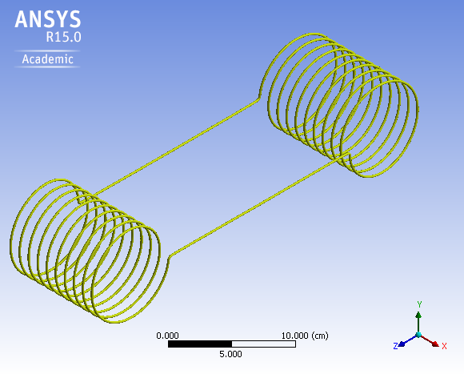
Figure 1a. Physical Model of OHP Designed in Rhinoceros 5. | Figure 1b. 3D Geometrical Model in ANSYS Design Modeler R15.0.
Based on the working temperature range of the packed bed system which the OHP would be integrated with, the merit number and also the compatibility with the heat pipe material; water was chosen as the main reference working fluid. Two other working fluids namely ethanol and methanol with similar operating temperature ranges and compatibility with copper were used to compare to the water based OHP.
Table 1. Specifications for The Helically Coiled Oscillating Heat Pipe.
Parameter | Value | Units
Inner Diameter | 2 | mm
Thickness | 1 | mm
Diameter of Coil | 8 | cm
Length of Coil | 10 | cm
Number of Turns | 10 | -
Pitch | 0.857143 | -

The Meshed Model
The mesh was a mix of hexahedral, tetrahedral, quadrilateral and triangular type meshes (See Figure 2). According to the ANSYS Fluent²⁹ literature surface tension effects are deemed not as accurate on triangular and tetrahedral meshes as on quadrilateral and hexahedral meshes, however the helical coils of the evaporator and condenser sections generated high order Non-Uniform Rational Basis Spline (NURBS) with many knot insertions which presented significant difficulties in meshing. Without the NURBS, the helical shape was not possible to maintain. This difficulty also was one of the key reasons the number of turns for the helical coils was ten (10) as beyond that the mesh quality was extremely poor with a large number of elements which the ANSYS academic license does not support. The mesh statics is presented on Table 2.
Figure 2. Section of the Meshed Model of OHP in ANSYS R15.0.
Table 2. Mesh Statistics.
Nodes | 11097
Elements | 16684
Mesh Metric | Orthogonal Quality
Min | 0.47956838481876
Max | 0.987901289871883
Average | 0.913829429235315
Standard Deviation | 4.98220420738575E-02

Governing Equations
The VOF model tracks the interface between phases via a continuity equation for the volume fraction given by ²⁹ equation (23);
$\frac{1}{ρ_{q}}\left[\frac{∂}{∂t}\left(α_{q}ρ_{q}\right)+∇.\left(α_{q}ρ_{q}{\vec{v}}_{q}\right)=S_{αq}+\sum_{p=1}^{n}{\left({\dot{m}}_{pq}-{\dot{m}}_{qp}\right)}\right]$
(23)
The density in each cell is determined according to;
$ρ=α_{2}ρ_{2}+\left(1-α_{2}\right)ρ_{1}$
(24)
In the general form, the volume fraction averaged density is
$ρ=\sum{α_{q}ρ_{q}}$
(25)
ANSYS Fluent solves the Momentum equation by:
$\frac{∂}{∂t}\left(ρ\vec{v}\right)+∇.\left(ρ\vec{v}\vec{v}\right)=-∇p+∇.\left[μ\left(∇\vec{v}+∇{\vec{v}}^{T}\right)\right]+ρ\vec{g}+\vec{F}$
(26)
The energy equation for the phases is given by:
$\frac{∂}{∂t}\left(ρE\right)+∇.\left(\vec{v}\left(ρE+p\right)\right)=∇.\left(k_{eff}∇T\right)+S_{h}$
(27)
For the VOF model, energy E and temperature T are mass averaged variables determined as follows:
$E=\frac{\sum_{q=1}^{n}{α_{q}ρ_{q}E_{q}}}{\sum_{q=1}^{n}{α_{q}ρ_{q}}}$
(28)

Surface Tension

The VOF model also included the effects of surface tension along the interface between each pair of phases. For the Continuum Surface Force (CSF) Model in ANSYS Fluent, the pressure drop across the surface depends on the surface tension coefficient and the surface curvature measured by two radii in orthogonal directions ²⁹.
$p_{2}-p_{1}=σ\left(\frac{1}{R_{1}}+\frac{1}{R_{2}}\right)$
(29)
The CSF is computed from local gradients in the surface normal (n)
$n=∇α_{q}$
(30)
The curvature $κ$ is
$κ=∇.\hat{n}$
(31)
Where
$\hat{n}=\frac{n}{\left|n\right|}$
(32)
The surface tension can be written in terms of the pressure jump across the surface with the force at the surface expressed as a volume force using the divergence theorem ²⁹.
$F_{vol}=\sum_{pairs ij, i<j}{σ_{ij}}\frac{α_{i}ρ_{i}{ κ}_{j}∇α_{j}+α_{j}ρ_{j}{ κ}_{i}∇α_{i}}{\frac{1}{2}\left(ρ_{i}+ρ_{j}\right)}$
(33)
For two phases ${ κ}_{i}=-{ κ}_{j}$ and $=∇α_{i}-∇α_{j}$, hence we have
$F_{vol}=σ_{ij}\frac{ρ{ κ}_{i}∇α_{i}}{\frac{1}{2}\left(ρ_{i}+ρ_{j}\right)}$
(34)

The Evaporation – Condensation Model

ANSYS Fluent ²⁹ solves the liquid-vapour mass transfer (evaporation and condensation) equation using the Lee³⁰ Model governed by equation (35):
$\frac{∂}{∂t}\left(αρ_{v}\right)+∇.\left(αρ_{v}{\overset{⃑}{V}}_{v}\right)={\dot{m}}_{l→v}-{\dot{m}}_{v→l}$
(35)
$if T_{l}>T_{sat}$then the mass transfer can be described by
${\dot{m}}_{l→v}=coeff×α_{l}ρ_{l}\frac{\left(T_{l}-T_{sat}\right)}{T_{sat}}$
(36)
$if T_{v}<T_{sat}$then the mass transfer can be described by
${\dot{m}}_{v→l}=coeff×α_{v}ρ_{v}\frac{\left(T_{v}-T_{sat}\right)}{T_{sat}}$
(37)
During evaporation, the vapour pressure and temperature of the working fluid is independent of volume ³¹. The relationship between the temperature and vapour pressure of the working fluid can be expressed using Clausius-Clapeyron equation ³². The saturation temperature of the working fluids was calculated using the integrated form of the Clausius-Clapeyron equation given by equation (38);
$ln\frac{p_{2}}{p_{1}}=\frac{h_{fg}}{R_{g}}\left[\frac{1}{T_{1}}-\frac{1}{T_{2}}\right]$
(38)

Periodic Condition

The oscillations were simulated using the stream-wise periodic condition which ANSYS Fluent ²⁹ defines as the pressure drop between modules;
$∆p=p\left(\vec{r}\right)-p\left(\vec{r}+\vec{L}\right)=p\left(\vec{r}+\vec{L}\right)-p\left(\vec{r}+2\vec{L}\right)=….$
(39)
Since the pressure based solver was used, the local pressure gradient decomposed in to;
- The gradient of a periodic component, $∇\tilde{p}\left(\vec{r}\right)$
- And the gradient of a linearly varying component $β\frac{\vec{L}}{\left|\vec{L}\right|}$
$∇p\left(\vec{r}\right)=β\frac{\vec{L}}{\left|\vec{L}\right|}+∇\tilde{p}\left(\vec{r}\right)$
(40)
$β$ is not known a priori and the PISO algorithm was used to correct in the pressure correction step where the value was updated based on the difference between the desired mass flow rate and the actual mass flow rate.

Convective Heat Transfer Boundary Conditions

At the walls, convective heat transfer coefficient boundary conditions were specified. ANSYS Fluent²⁸ uses inputs for the external heat transfer coefficient and external heat sink temperature to compute the heat flux to the wall as;
$q=h_{ext}\left(T_{ext}-T_{w}\right)$
(41)
ANSYS Fluent ²⁹ computes the fluid side heat transfer coefficient at the walls using the Fourier’s law applied to the wall as shown in equation (42)
$q=k_{f}\left(\frac{∂T}{∂n}\right)$
(42)

Simulation Method
The Eulerian Volume of Fluid (VOF) model in ANSYS Fluent R15.0 has been used to numerically evaluate the thermal performance of a helically coiled closed loop oscillating heat pipe (OHP) system. The OHPs were filled to a fill ratio of 0.6 with three different working fluids namely ethanol, methanol and water, all suitable for the operating temperature range of interest. In the setup process, the evaporation and condensation frequency was left at the default settings however the saturation temperatures were determined for individual working fluids at the relevant working pressure using equation (38). Constant contact angles values were updated for respective working fluids with user defined (UDF) temperature dependent surface tension functions hooked in the phase interaction zones or all three OHPs. Before initialization, text user interface (TUI) commands were used to activate the temperature dependent surface tension. The model was set to have gravitational force, -9.81m/s, working in the y direction.
Due to the evaporation and condensation of the working fluid during operation, the Phase Localized Compressive Scheme was applied to model the diffused and sharp interfaces in those regimes. Here, a slope limiter value of 2 was chosen for the compressive scheme. This represented a maximum compression with respect to the degree of compression/anti-diffusion for this approach as recommended in ANSYS Fluent ²⁸.
The translational periodic condition was set in the x direction and the relevant pressure gradient and bulk temperature of 298K updated. The maximum velocity for the translational motion was set to 1m/s. The Pressure-Implicit with Splitting of Operators (PISO) pressure-velocity coupling scheme was then used to solve the related transport equations for the model. By default, a compressive scheme was used to obtain the face fluxes.
The heat input was via the evaporator wall. Here constant volumetric heat generation rate in W/m³ determined from the chosen heat input power and the cell volume of the evaporator was used. Here the evaporator heat input power corresponded to 20W, 40W and 60W as shown on the legends on the plots in Figures 3 to 8. Convective wall boundary condition was then set for both the evaporator and condenser walls using a temperature profile UDF. The simulation was initialized at the evaporator condition with the volume fraction patched to the evaporator and condenser fluid zones.
A time step size of 3.351482e⁻⁰⁸s for 350 time steps was then used for this transient simulation. This provided a perspective of about 1.2e-05s of the OHPs performances.

Numerical Results
For simplicity in the numerical study, each test was distinguished with heat input power for the cell volumetric heat generation rate used at the evaporator wall. The results obtained for the three OHPs were then compared in ANSYS CFD post. In the presentation of the numerical results, EOHP represents the ethanol OHP, MOHP the methanol OHP and WOHP the water OHP. The plots presented subsequently shows the parameter of interest on the y-axis and on the x-axis the physical time in seconds.

OHP Wall Temperature
Figures 3a-f shows the evaporator and condenser temperatures of the three OHPs subjected to the respective heat inputs. In Figures 3a, 3c and 3e, the varied heat inputs clearly result in varied evaporator temperatures with the evaporator temperatures increasing with increasing evaporator heat inputs. Here for the same evaporator heat input, the rise in evaporator temperature was higher for the EOHP, followed by MOHP with the evaporator for the WOHP showing a significantly lower temperature compared to the other two. The difference in the evaporator temperatures between the three OHPs increased with increasing power input.
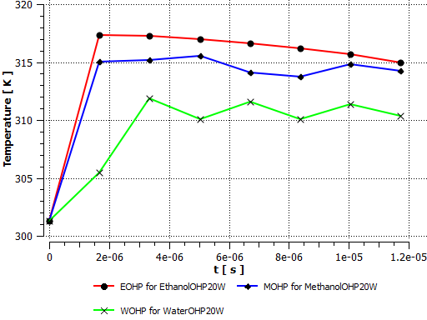 | 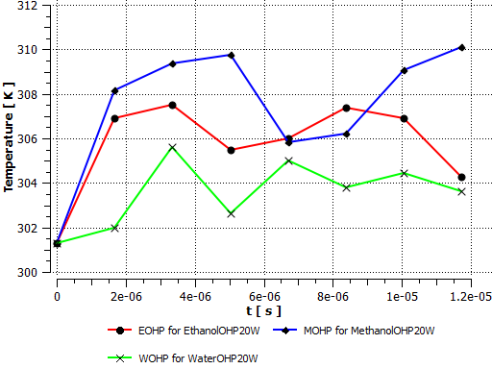
Figure 3a. Evaporator Temperature. | Figure 3b. Condenser Temperature.
The condenser temperature on the other hand was slightly different (see Figures 3b, 3d and 3f). Here at the varied evaporator heat inputs, the MOHP overall exhibited a slightly higher condenser temperature than the EOHP and the WOHP. For all the condensers, regardless of the heat inputs, they maintained similar temperature profiles. Hence the as the heat input increased a wider evaporator – condenser temperature difference was observed.
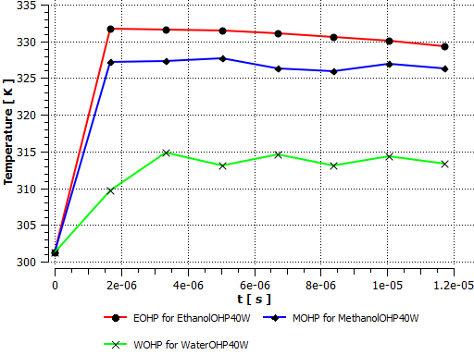 | 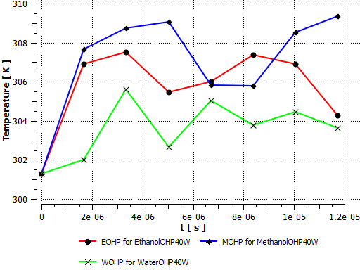
Figure 3c. Evaporator Temperature. | Figure 3d. Condenser Temperature.

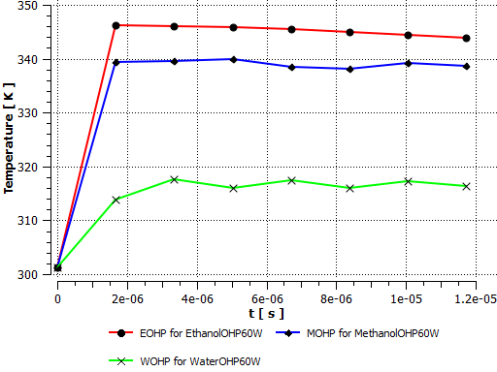 | 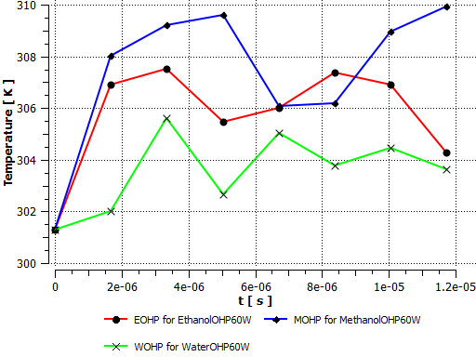
Figure 3e. Evaporator Temperature | Figure 3f. Condenser Temperature
Overall, as shown in Figures 3a-f, the EOHP was able to maintain a wider evaporator – condenser temperature difference with the WOHP maintaining the least.

OHP Heat Flux
The wall heat flux was computed by ANSYS Fluent using equation (41). At the evaporators, the constant heat source resulted in a steady increase in the evaporator heat flux to a maximum steady heat flux value throughout the simulation (see Figures 4a, 4c and 4e). In Figures 4a-f, the wall heat flux at the condensers for all the OHPs were significantly lower than at their respective evaporators.
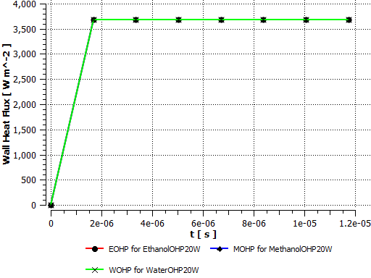 | 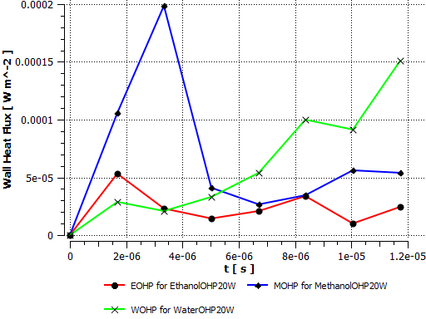
Figure 4a. Evaporator Wall Heat Flux. | Figure 4b. Condenser Wall Heat Flux.
In the condenser section, the profiles in Figures 4b, 4d and 4f shows the wall heat flux for WOHP gradually increase with time regardless of the power input. For the EOHP and MOHP, the trend is however different as they initially increase in the first few seconds to a maximum before gradually declining.
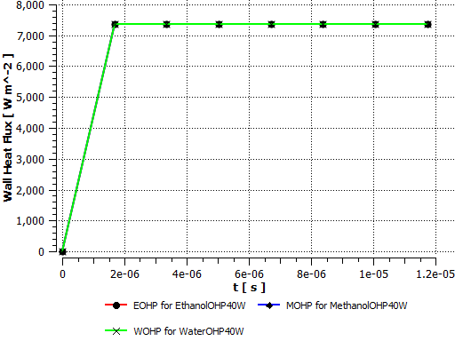 | 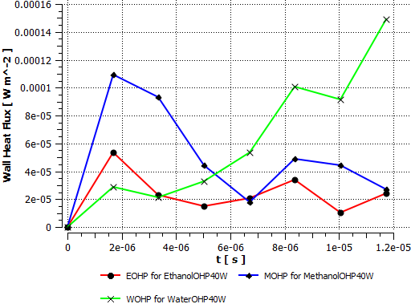
Figure 4c. Evaporator Wall Heat Flux. | Figure 4d. Condenser Wall Heat Flux.

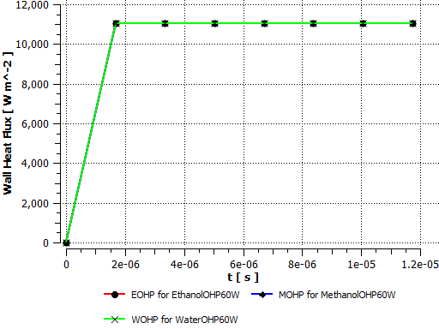 | 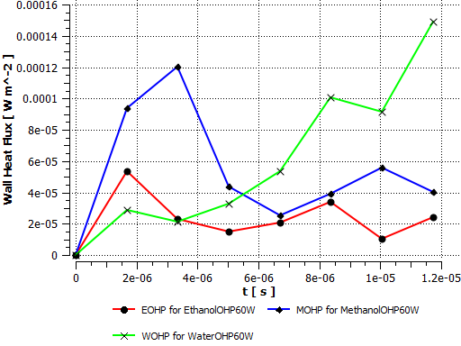
Figure 4e. Evaporator Wall Heat Flux. | Figure 4f. Condenser Wall Heat Flux.

OHP Internal Velocity
The velocity of the working fluid gave an indication of the start-up of the OHPs on heat input. Before the simulation begun, the OHPs were initialized at velocity of 1m/s. However, as the heat was transferred to the working fluid from the walls over time, the internal velocity of the working fluid, in this case the pulsating of the liquid slugs and vapour plugs begun. In Figures 5a-f, the profiles show the velocity of the working fluid gradually increases in both the condenser and evaporator on heat input. The rate at which this increase occurs was similar in both the condensers and evaporators. For the EOHP and MOHP, their velocities were similar and higher in both evaporator and condenser compared to the WOHP. In the evaporators, the plots also show a slightly higher velocity than in the condensers.
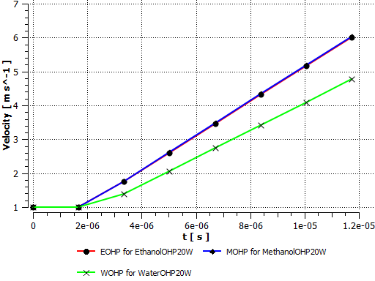 | 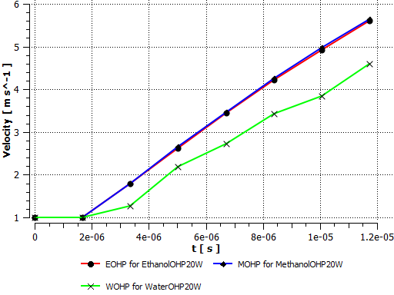
Figure 5a. Evaporator Working Fluid Velocity. | Figure 5b. Condenser Working Fluid Velocity.

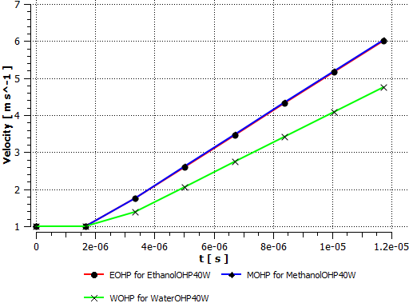 | 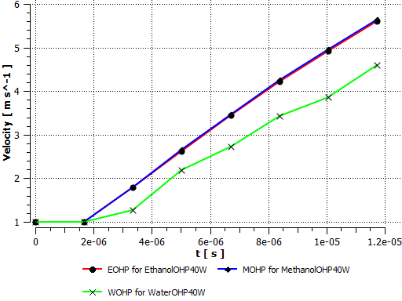
Figure 5c. Evaporator Working Fluid Velocity. | Figure 5d. Condenser Working Fluid Velocity.

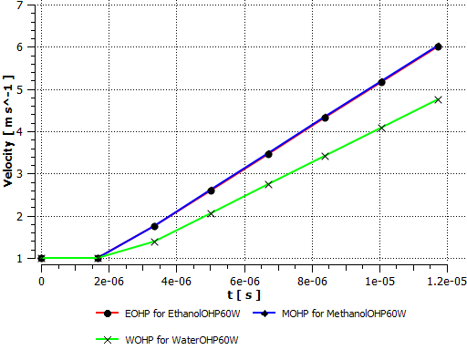 | 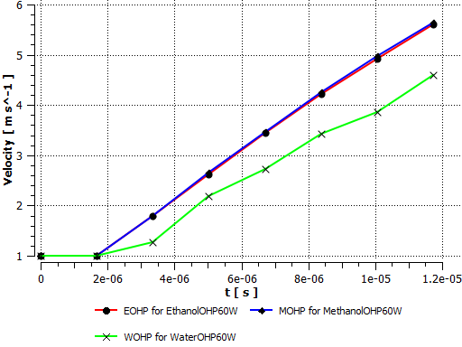
Figure 5e. Evaporator Working Fluid Velocity. | Figure 5f. Condenser Working Fluid Velocity.

OHP Internal Pressure
The OHPs were set up to operate at a vacuum pressure of 0.08MPa as determined from experimental data. In Figures 6a, 6c and 6e the evaporator internal pressure profiles were the same regardless of the varied heat input at the evaporator. In these figures the WOHP shows a maximum peak pressure over 3.5e⁰⁸Pa. Subsequent to this uniquely high pressure shown, all the evaporator pressures fall within the range of 1.5 e⁰⁸ and 4 e⁰⁷Pa.
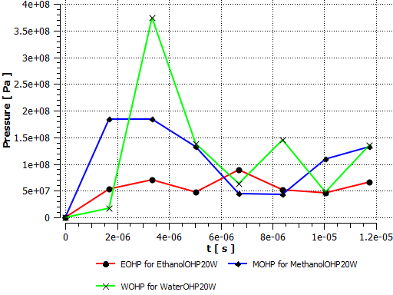 | 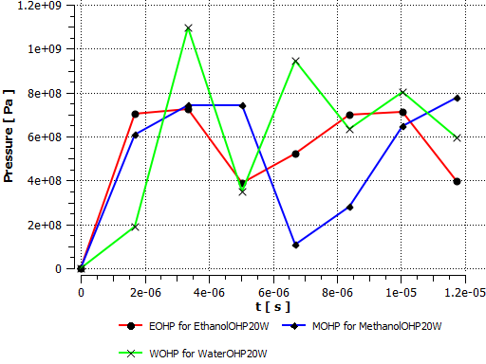
Figure 6a. Evaporator Pressure. | Figure 6b. Condenser Pressure.
In Figures 6b, 6d and 6f, the corresponding condenser pressures are relatively higher than in the evaporators. Here also the pressure profiles for condensers are observed to be similar for the varied heat input over the period of simulation. In the condensers, the peak pressures profile is once again exhibited by the WOHP.
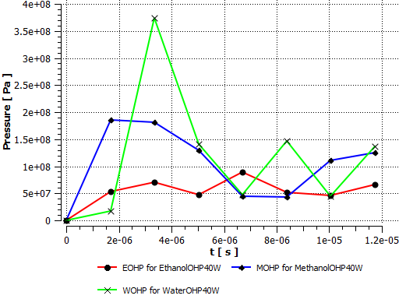 | 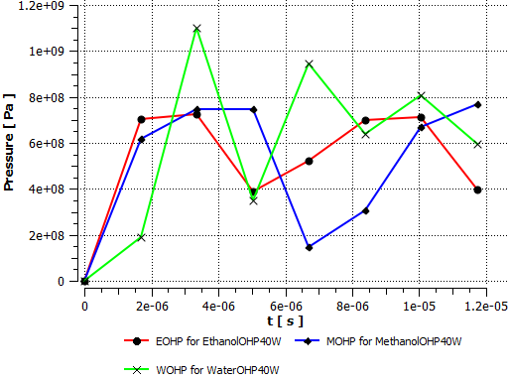
Figure 6c. Evaporator Pressure. | Figure 6d. Condenser Pressure.

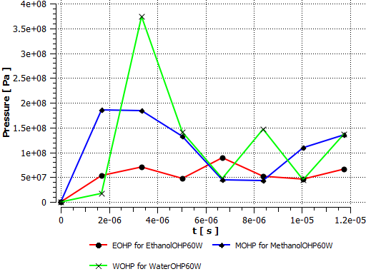 | 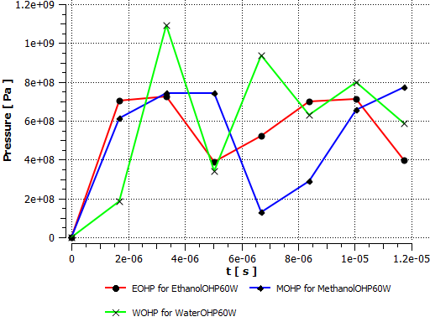
Figure 6e. Evaporator Pressure. | Figure 6f. Condenser Pressure.

Overall, the internal pressures in the condensers were relatively higher than in the evaporators for all heat inputs.

Vapour to Liquid Mass Transfer Rate
ANSYS Fluent ²⁹ solves the vapour to liquid mass transfer (evaporation and condensation) equation using the Lee³⁰ Model. In Figures 7a-f, the mass transfer from the vapour phase to the liquid phase of the working fluid is presented. From Figure 7a, 7c and 7e the plots show a higher rate of vapour mass transferred to liquid phase for the ethanol working fluid and lowest for water in the evaporator.
For both ethanol and methanol in all test conditions, the vapour to liquid mass transfer rates were relatively higher in the condenser than the respective evaporator. The opposite however was true for water, where the vapour to liquid mass transfer rate was higher in the condenser than in the evaporator.
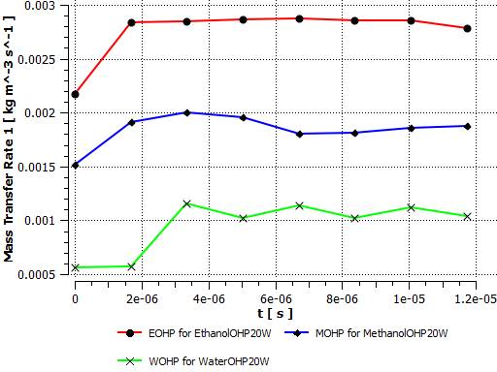 | 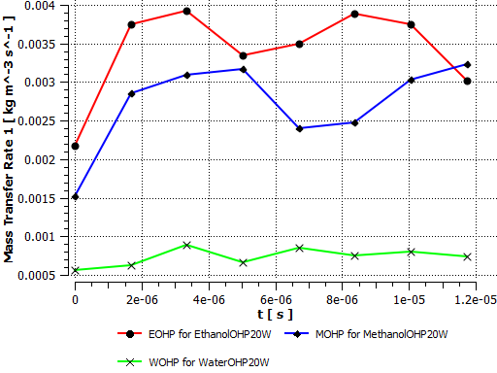
Figure 7a. Evaporator Vapour to Liquid Mass Transfer Rate. | Figure 7b. Condenser Vapour to Liquid Mass Transfer Rate.

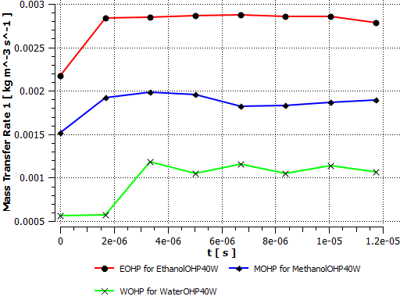 | 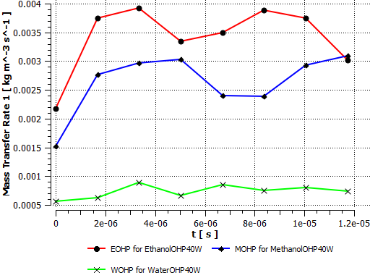
Figure 7c. Evaporator Vapour to Liquid Mass Transfer Rate. | Figure 7d. Condenser Vapour to Liquid Mass Transfer Rate.

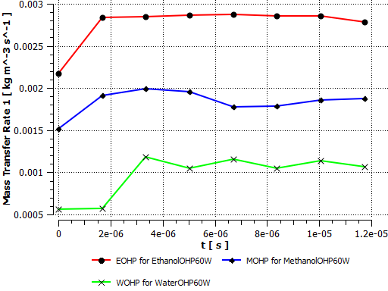 | 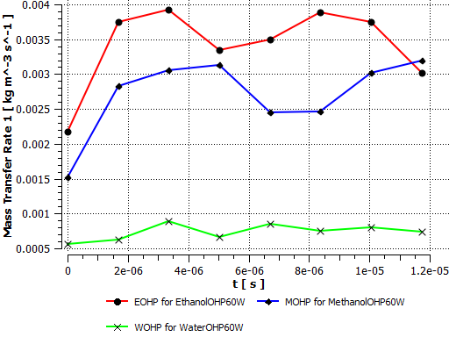
Figure 7e. Evaporator Vapour to Liquid Mass Transfer Rate. | Figure 7f. Condenser Vapour to Liquid Mass Transfer Rate.

From the results shown in Figures 7a-f, it is evident that for the length of time the investigations were carried out, the amount of heat input had little or no influence on the vapour to liquid mass transfer rates of the OHPs.

Liquid to Vapour Mass Transfer Rate
For the liquid to vapour mass transfer rate, Figures 8a, 8c and8e shows a significantly higher mass transfer rate for water than both ethanol and methanol in the evaporator. The liquid to vapour mass transfer rate for WOHP was almost double that for the EOHP and MOHP after 1.5e-⁰⁶s under all three heat input conditions investigated. Here the rate of mass transfer from liquid to vapour was found to be overall lower in the MOHP for similar heat input values.
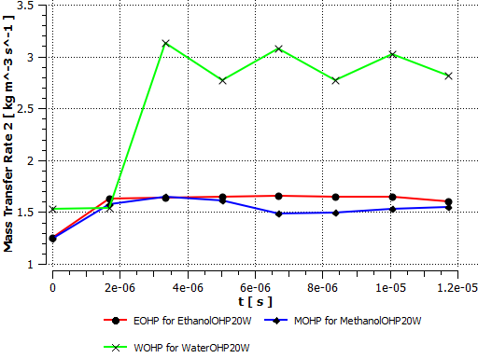 | 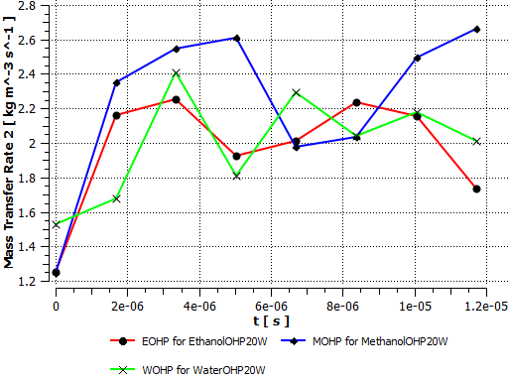
Figure 8a. Evaporator Liquid to Vapour Mass Transfer Rate. | Figure 8b. Condenser Liquid to Vapour Mass Transfer Rate.

In the condenser sections, the rate of mass transfer from liquid to vapour was virtually the same regardless of the amount of heat input (See Figures 8b, 8d and 8f). Here MOHP showed an unusually higher liquid to vapour mass transfer rate in the condenser opposite to its condition in the evaporator. Apart from the high liquid to vapour mass transfer rate for water in the evaporator, Figures 8b, 8d and 8f shows a higher mass transfer rate in the condenser than for the evaporators as shown in Figures 8a, 8c and 8e.
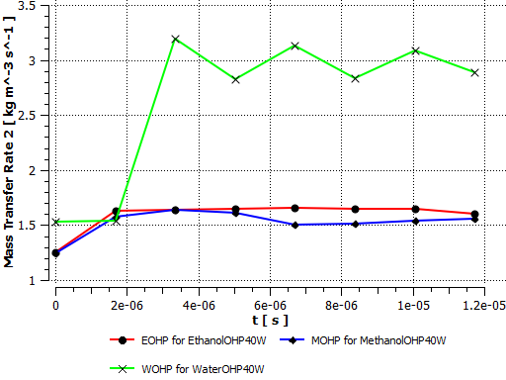 | 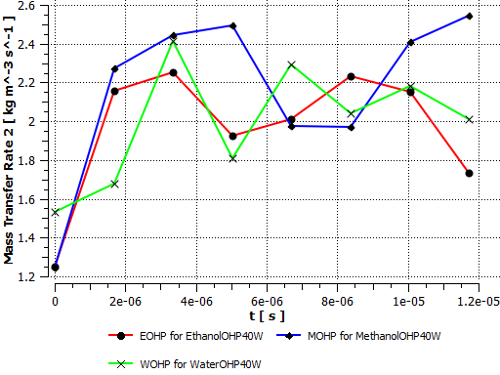
Figure 8c. Evaporator Liquid to Vapour Mass Transfer Rate. | Figure 8d. Condenser Liquid to Vapour Mass Transfer Rate.

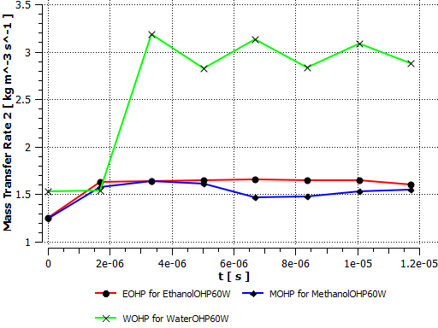 | 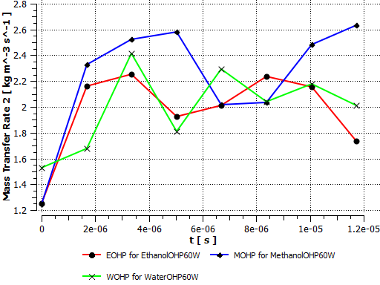
Figure 8e. Evaporator Liquid to Vapour Mass Transfer Rate. | Figure 8f. Condenser Liquid to Vapour Mass Transfer Rate.

Compared to Figures 7a-f, Figures 8a-f demonstrates the high rate of mass transfer from the liquid phase of the working fluid to the vapour phase.

Verification and Validation of the CFD Model
The verification and validation of the CFD model was done using a grid independence test. According to Chen ³¹ the varying degrees of uncertainties in CFD simulation results due to the different levels of approximations used in the computer models makes validation necessary. Guo and Zhu ³⁴ for instance used the grid independence test performed for overset grid to validate their CFD model. In this report, a finer mesh for the model was generated to show the results per mesh refinement. Since the mesh for the OHPs were the same regardless of the working fluid the water based OHP with 60W heat input per cell volume was randomly chosen for the mesh independence test. Tables 3a and 3b presents the mesh statistics for the original and the refined mesh respectively and Figures 9a and 9b the evaporator and condenser temperatures respectively on both grids.
Table 3a. Mesh Statistics.  Nodes 11097  Elements 16684  Mesh Metric Orthogonal Quality  Min 0.47956838481876  Max 0.987901289871883  Average 0.913829429235315  Standard Deviation 4.98220420738575E-02 | Table 3b. Refined Mesh Statistics.  Nodes 11170  Elements 16866  Mesh Metric Orthogonal Quality  Min 0.475217394362515  Max 0.980770766294561  Average 0.913738306736011  Standard Deviation 4.98005099004074E-02

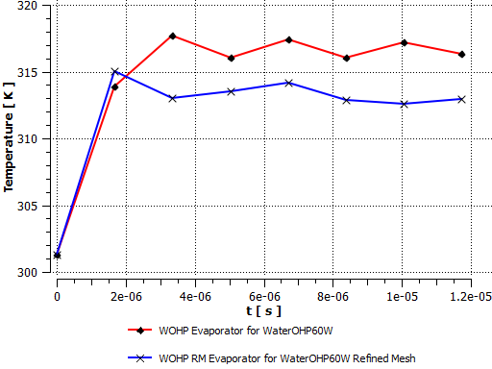 | 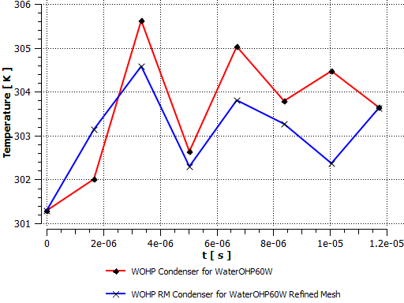
Figure 9a. Grid Independence Test for WOHP Evaporator Wall Temperature. | Figure 9b. Grid Independence Test for WOHP Condenser Wall Temperature.

From Figures 9a and 9b, it is evident that the evaporator and condenser temperatures varied with grid. However, this variation was only a maximum of 4K and 2K for the evaporator and condenser respectively. Although they appear to be wide variations, both blots on Figures 9a and 9b respectively show similar temperature profiles. Considering the maximum temperature differences observed, they are insignificant to the overall performance of the OHP.

Experimental Study of the Helically Coiled Closed Loop Oscillating Heat Pipe (OHP)
Prototypes of the helically coiled closed loop oscillating heat pipe numerically investigated were fabricated out of copper pipe with internal diameter of 2mm determined in accordance with the criteria established in equation (43). The general dimensions can be found on Table 1. Prior to experimentally investigating the OHPs thermal performances, they were pressure tested and evacuated to a pressure of about 0.08Mpa before charging with the working fluid to a fill ratio of approximately 0.6 in the laboratory (See Figure 10). According to Senjaya and Inoue ³⁵ high heat transfer rate occurs when OHPs are charged at the optimum filling ratios (about 50–60%), which are higher than those of conventional heat pipes.
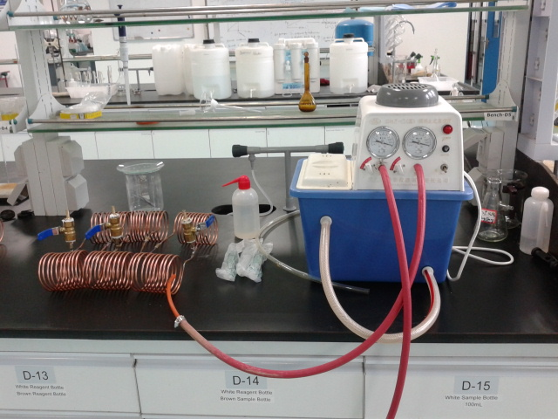
Figure 10. Evacuation and Filling of OHPs in the Laboratory.
OMEGA k-type thermocouples were then connected to the condensers, evaporators and adiabatic sections (See Figure 11 ). The thermocouples were then connected to a Yokogawa DX 200 data logger and a computer for the collection of temperature data. The evaporator sections were then subjected to varied heat input with the condensers exposed to the ambient surroundings.
Since the original purpose of the helically coiled OHPs were to fit around a vessel, testing was carried out with hot air blown into the copper vessel and the heat generated via the walls transferred to the evaporators. For this approach three tests were carried out namely Test1, Test 2 and Test 3, at average heat inputs of 665W, 1027W and 1574W respectively.

,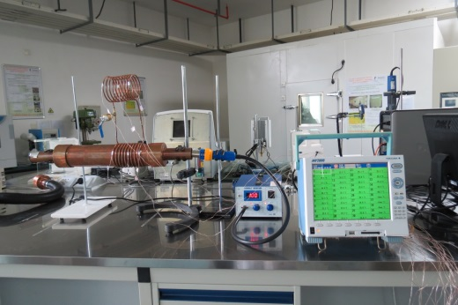
Figure 11. OHP Performance Test Set-up.

Governing Equations
The working fluid in the OHPs formed the liquid slugs and vapour plugs in the entire tube as the diameter of the pipes did not exceed the critical diameter ^{6, 36}. Since surface tension predominate the two-phase flow in an OHP, the inner diameters should satisfy ⁸ equation (43).
$D_{crit}=2L=2\sqrt{\frac{σ}{g\left(ρ_{l}{-ρ}_{v}\right)}}$
(43)
To enhance the heat transfer rate and sustain higher heat loads without dry-out, the evaporator length of the OHPs were no larger than that of the condenser ⁸.
$L_{eff}=\frac{1}{2}\left(L_{e}+L_{c}\right)+L_{a}$
(44)
The rate of heat transfer $\dot{Q}$ was estimated using Fourier’s Law given by equation (45) ³⁶.
$\dot{Q}=\frac{-kA∆T}{L}$
(45)
The OHPs thermal performance was evaluated by determining the thermal resistance (R) in equation (46) as shown by Hao et al ³⁷.
$R=\frac{{\overline{T}}_{e}{-\overline{T}}_{c}}{\dot{Q}}$
(46)
With the thermal resistance known, the overall heat transfer coefficient was determined by equation (47) as demonstrated by Qu and Wu ³⁸
$R=\frac{1}{hA_{e}}$
(47)

Experimental Results and Discussions
The test runs were carried out under ambient conditions. The data sampling time was 10.00s and each test lasted for about 60minutes. For the results, a summary of the average condenser and evaporator temperatures, thermal resistances and heat transfer coefficient for the thee OHPs experimentally studied are presented.

Average Temperature
The evaporator and condenser temperatures for the three OHPs were obtained directly from the Omega k-type thermocouples attached to them. Figures 12-14 shows the average evaporator and condenser temperatures of the OHPs for the three tests carried out. For all tests it can be observed that the condenser temperatures increased only slightly above ambient air temperature regardless of the amount of heat input at the evaporator. For all OHPs the evaporator temperature gradually increased from the ambient temperature to a maximum temperature.
Figure 12a. Evaporator and Condenser Temperatures. | Figure 12b. Evaporator and Condenser Temperatures.
Figure 12c. Evaporator and Condenser Temperatures.
For the same average heat inputs as shown in Figures 12-14, the OHPs showed slight variations in the rise of the evaporator and condenser temperatures. Here it could be that the ambient air temperature conditions may have influenced to some extent the rise in the overall condenser temperature. However, it was evident that the rise in temperature varied slightly per the working fluid in the OHP. Although the variation in the experimental was slight, it was far more obvious in the numerical study plots as shown in Figures 3a-f.
Figure 13a. Evaporator and Condenser Temperatures. | Figure 13b. Evaporator and Condenser Temperatures.
Figure 12c. Evaporator and Condenser Temperatures.
Figures 13a-c for instance shows that on higher heat input, the condenser temperatures increased reasonably significant over the ambient air temperature.
Figure 14a. Evaporator and Condenser Temperatures. | Figure 14b. Evaporator and Condenser Temperatures.
Figure 14c. Evaporator and Condenser Temperatures.
Overall, the three OHPs maintained a good temperature difference between the respective evaporators and condensers regardless of the heat inputs. These evaporator and condenser temperature differences from Figures 12-14 were found to increase with increasing heat input.

Overall Thermal Resistance
The overall thermal resistance is the criteria used in gauging the thermal performance of the OHPs ³⁹. Here the lower the value the better the performance. In Figures 15a-c, the thermal resistances of the OHPs were determined using equation (46) under the three test conditions. In all the tests the thermal resistance values were relatively low indicating generally good thermal performance of the three OHPs.
In Figure15a under the first test condition, the methanol OHP generally exhibited higher thermal resistance value compared to the other two OHPs. Here the water OHP initially exhibited lower thermal resistance values till t=2000s before maintaining an average thermal resistance relatively similar to that of the ethanol OHP.

Figure 15a. Overall Thermal Resistance.

In Figure 15b, the methanol OHP once again exhibited a relatively higher thermal resistance value on start-up however, over time, this value gradually declined becoming similar with the profile for the water OHP.
Figure 15b. Overall Thermal Resistance.
In Figure 15c, the heat input was higher and the performance of the three OHPs were generally similar from t=1000s. The key difference in performance here was at start-up where the ethanol OHP exhibited a relatively high thermal resistance value than the other two OHPs.
Figure 15c. Overall Thermal Resistance.

Overall Heat Transfer Coefficient
In Figures 16a-c, the overall heat transfer coefficient shown on the plots were determined from equation (47). Being inversely proportional to the thermal resistance, higher values are desirable. In Figure 16a the water OHP exhibited relatively higher heat transfer coefficient with the methanol OHP exhibiting relatively low values.
Figure 16a. Overall Heat Transfer Coefficient.

In Figure 16b at a slightly higher heat input, the performance of the water OHP and methanol OHP after 500s were relatively close with the ethanol OHP exhibiting slightly lower values.
Figure 16b. Overall Heat Transfer Coefficient.

In Figure 16c where the evaporator was subjected to highest heat input for the tests carried out, the performance of all three OHPs were similar. In all the plots shown in Figures 16a-c distinct performance between the OHPs was evident on start-up.

Figure 16c. Overall Heat Transfer Coefficient.

Conclusion
Numerical and experimental studies have been carried out on helically coiled oscillating heat pipes with three different working fluids. The OHPs were subjected to varied heat inputs for their thermal performances to be evaluated.
For the numerical study;
- Insights were provided into the internal working conditions of the OHPs.
- It was found that at the varied evaporator heat inputs, the evaporator temperature increased as the heat input increased. However, there was no difference in the corresponding condenser temperatures at the conditions studied.
- There was an indication of a reasonable evaporator – condenser temperature difference at the various evaporator heat inputs. This was also evident from the wall heat flux values at the evaporators and the condensers.
- It showed that start-up was a few seconds quicker in the water OHP than the ethanol and methanol OHPs.
- The WOHP showed higher peaks in internal pressure for both evaporator and condenser sections under all conditions than the EOHP and MOHP.
- The EOHP exhibited higher values of vapour to liquid mass transfer in both condenser and evaporator under all conditions with the WOHP exhibiting comparatively lower values.
- The WOHP exhibited higher values of liquid to vapour mass transfer in the evaporator with condenser performance generally close to the other OHPs under all conditions. Under both mass transfer conditions, the profiles were similar regardless of the amount of heat input.
- The grid independence test provided some validity to the CFD model.
The experimental results did not provide any indication of the internal workings of the OHPs however, it showed a reasonably significant evaporator-condenser temperature difference on heat input to the evaporator. Here the overall thermal resistance for all OHPs at the varied heat inputs were relatively low with very little distinction between the different OHPs. The key observation here was that at start-up, the thermal performance varied significantly between the OHPs, however over time their performances were similar.
Overall, the numerical results were in good agreement with the experimental results.

Reference
- Akachi, H. (1990) “Structure of a heat pipe”, U.S. Pat., 4921041.
- Zhang, Yuwen and Faghri, Amir (2008) 'Advances and Unsolved Issues in Pulsating Heat Pipes', Heat Transfer Engineering, 29:1, 20 – 44
- Lin, Zirong. Wang, Shuangfeng. Huo, Jiepeng. Hu, Yanxin. Chen, Jinjian. Zhang, Winston and Lee, Eton (2011) Heat transfer characteristics and LED heat sink application of aluminum plate oscillating heat pipes. Applied Thermal Engineering, Volume 31, Issues 14–15, Pages 2221-2229
- Bhuwakietkumjohn, N. and Rittidech, S. (2010) Internal flow patterns on heat transfer characteristics of a closed-loop oscillating heat-pipe with check valves using ethanol and a silver nano-ethanol mixture. Experimental Thermal and Fluid Science, Volume 34, Issue 8, Pages 1000-1007
- Qu, Jian. Wu, Huiying, and Cheng, Ping. (2012) Start-up, heat transfer and flow characteristics of silicon-based micro pulsating heat pipes. International Journal of Heat and Mass Transfer, Volume 55, Issues 21–22, Pages 6109-6120
- Jiao, A.J. Ma, H.B. and Critser, J.K. (2009) Experimental investigation of cryogenic oscillating heat pipes. International Journal of Heat and Mass Transfer, Volume 52, Issues 15–16, Pages 3504-3509
- Khandekar, Sameer. Charoensawan, Piyanun. Groll, Manfred., and Terdtoon. Pradit (2003) Closed loop pulsating heat pipes Part B: visualization and semi-empirical modeling. Applied Thermal Engineering, Volume 23, Issue 16, November 2003, Pages 2021-2033
- Qu, Jian and Wang, Qian (2013) Experimental study on the thermal performance of vertical closed-loop oscillating heat pipes and correlation modeling. Applied Energy, Volume 112, Pages 1154-1160
- Dilawar, Mahendra and Pattamatta, Arvind (2013) A parametric study of oscillatory two-phase flows in a single turn Pulsating Heat Pipe using a non-isothermal vapor model. Applied Thermal Engineering, Volume 51, Issues 1–2, March 2013, Pages 1328-1338
- Arab, M. Soltanieh, M. and Shafii, M.B.(2012) Experimental investigation of extra-long pulsating heat pipe application in solar water heaters. Experimental Thermal and Fluid Science, Volume 42, October 2012, Pages 6-15
- Sukchana, Thanaphol and Jaiboonma, Chaiyun (2013) Effect of Filling Ratios and Adiabatic Length on Thermal Efficiency of Long Heat Pipe Filled with R-134a. Energy Procedia, Volume 34, 2013, Pages 298-306
- Chiang, Ching-Ming. Chien, Kuo-Hsian. Chen, Han-Ming. and Wang, Chi-Chuan (2012) Theoretical study of oscillatory phenomena in a horizontal closed-loop pulsating heat pipe with asymmetrical arrayed minichannel. International Communications in Heat and Mass Transfer, Volume 39, Issue 7, August 2012, Pages 923-930
- Lin, Zirong, Wang, Shuangfeng, Shirakashi, Ryo. and Zhang, L. Winston (2013) Simulation of a miniature oscillating heat pipe in bottom heating mode using CFD with unsteady modeling. International Journal of Heat and Mass Transfer, Volume 57, Issue 2, February 2013, Pages 642-656
- Charoensawan, Piyanun. Khandekar, Sameer. Groll, Manfred. and Terdtoon, Pradit. (2003) Closed loop pulsating heat pipes: Part A: parametric experimental investigations. Applied Thermal Engineering, Volume 23, Issue 16, November 2003, Pages 2009-2020
- Khandekar, S. and Groll, M. (2004) An insight into thermo-hydrodynamic coupling in closed loop heat pipes. International Journal of Thermal Sciences, 43 (2004), pp. 13–20
- Mameli, M., Marengo, M. and Zinna, S. (2012) Numerical model of a multi-turn Closed Loop Pulsating Heat Pipe: Effects of the local pressure losses due to meanderings. International Journal of Heat and Mass Transfer, Volume 55, Issue 4, 31 January 2012, Pages 1036-1047
- Mameli, Mauro. Marengo, Marco. and Khandekar, Sameer. (2014) Local heat transfer measurement and thermo-fluid characterization of a pulsating heat pipe. International Journal of Thermal Sciences, Volume 75, January 2014, Pages 140-152
- Jahani, Kambiz. Mohammadi, Maziar. Shafii, Mohammad Behshad. and Shiee, Zahra. (2013) Promising Technology for Electronic Cooling: Nanofluidic Micro Pulsating Heat Pipes. Journal of Electronic Packaging Copyright VC 2013 by ASME JUNE 2013, Vol. 135 / 021005-1
- Smoot, C. D. Ma, H. B. Wilson, C. A. and Greenberg, L. (2011) Heat Conduction Effect on Oscillating Heat Pipe Operation. Journal of Thermal Science and Engineering Applications JUNE 2011, Vol. 3 / 024501-5
- Lin, Zirong. Wang, Shuangfeng. Chen, Jinjian. Huo, Jiepeng. Hu, Yanxin. and Zhang, Winston (2011) Experimental study on effective range of miniature oscillating heat pipes. Applied Thermal Engineering, Volume 31, Issue 5, Pages 880-886
- Thompson, S.M. Cheng, P. and Ma, H.B. (2011) An experimental investigation of a three-dimensional flat-plate oscillating heat pipe with staggered microchannels. International Journal of Heat and Mass Transfer, Volume 54, Issues 17–18, August 2011, Pages 3951-3959
- Liu, Zhen-Hua and Li, Yuan-Yang (2012) A new frontier of nanofluid research – Application of nanofluids in heat pipes. International Journal of Heat and Mass Transfer, Volume 55, Issues 23–24, Pages 6786-6797
- Yau, Y.H. and Foo, Y.C. (2011) Comparative study on evaporator heat transfer characteristics of revolving heat pipes filled with R134a, R22 and R410A. International Communications in Heat and Mass Transfer, Volume 38, Issue 2, Pages 202-211
- Han, Hua. Cui, Xiaoyu. Zhu, Yue and Sun, Shende (2014) A comparative study of the behavior of working fluids and their properties on the performance of pulsating heat pipes (PHP). International Journal of Thermal Sciences, Volume 82, Pages 138-147
- Yin, D. and Ma, H.B. (2014) Analytical solution of heat transfer of oscillating flow at a triangular pressure waveform. International Journal of Heat and Mass Transfer, Volume 70, Pages 46-53
- Peyghambarzadeh, S.M. Shahpouri, S. Aslanzadeh, N. and Rahimnejad, M. (2013) Thermal performance of different working fluids in a dual diameter circular heat pipe. Ain Shams Engineering Journal, Volume 4, Issue 4, Pages 855-861
- Pachgharea, Pramod R. and Mahalleb, Ashish M. (2012) Thermal Performance of Closed Loop Pulsating Heat Pipe Using Pure and Binary Working Fluids. Frontiers in Heat Pipes (FHP), 3, 033002 (2012) DOI: 10.5098/fhp.v3.3.3002
- ANSYS, Inc. (2014) ANSYS Fluent User's Guide. February 2014. Release 15.0 - © SAS IP, Inc. All rights reserved.
- ANSYS, Inc. (2012) ANSYS Fluent Theory Guide. February 2012. Release 14.5 - © SAS IP, Inc. All rights reserved.
- W. H. Lee. "A Pressure Iteration Scheme for Two-Phase Modeling". Technical Report LA-UR 79-975. Los Alamos Scientific Laboratory, Los Alamos, New Mexico. 1979.
- Rajput, R. K. (2010) Engineering Thermodynamics. 3rd Edition. Jones and Bartlett. Sudbury, Massachusetts. Pp 357-359.
- Singh, N.B., Das, S.S., and Singh, A.K. Physical Chemistry, Volume 2. Daryaganj, Delhi, IND: New Age International, 2009. ProQuest ebrary. Web. 13 September 2015. Copyright © 2009. New Age International. All rights reserved.
- Chen, Q. (2007) Computer simulation and experimental measurements of air distribution in building: past, present, and future. HVAC&R Res., 13 (6) (2007), pp. 849–851
- Guo, Xueyan. and Zhu, Zhangping (2015) CFD based modeling on chemical looping combustion in a packed bed reactor. Chemical Engineering Science, Volume 138, 22 December 2015, Pages 303-314
- Senjaya, Raffles and Inoue, Takayoshi (2013) Oscillating heat pipe simulation considering bubble generation Part I: Presentation of the model and effects of a bubble generation. International Journal of Heat and Mass Transfer, Volume 60, Pages 816-824
- Panyoyai, N. Terdtoon, P. and Sakulchangsatjatai, P. (2009) Effects of aspect ratios and number of meandering turns on performance limit of an inclined closed – loop oscillating heat pipe. International Conference on Science, Technology and Innovation for Sustainable Well-Being (STISWB), 23-24 July 2009, Mahasarakham University, Thailand.
- Hao, Tingting. Ma, Xuehu. Lan, Zhong. Li, Nan. Zhao, Yuzhe and Ma, Hongbin. (2014) Effects of hydrophilic surface on heat transfer performance and oscillating motion for an oscillating heat pipe. International Journal of Heat and Mass Transfer, Volume 72, Pages 50-65
- Qu, Jian. and Wu, Huiying. (2011) Thermal performance comparison of oscillating heat pipes with SiO2/water and Al2O3/water nanofluids. International Journal of Thermal Sciences, Volume 50, Issue 10, Pages 1954-1962
- Qu, Jian. Wu, Hui-ying. and Cheng, Ping (2010) Thermal performance of an oscillating heat pipe with Al2O3–water nanofluids. International Communications in Heat and Mass Transfer. Volume 37, Issue 2, Pages 111-115

