Combined effect of the magnetic field, orientation, and filling ratio on cylindrical pulsating heat pipe using distilled water and distilled water/Fe₃O₄ nanofluid

Abstract
To investigate the effect of the magnetic field, a pulsating heat pipe was made in the shape of a cylinder and Fe₃O₄ nanoparticles (%0.1 wt.) were used with the base fluid of distilled water as the working fluid. (Tetramethyl ammonium hydroxide) TMAH surfactant was used as a stabilizer. To investigate the effect of gravity on the performance of the pipe, the device was tested at different angles from zero to 90 degrees. In this research, the effect of different variables, including the type of working fluid (distilled water vs. nanofluid), filling ratio, slope, and amount of heat input to the evaporator (30 to 300 W), in two different states, once without the influence of the magnetic field and once again with the application of a magnetic field was investigated. The results of the tests showed that the performance of the device at 50% filling ratio is better than 60% filling ratio. The use of nanoparticles improved the performance of the device. Inclining the device increases the thermal resistance so that the device performs poorly in the horizontal mode in all modes except when it is under the influence of a magnetic field. The use of nanofluid as well as the application of a magnetic field makes the start-up time of the device decrease by 37% and 30%, respectively, compared to distilled water. The temperature of the start of fluctuations also decreases by 24% and 32%, respectively.

Keywords: Nanofluid; Heat transfer enhancement; Cylindrical PHP; Filling ratio; Magnetic field.

Nomenclature
A | surface area (m²)
D | diameter (mm)
f | friction factor (-)
I | electric current (A)
m | mass (kg)
v | volume (m³)
q | heating power (W)
h | coefficient of heat transfer (W m⁻² K⁻¹)
L | length (m)
T | temperature (°C)
R | thermal resistance ((K W⁻¹)
Re | Reynolds number (-)
V | Voltage (V)
t | Time (S)
Greek symbols
Δ | Uncertainty (-)
ρ | density (kg m⁻³)
μ | dynamic viscosity ((kg m⁻¹ s⁻¹)
Acronyms
FR | filling ratio
OHP | Oscillating heat pipe
3D- PHP | Three dimension -pulsating heat pipe
Subscripts
ave | average
c | condenser
e | evaporator
i | inner
in | input
out | Output
o | outer
np | Nanoparticle
bf | Base fluid
f | fluid
t | total

- Introduction
Researchers are always investigating ways to increase the rate of heat transfer in various industries, especially electronic equipment, because they need to transfer heat at a high rate and at a low temperature. The development of heat pipes that are used to transfer heat in electronic equipment led to the invention of a new generation of these pipes called Pulsating heat pipes. Pulsating Heat Pipes (PHPs), also known as Oscillating heat pipes (OHPs), are more efficient than conventional heat pipes due to the simultaneous use of sensible and latent heat transfer [1]. They are made of narrow tubes with a number of U-shaped bends, which are filled by a working fluid with a suitable filling ratio, and the remaining air is evacuated by the vacuum system. Due to the presence of boiling and condensation during operation, the oscillating heat pipe has the ability to transfer heat with a low-temperature drop, and transfer high heat in a small volume. In these exchangers, heat is introduced to the evaporator, which causes the evaporation of the liquid and the formation of steam bubbles to move the working fluid to the top of the pipe. As heat is absorbed in the condenser, the fluid is redistilled and returns to the bottom. By repeating this oscillating and circulating movement, the heat transfer process continues. Despite the simple structure of the oscillating heat pipe, many parameters affect its operation, including: magnetic field [2], tube diameter [3,4], tube material [5], heat losses [6] and fuel cell [7], different kinds of fluids [8], size of the condenser and evaporator [9], heat flux [10,11] filling ratio [ 12] hybrid nanofluids [13] and different structure [14,15]. A grade number of researchers investigated 3D-OHP [16,17] experimentally. Research by Borgmeyer et al. [18] and Qu and Zhao [19] indicated that the efficiency of a 3D-OHP depends on the orientation, filling ratio, inner diameter and number of 3D-OHP bends. Zeyu et al. [20] experimented with a flat heat pipe for different inclination angles. Their investigation indicated inclination angles are an important factor in designing the PHP. Experimental research to find the thermal performance of NiFe₂O₄ nanoparticles dispersed in deionized water in a thermosyphon-type heat pipe was carried out by Aydin et al. [21]. Their results showed that the use of NiFe2O4 nanofluid significantly improves the thermal performance of the heat pipe, which also shows that increasing the heat transfer coefficient can be achieved by increasing the mass fraction and in the presence of a low parallel magnetic field. In another research, Qiu et al. [29] made a three-dimensional oscillating heat pipe with 3 and 6 rounds and investigated the performance of the device at different angles and filling ratios. The results showed that at low powers, the device has the lowest thermal resistance at an angle of 60 degrees, and after that, the performance of the device will be the same at all angles. For the stability of nanofluids, researchers have tested different surfactants. One of the best stabilizers for Fe3O4 nanoparticles is the use of tetra methyl ammonium hydroxide [30-31], which is also used in this research for nanofluid stability.
A literature review shows that most studies of heat transfer in a 3D-PHP include experimental measurements, which lead to only a partial understanding of the influence of tilt, and no papers have been published regarding the influence of the tilt angle of a 3D-PHP. PHP using Fe₃O₄ under a magnetic field. The convection heat transfer of ferrofluids in an inclined 3D-PHP needs further investigation. As the results, in this research, a ferrofluid composed of Fe₃O₄ was applied to an inclined, closed-loop 3D-PHP in the presence of a magnetic field to evaluate the thermal efficiency of the system and find the optimal angle of 3D-PHP. Heat transfer in an inclined 3D-PHP with Fe₃O₄ under a magnetic field has received little attention in the literature for vertical and horizontal PHP. To achieve the optimal design of these systems, it is necessary to analyze the heat transfer and evaluate the optimal angle of a 3D-PHP, that is, the angle at which the maximum heat transfer is achieved. The purpose of this experimental study is to investigate the increase of thermal efficiency by a pulsating heat pipe with different tilt angles using Fe₃O₄ under a magnetic field. These tests have been performed on a 3D-PHP cylindrical device with a specific geometry for the first time. Indeed, to do this, the 3D device was made with a copper tube and tests were performed on it.

- Materials and methods
2-1. Experimental setup
During the experimental tests, pure water and nanofluid of Fe₃O₄/water with a filling ratio of 50% were utilized and a percent of weight concentration of the test section and then the results were compared and the best mode for the system was made. As it is shown in Fig 1 the requirements for the production of heat pipe were copper tubes with an outer diameter of 4.8 mm and also an inner diameter of 3.4 mm and a volume of 63.88 cm³ in this experiment. Table 1 presents the 3D-OHP configuration.
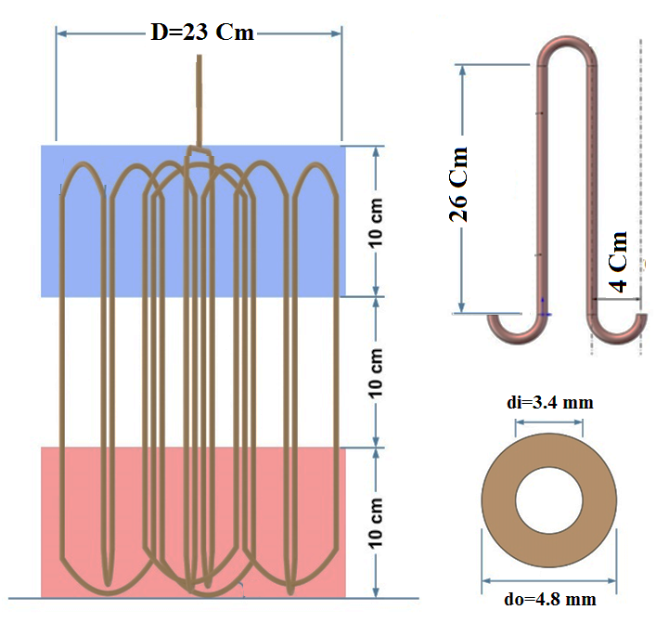
Fig. 1. Schematic of the experimental equipment.

To get started with an oscillating heat pipe, the vacuum pump for at least 30 minutes by - 0.9 bar has been used. This must be done because the air extends the evaporation time and as mentioned, evaporation and the creation of bubbles are the basics of oscillating heat pipe and by making a vacuum in the heat pipe evaporation work at low temperatures. According to the magnetic properties of the nanoparticles with the composition of these particles in the water-based fluid to the magnet can be seen that all particles are attracted to the magnet.

Table 1. 3D-OHP configuration
OHP container | Copper
Number of bends | 11
OHP length | 7 m
Adiabatic length | 100 mm
Condenser length | 100 mm
Evaporator length | 100 mm
Inner diameter | 3.4 mm
Outer diameter | 4.8 mm
Wall thickness | 0.7 mm
Liquid filled ratio | 50%

A set of K-type thermocouples along with a display system and a portable data logger were used to monitor the temperature in the condenser and evaporator. Defined by the temperature monitoring scheme, the uncertainty of temperature measurement was obtained as ± 0.1 K. A MADECO-MD5X model vacuum pressure transmitter (-1 to +4 atmospheres) was used along with a data recorder to record the pressure values ​​every 5 seconds during the test period. Condenser cooling is done by a fan with a diameter of 20 cm and a wind speed of 8 meters per second. The wind speed was measured by the Lutron-AM4206 anemometer. The airflow through the condensing tubes is 15 cubic meters per minute. The temperature of the air passing through the pipes was measured and recorded by a K-type thermocouple sensor. Figure 2 shows the experimental apparatus and measuring instrument of the 3D-PHPs test system and also a schematic of the 3D-PHPs test system.
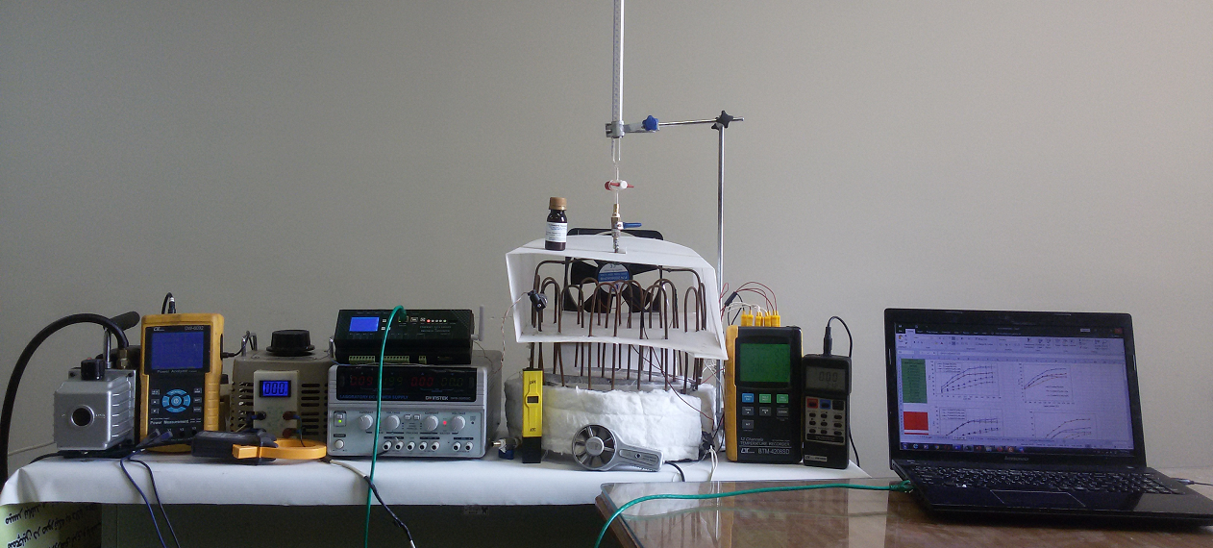
(a)
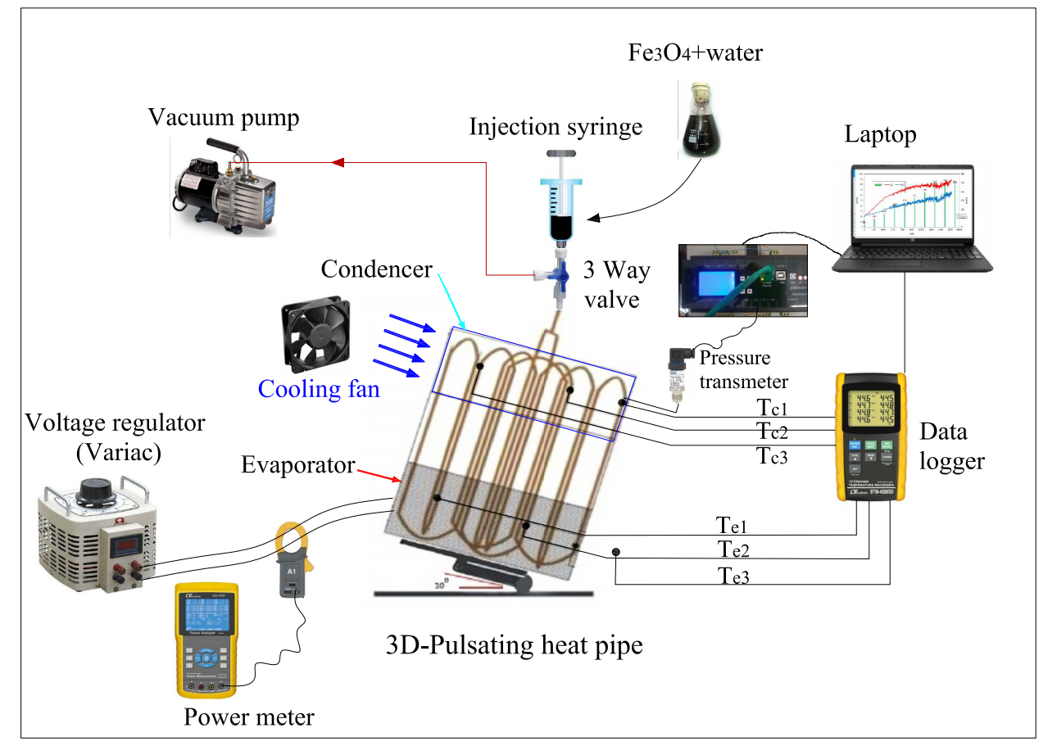
(b)
Fig. 2.a: Experimental apparatus and measuring instrument of 3DPHPs test system. b: schematic of the 3D-PHPs test system.

To investigate the effect of the magnetic field on the performance of the oscillating heat pipe, 11 neodymium block magnets with dimensions of 15*7 and 2 mm thickness were used. The intensity of the magnetic field of the magnets was measured by a Gauss meter, and its value is equal to 60 mT (600 Gauss). Because the device has 11 turns, 11 magnets were placed on the evaporator tubes. The way of placing the magnet in the vicinity of the pipe was such that the magnetic field lines of the magnet were placed along the path of the fluid flow (Fig. 3).

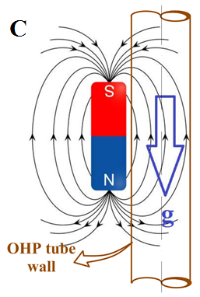
Fig. 3. Schematic of the placement of the magnet near the pipe.
Two steel heaters, one in the form of a belt around the cylindrical part and the other in a flat form are installed on the evaporator tubes. These heating elements (with a power of 1300 W) consist of chrome-nickel wire with a steel coating. To check the effect of the heat input on the performance of the device, it is necessary that the heat input can be changed and controlled. Therefore, a Variac device with the ability to change the voltage in the range of zero to 250 volts has been used. The amount of heat input from the heating element to the evaporator is calculated from the following equation:
$q=VI$ (1)
The amount of input heat is achieved from the above equation. I and V are current and voltage, respectively. By setting the device at a certain voltage and measuring the intensity of the current with an ammeter, the input heat can be calculated. But in this test, a Lutron DW-6092 wattmeter device was used, which directly measures the amount of power applied to the device. The temperature in 3 points of evaporator sections by the thermometer has already been recorded and the temperature of three sections in the evaporator can be obtained through the following formula:
(2) |  | $$T_{e}=\frac{T_{e1}+T_{e2}+T_{e3}}{3}$$
Accordingly, the following relationships are used to calculate T_{c}.
(3) |  | $$T_{c}=\frac{T_{c1}+T_{c2}+T_{c3}}{3}$$

According to Eq. 4, the thermal resistance of the OHP is calculated by [40]

(4) Where T_{e} is the average temperature of the evaporator, T_{c} is the average temperature of the condenser, R is the heat resistance and q is the input power.

2-2. Preparation of the nanofluids
To prepare nanofluids, Fe₃O₄ nanoparticles were purchased from Merck with a specific density of 4.8-5.1 g/cm³ and thermal conductivity of 80 W/m K. Fe₃O₄ specifications are listed in Table 2.

Table 2. Physical properties of Fe₃O₄ nanoparticles
Quality | Specifications
Purity | 98%
Nanoparticles diameter | 20-30 nm
Thermal conductivity | 80 W/m. K
True density | 4.8-5.1 g/cm³
Color | Dark Brown
Morphology | spherical

For this study, nanofluid samples were used with concentrations of 0.1%, by weight and the samples were sonicated in water for 90 minutes.
To prepare the magnetic nanofluid used in this experiment, a two-step method was used as follows:
According to Lei et al. [22] sonication and pH=10 and using of tetra methyl ammonium hydroxide surfactant to the ratio of 3:1 can reduce the effect of agglomeration. The use of surfactants in the nanofluid can reduce the surface tension so with the easier separation of bubbles from the boiling surface, the heat transfer coefficient can be increased. To achieve uniform dispersion and de-agglomeration of the Fe₃O₄ particles in the water, ultrasonic the 40 kHz ultrasonic device was used for 90 minutes. The preparation steps are described in Figure 4. Fe₃O₄ nanoparticles were mixed with the base fluid using a stirrer. The ultrasonic oscillator was also used for liquid sonication for 5 hours. This bath sonicator had a power supply of 120V/AC220~240V 50/60 Hz, AC100 and a working frequency of 45 kHz. Figure 5 shows the sedimentation level of the suspension studied in this work. Nanoparticles were easily dispersed in organic thinners. A 2-A electric current generated a magnetic field of 0.60 mT (600 Gauss), which was used in the current study.
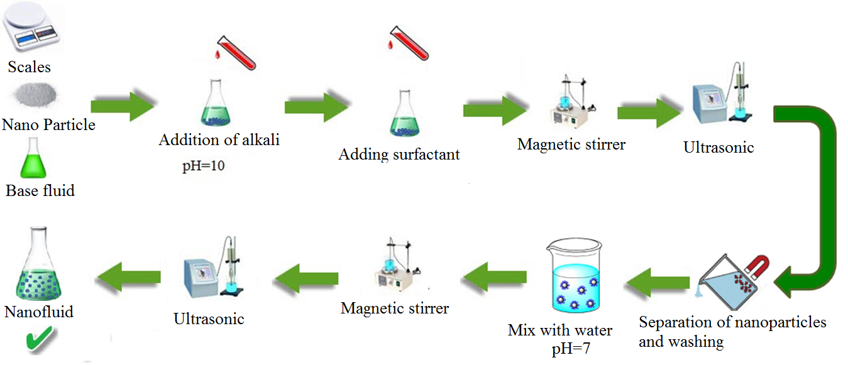
Fig. 4. Preparation steps of Fe₃O₄+ water.

Figure 5 shows the settling of Fe₃O₄+water in immobilized fluid, 0 min, b 24 h, c ​​after a week, d long time.
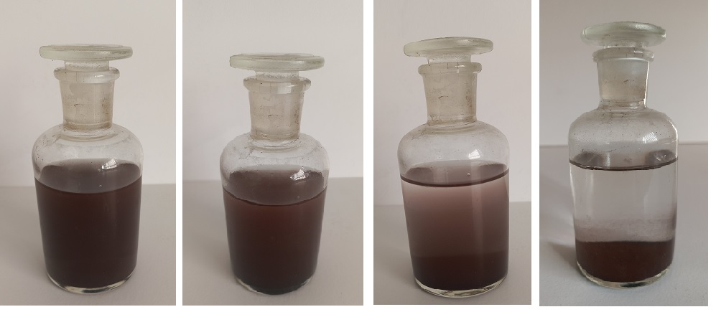
d) After 1 month | c) After 1 week | b) After 24 hours | - After 1 hour
Fig. 5. Settlement of Fe₃O₄+water in the motionless fluid, a) 1 hour, b) After 24 hours, c) After one week, d) After 1 month.

Zeta potential values for Fe₃O₄ nanoparticles are presented in Figure 6a, also Figure 6b shows the size of the particles in the nanofluid. This information is obtained using the dynamic light scattering (DLS) technique. According to Figure 6a, the average size of Fe₃O₄ + water is approximately 20 nm.
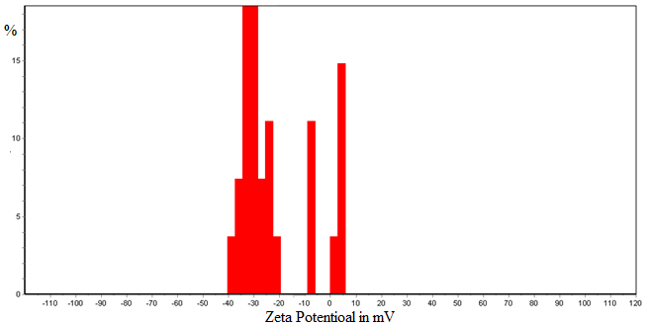

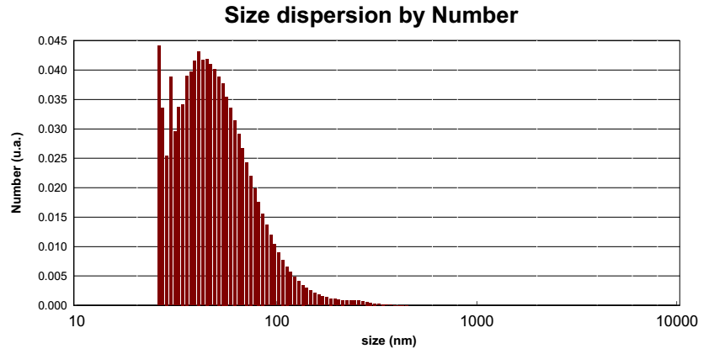

Fig. 6. (a) Zeta potential values for Fe₃O₄ nanofluids (b) Dispersion of the number of nanoparticles.

To check the correctness of the magnetism of the prepared nanofluid, as shown in Figure 7, when the magnet approaches the container containing the nanofluid, the nanoparticles are attracted to the magnet, which indicates the magnetism of the prepared nanofluid.
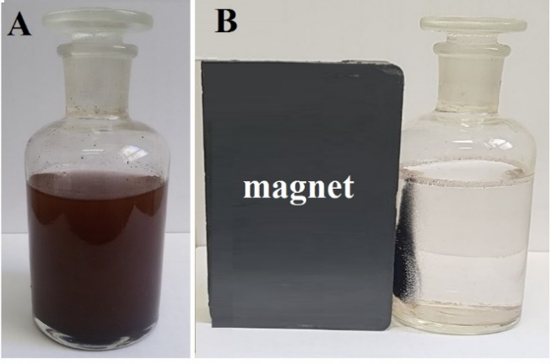
Fig. 7. (a) Ferrofluid. (b) Magnetite nanoparticles attracted by a magnet

The system was stopped for three hours after each run to account for repeatability and repeatability of recoding. To ensure the accuracy of the results, each experiment was repeated 3 times with the same method and exact amount of Fe₃O₄+ water nanofluid, and all conditions were almost the same during each experiment. The exceptional reproducibility can be attributed to the fact that the random movement of nanoparticles under the effect of buoyancy in the base fluid can create a uniform nanofluid. The experimental results can be well reproduced for a uniformly dispersed nanofluid. The main disadvantage of nanoparticles is their instability. The preparation of stable nanofluids is critical for thermophysical measurements. The exceptional repeatability can be attributed to the fact that the test equipment is more stable and has a good working environment.

2-3. Data accuracy and uncertainties
Since each measuring equipment has specific and limited accuracy, therefore the measured values ​​will also have some errors. Therefore, the calculation of parameters related to these quantities will not be accurate [23]. Therefore, it is necessary to determine the uncertainty caused by the measurement. In fact, by calculating the uncertainty, the interval in which the exact amount of the desired parameter is located in that range is determined. The uncertainty of a calculated quantity such as M can be calculated as follows [24]:
(5)
Where x_{i} is the measurable parameter and M is the quantity calculated from the measurable parameters. $U_{xi}$ is the measurement error that is equal to the measurement precision divided by the minimum measured value. The accuracy of each piece of equipment is given in Table 3.

Table 3. Accuracy of equipment.
Tools | Precision | Unit
Pressure transmitter | 0.001 | bar
Auto trans | 1 | volt
Digital thermometer | 0.1 | °C
Timer | 1 | Second
Meter | 1 | Millimeter
Calipers | 0.1 | Millimeter
Multimeter | 0.1 | amp

The uncertainties of the parameters used in this research are given in Table 4.

Table 4. The uncertainties of different parameters
Parameter | D | L | T_{e} | T_{c} | ΔT | V | I
Uncertainty (%) | 0.02 | 0.3 | 0.339 | 0.323 | 0.468 | 1.2 | 3

The maximum possible error in the calculation of a quantity. The effect of all errors can be calculated by Eq. 6 [25]:
(6)
As a result, the maximum uncertainty for input heat flux and also thermal resistance are obtained below equation [26]:
Therefore, the uncertainty of input heat is 3.23% and thermal resistance is 3.27%.

- Results and discussion
  - Investigation of pressure and temperature fluctuations
Figure 8 shows evaporator and condenser temperatures and pressure oscillations for distilled water in vertical mode (FR=50%)

Fig. 8. Evaporator and condenser temperatures and pressure oscillations for distilled water in vertical mode (FR=50%)

Figure 9 illustrate evaporator and condenser temperatures and pressure oscillations for Fe₃O₄ nanofluid in vertical mode (FR=50%). The changes in thermal resistance, thermal efficiency and equivalent heat transfer coefficient of water were compared with base fluid which was water. As it is clear from this Figure, the nanofluid could effectively improve heat transfer. The changes in thermal resistance, thermal efficiency and heat transfer coefficient were compared with the base fluid which was water. As can be seen from this figure, the nanofluid can effectively improve heat transfer. When the input power added to the evaporator section of the 3D-OHP increased from 10 W to 30 W, all measured temperatures increased rapidly until the 3D-OHP reached a steady state. At this stage, temperature fluctuation was not observed, which means that the heat was mainly absorbed by the working fluid. When the thermal power was increased to 40 W, all measured temperatures began to fluctuate, indicating the occurrence of a start-up.

Fig. 9. Evaporator and condenser temperatures and pressure oscillations for Fe₃O₄ nanofluid in vertical mode (FR=50%).

The diagram of temperature fluctuations for nanofluid with magnetic field (FR=50%) in vertical mode is shown in Figure 10. As can be seen, after about 2250 seconds have passed while the temperature of the evaporator has reached 64 °C, the fluctuations begin. In this position, the input power to the device is 90 W. Pressure fluctuations have also started in this range. After about 10,600 seconds, when the evaporator temperature has reached about 94°C, there are no more fluctuations in temperature, although the temperature is still increasing. From this point onwards, the temperature fluctuations in the condenser have also decreased, indicating that the flow regime has changed from the drop-bubble state to the annular flow and finally to the fog state and the air condenser is no longer capable of condensing steam. Using a fan with a higher flow rate or a water condenser can lead to the continuation of the heat transfer operation.

Fig. 10. Evaporator and condenser temperatures and pressure oscillations for nanofluid in vertical mode with magnetic field (FR=50%).

  - Effect of filling ratio on thermal resistance
By changing the input power to the device, the average value of the thermal resistance in the filling ratios of 50% and 60% is drawn in Figure 11. The results of the studies show that at a very low heat flux (at the beginning of the work), the oscillating movement is not performed inside the tube, which is due to the lack of formation of steam bubbles enough to move the liquid inside the tube. Therefore, until the thermal flux has not increased to the required amount to start the oscillations, the thermal resistance increases. In this case, the thermal performance of the device is still not suitable. With the start of oscillations and transfer of liquid clots by steam bubbles inside the tube, the amount of thermal resistance starts to decrease. As seen in Figure 11, the thermal resistance of the device at a 50% filling ratio is lower than its resistance at a 60% filling ratio, and the device has better thermal performance in this state. Its cause can be attributed to the volume of fluid inside the tube. In the filling ratio of 60%, the height of the fluid inside the tube is higher than that of 50%, so more force is needed to start the oscillations and as a result the heat transfer process.
In other words, more input power is needed. At low powers, the difference in thermal resistance is also greater. As the input heat flux increases, the range of oscillations also increases and as a result, the fluid inside the tube flows. Therefore, at higher heating powers, the thermal resistance in both filling ratios is closer to each other.

Fig. 11. Thermal resistance of 3D-OHP vs. input power for nanofluids at different filling ratios.

  - Effect of installation angle on thermal resistance
In the vertical mode, gravity plays an essential role in returning the fluid from the condenser to the evaporator, but in the horizontal mode, gravity does not affect the device's performance. If the device can continue to work completely and correctly in horizontal mode, it is called anti-gravity. In this research, the performance of the device at angles of zero, 30, 60 and 90 degrees to the horizon has been investigated (Figure 12).
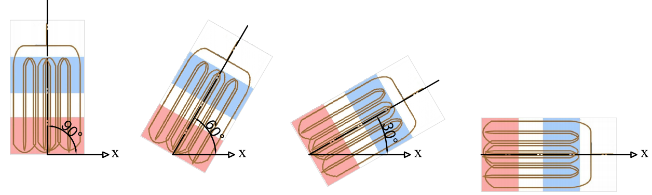
θ = 0 | θ =60 | θ = 30 | θ = 90
Fig. 12. Different positions of the device

Experiments were first performed with distilled water as the working fluid. Figure 13 shows the thermal resistance of the device at different angles and from input powers of 30 W to 300 W. As the input heat increases, the thermal resistance of the device increases first, then the thermal resistance suddenly decreases with the start of oscillations and the creation of pulsating current. The reason for the increase in resistance before the formation of bubbles and fluctuations is that during this time, heat is transferred only by conduction through the copper tube. In all angles, a minimum input power (90 W) is required to start the device. In the horizontal mode, when the input power reaches about 180 W, drying occurs in parts of the evaporator and the thermal resistance suddenly increases.
In fact, due to the lack of influence of gravity in the horizontal state, the fluid does not return from the condenser to the evaporator, and this causes a sharp increase in the temperature of the evaporator and disrupts the performance of the device [27]. In other modes, as the input power increases, the thermal resistance decreases, but the lowest thermal resistance is always related to the 90-degree angle (vertical mode).

Fig. 13. Thermal resistance of 3D-OHP vs. input power for distilled water at different inclination angles

Figure 14 shows that if ferrofluid is used as the working fluid, the lowest thermal resistance will be related to the vertical state. The main reason is the presence of gravity. In this case, of course, the power required to start the device is reduced (60 W), which is less than in the previous case, which indicates that the use of nanofluid has improved the performance of the device. In the horizontal mode, when the input power reached 210 W, the temperature in some evaporator tubes reached more than 100 °C, and to comply with safety principles, a further increase in power was omitted.

Fig. 14. Thermal resistance of 3D-OHP vs. input power for nanofluid at different inclination angles

By applying a magnetic field to the ferrofluid, we can see changes compared to the previous states (Figure 15). The first change is the possibility of operating the device in horizontal mode for all input powers. Also, the performance of the device at 60° and 90° angles is very close to each other. In fact, by tilting the device and approaching the horizontal position, the effect of gravity decreases. But by applying the magnetic field, it is possible to compensate for the absence of gravity (gravitational force).

Fig. 15. Thermal resistance of 3D-OHP vs. input power for nanofluid with the magnetic field at different inclination angles
  - Thermal performance of 3D-OHPs
By applying the magnetic field, we can see changes compared to the previous states (Figure 16). The first and most important change is the possibility of operating the device in horizontal mode for all input powers. Also, the performance of the device at an angle of 60 degrees and 90 degrees (and at a power of more than 150 watts even at an angle of 30 degrees) is very close. In fact, by tilting the device and approaching the horizontal position, the effect of gravity decreases. But by applying the magnetic field, it is possible to compensate for the absence of gravity (gravitational force). Because in the presence of a magnetic field, the magnetic moment of Fe₃O₄ nanoparticles is aligned with the magnetic field by the Brownian and Neel rotation mechanisms. In the inclined state, by reducing and finally eliminating the effect of gravity, the magnetic force pulls the nanofluid from the condenser into the evaporator and by letting the working fluid flow, it delays the drying of the evaporator. This issue is the most important reason for the continued operation of the device at angles close to the horizon and even in horizontal mode.

Fig. 16. Thermal resistance of 3D-OHP vs. input power in vertical mode at different working fluids
Although due to the unique geometry of the 3D devices and the variety of their structure, it is not possible to compare them accurately with each other, but maybe finally their thermal performance can be compared. In the following, the results obtained in this research are compared with some studies that are structurally closer to these experiments.
Qu et al [29] investigated a 3-D oscillating heat pipe with 3 and 6 turns at different inclination angles for input powers of 20-300 W. The thermal resistance of these devices is in the range of 1-0.1 K/W. Chu et al. [32] have also investigated a 3-D OHP with 8 turns at input powers of 10-100 W. The thermal resistance of their device is in the range of 2.1-0.2 K/W. Ling et al. [33] have also investigated a 3-D OHP at input powers of 25-100 W. The thermal resistance of their device is in the range of 0. 5-0.15 K/W. In the current studies, the thermal resistance of the device is in the range of 0.05-0.2 K/W, which is lower than all the above cases, and therefore the thermal performance of the device has been improved.

  - The effect of constant heat flux on the thermal performance of the device
In some industrial equipment, the amount of heat produced is a constant value. Therefore, to investigate the effect of constant input power on the thermal performance of the device in vertical mode and 50% filling ratio, a constant power of 100 W was applied to the device for 3600 seconds. Figure 17 shows the temperature changes of the evaporator and condenser while using distilled water as the working fluid. The start time of the oscillations of the device will be 775 seconds after applying heat and at a temperature of 66.1 °C. The average temperature of the evaporator after the start of fluctuations is 55.8 °C. If nanofluid is used, the heat transfer process starts at a lower temperature (50.2 °C) and a shorter time (485 seconds). In this case, the average temperature of the evaporator in the steady state will be 55.3 °C. Applying the magnetic field causes the oscillations to start when the temperature reaches 44.7 °C. For many electronic equipment, low operating temperature is very important. The start time of the evaporator and condenser temperature fluctuations will be about 535 seconds after applying the input heat. In addition, the average temperature of the evaporator in a steady state is 50.6 °C. Also, when using distilled water, the temperature fluctuations of the device almost stop after about 2500 seconds, but in ferrofluid states, the fluctuations continue in a stable manner, which indicates the continued operation of the device.

Fig. 17. Evaporator and condenser temperature oscillations for distilled water in vertical mode at constant input power.

Fig. 18. Evaporator and condenser temperature oscillations for nanofluid in vertical mode at constant input power.

Fig. 19. Evaporator and condenser temperatures oscillations for nanofluid with magnetic field in vertical mode at constant input power.

Figure 20 shows a comparison of evaporator temperature and start-up time of fluctuations in constant input power for different states. As we can see from the graph with the use of nanofluid with using a magnetic field, oscillation has been started at lower temperatures. In fact, by increasing the 3D-OHP temperature and using of magnetic field vapor bubble is created in a short time and as a result, the liquid slug can move faster. With the use of Fe₃O_{4,} the oscillating of the flow can be increased by 30% compared to using this ferrofluid.

Fig. 20. Comparison of evaporator temperature and start-up time of fluctuations in constant input power for different states.
- Conclusions
In this research, a three-dimensional oscillating heat pipe with 11 turns was made in the evaporator part and its thermal performance was investigated experimentally. The performance of the device was compared with two different types of working fluids, including distilled water and Fe₃O₄ nanofluid with a mass fraction of 0.1% under different angles from vertical to horizontal in 30-degree steps. The effect of the magnetic field on the performance of the device was also investigated. The magnetic field leads to the circulation of the fluid flow and improves heat transfer. By increasing the input power from 30 to 300 W, the main results of this research are stated as follows:
- The use of nanofluid reduces the thermal resistance and improves the thermal performance of the device.
- The thermal resistance in the filling ratio of 50% is lower than the filling ratio of 60% in the vertical state.
- The thermal resistance decreases with the increase of the input heat flux.
- In the horizontal mode, only when the magnetic field is applied, the device can continue to work.
- The best performance of the device for distilled water as well as nanofluid will be in vertical mode and its performance will decrease by tilting the device. Oscillating heat pipe performance for using nanoparticles Fe₃O₄ in water flow increases.
- If a magnetic field is applied, the influence of the tilt angle on the performance of the device is reduced.
- In constant heat flux; the use of nanofluid as well as the application of a magnetic field makes the start-up time of the device decrease by 37% and 30%, respectively, compared to distilled water. The temperature of the start of fluctuations also decreases by 24% and 32%, respectively.

References
[1] Akachi H, Looped capillary heat pipe, Japanese Patent No. Hei697147, (1994).
[2] Ma H., Oscillating heat pipes. Springer, 2015.
[3] Mameli M., Marengo M., and Zinna S., Numerical model of a multi-turn closed loop pulsating heat pipe: effects of the local pressure losses due to meanderings, International Journal of Heat and Mass Transfer, Vol. 55, No. 4, pp. 1036-1047, 2012. https://doi.org/10.1016/j.ijheatmasstransfer.2011.10.006
[4] Qu J., Wang Q., Sun Q., Lower limit of internal diameter for oscillating heat pipes: a theoretical model, International Journal of Thermal Sciences, Vol. 110, pp. 174-185, 2016. https://doi.org/10.1016/j.ijthermalsci.2016.07.002
[5] Goshayeshi H. R. and Chaer I., Comparison of copper and glass oscillating heat pipes with Fe₂O₃ under magnetic field, International Journal of Low-Carbon Technologies, Vol. 11, No. 4, pp. 455-459, 2016. https://doi.org/10.1093/ijlct/ctv021
[6] Srimuang W., Amatachaya P., A review of the applications of heat pipe heat exchangers for heat recovery, Renewable and Sustainable Energy Reviews, 16 (2012) 4303-4315. https://doi.org/10.1016/j.rser.2012.03.030
[7] J. Clement, X. Wang, Experimental investigation of pulsating heat pipe performance with regard to fuel cell cooling application, Applied Thermal Engineering, 50 (2013) 268-274. https://doi.org/10.1016/j.applthermaleng.2012.06.017
[8] Nazari M. A., Ahmadi M. H., Ghasempour R., and Shafii M. B., How to improve the thermal performance of pulsating heat pipes: A review on working fluid, Renewable and Sustainable Energy Reviews, Vol. 91, pp. 630-638, 2018. https://doi.org/10.1016/j.rser.2018.04.042
[9] Sedighi E., Amarloo A., and Shafii B., Numerical and experimental investigation of flat-plate pulsating heat pipes with extra branches in the evaporator section, International Journal of Heat and Mass Transfer, Vol. 126, pp. 431-441, 2018. https://doi.org/10.1016/j.ijheatmasstransfer.2018.05.047
[10] Lee J, Joo Y., and Kim S. J., Effects of the number of turns and the inclination angle on the operating limit of micro pulsating heat pipes, International Journal of Heat and Mass Transfer, Vol. 124, pp. 1172-1180, 2018. https://doi.org/10.1016/j.ijheatmasstransfer.2018.04.054
[11] Li M., Li L., and Xu D., Effect of number of turns and configurations on the heat transfer performance of helium cryogenic pulsating heat pipe, Cryogenics, Vol. 96, pp. 159-165, 2018. https://doi.org/10.1016/j.cryogenics.2018.09.005
[12] Khandekar S., Dollinger N., Groll M., Understanding operational regimes of closed loop pulsating heat pipes: an experimental study, Applied Thermal Engineering, Vol. 23, No. 6, pp. 707-719, 2003. https://doi.org/10.1016/S1359-4311(02)00237-5
[13] Zufar M., Gunnasegaran P., Kumar H., Ng K., Numerical and experimental investigations of hybrid nanofluids on pulsating heat pipe performance, International Journal of Heat and Mass Transfer, Vol. 146, p. 118887, 2020. https://doi.org/10.1016/j.ijheatmasstransfer.2019.118887

[14] Ling YZ, Zhang XS, Wang F, She XH. Performance study of phase change materials coupled with three dimensional oscillating heat pipes with different structures for electronic cooling. Renewable Energy. 2020; 154:636-649. https://doi.org/10.1016/j.renene.2020.03.008.

[15] He Y, Jiao D, Pei G, Hu X, He L. Experimental study on a three-dimensional pulsating heat pipe with tandem tapered nozzles. Experimental Thermal and Fluid Science. 2020. https://doi.org/10.1016/j.expthermflusci.2020.110201.
[16] Jie Q, Jiateng Z, Zhonghao R. Experimental investigation on the thermal performance of three dimensional oscillating heat pipe. Int J Heat Mass Transf. 2017; 109: 589-600. https://doi.org/10.1016/j.ijheatmasstransfer.2017.02.040.
[17] Sha L, Ju Y, Zhang H. The influence of the magnetic field on the convective heat transfer characteristics of Fe₃O₄/water nanofluids. Appl Therm Eng. 126 (2017) 108–116. https://doi.org/10.1016/j.applthermaleng.2017.07.150.
[18] Borgmeyer B, Wilson C, Winholtz RA, Ma HB, Jacobson D, Hussey D. Heat transport capability and fluid flow neutron radiography of three-dimensional oscillating heat pipes. J Heat Transfer. 2010;132: 061502-1. https://doi.org/10.1115/1.4000750.

[19] Qu J, Zhao J, Rao Z. Experimental investigation on the thermal performance of three-dimensional oscillating heat pipe. Int J Heat Mass Transf. 2017;109: 589–600. https://doi.org/10.1016/j.ijheatmasstransfer.2017.02.040.

[20] Wang,Zeyu Diao Yanhua, Zhao Yaohua, Chen Chuanqi, Wang Tengyue, Liang Lin. Effect of inclination angle on the charging process of flat heat pipe-assisted latent heat storage unit. Journal of Energy Storage. (51) 2022- 104402. https://doi.org/10.1016/j.est.2022.104402
[21] Duygu Yılmaz Aydın, Emrullah Aydin, Metin Gürü. The effects of particle mass fraction and static magnetic field on the thermal performance of NiFe₂O₄ nanofluid in a heat pipe. International Journal of Thermal Sciences. 183(2023) 107875. https://doi.org/10.1016/j.ijthermalsci.2022.107875
[22] Lei J., Luo Z., Qing S., Huang X., and Li F., Effect of surfactants on the stability, rheological properties, and thermal conductivity of Fe₃O₄ nanofluids, Powder Technology, Vol. 399, p. 117197, 2022. https://doi.org/10.1016/j.powtec.2022.117197
[23] J. Holman, Heat transfer, Eighth SI Metric Edition, in, McGraw-Hill Inc, 2001.
[24] M.M. Sarafraz, F. Hormozi, S.M. Peyghambarzadeh, Thermal performance and efficiency of a thermosyphon heat pipe working with a biologically ecofriendly nanofluid, International Communications in Heat and Mass Transfer, 57 (2014) 297-303. https://doi.org/10.1016/j.icheatmasstransfer.2014.08.020
[25] M.M. Sarafraz, F. Hormozi, Nucleate pool boiling heat transfer characteristics of dilute Al₂O₃–ethyleneglycol nanofluids, International Communications in Heat and Mass Transfer, 58 (2014) 96-104. https://doi.org/10.1016/j.icheatmasstransfer.2014.08.028
[26] S. Venkatachalapathy, G. Kumaresan, S. Suresh, Performance analysis of cylindrical heat pipe using nanofluids – An experimental study, International Journal of Multiphase Flow, 72 (2015) 188-197. https://doi.org/10.1016/j.ijmultiphaseflow.2015.02.00
[27] A. Gandomkar, M.H. Saidi, M.B. Shafii, M. Vandadi, K. Kalan, Visualization and comparative investigations of pulsating ferro-fluid heat pipe, Applied Thermal Engineering, Volume 116, (2017) 56-65. https://doi.org/10.1016/j.applthermaleng.2017.01.068
[28] R. Eluru, D. K. Mohanty, Significance of Magnetic Nano Fluids in Pulsating Heat Pipes–A Review. Energy Sources, Part A: Recovery, Utilization, and Environmental Effects, (2021) 1-30. https://doi.org/10.1080/15567036.2021.1968075
[29] Qu J., Zuo A., Liu H., Zhao J., and Rao Z., Three-Dimensional oscillating heat pipes with novel structure for latent heat thermal energy storage application, Applied Thermal Engineering, Vol. 187, p. 116574, 2021.
[30] Lei J., Luo Z., Qing S., Huang X., and Li F., Effect of surfactants on the stability, rheological properties, and thermal conductivity of Fe3O4 nanofluids, Powder Technology, Vol. 399, (2022) 117197.
[31] Wang J., Li G., Li T., Zeng M., and Sundén B., Effect of various surfactants on stability and thermophysical properties of nanofluids, Journal of Thermal Analysis and Calorimetry, Vol. 143, No. 6, (2021) 4057-4070.
[32] Lilin Chu, Yulong Ji, Zhang Liu, Chunrong Yu, Zhenting Wu, Zongyu Wang, Yunxiao Yang, Xin Yang, Structure optimization of a three-dimensional coil oscillating heat pipe, International Journal of Heat and Mass Transfer, Vol. 183, Part C (2022), 122229. https://doi.org/10.1016/j.ijheatmasstransfer.2021.122229.
[33] Yun-Zhi Ling, Xiao-Song Zhang, Feng Wang, Xiao-Hui She, Performance study of phase change materials coupled with three-dimensional oscillating heat pipes with different structures for electronic cooling, Renewable Energy, Vol. 154 (2020), 636-649. https://doi.org/10.1016/j.renene.2020.03.008.

