Acoustic analysis of sound transmission in a mixed-use development using Statistical Energy Analysis

Rioperez Rodriguez, Juan L.¹
RBA Adnitt Acoustics
Paseo de la Castellana 18, Planta 7, 28046 Madrid, Spain

Gomez-Agustina, Luis²
London South Bank University
The Acoustics Group, School of the Built Environment and Architectural, London South Bank University, London SE1 0AA, United Kingdom

Adnitt, Robert I.³
Adnitt Acoustics
Epsom, Surrey KT17 4QJ, United Kingdom

ABSTRACT
Statistical Energy Analysis (SEA) is an energy-based method used to estimate the vibro-acoustic response of complex structures by analysing the energy exchange between subsystems. It is widely applied in a variety of industries due to its relative simplicity, reliability and low computational cost.
This paper presents research into the suitability of SEA as a design aid in the construction process of developments containing noise-sensitive spaces. The focus is on the challenging case of sound transmission between non-adjacent spaces. SEA-based models are developed for this study with the aid of a commercial software package. The models provide predictions of the structure-borne flanking sound transmission between cinema auditoria and residential apartments within a mixed-use development. Input data obtained from drawings and final construction details are used to inform the models which are then validated using measured data from a series of airborne sound insulation measurements. An iterative approach is adopted to fine-tune the prediction performance of the models developed. The performance is also evaluated for varying number of building elements and connections.
For this case study, it was found that SEA-based technique can serve as a valuable design aid in the early stages of acoustic design process, particularly in the challenging cases of non-adjacent spaces. However, inherent limitations and uncertainties should be considered.

Keywords: Statistical Energy Analysis, structure-borne flanking transmission, sound insulation, computer modelling. I-INCE Classification of Subject Number: 76
____________________________
¹ juanluis.rioperez@rba-adnitt.com
² gomezagl@lsbu.ac.uk
³ robert@adnitt.com

1. INTRODUCTION
The level of demand in sound insulation standards, policy, regulations and enforcement in the UK has significantly increased in the last two decades. This is partly to address the higher expectations for improved living conditions in residential buildings. According to an investigation carried out in the UK in 2003 [], noise from neighbours was reported to be the largest cause of dissatisfaction with householder’s homes. The design of the layout of the building, materials and construction details together with the implementation of noise control measures can have significant impact on the privacy, comfort and quality of life of the occupants. The above becomes crucial especially when multiple uses are combined in the same building.
Prediction models, either based on theory, test data or a combination of the two, are commonly used in the construction industry to estimate the sound insulation performance of a given separating element during the design stage of the building. However, these are usually employed in cases of rooms that are adjacent to each other [,] or applications where the direct transmission across complex structures, such as a timber-concrete composite floor, is predicted []. Only a reduced number of practical cases in the literature focus on long flanking paths [3,,]. However very little measured data is provided.
Statistical Energy Analysis (SEA) is an energy-based method used to estimate the vibro-acoustic response to airborne and structure borne sound excitation of complex structures using a statistical approach. Its main advantages are its relative simplicity due to the reduced number of parameters needed to define the systems. It allows the analysis of sound transmission paths individually helping the early identification in preliminary design stages of dominant and non-dominant paths. However, one of its main limitations is the low reliability in the low frequency range associated with a low mode count within this range. [,],
More recent research has been developed by Reynders et al. [] and Van den Wyngaerta et al. [] on hybrid deterministic-SEA approaches to overcome some limitations of both techniques.
This paper presents research undertaken on a series of real cases to determine whether modelling techniques based on SEA are a suitable design aid in the prediction of sound transmission through non-adjacent noise sensitive spaces in mixed-use developments. The effect of the amount of detail included in the SEA models on the prediction accuracy of the structure-borne flanking sound transmission is also analysed.

2. OBJECT OF INVESTIGATION
This section describes the development used during the study and provides some details on the building construction.

2.1 Scheme Description
A new development located within the London Borough of Bromley was chosen as the object of investigation, which comprises a leisure led mixed-use scheme including a 130-bedroom hotel, a 9-screen multiplex cinema, 9 restaurant/cafe units, 200 residential apartments, subterranean car park providing 400 car parking spaces and a landscaped public plaza (see Figure 1).
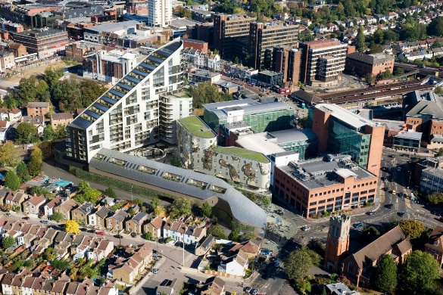
Figure 1 Aerial view (left) and 3D computer render (right) of the development

2.2 Building Construction Details
The building construction of the development section considered consists of a concrete core structure of varying depths with different dry lining systems forming the walls and ceilings and air voids with some form of insulation installed depending on the location.
The construction of the ceiling in one of the cinema auditoria consisted of:
- Structural concrete slab;
- 246mm void from top of plasterboard with 80mm mineral wool insulation above ceiling boards;
- MF suspended ceiling system consisting of 5 layers of 15mm plasterboard on acoustic hangers.
The floor construction in the residential apartments consisted of:
- Screed board;
- Underfloor heating system;
- 200mm structural concrete slab;
- 210mm void and plasterboard ceiling.
The floor construction in the restaurant units consisted of:
- Sand-cement screed on beam & block floor;
- 700mm service void;
- Concrete structural slab of varying depths (typically between 825mm and 1000mm).
Cinema auditoria floors consist of a floating floor system on structural concrete slab as follows:
- 97mm concrete floor slab;
- 30mm insulation;
- 18mm ply deck;
- Acoustic pads on structural concrete slab.

3. METHODOLOGY
This section describes the methodology used during the sound insulation measurements and prediction modelling and outlines the methods and procedures followed.
SEA has been applied to two particular real scenarios to predict structure-borne flanking sound transmission between both adjacent and non-adjacent spaces. Airborne sound insulation measurements have been undertaken in order to compare against SEA-based predictions.
Two different cases were assessed within each scenario depending on the type of adjacency of the spaces and therefore, the transmission paths present:

- Adjacent spaces, between restaurant units and residential apartments; and
- Non-adjacent spaces, between cinema auditoria and residential apartments.

Table 1 below defines the spaces used for each of the scenarios assessed. These were selected based on their use, operating times and potential risk of significant adverse effects on the noise sensitive receptors, identified to be the residential apartments on Level 1 above the commercial and cinema spaces. To assist the reader, a schematic 3D view of the spaces is included in Figure 2 below showing each scenario: Scenario 1 (orange) and Scenario 2 (blue).

Table 1 Description of the scenarios assessed
Scenario | Type of Adjacency | Source Room | Receive Room
1 | Adjacent | Restaurant Unit 4 | Apartment C.01.2 Bedroom 1
 | Non-adjacent | Cinema Auditorium 9 | Apartment C.01.2 Bedroom 1
2 | Adjacent | Restaurant Unit 3 | Apartment D.01.2 Bedroom 1  Apartment D.01.3 Bedroom 1
 | Non-adjacent | Cinema Auditorium 1 | Apartment D.01.1 Bedroom 1  Apartment D.01.2 Bedroom 1

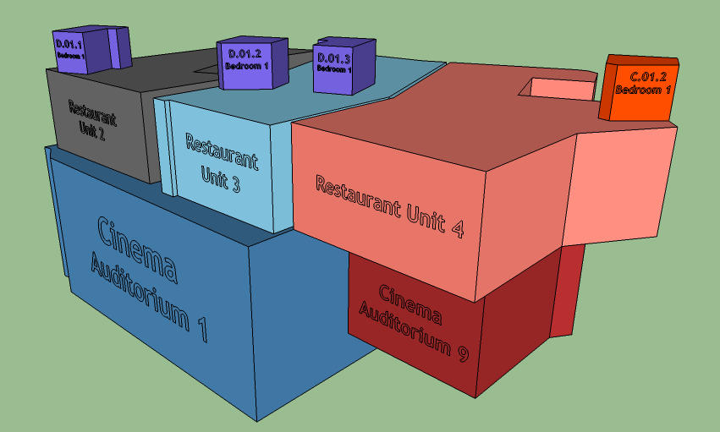
Figure 2 3D View Showing Spaces Locations - Scenario 1 (orange), Scenario 2 (blue)

3.1 Measurement method
A total of six airborne sound insulation measurements in terms of Standardized Level Difference (D_{nT}) were undertaken between the cinema auditoria/restaurant units and the residential spaces above in accordance with BS EN ISO 140-4:1998 []. It should be noted that this standard has been superseded although it is still referred to in the Building Regulations that apply in this case and therefore has been used. All the measurements were undertaken in 1/3 octave bands across the frequency range between 50Hz and 5000Hz. Spatially-averaged sound pressure levels using the manual scanning technique, described in BS EN ISO 16283-1:2014 [], were measured simultaneously in the source and receive rooms.
Two sound sources fed with the same test signal and operating simultaneously were used, each of which comprising two subwoofer systems and two line array systems to achieve adequate signal-to-noise ratio in the receive spaces [11] [12].
A summary of the sound insulation measurement locations is shown in Table 2 below.

Table 2 Sound Insulation Measurement Locations
Meas. ID | Type of Adjacency | Source Room | Receive Room
1 | Adjacent | Restaurant Unit 4 | Apartment C.01.2 Bedroom 1
2 | Non-adjacent | Cinema Auditorium 9 | Apartment C.01.2 Bedroom 1
3 | Adjacent | Restaurant Unit 3 | Apartment D.01.2 Bedroom 1
4 | Adjacent | Restaurant Unit 3 | Apartment D.01.3 Bedroom 1
5 | Non-adjacent | Cinema Auditorium 1 | Apartment D.01.1 Bedroom 1
6 | Non-adjacent | Cinema Auditorium 1 | Apartment D.01.2 Bedroom 1

All the residential apartments were completed and unfurnished whereas only the restaurant units and the cinema shell construction was completed at the time of the measurements. Temporary doors fully sealed around the edges were required in the cinema auditoria to prevent noise break-out.

3.2 SEA Prediction Model
SEA-based prediction models were built for each scenario in order to estimate structure-borne sound transmission.
Input data obtained from drawings and final construction details were used to inform the prediction models. Physical properties of the fibre, gas and isoelastic materials forming the various building elements were defined based on either the product datasheets provided by the manufacturer or generic data found in the literature ([], [] and []).
In each model, SEA subsystems were generated for both bending and in-plane waves depending on the element type: beam, plate, acoustic layer or acoustic space.
Cinema Auditorium 1 is directly in contact with the ground whereas Cinema Auditorium 9 is located above the cinema concourse. The effect of damping due to coupling between the Cinema Auditorium 1 slab and the ground was taken into account by modelling the damping of the floor slab to give a moderate average damping loss factor across the frequency range of interest.
For the remaining reinforced concrete and concrete lightweight blockwork elements, total damping loss factors due to coupling were estimated using Equation 1 [].
$$η=\frac{1}{\sqrt{f}}$$ | Equation 1
where:
$η$ is the coupling loss factor;
$f$ is the frequency.
Energy transmission across plates junctions formed by walls, floors, ceilings and façade elements in the building as well as across structural elements such as wall fixing systems to reinforced concrete shear walls, floating floor isolation pads and wall studs were modelled using line and point structural connections between given pairs of plates where applicable.
Different degrees of detail with increasing number of elements, connections and subsystems were applied in order to assess the impact of increasing level of detail on the prediction accuracy. The lowest level corresponds to the concrete structure only in the source and intermediate spaces whereas the highest level includes all elements in all rooms involved (i.e. wall linings, cavity absorbers, structural connections, floor beams, etc.).

3.3 Analysis
Sound insulation measurements were compared with the predictions and prediction errors in terms of dB difference and percentage (%) were computed using Equation 2 below:
$$e\left(\%\right)=\left({{\left[D_{nT}\right]}_{p}-{\left[D_{nT}\right]}_{m}}/{{\left[D_{nT}\right]}_{m}}\right) x 100$$ | Equation 2
where:
$e$ is the prediction error;
${\left[D_{nT}\right]}_{p}$ is the predicted Standardized Level Difference at each frequency band;
${\left[D_{nT}\right]}_{m}$ is the measured Standardized Level Difference at each frequency band.

4. RESULTS AND DISCUSSION
This section presents a comparison between the measured D_{nT} values and the SEA-based predictions and discusses the prediction errors obtained for each type of adjacency.

4.1 Adjacent Spaces
Figure 3 and Figure 4 below show predicted and measured D_{nT} for adjacent spaces for different levels of modelling detail. Section 4.3 below discusses prediction errors associated with the measured data and predictions illustrated in these figures.
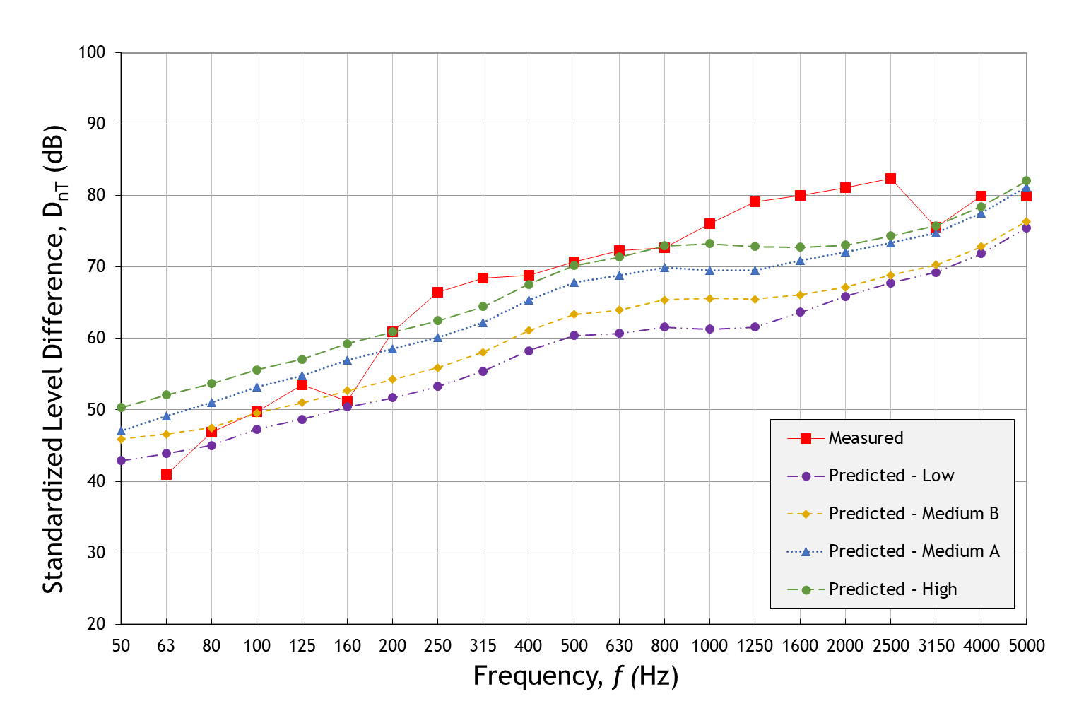
Figure 3 Predicted and Measured Standardized Level Difference (D_{nT}) (Adjacent Spaces - Scenario 1)
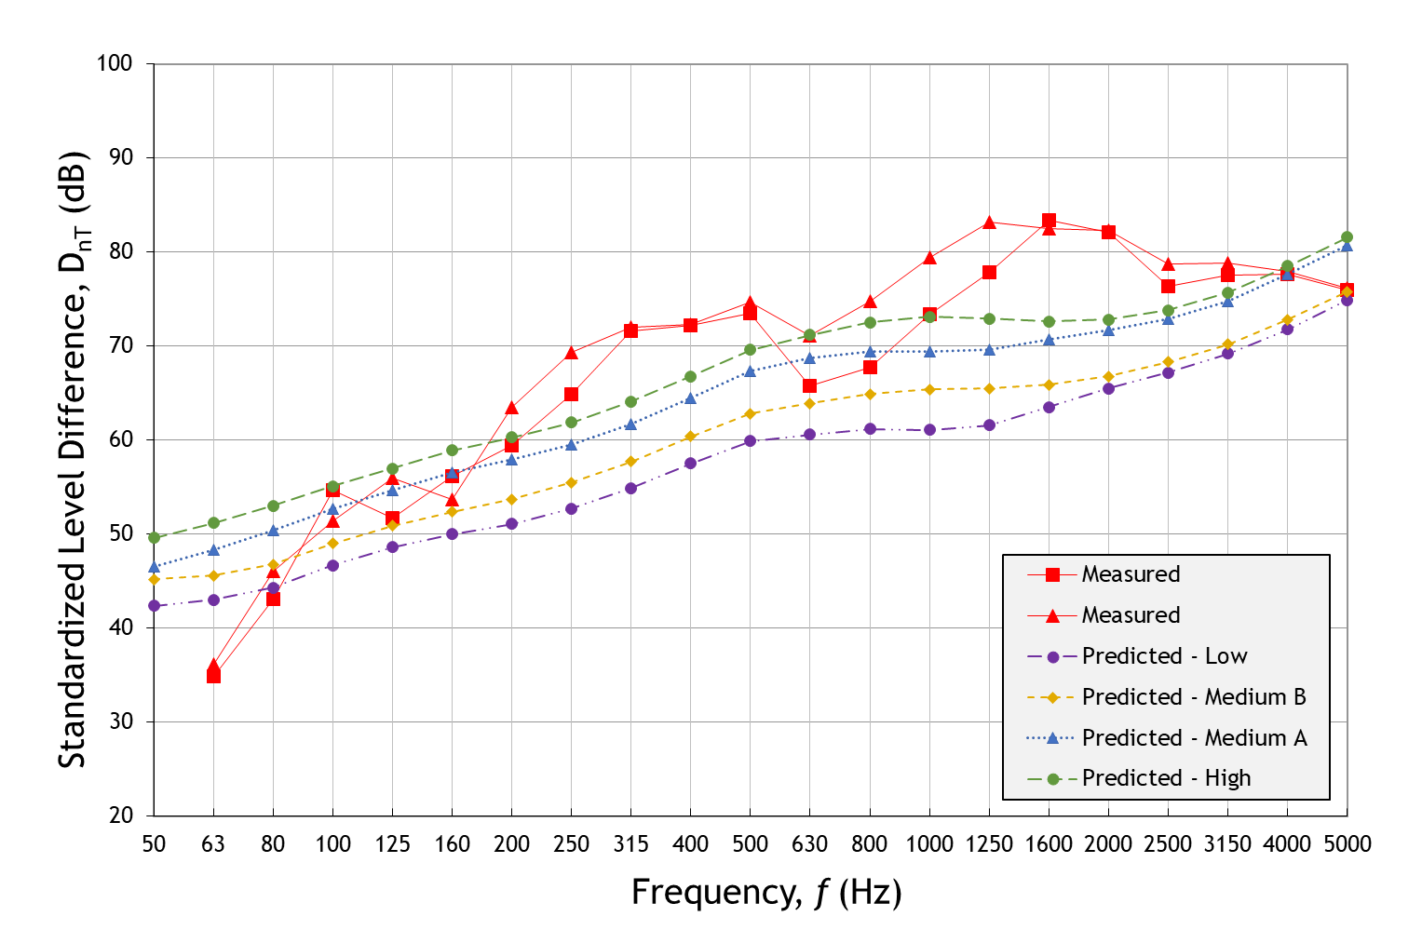
Figure 4 Predicted and Measured Standardized Level Difference (D_{nT}) (Adjacent Spaces - Scenario 2)

4.2 Non-adjacent Spaces
Figure 5 and Figure 6 below show predicted and measured D_{nT} for non-adjacent spaces for different levels of modelling detail. Section 4.3 below provides the corresponding discussion on the prediction errors.
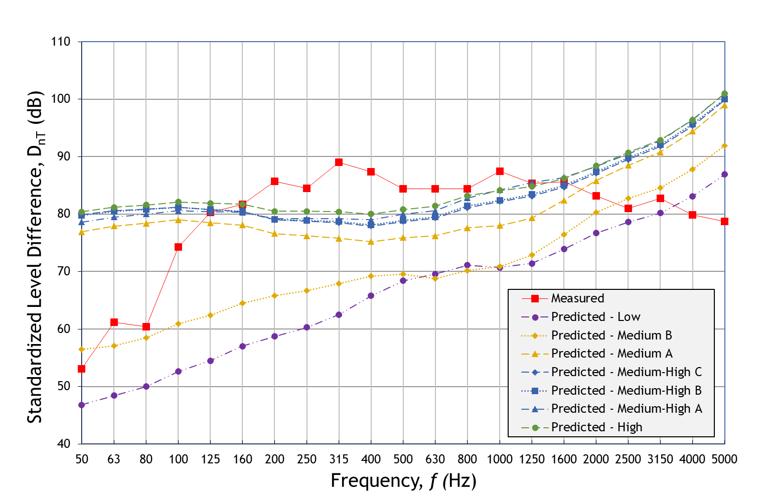
Figure 5 Predicted and Measured Standardized Level Difference (D_{nT}) (Non-adjacent Spaces - Scenario 1)
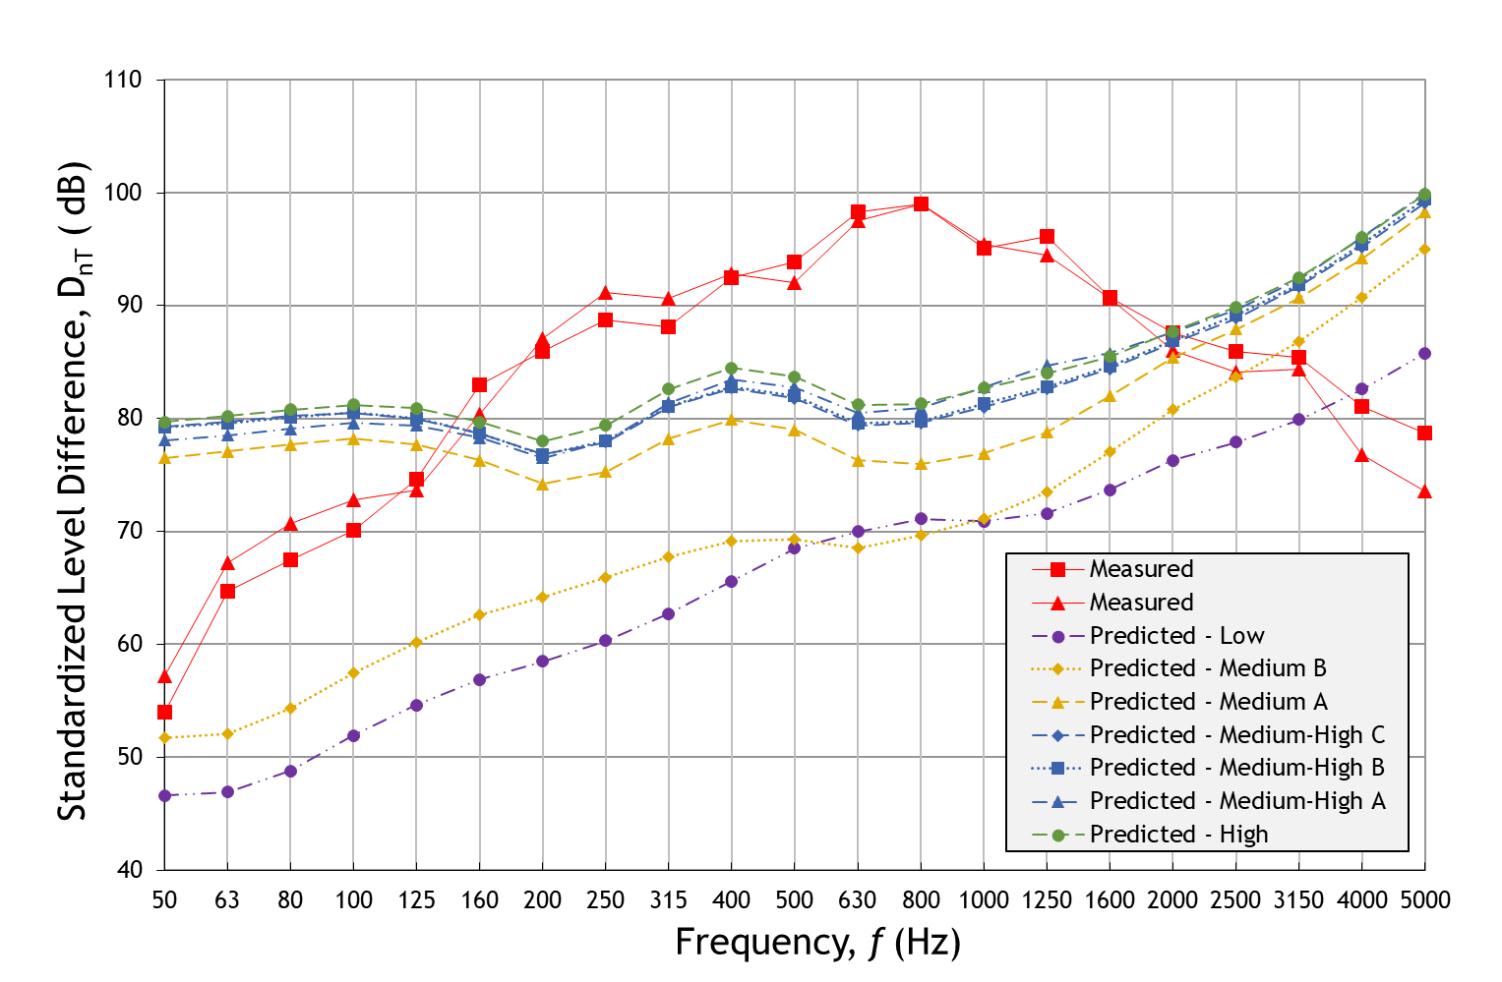
Figure 6 Predicted and Measured Standardized Level Difference (D_{nT}) (Non-adjacent Spaces - Scenario 2)

4.3 Prediction Error Analysis
Prediction errors in terms of percentage (%) are presented in Figure 7 for adjacent spaces and Figure 8 for non-adjacent spaces. Lower frequency bands are shown in dark blue whereas clear blue represents higher frequency bands for each level of detail specified (i.e. number of elements).

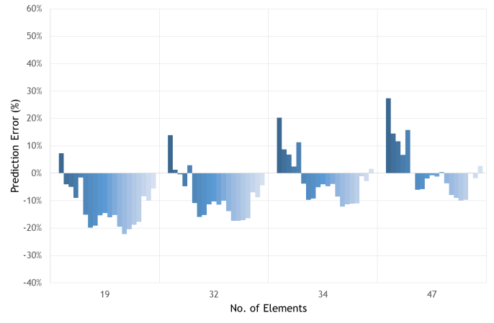 | 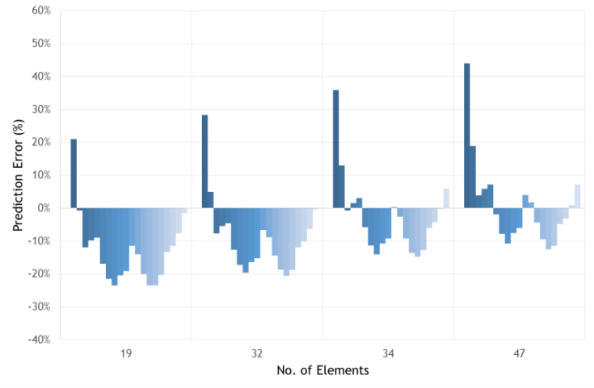
Figure 7 Prediction Error in Terms of Percentage (%) (Adjacent Spaces - Scenario 1, left; Scenario 2, right)

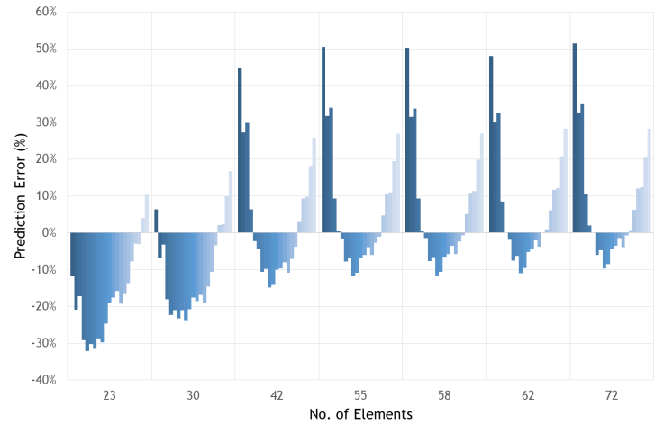 | 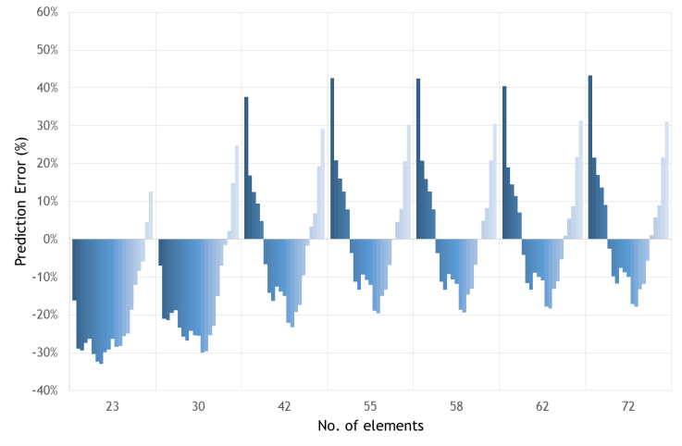
Figure 8 Prediction Error in Terms of Percentage (%) (Non-adjacent Spaces - Scenario 1, left; Scenario 2, right)

Predictions are generally more accurate for adjacent spaces compared to non-adjacent spaces which could be explained by the fact that errors tend to increase and accumulate with longer transmission paths.
Moreover, a relationship between frequency and prediction error can be observed in Figure 7 and Figure 8. For lower frequencies, a low mode count together with potential bias errors accumulated as distance from the source increases may explain why the prediction models above certain level of detail underestimate the sound transmission significantly. For higher frequencies, energy transmission is considerably underestimated only in the case of non-adjacent spaces, as it can be observed in Figure 8. Conversely, as shown in Figure 7, transmission is generally overestimated for adjacent spaces achieving relatively lower errors in the high frequency range.
Better accuracy is achieved when both the source room and previously identified dominant transmission paths are modelled containing as much detail as possible, regardless the type of adjacency.

Mean prediction error in terms of dB difference obtained for each scenario analysed is presented in Figure 9 below for each type of adjacency. These are only shown for the levels of detail based on approximately 75% of the number of elements used in the highest level of detail (i.e. ‘High’). Such level of detail was found to provide a good compromise between accuracy and detail for each type of adjacency.

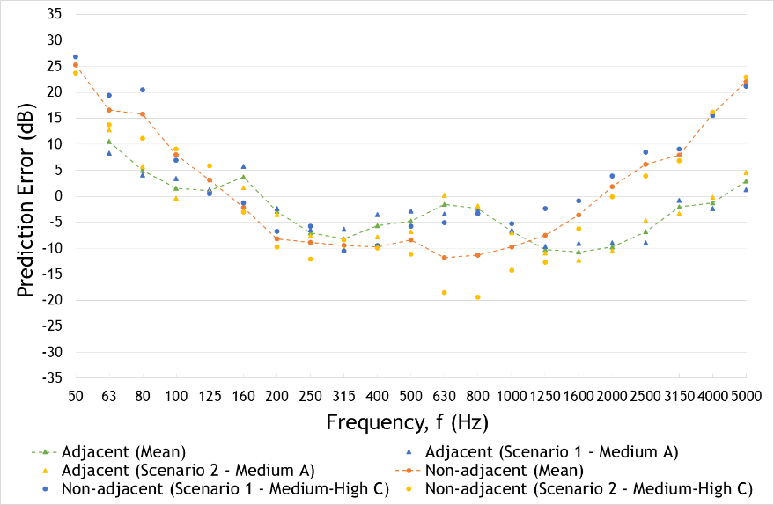
Figure 9 Mean Prediction Error (dashed lines) for Adjacent and Non-adjacent Spaces

Overall, the mean prediction errors obtained in this study in 1/3 octave bands are within ±10dB for adjacent spaces and ±12dB for non-adjacent spaces within a limited frequency range between 100Hz and 3150Hz. This accuracy can be considered a reasonable accuracy for early stages in the design process although significantly lower than that of ±4dB in magnitude achieved by Churchill and Hopkins in [4], where direct transmission was modelled using SEA including measured data to model the dynamic stiffness of the isolators and the cavity reverberation time un controlled conditions.
Therefore, in a practical and real design situation as described in this study in which input data may be unknown or not defined yet, SEA can be a useful tool to guide early design choices. However, such prediction errors may not be acceptable for other applications or stages in the design process. Outside the frequency range 100Hz - 3150Hz, significant prediction errors are likely to be obtained. Errors in the mid and high frequencies may be reduced by including measured data in the SEA model while errors obtained in the low frequencies could be reduced by combining deterministic and SEA techniques, as suggested in the literature.
Furthermore, a higher variability in the errors has been found for non-adjacent spaces (maximum standard deviation of 11dB) compared to adjacent spaces (maximum standard deviation of 3dB), with errors up to -20dB in the mid frequency range, which highlights the need of assessing other different cases to validate the results presented.

4.4 Uncertainty
The main potential source of uncertainty has been identified to be the exclusion of some elements or structural connections from the prediction model as a result of initially underestimating their contribution to the overall sound transmission, which at an early stage could be quite common due to systems and fixings/structural connections not being defined yet.
Another significant source of uncertainty is the variability in the modal properties of the subsystems. SEA uses a purely statistical approach and do not take modal behaviour into consideration since,
The uncertainty associated with the potential lack of knowledge of the exact physical and geometric properties of the spaces, commonly found at an early stage, is considered to be marginal for the SEA techniques as opposed to that associated with deterministic approaches. Nevertheless, this has been minimised by incorporating actual data where possible.
There is also an element of uncertainty associated with other transmission paths not being modelled such as airborne sound being transmitted through the external façades/glazing, especially in the case of adjacent spaces, where this type of transmission may not be negligible.

4.5 Limitations
The main limitation of this research is that it only relies on a reduced sample of cases and predictions have been undertaken using only one software package. As a result, the findings presented cannot be considered conclusive but indicative, as more cases in different buildings and other prediction tools should be used in further investigations in order to validate these results.

5. CONCLUSIONS
Sound insulation and noise control measures play a primary role in buildings design process, especially when multiple uses are combined in the same building presenting a potential risk of significant adverse effects on the noise sensitive receptors.
Structure-borne flanking sound transmission between both adjacent and non-adjacent spaces has been predicted using Statistical Energy Analysis (SEA). Airborne sound insulation measurements have been undertaken in order to compare against SEA-based predictions.
The mean prediction errors obtained in this study in 1/3 octave bands were within ±10dB for adjacent spaces and ±12dB for non-adjacent spaces within a typical frequency range between 100Hz and 3150Hz. Outside this frequency range, unacceptable prediction errors were obtained. Errors in the mid and high frequencies may be reduced by including measured data in the SEA model whereas errors obtained in low frequency ranges could be reduced by combining deterministic and SEA techniques, as suggested in the literature.
The effect of the amount of detail to be included in the SEA-based models has also been studied. It was found that to improve the prediction accuracy, both the source room and previously identified dominant transmission paths should be modelled containing as much detail as possible, regardless the type of adjacency.
This study has shown that SEA-based technique can serve as a valuable design aid in the early stages of the acoustic design process, particularly in the challenging cases of non-adjacent spaces.
However, the inherent limitations and uncertainties should be understood in the modelling process and data interpretation.

6. ACKNOWLEDGEMENTS
This research has been supported by Adnitt Acoustics. The authors are grateful to Ian Gorton and Matt Ward for their assistance during some of the measurements on site.

7. REFERENCES

[] MORI Social Research Institute. Neighbour noise - Public opinion research to assess its nature, extent and significance. Defra Research Study (2003)
[] Galbrun, L. “The prediction of airborne sound transmission between two rooms using first-order flanking paths”, Applied Acoustics, 69, pp. 1332-1342 (2008)
[] Craik, R.J.M. “The contribution of long flanking paths to sound transmission in buildings”, Applied Acoustics, 62(1), pp. 29-46 (2001)
[] Churchill, C. and Hopkins, C. “Prediction of airborne sound transmission across a timber–concrete composite floor using Statistical Energy Analysis”, Applied Acoustics, 110, pp. 145-159 (2016)
[] Craik, R.J.M. and Thancanamootoo, A. “The importance of in-plane waves in sound transmission through buildings”, Applied Acoustics, 37(2), pp. 85-109 (1992)
[] Craik, R.J.M. “The contribution of long flanking paths to sound transmission in buildings”, Applied Acoustics, 62(1), pp. 29-46 (2001)
[] Craik, R.J.M., Steel J.A. and Evans D.I. “Statistical energy analysis of structure-borne sound transmission at low frequencies”, Journal of Sound and Vibration, 144(1), pp. 95-107 (1991)
[] Elmallawany, A. “Criticism of statistical energy analysis for the calculation of sound insulation - Part 2: Double partitions”, Applied Acoustics, 13(1), pp. 33-41 (1980)
[] Reynders, E., Langley, R.S., Dijckmans, A., Vermeir, G. “A Hybrid Finite Element – Statistical Energy Analysis Approach to Robust Sound Transmission Modelling”, Journal of Sound and Vibration, 333(3), pp. 4621–4636 (2014)
[] Van den Wyngaerta, J.C.E., Schevenelsb, M., Reyndersa, E.P.B. “Predicting the Sound insulation of Finite Double-leaf Walls with a Flexible Frame”, Applied Acoustics, 141, pp. 93-105 (2018)
[] British Standards Institution, BS EN ISO 140-4:1998 Acoustics — Measurement of sound insulation in buildings and of building elements — Part 4: Field measurements of airborne sound insulation between rooms. London: BSI (1998)
[] British Standards Institution, BS EN ISO 16283-1:2014 Acoustics — Field measurement of sound insulation in buildings and of building elements — Part 1: Airborne sound insulation. London: BSI (2014)
[] Hopkins, C., “Sound Insulation”, Oxford: Elsevier. pp. 608-609 (2007)
[] Nilsson, A. and Liu, B., “Vibro-Acoustics”, Volume 1, p.79. Berlin and Beiging: Springer and Science Press. (2015)
[] Vigran, Tor E., “Building Acoustics”, p. 88. Abingdon: Taylor & Francis. (2008)
[] Craik, R.J.M. “Damping of Building Structures”, Applied Acoustics, 14, pp. 347-359 (1981)

