Improving maternity experience through crowdsourcing activity: midwives’ evaluation of their participation. Part 2

Abstract
This is the second of two papers on crowdsourcing. In the first paper (Frewin and Church 2019), crowdsourcing was introduced as an innovative way to find solutions to issues in practice. Defined as a process by which problems can be solved by using ideas sourced from a group of people (Howe, 2006), crowsourcing can be used to discover rich and relatively low-cost ideas to improve the maternity experience. This second paper will present the findings of midwives’ evaluation of their participation at a WhoseShoes?® workshop.

Keywords: crowdsourcing, quality improvement, midwives as change agents, service evaluation

Improving maternity experience through crowdsourcing activity: midwives’ evaluation of their participation. Part 2

Introduction
The need for improvement in the maternity experience has been highlighted in national enquires (Kirkup 2015) and is the subject of regular review by the Care Quality Commission (CQC). Whilst there is no single definition of quality improvement, there is a general agreement that ‘Improving quality is about making healthcare safe, effective, patient-centred, timely, efficient and equitable’ (The Health Care Foundation 2013:3). Quality improvement methods should be systematic and robust, able to focus on evaluation, action and change. Two principles underpinning quality improvement relevant to this paper focus on enthusiastic and engaging staff and the service user feedback and involvement in co-design (DH 2008).

The Role of midwives
To increase innovation in practice, midwives should be supported to see innovation and improvement as a core part of their role. Whilst all members of staff have a role to play in improving the quality of services, midwives through their relationships with women and their families, are uniquely placed to identify areas in need of improvement. Achieving change requires collaboration and buy-in from the multidisciplinary team; it is crucial that midwives have the opportunity to develop leadership and management skills to lead innovation and quality improvement in practice (RCM, IPA 2012).
All midwives have the power to influence and change the maternity experience. To improve experiences of maternity care, midwives are able to use direct feedback gathered from verbal and or written means such as for example the Friends and Family (NHS England 2014); via social media and through bespoke workshops. Therefore, the relationship between service users and midwives is crucial.
Service users
Wenzel and Jabbal (2016) emphasise the significance of receiving feedback from those who experience care within the maternity services. They suggest that feedback is central to quality and that obtaining feedback is a way of monitoring the quality of care. However, Coulter et al (2014:3) suggest that;
‘It is unethical to ask patients to comment on their experiences if these comments are going to be ignored. We believe a more concerted attempt is now required to make use of the evidence. An institutional focus could prove to be the key to getting it taken more seriously’.

Over a decade ago, Granville (2006) stated that co-designing services with patients was a way in which feedback could be used to improve care and should be encouraged across organisations. Ten years later, Better Births (National Maternity Review, 2016) focused on the personalisation of care as a key issue. Choice and personalisation of care ensures that midwives are invested in every woman’s unique maternity journey. As a result, midwives are perfectly placed to influence care through quality improvement activities such as crowdsourcing. Establishing a multidisciplinary crowdsourcing workshop to explore experiences and share ideas is crucial in the process of improving the quality of care and in the co-design of services.
The workshop
In March 2016, an NHS Trust won funding from NHS England Challenge Fund to improve services for women. Through social media the change platform #MatExp felt compelled to highlight concerns voiced by women who were seldom heard within maternity services. These included:
- Families with babies in Neonatal Unit (NNU) and paediatrics;
- Severely ill women who developed unexpected serious illness in pregnancy and the postnatal period;
- Women who had experienced a mid-trimester loss.

Organisers of the project known as ‘Nobody’s patient’ held a WhoseShoes?® workshop designed to crowdsource new ideas to focus on improving the care of women in these three groups. Co-produced scenarios based on women’s experiences generated through #MatExp were used during the workshop. The workshop used crowdsourcing as the mechanism for change and contributed to improvements in practice. The crowdsourcing workshop was attended by a multidisciplinary audience including service users and ten midwives with knowledge and understanding of women’s experiences.

Aim of service evaluation project
The service evaluation project focused on midwives who participated in the crowdsourcing workshop. The aim of this project was to:
1. Explore how midwives who attended the workshop viewed their involvement in crowdsourcing
2. Examine whether midwives who attended the workshop considered themselves as agents of change for quality improvement.

It was important to discover what the midwife participants felt their role was in affecting change and the extent to which they felt they were successful in contributing to improving the quality of services (Fig 1).
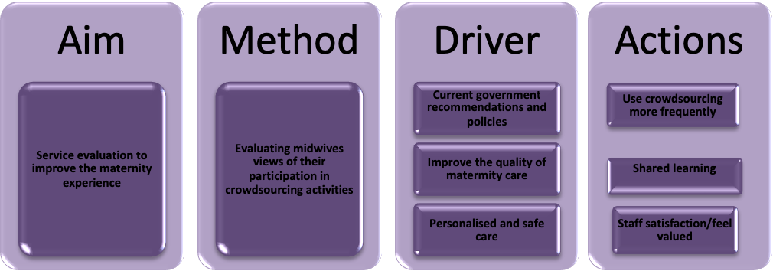

Figure 1 Overview of service evaluation process
Method
A service evaluation is a rigorous and systematic review of a service, and or aspect of a service or care provided. The intention of this approach as opposed to research, is not to generate new knowledge or generalise findings, neither is it to measure services against pre-existing standards such as in clinical audit; rather the aim is to define current care or activity, to gather information as a means to inform decision-making (Gerrish and Mawson, 2005). Although service evaluations are limited to specific local services, they provide relevant information for service users and health professionals and generate recommendations for service improvements.
To address the aim of this service evaluation, a generic qualitative approach (Cooper and Endacott, 2007) was employed. A generic qualitative approach is not guided by philosophical assumptions associated with known qualitative methodologies such as phenomenology, grounded theory and ethnography; where the focus is on exploring in-depth experience, complexity of culture and theory building. Rather, it is said to respond to experience-based questions of interest relevant to a practice-based discipline such as midwifery (Kahlke 2014). Two sub categories of this generic approach, namely qualitative descriptive approach (Bradshaw et al 2017) and interpretive description (Thorne et al 2004) are discussed in the literature. Caelli et al (2003: 4-5) define this generic approach as:
‘…those that exhibit some or all of the characteristics of qualitative endeavor but rather than focusing the study through the lens of a known methodology they seek to do one of two things: either they combine several methodologies or approaches, or claim no particular methodological viewpoint at all. Generally, the focus of the study is on understanding an experience or an event.’
It is argued that whilst generic approaches present an opportunity to develop new methodologies and new theoretical perspectives (Lim 2011), they also offer researchers flexibility to explore questions from different perspectives (Kahlke 2014). For this reason, a generic qualitative approach was considered appropriate to underpin this evaluation, since as Percy et al (2015:79) state;
By and large, generic qualitative data collection seeks information from representative samples of people about real-world events and processes, or about their experiences. We want less to “go deep” and more to get a broad range of opinions, ideas, or reflections. Occasionally, a small, non-representative, but highly informed sample can provide rich information about the topic.

However, concerns raised in relation to the issue of rigour (Neergaard et al 2009) focus on the absence of specific theoretical assumptions, where there may be incongruence between epistemological intent, theoretical positioning of the researcher, and methodological and methods structure (Kahlke 2014). Sandelowski (2010) suggests the need to apply theoretical frameworks that make sense in the context of the research questions and design of individual research, in which the researcher can decide which theoretical perspective is the most appropriate. Emphasis should be placed on the role of the researcher and their engagement with reflexivity, consideration of ethical issues and methodological challenges, as means to illustrate rigour of the decision making process and research design (Kahlke 2014).

Ethics
Since this service evaluation was undertaken as part of a Master’s degree, the project proposal was reviewed and approved by the School of Health Ethics Committee; research governance approval was also granted from the local hospital trust. Although ethical review for service evaluation projects is not considered necessary, (NHS HRA, 2013), there has been recent discussion about the ethics of conducting ‘research-like activities’ (Chen and Fawcett, 2017). For this reason, this project was undertaken according to the principles of good ethical practice (NHS HRA, 2017). Written informed consent was acquired from all participants; maintaining confidentiality and protecting anonymity was paramount.

Sample
From the ten midwives that attended ‘Nobody’s patient’ workshop, six midwives were available and agreed to be interviewed as part of this service evaluation.

Data collection method
Data collection used face-to-face, semi-structured interviews (Parahoo, 2014) supported by the use of an interview guide. The participant’s anonymity was enhanced by assigning each individual a number. All interviews were digitally recorded with consent.

Data analysis
Thematic analysis was used to uncover the descriptive phenomena within the interview process (Smith & Firth, 2011). Following the steps of Howitt and Cramer (2014), data were analysed by transcribing the material, coding the text and identifying themes that emerged. By transcribing the interviews verbatim, and re-reading the interviews, a deeper understanding and familiarisation of the data was achieved.
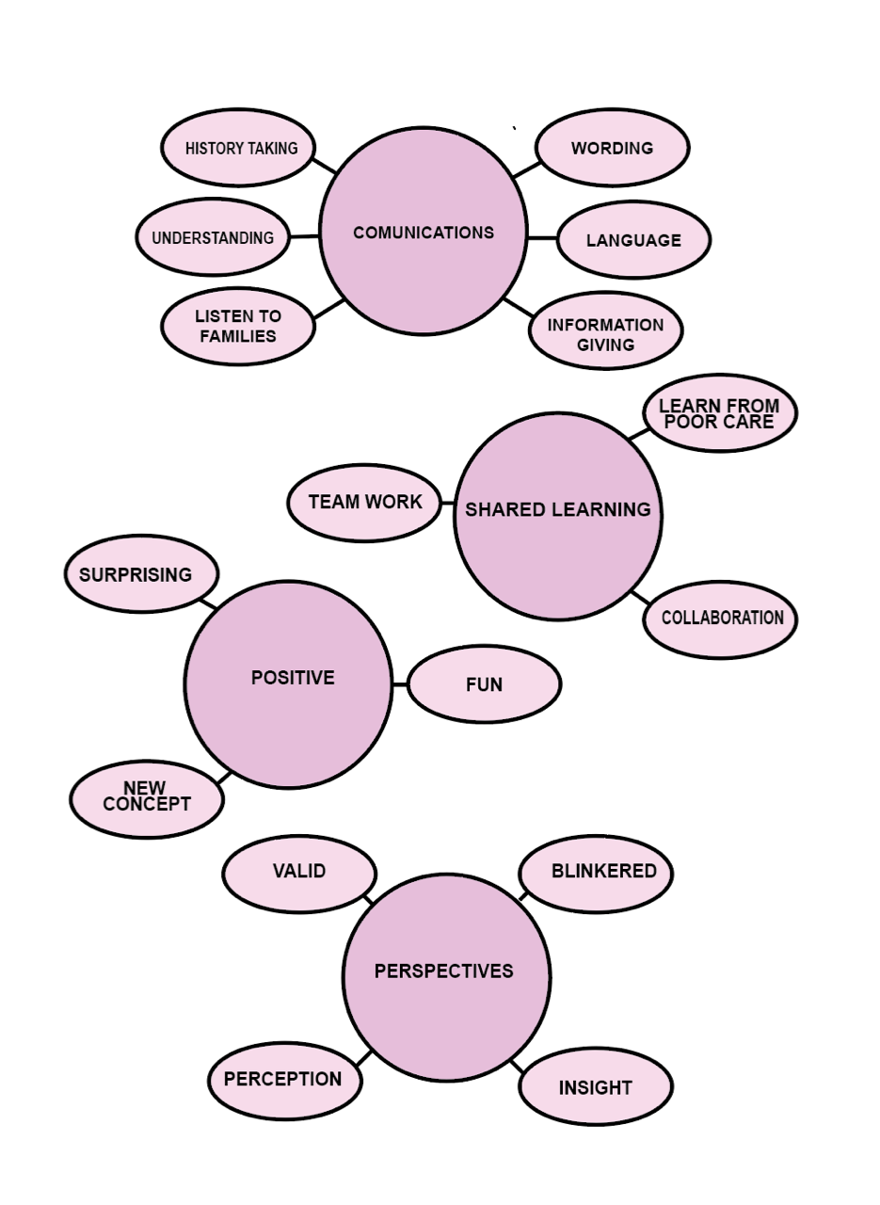
Fig 2. Themes generated from thematic analysis

Findings
Four key themes emerged from analysing the data (Figure 2). These were; improving communication, experience different perspectives, shared learning and positivity.
Improve communication
Midwife participants agreed that communication was a major factor in achieving excellence in practice. During the interviews, midwives drew on personal experiences of poor communication to illustrate how communication had an impact on women’s experience of care and their relationship with healthcare professionals.

One of the midwives reported that since she attended the workshop and participated in crowdsourcing, making simple changes in practice had resulted in a completely different relationship with service users. She says:
They (the service user) want to tell us their side of the story...maybe we seem a bit more human or maybe it’s just more approachable, it’s definitely made a difference [Midwife 2].

Improvement in communication and language used in bereavement care was one specific area crowdsourced in the ‘Nobody’s patient’ workshop. Midwives expressed a need for greater insight into the terminology used around bereavement that women may find more acceptable. As a result of participating in the crowsourcing activity, one midwife reported learning a valuable lesson in communicating with families whose babies had died.
So I’ve used the term loss quite a lot, I thought it sounded better than using death… [Midwife 2]

She drew on one specific example in which many bereaved mothers objected to official letters from the hospital referring to their baby as ‘lost’. One bereaved mother was reported to have said that her six babies were not lost and that she knew exactly where they were, illustrating that what may seem correct and sensitive language maybe inappropriate and upsetting.

Another midwife reported how she was made aware of using acceptable and appropriate terms with bereaved families.
I’m very careful now with the language that I use, when dealing with a sad case [Midwife 6].

Crowdsourcing encouraged open and honest discussions around communication. Midwife participants stated that the crowdsourcing activity highlighted the importance of language in communication. For women who experienced insensitive care following emotional and potentially traumatic events, it is the healthcare professional who may benefit from education on how best to care for bereaved women and women who are critically unwell in pregnancy.
Getting people to sit down and speak and listen to somebody who has had a really bad outcome, or somebody used a poor choice of language or words [Midwife 6]

Another midwife whilst discussing her role in facilitating care for women outside normal midwifery pathway, recognised that the fundamental issue was good communication.
Communication is key to improving services…we are going to do what people want in a safe way [Midwife 5]

The value of improving communication is often highlighted as a vital area of concern from the maternity service user perspective (Rowe et al 2002, Prosser-Snelling 2015). Women report greater satisfaction of care when they are given adequate information in a way that they understand (Fowler & Patterson, 2013). As well as service users, healthcare professionals also report that communication is an issue where a degree of hierarchy exists between professional groups perpetuating a barrier to creative innovation (RCOG, 2015).

Experience different perspectives
The importance of sharing experiences from different perspectives was common across the interviews. Since the workshop was multidisciplinary and also included service users, participation in crowdsourcing enabled the discussion of issues from different perspectives.

Some midwives felt that participating in the discussion had enabled them to review how they delivered care within their particular areas. One midwife stated:

It was nice to see and hear other people’s thoughts and experiences. [Midwife 1]

One midwife participant felt that crowdsourcing enabled her to share her concerns of how midwives on the ‘shop floor’ were viewed by management. The midwife felt that the multidisciplinary approach of crowdsourcing could provide managers with an appreciation of the complexities of the role of the midwife and the dedication and passion that midwives devote to their role.
People that make big decisions sometimes aren’t aware of what goes on at ground level and the pressures we are under… [Midwife 3]

This midwife shared her thoughts on the relationship between the provision of care and the experience of care. Since every pregnancy and birth experience is unique, care should be personalised and not prescriptive, and the midwife participants firmly believed this.
So, for me it was important to gain people’s perspectives of their level of care so that we could improve care as service providers [Midwife 3].

Shared learning
All midwife participants shared what they had learnt almost immediately with their peers.
After the workshop, I went back to the labour ward and discussed what we’d learnt with people who hadn’t been at the workshop [Midwife 5]

Through the shared experiences of the service user, the ‘crowd’ was able to collectively suggest ways of improving specific aspects of care, so that issues in the provision of care could be addressed.
I shared some of the stories I had heard because they were really heartfelt and really important to share” [Midwife 2].

One of the slogans used by #MatExp and WhoseShoes? is “No hierarchy, just people”. The idea is focused on the fact that all people present at the workshop, regardless of their position within the Trust, have a maternity experience story. One midwife reported a general atmosphere of recognition and gratitude for the opportunity to share personal stories, not only from the service users’ perspective, but some of the healthcare professionals had sad and emotive stories of their own maternity experiences.
It was good to be in a small group…so you share your ideas intimately…everyone was very welcoming and appreciative that you were there and sharing your views [Midwife 5]

Midwives felt admiration for the women who attended the workshop for sharing their stories with everyone so that learning could take place. Midwives described the impact of listening to women’s experiences face to face and considered this more effective than crowsourcing on the internet. One midwife said;
I tried to speak with the Mums who had a bad outcome that had the courage to share their stories [Midwife 6]

Positivity
Four out of the six midwife participants described the experience of crowdsourcing as a positive experience.

It was really sort of happy ...a positive experience [Midwife 5].

Midwives relished being included in pioneering a different approach to improving care, with the variety of attendees adding an extra dimension to the experience.

I just felt really proud to be involved...and we were using a different method...and all those different people involved [Midwife 2].

Midwives and other healthcare professionals strive to ensure women arrive at a mutually agreeable personalised plan of care, using open discussions between the health disciplines (National Maternity Review 2016; Coxon et al 2017). As a service provider, the NHS has a duty not only to provide safe care, but a quantifiable service, since women expect high quality care (Redshaw and Henderson 2015). Maternity service workers face this challenge daily and yet, the midwife participants still felt that making steps to ensure women receive personalised care was a positive experience.

Collating information
Developing and testing bespoke crowdsourced material at the ‘Nobody’s patient’ workshop resulted in many ideas to advance practice and develop co-produced solutions with the aim of improving care for women and their families across the three groups. The ideas formed during the workshop were written onto ‘pledge cards’ and followed up by the project midwife to enable implementation into practice. These solutions (Table 1) have the potential to be replicated by other trusts and have been discussed in more detail elsewhere (NHS London Clinical networks 2017).

Table 1: Crowdsourced co-produced solutions
- Rewording of letters to families whose baby has died at any gestation.

- A guideline for women who required admission to Intensive care unit so that their babies if well, could stay with them instead of being at home or in neonatal unit

- A free text box was added to the maternity self-referral form to enable women to disclose what they wanted midwives to know about them in preparation for the booking appointment

- To improve communication between staff and parents, every baby on the neonatal unit was given a diary so that parents and staff could write things about what the baby had done, last feed etc

Implications of findings
Crowdsourcing is an innovative, simple and cost-effective way of finding co-produced solutions that are easily adaptable to improve women’s experiences of care within the maternity services (NHS London Clinical Networks 2015). The findings of this service evaluation have shown that midwives were able to implement small changes to areas highlighted by the service user in need of reform. Through shared learning with colleagues following a crowdsourcing activity, midwives had a greater understanding of what women in their care want from a maternity service. This service evaluation highlighted the positive effects for midwives of being involved in crowdsourcing that in turn benefit the service user. Midwife participants appreciated the shared knowledge of the crowd whether as service users, or healthcare professionals; and went on to share their learning with colleagues. Midwife participants felt their input was valued, and appreciated the opportunity to improve the maternity experience.

Recommendations for practice
1. Dedicated yearly time slots for crowdsourcing activities should be organised to explore solutions to real issues highlighted from user experience feedback.

2. Directors and managers of maternity services will benefit from the potential and necessary use of new innovative ways firmly embedded in maternity care. Incorporating crowdsourcing into routine practice, such as mandatory study days would be an exciting addition to standard programmes.

Recommendations for policy

- As technology evolves, crowdsourcing will increase in popularity as exposure through networking via social media sites such as Twitter and Facebook, are more frequently used by healthcare commissioners and service users alike. It is imperative that commissioners and policy makers realise the potential of using new innovative ways to improve care and utilise these innovations to their absolute potential.

- Multidisciplinary teamwork is the key to safe, high quality maternity care, where crowdsourcing is a cost-effective way of fulfilling these objectives (Wilcock 2016). Current policy for maternity services must address the benefits of crowdsourcing as a way of co-producing solutions between disciplines and with the service user.

Recommendations for research
1. Further exploration of the thoughts and feelings of members of the multidisciplinary team and more senior healthcare colleagues would add a further dimension to current analysis.

Conclusion
Crowdsourcing can be fun and creative, which is sometimes lacking in healthcare. The findings of this service evaluation indicate that involving stakeholders, as a crowd in finding solutions to problems within care is a successful and highly rewarding experience. Midwife participants took pride in sharing their ideas for improvement especially when they were put into practice. This ownership of idea and pride in problem solving added an extra dimension to the role of the midwife. Midwives realised that small, no-cost improvements to care were easily achievable; here ideas were seen as acceptable, fun and appreciated by women and their families.

Declaration of interests
The authors have no conflicts of interest to declare.

Funding
This research received no specific grant from any funding agency in the public, commercial or not-for-profit sectors.

Acknowledgements
We would like to thank all the midwives who participated in this service evaluation and for their valuable contribution.

Key points

• Midwives are key change agents in the drive to improve the quality of care in line with key policy documents.

• Midwives have the tacit knowledge and innate power to influence the strategic development of the maternity services.

• The collaborative nature of maternity services enables small, low and non-cost changes to be made as a collective with immediate benefits to women.

• Ensuring that midwives feel valued and crucial to the workforce enables them to feel empowered to drive and create change and in collaboration with women and their families.

CPD reflective questions
- Discuss the reasons why midwives should be involved in quality improvement
- How is service user feedback obtained in your place of work?
- Consider the way in which crowdsourcing could be used as a mechanism of change in your place of work?

References
Bradshaw, C; Atkinson, S; and Doody, O. (2017) Employing a Qualitative Description Approach in Health Care Research. Global Qualitative Nursing Research Volume 4: 1 –8 https://doi.org/10.1177/2333393617742282
Caelli, K., Ray, L., & Mill, J. (2003) ‘Clear as mud’: Toward greater clarity in generic qualitative research. International Journal of Qualitative Methods, 2(2). Article 1. Retrieved [INSERT DATE] from http://www.ualberta.ca/~iiqm/backissues/pdf/caellietal.pdf
Chen, L & Fawcett, J (2017) 'Service evaluation: A grey area of research?' Nursing Ethics, pp. 1-14. DOI: 10.1177/0969733017742961
Cooper and Endacott (2007) Generic qualitative research: a design for qualitative research in emergency care? Emerg Med J 24:816–819. doi: 10.1136/emj.2007.050641
Coulter A Locock L Ziebland S and Calcbresse J (2014) Collecting data on patient experience is not enough: they must be used to improve care. BMJ 348:g2225 doi: 10.1136/bmj.g2225
Coxon K, Chisholm A, Malouf R, Rowe R, Hollowell J (2017) What influences birth place preferences, choices and decision-making amongst healthy women with straightforward pregnancies in the UK? A qualitative evidence synthesis using a ‘best fit’ framework approach. BMC Pregnancy Childbirth.17(1):103
Department of Health (2008) High quality care for all: NHS Next Stage Review final report. London: Department of Health. Available at: http://webarchive.nationalarchives.gov.uk/20130107105354/ http:/www.dh.gov.uk/en/publicationsandstatistics/publications/publicationspolicyandguidance/ DH_085825 [Accessed: 13th January 2019].
Fowler, G., Patterson, D. (2013) Use of maternity surveys in improving the care experience – a review of the evidence. British Journal of Midwifery Vol 21, (6) pp: 410-415. DOI: 10.12968/bjom.2013.21.6.410.
Frewin S and Church S (2019) Introducing crowdsourcing as a way of improving the maternity experience: Part 1. British Journal of Midwifery

Gerrish K, Mawson S (2005) Research, audit, practice development and service evaluation: implications for research and clinical governance. Practice Development in Health Care 4:1 33–39
Granville, G. (2006) What does the service improvement literature tell us and how can it make a difference to implementation? Available from: http://www.gilliangranville.com [Accessed April 2017].

Howe, R. (2006) The Rise of Crowdsourcing. Wired Magazine, 14, (06). Available from: https://www.wired.com/2006/06/crowds/ [Accessed March 2017].

Howitt, D., Cramer, D (2014) Introduction to Research Methods in Psychology. 4th Edn. Harlow England: Pearson

HQIP (2015) A guide to quality improvement methods, Available at: http://www.hqip.org.uk/public/cms/253/625/19/38/Guide-to-quality-improvementmethods-2015-7-1.pdf?realName=3hoUed.pdf. (Accessed on 14 September 2018).
Kahlke, R. (2014) Generic Qualitative Approaches: Pitfalls and Benefits of Methodological Mixology. The International Journal of Qualitative Methods 13(1):37 DOI: 10.1177/160940691401300119
Kirkup, B. (2015) The Report of the Morecombe Bay Investigation. Available from:https://www.gov.uk/government/uploads/system/uploads/attachment_data /file/408480/47487_MBI_Accessible_v0.1.pdf [Accessed March 2017].

Lim, J. H. (2011). Qualitative methods in adult development and learning: Theoretical traditions, current practices, and emerging horizons. In C. Hoare (Ed.), The Oxford handbook of reciprocal adult development and learning (2nd ed., pp. 39–60). New York, NY: Oxford University Press.
National Maternity Review (2016) Better Births, Improving outcomes of maternity services in England, A Five Year Forward View for maternity care. London: NHS England.
Neergaard, M. A., Olesen, F., Andersen, R. S., & Sondergaard, J. (2009). Qualitative description – the poor cousin of health research? BMC Medical Research Methodology, 9(1), 52–56. doi:10.1186/1471-2288-9-52
NHS Health research Authority (2017) UK policy framework for health and social care research https://www.hra.nhs.uk/planning-and-improving-research/policies-standards-legislation/uk-policy-framework-health-social-care-research/(Accessed on 18 September 2017).
NHS Health Research Authority (2013) Decision tool. http://www.hra-decisiontools.org.uk/research/(Accessed on 14 September 2017).
NHS England (2014) Review of the Friends and Family Test. Available at: www.england.nhs.uk/ ourwork/pe/fft/fft-test-review/ (accessed on 19 September 2018).
NHS London Clinical Networks (2017) Co-designed solutions: ‘Nobody’s Patient’ #MatExp. London, NHS England.
NHS London Clinical Networks (2015) Involving service users for quality improvements in maternity. London, NHS England.

Parahoo K (2014) Nursing Research: Principles, Process and Issues. London: Palgrave 3rd edition
Percy, W. H., Kostere, K., & Kostere, S. (2015). Generic Qualitative Research in Psychology. The Qualitative Report, 20(2), 76-85. Retrieved from http://nsuworks.nova.edu/tqr/vol20/iss2/7
Prosser-Snelling, E. (2015) Safer Births Through Better Teamworking. The Health Foundation. Available from: http://patientsafety.health.org.uk/resources/safer-births-through-better- teamworking [Accessed August 2017].

Redshaw, M and Henderson, J. (2015) Safely delivered: a national survey of women’s experience of maternity care 2014 https://www.npeu.ox.ac.uk/downloads/files/reports/Safely%20delivered%20NMS%202014.pdf

RCM, IPA (2012) Innovation and Improvement in Maternity Services. ISBN: 978-1-902922-34-8

Rowe, R.E. Garcia, J., Macfarlane, A.J., Davidson, L.L. (2002) Improving communication between health professionals and women in maternity care: a structured review. Health Expectations 5 pp. 63-83. DOI: 10.1046/j.1369- 6513.2002.00159.x

Royal College of Obstetricians & Gynaecologists (RCOG) (2015) Leading the way to better health care. O&G 2015

Sandelowski, M. (2010). What’s in a name? Qualitative description revisited. Research in Nursing and Health, 33, 77–84. doi:10.1002/nur.20362

Smith, J., Firth, J. (2011) Qualitative data analysis: the framework approach. Nurse Researcher 18 (2) pp. 52-62. DOI: 10.7748/nr2011.01.52.c8284.

The Health Foundation (2013) Quality Improvement made simple. What everyone should know about healthcare quality improvement. London: The Health Foundation. Available: https://www.health.org.uk/sites/default/files/QualityImprovementMadeSimple.pdf (accessed on February 13th 2019).

Thorne, S., Kirkham, S. R., & O’Flynn-Magee, K. (2004). The analytic challenge of interpretive description. International Journal of Qualitative Methods, 3(1), 1–11

Wenzel, L., Jabbal, J. (2016) User feedback in maternity services. The King’s Fund. Available from: https://www.kingsfund.org.uk/sites/default/files/field/field_publication_file/User_f eedback_maternity_Kings_Fund_Oct_2016.pdf [Accessed 21st August 2017].

Wilcock, F. (2016) O&G One Team. Midwives Spring 2016 Vol 19 (1) pp. 26.

