Multiscale interplay of higher-order moments between the carbon and energy markets during Phase III of the EU ETS

Abstract: The Phase III of the European Union Emission Trading System (EU ETS) is significantly different from the previous Phases in terms of price trajectory and operational mechanisms. Against this background, this study reveals the multiscale interplay of higher-order moments (skewness and kurtosis) between the carbon and energy markets, and formulates the optimal portfolio strategies to manage higher-order moments risks at different time horizons. We detect a breakpoint, September 15, 2016, in the carbon-energy markets which divided Phase III into two stages corresponding to different market status. Our findings show that the bidirectional higher-order moments spillovers between the carbon and energy markets are weak at the short-run timescales (below 16 trading days), while the long-run (over 16 trading days) higher-order spillover effect is greatly enhanced. In particular, we find the spillovers in the higher-order moments are strong when the carbon and energy markets are in bullish status. Furthermore, we demonstrate that carbon assets are good short-run hedge against exposure to spillover risks in higher-order moments of the energy markets, while the hedging effectiveness declines at the long-run timescales.

Keywords: EU ETS; Energy markets; Higher-order moments; Multiscale analysis; Portfolio management

Introduction
For the benefits of the carbon and energy markets risk management (Hammoudeh et al., 2014a, b), portfolio construction (Luo and Wu, 2016; Uddin et al., 2018), and energy markets regulation (Chevallier et al., 2019; International Energy Agency, 2020), there is significant interest in studying the interplay between the European Union Emissions Trading Systems (EU ETS) and energy markets.
This study deals challenges in the crucial Phase III of EU ETS in terms of price trajectory and operational mechanisms (Bocklet et al., 2019). There are three distinctive features of Phase III including first, auctions are the default method for allocating quotas (rather than free allocation), which allows the carbon prices to fully reflect the demand and supply of emission under energy price shocks. As a result, the non-gaussian behaviour in carbon and energy price is likely to intensify in Phase III (Hammoudeh et al., 2014a). Second, the European Commission (EC) directly sets a single EU-wide carbon emission cap instead of National Allocation Plans (NAPs). Moreover, the increase of the Linear Reduction Factor (LRF) contributes a stricter and more effective cap-settings. This will undoubtedly increase the complexity and non-linearity of the carbon price patterns and its interplay with energy assets (Lutz et al., 2013).
Finally, it is claimed that the Market Stability Reserve (MSR) has significantly reduced the surplus allowances and caused the carbon prices surging high in Phase III (Chaton et al., 2018; Hepburn et al., 2016). This implies that the “waterbed effect” may be undermined (Anke et al., 2020; Hintermayer, 2020; Perino, 2018; Rosendahl, 2019) and the long-run price signaling mechanism of the carbon market could be strengthened. This directly entails the impact of long-run carbon markets on energy markets will intensify, and vice versa. Therefore, the debate on timescale heterogeneity of interplay between carbon and energy markets in Phase III of the EU ETS continuously develop (Zhu et al., 2017; Zhu et al., 2019). It remains controversial and unsettled if the MSR policy could increase the long-term impact of carbon markets (Perino and Willner 2016, 2017). It is then expected that Phase III would present a more complex bidirectional relationship between carbon-energy prices which creates new challenges for investors and policy makers who concern the systemic risk of the carbon and energy markets.
Considering the unique features and changes in EU ETS Phase III, this study aims to reveal the interplay between the carbon and energy markets to depict spillovers of higher-order moments, namely spillovers of asymmetric and fat-tailed risks. This paper also examines the timescale heterogeneity depending on interplay between the carbon and energy markets. This is addressed as a direct response to the debate on the distinctness envisioned between the long- and short-run price signals leadership in the carbon market due to the “waterbed effect” (Anke, 2020; Rosendahl, 2019), fuel-switching cost (Chevallier, 2019) and policy conflicts (Van den Bergh, 2013). Mining this complex feature can directly help investors of the carbon and energy assets holding different investment horizons to better measure and manage risks given the importance of higher-order moments in portfolio risk management (Christoffersen et al., 2021; Langlois, 2020). To demonstrate the implication of higher order moments risk in portfolio management, this paper also formulates an optimal wavelet-based skewness-kurtosis portfolio strategy to hedge exposure to spillovers of higher-order moments risk of the carbon and energy markets.
This study has a three-fold potential to provide new insights for understanding the interplay between the carbon and energy markets in Phase III of the EU ETS. First, the higher-order moments analysis used in this study complements the study of mean/variance analysis on carbon and energy markets (Aatola et al, 2013; Ji et al., 2018; Hammoudeh et al., 2015), tail dependence- (Reboredo, 2013; Uddin et al., 2018) and quantile dependence-based (Duan et al., 2021; Hammoudeh et al., 2014a), and this will greatly enhance our understanding of the complex carbon-energy interplay during the Phase of dramatic changes in the EU ETS market. Second, empirical evidence found to show timescale heterogeneity features which is a powerful response to the misgivings and debates about the ability of the market’s long-run carbon price signal leadership (Anke, 2020; Rosendahl, 2019). It also largely extends the findings of previous multiscale analysis work on carbon and energy markets (Dai et al., 2020; Huang et al., 2021; Yu et al., 2015; Zhu et al., 2019). Thirdly, to our best knowledge, this paper offers the first empirical attempt to formulate an optimal wavelet-based skewness-kurtosis portfolio strategy to hedge exposure to higher-order moments risk in the carbon and energy markets in short- and long-run time horizons. It directly extends the work of Luo and Wu (2016), and Uddin et al. (2018).
The rest of this paper is organised as follows. Section 2 reviews literature and identifies the importance and gaps of the spillovers and their heterogeneity of higher-order moments between the carbon and energy markets at different timescales. Section 3 introduces the econometric approaches we use in this study. Section 4 describes the data used in this study. Section 5 presents and discusses the empirical findings, and section 6 concludes and highlights the policy implications.

New perspectives on the interplay between the carbon and energy markets
There is abundant literature show that carbon prices are closely associated with energy prices on mean and volatility at the theoretical and empirical level especially in the Phase I and Phase II of the EU ETS (Aatola et al., 2013; Bunn and Fezzi, 2007; Chevallier, 2009, 2011b, 2012; Christiansen et al., 2005; Hammoudeh et al., 2015; Ji et al., 2018; Keppler and Mansanet-Bataller, 2010; Mansanet-Bataller et al., 2007; Reboredo, 2014; Zhang and Sun, 2016). Apparently, changes in energy prices have impact on carbon emissions, whether it is an income effect or a substitution effect, thereby affecting carbon prices, and vice versa.
However, as both carbon and energy assets have strong financial attributes (Medina and Pardo, 2013), classical mean/volatility-based analysis loses a great deal of panoramic information in the interplay of carbon and energy assets, especially in this EU ETS Phase III that has changed dramatically. If and to what extent extreme prices, namely asymmetric and fat-tailed risk, of carbon and energy assets will affect each other? Researchers argue that such higher-order moments information (Bali, 2008; Christoffersen et al., 2021; Harvey et al., 2010; Langlois, 2020) is precisely the primary risk that investors face and the main sources of systemic risk that needs to be considered by policy makers. Various tail modelling methods are used to show that although carbon prices may not co-move with energy prices closely, but they do affect the tail distribution of energy prices and vice versa (Chevallier et al., 2019; Marimoutou and Soury, 2015; Reboredo, 2013; Uddin et al., 2018). Duan et al. (2021), Hammoudeh et al. (2014), and Tan and Wang (2017) reveal the interplay between different price distributions based on geographical location, documenting the widespread existence of asymmetric tail dependence between carbon and energy markets. Besides, there has been a growing interest in the non-gaussian behaviour on carbon and energy markets (Yu et al., 2015), suggesting that mean-/volatility-based analysis may fail to analyse the underlying risk between the carbon and energy markets. Hence, it is essential to investigate the interplay of asymmetry or fat tail prices which are related to the third and fourth order moments feature of carbon and energy prices.
Both theoretical foundations and empirical evidence imply that heterogeneity in higher-order moments spillovers across different timescales may exist. As a result of the “waterbed effect” (Anke et al., 2020; Hintermayer, 2020; Perino, 2018; Rosendahl, 2019), the renewable energy sources (RES) policy, fossil (crude oil, coal, natural gas) consumption demand has been hit hard and prices have declined, which has triggered a short-run decrease in carbon prices. However, regions with high fossil energy dependence will likely leverage the low carbon prices and increase carbon price usage as the development of renewable energy technologies is geographically heterogeneous, while carbon prices are uniform across the EU. This will then restore the carbon prices in long-run. Hence, because of the waterbed effect, many RES policies and the EU ETS may be contradictory and could affect the price steering ability of the carbon prices in the long-run timescales. Chevallier et al. (2021) report that the carbon pricing could influence the consumption of stranded energy assets, and the current carbon prices drive the movements of the future energy price. The heterogeneity is also related to different price drivers of carbon and energy assets. For example, energy assets are highly susceptible to international geopolitical shocks and influences (e.g., the US economic sanctions against Iran in 2017), while carbon prices are highly dependent on long-run industrial production conditions.
Some empirical studies also show that the interaction between carbon and energy prices is heterogeneous in the short- and long-run timescales. The carbon, oil, coal, and gas markets show heterogeneous price characteristics at different timescales (Dai et al., 2020; Huang et al., 2021; Wang et al., 2020) and such features could be embedded in the higher-order moments interplay between carbon and energy markets. Besides, Ortas and Álvarez (2016), Zhu et al. (2015) and Zhu et al. (2019) use the decomposition method to find the linear lead-lag relationship between carbon and energy prices, while Yu et al. (2015) extend the result to a non-linear aspect.
In summary, this study addresses the gaps in previous studies from two new perspectives:
- Interplay in higher-order moments between the carbon and energy markets.
- Heterogeneity of timescales in the interplay between the carbon and energy markets.
Findings from new perspectives could provide both investors and policy makers new insights about the interplay and risk spillovers of higher-order moments between the carbon and energy markets during Phase III of the EU ETS.

Methodology
First, we explore structural breakpoints in a quaternary system using methods proposed by Matteson and James (2014), and divide the sample into various stages which depend on different market situations. Second, a state-of-the-art multiscale information network spillover analysis model, proposed by Baruník and Křehlík (2018), is used to reveal the higher-order moment spillover at different timescales for each stage. Third, a wavelet-based portfolio strategy (Dai et al., 2020; Lai et al., 2006) is designed to hedge against exposure to risks of high-order moments and compute the optimal weights of carbon and energy assets at different time frequencies.

3.1. Detection of structural breaks
Many studies have found structural breaks in carbon and energy commodities prices series. This study engages with a multivariate data analysis and thus requires the modeling of a quaternary system comprising carbon, coal, gas, and oil, making it futile to seek for individual market breaks, as in previous studies. A state-of-the-art non-parameter joint distribution structural breaks detection method proposed by Matteson and James (2014) is applied for detecting structural breaks.
Let $X_{n}=\{X_{i}:i=1,2,...,n\}$ be $n$ independent observations with $X_{i}\sim F$ and $Y_{m}=\{Y_{j}:j=1,...,m\}$ as $m$ independent observations with $Y_{j}\sim G$. Following Matteson and James (2014), the sample distance between $d$-dimensional distributions $X\sim F$ and $Y\sim G$, for arbitrary distributions $F$ and $G$, can be computed by
$\hat{Q}\left(X_{n},Y_{m};α\right)=\frac{mn}{m+n}\hat{E}\left(X_{n},Y_{m};α\right).$ (1)
Based on such a distance definition, we can estimate the location of systemic change points and hierarchically further estimate Matteson and James’s (2014) multiple change points.

3.2. Computing skewness and kurtosis of carbon and energy assets
It is one of the most recent universally accepted stylised facts that financial assets have conditional time-varying skewness and kurtosis (Brooks et al., 2005). A large number of researchers adopt the realised methods to calculate time-varying kurtosis and skewness of financial assets (Fernandez-Perez et al., 2018; Finta and Aboura, 2020) as carbon and energy products are seen as financial instruments.
In this study, we consider not only the higher-order moments of individual assets but also the higher-order co-moments of a portfolio of assets between the carbon and energy markets. There are two reasons first, co-moment is regarded as an important factor driving price movements of individual assets . For example, the classic BEKK-GARCH consider conditional variance and co-variance as the drivers of price movements of individual assets in a multivariate framework . Second, the number of co-moment terms will substantially increase when we consider higher-order moments in a quaternary system. Ignoring co-movement terms will make the empirical analysis less rigorous as we lose a great deal of important information of the interrelationship presenting in higher moments. We compute the dynamic skewness, co-skewness, kurtosis and co-kurtosis at time $t$ as follows.
The dynamic sample skewness-co-skewness matrix is a $4*4^{2}$ form computed as
$M_{3,t}=E[(R_{t}-μ_{t}){(R_{t}-μ_{t})}^{T}⨂{(R_{t}-μ_{t})}^{T}]=\{S_{i,j,k,t}\}$, (2)
where $S_{i,j,k,t}=\frac{1}{99}\sum_{i,j,k=1}^{4}{\sum_{l=t-99}^{t-1}{(r_{i,t}-\frac{1}{99}\sum_{l=t-99}^{t-1}{r_{i, t}})(r_{j,t}-\frac{1}{99}\sum_{l=t-99}^{t-1}{r_{j, t}})(r_{k,t}-\frac{1}{99}\sum_{l=t-99}^{t-1}{r_{k, t}})}}$ is the sample co-skewness among the carbon and energy portfolios, $i,j,k,t=\{carbon, coal, gas, oil\}$. Moreover, the dynamic sample kurtosis-co-kurtosis matrix is a $4*4^{3}$ form computed as
$M_{4,t}=E[(R_{t}-μ_{t}){(R_{t}-μ_{t})}^{T}⨂{(R_{t}-μ_{t})}^{T}⨂{(R_{t}-μ_{t})}^{T}]=\{K_{i,j,k,l,t}\}$, (3)
Where$K_{i,j,k,t}=\frac{1}{99}\sum_{i,j,k=1}^{4}{\sum_{l=t-99}^{t-1}{\sum_{i,j,k=1}^{4}{\sum_{l=t-99}^{t-1}{(r_{i,t}-\frac{1}{99}\sum_{l=t-99}^{t-1}{r_{i, t}})(r_{j,t}-\frac{1}{99}\sum_{l=t-99}^{t-1}{r_{j, t}})(r_{k,t}-\frac{1}{99}\sum_{l=t-99}^{t-1}{r_{k, t}})}}(r_{l,t}-\frac{1}{99}\sum_{l=t-99}^{t-1}{r_{l,t}})}}$ is the sample co-skewness among carbon and energy portfolios, $i,j,k,t=\{carbon, coal, gas, oil\}$.

3.3. Computing multi-scale higher-order moments spillover
This study adopts the connectedness methodology introduced by Baruník and Křehlík (2018) to assess the skewness and kurtosis spillover at different timescales among assets. This technique can be regarded as an extension to the time-frequency domain of the better-known spillover index measuring approach proposed by Diebold and Yilmaz (2012) which has been widely applied in energy markets spillover network analysis (Lau et al., 2017; Geng et al., 2020; Hu et al., 2020; Ma et al., 2021). Suppose $x_{t}=(x_{1,t},x_{2,t},...,x_{n,t})'$ is non-overlapping elements series of (co-)skewness or (co-)kurtosis matrix $M_{3,t}$ or $M_{4,t}$ in Eq. (2) or Eq. (3) of carbon, coal, natural gas and oil. First, a stationary $n$-variate VAR ($p$) is rewritten as a VMA ($∞$) process, that is, $\begin{matrix}x_{t}=C(L)ϵ_{t}\end{matrix}.$ Diebold and Yilmaz (2012) define the spillover index from $x_{j}$ to $x_{i}$ as
$\begin{matrix}{\tilde{θ}}_{i,j}^{DY}(H)=\frac{θ_{i,j}^{DY}(H)}{Σ_{k}(θ_{j,k}^{DY}(H))}\end{matrix}$. (4)
Following Baruník and Křehlík (2018), we set $H$ to 100 in Eq. (4). To describe the higher-order moments spillovers in the frequency domain (i.e., at different timescales), Baruník and Křehlík (2018) give a Fourier transform of $C_{k}（L）$, which can be see a function with respect to $k$, that is, $\begin{matrix}C(e^{-ikω})=\sum_{k=0}^{∞}{e^{-ikω}}C_{k}（L）\end{matrix}$. Therefore, the spillover from the variation of skewness elements $x_{j}$ transmitting to the variation of skewness elements $x_{i}$ at a given frequency $ω$ can be computed as:
$\begin{matrix}{\tilde{θ}}_{i,j}(ω,H)=\frac{θ_{i,j}(ω,H)}{Σ_{k}(θ_{j,k}(ω,H))}\end{matrix}$. (5)
This relationship can be mathematically expressed through formulas as follows: $\int_{-π}^{π}{{\tilde{θ}}_{i,j}}(ω,H)dω={\tilde{θ}}_{i,j}^{DY}(H)$ where the integral denotes $d=[-π,π]$ implies integrating all the periods (i.e., no considering different timescales). The spillover from the variation of (co-)skewness or (co-)kurtosis elements $x_{j}$ transmitting to the variation of (co-)skewness or (co-)kurtosis elements $x_{i}$ at a particular timescale band $d=[a,b]$ can be obtained as:
$\begin{matrix}{\tilde{θ}}_{i,j}(d,H)=\int_{a}^{b}{{\tilde{θ}}_{i,j}}(ω,H)dω\end{matrix}$. (6)
This study uses the network to represent the spillover between individual and non-overlapping elements of $M_{3,t}$ and $M_{4,t}$ in Eq. (2) and Eq. (3), and we exclude the amount of self-to-self spillover.

3.4. computing multiscale portfolio weights against skewness and kurtosis risk
After discovering the interplay of higher-order moments between the carbon and energy markets, this study demonstrates how to compute the weight of carbon and energy assets in a portfolio to hedge against exposure to risk of higher-order moments. We attempt to maximise skewness to increase the upside (winning) probability and minimise kurtosis to reduce the probability of occurrence of extreme returns. Suppose $ω_{t}'=(ω_{1t},ω_{2t},ω_{3t},ω_{4t})'$ is the weights of carbon, coal, natural gas, and oil assets at time $t$, and they are not allowed during the time short positions are in place. We obtain the following multi-object nonlinear program (NLP).
$\left\{\begin{matrix}max μ_{t}(ω_{t}) & =ω_{t}'M_{1t} & \\ min σ_{t}(ω_{t}) & =ω_{t}'M_{2t}ω_{t} & \\ max s_{t}(ω_{t}) & =ω_{t}'M_{3t}(ω_{t}⊗ω_{t}) & \\ min k_{t}(ω_{t}) & =ω_{t}'M_{4t}(ω_{t}⊗ω_{t}⊗ω_{t}) & \\ s.t. ω_{t}\text{1} & =1 & \\ ω_{t}i & ≥0,(i=1,...,4) & \end{matrix}\right.$, (P1)
where $⊗$ is Kronecker product, and $M_{1t}$, $M_{2t}$, $M_{3t}$ and $M_{4t}$ refers to the first- to fourth-order moment matrix of carbon and energy assets at time $t$. To find the optimal weights of programming (P1), following the polynomial goal programming technology of Lai et al. (2006), we first split programming (P1) into four NLPs as follows.
$\left\{\begin{matrix}max μ_{t}(ω_{t}) & =ω_{t}'M_{1t} & \\ s.t. ω_{t}\text{1} & =1 & \\ ω_{t}i & ≥0,(i=1,...,4) & \end{matrix}\right.$, (P2)
$\left\{\begin{matrix}min σ_{t}(ω_{t}) & =ω_{t}'M_{2t}ω_{t} & \\ s.t. ω_{t}\text{1} & =1 & \\ ω_{t}i & ≥0,(i=1,...,4) & \end{matrix}\right.$, (P3)
$\left\{\begin{matrix}max s_{t}(ω_{t}) & =ω_{t}'M_{3t}(ω_{t}⊗ω_{t}) & \\ s.t. ω_{t}\text{1} & =1 & \\ ω_{t}i & ≥0,(i=1,...,4) & \end{matrix}\right.$, (P4)
$\left\{\begin{matrix}min k_{t}(ω_{t}) & =ω_{t}'M_{4t}(ω_{t}⊗ω_{t}⊗ω_{t}) & \\ s.t. ω_{t}\text{1} & =1 & \\ ω_{t}i & ≥0,(i=1,...,4) & \end{matrix}\right.$. (P5)
Solving them individually, we obtain the optimal solution of programming (P2) to (P5), $μ_{t}^{*}$,${ σ}_{t}^{*}$, $s_{t}^{*}$ and $k_{t}^{*}$. Then we solve the following programming with a vector $λ=\left(λ_{1},λ_{2},λ_{3},λ_{4}\right)'$ controlling how much we care about mean, variance, skewness and kurtosis. The optimal $ω_{t}^{*}$ of programming (P6) is the approximation of the optimal weights to programming (P1) function.
$\left\{\begin{matrix}min & Z_{t}=|\frac{d_{1}}{μ_{t}^{*}}|^{λ_{1}}+|\frac{d_{2}}{σ_{t}^{*}}|^{λ_{2}}+|\frac{d_{3}}{s_{t}^{*}}|^{λ_{3}}+|\frac{d_{4}}{k_{t}^{*}}|^{λ_{4}} & \\ & ω_{t}'M_{1t}+d_{1}=μ_{t}^{*} & \\ & ω_{t}'M_{2t}ω_{t}-d_{2}=σ_{t}^{*} & \\ & ω_{t}'M_{3t}(ω_{t}⊗ω_{t})+d_{3}=s_{t}^{*} & \\ & ω_{t}'M_{4t}(ω_{t}⊗ω_{t}⊗ω_{t})-d_{4}=k_{t}^{*} & \\ s.t. & ω_{t}\text{1}=1 & \\ & ω_{ti}≥0,(i=1,...,4) & \\ & d_{j}≥0,(j=1,...,4) & \end{matrix}\right.$. (P6)
In this study, we select $λ=\left(1,1,1,1\right)'$and $\left(1,0,1,1\right)'$ to measure the optimal weights of energy and carbon assets against higher-order moments risk. To compute the optimal weights under different timescales, we use a wavelet method (Dai et al., 2020) to decompose the raw returns into short- and long-run timescales.

Data description
The EUA futures contracts, which is denominated in euros and traded on the Intercontinental Exchange (ICE) Futures Europe electronic platform, is selected as the proxy for carbon prices. The future price of EUA can better reflect the market supply and demand than spot prices because of its high trading volume. The energy sectors consist of oil futures (Brent oil futures, USD/bbl, see Alberola et al. (2008)), Coal (Europe Coal 6,000 kcal delivered CIF ARA forward month 1, USD/metric ton, see Hintermann (2010)) and natural gas futures (TTFG1MON Comdty, Euro/MWh, see Hintermann (2010)) which are used as proxies for the European energy assets. Data were collected from the Bloomberg Terminal. This time span of this study ranges from January 3, 2013 to November 1, 2019 (or a total of 1,717 days), which covers Phase III of the EU ETS. The daily closing price series are converted into natural logarithm returns as $R_{t}=100*ln\left(\frac{p_{t}}{p_{t-1}}\right)$.
Table 1 shows significant evidence of the unconditional skewness in the sample data, which implies the asymmetric rise or declining probability of return distributions. Furthermore, unconditional kurtosis exhibits high value which indicates the “fat-tail” features of the four assets’ returns. The Augmented-Dickey-Fuller (ADF) and Phillips-Perron (PP) unit root test shows that all returns are stationary and the Ljung-Box(LB)-Q test documents that the autocorrelation in the four returns series.
Table 1
Descriptive statistics of four assets returns.
 | Mean | SD. | Skewness | Kurtosis | J-B test | ADF | PP | LB-Q
EUA | 0.064 | 3.215 | -1.119 | 16.466 | 13331.023*** | -12.346*** | -1633.753*** | 18.254***
Coal | -0.01 | 1.537 | 0.536 | 9.64 | 3236.047*** | -11.935*** | -1525.794*** | 25.595***
Gas | -0.03 | 2.393 | 1.889 | 27.01 | 42262.724*** | -13.521*** | -1513.507*** | 14.609**
Oil | -0.038 | 1.931 | 0.168 | 6.156 | 720.629*** | -11.685*** | -1808.588*** | 2.044
Note: The JB test denotes the Jarque-Bera tests. ADF represents the Augmented Dickey–Fuller test. PP denotes the Phillips-Perron test. LB-Q denotes the Ljung-Box test holding the null hypothesis that the series has no autoregression. Subscript "*", "**" and "***" denote significance at the 1%, 5% and 10% level, respectively.

Empirical findings
In this paper, we define the short-run timescales as a period of below 16 trading days and the long-run timescales as a period of over 16 trading days. The reasons for this are twofold. First, we consider short-run timescales to be under a one-month period (22 trading days) and long-run timescales to be over a one-month period (22 trading days). Second, the period of the wavelet decomposed mode must be a diploid number ($2^{n}$ where $n$ is a positive integer), thus we choose the period closest to one month (22 trading days), i.e. 16 trading days as the watershed of short- and long-run timescales.

5.1. Price structural breaks in the joint energy and carbon markets
The Matteson and James (2014) test results indicate that September 15, 2016 is a critical change point in a quaternary system comprising of carbon, oil, coal, and gas. By dividing the Phase III of the EU ETS into two stages according to the structural break in a quaternary system, we can distinguish the similarities and differences in spillover of higher-order moments between the carbon and energy markets under various market situations. This could advance the existing studies which only examine the structural breaks of individual carbon markets, for example Phase I and II of the EU ETS (e.g., Alberola et al., 2008; Balcılar et al., 2016).
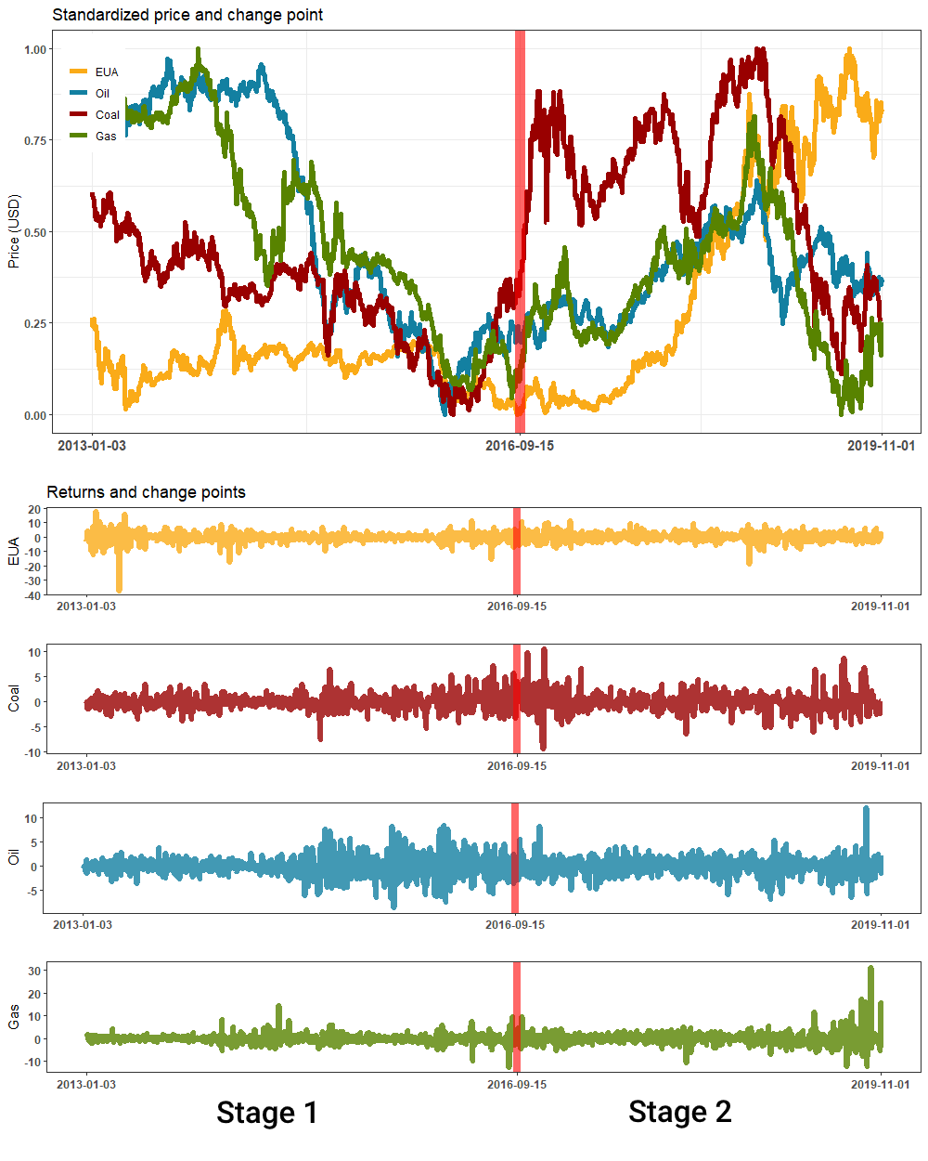
Figure 1. The change point in a quaternary system of energy and carbon.
Note: Matteson and James’s (2014) change point (September 15, 2016) is marked in red. Since the price ranges of the four assets are very different, original prices are converted to normalised prices in the top graph, allowing the prices of the assets to be uniformly distributed between 0 and 1.

Figure 1 clearly shows the difference in prices and returns of carbon and energy markets between Stage 1 and Stage 2 which correspond to the time periods before and after the structural break, i.e. September 15, 2016. The carbon price stayed in a relative stable and low level in Stage 1 despite the free allocation of allowances was removed in Phase III. This could attribute to surplus supply brought forward from the large number of allowances banked in Phase II. During the same period, energy prices plummeted which was largely influenced by the Shale Gas Revolution, the European Debt Crisis, Ukrainian Crisis, and so on. The carbon and energy markets are slumped towards a bearish market in Stage 1.
In Stage 2, the EU ETS reforms has contributed significantly to the surge in carbon prices, while the energy markets reverted to high price levels and showed extraordinary volatility characteristics, especially for coal and natural gas. These factors are responsible for the sharp rise in the carbon market, especially as the breakpoint is close to September 10, 2015 when the MSR policy was proposed by European Commission. It can be said that the carbon market and energy prices are in a bullish market at Stage 2.
Table 2 summarises and compares the price movements of carbon and energy assets between the two stages. By examining the spillovers of higher-order moments in Stage 1 and Stage 2 separately, we will be able to find out whether the implementation of reform policies such as the MSR, and the recovery in carbon and energy prices has an impact on the price transmission mechanism between the carbon and energy markets.
Table 2.
Two stages in Phase III of the EU ETS
Stage | Period | Energy market | Carbon market | Market condition
1 | 2013/1/3-2016/9/15 | Prices continued to plummet, particularly due to the Shale Gas Revolution and so on. | Prices remained very low around 10 EUR. | Bearish market
2 | 2016/9/16-2019/11/1 | Prices have been volatile especially for coal and gas. | Prices have risen rapidly as a result of the carbon market reforms. | Bullish market

5.2. Short-run spillovers of higher-order moments
In this sub-section, we examine the spillover of higher-order moments between the carbon and energy markets at short-run(below 16 trading days). Short-run skewness reflects the impact of unexpected market sentiment, such as geopolitical conflicts, on the probability of assets price movements. In Stage 1, as it shown in left panel of Figure 2, there exists a weak skewness and co-skewness spillovers between the carbon and energy markets, the biggest of these spillovers is 1.7% from S124 to S222. This implies that the co-skewness of carbon, coal and natural gas transmit 1.7% to the skewness variation of coal market. The thickness of the edges shows that that the short-run skewness spillover from energy market to the carbon market is not significant in Stage 1. The short-term skewness spillovers from the carbon market to the crude oil and natural gas markets are weak. As discussed in the sub-section 5.1, the carbon and energy markets were in a bearish market condition in Stage 1. Hence the weak skewness and co-skewness spillovers implies that the left skewness of the energy assets prices were not substantially affected by the carbon market, and vice versa.
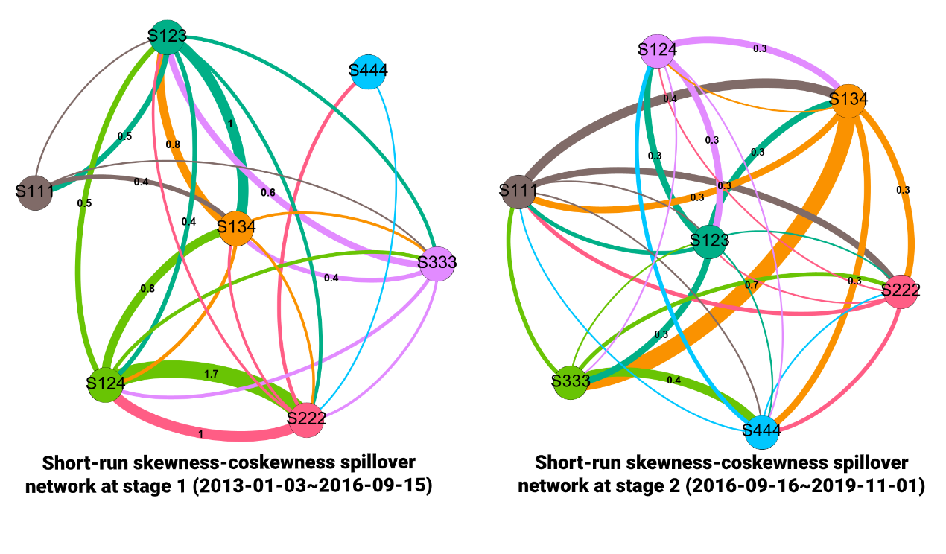
Figure 2. Short-run skewness spillover between the carbon and energy markets.
Note: This figure presents the skewness spillover index. Each asset is presented by “1”, “2”, “3” and “4”, whereby “1” denotes the carbon market, “2” denotes the coal market, “3” denotes the gas market, and “4” denotes the oil market. S123 denotes the co-skewness of carbon, coal and natural gas. S111 refers to the skewness of carbon. The specific definitions can refer to Eq. (2). The thickness of the edge represents the size of the spillover. An edge whose colour is the same as that of the node represents the spillover from one node (of the same colour) to another node. For display purposes, we have marked the top ten edges with the highest spillover in %, which is calculated by Eq. (6).

The recent implementation of the MSR and LRF policies falls in Stage 2, thus the spillovers of higher-order moments between the carbon and the energy market of this stage could uncover the spillover transmission across the markets after the reform. Surprisingly, the total sum of short-run skewness is slightly more modest compared Stage 1 despite both the carbon and energy markets had high price volatility and in particular, the price of EUA rises rapidly in Stage 2. To note that the skewness spillover transmission between coal and carbon is relative stronger compared to other pairs. This could relate to the fact that many carbon emitting industries mainly consume coal, and thus the market news of carbon emission policy reforms such as MSR could have a short-term impact on the skewness of coal price. However there is lack of interaction between the electricity and carbon as plants are less motivated to change their energy consumption structure at short-run timescales when carbon prices rise. The benefits gained by a electricity plant shutting down a coal generator in favor of a gas generator are far less than the costs incurred by a plant shutdown.
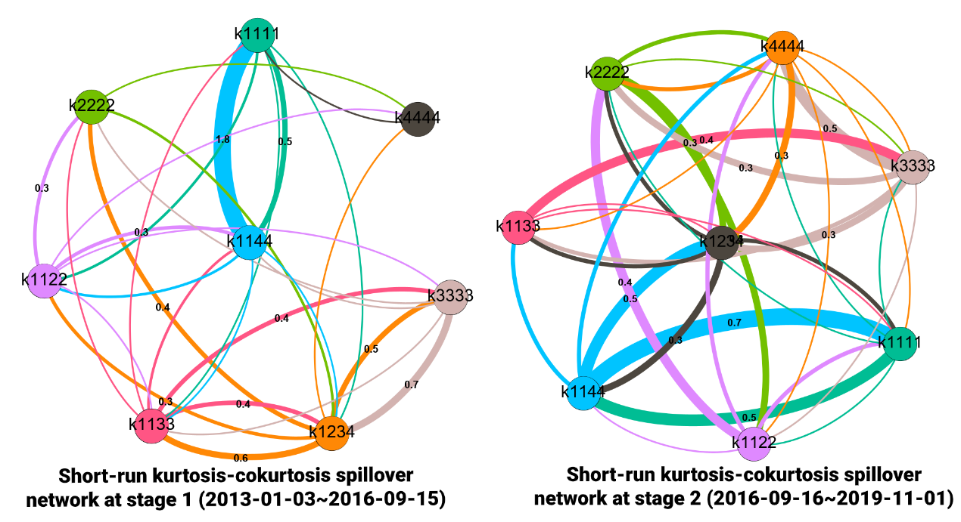
Figure 3. Short-run kurtosis spillover between carbon and energy markets.
Note: This figure presents the kurtosis spillover index. Each asset is presented by “1,”“2,” “3,” and “4,” whereby “1” refers to the carbon market, “2” refers to the coal market, “3” refers to the gas market, “4” refers to the oil market. S1234 denotes the co-kurtosis between the portfolio of carbon, coal, natural gas and oil. K1111 refers to the kurtosis of carbon. For the co-kurtosis of carbon and coal, there are three definitions as K1122, K1112, and K1222. In kurtosis spillover analysis, we select K1122 as the optimal term reflecting the co-kurtosis between carbon and coal. The same applies to K1144 and K1133. The specific definitions can refer to Eq. (3). An edge whose colour is the same as that of the node represents the spillover from one node (of the same colour) to another node. For display purposes, we have marked the top ten edges with the highest amount of we have marked the top ten edges with the highest spillover in %, which is calculated by Eq. (6).

Kurtosis spillover involves the fourth-order moment which indicates how the probability of extreme returns occurrence of one asset affects that of another asset. The left panel of Figure 3 shows that the carbon and energy markets have low degree of short-run kurtosis spillover in Stage 1, with its highest magnitude of 1.8%, which is spillover from the K1144 to K1111. As discussed in the sub-section 5.1, the decline of energy prices is strongly associated with the long-run supply and demand of the energy market. For example, the Shale Gas Revolution has made the US a major energy exporter, and a substantial increase in crude oil supply has been the dominant factor for the decline in all energy prices. As a result, any price changes due to short-run shocks do not contribute to kurtosis spillover between the carbon and energy markets. In Stage 2 the short-run kurtosis spillover became weaker as magnitudes of kurtosis spillovers are less than 1%. This implies that high carbon prices do not seem to influence the short-run kurtosis in the energy markets and vice versa.
In summary, we report that the spillovers in the higher-order moments between the carbon and energy markets at the short-run timescales are weak, despite the potential impactful drivers of spillovers such as implementation of reform policies in the carbon market and the price rising in carbon. This finding expands our knowledge of the short-run nature of the drivers of the carbon market. Number of studies such as Keppler and Mansanet-Bataller (2010), Zhu et al. (2019) found a short-run impact of energy markets on the carbon market. To advance this area of research, our findings evidence the seeming inability of energy assets to drive the asymmetric fat-tailed return distributions of carbon prices at the short-run timescales.
The previous studies such as Ji et al. (2018) and Geng et al. (2021) do not consider co-moment of higher-order moments. As pointed out in the section 2, the neglect of the co-moment of higher-order moments will make empirical studies less rigorous. Specifically, spillovers of the co-skewness and co-kurtosis are assigned to individual skewness/kurtosis terms (e.g., S222 or K3333) when the co-moment is ignored. This may mislead us into overestimating or underestimating the spillovers of higher-order moments between the carbon and energy markets. However the relatively weak co-moment of higher-order moments shown in Figure 2 and Figure 3 could be beneficial for investors to hedge exposure to the risk of the higher-order moments between energy and carbon assets. We will continue this discussion in the sub-section 5.4.

5.3. Long-run spillovers in higher-order moments
The left panel of Figure 4 shows the long-run skewness spillover is notably stronger than the short-run case in Stage 1. The source of skewness spillover is not only from the co-skewness between the carbon and energy market but also from individual energy markets. For example, the oil market contributes 11.8% skewness spillover on the carbon market. There is a downward trend in crude oil prices in Stage, as seen in Figure 1, which could motivate carbon emitters to use crude oil as a raw material for production in a longer timescale, thus contributing to the increase in carbon prices. Since this is a fundamental supply of demand change at long-run time scale, the negative skewness coefficient of the crude oil market adversely affect the carbon price. As coal and natural gas are oil indexed, the long-run decline in crude oil prices makes energy assets cheaper, and consumers of coal and gas will take advantages of the decreasing oil price by changing the structure of energy consumption, thus increasing carbon emission and contributing to the change in carbon prices in long-run.
In Stage 2, the co-skewness between the carbon and energy markets bursts into huge spillover effects for example the spillovers from S134 to S124 is 33.6% as shown in the right panel of Figure 4. Evidently the long-run skewness transmission of the carbon market becomes stronger. Furthermore, the carbon market profoundly affects the asymmetric up and down probabilities of the coal market and has a steering spillover effect on the gas market i.e. the carbon market dominately transmits 18.7% to coal market.
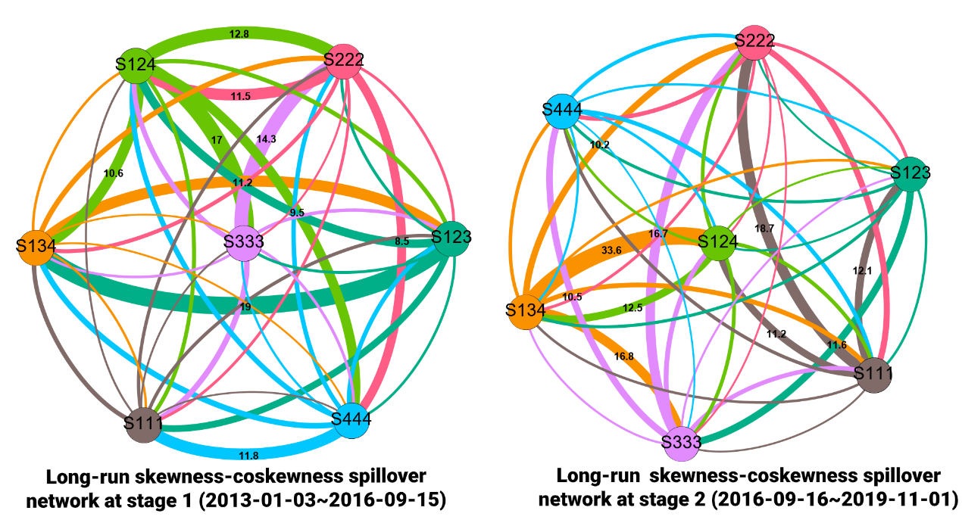
Figure 4. Long-run skewness-coskewness spillover between carbon and energy markets.
Note: See Figure 2.

The long-run kurtosis spillover reveals the extent to which the carbon market affects extreme returns in the energy markets, and vice versa. The left panel of Figure 5 shows that the carbon market receives a considerable amount of long-run kurtosis from the individual energy market during Stage 1. This indicates that the long-term extreme price movement of the carbon market is subject to changes in the energy market. However, this situation reversed during Stage 2. In addition to the coal market, the carbon market had a net impact on the emergence of extreme prices in the crude oil and natural gas markets. This finding implies that the carbon market price leadership become stronger in Stage 2. This is maybe largely related to the high carbon prices triggered by the reforms in Phase III of the EU ETS.
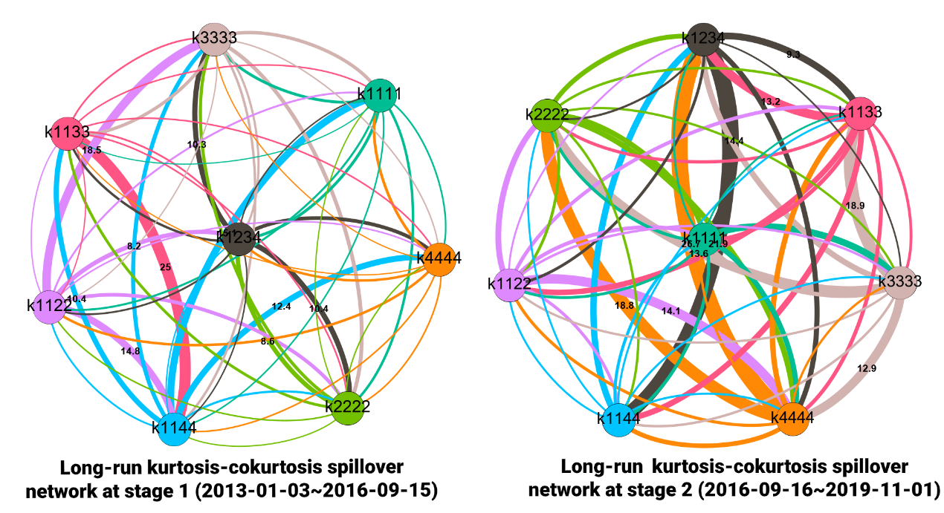
Figure 5. Long-run kurtosis-co-kurtosis spillover between the carbon and energy markets.
Note: See Figure 3.

Evidently, the long-run transmission intensity of skewness and kurtosis of the carbon market on energy assets has been strengthened after the implementation of MSR and other policies especially during Stage 2. This responds to concerns of some members in the academic community about the "water-bed effect" which may reduce the effectiveness of the EU ETS. Keppler and Mansanet-Bataller (2010) claimed that the carbon price in Phase I and Phase II of the EU ETS was affected by the energy markets. Our findings support that the carbon market is able to transmit price information to the energy market in terms of higher-order moments. The strong long-run spillovers in higher-order moments between the energy and carbon portfolio suggest that investors should focus on asymmetric price movements as well as risk of extreme price when constructing a carbon-energy markets portfolio.
The manifestation of significant spillover of higher-order moments at long-run is an extension of the findings of Zhu et al. (2019), whereby they document the long-run returns(the first-order moment) drivers of carbon markets include coal, oil and gas. After removing the effects of co-moment, we still find a strong long-run higher-order moment spillover between energy and carbon markets. The heterogeneity in the interplay of higher-order moments between the carbon and energy markets at short- and long-run timescales inspire us to construct a portfolio of carbon and energy markets to allow investors to hedge risk exposure of spillover of higher-order moments in the subsequent sub-section.

5.4. Portfolio risk management with multiscale higher-order co-moments
Here we apply the previous findings into portfolio risk management. Sub-section 5.2 and 5.3 reports that weak higher-order moments interplay between the energy and carbon markets in the short-run and such interactions enhanced at long-run timescale. We use programming (P6) to compute the optimal portfolio weights hedging against higher-order moments risk in carbon and energy markets.
Figure 7 shows the out-of-sample portfolio wealth chart for high-order moments hedging strategy in the short-run by programming (P6). The advantage of the skewness and kurtosis hedging frameworks is significantly improved than that of naive strategy (i.e., the equal-weight strategy). The weak short-run higher-order spillover (especially co-moment) is a direct result of the weak interdependence between energy and carbon at higher-order moments. This is precisely the reason why the asset portfolio (hedging higher-order moments) constructed in this study works well. The weak spillovers in higher-order moments enable investors to better use the carbon market to manage and diversify risk in higher-order moments of the energy markets. At the long-run timescales, the optimal portfolio wealth considering skewness-kurtosis does not seem to outperform the naive strategy (as much as it does at short timescales) as the higher-order moment spillovers between carbon and energy markets are stronger at the long-run timescales which do not facilitate the construction of portfolio hedging against higher-order moments risk (i.e. asymmetric and fat-tailed risk).
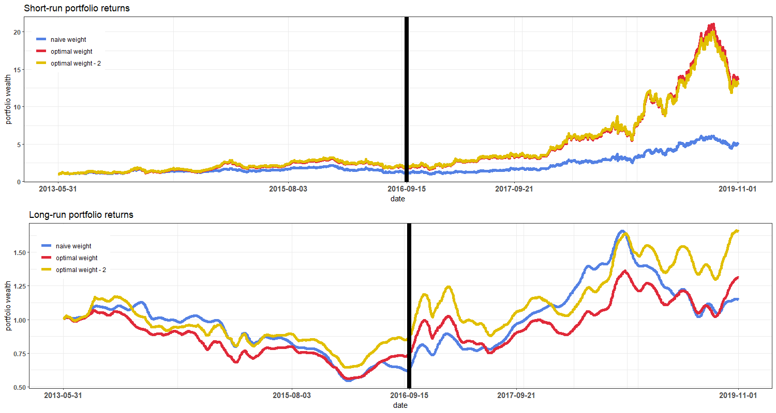
Figure 7. out-of-sample higher-order moments optimal portfolio performance.
Note: The optimal portfolio accumulation wealth plot is an initial investment of $1. The plot is based on the results of the out-of-sample portfolio back-testing. The portfolio returns are obtained based on a two-step procedure. We use a fixed rolling window of 99 days length at time t to predict the higher order moments of the asset sample at time t+1, that is, we predict the out-of-sample higher order moments at 1618 days using 1717 days of sample data. We then employ programming (P6) for calculating the optimal weights and use the real returns data to derive Figure 7. “Naïve weight” refers to equal weight of 0.25 for all time. “Optimal weight,” “Optimal weight - 2” refers to the program P (6) with $λ=\left(1,1,1,1\right)'$and $\left(1,0,1,1\right)'$ in programming (P6).

Conclusion and policy implications
The new price trajectories and the polices implemented in the carbon and energy markets make Phase III of EU ETS complicated to understand. This study contributes to the literature by examining the spillovers of higher-order moments between the carbon and energy markets and a multiscale analysis enable us to reveal the heterogeneity in different time frequencies. We also demonstrate an application of portfolio risk management strategy with multiscale higher-order co-moments. This application demonstrates that the heterogeneity of spillovers of higher-order moments allows investors with different time horizon to manage and diversify risk.
We detect a critical breakpoint of carbon and energy markets, September 15, 2016, which divides Phase III into two stages. The carbon and energy markets have bearish movements before the breakpoint, and this period is defines as Stage 1. Stage 2 covers the period after the breakpoint, and during this stage the carbon and energy markets follow overall bullish movements. The division of Phase III helps us thoroughly analyse the interplay between the carbon and energy markets according to different market status.
The spillovers in higher-order moments between the energy and carbon markets are weak at short-run timescales (period less than 16 trading days). This shows that the probability of asymmetric changes in carbon price and the emergence of extreme prices hardly affect the energy market in short-run. Likewise, the higher-order moments of energy assets are not significantly affected by the carbon market at short-run timescales. The spillovers of co-skewness of between the carbon market and the energy market’s asset is also relatively small. The weak skewness and co-skewness spillovers implies that the left skewness of the energy assets prices are not likely to be affected by short-run shocks such as political sentiments but long-run macroeconomic factors such as the Shale revolution.
At the long-run timescales (over 16 trading days), the strength of the spillovers in higher-order moments between the carbon and energy markets increases by a large extent. The spillovers in higher-order moments from the carbon and energy markets during Stage 2 are much stronger than that of Stage 1. This indicates that price movements in the carbon market largely affect the probability of asymmetric increases and decreases in other energy markets during Stage 2. The enhanced long-run transmission of skewness and kurtosis of the carbon market on energy assets could attribute to the implementation of MSR and other policies during Stage 2 which reduce the surplus EUA banked from Phase I and II. The auctions become the default method for allocating quotas (rather than free allocation) in Phase III, this could also improve the carbon market efficiency with a proper supply of demand mechanism in placed. Our findings support that the carbon market is able to transmit price information to the energy market in terms of higher-order moments. This responds to concerns of some members in the academic community about the “water-bed effect” which may reduce the effectiveness of the EU ETS.
The portfolio construction with carbon and energy assets shows us the investment implications of risk spillovers of higher-orders moments at different timescales. Our findings report that the portfolio performance improves when we long the carbon allowance in short investment horizon. However, the long-run the optimal strategy in higher-order moments is less effective as evidenced by the less satisfying portfolio performance. It is apparently due to the fact the spillover effects are considerably stronger in long-run and thus leads a diminished risk diversification.
This study reminds policymakers should acknowledge that the interplay between the carbon and energy markets is not restricted to the spillovers of price and volatility, it is important to consider the how the probability of asymmetric increases and decreases of carbon price, and the probability of extreme carbon prices affect energy prices, and vice versa. The previous study report disappointing findings that there is lack of leadership of the EU ETS to energy markets by merely examining the interplay between prices or price volatilities of the carbon and energy markets. Our results offer new perspective, that is policymakers should not only purely focus on the general level of price signaling, but also the systemic risk to energy markets in light of the significant spillovers of higher-order moments in the carbon and energy markets.
One criticism of the EU ETS market is its "waterbed effect," which can distort the long-term price of the EU ETS (Perino, 2018; Rosendahl, 2019). This study shows that the EU ETS releases strong price signals to the energy market when the market is at long-run, particularly in bullish market. The energy market also influences the price characteristics in higher-order moments of the carbon market at long timescales. This suggests that despite the "waterbed effect", information on the probability of asymmetric increases or decreases and the probability of extreme prices still actively transmit between the two markets in long-run scale.
The empirical results show that changes in carbon prices do not appear to affect the risk in higher-order moments in the energy markets at the short-run timescales. This suggests that policymakers do not have to immediately react to each short-term shocks of energy market. In contrast, the spillovers in higher-order moments in the energy market from rising carbon prices is evident in the long term. As mentioned earlier, the spillovers in higher-order moments contain not only price signals but also systemic risks. Therefore, we suggest that policy makers should allow carbon prices to increase gradually in the next phase, namely, Phase IV. The EU ETS policy makers may also want to prioritise cap adjustment and the banking policy in the discussions on structural reform of the EU carbon market in Phase IV. Our research contributes similar insights to the construction of carbon markets in the emerging markets such as China (Zhou et al., 2019; Zhou et al., 2020).

References
Aatola, P., Ollikainen, M., & Toppinen, A. (2013). Price determination in the EU ETS market: Theory and econometric analysis with market fundamentals. Energy Economics, 36, 380-395.
Alberola, E., Chevallier, J., & Chèze, B. t. (2008). Price drivers and structural breaks in European carbon prices 2005–2007. Energy Policy, 36(2), 787-797.
Anke, C. P., Hobbie, H., Schreiber, S., & Möst, D. (2020). Coal phase-outs and carbon prices: Interactions between EU emission trading and national carbon mitigation policies. Energy Policy, 144, 111647.
Apergis, N., & Lau, M. C. K. (2015). Structural breaks and electricity prices: Further evidence on the role of climate policy uncertainties in the Australian electricity market. Energy Economics, 52, 176-182.
Balcılar, M., Demirer, R., Hammoudeh, S., & Nguyen, D. K. (2016). Risk spillovers across the energy and carbon markets and hedging strategies for carbon risk. Energy Economics, 54, 159-172.
Bali, T. G., Mo, H., & Tang, Y. (2008). The role of autoregressive conditional skewness and kurtosis in the estimation of conditional VaR. Journal of Banking & Finance, 32(2), 269-282.
Baruník, J., & Křehlík, T. (2018). Measuring the Frequency Dynamics of Financial Connectedness and Systemic Risk. Journal of Financial Econometrics, 16(2), 271-296.
Bel, G., & Joseph, S. (2015). Emission abatement: Untangling the impacts of the EU ETS and the economic crisis. Energy Economics, 49, 531-539.
Bocklet, J., Hintermayer, M., Schmidt, L., & Wildgrube, T. (2019). The reformed EU ETS - Intertemporal emission trading with restricted banking. Energy Economics, 84, 104486.
Brooks, C., Burke, S. P., Heravi, S., & Persand, G. (2005). Autoregressive Conditional Kurtosis. Journal of Financial Econometrics, 3(3), 399-421.
Bruninx, K., Ovaere, M., & Delarue, E. (2020). The long-term impact of the market stability reserve on the EU emission trading system. Energy Economics, 104746.
Bunn, D. W., & Fezzi, C. (2007). Interaction of European carbon trading and energy prices.
Chaton, C., Creti, A., & Sanin, M. E. (2018). Assessing the implementation of the Market Stability Reserve. Energy policy, 118, 642-654.
Chevallier, J. (2009). Carbon futures and macroeconomic risk factors: A view from the EU ETS. Energy Economics, 31(4), 614-625.
Chevallier, J. (2011a). Detecting instability in the volatility of carbon prices. Energy Economics, 33(1), 99-110.
Chevallier, J. (2011b). Econometric analysis of carbon markets: the European Union emissions trading scheme and the clean development mechanism: Springer Science & Business Media.
Chevallier, J. (2012). Time-varying correlations in oil, gas and CO2 prices: an application using BEKK, CCC and DCC-MGARCH models. Applied Economics, 44(32), 4257-4274.
Chevallier, J., Khuong Nguyen, D., & Carlos Reboredo, J. (2019). A conditional dependence approach to CO2-energy price relationships. Energy Economics, 81, 812-821.
Chevallier, J. , Stéphane Goutte, Ji, Q. , & Guesmi, K. (2021). Green finance and the restructuring of the oil-gas-coal business model under carbon asset stranding constraints. Energy Policy, 149, 112055.
Christoffersen, P., Fournier, M., Jacobs, K., & Karoui, M. (2021). Option-Based Estimation of the Price of Coskewness and Cokurtosis Risk. Journal of Financial and Quantitative Analysis, 56(1), 65-91.
Christiansen, A. C., Arvanitakis, A., Tangen, K., & Hasselknippe, H. (2005). Price determinants in the EU emissions trading scheme. Climate Policy, 5(1), 15-30.
Creti, A., Jouvet, P.-A., & Mignon, V. (2012). Carbon price drivers: Phase I versus Phase II equilibrium? Energy Economics, 34(1), 327-334.
Dai, X., Wang, Q., Zha, D., & Zhou, D. (2020). Multi-scale dependence structure and risk contagion between oil, gold, and US exchange rate: A wavelet-based vine-copula approach. Energy Economics, 88, 104774.
Diebold, F. X., & Yilmaz, K. (2012). Better to give than to receive: Predictive directional measurement of volatility spillovers. International Journal of Forecasting, 28(1), 57-66.
Duan, K., Ren, X., Shi, Y., Mishra, T., & Yan, C. (2021). The marginal impacts of energy prices on carbon price variations: Evidence from a quantile-on-quantile approach. Energy Economics, 95, 105131.
European Commission. (2017, February 16). EU Emissions Trading System (EU ETS). Retrueved from https://ec.europa.eu/clima/policies/ets_en.
Ewing, B. T., & Malik, F. (2005). Re-examining the asymmetric predictability of conditional variances: The role of sudden changes in variance. Journal of Banking & Finance, 29(10), 2655-2673.
Ewing, B. T., & Malik, F. (2010). Estimating volatility persistence in oil prices under structural breaks. Financial Review, 45(4), 1011-1023.
Feng, Z.-H., Zou, L.-L., & Wei, Y.-M. (2011). Carbon price volatility: Evidence from EU ETS. Applied Energy, 88(3), 590-598.
Fernandez-Perez, A., Frijns, B., Fuertes, A.-M., & Miffre, J. (2018). The skewness of commodity futures returns. Journal of Banking & Finance, 86, 143-158.
Finta, M. A., & Aboura, S. (2020). Risk premium spillovers among stock markets: Evidence from higher-order moments. Journal of Financial Markets, 100533.
Geng, J. B., Chen, F. R., Ji, Q., & Liu, B. Y. (2020). Network connectedness between natural gas markets, uncertainty and stock markets. Energy Economics, 105001.
Gil-Alana, L. A., Gupta, R., & de Gracia, F. P. (2016). Modeling persistence of carbon emission allowance prices. Renewable and Sustainable Energy Reviews, 55, 221-226.
Harvey, C. R., Liechty, J. C., Liechty, M. W., & Müller, P. (2010). Portfolio selection with higher moments. Quantitative Finance, 10(5), 469-485.
Hammoudeh, S., Nguyen, D. K., & Sousa, R. M. (2014). Energy prices and CO2 emission allowance prices: A quantile regression approach. Energy Policy, 70, 201-206.
Hammoudeh, S., Lahiani, A., Nguyen, D. K., & Sousa, R. M. (2015). An empirical analysis of energy cost pass-through to CO2 emission prices. Energy Economics, 49, 149-156.
Hammoudeh, S., Nguyen, D. K., & Sousa, R. M. (2014). What explain the short-term dynamics of the prices of CO2 emissions?. Energy Economics, 46, 122-135.
Hepburn, C., Neuhoff, K., Acworth, W., Burtraw, D., & Jotzo, F. (2016). The economics of the EU ETS market stability reserve. Journal of Environmental Economics and Management, 100(80), 1-5.
Hintermann, B. (2010). Allowance price drivers in the first phase of the EU ETS. Journal of Environmental Economics and Management, 59(1), 43-56.
Hintermayer, M. (2020). A carbon price floor in the reformed EU ETS: Design matters!. Energy Policy, 147, 111905.
Hobbie, H., Schmidt, M., & Möst, D. (2019). Windfall profits in the power sector during phase III of the EU ETS: Interplay and effects of renewables and carbon prices. Journal of Cleaner Production, 240, 118066.
Hu, M., Zhang, D., Ji, Q., & Wei, L. (2020). Macro factors and the realized volatility of commodities: a dynamic network analysis. Resources Policy, 68, 101813.
Huang, Y., Dai, X., Wang, Q., & Zhou, D. (2021). A hybrid model for carbon price forecasting using GARCH and long short-term memory network. Applied Energy, 285, 116485.
International Carbon Action Partnership. (n.d.). Allocation. Retrieved March 9, 2020, from https://icapcarbonaction.com/en/allocation.
Intercontinental Exchange. (n.d.). EUA Futures. Retrieved March 9, 2020, from https://www.theice.com/products/197/EUA-Futures.
International Energy Agency. (2020). Implementing Effective Emissions Trading Systems, IEA, Paris. Retrieved from https://www.iea.org/reports/implementing-effective-emissions-trading-systems.
Ji, Q., Zhang, D., & Geng, J. B. (2018). Information linkage, dynamic spillovers in prices and volatility between the carbon and energy markets. Journal of Cleaner Production, 198, 972-978.
Keppler, J. H., & Mansanet-Bataller, M. (2010). Causalities between CO2, electricity, and other energy variables during phase I and phase II of the EU ETS. Energy Policy, 38(7), 3329-3341.
Kollenberg, S., & Taschini, L. (2016). Emissions trading systems with cap adjustments. Journal of Environmental Economics and Management, 80, 20-36.
Lai, K. K., Yu, L., & Wang, S. (2006, June). Mean-variance-skewness-kurtosis-based portfolio optimization. In First International Multi-Symposiums on Computer and Computational Sciences (IMSCCS'06) (Vol. 2, pp. 292-297). IEEE.
Langlois, H. (2020). Measuring skewness premia. Journal of Financial Economics, 135(2), 399-424.
Lau, M. C. K., Vigne, S. A., Wang, S., & Yarovaya, L. (2017). Return spillovers between white precious metal ETFs: The role of oil, gold, and global equity. International Review of Financial Analysis, 52, 316-332.
Lutz, B. J., Pigorsch, U., & Rotfuß, W. (2013). Nonlinearity in cap-and-trade systems: The EUA price and its fundamentals. Energy Economics, 40, 222-232.
Luo, C., & Wu, D. (2016). Environment and economic risk: An analysis of carbon emission market and portfolio management. Environmental research, 149, 297-301.
Ma, Y. R. , Ji, Q. , Wu, F. , & Pan, J. (2021). Financialization, idiosyncratic information and commodity co-movements. Energy Economics, 94, 105083.
Mansanet-Bataller, M., Pardo, A., & Valor, E. (2007). CO2 prices, energy and weather. The Energy Journal, 28(3).
Marimoutou, V., & Soury, M. (2015). Energy markets and CO2 emissions: Analysis by stochastic copula autoregressive model. Energy, 88, 417-429.
Matteson, D. S., & James, N. A. (2014). A Nonparametric Approach for Multiple Change Point Analysis of Multivariate Data. Journal of the American Statistical Association, 109(505), 334-345.
Medina, V., & Pardo, A. (2013). Is the EUA a new asset class?. Quantitative Finance, 13(4), 637-653.
Ortas, E., & Álvarez, I. (2016). The efficacy of the European Union Emissions Trading Scheme: depicting the co-movement of carbon assets and energy commodities through wavelet decomposition. Journal of Cleaner Production, 116, 40-49.
Perino, G. (2018). New EU ETS Phase 4 rules temporarily puncture waterbed. Nature Climate Change, 8(4), 262-264.
Perino, G., & Willner, M. (2016). Procrastinating reform: The impact of the market stability reserve on the EU ETS. Journal of Environmental Economics and Management, 80, 37-52.
Reboredo, J. C. (2013). Modeling EU allowances and oil market interdependence. Implications for portfolio management. Energy Economics, 36, 471-480.
Reboredo, J. C. (2014). Volatility spillovers between the oil market and the European Union carbon emission market. Economic Modelling, 36, 229-234.
Rosendahl, K. E. (2019). EU ETS and the waterbed effect. Nature Climate Change, 9(10), 734-735.
Tan, X. P., & Wang, X. Y. (2017). Dependence changes between the carbon price and its fundamentals: A quantile regression approach. Applied Energy, 190, 306-325.
Uddin, G. S., Hernandez, J. A., Shahzad, S. J. H., & Hedström, A. (2018). Multivariate dependence and spillover effects across energy commodities and diversification potentials of carbon assets. Energy Economics, 71, 35-46.
Van den Bergh, K., Delarue, E., & D'haeseleer, W. (2013). Impact of renewables deployment on the CO2 price and the CO2 emissions in the European electricity sector. Energy Policy, 63, 1021-1031.
Wang, Q., Dai, X., & Zhou, D. (2020). Dynamic Correlation and Risk Contagion Between “Black” Futures in China: A Multi-scale Variational Mode Decomposition Approach. Computational Economics, 55(4), 1117-1150.
Yu, L., Li, J., Tang, L., & Wang, S. (2015). Linear and nonlinear Granger causality investigation between carbon market and crude oil market: A multi-scale approach. Energy Economics, 51, 300-311.
Zhang, Y.-J., & Sun, Y.-F. (2016). The dynamic volatility spillover between European carbon trading market and fossil energy market. Journal of Cleaner Production, 112, 2654-2663.
Zhou, B., Zhang, C., Song, H., & Wang, Q. (2019). How does emission trading reduce China's carbon intensity? An exploration using a decomposition and difference-in-differences approach. Science of the total environment, 676, 514-523.
Zhou, B., Zhang, C., Wang, Q., & Zhou, D. (2020). Does emission trading lead to carbon leakage in China? Direction and channel identifications. Renewable and Sustainable Energy Reviews, 132, 110090.
Zhu, B., Han, D., Chevallier, J., & Wei, Y. M. (2017). Dynamic multiscale interactions between European carbon and electricity markets during 2005–2016. Energy Policy, 107, 309-322.
Zhu, B., Wang, P., Chevallier, J., & Wei, Y. (2015). Carbon Price Analysis Using Empirical Mode Decomposition. Computational Economics, 45(2), 195-206.
Zhu, B., Ye, S., Han, D., Wang, P., He, K., Wei, Y.-M., & Xie, R. (2019). A multi-scale analysis for carbon price drivers. Energy Economics, 78, 202-216.

The EU ETS is organised in four phases: Phase I was considered as a ‘trial period’ in 2005–2007; Phase II coincided with the period of Kyoto Protocol commitment in 2008–2012; Phase III runs in 2013–2020 to help meet the European mitigation target of green gas emissions by 20% in 2020 in contrast to 1990 (European Commission, 2017).
The European Allowance (EUA), the unit of compliance, has even been hovering under €10 before 2016. The EUA price of EU ETS increased steadily and rose to €42 in 2020 (Intercontinental Exchange, n.d.).
At least 90% of the allowances were allocated to emitters for free in Phase I/II of the EU ETS and about 90% in Phase II (International Carbon Action Partnership, n.d.). The resulting "windfall profits" in the power sector directly distort market competition, thereby distorting the interplay between energy and carbon assets. At the beginning of Phase III of the EU ETS, the shift to an auction-based distribution system was one of the main purposes of eliminating windfall profits (Hobbie et al., 2019).
The MSR was proposed in 2015 by the European Commission to address the surplus of unused allowances which have been accumulated from Phase I and Phase II, and to improve the EU ETSs resilience to shocks.
The "waterbed effect" means that the reduction of carbon emissions in one area (time) will contribute to carbon emissions in another area or time.
Perino and Willner (2016, 2017) stress that the MSR does little to incentivize abatement if it is allowance preserving. Chaton et al. (2018), on the other hand, point out that the MSR by substituting for private banking efforts, can lead to a collapse in present-day allowance prices. Despite its purported shortcomings, Kollenberg and Taschini (2016) argues that MSR improves the performance of the EU ETS and suggests ways to make the MSR fully flexible and responsive to shocks.
The third-order moment is the skewness of one asset revealing the financial instability information. The negative skewness implies the higher probability in a price drop and vice versa. Moreover, the fourth-order moment, the kurtosis of one asset, shows the tail and peak feature of one asset distribution. A high kurtosis suggests that asset returns have a “fat tail,” implying the high probability of extreme price (Bali et al., 2008).
The empirical analysis has vividly documented that both carbon and energy prices show distinct patterns under different timescales (Dai et al., 2020; Huang et al., 2021; Wang et al., 2020), and there is evidence of timescale heterogeneity in the mean-based or non-linear interplay between the carbon and energy markets (Yu et al., 2015; Zhu et al., 2015). See Section 2.
In Section 2, we discuss the characteristics in detail.
See Alberola et al. (2008), Balcılar et al. (2016), Chevallier (2011a), Feng et al. (2011), Lutz et al. (2013), and Zhang et al. (2008)
where $\hat{E}(X_{n},Y_{m};α)=\frac{2}{mn}\sum_{i=1}^{n}{\sum_{j=1}^{m}{{\left|X_{i}-Y_{j}\right|}^{α}-{(\begin{matrix}n \\ 2\end{matrix})}^{-1}}}\sum_{1≤i<k≤n}{{\left|X_{i}-X_{k}\right|}^{α}}-{(\begin{matrix}n \\ 2\end{matrix})}^{-1}\sum_{1≤j<k≤m}{{\left|Y_{j}-Y_{k}\right|}^{α}}$.
$C(L)=I_{n}+C_{1}L+C_{2}L^{2}+...$ is $∞$-th order $n$x$n$ lag-polynomial, $C_{k}=B_{1}C_{k-1}+B_{1}C_{k-1}+...+B_{p}C_{k-p}$($C_{0}=I_{n}$), and $ϵ_{t}∼i.i.d(0,Σ)$, and $θ_{i,j}^{DY}(H)=\frac{σ_{jj}^{-1}\sum_{k=o}^{H-1}{(}e_{i}'C_{k}Σe_{j})^{2}}{\sum_{k=0}^{H-1}{(}e_{i}'C_{k}ΣC_{k}'e_{i})}$.
$i$ is a unit imaginary number and $ω$ is frequency.
Although we have chosen futures data as a proxy for the so-called partial assets, our research is not aimed at speculators, but rather at the major players in the energy and carbon markets. This includes power plants and generators, that mostly holders of spot assets; therefore we have imposed restrictions that do not allow short selling.
The price series of four assets are converted into USD in order to exclude the effects of foreign exchange by the daily EUR/USD exchange rate.
Although some studies have considered spread price and electricity prices as part of the energy sectors, this study has not selected them given as crude oil refining products, such as heating oil, and cruises have highly consistent price trajectories (Keppler and Mansanet-Bataller, 2010). Moreover, using renewable energy companies’ stock index as a proxy for renewable energy prices has a particular bias because the stock price will be more affected by other factors, not just the carbon market. In addition, electricity markets across Europe are not uniform, there is no leading electricity price, and the switch price or spread price can be considered as a linear combination of coal and gas (Chevallier et al., 2019).
A large amount of the EUA credits have been banked from Phase II to Phase III. Besides, there are still many oversupply allowances that are given to emitters for free, whereby these two reasons contribute to the EUA prices plummeting.
Including the political agreements which have strengthened the MSR and increased Linear Reduction Factor in 2017.
It makes logical sense, if we assume that the higher order moment spillover between energy and carbon reaches 100%, then no matter how much weights are adjusted it will not help.

