(title page)

THE SINGER AND THE SONG:
CONSERVATION CONSIDERED FROM A VIEWPOINT IN PLANNING THEORY

This draft May 2010(Version 2)

THE AUTHOR
Dr Bob Jarvis was Urban Design Coordinator in the Faculty of Arts and Human Sciences at London South Bank University. Prior to that he had practical conservation experience on a ‘suicide mission’ as Gateshead’s conservation officer. He also has an MA in Creative Writing and, as a result of work in contemporary dance is developing the idea of urban design as choreography. He is currently studying Art History at Sussex University.

ABSTRACT
‘Conservation considered from a viewpoint in planning theory’ examines a one of the only detailed ethnomethodological studies of conservation practice . It draws on extended experience in and reflection on conservation which is framed by new perspectives in organisational and social research and emerging rhetorical perspectives of planning and policy making.

This perspective drawing on communication based theories of planning, includes two commonplace fundamentals : place and everyday practice that conservation practicioners take for granted - and so are rarely examined critically.

On the basis of this four 'oppositions' are identified - between people and organisations, process and place, planning and communication and poetics and power - that help to define the everyday practices of planning at an individual and personal level.

These are used to suggest directions for planning theories that relate them to the realities of planning practice rather than the abstractions of philosophy.

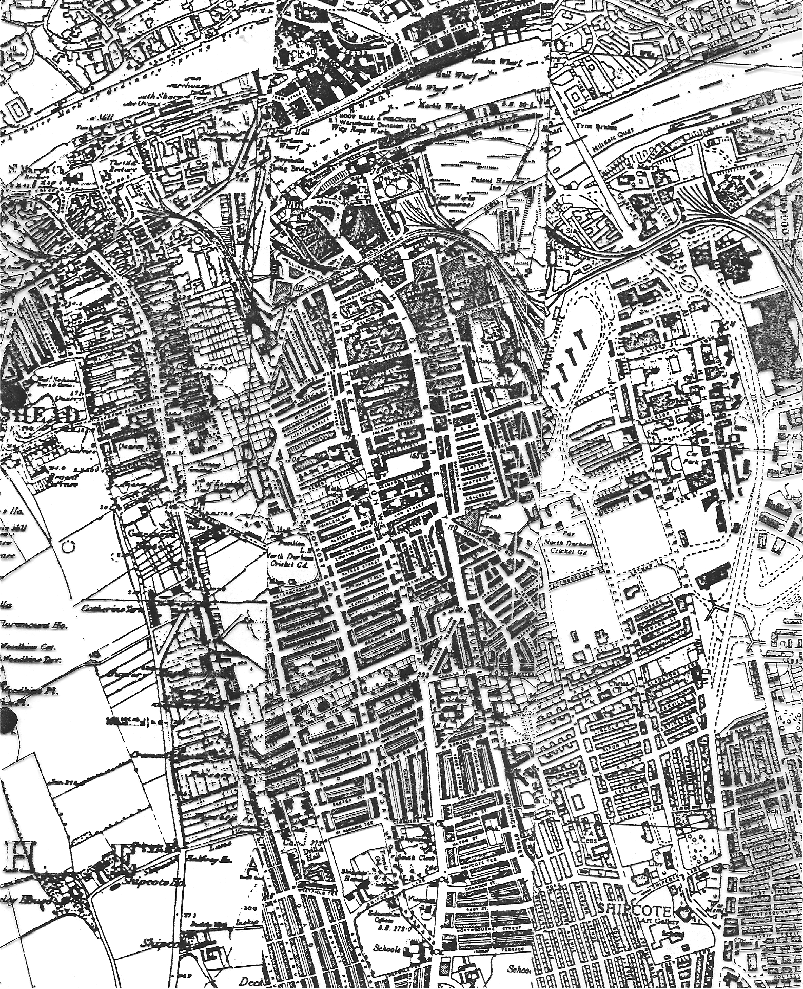

A WORLD FAMILIAR AND STRANGE

The literature on planning of commentaries, critiques and theories, advice on procedure and analysis of its effects is extensive, but they rarely extend to the detials of practice, let alone conservation practice. Recently theoretical perspectives have begun to draw attention to the realities and experience of planning as a process, and specifically to its interactive and rhetorical nature (most notably Fischer and Forester 1993). Yet of what actually takes place, in words and influences, control and advice, permission and enforcement, which always precedes and surrounds planning and conservation’s tangible physical 'achievements' there are few first hand accounts that are anything more than anecdotal. The 'actor's perspective', in sociological terms is rarely coherently given. Where it is - of the necessity from research requirements - it is limited in duration and extent: 'A planner's day' was the precise and finite title of one such piece (Healy, 1992). That such a common place of practice should warrant such scrutiny (and publication in another continent) is to emphasise the gaps in our understanding of what really goes on in planning. When such studies have been carried out they revealed a richer and much more complex working environment and process than many would dare to admit.

This paper summarises the findings of one of the longest and deepest pieces of research into the everyday practice of conservation planning and points to some important dimensions, not only to understanding conservation practice but also to framing planning theory. The literary implications of the title are deliberate : the paper is also a call for the lyrical and the poetic and celebrates ten years working alongside and unobtrusively but sympathetically researching a small team who instinctively understood the practical value of the poetic voice in the hard nosed world of practice.

Outside the few questionnaire studies of 'what planners do' our first hand knowledge and understanding of practice drawn from two predominant patterns of research - the councillor/academic and the short term participant observation research (2). Although the former has the benefits of extended research periods and often privileged access to the formal working of local authorities, the realities of the office/member divide limit the extent of its access to everyday office practices, and, at worst have resulted in extreme caricatures (3)

The alternative model, closer to day to day practice, is the classical model of participant observation where researcher remains essentially a detached observer. Such research requires both the resources to carry out extended access to the continuous process and entree to often confidential episodes. These alone make it a difficult and even then limited research method. The first detailed published account is now nearly years old (Underwood, J, 1980) and the other seminal study (Forester, 1977) even older, but neither are less valuable for that: it is an indication of the rarity of such in depth extended research and the difficulties in setting up and sustaining extended participant observation research in planning . These two studies will be used as reference points and comparisons in this discussion.

BACKGROUND AND METHOD

The singer and the song draws on the rarest and riskiest research method: covert participant observation, where the observer is a full participant. Against the older classical traditions such 'native' (4) investigations are forever flawed, but more recent methodologies admit and value even fictionalised accounts. It is a method that has frequently offered new and positive insights into organisations and their cultures from Melville Dalton's seminal Men Who Manage (Dalton, 1959) onward. The focus here is ten years first hand experience of conservation activity in one of the short lived English metropolitan county councils between 1976 and 1986, as one of Tyne and Wear County's Joint Conservation Team acting as area officer primarily for Gateshead (5) - though long ago and far away in terms of operating contexts. This period of conservation has been discussed by my successor at Gateshead (Pendlebury, 2000,2009) but from broader result focused perspective. This discussion which focusses on the day to day reality of ‘doing conservation’ offers complementary accounts of the practices and attitudes which enrich the picture.

The lyric emphasis in the title is deliberate, and opens up to scrutiny aspects of practice too easily neglected and which sit uneasily with notions of “the professional” - and to emphasise gradually evolving poetic and expressive perspective. It draws on a period when being a conservation officer was combined with being a research student, and the everyday discussions and memoranda, meeting and site visits, correspondence and reflection which made up the language
systems and 'media logic' (6) of planning were both practice and the field source of research. Because conservation was at that time and place undertaken as a two tiered system of local government and because the low priority given to conservation at both levels, the members of the Joint Conservation Team (JCT), employed by the Metropolitan County but able to work for both district and county offices, had, by their very situation to become experts in communication, persuasion, subtlety and sometimes subterfuge and duplicity. But the content and conclusions are no less valid (and revealing) for this and, largely as a result of this different perspective, can be contrasted with policy orientated outsider discussions that predominate in the literature of planning.

The conservation of historic buildings and areas is usually presented either as a matter of polemic - of what ought to be preserved and protected - or of practicality - of how to go about the technical and legal procedures to preserve and protect. Wider theoretical and philosophical work in turn relates conservation to political, social and cultural issues. Although there are substantial reviews of technique and achievement, few accounts of any substance of local continuous negotiation and interaction have been published. The exceptions to this are occasional articles in Context (7) which are short and anecdotal, and Marcus Binney's account of this crusades for SAVE ( whose national and political level is far removed from the quotidian realities of this research, which because of the way official responsibilities were prescribed even excluded direct access to local authority committees.

Personal engagement held the key to conservation success. Sustained conservation activity in the context of locally powerful left-wing local politics, with economic development rather than conservation as priority, relied on it. The working structure and management - of the JCT and its complicated relationships with the Metropolitan county and the Districts and their officers encouraged it. The conflict of resources, priorities and decisions that followed required it. Topographical rather than organisational loyalty, evangelical as much as professional responses, and a close supportive sub-group sustained a marginal and contradictory culture. (8)

The research on which this paper is based (Jarvis, 1994) establishes conservation as much as growing out of the collective and individual activity of concerned professionals rather than a straight-forward, logical, inevitable sequence from powers, through policy, to implementation . The research emphasises the conversational and interactive nature of conservation, through chapters that follow different conversational roles to its title Talking about Special Places.

So what might be conserved and for what reasons is not seen as an absolute but a balance achieved through discussion, the outcome dependent on the weight given to conservation issues in particular balances of place, agencies and power. Similarly conservation through control and permission inevitably involves advice and discretion, negotiation and judgment and success depends as much on persuasion as power. Initial statements of possibility, set out in briefs, plans or policies depend for their success on the way in which they communicate and the personal and organisational modes and roles through which they work. Even implementation itself is a consequence of debate and discussion; only the final contractual works on site are precise and (almost) beyond dispute. In all of these, at every stage, there were possibilities to raise, alternatives to suggest, second thoughts to be had; the role of individuals, to support, to countermand, to waiver, to leave aside, to edit and rewrite, to present and to argue cases became clear.

What became clear was the importance of individual persistence and perseverance on issues that could easily have been forgotten or laid aside. However precise and pragmatic the means for achieving conservation, it is at its core a passionate activity. These individual, evangelical traits, of individual commitment and
persuasion, of creative and sympathetic response to place have been revealed and opened to analysis in the research. This paper concentrates on general implication rather than particular cases (9).

FOUR OPPOSITIONS

From the field research four themes, oppositional in structure were identified, each an area of tension in the practice of conservation planning. First, within the relationship between people and organisations lay a continual stress of individual enthusiasms against organisational management and authority, between providing 'facts' for 'decision makers' in a 'rational' political process (but which was actually shaped by its own managers). The second tension, between process and place was found in concern for, involvement in and attachment to particular localities and commitment to them rather than to local authority organisation. The third theme concerns planning and communication, the whole range of processes, personal and interpersonal, oral and documented, written and illustrated, formal and casual, that link ideas about the possible futures for places with the authority, resources and techniques to realise them. The fourth and final theme subsumes the others: the tension between poetics and power, between the intuitive emotive origins of response to place and its formal, pragmatic application in the planning processes and procedures of local and central government.

PEOPLE AND ORGANISATIONS (fig 1)

In terms of organisational identity the JCT had a particularly complex character. Its members operated freely, seeking individual opportunity, often alone rather than in closely supervised situations; as well as being in 'teams' within the structure of the County Planning Department they were also advisers to District planning departments responding to applications or plans at the request of district staff in cases where conservation issues were involved, responding on the basis of their individual judgment. Ultimately they were employees of the County Council with desks at its headquarters in a team reporting to (and often reprimanded by)its planning managers and able to call on its limited financial resources for conservation . In extremis they would write letters to themselves from the District to the County in order to document or formally draw attention to matters that were beyond the individual informal resolution. Repeated admonitions to the
team (including its team leader) by management, Assistant Directors, to whom the Team Leader reported, indicated how far it was in practice an organisational nightmare. But for the persistent and the motivated, strength lay in this complexity, something which the JCT's team leader had always envisaged (Jobling, 1976).

The nearest comparable study is Jackie Underwood's documentation of local planners working in London (Underwood, 1980). The planners she studied were searching for a role in the complex and disputed area of local policy, between central and local government, between social and economic issues but essentially working within the organisation. By contrast the JCT's purpose and individual roles were clearly defined, but constantly refined and sharpened in response to individual cases and opportunities. Though 'Conservation' was a low priority in the Districts and (explicitly so) in the County and (at the time of research) marginalised professionally this adversity and neglect perversely helped the JCT generate a clear sense of mission and purpose through an essentially adversarial perspective.

Underwood's planners belief that 'planning' was (or could be) a rational, technical and apolitical activity would have been regarded as naive or absurd by the JCT, so much so that the notion was more a focus of ridicule or contempt than serious, practical discussion. There was, therefore, none of the 'confusion' that Underwood found. Conservation, although it may be supported by strong planning policies and can use statutory plans as a vehicle was, for the JCT, distant from 'planning' and the debates about what it did or might do or could do or should do, either in practice or theory. 'Planning' for the JCT was a means to bring about conservation, whether through implementation of projects and grants, statutory plans or the control of development and works to listed buildings. Team members may have held a cynical disrespect for its theory, but they had a pragmatic grasp of its possibilities and limitations in practice.

Underwood's planners were concerned about their professional autonomy as planners. This hardly concerned the JCT: though some styled themselves “Conservation Planner” it was, like much of the team’s personal activity, a matter of individual choice as collective identity in a multi-disciplinary team. Architects, architectural historians, conservation specialists, even planners, were treated equally (10). Underwood saw the reliance of planners on the statutory and local political system to legitimate theory as a major source of professional weakness, contradicting claims to autonomy, from which the only resolutions were either a fall back positions of land management or advocacy, in the extreme becoming bureaucratic guerrillas (Needham M & C E, 1974). But the JCT were able to cultivate a third role. From their quasi-autonomous (if neutered) role,with access to both tiers of local authority and inevitable involvement in highly charged and long running problems, they became what might best be described as “creative advisors”. This started from an awareness that others, better placed politically, in a position of power,and so able to authorise and implement schemes, could take up ideas. This was hard won and not without disappointment. One of its consequences was the unusually clear separation of some form of discrete ideas document, which however short-lived and privately circulated, had an independence, a personal signature that separated it from the morass of messages, drafts, memoranda and reports. Persistent and active engagement in discussion, negotiation and persuasion with all interested or potentially interested parties was the result. Organisations were not regarded as single fixed routes to move from policy to implementation, but shifting channels to be navigated as best possible to achieve conservation specific objectives. Just as power ultimately lay elsewhere, places have historically been shaped not by advisors but by those with authority, the JCT were aware that their role was marginal at best.

Yet often full of ideas of seemingly fantastic possibilities, they often took a role perhaps best seen as court jester, conscience, dreamers secure in the knowledge that often they alone had the freedom to raise such hopes. Such a role provided a buffer against disappointments (though dreams are always true) and a framework from which achievements were possible - many of which are still live projects (or unresolved issues)fifteen years later (11).

The JCT differed from the conventions of planning practice was in their support (or at least tacit permission) of individual creativity. Local authority practice conflicts with individual sensitivity; this is the process of subservience, of deferring to the committee decision, of writing of oneself as “my assistant Mr Jarvis”, and a second person, senior in the hierarchy, signing the letter in the Chef Officer’s name. Only at Public Inquiries will professionals be challenged to give their professional opinions. A measure of the independence of individuals in the JCT, is that though they obeyed these conventions they did so in considerable frustration, and were at least able to advise the Districts independently and autonomously. The importance of personal signature, the characteristic of design and architecture rather than planning was evident in nearly all of the cases documented in the research. If frustrated, if held in check too long, this could explode. Furious arguments and verbal abuse were part of the consequence of this tension. Such cases pushed the tact and discretion of local government officers to the limit: disciplinary action may have been threatened, the Team Leader may have written to culprits “If anything like this happens again I shall make sure you personally regret it”(Jarvis, 1994, p 259 ) but the spirit behind their action was the spirit that kept the JCT alive.

ORGANISATION AND PLACE (fig 2)

The rapid professionalisation of planning has obscured the attachment of planners as individuals to particular places. Mobility of employment, emphasis on planning as rational analysis, cultures of management and successive internal and external reorganisations of departments and local authorities have masked the topographical empathy which is traceable in the design stream of planning literature. Key writers on urban design use their home or adopted town for their most persuasive advocacy or swingeing criticisms: Camillo Sitte on Vienna, Rob Krier on Stuttgart, Leon Krier on Luxembourg, Thomas Sharp on Durham and Oxford, Jane Jacobs on Hudson Street, and Kevin Lynch on Boston are preeminent (Sitte, 1889; Sharp,1945,1948; Lynch, K, 1960; Jacobs, J, 1960; Krier, L, 1979; Krier, R, 1975). Their style and
commitment suggests a deeper affiliation than purely professional commissions. (12)

Relationship to place is not something that directly concerned either Underwood or Forester in their investigations. Forester admits in his model a role for the planner as a listener to local voices, shaping attention and significance in the form of questioning, but does not extend this to topographical matters in his discussion. Though Underwood's study was based in one particular locality - and the preparation of the Local Plan for it - her research interests in the organisational pattern and the role of planners in that make it difficult to discern her subjects response to the landscape of Harringey itself, instead; "Planners are seen as located in a complex structure of relations, comprising groups with varying interests and powers" (Underwood, 1980, p 23) She mentions 'Environment' briefly as part of the 'context' in which planners seek to apply ideas: but cited in this way it is a one way relationship. 'Design issues' themselves were marginal concerns. One wonders if the planners of Harringey ever, as the JCT so often did, simply went for a walk around the area for which they were responsible .

This omission makes it the more important to stress how the JCT were immersed in place. Their work-space was packed with documents, photographs, records of architectural and topographical history .Of their professional training they emphasised awareness of place, possibilities for physical change, and the skills and resources to outline them. They spoke scathingly of officers who never left their offices, who'd never seen the site, and mythologised 'walking the patch'. Yet of these resources, knowledge and skill was frequently
denied expression in the organisation of local government. It is not surprising that in order to retain a sense of purpose and continuity against adversity, a separate identity and mythology should have been evolved to sustain individual and collective creative activity. In the practice of the JCT the larger organisation seems to have frustrated this desired, direct relationship with place; the JCT's advisory role kept them as a third party in the direct engagement of design:

"How it must be satisfying to be working on a single place, to have clear objective and scope to work on them. Reflecting on my own work I saw how much more satisfying it was when I could take up (projects), white elephants maybe, and how unsatisfying it is now these have disappeared, taken up by others ...maybe there is a matter of needing some focus ... something more concrete (on which) to focus attention as much as anything?" (Jarvis, 1994, p 261)

The reality of places seemed frequently frustrated by continual notes and meetings, ideas and opinions so that:

"difficult to relate to anything real at all ... who ever is involved it is not us, except to hold people's hand" (Jarvis, 1994, p 261)

Superficially objective 'surveys' were less about the substantive facts collected than orienting the 'surveyor' to the place

"learning by being there in the place, the survey sheet like prayer beads to keep the mind from wandering". (Jarvis, 1994, p 261)

about establishing some stronger contact than the brevity and remoteness of the litanies and formulae of planning texts and their standard phrases.

This was perhaps exaggerated where there were no other channels of expression of topographical interest and concern. In Gateshead a Conservation Area Advisory Committee had been advocated since 1975 but deferred (indefinitely) by Committee; the local paper did not investigate planning and conservation matters beyond reporting Committee papers; local amenity societies were moribund; community action dealt with more urgent social and economic problems. In isolated, short lived instances local interested people would briefly speak out and become involved, but lacked the JCT's persistence, which was made possible by their employment in the very continuing system with which the JCT had such a difficult relationship.

Within their 'District Officer' pattern of responsibility members of the JCT were prepared to go to considerable and often potentially dangerous lengths to circulate ideas, to raise concern, to use
channels that lay outside their official role as local government
officers which if discovered would certainly have jeopardised their employment. Meetings with amenity societies, providing details of buildings for other parties to request listing, phone calls to alert the DoE to threats to buildings, contacts with journalists were all part of this wider network.

Individually, in the work, this topocentric approach was rarely made explicit. It is hinted in the JCT's description of themselves as a 'fire brigade' responding quickly to problems of destruction, and in the way others described their work;

" (an inspector for English Heritage on the resurvey) tells me that when she was passing through with senior staff at English Heritage, they remarked that the place was looking better these days due to my efforts. When (she) told me I was flattered, but replied it was not true, I was just part of the story. 'Rather like their conscience', (she) added". (Jarvis, 1994, p 262)

POETICS AND POWER (fig 3)

The conservation of historic buildings and areas operates through local and central government authority and the planning system; its powers are defined by statute; its activities are entrusted to qualified professionals who advise lay elected committees of Local Authorities or Ministers of the Crown. What may be considered, what may be undertaken, what may be financed are all defined by Acts of Parliament and the Orders and Regulations appended to them, explained in Ministerial advice set out in various Circulars (and, since then,PPG’s)and inferred from the case law of appeal and inquiry decisions, interpreted at the discretion and judgments of officers and consultants.

Yet underlying this rational, explicable legislative government a wildness of spirit, a response to place in the passing of laws and generations has faded from view. The 'genius loci' reintroduced in Pope's Epistle to Lord Burlingham (Pope, 1731) was cultivated in the English Landscape Movement during the 18th Century, and translated into the 'Picturesque' in the late 18th and early 19th Century can be traced through to modern Conservation (Smith, C, 1976) and flowered last in the 'Townscape School' in such inspirational texts as Gordon Cullen's Townscape, now nearly sixty years old, whose style and language touches on the surreal in such passages as Nostalgia and The White Peacock. (Cullen, 1961, p68).

But admission of these poetic roots for professional responsibility are difficult to place in current rational practice and stand at odds with the irony and critical distance of a post-modern stance though it is still acknowledged and can be reevaluated in a contemporary way (Jarvis, B, 1994a). Conventional planning analysis of environmental quality looks to the scientific, the rational and the quantifiable. Even public opinion is filtered through surveys and questionnaires. The JCT ignored such professional pseudo-objectivity . They preferred more direct expression of the qualities of place , which were later ruthlessly deleted from reports and letters by others:

"(one of the team) was reading from a florid 18th Century diarist's description of Gibside, and I say we must be allowed to use words like that now. He agrees, even 'beautiful' had been cut from a report, and not even its diminutive 'attractive' used, just omitted altogether". (Jarvis, 1994, p 264)

The anecdotal, the personal, the sensitive had to be reconstructed and reconstituted into numbers, into acceptable language, into a style of writing without person ('The Committee will recall ...'), without point of view; just as, so often the Team Leader was instructed to provide the Assistant Director with 'the facts'.

Yet the basis of those 'facts' is brute experience of place. Its professional version, 'The Site Visit' that could introduce the area to DoE officers and demonstrate better than photographs exactly why a detail is vital in a building, the relation of a building to its setting or illustrate the sense of inevitable rightness of a particular building in its place, is an unrepresentative stage managed moment but still offers opportunity for direct experience.One of the team remarked on a particular committee absurdity of seeing 'samples' - bits of window frames, panels of bricks wheeled into meetings to make decisions more 'rational';

"that kind of thing must be judged on site, in the setting, on sight and even then with the knowledge that the samples are not wholes, that real light and real shadows will change them". (Jarvis, B, 1994, p 264)

The JCT acknowledged the roots of artistic response and sensed a different importance, their Team Leader proudly placed the JCT's work in artistic traditions,citing Gordon Cullen:

"Successful urban spaces have never been contrived or, justified by rational means but left in the hands of the artists". (Jarvis, B, 1994, p.264)

Such special sensitivity seemed to require an enrichment and elaboration of language which was only gradually allowed, parenthesised and appendicised, into official work. The importance of the visionary sketch, the first partial realisation of possibility that seemed to occur in so many of the case studies is a manifestation of this poetic creativity.

Such tensions on organisational practice are not unique. The last paragraphs of Melville Dalton's pioneering participant observation study of managers in an industrial organisation sets a context.

"The for Total conformity and the death of originality should refocus...". battle between impersonal organisation and the personalising individual is old ... Those who mistake surface conformity in organisations (Dalton, M, p271-2)

Dalton discovered, and sanctioned, originality and personalising, of finding ways round rules, of ingenuity and creativity in the administration and management of heavy industry. The creative impulse in planning has not always been so kindly mentioned. The death knell of such a view was sounded on the one hand by the advancement of claims for rationalist models of planning as a part of the 'system view' and on the other by the argument (from one case study) to identify a whole mythical ideology of planners by John Davies in his (participant observation) study of one particular scheme in Newcastle. But id it was rewritten, with less vitriol, his description of the Evangelistic Bureaucrat is not too far removed from more sympathetic descriptions;

"The far sighted, imaginative, global thinking, selfless, dedicated planner of Vision, pregnant with all the potentialities of the future and beset by the carping criticisms of narrow minded rate payers, greedy speculators, parochial councillors apathetic citizenry, calculating vested interests, impecunious old people, stolid middle class people, jealous rival professionals, reluctant legislators and
academics. The planning milieu is one long gunfight at the twittering OK corral". (Davies, J, 1972, pp 94-5)

But Davies' attribution of 'Vision, pregnant with all the potentialities of the future' is less than familiar territory, detached from consideration in planning. Though 'vision' is now more common it serves more as a publicity device than as a thorough going investigation into the nature and function, rhetorically and procedurally, of the visionary mode in any serious sense. Discussion of the creative impulse within the scientific and professional analysis has always proved problematic (13).

The troubled relationship of the JCT to the formal and (notionally) neutral committee style and reporting is part of this. Official style is not really 'neutral' but merely congruent with dominant patterns of communication in style and language. The continued disputes around the form and nature of the JCT reports, and the elaboration and importance of other means of communication, verbal or graphic messages, site meetings can be as a practical testing of alternatives and as an expression of creative impulse and identity. The contrasts between the careful fine and pointed architectural language (verbal and graphic) of the JCT’s architect, the concerned folksiness of some of the planners’ idioms ('walking the patch', 'fire brigade'), and the cautious, ironic whimsy of many of my own communications can all be seen as exploring different aspects of this poetic dimension in official contexts.

Studies of communication in organisations have barely explored the potential of this poetic dimension, with it's seemingly trivial and irrational concern. Borman's symbolic approach however, discussed organisations as 'cultures of rhetoric'. He asks

"How can an innocuous communication episode when a group of people clustered around a desk break into laughter and excitement as they trade a few stories have any importance...?" (Borman, 1983, p 100)

By studying the dynamics of people sharing group fantasies, he argues it is possible to gain an insight into the working of organisations. Fantasies, impossible projects, ideal schemes that are unrealisable may be traded within a group just as they were in the JCT. The recurrent themes of these fantasies, the nature of 'inside jokes', create what Borman describes as a 'rhetoric vision' and a 'rhetorical community' which together with the often contradictory and laundered official image and pattern create a rich 'organisational saga'. Borman's view helps to explain aspects of the JCT which admit to a communications model of planning - the theoretical ideal of this research - the possibilities of poetic and creative language and imagery that exclusively rational models would exclude.

Buccarelli's account of engineering as social rhetoric relates similar findings to design;

"I see continual negotiation, hear banter and stories, sense uncertainty and ambiguity listen to participants as they voice their
hopes, fears and sometimes condemnations. Design is, in progress, a social progress, ... and it demands an account that searches for true
significance of technical constraint', values and norms on the form of the artifact in the everyday thought, expressed beliefs and practice of the participants". (Buccarelli, 1984, p 185)

In everyday life this is not news. In caricature designers are normally 'odd' in some way, even if it was just a bow tie or a loud suit. Design theorists sought descriptions if not explanations of the process. Chris Jones (Jones, 1980) acknowledged the 'black box' model of design problems as ultimately 'wicked' in the sense of tricky or vexatious, where rational process models had to stop and 'one shot solutions' take over, as creative activity (Rittel & Webber, 1993). Research on design practices has revealed varieties of communication an imagery that are closer to poetic, visionary models than to linear, authoritative schema. The metaphors discussed by Hack & Canto (1984) in multi-disciplinary teams, the sketched generative schema described by Darke (1984) in architectural design contribute to a much more complex communication environment, in which
the vision of future is central, however partial, however subject to modification and evolution. Christopher Alexander (1985) included the 'vision' as one of his principles for urban design.

The establishment of conservation as a separate area of activity has enabled a poetic and visionary sense to exist in the most unlikely of English local authority planning departments.

TOWARDS A COMMUNICATIONS MODEL (fig 4)

All the discussions alone can be embraced in a communication perspective. Communication is usually discussed as something "in" planning or conservation. These are seen as higher order activities which establish various needs to communicate and patterns of communication. There are many patterns of communication that are unique to the legislative, administrative, professional and consultative nature of planning. But on the other hand, 'Planning' is nothing special and conservation just an approach to old stuff that society has identified in some way.
They are ways social groups discuss ideas and
proposals for the way things are going to be in certain places, what should be kept and how it might be alrered.

Naturally, unselfconsciously people do it all the time. Most of that
talking, of which statutorily constituted town and country planning can be seen as a special case, is about where things will happen, when, and who will be involved and what the future will be like and how to bring it about (or prevent it). Such an 'ordinary life' view is frequently discredited along with the systems view that promoted it. Reade's essay on 'keeping theory' was the wittiest attack (Reade, 1977). But linguistics and communications approaches give this theoretical perspective a new life. Martin Krieger's paper 'What do Planners Do' (Krieger, 1975) aphoristic in its precision but catholic and radical in its sources relates planning to astrological and shamanistic dialogues, which stands necessary contrast to the ordinary and the everyday, and challenges planning's claims to rationalism. These ideas are complimented by the idea of 'Media Logic' derived from existential studies of the sociology of mass media production, by which

"Social reality is constituted, recognised and celebrated with media ... form is not a structure, but a process through which reality is rendered intelligible". (Altheide and Snow, 1979, p 12)

is as applicable to the social reality of planning and conservation as to their case studies in mass media.

The early empirical work of Forester is helpful in developing ideas of communication perspective. In Questioning and Shaping Attention as Planning Strategy (1977) he focused on one particular act, questioning, during planning evaluation meetings in San Francisco. Despite these differences of context and focus his legitimisation of (a part of) planning activity as linguistic practice is one that this research, like Forester's later theoretical writing broadens into a wider view of planning activity. The linguistic activity of the JCT often served as a way of making sense of their activity to themselves. Judged by more pragmatic standards it was wholly futile. Forester's concluding remarks are an apposite summary of many of the attributes of
the role in which the JCT would see themselves, holding human and individual values against an insensitive and bureaucratised local government;

"The planner is one of us - a human being with others, speaking and being spoken to, considering possibilities for changes, respecting traditions as well. And as a person working within the structures of power and ideology and knowing better than many others the local perversities of those structures planners must continue to speak and act, not as machines transferring bits of information but as caring persons acting with other caring persons". (Forester, 1977, p 252)

The idea of planning and conservation having their own 'media logic' develops from this research. The activities of the JCT can be seen as a socially constituted way, rooted in a particular conjunction of organisations and professions in which environmental reality was shared, made apparent and given a particular image form the more important for its legal roots. Important elements of its grammar were its conventions and regulations and the argument, challenge and experiments the JCT continually made in the form and style of studies, plans, proposals and discussions. Because the idea of 'Media Logic, places equal emphasis on the social process of making and transmitted content, it gives scope for a synthesis of the everyday interaction of planners and the planning process, the content of their plans and the real present and possible future of places, and 'communication' becomes an equal, and enriched partner with 'planning'.

PRACTICE AND THEORY
The observations that have been drawn from Talking about Special Places (Jarvis, 1994) are important for several reasons. First, their subject matter - conservation - is part of the small scale, physical implementation of planning that has been under-represented in planning theory, where the typical focus has been on policy and plan making. Secondly, they are derived from a 'bottom-up' perspective where (unlike the more common role of councillor/researcher), the decision making authority of Council and Committee was remote (indeed excluded, accessible only through edited and scrutinised formal reports presented by management rather than JCT members). Thirdly, is extensive and presents the history of cases (and staff) over ten years, and traces repeated attempts to deal with difficult organisational relationships, and with developing personalities and personal strategies. It did so within a broadly interactionist approach, accepting the idiosyncratic and personal not as uncertainty to be explained away, but as part of the essential reality of the planning process.

Two broad observations can be made: first there is a major difference with Underwood's conclusions. (Underwood, 1980) She claims that interactionist perspectives are fragmentary and tend to underplay the stability and continuity of procedures and established formalities were less prescribed and especially in complex two tiered, joint working, these stable channels are less important. There may be the ultimate controls and authority, but informal contacts, rhetoric and persuasion are an essential part of the less structured work of the small scale physical planning. Ultimately the whole formal structure of two tier metropolitan authorities was abolished (in 1986) as swiftly as it had been established (in 1974).

Secondly practice rather than theory and normative claims in aesthetics and design (one of the most vexed areas of the discipline) have hardly been studied. Though these topics have begun to receive more attention in recent debates on aesthetic control, and in arguments on design guidance and townscape
quality, these concern outcomes in a pragmatic way, and rarely examine the aesthetic basis of planning professional's decisions. Participant observation has brought out the 'actors definitions' shaped by the terms, concerns and language from within the process itself, a combination of statutory prescription, procedural form, personal enthusiasm and political and topographical opportunity has been emphasised. Furthermore it establishes a claim for the revival of serious consideration as part of planning of 'a sense of place', of the old ghosts of the 'genius loci, dormant since the high season of the Townscape School. But where Cullen separated heightened aesthetic sensibilities to townscape from the mundane world of planning(Cullen, 1961, pp 7-13) this research argues for their integration. A recurrent situation in may of the cases presented here is the conflict between rational, decision oriented 'facts' demanded by those who would be 'professional' (but who rarely, if ever, visited or experienced, the sites of their remote professional actions) and this 'sense of place' and its affective dimension.

Although the research discussed here was exploratory and descriptive, presenting a few detailed cases and contexts than attempting to describe a complete, model of 'planning', there are some considerations from this closely observed practice, which enrich more general models and can be confidently suggested.

First, consideration of particular places is a crucial stage in the process. First hand and personal experience of place translated or transcribed by the individual and shared with others is the rout of planning. Models and theories of complex planning that omit this are impoverished. In routine local authority practice, complex simulations and substitutes are usually impracticable . Though professional ' site visits' and 'field surveys' are themselves only approximations and substitutes for ordinary, everyday experience of places, they are essential linkages between place and practice. Dealing with places is rarely included in planning theory.

Second, images of future possibilities are powerful and emotive tools which emphasise and stress the creative leap involved between what exist, in reality and what is proposed which does not yet exist, which is only now on image, a fiction. Purely procedural and administrative models tend to blur this distinction, their exclusive concern with messages where past present and future are already equalised obscures this fundamental schism.

Third, however bound and constrained their administrative actions may be by the procedural process of planning, the scope of vision, the possibility of rhetoric, the shared jokes, the informal network of
imagination does not have this limitation. Planners are frequently aware of this gap but are unable to transcend it or express it in the conventions of professional and academic procedural accounts.

Fourth, the continual dialogue of practice is also a practice, a rehearsal of possibilities -whether ideal or pragmatic. Negotiation, sketches, drafts are important even if in pragmatic and realistic terms they are abortive.

Finally, a communication model must include the whole media environment, not only professional intentions and messages, but the sources and styles that are part of the public, academic and technical cultures, and which have an influence on the limited scope of 'planning'. These will include, on the one hand the sophisticated images and techniques of mass media and on the other hand simple and direct interpersonal styles, such as asking and telling, using the full range of tense and cases of verbal and oral language, to enable fluent combination of images of the past and the future; the possible with the forbidden.

The final consideration is implicit in all the others. The cases researched for this paper may have been particular instances, in a unique local and organisational context, described with personal, almost heroic focus, in individual accounts. Nevertheless, they are a reminder, perhaps exaggerated, of the importance of individuals. The role of character and personality, the way people respond, the way people develop, the way they comprehend, respond to, act with their roles as officers, as professionals in organisations and official procedures, is inescapable.

CONCLUSIONS

In the context of the conservation activity which was the locus of the research reported here, neutered of direct action, with little funds for grants, working on a topic seen as being of little social
or economic value, only able to advise on development, control and draft parts of plans, to seek listing protection, what else could the individuals do except talk about places that seem special and to argue for their specialness, to plead for their protection: to learn in some way to sing in a world where they were condemned to be forever slightly out of tune? The JCT’s cultivation of a unique communication role, their focus and persistence on ideas and projects stood against the gradual emasculation and eventual demise of the authority that employed them.

These particular circumstances highlighted and have been used to open for investigation the general importance and significance of communication. The richness filtered out of the (brief) accounts and evaluations of ’ achievements' (physical rather than procedural, actions without words) has been recreated, the lost individuals reinstated and the words that precede action have been written. At the core of the work the JCT lay the same fundamental activity, how to describe places as they are and as they might be, and how to link these images - whether words or pictures diagrams of figures - to effective control of future possibilities. Struggles to balance experience, reality, language and communication are not unique to conservation but the impoverishment of the topographical vocabulary and the suppression of sensitivity and response to places in local authority practice is perhaps the most telling message. That suggests need for a re-reading of all our practices in the light of all the devices and techniques of critical analysis - the denial of a epistemological privilege, deconstruction, the use of humour and rhetoric - that the research touched upon.

FOOTNOTES

(1) The focus of the RTPI Awards for Planning Achievements has typically focussed on projects and physical developments for instance.

(2) This leaves aside the more reflective and the more anecdotal patterns of accounts where personal experience is woven into a particular didactic view of planning. In the UK there have tended to be exclusively chief officers (though ranging in philosophy from Wilfred Burns to Graham A.D. King) in the USA there is a more radical tradition.

(3) The short title of Jon Davies’s The Evangelistic Bureaucrat: (Davies, J, 1972) has for instance endured even the book itself is little cited these days.

(4) 'Going Native' - fully identifying with the participants, losing the supposedly objective stance of the observer/researcher was the primordial sin for classical participant observation in the 1950's and 60's.

(5) Such an extended, personal research experience inevitably becomes as much 'bildungsroman' as thesis. Some recent accounts of organisational research have begun to validate such approaches and the special depth and insider perspectives they offer: Glazer, A G and Strauss A.L. The Discovery of Grounded Theory Weidenfeld, London, 1967; Douglas, J.D. Investigative Social Research Sage, Beverly Hills, 1976; Van Maanen, J, (ed) 1984 Qualititative Methodology Sage, Beverly Hills, 1984 all emphasise the value of this approach.

(6) 'Media Logic' is the thesis put forward by Altheide D Snow R, (1979) that every are of communicative activity develops a world view that is defined by the media it uses.

(7) Context is the quarterly journal of the Institute of Historic Building Conservation, at the time of the research the Association of Conservation Officers . .

(8) The independence of the JCT combined with its advisory role brought to the foreground and made explicit many conflicts, issues and disputes. Single officers working in unitary authorities have to deal with these alone.

(9) Jarvis, B. (1992) provides a short summary with poetic inserts. Since hardly any buildings one listed, no Conservation Areas designated, and few schemes completed this may be an unusual scenario for conservation. The PhD dissertation, unusually, is written in the first person singular on the advice of the external examiner, Professor Patsy Healy, since it is so clearly based on a personal account.

(10) The newly formed 'Association of Conservation Officers' only began to take on a major significance as the County's life was curtailed, and has subsequently developed to the extent where it has become a professional institute itself ‘The Institute of Historic Building Conservation’.

(11)For instance two cases that are discussed at length in Talking about Special Places, The National Trust has recently begun to undertake wider restoration at Gibside, while Saltwell Towers is to be considered as part of the restoration of Saltwell Park.

(12) There is a tradition of Chief Officers becoming associated with particular times and moments in history, a more political and opportunistic relationship, perhaps publicising a chance 'to get things done' centred on political rather than an emotional and affective engagement. Wilfred Burns in Newcastle is one model here, but there are other examples of strong individuals and opportunities in New Towns.

(13) Even linguistic analysis has problems with 'poetic' structures - their carefully designed yet often unconventional, grammatically 'incorrect' forms, combined with purposes which lie outside the conventions of everyday speech. One early attempt to integrate them is Roman Jacobson's paper, which concludes that the expressive and emotive functions of poetics are present in all everyday speech; and that pure poetics is just one level in languages' functions. (Jacobson, R. 1960)

REFERENCES

Though it is always tempting and sometimes necessary to constantly revise and update material, the sources used in this paper are, for the most part, those of the original research to retain the coherence and integrity of the work . The alternative would be an endless and ever expanding series of ‘frames’ around the original experiences and research to keep pace with the evoltution of research and documentation in planning theory, conservation and communications and critical theory.

Alexander, C (1985) A New Theory of Urban Design. Oxford University Press, New York, 1985

Altheide, D and Snow, R (1979) Media Logic Sage, Beverly Hills, 1979

Binney, M (1985) Our Vanishing Heritage Arlington Books, London, 1985

Boorman, E.G (1983) Symbolic Convergence, Organisation, Communication and Culture, in Putnam, C and Pacanowsky, M.E. Communications and Organisations: a Communicative Approach.
Sage, Beverly Hills, 1983

Bucciarelli, L.L (1984) Reflective Practice in Engineering Design, in Design Studies. Vol 5, No.3. 1984

Cullen, G, (1961) Townscape Architectural Press, London, 1961

Dalton, M (1959) Men Who Manage: Fusion of Feeling and Theory in Administration Wiley/Chapman & Hall, New York and London, 1959

Davies, J, (1972) The Evangelistic Bureaucrat: a study of a planning excercise in Newcastle upon Tyne ,Tavistock, London, 1972

Darke, J (1984) The Primary Generator and the Design Process reprinted in Cross, N. (ed)Developments in Design Methodology.
Wiley, Chichester, 1984

Fischer, F & Forester, J (eds.) (1993) The Argumentative Turn in Policy Analysis and Planning Duke UP/UCL Press, London, 1993

Forester, J (1977) Questioning and Shaping Attention as Planning Strategy Unpublished PhD thesis, University of California at Berkeley; University Microfilms (ref 77.31355)

Hack, G & Canto, M (1984) Collaboration & Context in Urban Design. in Design Studies. Vol. 5, No.3, 1984, pp 178-184

Healy, P (1992) A Planners Day,
in American Planning Association Journal , Vol 58, No.1, pp 9-20

Jacobs, J (1960) The Death and Life of Great American Cities Random House, New York, 1960

Jacobson, R.L (1960) Closing Statement: Linguisitcs and Poetics in Seoboek, T. (ed) Style in Language MIT/Wiley, Cambridge/London, 1960

Jarvis, B (1992) Things don't Need (Designing and Talking) in Bulos, M & Teymur, N (eds) (1992) Housing, Design Education
Avebury Press, London, 1992

Jarvis, B (1994) Talking about Special Places
Unpublished Phd dissertation, Faculty of Social Sciences, Open University, Milton Keynes.

Jarvis, B (1994a) Townscape Revisited, in Urban Design Quarterly, 52, pp20-22

Jobling, B.L (1976) Conservation in Tyne and Wear: The Joint Conservation Team, in Northern Architect, 11, 1976, pp 22-25

Jones, J.C (1980) Design Methods: Seeds of Human Futures. Wiley, Chichester, 1980

Krieger, M (1975) What do Planners do? ,in American Inst. Planners Jnl. Sept. 1975, pp 367-9

Krier, L, (1979) The Cities within a City II :Luxembourg, in AD Vol 49 (i) pp 19-32 AD Profile 18.

Krier, R (1975) Urban Space, Academy Editions, London

Lynch, K (1960) The Image of the City MIT Press, Cambridge, Mass, 1960

Needham, M & CE (1974) Guerillas in the Beurocracy John Wiley & Sons, New York, 1974

Pendlebury,J(2000) Conservation, Conservatives and Consensus : the sucess of conservation under the Thatcher and Major Governments in Planning Theory and Practice, vol 1,no 1, 2000, pp 31- 52

Pendlebury, J (2009) Conservation in the Age of Consensus Routledge, 2009

Pope, A (1731) Epistle to Lord Burlingham part reprinted in Hunt,J.D. and Willis, P. (eds.), The Genius of the Place: The English Landscape Garden 1620-1820 Paul Elek, London, 1975

Reade, E (1977) The content of 'Theory' courses in Planning Education in Oxford Polytechnic Working Paper 25: Seminar Papers on the theory content of a planning course. Oxford Polytechnic, 1977

Rittel, H & Webber, M (1978) Dilemmas in a general theory of Planning, in Policy Sciences, 4, 1973

Sharp, T, 1945 Cathedral City : a plan for Durham Architectural Press for Durham City Council, London 1945

Sharp, T,1948 Oxford Replanned Architectural Press for Oxford City Council, London, 1948

Sitte, C, 1989. City Planning According to Artistic Principles, translated by Collins, G.R. and C.C.,(1986) Camillo Sitte: The Birth of Modern Town Planning, Rizzoli, New York, 1986.

Smith, C.G, 1976 The Picturesque in Conservation Unpublished MSc dissertation, Herriot Watt University, Edinburgh, 1976

Underwood, J (1980) Town Planners in search of a role, SAUS Occaisional Paper 6, University of Bristol, 1980.

Figures and captions

Fig 1 JCT Desk(author's photograph c. 1981)

The JCT operated in an office environment rich with images and references: photographs, drawings, books, mementoes.

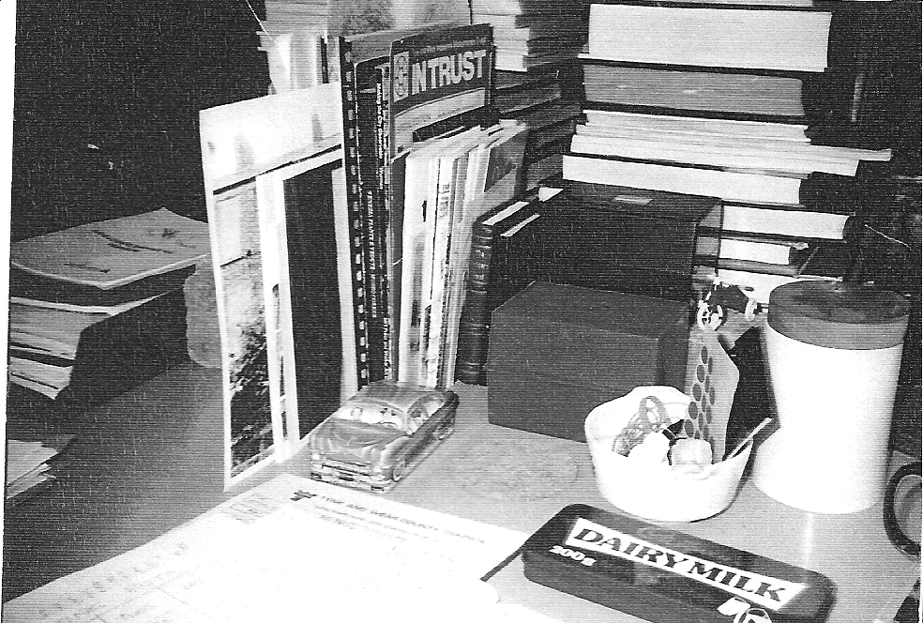

Fig 2 Work in Progress (author's photograph)

Definitions of 'conservation' are not precise: to Gateshead MBC the works on the left hand of Whickham Thorns were part of a conservation project, to the JCT they were its ruination, obliterating many original features, still visible on the right.
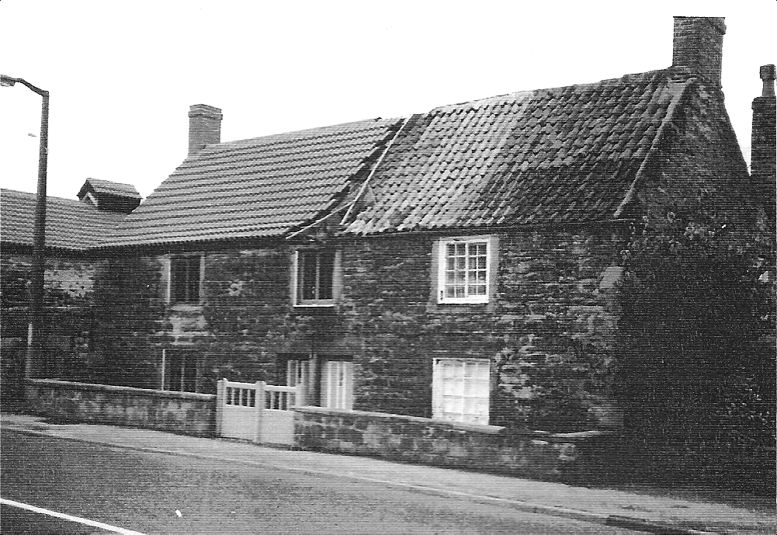

Fig 3 Proposed Memorial Haiku, St Mary's, Gateshead
(author's drawing, 1984)

In local authority planning opportunity for poetic expression is rare. This sketch is for one of a series of unrealised landmarks in Gateshead's riverside.
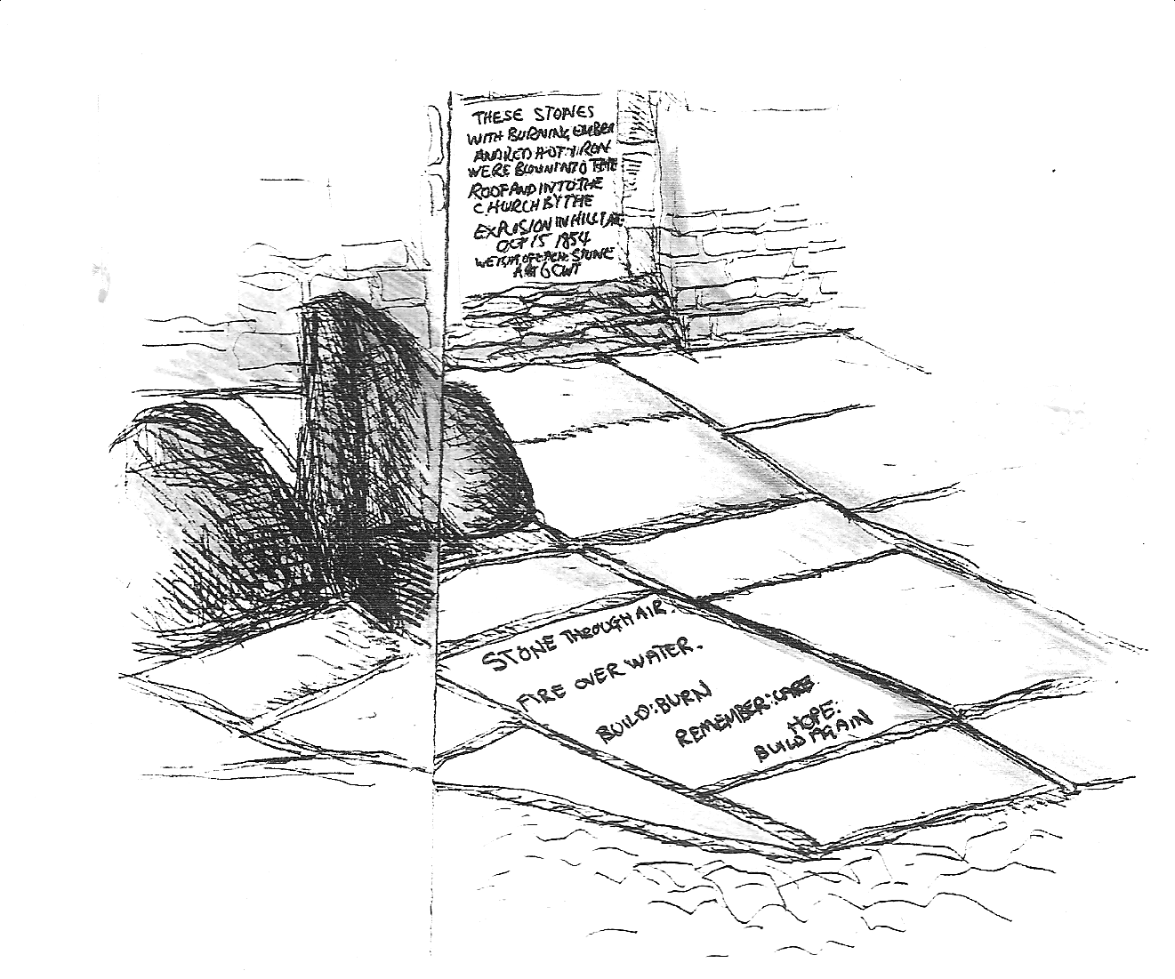

Fig 4 Proposed stone plaque for the Spitcrow Road
(author's drawing, 1985)

Organisational memory is selective and demolition absolute; this unrealised commemorative stone sought to at least sketch the communications obliterated on official amnesia.
