An overview of traumatic brain injury
in adults
Abstract
The epidemiology of traumatic brain injury (TBI) in high-income countries is changing, with falls in older adults as one of the leading causes. Disability after TBI results largely from cognitive, emotional and behavioural problems, as well as physical impairments. The consequences are long term and far-reaching, affecting not only the survivor and carers, but also incurring major socioeconomic costs to society. TBI is a heterogeneous disease, which has different causes, severity and encompasses a spectrum of pathological features. In part one of this two-part series, the author provides an overview of the different pathophysiological features of TBI. Part two will focus on management of adult patients with a severe TBI (Glasgow Coma Scale score ≤8) who require critical care, based on current evidence.

iNTRODUCTION
In the UK, it is estimated that there are 900 000 accident and emergency attendances with head injuries, with 160 000 people admitted to hospital annually. Approximately 1.3 million people are living with disabilities resulting from these injuries (Medical Research Council, 2022). Traumatic brain injury (TBI) is an acute injury to the skull, brain or both, as a result of a sudden external force that is of sufficient magnitude to interfere with normal function and may require treatment (Haydel et al, 2021). Many patients present to the emergency department after a head injury; however, not all impacts to the head cause a TBI (Bloom et al, 2022). TBI is often referred to as the ‘silent epidemic’ and as a ‘hidden handicap’, as it represents one of the leading causes of death and disability globally. It results in disability largely from cognitive, emotional and behavioural problems, rather than physical impairments (Li et al, 2021; Giner et al, 2022). Survivors can have long-term and far-reaching consequences, which disrupt the life of individuals and families, and incur major socioeconomic costs to society such as an increased all-cause mortality, loss of independence and employment, relationship breakdown, social isolation, mental illness, addiction and homelessness (Maas et al, 2017; Li et al, 2021).
Initial classification of TBI is typically based on clinical severity using the post-resuscitation Glasgow Coma Scale (GCS) score: mild TBI GCS score of 13 to 15; moderate TBI: GCS score of 9 to 12; severe TBI score of 3 to 8. Severe TBI has high rates of mortality and disability (Raith et al, 2020). Those who are in the moderate–severe TBI category require specialist critical care with neuroscience expertise and a multidisciplinary collaborative approach to care.
The epidemiology of TBI has been changing for some years in high income countries such as the UK, as the population has increased by 20% to 67 million and the proportion of people aged over 65 years has grown. Older patients who are taking anticoagulants and experience a ground-level fall are an increasing group of trauma patients (Giner et al, 2022). As a result, more patients with TBI have comorbid medical conditions, which are associated with an increase in mortality rates (Xiong et al, 2019). These changing characteristics present challenges for clinicians (Wiles, 2022). Young adults with more severe injuries, often related to road traffic collisions, are another increasing group of trauma patients. In fact, it is the most common cause of death and disability in people aged <40 years (Lockey and Wilson, 2020; Li et al, 2021).
In part one of this series, the author provides clinicians with a brief summary of some of the specific injuries and pathologies associated with severe TBI.
Pathophysiology of
traumatic brain injury
TBI is a collection of heterogeneous disease types because of the wide variations in causes, severity, concomitant extracranial injury, age and pre-existing comorbidities (Menon and Ercole, 2017). TBI encompasses a spectrum of pathological features that result from damage to neurons, glia (different types of supporting cells) and blood vessels. Each pathological feature has different clinical patterns and outcomes that require different approaches to diagnosis and management (Maas et al, 2017). Individuals may react very differently to similar injury forces. Conceptually, it is important to distinguish between neurological damage that occurs at the time of the injury (primary brain injury) and damage that evolves over the following minutes, hours, days, weeks or months (secondary or progressive brain injury).
Primary brain injury
During primary injury, the external mechanical forces can be transferred directly to damage the intracranial contents in a number of ways (Raith et al, 2020). Primary injury can be focal, multifocal and/or diffuse pattern, and can vary in severity depending on the mechanism of injury and types of mechanical forces. The extent of damage depends on type, intensity, direction and duration of the external forces (Maas et al, 2017). Focal and/or multifocal injuries such as brain contusions, intracerebral, extradural (Figure 1) and subdural haemorrhages occur in a specific area of the brain, whereas diffuse brain injury describes widespread brain damage. The types of mechanical forces involved include acceleration and/or deceleration linear forces, rotational forces, forces generated by blast winds associated with blast injury, blunt impact, and penetration by a projectile (Mckee and Daneshvar, 2015). In traffic-related injuries, acceleration-deceleration forces can result in immediate shearing of connecting nerve fibres or initiate progressive loss of connectivity between nerve cells over time. A coup injury occurs under the site of impact with an object and a contrecoup injury occurs on the side opposite the area that was hit. For example, when a restrained passenger comes to a sudden stop when a car strikes a tree (coup), they may also sustain a contusion opposite to the actual site of impact to the head (contrecoup) (Payne et al, 2023).
Following a contrecoup brain injury, the floating brain rebounds in the opposite direction. Lesions such as a haemorrahagic contusion (Figure 2) may arise from forces within the intracranial cavity, which are not directly related to the site of the focal blow; instead, it is related to the stress on the brain and its structure caused by the force of the blow on an already moving head. Falls and road traffic accidents are the most common aetiologies. Haemorrahagic contusions are usually found in the frontal and temporal lobes where brain tissue comes into contact with bony protuberances at the base of the skull (Hickey, 2019). They can also be found in the occipital lobe (as shown in Figure 2). In order to sustain a traumatic intracerebral and intraventricular haemorrhage (Figure 3), a significant force will have to be transmitted from its impact site through brain tissue in order to cause deep capillary rupture (Raith et al, 2020). Diffuse axonal injury (DAI) is the result of shearing mechanisms and is difficult to characterise or quantify initially on neuroimaging. DAI should be suspected in comatose patients without obvious mass lesions (e.g. haematoma) or raised intracranial pressure (Raith et al, 2020). Table 1 summarises some of the types of brain injury associated with TBI.
The magnitude of the primary injury can be modified by the use of preventative measures, such as protective equipment and helmets. However, once the trauma occurs, the immediate neurological damage produced by the primary traumatic forces is usually not alterable (Mckee and Daneshvar, 2015).
Secondary brain injury
Secondary brain injury refers to the evolving pathophysiological consequences of the primary injury and is characterised by a cascade of biochemical, cellular, and molecular events (Lazaridis et al, 2019). Table 2 outlines some intracranial and extra-cranial (systemic) processes leading to secondary brain injury.
Little can be done about the extent of primary injury to the brain when patients present to critical care following TBI; however, the detrimental contribution to outcomes from secondary neuronal injury processes and secondary insults can be substantial.
Conclusion
Acute TBI is a complex heterogeneous condition that can result in physical, cognitive, neurobehavioral symptoms that can have far reaching psychosocial and economic consequences for survivors and carers. Outcome can vary depending on the individual, type and mechanism of injury, and comorbid medical conditions.
Critical care management aims to attenuate secondary brain injury processes and prevent secondary brain insults, and optimise neurological outcomes. In part two of this series, the author will discuss the critical care management of a severe TBI. bjnn
Declaration of interest: None
Bloom BM, Newcombe V, Roberts I. What’s in a number? Problems with counting traumatic brain injuries. Emerg Med J. 2022;39(3):233-234. https://doi.org/10.1136/emermed-2021-212076
Giner J, Mesa Galán L, Yus Teruel S, Guallar Espallargas MC, Pérez López C, Isla Guerrero A, Roda Frade J. Traumatic brain injury in the new millennium: new population and new management. Neurologia (Engl Ed). 2022;37(5):383–389. https://doi.org/10.1016/j.nrleng.2019.03.024
Haydel MJ, Lauro AJ. Assessment of traumatic brain injury, acute. 2021. https://bestpractice.bmj.com/topics/en-gb/515 (accessed 17 August 2023)
Hickey J. The clinical practice of neurological and neurosurgical nursing. 8th edn. Philadelphia (PA): JB Lippincott; 2019
Lazaridis C, Rusin CG, Robertson CS. Secondary brain injury: Predicting and preventing insults. Neuropharmacology. 2019;145(Pt B):145–152. https://doi.org/10.1016/j.neuropharm.2018.06.005
Li LM, Dilley MD, Carson A et al. Management of traumatic brain injury (TBI): a clinical neuroscience-led pathway for the NHS. Clin Med (Lond). 2021;21(2):e198–e205. https://doi.org/10.7861/clinmed.2020-0336
Lockey DJ, Wilson M. Early airway management of patients with severe head injury: opportunities missed? Anaesthesia. 2020;75(1):7–10. https://doi.org/10.1111/anae.14854
Maas AIR, Menon DK, Adelson PD et al. Traumatic brain injury: integrated approaches to improve prevention, clinical care, and research. Lancet Neurol. 2017;16(12):987–1048. https://doi.org/10.1016/s1474-4422(17)30371-x
Mckee AC, Daneshvar DH. The neuropathology of traumatic brain injury. Handb Clin Neurol. 2015;127:45–66. https://doi.org/10.1016%2FB978-0-444-52892-6.00004-0
Medical Research Council. Traumatic brain injury across the life course: priorities, challenges, and opportunities 2022. https://www.ukri.org/wp-content/uploads/2022/12/MRC-07122022-MRC-Traumatic-Brain-Injury-Workshop-report_June-2022.pdf (accessed 21 August 2023)
Menon DK, Ercole A. Critical care management of traumatic brain injury. Handb Clin Neurol. 2017;140:239–274. https://doi.org/10.1016/b978-0-444-63600-3.00014-3
Payne WN, De Jesus O, Payne AN. Contrecoup Brain Injury. In: StatPearls [Internet]. Treasure Island (FL): StatPearls Publishing; 2023
Raith EP, Fiorni F, Reddy U. Critical care management of adult traumatic brain injury. Anaesth Intensive Care Med. 2020;21(6):285–292
Wiles MD. Management of traumatic brain injury: a narrative review of current evidence. Anaesthesia. 2022;77 Suppl 1:102−112. https://doi.org/10.1111/anae.15608
Xiong C, Hanafy S, Chan V, et al. Comorbidity in adults with traumatic brain injury and all-cause mortality: a systematic review. BMJ Open. 2019;9(11):e029072. https://doi.org/10.1136%2Fbmjopen-2019-029072

Table 1. Types of brain injury associated with traumatic brain injury (TBI)
Types of brain injury associated with traumatic brain injury | Explanation
Extradural haematoma | An accumulation of blood in the epidural space, which is between the periosteum on the inner side of the skull and the dura mater
Acute subdural haematoma | An accumulation of blood between the dura mater and arachnoid mater. Caused by the rupture of bridging veins from the cortical surfaces to the venous sinuses (cortical veins)
Cerebral contusion | Damage to small blood vessels and to brain tissue (parenchyma) produces small haemorrhage. Frontal and temporal regions are particularly vulnerable, given their relation to the base of the skull
Diffuse axonal injury | Damage to axons as a result of shearing mechanisms
Traumatic intracerebral haemorrhage | Bleeding deep within the brain parenchyma (e.g. basal ganglia, thalamus)
Traumatic (non-aneurysmal) subarachnoid haemorrhage | An accumulation of blood in the subarachnoid space that may be associated with contusions and acute subdural haematoma
Traumatic intraventricular haemorrhage | Haemorrhage within the ventricles, which may be secondary to traumatic subarachnoid haemorrhage or as an extension of an ICH. May be associated with DAI
Skull base fracture | A linear fracture at the base of the skull. May involve the temporal, occipital, sphenoid and/or ethmoid bone

Table 2. Processes that lead to secondary
brain injury
Intracranial cause of secondary brain injury | Extracranial causes of  secondary injury
Intracranial hypertension (intracranial pressure >20 mmHg) | Systemic hypotension
Cellular cascades (i.e. ischaemia, inflammation, excitotoxicity) | Hypoxaemia (pO2 less than 8.5 Kpa)
Oedema, haemorrhage | Hypo- or hyperglycaemia
Hydrocephalus | Hypo- or hypernatraemia
Seizures | Hypocapnia
Vasospasm | Hypo- or hyperthermia
Infection

Key Points
Traumatic brain injury (TBI) is a heterogeneous condition that includes various brain lesions and complex pathophysiological pathways and is therefore not a single entity.
Numerous secondary molecular and cellular injury processes may develop following the primary injury that inevitably worsen outcome.
Secondary insults such as hypotension and hypoxia further exacerbate secondary injury and should be avoided.
Due to ageing populations, falls are a leading cause of TBI, which bring challenges for clinicians due to comorbid medical conditions and pharmacological treatment.

CPD reflective questions
What type of primary brain injury has the patient with a traumatic brain injury sustained? Is the injury focal and/or multifocal and/or diffuse?
What are the intracranial causes of secondary brain injury?
What are the extracranial causes of secondary brain injury?

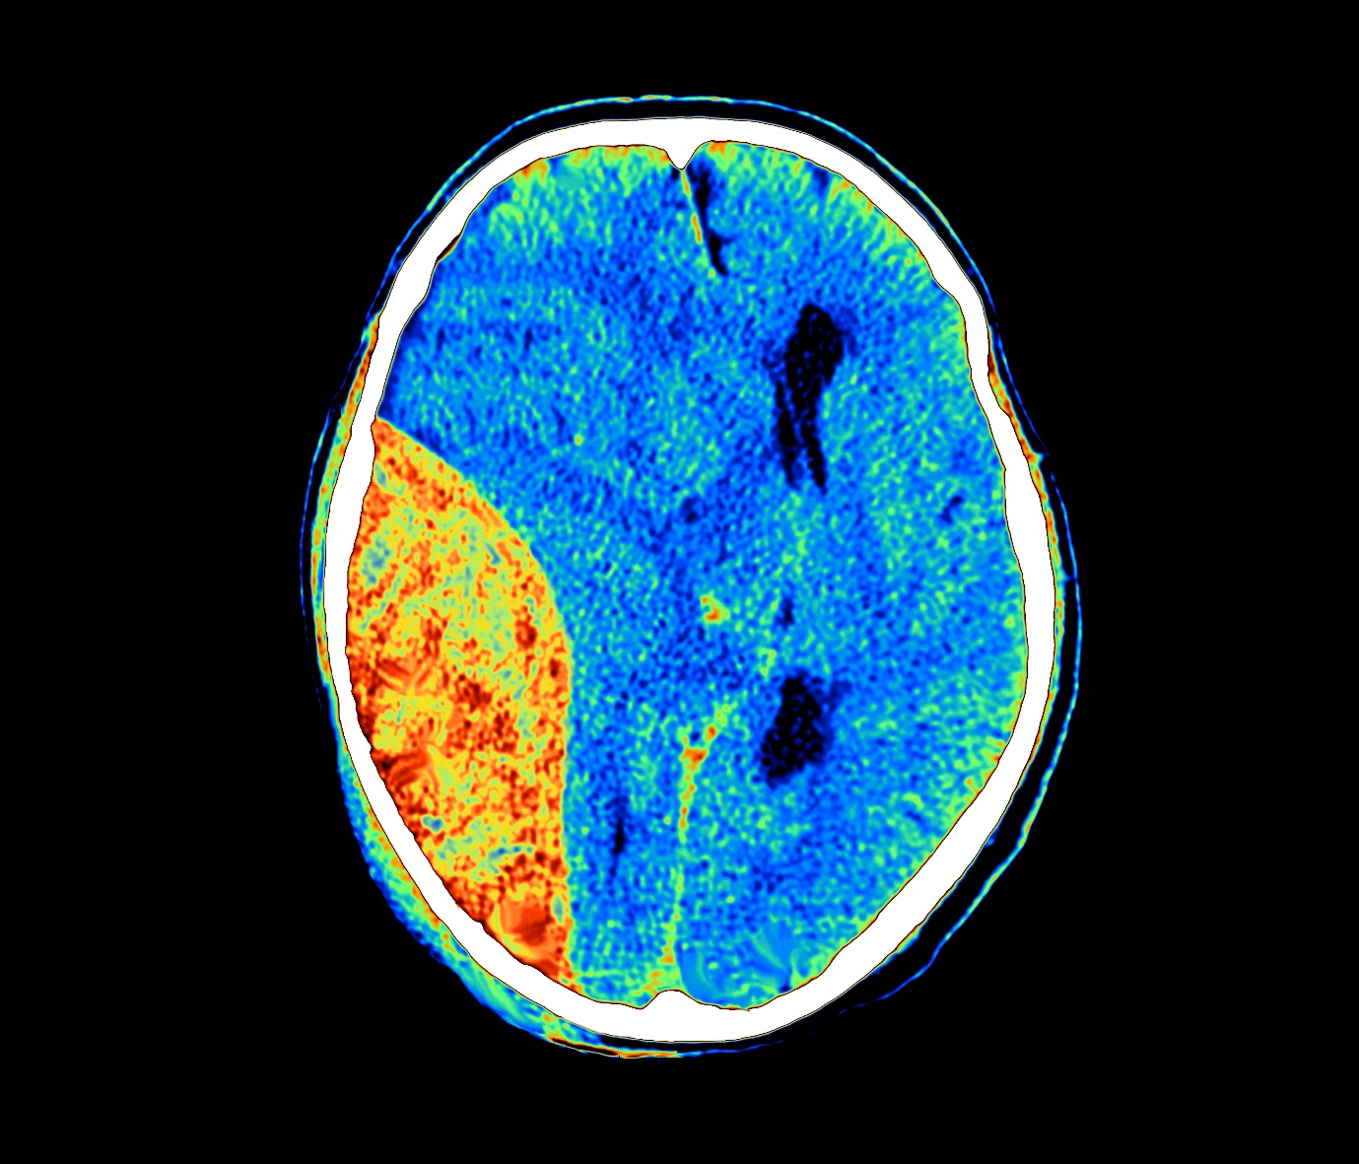
Figure 1. Coloured computed tomography (CT) scan of the brain shows an extradural hematoma (orange, left) in the right tempoparietaloccipital region of the brain, accompanied by cerebral oedema (swelling).

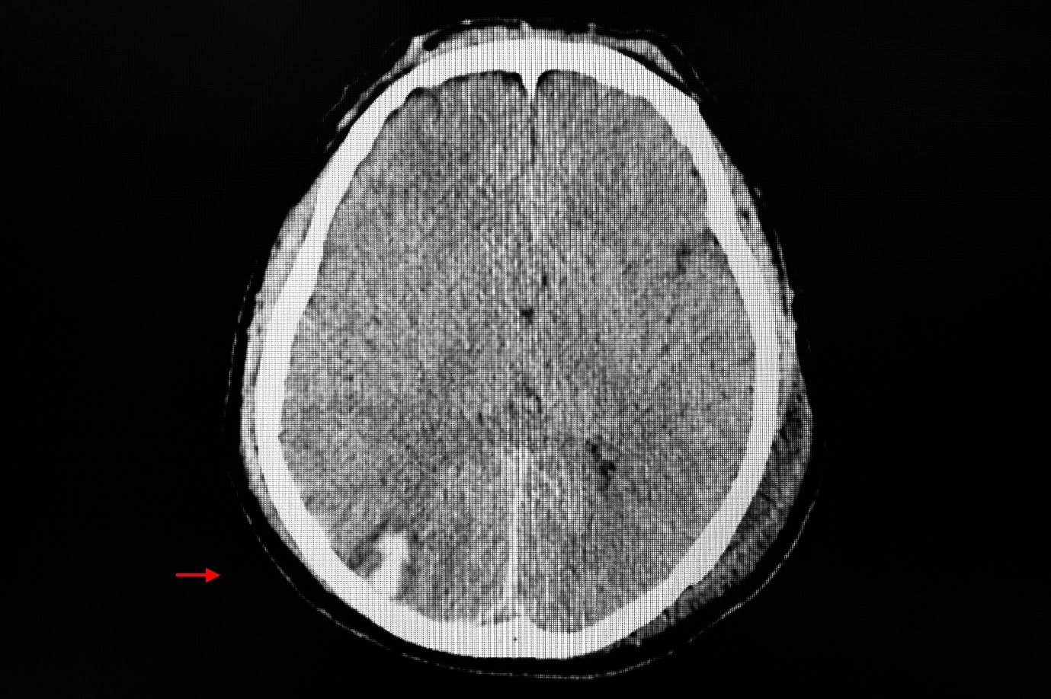

Figure 2. CT scan of the brain showing haemorrhagic contusion at right occipital lobe.
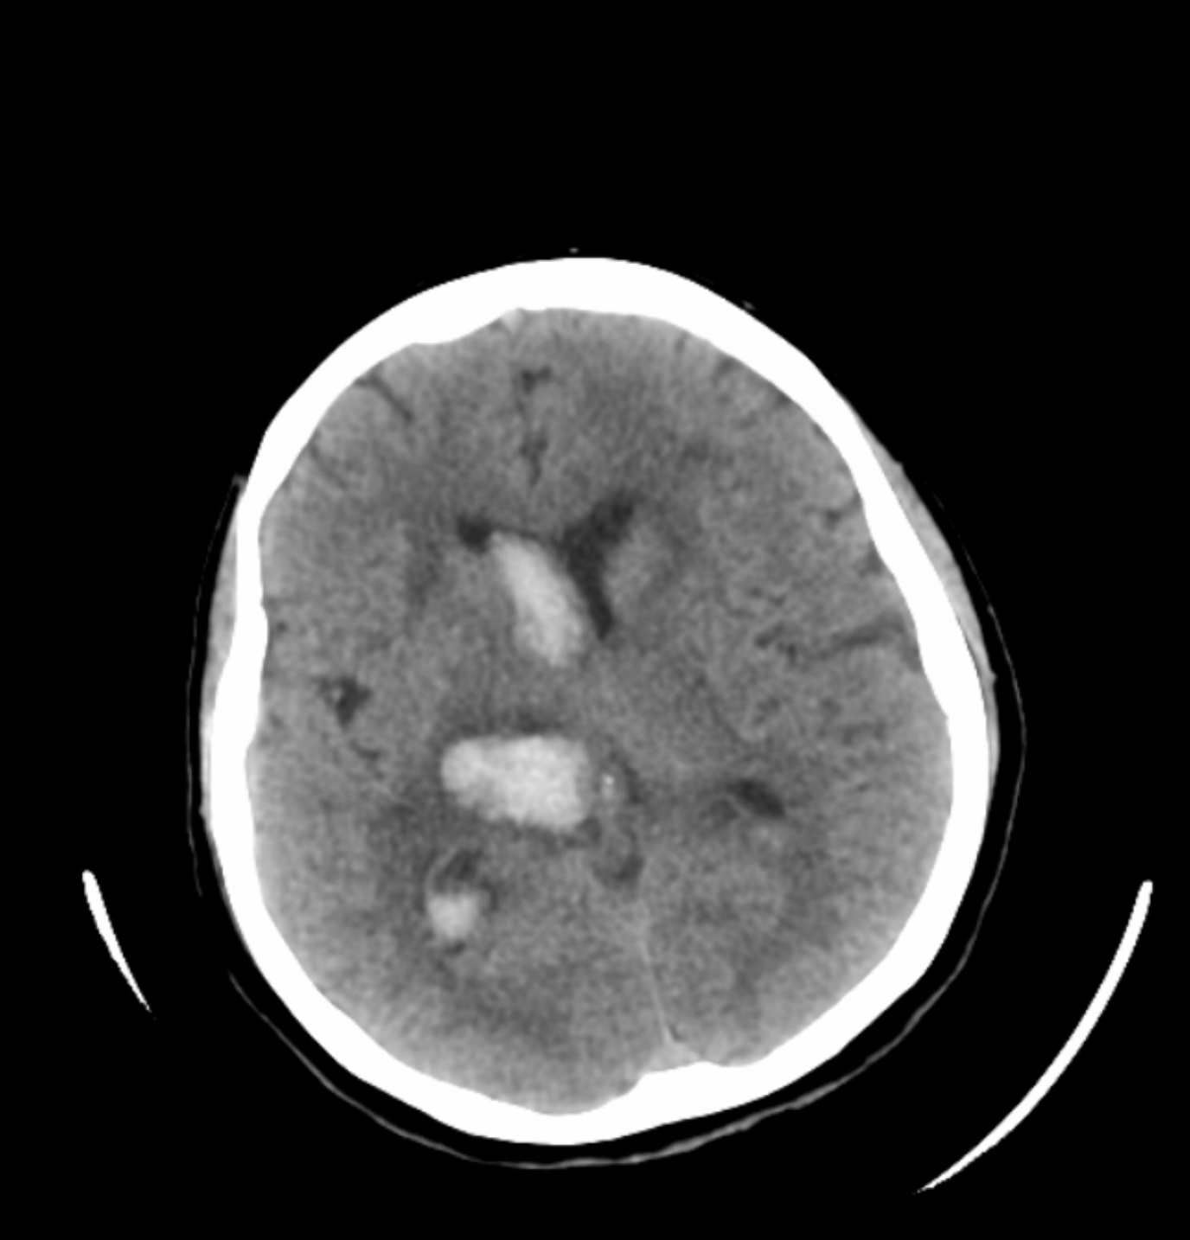
Figure 3. Computed tomography (CT) scan of the brain showing an intracerebral haemorrhage on the right thalamus (centre left) and an intraventricular haemorrhage (white).

