Validation of guidance for the prediction of the directivity index of ventilation louvres

Traveller, Jack
Bickerdike Allen Partners LLP
121, Salusbury Road, London, UK, NW10 7FL

Gomez--Agustina, Luis
London South Bank University
103, Borough Road, London, UK, SE1 0AA

ABSTRACT

The accurate prediction of external noise levels received at sensitive locations from building services plant is crucial at the design and planning stages of many construction projects. Guidance for the prediction of the directivity index of ventilation louvres found in the literature has been reviewed and partially validated. CIBSE Guide B4 is widely used by acousticians in the UK and other parts of the world. It presents guidance for predicting the directivity index of wall-mounted building ventilation louvres emitting noise to atmosphere at various angles. For louvres of large surface area it predicts very high values of frequency independent attenuation. This is not consistent with theoretical understanding of source directivity. The origin or basis for this correction has not been found in the literature. Experimental results strongly suggested that that the CIBSE B4 prediction method is not accurate for predicting the directivity index of large external ventilation louvres and that the guidance is questionable for small louvres. Of the other prediction methods found in the literature and tested in this study, one method showed stronger agreement with the measurements. Further investigation into this method is proposed to determine its suitability as a valid prediction alternative.

Keywords: Building services noise, CIBSE B4, louvres, ventilation, industrial noise,
I-INCE Classification of Subject Number: 30
http://i-ince.org/files/data/classification.pdf

1. INTRODUCTION

The accurate prediction of external noise levels received at sensitive locations from building services plant is crucial at the design and planning stages of many construction projects. Guidance for the prediction of the directivity index of ventilation louvres found in the literature has been reviewed and partially validated.

This paper summarises the results of a study which aimed to validate guidance for predicting the angular directivity loss of ventilation louvres given in the Chartered Institute of Building Services Engineers (CIBSE) guide B4 [1].

When using the CIBSE B4 methodology, the predicted on-axis directivity index is converted to off axis directivity index for a given angle using lookup tables given in the document. These are reproduced below in Figure 1 and Figure 2. For sources of surface area ≥10 m², this gives rise to a frequency independent correction of -30 dB at angles of 80° or greater [1]. The fact that this large correction is frequency independent seems to contradict the well accepted theory that the radiation patterns of sound sources are a function of the wavelength of the sound produced and the source’s dimensions [2].

It would generally be expected that for a source that is strongly directional on-axis, the greatest off-axis reduction in level would be in the high frequencies, with low frequencies remaining comparatively omnidirectional [3]. On the basis of theoretical understanding and real-world observations of such sources, it is difficult to conceive of obtaining a 30 dB loss in the 125 Hz band simply on the basis of receiver angle to the normal.

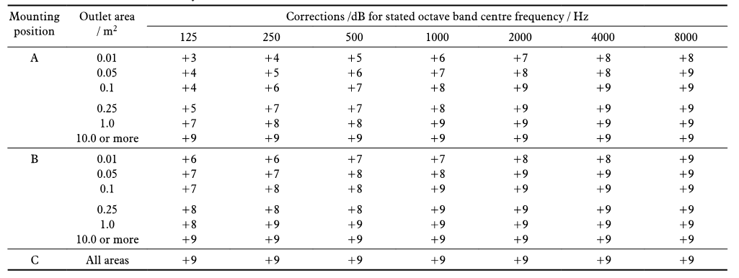
Figure 1: CIBSE B4 table 4.43 correction for on-axis directivity [1]
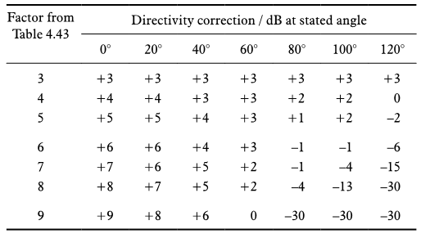
Figure 2: CIBSE B4 correction for off axis directivity [1]
Although the potential inaccuracies of this correction are most apparent at low frequencies (the jump from a directivity correction of 0 dB at 60° to -30 dB at 80° does not seem physically possible), on the basis of observation of such sources in real-world conditions it is not clear that a large correction of -30 dB is justified even in the 8 kHz octave band without the presence of intervening obstacles (e.g. the corner of the building) to provide screening loss. It is also noted that the provenance of the correction factors is not addressed in the text of CIBSE B4 [1]. The corrections are not traceable to another source or standard, although some of them do bear similarities to other guidance, discussed below.

In order to validate this guidance, the correction values were first compared to corrections obtained from several other commonly used methods. Then values were evaluated against field measurements taken from a range of suitable and representative ventilation louvres.

2. COMPARISON OF GUIDANCE

The method for predicting the off-axis directivity index of large, external wall mounted louvres given in CIBSE B4 [1] was compared with relevant predictive methods or guidance given in BS EN ISO 12354-4: 2000 [4], the textbooks Noise Control in Building Services [5], Woods Practical Guide to Noise Control, Engineering Noise Control [6], and research by Oldham [7], Potente [8], Davy [9] and Day [10].

Prediction models found in [3], [5] and [6], give results in terms of directivity index
(D_{I}) in dB.

Prediction models found in [7], [8] and [10] give results in terms of ΔL(Φ); the change in sound pressure level at the receptor in dB between angle Φ and reference angle 0°.

Davy [9] does not state his results explicitly, but compares predictions generated by his model to experimental data from a variety of studies, including Oldham [7] and Potente [8], using the standard deviation of the difference between his model and experimental data over all angles of radiation and all frequencies as a measure of agreement.

Among the sources examined there is little agreement on precise input variables. It is clear (as might be expected due to the relationship between wavelength and source dimension) that source size is important, however the sources disagree on whether this should be characterised using length, width, surface area, or Strouhal number. As some sources rely on on-axis directivity index as an input value (which they state as frequency independent at certain source sizes), this leads to frequency independent axial directivity index corrections. This is contradicted by experimental work such as that of Oldham [7] and Day [8].

The CIBSE B4 corrections are by far the most extreme frequency independent corrections and appear as outliers among all sources examined, which show a general lack of consistency over a relatively long period of time (1972-2008)

2.1 Comparative exercise

For analytical and comparative purposes, directivity corrections for a hypothetical large external louvre at a large angle off axis have been predicted using all of the models described above.

As some models predict directivity index and some predict ΔL(Φ), where relevant, directivity index has been converted to ΔL(Φ) for consistency.

The hypothetical source was taken to be a 10 m² louvre of height 2.5 m and width 4 m. For models explicitly dealing with circular ducts ([6], [8] and [10]) the diameter of a duct of cross sectional area of 10 m² has been used. Bies states that his model may be used for rectangular sources with caution [6, p284]. Potente [8] and Day [10] do not state this explicitly, but their work was partially undertaken as an update to guidance given for rectangular ducts (originally published by New South Wales Environmental Protection Agency) [8], [10]. As such it is assumed that their findings are intended to be applicable to both square and circular ducts.

Corrections have been predicted for an angle of 80° (0° being on axis). Where the model does not include a correction of 80°, the closest angle provided has been used (75° for [8] and [10], 90° for [7] and [6]). Oldham’s model includes a correction for diffraction around the wall of the louvre aperture based on the wall’s thickness. For this correction a wall of 0.24 m thickness was used. This is the median correction value given by Oldham [7].

Davy’s model has been omitted in this comparison as he does not present his results in terms comparable to the other sources [9].

ISO 12354-4 [4] is vague on the topic of source directivity, stating only that the directivity index correction “roughly varies between D_{I} = +2 dB and D_{I} = -10 dB”. The guidance given in this standard has therefore also been omitted.

The results of the comparative exercise are given below in Table 1 and presented graphically in Figure 3.
Table 1: Comparison of predicted ΔL(Φ) in dB for approx. 80° off axis from different prediction methods for a louvre of 10 m²
Source | Octave band centre frequency (Hz)
 | 125 | 250 | 500 | 1000 | 2000 | 4000
CIBSE B4 [1] | -39 | -39 | -39 | -39 | -39 | -39
Fry [5] | -19.5 | -19.5 | -19.5 | -19.5 | -19.5 | -19.5
Sharland [3] | -13 | -13 | -14 | -14 | -14 | -14
Bies [6] | -12 | -21 | -26 | -28 | -28 | -28
Oldham [7] | -13.5 | -17 | -19 | -21.5 | -22.5 | -23
Potente [8] | -5 | -12 | -14 | -18 | -22 | -22
Day [10] | -11.5 | -12.5 | -17 | -20 | -24 | -27.5

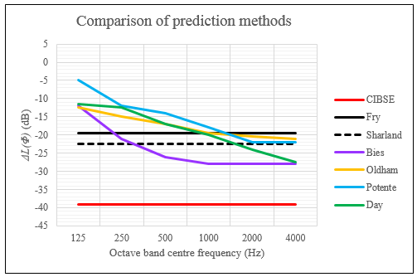
Figure 3: Comparison of prediction methods for approximately 80° off axis for a louvre of 10 m²
It can be seen from Table 1 and Figure 3 that the examined prediction methods do not show close agreement with one another. In general, these methods can be classified as those which give a frequency independent correction, and those which show ΔL(Φ) increasing (i.e. giving a greater loss of level) as a function of frequency and angle.

3. FIELD MEASUREMENTS

Following the above comparison, it was felt that a further comparison with measured data was necessary.

Seven large louvres suitable for measurement were located (subjects 4 to 10). Each of these had a surface area of ≥10 m², with the exception of Subject 10, which had a surface area of 5 m². Subject 10 was included as it was felt that this would be a good control subject to investigate sensitivity to source size, as the CIBSE B4 method does not allow for sizes between 1 m² and 10 m² [1]. Each source was situated in such a way that sound could propagate freely without the influence of reflecting surfaces, other than the ground and the wall in which the source is mounted.

Sources were situated such that it was possible to take measurements at angles of ≥ 75° (0° being on axis). It was anticipated that for sources mounted in a wall acting as an infinite baffle, 75° would be the maximum possible angle to measure at while remaining sufficiently far away from the wall in which the source is mounted to minimise the influence of reflections. All sources produced noise of sufficient level to enable valid measurements not incorporating the potential contribution of the background present at the measurement positions up to the 4 kHz octave band. The blade geometry and spacing of all sources was similar.

For each in-situ source, measurements of the emitted sound pressure level were made at positions 0° on axis to the source and 20°, 40°, 60° and 75° off axis, in the far field at a distance of 5.48 m. Figure 4 shows two photographs. The left photograph shows the measurement set up (only the rightmost louvre was generating noise). The right photograph shows another typical source. Figure 5 shows a sketch of the measurement set up. The results of these measurements were used to calculate the ΔL(Φ) for each source. This was then compared to the ΔL(Φ) predicted by [1].

At each measurement position, three L_{Zeq} measurements of 15 second duration were taken. As the sources produced steady state broadband noise, 15 seconds was deemed a suitable measurement time interval. Three measurement were taken at each position in order to check consistency between measurements and reduce the influence of uncertainty.

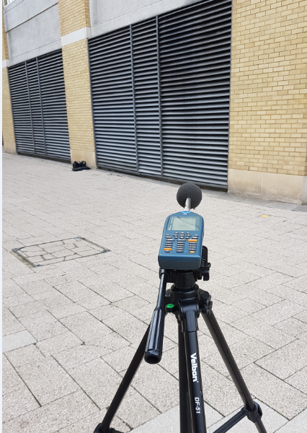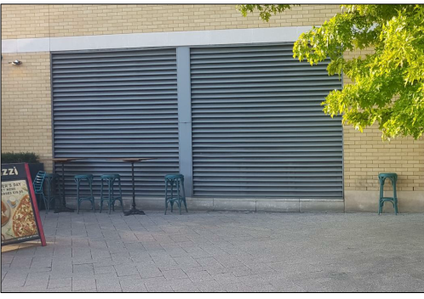
Figure 4: Measurement set up and typical source
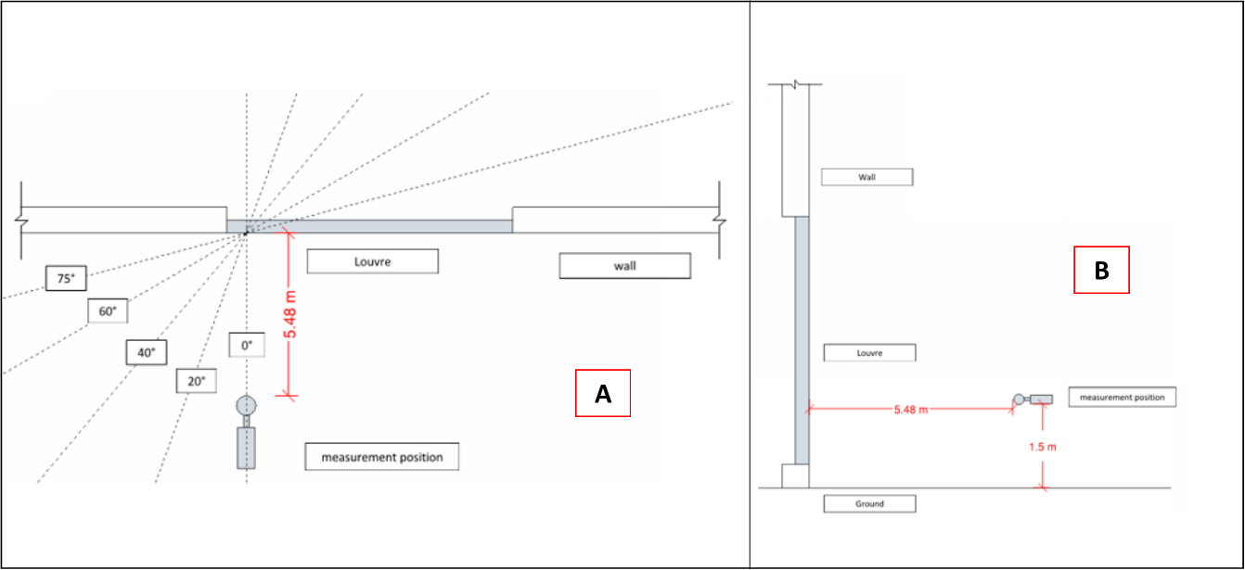
Figure 5: Sketch of measurement positions (A: plan, B: elevation)
Measurements were also taken of three smaller louvres (Subjects 1, 2 & 3) in order to validate the guidance given in CIBSE B4 for small sources [1]. These had a surface area of 0.06, 0.25 and 1.3 m² respectively.

4. RESULTS
The measured values and predictions based on guidance in [1] are presented below as variance in level with angle (ΔL(Φ)) as a function of angle and frequency. Measured values are based on the arithmetic average of the three measurements taken at each angular position. One result representative of the smaller subjects has been presented (Figure 6). Five results representative of the large subjects have been presented (Figure 7 to Figure 11).

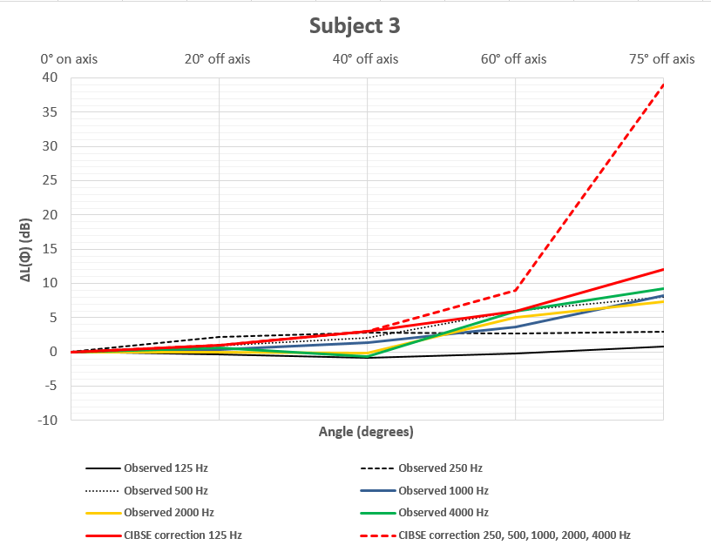 | 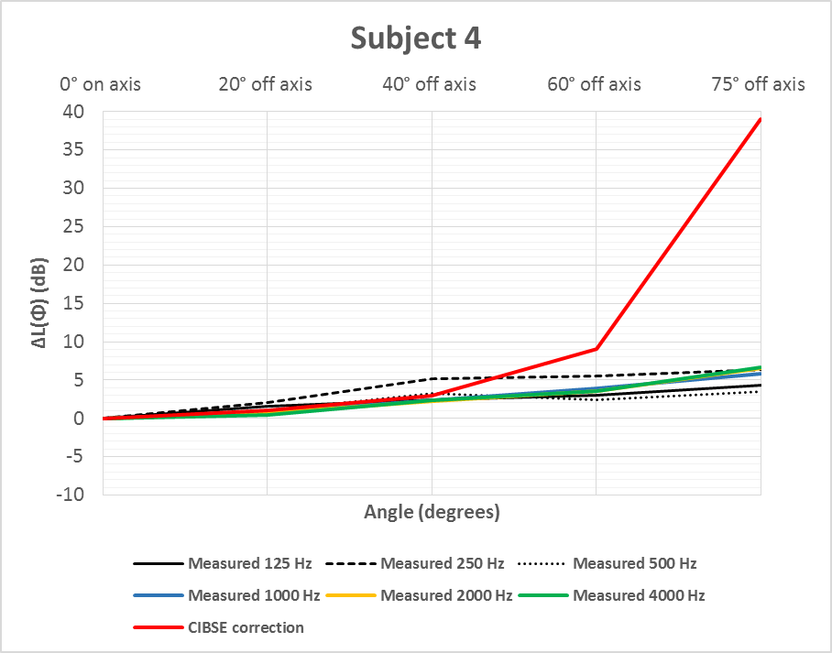
Figure 6: Results, subject 3 | Figure 7: Results, subject 4
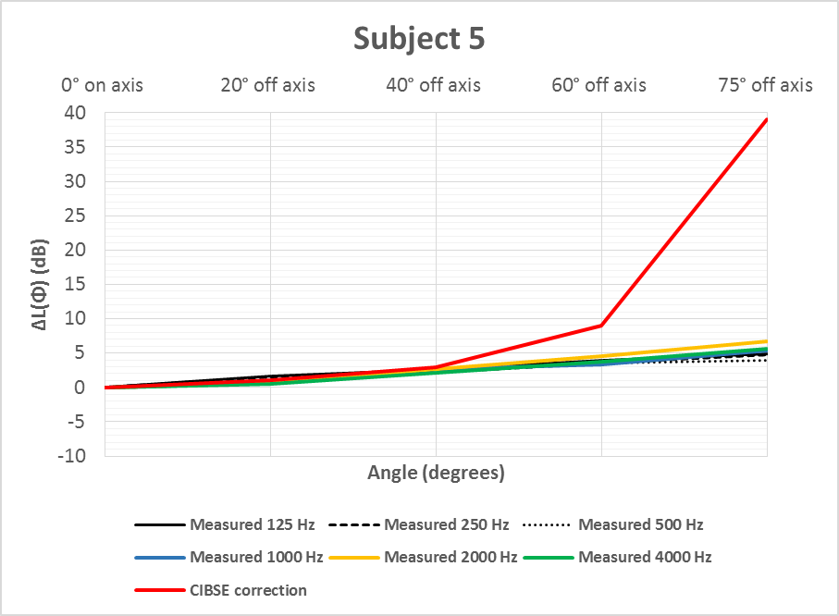 | 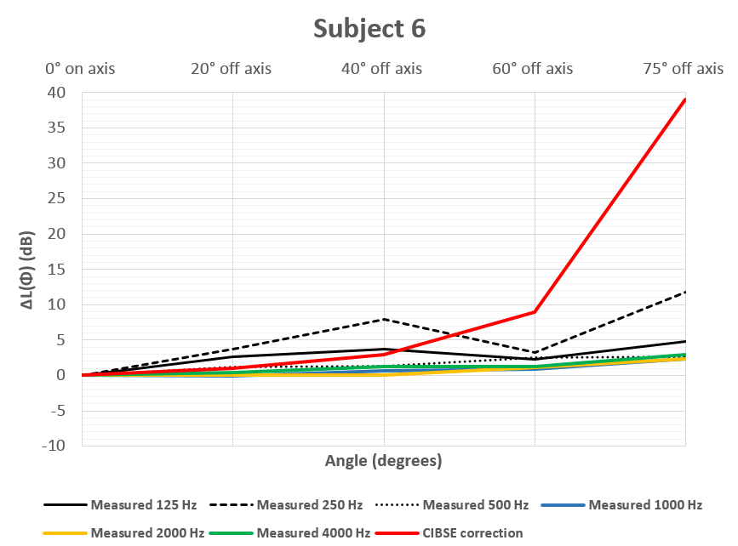
Figure 8: Results, subject 5 | Figure 9: Results, subject 6
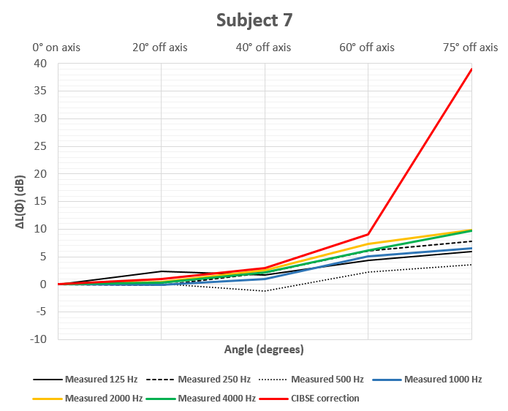 | 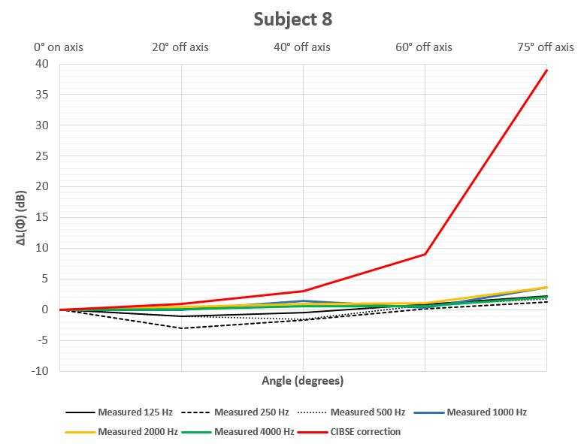
Figure 10: Results, subject 7 | Figure 11: Results, subject 8

5. DISCUSSION

It can be seen from graphs presented in Figure 6 to Figure 11 that in all cases where a large (≥10 m²) louvred opening has been measured, the measured ΔL(Φ) shows a strong disagreement with the ΔL(Φ) of 39 dB predicted using the CIBSE B4 method [1].

Although the measured subjects generally show increasing directivity loss with increasing frequency, in most cases this was marginal.

The measured results were generally as expected, due to the theoretical understanding of the relationship between frequency and source directivity [5], which has been upheld by recent research such as Potente et al [8], and historical research such as Oldham [7].

For all of the large subjects, the average directivity loss of all subjects in terms of ΔL(Φ) in dB at 20° and 75° for each frequency band is shown below and compared to the values predicted by CIBSE B4 [1] in Table 2. The small grilled openings (subjects 1, 2 and 3) are not included.

Guidance in [1] does not provide values for predictions of directivity for sources of surface area between 1 m² and ≥10 m². Subject 10 has therefore been excluded as its surface area is only 5 m².
Table 2: Comparative measured vs CIBSE B4 predicted values of directivity loss ΔL(Φ) in dB at 20° and 75° for each frequency band
Angle | Measurement or prediction | Octave band centre frequency (Hz)
 |  | 125 | 250 | 500 | 1000 | 2000 | 4000
20 degrees | Average ΔL(Φ) (measured) | 2 | 1 | -1 | 0 | 0 | 0
 | Average ΔL(Φ) (CIBSE B4) | 1 | 1 | 1 | 1 | 1 | 1
75 degrees | Average ΔL(Φ) (measured) | 4 | 6 | 3 | 5 | 6 | 5
 | Average ΔL(Φ) (CIBSE B4) | 39 | 39 | 39 | 39 | 39 | 39
Figure 6 to Figure 11 and Table 2 show that at small angles the CIBSE B4 [1] method makes reasonable predictions. At large angles however, the measured ΔL(Φ) does not exhibit the extreme drop-off given by the method in [1]. This demonstrates that this method significantly over-predicts directivity loss for large sources.
5.1 Sensitivity of directivity loss to source size
It can be seen from Figure 6 that for the smaller sources (subjects 1-3), the measured results agree more closely with the predicted results. For the smallest source, the predictions show better agreement with measurements all the way to the 1 kHz band (although there was an over-prediction of up to 9 dB in the case of low frequencies and large angles). Above this band the predictions exhibit their characteristic extreme drop off in [1]. As subjects 1-3 increase in size, this drop off happens in lower octave bands. For the largest source, only the 125 Hz band remains accurate to the measured data. It is speculated that the original research which was used to develop the prediction methods relied on measurements of relatively small sources and the corrections for larger sources were extrapolated from these.
5.2 Comparison with prediction methods

In order to investigate the relative accuracy of each of the prediction methods, the measured results from Subject 5 were compared to the various predicted results from each method. The prediction method showing best agreement with measured results for subject 5 was Oldham’s [7]. Oldham’s method still exhibited an over-prediction of up to 7 dB at high frequencies and large angles. This comparison is shown below in Figure 12. Only Oldham’s method has been presented.

It is speculated that Oldham’s method shows better agreement because it was developed using sources more similar to the types of source that were measured in this project (i.e. large rectangular sources). Oldham’s model relies on the variable fa, the product of frequency and source width [7]. Oldham provides prediction curves for values of fa consistent with the centre frequency of standard octave bands (this is shown in the legend below Oldham’s prediction curves, reproduced below in Figure 13). When using Oldham’s model to predict directivity loss for real-world louvres, unless the width of the source is 1 m or a multiple of 2, values of fa do not perfectly match the values Oldham provides curves for. The range of possible fa values also only extends to 16,000 Hz m [7].

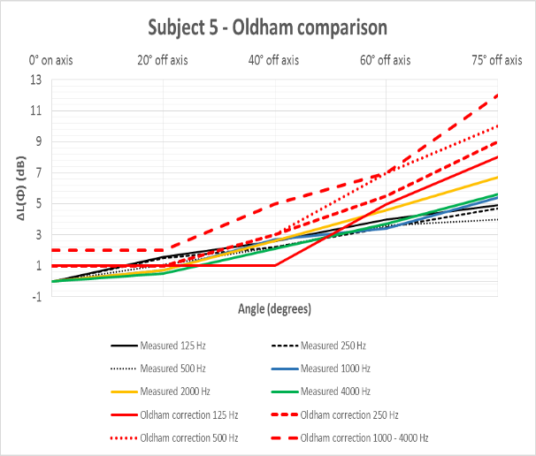 | 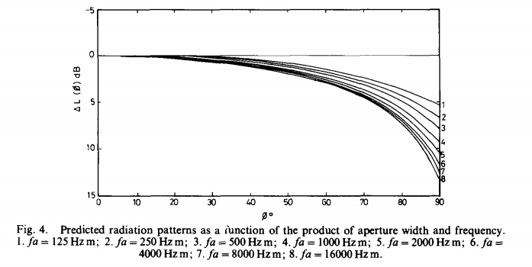
Figure 12: Comparison of subject 5 measured results with Oldham prediction method | Figure 13: Oldham and Shen’s directivity prediction curves [7]

It is speculated that this discrepancy could account for the over-prediction encountered above. As a test of sensitivity to source size, the model in [7] was used to predict directivity loss for subject 3, which has a width of 1.1 m. The prediction was compared to the measured results for Subject 3. This is shown below in Figure 14.

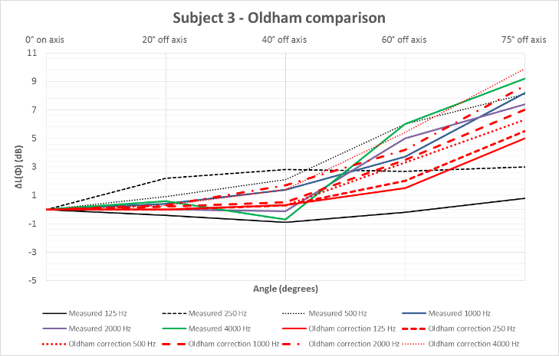
Figure 14: Subject 3 comparison ΔL(Φ) measured vs Oldham prediction method
It can be seen from Figure 14 that while [7] still over-predicts, particularly at low frequencies and small angles, the range of ΔL(Φ) values that [7] predicts falls within the range of measured ΔL(Φ) values.

Uncertainty is introduced by the fact that Oldham is considering only open apertures, while all the subjects measured in this project had grilles or louvres, which will offer some transmission loss and potentially influence the radiation pattern. Further uncertainty is introduced by Oldham’s correction for the width of the aperture wall being only available for three arbitrary values of thickness based on Oldham’s experimental data. Moreover, while Subject 3 matches Oldham’s range of fa values most closely, it is not a perfect match. Nonetheless, it may be seen that of the models tested, Oldham’s appears to give the closest agreement with values for all louvres measured [7].

6. CONCLUSIONS

The angular directivity loss for 7 wall mounted large louvres emitting sound to the outdoors was measured in-situ. Three smaller grilles were also measured as a test of sensitivity to source size. The results have been compared to the predicted corrections given in CIBSE guide B4 [1], as well as other relevant prediction methods found in the literature. The project findings were as follows:
- The predictive correction factors given in CIBSE B4 [1] significantly over-predict the directivity of large (≥10 m²) louvres at angles above 40° at all frequencies by up to 39 dB in the worst case.
- The predictive correction factors given in CIBSE B4[1] significantly over-predict the directivity of small (≤1 m²) louvres. For louvres of surface area 1 m², the over-prediction occurred above 60° in every frequency band above 125 Hz. The worst case over-prediction (4 kHz at 75°) was 30 dB.
- Oldham’s results [7], which focused on source types broadly similar to those dealt with in the project, showed the best agreement with measured results, but still over-predicted the directivity loss at frequencies above 500 Hz. The worst case over-prediction was 7 dB at 1000 kHz.
- Values predicted by Oldham’s model [7] for a louvre of 1 m width were compared to measurements for a louvre of 1.1 m width. Over-prediction was less significant.

8. REFERENCES

[1] Chartered Institute of Building Services Engineers. “Guide B4”. Norwich (2016)
[2] Peters, R.J. “Acoustics and noise control”. Third edition. Routledge, London. (2011).
[3] Sharland, I. “Woods Practical Guide to Noise Control”. Woods of Colchester, Colchester (1972).
[4] BSI. “EN 12354-4:2000 Estimation of acoustic performance of buildings from the performance of elements -- Part 4: Transmission of indoor sound to the outside”. BSI. (2000).
[5] Fry, A. “Noise Control in Building Services”. Pergammon Press, Oxford. (1988)
[6] Bies, D.A., Hansen C,H. “Engineering Noise Control”. Unwin Hyman Ltd, London. (1988).
[7] Oldham, D.J., Shen, Y. “A scale model investigation of sound radiation from a large aperture in a building”. Journal of Applied Acoustics Vol 15 (1982)
[8] Potente, D., Gauld, S, and Day, A. “Directivity loss at a duct termination”. Christchurch, November 20-22, Proceedings of Acoustics 2006, Noise of Progress, First Australasian Acoustical Societies’ Conference, (2006).
[9] Davy, J. “The directivity of the sound radiation from panels and openings”. Journal of the Acoustical Society of America, vol 125, no. 6. (2009)
[10] Day, A. Bennett, B. (2008). “Directivity of sound from an open ended duct”. Proceedings of Acoustics 2008. Acoustics and Sustainability: How should acoustics adapt to meet future demands? Australian Acoustical Society conference

Jtraveller@bickerdikeallen.com
gomezagl@lsbu.ac.uk

