Influence of reactor design on product distributions from biomass pyrolysis
Meredith Rose Barrª, Roberto Volpe^{a,}* and Rafael Kandiyoti^{b}
ª School of Engineering and Materials Science, Queen Mary University of London, Mile End Road, London E1 4NS, UK
^{b} Department of Chemical Engineering, Imperial College London; London SW7 2AZ, UK
* Corresponding author: r.volpe@qmul.ac.uk
Keywords: Biomass Pyrolysis, Thermogravimetric analysis, Reactors design
ABSTRACT
This paper explores the elements of experimental design that affect outcomes of pyrolysis experiments conducted in the authors’ labs. Primary pyrolysis products are highly reactive and reactor properties that tend to promote or suppress their secondary reactions play a key role in determining final product distributions. In assessing particular experimental designs, it is often useful to compare results from different configurations under similar experimental conditions. In the case of pure cellulose, char yields from pyrolysis experiments were observed to vary between 1 and 26 %, as a function of changes in reactor design and associated operating parameters. Most other examples have been selected from the pyrolysis of lignocellulosic biomass and its main constituents, although relevant data from coal pyrolysis experiments have also been examined. The work focuses on identifying the ranges of conditions where diverse types of reactors provide more dependable data. The greater reliability of fluidized-bed reactors for weight loss (total volatile) determinations in the 300-550 °C range, particularly relevant to the study of biomass pyrolysis, has been highlighted and compared with challenges encountered in using wire-mesh reactors and thermogravimetric balances in this temperature range.
1. Introduction
The principal factor that distinguishes pyrolytic reactions is the highly reactive nature of primary products released during thermal breakdown [1–3]. Volatile products may undergo secondary reactions with each other, or crack “in flight”, or react with the pyrolyzing solid matrix [4,5]. Collisions between the larger molecular mass components of the volatiles and the pyrolyzing matrix frequently lead to secondary char and tar formation [6]. The extents of secondary pyrolytic reactions are affected by the configuration of the sample and the design of the reactor.
When the aim is to investigate the fundamental pyrolytic behaviour of a selected material in order to evaluate its suitability for specific applications, it is necessary to distinguish between the thermal response of the sample and effects due to secondary reactions. While the main task of the designer must be to minimize spurious secondary effects, their total elimination is difficult. Alternatively, it often proves useful to devise methods for estimating the extent to which secondary reactions affect the outcome of experiments.
The work presented below draws on data from both biomass and coal pyrolysis experiments [1,7–11]. The basic elements of the two strands of work present many common aspects and shared challenges. Indeed, the level of similarity raises legitimate questions regarding why research on these classes of substrates has so often been considered as disparate fields of investigation. Below, basic concepts to help design of pyrolysis reactors are summarised by highlighting the ways in which experimental design may alter product distribution. This work demonstrates that different types of reactors may prove more useful than others in teasing out the fundamental thermal responses of particular samples over limited temperature ranges. Comparing results from different types of reactors is used as a principal tool in evaluating the role of particular design elements under similar experimental conditions.
2. Basic design features of some pyrolysis reactors in general use
As a general rule, the result of a measurement must be independent of the method of measurement, or any dependence must be quantified. In the case of pyrolysis experiments, this rule implies that the pyrolytic behaviour (char yield, etc.) of the sample material needs to be independent of effects due to sample configuration and reactor design and operation. Strict adherence to this rule is difficult, however, and usually a number of compromises have to be made. It is critically important, nonetheless, to identify the elements of design which allow distinguishing between the thermal response of the sample and effects relating to experimental layout. The aim is to arrive at results that are as independent as possible from experimental design.
Minimizing secondary reactions of primary volatiles often requires that reactions of sample particles be assessed under conditions in which particles are as near to total isolation as possible. The intensity of secondary reactions of volatiles may also be reduced by forcing volatiles away from the vicinity of the pyrolyzing matrix. Furthermore, in order to minimize intra-particle secondary reactions, it is necessary to subdivide sample particles as finely as possible. Ideally, therefore, we must work with infinitesimally small particles, in total isolation from one another. References [7,8] provide discussions of the smallest particles that can be worked with in actual practice. Static electricity related effects make the handling of particles much below 70 μm extremely difficult. In most applications, particles in the 100 – 150 μm range may be used as an adequate practical compromise.
It follows from the foregoing that, particle stacking must not be allowed in experimental design, in order to suppress secondary reactions. Meanwhile, fixed-bed reactors are often used for pyrolysis experiments, where there is intimate contact between evolving volatiles and heated pyrolyzing solids. In early work, Griffiths and Mainhood [12] showed that the motion of tar molecules (or tar aerosols) through a fixed bed composed of heated coal particles is similar to that of molecules moving within a chromatographic column, sequentially adsorbing onto and desorbing from a succession of heated particles. Above 350 °C, tars and lighter volatiles react with pyrolyzing bed solids; volatile materials may re-polymerize to form secondary char or crack to release lighter volatiles. Despite these potential drawbacks, in the past, fixed-bed reactors have been used to good effect in pyrolysis research; it is possible to do sensible experiments so long as the effect of secondary reactions on results may be controlled and quantified.
We next introduce the basic design elements of some bench-scale pyrolysis reactors in general use. The discussion will focus on the evaluation of design elements as they affect eventual product distributions. To limit the length of the present article, no discussion of drop-tube and spouted-bed reactors has been included. A separate survey of the characteristics of these important reactor types would be useful.
2.1 Fixed-bed (hot-rod) reactors
Fixed-bed (“hot-rod”) reactors are usually mounted vertically. Sample particles are stacked inside the reactor. With electrodes attached top-and-bottom, the cylindrical reactor body often serves as a resistance heater, as well as the containment vessel. A stream of inert or reactive gas is usually passed through the sample bed. When an electrical current is passed through the reactor body, heat diffuses radially inwards into the column of sample. As thermal breakdown is initiated, evolving volatiles are removed from the reaction zone by means of the stream of sweep-gas, towards traps where condensable products are recovered. The original “hot-rod” design, using thick walled stainless steel tubing has been described by Hiteshue and co-workers at the U.S. Bureau of Mines. They conducted high-pressure coal hydropyrolysis experiments at pressures up to 400 bars and temperatures up to 900°C [13,14]. Figure 1 presents a schematic diagram of an early version of a hot-rod reactor constructed at Imperial College London [15].
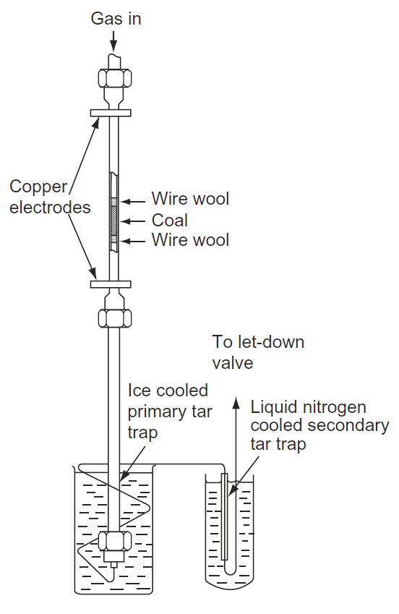
Figure 1. The ‘hot-rod’ reactor configuration. The common single-bed reactor. Source: Reprinted from [15] (Copyright 1987), with permission from Elsevier.
Despite obvious complications involving direct contact between evolving volatiles and pyrolyzing solid particles, this reactor configuration has proved flexible and versatile for carrying out several types of thermochemical reaction experiments (cf. sections 3.4, 3.6 and 3.8 in [8]). Heating rates may be changed up to about 10 °C s⁻¹ and the sweep gas velocity can be altered to try to reduce secondary effects. A second stage may be added, when catalytic [16] or thermal post-treatment of the product stream is required. Nunes et al. [17], Dabai et al. [18] and Volpe et al [19] have studied the cracking reactions of biomass pyrolysis tars/oils, by injecting tar/oil vapours generated in the first stage into a solids-packed second-stage fixed-bed reactor.
Compared to most other reactor types, fixed-bed reactors are relatively simple to build and operate. The reactor geometry lends itself to quantitatively evaluating the effects of secondary reactions of volatiles and of secondary char formation (see below). A more detailed description of fixed-bed (“hot-rod”) reactors, their design features, the modifications required for operating under high-pressures and the diverse uses they have been put to over the years may be found in Ref. [8] [cf. Section 3.4, 3.6 and 3.8 and Chapter 4]. More recently, experiments using this reactor configuration have been carried out at Shanghai Jiaotong University [20].
2.2 Fluidized-bed pyrolysis reactors
Pyrolysis experiments in bench-scale fluidized-bed reactors are usually done by injecting a batch of sample into a preheated fluidized-bed of inert particles. Heating rates are unknown, but estimated to be high, as sample particles introduced into the already heated bed are quickly dispersed among fluidizing bed solids. The volatile products of pyrolysis are swept out of the reactor by the fluidizing gas stream. At temperatures between 300 and 550 °C, conversions reported in fluidized-bed experiments are found to be higher (i.e. giving lower char yields) than those observed in wire-mesh reactors or thermogravimetric balances at similar temperatures (see below). This is because heat transmission to sample particles is relatively fast and, second, particle residence times are long, due to the time taken before heating to the bed is turned off, coupled with relatively long cool-down periods required by the thermal mass of the reactor.
In general, reaction rates within the 300-550 °C range are relatively slow and longer times at (or near) the peak temperature are required to help pyrolysis reactions to reach completion. This ensures char (i.e. total volatile) yield determinations as a function of temperature to be done reliably – within the limits of experimental error inherent in the measurement.
Several features of more recently constructed fluidized-bed pyrolysis reactors derive from a seminal bench-scale design by Tyler at CSIRO Sydney (Figure 2A). The reactor was constructed of silica and designed primarily for coal pyrolysis experiments.
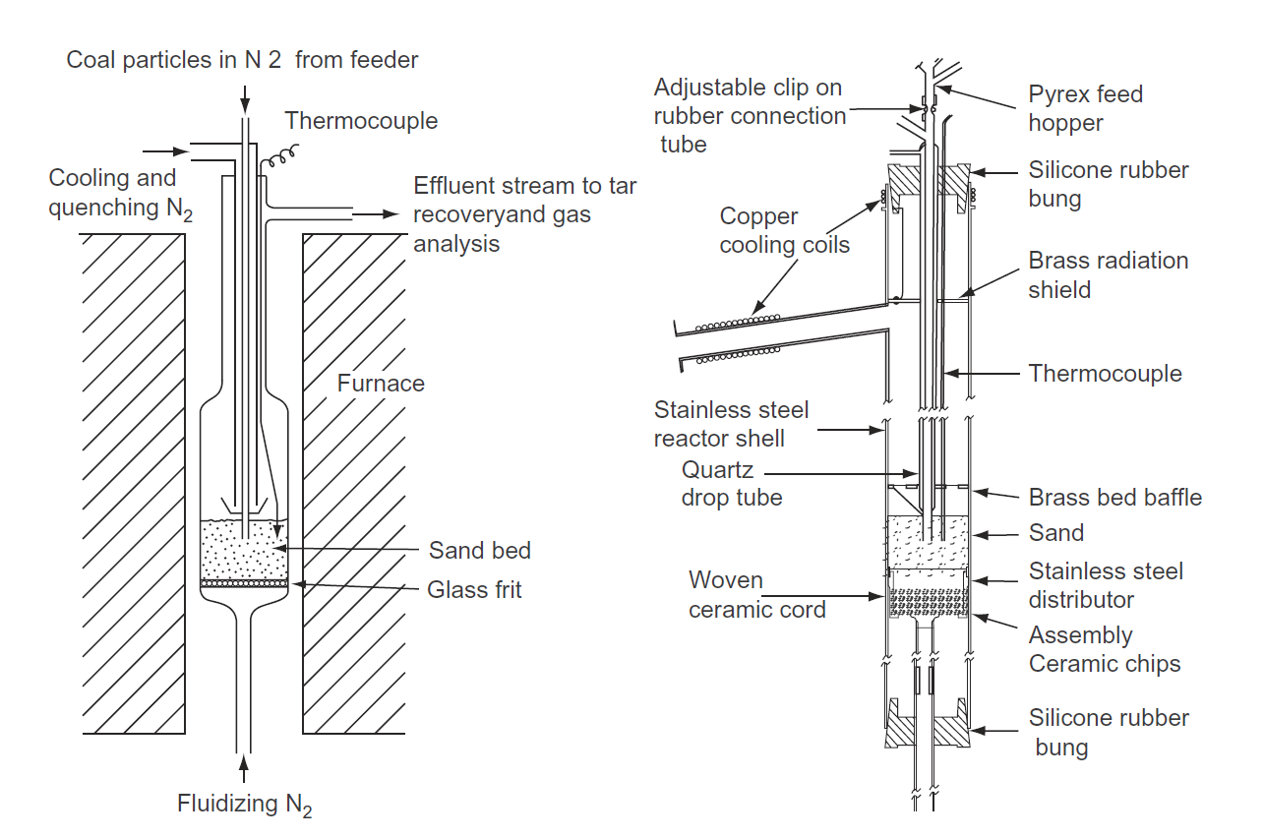
- (b)
Figure 2. (a) Fluidized-bed pyrolysis reactor made of silica [21,22]. (b) Fluidized-bed pyrolysis reactor equipped with movable support plate, where volatile residence times in the freeboard may be varied without altering fluidising conditions [23]. Source: Adapted from: (a) [21,22], with permission from Elsevier; (b) [23], with permission from Elsevier.
Figure 2b presents the schematic diagram of a larger (76 mm i.d.; 1000 mm high) reactor constructed of stainless steel [23]. Several novel features were added to Tyler’s original design. The fluidized-bed itself was mounted on a vertically movable support plate, which allowed changing the freeboard height between experiments. This made it possible to alter freeboard residence times of pyrolysis volatiles, without altering fluidizing conditions. This allowed comparing the cracking reactivities of tars/oils from different substrates, as well as providing data for calculating “in-flight” thermal cracking kinetics. In this reactor, freeboard residence times could be altered between 0.8 and 4 seconds, when using 3 – 3.7 times minimum fluidizing velocity. Initially, sample particles were observed to escape from the bed, which adversely affected the quality of the data. A wire-mesh barrier (shown as “brass bed baffle” in the diagram) was installed in the space between the fluidized-bed and the volatiles exit, to block the elutriation of smaller and/or lower density particles, the latter more common in the case of biomass pyrolysis. Recently, Morgan and co-workers used improved instrumentation to develop a reactor of similar conception, which they used for studying the pyrolytic behaviour of the sub-tropical plant biomass of Hawaii [24,25]
One often neglected characteristic of these useful devices is the “long” residence time of the residual sample particles at or near the peak temperature. As explained above, this is a consequence of the “long” time it takes for power to be turned off and for cool-down to take place. The latter is inevitably a slow process given the thermal mass of the fluidized-bed compared to the sample mass. Tyler was the first researcher to compare his results with those from a wire-mesh (“heated-grid”) reactor, constructed and operated by Howard and co-workers [26] at the Massachusetts Institute of Technology (MIT). Comparing his data with those of Anthony at al., Tyler observed that “The higher volatile-matter yields in the fluidized-bed at lower temperatures may be due to longer particle residence time” [21].
We will see below that fairly low conversions have been reported in wire-mesh reactors and thermogravimetric balances operated in the 300-550°C range, where observing the onset of pyrolysis reactions has also proved problematic.
2.3 Wire-mesh pyrolysis reactors
Figure 3 presents a schematic diagram of the atmospheric pressure wire-mesh reactor constructed at Imperial College London. For all the several milligrams of sample that it enables experimenting on, the development of the wire-mesh reactor configuration can boast a rich history, several wrong turnings, much debate and contributions to its basic design by many distinguished scientists. The original design by Loison and Chauvin [27] of CERCHAR in France published in 1964 was adopted and developed by Jüntgen and van Heek (1967) [28], followed by seminal work at MIT, summarized by Howard [29]. A detailed account of the development stages of wire-mesh reactors, and diverse types of experiments done using these instruments may be found in Ref [8] (cf. Section 3.3; also cf. Ref. [7]).
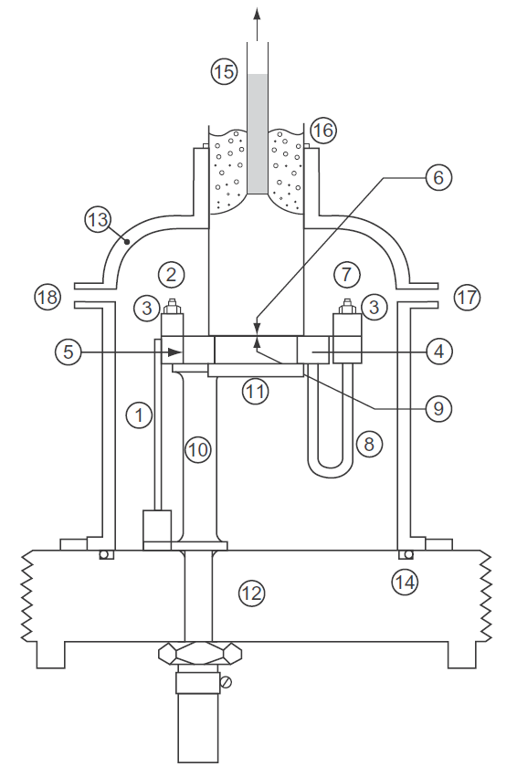

Figure 3. The atmospheric pressure wire-mesh reactor. (1) Copper current carrier; (2) Live electrode; (3) Brass clamping bar; (4) Sample holder support plate; (5) Mica strip; (6) Wire-mesh sample holder; (7) Electrode; (8) Stainless steel tubes; (9) Mica layer; (10) Brass pillars; (11) Sintered pyrex Glass disk; (12) Base plate; (13) Pyrex bell; (14) O-ring seal; (15) Off-take column; (16) O-ring; (17) Carrier gas entry port; (18) Connection for vacuum pump. Source: Reprinted from [30], with permission from Elsevier.
Hoekstra et al. [31] have given what appears to be a fairly complete list of biomass pyrolysis experiments carried out in wire-mesh reactors up the year 2012. We will describe several more recent experiments further on in the text.
The basic wire-mesh reactor experiment consists of placing sample particles on a piece of wire-mesh, which is folded, weighed and stretched between two electrodes. The mesh serves as the sample holder as well as the resistance heater. Its temperature is monitored by means of (preferably two) pairs of thermocouples. This configuration allows work to be carried out with “less than a monolayer” of particle dispersion on the mesh, in order to minimize contact between evolving volatiles and pyrolyzing solids. The reactor constructed at Imperial College London was configured to pass a stream of gas through the mesh for sweeping volatiles away from the reaction zone.
The basic wire-mesh reactor design shown in Figure 3 has proved versatile, allowing the performance of experiments under fairly extreme conditions. Among others, experiments have been carried out under vacuum [32] and at temperatures up to 2000 °C and pressures up to 40 bars [33]. Research has been carried out for developing the “zero emission carbon concept” (ZECA), with hydropyrolysis experiments at up to 900 °C and 90 bars H₂-pressure [34]. The wire-mesh reactor has also been configured to simulate blast furnace tuyere and raceway conditions, by injecting air, oxygen and CO₂, during successive millisecond intervals, at temperatures up to 2000 °C and pressures up to 6 bars [35].
Several atmospheric pressure wire-mesh reactors of similar conception have been reported in the literature. Zamansky and co-workers [36] constructed a “…WMR similar to that described by Gibbins et al. and Li et al…. for pyrolysis…” (Refs. [37] and [38] cited) at GE laboratories in Beijing. The instrument was used for determining gas evolution kinetics. Another reactor has been constructed at Huazhong University of Science and Technology in Wuhan, to recover and analyse products from the pyrolysis of polystyrene [39] and PVC [40]. Researchers at Xi’an Jiaotong University have also constructed a wire-mesh reactor using the same design [41].
Within this framework, Hoekstra et al. [31] described a “novel” wire-mesh reactor, where the sample holding mesh was placed vertically downward inside a silica container. An optical pyrometer was used in lieu of thermocouples, which the authors claimed as a marked improvement on the use of thermocouples. No on-line temperature control facility appears to have been developed. The reactor was operated under vacuum and the walls were cooled with liquid nitrogen, “…with samples typically heated to the set temperature of 500 °C…” It was also reported that “…the yields and oil composition were changing with [sample] loading from 0.05 g to 0.1 g, despite the small sample amounts.” Most experiments appear to have been carried out using 0.05 g (50 mg) samples in sample holders, which apparently had surface areas not much larger than those in the instrument shown in Figure 3 (~25 mm x 90 mm). “The sample was carefully spread on one of the meshes to form a (visually) uniform layer.” It seems possible to infer that sample particles were stacked. Nevertheless, under rapid heating conditions, the cellulose char yield was reported to be below 1%. Moreover, very high “oil” yields were reported. The authors have explained this by the combination of operation under vacuum and the wall cooling facility using liquid-N₂. Meanwhile, they quoted “confidence intervals” of ±4% for the “oil” data, which may point to experimental difficulties. No further work appears to have been reported after the two initial publications.
Despite their useful design features, wire-mesh reactors [37,42] should not be viewed as providing definitive solutions to all the intricate challenges of studying pyrolysis phenomena. In Section 7 below, we will discuss some of the problems encountered when wire-mesh reactors were used at temperatures below 500-550 °C.
2.4 Thermogravimetric balances
Thermogravimetric (TG) balances offer a tempting combination of characteristics for performing pyrolysis experiments on a turn-key basis. They can be easily programmed to heat samples to pre-set temperatures, over a limited but adjustable range of heating rates and they usually provide reasonably good repeatabilities. The basic design of ordinary TG-balances is relatively simple. The sample holder is a small pan, suspended within a cylindrical ceramic furnace, blocked off at one end. The thermocouple may be mounted inside the ceramic tube holding-up the furnace or may be suspended from above the sample pan. Usual sample loading on TG-pans is within the milligram range.
TG-balances present several problems during pyrolysis experiments. Sample particle stacking in the pans is inevitable. It has been previously explained that “…when coal particles are stacked together (as in a fixed-bed), volatile release is affected by reactions between evolving tars and the coal particles they come in contact with … Tars re-condense on heated solid surfaces, re-polymerise to a char or partially crack to release lighter volatiles…” [26]. These effects are amplified when the sample being pyrolyzed is a lignocellulosic biomass material, rather than coal. This is because both biomass materials and their evolving pyrolysis volatiles are significantly more reactive than coals and their corresponding volatiles.
Figure 4 shows that in the case of pure cellulose, the change in weight loss as a function of sample loading, presents a clear trend for experiments with peak temperatures between 300 and 450 °C.
Figure 4 presents results from the pyrolysis of pure cellulose in a TG-balance, with experiments carried out to peak temperatures between 300 and 450 °C. The data shows that mass loss at temperatures within this interval turns out to be a smooth function of sample loading. It is clearly observed, therefore, that sample loading directly affects the extent of char formation during pyrolysis experiments in TG-balances, as has been previously highlighted by Suuberg and co-workers [43]. Extracting kinetic data by differentiating already flawed weight loss data would tend to amplify the level of error in the calculations. In fact, it has been shown that kinetic parameters drawn from this data-set result in rate constants for 2 mg and 20 mg sample loading which differ by up to two orders of magnitude

Figure 4. Change in weight loss as a function of sample loading in a thermogravimetric balance. Sample: 50µm microcrystalline cellulose (Sigma-Aldrich, CAS No. 9004-34-6). Heating rate 2°C min⁻¹; 30 minutes holding at the final experimental temperature. Final temperature: (×) 300°C; (ο) 325°C; (Δ) 450°C. daf: dry ash-free basis.
Another complication arises from the fact that, in most TG-balances, it is not possible to force volatiles evolving from the sample out of the reaction zone in an orderly manner. The carrier gas stream flows in a manner dependent on the particular balance design: e.g. the flow may be up through the cylindrical furnace and around the sample pan, or across the furnace, passing over top of the sample pan. This implies that pyrolysis volatiles may linger in the vicinity of the pyrolyzing matrix for an undefined period of time, before either repolymerizing or being moved out of the furnace. Contact with the furnace and other containment surfaces will normally lead to partial loss of volatiles, which makes it impossible either to know the proportion of tars released, or to recover these condensables, as the majority are thermally degraded in the process of exiting the furnace. These considerations raise inevitable questions regarding the significance of weight loss determinations carried out in TG-balances. In the case of weight loss determinations in related gasification experiments using high-pressure TG-balances, furthermore, Jess and Andresen [44] have shown that the reaction process is mass transfer limited.
TG-balances may be used for any number of valid and useful experiments. As discussed in [8] (cf. Section 3.1), these applications include comparing the combustion and gasification reactivities of chars and the simulated distillation of heavy hydrocarbon mixtures. However, it seems difficult to justify carrying out pyrolysis weight loss determinations in TG-balances, particularly when the detailed fundamental behaviour of particular samples during thermal breakdown is being investigated.
3. Sensitivity of cellulose pyrolysis processes to experimental design
The relatively high reactivity of cellulose and its pyrolysis products is helpful for investigating the influence of experimental design on product distributions. The findings outlined below attempt to map out the upper limits of changes in yields that can be brought about by modifying experimental design. Several distinct sets of equipment have been used to generate the data presented below.
The Gray-King reactor: As described in British Standard BS 1016 [45], a Gray-King retort is a 200 mm long, 30 mm diameter silica tube, which is heated by insertion into a cylindrical oven. In the present application, an additional 3 mm o.d. glass tube (labelled as “Gas Inlet” in Figure 5) is inserted into the retort through the plug covering the open end of the reactor tube. The tip of the gas inlet tube is positioned near the blocked end of the retort. Sample is placed in the retort, between two wire mesh plugs. The gas introduced into the retort through the gas inlet tube has the effect of sweeping volatiles out of the retort, once the furnace is heated and pyrolytic reactions are initiated.

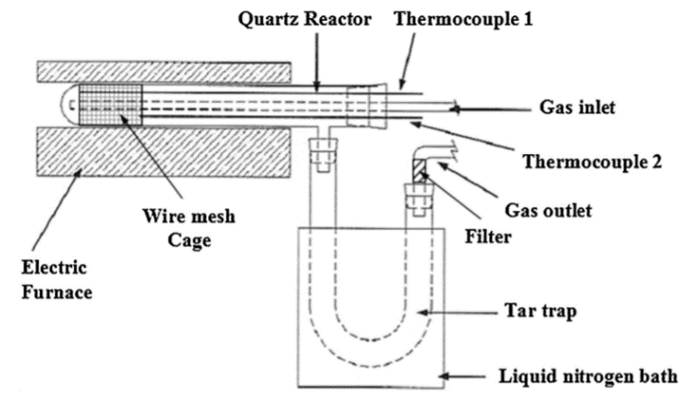
Figure 5. The modified Gray-King apparatus used by Cordella et al. [46]. Source: Reproduced from [46], with permission from Elsevier.
Figure 5 presents the schematic diagram of a similar system used by Cordella et al. [46] (also cf. [6] & [47]). Nitrogen was passed through the “gas inlet” tube, to generate an outward carrier gas flow. More recent experiments using a similar reactor configuration have been described by Volpe et.al. [4,6,48].
The McBain thermogravimetric balance: This consists of a silica tube placed in a vertical cylindrical oven. A silica spring hangs inside the vertical tube and the sample is attached to the spring. The length of the silica spring is calibrated for a fixed downward flow of carrier gas, against the mass of sample hanging from the spring. The measurement consists of monitoring the length of the spring as the sample loses weight during pyrolysis.
Fluidized-bed and wire mesh reactors: These reactors have been described above and in Refs. [23] and [37,42,49,50] respectively.
Table 1. Cellulose char yields determined in four reactors with different designs.ª
Reactor configuration | char yield  (% w/w) | temperature program
Gray-King retort (without carrier gas) [47] | 26.0 | 5°C min⁻¹ to 480 °C
Gray-King retort (with carrier gas) [47] | 12.5 | 5°C min⁻¹ to 480 °C
McBain thermogravimetric balance [47] | 12.0 | 14°C min⁻¹ to 480 °C
Fluidized-bed reactor [23] | < 3%^{b} | fast (estim. > 1000 °C s⁻¹) to 400°C
Wire-mesh reactor [49] | < 1.5%^{b} | 1000 °C s⁻¹ to 600 °C
ª 100 μm thick strips of cellulose filter paper used as sample in the McBain balance and Gray-King retort. 106-152 μm particles used in the fluidized-bed and wire mesh reactors.
^{b} Below limit of determination.
Source: Adapted with permission from [8].
Table 1 presents char yields from four experiments where pure cellulose was pyrolyzed using distinct experimental configurations. When samples of cellulose (Whatman No. 1 filter paper) were heated to 480 °C, using a stream of nitrogen to sweep the volatiles away, about 12% char residue was recovered in both the McBain balance and the modified Gray-King retort. The similarity of the results for these two “slow” heating rate experiments, 5 and 14 °C min⁻¹, would have been expected. However, with all other parameters kept constant, when the nitrogen flow to (and through) the Gray-King retort was interrupted, the char yield from cellulose pyrolyzed in the stagnant environment was found to increase to 26%. It appears that tar vapours (aerosols), which ordinarily would have been removed from the vicinity of the pyrolyzing solid matrix (when using the stream of sweep gas), instead remained near the pyrolyzing solids and partly reverted to char.
Meanwhile, near extinction of char residue could be observed when cellulose was pyrolyzed in the wire-mesh and fluidized-bed reactors, where high heating rates were used and volatiles were rapidly removed from the reaction zone. It may be noted that the “<1.5%” char yield observed in the wire-mesh reactor was from experiments at the higher temperature of 600 °C. For pure cellulose at 400 °C, Fraga [49] reported a char yield of 9.6% in the wire-mesh reactor, which seems high compared to the result in the fluidized-bed reactor. We will return to this point in Section 7.
Clearly experiments using samples of filter paper and the wire mesh reactor experiments using cellulose powder are not directly comparable. The latter results are presented to show the limiting yields, where high heating rates were used and volatiles were rapidly removed from the reaction zone. Taken together, this set of experiments confirms that the results of cellulose pyrolysis experiments are extremely sensitive (in addition to the effect of the temperature) to the sample and reactor configuration, the heating regime and the flow conditions within the reactor.
4. Tar capture in a fixed-bed vs. the wire-mesh reactor - experimenting with Linby coal
Figure 6 compares total volatile and tar yields from the pyrolysis of Linby (U.K.) coal in a fixed-bed and a wire-mesh reactor, at temperatures up to 800 °C. In the fixed-bed reactor, 300 mg samples were heated at 5 °C s⁻¹. Samples were held at the peak experimental temperature for 200 seconds. In the wire-mesh reactor, samples were heated at 1 or 1000 °C s⁻¹, with 30 seconds holding at the peak experimental temperature. In both reactors, helium or hydrogen was used to sweep volatiles out of the reaction zone, at a superficial velocity of 0.1 m s⁻¹. In Figure 6, wire-mesh reactor data are shown as solid lines.

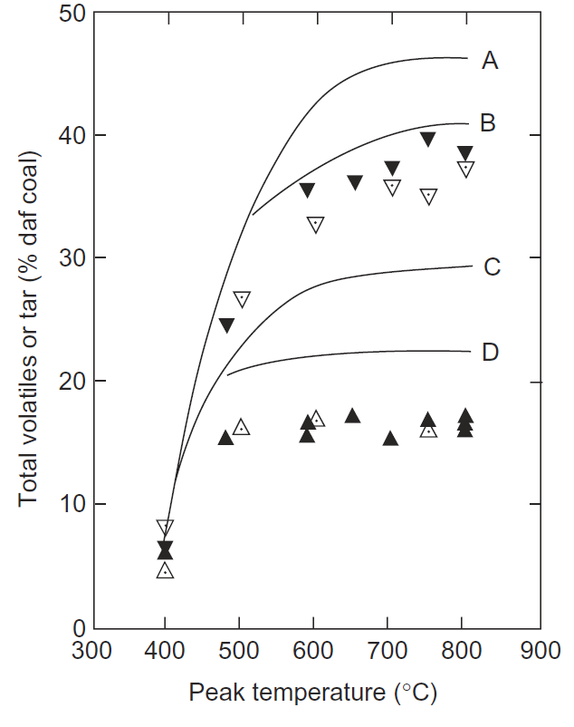
Figure 6 Comparison of results from the wire-mesh (solid lines) and ‘hot-rod’ reactors (Linby Coal UK). (∇,▼): Total volatile yield from the ‘hot-rod’ reactor with helium (∇) and H₂ (▼) as carrier gas, respectively. (Δ,▲): Tar yields from the ‘hot-rod’ reactor with helium (Δ) and H₂ (▲) as carrier gas, respectively. Solid lines show data from the wire-mesh reactor. (A) Total volatiles; 1000°C s⁻¹. (B) Total volatiles; 1°C s⁻¹. (C) Tar yield; 1000°C s⁻¹. (D) Tar yield: 1°C s⁻¹. Source: Reprinted from [51], with permission from Elsevier.
These data clearly show that tar yields and weight loss in the hot-rod reactor were significantly lower than those observed in the wire-mesh reactor, operated under broadly similar conditions (Lines B and D). As already indicated, product loss in the fixed bed is likely to be due to contact between evolving volatiles and the heated bed of solids. Small pressure drop increases in the fixed-bed reactor, around 500-550 °C, also suggested the partial constriction of volatile flow through the bed, probably due to sample softening. Replacing helium with hydrogen was used in an attempt to enhance volatiles mobility. The result is shown as the dark triangles in Figure 6, indicating that tar yields remained largely unchanged, while a little more gas appears to have formed at the higher temperatures. Apart from the higher temperatures, hydrogen reactivity appears to be near-negligible at atmospheric pressure.
Tar loss through a fixed bed: Tar loss as a function of sample bed depth and gas sweep velocity was investigated in the same fixed-bed (“hot-rod”) reactor using samples of Linby (U.K.) coal drawn from the same batch as the work outlined above [51]. As before, hydrogen was used as sweep gas to enhance mobility through the bed. Experiments reported in Table 2 were carried out by heating at 5 °C s⁻¹ to 590 °C. The data showed measurable tar loss (to solid product) with increasing bed height and decreasing gas flow rates. When using the higher flow rate with the shortest bed height, tar yields approached 22%, relatively close to the 24% tar yield recorded in the wire-mesh reactor with heating at 5 °C s⁻¹.
Table 2. Comparison of the effects of bed height and sweep gas flow rate on tar yields from the ‘hot-rod’ reactor
Sample size (mg) | 300 | 300 | 50 | 50
Approximate bed depth (mm) | 20 | 20 | 4 | 4
Superficial velocity (m s -1) | 0.1 | 9.5 | 0.1 | 9.5
Approximate gas residence time in coal bed (s) | 0.2 | 0.002 | 0.03 | 0.0003
Tar yields (% w/w daf^{c}) | 16.0a | 18.0 | 18.6a | 21.9b
Percent change in tar yield over the ‘Base Case’ (% w/w daf^{c}) | - | +2.0 | +2.6 | +5.5
ªAverage of two runs.
^{b}Average of three runs.
^{c}daf: dry ash-free coal.
Source: Reprinted from [51], with permission from Elsevier.
Comparing data between Column 1 and Columns 2 and 3 in Table 2, shows that a hundred-fold increase in the superficial gas velocity gave rise to an increase in tar recovery comparable to reducing the bed depth by a factor of five. Indications are that pyrolysis volatiles are not swept out at the same velocity as the stream of sweep gas. This observation is consistent with the “chromatographic” mode of motion of tar molecules (or aerosols) through the heated bed of solids by means of the chemically active “sticky” collisions postulated by Griffiths and Mainhood [12]. The effect has been discussed in greater detail in Ref. [8] (Section 3.6.2).
5. The coal volatile matter test compared to pyrolysis in a wire-mesh reactor [52]
The “volatile matter” (“VM”) determination is one of the elements of conventional “proximate analysis” tests. The experimental conditions specified in British (BS ISO 562:2010), United States (ASTM D3175) and other national standards are fairly similar. It consists of placing about 7-8 grams of dried, powdered coal in a ceramic (usually vitreous silica) crucible, about 34 mm high (~22 mm dia.) and equipped with a lid. The charged crucible is introduced into an oven preheated to 900 °C and withdrawn after 7 minutes. Sample weight loss during this procedure is recorded as the “VM” of the sample. The calculated average heating rate for this test is about 16 °C s⁻¹.
It is clear that this test conforms to none of the niceties we have enumerated above regarding proper pyrolysis reactor design. The configuration of the crucible assembly is not designed to suppress secondary reactions or differentiate between equipment related effects and sample behaviour. The role of the lid in impeding volatiles release is an added complication. However, the procedure is simple and repeatabilities are usually within 1-2%. It may be done without the need for complicated equipment or lengthy operator training and is widely used at power stations and under possibly challenging field conditions. Furthermore, this is a widely known and accepted procedure, considered particularly useful when comparing different batches of feedstock, usually within the framework of data accumulated over periods of time. We may expect therefore that the “VM” crucible test will continue to be used in power plants and other traditional industrial applications.
When the crucible test results were compared with corresponding total volatile yields from the wire-mesh reactor, the results were much as expected [52] . The carbon contents of the coal samples selected from the Argonne Premium Sample set [53], ranged from 73 to 90%. The crucible test gave between 6 and 15% lower volatiles values than those recorded in the wire-mesh reactor operated at 5000 °C s⁻¹ to 950 °C with 5 second holding at the peak temperature.
When the heating rate of the wire-mesh reactor was reduced to match the estimated average heating rate in the crucible test (about 16 °C s⁻¹), volatile matter determinations with the crucible test were still found to be lower than those from the wire-mesh reactor by between 7 and 10%.
At this stage, it seems useful to recall the commonly agreed finding that volatile matter determinations in thermogravimetric balances and volatile matter determinations by the crucible test are in agreement, usually within 1%. Indeed, commercial manufacturers of thermogravimetric balances have used such agreement between the two measurements in their sales promotion literature. Comparing wire-mesh and crucible-test data thus appears to help gauge the level of error inherent in the volatile matter determinations performed in thermogravimetric balances.
6. Not all flash heating is the same: wire-mesh & fluidized-bed reactors
Tables 3 and 4 present data from pyrolysis experiments in a wire-mesh reactor, using samples of silver birch wood [50] and sugar cane bagasse [49], respectively. In both cases, the particle size distribution was 106−152 μm. During relatively slow heating at 1 °C s⁻¹ to 500 °C in the wire mesh reactor, the weight loss observed for silver birch wood particles was just short of 90% (i.e. just above 10% char yield). During heating at 1000 °C s⁻¹ to the higher temperature of 700 °C, the silver birch char residue was found to be below the limit of detection, ~0.2%. The fast heating (1000 °C s⁻¹) experiments to 500 °C and above gave tar/oil yields of about 57-58%.
Table 3. Tar and Total Volatile Yields from Atmospheric-Pressure Pyrolysis of Silver Birch Wood Determined Using the Wire-Mesh Reactorª
 | Heating rate
 | Total volatiles |  | Tar/oil yield |  | Char residue
 | (% w/w daf^{b}) |  | (% w/w daf^{b}) |  | (% w/w daf^{b})
Temp (°C) | 1 °C s⁻¹ | 1000 °C s⁻¹ | 1 °C s⁻¹ | 1000 °C s⁻¹ | 1 °C s⁻¹ | 1000 °C s⁻¹
400 | 77 | 89 | 43 | 56 | 23 | 11
500 | 89 | 96 | 49 | 58 | 11 | 4
700 | 93 | 99 | 54 | 57 | 7 | 1^{c}
900 | 93 | 99 | 52 | 57 | 7 | 1^{c}
ªHelium was used as ambient gas in all experiments; 30 sec holding at the peak temperature.
^{b}daf: dry ash-free basis.
^{c}Below limit of determination.
Source: Reproduced from [50], with permission from Elsevier.
Table 4 shows analogous experiments on samples of sugar cane bagasse, which has a somewhat higher lignin content than silver birch. The results were qualitatively similar, but sugar cane bagasse gave slightly lower tar/oil and total volatile yields. As in the case of coal samples (see Figure 6), these data show that conversion to tars/oils and other volatiles increased with increasing heating rate. Unlike coal samples, however, the data indicate that biomass char residues may be reduced to near extinction by the appropriate choice of experimental conditions: high heating rates to temperatures above 700 °C, with active volatiles removal.
The “near extinction of char residue” cannot be achieved, where sample particle diameters are much larger than the 100-150 μm range [54]. As explained in detail elsewhere [cf. Ref. 8; pp. 46-47], high heating rates imposed on the boundaries of larger particles do not propagate through the mass of the particle as rapidly as the rate imposed at the surface. This is because the temperature front advances inwards, into the particle, at rates modulated by the thermal conductivity of the sample mass itself. Moreover, the outward path of evolving volatiles is restricted by the pyrolyzing mass of the particle; the higher temperatures of the outer regions would tend to degrade tar/oil vapours through cracking and re-polymerization reactions. In the case of larger diameter particles, these effects would contribute to the consolidation of the char residue.

Table 4. Tar and Total Volatile Yields from Atmospheric-Pressure Pyrolysis of Sugar Cane Bagasse Determined Using the Wire-Mesh Reactorª
 | Heating rate
 | Total volatiles |  | Tar/oil yield |  | Char residue
 | (% w/w daf^{b}) |  | (% w/w daf^{b}) |  | (% w/w daf^{b})
Temp (°C) | 1 °C s⁻¹ | 1000 °C s⁻¹ | 1 °C s⁻¹ | 1000 °C s⁻¹ | 1 °C s⁻¹ | 1000 °C s⁻¹
400 | 74.3 | 88.3 | 37.0 | 49.2 | 25.7 | 11.7
500 | 86.1 | 93.7 | 42.4 | 56.4 | 13.9 | 6.3
600 | 89.1 | 96.1 | 45.4 | 54.4 | 11.1 | 3.9
700 | 87.5 | 96.9 | 45.6 | 53.7 | 12.5 | 3.1
900 | 88.8 | 96.9 | 45.4 | 53.7 | 11.2 | 3.4
ªHelium was used as ambient gas in all experiments. 30 sec holding at the peak temperature.
^{b}daf: dry ash-free basis.
Source: Reproduced with permission from [49].
Tar cracking at the higher temperatures: The data in Tables 3 and 4 show that tar/oil yields from the wire-mesh reactor tend to increase with temperature to the peak tar yield and, as the experimental temperature is raised further, to stabilize around this value, within experimental error. This is because, in wire-mesh reactors, all tar/oil product released by the sample is rapidly removed from the reaction zone by the stream of sweep gas, before the mesh temperature reaches much higher values. By contrast, the design of a fluidized-bed requires evolving volatiles to pass through the fluidized-bed itself and the reactor freeboard (normally at reactor temperature), before reaching the quench zone.

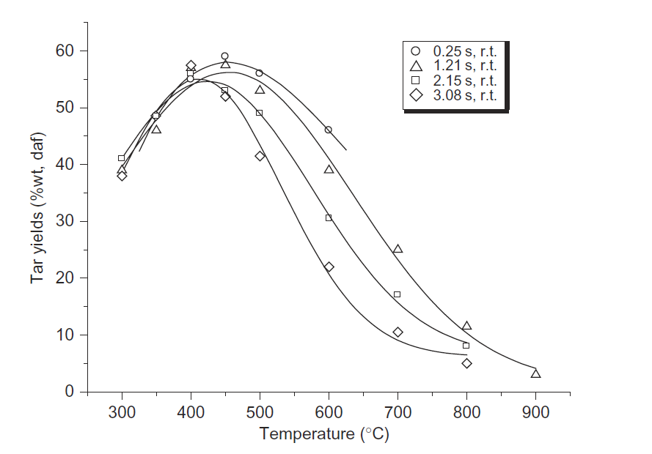

Figure 7. Silver Birch pyrolysis tar yields as a function of temperature and freeboard residence times in a fluidized-bed reactor. The silver birch wood sample used in these experiments was drawn from the same batch as that of the sample in Table 2. Source: Reprinted from [23], with permission from Elsevier.
The design of the fluidized-bed reactor thus forces the extended exposure of evolved volatiles to the temperature of the freeboard, resulting in secondary (“in-flight”) cracking. That is the reason why tar yields in Figure 7 are observed to go through a maximum and to diminish as the reactor is heated to higher temperatures. The extent of gas phase cracking depends on the reactor temperature, the residence time in the free board and indeed the reactivity of the evolving tars/oils.
The data in Figure 7 was obtained in a fluidized-bed reactor equipped with a support plate that could be moved up or down between experiments. This facility enabled altering the volatile residence time in the freeboard, without altering fluidizing conditions. Figure 7 shows that as the freeboard residence time was increased from 0.25 to 3.08 s, the extents of tar cracking in the freeboard gradually increased. At the shortest freeboard residence time, the peak tar yield (~400-450 °C) appears to be within several percent of the value found in the wire-mesh reactor.
At first glance, it may be concluded that the wire-mesh reactor is able to produce data more representative of the fundamental behaviour of the sample. However, when the experimental objective requires the collection of more tar product than the several milligrams collected in the wire-mesh reactor, other solutions must be sought. In the next section, we will also discuss whether the wire-mesh reactor configuration is the most suitable design for use at lower temperatures (300‒550°C), the range that is more relevant for exploring the pyrolysis behaviour of most lignocellulosic biomass materials. The discussion will require entering into the minutiae of the experimental procedure.
7. Fluidized-bed vs. wire-mesh reactor data at low temperatures
The outcome of experiments in a wire-mesh reactor depends (among other factors) on the manner in which heat is transmitted from the mesh to the sample. The surface area of contact between solid-wire and solid-particle is limited. This limited area of contact raises questions regarding the adequacy of heat transmission, and whether sample particles are able to track the temperature of the mesh very closely. What may be observed with the naked eye is that, as temperatures rise above 500 °C, the stainless steel mesh begins to glow and radiative heat transfer begins to take place from the glowing mesh to sample particles. Moreover, many coal samples soften and/or melt at and above these temperatures, particularly when using high heating rates. The plastic behaviour of coal particles increases contact surface area between mesh and sample and tends to improve heat transmission to the sample (cf. photomicrographs in [42]). During experiments to 600 °C and above, conversions are observed to increase systematically as a function of temperature and heating rate. The results are by and large internally consistent and, where comparison is possible, comparable to data from other sources.
Instances of softening and melting have also been observed at very high heating rates and high temperatures in the case of lignin and wood derived samples ([7]; also see [8], Chapter 3). However, the duration of the plastic phase formed in these instances appears to be extremely short and how this phase affects heat transfer in wire-mesh reactors remains to be investigated.

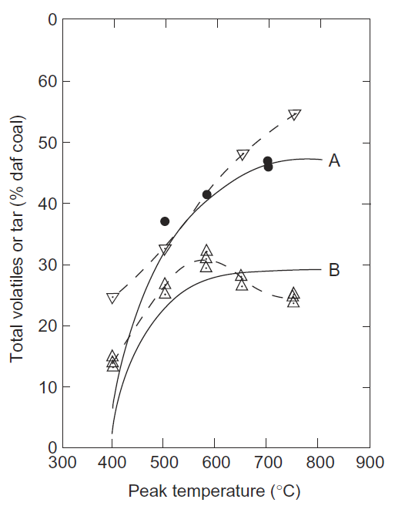
Figure 8. Comparison of results from the wire-mesh and fluidized-bed reactors (Linby Coal UK). (∇): Total volatile yield from the fluidized-bed reactor. (Δ): Tar yield from the fluidized-bed reactor. Solid lines show data from the wire-mesh reactor (heating at 1000 °C s−1 with 30 s holding). (A) Total volatiles. (B) Tar yield. (●): Total volatiles from wire-mesh reactor during heating at 1000 °C s⁻¹ with 1000 s holding at peak temperature. Source: Reprinted from [51], with permission from Elsevier.
Wire-mesh reactors operated at low temperatures: An early indication of “trouble at low temperatures” was encountered during pyrolysis work in the wire-mesh reactor shown in Figure 3, when comparing performances with the fluidized-bed reactor of Figure 2B (Ref. [23]). Figure 8 shows that at 400 °C, about 10% more volatiles were observed in fluidized-bed experiments, compared to the wire-mesh reactor. Furthermore, at 500 °C, the total volatile yield observed in the wire-mesh reactor increased by several percent, when the sample coal was “held” at the peak experimental temperature for 1000 seconds, rather than the usual 30 seconds. At 600 °C and above, extended residence times did not perceptibly alter the results. These findings indicated that at temperatures up to 500-550°C, the pyrolysis reactions of Linby coal required a considerably longer holding time to reach completion. Thus results from high heating rate and/or short hold time experiments in wire-mesh reactors, conducted to temperatures below about 550 °C need to be evaluated with some care.
Another indication that “all is not well” in wire-mesh reactors at temperatures much below 550 °C was observed during the comparison of cellulose and silver birch wood pyrolysis data from the two reactors. Data for cellulose pyrolysis char yields reported in the fluidized-bed reactor [23] may be summarized as follows: 300 °C: 20% (average of four determinations); 350 °C: 7% (average of three determinations); 400 °C: 3% (near the limit of detection). The conclusion seemed to be fairly clear: cellulose begins to pyrolyze at temperatures below 300 °C. Nearly thirty years later, working with cellulose pyrolysis in a fluidized-bed reactor of similar conception to that of [23], Morgan et.al [24] in Hawaii chose 400 °C as the starting point for their experiments. At that temperature, the average char yield from four determinations was 3.5%, consistent with the 400 °C result from the Stiles reactor described in [23]. Within this framework, the 96% char yield reported during the use of a wire-mesh reactor at 325 °C [55] appears to be somewhat of an outlier, underscoring the challenges of getting sensible results from wire-mesh reactors at these low temperatures. Table 2 of the same paper reported an approximately 15 % greater total volatile yield from slow heating to 325 °C (at 0.5 °C s⁻¹), compared to heating at 1000 °C s⁻¹. Once again, this result is consistent with poor heat transfer in the wire-mesh reactor at these low temperatures, the inherently slow reaction rates in this temperature range, or a combination of the two factors. Fraga [49], using a wire-mesh reactor also worked at 400 °C and above. The char yield recorded at 400 °C was 9.6%, nearly 6% higher than char yields reported from the two fluidized-bed reactors.
As explained above, when operating fluidized-beds, it normally takes several minutes for the experimenter to initiate the cool-down sequence. Given the thermal mass of the fluidized-bed and its ancillaries, sample particles tend to remain in the heated zone for quite some time. As observed by Tyler in 1981, who also compared data from different laboratories, “…the higher volatiles yields in the fluidized-bed at lower temperatures, compared to the wire-mesh reactor, appears to be due to the longer residence times at or near the peak temperature…” [26].
Clearly, available data sets for the low temperature operation of both wire-mesh and fluidized-bed reactors are sparse. This may need to be remedied. What seems clear, however, is that the agreement noted between wire-mesh and fluidized-bed reactor results at higher temperatures, is not apparent in the temperature range below 550 °C. The evidence suggests that the discrepancy arises from the poor heat transfer characteristics of wire-mesh reactors, when operating at temperatures below 500-550 °C. At these low temperatures, the difference between the two reactors does seem to narrow, however, when fairly long (e.g. 1000 seconds) holding-times are used in the wire-mesh reactor (cf. Figure 8).
8. When does cellulose begin to breakdown? Fluidized-bed vs. TG-balance data at low temperatures
One clear advantage of using pure cellulose as a test sample in pyrolysis experiments is its uniform composition and general availability. It allows direct comparisons across different experimental systems as well as between laboratories.
Most TG-balance derived data encountered in the literature to date have given the onset temperature for cellulose weight loss upon heating, at or above 300 °C (e.g. cf. Yang et.al.[56]). In the present context, we define the “onset temperature” as the temperature interval where discernible and measurable sample weight loss attributable to thermal breakdown is first observed. Wang et al. [57] claimed to have observed the onset of cellulose pyrolysis at 260 °C, although an examination of the raw data (Figure 2 in the publication) suggests an onset temperature somewhat above that temperature. During heating at 20 °C min⁻¹, the cellulose weight loss observed at 300 °C did not exceed about 7%. In other work, Yu et al.[55], reported the cellulose pyrolysis “…onset temperature at around 315 °C, with the maximum decomposition rate observed near 370 °C…”. In their TG-balance, samples were heated at 30 °C min⁻¹ up to 900 °C. These reported “onset points” contrast sharply with findings from a fluidized-bed reactor [23], where, at 300 °C, a char yield of about 20% was reported, i.e. a total conversion (total weight loss) to gas and liquid products of about 80% (Figure 9 shows tar yields during those experiments).

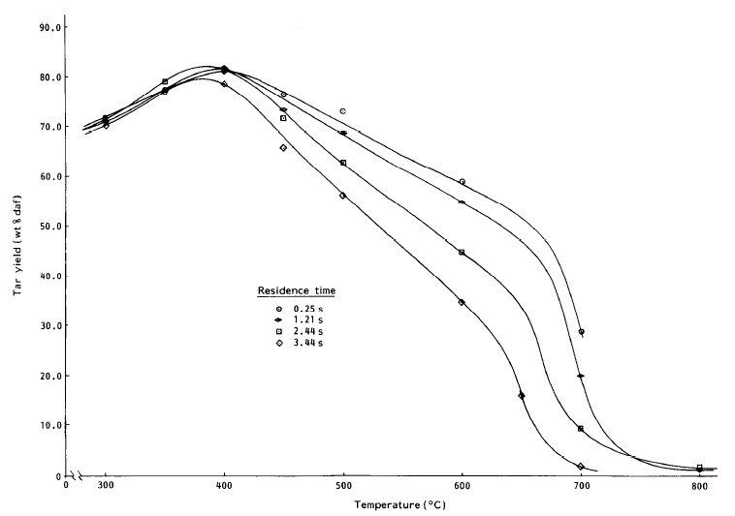
Figure 9. Cellulose tar yields versus reactor temperature as a function of residence time in the freeboard Source: Reprinted from [23],with permission from Elsevier
Taken at face value, the fluidized-bed data suggests that it is possible to achieve a large part of the conversion of pure cellulose at temperatures below 300 °C, so long as adequate heat transmission to the cellulose particles is ensured and so long as sufficient time is allowed for pyrolysis reactions to reach completion.
Returning to TG-balances, Figure 10 presents recent data on cellulose pyrolysis, where a relatively low heating rate (2 °C min⁻¹) was used with sample masses of approx. 2 mg, coupled with 30 minutes holding at peak experimental temperatures between 225 and 315 °C. The slow heating rates and long holding times led to closer agreement with fluidized-bed data [23] regarding the cellulose pyrolysis onset temperature, compared to the aforementioned TG-balance data [55–57].

Figure 10. Cellulose pyrolysis mass loss in a thermogravimetric balance; experiments were carried out by heating the sample at 2 °C min⁻¹, with a hold time of 30 minutes at peak temperature.
Figure 10 shows that, under these conditions, the first weight loss for cellulose pyrolysis takes place in the vicinity of 225 °C. At peak temperatures up to 300 °C, most of the conversion appears to take place during the “holding” period, which shows that pyrolysis reactions proceed relatively slowly in this temperature range. Greater mass loss might have been expected during the “ramp”, had the sample been heated at an even slower heating rate than 2 °C min⁻¹.
Figure 10 also shows that during experiments taken to peak temperatures of 300 °C and above, the proportion of the total conversion (to volatile products) during the temperature-ramp increased, compared to conversion during the holding period. As expected, these findings indicate that thermal breakdown proceeds at far faster rates when the temperature is raised. The nearly 90% total conversion at 300 °C under these experimental conditions was larger than the weight loss recorded in the fluidized-bed (~ 80% in [23]).
Taken together, these data indicate that rapidly ramping the temperature through the critical early stages of the pyrolytic process at relatively high heating rates, does not allow observing the conversion levels that would have been reached if sufficient time had been allowed at the lower temperatures. The broad distribution of onset temperatures reported in the literature for cellulose pyrolysis, appear to have resulted from the fairly high heating rates used (20-30 °C min⁻¹) to ramp to high (800-900 °C) temperatures. These temperature programs simply did not allow sufficient time for the slower pyrolysis reactions taking place at lower temperatures to reach completion.
In other work, Zhang et al. [58] used a wire-mesh reactor to compare data with results from a TG-balance. The latter was programmed to ramp samples up to 800 °C, with similar loss of detailed thermal breakdown information at lower temperatures. It was not possible to compare results with data from other sources, since no tests were carried out with cellulose, although the reported energies of activation (47 – 72 kJ mol⁻¹) derived from the TG-balance data appear more appropriate to diffusion related processes, rather than to pyrolytic bond scission.
The temperature range below 550 °C happens to be the range critical to the analysis of pyrolytic processes for most lignocellulosic biomass materials. From the foregoing (also cf. sections 2.4 and 7), it seems appropriate to conclude that mapping out the levels of pyrolytic conversion (char yield determinations) of lignocellulosic biomass in this temperature range by TG-balances or wire-mesh reactors presents a series of challenges. Nevertheless, the present study has made good use of a TG-balance to track the onset temperature for cellulose pyrolysis, through mindful programming of time-temperature profiles.
The foregoing suggests that the fluidized-bed reactor configuration is a more appropriate tool for studying conversions (char yield determinations) of biomass pyrolysis. Its advantages include rapid heat transmission to sample particles at low as well as high temperatures and provision to determine char yields reliably. At first glance, this may seem surprising, since fluidized-beds are not configured to minimize secondary reactions of primary volatiles. However, unlike TG-balances, fluidized-bed reactors allow the collection of tars/oils in a reproducible way and in a manner where secondary reactions may be controlled and quantified. Heating rates are presumed to be high but are unknown. Nonetheless, maximum tar yields in these reactors have been observed to closely match those observed during rapid heating experiments (e.g. 1000 °C s⁻¹) in wire-mesh reactors. The rate of tar cracking in the freeboard may then be used to gauge the reactivity of tars. Compared to TG-balances and wire-mesh reactors, furthermore, far larger amounts of char and tar/oil samples may be generated if needed for post-pyrolysis characterizations. Finally, it is possible to arrive at compact designs for small reactors, or indeed for operation at high-pressure [59], if and when the need arises. It should be noted that in designing and operating these small reactors, care should be taken to overcome any potential challenges such as wall effects and radial heat gradients or non-uniform heat transfer.

9. Summary and Conclusions
The relationships between experimental design and the outcomes of pyrolysis experiments have been examined. Data from reactors with contrasting designs have been compared; the samples used were cellulose, several lignocellulosic biomass materials and several coal samples. Salient points emerging from the study are as follows.
1. During pyrolysis experiments in thermogravimetric balances, secondary reactions of primary pyrolysis products were found to influence sample weight loss. Extracting kinetic constants by differentiating this data may amplify the level of error in the calculations.
2. The consistency noted between wire-mesh and fluidized-bed reactor data at higher temperatures was not apparent in the temperature range below 500-550 °C. The evidence suggests that the discrepancy arises from poor heat transfer in wire-mesh reactors at temperatures below 500‒550 °C.
3. Data from a fluidized-bed reactor showed that nearly 80% conversion of pure cellulose may be achieved at temperatures below 300 °C.
4. Nearly 90% cellulose conversion was observed below 300 °C in a TG-balance, consistent with high conversions of cellulose observed below 300 °C in the fluidized bed reactor. Samples were heated slowly (2 °C min⁻¹) to peak experimental temperatures between 225 and 315 °C, with long (30 minutes) holding at the end temperature.
5. The onset of cellulose pyrolysis at 2 °C min⁻¹ was observed near 225 °C.
6. In the low temperature range, pyrolytic reactions of cellulose are slow. Ramping through these critical early stages relatively rapidly and directly up to 800 or 900 °C tends to miss much critical information relevant to the early stages of pyrolysis.
7. The evidence suggests that fluidized-bed reactors are more reliable for carrying out total conversion (i.e. char yield) determinations at temperatures below 500-550 °C. Meanwhile, although heating rates are presumed to be high, they remain unknown and, clearly, may not be increased or decreased.
AUTHOR INFORMATION
Corresponding Author
Roberto Volpe
School of Engineering and Materials Science, Queen Mary University of London, Mile End Road, London E1 4NS, UK. email: r.volpe@qmul.ac.uk
Author Contributions
The manuscript was written through contributions of all authors. All authors have given approval to the final version of the manuscript.
Reference
[1] W.E. Ladner, The products of coal pyrolysis: properties, convertion and reactivity, Fuel Process. Technol. 20 (1988) 207–222. doi:10.1016/0378-3820(88)90021-5.
[2] M. Asmadi, H. Kawamoto, S. Saka, Thermal reactivities of catechols/pyrogallols and cresols/xylenols as lignin pyrolysis intermediates, J. Anal. Appl. Pyrolysis. 92 (2011) 76–87. doi:10.1016/j.jaap.2011.04.012.
[3] T. Kotake, H. Kawamoto, S. Saka, Pyrolytic formation of monomers from hardwood lignin as studied from the reactivities of the primary products, J. Anal. Appl. Pyrolysis. 113 (2015) 57–64. doi:10.1016/j.jaap.2014.09.029.
[4] R. Volpe, A. Messineo, M. Millan, Carbon reactivity in biomass thermal breakdown, Fuel. 183 (2016) 139–144. doi:10.1016/j.fuel.2016.06.044.
[5] G.D. Ripberger, J.R. Jones, A.H.J. (Tony. Paterson, C. Kirwan, Effect of autogenous pressure on volatile pyrolysis products, Fuel. 225 (2018) 80–88. doi:10.1016/j.fuel.2018.03.111.
[6] R. Volpe, J.M.B. Menendez, T.R. Reina, A. Messineo, M. Millan, Evolution of chars during slow pyrolysis of citrus waste, Fuel Process. Technol. 158 (2017) 255–263. doi:10.1016/j.fuproc.2017.01.015.
[7] T.J. Morgan, R. Kandiyoti, Pyrolysis of Coals and Biomass: Analysis of Thermal Breakdown and Its Products, Chem. Rev. 114 (2014) 1547–1607. doi:10.1021/cr400194p.
[8] Kandiyoti, R., Herod, A.A., Bartle, Keith D and Morgan, T.J., Solid Fuels and Heavy Hydrocarbon Liquids, Thermal Characterisation and Analysis”, in: 2nd ed., Elsevier Science Publishers, 2017. https://www.elsevier.com/books/solid-fuels-and-heavy-hydrocarbon-liquids/kandiyoti/978-0-08-100784-6.
[9] J.E. White, W.J. Catallo, B.L. Legendre, Biomass pyrolysis kinetics: A comparative critical review with relevant agricultural residue case studies, J. Anal. Appl. Pyrolysis. 91 (2011) 1–33. doi:10.1016/j.jaap.2011.01.004.
[10] T. Kan, V. Strezov, T.J. Evans, Lignocellulosic biomass pyrolysis: A review of product properties and effects of pyrolysis parameters, Renew. Sustain. Energy Rev. 57 (2016) 126–1140. doi:10.1016/j.rser.2015.12.185.
[11] P.R. Solomon, M.A. Serio, E.M. Suuberg, Coal pyrolysis: Experiments, kinetic rates and mechanisms, Prog. Energy Combust. Sci. 18 (1992) 133–220. doi:10.1016/0360-1285(92)90021-R.
[12] D.M.L. Griffiths, J.S.R. Mainhood, The tar cracking of tar vapor and aromatic compounds on activated carbon, Fuel. 46 (1967) 167-176.
[13] R.W. Hiteshue, R.B. Anderson, M.D. Schlesinger, No Title, Ind. Eng. Chem. Res. 49 (1957) 2008–2010.
[14] R.W. Hiteshue, S. Friedman, R. Madden, No Title, USBM Reports Investig. (1962) 6125.
[15] C. Bolton, C.E. Snape, R.J. O’Brien, R. Kandiyoti, Influence of carrier gas flow and heating rates in fixed bed hydropyrolysis of coal, Fuel. 66 (1987) 1413–1417. doi:https://doi.org/10.1016/0016-2361(87)90189-X.
[16] R. V. Pindoria, A. Megaritis, A.A. Herod, R. Kandiyoti, A two-stage fixed-bed reactor for direct hydrotreatment of volatiles from the hydropyrolysis of biomass: Effect of catalyst temperature, pressure and catalyst ageing time on product characteristics, Fuel. 77 (1998) 1715–1726. doi:10.1016/S0016-2361(98)00079-9.
[17] S. Monteiro Nunes, N. Paterson, D.R. Dugwell, R. Kandiyoti, Tar Formation and Destruction in a Simulated Downdraft, Fixed-Bed Gasifier: Reactor Design and Initial Results, Energy & Fuels. 21 (2007) 3028–3035. doi:10.1021/ef070137b.
[18] F. Dabai, N. Paterson, M. Millan, P. Fennell, R. Kandiyoti, Tar Formation and Destruction in a Fixed Bed Reactor Simulating Downdraft Gasification: Effect of Reaction Conditions on Tar Cracking Products, Energy & Fuels. 28 (2014) 1970–1982. doi:10.1021/ef402293m.
[19] R. Volpe, S. Messineo, M. Volpe, A. Messineo, Catalytic Effect of Char for Tar Cracking in Pyrolysis of Citrus Wastes , Design of a Novel Experimental Set Up and First Results, Chem. Eng. Trans. 50 (2016) 181–186. doi:10.3303/CET1650031.
[20] Y. Zhang, W. Wu, S. Zhao, Y. Long, Y. Luo, Experimental study on pyrolysis tar removal over rice straw char and inner pore structure evolution of char, Fuel Process. Technol. 134 (2015) 333–344. doi:https://doi.org/10.1016/j.fuproc.2015.01.047.
[21] R.J. Tyler, Flash pyrolysis of coals. 1. Devolatilization of a Victorian brown coal in a small fluidized-bed reactor, Fuel. 58 (1979) 680–686. doi:https://doi.org/10.1016/0016-2361(79)90223-0.
[22] R.J. Tyler, Flash pyrolysis of coals. Devolatilization of bituminous coals in a small fluidized-bed reactor, Fuel. 59 (1980) 218–226. doi:https://doi.org/10.1016/0016-2361(80)90138-6.
[23] H. Stiles, R. Kandiyoti, Secondary reactions of flash pyrolysis tars measured in a fluidized bed pyrolysis reactor with some novel design features, Fuel. 68 (1989) 275–282.
[24] T.J. Morgan, S.Q. Turn, A. George, Fast Pyrolysis Behavior of Banagrass as a Function of Temperature and Volatiles Residence Time in a Fluidized Bed Reactor, PLoS One. 10 (2015) 1–28. doi:10.1371/journal.pone.0136511.
[25] T.J. Morgan, S.Q. Turn, N. Sun, A. George, Fast Pyrolysis of Tropical Biomass Species and Influence of Water Pretreatment on Product Distributions, PLoS One. 11 (2016) 1–27. doi:10.1371/journal.pone.0151368.
[26] D.B. Anthony, J.B. Howard, H.C. Hottel, H.P. Meissner, Rapid devolatilization and hydrogasification of bituminous coal, Fuel. 55 (1976) 121–128. doi:https://doi.org/10.1016/0016-2361(76)90008-9.
[27] R. Loison, R. Chauvin, 1964. Chim. Ind. Paris 91, 269, Chim. Ind. Paris Transl. by Univ. Sheff. May 1964; Natl. Coal Board, Coal Res. Establ. Libr. (Sept. 1964). 91 (1964) 269.
[28] K.H. Van Heek, H. Jüntgen, W. Peters, 1967,48, 163, Brennsfoff-Chemie. 48 (1967) 163.
[29] J. Howard, Fundamentals of coal pyrolysis and hydropyrolysis, in: M. Elliot (Ed.), Chem. Coal Util., John Wiley and Sons, Inc., New York, 1981: pp. 665–784.
[30] J.R. Gibbins, R. Kandiyoti, The effect of variations in time-temperature history on product distribution from coal pyrolysis, Fuel. 68 (1989) 895–903. doi:https://doi.org/10.1016/0016-2361(89)90127-0.
[31] E. Hoekstra, W.P.M. Van Swaaij, S.R.A. Kersten, K.J.A. Hogendoorn, Fast pyrolysis in a novel wire-mesh reactor: Decomposition of pine wood and model compounds, Chem. Eng. J. 187 (2012) 172–184. doi:10.1016/j.cej.2012.01.118.
[32] C.-Z. Li, K.D. Bartle, R. Kandiyoti, Vacuum pyrolysis of maceral concentrates in a wire-mesh reactor, Fuel. 72 (1993) 1459–1468. doi:https://doi.org/10.1016/0016-2361(93)90001-I.
[33] D. Peralta, N. Paterson, D. Dugwell, R. Kandiyoti, Pyrolysis and CO2 Gasification of Chinese Coals in a High-Pressure Wire-Mesh Reactor under Conditions Relevant to Entrained-Flow Gasification, Energy & Fuels. 19 (2005) 532–537. doi:10.1021/ef049762w.
[34] L. Gao, N. Paterson, D. Dugwell, R. Kandiyoti, Zero-Emission Carbon Concept (ZECA): Equipment Commissioning and Extents of the Reaction with Hydrogen and Steam, Energy & Fuels. 22 (2008) 463–470. doi:10.1021/ef700534m.
[35] L. Wu, N. Paterson, D.R. Dugwell, R. Kandiyoti, Simulation of Blast-Furnace Raceway Conditions in a Wire-Mesh Reactor: Interference by the Reactions of Molybdenum Mesh and Initial Results, Energy & Fuels. 20 (2006) 2572–2579. doi:10.1021/ef060289r.
[36] L. Chen, C. Zeng, X. Guo, Y. Mao, Y. Zhang, X. Zhang, W. Li, Y. Long, H. Zhu, B. Eiteneer, V. Zamansky, Gas evolution kinetics of two coal samples during rapid pyrolysis, Fuel Process. Technol. 91 (2010) 848–852. doi:https://doi.org/10.1016/j.fuproc.2010.02.010.
[37] C.-Z. Li, K.D. Bartle, R. Kandiyoti, Characterization of tars from variable heating rate pyrolysis of maceral concentrates, Fuel. 72 (1993) 3–11. doi:https://doi.org/10.1016/0016-2361(93)90368-C.
[38] J.R. Gibbins, R.A. V King, R.J. Wood, R. Kandiyoti, Variable‐heating‐rate wire‐mesh pyrolysis apparatus, Rev. Sci. Instrum. 60 (1989) 1129–1139. doi:10.1063/1.1140327.
[39] J. Zhou, Y. Qiao, W. Wang, E. Leng, J. Huang, Y. Yu, M. Xu, Formation of styrene monomer, dimer and trimer in the primary volatiles produced from polystyrene pyrolysis in a wire-mesh reactor, Fuel. 182 (2016) 333–339. doi:https://doi.org/10.1016/j.fuel.2016.05.123.
[40] J. Zhou, B. Gui, Y. Qiao, J. Zhang, W. Wang, H. Yao, Y. Yu, M. Xu, Understanding the pyrolysis mechanism of polyvinylchloride (PVC) by characterizing the chars produced in a wire-mesh reactor, Fuel. 166 (2016) 526–532. doi:https://doi.org/10.1016/j.fuel.2015.11.034.
[41] S. Pan, S. Hui, L. Liang, C. Liu, C. Li, X. Zhang, Weight Loss and Tar Evolution during Coal Devolatilization at Various Heating Rates, Energy & Fuels. 29 (2015) 520–529. doi:10.1021/ef502031v.
[42] J. Gibbins-Matham, R. Kandiyoti, Coal pyrolysis yields from fast and slow heating in a wire-mesh apparatus with a gas sweep, Energy & Fuels. 2 (1988) 505–511. doi:10.1021/ef00010a017.
[43] I. Milosavljevic, V. Oja, E.M. Suuberg, Thermal effects in cellulose pyrolysis: Relationship to char formation processes, Ind. Eng. Chem. Res. 35 (1996) 653–662. doi:10.1021/ie950438l.
[44] A. Jess, A.K. Andresen, Influence of mass transfer on thermogravimetric analysis of combustion and gasification reactivity of coke, Fuel. 89 (2010) 1541–1548. doi:10.1016/j.fuel.2009.09.002.
[45] British Standard 1016-107.2, Methods for analysis and testing of coal and coke. Caking and swelling properties of coal. Assessment of caking power by Gray-King coke test., 1991.
[46] M. Cordella, C. Berrueco, F. Santarelli, N. Paterson, R. Kandiyoti, M. Millan, Yields and ageing of the liquids obtained by slow pyrolysis of sorghum, switchgrass and corn stalks, J. Anal. Appl. Pyrolysis. 104 (2013) 316–324. doi:10.1016/j.jaap.2013.07.001.
[47] C.A. Zaror, I.S. Hutchings, D.L. Pyle, H.N. Stiles, R. Kandiyoti, Secondary char formation in the catalytic pyrolysis of biomass, Fuel. 64 (1985) 990–994. doi:10.1016/0016-2361(85)90156-5.
[48] R. Volpe, A. Messineo, M. Millan, M. Volpe, R. Kandiyoti, Assessment of olive wastes as energy source : pyrolysis , torrefaction and the key role of H loss in thermal breakdown, Energy. 82 (2015) 119–127. doi:10.1016/j.energy.2015.01.011.
[49] A.R. Fraga-Araujo, Pyrolytic Decomposition of Lignocellulosic Materials. Ph.D. Thesis, University of London, 1990.
[50] A.-R. Fraga, A.F. Gaines, R. Kandiyoti, Characterization of biomass pyrolysis tars produced in the relative absence of extraparticle secondary reactions, Fuel. 70 (1991) 803–809.
[51] Z.S. Gonenc, J.R. Gibbins, I.E. Katheklakis, R. Kandiyoti, Comparison of coal pyrolysis product distributions from three captive sample techniques, Fuel. 69 (1990) 383–390.
[52] J.R. Gibbins, K. Khogali, R. Kandiyoti, Relationship between results from conventional proximate analyses and pyrolysis yields under rapid-heating conditions, Fuel Process. Technol. 24 (1990) 3–9. doi:https://doi.org/10.1016/0378-3820(90)90036-R.
[53] K.S. Vorres, The preparation and distribution of Argonne Premium Coal Samples, ACS DFC Prepr. 32 (1987) 221–226.
[54] H. Bennadji, K. Smith, M.J. Serapiglia, E.M. Fisher, Effect of Particle Size on Low-Temperature Pyrolysis of Woody Biomass, Energy & Fuels. 28 (2014) 7527–7537. doi:10.1021/ef501869e.
[55] J. Yu, N. Paterson, J. Blamey, M. Millan, Cellulose , xylan and lignin interactions during pyrolysis of lignocellulosic biomass, Fuel. 191 (2017) 140–149. doi:10.1016/j.fuel.2016.11.057.
[56] H. Yang, R. Yan, H. Chen, C. Zheng, D.H. Lee, D.T. Liang, In-Depth Investigation of Biomass Pyrolysis Based on Three Major Components: Hemicellulose, Cellulose and Lignin, Energy & Fuels . 20 (2006) 388–393. doi:10.1021/ef0580117.
[57] S. Wang, X. Guo, K. Wang, Z. Luo, Influence of the interaction of components on the pyrolysis behavior of biomass, J. Anal. Appl. Pyrolysis. 91 (2011) 183–189. doi:10.1016/j.jaap.2011.02.006.
[58] Y. Zhang, Y. Niu, H. Zou, Y. Lei, J. Zheng, H. Zhuang, S. Hui, Characteristics of biomass fast pyrolysis in a wire-mesh reactor, Fuel. 200 (2017) 225–235. doi:https://doi.org/10.1016/j.fuel.2017.03.070.
[59] A. Megaritis, Y. Zhuo, R. Messenböck, D.R. Dugwell, R. Kandiyoti, Pyrolysis and Gasification in a Bench-Scale High-Pressure Fluidized-Bed Reactor, Energy & Fuels. 12 (1998) 144–151. doi:10.1021/ef970115x.

