Characterization of Aggregate Behaviors of Torrefied Biomass as a Function of Reaction Severity
Meredith Barr^{5,+}, Kevin S. Kung^{1,2,3,6,+}, Sonal K. Thengane¹, Daniel Sweeney⁴, and Ahmed F. Ghoniem^{1,2}
¹ Department of Mechanical Engineering, MIT, Cambridge, MA
² Tata Center for Technology and Design, MIT, Cambridge, MA
³ Department of Biological Engineering, MIT, Cambridge, MA
⁴ D-Lab, MIT, Cambridge, MA
⁵ Department of Chemical Engineering, MIT, Cambridge, MA
⁶ Cyclotron Road Program, Lawrence Berkeley National Laboratory
⁺ These two authors contributed equally to the manuscript.

Abstract
Many studies have shown that torrefaction can improve various characteristics of biomass, including grindability, flowability, and energy density, at least at the microscopic level. Furthermore, many of these studies have shown that the improvements are often a monotonic function of the torrefaction severity. However, the existing literature is less clear on whether or not these improvements persist at the aggregate level, where torrefied biomass, for example, is actually combined with a binding agent, made into a fuel, and consumed in a combustor or stove. This paper demonstrates that, at the aggregate level using differently torrefied biomass in an experimental cookstove as a case study, the relationship between the improvements and torrefaction severity tells much more complex story than a simple, monotonic correlation. Notably, by defining and measuring various cookstove performance characteristics ranging from stove temperature, effective heat output, and emission profiles, and how these characteristics vary with the severity of torrefied fuel, we conclude that, contrary to the conventional wisdom, more severe torrefaction in many cases does not always lead to more improved fuel characteristics.

Highlights
- There has been lack of study examining the impact of torrefaction on aggregate-level behaviors of solid fuel.
- We used an experimental cookstove set-up as an illustrative case study.
- We quantified stove temperature, effective heat output, and emission profiles.
- At the aggregate level, the relationship between torrefaction severity and fuel improvements is complex.
- More severe torrefaction does not always lead to improved fuel characteristics.

Keywords: Biomass torrefaction; cooking fuel; binder; emissions; combustion; briquette

Introduction
Torrefaction is a thermochemical pretreatment process by which more mass than energy is released from biomass in the form of low-energy gaseous species, yielding a more carbon-rich end product which resembles coal or charcoal (Bates and Ghoniem, 2012). Biomass is typically treated between 200 and 350°C in an inert atmosphere for 5-60 minutes. More severe torrefaction conditions waste more energy but also result in fuel that is more energy dense, and chemically distinct to fuels resulting from less severe reaction conditions (Arias et al., 2008). In recent years, there has been an increasing interest in torrefaction because it can improve the quality of biomass as input feedstock for downstream processes such as gasification or direct combustion. Some reported fuel improvements include: extended shelf life (Acharya and Dutta, 2016), increased energy density (Tumuluru et al., 2011), and reduced energy consumption for grinding into smaller pieces (improved grindability) (Arias et al., 2008).

Due to the need to understand what kind of torrefaction severity is necessary to achieve certain types of fuel improvement required by specific end users, the recent literature has begun to evaluate, more quantitatively, the correlation between torrefaction severity and these fuel improvements. Phanphanich and Mani (2011) investigated the torrefaction of pine chips and logging residues at temperatures ranging from 225⁰C to 300⁰C and 30 min residence time, and observed the decrease in specific grinding energy and increase in gross calorific value with increase in torrefaction temperatures. Zhang et al. (2018) introduced the dimensionless parameter of the torrefaction severity index based on the weight loss of biomass and established the correlations with HHV, energy yield, decarbonization, dehydrogenation, deoxygenation, and atomic O/C and H/C ratios. The study inferred that biomass torrefaction with lower severity has a higher energy efficiency which means it is important to balance the energy efficiency and fuel quality in a specific application. Recently, Kung et al. (2019) also defined an energy-density-based index of torrefaction, and investigated its correlation with a variety of measures ranging from grindability to chemical composition of torrefied biomass. Most of these studies have reported a monotonic relationship between torrefaction severity and improved fuel characteristics. However, one notable limitation is that these studies have focused on changes to biomass characteristics at the microscopic level. For example, in characterizing the energy density of torrefied biomass, Kung et al. (2019), like many other prior researchers, utilized a bomb calorimeter on small quantities of torrefied samples in a well-controlled laboratory environment. However, in real life, when torrefied fuel is actually combusted, the setup will not be a high-precision bomb calorimeter, but rather, an imperfectly designed combustor at a much larger scale that has various thermal losses and spatial inhomogeneities. In the literature, it is currently unknown how the varying degree of torrefaction severity interact with the other factors of the combustion setup, and how this in turn affect the ultimate performance of the torrefied fuel at an aggregate level.

The hypothesis that this present study sets out to test is that, at the aggregate level in real-world applications, torrefaction severity affects various fuel improvements in a way that is very different from the monotonic relationship observed at the microscopic level in a well-controlled, laboratory setting. To prove this hypothesis, this paper focuses on the effect of varying torrefaction severity on torrefied biomass as briquetted cooking fuel, which will serve as a case study. It is assumed that the same analysis can be easily extended to other real-life applications in subsequent studies.

The reason that we choose briquetted cooking fuel as the case study in this paper is that we believe a deeper understanding in this area will have significant societal and public health impacts worldwide. It is estimated that more than 3 billion people worldwide depend on solid fuels for indoor cooking and heating, and in such countries, burning solid fuels often accounts for greater than 90% of household energy consumption (Jetter and Kariher, 2009; OECD/IEA, 2006). There are severe health risks associated with burning solid fuels indoors due to particulate inhalation, such as lung cancer, chronic obstructive pulmonary disease, and acute infections of the lower respiratory tract. Annually, more than 1.5 million people die prematurely due to exposure to indoor air pollution from solid fuels. The poorest households typically cannot afford coal or charcoal, and are forced to burn wood, agricultural waste, or animal dung, which are far less clean-burning and energy dense (WHO, 2018). Agricultural waste is often too voluminous to warrant transportation for use as a solid fuel, and as a result is frequently burned in the field, a source of both pollution and energy waste. Torrefaction of agricultural waste, a form of slow pyrolysis that can be carried out in the field under autothermal conditions, has the potential to increase its energy density and decrease its combustion emissions, making it easier to transport, safer to burn, and more desirable to its market (Kung et al., 2015). However, it is currently not known what is the impact of biomass torrefaction on the fuel behavior and emission profiles when placed in an indoor cookstove setting. Given the immense health risks associated with indoor cooking, we feel it to be a moral imperative to more deeply understand this issue before torrefied agricultural residues can be promulgated as a beneficial solution in this context.

It is well documented that charcoal is more energy dense and emits fewer pollutants than untreated biomass when used as a cookstove fuel (Banzaert, 2013). The combination of best solid fuel and a cookstove design is expected to result in improved human health, reduced fuel use, reduced deforestation, and reduced global climate change. Several studies have compared the cookstove emissions for different designs of cookstoves and for different kinds of fuels (Banzaert, 2013; Jetter and Kariher, 2009; McCracken and Smith, 1998; Motghare et al., 2016; Roden et al., 2006; Ruiz-Mercado et al., 2011). Most of these studies have addressed the importance of pre-processing of biomass feedstock as an essential requirement before using it in a cookstove. Different approaches of pre-processing of raw biomass feedstock may include drying, sorting and separation, size reduction (cutting, chipping, grinding), densification (pelletizing, briquetting), and thermal or thermochemical treatment such as torrefaction. Amongst these approaches, torrefaction has proved to improve the energy density and shelf life of the biomass resulting in a product with more uniform properties which is an important criterion for consistent performance in subsequent utilization or application (Kung et al., 2019; Kung, 2017; Thengane, 2018). However, the combustion emissions and energy quality of biomass torrefied to different levels of severity as a form of cooking fuel has not been explored.

The goal of this study is to characterize the effects of degree of torrefaction on the common cooking fuel characteristics, such as the combustion emissions, rate, and energy quality based on pine shavings as an input biomass. The reason for choosing pine shavings is that it is the only biomass that is locally available near our research facility in sufficient quantities. In the future, the same analysis can be extended to other types of biomass in other regions. In our case, pine shavings were torrefied to two different extents to determine the utility of torrefaction as a pretreatment as well as the optimal level of torrefaction for use as a cookstove fuel. Combustion was studied using a water-boiling test, during which biomass briquettes were burned in a cookstove to boil a fixed volume of water.

Material and Methods

Defining torrefaction severity
In the literature, there are various ways to define torrefaction severity, ranging from a combination of temperature and residence time (Tumuluru et al., 2011), to a combination of solid mass yield and energy yield (Bergman et al., 2005). In this paper, we use a concept called index of torrefaction I_{torr}, which is based on the higher heating value (HHV) of the torrefied fuel, as measured by bomb calorimetry (Kung et al., 2019):
$$I_{torr}≡\frac{{HHV}_{torrefied}}{{HHV}_{raw}}$$

Thus, any form of energy densification (torrefaction) will yield I_{torr} > 1. We find this definition to be advantageous, as it is wholly dependent on the intrinsic property does not depend on the reactor condition. Furthermore, in a previous study, Kung et al. (2019) demonstrated that this index of torrefaction can be correlated with many classical fuel properties such as grinding energy and chemical composition in a monotonic manner. Therefore, this index of torrefaction, which is measured using a bomb calorimeter under well-controlled laboratory condition, will also serve as a very good basis against which the various real-life cookstove performance metrics will be measured. If our hypothesis is true, then we may find that there may not be a strong monotonic relationship between the two.

In order to determine the index of torrefaction, the only necessary measure is the higher heating value (HHV) of a torrefied fuel sample relative to the raw biomass sample. In our case, in order to perform bomb calorimetry, torrefied sample was collected and milled by an IKA MF 10.1 mill to small particles of sizes inferior to 0.5 mm. These particles were compressed into pellets using a manual ¼’’-diameter-by-1’’ pelleting press (Parr Instrument 2810 series), and then analyzed using a calorimeter (Parr Instrument Model 6200 isoperibol).

Producing biomass fuel with different indices of torrefaction
The selected biomass of pine shavings procured from local county store was torrefied in the auto-thermal moving bed reactor operating in oxygen lean medium as described in (Kung et al., 2019; Kung, 2017). The procedures and results for the proximate and ultimate analyses of the raw biomass and torrefied biomass samples are reported in previous study (Kung et al., 2019). Table 1 shows the operating conditions for torrefaction of pine shavings to produce the samples with different indices of torrefaction.

Table 1. Operating conditions for torrefaction of pine shavings (Kung et al., 2019)
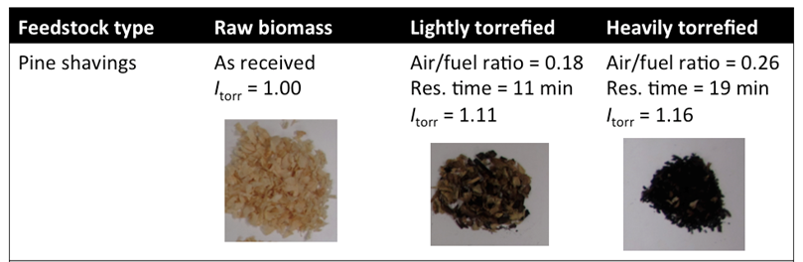

Cooking Fuel Formulation
As described earlier, briquetted solid fuel for cookstove application was used as a case study. In order to formulate this cooking fuel, we first define a formulation of cooking fuel from torrefied biomass. There is a myriad of formulations for briquetting, and our goal is not to make the optimal-quality briquettes, but rather to scour the literature in order to identify a relatively standard and replicable briquetting process for our scientific study. As shown in Figure 1, torrefied biomass is first comminuted, using the same grinding set-up discussed in previous study (Kung et al., 2019), into small powder (particle size < 2 mm). Once we have the pulverized torrefied biomass, we need to bind it into a usable form of solid fuel. There are many types of “binders” available, such as paper pulp, wheat flour mixture (Demirbaş and Şahin, 1998), molasses (Chin and Siddiqui, 2000), sawdust (Taulbee et al., 2009), cow dung (Emerhi, 2011; Jain et al., 2015), acid-denatured biomass (Zhang et al., 2001), and even natural innate binders in the raw biomass itself (Kaliyan and Morey, 2010). Other meta-studies have furthermore compared the performance characteristics of the resultant fuel briquettes—such as mechanical strength and calorific value—under different binder mixtures and ratios in seeking an optimum (Richards, 1990; Rubio et al., 1999; Shyamalee et al., 2015). In our study, we are not interested in necessarily optimizing the binder selection or ratios with respect to differently torrefied biomass, but rather in consistently defining a binding protocol so that the test results from the different torrefaction outcomes can be comparable. We therefore selected molasses as the binder as it was easily accessible and did not require extensive processing or pre-treatment. The binder to biomass ratio was gradually increased until we have stable briquettes that do not easily crumble into small pieces. The binder-to-fuel powder ratio that we used was 1:1 by mass, and no water was added in the process.

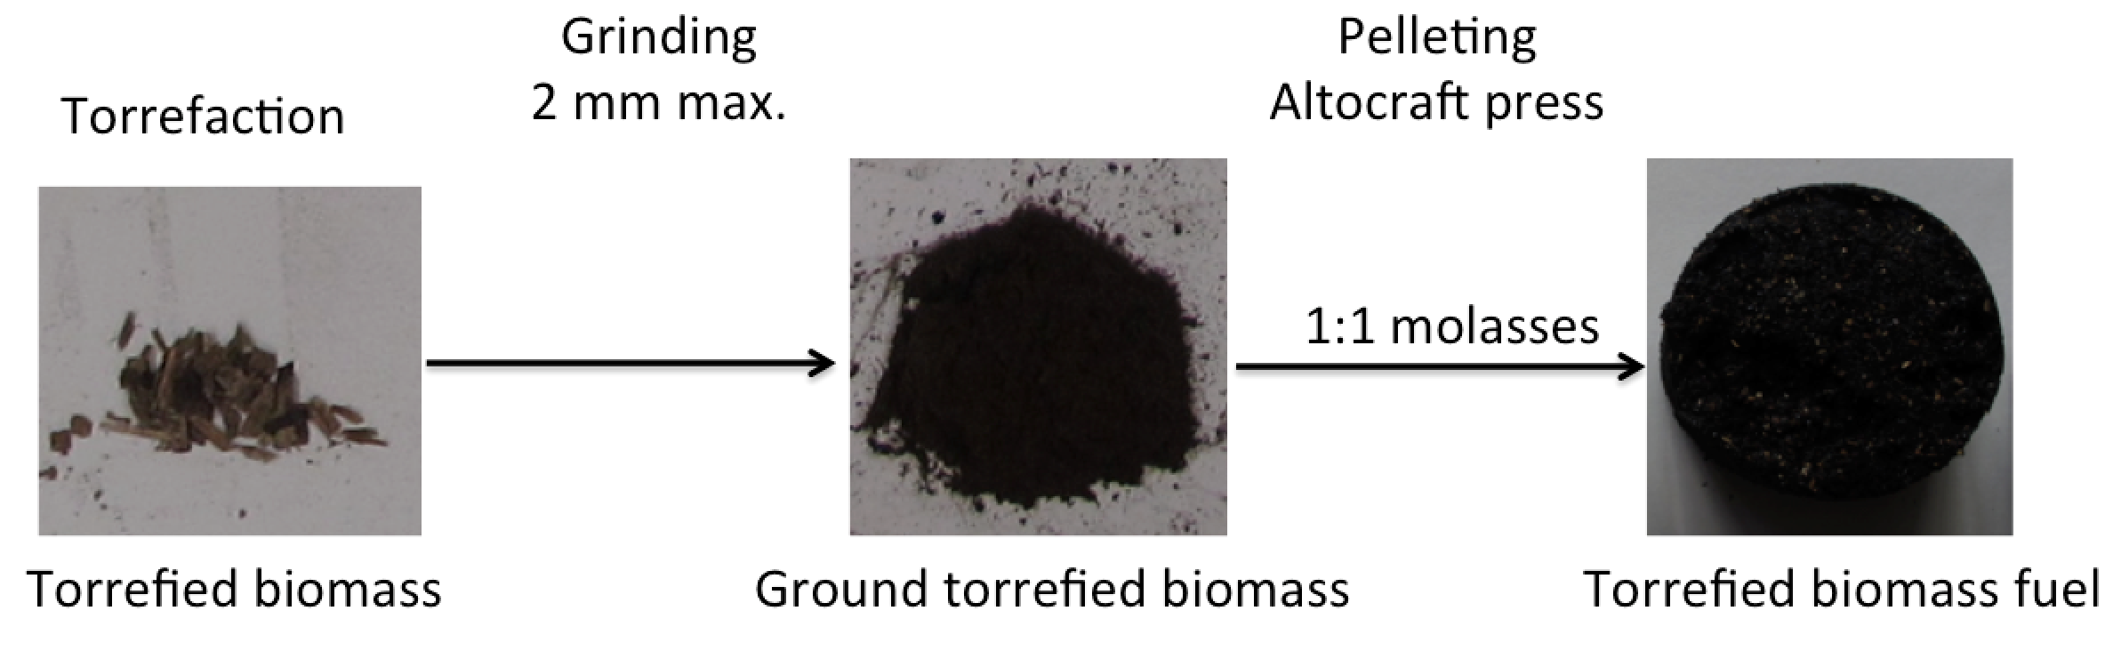
Figure 1. Formulation of cooking fuel from torrefied biomass

Figure 2 shows four sample fuel briquettes prepared using the process described above, consisting of raw pine shaving briquettes (I_{torr} = 1.00, as a negative control), lightly torrefied briquettes (I_{torr} = 1.11), and heavily torrefied briquettes (I_{torr} = 1.41). As the index of torrefaction increases, the color of the biomass briquettes also turns from yellow to brown to black. For comparison purpose as a positive control, we also purchased commercial-grade wood charcoal, pulverized it, and then reconstituted the fuel briquettes using the above discussed technique.

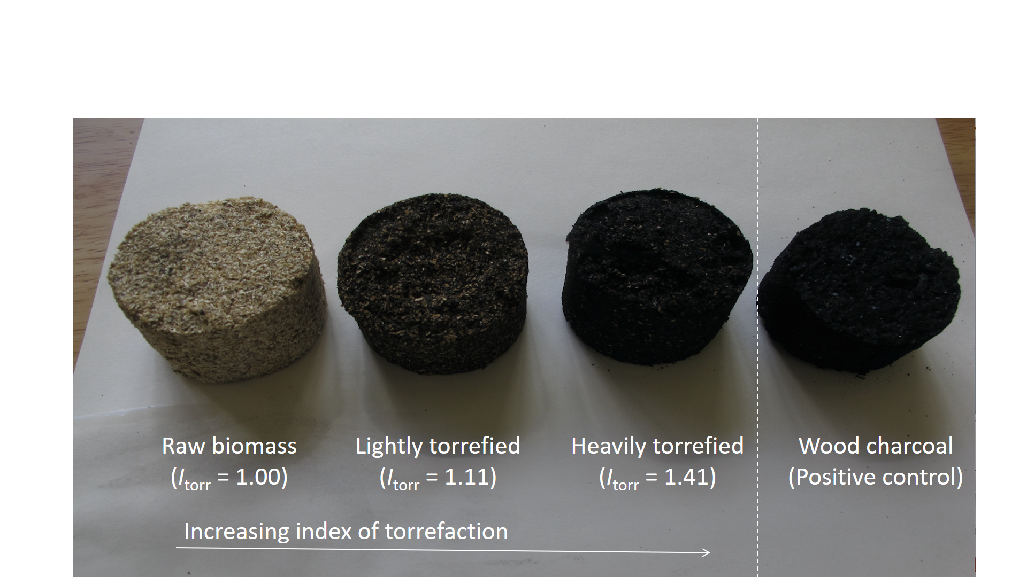
Figure 2. Samples of biomass briquettes under different torrefaction conditions and commercial wood charcoal briquette as a positive control.

Cooking Experimental Set-up
After the fuel formation protocol is defined, the next step is to define the standard cooking experiment al set-up to quantify the relationship between the index of torrefaction and the cooking characteristics of the solid fuel. There are many cookstoves designed for combustion of solid fuel, some unimproved (for example, (Jetter and Kariher, 2009; McCracken and Smith, 1998; Roden et al., 2006)), and some improved (for example, (Armendáriz-Arnez et al., 2010; Ruiz-Mercado et al., 2011; Singh et al., 2012)). For the purpose of defining a standard protocol, we selected a charcoal-burning stove—called a jiko—that is commonly used for domestic cooking in Kenya. The primary goal here is not to optimize the cooking performance, but rather, to demonstrate that for a specifically and realistically defined cooking practice, we can relate changes in the fuel performance to the index of torrefaction. Therefore, without investigating which cookstove design or cooking procedure is better, we preferred to just specify one cookstove and one procedure as a standard for this study. Figure 3a displays a typical Kenyan jiko cook stove and Figure 3b shows the complete set-up with cookstove and water pot.

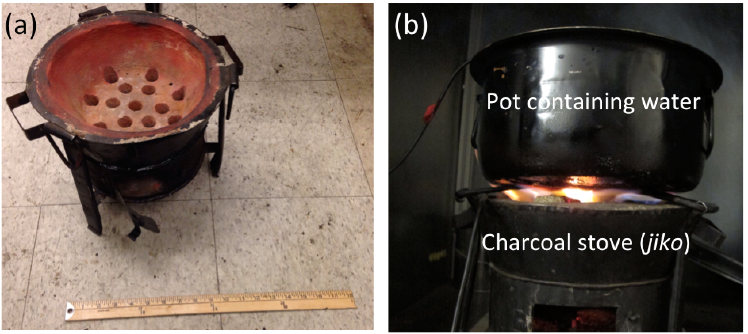
Figure 3. Cookstove performance experimental set-up. (a) A Kenyan charcoal-burning cook stove called jiko (b) Set-up consisting of the jiko and a pot of boiling water (3 liters).

To set up an experiment as per the protocol described in Banzaert (2013), about 400 grams of the solid fuel briquettes of a given type is loaded into the stove. A fire lighter was placed at the center of the briquettes to provide ignition. A metal pot containing 3 liters of water at room temperature was placed onto the lit stove. The experimental set-up consists of a mass balance on which the stove, the fuel, and a pot of water are placed. The mass balance logs the weight loss of the cooking experiment in real time. The stove was covered with minimal evaporation taking place, such as the majority of this mass loss can be attributed to the fuel mass loss. We also placed a thermocouple inside the pot of water, as well as inside the cook stove, in order to log the temperature in real time. The tests were first carried out using a cold cookstove (a “cold start” test), and then repeated using the pre-heated and pre-ignited stove (a “hot start” test) in order to study the effects of ignition and heating the stove. In addition to raw and torrefied biomass briquettes, biochar briquettes and commercial wood charcoal (Royal Oak 100% All Natural Hardwood Lump Charcoal) were tested for interpreting the performance of the experimental fuels, and as a control for the effect of the molasses binder.

Emission Experimental Set-up
The emission measurement set-up, first described in Banzaert (2013), is described in Figure 4. As shown, the cookstove is placed inside an exhaust hood with a known air flow rate. The diluted exhaust from the cookstove is drawn by a standard vacuum pump, from which it is then distributed for emission analysis using a DustTrak (total suspended particles), as well as Bacharach (other chemical species). The data from these devices, together with the load cell and temperature data, are logged continuously on an Arduino-based data acquisition system once every 5 seconds.

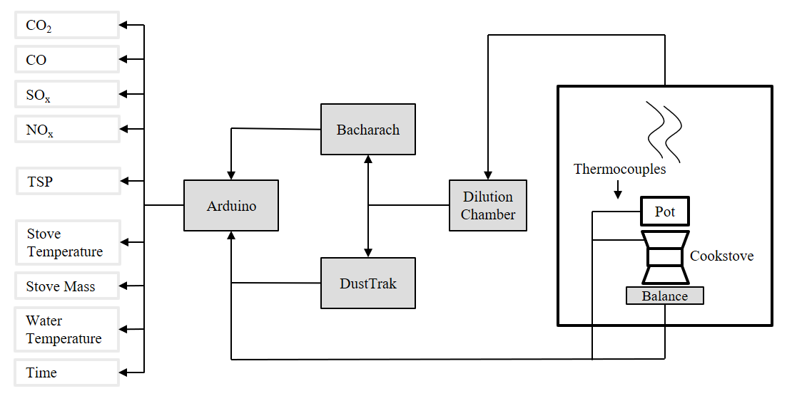
Figure 4. Experimental setup used to characterize combustion and emission characteristics from a representative cookstove.

Experimental Results

Densities
It is well known that torrefaction can improve the energy density [J kg⁻¹] of biomass (Bergman et al., 2005). The higher heating values (HHVs) were measured from the powdered (unbriquetted) samples using bomb calorimeter. As expected from conventional wisdom, the HHV of the torrefied pine shavings is linearly proportional to the index of torrefaction. As control samples, lump wood charcoal as well as powdered-then-briquetted charcoal samples were also measured. As can be seen from Figure 5a, judging based on HHV alone, in order to match the standards of conventional wood charcoal (around 30 MJ kg⁻¹), raw pine shavings and even lightly torrefied pine shavings are insufficient. It is only under the heavily torrefied regime (I_{torr} = 1.41) that the HHV value can match that of wood charcoal. Indeed, from most existing studies in the literature as well as from interviews with most industry practitioners and boiler operators, HHV indeed appears to be the only measure that matters (Eseyin et al., 2015; Stępień et al., 2019). However, we contend that HHV is, in reality, only one of the many facets of the solid fuel design process, and there are other factors at play, as we will unveil below.

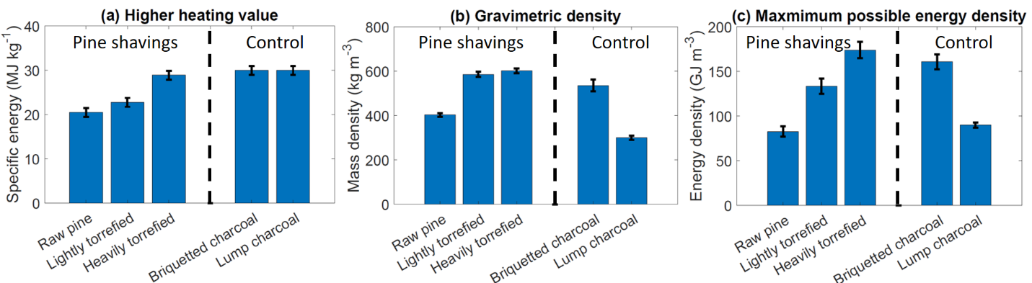
Figure 5. (a) Average specific energy of briquettes made from raw pine shavings (I_{torr} = 1.00), lightly torrefied pine shavings (I_{torr} = 1.11), and heavily torrefied pine shavings (I_{torr} = 1.41), in comparison with control briquettes made from charcoal, as well as lump wood charcoal. (b) Average gravimetric density and (c) maximum possible energy density of the same samples as described above.

After the powdered samples were briquetted, the average densities of the different types of briquettes were quantified, as shown in Figure 5b. Here, the average briquette density shows variation amongst samples rather than over time (which will be quantified in a subsequent section), and was calculated using each briquette’s average mass, and dimensions 3 weeks after briquetting, in order to approximate average long-term-storage density. Briquetted and lump charcoal samples were also included as points of reference. Notably, after the torrefaction of pine shavings, with the same amount of pressure and binding agent ratio, it is now possible to pack significantly more mass into the same volume compared to raw pine shavings. Therefore, the effective gravimetric densities of the torrefied samples have increased by around 50% compared to the raw pine shavings. Furthermore, unlike the previous analysis, where HHV is directly proportional to index of torrefaction, we observe here that there is not significant difference in the effective gravimetric density between lightly torrefied (I_{torr} = 1.11) and heavily torrefied (I_{torr} = 1.41), suggesting that if our interest is only to pack as much mass as possible into a certain volume, then lightly torrefied biomass is as good as heavily torrefied biomass. By comparing these results with those of the briquetted and lump wood charcoal as reference, we observe that when wood charcoal is first powdered and then briquetted, it can achieve roughly the same gravimetric density (540 kg m⁻³) as the torrefied briquettes. On the other hand, lump wood charcoal exhibits a much lower gravimetric density (around 300 kg m⁻³). This is not too surprising, as the wood is known to lose density during carbonization (Byrne and Nagle, 1997), and in this case, the lump wood charcoal was produced without the benefit of briquetting to pack more materials into the porous volume.

These two factors above—higher heating value [J kg⁻¹] and gravimetric density [kg m⁻³]—can be multiplied to yield the energy density [J m⁻³], which describes how many units of energy can be packed into a certain volume of briquettes. This is plotted in Figure 5c. Here, for torrefied biomass, the dependency on the index of torrefaction represents a blended effect between HHV and the gravimetric density. In general, the energy density increases as the index of torrefaction increases. However, we find that the energy densities for both torrefied samples far exceed that of the lump wood charcoal, which is more similar as raw pine shaving briquettes. However, we note that the energy density here simply represents the maximum possible energy density that is stored in the briquettes. In reality, as we will demonstrate in a subsequent section with actual cooking experiments, the actual useful energy density that is released towards heating water can often be a very different quantity, due to the various losses that can occur.

Density variations and hydroscopic activities
On the aggregate level, there are various external sources of experimental noise that may complicate the analysis of the dependency of the index of torrefaction with cooking fuel performance metrics. As mentioned in the materials and methods section, to the extent possible, the briquetting process and the stove tests have been standardized across the different experiments in order to avoid any variations. However, even so, we anticipate that external factors such as the prevailing weather and moisture conditions will have an effect on the briquette behaviors, because it is well known that differently torrefied biomass samples possess different hydroscopic properties—namely, more severely torrefied biomass is traditionally associated with hydrophobic behavior compared to raw biomass (Bridgeman et al., 2010; Saddawi et al., 2012).

A good measure of this hydroscopic variability is the density variation within each briquette as a function of time, when the sample is stored in ambient conditions shielded from rain. Upon briquetting, the densities of 4-5 briquettes of each type are noted as the reference density. Then subsequently, each briquette was weighed and measured regularly over a period of 25 days in order to estimate fold changes from the original reference density, as plotted in Figure 6a for raw pine shaving briquettes (blue), lightly torrefied pine shaving briquettes (red), heavily torrefied pine shaving briquettes (orange), and briquetted charcoal as a control (purple). Concurrently, the ambient local humidity data were recorded from the Weather Underground Historical Weather Database for Boston, MA, as shown as a green dashed line in Figure 6a. Qualitatively, there is a noticeable covariation between the ambient humidity and the briquette densities over the same period. This covariation is further quantified in a correlation scatter plot (Supplemental Figure S-1), and was found to yield statistically significant (p < 0.0001) positive correlation coefficient in all cases. This suggests that the density of the briquettes is a strong function of the ambient humidity. In particular, a greater ambient humidity level leads to a higher briquette density, possibly due to the uptake of moisture into the briquettes. However, for all torrefied briquettes and the charcoal briquettes (as a control), the changes in density are miniscule: around 0.5% from the reference density during the four-week period, as seen in Figure 6b. Raw pine shaving briquettes, on the other hand, exhibited a very different behavior. It began to expand immediately after briquetting, and continued to do so for approximately 8 days, resulting in an effective gravimetric density loss of 13%. These expanded briquettes, qualitatively, were also crumblier compared to the torrefied and charred briquette counterparts for the purpose of long-term storage and cookstove combustion.

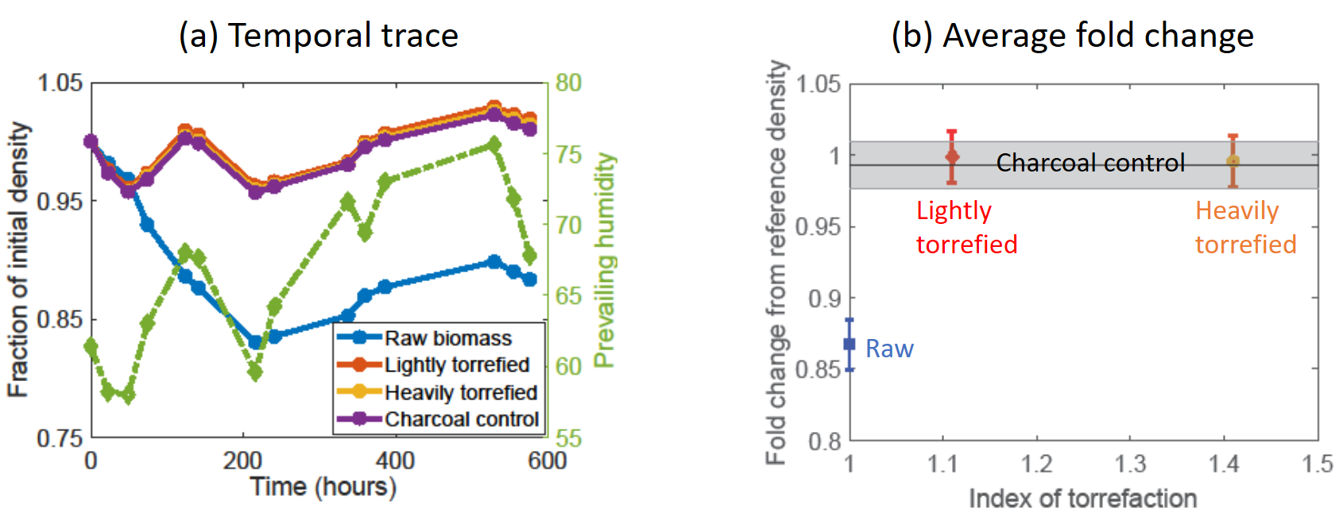
Figure 6. Hydroscopic behaviors of different types of briquettes measured as (a) Fraction of initial density as a function of time (b) Average fold change from the reference density of the various briquettes and the prevailing humidity as a function of the index of torrefaction. Gray shaded range indicates the average fold change of charcoal briquettes as a positive control.

Sample Cooking Experiment Output
After the initial characterization described above, the different briquette samples were subject to the burn tests as described previously. Figure 7 summarizes the time trace of the water temperature in the pot using different types of biomass/torrefied fuel briquettes, as a sample illustration in the cold start mode. We see that the raw biomass fuel briquettes (blue curve) is actually insufficient to bring the pot of water to a boil even after 90 minutes. In contrast, both mild torrefied (black dashed curve) and heavy torrefied (red curve) fuel dramatically improves the cooking experience by (a) successfully bringing water to boiling state, and (b) completing this heating at a much faster rate of less than 20 minutes, in a way that is comparable to charcoal briquettes. Hence, we can see that torrefaction has dramatic benefits in upgrading the characteristics of the cooking fuel, such that it is actually usable in the actual cooking scenario.

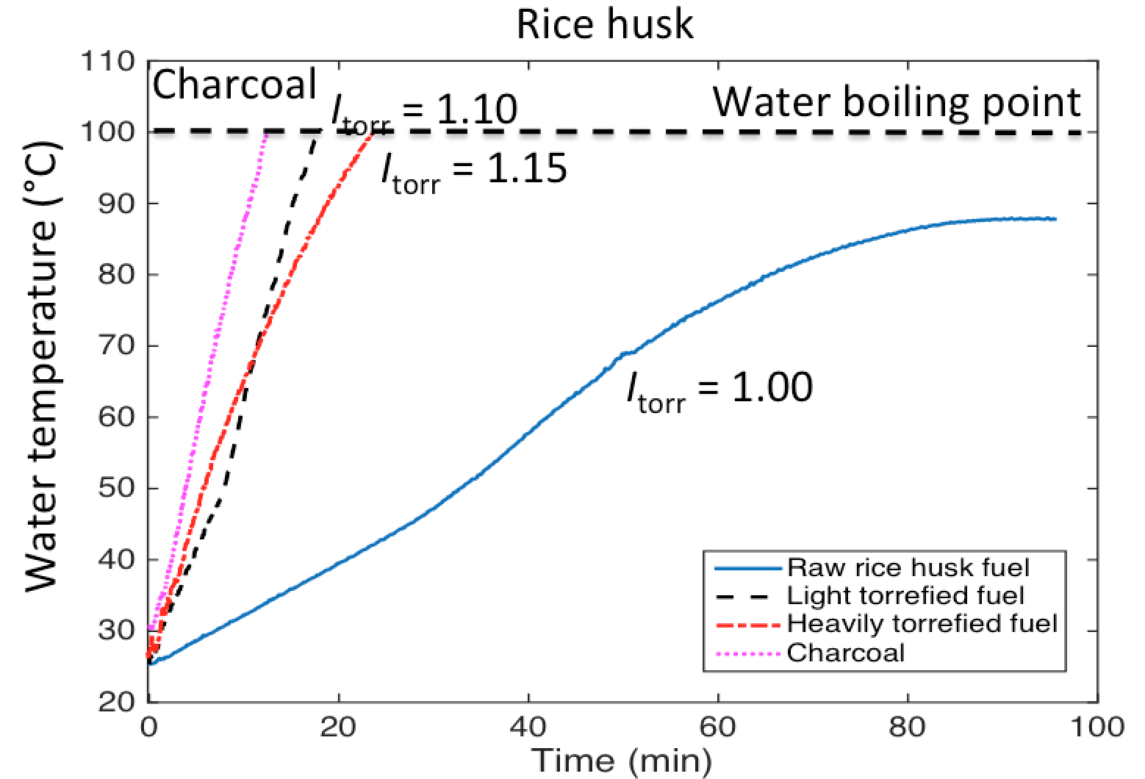
Figure 7. Time trace of temperature inside a pot of water being heated on a cook stove using different types of fuel.

Useful power output and cookstove temperature
In order to quantify the observations in Figure 7 more rigorously, we defined an aggregate quantity called the useful power output P_{u} as the “useful” heat flow from combusting the fuel briquettes that actually contributes to the heating of the water (e.g. rather than heating up the stove, or being lost to the surrounding environment). Essentially, the useful power output quantifies how rapidly things can be cooked with a given fuel type, and is roughly proportional to the slopes of Figure 7:
$$P_{u}≡\frac{m_{water}c_{water}\left(T_{end}-T_{start}\right)}{t_{end}-t_{start}},$$
where the subscript “start” denotes the water temperature and time at the starting point of the cooking experiment, and “end” denotes the water temperature and time at the end point of the cooking experiment, respectively.

Furthermore, since in cooking, the amount of useful power output is likely related to the thermal gradient between the stove and the pot. In order to investigate this relationship further, we compute, simultaneously, the average stove temperature by placing a thermocouple into the center of the pot for the different fuel types.

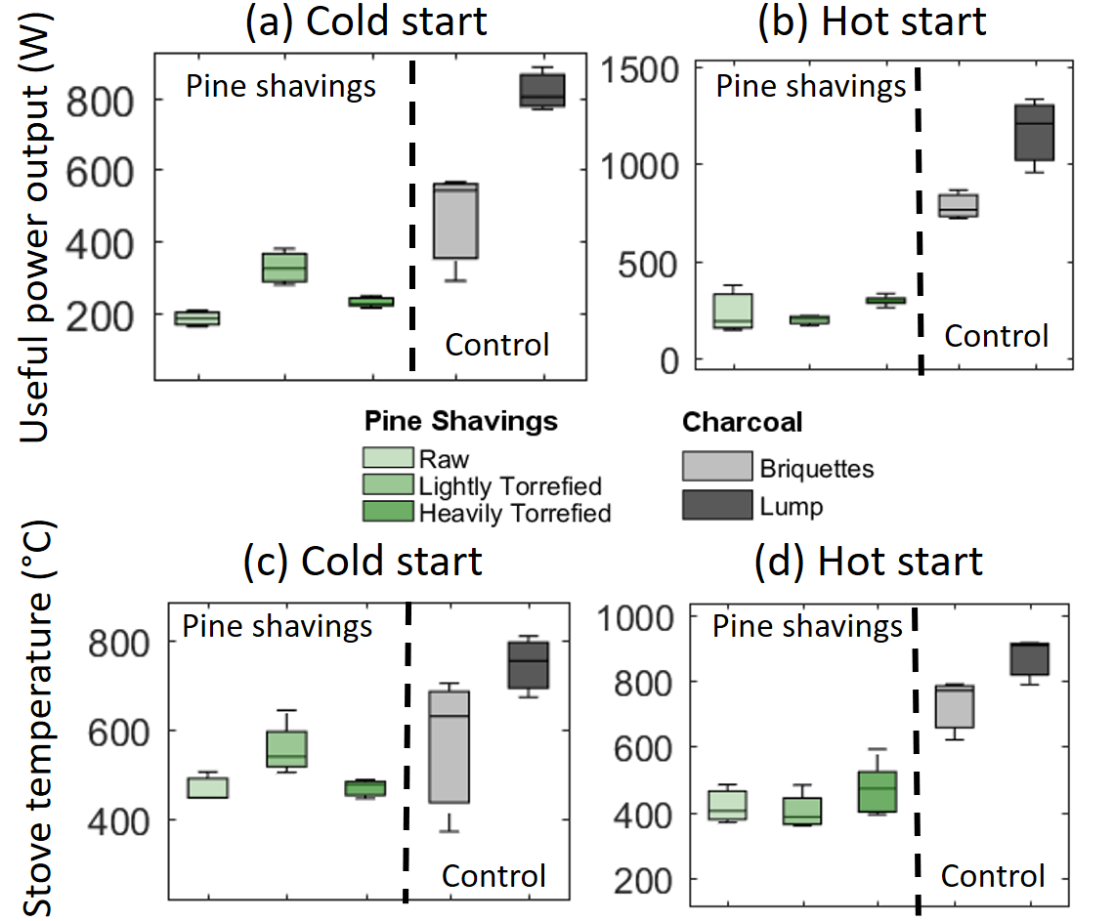
Figure 8. Useful power output from cold start and hot start cookstove experiments for different samples

The upper half of Figure 8 shows the useful power outputs for different types of fuel samples, for both (a) cold start and (b) hot start cookstove experiments. We see that, in the cold start mode, torrefied pine shaving briquettes do improve on the useful power output as compared to the raw pine shaving briquettes. Somewhat surprisingly, the heavily torrefied pine shaving briquettes display a lower useful power output than the lightly torrefied pine shaving briquettes. This behavior, however, is not replicated in the hot start scenario where the stove is already warm. In this case, the three types of pine shaving briquettes (whether torrefied or untorrefied) actually behave quite similarly in terms of useful power output. To better understand the underlying mechanism of these somewhat unexpected behaviors, we turn to the stove temperature in panels (c) and (d) in Figure 8. A similar trend is observed in Figure 8c, where in the cold start case, heavily torrefied pine shaving briquettes result in a somewhat lower cooking temperature compared to lightly torrefied pine shaving briquettes. Once again, in the hot start case, the stove temperatures for the three pine shaving briquettes are roughly similar. This suggests that, when the stove is already hot, torrefaction severity does not really confer any advantage in the useful power output from the stove. However, when the stove is starting from a cold state, an intermediate level of torrefaction can help accelerate the process. Finally, briquetted and lump wood charcoal references, at least in comparison with our current briquetting procedure and formulation for the pine shaving samples, perform better in terms of the useful power output. But this serves really just as a reference rather than any meaningful indication of competitive performance metrics. As we stated previously, the scope of this paper is not to identify or optimize a briquetting procedure or mix that can compete in all performance aspects as standard wood charcoal lumps or briquettes, but rather to focus on the impact of torrefaction severity on aggregate cookstove characteristics. And in this case, we see that, due to a myriad of combustion-related reasons, more severe torrefaction does not always lead to more desirable cooking fuel from the perspective of useful power output or stove temperature.

Useful Specific Energy
The analysis above regarding the useful power output, while insightful, does not yield any information on how much solid fuel was actually consumed to support the combustion, which may vary depending on the torrefaction severity. The fuel consumption rate depends on many factors, such as the combustion temperature, as well as the underlying chemistry of the fuel after torrefaction of different degrees of severity. The useful energy density ρ_{E}, as we define below, tells us about how much fuel (in mass) is needed in order to deliver a certain quantity of useful energy that heats up the water in the pot:
$$ρ_{E}≡\frac{m_{water}c_{water}\left(T_{end}-T_{start}\right)}{m_{fuel, end}-m_{fuel,start}}.$$
where m_{water} is the initial mass of water, c_{water} is the heat capacity of water at standard temperature and pressure, T_{start} is the water temperature at the start of the cooking test, T_{end} is the water temperature at the end of the cooking test, m_{fuel,start} is the mass of fuel at the start of the cooking test, and m_{fuel,end} is the water temperature at the end of the cooking test. It is assumed for this calculation that no water was vaporized during the water-boiling test with the lid closed.
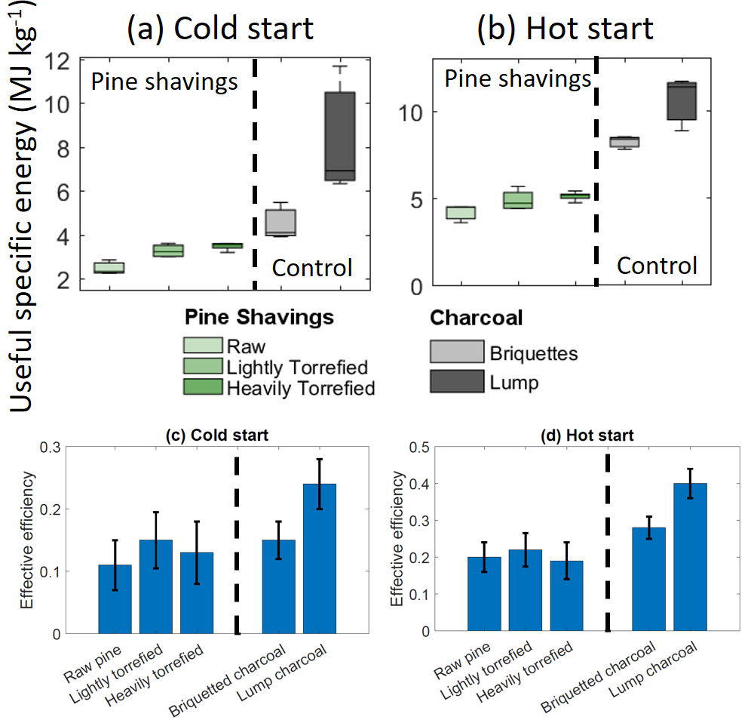
Figure 9. Useful specific energy [MJ kg⁻¹] and effective stove efficiency in cold start and hot start modes, for different samples.

Figure 9 shows the useful specific energy in the cold start (a) and hot start (b) modes. As can be seen, in both modes, there is generally an improvement in the useful specific energy as a function of increasing torrefaction severity, in a trend that roughly approximates the higher heating value results shown in Figure 9a for powdered (unbriquetted) fuel samples. This makes sense, as it implies that the more heating value can be packed into a unit mass of fuel, then during cooking, this unit mass is also capable of heating up more water, in a way that is somewhat independent of the different trends in useful power output and stove temperature as explored previously. However, there are also fundamental differences between using HHV and using the useful specific energy as the performance metric for cooking fuel. As seen earlier in Figure 5a, in terms of HHV, those of briquetted and lump wood charcoal are well-matched by the heavily torrefied pine shavings. However, Figure 9 tells a different story: despite the well-matched HHV, lump wood charcoal markedly outperform briquetted untorrefied or torrefied pine shavings, as though the jiko stove has been optimized to extract more heat energy from wood charcoal, despite it has a similar HHV as the other alternatives.

In order to quantify this further, we define an ad hoc effective stove efficiency η as the ratio between the measured useful specific energy and the higher heating value of the powdered (unbriquetted) fuel:
$$η≡\frac{Useful specific energy}{HHV}.$$
This yields a dimensionless quantity that is related to how effectively the stove extracts the higher-heating value from the fuel for the useful purpose of heating up a pot of water. Figure 9 plots this quantity in (c) cold start and (d) hot start modes, for the different fuel types. In general, the hot start mode has an efficiency that is around 10% higher for all fuel samples than the cold start mode. This is hardly surprising, as in the cold start mode, additional energy penalty goes into heating up the stove from a cold state. What is instructive is that for all briquetted fuel types, the differences in the HHV and in the useful specific energy tend to cancel each other out, such that they all exhibit similar effective stove efficiencies (around 10% in the cold start mode and 20% in the hot start mode). In both modes, lump wood charcoal outperforms the briquetted fuel types by a factor of 2.

This leads to an important pair of conclusions. Firstly, torrefaction severity, by increasing both the higher heating value and the useful specific energy, allows the same amount of cooking to be done with less amount of fuel. This is a known benefit prized by many solid fuel users (Kung et al., 2015). Secondly, as seen from the effective stove efficiency calculation, the jiko stove is about twice as efficient in extracting energy from its native fuel type (lump wood charcoal) as any briquetted alternatives. This characteristic is fundamental to the stove design and the briquetting process that seems independent of torrefaction severity. Therefore, unless we can make the briquetted fuel almost twice as dense as lump wood charcoal, or unless the briquetting process is otherwise improved to be more competitive with lump wood charcoal (which is beyond the scope of the present study), there will always exist an efficiency gap between briquetted fuel and lump wood charcoal.

Combustion Emissions
The previous sections explored how torrefaction severity is related to different aspects of density and cooking performances of solid fuel. In this section, we turn our attention to the emission characterization of the cooking fuel as a function of the index of torrefaction, because indoor air pollution from solid fuel combustion is a major public health concern (Armendáriz-Arnez et al., 2010). Mean combustion emission level for the ith species <ΔX_{i}> were determined from water-boiling tests as the change in the time-averaged concentration of the ith species, in comparison with the baseline level (${\overline{X}}_{i}$) not in the vicinity of any cooking activities:
$$〈∆X_{i}〉= \frac{1}{∆t}\sum_{n=0}^{N}{(X_{i,n}}-{\overline{X}}_{i,n})∆t.$$
However, the actual quantity that will be important to a household user performing a certain cooking task requiring a certain unit of total energy ΔH will be the total exposure (TE) to the ith pollutant. The user’s total exposure to these different emission species for this cooking task depends on the product of the pollutant concentration, of the amount of air flow (${\dot{m}}_{air}$) containing this pollutant, and of the length of time the fuel is being combusted, which is roughly proportional to the total energy divided by the useful power output (P_{u}):
$${TE}_{i}=〈∆X_{i}〉×{\dot{m}}_{air}×\frac{∆H}{P_{u}}.$$
While ΔH will depend on the cooking task at hand, and is beyond the control of this study, the term here that are directly attributable to the intrinsic behaviors of cooking relevant to this study is the ratio $〈∆X_{i}〉×{\dot{m}}_{air}/P_{u}$, which has the unit of total exposure divided by energy (for example, g J⁻¹). Therefore, our emission data are normalized accordingly. In this case, the following species were logged in time: total suspended particles (TSP), carbon monoxide (CO), sulfur oxides (SO_{x}), and nitrogen oxides (NO_{x}).
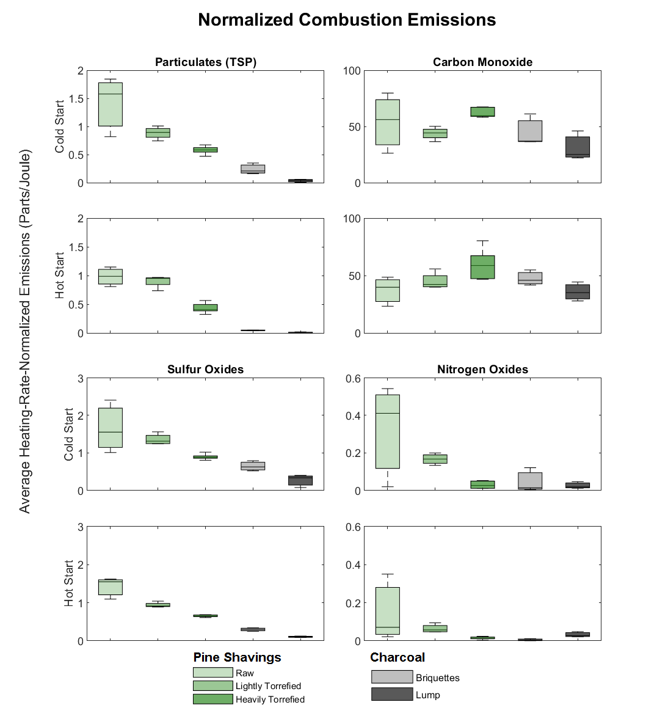
Figure 10. Emission profiles of the different pollutant species in cookstove experiments for different fuel samples, for total suspended particulates in (a) cold and (b) hot start modes, for sulfur oxides in (c) cold and (d) hot start modes, for carbon monoxide in (e) cold and (f) hot start modes, and for nitrogen oxides in (g) cold and (h) hot start modes.

Figure 10 shows the total suspended particles (panels a and b), carbon monoxide (panels e and f), sulfur oxides (panels c and d), as well as nitrogen oxides (panels g and h), both in the cold and hot start modes, for all types of fuels. In general, there is a large spread in the emissions for combusting raw (untorrefied) biomass fuel briquettes, as consistent with Banzaert’s observations (Banzaert, 2013). There is a noticeable decrease in all species except carbon monoxide with increasing torrefaction. On the other hand, for carbon monoxide, the level of emission increases with increasing torrefaction severity. This is not surprising, because increasing torrefaction severity is associated with a more carbon-rich, coal-like fuel (Basu et al., 2017). Given that the heterogeneous combustion at the solid fuel surface is generally diffusion-limited (Bu et al., 2015), the increased density of carbon-rich reactive sites means that there will be higher instances of incomplete combustion, leading to higher CO concentrations. Therefore, we see that there is a general trade-off in the emission characteristics of the solid fuel briquettes as a function of increasing severity: while most noxious species decrease, the risk of CO poisoning increases on the other hand.

Conclusions
The overarching goal of this study is to demonstrate that, at the aggregate level, biomass torrefaction influences feedstock performance characteristics in a way that is often very different at the microscopic level under well-controlled laboratory settings. In order to illustrate this point, this study utilizes torrefied pine shaving fuel briquettes for the purpose of domestic cooking using a conventional solid fuel combustion stove as a case study. In this case, the microscopic-level characteristics such as higher-heating value (HHV) often have little correlation with aggregate-level characteristics such as the useful power output and emission profiles as a function of torrefaction severity.

In particular, in some instances, torrefaction has some rather unexpected advantages on the fuel briquettes, for example, the ability to pack much more biomass into a certain volume (improved gravimetric density), which in turn leads to more strongly advantaged volumetric energy density. However, in other instances, we see that torrefaction does not always improve the fuel performance, especially from the consideration of useful power output and stove temperature. Furthermore, we also identified factors—such as the effective stove efficiency—which seem to be independent of the torrefaction severity. Namely, while torrefaction is a useful way to pack more energy into the same mass and volume of fuel, the cookstove also appears to be fundamentally more efficient at combusting lump wood charcoal rather than briquetted alternatives. In some cases, the penalty in this efficiency is so large that it essentially eliminates any advantages that torrefaction may confer. Therefore, one main conclusion from this study is that, while torrefaction is an important design factor, the briquetting process as well as the cookstove design are equally important in conferring additional performance advantages to any alternative fuel briquettes. These topics—while beyond the scope of the present study—will serve as fertile ground for future follow-up studies.

By investigating the total exposure potential of the different pollutant species as a function of torrefaction severity, we arrived at another set of interesting conclusions. While the presence of most pollutants—such as particulate matter, NO_{x}, and SO_{x}—are somewhat mitigated by increasing torrefaction severity, carbon monoxide is exacerbated by torrefaction. This intuitively makes sense, as on one extreme, households using raw biomass (such as wood logs) for cooking are mainly beset by particulate emissions, while on the other extreme, households depending on charcoal for cooking often suffer from carbon monoxide poisoning concerns. As stated earlier, this study focuses merely on the effect of biomass torrefaction on these trends, but does not attempt to match the torrefied fuel types to acceptable standards. As future work, we recognize that—in addition to useful clean-burning cookstoves as well as improved briquetting methods—torrefaction severity is another knob that can be tuned to design solid fuels that are compatible with the acceptable standards. Further quantification of this role is likely to yield impactful results, as indoor cooking presents one of the gravest respiratory health risks to a large population today.

Ultimately, our research points to a more complex interplay between the various cooking characteristics and the index of torrefaction. We strongly suspect that most of these characteristics are dependent on the method of briquetting, the cookstove design, and the method of cooking. Therefore, it is recommended that for any new potential application for the torrefied fuel, that the desired performance characteristics of the fuel be carefully mapped using the index of torrefaction as the conduit to guide the design and reactor condition selection. However, it should be noted that cooking fuel application is used here only as a case study. The insights and analytical framework developed here can also be applied towards aggregate performance metrics that are important to other energy and biofuel production applications.

Acknowledgements

This materials and equipment of work was funded by the MIT Tata Center and the Abdul Latif Jameel Water and Food Systems Lab. This study benefits from existing cookstove experiment setup funded by MIT D-Lab and established by Dr. Amy Banzaert. KSK would like to acknowledge the MIT Tata Center Fellowship, the Cyclotron Road Fellowship, the Dolores Zohrab Liebmann Fellowship, and the Legatum Fellowship for support. MB would like to acknowledge the MIT Undergraduate Research Opportunities Program for support.

References

Acharya, B., Dutta, A., 2016. Fuel property enhancement of lignocellulosic and nonlignocellulosic biomass through torrefaction. Biomass Convers. Biorefinery 6, 139–149. https://doi.org/10.1007/s13399-015-0170-x
Arias, B., Pevida, C., Fermoso, J., Plaza, M.G., Rubiera, F., Pis, J.J., 2008. Influence of torrefaction on the grindability and reactivity of woody biomass. Fuel Process. Technol. 89, 169–175. https://doi.org/10.1016/j.fuproc.2007.09.002
Armendáriz-Arnez, C., Edwards, R.D., Johnson, M., Rosas, I.A., Espinosa, F., Masera, O.R., 2010. Indoor particle size distributions in homes with open fires and improved Patsari cook stoves. Atmos. Environ. 44, 2881–2886. https://doi.org/10.1016/j.atmosenv.2010.04.049
Banzaert, A., 2013. Viability of Waste-Based Cooking Fuels for Developing Countries : Combustion Emissions and Field Feasibility by. MASSACHUSETTS INSTITUTE OF TECHNOLOGY.
Basu, P., Kulshreshtha, A., Acharya, B., 2017. An Index for Quantifying the Degree of Torrefaction. BioResources 12, 1749–1766. https://doi.org/10.15376/biores.12.1.1749-1766
Bates, R.B., Ghoniem, A.F., 2012. Biomass torrefaction: Modeling of volatile and solid product evolution kinetics. Bioresour. Technol. 124, 460–469. https://doi.org/10.1016/j.biortech.2012.07.018
Bergman, P.C.A., Boersma, A.R., Zwart, R.W.R., Kiel, J.H.A., 2005. Torrefaction for biomass co-firing in existing coal-fired power stations “BIOCOAL,” Energy Research Centre of the Netherlands. Petten. https://doi.org/ECN-C--05-013
Bridgeman, T.G., Jones, J.M., Williams, A., Waldron, D.J., 2010. An investigation of the grindability of two torrefied energy crops. Fuel 89, 3911–3918. https://doi.org/10.1016/j.fuel.2010.06.043
Bu, C., Leckner, B., Chen, X., Gómez-Barea, A., Liu, D., Pallarès, D., 2015. Devolatilization of a single fuel particle in a fluidized bed under oxy-combustion conditions. Part B: Modeling and comparison with measurements. Combust. Flame 162, 809–818. https://doi.org/10.1016/j.combustflame.2014.08.011
Byrne, C.E., Nagle, D.C., 1997. Carbonization of wood for advanced materials applications. Carbon N. Y. 35, 259–266. https://doi.org/10.1016/S0008-6223(96)00136-4
Chin, O.C., Siddiqui, K.M., 2000. Characteristics of some biomass briquettes prepared under modest die pressures. Biomass and Bioenergy 18, 223–228. https://doi.org/10.1016/S0961-9534(99)00084-7
Demirbaş, A., Şahin, A., 1998. Evaluation of biomass residue 1. Briquetting waste paper and wheat straw mixtures. Fuel Process. Technol. 55, 175–183. https://doi.org/10.1016/S0378-3820(98)00041-1
Emerhi, E.A., 2011. Physical and combustion properties of briquettes produced from sawdust of three hardwood species and different organic binders. Adv. Appl. Sci. Res. 2, 236–246. https://doi.org/10.3182/20070606-3-MX-2915.00102
Eseyin, A.E., Steele, P.H., Pittman, C.U., 2015. Current Trends in the Production and Applications of Torrefied Wood/Biomass - A Review. BioResources 10, 8812–8858.
Jain, H., Vijayalakshmi, Y., Neeraja, T., 2015. Preparation of Briquettes Using Biomass Combinations and Estimation of Its Calorific Value. Int. J. Sci. Res. 4, 322–326.
Jetter, J.J., Kariher, P., 2009. Solid-fuel household cook stoves: Characterization of performance and emissions. Biomass and Bioenergy 33, 294–305. https://doi.org/10.1016/j.biombioe.2008.05.014
Kaliyan, N., Morey, R.V., 2010. Natural binders and solid bridge type binding mechanisms in briquettes and pellets made from corn stover and switchgrass. Bioresour. Technol. 101, 1082–1090. https://doi.org/10.1016/j.biortech.2009.08.064
Kung, K., Thengane, S., Ghoniem, A., 2019. A generalizable reactor design framework based on index of torrefaction. Appl. Energy.
Kung, K.S., 2017. Design and Validation of a Decentralized Biomass Torrefaction System. Massachusetts Institute of Technology May.
Kung, K.S., Rigu, S.W., Karau, S.K., Gachigi, K., McDonald, L., 2015. Techno-Economic Feasibility of Green Charcoal Production in Kenya, in: Sustainable Access to Energy in the Global South Essential Technologies and Implementation Approaches. Springer International Publishing AG Switzerland, pp. 87–100. https://doi.org/10.1007/978-3-319-20209-9
Kung, K.S., Thengane, S.K., Shanbhogue, S., Ghoniem, A.F., 2019. Parametric analysis of torrefaction reactor operating under oxygen-lean conditions. Energy 181, 603–614. https://doi.org/10.1016/j.energy.2019.05.194
McCracken, J.P., Smith, K.R., 1998. Emissions and efficiency of improved woodburning cookstoves in highland Guatemala. Environ. Int. 24, 739–747. https://doi.org/10.1016/S0160-4120(98)00062-2
Motghare, K.A., Rathod, A.P., Wasewar, K.L., Labhsetwar, N.K., 2016. Comparative study of different waste biomass for energy application. Waste Manag. https://doi.org/10.1016/j.wasman.2015.07.032
OECD/IEA, 2006. Energy for Cooking in Developing Countries, in: World Energy Outlook. pp. 419–445. https://doi.org/10.1787/weo-2006-16-en
Phanphanich, M., Mani, S., 2011. Impact of torrefaction on the grindability and fuel characteristics of forest biomass. Bioresour. Technol. 102, 1246–1253. https://doi.org/10.1016/j.biortech.2010.08.028
Richards, S.R., 1990. Physical Testing of Fuel Briquettes. Fuel Process. Technol. 25, 89–100.
Roden, C.A., Bond, T.C., Conway, S., Pinel, A.B.P., 2006. Emission factors and real-time optical properties of particles emitted from traditional wood burning cookstoves. Environ. Sci. Technol. 40, 6750–6757. https://doi.org/10.1021/es052080i
Rubio, B., Izquierdo, M.T., Segura, E., 1999. Effect of binder addition on the mechanical and physicochemical properties of low rank coal char briquettes. Carbon N. Y. 37, 1833–1841. https://doi.org/10.1016/S0008-6223(99)00057-3
Ruiz-Mercado, I., Masera, O., Zamora, H., Smith, K.R., 2011. Adoption and sustained use of improved cookstoves. Energy Policy 39, 7557–7566. https://doi.org/10.1016/j.enpol.2011.03.028
Saddawi, A., Jones, J.M., Williams, A., Le Coeur, C., 2012. Commodity fuels from biomass through pretreatment and torrefaction: Effects of mineral content on torrefied fuel characteristics and quality. Energy and Fuels 26, 6466–6474. https://doi.org/10.1021/ef2016649
Shyamalee, D., Amarasinghe, A.D.U.S., Senanayaka, N.S., 2015. Evaluation of different binding materials in forming biomass briquettes with saw dust. Int. J. Sci. Res. Publ. 5, 1–8.
Singh, A., Tuladhar, B., Bajracharya, K., Pillarisetti, A., 2012. Assessment of effectiveness of improved cook stoves in reducing indoor air pollution and improving health in Nepal. Energy Sustain. Dev. 16, 406–414. https://doi.org/10.1016/j.esd.2012.09.004
Stępień, P., Serowik, M., Koziel, J.A., Białowiec, A., 2019. Waste to Carbon Energy Demand Model and Data Based on the TGA and DSC Analysis of Individual MSW Components. Data 4, 1–6. https://doi.org/10.3390/data4020053
Taulbee, D., Patil, D.P., Honaker, R.Q., Parekh, B.K., 2009. Briquetting of Coal Fines and Sawdust Part I Binder and Briquetting-Parameters Evaluations. Int. J. Coal Prep. Util. 29, 1–6.
Thengane, S.K., 2018. Assessment of Different Technologies for Managing Yard Waste Using Analytic Hierarchy Process. Process Integr. Optim. Sustain. https://doi.org/doi.org/10.1007/s41660-018-0070-1
Tumuluru, J.S., Sokhansanj, S., Hess, J.R., Wright, C.T., Boardman, R.D., 2011. A review on biomass torrefaction process and product properties for energy applications. Ind. Biotechnol. 1–19. https://doi.org/10.1089/ind.2011.0014
WHO, 2018. Household air pollution and health [WWW Document]. URL https://www.who.int/news-room/fact-sheets/detail/household-air-pollution-and-health (accessed 8.2.19).
Zhang, C., Ho, S.H., Chen, W.H., Xie, Y., Liu, Z., Chang, J.S., 2018. Torrefaction performance and energy usage of biomass wastes and their correlations with torrefaction severity index. Appl. Energy 220, 598–604. https://doi.org/10.1016/j.apenergy.2018.03.129
Zhang, X., Xu, D., Xu, Z., Cheng, Q., 2001. The effect of different treatment conditions on biomass binder preparation for lignite briquette. Fuel Process. Technol. 73, 185–196. https://doi.org/10.1016/S0378-3820(01)00179-5

Supplemental figures
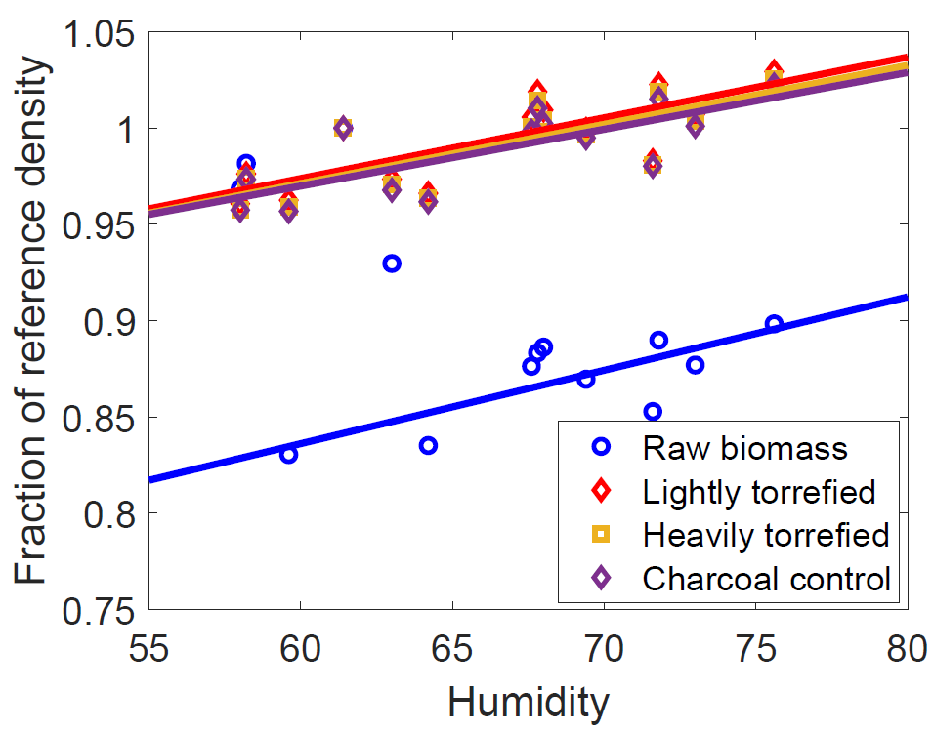
Figure S-1. Hydroscopic behaviors of different types of briquettes (measured by the fold change from reference density) as correlated with the ambient humidity, for different fuel samples

