Study of the Flow Characteristics, Pressure Drop and Augmentation of Heat Performance in a Horizontal Pipe with and without Twisted Tape Inserts
Dr. Ahmed Ramadhan Al-Obaidiª and Prof. Dr. Issa Chaer^{b,*}
ª Department of Mechanical Engineering, Faculty of Engineering, Mustansiriyah University, Baghdad, Iraq, E-mail: ahmedram@uomustansiriyah.edu.iq

^{b} Director of Research and Enterprise, School of the Built Environment and Architecture, London South Bank University, London, UK
*Corresponding Author E-mail: chaeri@lsbu.ac.uk
Abstract
Heat exchangers are utilised in many heating and cooling processes within different industries. The effectiveness of the heat exchanger is partly dependent on the flow and heat transfer characteristics of the fluid inside the heat exchangers. This study focus on analysing the flow and heat transfer characteristics of water within a straight circular pipe with twisted-tape inserts. For this study, a 3D numerical model for straight circular pipe 11.08 mm diameter and 1920 mm length was developed with water as the heat transfer fluid and validated using published experimental data. The simulation was done for a range of Reynolds numbers (1500 to 24000) and four twisted-tape inserts with different widths (1, 2, 2.5 and 3 mm). The results revealed that the twisted-tape inserts induced noticeable swirling of the flow inside the pipe. The swirling was more prominent with the wider twisted-tape geometry (1 mm x 3 mm). The pressure drop along the pipe also increased with the use of the inserts. The numerical results also gave significant improvement in the heat transfer with the use of the twisted-tape inserts. The enhancements achieved with the twisted-tape inserts was between 23% and 29% with higher enhancement achieved with the wider twisted-tape inserts.
Keywords: Heat transfer enhancement, twisted-tape inserts, flow characteristics, turbulent flow, 3D horizontal circular pipe.
Nomenclature
D Pipe Diameter (m)

E Total Energy | P Static Pressure(N/m² or Pa)
H Twist Pitch Length (m) | Pr Prandtl Number
h Convective Heat Transfer Coefficient (W/m²K) | q Heat Flux (W/m²)
k Thermal Conductivity of the Material (W/m K) | Q Heat Transfer Rate (kW)
L Pipe Axial Length (m) | V̇ Flow rate (Litre/min)
ṁ Mass Flow Rate (kg/s) | Re Reynolds Number
Nu Nusselt Number | T Temperature (K)
Greek alphabet letters & symbols
f Friction Factor | u,v,w Components of Velocity Vector in Cartesian coordinates x, y , z directions (m/s)
g Gravitational acceleration m/s^2 | ΔT Temperature Difference (K)
ρ Density (kg/m³) | μ Dynamic Viscosity (N.s/m²)
Subscripts
i, j, k Tensor notations | b Bulk Fluid Value
w Wall

- Introduction
Heat transfer enhancement in different types of heat exchangers can lead to better heat exchanger performance and hence decrease the cost and size of the system [1–4]. Different techniques are used to enhance and improve the heat transfer such as fluted [4], different finned [5,6] and micro fined [7], louvered [8], wire brushes [9], coiled wires [10], and twisted-tape inserts. The inserts of twisted-tape in the pipes are widely and employed to enhance the heat transfer in heat exchangers. Using the CFD method can be informative in studying the flow behaviour of internal flows which are difficult to obtain through traditional experimental tests [11-12]. Different studies have been carried out to achieve optimal design and the best heat transfer performance [13–14]. Eiamsa-ard et al. [15] published the results from a case study on the thermal performance assessment of a concentric tube heat exchanger with regularly-spaced twisted-tape inserts as swirl generators. The article also presents comparison against results obtained with full length twisted-tape inserts and the development of a mathematical model to simulate the swirling induced by the regularly-spaced twisted tape inserts in the concentric tube heat exchanger. They concluded that at similar conditions, full length twisted tapes gave higher heat transfer rate and thermal performance factor than the regularly-spaced inserts. In addition, they reported that the augmented heat transfer decreased with increasing the space ratio. Tamna et al. [16] used V ribbed twisted-tapes to enhance the heat transfer within the heat exchanger. The air in the test flowed having the Reynolds number range (between 5300 to 24,000 using constant wall heat flux. Results noted that the pressure drop and heat transfer increased with higher Reynold numbers. They also report that the maximum pressure drop and heat transfer achieved from the twisted-tape type V-ribbed were at the highest relative rib heights. Suri et al. [17] conducted an experimental study on the effect of square wings in multiple square perforated twisted-tapes on fluid flow and heat transfer of heat exchanger tube. Their experimental study encompassed analysis of the Nusselt number and friction factor of circular tube heat exchanger fitted with multiple square perforated with square wing twisted-tape inserts under a ranger of Reynolds number from 5000 to 27,000. They reported that the maximum enhancement in Nusselt number and frictions factor as being 6.96 and 8.34 times of that of the plain circular tube, respectively. Bhattacharyya [18] numerically investigated the enhancement of heat transfer within the pipe using a twisted-tape insert. They used different twist ratios with a range of Re from 100 to 20000. The turbulence model of transition-SST was applied. For the energy and momentum equations, the scheme of first-order upwind was used. The numerical model was carried out using the CFD code Ansys Fluent 15. A 3D, the steady-state investigation was used to incompressible liquid. The numerical results revealed that using twisted-tape inserted can enhance heat transfer with a higher pressure drop in the heat exchanger pipes. Also, they found that the thermal-hydraulic enhancement can just be shown for Re and certain configurations. Osley et al. [19] investigated the flow and heat transfer enhancement in tubes numerically. They found that using numerical simulations was a powerful tool to investigate the flow field in complex geometries. The performance of heat transfer and outlet temperatures are verified as reliable. They found that inserts hiTRAN wire matrix provide a good enhancement in the laminar flow region. Deshmukh et al. [20] conducted a numerical simulation analyses to study the thermal–hydraulic characteristics of air ﬂow inside a circular tube with different tube inserts. They considered a range of Reynolds number between 2300 and 8800. The swirling flow devices consisted of the full-length helical tape with or without centered-rod in a concentric tube heat exchanger. They reported excellent enhancement of the heat transfer rate with the different types of helical tape constructions. The maximum mean Nusselt number reported by the team was 160% for the full-length helical tape with centered-rod, 150% for the full-length helical tape without rod in comparison with the plain tube. They explained that the increase in heat transfer can be due to the swirling flow as a result of the secondary flows of the fluid. Yadav et al. [21] carried out a CFD investigation of the heat transfer enhancement characteristics of air flow inside a circular tube with a partially decaying and partly swirl flow. Four combinations of tube with twisted-tape inserts, the half-length upstream twisted-tape condition (HLUTT), the half-length downstream twisted-tape condition (HLDTT), the full-length twisted tape (FLTT), and the plain tube (PT) with three different twist parameters (, 0.27, and 0.38) were investigated. To validate their numerical data, they carried a test of grid independence for the numerical model in the CFD code. Their results revealed that the pressure drop in the twist tubes was between 203–623% higher than without twist inserts. In addition, they observed that the local peak heat transfer and overall thermal performance can be raised when using a combination of twisted-tape and various geometries. Sivakumar and Rajan [22] carried out an experimental analysis of the heat transfer enhancement in a circular tube with a different twist ratio of twisted-tape inserts. In their analysis, Ansys Fluent was used to model the heat exchanger. The twisted tube meshing was applied using the CFD solver method. CFD interface three dimensions with double precision were used to simulate the numerical investigation segregated solver approaches. The friction factor and heat transfer value under laminar flow inside the circular pipe with twisted-tape were investigated. The results indicated that heat transfer enhancement was between 7% to 10% for the pipe with the twisted-tape inserts compared to that obtained for the pipe without the twisted-tape inserts. Also, the Nusselt number was raised as the Reynolds number increased. Bhosale et al [23] numerically analysed the pressure and heat enhancement in a pipe with rectangular twisted-tape inserts. For their study they considered a 2300 mm pipe with 10 mm outer diameter, 9.2 mm inner diameter. The heat transfer fluid (HTF) considered for their analysis is water and its inlet temperature was maintained constant as 288K. The pipe was subjected to constant heat flux of 15000 W/m². They reported that the geometry assembly was done using Solid works 2013 and exported to the ICEM CFD 14.5 for the generating of the mesh domain. They also reported that tetrahedral mesh was applied for both solid and liquid geometries. The meshed file in their work was imported employing into the FLUENT 14.5 to perform the investigation. They found that using rectangular cut twisted-tapes increased the heat exchanger heat transfer rate and convective heat transfer coefficient. Also, the heat exchanger pressure drop for the twisted-tape was larger than the plain pipe. Moreover, when the swirl flow is created that causes to a rise in the turbulence, the fluid flow length, and more time for exposing heat flux in fluid and hence augmented heat transfer performance. Mashoofi et al. [24] investigated the influence of axially twisted-tapes on the enhancement of thermal rate in the heat exchanger. The single phase heat transfer was a simulated model in the CFD method. Using a turbulence model kind (RNG) k-ε with constant heat flux and physical properties, the influence of gravity in this work was negligible. The algorithm type SIMPLE was applied to evaluate the coupling between pressure and velocity. While, the turbulence, energy, and momentum parameters were calculated by the 2nd upwind scheme. Their results showed that heat exchanger effectiveness and friction factor decreased to 2.17–10.5% and 8.5–44.2% respectively when using axially twisted-tapes. Nagarajan and Ranganathan [25] used CFD simulation to study heat transfer of concentric tube heat exchanger and concentric tube heat exchanger with insert used for heating air using ANSYS FLUENT software. It was reported an increase in the heat transfer by approximately 25 % when using twisted-tape inserts in the heat exchanger pipe and better increase of the heat transfer with higher Reynold numbers. They found that the twisted tape insert introduces swirl into the bulk flow which consequently disrupts the thermal boundary layer on the tube surface. Nakhchi et al. [26-30] studied thermal performance using transverse-cut twisted turbulators. It was observed that using this types of turbulators can produce more turbulent kinetic energy due to higher flow disturbance and swirl generation. The important another physical factor for augmentation of heat transfer was produced additional recirculating flow near the alternate edges. Also, the results noted that increasing in nanoparticles volume concentration can cause to decreases the thermal entropy generation. Moreover, the Nusselt number was improved more than 177.4% through rising the ratio of cut between 0.25 and 0.90. Furthermore, it was found that the higher flow disturbance between the louvered strip and wall was an important reason for increment in TKE. This study aims to investigate the flow characteristics, pressure drop, and heat performance in a horizontal circular pipe with and without twisted-tape inserts.
- Numerical Model
The numerical investigation for this study was developed using ANSYS/Fluent 19. In this section, we first start with a description of the numerical model and the mesh domain followed by descriptions of the governing equations, boundary conditions and simulation range.
2.1 Description of the Numerical Model and Mesh Domains
To analyse the hydrodynamic and heat transfer characteristics through a straight pipe the dimensions and characteristics of a smooth pipe with published experimental data was selected. For this research, the dimensions and characteristics of the smooth pipe used in the experimental study of Albanesi et al. [31] were used to build the pipe 3D model. The dimensions of the pipe and the twisted tape inserts are listed in Table 1. The geometrical design of the pipe was developed using the ANSYS Workbench. For the numerical investigation, the pipe length was divided into 6 equal sections, each 0.24 m, as depicted in Figure 1 (a). The upstream length was selected to be straight pipe ten diameters in length. This is in line with the experimental test pipe used to validate the model. Normally Ten diameter upstream is normally used in experimental tests especially with flow measuring instruments to minimise inlet disturbances in test sections.
Three-dimensional unstructured meshing was employed in the development of the pipe design. Figure1 (a), shows the geometrical and structural parameters of the pipe without the twisted-tapes inserts plus the mesh domain and figure 1 (b) shows the geometrical and structural parameters of the pipe with the twisted-tapes inserts and the mesh domain. The mesh independence for the numerical simulation results was carried out at three various sets of grid element numbers including one million, two million, and three million cells as listed in Table 2. The mesh of 3.5 million is used for this analysis purpose due to its better results as compared to the available experimental data reported by Albanesi et al. [31].
Table 1: Pipe dimensions
Pipe diameter (D) | 11.08 mm
Pipe length (L) | 1920 mm
Segments S1 to S7 | 0.24 m
Geometry of Model-1 twisted-tape | 1 mm thickness x 1mm width  three rotations
Geometry Model- 2 twisted-tape insert | 1 mm thickness x 2 mm width  three rotations
Geometry of Model- 3 twisted-tape insert | 1 mm thickness x 2.5 mm width  three rotations
Geometry of Model -4 twisted-tape insert | 1 mm thickness x 3 mm width  three rotations

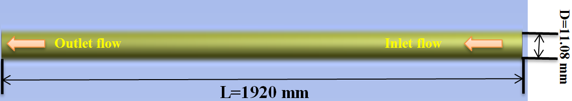
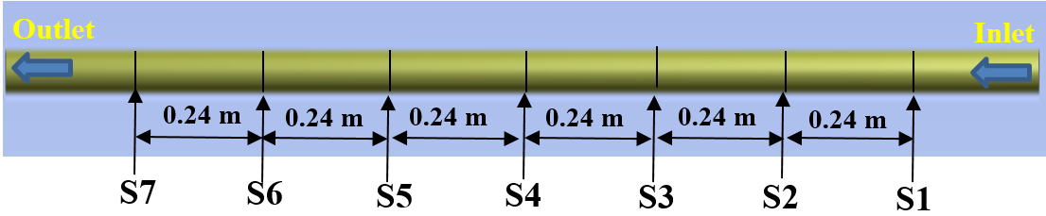

- Schematic of pipe without inserts and mesh domain

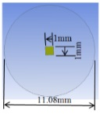 |  | 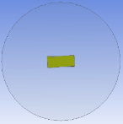
1mm x 1mm Twisted-tape geometry (Model-1) | 1mm x 2mm Twisted-tape geometry (Model-2) | 1mm x 2.5mm Twisted-tape geometry (Model-3) | 1mm x 3mm Twisted-tape geometry (Model-4)
Pipe with twisted tape insert
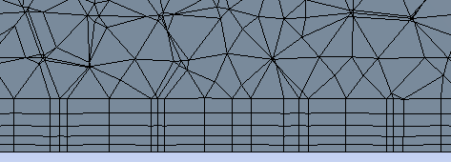
(b) Schematic of the pipe with twisted-tape inserts and mesh domain

Figure 1: Illustration of the heat exchanger pipe and fluid flow direction used in the computational flow domain: (a) Pipe and mesh without inserts; (b) Pipe and mesh with the four twisted-tape inserts configurations
Table 2: The mesh independency analysis
Number of mesh elements | CFD Nusselt number | Difference in  The Nusselt number analysis
 | (-) | (%)
1.2 million | 58.5
2.4 million | 60.8 | 3.75
3.5 million | 62.3 | 2.40
  - Governing Equations
In the present numerical model, the incompressible and continuity equations are used.
Continuity equation:
$\frac{∂u}{∂x}+\frac{∂u}{∂y}+\frac{∂u}{∂z}$ (1)
Momentum equation:
$ρ_{nf}\left(u\frac{∂u}{∂x}+v\frac{∂u}{∂y}+w\frac{∂u}{∂z}\right)=-\frac{∂p}{∂x}+μ_{nf}\left(\frac{∂^{2}u}{∂x^{2}}+\frac{∂^{2}u}{∂y^{2}}+\frac{∂^{2}u}{∂z^{2}}\right)$ (2)
$ρ_{nf}\left(u\frac{∂v}{∂x}+v\frac{∂v}{∂y}+w\frac{∂v}{∂z}\right)=-\frac{∂p}{∂y}+μ_{nf}\left(\frac{∂^{2}v}{∂x^{2}}+\frac{∂^{2}v}{∂y^{2}}+\frac{∂^{2}v}{∂z^{2}}\right)$ (3)
$ρ_{nf}\left(u\frac{∂w}{∂x}+v\frac{∂w}{∂y}+w\frac{∂w}{∂z}\right)=-\frac{∂p}{∂z}+μ_{nf}\left(\frac{∂^{2}w}{∂x^{2}}+\frac{∂^{2}w}{∂y^{2}}+\frac{∂^{2}w}{∂z^{2}}\right)$ (4)
Where, u, v, and w are the velocity components in the x, y, and z directions
P is the pressure, μ is Dynamic Viscosity and ρ is the density.

Energy equation:
The energy derivation relation equations has been used based on the work of Mashoofi, [24]:
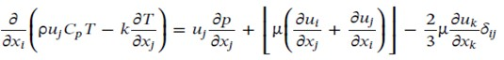
(5)

Where, μ, k, and C_{p} are the dynamic viscosity, turbulent kinetic energy, and specific heat respectively. In order to apply the coupling between pressure and velocity, the SIMPLE algorithm is adopted. While, the turbulence, energy, and momentum factors are solved in the 2nd order upwind scheme. The convergence scale for the flow and energy variables is defined 10⁻⁶.
2.3. Turbulent Flow Model
In this numerical investigation, the standard turbulent model of k-epsilon (k-ε) is used. This turbulent model consisted of two equations (rate of turbulent dissipation and turbulent kinetic energy) the equations (4) and (5) expressed the turbulent viscosity of K and ε functions [32-33].
The turbulence energy equation:
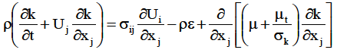 (6)
Turbulence dissipation:
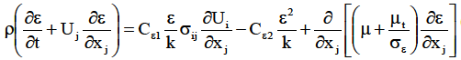 (7)
Turbulent viscosity:
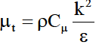 (8)
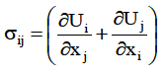 (9)
Calculation of the pressure drop equation is based on the Darcy-Weisbach equation
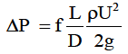 (10)
Where D represented the pipe diameter. f, U, and L are the friction factor, fluid velocity, and pipe length [23].
The friction factor is representing the loss of pressure of a fluid in a pipe due to the interactions in between the fluid and the pipe. The Darcy friction factor can be calculated using equation
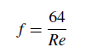 (11)
Also, the friction factor can be obtained using Filonenko’s friction factor correlation equation [32]:
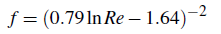 (12)
The Reynolds number was calculated using the following equation.
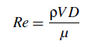 (13)
Where μ and ρ are the water dynamic viscosity (N.s/m²) and density (kg/m³), respectively.
The heat transfer rate in the pipe was calculated as follows:
$Q=ṁCp∆T$ (14)
Where, c_{p}, ΔT and ṁ are the specific heat capacity, temperature difference and mass flow rate, respectively.
2.3 Boundary Conditions and Simulation Range
For the numerical simulation the following boundary conditions were assumed :
- Smooth Pipe with constant heat flux of 800 W/m² assumed along the surface of the pipe [33].
- The working fluid is a single phase water with constant thermal properties due to the small range of the temperatures considered in this work. the bulk temperature (T_{b}) used for the properties is 293.15 K.
  - The inlet temperature of the water was held constant T_{in} = 313.15 K
  - Density of Water (ρ) = 992.32 kg/m³
  - Specific heat Capacity of Water (Cp) 4178 J/kg.K
  - Thermal conductivity of Water (k) = 0.63 W/m.K
  - Dynamic viscosity (μ) = 6.71E-04 Ns/m²
  - Prandtl number Pr 4.45
- Inlet velocity for each case as shown in table 2
- Inlet turbulence intensity is 5 % for the Turbulent flows V̇2 to V̇4
- Pressure at the outlet of the pipe is atmospheric
The simulations were performed for a range of Reynolds numbers between 1500 and 24000. Table 3, gives the flow rates and corresponding Reynold numbers used in the simulation.
Table 3: Ranges of flow rates and Reynolds numbers
Cases | Range of flow rate | Range of Reynolds number
(-) | (Litre/min) | (-)
V̇₁ | 0.56 | 1573
V̇₂ | 3.15 | 8912
V̇₃ | 5.74 | 16252
V̇₄ | 8.33 | 23592
- Validation of Numerical Results
Before starting, it was important first to investigate the flow structure in the smooth pipe without the inserts to gain an understanding of the local and global flow field characteristics. As mentioned previously, the dimensions and characteristics of a pipe with published experimental data were selected for this study and the CFD results were validate against the published data. Figure 2 shows a comparison of the heat transfer rate plotted versus the flow rate for both the CFD results from this study and the experimental results obtained from Albanesi et al. [34] for the smooth pipe without the insert. It is clear from figure 2 that the numerical simulation results follow the same trend as the experimental results with a good agreement between the experimental and the simulation results at the low and upper flow rates. The maximum deviation between the CFD results and the experimental data were less than 0 %, with the highest deviation occurring around the 3.15 m/s flow region. This in consideration is a good agreement between both results. This deviation could be attributed to the numerical diffusion within the solver (numerical errors–iterative convergence errors), or due to hydraulic losses, which is an important loss, caused by friction losses, vortexes, and separation due to change in flow direction.
In order to find more details concerning the flow pattern in a pipe without and with the inserts, a set of numerical analyses were conducted on the pressure, velocity, vorticity, temperature, TKE, wall shear stress, and turbulent intensity as represented in the next part.
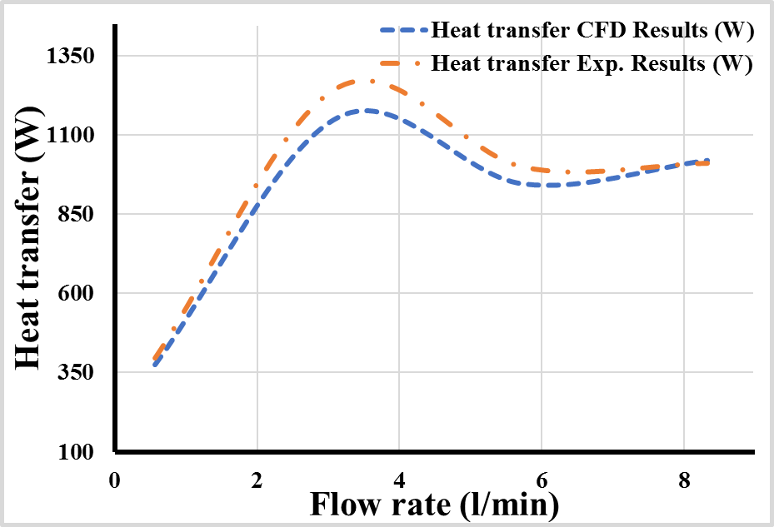
Figure 2: Veriﬁcation and validation of the numerical heat transfer results against physical experiment results
- Model Results and Discussion
  - Flow Field Investigation in pipe without inserts
As mentioned previously, in order to study the flow characteristic in a flow pipe, length of a pipe was divided into different cross-sectional zones as noticed in Figure 1a. Fluent post-processing was used to obtain the static pressure variations in the different sections of the pipe. The conditions used for the analysis are inward heat flux of 800 W/m²K and T_{in} of 313.15 K. Table 4, summarise the static pressure results obtained from the CFD model for the different flow rates V̇1= 0.56, V̇2= 3.15, V̇3= 5.74 and V̇4= 8.33 (l/min). As could be seen from the table, the maximum pressure was obtained at cross section S1 near the pipe inlet. the static pressures for section 1 increased with flow rate and are 28.6, 703.8, 1917.6, and 3865 Pa respectively, with the aforementioned flow rates. In addition, it can be clearly observed that the minimum static pressure value was achieved, as expected, close to the cross section S7.
Table 4: Static pressure (Pa) results at various sections of the pipe and for different flow rates without inserts
Section | Static Pressures (Pa) with V̇₁ | Static Pressures (Pa) with V̇₂ | Static Pressures (Pa) with V̇₃ | Static Pressures (Pa) with V̇₄
S1 | 29.6 | 704.8 | 1918.6 | 3865.4
S2 | 25.7 | 604.5 | 1646.1 | 3317.5
S3 | 21.5 | 503.9 | 1371.9 | 2764.4
S4 | 17.4 | 403.6 | 1098.5 | 2213.3
S5 | 13.3 | 302.7 | 824.3 | 1659.6
S6 | 8.21 | 202.4 | 549.1 | 1107.9
S7 | 5.18 | 101.8 | 255.9 | 555.2
In order to understand the flow dynamic mechanism, the variations of dynamic pressure (Pa) and velocity profiles within the smooth pipe were obtained from the simulation as shown in Figure 3. It is clear from Figure 3 a, that dynamic pressure is higher at the center of the pipe and reduces near the edges. This is in line with expectations and is due to the higher velocity magnitude in the centre of the pipe. Furthermore, it is noted that all dynamic pressure curves in Figure 3 b for the entire sections are smooth and they are identical and symmetrical to each other except cross section S1. This could be attributed to the inlet disturbance. Furthermore, increasing the flow velocity resulted in an increase in the dynamic pressure and the Reynolds’ number. This is in line with expectation as the Reynolds number is defined as the ratio of the inertia force (ρ u L) to viscous or friction force (μ) which can also be interpreted as the ratio of the dynamic pressure (ρ u²) to shearing stress (μ u / L).

- CFD results of the dynamic pressure inside the smooth pipe without inserts

Dynamic pressure (Pa)
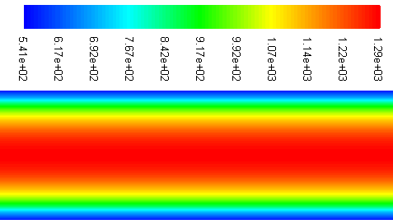

- Dynamic pressure and axial velocity profiles within the smooth pipe (without inserts) for different Reynolds numbers

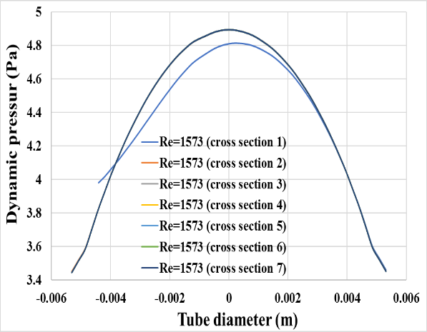 | 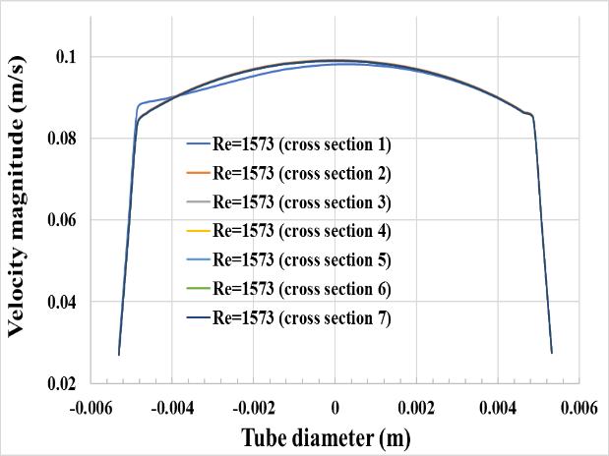
With Re 1573
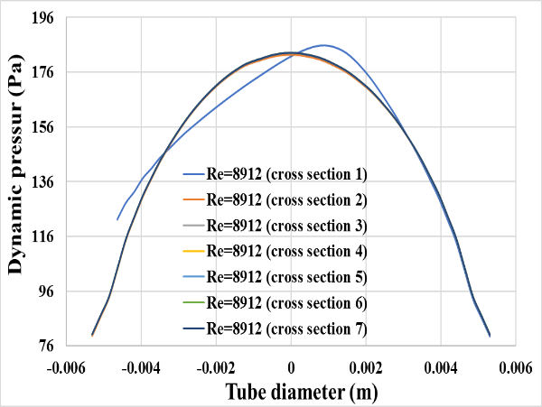 | 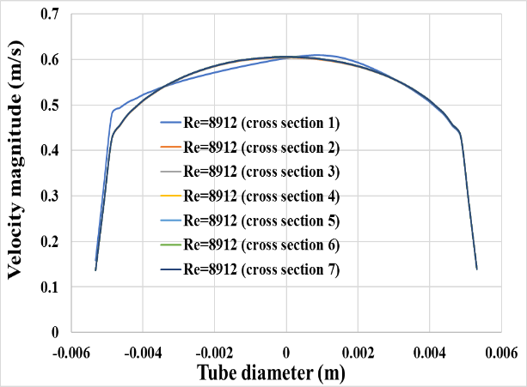
With Re 8912
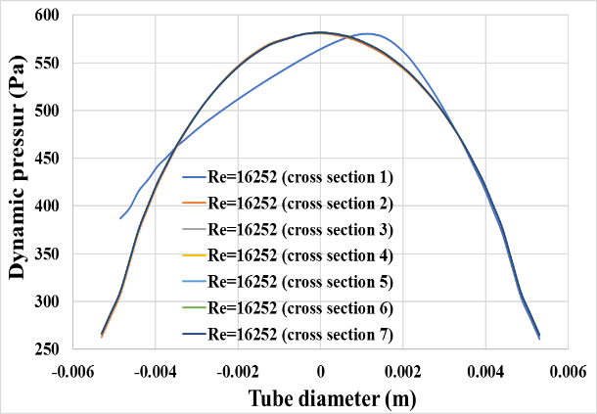 | 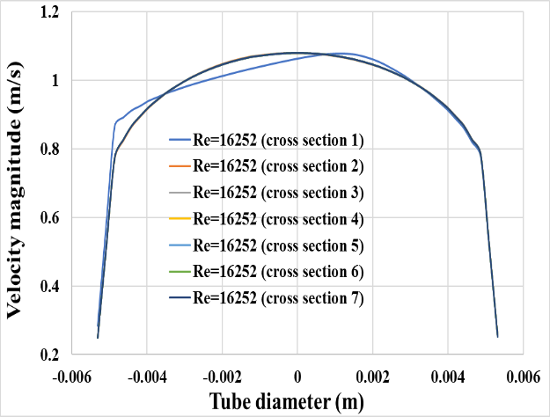
With Re 16252
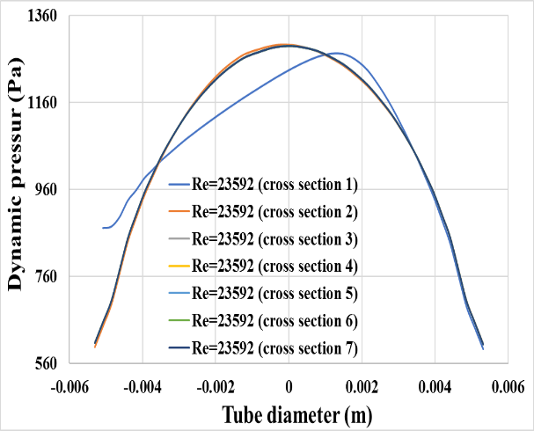 | 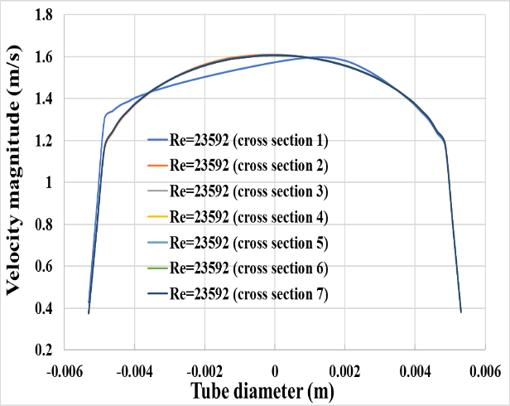
With Re 23592

Figure 3: Pressure and axial velocity profiles within the pipe (without inserts) at different sections and for different Reynolds numbers
  - Analysis of the Static Temperature Variations inside the Smooth pipe
Table 5, presents the model results for the static temperature variations along the length for different flow rates. The operating conditions used for the simulation are the heat flux of 800 W/m²K, and T_{in} of 313.15 K. It is clear from the results that the temperature drop was greatest at the low flow rate V̇₁ = 0.56 (l/min),
Table 5: Temperature results for pipe-without inserts at different cross sections and different flow rates
Cross Section | V̇₁  0.56 (l/min) | V̇₂  3.15 (l/min) | V̇₃  5.74 (l/min) | V̇₄  8.33 (l/min)
S1 | 311.84 K | 312.61 K | 312.81 K | 312.91 K
S2 | 310.49 K | 312.11 K | 312.51 K | 312.70 K
S3 | 309.24 K | 311.63 K | 312.21 K | 312.49 K
S4 | 308.07 K | 311.16 K | 311.91 K | 312.28 K
S5 | 306.99 K | 310.70 K | 311.62 K | 312.07 K
S6 | 305.99 K | 310.26 K | 311.33 K | 311.86 K
S7 | 305.06 K | 309.82 K | 311.05 K | 311.66 K
∆T_{S1 – S7} | 6.78 K | 2.79 K | 1.76 K | 1.25 K

  - Analysis with twisted-tape inserts
Following the initial CFD analysis and validation of the smooth pipe, a new set of CFD simulations were carried out without the inserts. Table 6, presents comparison of the the static pressures at different sections of the pipe with different insert models against to the static pressure for the tube without inserts. It is clear from table 6 that the static pressure values and pressure drops are greater with the twisted-tape inserts than the static pressure values and pressure drops obtained for the pipe without the inserts. Model 1 static pressure drop of 50.15 Pa between sections S1 and S7 compared to 24.42 Pa obtained for the pipe without the twisted-tape inserts. This equates to almost 2 fold increase in the pressure drop along length of the pipe. Similarly, for models 2, 3, and 4 the statics pressure drops along the length of the pipe were 58.72, 63.24, and 65.17 Pa, respectively.
Table 6: Comparison of the static pressure results obtained with different models of twisted-tape inserts in the pipe at flow rate of 0.56 (Litre/min) against that obtained without Inserts
section | Static Pressure | Static Pressure | Static Pressure | Static Pressure | Static Pressure
-
 | Without Insert | With Model-1 Insert | With Model-2 Insert | With Model-3 Insert | With Model-4 Insert
S1 | 29.6 | 58.51 | 68.54 | 73.78 | 75.98
S2 | 25.7 | 50.11 | 58.70 | 63.24 | 65.24
S3 | 21.5 | 41.74 | 48.92 | 52.72 | 54.25
S4 | 17.4 | 33.43 | 39.20 | 42.23 | 43.47
S5 | 13.3 | 25.11 | 29.44 | 31.76 | 32.80
S6 | 8.21 | 16.77 | 19.68 | 21.21 | 21.76
S7 | 5.18 | 8.36 | 9.82 | 10.54 | 10.81
S1- S7 | 24.42 | 50.15 | 58.72 | 63.24 | 65.17
It is also clear from the above table that the pressure values in the pipe with twisted tapes insert are higher than that obtained for the pipe without inserts. To view the effect of the different twisted-tape configurations on the flow, profiles of the dynamic pressure have been plotted along the pipe radius, as shown in figure 6, for different models of twisted-tape inserts and cross sections. The profile of dynamic pressure with the inserts is not-uniform compared to the profiles obtained with the smooth pipe without the inserts. Also, the dynamic pressure has greater non-uniformity when using twisted-tape inserts with bigger dimensions. The reason behind that is due to the twisted tape causing more unstable flow in the pipe espcially at the centre of the pipe, please figure 4 for more detail.
For comparative purposes, the total pressure (Pa) along the pipe was analysed for different models of twisted-tape inserts. It was found as expecetd, that the total pressures decreased along the length of the pipe reaching its lowest pressure value at end of the pipe. Figure 4, presents comparison of the velocity magnitude variations in the pipe with different twisted-tape insert models at a flow rate of 0.56 (l/min). It is clear from figure 4, that the region near the twisted insert exhibits clear velocity variation compared to the smooth pipe without an insert. Moreover, the numerical results have revealed that the minimum velocity takes place at two important regions the first one at the edges of the twist tape and the second region, as expected, adjscent to the inner walls surface of the pipe. Furthermore, the velocity near the twist tape changes as the dimensions of the twist tape increases as mentioned previously.
Impact of the different twisted tape geometries on radial and tangential velocity flow in the pipe are presented in figure 5 for a flow rate of 0.56 (L/min). It is clear that the twisted-tape induce swirling flow and mixing inside the pipe especially in the region close to tape inserts. Furthermore, the results show a greater effect on both the radial and tangential velocity components of the fluid with the wider twisted tap inserts especially near and close to the twisted-tape region as shown in figure 5. In addition, it can be observed that an increase of twisted-tape dimensions can cause more throttling influence and hence that can lead to producing more pressure gradient on both sides (upstream and downstream).
velocity magnitude (m/s) in the pipe with and without twisted-tape inserts
 | 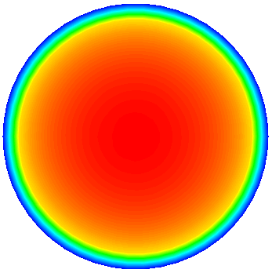
Smooth pipe without insert
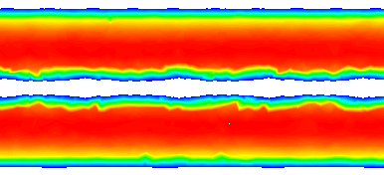 | 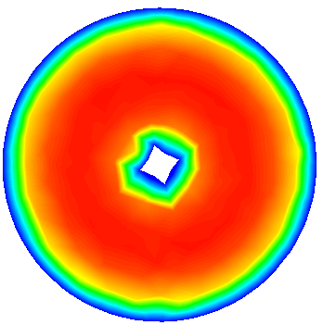
Pipe with insert-1mm x1mm Twisted-tape (Model-1)
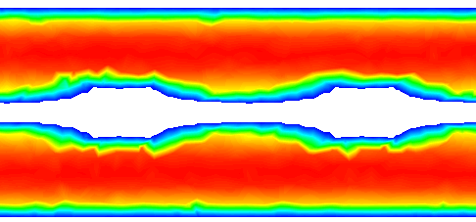 | 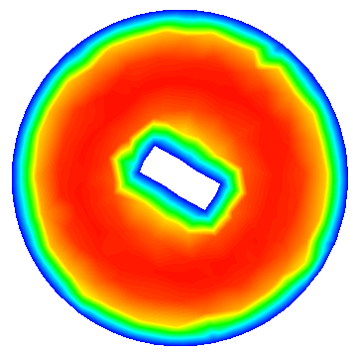
Pipe with insert - 1mm x2mm Twisted-tape (Model-2)
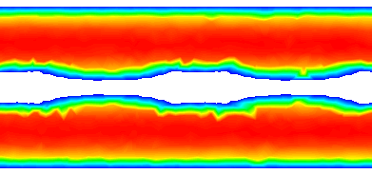 | 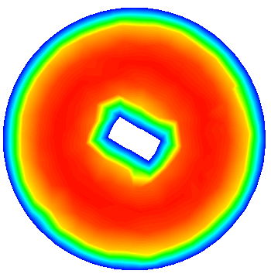
Pipe with insert- 1mm x2.5mm Twisted-tape (Model-3)
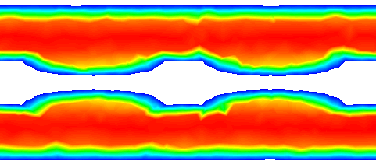 | 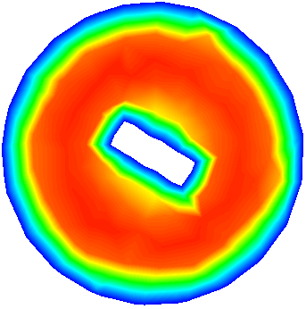
Pipe with indert -1mm x3mm Twisted-tape (Model-4)
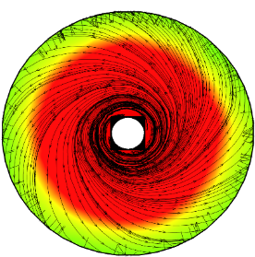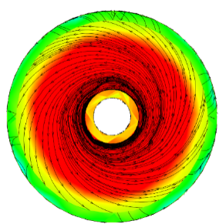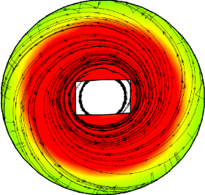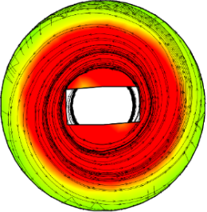
1mm x1mm 1mm x2mm 1mm x2.5mm 1mm x3mm
Figure 4: Comparison of the velocity magnitude (m/s) in pipe with and without twisted-tape inserts
The simulation showed that the twisted tape inserts affect the flow field inside the pipe near the insert. Increasing the dimensions of the twisted tape inserts resulted in an increase in the radial velocity (m/s) and the tangential velocity as depicted in Figure 5. The numerical results have shown that as the twist tape configuration dimensions increase that leads to the tangential velocity variations especially near and closed to the twist tape region as shown in this figure.

Radial velocity (m/s) | Tangential velocity profile (m/s)
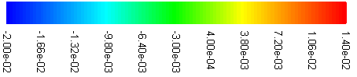 | 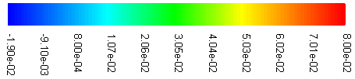
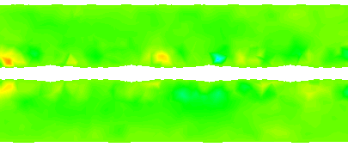 | 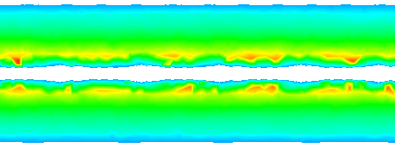
Pipe with 1mm x1mm Twisted-tape (Model-1)
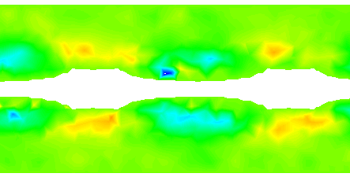 | 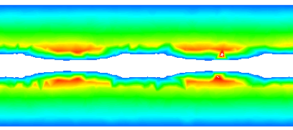
Pipe with 1mm x2mm Twisted-tape (Model-2)
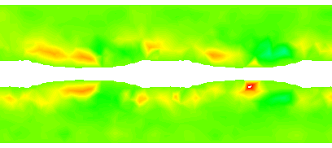 | 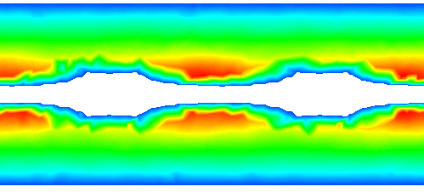
Pipe with 1mm x2.5mm Twisted-tape (Model-3)
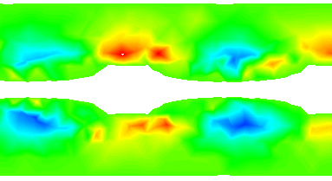 | 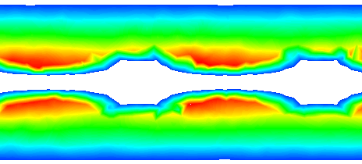
Pipe with 1mm x3mm Twisted-tape (Model-4)
Figure 5: Variations of the radial and tangential v velocity in the pipe with different twisted-tape geometries and at a flow rate of 0.56 (l/min)
The overall profile of static temperature (K) curves at varying sections of a pipe with different tape inserts are shown in Figure 6. In this figure also presents the static temperature profiles of the flow in the pipe without any inserts. It can be seen from the figure that the twisted-tape inserts induced a significant effect of the temperature profile, especially near the twisted-tape region. The twisted tape-insert induce mixing and swirling near the insert and overall results in greater temperature drop along the pipe when compared to the smooth pipe and resulted in greater temperature drop between sections S1 and S7, for example, the temperature drop for the smooth pipe between S1 and S7 is 8.9 K. However, the temperature drop between S1 and S7 with the 1 x 3 mm twisted-tape geometry reached 12.4 K.
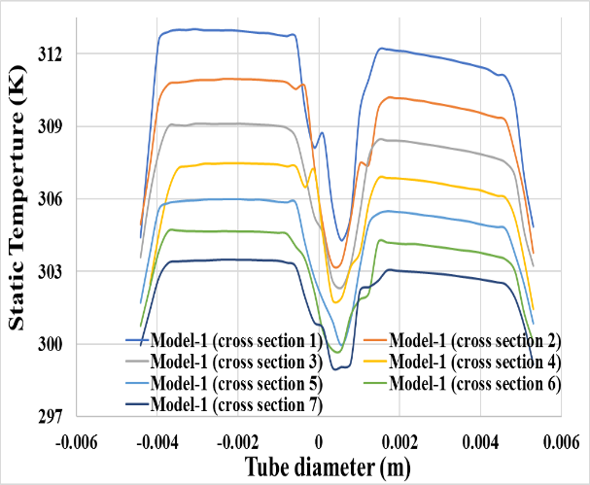 | 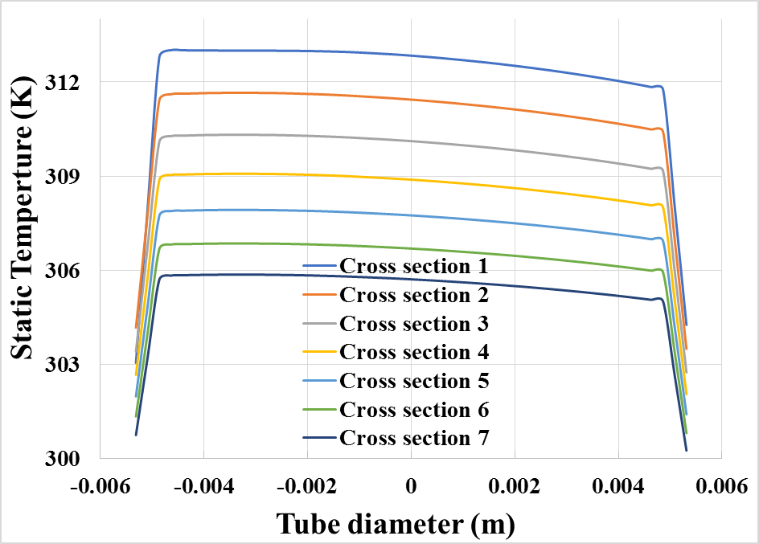
Pipe with 1mm x1 mm Twisted tape (Model-1) | Smooth pipe-without inserts
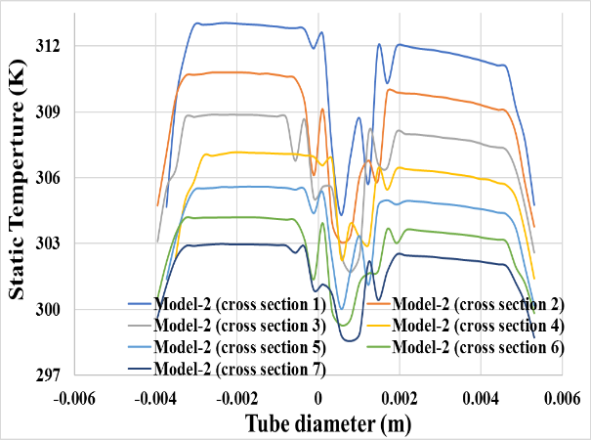
Pipe with 1mm x 2mm Twisted tape (Model-2) | Smooth pipe-without inserts
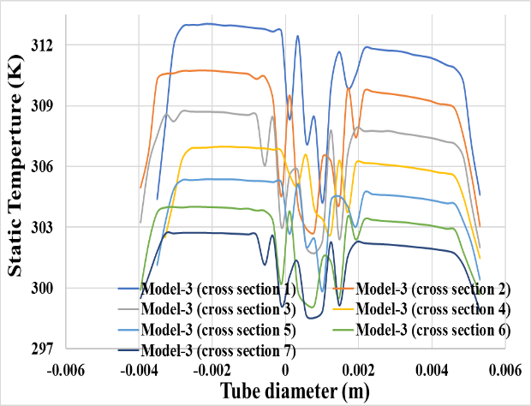
Pipe with 1 mx 2.5 mm Twisted tape (Model-3) | Smooth pipe-without inserts
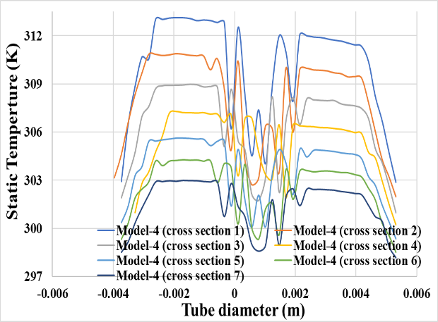 | 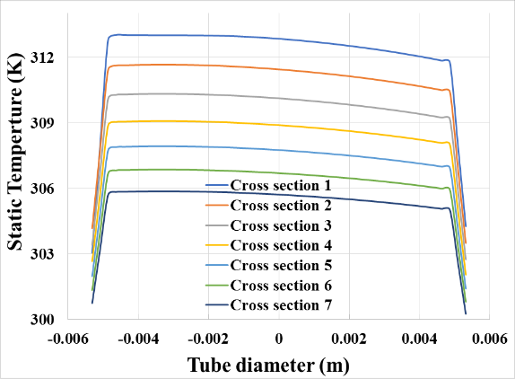
Pipe with 1mm x 3mm Twisted tape (Model-4) | Smooth pipe-without inserts
Figure 6: Comparison of the static temperature profiles flow in pipe with varying twisted compared to that of the pipe without inserts and at flow rate of 0.56 (l/min)
For more qualitative analysis, Figure 7 depicted the static temperature (K) differences at different section areas with various twisted tape models compared to similar locations for the smooth pipe without the twisted-tape inserts. It can be seen that overall the bulk temperature near the inlets (S1) is similar for all cases. However, with inserts, there is a reduction in the bulk temperature in sections 4 and 7. This is more predominant for wider twisted-tape inserts. This clear evidence of better heat transfer enhancement with inserts. Figure 7, depicts the static temperature (K) between each two cross section areas in the pipe. It can be seen that when a pipe length rises the static temperature declines. The latter pattern was for all models under investigation. Table 7, provides comparison of the temperature drop along the pipe at the four flow rates with and without inserts. By analysing the table, it can be noticed that as the twisted-tape dimension increase the temperature difference also increase especially at a low flow rate. The results found that the best heat transfer enhancement is at low flow rate and twisted-tape of 1mm x 3mm is equal 27.69%, 26.45%, 26.24% and 22.87% for twisted-tape dimensions of 2.5 mm x 1mm, 1mm x 2mm and 1mm x 1mm respectively. Based on the above numerical analysis it can be concluded that twisted-tape inserts in heat exchanger pipes can provide better heat transfer and mixing of the fluid near the twisted tape area.
Temperature (K)
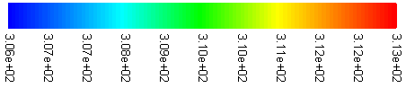
 | 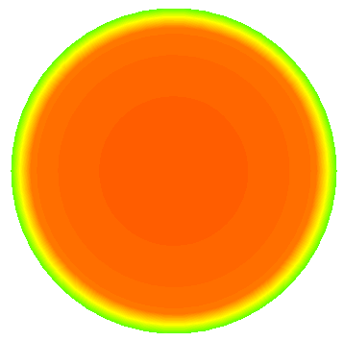
Smooth pipe-without insert-S7 | Smooth pipe-without insert-S4 | Smooth pipe-without insert- S1
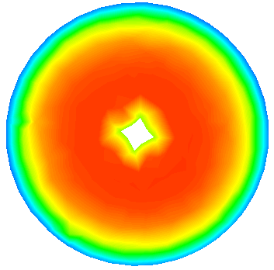 | 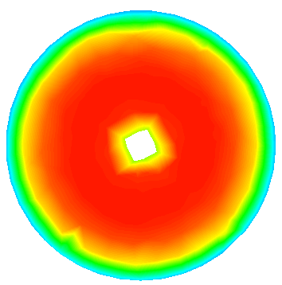
Model-1-S7 | Model-1-S4 | Model-1-S1
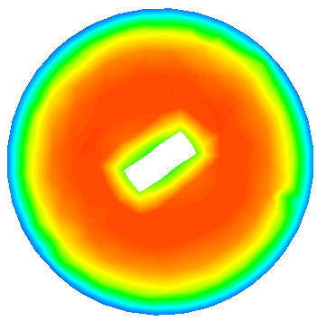
Model-2-S7 | Model-2-S4 | Model-2-S1
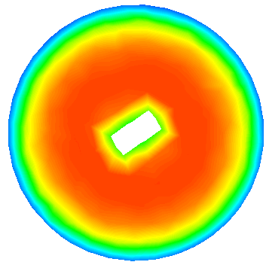 | 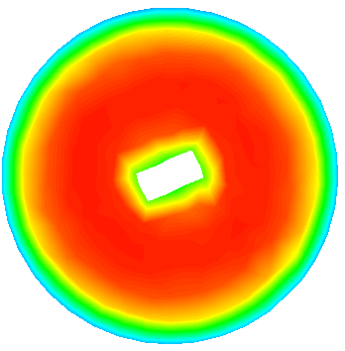 | 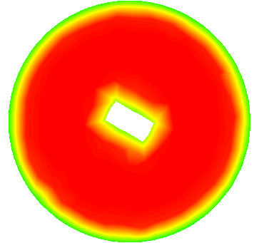
Model-3-S7 | Model-3-S4 | Model-3-S1
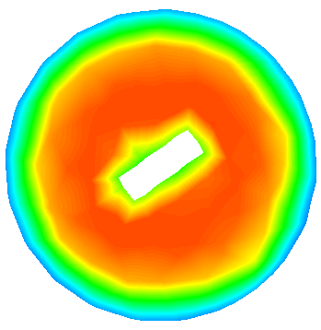
Model-4-S7 | Model-4-S4 | Model-4-S1
Figure 7: Simulation of the temperature (K) inside the pipe with the different twisted-tape geometries at flow rate of 0.56 (l/min)
Table 7: Temperature drop variations with different conditions
Flow rate | Temperature drop (ΔT) | Temperature drop (ΔT) | Temperature drop (ΔT) | Temperature drop (ΔT) | Temperature drop (ΔT)
l/min | K | K | K | K | K
 | Smooth pipe | Model-1 | Model-2 | Model-3 | Model-4
V̇1 | 8.947 | 11.60 | 12.130 | 12.166 | 12.374
V̇2 | 3.747 | 3.951 | 4.1596 | 4.276 | 4.280
V̇3 | 2.372 | 2.540 | 2.662 | 2.741 | 2.819
V̇4 | 1.686 | 1.886 | 1.966 | 2.021 | 2.058

The turbulence kinetic energy (J/kg) plays important role in the flow boundary layer. The latter parameter was commonly linked with the profile of velocity flow. Figure 8, illustrated the turbulent kinetic energy contour and shear stress within the twisted pipe. It can be noticed that the high value of turbulent kinetic energy happened close to the twisted-tape surface for all cases under investigation. Moreover, the numerical results have shown that the turbulence kinetic energy and flow shape variations when the twisted-tape dimensions increase. The simulation of the shear stress (Pa) in the pipe shows the presence of high shear stress close to the twisted-tape surfaces.
Turbulent Kinetic Energy (J/kg) | Shear Stress (Pa)
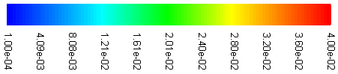 | 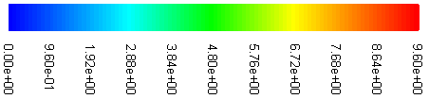
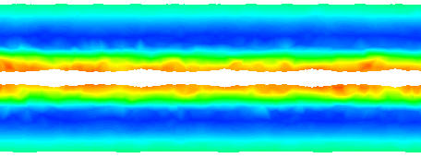 | 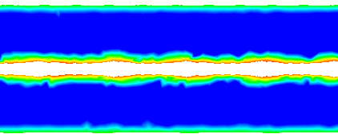
Pipe with 1mm x 1 mm Twisted-tape (Model-1) | Pipe with 1mm x 1 mm Twisted-tape (Model-1)
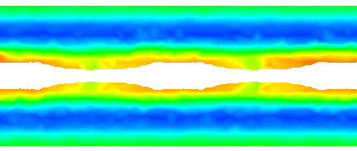 | 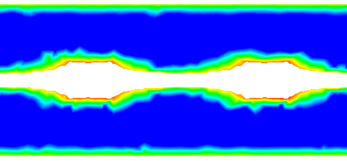
Pipe with 1mm x2 mm Twisted-tape (Model-2) | Pipe with 1mm x2 mm Twisted-tape (Model-2)
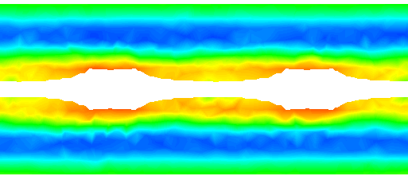 | 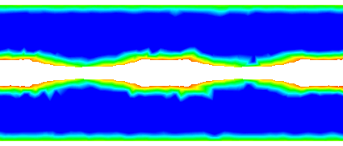
Pipe with 1mm x 2.5mm Twisted-tape (Model-3) | Pipe with 1mm x 2.5mm Twisted-tape (Model-3)
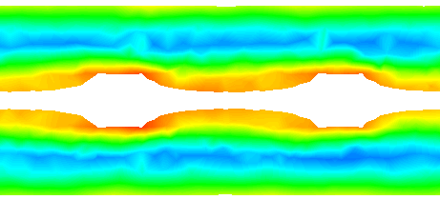 | 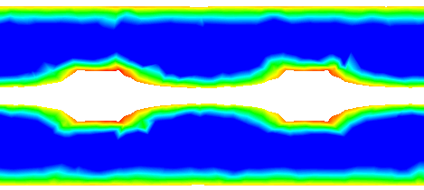
Pipe with 1mm x3mm Twisted-tape (Model-4) | Pipe with 1mm x3mm Twisted-tape (Model-4)
Figure 8: Variations of the turbulent kinetic energy (J/kg) and shear stress (Pa) in the pipe with the different twisted-tape geometries at flow rate of 0.56 (l/min)
- Conclusions
The thermo-hydraulic performance for a circular pipe with and without twisted-tape inserts was numerically studied for a range of Reynolds numbers (1500 to 24000) using a newly developed CFD model. Initially the model of the smooth pipe without inserts was validated using published experimental results from the literature. The maximum deviation between the CFD results and the experimental results was less than 10 %.
For the analysis with twisted-tape inserts, four different twisted-tape configurations were considered (1mm x1mm, 1mm x 2mm, 1mm x 2.5mm, and 1mm x 3mm). The simulations revealed the following findings:
- The twisted tape inserts resulted in swirling of the flow and transverse mixing in the area around the inserts.
- The pressure drop through the pipe-with-inserts was more than double the pressure drop through the same pipe without the inserts.

- The profile of the dynamic pressure, temperature, velocity flow, and static temperature were non-uniform at the center of the pipe compared to the smooth pipe. Furthermore, the dynamic pressure became more non-uniform as the twisted-tape dimensions increased.
- With regard to temperature, the twisted tape inserts induced a significant effect on the profile of static temperature especially near the twisted-tape boundaries and with the wider twisted-tape inserts, the effect on the static temperature in the core was more pronounced.
- The overall heat analysis revealed with the twisted tape inserts almost 28 % heat transfer enhancement with the 1mm x 3mm twisted-tape insert and almost 27%, 26% and 23% enhancement with the 1 x 2.5 mm. 1 x 2 mm and 1 x 1 mm twisted-tape inserts, respectively.

Acknowledgments
The authors would like to` thank both Mustansiriyah University (www.uomustansiriyah.edu.iq) Baghdad – Iraq and the School of the Built Environment and Architecture at London South Bank University (UK) for their support with the dissemination of this research work.
Authors ORCID ID
Dr Ahmed Ramadhan Al-Obaidi
https://orcid.org/0000-0003-3819-7008

Prof. Issa Chaer
https://orcid.org/0000-0001-7685-983X
Compliance with Ethical Standards:
Funding: This study was not funded.
Conflict of Interest: Author has not received any grants.
The authors declare that they have no conflict of interest.
References
[1] Aly, W. I. (2014). Numerical study on turbulent heat transfer and pressure drop of nanofluid in coiled tube-in-tube heat exchangers. Energy Conversion and Management, 79, 304-316.
[2] Khedkar, R. S., Sonawane, S. S., and Wasewar, K. L. (2014). Heat transfer study on concentric tube heat exchanger using TiO2–water based nanofluid. International communications in Heat and Mass transfer, 57, 163-169.
[3] Mohammed, H. A., Hasan, H. A., and Wahid, M. A. (2013). Heat transfer enhancement of nanofluids in a double pipe heat exchanger with louvered strip inserts. International Communications in Heat and Mass Transfer, 40, 36-46.
[4] Dengliang, Z., Hong, X., Yan, S., and Baojin, Q. (2010). Numerical heat transfer analysis of laminar film condensation on a vertical fluted tube. Applied Thermal Engineering, 30(10), 1159-1163.
[5] Zhnegguo, Z., Tao, X., and Xiaoming, F. (2004). Experimental study on heat transfer enhancement of a helically baffled heat exchanger combined with three-dimensional finned tubes. Applied Thermal Engineering, 24(14-15), 2293-2300.
[6] Hatami, M., Ganji, D. D., and Gorji-Bandpy, M. (2015). Experimental and numerical analysis of the optimized finned-tube heat exchanger for OM314 diesel exhaust exergy recovery. Energy conversion and management, 97, 26-41.
[7] Lee, E. J., & Kim, N. H. (2016). Evaporation heat transfer and pressure drop in flattened microfin tubes having different aspect ratios. International Journal of Heat and Mass Transfer, 92, 283-297.
[8] Eiamsa-ard, S., Pethkool, S., Thianpong, C., and Promvonge, P. (2008). Turbulent flow heat transfer and pressure loss in a double pipe heat exchanger with louvered strip inserts. International Communications in Heat and Mass Transfer, 35(2), 120-129.
[9] Naphon, P., and Suchana, T. (2011). Heat transfer enhancement and pressure drop of the horizontal concentric tube with twisted wires brush inserts. International Communications in Heat and Mass Transfer, 38(2), 236-241.
[10] Akhavan-Behabadi, M. A., Mohseni, S. G., Najafi, H., and Ramazanzadeh, H. (2009). Heat transfer and pressure drop characteristics of forced convective evaporation in horizontal tubes with coiled wire inserts. International Communications in Heat and Mass Transfer, 36(10), 1089-1095.
[11] Al-Obaidi, A. (2018). Experimental and Numerical Investigations on the Cavitation Phenomenon in a Centrifugal Pump (Doctoral dissertation, University of Huddersfield).
[12] Al-Obaidi, A. R. (2019). Monitoring the performance of centrifugal pump under single-phase and cavitation condition: A CFD analysis of the number of impeller blades. Journal of Applied Fluid Mechanics, 12(2), 445-459.
[13] Mangtani, M. P., & Watt, K. M. (2015). EFFECT OF TWISTED-TAPE INSERTS ON HEAT TRANSFER IN A TUBE-A REVIEW. International Journal of Mechanical Engineering and Robotics Research, 4(2), 97.
[14] Sarada, S. N., Raju, A. S. R., Radha, K. K., & Sunder, L. S. (2010). Enhancement of heat transfer using varying width twisted-tape inserts. International Journal of Engineering, Science and Technology, 2(6).
[15] Eiamsa-ard, P., Piriyarungroj, N., Thianpong, C., & Eiamsa-ard, S. (2014). A case study on thermal performance assessment of a heat exchanger tube equipped with regularly-spaced twisted-tapes as swirl generators. Case Studies in Thermal Engineering, 3, 86-102.
[16] Tamna, S., Kaewkohkiat, Y., Skullong, S., and Promvonge, P. (2016). Heat transfer enhancement in tubular heat exchanger with double V-ribbed twisted-tapes. Case studies in thermal engineering, 7, 14-24.
[17] Suri, A. R. S., Kumar, A., and Maithani, R. (2017). Effect of square wings in multiple square perforated twisted-tapes on fluid flow and heat transfer of heat exchanger tube. Case Studies in Thermal Engineering, 10, 28-43.
[18] Bhattacharyya, S., Chattopadhyay, H., and Benim, A. C. (2017). Simulation of heat transfer enhancement in tube flow with twisted-tape insert. Progress in Computational Fluid Dynamics, an International Journal, 17(3), 193-197.
[19] Osley, W. G., Droegemueller, P., and Ellerby, P. (2013). CFD investigation of heat transfer and flow patterns in tube side laminar flow and the potential for enhancement. In Conference chemical engineering transactions PRES (Vol. 13, pp. 997-1002).
[20] Deshmukh, K. P., Dhanokar, M. J., Varkute, N. S., and Kumar, T. S. (2014). Numerical simulation of enhancement of heat transfer in a tube with and without rod helical tape swirl generators. International Journal of Mechanical Engineering and Technology, 5(6), 1-13.
[21] Yadav, R. J., and Padalkar, A. S. (2012). CFD analysis for heat transfer enhancement inside a circular tube with half-length upstream and half-length downstream twisted-tape. Journal of Thermodynamics 2012(1).
[22] Sivakumar, K., and Rajan, K. (2015). Experimental analysis of heat transfer enhancement in a circular tube with different twist ratio of twisted-tape inserts. International Journal of Heat and Technology, 33(3), 158-162.
[23] Bhosale, A., Karunamurthy, K., and Sivakumar, R., (2015). CFD analysis on heat transfer enhancement and pressure drop reduction in tube fitted with rectangular cut twisted-tapes. International Conference on Technological Convergence for Information, Health, Food, Energy Security, CSIR-CLRI, 1-2 May 2015.
[24] Mashoofi, N., Pourahmad, S., and Pesteei, S. M. (2017). Study the effect of axially perforated twisted-tapes on the thermal performance enhancement factor of a double tube heat exchanger. Case studies in thermal engineering, 10, 161-168.
[25] Nagarajan, G. and Ranganathan, S. (2015). Heat Transfer Enhancement in Double Pipe Heat Exchanger with Twisted Type Inserts In ANSYS Fluent. International Journal of Engineering Development and Research. Volume 3, Issue 2 | ISSN: 2321-9939.
[26] Nakhchi, M. E., & Rahmati, M. T. (2020). Entropy generation of turbulent Cu–water nanofluid flows inside thermal systems equipped with transverse-cut twisted turbulators. Journal of Thermal Analysis and Calorimetry, 1-10.‏
[27] Nakhchi, M. E., Hatami, M., & Rahmati, M. (2020). Experimental investigation of heat transfer enhancement of a heat exchanger tube equipped with double-cut twisted tapes. Applied Thermal Engineering, 180, 115863.‏
[29] Nakhchi, M. E., & Esfahani, J. A. (2020). Numerical investigation of heat transfer enhancement inside heat exchanger tubes fitted with perforated hollow cylinders. International Journal of Thermal Sciences, 147, 106153.‏
[30] Nakhchi, M. E., & Esfahani, J. A. (2020). CFD approach for two-phase CuO nanofluid flow through heat exchangers enhanced by double perforated louvered strip insert. Powder Technology, 367, 877-888.‏
[31] Albanesi, A. W., Daish K. D., Dally B. and Chin R. C., (2018). Investigation of heat transfer enhancement in dimpled pipe flows. 21st Australasian Fluid Mechanics Conference Adelaide, Australia.
[32] Filonenko, G. K. (1954), "Hydraulic Resistance in Pipes," Teploenergetika (In Russian), Vol. 1 pp. 10-44
[32] Al-Obaidi, A. R. (2019). Investigation of fluid field analysis, characteristics of pressure drop and improvement of heat transfer in three-dimensional circular corrugated pipes. Journal of Energy Storage, 26, 101012.‏
[33] Al‐Obaidi, A. R. (2020). Investigation of the influence of various numbers of impeller blades on internal flow field analysis and the pressure pulsation of an axial pump based on transient flow behavior. Heat Transfer, 49(4), 2000-2024.‏
[34] Al‐Obaidi, A. R. (2020). Analysis of the flow field, thermal performance, and heat transfer augmentation in circular tube using different dimple geometrical configurations with internal twisted‐tape insert. Heat Transfer.‏

