Chapter 5
Display of unwrapped foods
Tim Brown
Refrigeration Developments and Testing Limited, Churchill Building, Langford, Bristol, BS40 5DU, UK

Introduction

Display of unwrapped food products presents particular challenges to the retailer. Unwrapped products include delicatessen items such as sliced raw, cooked and cured meat, cheeses and other ‘delicacies’, fish displayed on ice, fruit, vegetables, salad and other ready to eat (RTE) food items. Without sealed protective packaging they are subject to loss of surface moisture through evaporation, and this can represent a loss of quality, reduced display life and also a loss in saleable weight. In addition, contamination from handling and external sources, as well as cross contamination between different unwrapped items, can lead to microbiological spoilage and safety issues.

Mass transfer

The rate of moisture loss from unwrapped product surfaces can be approximated using the following equation:

m = k . (p_{ws} . a_{w} – p_{wa} . RH / 100) . A

where

m = rate of moisture loss (kg.s⁻¹)
k = mass transfer coefficient (kg.m⁻².Pa.s )
p_{ws} = water vapour pressure at the product surface (Pa )
a_{w} = water activity (no units)
p_{wa} = water vapour pressure at saturation in the surrounding air (Pa )
RH = relative humidity (%)
A = surface area (m²)

The mass transfer coefficient is a measure of the ability of the product surface to air interface to transfer mass (moisture), and is dependant among other things on the velocity of the air passing over the surface. The water vapour pressures are the pressure exerted by water vapour at the temperatures of the surface and the air. Water activity is the availability for evaporation of water at the product surface. The relative humidity is the proportion of water vapour in the air relative to the amount it can hold when saturated. It can be noted that if the product is at the same temperature as the air, the vapour pressures will be the same, and mass transfer will then be proportional to the difference between water activity and RH / 100.

To minimise mass transfer it is therefore important that the product temperature is as close as possible to the air temperature and that the relative humidity of the air is maintained at high levels (but not excessive levels as this may promote bacterial growth). Refrigeration systems in display cabinets will of course produce air which is colder than the product to allow for heat loads such as infiltration, transmission and radiation. They also tend to dry out the air, as moisture is condensed on the cold surfaces of the evaporator. This can be reduced to some degree by careful temperature control and by using large surface area evaporators which operate at temperatures closer to the product temperature. If this is not sufficient and product drying is still excessive, the use of additional moisture maintenance systems may be advisable and examples of these are described later.

The impact of weight loss on quality and operating costs

The display lives of unwrapped foods are normally limited by changes in appearance, including surface drying and darkening, such as the changes found by James and Swain, 1986 for red meat (Table 1), and for other products cracking or wilting of surfaces such as cut stems or leaves.

Table 1. Effect of evaporative weight loss on the appearance of raw sliced beef topside (James and Swain, 1986)
Evaporative loss (g.cm⁻²) | Change in appearance
up to 0.01 | Red, attractive and still wet; may lose some brightness
0.015 - 0.025 | Surface becoming drier; still attractive but darker
0.025 - 0.035 | Distinct obvious darkening; becoming dry and leathery
0.035 - 0.05 | Dry, blackening
0.05 - 0.10 | Black

Relative humidity had the greatest impact on these weight losses, with a reduction from 95 to 40% increasing weight loss over a six hour display period by a factor of between 14 and 18. The effect of RH on weight loss was confounded by that of air velocity. Raising the air velocity from 0.1 to 0.5 m.s⁻¹ had little effect on weight loss at 95% RH but increased the loss by a factor of between 2 and 2.4 at 60% RH. Temperature changes from 2 to 6°C had a far smaller effect on weight loss than the changes in either relative humidity (from 95 to 40%) or velocity (from 0.1 to 0.5m.s⁻¹) used in the investigations. Fulton et al. (1987) showed that fluctuations in temperature or relative humidity had little effect on weight loss and any apparent effect is caused by changes in the mean conditions.

Evans and Russell (1994a, b) also showed that RH was the main factor controlling weight loss during the display life of a range of delicatessen products. At an RH of 40% the effect of surface drying became apparent after approximately 100 minutes, whereas at 85% RH the products could be displayed for between 4 to 6 hours before surface drying could be noted. The overall weight loss at 40% RH was approximately 3 times that at an RH of 85%.

In the same work they also found that changing the type of lighting could have a significant impact on weight loss. Changing from a combination of 50 W sodium lamps and 100 W halogen lights to 100 W sodium lamps and a colour 83 fluorescent light resulted in an increase in weight loss similar to that produced by a 20% reduction in relative humidity. On average the rate of weight loss under the combination of 50 W sodium lamps and 100 W halogen (spot) lights was approximately 1.4 times less than the 100 W sodium lamps and colour 83 fluorescent lighting (Figure 1). The effect of lighting was attributed to the radiative heating effect from the hot bulbs/lamps. Interestingly, more modern low energy light emitting diode (LED) lighting would be beneficial in this respect and is becoming increasingly common in many display applications.

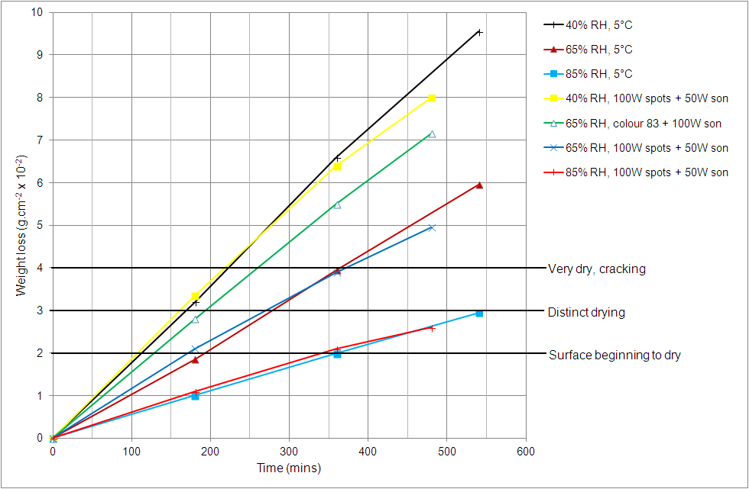
Figure 1. Comparison of mean weight loss for delicatessen products displayed with different relative humidities and lighting regimes (Evans and Russell, 1994b)

In addition to reducing display life and increasing waste, weight loss also directly reduces the mass of product available for sale to consumers. For example, the direct cost of evaporative loss from unwrapped sliced meats alone was estimated in 1986 to approach £2.5m per annum in the UK (Swain and James, 1986). Maidment et al (1999a) put these costs into the perspective of the total cost of operating a delicatessen cabinet, and although the relative proportions of the costs (and particularly the prominence of energy) may have altered slightly in recent years, the cost of weight loss is still by far the greatest operating cost (Figure 2). The influence of cabinet design choices on life cycle cost savings was also shown to be largely dependent on their effect on evaporative weight losses. Reduction of heat loads on the cabinet (e.g. conduction and radiation) generally allows for increases in evaporator temperature, and this in turn results in less dehydration of the cabinet air. Weight losses from the food are thereby decreased. In a similar way, increasing the heat transfer area of the evaporator allows for warmer evaporator temperatures and reduction of evaporative weight loss.
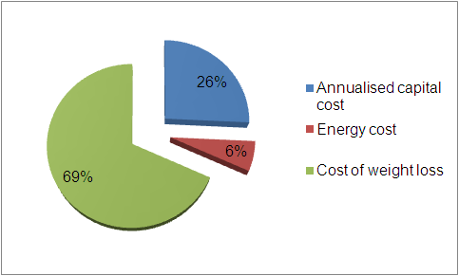

Figure 2. Breakdown of annualised operating costs for a delicatessen cabinet (Maidment et al, 1999a)

Common types of display cabinets for unwrapped food

Display cabinets used for unwrapped food products vary depending on the type of food and how it is merchandised.

- Delicatessen products
Delicatessen display cabinets are often ‘serve-over’ designs, typically open at the rear for staff-assisted sales but some having open fronts for self service.

- Fruit and vegetable produce
With higher stocking levels of bulkier (and cheaper) items, produce cabinets are often based on open-fronted multi-deck designs similar to those used in the main refrigerated aisles for wrapped products. However, increasing sales of fresh produce have led over recent years to ever greater dedicated sales floor areas, and bespoke display cabinet designs with flat, tiered or sloping displays which are now more commonplace.

- Fish
Unwrapped fish is often sold from horizontal or sloping displays, often utilising the traditional method of storage on ice. Moist surfaces of skin and exposed cut surfaces on fillets and portions are particularly susceptible to weight loss and its effects on appearance.

Schematic representations of typical cabinet designs are presented in Chapter 2.

Air circulation in the cabinets can be driven by natural convection, where denser cooled air from the raised rear-mounted evaporator coil descends into the display area and less dense warm air rises back to the evaporator. These types of cabinet are often termed ‘gravity’ cabinets, and can work well where product loading is uniform and the low air velocities are sufficient to maintain a reasonable temperature distribution in all parts of the display. However, high usage and frequent access by sales staff can affect air distribution.

For increased air circulation, ‘forced air’ cabinets are used. These can be similar to the gravity design but employ fans to draw the air through the evaporator coil and pass it over the display area before circulating back to the evaporator. Alternatively the airflow may be ducted, with fans supplying air to a back duct at the rear of the display. Perforated panels and a discharge air grille distribute the cold air into the cabinet to pass over the products before collection by a return air grille for return to the fans and evaporator.

Examples of display cabinets for unwrapped products are shown in Figure 3.

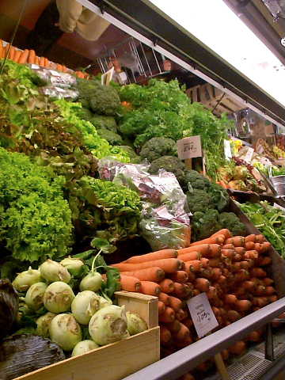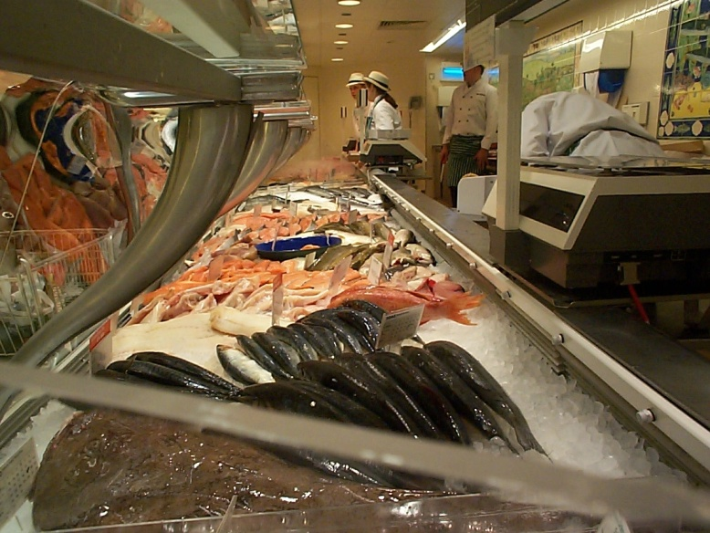

Figure 3. Examples of displays for unwrapped products (courtesy Pendred Humidification & Water Systems, London, UK)

Temperature and moisture control issues

Although the ideal conditions for storage and display of many products have been defined (see for example Paul, 1999), the conditions found in practice are often far from ideal and cabinet designs have changed little over the years (Maidment et al, 1999a). In a typical study, Nunes et al (2009) surveyed temperatures and relative humidities in refrigerated and unrefrigerated fruit and vegetable display cabinets. Temperatures measured inside the displays ranged from −1.2 to 19.2°C in refrigerated displays and from 7.6 to 27.7°C in non-refrigerated displays. RH ranged from 55.9% to 92.9% in refrigerated displays and from 29.7% to 86.6% in non-refrigerated displays. An estimated 55% of produce wasted at retail was attributed to the effects of poor temperature management and low relative humidities.

A feature common to the types of cabinets used for unwrapped products is open fronts or backs for access either by the customer or by serving staff. These large openings make the cabinets susceptible to infiltration of warm and moist ambient air from the store. This increases the heat load on the cabinet, and also adds significant amounts of moisture, which as mentioned earlier, subsequently condense and freeze on the cold surfaces of the cabinet’s evaporator. Careful defrost scheduling is required to make sure that this ice is removed without adding even more heat from overly long or too frequent defrosting.

A common approach to maintaining high relative humidity in chilled spaces is to use large evaporators operating with small temperature differences. This results in less condensation of moisture from the air and increases the dew point in the air. However, in the case of delicatessen and serve-over cabinets evaporator temperatures smaller evaporators are often used to maximise loading volume, and this can mean that lower evaporating temperatures than those normally used for chilled cabinets are required. Although this may help to maintain acceptable temperatures, it can also reduce relative humidities and increase the rate at which the evaporators ice up. As it is desirable from the products’ point of view to maintain high relative humidities in the cabinets, the drying effect of the refrigeration system is often counter-balanced using methods of humidification. However, if these are not carefully controlled, they can also increase the rate at which evaporators ice up. In such situations, defrost systems and the strategies used to control them become increasingly important.

Control of refrigerant flow into the cabinets is another important consideration. Maidment et al (1999b) examined the role of common thermostatic expansion valves (TEVs) in temperature and humidity maintenance of delicatessen cabinets. TEVs were found to be unstable in operation and produced relatively high evaporator temperature differences, which constrained the levels of humidity achieved in the cabinets. Alternative expansion devices such as capillary tubes, short tube restrictors and thermistor type electronic expansion valves (TEEVs) were considered. Such work emphasises the importance of correct expansion device sizing and setup in maintaining evaporator performance which does not excessively dehumidify cabinet air and lead to high weight losses.

Reducing weight loss and drying by humidification

While good control of temperature, humidity and airflow can help to reduce evaporative weight loss, use of humidification systems can offer more effective control. Several types of equipment are used to maintain high moisture levels in the air inside display cabinets or to provide sacrificial layers of moisture on the displayed food products, which evaporate in preference to moisture from within the food and thereby reduce drying. The majority of systems introduce water droplets, and depending on the size of the water droplets these are commonly referred to as fogging or misting systems. Although definitions vary, the water droplets produced by fogging systems are typically less than 50 µm in diameter, while those produced by misting systems are generally larger at up to 100 µm in diameter.

The equipment used in humidification systems are typically:
- Ultrasonic humidification units with one or more transducers submerged in small fresh water reservoirs. When energised these transducers vibrate at ultrasonic frequencies, and this vibration transfers to the water molecules in the reservoirs, causing some to ‘nebulise’ and leave the bulk of the water. These subsequently form a fog of water droplets which can be readily distributed to the display areas using cabinet ductwork or distribution bars. The fogging system is typically operated continuously during store opening hours, but can be based on simple on-off operation using a timer. On cabinets where a night blind or cover is used during store closure, a humidistat can be used to maintain a set level of humidity.
- Spray systems introduce pressurised water via fine spray nozzles, producing mists which deposit water onto the food surfaces. Operation tends to be periodic (for example for several seconds every 10 or 15 minutes).
- Steam generators can also be used to introduce large amounts of moisture vapour, although as they introduce heat as well as moisture they are less suited to low temperature applications.

Figure 4 shows example of humidification systems installed on produce and meat displays:

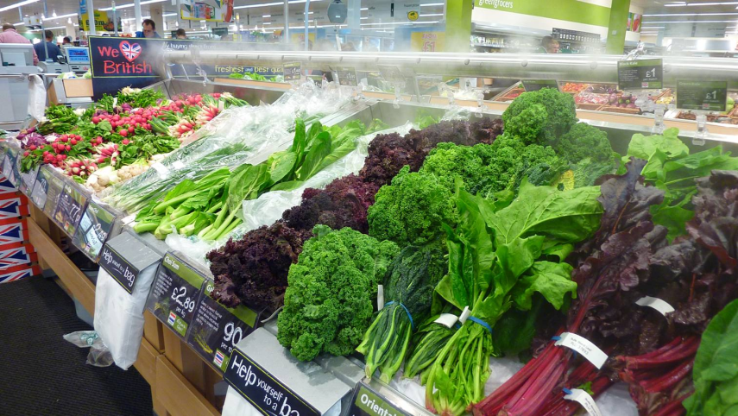
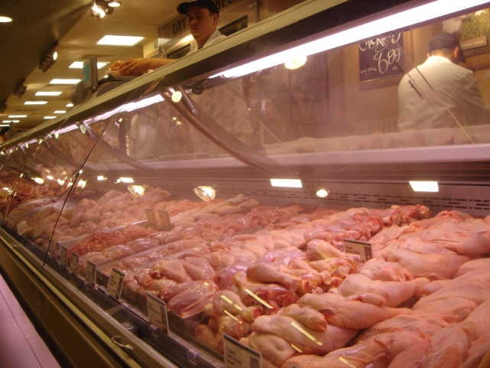
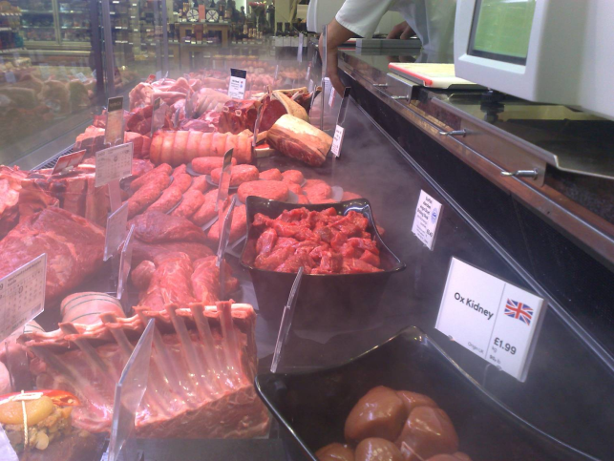

Figure 4. Humidification systems in use on produce and meat displays

Hygiene

Maintaining hygiene is extremely important in systems which could otherwise harbour and promote the growth of food spoilage or even pathogenic bacteria. As well as contamination of the food, in the past there have also been reports of outbreaks of Legionaire’s Disease attributed to the use of humidification equipment on display cabinets (Anon, 1990), although these have been associated either with unrefrigerated displays or with malfunctioning hygiene maintenance measures. Measures to maintain hygiene include air treatment, water treatment and decontamination techniques for the equipment and / or the cabinets:
- Air treatment is the simplest of these, typically being filtration to remove dirt particles and other unwanted matter.
- Water treatment begins with de-mineralisation to avoid build up of calcium chloride deposits on the humidification equipment and surfaces of the cabinets. It also includes filtration, often by Reverse Osmosis where the water is forced through a semi-permeable membrane which can remove not only particulate matter but also typical dissolved impurities. If required activated carbon filters can also be used to remove chemical content.
- Active control of bacteria and decontamination of the equipment can include use of chemical systems e.g. chlorine dioxide and ozone, ultra violet lamps, heat treatment and bactericidal coatings. Chlorine dioxide and ozone can be used not only for routine treatment of water supplies, but also for periodic cleansing of the display cabinets. Consideration must however be given to possible oxidation issues with certain foods and packaging, which in the extreme can cause, for example, fat rancidity and rapid deterioration of materials such as elastic bands. Ultra violet lamps and heat treatment are aimed at decontamination of incoming water, and bactericidal coatings can decrease the viability of deposited bacteria and prevent growth in numbers and development of bio-films.

Research results – hygiene and bacteria

Retailing of unwrapped food such as delicatessen products, which are often ready to eat (RTE) items requiring no heat treatment before consumption, can present significant hygiene challenges. A considerable number of surveys and laboratory studies have focussed on handling and hygiene practices in staff-served retail environments, and also on the microbiological condition of the products themselves. Some examples which highlight the need for strict and careful hygiene practices are given below.

Christison, Lindsay and von Holy (2008) conducted microbiological sampling of various RTE foods in delicatessen outlets in South Africa, and found that counts of Escherichia coli were highest in filled baguettes and salads containing meat. Possible causes were said to include poor handling practices by food handlers, cross contamination from food contact surfaces, or high storage temperatures (which were found in the study). Contamination on hands, utensils and equipment surfaces were also studied. Coliform counts of cutting surfaces and on processors’ hands were higher than those on knives and utensils, indicating that hygiene practices related to cleaning of surfaces and hands were less effective. In a similar study Lues and Tonder (2007) surveyed the bacterial contamination on delicatessen workers’ hands and aprons, both of which were frequently contaminated to unacceptable levels.

Hygiene practices and microbiological quality during slicing and handling of Spanish cooked meat products were evaluated by Pérez-Rodríguez et al (2010). Greater incidences of contamination of various bacteria, including Listeria spp., were found on samples from smaller retail organisations, and it was concluded that hygiene education and practices needed to be improved, particularly in these retailers.

Firmesse et al (2012) assessed how quickly the surfaces of a supermarket delicatessen counter can become loaded with bacteria and how bacterial attachment strengths vary with time, cleaning and disinfection. On new polyvinyl chloride and stainless steel surfaces, levels of bacteria reached 10³–10⁴ log total cells/cm² on day 1, although they remained at these levels subsequently due to the lack of growth at refrigerated temperatures and as a result of cleaning and disinfection compensating for further deposition of bacteria. Attachment strengths increased with time.

Elviss et al (2009) determined the prevalence of salmonella contamination and levels of Escherichia coli in fresh ready to eat herbs on sale in the UK. 0.5% of samples of six different herb types were contaminated with Salmonella spp. and a total of 1.6% of herb samples were found to be of unsatisfactory quality according to Regulation (EC) No. 2073/2005 on the microbiological criteria of foodstuffs, i.e. contaminated with any Salmonella spp. and/or Escherichia coli at >10³ cfu/g. The necessity of applying good agricultural and hygiene practices pre-, during and post-harvest, at processing, retail and use was reiterated. Best practice was said to include storage and display at, or below, 8°C as this inhibits bacterial growth.

Research results – impact of humidification systems

Research studies have also looked at various aspects relating to the benefits and potential risks involved in the use of moisture maintenance systems for storage and display of foods. For example, Brown et al (2004) assessed weight losses and quality impacts on fruit and vegetable produce displayed in a cabinet with and without the use of an ultrasonic humidifier. Display lives were extended and weight losses, although variable with product type, were reduced by up to almost 50% over 7 days. No significant impact was found on product temperatures or on bacterial load on the produce and cabinet shelf surfaces, the latter probably because the humidification system included an ozone sterilisation system. This was followed by a similar study on display of meat (Brown et al, 2007), this time using an ultrasonic humidifier without ozone sterilisation. The studied confirmed the benefits of reduced weight loss (Figure 5) and extended display life (the un-humidified trial terminated at 14 h due to surface drying and deterioration of appearance, whereas the humidified trial continued to 24 h), but suggested that the use of active bacterial control measures might be advisable.

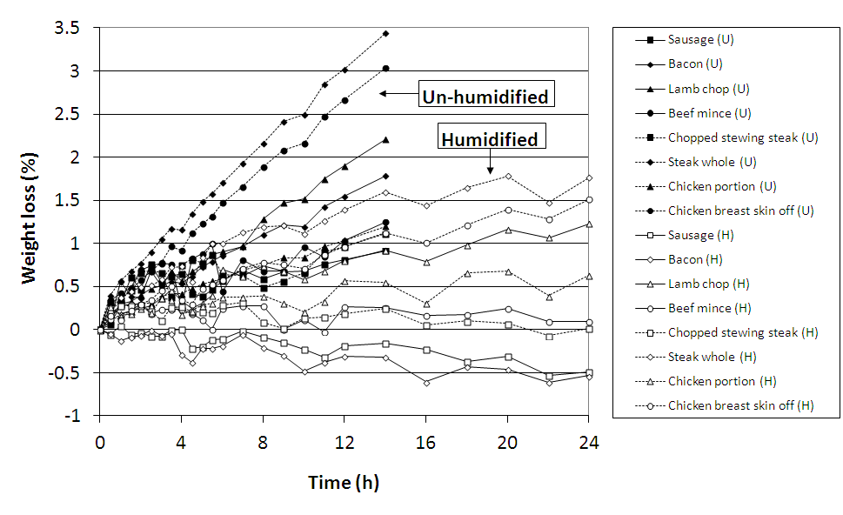
Figure 5. Weight losses from meat on display in humidified and un-humidified cabinet

Barth et al (1990) used intermittent spray misting during ambient (18°C) retail display of broccoli, which was found to promote retention of ascorbic acid. Improvements to retention of chlorophyll and colour using the same experimental set up were reported in Barth et al (1992).

Mohd-som et al (1994) found that spray misting of broccoli during chilled storage reduced bacterial loads, resulting from a washing effect and from residual chlorine in the mist due to the use of a chlorinated tap water supply. Dieckmann, List and Zache (1993) used an intermittent spray misting system in unrefrigerated ambient ‘retail’ storage of lettuce, broccoli, chicory and carrots and found far lower weight losses and better retention of texture and ascorbic acid. Colour was not affected, and there were no differences in bacterial numbers due to misting.

Moureh et al (2009) used a ‘mist flow’ system which introduced fine water droplets into the discharge air duct before the air curtain. The system relied on evaporation of deposited water droplets to compensate for some of the radiant heat gain at the surfaces of exposed foods. A further benefit was said to be that the specific heat capacity of the misted air was double that of the un-misted air, a factor which may have acted to reduce the temperature rise in the air curtain.

There have also been several related studies on humidification of food in chilled storage. Hung et al (2011) compared misting and ‘nano-misting’ to maintain quality and reduce weight loss during chilled storage of eggplant, mizuna and figs. The finer particles in the nano-mists resulted in greater closure of the stoma and gave bigger reductions in weight loss, reduced indices of chilling injury and better retention of colour. Seanmuang et al (2012) reported similar results for spinach.

Conclusions

Evaporative weight loss during display of unwrapped food products is critical to the economic viability of delicatessen and produce retailing. The environmental conditions within display cabinets are affected by various factors, including cabinet and refrigeration system design, usage patterns and store ambient. In situations where excessive weight loss is experienced or expected, active humidification systems offer a solution.

As many of the food products are intended for consumption without any further processing and are open to contamination, good hygiene practices and control of bacterial growth are further essential requirements in retailing of unwrapped food.

References
Anon (1990) Legionnaires’ disease outbreak associated with a grocery store mist machine – Louisiana, 1989. Morbidity and mortality weekly report, US Centers for Disease Control and Prevention, 39(7), pp108–110.
Barth M.M., Perry A.K., Schmidt S.J. and Klein B.P. (1990) Misting effects on ascorbic acid retention in broccoli during cabinet display, Journal of Food Science, 55(4), pp1187-1188, 1191.
Barth M.M., Perry A.K., Schmidt S.J. and Klein B.P. (1992) Misting affects market quality and enzyme activity of broccoli during retail storage, Journal of Food Science, 57(4), pp954-957.
Brecht J.K., Chau K.V., Fonseca S.C., Oliveira F.A.R., Silva F.M., Nunes M.C.N. and Bender R.J. (2003) Maintaining optimal atmosphere conditions for fruits and vegetables throughout the postharvest handling chain, Postharvest Biology and Technology, 27, pp87-101.
Brown T. (1996) Humidification of refrigerated produce display cases, FRPERC - Internal report.
Brown T., Corry J.E. and Evans J.A. (2007) Humidification of unwrapped chilled meat on retail display using an ultrasonic fogging system, Meat Science, 77 (4), pp. 670-677.
Brown T., Corry J.E.L. and James S. J. (2004). Humidification of chilled fruit and vegetables on retail display using an ultrasonic fogging system with water / air ozonation, International Journal of Refrigeration, 27, pp862-868.
Christison C.A., Lindsay D. and von Holy A. (2008) Microbiological survey of ready-to-eat foods and associated preparation surfaces in retail delicatessens, Johannesburg South Africa, Food Control, 19, pp727–733.
Dieckmann A., List D. and Zache U. (1993) Cold water mist humidification to preserve the quality of fresh vegetables during retail sale, Lebensm-Wiss U-Technol, 26, pp340–346.
Elviss N.C., Little C.L., Hucklesby L., Sagoo S., Surman-Lee S., de Pinna E. and Threlfall E.J. (2009) Microbiological study of fresh herbs from retail premises uncovers an international outbreak of salmonellosis, International Journal of Food Microbiology, 134, pp83–88.
Evans J.A. and Russell S.L. (1994a) The influence of surface conditions on weight loss from delicatessen products. FRPERC - Internal report, August 1994.
Evans J.A. and Russell S.L. (1994b) The influence of surface conditions on weight loss from delicatessen products. FRPERC - Internal report, November 1994.
Firmesse O., Morelli E., Vann S. and Carpentier B. (2012) Monitoring of bacterial load in terms of culturable and non-culturable cells on new materials placed in a delicatessen serve over counter, International Journal of Food Microbiology, 159, pp179–185.
Fulton G.S., Burfoot D., Bailey C. and James S.J. (1987) Predicting weight loss form unwrapped chilled meat in retail displays, Proc. XVIIth International Congress of Refrigeration, Vienna, Section C, pp 2-8.
Hung D.V., Tong S., Tanaka F., Yasunaga E., Hamanaka D., Hiruma N. and Uchino T. (2011) Controlling the weight loss of fresh produce during postharvest storage under a nano-size mist environment, Journal of Food Engineering, 106, pp325–330.
James S.J. and Swain M.V.L. (1986) Retail display conditions for unwrapped chilled foods, Proc. Institute of Refrigeration, 83, 3.1.
Khadre M.A., Yousef A.E., Kim J.G. (1999) Microbiological aspects of ozone applications in food: a review, Journal of Food Science, 66, pp1242–1252.
Lues J.F.R. and Van Tonder I. (2007) The occurrence of indicator bacteria on hands and aprons of food handlers in the delicatessen sections of a retail group, Food Control, 18, pp326–332.
Maidment G.G., Missenden J.F., James R.W., Tozer R.M., Bailey C. (1999a) Optimisation of environmental conditions for unwrapped chilled foods on display, In Proceedings of the Institute of Refrigeration, Session 1998–99, pp5.1–5.16.
Maidment G.G., Missenden J.F., James R.W. and Tozer R.M. (1999b) Analysis of the expansion valves used for controlling refrigerant feed into delicatessen cabinets in supermarkets, Proc Inst Refrigeration, Session 1998–99, 5-1 to 5-16.
Mohd-som F., Spomer L.A., Martin S.E. and Schmidt S.J. (1995) Microflora changes in misted and non-misted broccoli at refrigerated storage temperatures, Journal of Food Quality, 18, pp279–293.
Moureh J., Letang G., Palvadeau B. and Boisson H. (2009) Numerical and experimental investigations on the use of mist flow process in refrigerated display cabinets, International Journal of Refrigeration, 32, pp203–219.
Nunes M.C.N., Emond J.P., Rauth M., Dea S. and Chau K.V. (2009) Environmental conditions encountered during typical consumer retail display affect fruit and vegetable quality and waste, Postharvest Biology and Technology, 51, pp232–241.
Paull R.E. (1999) Effect of temperature and relative humidity on fresh commodity quality. Postharvest Biol Tec, 15, pp263–77.
Pérez-Rodríguez F., Castro R., Posada-Izquierdo G.D., Valero A., Carrasco E., García-Gimeno R.M. and Zurera G. (2010) Evaluation of hygiene practices and microbiological quality of cooked meat products during slicing and handling at retail, Meat Science, 86, pp479–485.
Saenmuang S., Al-Haq M.I., Makino Y., Yoshinori Kawagoe Y. and Oshita S. (2012) Particle size distribution of nano-mist in a spinach-storage atmosphere and its effect on respiration and qualities, Journal of Food Engineering, 112, pp69–77.
Swain M.V.L. and James S.J. (1986) Evaporative weight losses from unwrapped meat and food products in chilled display cabinets, Proc. IIR Commission C2 Symposium ‘Meat Chilling’, Bristol, UK, 3, pp415-422.

