**ASOCSA2018 – [12 – 78]**

**Exploring The Perceptions of Construction SMEs On Appropriate Supporting Policies For Growth and Development the Qatari Government For Effective Participation in Infrastructure Procurement and Delivery for the 2022 World Cup**

**ABSTRACT AND KEYWORDS**

**Purpose of this paper.** The purpose of this paper is to gauge the perceptions of SMEs of the measures they believe would enhance their development and growth by the Qatari government to ensure full and effective participation in the procurement of infrastructure and services for 2022 World Cup, which also serves the strategy of capacity building in the construction sector and diversification of the Qatari economy.

**Design/methodology/approach**. A quantitative research methodology was applied allowing a cross sectional data to be collected using questionnaire survey. The literature on SMEs in Qatar indicates heterogeneity and this resulted in the categorisation of SMEs into three types. These include micro construction SMEs, small construction SMEs, and medium Construction SMEs. A total of 146 fully completed on-line questionnaire were obtained and analysed using the Statistical Package for the Social Sciences (SPSSx). The Kruskal-Wallis test was used to rank the factors believed by SMEs to hindering their effective participation in construction activities in Qatar.

**Findings.** The results from SPSS results clearly showed that there is a huge variance in the perception of factors believed by SMEs to be hindering their effective participation in construction activities in the country. SMEs are particular about their underdeveloped entrepreneurial skills, lack of access to both financial and human capital, distance between SMEs and construction educational institutions, unfair market competition for labour, materials, and equipment. From these findings, the study concluded that it is important that intended beneficiaries of government policies are consulted for inputs into policy formulation for effective outcome.

**Research limitations/implications.** The study only focused on Small Medium Enterprises in Qatar, however, given similar socio-economic and political characteristics, the findings have wider applicability across the Gulf Corporation Council (GCC) countries, including Saudi Arabia, Kuwait, the United Arab Emirates, Qatar, Bahrain, and Oman.

**Practical implications.** The study callsfor an interface or platform where construction SMEs can interact with the Qatari government on how SMEs can be better supported for enhanced capacity building and development.

**Response to the conference theme.** The paper acknowledges the global pattern of the predominance of construction SMEs and their roles in construction industry development. This explains the various initiatives advanced by governments for SMEs development, and by critically appraising the effectiveness of such initiatives by the Qatari government, this study advances previous knowledge with its findings and recommendations.

**Keywords: Qatar, SMEs, Participation, Infrastructure, Procurement, 2022 World Cup**

**A paper Presented at the ASOCSA 12TH BUILT ENVIRONMENT CONFERENCE in DURBAN, South Africa, 5-7 August, 2018**

**\***First author; **\*\***Second author

1. **Introduction**

Qatar is hosting the 2022 **Fédération Internationale de Football Association** (FIFA) games, requiring huge infrastructure and service in support. Previous experience has shown that these infrastructure and services are huge and indivisible, requiring considerable managerial and technical expertise as well huge financial outlay to deliver (Ebohon, et. Al, 2002). Being one of the few countries with huge balance of payment surpluses, Qatar is one of the few countries with the economic strength to host the World Cup. As Figure 1 shows, Qatar has consistently maintained a balance of payment surplus since 1995 (IMF, 2018a), and has the purchasing power parity to effect the huge indivisible capital requirements in terms of infrastructure and services to stage the quadrennial event.

**Figure 1**

**Extrapolation of Trade Balance for Qatar in 2016**

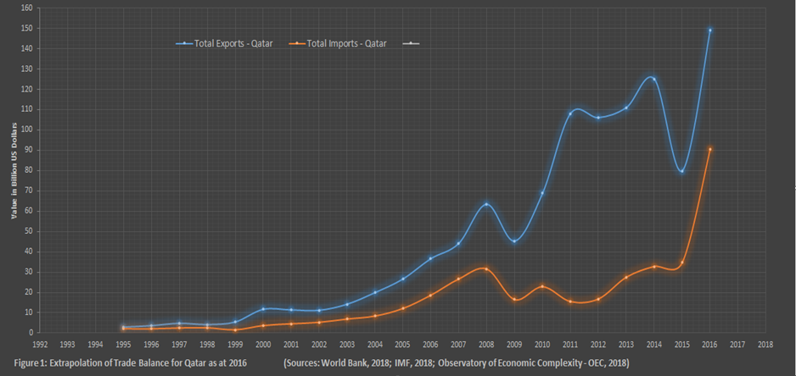

However, the dramatic fall in oil prices, from a peak of $115 per barrel in June 2014 to under $35 at the end of February 2016, has forced many oil and gas dependent countries to consider major economic restructuring. As Figure 2 shows, gas is Qatar’s main export and source of foreign exchange, making the country largely a monocultural economy, these being a set of countries that rely predominantly on one or two commodities for export earnings. Qatar’s problem is further compounded by its reliance on foreign workers for technical and managerial expertise to propel the economy. This has huge significance for balance of payments given dwindling foreign export earnings occasioned by falling oil and gas prices in view of the impact of guest workers’ remittances on foreign exchange and currency.

**Figure 2**

**Structure of Qatar’s Export**

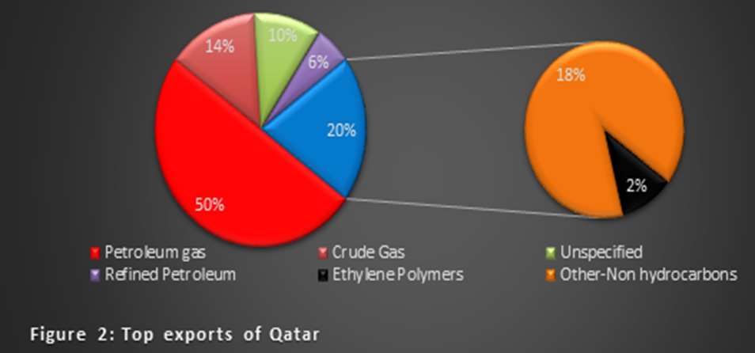

**Source: Observatory of Economics Complexity (2018)**

Qatar saw its successful bid as a golden opportunity to begin the process of economic restructuring; beginning with the construction sector, it sets about ensuring that locally based small and medium size construction enterprises (SMEs) participate effectively in the huge infrastructure procurement and development to effect the 2022 Football World Cup game. Similarly, it was also envisaged that the growth and development of local construction SMEs will obviate the need for foreign technical and managerial expertise for maintenance of existing infrastructure and services, as well as replication in areas of disamenities. This initiative is captured in two strategic policy documents – Qatar National Vision (QNV) 2030 and the National Development Strategy both of which are purposeful in creating an enabling regulatory environment generally, and specifically for enhancing industrial capacity building, particularly with regards to SMEs’ growth and development (Jaoui and Rashi, 2015; The Business Year 2015). Of particular interest is in creating an enabling environment for Qatari SMEs to grow and prosper.

1. **SMEs and Economic Development**

It is a fact that large firms and conglomerates all started life as SMEs, and the most formidable competitions faced by large firms and global conglomerates are also from SMEs. Moving from corporate to the individual, SMEs affords numerous opportunities for skills and career developments, particularly entrepreneurship. In other words, SMEs incubate innovation, entrepreneurship, facilitate corporate discipline; all of which are critical to economic growth and development, especially economic diversification (OECD, 2017, Fernandez and Ali (2013). According to the World Bank Group, Small and Medium Enterprises (SMEs) play a major role in most economies, particularly in developing countries (Ayyagari, et al. 2011). Formal SMEs contribute up to 60% of total employment and up to 40% of national income (GDP) in emerging economies. These numbers are significantly higher when informal SMEs are included. As Figure 3 clearly indicates for India, SMEs contributes significantly to its economic growth, contributing 17% of GDP, and accounting for 45% of manufacturing output, 40% of total export, and employing 110 million employees.

**Figure 3**

**SMEs and Economic Growth in India**

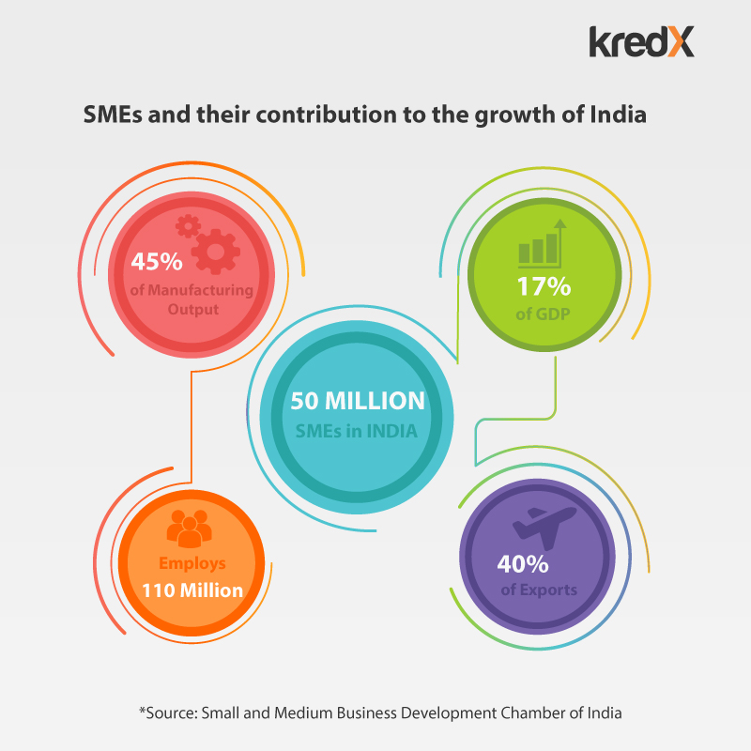

Indeed, a 2003 comprehensive study of the significance of SMEs in Europe confirmed its importance to European economic growth and prosperity when it concluded that SMEs are a catalyst and engine of economic growth and development (EU, 2003, Ayyagari et al. 2003). This has huge implications for economic diversification efforts given the evidence that supports the growth and performance of SMEs as necessary prerequisites to effective economic diversification (EU, 2003, Ayyagari, 2011, and OECD 2018, IMF 2018b)). This is the reality that Qatar have grasped firmly in view of the concerted efforts by governments, particularly in the developing countries, to develop and grow their SMEs’ sector. In Great Britain for example, specific policies in place to develop and grow SMEs manifest in financing, technology and innovation, electronic commerce, management and internationalisation measures. Similarly, in Korea, tax concessions and loans at favourable interest rates are introduced to grow and support SMEs. In the United States, small and medium size enterprises are heavily supported, and the range of support include providing direct research and development grants; loans to scale and grow the enterprise; innovation vouchers to assist SME manufacturers with new product development and innovation efforts; and funding joint pre-competitive research programs (Ezell, and Atkinson, 2011). The use of innovation vouchers is most commonly used across many countries, including Austria, Canada, and Germany, to grow SMEs.

1. **Qatar Choice of Construction SMEs**

The choice of the construction sector, apart from the opportunism of the 2022 World Cup Games, comes as no surprises. Across the global economy, the construction industry is driven by SMEs (EU 2003; Institute of Value Management, 2015)), and as Figure 4 indicates, 98.9% of European construction enterprises employ less than 50 employees, 80% of total construction output is accounted for by construction SMEs, and also responsible for 83% of total construction workforce.

**Figure 4**

**European Construction and SMEs**

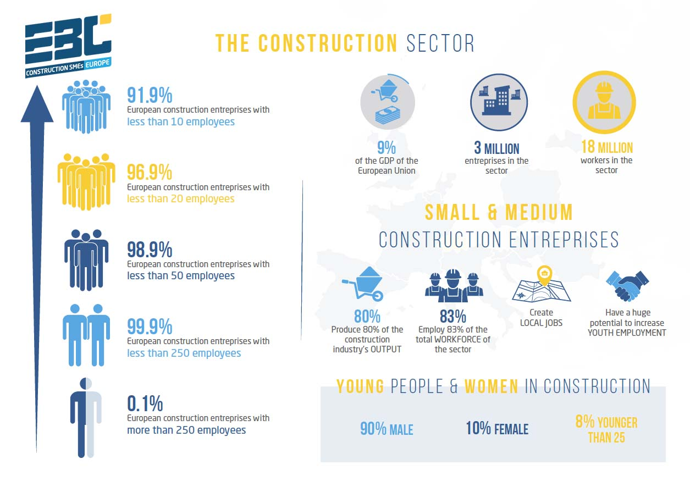

**Source:** <https://www.euractiv.com/section/social-europe-jobs/infographic/the-construction-sector-in-europe-and-its-smes-facts-and-figures/>

The Construction Industry is diversified, and with extensive backward and forward linkages with the rest of the economy involving numerous clients like property builders, property developers, material suppliers and contractors, attracting inward investors to the economy. The construction sector is an important sector that contributes greatly in the economic growth of a nation (Adam, 1997; Swett, 2015), hence the ideal sector to lead economic diversification efforts.

Given the policy decision of the Qatar government to pioneer economic diversification by seizing on the timing of the 2022 World Cup and the opportunities it presents, this study sets out to investigate the appropriate measures construction SMEs would like to see implemented that will enable them to grow and become effective partners in the building and delivery of infrastructure and services for the 2022 World Cup and beyond.

**Current State of Qatari Construction Industry**

Qatar’s construction industry remains one of the most vibrant and fast-expanding in the Middle East, and a key driver of non-oil growth in the state. Major infrastructure projects including the Doha Metro, Long Distance Rail, Hamad Port, the next phase of expansion at Hamad International Airport (HIA), and a network of new roads and drainage systems are expected to keep the industry on track are ongoing, while new builds in the health, education, real estate and hospitality segments will further complement existing growth in the sector. Qatar’s construction industry is a critical non-oil growth driver, accounting for around 10% of GDP at the end of 2015, and the single largest employer, employing 37% of Qatar’s 1.7 million workforce (MDPS, 2015).

Total estimate of the value of construction projects undertaken for Qatar in 2015 stood at US$200 billion and the sector is estimated to grow at an annual rate of 11.4% up till 2022 when the World Cup games comes to end. Additional to the current ongoing 2022 World Cup infrastructure and service provision, other the high-profile projects undertaken include:

* Qatar Rail and Metro Project. This is thought to be the world’s largest civil engineering project that started in 2013. This involves the design and construction of the tunnels and stations of the initial phase of the Doha Metro. These contracts relate to the first 130 kilometres of the railway, of which 99 kilometres will be underground.
* Hamad International Airport (HIA) previously known as New Doha International Airport (NDIA) had a passenger terminal, capable of handling up to 50 million passengers per year; a 750,000 tonnes-per-year cargo terminal; free trade zone; and a business park.
* New Doha Port Development Project (New Port). A major new sea port to the south of Doha, with annual capacity to accommodate six million 20-foot equivalent units as well as a naval component.
* Doha Bay Crossing.
* Lusail Real Estate Development. A mixed use development of 38 square kilometres including housing, offices, shops and four exclusive islands.
* Energy City. An integrated energy hub to enhance the Gulf region’s ability to capture critical revenue streams from hydrocarbons and act as a nucleus for the Middle East’s oil and gas industry.
* Msheireb Downtown Doha. A large urban regeneration complex by Msheireb Properties in central Doha, designed to reflect the architectural heritage of Qatar.
* Doha Festival City. Entertainment and leisure complex with retail outlets, hotels; convention centre.
* Healthcare facilities, including five primary healthcare centres across Doha, plus four hospitals at Hamad Medical City.

Most of these projects are of huge and indivisible capital type investments which are the technical and management capacity and expertise of local construction firms, particularly the small and medium term construction enterprises. The measure adopted by the Qatari government to grow and develop construction SMEs can be found in Law No (13) of 2000 for the Regulation of Foreign Capital Investment in Economic Activity generally (subject to a few specific exceptions), which requires non-Qatari contractors and consultants to form partnerships with Qatari partners to be able to bid for work generally. Joint ventures, which can be either incorporated to become a single company (LLC), or based on a contractual joint venture agreement are mostly favoured. For the huge infrastructure procurement occasioned by Qatar 2022 World Cup, international contractors must comply with Law (13) of 2000.

Many would regardthe indigenisation policy, well intended as it may be, to be a necessary but insufficient policy instrument to enhance the growth and development of construction SMEs in Qatar (Oxford Analytica, 2013, Uppal, 2014). Evidences abound showing that at the end of most joint ventures, local firms still struggle to remain in business. Indeed, looking at the work of Jarkas and Haupt (2015) where the challenges faced by SMEs revolve, amongst other factor, around problems of capacity to compete for skilled and experienced workers with large firms. The absence of ‘level playing field’ that enables local construction SMEs to grow and compete remains a major factor inhibiting growth and development of construction SMEs in Qatar. This brings to the fore, the significance of this study, which is to investigate measures local SMEs consider effective to their growth and development in Qatar.

**Research Methodology**

The approach taken to explore the perceptions of construction SMEs regarding the appropriate measures to be introduced by the Qatari Government to enhance their growth and development, according to Kothari (2004) is systematic. In the process of seeking knowledge, which is the purpose of this study to derive appropriate measures that will support the growth and development of construction SMEs in Qatar, a methodological approach is necessary (Chadwick et. Al. 2004, Creswell, 2003). The research methodology for this study is informed by the epistemological and ontological positioning of the researchers. Epistemology concerns knowledge and how it is derived and understood, while ontology on the other hand, is about the conception and understanding of reality (Saunders et al 2015). The researchers adopt the positivist and interpretivist methodological approach to the study in the belief that it will yield objective and rich knowledge to lead to new knowledge on the measures to facilitate the growth and development of Qatari construction SMEs.

In order to ensure the sample studied adequately represents the target population, in this case, all construction SMEs in Qatar, the OECD (2016) and QDB (2016) definition and categorisation of SMEs were considered. SMEs are defined as non-subsidiary, independent firms likely to employ less number of employees than large organizations. The two important criteria here are the number of employees and income or asset levels of firms. According to Table 1, construction SMEs have been classified into three categories , including Micro with 1-10 employees, small that employs 11 to 50 employees, and the medium SMEs employ 51 to 250 employees (Oxford Business Group, 2010; Clyde and Company 2013).

**Table 1**

**SMEs Classification in Qatar**

|  |  |  |  |  |
| --- | --- | --- | --- | --- |
| **Sector** | **Criteria** | **Micro** | **Small** | **Medium** |
| Agriculture | No. of Employees**\***  Annual Turnover | 1 to 5  Less than 1 | 6 to 30  1 to less than 20 | 31 to 250  20 to 100 |
| Manufacturing | No. of Employees**\*\***  Annual Turnover | 1 to 5  Less than 3 | 6 to 50  3 to less than 20 | 51 to 250  20 to 100 |
| Creative Industry | No. of Employees**\***  Annual Turnover**\*\*** | 1 to 5  Less than 1 | 6 to 30  3 to less than 20 | 31 to 100  20 to 100 |
| **Construction** | **No. of Employees\***  **Annual Turnover\*\*** | **1 to 10**  **Less than 3** | **11 to 50**  **3 to less than 20** | **51 to 250**  **20 to 100** |
| Trade | No. of Employees**\***  Annual Turnover**\*\*** | 1 to 5  Less than 3 | 6 to 50  3 to less than 20 | 31 to 100  20 to 100 |
| Other Services | No. of Employees**\***  Annual Turnover**\*\*** | 1 to 5  Less than 3 | 6 to 50  3 to less than 20 | 51 to 250  20 to 100 |
| **\***Employees measured by staff headcount; **\*\*** Annual turnover measured in Qatar Riyals | | | | |

**Source: State of Small and Medium Enterprises in Qatar, Qatar Development Bank (2016)**

**Data Collection**

The first task was to identify a homogenous set of SMEs respondents to ensure a broader well representative sample of construction SMEs in the sector. In Qatar the Company Registration Office – CRO (2016) houses a search engine where all the companies register their contact details from which contact details in form of email and website addresses were generated. This allowed visits to respective websites and to then send emails to construction professionals. As shown in Figure 3, the CRO is a public body accessible to anyone in Qatar(Moubaydee, et al 2013, Central Tender Committee (2016)).Other contact details where obtained by looking at respective website addresses based on company grade listing.

**Figure 3**

**Company Registration Office – CRO for Qatar - SMEs Registration Portal**

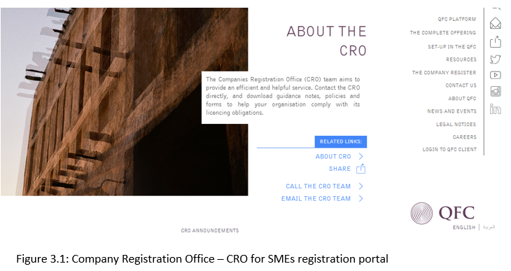

**Source**: **The Qatar Financial Centre Authority**

## **The Structure of Questionnaire**

A questionnaire was designed to elicit the necessary data for the study. The first section of the questionnaire was designed to inform on the characteristics of potential respondents. This was to assist in categorising responses according to key themes derived from literature to form the required data for the study. For instance, the study needed to tease out whether construction experience explains for variations in respondents’ perception about the appropriate measures necessary to grow construction SMEs in Qatar. It is expected that credible conclusions can only be generated if study parameters for the sample frame are clearly defined. Therefore, the study generated comparative data around the following:

* Age
* Gender
* Professional background
* Construction industry experience
* Scale of organisation: large, medium, small firms
* Specialism: whether they work for general or specialist contractors
* Contractor’s Classification: low/ medium or high?

**Table 2**

**Characteristics of Respondents**

|  |  |  |  |  |
| --- | --- | --- | --- | --- |
| **Professional background and contractor's specialism** | | | |  |
| **Age** | Scale of SME organisation (N = 146) | | | ***Total*** |
| **Micro** | **Small** | **Medium** |
| 18 to 24yrs | 1 | 4 | 7 | 12 |
| 25 to 29yrs | 3 | 9 | 4 | 16 |
| 30 to34yrs | 8 | 8 | 3 | 19 |
| 35 to 39yrs | 6 | 2 | 1 | 9 |
| 40 to 44yrs | 4 | 5 | 6 | 15 |
| 45 to 49yrs | 6 | 8 | 7 | 21 |
| 50 to 54yrs | 2 | 7 | 6 | 15 |
| 55 to 59yrs | 9 | 10 | 7 | 26 |
| 60yrs+ | 4 | 4 | 5 | 13 |
| ***Total*** | 43 | 57 | 46 | 146 |
|  |  |  |  |  |
|  |  | ***Percentage*** |  |  |
| **Age** | **Micro** | **Small** | **Medium** | ***Total*** |
| 18 to 24yrs | 0.68 | 2.74 | 4.79 | 8.22 |
| 25 to 29yrs | 2.05 | 6.16 | 2.74 | 10.96 |
| 30 to34yrs | 5.48 | 5.48 | 2.05 | 13.01 |
| 35 to 39yrs | 4.11 | 1.37 | 0.68 | 6.16 |
| 40 to 44yrs | 2.74 | 3.42 | 4.11 | 10.27 |
| 45 to 49yrs | 4.11 | 5.48 | 4.79 | 14.38 |
| 50 to 54yrs | 1.37 | 4.79 | 4.11 | 10.27 |
| 55 to 59yrs | 6.16 | 6.85 | 4.79 | 17.81 |
| 60yrs+ | 2.74 | 2.74 | 3.42 | 8.90 |
| ***Total*** | 29.45 | 39.04 | 31.51 | 100.00 |

Clearly evident in Table 2 is the even representation of construction practitioners across Qatari construction SMEs where 30% of construction professionals that responded were from Micro SMEs; 39% and 32% for small and medium SMEs respectively. The importance being that with equal number of professionals in all bands of SMEs, there is a good chance of capturing a broad range of construction SMEs in Qatar.

Table 3 also shows a fair distribution of respondents’ age relative construction experience. A quick definition seems to be prevalent with individuals with less experience likely to be the younger professional and expectedly, individuals with 20 years and above of construction experience are also likely to be 40 years or older. It is feasible to deduce from this that the earliest entry age is on average 20 years.

|  |  |  |  |  |  |  |  |  |  |
| --- | --- | --- | --- | --- | --- | --- | --- | --- | --- |
| **Table 3: Age of respondents by construction industry experience** | | | | | | | | | |
| **Age** | Industry experience (N = 146) | | | | | | | | ***Total*** |
| **0 to 4 yrs** | **5 to 9 yrs** | **10 to 14 yrs** | **15 to 19yrs** | **20 to 24yrs** | **25 to 29yrs** | **30yrs+** | |
| 18 to 24yrs | 10 | 2 | 0 | 0 | 0 | 0 | 0 | | 12 |
| 25 to 29yrs | 9 | 7 | 0 | 0 | 0 | 0 | 0 | | 16 |
| 30 to 34yrs | 4 | 13 | 2 | 0 | 0 | 0 | 0 | | 19 |
| 35 to 39yrs | 0 | 3 | 6 | 0 | 0 | 0 | 0 | | 9 |
| 40 to 44yrs | 0 | 2 | 5 | 4 | 0 | 4 | 0 | | 15 |
| 45 to 49yrs | 0 | 0 | 10 | 7 | 2 | 2 | 0 | | 21 |
| 50 to 54yrs | 0 | 0 | 1 | 5 | 4 | 4 | 1 | | 15 |
| 55 to 59yrs | 0 | 0 | 0 | 0 | 8 | 5 | 13 | | 26 |
| 60yrs+ | 0 | 0 | 0 | 0 | 1 | 5 | 7 | | 13 |
| ***Total*** | 23 | 27 | 24 | 16 | 15 | 20 | 21 | | **146** |
|  |  |  |  |  |  |  |  | |  |
|  |  |  |  |  |  | ***Percentage*** | |  |  |
| **Age** | **0 to 4 yrs** | **5 to 9 yrs** | **10 to 14 yrs** | **15 to 19yrs** | **20 to 24yrs** | **25 to 29yrs** | **30yrs+** | | ***Total*** |
| 18 to 24yrs | 6.85 | 1.37 | 0.00 | 0.00 | 0.00 | 0.00 | 0.00 | | 8.22 |
| 25 to 29yrs | 6.16 | 4.79 | 0.00 | 0.00 | 0.00 | 0.00 | 0.00 | | 10.96 |
| 30 to34yrs | 2.74 | 8.90 | 1.37 | 0.00 | 0.00 | 0.00 | 0.00 | | 13.01 |
| 35 to 39yrs | 0.00 | 2.05 | 4.11 | 0.00 | 0.00 | 0.00 | 0.00 | | 6.16 |
| 40 to 44yrs | 0.00 | 1.37 | 3.42 | 2.74 | 0.00 | 2.74 | 0.00 | | 10.27 |
| 45 to 49yrs | 0.00 | 0.00 | 6.85 | 4.79 | 1.37 | 1.37 | 0.00 | | 14.38 |
| 50 to 54yrs | 0.00 | 0.00 | 0.68 | 3.42 | 2.74 | 2.74 | 0.68 | | 10.27 |
| 55 to 59yrs | 0.00 | 0.00 | 0.00 | 0.00 | 5.48 | 3.42 | 8.90 | | 17.81 |
| 60yrs+ | 0.00 | 0.00 | 0.00 | 0.00 | 0.68 | 3.42 | 4.79 | | 8.90 |
| ***Total*** | 15.75 | 18.49 | 16.44 | 10.96 | 10.27 | 13.70 | 14.38 | | **100** |

At the time of capturing the respondents, about 53% of the sample had worked for longer than 15 years in the construction industry in Qatar, allowing us to deduce that the study is informed by construction professionals with substantial experience of Qatar’s construction industry and therefore likely to reflect accurate and sustained experiences of construction SMEs in the country. This factor is critically important to the study, particularly where it is knowledge and experience practitioners regarding adjudged appropriate measures to grow and develop this subsector of the industry. This goes without saying that beyond this, is also the fact that with experience of completing various projects comes detailed insights about the workings of the industry, particularly the interactions within construction sector itself, and also with the wider economy. With this in mind, the study is a homogenous sample of SMEs with an interdisciplinarity of construction knowledge as represented by the main professions who make up a typical construction project. These characteristics and profiles will enable respondents give a good account of the challenges SMEs face and therefore the measures that can be put in place to ensure the longer term sustainability of this subsector critical Qatar’s Construction industry development and the wider ambition of economic diversification.

The second part of the questionnaire was open ended, and respondents, as SMEs, were asked to list the challenges they face operating in Qatar that they feel hinder their growth and development. The challenges identified were combined in to the following themes in Table 5:

**Table 5**

**Themes and Variable Labels**

|  |  |
| --- | --- |
| **Themes** | **Variable Labels\*** |
| * Limited scope for technology transfer and absorption between construction SMEs and large construction firms | ***PerSMEs1*** |
| * Inability to compete with large construction multinationals with specialism and established goodwill | ***PerSMEs2*** |
| * Difficulties competing with large multinational firms on quality and other none-price competitive activities | ***PerSMEs3*** |
| * Low capacity to invest in human capital development regarding up-skilling workers in new construction technology and management knowledge | ***PerSMEs4*** |
| * Increased barriers to entry through the indivisibility nature of projects | ***PerSMEs5*** |
| * Lack of enforcement of existing labour rules and regulations about the six-year expatriate rule | ***PerSMEs6*** |
| * Lack of national framework to encourage SMEs in up-skilling their workforce | ***PerSMEs7*** |
| * Insufficient local vocational training institutions to produce necessary construction skills | ***PerSMEs8*** |
| * Vertical integration structure of large multinational companies and the effects on volume of work for SMEs | ***PerSMEs9*** |

\***Perceived challenges by Construction SMEs in Qatar**

The frequency analysis of the challenges identified by construction SMEs shows the pervasive nature of these challenges, as shown in Table 6. Prominent amongst them is the inability to compete with established large specialist or household name multinational construction firms. Issues with vocational training institutions, evidencing lack of capacity was also identified by all construction SMEs. It comes as no surprise that the other three challenges that featured highly also deal with inadequate capacity, namely, competition on quality, inadequate capacity to absorb technology, and finally, inadequate capacity to overcome barriers to entry owing to capital indivisibility.

**Table 6**

**Frequency of Identified Challenges by Qatari Construction SMES**

|  |  |  |  |
| --- | --- | --- | --- |
| **Themes** | **Attributes of Themes** | **Frequency (N = 146)** | |
| Count | *%* |
| ***PerSMEs1*** | Limited scope for technology transfer and absorption between construction SMEs and large construction firms | 117 | *80* |
| ***PerSMEs2*** | Inability to compete with large construction multinationals with specialism and established goodwill | 146 | *100* |
| ***PerSMEs3*** | Difficulties competing with large multinational firms on quality and other none-price competitive activities | 137 | *94* |
| ***PerSMEs4*** | Low capacity to invest in human capital development regarding up-skilling workers in new construction technology and management knowledge | 102 | *70* |
| ***PerSMEs5*** | Increased barriers to entry through the indivisibility nature of projects | 117 | *80* |
| ***PerSMEs6*** | Lack of enforcement of existing labour rules and regulations about the six-year expatriate rule | 95 | *65* |
| ***PerSMEs7*** | Lack of national framework to encourage SMEs in up-skilling their workforce | 110 | *75* |
| ***PerSMEs8*** | Insufficient local vocational training institutions to produce necessary construction skills | 146 | *100* |
| ***PerSMEs9*** | Vertical integration structure of large multinational companies and the effects on volume of work for SMEs | 99 | *68* |

The final research strategy for this study was to go back and ask respondents to rank their perceived challenges already identified on a Likert scale where 5 is strongly agree, 4 = agree, 3 = undecided, 2 = disagree and 1 = strongly agree, as presented in Table 7.

**Table 7**

**Aggregate rank order of perceived challenges to SMEs growth and Development in Qatar**

|  |  |  |  |  |
| --- | --- | --- | --- | --- |
| **Themes** | **Attributes of Themes** | **Mean score** | **Rank** | **Themes Attributes Analysis** |
| ***PerSMEs1*** | Limited scope for technology transfer and absorption between construction SMEs and large construction firms | 3.93 | 1 | ***Issues of the need for technological capacity to innovate and compete with large established and specialist construction firms*** |
| ***PerSMEs3*** | Difficulties competing with large multinational firms on quality and other none-price competitive activities | 3.86 | 2 |
| ***PerSMEs2*** | Inability to compete with large construction multinationals with specialism and established goodwill | 3.72 | 3 |
| ***PerSMEs7*** | Lack of national framework to encourage SMEs in up-skilling their workforce | 3.66 | 4 | ***Issues of the need for appropriate institutions and framework guiding investments in human capital as well as continuing professional development (CPDs) in new and innovative construction skills*** |
| ***PerSMEs4*** | Low capacity to invest in human capital development regarding up-skilling workers in new construction technology and management knowledge | 3.64 | 5 |
| ***PerSMEs6*** | Lack of enforcement of existing labour rules and regulations about the six-year expatriate rule | 3.58 | 6 |
| ***PerSMEs8*** | Insufficient local vocational training institutions to produce necessary construction skills | 3.54 | 7.5 |
| ***PerSMEs9*** | Vertical integration structure of large multinational companies and the effects on volume of work for SMEs | 3.54 | 7.5 | ***Issues of access to construction market owing to the structure of the large established and specialist construction firms.*** |
| ***PerSMEs5*** | Increased barriers to entry through the indivisibility nature of projects | 3.46 | 9 |

The data has been collated and rank ordered in decreasing order of importance, using the ‘theme attribute analysis’ similar to principal component factor analysis (Kangwa and Olubodun, 2003). It can be observed that those challenges ranked highest by respondents have the attributes of the need for technological capacity to innovate and compete with large established and specialist construction firms in Qatar. The second rank ordered challenges have the attributes of the need for appropriate institutions and framework to guide investments in human capital as well as continuing professional development (CPDs) in new and innovative construction skills. The third rank ordered challenges have the attributes of the need for measures and intervention to leverage market access for construction SMEs in Qatar. These three overarching attributes are critically evaluated to inform policy prescriptions that the Qatari government may consider implementing to enhance, not only the growth and development of construction SMEs, but also their resilience. However, it is important to investigate the likelihood of variance in perception of challenges facing construction SMEs in Qatar. This acknowledges the fact that construction SMEs in Qatar are constituted into micro, small, and medium categories, and reflects the earlier disposition that they are likely to perceive and respond to the challenges affecting the growth in construction SMEs differently. The importance of capturing this effects is in policy prescription; it allows the tailoring of policies to the specific needs of the different categories of construction SMEs.

**Variance Analysis of Perceived Challenges to construction SMEs Growth and Development in Qatar**

The 146 survey respondents comprised of the micro contractors, small contractors, and medium contractors. It is hypothesised that the experiences of contractors in undertaking construction projects will be shaped by the procurement team, including the clients, designers, principle designers and main contracting organisations who sublet works which most SMEs depend on for their survival. Micro contractors are small in scale and can only take fairly small-scale works, whereas the small and medium contractors, by representation, are theoretically able to undertake any sub-contract works with the limiting factor being finance to purchase equipment and expertise for higher value projects (Quartey, et al 2017; Oxford Business Group, 2016). These experiences by construction SMEs are influenced by their knowledge and understanding of the structure, conduct and performance of the Qatari construction sector. Mindful of this, the study sets out to establish the extent to which the experiences differ among the three SMEs classifications – micro, small, and medium, and whether there are persistent notable rank-variations depending on the size of SMEs.

To this effect, the Kruskal Wallis procedure allows the study to compare the mean ranks for all the *K* groups across the three levels of Perceived construction SMEs Challenges (PerSMEs) in Qatar. The process of identifying and pooling the means for each group is shown in Figure 5.

**Figure 5**.

**Procedure for Kruskal-Wallis Analysis of Variance**

Classification of SMEs

1 = Micro

2 = Small

3 = Medium

DV = Ranking of factors impacting on fair access and participation of SMEs in Qatar’s construction sector

Are ranks of perceived challenges to fair access and participation independent of SMEs classification?

Regulatory framework for fair access and participation of SMES in the nonhydrocarbon sector – construction

Thus, a hypothesis is constructed, with the null-hypothesis that there is no difference in the ranking of the challenges to growth and development experienced by the three categories of construction SMEs in Qatar. The Alternative hypothesis on the other hand is that at least two categories of construction SMEs have different experience of the challenges to growth and development experienced by the three categories of construction SMEs in Qatar.

**Null Hypothesis:**

$H_{0}$: The *k* population have identical ranking of PerSMEs

**Alternative Hypothesis:**

$H_{1}$*:* At least two of the population differ in the ranking of PerSMEs.

The ***decision rule*** is to reject the null hypothesis in favour of the alternative hypothesis if the challenges to growth and development by the three categories of construction SMEs in Qatar are the same, in other words, if the mean value rankings are the same for at least two of the three categories of construction SMEs in Qatar – that is if the computed value KW is > $χ_{a.df}^{2}$ and significant (α) 0.05 or at the 5% level of significance.

Thus, the Kruskal Wallis test is derived from the formula:

$$KW=\frac{12}{n(n+1)}\sum_{i=1}^{k}{+\frac{T^{2}}{n1}}-3(n+1)$$

The next step is let $T_{1}=$ the total of the ranks from the *i*th sample in which the *KW* statistic follows the chi-square distribution with *k -1*df. There are k = 3 classifications of SMEs, the degree of freedom (df) is *df = 3 -1 = 2.* The *KW* is derived from independent samples (Micro, small and medium organisations). The derived mean values relating to the nine PerSMEs factors (as presented in Table 1) were score on a Likert scale where 5 = strongly agree; 4 = agree; 3 = undecided; 2 = agree; and 1 = strongly disagree.

The next step is to represent the mean score per SMEs classification (the *K* population samples) as shown in Table 8, in which the respective mean score relative to the three SMEs organisations are identified and colour coded for ease of identification with regards to each of the respective samples *n1, n2 and nk*.

|  |  |  |  |  |  |  |  |  |  |  |  |  |  |  |  |  |  |  |  |  |  |  |  |  |  |  |  |  |  |  |  |  |  |  |  |  |  |  |  |  |  |  |  |  |  |  |  |  |  |  |  |  |  |  |  |  |  |  |  |  |  |  |  |  |  |  |  |  |  |  |  |  |  |  |  |  |  |  |  |  |  |  |  |  |  |  |  |  |  |  |  |
| --- | --- | --- | --- | --- | --- | --- | --- | --- | --- | --- | --- | --- | --- | --- | --- | --- | --- | --- | --- | --- | --- | --- | --- | --- | --- | --- | --- | --- | --- | --- | --- | --- | --- | --- | --- | --- | --- | --- | --- | --- | --- | --- | --- | --- | --- | --- | --- | --- | --- | --- | --- | --- | --- | --- | --- | --- | --- | --- | --- | --- | --- | --- | --- | --- | --- | --- | --- | --- | --- | --- | --- | --- | --- | --- | --- | --- | --- | --- | --- | --- | --- | --- | --- | --- | --- | --- | --- | --- | --- | --- | --- |
|  | |  |  |  | | --- | --- | --- | | **Table 8: Perceived challenges to growth and development of SMEs in Qatar by classification** | | | | **Factors** | **Mean** | **SMEs Classification** | | PerSMEs1 | 4.15 |  | | PerSMEs2 | 3.85 |  | | PerSMEs3 | 3.72 |  | | PerSMEs4 | 4.00 | **Medium Contractor** | | PerSMEs5 | 3.43 |  | | PerSMEs6 | 3.65 |  | | PerSMEs7 | 3.50 |  | | PerSMEs8 | 3.72 |  | | PerSMEs9 | 3.72 |  | | PerSMEs1 | 4.05 |  | | PerSMEs2 | 3.95 |  | | PerSMEs3 | 4.00 |  | | PerSMEs4 | 3.79 | **Small**  **Contractor** | | PerSMEs5 | 3.82 |  | | PerSMEs6 | 3.79 |  | | PerSMEs7 | 3.72 |  | | PerSMEs8 | 3.72 |  | | PerSMEs9 | 3.56 |  | | PerSMEs1 | 3.53 |  | | PerSMEs2 | 3.00 |  | | PerSMEs3 | 3.81 |  | | PerSMEs4 | 3.33 | **Micro**  **Contractor** | | PerSMEs5 | 3.00 |  | | PerSMEs6 | 3.21 |  | | PerSMEs7 | 3.74 |  | | PerSMEs8 | 3.12 |  | | PerSMEs9 | 3.33 |  | |  |  |  |

The next stage, is to pool the sample in decreasing order, and assigning each a rank value, as shown in Table 9.

|  |  |  |  |
| --- | --- | --- | --- |
| **Table 9: Pooled ranking of Perception of the challenges to growth and development of SMEs in Qatar by classification** | | | |
| Factors | | Mean | *Pooled rank* |
| 1 | PerSMEs1 | 4.15 | *1* |
| 2 | PerSMEs1 | 4.05 | *2* |
| 3 | PerSMEs4 | 4.00 | *3.5* |
| 4 | PerSMEs3 | 4.00 | *3.5* |
| 5 | PerSMEs2 | 3.95 | *5* |
| 6 | PerSMEs2 | 3.85 | *6* |
| 7 | PerSMEs5 | 3.82 | *7* |
| 8 | PerSMEs3 | 3.81 | *8* |
| 9 | PerSMEs1 | 3.79 | *9.5* |
| 10 | PerSMEs1 | 3.79 | *9.5* |
| 11 | PerSMEs7 | 3.74 | *11* |
| 12 | PerSMEs3 | 3.72 | *14* |
| 13 | PerSMEs2 | 3.72 | *14* |
| 14 | PerSMEs2 | 3.72 | *14* |
| 15 | PerSMEs5 | 3.72 | *14* |
| 16 | PerSMEs3 | 3.72 | *14* |
| 17 | PerSMEs1 | 3.65 | *17* |
| 18 | PerSMEs9 | 3.56 | *18* |
| 19 | PerSMEs1 | 3.53 | *19* |
| 20 | PerSMEs7 | 3.50 | *20* |
| 21 | PerSMEs5 | 3.43 | *21* |
| 22 | PerSMEs4 | 3.33 | *22.5* |
| 23 | PerSMEs9 | 3.33 | *22.5* |
| 24 | PerSMEs6 | 3.21 | *24* |
| 25 | PerSMEs8 | 3.12 | *25* |
| 26 | PerSMEs2 | 3.00 | *26.5* |
| 27 | PerSMEs5 | 3.00 | *26.5* |

In Table 9, it is observable that the means of some of the pooled challenges (PerSMEs) happen to tie, and as is the conventional approach Kvanli et al (1992) and Kangwa and Olubodun (2004), the average of the rank to the tied position is assigned. For instance, there are separate 7 sets of ties which have been assigned the average rank of the position of tied factors. Examples are factors rank 3rd and 4th in Table 9 that have tied mean scores. The sum of their position is halved (3 +4)/2 = 3.5. This procedure is repeated down the table with positions 12th, 13th, 14th, 15th, and 16th all tied. The value to each factor is (12+13+14+15+16)/5 =14 and therefore all the factors have been allocated the mean rank of 14.

Once this is done the respective rank positions for each corresponding factor from Table 9 is reallocated to each factor in Table 10.

|  |  |  |  |  |  |  |  |  |
| --- | --- | --- | --- | --- | --- | --- | --- | --- |
| **Table10: Pooled ranks of perceived challenges to construction SMEs in Qatar by classification**  **(N = 146)** | | | | | | | | |
| **Factors** | **Sample mean**  **(N = 146)** | **Medium**  **Contractor**  **(*n = 43)*** | | **Rank of Medium**  **contractor** | **Small**  **Contractor**  ***(n = 58)*** | **Rank of Small**  **Contractor** | **Micro**  **Contractor**  ***(n = 45)*** | **Rank of**  **Micro**  **Contractor** |
| **PerSMEs1** | ***3.93*** | ***4.15*** | ***1*** | | ***4.05*** | ***2*** | ***3.53*** | ***19*** |
| **PerSMEs3** | ***3.86*** | ***3.72*** | ***14*** | | ***4.00*** | ***3.5*** | ***3.81*** | ***8*** |
| **PerSMEs2** | ***3.72*** | ***3.85*** | ***6*** | | ***3.95*** | ***5*** | ***3.00*** | ***26.5*** |
| **PerSMEs7** | ***3.66*** | ***3.5*** | ***20*** | | ***3.72*** | ***14*** | ***3.74*** | ***11*** |
| **PerSMEs4** | ***3.64*** | ***4.00*** | ***3.5*** | | ***3.74*** | ***9.5*** | ***3.33*** | ***22.5*** |
| **PerSMEs6** | ***3.58*** | ***3.65*** | ***17*** | | ***3.79*** | ***9.5*** | ***3.21*** | ***24*** |
| **PerSMEs8** | ***3.54*** | ***3.72*** | ***14*** | | ***3.72*** | ***14*** | ***3.12*** | ***25*** |
| **PerSMEs9** | ***3.54*** | ***3.72*** | ***14*** | | ***3.56*** | ***18*** | ***3.33*** | ***22.5*** |
| **PerSMEs5** | ***3.46*** | ***3.43*** | ***21*** | | ***3.82*** | ***7*** | ***3.00*** | ***26.5*** |
|  | | | ***110.5*** | |  | ***82.5*** |  | **185** |
| $$T_{1}$$ | | $$T_{2}$$ | $$T_{3}$$ |

Substituting the sum of the ranks for *Ts* from the Table 7, the KW statistic is derived as follows:



$$\frac{12}{27\left(27+1\right)}\left[\frac{{110.5}^{2}}{9}+\frac{{82.5}^{2}}{9}+\frac{{185}^{2}}{9}\right]-3(27+1)$$

$$\frac{12}{756}\left[\frac{12210.25}{9}+\frac{6806.25}{9}+\frac{34225}{9}\right]-84$$

$$\frac{12}{756}\left[1356.69+756.25+3802.78\right]-84$$

$$\frac{12}{756}\left[5915.72\right]-84$$

$$93.90-84$$

$$KW=9.90$$

Reverting to the decision rule to reject $H_{0}$ if KW (9.90) is greater than chi-square value at 5% level of significance and two degrees of freedom ( $where χ_{0.5.2df}^{2}$ = 5.991, as derived from the standard chi-square distribution table). Since *KW* > *χ2* (ie 9.90 > 5.991 Refer to Appendix A) we reject the null hypothesis in favour of the alternative hypothesis that at least two of the population differ in the ranking of PerSMEs. In other words, two of the three SMEs classification perceive the challenges facing construction SMEs growth and development in Qatar differently.

**Policy Implications of Findings**

The three overarching attributes detailed in Table 7 have huge policy implications. They show the onerous environment construction SMEs operate in Qatar, requiring urgent action by the government, particularly in view of the importance of SMEs to the wider economy, and more so, to the economic diversification commitment of the government.

The first attribute to be considered for analysis and policy responses concerns ***issues of the need for technological capacity to innovate and compete with large established and specialist construction firms*** amalgamates three perceived critical challenges to growth and development of SMEs in Qatar. This reflects the fact that construction SMEs in Qatar lack technological and managerial expertise to be able to effectively compete with larger firms that are often multinationals.

There are several policy initiatives the Qatari government may want to implement regarding these challenges faced by construction SMEs. Firstly, the government should invest and assist with developing the skills and capability of construction workers. There are several ways this could be implemented, for example, the Qatari Government facilitate access and training on new and innovate construction technology and management skills. The cost of training can be burdensome to SMEs, particularly the micro and small SMEs who tend to operate from very low capital base. The government could subsidise the cost to the SMEs of retraining staff through the use of vouchers and other forms of direct grants. Similarly, the government can also offer support to construction SMEs to acquire or access relevant and construction technologies through tax initiatives such as Technology Acquisition Tax Credits and capital allowances to encourage investments in technology and attendant trainings.

Also, the Qatari Government should establish a National Business Support Helpline for SMEs where construction SMEs can be signposted to available opportunities. This will particularly benefit micro construction SMEs with very capital base unable to access and act on local, national and national information critical to growth and development owing to low capital base. Another of such initiative targeting micro SMEs is a mentoring scheme, which the government should invest heavily to mentor construction SMEs on various aspects of construction business, particularly how to leverage growth and development using current technology. This should also be extended to business planning, innovation and efficiency, raising finance, and growing and managing the supply chain.

The second overarching attribute concerns i***ssues of the need for appropriate institutions and framework guiding investments in human capital as well as continuing professional development (CPDs) in new and innovative construction skills*.** The Qatari government should establish a Construction Industry Development Board (CIDB) to provide a national framework to facilitate the growth and development of construction capacity in Qatar. Its remit, as with CIDB in other countries, should involve establishing guidelines for best practice, quality assessment system and thresholds, and health and safety standards to which all construction firms must subscribe. A mechanism must be put in place to ensure that educational institutions support the construction sector by working together to produce the skills and competences required. The Qatari government should invoke the ‘infant industry’ argument to protect and grow the construction sector. This requires all construction companies to employ only skills and competences not available in Qatar. This means enforcing the 6-year expatriate rule, expecting that this will encourage multinational firms to invest in developing local construction skills and competences.

The third overarching attribute relates to ***issues of the market access owing to the structure of the large and established specialist construction firms***. Participation of construction SMEs must be at the heart of Qatari Government’s procurement strategy for public procurement. Apart from facilitating the growth and development of SMEs, it also underpins the basis for effective competition, which is critical in driving down construction prices and raising construction value. To facilitate market access for SMEs, huge indivisible lump sum contracts should be broken down into smaller lots, and limits placed on the number of lots a single firm can bid. This is where concerns expressed about the vertical market structure of large construction firms come into play, and taken seriously by the Qatari government by legislating that construction subsidiaries must declare their parent companies. To further ensure market access, construction SMEs should be encouraged to jointly bid for government contracts. Similarly, barriers such as pre-qualifications should be made less onerous, and should be dropped for below threshold procurements. In addition, efforts should be made to ensure where minimum turnover is required as pre-qualification, it should not be such that SMEs are disadvantaged. One of the challenges facing construction SMEs is the low capital base from which they operate, and prompt payments are critical to their survival; the Qatari Government must establish some maximum period that contract payments must be made to enhance liquidity and market survival by construction SMEs.

This not to say that the Qatari Government had not intervened to assist construction SMEs, as can be seen in the just recently convened 3-day private sector conference – the Moushtarayat 2018 organised by key government and state agencies targeted at SMEs (Oxford Business Group, 2016 & 2018). However, in the light of the experience of construction SMEs, these measures grossly underestimate the challenges that hinder their growth and development, hence their effective participation in the construction market of Qatar.

**Conclusion**

This study sets out to investigate and understand the challenges facing local construction SMEs in Qatar with the hope of proposing appropriate policy response. The finding show that local construction firms in Qatar do face huge challenges in terms of their capacity to grow and develop to effectively compete with the larger multinational construction firms. Measures such as the joint venture initiative between local and potential investors do nothing to enhance the fortunes of local construction SMEs who neither have the capacity to adopt, adapt, and absorb new and innovative construction technology and management practices. The Qatar government has a fundamental role to pay in facilitating a level playing field for construction SMEs to thrive. This may require direct and indirect interventions in terms of grants, subsidies, and legal framework respectively to deliver the comprehensive solution necessary.

**References**

Adam, O (1997) Contractor Development in Nigeria: Perceptions of Contractors and professionals. *Construction Management and Economics*, V.15, 1997, Issue 1 pp 98- 108

DOI: <https://doi.org/10.1080/014461997373141>.

Ayyagari, M., DemirgÜÇ-Kunt, A. and Makisimovic, V. (2011). Small vs Young Firms Across the World-Contribution to Employment, Job creation, and Growth, Policy Research Working Paper 5631 (The World Bank Development Research Group).

Central Tender Committee (2016) Classification Service [Online] Available at < <https://www.ctc>. gov.qa/class-en.aspx> (accessed 12/03/2016)

Clyde and Company (2013). *Projects and Construction: Structure of the Construction Industry in Qatar.* [Online] available at <http://www.inhousecommunity. com/upload/ pdf/ e03348b 1933c 78bb6127f679678fe45e.pdf> (Accessed 27/02/2016).

Company Registration Office – CRO (2016) [Online] available from < <http://www.qfc.qa/en/> the companyregister > (accessed15/04/2016)

Chadwick,B; Bahr, H., and Albrecht, S. (2004) Social Science Research Methods. N.J: Prentice-Hall, Englewood Cliffs.

Creswell, J (2003) Educational Research: planning, conducting & evaluating quantitative Research, 2.

Ebohon, O.J, Field, B.G, and Mbuga, R. R. (2002). A conceptual analysis of the problems associated with real property development in sub-Saharan Africa. Property Management, Vol. 20 Issue: 1, pp.7-22, <https://doi.org/10.1108/02637470210418933>

EU (2003). SMEs in Europe 2003: Observatory of SMEs, No. 7. KPMG Special Services and EIM Business & Policy Research in the Netherlands in co-operation with: European Network for SME Research (ENSR), and Intomart[Online] Available from <<http://europa.eu.int/comm/enterprise>.> (Accessed 18/07/2018).

Ezell, S. J, and Atkinson, R. D. (2011). International Benchmarking of Countries’ Policies and Programs Supporting SME Manufacturers. National Institute of Standards and Technology, ITIF, Washington D.C, USA.

Fernandez, R., and Ali, S. (2013). SME Contributions for Diversification and Stability in Emerging Economies – An empirical study of the SME segment in the Qatar Economy.[Online] Availabe from< <http://cibg.org.au/wp-content/uploads/2018/01/3-8.pdf>.> (Acc3essed 12/07/2018).

IMF 2018a) National Gross Domestic product - data mapper trajectory for Qatar vs the rest of the world [Online] Available at <ttp://www.imf.org/external/ datamapper/%20NGDPDP C@WEO/%20OEMDC/ADVEC/WEOWORLD/QAT?year=2023> (Accessed 19/05/2018).

IMF (2018b) World Economic Outlook April 2018: Cyclical Upswing, Structural Change [Online] World Economic and Financial Surveys. Available from < <http://www.imf.org/en/> Publications/ WEO/Issues/ 2018/03/20/world-economic-outlook-april-2018 > (Accessed: 12/06/2018).

Institute of Value Management (2015) What is value management? [Online] Available at < [https://ivm.org.uk/what-is-value-management>(Accessed](https://ivm.org.uk/what-is-value-management%3e(Accessed) 28/-04/2018).

Jaoui and Rashi (2015) Improving the Business Regulatory Environment for Entrepreneurs and SMEs in Qatar [Online] available at <http://www.silatech.org/docs/default-source/publications-documents/improving-the-business-regulatory-environment-for-entrepreneurs-and-smes-in-qatar.pdf?sfvrsn=8> (Accessed 19/05/2018).

Jarkas, M.A and Haupt, C. T (2015) "Major construction risk factors considered by general contractors in Qatar", Journal of Engineering, Design and Technology, Vol. 13 Issue: 1, pp.165 – 194 <<https://doi.org/10.1108/JEDT-03-2014-0012>> (Accessed 15/06/2018).

Kangwa, J. and Olubodun, F. (2003). A factor approach to analysis of home maintenance outcomes and attributes of Management Successes in the owner-occupied sector. Structural Survey, Vol. 21, No. 4, pp. 158 – 172.

Kofi Offei-Nyako, Leslie Cyprian Ohene Tham, Mark Bediako, Charles Dela Adobor, and Richard Oduro Asamoah, “Deviations between Contract Sums and Final Accounts: The Case of Capital. Projects in Ghana,” Journal of Construction Engineering, vol. 2016, Article ID 2814126, 8 pages, 2016. <https://doi.org/10.1155/2016/2814126>.

Kothari, C (2004) Research methodology: methods and techniques. New Age International.

Kredx (2016) The role of SMEs in the economic development of India [Online] October, 14 Available from < https://community.kredx.com/role-of-sme-in-economic-development-of-india/ >(Accessed 15/06/2018).

Kvanli, H, A; Guynes, S.C and Pavur, J.R. (1992) ***Introduction to Business Statistics***: A Computer Integrated Approach, 3rd Edition, St Paul, West.

Ministry of Development Planning and Statistics (2015). Labour Force Sample Survey, Annual Report 2014, December.

Moubaydee, S; Pope, J; Tuck, J; Walker, M and Mackay, N (2013). Construction and projects in Qatar: Overview [Online] Practical Law. Multi-jurisdiction Guide 2013/14.Thomas Reuters. Available from < https://uk.practicallaw.thomsonreuters.com/5-519-5882? transition Type= Default&contextData =(sc.Default) >(Accessed:15/06/2018).

Organisation for Economic Co-operation and Development - OECD (2016) Promoting Entrepreneurship and Innovative SMEs in a global economy: towards a more responsibleand inclusive globalisation[Online] 2nd OECD Conference of Ministers Responsible for Small and Medium Sized Enterprises (SMEs) Available at < https://www. oecd.org /cfe/smes/ 31919590.pdf>(Accessed 05/05/2018).

Observatory of Economic Complexity – OEC (2018) Qatar – Imports and exports [Online]. Available from < https://atlas.media.mit.edu/en/profile/country/qat/ > (Accessed: 05/06/2018).

Oxford Business Group (2010) Qatar Construction - Foreign contractors in Qatar should keep abreast of new terms [Online. Available from < http://www.oxfordbusinessgroup.com/analysis/foreign-contractors-qatar-should-keep-abreast-new-terms> ([accessed 14/05/2018)](http://www.oxfordbusinessgroup.com/analysis/foreign-contractors-qatar-should-keep-abreast-new-terms).

Oxford Business Group (2016) Qatar seeks to diversify its economy by supporting SMEs [Online] Available at <<https://oxfordbusinessgroup.com/analysis/qatar-seeks-diversify-its-economy-supporting-smes>> (Accessed 05/04/2018).

Oxford Business Group, (2018) SMEs set for growing role as Qatar looks towards private sector for diversification. [Online] Available at <https://oxfordbusinessgroup.com/news/smes-set-growing-role-qatar-looks-towards-private-sector-diversification> (accessed 15/05/2018).

Oxford Analytica (2013). Zimbabwe’s indigenisation legacy dampens investor mood, December 18.

Qatar Development Bank (2016) The State of Small and Medium Enterprises (SMEs) in Qatar – 2016. [Online] available at < <https://wlabdemo.com/> qdb_sliced3 /The%20Satate% 20of%20SMEs%20in%20Qatar-2016_EN-Web%20-%20P.pdf> (Accessed 22/04/2018).

Quartey, P; Turkson, E; Abor, Y. J; Iddrisu, M, A (2017) Financing the growth of SMEs in Africa: what are the constraints to SME financing within ECOWAS? Africa growth Institute in Review of Development Finance, Volume 7 Issue 1, 2017 pp 18-25 Elsevier. Available at <. [https://doi.org/10. 1016/j.rdf.2017.03.001](https://doi.org/10.%201016/j.rdf.2017.03.001)> (Accessed, 15/05/2018).

Saunders, M., Lewis, P. & Thornhill, A (2015) Research methods for business students, 7th ed. Harlow: Apprentice Hall.

Simmons and Simmons (2015) Doing Business in Qatar – 10 key points. [online] available from <simmons-simmons.comelexica.comLLPME_008_Doing business in Qatar 10 key points> (Accessed 13/05/18).

Swett (2015) Directory of Construction SMEs in the City and the City’s Surrounding Boroughs: A local Procurement and Directory for Developers and Main Contractors 2017/18 Issues 3.

Uppal, V (2014). Global Experience of Black Economic Empowerment and Indigenisation Policies. Oxford Policy Management.

World Bank (2018) Qatar Economic outlook – April 2018 [Online] Available from <<https://www.worldbank.org/> en/ country/gcc/publication/economic-outlook-april-2018-qatar> (Accessed: 15/06/2018).

World Bank (2016). Competition in the GCC SME Lending Markets: An Initial Assessment. GCC Knowledge Series [Online] Available at<https://openknowledge. worldbank.org/handle/10986/25404 License: CC BY 3.0 IGO>World Bank, Washington, DC. (Accessed: 12/05/2017).

World Bank (2014) *International committee on Credit Reporting: Facilitating SME financing through improved credit reporting (English)* [Online]May 2014 Washington DC: International Bank for Reconstruction and Development –IBRD-World Bank Group. Available from <http://documents.worldbank.org/curated/en/429511468053058455/International-committee-on-credit-reporting-facilitating-SME-financing-through-improved-credit-reporting>(Accessed 15/05/2018).

World Economic Forum (2018) The Global Competitiveness Report 2017-2018: Insight Report: [Online] Available from < <http://www3.weforum.org/docs/GCR2017-2018/05FullReport> /The Global Competitiveness Report2017% E2%80% 932018.pdf> (Accessed 15/05/2018).

Wood, P (2015) The biggest risk to the GCC’s €1.2trn construction market [Online] Insurance Times. Available from <http://www.insurancetimes.co.uk/the biggest-risk to the -gccs-12trn-construction--market//1413501.article> (Accessed 4/09/2015).

**Appendix A**

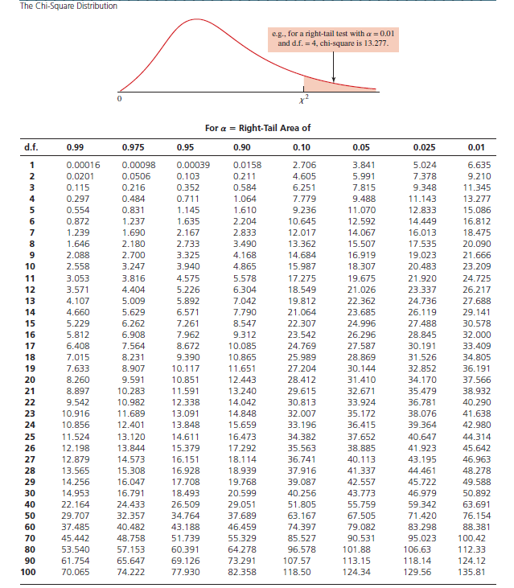Critical