From EU Student Mobility to Lockdown:
“Virtual Study Mobility” in the COVID-19 Era and a
Case Study of Transnational Law in an International Classroom Delivered Online

Cherry James
Law Division
London South Bank University
London, UK
jamesci@lsbu.ac.uk

John Koo
Law Division
London South Bank University
London, UK
kooj@lsbu.ac.uk

Emmanouela Mylonaki
Law Division
London South Bank University
London, UK mylonake@lsbu.ac.uk

Abstract

This chapter comprises a case study of the adaptation of an undergraduate law module, EU Criminal and Migration Law, necessitated by COVID-19. The short overseas study programme- field trip, incorporated in the module and shared by several European universities became, of necessity, an entirely online experience. Comprising a programme of lectures, workshops and presentations and placing considerable value on developing intercultural skills, the customary short study abroad programme could not take place in 2021 and was, therefore, replaced with a five-day online study week. The chapter surveys the literature, which consistently confirms key benefits of study abroad including and particularly for trips of short duration such as that delineated here. Ultimately, the authors of this chapter (the leaders of the module) seek to understand the extent to which, and the ways in which, an online experience can stand in for study abroad. The chapter aims to provide insights into how to design short term virtual study mobility, which as a result of COVID-19 is likely to become more widespread at least in the short term and possibly thereafter.

Keywords: collaboration, intercultural skills, short term study mobility, field trip, inclusion

“This has been the most worthwhile part of my time at LSBU…I now think I will study for my masters abroad, which I hadn’t thought of doing before” [student’s response to field trip in Hungary a few years ago]

Introduction
The focus of this paper is a field trip, established in 2010 by a group of European universities, and its transformation into a purely online event in 2021 because of the Covid 19 pandemic. The field trip takes place annually at one of the participating universities, a group whose membership has changed slightly over time but includes or has included universities in England, Northern Ireland, Hungary, The Netherlands, France, Croatia and Lithuania. At London South Bank University (“LSBU”), part of the group since its inception in 2010, the field trip forms part of an optional module on the law relating to border security, migration and transnational crime and terrorism in the European Union. This chapter considers the impact of COVID-19 on the field trip within this module. While the module can be completed successfully without the field trip, the travel has always been considered integral to the module, and for many years, was the only opportunity for study abroad on the law degree. The module was launched in 2010 with the assistance of funding from the European Union (EU) under the Erasmus Programme for the field trip.

The Erasmus Programme
The Erasmus Programme is, in the area of education, the most conspicuous of the EU integration projects. The original and best known aspect of this flagship policy is a multi-billion euro scheme which finances student exchanges on a fee free basis between European universities for periods of study of up to one year, providing grants to students to assist with travel and living costs. In addition, the programme funds various collaborative initiatives, such as Intensive Programmes for shorter study periods, and it was this type of funding which originally supported the launch of the module on which this case study is based, providing funding for the first three years of the field trip. Erasmus Intensive Programmes have to involve universities from at least three EU countries. Staff and students meet for at least a week to study a subject of relevance to them all, where differing national perspectives ‘add value’ pedagogically. The module discussed in this chapter, focusing on European border security, its relationship with transnational organised crime and terrorism, and cross border migration, fitted this brief perfectly.

The benefits of student mobility
There have been numerous evaluations into the benefits of student mobility as a general phenomenon. The benefits range from improvement in grades to enhancing the student experience and their employability (Cardwell 2020 148; 150), seeing a different way of life, experiencing a different style of study, and improving foreign language skills, (Murphy-Lejeune 2002; Byram and Dervin 2008; Feyen and Krzaklewska 2013).
Studies of the Erasmus Programme point to similar outcomes. Official publications on Erasmus attribute to it four main objectives: the creation of a European consciousness; helping alumni transcend intra-European borders during future careers; facilitating the transfer of skills, techniques and technology within Europe, and helping students to acquire personal characteristics such as independence and intercultural sensitivity and improved language skills (Papatsiba 2005). Jan Figel, a previous EU Commissioner for Education, Training, Culture and Youth, celebrating the 20th anniversary of Erasmus, pointed to Erasmus’s long term benefits, citing competitiveness and growth in the knowledge era and ‘the opportunities it has provided for human and civic development’. Erasmus students, he continued, developed ‘open-mindedness….and cross-cultural skills’, attributes which enhanced their international employability (Figel 2007).
Much student mobility worldwide is, like Erasmus mobility, designed either for a semester or a full academic year. However, for many students, such a period of study abroad presents challenges. Sometimes the difficulties are logistical and practical as much as financial: these range from caring responsibilities to fear of loss of a tenancy or of a part time job. For many LSBU students, these are real difficulties, meaning that however beneficial a period of study abroad may be, it is only ever going to be a realistic prospect if it is for a very short time. Even then, it can present challenges.
Short term study mobility often takes place in the context of a field trip built into a module being studied at the home university, requiring a visit to a university abroad. This is the context of the case study examined in this chapter. The Erasmus Programme identified a gap in traditional student mobility programmes based on semester or year long exchanges. Erasmus Intensive Programmes were therefore designed, inter alia, to enable students and lecturers to work together in multinational groups to share and gain new perspectives on the same topics, students, therefore, benefiting from a short period abroad, studying alongside students of different nationalities, whilst minimising the practical disruption to their normal lives. Since 2013, the Erasmus Programme has funded projects where the study period abroad may last for a period as short as one week.
Short periods of study mobility may sound enjoyable and even have overtones of a short adventure or holiday; however, if funds are to be provided and if university staff are to make the considerable efforts needed to enable and generally accompany such trips, short term study mobility as a specific phenomenon must demonstrably ‘add value’ in some way.
A major EU Commission study (2006) on the professional value of Erasmus mobility reported that ‘a temporary period of study in another European country helps to enhance international competences, contributes to international mobility of graduates and places former Erasmus students in visibly international professional positions’ (Bracht et al 2006). Evaluations of individual Erasmus Intensive Programmes report positive results both for students and in terms of the enhanced international outlook of the students and staff at the participating institutions (Kammerer-Rutten & Schulze 2011; Precey and Rodriguez Entrena 2011).

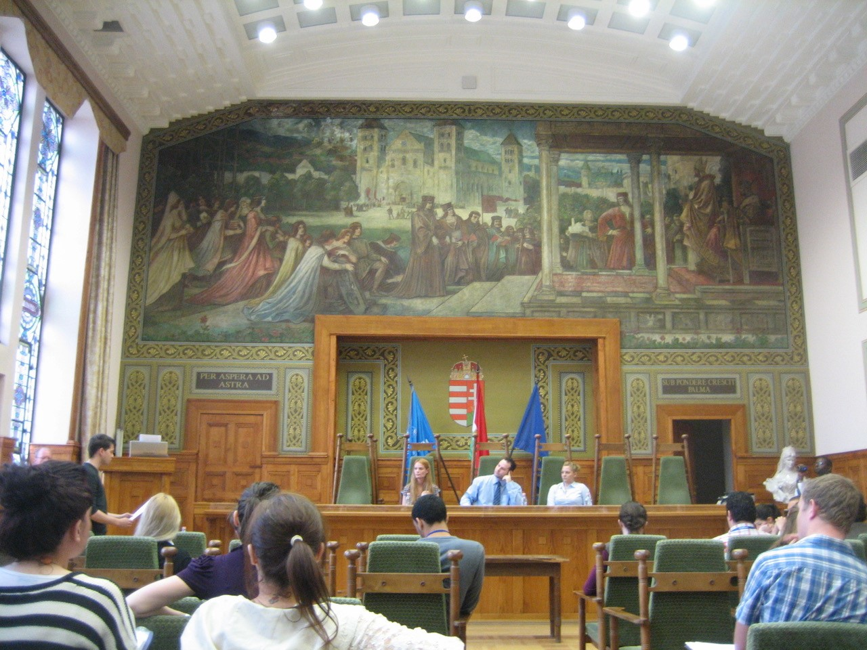
Figure 1. Students participating in a moot (mock trial) during a field trip week in Hungary.

Outside of the Erasmus context, Stronkhurst (2005) reports the findings of a study showing that international and intercultural competencies in the professional sphere are primarily developed in situations where intensive interaction occurs between students of different cultures, for example through projects in which students of different cultures have to work and co-operate towards the same goal. This context describes precisely the situation pertaining to the field trip in this case study. The field trip’s other notable feature is its brevity. This aspect was addressed by a major UK study, which reported considerable benefits to students of short term mobility even when it lasts for no longer than a week to a month (Universities UK International 2017). Furthermore, as the staff involved with this field trip have consistently found, this report confirmed not only that short term mobility was more attractive to less advantaged students than mobility requiring longer periods abroad, but that even such short periods made graduate level employment more likely, unemployment less likely, and led to better degree outcomes than for students who had not taken part in any form of study mobility. This study also found that such benefits were more marked in students from widening participation backgrounds than in their more privileged peers. Five student demographics were considered in the study: students from low socio-economic backgrounds; students from low participation neighbourhoods, black and minority ethnic (BAME) students; students with disabilities and students who are care leavers. All of these students are represented amongst students at LSBU, and particularly those studying for law degrees, the courses in which the module housing the field trip is offered.

The field trip
The field trip is part of a final year, final semester elective module for undergraduate law students and an elective module for law master’s students. The title of the module is EU Crime and Migration Law (EUCML). The module introduces students to the law and policy pertaining to border control, migration and asylum, transnational organised crime and terrorism, interrelated topics with legal and policy links to the Schengen area of border-free movement which operates across most EU member states.
To appreciate the challenges of translation into the online world, it is necessary to set out in some detail how the field trip proceeds in normal years. The field trip takes place part way through the delivery of the module and lasts one week. Over the years, it has taken place at various of the participating universities: France, the Netherlands, Hungary, Croatia and Lithuania. It has not taken place in the UK because the cost of staying even for a week in London is too high for most of the participating universities. The week is intense, true to its origins as an Erasmus Intensive Programme. On the first day, there are lectures all morning and all afternoon. In the evening, students participate in an intercultural session incorporating short presentations by the students from each university in which they are required to ‘introduce their country’. While this might be seen as a somewhat simplistic approach to intercultural relations, it is short, an effective ice-breaker and enables students at this early stage in the week to realise that they can share and present in an international setting. This light-hearted and easy-going session is inevitably varied, diverse and often entertaining (e.g., displays of national dancing, quizzes and songs from popular national television series). The choice of how and what to present is left entirely to the students. Humour, sharing, expressions of interest and being in the same unfamiliar setting provides a good foundation for working together during the week; the evening proceeds with the sharing of typical food and drink from each of the countries represented, brought with them by the students and staff of each of the participating universities. The evening sets the scene for the work of the second day, sessions on intercultural communications, run by a lecturer specialising in this subject. On the third day, students work in one of four or five specialist topic groups with a lecturer who has expertise in that particular field, who first delivers a more specialist lecture and then provides guidance to the topic group so that they can start to analyse a mock factual scenario involving a range of issues which each group analyses from the perspective of their specialist topic. On the fourth day students work in their specialist topic groups, with light touch guidance from the group’s lecturer. Students are given a choice of their specialist topic, but care is taken to ensure that there are students from each university in each group, so students are not working in university or national groups. On the final working day, students present their advice in topic groups to the whole cohort of staff and students. While the delivery of lectures is, perhaps necessarily, didactic, students are encouraged to interact as appropriate; this is easier for them in the second half of the week when they are working in small groups, and occurs to differing extents amongst the students depending on the differing pedagogical approaches prevailing in their home universities. The final presentation, the cumulation of the students’ academic endeavours for the week, is both a display of what the students have achieved during the week and is year on year a test of and testament to the students’ ability and willingness to collaborate with each other and participate in a group task which transcends national boundaries.

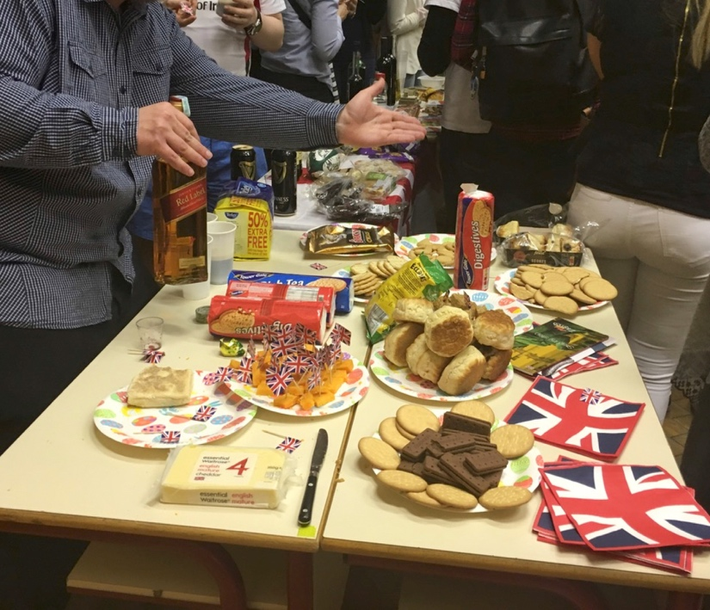

Figure 2. The ‘Introduce your country evening during the field trip: the UK students’ table

The field trip is no longer funded by the Erasmus Programme, but the initial funding acted as the catalyst for the origins of this module, which was created following an invitation from a university in the Netherlands to LSBU and three other EU universities to join the (ultimately successful) bid for Erasmus Intensive Programme funding. As an Intensive Programme, it required a model of participation based upon collaboration to enable teaching in an ‘international classroom’ setting. The funding covered three years of staff and student costs involved in setting up and running the field trip, and the EUCML module was created to ‘house’ the field trip. The collaboration between the partner universities has, with some changes, endured since 2010, so the original Intensive Programme was the foundation of a successful collaboration between the partner universities for the longer term. While Brexit, the UK’s formal disassociation from membership of the EU, has fundamentally changed the UK-EU relationship, the loss of access to Erasmus funding will not be relevant to the field trip, given that it has been funded by each participant institution since the Erasmus funding ended.

The outcomes of the EUCML field trip consistently match the key findings from the widespread research on study abroad, which shows that students benefit from it in ways wider than a simple positive impact on results. In the case of the EUCML trip, the effect seen most immediately is the increased personal engagement of the students in and enthusiasm for their studies. The experience has always been, in line with the spirit of the original Erasmus Intensive Programme, short and intense, and the evaluations undertaken after each field trip make it clear that it leaves an impression on the student. The one week is more than the sum of its parts, more than a multinational veneer, but rather a deeper experience that extends beyond an international classroom taster to a personal intercultural interpretation and experience of sharing and living mediated principally not as student, but as an individual, for whom as the week progresses, national and university boundaries fade. Responses from LSBU students, following the event and following graduation, and some unsolicited correspondence from students from the partner universities, reveal how that one week often marks their time as a student like no other learning or university experience. Evidently it is not the study per se that effects the responses but the personal journey during that week. Given this, but not surprising for those who have been involved in organising study abroad programmes, it has always been an irony and a shame that it is often a challenge to convince final year students to opt for this module. It is important to consider the reasons for this, since they have in some respects emerged as relevant to the online model designed of necessity in 2021.

Widening participation

The profile of the LSBU student body, mirrored in the law students, is characterised by above average numbers of students from ethnic minorities. LSBU is identified as a ‘widening participation’ university in the UK, distinguished from the elite and highly selective ‘Russell Group’ of UK universities (the Russell Group comprises 24 research-intensive universities, which together produce about two thirds of world-class research produced in UK universities). LSBU law students cannot participate in standard Erasmus student exchanges since in every semester they are studying at least one compulsory module mandated by the UK legal professional bodies, which cannot be studied in universities abroad. In any event, for many LSBU students it would be impractical to participate in a programme taking them abroad for as long as a semester, let alone a whole year. Many of the students come from the lower socio-economic or ethnic minority groups which predominate in the university’s inner city location, the major ethnic minority groups represented being West African, Afro-Caribbean and South Asian, generally second generation residents. A large number of LSBU students have to balance their study with work and/or caring or other family responsibilities.

The participation of LSBU students in this module and, therefore, in the field trip is, to some extent, a counterweight to the narrative that study abroad is an elitist phenomenon. In Bourdieu’s terms, undertaking student mobility is a form of cultural capital, which necessarily suggests that it is a privilege not accessible to all students (Bourdieu 1986). It could be said that in some ways student mobility is a modern version of the aristocratic grand tour of days of yore. In this respect, mobility capital has become a phenomenon of concern as well as celebration, because of its potential to exclude: conversely, although an online study experience also raises some exclusory concerns as is noted later, in this respect it has the potential to be more inclusive. The accusation of elitism has been levelled against the Erasmus Programme, based principally on evidence indicating that students already blessed with mobility capital are those most likely to choose to build upon it by studying abroad (Kuhn 2012; Brooks and Waters 2009; King and Ruiz-Gelices 2003). This is despite Erasmus’s attempts to make study abroad more accessible for students from less advantaged backgrounds by providing additional funding for such participants. It is clear that the policy behind Erasmus has broadened and that the Programme has become increasingly attentive to the need to widen participation (European Parliament 2019). The original funding to enable the launch of the EUCML module at a university like LSBU is a perhaps a case in point.

Readiness to study abroad

Initially, the successful bid for funding an Erasmus Intensive Programme and the consequent launch of the EUCML module, at the time the only opportunity provided by LSBU to enable its law students to study abroad, was accompanied with the expectation that it would be a popular option. This newly available study abroad opportunity was fully funded, entirely run in the English language, of short duration, and accompanied by members of staff well known to students. However, whilst all available places on the module have always been filled, there has always been less competition for the places than originally anticipated. As has been noted, the situation of many students at the university means that even a funded week abroad is not practical or affordable because of their caring responsibilities, family duties or employment. Caring responsibilities and other family duties still often impact more on female students, who usually comprise roughly two thirds of students taking choosing the module, a proportion similar to the gender balance amongst LSBU law students as a whole. Some students may consider that the field trip entails risk and disruption during their final year and, therefore, to the overall classification of their degree (cf Cardwell 2020, 150). There are some suggestions that a law student may have less desire to embrace globalization and the European project than, say, a typical business studies student (Hackney 2012). There may also be some latent resistance based on sense of identity and location: the evidence shows that UK students are generally more reluctant to study abroad compared with students in other countries (Cardwell; James 2013, 66-7). Furthermore, some students from ethnic minority groups, as already noted significantly represented amongst the LSBU law student population, may come from relatively conservative backgrounds, less open to the liberal forces of migration and globalisation exemplified by a determinedly transnational study experience and less ready to perceive such experience as valuable (Sobolewska and Ford 2020, 44-45, 70-71). Amongst some of the ethnic minority groups represented at LSBU, familial pressure not to study abroad weighs particularly heavily on female students.

It is evident that there is a complex set of factors behind a decision to choose a study abroad option. Even when the circumstances pertaining to the study abroad are very favourable, a decision to take up the opportunity is practical, personal and perceptional, based on a set of evaluations about the value and risk of studying abroad, evidently even for a short period. (Hackney; Cardwell). It is worth observing that there has always been a relatively high representation of students on the module who have had previous experience of international travel and living; particularly notable has been the participation of EU citizens from eastern European countries whose families came to the UK to settle and who have now enrolled on LSBU courses, and international students from South Asian countries and from those in West Africa. This background underlies the observation that possessing mobility capital generates a pre-disposition to acquire more. For those who already have it, the module is a further gain; for others, it is an important first step across a boundary, and it is notable that a number of students in this latter group have subsequently gone on to undertake postgraduate study abroad and have attributed their interest and increased confidence in so doing to their participation in the field trip.

Such are the factors influencing the composition of the student cohorts participating in the field trip over the last decade. In the event, as will be explained, the radically changed circumstances wrought by the pandemic may have resulted in a quantum shift in perception of the accessibility of the module, and in this respect, as explained below, the online offering has achieved something the field trip in normal years has struggled to do.

2020-2021: the impact of the pandemic

The national and international restrictions imposed in response to the worldwide health emergency meant that plans for the 2020 field trip had to be abandoned in mid-March 2020, two weeks before the trip would have taken place and leaving no time, in those fevered and shocked days as country after country withdrew into itself to formulate a replacement for that year. However, the value the participating universities placed on the opportunity to study abroad and the desire of the partner universities to maintain their collaboration drove the assumption that 2020 was simply a lacuna in the history of the field trip. Throughout much of 2020 it was hoped that it would be able to proceed as normal in 2021, but the worsening rate of infection and the reimposition of travel restrictions in the UK and the EU made it clear by January 2021 that once again there could be no field trip. However, this time there has been an opportunity to prepare: hence the design of a five-day online study programme, modelled, so far as possible, on the field trip. The rest of this paper will focus on how comparable such modelling actually is, viz., to what extent can an international study abroad experience be replicated by online study, what is lost, and whether anything may actually be gained by the replacement format?

The authors anticipated in advance that it would be possible to replicate the substance of an ‘international classroom’ online, with different European perspectives provided in presentations given to all the students by academics from the partner universities. What remained less clear was whether the online study week, with its decade long history of collaboration between the partners and in depth awareness of the contribution of each part of the schedule, would be able to achieve something more, beyond another online learning experience.

The online study week programme
*For further details, see the table at the end of the chapter

The challenge to deliver a successful study week online was clear. A study by Rovai, Wighting, and Lui suggested that ‘online students feel a weaker sense of connectedness and belonging than on campus students who attend face-to-face classes,’ (Rovai et al., 2005, p.4). The risk in a one-off international classroom setting, where students come from different pedagogical cultures and do not know each other in advance, of misunderstanding and exclusion was potentially greater. The staff and students in 2021 were from universities in the Netherlands, Hungary, England and Ulster; the students came from all of these countries as well as France, Georgia, Moldova, Lithuania, Romania, Jordan and Nigeria; a number of the LSBU and Dutch students were from ethnic minority groups represented in London and Rotterdam. As Shin has pointed out, limited or no face to face interaction makes it difficult for students to receive guidance or instructions from supervisors and can lead to ambiguity (Shin, 2005). As was expected, this was a challenge for the online study week, where even live face to face interaction was limited as students and staff turned on cameras for only limited periods. Inevitably there was a loss of important communication by the inability to observe each other’s body language, demeanour and interactions.

Thought was given to the complex play of these factors. But there was an inevitability about delivering the programme along the lines of the time-honoured field trip, as there was about the decision that the study week should take place online. A year of experience of teaching online, together with confidence within the organising team that the programme could be offered effectively in this way, appeared to afford some compensation for the realities and limits of it taking place entirely online.

As it would have been for the field trip, the content was organised over a five-day working week. The series of lectures were the same, but some differences can be observed. First, they were shorter in length, as staff were aware that online lectures need to be shorter to be palatable. The lectures were delivered live, at scheduled times, but were all recorded as they were delivered. In contrast with the field trip week, students could not be expected or required to attend all online sessions throughout the week as students could not be expected to give the study week precedence over other classes, albeit also online, timetabled at their home universities. Recording lectures was also an insurance for the inherent risk of online delivery outage, which turned out not to be a problem; the recordings were also useful as a learning resource for activities later in the week.
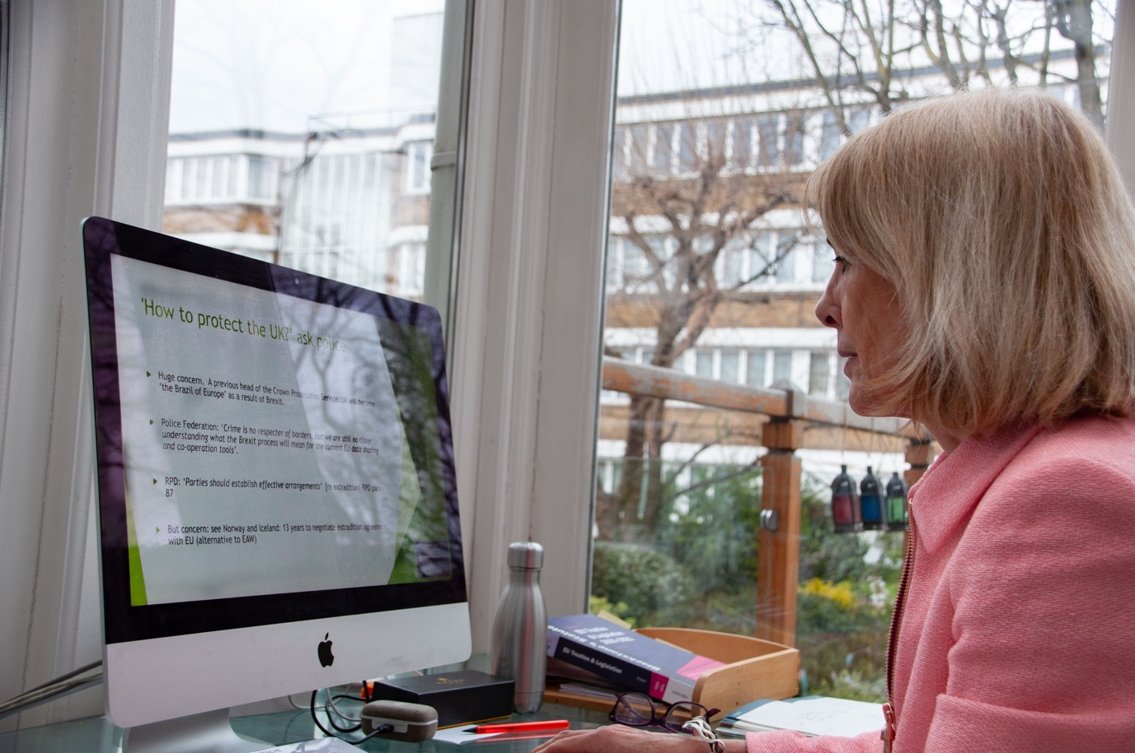

Figure 3. Cherry James delivers her lecture from home during the online study week in 2021.

In the spirit of the programme and with the attendant value of intensity (as advocated by Stronkhurst), the first day was full of activities. In addition to recorded lectures, students were expected to attend both an opening session and an intercultural communications session. It was made clear that these two sessions were important and attendance expected. Given the value afforded by the field trip in intercultural engagement and the corresponding loss from the absence in the online study week of travelling and living together, considerable value was placed on the intercultural communications session both to break the ice and set the tone and expectations for the week. While only ninety minutes long, the class was nonetheless intense and searching. Through the ‘breakout rooms’ function, groups of students engaged with each other discussing cultural and national notions of time. For this session students were strongly encouraged to turn on cameras with the intention to make interactions more meaningful and richer. This was seen as important and a precursor to the group work later in the week. By Thursday (day four) all lectures had been delivered and students had been organised into groups according to their preferred specialist topic. Each group was allocated to and met and worked in a different channel on the online platform. At the beginning of Thursday a lecturer met with the group, to ensure their tasks were properly framed and understood, and crucially that the students had thought about the dynamics of group work and the limitations and challenges of their circumstances. The lecturer judged the moment to leave the group and let the students work together. The lecturers also used their judgment about the level of support to provide and whether to ‘check in’ with their group at points during the day. On the Friday all participants came together and each group presented, by sharing their screen, its analysis of a scenario from the perspective of their specialist topic. The week was completed with a virtual presentation of certificates of participation to the students.

Inclusion in the online world
One has to be careful not to equate the convenience and ease of connectivity with inclusion. There is a considerable risk of superficial and passive or partial engagement by students. The fact that the students were physically absent made the creation of a learning environment which was inclusive, which students felt a part of and ownership of, a much more complex process. The pandemic has perhaps exacerbated or reframed exclusion in the obvious forms of access to appropriate technology: there is much talk of the ‘digital divide’, and academics are becoming used to the fact that some students clearly have much better computer facilities and internet access at home than do others. However, online academic delivery has the potential to raise issues in other dimensions too, such as space and privacy, attitudes and methods. This is particularly so in an event such as the one under consideration here: the field trip always emphasizes considerable differences in pedagogical expectations and styles between the different national groups and it has always been an interesting challenge for students and staff alike to manage these differences during the week together.
The delivery of the online study week benefited from, indeed relied on, a year of exponential growth in learning on ways to instruct and facilitate online learning. Hockings (2010) defined inclusive learning as ‘teaching which engages students in learning that is meaningful, relevant and accessible to all, embracing a view of the individual and of individual difference as a source of diversity that can enrich the lives and the learning of others.’ This resonates with the notion of the international classroom and the emphasis on and a sensitivity to intercultural differences, which manifest themselves whether in the real or the virtual world in varying approaches to the relationship between student and teacher. In this respect, the experience of teaching in the field trip over the past decade was invaluable. Respecting inclusivity called for the introduction of mechanisms online by which each student was valued as an individual with specific needs, and implied delivery in a manner that offered an equitable experience to all students. For the online study week this mandated, amongst other things, heightened awareness that most students were operating in their second or third language, in time zones which might be inconvenient to varying degrees, and had had received differing levels of tuition in the subjects underpinning the focus of the study week.
Some indications have emerged that these aims may have been achieved, at least to some extent. The intercultural communications session, so popular and beneficial during the field trip, was obviously a deliberate intervention to emphasise differences but in doing so to foster a sense of validity of those differences and to sow seeds of understanding and acceptance. Anecdotal comments from the students as the week progressed and in the short evaluation survey administered at the end of the week indicated that the session had largely achieved its aims.

All members of the teaching team have established a strong connection and indeed it is the relationship that made it is so easy and obvious to organize the online study week as a replacement to the field trip. The rich experience of the partnership and a year of learning how to deliver best online clearly enabled the team to confidently approach the organization and to manage the surprisingly few live technical problems as they occurred. In short, the commitment to the partnership and to the success of the online study week was key. It has been suggested that students’ presence and hence sense of inclusion is linked to staff presence. (Anderson et al, 2001). During this week, as with the field trip, the presence of the staff was essential. Anderson distinguishes two categories of staff presence: a cognitive presence, focusing on how teachers take into consideration students’ preparedness to participate in the online learning experience and a social presence, referring to the social communication channels that teachers must open to maintain and possibly enhance the spontaneous student-student and student-teacher interaction which can tend to be lost or reduced in the online world. For this medium, and given the aim of interculturality, the sense of the presence and availability of staff, even if in the background at times, throughout the online study week it was seen as integral to facilitating a sense of social and person connectivity. For the group activity to work well, it was vital that there was a sense of commitment and connectivity between students, and for this, as much as topic expertise, staff participation and engagement in what was essentially meant to be a student group endeavour was key. Staff had different experiences with their groups and the presentations on the Friday, mostly given by one or two student leads, inevitably hid the actual dynamics that played out between the students and the levels of cohesion achieved. This is one important area in need of further research. Before the closing of the study week on the fifth day there was a virtual presentation of certificates of participation to the students. The organisers and indeed all participating staff considered this to be an important conclusion to the week, helping to underline the achievement of the students, their inclusion in a unique experience, and having acted as an incentive for active participation as has been the case during the field trips. It is hoped that the certificates will denote and so reinforce the sense of an intercultural experience and so foster the possibility of real physical mobility when circumstances permit: the virtuous circle of mobility capital acquisition which actual study mobility has been shown to encourage.

The numbers of LSBU students who took the module were in line with previous years. A number of these students justified their decision by explaining that they were interested in choosing a module requiring collaborative study with students from other universities but had personal circumstances which would have prevented studying away from home. The body of students who participated in this online study week including from LSBU included young mothers with babies in arms. These authors consider that this interesting outcome itself justified the efforts necessary to attempt to translate the field trip into the virtual world, which perhaps could, given the challenges of even a short field trip for many, be seen as a more inclusive proposition for some students.

Conclusion
There are independent bodies of literature addressing online delivery and study mobility programmes. However, the COVID-19 outbreak has revealed the need to synthesise the two and consider them collectively in the context of the online delivery of study mobility programmes. The present chapter contributes to this discussion by providing an insight into the online delivery of a particular field trip and in so doing offers some insights that may be useful for academics involved in the delivery of similar programmes in the future. The experience of preparing for the international online study week provides an indication of the challenges associated with this mode of delivery while reflecting on the shortcomings of the process. Despite the different mode of delivery, the response of students who participated is a vindication of the efforts to organise it, and suggests its value to students, particularly notable given that on its own, it offered no credits towards qualification. The absence of the practical obstacles to travel clearly helped some students, which included a number of students from LSBU representing different ethnic groups and as already noted, a mother of a young baby. In this particular respect, the online study week can be considered successful and obviously provided an opportunity that would not have been realistic or might have been perceived as too much of a risk for some had there been a field trip. Although it was accepted all along that it would be impossible to achieve online precise replication of a trip away from home, a number of practical steps were adopted to address the challenges to students’ inclusivity and engagement with the programme. Staff presence and availability throughout the whole week provided clear direction to students and contributed to an online space where student felt motivated and engaged. Student engagement was consistently high throughout the week. The early session on intercultural communications was considered to be of primary importance to set a tone of togetherness in diversity. During the week, the learning outcomes of the field trip were fulfilled as evidenced by the students’ performance in the final presentations on the final day. The presentations revealed the possibility of students interacting online and engaging in critical discussions to produce collective responses to set tasks, though on this point, some caution must be exercised, given that the actual evidence of the level of interactivity and cohesion is inevitably limited.
The present case study is subject to certain limitations due to the lack of the formal collection of primary data from staff and students involved in the programme, relying instead on informal evaluations. In fact, the chapter sheds some light on the need to conduct further investigations which synthesise research on the extent to which mobility programmes may be delivered online in the future, in order to reach more valid conclusions. The experience delineated here suggests that this is possible, though with reservations. In particular, the cultural aspects that are integral to mobility programmes and the benefits associated with such programmes in terms of the value of intercultural experience of visiting, studying and spending time in a course of study abroad are not possible to replicate in exactly the same way or for precisely the same outcomes online. Nevertheless, with increasing attention in higher education worldwide to the looming imperative to place sustainability centre stage in educational programmes, it seems likely that the rapid shift necessitated by COVID-19 from a week requiring international travel by staff and students to online delivery of a similar programme, may turn out to be a serendipitously timed experiment.

*Table summarising the learning activities undertaken in the online study week in 2021
Working in groups: students chose a specialist topic which corresponded to one or more of the lectures.
In their specialist topic groups, which each incorporated students from the different universities, students analysed the issues pertaining to their topic which arose in a case study. All groups worked on the same case study, analysing it from the perspective of their specialist topic.
The case study: this was written by a member of the group who works for a national police agency; while fictionalised, it reflected real life issues for a person caught up with organised crime within the EU and who makes an asylum claim.

The case study followed the journey of a vulnerable Bangladeshi national who, through a middle person, was persuaded to sell one of his kidneys; for this he was flown to a hospital in Doha; after the operation, while recovering, he was taken to the EU where he was kept by criminal operators who moved him through the EU, from Hungary, through Austria and Germany to the Netherlands and thence to France, using falsified papers, eventually ending his journey by crossing the border between Republic of Ireland and the UK, where he claimed asylum.
Lecture topics/specialist groups | Matters that the student groups considered in their 2021 presentations
EU free movement rights and border controls including with the UK | The possible ways a person could make such a journey into and through the EU, taking account of EU border law and the law of rights of stay.
Rights of asylum seekers in the EU and the UK | The rules for determining which EU state is responsible for an asylum claim; the separate rules for an asylum claim in the UK as a non-EU state.
EU law and policy to tackle transnational organised crime and terrorism | Classifying the cross- border criminal activity; assessing the characteristics of criminal activity that is considered organised; identifying equivalent national laws that prohibit criminal activity and comparing sentencing tariffs.
EU law relating to surveillance | The framework of EU law under which national laws permit phone tapping and surveillance of internet activity; identifying EU law enforcement agencies coordinating national police forces.

References

Anderson, R. (2004). European Universities from the Enlightenment to 1914, Oxford: Oxford University Press, 4-19.

Anderson, T., Rourke, L., Garrison, D. R., and Archer, W. (2001). Assessing teaching presence in a computer conferencing context. Journal of Asynchronous Learning Networks, 5(2), 1–17.

Bourdieu, P. (1986). The Forms of Capital. In J Richardson (ed.), Handbook of Theory and Research of the Sociology of Education, Westport CT: Greenwood, 241-58.

Bracht, O., Engel, C., Janson, K., Over, A., Schomburg, H. and Teichler, U. (2006). The Professional Value of ERASMUS mobility., Kassel: International Centre for Higher Education Research. Available from https://www.eurashe.eu/library/modernising-phe/mobility/professional/WG4%20R%20Professional%20value%20of%20ERASMUS%20mobility%20Teichler.pdf. Accessed 13/2/21.

British Academy (2020). Association to Erasmus: Challenges and Opportunities, A British Academy UK-EU Briefing.

Brooks, R. and Waters, J. (2009). International higher education and the mobility of UK students. Journal of Research in International Education 8(2) 191-209.

Byram, M. and Dervin, F. (eds) (2008). Students, Staff and Academic Mobility in Higher Education, Newcastle: Cambridge Scholars Publishing.

Cardwell, P. J. (2020). Does studying abroad help academic achievement? European Journal of Higher Education Vol 10(2): 148; 150.

Erasmus+. (2020). https://www.erasmusplus.org.uk/apply-for-higher-education-student-and-staff-mobility-funding Accessed 26/1/21.

European Commission. Erasmus+. Opportunities for Individuals. https://ec.europa.eu/programmes/erasmus-plus/opportunities/individuals/students/studying-abroad_en Accessed 26/1/21.

European Parliament, News. (2019). https://www.europarl.europa.eu/news/en/press-room/20190321IPR32121/erasmus-2021-2027-more-people-to-experience-learning-exchanges-in-europe Accessed 26/1/21.

Feyen, B. and Krzaklewska, E. (eds) (2013). The Erasmus Phenomenon – Symbol of a New European Generation? Frankfurt: Peter Lang GmbH.

Figel, J. (2007). ‘20 Years of Erasmus: from Higher Education to European Citizenship’, Erasmus 20th Anniversary Closing Conference, Lisbon.

Hackney, K., Boggs, D. and Borozan, A. (2012). An Empirical Study of Student Willingness to Study Abroad. Journal of Teaching in International Business 23(2): 123–144.

Hockings, C. (2010). Inclusive learning and teaching in higher education: A synthesis of research. York: Higher Education Academy.

Hofstede, G. (1980). Culture’s consequences: international differences in work-related values. London: Sage.
Hotson, H. (2016). The Stars Are Still Aligned. Times Higher Education, 7/7/16.

Hughes, G. (2007). Diversity, identity and belonging in e-learning communities: some theories and paradoxes. In: Teaching in Higher Education, 12 (5–6), 709–720.

James, C. (2013). Enhancing the QLD: internationalisation and employability: the benefits of Erasmus Intensive Programmes. The Law Teacher 47(1) 64-82.

Jan, S.K., Vlachopoulos, P., and Parsell, M. (2019). Social network analysis and learning communities in higher education online learning: A systematic literature review. [online] Online Learning, 23(1), 249-264. doi:10.24059/olj.v23i1.1398.

Kammerer-Rutten, U. and Schulze, U. (2011). International education and the cross-cultural setting: Learning and teaching in international settings. In: Hatakka, H (ed) Interprofessional and international learning experiences in social and health care higher education in Lahti University of Applied Sciences: Lahti University of Applied Sciences, Finland, 58ff at 67.

King, R. and Ruiz-Gelices, E. (2003). International Student Migration and the European “Year Abroad”: Effects on European Identity and Subsequent Migration Behaviour. 9(3) International Journal of Population Geography 9(3) 229-252.

Kuhn, T. (2012). Why Educational Exchange Programmes Miss Their Mark: Cross-Border Mobility, Education and European Identity. Journal of Common Market Studies, 50(6): 994-1010.

McLoughlin, C. (2001). Inclusivity and alignment: Principles of pedagogy, task and assessment design for effective cross-cultural online learning. In: Distance Education, 22(1), 7–29.

Miller, M. D. (2014) Minds online: teaching effectively with technology, Cambridge MA: Harvard University Press.

Murphy-Lejeune, E. (2002). Student Mobility and Narrative in Europe, Abingdon: Routledge.

Olajide, O. (2013). The Complete Concise History of the Slave Trade, Bloomington: Authorhouse, 18.

Papatsiba, V. (2005). Political and Individual Rationales of Student Mobility. European Journal of Education 40(2): 173-188.

Precey, R. and Rodriguez Entrena, MJ. (2011). Developing the Leaders We Want to Follow: lessons from an International Leadership Development programme. International Journal of Contemporary Management, 10(2): 70-83.

Rivza, B. and Teichler, U. (2007). The Changing Role of Student Mobility. Higher Education Policy 20(4): 457-75.

Savenye, W.C. (2005). Improving Online Courses: What is Interaction and Why Use It?
Distance Learning, 2(6), 22-28

Shin, Y. (2005). Conflict resolution in virtual teams. Organizational Dynamics. 34(4), 331-334.
Sobolewska, M. and Ford, R. (2020). Brexit Land. CUP 2020. Cambridge: Cambridge University Press: 5, 44-45, 70-71.

Stronkhurst, R. (2005). Learning Outcomes of International Mobility at Two Dutch Institutions of Higher Education. Journal of Studies in International Education 9(4): 292-315 at 292.

Teichler, U. and Janson, K. (2007). The Professional Value of Temporary Study in Another European Country: Employment and Work of Former ERASMUS students. Journal of Studies in International Education, 11(3-4):486-95 at 492-3.

Universities UK International (2017). Widening Participation in UK Outward Student Mobility at
http://www.universitiesuk.ac.uk/policy-and-analysis/reports/Documents/International/widening-participation-in-uk-outward-student-mobility.pdf Accessed 14/2/18.

Photographs
- IMG 4389 Students participating in a moot (mock trial) during a field trip week in Hungary.
- IMG 1451 [1] The ‘Introduce your country’ evening: the UK students’ table.
- DSC 0327 Cherry James delivers her lecture from home during the online study week in 2021.

