Spray deposited copper zinc tin sulphide (Cu 2 ZnSnS 4) film as a counter electrode in dye sensitized solar cells
Sanjay Kumar Swamiª, Neha Chaturvediª, Anuj Kumarª, Nikhil Chanderª, Viresh Duttaª, D. Kishore Kumar^{b}, A. Ivaturi^{b}, S. Senthilarasu^{c} and Hari M. Upadhyaya^{b}
ªPhotovoltaic Laboratory, Centre for Energy Studies, Indian Institute of Technology Delhi,
New Delhi-110016, India
^{b}Energy Conversion Laboratory (ECL), Institute of Mechanical Process and Energy Engineering (IMPEE), School of Engineering and Physical Sciences, Heriot-Watt University, Riccarton, Edinburgh EH14 4AS, UK
^{c}Environment and Sustainability Institute (ESI), University of Exeter, Penryn, Cornwall, TR10 9EZ, UK

Abstract
Stoichiometric thin films of Cu₂ZnSnS₄ (CZTS) were deposited by spray technique on FTO coated glass substrate, with post annealing in H₂S environment to improve the film properties. CZTS films were used as counter electrode (CE) in Dye-Sensitized Solar Cells (DSC) with N719 dye and iodine electrolyte. The DSC of 0.25 cm² area using CE of CZTS film annealed in H₂S environment under AM1.5G illumination (100 mW cm⁻²) exhibited a short circuit current density (J_{SC}) = 18.63 mA cm⁻², an open circuit voltage (V_{OC}) = 0.65 V and a fill factor (FF) = 0.53, resulting in an overall power conversion efficiency (PCE)= 6.4%. While the DSC using as deposited CZTS film as CE showed the PCE = 3.7% with J_{SC} = 13.38 mA cm⁻², V_{OC} = 0.57 V and FF = 0.48. Thus, the spray deposited CZTS films can play an important role as a CE in the large area DSC fabrication.

Keywords: CZTS, Spray Process, Sulphurisation, Dye Sensitized Solar Cell

- Introduction
Dye-Sensitized Solar Cell (DSC) can play an important role in the field of solar photovoltaic due to its low cost and relatively high light to energy conversion efficiency.¹ A combination of mesoporous photoanode,² sensitizer dye,^{3,4} electrolyte composed of a redox couple^{5,6} and counter electrode (CE)⁷⁻¹¹ determines the device performance both in terms of efficiency as well as cost. The photoexcited electrons injected into the conduction band of TiO₂ photoanode from the excited state of sensitizer dye cause an oxidation reaction of the redox couple (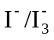) at the CE: 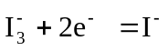. The reduction reaction takes care of the photo generated holes and causes dye regeneration to continue the process. Thus an ideal CE should have high electro-catalytic activity for the redox couple in the electrolyte and high stability during the solar cell operation. A thin layer of Platinum (Pt) on FTO coated glass is commonly used as the CE in DSCs. The high cost, stability under field conditions and low abundance of Pt are important considerations in the commercial development of DSCs.¹¹ Efforts are being made to replace Pt with earth abundance and cheap materials such as carbon based material,^{7,12,13} conjugated polymeric material¹⁴⁻¹⁶, cobalt sulphide^{17,18} and kesterite.¹⁹⁻²⁷
Kesterite (Cu₂ZnSnS₄) is a quaternary chalcogenide p-type semiconductor with a direct band gap of 1.45 eV.²⁸ CZTS contains the combination of non-toxic, cheap and earth abundant materials, viz Cu, Zn, Sn and S.CZTS thin films have been prepared by various methods such as spray,^{29,30} thermal evaporation³¹ and spin³² for solar cell applications. CZTS nanoparticles synthesized by solution based method spin coated on FTO and used as the CE in DSCs yielded a power conversion efficiency (PCE) ~ 7.3%.¹⁹ One step synthesized CZTS nanoparticles used as CE showed PCE of ~3.85%.²⁰ CZTS nano particles synthesized by solvo-thermal method were used as the CE to obtain PCE ~ 6.98%. Spin coating method was used to make a CZTS CE giving PCE~5.63%.²² Sputtering technique was used to make a CZTS CE for DSC and yielded PCE~3.65% .²³ Graphene + CZTS film also used as the CE in DSC showed PCE ~7.81%.²⁴ The CE using CZTSe nanoparticle synthesized by ligand exchange method resulted in DSC PCE~7.06%.²⁵
This paper reports on the direct formation of CZTS film by a low cost spray technique followed by annealing in H₂S environment. As deposited and annealed CZTS films have been used as the CE in DSCs. Annealed CZTS film shows a better catalytic behavior than as deposited CZTS film. A PCE ~6.4% with annealed CZTS CE film proves the effectiveness of the spray technique with inherent advantages of less deposition time, easy thickness control, large area deposition and cost effectiveness.³³

2. Experimental Methods
The set-up for spray deposition is given in details in our earlier publication.³³ Cu₂ZnSnS₄ (CZTS) thin films were spray deposited on FTO coated glass substrates by taking 0.02 M cuprous chloride, 0.0125 M zinc chloride, 0.01 M stannous chloride and 0.15 M thiourea precursors dissolved in deionized water. Nitrogen (N₂) was used as the carrier gas with 1.8 kgf cm⁻² pressure and the solution flow rate was maintained at 1 ml min⁻¹ during the process. The FTO coated glass substrates were maintained at 350˚C during deposition. In order to sulphurise the spray deposited CZTS thin films, the samples were introduced in to N₂+H₂S (5%) environment inside a tubular furnace. The flow rate of the reactive gas was kept constant to 10 sccm. The temperature of the furnace was increased from room temperature to 300˚C at a step size of 10˚C min⁻¹, from 300˚C to 500˚C at 2˚C min⁻¹ and then maintained at 500˚C for one hour. The reactive gas was replaced with nitrogen and the furnace was left to cool down to room temperature. As deposited sprayed CZTS film is named CZTS I and sprayed CZTS film annealed in N₂+H₂S (5%) environment at 500°C for one hour is named CZTS II.
The commercially available TiO₂ paste (DSL 18NR-T, Dyesol) as the transparent layer (9 µm) and DSL 18NR-AO, Dyesol as the scattering layer (6 µm) were used to prepare mesoporous nano-crystalline TiO₂ photoanodes on FTO coated float glass substrates (TEC-8, Pilkington) pretreated with 40 mM aqueous TiCl₄ solution at 80˚C for 30 min. The TiO₂ photoanodes were made by screen printing method. After screen printing TiO₂ photoanode was annealed with a ramping program on hot plate.³⁴ TiO₂ photoanodes were further treated with 40 mM TiCl₄ solution as described above, rinsed with water and annealed at 450˚C for 30 min. Thus prepared TiO₂ photoanodes were soaked in 0.5 mM ethanolic solutions of N719 dye (Dyesol) for 18-20 hrs. A reference Pt CE was deposited on FTO coated glass by covering it with a drop of H₂PtCl₆ solution (2 mg ml⁻¹ in ethanol) followed by annealing at 450˚C for 15 min. Pt film and spray deposited CZTS films with and without sulfurization were used as the CE in DSC. The DSC was assembled by making a sandwich structure of the photoanode and the counter electrode, sealing it with 25 µm thick surlyn (Solaronix SA) which also acts as a spacer. The electrolyte consisting of 0.6 M 1,3-dimethylimadazolium iodide, 0.1 M lithium iodide, 0.05 M Iodine, 0.5 M 4-tert-butylpyridine (TBP) and 0.6 M benzmethyl imidazolium iodide in acetonitrile: valeronitrile (85:15) was injected through a previously drilled hole in the counter electrode. After the electrolyte injection the hole was sealed with a cover glass slide and surlyn. A mask of 0.25 cm² area was used on the photo electrode for specifying the solar cell area.
The crystal structure of CZTS films was analyzed using X-ray diffractometer (Phillips X’PERT PRO, using Cu Kα line λ= 1.5405 Å). Chemical composition of the film was analyzed using Zeiss EVO-50 having EDX analysis instrument. High resolution scanning electron microscope (Dual beam FEI Quanta 3D Field emission gun SEM) was used for studying the surface morphology and cross-section of CZTS layers. To avoid charging during SEM imaging, a thin layer of gold was sputter coated on the samples. Optical characterization was done using Perkin Elmer Lambda 1050 UV-vis-NIR spectrophotometer. Raman spectrum was recorded at room temperature by RenishawInVia Raman microscope with the excitation by 514.5 nm photons of 50 mW Argon ion laser from Spectra Physics. Cyclic Voltammetry (CV) was done by Princeton Applied Research (PAR) model no. 273A-2 with a three electrode system in an acetonitrile solution containing 0.1 M LiClO₄, 10 mM LiI and 1 mM I₂ at a scan rate of 50 mV s⁻¹. Ag/Ag+ was used as the reference electrode and Pt wire as the CE. Impedance measurement was done by Autolab Model No. PGSTAT 128N in the frequency range from 100 mHz to 1 MHz. The J-V characteristics were measured under AM 1.5 G illumination (100 mW cm⁻²) using Oriel Sol 3 A, a class AAA solar simulator with Keithley 2440 source meter. The simulator was calibrated using an NREL certified Si solar cell. Incident Photon to Electron Conversion Eﬃciency (IPCE) spectra at room temperature were recorded using SpeQuest quantum efficiency measurement system from Rera solutions, the Netherlands. The Jsc values for AM1.5 spectrum were obtained from the IPCE spectrum using a built in function in the measurement system.
3. Results and discussions
3.1 Structural analysis
The XRD patterns of spray deposited CZTS films are shown in Fig. 1. The XRD peaks of CZTS II film at 2θ = 28.5, 32.9, 47.3, 56.1 and 76.1º can be attributed to the (112), (200), (220), (312) and (332) planes, respectively. This shows a single phase formation of CZTS film with no secondary phases. CZTS I film expectedly shows for a lower peak intensity in comparison to the CZTS II film, which shows an enhancement in the crystallinity of CZTS II film. CZTS I film also shows a higher FWHM at 2θ = 28.5º in comparison to that for CZTS II film. All diffraction peaks for both the CZTS films are corresponding to the tetragonal CZTS structure (JCPDS Card no. 26-0575). The lattice parameters of CZTS II film are found to be a = 0.5426 nm, c = 1.0828 nm which are close to the reported values.³⁵ Since the XRD pattern may not distinguish between the different phases, Raman study has been done to identify the phases present in the films. Indeed the Raman analysis (Fig. 2) also shows that there is no secondary phases present in the CZTS films. The peak at 336 cm⁻¹ for CZTS I and CZTS II films in the Raman spectra is the main peak attributed to pure kesterite film.^{22-24,36} Therefore, it can be confirmed that there are no other phases present in the as-deposited and annealed CZTS films.
3.2 Microstructure analysis
The SEM micrographs of CZTS I and CZTS II films are shown in Fig. 3. Well distributed CZTS particles can be clearly seen in the films (Fig. 3b) with CZTS II film showing a larger particle size in comparison to the CZTS I film (Fig. 3a). CZTS I film also shows particle agglomeration. The cross sectional SEM micrographs of CZTS I and CZTS II films are shown in Fig. 3c and 3d, respectively. Continuous nanoflakes can be seen in both CZTS I and CZTS II films in the form of needle like structures. CZTS II films which are annealed in N₂+H₂S (5%) atmosphere have shown an improvement in the crystallinity with enhancement in the number of nanoflakes, which should play a role in enhancement of the charge extraction from the active layer leading to higher current densities comparable to Pt CE. The annealing has also helped in improving the crystallinity of FTO layer underneath further helping in charge transport.
3.3 EDX analysis
The elemental composition of the CZTS film is determined by EDX analysis (Table I). There is a considerable change in the stoichiometry of the CZTSfilm after sulphurisation. The as-deposited film is Cu rich, Zn rich and S deficient. Annealing results in stoichiometric CZTS film formation. Sulphur to metal ratio (S/Metals) of CZTS film increases from 0.70 to 0.98 after the sulphurisation.

Table I: EDX analysis of CZTS I and CZTS II films.
Elements (atomic %) | CZTS I | CZTS II
Cu | 28.07 | 23.30
Zn | 15.76 | 14.21
Sn | 14.73 | 12.89
S | 41.44 | 49.60
Zn/Sn | 1.06 | 1.10
S/Metal | 0.70 | 0.98
Cu/(Zn+Sn) | 0.92 | 0.85

3.4 Optical analysis
Fig. 4a shows the transmission spectra of CZTS I and CZTS II films. It can be seen from Fig. 4a that there is a slight increase in the transmission of the CZTS film after sulphurisation. It may possibly due to the evaporation of the elements during annealing. The Tauc-plots ((αhν)² vs hν, where α is the absorption coefficient and hν is photon energy) of the films are shown in Fig. 4b. The optical band gap for CZTS II film is found to be 1.45 eV, which is perfectly matched with the reported value for stoichiometric CZTS film.³⁷
3.5 Cyclic Voltammetry (CV) analysis
Having established the improvement in the structural and optical properties of CZTS films due to the sulphurisation treatment, the properties required for suitability of the CZTS films as CE are studied. CV characterization was done to establish the electro-catalytic action of CZTS films for the reduction of triiodide (Fig. 5). Fig. 5a shows the comparison of the cathodic current density of CZTS I and CZTS II films. The CZTS II film shows a higher cathodic current which demonstrates a much faster 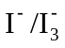 reaction rate. The cathodic peak potential of CZTS II film is more positive than that of the CZTS I film, which indicates the over potential for reduction of 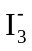 to 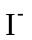 of the CZTS II film is much smaller than the CZTS I film. 100 cycles CV test (Fig. 5b) carried out consecutively for CZTS II film, CV does not show any change and exhibits a stable peak current densities. This indicates that CZTS II film does not only possesses excellent electro chemical stability, but also is attached firmly and uniformly onto the FTO coated glass substrate. Fig. 5c shows the CVs of CZTS II film on system with different scan rates (100, 50, 25, 10 mV s⁻¹). The cathodic peak current density (i_{pc}) and anodic peak current density (i_{pa}) gradually and regularly shift to negative and positive directions with increasing scan rates. It also shows a very good linear relationship between square root of the scan rate and peak current density.

3.6 Photovoltaic Performance

Fig. 6a shows the J-V curve of DSCs with CZTS I, CZTS II and Pt film used as the CEs and the device parameters are given in Table II. CZTS II film shows a good catalytic behavior resulting in the DSC with short-circuit current density (J_{SC}) of 18.63 mA cm⁻², open-circuit voltage (V_{OC}) of 0.65 V, fill factor (FF) of 0.53 and overall PCE of 6.4%. On the other hand, the CZTS I film shows a lower current density due to a lower catalytic behavior. DSC, with CZTS I CE exhibiting J_{SC} of 13.38 mA cm⁻², V_{OC} of 0.57 V and FF of 0.48 with PCE of 3.7%. DSC with Pt yields J_{SC} of 18.18 mA cm⁻², V_{OC} of 0.62 V and FF of 0.74 with PCE of 8.3%. The increase in V_{OC} of the CZTS II samples based devices can be attributed to the annealing under N₂+H₂S (5%) treatment which has resulted in an increase in the crystallinity as evident from the XRD, SEM data. This may have helped passivate the defects on the surface leading to reduction in the recombination losses in the device, which is also confirmed by the life time measurements where CZTS II CE based DSC has exhibited higher life time. DSC with CZTS II CE shows the higher J_{SC} and V_{OC} due to the higher cathodic current, more positive reduction potential and lower R_{CT} (from CE-CE impedance analysis discussed later).
The J_{SC} value of CZTS II device is enhanced which may be due to the increased catalytic behavior and increased charge collection. These observed effects are validated from the IPCE spectra. The IPCE spectra (in the range of 400 nm-800 nm) of DSCs fabricated with CZTS I, CZTS II and Pt CEs are shown in Fig. 6b. The measured J_{SC} values from the J-V curve and the values calculated from IPCE spectra are tabulated in Table II, both values are close to each other and follow the trend.
The IPCE spectra shows lower response for CZTS I resulting in a lower J_{SC} value and higher response for CZTS II resulting in higher J_{SC} value. This supports the enhanced light harvesting associated with the CZTS II CEs as compared to both Pt and CZTS I CE. It is clear that though the sulphurisation treatment helps CZTS layer in showing a better CE characteristics in terms of J_{SC} and V_{OC} values but a reduced FF causes a poorer efficiency. Doing suitable changes in the film resistivity should help overcome this deficiency making the CZTS film perform comparable to or better than the Pt film.
Table II: Photo-voltaic parameters of DSCs with different CEs.
Counter electrode | J_{SC} (mA cm⁻²) | V_{OC} (V) | FF | η (%) | J_{SC} value from IPCE (mA cm⁻²)
CZTS I | 13.38 | 0.57 | 0.48 | 3.7 | 13.50
CZTS II | 18.63 | 0.65 | 0.53 | 6.4 | 18.23
Pt | 18.18 | 0.62 | 0.74 | 8.3 | 17.92

3.7 Electrochemical Impedance Spectra (EIS)
3.71 CE-CE cell configuration
The EIS measurements have been carried out to elucidate the electrochemical behavior of CEs. EIS measurements are performed on the symmetrical cell structure: CE/electrolyte/CE. The circuit parameters given in the model (Fig. 7a) are used to fit the data. The fitted values are given in Table III. The Nyquist plots of CZTS I and CZTS II film as well as Pt are shown in Fig. 7b. Series resistance R_{S} represents the intercept on real axis at high frequency.³⁸ Charge transfer resistance R_{CT} and constant phase element (CPE) due to the electrolyte/CE interfaces are represented by the semicircle in the high frequency range, while the semicircle at low frequency represents the Warburg impedance (W) corresponding to diffusion resistance of triiodide/iodide redox electrolyte. It is generally recognized that a smaller R_{CT} represents a higher electro-catalytic activity towards redox electrolyte.³⁹ CZTS I film exhibits a higher R_{CT}, in confirmation with its poor catalytic behavior, as seen earlier in the CV study and a low efficiency of DSC. Lower R_{CT} and high CPE of CZTS II indicate a good catalytic activity in conformity with other studies such as CV and J-V studies. R_{CT} of CZTS II film is in fact less than that for Pt CE, showing the superior catalytic activity. However R_{S} of Pt CE is lesser which is expected due to the relatively high conductivity of Pt in comparison to the CZTS I and CZTS II films.

Table III: Best fit values of R_{S}, R_{CT} and CPE using equivalent circuit in Fig. 7(a) for different symmetrical cells.
Counter electrode | R_{S} (Ω cm²) | R_{CT} (Ω cm²) | CPE-T (µF cm⁻²)
CZTS I | 18.0 | 8.5 | 3.49
CZTS II | 15.2 | 1.8 | 12.29
Pt | 13.6 | 6.5 | 5.29

3.72 Impedance spectra of complete DSC configuration
Different techniques can be used to calculate the electron life time such as EIS⁴⁰, Intensity Modulated Voltage Spectroscopy/Intensity Modulated PhotocurrentSpectroscopy⁴¹, Transient Absorption Spectroscopy.⁴² Here we are using EIS Bode plot to calculate the life time(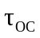) in V_{OC} condition.⁴⁰ Bode diagram represents different features of the electrochemical phenomena: counter electrode/electrolyte interfaces (high frequency), TCO/TiO₂/dye/electrolyte interfaces (middle frequency) and diffusion phenomenon in the electrolyte (low frequency), respectively. Three characteristic peaks are present in the Bode diagram (phase v/s frequency) of the complete DSC.⁴³
Using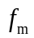the characteristics frequency of the phase peak related to the TCO/TiO₂/dye/electrolyte interfaces, one can obtain from the relation:
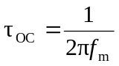 (1)
Higher means a lower recombination probability and a better carrier collection in the DSC.
Fig. 7c represents the EIS Bode spectra of the complete DSCs with CZTS I, CZTS II and Pt CEs. All measurements were performed under AM 1.5G illumination (100 mW cm⁻²) and open circuit voltage conditions. AC sinusoidal signal of 10 mV was applied during the measurements.
The calculated values of the life time () from equation (1) for CZTS I, CZTS II and Pt CEs based DSCs are 0.8 ms, 4.9 ms and 4.7 ms, respectively.
There is a marked improvement in the life time from pristine CZTS I samples to CZTS II samples after annealing treatment. DSC based on CZTS II CE shows almost the same life time as that of Pt CE based DSC. Longer the life time, better is the carrier collection efficiency in solar cells.⁴⁴ Comparable life times of CZTS II and Pt CEs show that the catalytic behavior of both in iodine based electrolyte is similar. The reported improvements in the film properties of CZTS II like catalytic behavior (from CV analysis) and charge transfer resistance (from CE-CE impedance analysis) result in the life time improvement to match the Pt CE value. On the other hand, the poorer film properties result in a lower lifetime for CZTS I CE.
The shift in Bode plot (Fig. 7c) at mid frequency for CZTS II CE is also due to the higher carrier collecting efficiency compared to that for CZTS I CE. This is also the reason CZTS II shows mid frequency response the same as Pt CE.
Hence one can say that there is a marked improvement in the life time from pristine CZTS I samples to CZTS II samples after annealing treatment. DSC based on CZTS II CE shows almost the same life time as that of Pt CE based DSC, which is quite significant.

4. Conclusion
We have successfully prepared stoichiometric CZTS film by spray technique on FTO coated glass substrate by carrying out the post annealing treatment in N₂+H₂S(5%) environment for one hour. Sulphurised CZTS CE shows a good catalytic behavior with a 6.4% DSC efficiency for 0.25 cm² effective cell area. The J_{SC} and V_{OC} values for DSC obtained by using sulphurised CZTS CE are higher than that for the Pt CE. The continuous growth of nanoflakes in the CZTS II film plays an important role in the enhancement of charge extraction from the active layer of the device resulting comparable J_{SC} to that observed with Pt CE.
In view of the spray deposited CZTS showing good electrochemical behavior, excellent stability, and the use of cheap, earth abundant and nontoxic materials, the technique can play an important role in fabrication of large area DSC, given the other advantages offered by the spray deposition.

Acknowledgment

The work presented in this paper was done under the Department of Science and Technology (DST)–Research Council UK (RCUK) project “Advancing the efficiency and production potential of excitonic solar cells”. Sanjay Kumar Swami acknowledges Ministry of National Renewable Energy (MNRE), New Delhi, India for providing the financial assistantship. Mr. Firoz Alam is also thanks for helping in initial impedance measurements.

References
- M. Grätzel, Nature, 2001, 414, 338.
- C. J. Barbe, F. Arendse, P. Comte, M. Jirousek, F. Lenzmann, V. Shklover and M. Grätzel, J. Am. Ceram. Soc., 1997, 80, 3157.
- A. Mishra, M. K. R. Fischer and P. Bauerle, Chem. Int. Ed., 2009, 48, 2474.
- M. K. Nazeeruddin, P. Pechy, T. Renouard, S. M. Zakeeruddin, R. H. Baker,
P. Comte, P. Liska, C. Le, E. Costa, V. Shklover, L. Spiccia, G.B. Deacon, C. A. Bignozzi and M. Grätzel, J. Am. Chem. Soc., 2001, 123, 1613.
- X. Zhang, H. Yang, H. M. Xiong, F. Y. Li and Y. Y. Xia, J. Power Sources, 2006, 160, 1451.
- H. R. Jhong, D. S. Wong, C. C. Wan, Y. Y. Wang and T. C. Wei, Electrochem. Commun., 2009, 11, 209.
- A. Kay and M. Grätzel, Sol. Energy Mater. Sol. Cells, 1996, 44, 99.
- J. Halme, M. Toivola, A. Tolvanen and P. Lund, Sol. Energy Mater. Sol. Cells, 2006, 90, 872.
- T. N. Murakami, S. Ito, Q. Wang, K. M. Nazeeruddin, T. Bessho, I. Cesar, P. Liska, R. H. Baker, P. Comte, P. Pechy and M. Grätzel, J. Electrochem. Soc., 2006, 153, A2255.
- E. Ramasamy, W. J. Lee, D. Y. Lee and J. S. Song, Electrochem. Commun., 2008, 10, 1087.
- S. Ahmad, J. H. Yum, H. J. Butt, M. K. Nazeeruddin and M. Gratzel, Chem. Phys. Chem., 2010, 11, 2814.
- K. Suzuki, M. Yamamoto, M. Kumagai and S. Yanagida, Chem. Lett., 2003, 32, 28.
- W. J. Lee, E. Ramasamy, D. Y. Lee and J. S. Song, Sol. Energy Mater. Sol. Cells, 2008, 92, 814.
- J. G. Chen, H. Y. Wei and K.C. Ho, Sol. Energy Mater. Sol. Cells, 2007, 91, 1472.
- Y. Saito, W. Kubo, T. Kitamura, Y. Wada and S. Yanagida, J. Photochem. Photobiol. 2004, A164, 153.
- J. H. Wu, Q. H. Li, Z. Lan, P. J. Li, J. M. Lin and S. C. Hao, J. Power Sources, 2008, 181, 172.
- M. Wang, A. M. Anghel, B. Marsan, N. C. Ha, N. Pootrakulchote, S. M. Zakeeruddin and M. Grätzel, J. Am. Chem. Soc., 2009, 131, 15976.
- J. Y. Lin, J. H. Laio and T. C. Wei, Electrochem. Solid-State Lett, 2011, 14, D41.
- X. Xin, M. He, W. Han, J. Jung, and Z. Lin, Angew. Chem. Int. Ed., 2011, 50, 1.
- Y. Du, J. Fan, W. Zhou, Z. Zhou, J. Jiao, and S. Wu, ACS Appl. Mater. Interfaces, 2012, 4, 1796.
- Y. Xie, C. Zhang, F. Yue, Y. Zhang, Y. Shi and T. Ma, RSC Adv., 2013, 3, 23264.
- Z. Tong, Z. Su, F. Liu, L. Jiang, Y. Lai, J. Li and Y. Liu, Mater. Lett., 2014, 121, 241.
- S. Wozny, K. Wang and W. Zhou, J. Mater. Chem. A, 2013, 1, 15517.
- L. Bai, J. N. Ding, N. Y. Yuan, H. W. Hu, Y. Li and X. Fang, Mater. Lett., 2013, 112, 219.
- X. Wang, W. H. Zhou, Z. J. Zhou, Z. L. Hou, J. Guo and S. X. Wu, Electrochimica Acta, 2013, 104, 26.
- X. Xin, M. He, W. Han, J. Jung and Z. Lin, Chem Inform, 2012, 43, 12.
- S. S. Mali, P. S. Patil, C. K. Hong, ACS Appl. Mater. Interfaces, 2014, 6, 1688.
- K. Ito and T. Nakazawa, Jpn. J. Appl. Phys. 1988, 27, 2094.
- Y. B. K. Kumar, G. S. Babu, P. U. Bhaskar and V. S. Raja, Phys. Status Solidi A, 2009, 206, 1525.
- Y. B. K. Kumar, G. S. Babu, P. U. Bhaskar and V. S. Raja, Sol. Energy Mater. Sol. Cells, 2009, 93, 1230.
- K. Wang, O. Gunawan, T. Todorov, B. Shin, S. J. Chey, N. A. Bojarczuk, D. Mitzi, and S. Guha, Appl. Phys. Lett., 2013, 97, 143508 .
- S. K. Swami, A. Kumar and V. Dutta, Energy Procedia, 2013, 33, 198.
- N. Chaturvedi , F. Alam , S. K. Swami and V. Dutta, J. Appl. Phys., 2013, 114, 84501.
- S. Ito, T. N. Murakami, P. Comte, P. Liska, C. Grätzel, M. K. Nazeeruddin and M. Grätzel, Thin Solid Films, 2008, 516, 4613.
- W. Schafer and R. Nitsche, Mater. Res. Bull., 1974, 9, 645.
- P. A. Fernandes, P. M. P. Salomé and A. F. Cunha, J. Alloys Comp., 2011, 509, 7600.
- H. Katagiri, N. Sasaguchi, S. Hando, S. Hoshino, J. Ohashi and T. Yokota, Sol. Energy Mater. Sol. Cells, 1997, 49, 407.
- H. Xu, X. Zhang, C. Zhang, Z. Liu, X. Zhou, S. Pang, X. Chen, S. Dong, L. Zhang, P. Han, X. Wang and G. Cui, ACS Appl. Mater. Interfaces, 2012, 4, 1087.
- M. X. Wu, X. Lin, A. Hagfeldt and T. L. Ma, Angew. Chem., Int. Ed., 2011, 50, 3520.
- R. Kern, R. Sastrawan, J. Ferber, R. Stangl, and J. Luther, Electrochim. Acta, 2002, 47, 4213.
- L. M. Peter, E. A. Ponomarev, and D. J. Fermin, J. Electroanal. Chem., 1997, 427, 79.
- S. E. Koops and J. R. Durrant, Inorg. Chim. Acta, 2008, 361, 663.
- Q. Wang, J. E. Moser, and M. Graetzel, J. Phys. Chem. B, 2005, 109, 14945.
- A. C. Fisher, L. M. Peter, E. A. Ponomarev, A. B. Walker, and K. G. U. Wijayantha, J. Phys. Chem. B, 2005, 104, 949.

List of Figures:
Fig. 1: XRD pattern of CZTS I and CZTSII film.
Fig. 2: Raman spectra of CZTS I and CZTS II film.
Fig. 3: SEM images of (a) CZTS I, (b) CZTS II film, Cross sectional SEM images of (c) CZTS I, and (d) CZTS II film.
Fig. 4: (a) Transmission spectra of CZTS I and CZTS II film, (b) Tauc plot of CZTS I and CZTS II film.
Fig. 5: (a) CV of CZTS I and CZTS II film, (b) Relation between cycle times and redox peak current densities of CZTS II film, and (c) Relationship between redox peak current densities and scan rates of CZTS II film.
Fig.6: (a) J-V curve of DSCs using different CEs, (b) IPCE spectra of DSCs using different CEs.
Fig.7: (a) Equivalent circuit model used for fitting of dummy cells impedance, (b) Nyquist plot of the symmetrical sandwich like structure of two identical electrodes consisting of different CEs, and (c) Bode diagram of complete DSC using different CEs.
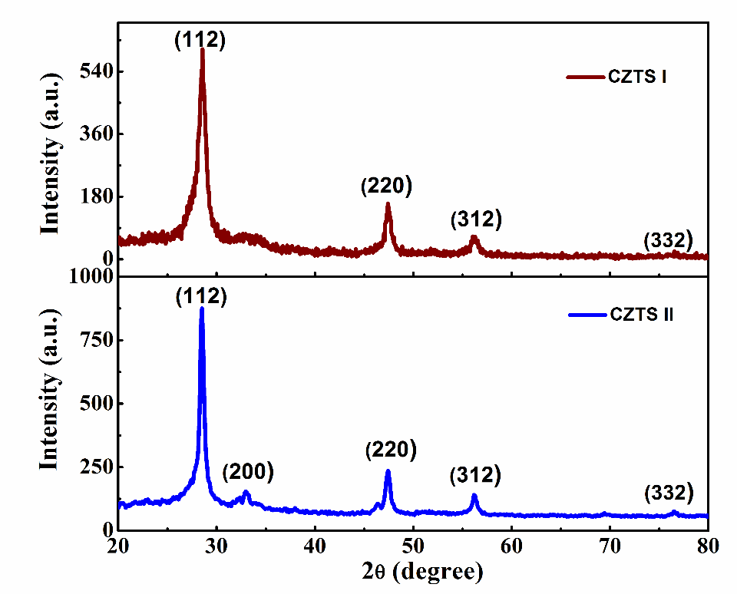

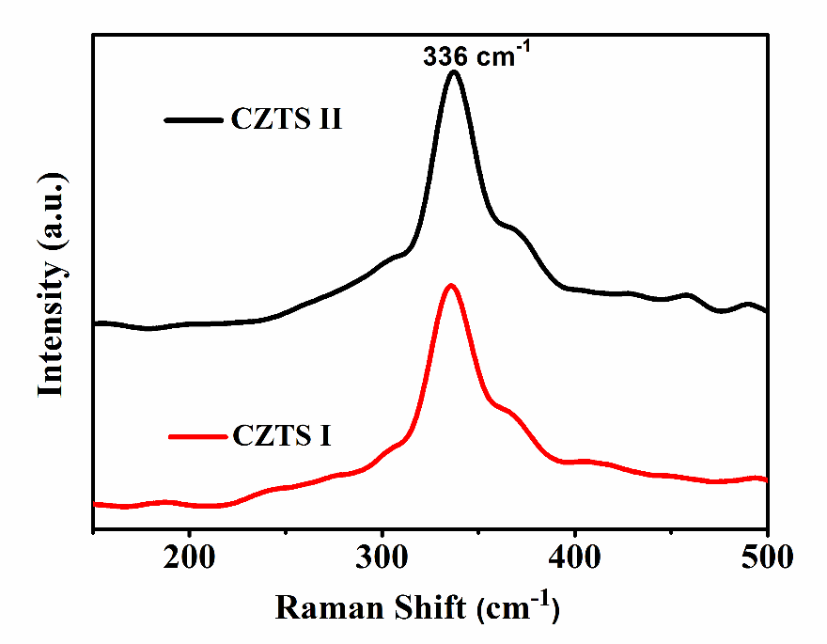
Fig.1: XRD pattern of CZTS I and CZTSII film.

Fig.2: Raman spectra of CZTS I film and CZTS II.

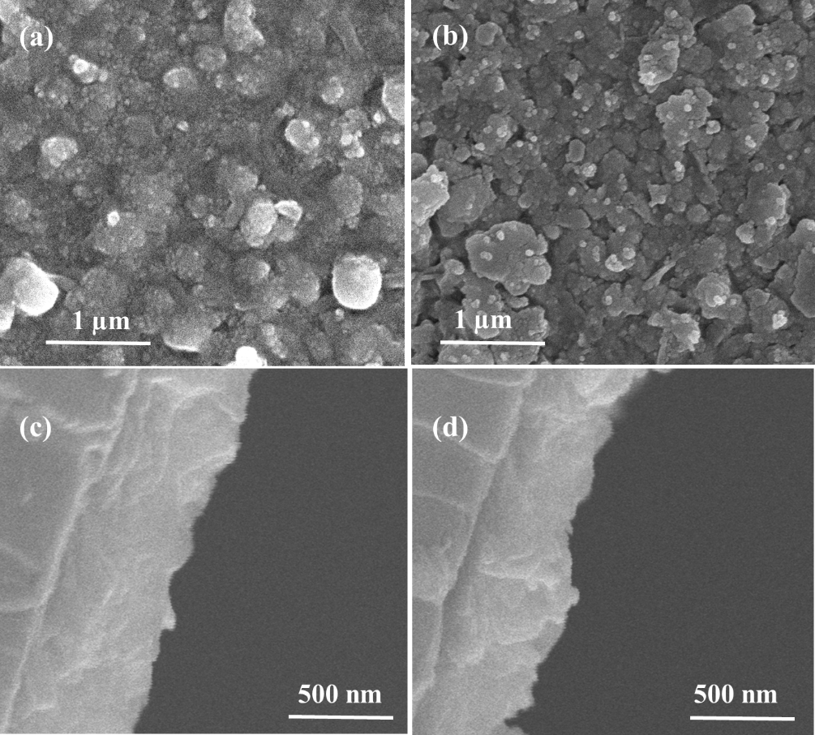

Fig.3: SEM image for (a) CZTS I film, (b) CZTS II film, (c) cross section image of CZTS I and (d) cross section image of CZTS II.
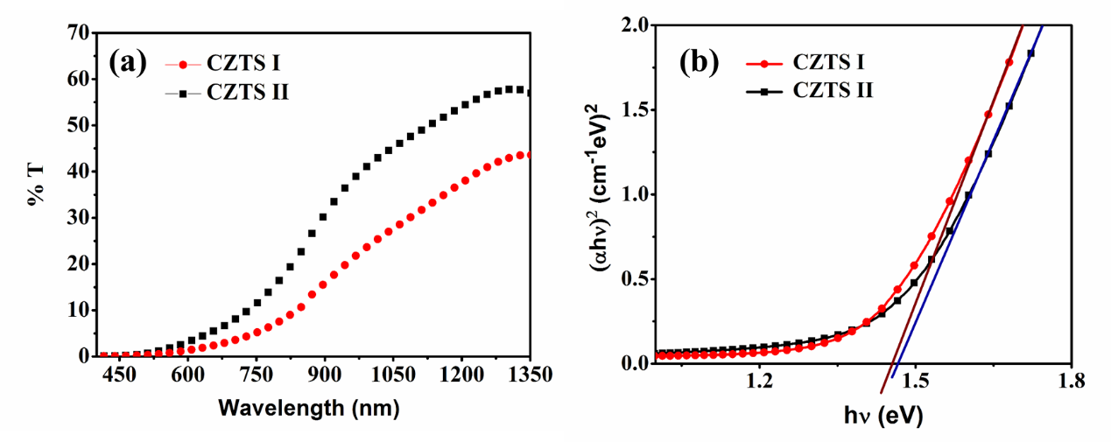

Fig.4: (a) Transmission spectra of CZTS I and CZTS II film (b) Tauc plot of CZTS I and CZTS II film.

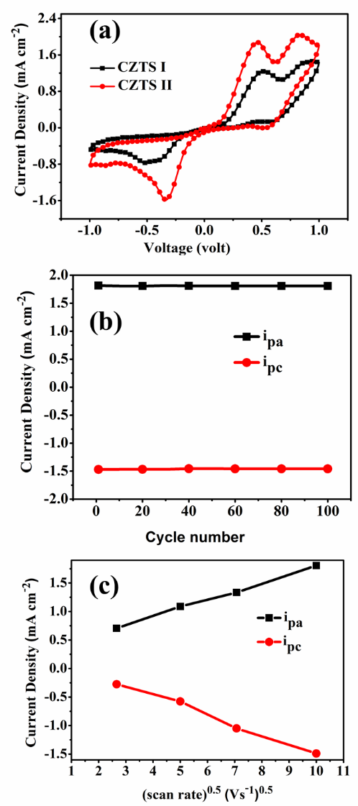

Fig. 5 (a) CV of CZTS I and CZTS II film, (b) consecutive 100 CVs cycle of /for CZTS II film (c) relationship between current densities and scan rates of CZTS II film.

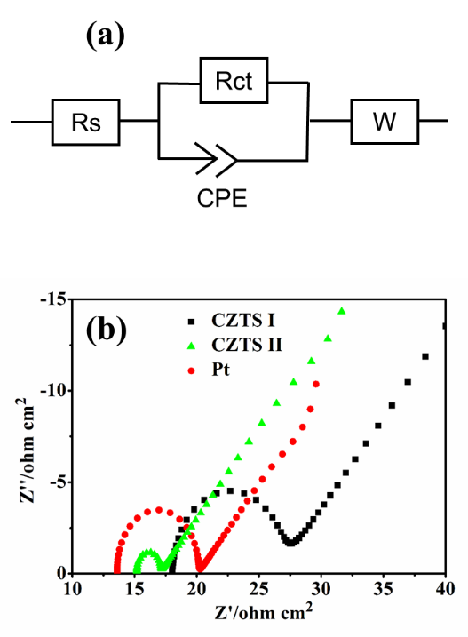

Fig.6. (a) Equivalent circuit model used for the fitting of impedance of dummy cells (b) Nyquist plot of the symmetrical sandwich like structure of two identical electrodes consisting of: CZTS I, CZTS II film and Pt counter electrode.
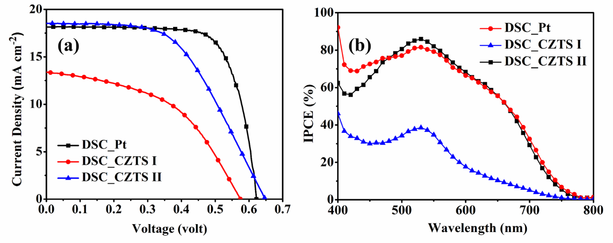

Fig.7: (a) J-V curve of DSSCs using CZTS I, CZTS II & Pt CEs (b) IPCE spectra of DSSCs using CZTS I, CZT II and Pt CEs

Corresponding author at: Centre for Energy Studies, Indian Institute of Technology Delhi, New Delhi 110016. India. Tel. +91 11-2659-6489; fax. +91 11-2659-1261. E-mail: swami.phy@gmail.com

