Digital Entrepreneurship: Global maps and trends of research

Design/methodology/approach: The bibliometric analysis was applied to offer a technological review on digital entrepreneurship. Seven hundred and four publications and their 34083 references from Web of Science (WoS) were retrieved as the sample set. Basic characteristics of publications, including the most influential documents, authors, journals, and countries, etc. were obtained. Then, co-citation and co-occurrence analyses were conducted to sketch the contours of the structure and evolution of digital entrepreneurship.

Purpose: Digital technologies, such as big data and artificial intelligence, significantly impact entrepreneurial activities worldwide. However, research on entrepreneurial activities enabled by digital technologies is fragmented, divergent, and delayed. This study aims to provide a structured review of digital entrepreneurship to identify status, hotspots, knowledge structure, dynamic trends, and future developments in this field.

Findings: Digital entrepreneurship (DE) has attracted increasing attention in the past three decades, especially after 2013. There are dozens of countries, hundreds of journals, and more than 1,000 authors that have contributed to this field. Based on keyword co-occurrence clustering and co-citation clustering, we proposed a 3E (empower, evolution, and ecosystem) framework of digital entrepreneurship to facilitate an interdisciplinary dialogue for evidence-based policymaking and practice. In the future, researchers need to pay more attention to theoretical research and study digital entrepreneurship from a holistic and dynamic perspective with consideration to the negative impact of digital technology on entrepreneurial activities.

Originality/value: The current study draws an outline of the global advance on digital entrepreneurship research. It presents an opportunity to comprehensively understand the contemporary achievements, the march of knowledge, and the logical venation underlying academic developments as well as foundations for policy-making.

Keywords: Digital entrepreneurship; Bibliometrics; Research hotspots; Knowledge mapping

1. Introduction
Humankind has entered a new era of digital technology revolution, and almost all countries in the world have realized that this digital transformation has been the main source of new economic and social developments (Shrader et al., 2000; Pergelova et al., 2019; Sang et al., 2020; Zhang et al., 2020; Anumba et al., 2021). Digital entrepreneurship (DE), the entrepreneurial action enabled by digital technologies, is naturally ubiquitous among global corporate giants as well as countless emerging start-ups (Hull et al., 2007; Zaheer et al., 2019). The booming development of DE has not only significantly shaped the trajectory of industries and markets, but has also turned into a powerful driving force for social evolution (Lin et al., 2020; Nambisan et al., 2019; Tang and Meng, 2020). It has brought fundamental changes in economic growth patterns, industrial layouts, entrepreneurial models, and lifestyles of human beings (Zaheer et al., 2019).
Because of its rapid growth, DE has brought enormous opportunities for academic research. Rosenbaum and Cronin (1993) discovered that visionary entrepreneurs began to use the information superhighway for entrepreneurial activities. Following this seminal study, research on DE has expanded to include various related topics in business and management fields, such as factors affecting DE (Hair et al., 2012; Scuotto and Morellato, 2013; Ziyae et al., 2014; Alderete, 2015, Hansen, 2019), DE models (Hull et al., 2007), entrepreneurial opportunity identification (Hafezieh et al., 2011 ), market orientation (Hair et al., 2012), network infrastructures (Alderete, 2015), and digital entrepreneurship ecosystems (DEE) (Li et al., 2017; Stam and Spigel, 2018).
Although trends emerge and fade, there is still a lack of consensus on this topic. Scholars recognize that DE has the following three distinct characteristics (Kollmann et al., 2009; Klotz et al., 2013; Farani et al., 2017; Giones and Brem, 2017): (1) Entrepreneurs combine digital technology with marketing, operations, communication, and other aspects of an enterprise; (2) The core business of startups needs to be closely related to digital technology; and (3) The enterprise generates strategic directions and business models based on digital technology. Without digital technologies such as the internet companies will not be able to survive.
Based on these characteristics, many early digital startups have developed into very successful companies, such as Amazon (an e-commerce company), Google (a search engine company), Facebook and Twitter (social media companies), and Microsoft (an operating system company). Although large companies have occupied a lot of market share in the digital industry, emerging new technologies have brought opportunities for startups. The internet of things (IoT), artificial intelligence (AI), big data analysis, and blockchain fields have created room for new digital startups to generate new digital technologies in the future (Pergelova et al., 2019; Hu et al., 2020; Tian et al., 2020; Wang et al., 2021). For example, these technologies enable more efficient functions in logistics operations (Feng and Ye, 2021). However, disciplinary boundaries in this rapidly developing field have erected an invisible wall between researchers and a large part of the existing literature. Research on entrepreneurial activities enabled by digital technologies is fragmented, divergent, and delayed. This study aims to provide a structured review of digital entrepreneurship to identify status, hotspots, knowledge structure, dynamic trends, and future developments in this field.
To adopt a broader perspective and address the need for more research on the topic (Hasnain et al., 2019; Kraus et al., 2019), this study aims to systematize the scientific achievements related to DE by providing scholars with a holistic overview of the fragmented literature available, and by proposing possible future research streams. These findings would help policymakers and practicing managers to effectively promote or embrace DE. With this, a bibliometric analysis was conducted to answer the following research questions (RQ):
RQ1: What was the past research framework of the digital entrepreneurship?
RQ2: What is the current research framework for digital entrepreneurship?
RQ3: What will be the future research framework of digital entrepreneurship?

Bibliometrics can reveal the law of scientific literature development and its distribution, the development history of a specific field, current research hotspots, and future development trends (Merigo et al., 2015). Based on the results of bibliometric analysis and scientific mapping, several indicators were considered to identify the most influential documents, authors, journals, and countries. Thus, a model framework for DE was created.
The results of the bibliometric analysis showed that the literature related to DE began more than 20 years ago and has shown an increasing growth trend in the past decade. Although several countries worldwide have paid attention to this field, the influence of the United States is far greater than theirs. However, the United States has a relatively low willingness to cooperate with other countries. Consequently, other countries are encouraged to study this field and strengthen international cooperation. Most articles were completed by multiple authors, but cooperation and networking among them were rarely formed. For example, more than 60% of the journals focusing on business and management fields also involve broader research directions, such as computer technology.
In addition, the results of science mapping enabled the identification of structures. The conceptual structure was analyzed through keyword co-occurrences and literature co-citations, which identified three thematic clusters: empowerment, evolution, and ecosystem. The influential literature and essential research directions introduced DE research topics and possible future research directions. Although a lot of studies on DE have been conducted, there are still some issues that need more attention from the academic community: (1) paying attention to integrity and dynamic evolution will help carry out future research; (2) the negative impact of digital technology on entrepreneurship needs to be considered; (3) advanced theoretical development is confronting urgent calls.
The rest of this study is organized as follows: Section 2 describes the adopted methodology; Section 3 presents the results of the bibliometric analysis; Section 4 discusses the results of science mapping; Section 5 contains the discussion; and Section 6 reports the conclusion.

2. Methodology
The inspiration for employing bibliometric analysis stems from Chen (2004). Its large-scale quantitative assessment of published documents could offer a panoramic vision of scientific communication, knowledge structure, and evolutionary trajectory in a particular research field (Yuan et al., 2021). As a technology-based review, bibliometrics can introduce systematic, transparent, and reproducible findings based on the statistical measurement of science, scientists, and scientific activity. Compared with typical author-scoped reviews, this method can provide more reliable and objective results (Broadus, 1987) For example, some of the significant achievements have been made in fields of management, family business, and sharing economy (Kraus et al., 2020; Mas-Tur et al., 2020; Rovelli et al., 2021).
In this study, we used bibliometrics to analyze global advances in DE research. Academic research on this subject has been conducted for more than 20 years, resulting in a significant number of relevant publications. Despite numerous publications, there is still a distinct fragmented knowledge pattern (Briner and Denyer, 2012). For example, benefits and disadvantages always coexist, the negative impacts of digital technology on entrepreneurship need to be considered. Furthermore, the march toward marrying remarkable practice with theoretical advancement is articulated with the hope of greater attention. Therefore, a synthetic overview is needed to coherently sort out the literature, and provide an agreed terminology and direction for prospective progress (Rousseau, 2012). By collecting and screening a large amount of comprehensive information, we aim to discover the development trends and research topics from the most prolific institutions and authors of DE research. We aim to present an opportunity to understand the knowledge and logic of DE evolution in a global context, which is essential to future policymaking.
2.1 Data collection
High-quality and comprehensive data are the key to obtaining reliable analysis results (Carvalho et al., 2013). Web of Science (WoS) from Clarivate Analytics is one of the world’s largest scientific databases, containing more than 15,000 international academic journals and over 90 million documents. Its core collection covers publication in various domains, including the Science Citation Index Expanded (SCI-EXPANDED), Social Sciences Citation Index (SSCI), Arts Humanities Citation Index (A&HCI), and Emerging Sources Citation Index (ESCI). Because of these advantages, the WoS Core Collection was selected as the original database for this study.
Given the varying concepts in different disciplines, it was not surprising that “digital entrepreneurship” had diverse expressions. Collecting relevant publications without narrowing down the search raised some challenges. Therefore, we deliberately designed our search strategy. First, we used “digital” and “entrepreneurship” as the primary search formulas to ensure the relevance and comprehensiveness of the data. As there was no consensus in the early academic circles, there were multiple studies in the same field that used different words to denote digital entrepreneurship, such as “internet entrepreneurship,” and “digital startup.” Then, we added “internet,” “cyber,” “startup,” and other keywords to cover the existing research of digital entrepreneurship more comprehensively. Finally, to avoid the loss of generality, the supplementary search formula was as follows: “digit* start up,” “digit* startup,” “cyber entrepreneur*,” “internet entrepreneur*,” “internet startup,” “internet startup,” “online entrepreneur*,” “online start up,” “online startup,” “e-entrepreneurship,” “e-startup,” “digit* venture,” “internet establish,” “internet venture,” or “big data entrepreneur*.”
Between January 1, 1985, and March 8, 2021, which was the period of data acquisition, 723 publications and 34,802 references were retrieved as the sample set. More detailed information of the retrieved publications, such as authors, institutions, periodicals, keywords, abstracts, and citations, were also structured for further analysis (Rousseau, 2012).
2.2 Selecting articles for the database
Before the final data analysis, it was necessary to pretreat the retrieved data. There were two criteria for data pretreatment in this study: (1) meta-synthesis and (2) relevance and authority.
The meta-synthesis method of Tranfield et al. (2003) was first applied in the medical field, and was also later widely used in business and management literature reviews. Massaro et al. (2016) developed a structured literature review (SLR) and provided researchers with 10 SLR steps as follows:
- Write a literature review protocol.
- Define the questions that the literature review sets out to answer.
- Determine the type of study and conduct a comprehensive literature search.
- Measure article impact.
- Define an analytical framework.
- Establish literature review reliability.
- Test literature review validity.
- Code data using the developed framework.
- Develop insights and criticize them by analyzing the dataset.
- Develop future research paths and questions.

While having a structure is advocated, the implementation of an SLR is flexible. SLRs provide an approach that can help academics discover under-investigated topics and methods, and develop new knowledge areas and research approaches.
Data relevance and authority are well-regarded by Zaheer et al. (2019). Relevance means that the article must be related to DE. In this study, some articles were excluded due to a lack of direct relevance. Authority means that the selected article must cite a reliable source. For example, consider Dual Cage High Power Induction Motor with Direct Start-up: Design and FEM Analysis. This title includes “start-up,” but the paper presents an investigation on the design of high-power induction motor with special constraints (Livadaru et al., 2013). Such articles have nothing to do with DE; therefore, similar articles were not covered in the dataset. Based on these two criteria, the final dataset comprised of 704 scholarly articles and 34,083 references.
3. Bibliometric analysis
Literature is the carrier of human knowledge and has the function of cognition and storage of knowledge. In 1969, after The British intelligence scientist Alan Britchard put forward the term "Bibliometrics", It has attracted increasing attention from researchers. There are many research methods of bibliometrics, compared with traditional literature review, professional bibliometrics tool has the characteristics of large literature volume, long practice span and visualization results from multiple dimensions. Bibliometrics has be widely applied in the research of various disciplines, such as transportation (Najmi et al., 2017), public administration (Curry et al., 2018), solar cells (Yeo et al., 2020). Karus et al. have made a systematic literature review in entrepreneurship research (Karus et al., 2020) and digital transformation in healthcare (Kraus et al., 2021). This study adopts the bibliometrix R package as an analytical tool. The package supports a recommended workflow to perform bibliometric analyses and is widely used in the ever-changing science domain (Aria and Cuccurullo, 2017).
A total of 704 scholarly articles were published between 1999 and 2021 across 401 journals. Among the articles’ disciplines, business and management accounted for more than 60%, followed by information science, computer science, economics, and environmental studies. There were 1,674 authors in 704 scholarly articles, with an average of 2.38 authors per publication. The top three authors with the highest number of relevant publications were Kraus, Ghezzi, and Cavallo. The top three institutions with the highest number of relevant publications were Renmin University of China, University of Texas in Austin, Texas, and Politecnico di Milano in Italy. Countries like China, United States, and Italy, where these institutions are located, are also influential countries where research on digital entrepreneurship is relatively active.

3.1 Time evolution of articles
Fifty articles were published between 1999 and 2013. Research on digital entrepreneurship has entered a stage of rapid development since 2014, with a total of 654 articles published, averaging a compound annual growth rate (CAGR) of more than 50%. The number of articles published since 2014 accounts for more than 90% of the total number of articles on DE. Using 2013 as the boundary, this study divided the evolution of articles into two time slices: 1999–2013 and 2014–2021 and discussed the influential articles and research content of each time slice. This study was performed to provide a more comprehensive picture of the different topics that scholars have studied over the years and to determine the path for future research. Figure 1 shows the number of articles published each year on DE.
<Insert Figure 1>
Figures 2 and 3 show thematic maps of 1999-2013 and 2014-2021, which were determined based on centrality (drawn on the X-axis) and density (drawn on the Y-axis). Centrality measures the degree of relevance of a theme to other themes, while density measures the level of agglomeration within the theme (Forliano et al., 2021). For example, the upper-right quadrant contains themes with high centrality and density, in which the theme develops well on its own and influences the other themes.
<Insert Figure 2>
<Insert Figure 3>

3.1.1 Time slice 1: 1999–2013
In the early days of DE studies, researchers observed that digital technology has a particular impact on entrepreneurial activities; therefore, they conducted research mainly on this phenomenon. Figure 2 shows the main research directions of the articles in this period, including behavior, innovation, knowledge, economy, and strategy.
It can be seen from the thematic map that the research themes in this period were concentrated in the first and fourth quadrants, with a relatively high centrality, thereby indicating that the themes have a strong correlation with other themes. However, with dynamic and institutional entrepreneurship, it had a high-density level, thereby indicating that the themes have a high intra-cluster cohesion.
Early research on digital entrepreneurship suggests that scholar mainly focused on combining digital technology and existing business activities. For example, towards the end of the 20th century, many companies have not yet widely accepted e-commerce. A startup company still faces several obstacles when selling software products to other companies. It must adjust its strategy, develop after-sales support, enter international market, and increase customer awareness (Leidner, 1999). The economic development of the region, where the startup company is located, is also an essential factor that affects the company’s growth. Differences in telecommunication services and infrastructure have an extraordinary impact on local digital startups (Guillen and Suarez, 2001; Roper and Grimes, 2005; Kleman, 2006; Tsai et al., 2008). Social control, authoritative sources, and community barriers also impose some constraints on some digital entrepreneurs (Campbell et al., 2011). Business incubators engaged in digital technology can strengthen the connection between entrepreneurs, suppliers, and customers, thereby helping startups grow (Carayannis et al., 2005).
Dynamic capability and innovation are characteristics that digital enterprises must possess. In the digital age, market barriers have become fragile, and market changes have accelerated. The digital revolution requires companies to dynamically adjust their core competencies (McGrath, 2013). Digital-based startups must use new technologies to adapt to the rapidly changing business environment (Siu, 2002). They must also have the agility to win against competition, thereby heavily relying on information technology, process, knowledge, and communication technology to improve agility (Sambamurthy et al., 2003).
Startups also need to adapt to new knowledge and behavior. Digital technology can be used to optimize a company's internal workflow and cooperation with other companies. Digital technology can help startups improve their performance by creating new workflows, such as electronic contracts (Chiu et al., 2002; Kollmann, 2006). The development of communication technology has also produced new forms of entrepreneurship in which virtual teams have increasingly become the competitive advantage of successful startups (Matlay and Westhead, 2005). From the perspective of entrepreneurs themselves, the interaction between entrepreneurs and international experience creates a social capital that has positive effects on digital companies (Batjargal, 2007).

3.1.2 Time slice 2: 2014–2021
Society’s demand for digital technology continues to grow. Since 2010, new technologies such as big data, AI, and blockchain have rapidly developed and penetrated entrepreneurial activities. Since 2014, the number of researchers focusing on digital entrepreneurship has been increasing rapidly. During this period, in addition to addressing previous research directions, researchers have expanded several new research fields, such as social networks, digital entrepreneurship ecosystems (DEE), blockchain, and digital entrepreneurship theories. Figure 3 shows the themes of this period, such as education, growth, perspective, performance, innovation, entrepreneurship, and absorptive capability, while Figure 4 shows the evolution of these themes in the two time slices.
<Insert Figure 4>
As shown in Figures 3 and 4, the themes in time slice 1 have developed in recent years. More research on the first quadrant indicate that the internal cohesion of the main themes has improved and that themes have become more mature with the inclusion of innovation, performance, and entrepreneurship. Disruptive innovation caused by digital technology can affect the business environment, reduce the difficulty of starting a business (Dy et al., 2017), and make traditional companies feel threatened (Ansari et al., 2016). The improvement of digital infrastructure can also enable startups to grow rapidly through the following mechanisms: data-driven, instant release, and rapid conversion (Huang et al., 2017). Several new business models have also been developed to help companies improve their performance levels, such as sharing economy (Richter et al., 2017), gig economy (Burtch et al., 2018), peer-to-peer (P2P) networking (Gossling and Hall, 2019), and lean entrepreneurship (Ghezzi and Cavallo, 2020). Social networks can provide business value to small and medium-sized enterprises (SMEs) (Scuotto et al., 2017), help entrepreneurs accumulate social capital (Smith et al., 2017), improve the quality of corporate information, and increase customer trust (Fischer and Reuber, 2014). Blockchain technology can help entrepreneurs raise funds and communicate with customers. It has triggered a new wave of entrepreneurship, bringing new opportunities for innovation and entrepreneurship (Hernandez et al., 2017; Chen, 2018; Zhang et al., 2020).
However, the third quadrant has some emerging themes and research directions that need to be further developed by scholars, such as absorb-capacity, perspective, and impact. Knowledge has become the cornerstone of innovation, and corporate absorb-capacity is one of the elements that enhance corporate innovation and help companies improve their performance (Scuotto et al., 2017). Several scholars have studied digital entrepreneurship and its impact on different perspectives such as ecosystems, platforms, and theories. The digital entrepreneurial ecosystem can be formed by integrating digital and entrepreneurial ecosystems. The digital entrepreneurial ecosystem framework consists of four concepts: digital infrastructure, digital user citizenship, digital entrepreneurship, and the digital industry (Sussan and Acs, 2017). Digital platforms can enhance SMEs’ business and management capabilities, thereby helping them achieve digital transformation (Li et al., 2018; Nambisan et al., 2019). Most of the research on DE focuses on practical issues. Some scholars have conducted theoretical research related to digital entrepreneurship. However, new digital technologies have changed the nature of the entrepreneurial process and its results by providing a method to deal with its inherent uncertainty (Nambisan, 2017). The rapid development of digitalization has begun to subvert existing entrepreneurial theories. Theoretical recommendations, in the form of four new theoretical logics or elements: dynamic adjustment, social cognition, technical enlightenment, and coordination and cooperation, may help to provide a more accurate explanation of the digital world’s innovation process and its results (Nambisian et al., 2018).
3.2 Author
Productivity and impact are two important indicators for evaluating authors’ academic influences in related fields (Forliano et al., 2020). This study evaluates an author’s productivity by the number of articles published and the author’s impact by the number of citations. Figure 4 shows the 20 most influential authors, while Table 1 lists the five authors with the most published articles and the most citations (repetitions removed), based on their h-index and g-index, these two indexes represent the author's influence in academia.
Most of the authors started to publish their first articles on DE after 2013. Only Kollmann paid attention to DE in time slice 1. Kollmann (2006) believed that electronic information technology can largely support enterprises’ communication processes. He also believed that, in the future, e-entrepreneurship will be established to realize the development and innovation of communication networks (Kollmann, 2006). Sambamurthy, the most cited author, discussed the critical role of agility in modern business environment, and how firms rely on information technologies, process, knowledge, and communication technologies to enhance their agility (Sambamurthy et al., 2003). Kraus, the author with the most significant number of articles, paid attention to the field of digital entrepreneurship since 2015. He has studied smart city (Richter et al., 2015) and sharing economy (Richter et al., 2017) with his collaborators, and has sorted out related research on digital entrepreneurship (Kraus et al., 2019). Another scholar, Nambisan, focused on the theoretical research of digital entrepreneurship and proposed the theoretical framework of digital entrepreneurship (Nambisan, 2017). His research witnessed a rapid increase in the past three years and had brought attention to digital technology’s impact on traditional theories of entrepreneurship. Reading key articles before starting DE research can help researchers master the development process and research direction of DE. The effective research of key authors can also greatly promote DE.
<Insert Table 1>
<Insert Figure 5>
<Insert Figure 6>
<Insert Figure 7>
Figures 6 and 7 show the cooperation network between the authors and the distribution of science authors. In DE, the cooperation among authors is relatively low, while primary authors tend to complete science independently of the study. Simultaneously, only a few authors have published three or more articles which indicates that most of the authors’ research on digital entrepreneurship is still in its early stages.
3.3 Articles and journals
Table 2 lists the top 10 articles with the highest local citations. Local citations are the number of times an article has been cited by other articles in the dataset, thereby representing the article’s importance in digital entrepreneurship. As presented in Table 2, Nambisan’s two articles are very influential in digital entrepreneurship. Digital technologies herald a new era in entrepreneurship, in which the boundaries between the process of entrepreneurship and its results are more blurred Hence, entrepreneurship agency will be more broadly defined (Nambisan, 2017). There is a critical need to theorize novels on digital innovation management (Nambisan et al., 2018). Sussan and Acs (2017) proposed the digital entrepreneurship ecosystem (DEE) conceptual framework, which includes: (1) digital infrastructure governance, (2) digital user citizenship, (3) digital entrepreneurship, and (4) digital marketplace. This was one of the first articles that focused on DEE. Simultaneously, the concept of digital technology entrepreneurship was also proposed (Giones and Brem, 2017). The large number of citations indicates that these papers occupy a very important position in DE, and some studies have even created a new research direction. Reading these articles is a must for every academic who studies digital entrepreneurship.
<Insert Table 2>
Articles on digital entrepreneurship have been published in a wide variety of journals. Over the years, steady advancements have been made on this topic. In Table 3, the 10 most relevant journals ordered by several publications were presented to describe the journals' impact.
Sustainability is the journal that publishes the most articles in terms of productivity. Technological Forecasting and Social Change ranks second, with the highest h-index and g-index, thereby indicating that it has an essential position in digital entrepreneurship. Most journals started to focus on DE in 2014. Journal of Strategic Information Systems and Small Business Economics began to publish articles in 1999 and 2001, respectively. With the number of articles relatively increasing, there is continuous attention to this field.
Technological Forecasting and Social Change focus on documents related to society, the environment, and technology. Sustainability focuses on green and sustainable development. Small Business Economics focuses on a wide range of fields, including small and medium-sized enterprises, innovation and entrepreneurship, public policy, and other directions. The focus of journals with high volume of publication in DE is quite different This indicates that digital entrepreneurship involves a wide range of fields and research direction with comprehensive characteristics. However, in general, it still focuses on business and management.
<Insert Table 3>
3.4 Institutions and regions
Table 4 lists the 10 countries that have published the most articles. The United States has the most significant number of articles published in DE, with the highest number of total citations and average article citations. United Kingdom is a distant second to the United States, indicating that the United States is the absolute leader in DE.
<Insert Table 4>
Since only less than 10% of single-authored documents exist, collaboration becomes a critical aspect for authors who are studying digital entrepreneurship. However, the most prolific country is ironically the least likely country to engage in international cooperation. Single-country publications (SCP) represent the number of publications written by authors from the same country, while multi-country publications (MCP) represent the number of publications written by authors from different countries. Moreover, MCP ratio is the ratio of MCP to SCP. It represents the willingness and level of a country to participate in international DE cooperation. Figure 8 shows the cooperative relationships among countries. Although the MCP ratio of the United States is low, it still has a significant number of articles, and also occupies an important position in international cooperation. The most active regions for international cooperation are the United States, Europe, China, and Australia. As a new research field, DE is highly related to the level of economic development and the research on DE has mainly been concentrated in developed countries.
<Insert Figure 8>
<Insert Table 5>
3.5 Keywords
Table 5 lists the 20 most frequently used keywords in the database, and the year when these keywords first appeared. The core of research in DE is “entrepreneurship,” in addition, the three keywords that appear most frequently are “innovation”, “performance,” and “technology.” They first appeared in the early 21st century. These keywords have received attention in the research direction of traditional entrepreneurial field. It is worth noting that “digital entrepreneurship,” “digital transformation,” and “digitalization” have only begun to appear in recent years. This shows that the research on DE was initially based on traditional research on entrepreneurship, with digital technology as part of its research content. In recent years, DE has begun to appear as an independent research field, with keywords appearing more frequently. Scholars have realized that digital entrepreneurship has many unique aspects, and it is necessary to study it as an independent direction rather than the branch direction of previous entrepreneurial research.

4. Science mapping
Science mapping is an important research method in bibliometrics (van Eck and Waltman, 2010). It is a spatial representation of how disciplines, fields, specialties, and individual documents or authors are related to one another (Small, 1999). It focuses on monitoring a scientific field and delimits research areas to determine its cognitive structure and evolution (Noyons et al., 1999; Cobo et al., 2012). Scholars often use co-occurrence analysis and co-citation analysis to study a specific discipline’s dynamic development (Small, 1973; Callon et al., 1983; van Eck and Waltman, 2014).
4.1 Keyword co-occurrence and co-citation network
Keywords are the highly condensed core content of a paper. According to the basic principles of co-occurrence analysis, if a specific keyword repeatedly appears in a research field, it means that the word is a research hotspot in this field. Suppose two keywords appear in the same document. In that case, it indicates that the two words have a certain degree of relevance, and the research topic they represent has attracted the attention of researchers. This study uses keyword plus as the unit of analysis for co-occurrence analysis, in which 35 nodes were obtained by adopting the Louvain cluster algorithm and the association strength normalization (van Eck and Waltman, 2009). Figure 9 shows the keyword plus co-occurrence network and a total of 3 main clusters that have been formed.
The concept of “co-citation” was first proposed in 1973 by Henry Small, an American intelligence scientist. Co-citation refers to two documents being cited at the same time by another document. The number of times that two papers are jointly cited is called the co-citation intensity. The greater the co-citation intensity, the closer is the relationship between the two papers. Through literature co-citation analysis, meaningful knowledge connections can be reflected in the research field. Figure 10 uses the article’s citation information and draws the paper’s co-citation network on 35 main articles.
<Insert Figure 9>
<Insert Figure 10>

4.2 Empower, evolution and ecosystem
It is apparent that there are many research directions in DE, such as innovation, performance, management, and ecosystems. According to the results of visualization analysis and literature research, DE research can be divided into three dimensions: empower, evolution, and ecosystem.
4.2.1 Empower
Empower refers to the digital technology in the entrepreneurial practice that helps entrepreneurs and startups achieve their entrepreneurial goals. The current literature in this cluster mainly focused on topics related to impact, firms, e-commerce, internet, growth, information, adoption, and strategies. In the digital age, everyone has the opportunity to create their brand, and the threshold for entrepreneurship has been dramatically reduced. At the same time, it also provides new financing channels for startups, thereby helping entrepreneurs start their businesses (Zavolokia et al., 2016). With digital technology support, companies can use digital technology to improve internal and external processes and integrate them into new business models that adapt to changing markets while maintaining competitive advantage and market share (Tohanean et al., 2019; Bouncken et al., 2021). Through e-commerce websites, startups can introduce consumer reviews as a platform for brand promotion, and start image entrepreneurship to build brand reputation (Kuehn, 2016). Digital technology then provides a new direction for academic entrepreneurship, in which academic institutions are changing from traditional teaching roles to entrepreneurial roles. Scholars' enthusiasm for creating academic spin-offs (ASOs) has increased (Galati et al., 2020), which led to digital academic entrepreneurship creating a virtual space that can interact with companies and universities. This has improved the communication efficiency of both parties (Linzalone et al., 2020). With the support of digital technology, digital academic entrepreneurship has evolved from network cooperation among individuals to a broader ecosystem (Toniolo et al., 2020).
The digital space provides a space for more individuals to showcase themselves and introduce themselves as new competitors in the existing industry. In this environment, startups need more specialized capabilities to remain competitive. At the spatial level, broadband technology solves the connection problem, reduces the inequality caused by enterprises’ geographical location (Haefinr and Stemberg, 2020), improves the geographical disadvantages of rural areas, and helps develop entrepreneurial enterprises in rural areas (Anderson et al., 2016). Digital technology can help marketing and e-commerce activities (Donnelly et al., 2015), gender equality (Rajahonka and Vilman, 2019), and corporate internationalization (Dillon et al., 2020). Informal investors of corporate venture capitalists (CVCs) have played a significant role in exploring breakthrough opportunities, using organizational assets, and looking for distinctive innovations (Rossi et al., 2020). With digital technology significantly reducing communication costs, startups will also have more opportunities in the international market, with a number of successful startups gaining sufficient knowledge. According to Qunones et al. (2020), it is easier for companies to integrate into the global economy. The higher the degree of digitization of the enterprise, the more pronounced is its entrepreneurial orientation. Thus, the more successful it will be to make strategic decisions in the international market (Herve et al., 2020).
4.2.2 Evolution
Evolution is a new entrepreneurial opportunity and organizational form, resulting from exponential technology of entrepreneurs and startups The current literature in this cluster mainly focused on topics related to performance, perspective, management, business model, social media, information technology, education, gender, framework, determinants, capabilities, and creation. Digital technologies have transformed the nature of entrepreneurial processes and outcomes by dealing with its inherent uncertainty (Nambisan, 2017). Digital technologies have inherently changed entrepreneurial processes and outcomes, thereby fully mobilizing external resources, increasing the interaction between entrepreneurial enterprises and stakeholders, and generating more opportunities (Delirmann et al., 2020). In the digital age, it is challenging to separate entrepreneurial activities from social networks (Wang et al., 2017), in which experienced entrepreneurs had more advantages in applying digital technology tools (Mack et al., 2017). For example, social media can be used as a tool to help individuals realize their brand, help them obtain employment in the freelance labor market, and help them realize social value (Fulton, 2015; Gandini, 2016). Social media also gives consumers the ability to influence product design and production in which consumers are no longer just passive recipients but can participate in product design and production in the digital community. Digital technology also plays a positive role in achieving gender equality. Female entrepreneurs are more likely to succeed in digital entrepreneurship than ever before (Dy et al., 2017; Pergelova et al., 2019).
Service innovation can create new business models that may completely change the industry sector, thus forming the basis for classifying different service innovations. Digital technology has always been a critical driver and component of the service business model innovation (Lusch and Nambisan, 2015). It is becoming a very active part of service innovation, thereby enabling the service innovation process to ensure the stability and efficiency of the innovation process. Companies can use digital technologies to improve internal and external processes and integrate them into new business models (Bouncken et al., 2021). They can also adapt to changing markets, while maintaining competitive advantage and market share. However, they require flexible management methods and rapid decision-making skills (Tohanean et al., 2020). Learning entrepreneurial methods in digital entrepreneurship can be used as an agile method of business model innovation (Ghezzi and Cavallo, 2019). Learning entrepreneurship can also help digital startups reduce uncertainty in the entrepreneurial process and significantly reduce costs (Carroll and Casselman, 2020). Digital technology makes startups more flexible and provides unique advantages in business model innovation. In addition, new services and business models of financial technology can lead to many new startups.
4.2.3 Ecosystem
Ecosystem refers to a group of interdependent subjects in an environment that promotes the occurrence of entrepreneurial activities through cooperation (Stam and Spigel, 2018). The current literature in this cluster mainly focused on topics related to entrepreneurship, innovation, technology, competition, networks, ecosystem, future, platform, industry, systems, firm, dynamic, and dynamic capabilities. Digital platforms are becoming increasingly important in creating and obtaining value (Nambisan et al., 2018). A variety of digital platforms are aimed at providing innovation to entrepreneurs to meet their entrepreneurship development and commercialization needs (Hsieh and Wu, 2019). Digital entrepreneurship changes the entrepreneurial system's structure, aims, and network, thus ultimately affecting the level and scale of the innovation (Satalkina and Steiner, 2020). Digital innovation in an innovation-driven entrepreneurial ecosystem and the active cooperation of various stakeholders related to entrepreneurship promote digital entrepreneurship development (Li et al., 2017). For traditional companies, building dynamic digital transformation capabilities has become an essential means of enhancing customer experience and building new business models (Warner and Wager, 2019).
There are still some political struggles and exclusions. For example, Etsy, a digital platform for creative small businesses, provides meaningful and fulfilling work for startups. Digital cultural production, such as fashion and beauty, enables some women to generate value and get paid in their fields (Duffy, 2016). Digital platforms can help many free developers protect their intellectual property (Miric et al., 2019) and help create new opportunities (Ricart et al., 2020). However, digital businesses also require jointly promoting government agencies, developers, civil, and other stakeholders.

5. Discussion
In the development of emerging digital technologies (e.g., AI, big data, cloud computing, and mobile communication), traditional research related to entrepreneurship find it difficult to keep pace with the times. By reviewing research in the field of digital entrepreneurship, this study demonstrates that there is a massive difference between digital entrepreneurship and traditional entrepreneurship. Digital technology has completely changed the traditional entrepreneurship model and has led to significant challenges to traditional entrepreneurship theories. Digital entrepreneurs use digital technology as the primary means of communication within and among organizations, having a high degree of virtualization and networking characteristics in the organizational management model. Most of the studies are based on existing digital entrepreneurship practices, which are mostly case studies, but with certain lags. Because of low marginal cost of digital technology expansion, digital technology in entrepreneurial practice has been very extensive. However, there is still a large gap between academic research and entrepreneurial practices. Several individuals and companies involved in digital entrepreneurship lack the guidance of authoritative theories. Although the topic has expanded in recent years due to various special issues and solicitation of papers, publications are still fragmented. This proves the need for systematic work, such as the work proposed in this article, and the need for more studies in the future.
Technology produces information faster than we can receive and digest it. With the application and deepening of digital technology, the environment of nonlinear development presents greater turbulence and unpredictability (Petani and Mengis, 2020; Troise and Camilleri, 2021). In this case, digital entrepreneurship needs more scholarly attention. This research can help scholars and practitioners study this topic and provide a comprehensive overview of the scientific literature produced to date. At the same time, policymakers and practitioners can find valuable benchmarks to promote DE. According to the bibliometric analysis results, the next step will be based on the shortcomings of existing research and the development of digital entrepreneurship avenues that will provide scholars with suggestions on the direction of continuing to study DE in the future.
First, paying attention to integrity and dynamic evolution will help carry out the following research steps. Existing studies are mainly carried out from a single aspect, such as e-sales (Parvinen et al., 2015), digital marketing (Wang, 2020), and FinTech (Gomber et al., 2018), etc. The changes resulting from digital technology in marketing, finance, and other aspects of entrepreneurial enterprises cannot be ignored. However, in the digital economy era, entrepreneurial activities involve a lot of participants and resources, thereby influencing each other to produce complex relationships and form a complex system. It is worth noting that DE can also be combined with other fields to produce new digital entrepreneurship types, such as digital academic entrepreneurship. Academic institutions are transforming from a traditional teaching role to an entrepreneurial role. Digital academic entrepreneurship can establish a virtual space that can interact with enterprises and universities, thereby improving the communication efficiency of both sides (Linzalone et al., 2020). The digital entrepreneurial ecosystem is a combination of elements within a region that supports the development and growth of innovative startups who are pursuing new opportunities presented by digital technologies (Sussan and Acs, 2017; Du et al., 2018; Elia et al., 2020). With the support of digital technology, digital academic entrepreneurship has developed from network cooperation among individuals to a broader ecosystem (Toniolo et al., 2020).
Second, the negative impact of digital technology on entrepreneurship needs to be considered. Benefits and disadvantages always coexist. Digital technology has provided considerable benefits to the rapid development of entrepreneurship, but some disadvantages cannot be ignored. Unfortunately, in the context of the growth of the digital economy, many problems in DE have been temporarily ignored. While digital technology can improve the efficiency of resource utilization, it can also create legal and ethical problems that hinder the development of startups. Benefitting from low marginal cost and network effect, digital platforms can easily form dominance in the industry. In this case, a large digital platform that has, to some extent, mastered making the rules poses a threat to startups (Nambisan et al., 2018). For example, after Apple changed its privacy policy, many companies whose primary business is analyzing users' data were affected. Apart from reducing marginal costs and helping startups develop markets, digital technology also enabled piracy of the enterprises' intellectual property products at a lower cost, especially in music, literature, and film. This will severely undermine the creative enthusiasm of content creators. Currently, laws and regulations related to digital entrepreneurship are flawed. Many digital enterprises collect valuable information to improve the effectiveness of an advertising push, at the expense of privacy being violated (Gozman and Willcocks, 2019). Although information in the digital age has expanded, enterprises still easily forge identities and cheat users through false publicity (Smith et al., 2017). This reduces users' trust in digital startups and is not conducive to the healthy development of society and economy.
Finally, theoretical research requires more attention. Most of the existing research focuses on the practical level, but only a few theoretical research are related to DE. It should also be acknowledged that digital technology also brings challenges to traditional entrepreneurship theories, such as dynamic capabilities perspective, institutional theory, network theory, opportunity discovery theory, and opportunity creation theory.
The dynamic capability perspective focuses on how enterprises integrate internal and external resources and capabilities to adapt to the complex external environment, in which enterprises are the subject of integrating internal and external resources to create value (Amit and Han, 2017). In the digital economy, enterprises also need to interact with multiple subjects, such as users and the government, to create value together (Amit and Han, 2017; Nambisan, 2017, Lin et al., 2021). Institutional theory emphasizes on the role of active subjects in creating value (Ansari and Philips, 2011). In the digital era, consumers play a crucial role in creating value through user-generated content (Smith et al., 2012). Network theory states that although the substantial relationship value is higher, maintaining strong relations will also incur higher costs, and with digital technology, the enterprise can spend less to maintain a strong relationship (Smith et al., 2017). Opportunity discovery theory emphasizes the role of entrepreneurs and their experience in opportunity development (Alvarez and Barney, 2007) It is believed that the entrepreneurial process is linear and phased (Korsgaard, 2011). Under the influence of digital technology, the participants of the entrepreneurial process are collectivized (Nambisan et al., 2018), and the role of data analysis in opportunity development is emphasized. The entrepreneurial process also becomes nonlinear, and the boundary of the stage becomes more unclear (Nambisan, 2017). According to the theory of opportunity creation, entrepreneurs' actions create entrepreneurial opportunities (Alvarez and Barney, 2007), while digital technology provide many entrepreneurial opportunities to society. At the same time, digital technology also promotes the interaction between individuals and the environment, which further increases the number of entrepreneurial opportunities (Giudice and Straub, 2011; Amit and Han, 2017; Gozman and Willcocks, 2019, Sun et al., 2021).
A series of questions has been provided as reference for researchers in deciding future research direction (Zaheer et al., 2019). Table 6 summarizes the agenda for future research based on the 3E framework. This agenda is not exhaustive, but it offers some interesting research questions that deserve attention in the future and might be useful in identifying additional questions.
<Insert Table 6>

6. Conclusion
Over the past three decades, the development of DE has attracted a sudden attention worldwide, especially since 2014. There are dozens of countries, hundreds of journals, and more than 1,000 authors that have contributed to development of DE. These numbers will continue to proliferate in the foreseeable future. By employing bibliometrics analysis and science mapping, we were able to analyze authors, journals, institutions, countries, co-citations, and co-occurrences and summarize the development stage, research framework, and future global DE trends. The 3E (empower, evolution, and ecosystem) framework can be used in studying DE, however, research directions such as holistic perspectives, disadvantages, and theories still needs to be considered in the future.
This study has some limitations. First, although the WoS-based database can improve the quality of the literature, some articles may also be overlooked. Second, the use of different indicators and drawing methods will have an impact on the results. Scholars interested in this field can further optimize these aspects. Digital entrepreneurship is a relatively new field, and its impact requires further academic attention.

Reference

Alderete, T. L., Autran, C., Brekke, B. E., Knight, R., Bode, L., Goran, M. I., and Fields, D. A. (2015), “Associations between human milk oligosaccharides and infant body composition in the first 6 mo of life”, The American Journal of Clinical Nutrition, Vol. 102 No. 6, pp. 1381-1388. https://doi.org/10.3945/ajcn.115.115451
Alvarez, S. A., and Barney, J. B. (2007), “Discovery and creation: Alternative theories of entrepreneurial action”, Strategic Entrepreneurship Journal, Vol. 1 No. 1‐2, pp. 11-26. https://doi.org/10.1002/sej.4
Amit, R., and Han, X. (2017), “Value creation through novel resource configurations in a digitally enabled world”, Strategic Entrepreneurship Journal, Vol. 11 No. 3, pp. 228-242. https://doi.org/10.1002/sej.1256
Anderson, A. R., Wallace, C., and Townsend, L. (2016), “Great expectations or small country living? Enabling small rural creative businesses with ICT”, Sociologia Ruralis, Vol. 56 No. 3, pp. 450-468. https://doi.org/10.1111/soru.12104
Ansari, S., and Phillips, N. (2011), “Text me! New consumer practices and change in organizational fields”, Organization Science, Vol. 22 No. 6, pp. 1579-1599. https://doi.org/10.1287/orsc.1100.0595
Ansari, S., Garud, R., and Kumaraswamy, A. (2016), “The disruptor's dilemma: TiVo and the US television ecosystem”, Strategic Management Journal, Vol. 37 No. 9, pp. 1829-1853. https://doi.org/10.1002/smj.2442
Anumba, C. J., Akanmu, A., Yuan, X., and Kan, C. (2021), “Cyber—physical systems development for construction applications”, Frontiers of Engineering Management, Vol. 8 No. 1, pp. 72-87. https://doi.org/10.1007/s42524-020-0130-4
Aria, M., and Cuccurullo, C. (2017), “Bibliometrix: An R-tool for comprehensive science mapping analysis”, Journal of Informetrics, Vol. 11 No. 4, pp. 959-975. https://doi.org/10.1016/j.joi.2017.08.007
Batjargal, B. (2007), “Internet entrepreneurship: Social capital, human capital, and performance of Internet ventures in China.”, Research Policy, Vol. 36 No. 5, pp. 605-618. https://doi.org/10.1016/j.respol.2006.09.029
Bouncken, R. B., Kraus, S., and Roig-Tierno, N. (2021), “Knowledge-and innovation-based business models for future growth: digitalized business models and portfolio considerations”, Review of Managerial Science, Vol. 15 No. 1, pp. 1-14. https://doi.org/10.1007/s11846-019-00333-8
Briner, R. B., and Denyer, D. (2012), “Systematic review and evidence synthesis as a practice and scholarship tool”, Handbook of Evidence-Based Management: Companies, Classrooms and Research, pp. 112-129. https://doi.org/10.1093/oxfordhb/9780199763986.013.0007
Broadus, R. N. (1987), “Toward a definition of bibliometrics”, Scientometrics, Vol. 12 No. 5, pp. 373-379. https://doi.org/10.1007/BF02016680
Burtch, G., Ghose, A., and Wattal, S. (2013), “An empirical examination of the antecedents and consequences of contribution patterns in crowd-funded markets”, Information Systems Research, Vol. 24 No. 3, pp. 499-519. https://doi.org/10.1287/isre.1120.0468
Campbell, H. A., and Golan, O. (2011), “Creating digital enclaves: Negotiation of the internet among bounded religious communities”, Media, Culture and Society, Vol. 33 No. 5, pp. 709-724. https://doi.org/10.1177/0163443711404464
Carayannis, E. G., and Von Zedtwitz, M. (2005), “Architecting gloCal (global–local), real-virtual incubator networks (G-RVINs) as catalysts and accelerators of entrepreneurship in transitioning and developing economies: lessons learned and best practices from current development and business incubation practices”, Technovation, Vol. 25 No. 2, pp. 95-110. https://doi.org/10.1016/S0166-4972(03)00072-5
Carvalho, M. M., Fleury, A., and Lopes, A. P. (2013), “An overview of the literature on technology roadmapping (TRM): Contributions and trends”, Technological Forecasting and Social Change, Vol. 80 No. 7, pp. 1418-1437. https://doi.org/10.1016/j.techfore.2012.11.008
Chen, C. (2004), “Searching for intellectual turning points: Progressive knowledge domain visualization”, Proceedings of the National Academy of Sciences, Vol. 101 No. 1, pp. 5303-5310. https://doi.org/10.1073/pnas.0307513100
Chen, Y. (2018), “Blockchain tokens and the potential democratization of entrepreneurship and innovation”, Business Horizons, Vol. 61 No. 4, pp. 567-575. https://doi.org/10.1016/j.bushor.2018.03.006
Chiu, D. K., Karlapalem, K., Li, Q., and Kafeza, E. (2002), “Workflow view based e-contracts in a cross-organizational e-services environment”, Distributed and Parallel Databases, Vol. 12 No. 2, pp. 193-216. https://doi.org/10.1023/A:1016503218569
Cobo, M. J., López‐Herrera, A. G., Herrera‐Viedma, E., and Herrera, F. (2012), “SciMAT: A new science mapping analysis software tool”, Journal of the American Society for Information Science and Technology, Vol. 63 No. 8, pp. 1609-1630. https://doi.org/10.1002/asi.22688
Del Giudice, M., and Straub, D. (2011), “Editor's comments: IT and entrepreneurism: an on-again, off-again love affair or a marriage?”, MIS Quarterly, Vol. 35 No. 4, pp. iii-viii. https://dl.acm.org/citation.cfm?id=2208941
Dellermann, D., Lipusch, N., Ebel, P., and Leimeister, J. M. (2020), “The potential of collective intelligence and crowdsourcing for opportunity creation”, International Journal of Entrepreneurial Venturing, Vol. 12 No. 2, pp. 183-207. https://doi.org/10.1504/IJEV.2020.105569
Dillon, S. M., Glavas, C., and Mathews, S. (2020), “Digitally immersive, international entrepreneurial experiences”, International Business Review, Vol. 29 No. 6, pp. 101739. https://doi.org/10.1016/j.ibusrev.2020.101739
Donnelly, C., Simmons, G., Armstrong, G., and Fearne, A. (2015), “Digital loyalty card ‘big data’ and small business marketing: Formal versus informal or complementary?”, International Small Business Journal, Vol. 33 No. 4, pp. 422-442. https://doi.org/10.1177/0266242613502691
Du, W., Pan, S. L., Zhou, N., and Ouyang, T. (2018), “From a marketplace of electronics to a digital entrepreneurial ecosystem (DEE): The emergence of a meta‐organization in Zhongguancun, China”, Information Systems Journal, Vol. 28 No. 6, pp. 1158-1175. https://doi.org/10.1111/isj.12176
Duffy, B. E. (2016), “The romance of work: Gender and aspirational labour in the digital culture industries”, International Journal of Cultural Studies, Vol. 19 No. 4, pp. 441-457. https://doi.org/10.1177/1367877915572186
Dy, A. M., Marlow, S., and Martin, L. (2017), “A web of opportunity or the same old story? Women digital entrepreneurs and intersectionality theory”, Human Relations, Vol. 70 No. 3, pp. 286-311. https://doi.org/10.1177/0018726716650730
Eck, N. J. V., and Waltman, L. (2009), “How to normalize cooccurrence data? An analysis of some well‐known similarity measures”, Journal of the American Society for Information Science and Technology, Vol. 60 No. 8, pp. 1635-1651. https://doi.org/10.1002/asi.21075
Elia, G., Margherita, A., and Passiante, G. (2020), “Digital entrepreneurship ecosystem: How digital technologies and collective intelligence are reshaping the entrepreneurial process”, Technological Forecasting and Social Change, No. 150, Art no. 119791. https://doi.org/10.1016/j.techfore.2019.119791
Farani, A. Y., Karimi, S., and Motaghed, M. (2017), “The role of entrepreneurial knowledge as a competence in shaping Iranian students’ career intentions to start a new digital business”, European Journal of Training and Development. https://doi.org/10.1108/EJTD-07-2016-0054
Feng, B., and Ye, Q. (2021), “Operations management of smart logistics: A literature review and future research”, Frontiers of Engineering Management, Vol. 8 No.3, pp. 344–355. https://doi.org/10.1007/s42524-021-0156-2
Fischer, E., and Reuber, A. R. (2014), “Online entrepreneurial communication: Mitigating uncertainty and increasing differentiation via Twitter”, Journal of Business Venturing, Vol.29 No.4, pp.565-583. https://doi.org/ 10.1016/j.jbusvent.2014.02.004
Forliano, C., De Bernardi, P., and Yahiaoui, D. (2021), “Entrepreneurial universities: A bibliometric analysis within the business and management domains”, Technological Forecasting and Social Change, No. 165, Art no. 120522. https://doi.org/10.1016/j.techfore.2020.120522
Fulton, J. (2015), “Are you a journalist? New media entrepreneurs and journalists in the digital space”, Javnost-The Public, Vol. 22 No. 4, pp. 362-374. https://doi.org/10.1080/13183222.2015.1091624
Galati, F., Bigliardi, B., Passaro, R., and Quinto, I. (2020), “Why do academics become entrepreneurs? How do their motivations evolve? Results from an empirical study”, International Journal of Entrepreneurial Behavior and Research, Vol. 26 No. 7, pp. 1477-1503. https://doi.org/10.1007/978-3-319-61949-1_21
Gandini, A. (2016), “Digital work: Self-branding and social capital in the freelance knowledge economy”, Marketing Theory, Vol. 16 No. 1, pp. 123-141. https://doi.org/10.1177/1470593115607942
Ghezzi, A., and Cavallo, A. (2020), “Agile business model innovation in digital entrepreneurship: Lean startup approaches”, Journal of Business Research, No. 110, pp. 519-537. https://doi.org/10.1016/j.jbusres.2018.06.013
Giones, F., and Brem, A. (2017), “Digital technology entrepreneurship: A definition and research agenda”, Technology Innovation Management Review, Vol. 7 No. 5, pp. 44-51. https://ssrn.com/abstract=2984542
Gomber, P., Kauffman, R. J., Parker, C., and Weber, B. W. (2018), “On the fintech revolution: Interpreting the forces of innovation, disruption, and transformation in financial services”, Journal of Management Information Systems, Vol. 35 No. 1, pp. 220-265. https://doi.org/10.1080/07421222.2018.1440766
Gössling, S., and Michael Hall, C. (2019), “Sharing versus collaborative economy: how to align ICT developments and the SDGs in tourism?”, Journal of Sustainable Tourism, Vol. 27 No. 1, pp. 74-96. https://doi.org/10.1080/09669582.2018.1560455
Gozman, D., and Willcocks, L. (2019), “The emerging cloud dilemma: Balancing innovation with cross-border privacy and outsourcing regulations”, Journal of Business Research, No.97, pp.235-256. https://doi.org/ 10.1016/j.jbusres.2018.06.006
Guillén, M. F., and Suárez, S. L. (2001), “Developing the internet: entrepreneurship and public policy in Ireland, Singapore, Argentina, and Spain”, Telecommunications Policy, Vol. 25 No. 5, pp. 349-371. https://doi.org/10.1016/S0308-5961(01)00009-X
Haefner, L., and Sternberg, R. (2020), “Spatial implications of digitization: State of the field and research agenda”, Geography Compass, Vol. 14 No. 12, Art no. e12544. https://doi.org/10.1111/gec3.12544
Hafezieh, N., Akhavan, P., and Eshraghian, F. (2011), “Exploration of process and competitive factors of entrepreneurship in digital space: A multiple case study in Iran”, Education, Business and Society: Contemporary Middle Eastern Issues, Vol. 4 No. 4, pp. 267-279. https://doi.org/10.1108/17537981111190051
Hair, J. F., Sarstedt, M., Pieper, T. M., and Ringle, C. M. (2012), “The use of partial least squares structural equation modeling in strategic management research: a review of past practices and recommendations for future applications”, Long Range Planning, Vol.45 No.5, pp.320-340. https://doi.org/ 10.1016/j.lrp.2012.09.008
Hansen, B. (2019), “The digital revolution–digital entrepreneurship and transformation in Beijing”, Small Enterprise Research, Vol. 26 No. 1, pp. 36-54. https://doi.org/10.1080/13215906.2019.1570321
Hernández‐Carrión, C., Camarero‐Izquierdo, C., and Gutiérrez‐Cillán, J. (2017), “Entrepreneurs' social capital and the economic performance of small businesses: The moderating role of competitive intensity and entrepreneurs' experience”, Strategic Entrepreneurship Journal, Vol.11 No.1, pp.61-89. https://doi.org/ 10.1002/sej.1228
Hsieh, Y. J., and Wu, Y. J. (2019), “Entrepreneurship through the platform strategy in the digital era: Insights and research opportunities”, Computers in Human Behavior, Vol. 95, pp. 315-323. https://doi.org/10.1016/j.chb.2018.03.033
Huang, J., Henfridsson, O., Liu, M. J., and Newell, S. (2017), “Growing on steroids: Rapidly scaling the user base of digital ventures through digital innovation”, MIS Quarterly, Vol. 41 No. 1, pp. 301-314. https://doi.org/10.1287/orsc.2013.0883
Hull, C. E. K., Hung, Y. T. C., Hair, N., Perotti, V., and DeMartino, R. (2007), “Taking advantage of digital opportunities: a typology of digital entrepreneurship”, International Journal of Networking and Virtual Organisations, Vol. 4 No. 3, pp. 290-303. https://doi.org/10.1504/IJNVO.2007.015166
Hu, X., Sun, L., Zhou, Y., and Ruan, J. (2020), “Review of operational management in intelligent agriculture based on the Internet of Things”, Frontiers of Engineering Management, Vol. 7 No. 3, pp. 309-322. https://doi.org/10.1007/s42524-020-0107-3
Klotz, A.C., Hmieleski, K.M., Bradley, B.H., and Busenitz, L.W. (2013), “New venture teams: a review of the literature and roadmap for future research”, Journal of Management, Vol. 40 No.1, pp. 226–255. https://doi.org/10.1177/0149206313493325
Kollmann, T. (2006), “What is e-entrepreneurship? fundamentals of company founding in the net economy”, International Journal of Technology Management, Vol. 33 No. 4, pp. 322. https://doi.org/10.4337/9781781951828
Korsgaard, S., and Anderson, A. R. (2011), “Enacting entrepreneurship as social value creation”, International Small Business Journal, Vol. 29 No. 2, pp. 135-151. https://doi.org/10.1177/0266242610391936
Kraus, S., Breier, M., & Dasí-Rodríguez, S. (2020). The art of crafting a systematic literature review in entrepreneurship research. International Entrepreneurship and Management Journal, Vol.16 No.3, pp. 1023-1042. https://doi.org/10.1007/s11365-020-00635-4
Kraus, S., Li, H., Kang, Q., Westhead, P. and Tiberius, V. (2020), “The sharing economy: A bibliometric analysis of the state-of-the-art”, International Journal of Entrepreneurial Behavior and Research, Vol. 26 No. 8, pp. 1769-1786. https://doi.org/10.1108/IJEBR-06-2020-0438
Kraus, S., Palmer, C., Kailer, N., Kallinger, F. L., and Spitzer, J. (2018), “Digital entrepreneurship: A research agenda on new business models for the twenty-first century”, International Journal of Entrepreneurial Behavior and Research, Vol. 25 No. 2, pp. 353-375. https://doi.org/10.1108/ijebr-06-2018-0425
Kraus, S., Roig-Tierno, N., and Bouncken, R. B. (2019), “Digital innovation and venturing: An introduction into the digitalization of entrepreneurship”, Review of Managerial Science, Vol. 13, pp. 519-528. https://doi.org/10.1007/s11846-019-00333-8
Kraus, S., Schiavone, F., Pluzhnikova, A., & Invernizzi, A. C. (2021). Digital transformation in healthcare: Analyzing the current state-of-research. Journal of Business Research, No.123, pp.557-567. https://doi.org/10.1016/j.jbusres.2020.10.030
Kuehn, K. M. (2016), “Branding the self on Yelp: Consumer reviewing as image entrepreneurship”, Social Media and Society, Vol. 2 No. 4, Art no. 2056305116678895. https://doi.org/10.1177/2056305116678895
Leidner, D. E. (1999), “Virtual partnerships in support of electronic commerce: the case of TCIS”, The Journal of Strategic Information Systems, Vol. 8 No. 1, pp. 105-117. https://doi.org/10.1016/S0963-8687(99)00012-8
Li, L., Su, F., Zhang, W., and Mao, J. Y. (2018), “Digital transformation by SME entrepreneurs: A capability perspective”, Information Systems Journal, Vol. 28 No. 6, pp. 1129-1157. https://doi.org/10.1111/isj.12153
Li, W., Du, W., and Yin, J. (2017), “Digital entrepreneurship ecosystem as a new form of organizing: the case of Zhongguancun”, Frontiers of Business Research in China, Vol. 11 No. 1, pp. 5. https://doi.org/10.1186/s11782-017-0004-8
Lin, H., Chen, L., Yu, M., Li, C., Lampel, J., and Jiang, W. (2021). “Too little or too much of good things? The horizontal S-curve hypothesis of green business strategy on firm performance”, Technological Forecasting and Social Change, Vol. 172, Art no. 121051. https://doi.org/10.1016/j.techfore.2021.121051
Lin, H., Zeng, S., Liu, H., and Li, C. (2020), “Bridging the gaps or fecklessness? A moderated mediating examination of intermediaries’ effects on corporate innovation”, Technovation, Vol. 94, Art no. 102018. https://doi.org/10.1016/j.technovation.2018.02.006
Linzalone, R., Schiuma, G., and Ammirato, S. (2020), “Connecting universities with entrepreneurship through digital learning platform: functional requirements and education-based knowledge exchange activities”, International Journal of Entrepreneurial Behavior and Research, Vol. 26 No. 7, pp. 1526-1545. https://doi.org/10.1108/IJEBR-07-2019-0434
Livadaru, L., Simion, A., Munteanu, A., Cojan, M., and Dabija, O. (2013), “Dual cage high power induction motor with direct start-up. Design and FEM analysis”, Advances in Electrical and Computer Engineering, Vol. 13 No. 2, pp. 55-59. https://doi.org/10.4316/AECE.2013.02009
Lusch, R. F., and Nambisan, S. (2015), “Service innovation”, MIS Quarterly, Vol. 39 No. 1, pp. 155-176. https://www.jstor.org/stable/26628345
Mack, E. A., Marie-Pierre, L., and Redican, K. (2017), “Entrepreneurs’ use of internet and social media applications”, Telecommunications Policy, Vo. 41 No. 2, pp. 120-139. https://doi.org/10.1016/j.telpol.2016.12.001
Massaro, M., Dumay, J. and Guthrie, J. (2016), “On the shoulders of giants: undertaking a structured literature review in accounting”, Accounting, Auditing and Accountability Journal, Vol. 29 No. 5, pp. 767-801. https://doi.org/10.1108/AAAJ-01-2015-1939
Mas-Tur, A., Kraus, S., Brandtner, M., Ewert, R., and Kürsten, W. (2020), “Advances in management research: A bibliometric overview of the review of managerial science”, Review of Managerial Science, Vol. 14 No. 5, pp. 933-958. https://doi.org/10.1007/s11846-020-00406-z
Matlay, H., and Westhead, P. (2005), “Virtual teams and the rise of e-entrepreneurship in Europe”, International Small Business Journal, Vol. 23 No. 3, pp. 279-302. https://doi.org/10.1177/0266242605052074
McGrath, R. G. (2013), “Transient advantage”, Harvard Business Review, Vol. 91 No. 6, pp. 62-70.
Merigó, J. M., Gil-Lafuente, A. M., and Yager, R. R. (2015), “An overview of fuzzy research with bibliometric indicators”, Applied Soft Computing, Vol. 27, pp. 420-433. https://doi.org/10.1016/j.asoc.2014.10.035
Miric, M., Boudreau, K. J., and Jeppesen, L. B. (2019), “Protecting their digital assets: The use of formal and informal appropriability strategies by App developers”, Research Policy, Vol. 48 No. 8, Art no. 103738. https://doi.org/10.1016/j.respol.2019.01.012
Nambisan, S. (2017), “Digital entrepreneurship: Toward a digital technology perspective of entrepreneurship”, Entrepreneurship Theory and Practice, Vol. 41 No. 6, pp. 1029-1055. https://doi.org/10.1111/etap.12254
Nambisan, S., Siegel, D., and Kenney, M. (2018), “On open innovation, platforms, and entrepreneurship”, Strategic Entrepreneurship Journal, Vol. 12 No. 3, pp. 354-368. https://doi.org/10.1002/sej.1300
Nambisan, S., Wright, M., and Feldman, M. (2019), “The digital transformation of innovation and entrepreneurship: Progress, challenges and key themes”, Research Policy, Vol. 48 No. 8, Art no. 103773. https://doi.org/10.1016/j.respol.2019.03.018
Noyons, E. C., Moed, H. F., and Luwel, M. (1999), “Combining mapping and citation analysis for evaluative bibliometric purposes: A bibliometric study”, Journal of the American Society for Information Science, Vol. 50 No. 2, pp. 115-131. https://doi.org/10.1002/(SICI)1097-4571(1999)50:2<115::AID-ASI3>3.0.CO;2-J
Parvinen, P., Oinas-Kukkonen, H., and Kaptein, M. (2015), “E-selling: A new avenue of research for service design and online engagement”, Electronic Commerce Research and Applications, Vol. 14 No. 4, pp. 214-221. https://doi.org/10.1016/j.elerap.2014.10.007
Pergelova, A., Manolova, T., Simeonova‐Ganeva, R., and Yordanova, D. (2019), “Democratizing entrepreneurship? Digital technologies and the internationalization of female‐led SMEs”, Journal of Small Business Management, Vol. 57 No. 1, pp. 14-39. https://doi.org/10.1111/jsbm.12494
Quinones, G., Heeks, R., & Nicholson, B. (2021), “Embeddedness of digital start-ups in development contexts: field experience from Latin America”, Information Technology for Development, Vol. 27 No. 2, pp. 171-190. https://doi.org/10.1080/02681102.2020.1779638
Rajahonka, M., and Villman, K. (2019), “Women managers and entrepreneurs and digitalization: On the verge of a new era or a nervous breakdown?”, Technology Innovation Management Review, Vol. 9 No. 6, pp. 14-24. https://doi.org/10.22215/timreview/1246
Ricart, J. E., Snihur, Y., Carrasco-Farré, C., & Berrone, P. (2020), “Grassroots resistance to digital platforms and relational business model design to overcome it: A conceptual framework”, Strategy Science, Vol. 5 No. 3, pp. 271-291. https://doi.org/10.1287/stsc.2020.0104
Richter, C., Kraus, S., and Syrjä, P. (2015), “The shareconomy as a precursor for digital entrepreneurship business models”, International Journal of Entrepreneurship and Small Business, Vol. 25 No.1, pp. 18-35. https://doi.org/10.1504/IJESB.2015.068773
Richter, C., Kraus, S., Brem, A., Durst, S., and Giselbrecht, C. (2017), “Digital entrepreneurship: Innovative business models for the sharing economy”, Creativity and Innovation Management, Vol. 26 No. 3, pp. 300-310. https://doi.org/10.1111/caim.12227
Roper, S., and Grimes, S. (2005), “Wireless valley, silicon wadi and digital island––helsinki, tel aviv and dublin and the ICT global production network”, Geoforum, Vol. 36 No. 3, pp. 297-313. https://doi.org/10.1016/j.geoforum.2004.07.003
Rovelli, P., Ferasso, M., De Massis, A., and Kraus, S. (2021), “Thirty years of research in family business journals: Status quo and future directions”, Journal of Family Business Strategy, Art no. 100422. https://doi.org/10.1016/j.jfbs.2021.100422
Rosenbaum, H.; Cronin, B. (1993), “Digital entrepreneurship: Doing business on the information superhighway”, International Journal of Information Management, Vol. 13 No. 6, pp. 461-463. https://doi.org/10.1016/0268-4012(93)90062-9
Rossi, M., Festa, G., Devalle, A., and Mueller, J. (2020), “When corporations get disruptive, the disruptive get corporate: Financing disruptive technologies through corporate venture capital”, Journal of Business Research, Vol. 118, pp. 378-388. https://doi.org/10.1016/j.jbusres.2020.07.004
Rousseau, R. (2012), “Comments on a hirsch-type index of co-author partnership ability”, Scientometrics, Vol.91 No.1, pp. 309-310. https://doi.org/10.1007/s11192-011-0606-4
Sambamurthy, V., Bharadwaj, A., and Grover, V. (2003), “Shaping agility through digital options: Reconceptualizing the role of information technology in contemporary firms”, MIS Quarterly, Vol. 27 No. 2, pp. 237-263. https://doi.org/10.1016/j.respol.2005.07.002
Sang, L., Yu, M., Lin, H., Zhang, Z., and Jin, R. (2021), “Big data, technology capability and construction project quality: A cross-level investigation”, Engineering, Construction and Architectural Management, Vol. 28 No.3, pp. 706-727. https://doi.org/10.1108/ECAM-02-2020-0135
Satalkina, L., and Steiner, G. (2020), “Digital entrepreneurship and its role in innovation systems: A systematic literature review as a basis for future research avenues for sustainable transitions”, Sustainability, Vol. 12 No.7, Art no. 2764. https://doi.org/10.3390/su12104018
Scuotto, V., and Morellato, M. (2013), “Entrepreneurial knowledge and digital competence: Keys for a success of student entrepreneurship”, Journal of the Knowledge Economy, Vol. 4 No. 3, pp. 293-303. https://doi.org/10.1007/s13132-013-0155-6
Scuotto, V., Del Giudice, M., and Carayannis, E. G. (2017), “The effect of social networking sites and absorptive capacity on SMES’ innovation performance”, Journal of Technology Transfer, Vol. 42 No. 2, pp. 409-424. https://doi.org/10.1007/s10961-016-9517-0
Shrader, R. C., Oviatt, B. M., and McDougall, P. P. (2000), “How new ventures exploit trade-offs among international risk factors: Lessons for the accelerated internationization of the 21st century”, Academy of Management Journal, Vol. 43 No. 6, pp. 1227-1247. https://doi.org/10.5465/1556347
Siu, W. S. (2002), “Marketing activities and performance: A comparison of the internet-based and traditional small firms in Taiwan”, Industrial Marketing Management, Vol. 31 No. 2, pp. 177-188. https://doi.org/10.1016/S0019-8501(01)00176-6
Small, H. (1973), “Co‐citation in the scientific literature: A new measure of the relationship between two documents”, Journal of the American Society for Information Science, Vol. 24 No.4, pp. 265-269. https://doi.org/10.1002/asi.4630240406
Small, H. (1999), “A passage through science: Crossing disciplinary boundaries”, Library Trends, Vol. 48, No. 1, pp. 72-108. http://www.ideals.illinois.edu/bitstream/handle/2142/8259/librarytrendsv48i1g_opt.pdf?sequence=1
Smith, A. N., Fischer, E., and Yongjian, C. (2012), “How does brand-related user-generated content differ across YouTube, Facebook, and Twitter?”, Journal of Interactive Marketing, Vol. 26 No. 2, pp. 102-113. https://doi.org/10.1016/j.intmar.2012.01.002
Smith, C., Smith, J. B., and Shaw, E. (2017), “Embracing digital networks: Entrepreneurs' social capital online”, Journal of Business Venturing, Vol. 32 No. 1, pp. 18-34. https://doi.org/10.1016/j.jbusvent.2016.10.003
Spigel, B., and Harrison, R. (2018), “Toward a process theory of entrepreneurial ecosystems”, Strategic Entrepreneurship Journal, Vol. 12 No.1, pp. 151-168. https://doi.org/10.1002/sej.1268
Sun, D., Zeng, S., Lin, H., Yu, M., and Wang, L. (2021). “Is Green the Virtue of Humility? The Influence of Humble CEOs on Corporate Green Innovation in China”, IEEE Transactions on Engineering Management, forthcoming, https://10.1109/TEM.2021.3106952
Sussan, F., and Acs, Z. J. (2017), “The digital entrepreneurial ecosystem”, Small Business Economics, Vol. 49 No. 1, pp. 55-73. https://doi.org/10.1007/s11187-017-9867-5
Tang, L., and Meng, Y. (2021), “Data analytics and optimization for smart industry”, Frontiers of Engineering Management, Vol. 8 No. 2, pp. 157-171. https://doi.org/10.1007/s42524-020-0126-0
Tian, Y., Lu, Z., Adriaens, P., Minchin, R. E., Caithness, A., and Woo, J. (2020), “Finance infrastructure through blockchain-based tokenization”, Frontiers of Engineering Management, Vol. 7 No. 4, pp. 485-499. https://doi.org/10.1007/s42524-020-0140-2
Tohãnean, D., Buzatu, A. I., Baba, C. A., and Georgescu, B. (2020), “Business model innovation through the use of digital technologies: Managing risks and creating sustainability”, Amfiteatru Economic, Vol. 22 No. 55, pp. 758-774. https://doi.org/10.24818/EA/2020/55/758
Toniolo, K., Masiero, E., Massaro, M. and Bagnoli, C. (2020), “A grounded theory study for digital academic entrepreneurship”, International Journal of Entrepreneurial Behavior and Research, Vol. 26 No. 7, pp. 1567-1587. https://doi.org/10.1108/IJEBR-06-2019-0402
Tranfield, D., Denyer, D., and Smart, P. (2003), “Towards a methodology for developing evidence‐informed management knowledge by means of systematic review”, British Journal of Management, Vol. 14 No. 3, pp. 207-222. https://doi.org/10.1111/1467-8551.00375
Tsai, H. H., Lee, H. Y., and Yu, H. C. (2008), “Developing the digital content industry in Taiwan”, Review of Policy Research, Vol. 25 No. 2, pp. 169-188. https://doi.org/10.1111/j.1541-1338.2007.00317.x
Van Eck, N. J., and Waltman, L. (2010), “Software survey: VOSviewer, a computer program for bibliometric mapping”, Scientometrics, Vol. 84 No. 2, pp. 523-538. https://doi.org/10.1007/s11192-009-0146-3
Van Eck, N. J., and Waltman, L. (2014), “Visualizing bibliometric networks”, Measuring Scholarly Impact, Vol. 13, pp. 285-320. https://doi.org/10.1007/978-3-319-10377-8_13
Wang, F. (2020), “Digital marketing capabilities in international firms: a relational perspective”, International Marketing Review, Vol. 37 No. 3, pp. 559-577. https://doi.org/10.1108/IMR-04-2018-0128
Wang, F., Mack, E. A., and Maciewjewski, R. (2017), “Analyzing entrepreneurial social networks with big data”, Annals of the American Association of Geographers, Vol. 107 No. 1, pp. 130-150. https://doi.org/10.1080/24694452.2016.1222263
Wang, K., Jiang, Z., Peng, B., and Jing, H. (2021), “Servitization of manufacturing in the new ICTs era: A survey on operations management”, Frontiers of Engineering Management, Vol. 8 No. 2, pp. 223-235. https://doi.org/10.1007/s42524-020-0103-7
Warner, K. S., and Wäger, M. (2019), “Building dynamic capabilities for digital transformation: An ongoing process of strategic renewal”, Long Range Planning, Vol. 52 No. 3, pp. 326-349. https://doi.org/10.1016/j.lrp.2018.12.001
Yuan, M., Lin, H., Wu, H., Yu, M., Tu, J., and Lü, Y. (2021), “Community engagement in public health: a bibliometric mapping of global research”, Archives of Public Health, Vol. 79, Art no. 6. https://doi.org/10.1186/s13690-021-00525-3
Zaheer, H., Breyer, Y., and Dumay, J. (2019), “Digital entrepreneurship: An interdisciplinary structured literature review and research agenda”, Technological Forecasting and Social Change, Vo. 148, Art no. 119735. https://doi.org/10.1016/j.techfore.2019.119735
Zavolokina, L., Dolata, M., and Schwabe, G. (2016), “The FinTech phenomenon: antecedents of financial innovation perceived by the popular press”, Financial Innovation, Vol. 2, Art no. 16. https://doi.org/10.1186/s40854-016-0036-7
Zhang, Z., Yuan, Z., Ni, G., Lin, H., and Lu, Y. (2020), “The quality traceability system for prefabricated buildings using blockchain: An integrated framework”, Frontiers of Engineering Management, Vol. 7 No. 4, pp. 528-546. https://doi.org/10.1007/s42524-020-0127-z
Ziyae, B., Sajadi, S. M., and Mobaraki, M. H. (2014), “The deployment and internationalization speed of e-business in the digital entrepreneurship era”, Journal of Global Entrepreneurship Research, Vol. 4, Art no. 15. https://doi.org/10.1186/S40497-014-0015-2

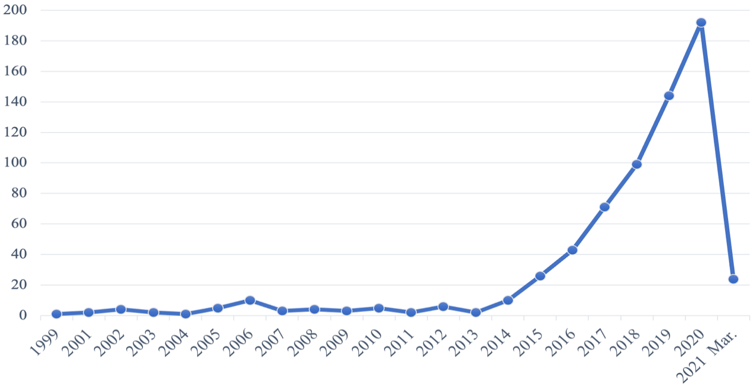
Figure 1 Number of published articles

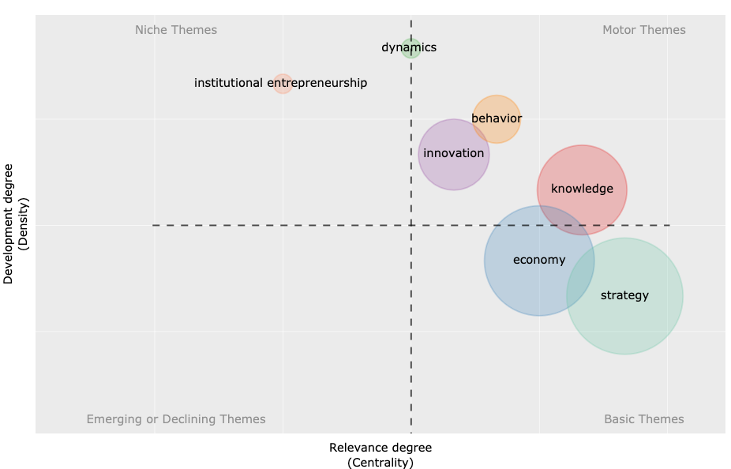
Figure 2 Thematic evolution of the topic: Time slice 1 (1999–2013)

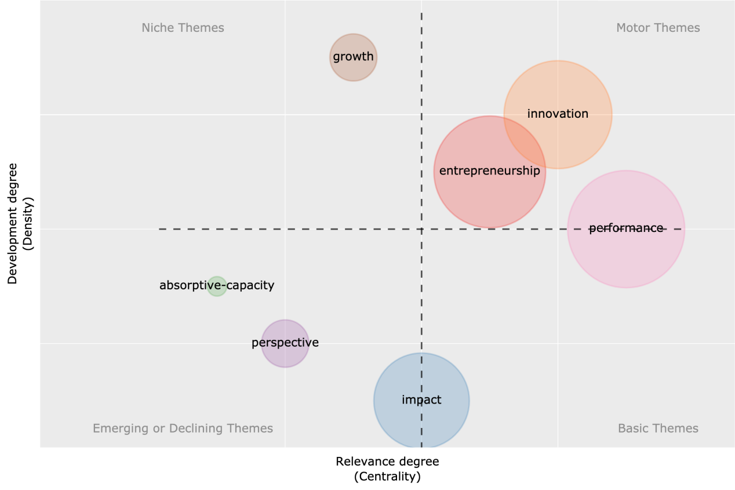
Figure 3 Thematic evolution of the topic: Time slice 2 (2014–2021 Mar.)

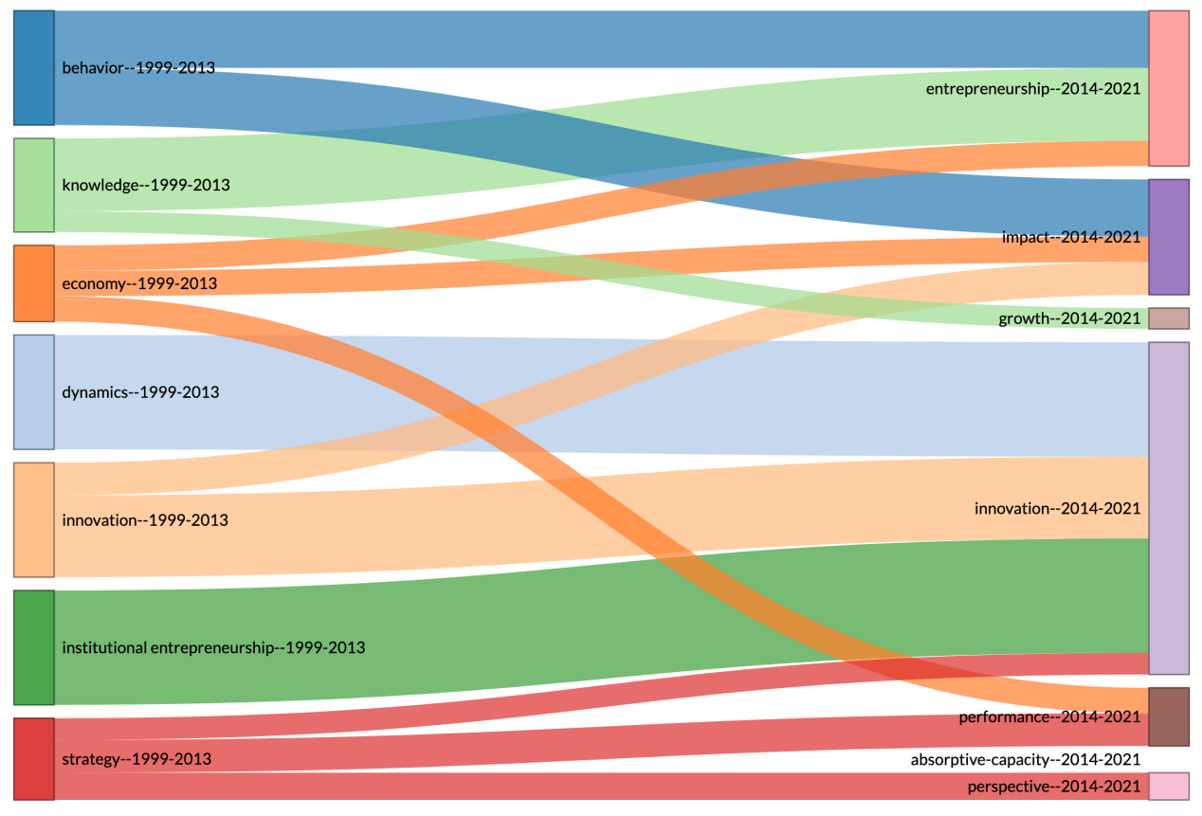
Figure 4 Thematic evolution of time slices

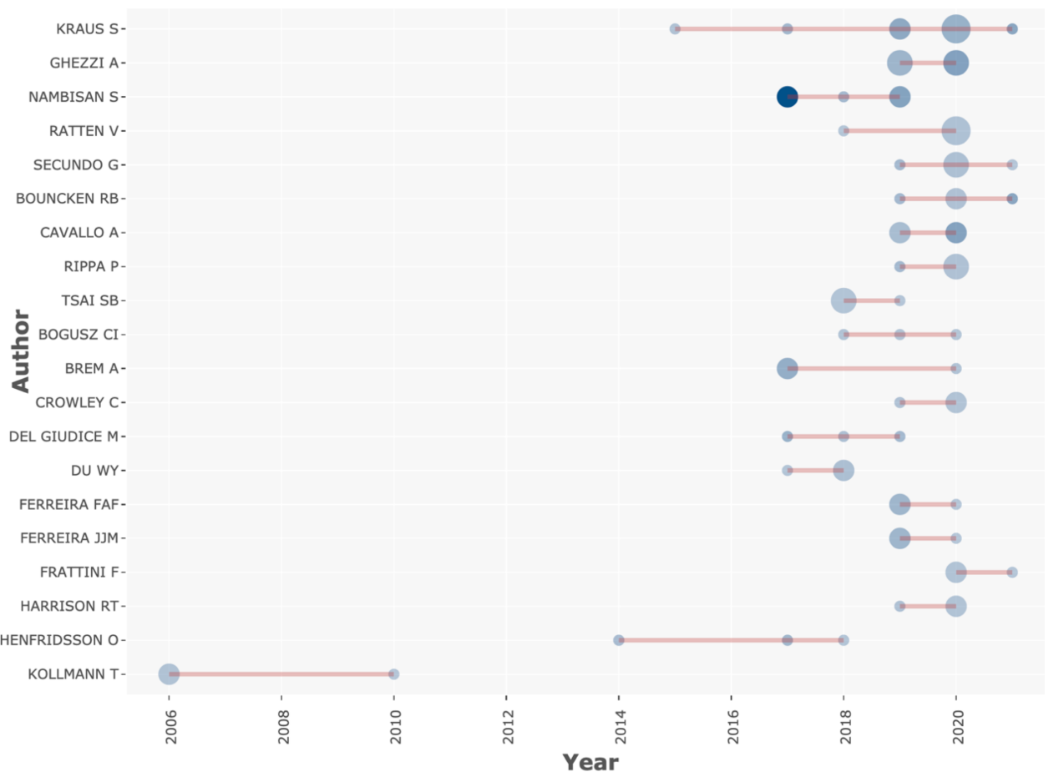
Figure 5 Top authors’ production over time

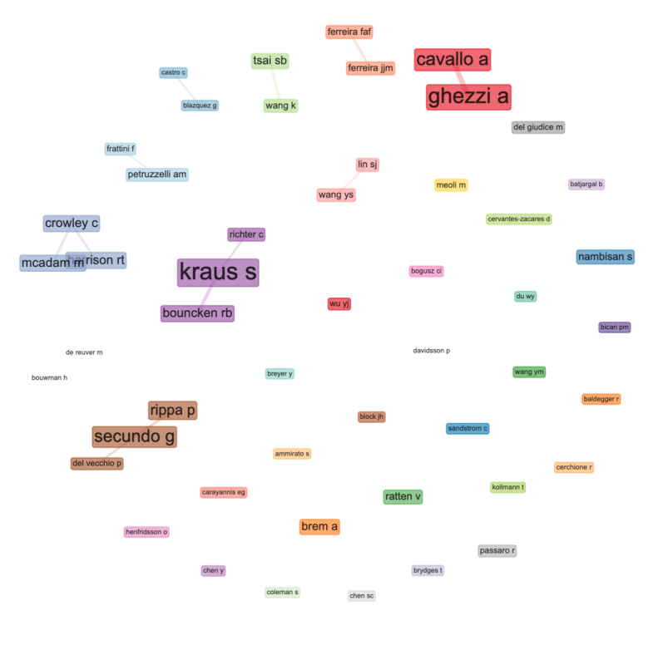
Figure 6 The social structure of the dataset

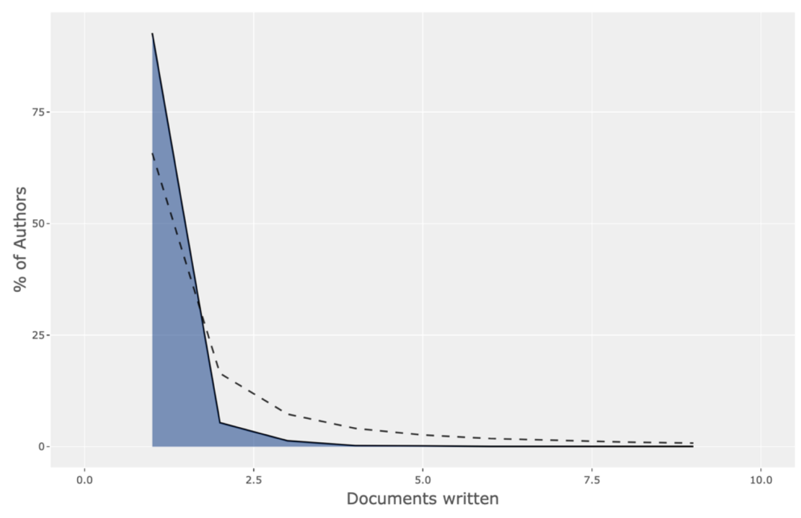
Figure 7 The frequency distribution of scientific productivity

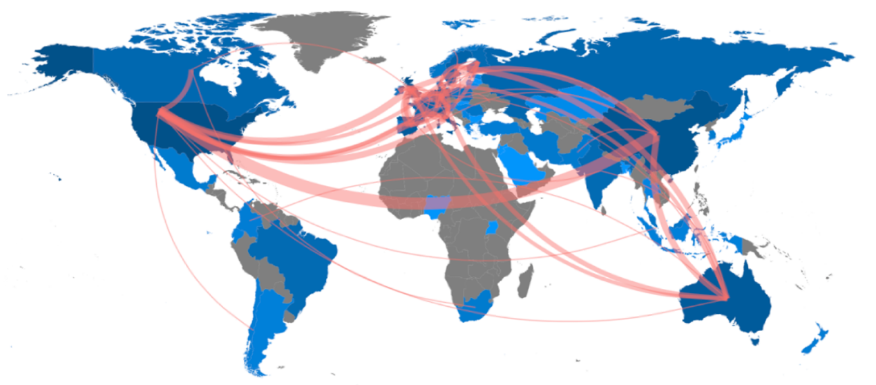
Figure 8 Country collaboration map

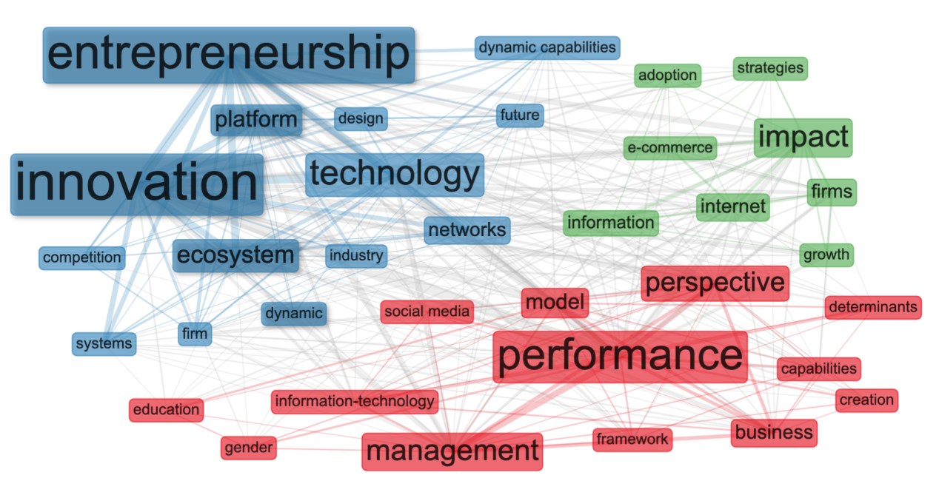
Figure 9 Keyword plus co-occurrence network

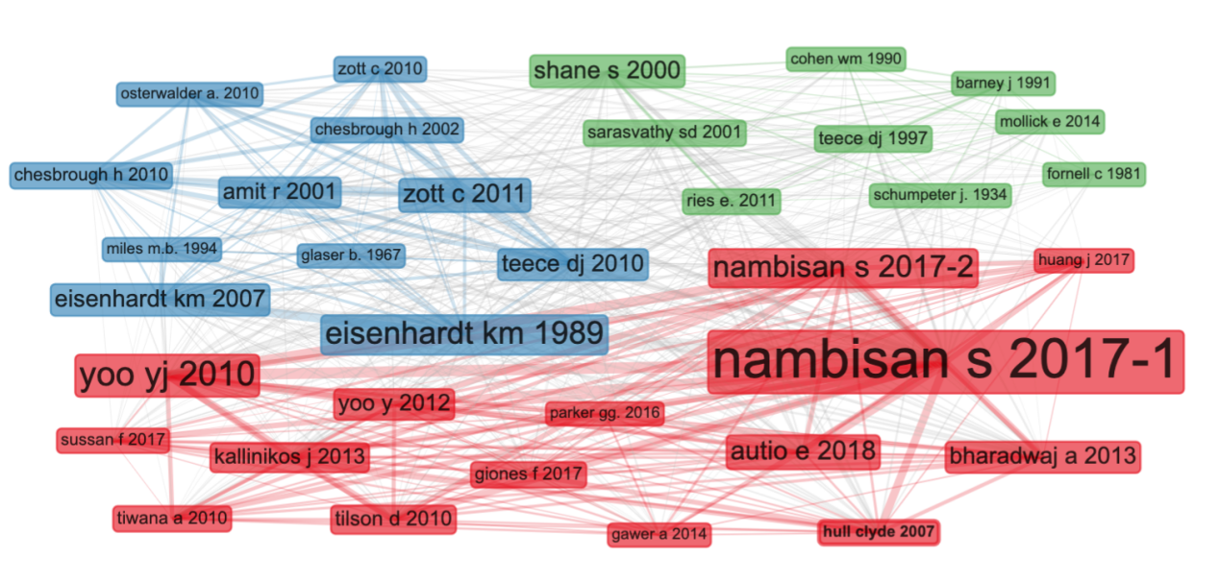
Figure 10 Papers co-citation network

Table 1 Main author
Author | Number of artical | h-index | g-index | Number of citations
Kraus | 9 | 7 | 9 | 190
Ghezzi | 8 | 5 | 8 | 96
Cavallo | 6 | 4 | 6 | 77
Nambisan S | 5 | 5 | 5 | 559
Ratten | 5 | 2 | 2 | 9
Sambamurthy V | 1 | 1 | 1 | 1165
Li L | 2 | 2 | 2 | 245
Carayannis Eg | 2 | 2 | 2 | 207

Table 2 Citation analysis of the 10 most relevant documents in the dataset
Paper | Local Citations | Total Citations | LC/TC Ratio (%) | TC per Year
Nambisan S, 2017, Entrepreneurship Theory and Practice | 111 | 203 | 54.68% | 40.6
Nambisan S, 2017, MIS Quarterly | 44 | 238 | 18.49% | 47.6
Sussan F, 2017, Small Business Economics | 27 | 68 | 39.71% | 13.6
Giones F, 2017, Technology Innovation Management Review | 27 | 37 | 72.97% | 7.4
Huang J, 2017, MIS Quarterly | 20 | 54 | 37.04% | 10.8
Kraus S, 2019, International Journal of Entrepreneurial Behavior and Research | 20 | 39 | 51.28% | 13
Von Briel F, 2018, Entrepreneurship Theory and Practice | 19 | 37 | 51.35% | 9.25
Sambamurthy V, 2003, MIS Quarterly | 17 | 1165 | 1.46% | 61.32
Richter C, 2017, Creativity and Innovation Management | 17 | 51 | 33.33% | 10.2
Dy Am, 2017, Hum Relations | 16 | 58 | 27.59% | 11.6

Table 3 The 10 most relevant journals
Journal | N. of publications | h-index | g-index | m-index | TC | PY-start
Substainability | 24 | 4 | 6 | 0. 667 | 49 | 2016
Technological Forecasting and Social Change | 22 | 10 | 19 | 1.25 | 380 | 2014
International Journal of Entrepreneurial Behavior and Research | 16 | 3 | 5 | 0.6 | 39 | 2017
Small Business Economics | 13 | 4 | 11 | 0 | 133 | 2001
Jorunal of Business Research | 12 | 7 | 12 | 1.75 | 149 | 2018
Technology Innovation Management Review | 10 | 3 | 8 | 0.6 | 66 | 2017
Information Systems Jorunal | 9 | 6 | 9 | 0 | 133 | 2016
Journal of Strategic Information Systems | 9 | 6 | 8 | 0.261 | 64 | 1999
International Entrepreneurship and Management Journal | 8 | 4 | 5 | 0 | 35 | 2018
Research Policy | 7 | 6 | 7 | 0.4 | 331 | 2007

Table 4 The top 10 countries ordered by the total number of articles
Country | Articles | MCP Ratio | TC | Average Article Citations
America | 90 | 0.1667 | 3678 | 40.867
Britain | 70 | 0.3571 | 798 | 11.4
China | 65 | 0.3385 | 356 | 5.477
Italy | 50 | 0.3 | 278 | 5.56
Australia | 42 | 0.3571 | 244 | 5.81
Germany | 40 | 0.25 | 293 | 7.325
Spain | 34 | 0.1765 | 153 | 4.5
Russia | 24 | 0.0417 | 52 | 2.167
France | 24 | 0.5833 | 239 | 9.958
Sweden | 21 | 0.3333 | 162 | 7.714

Table 5 Number of keyword occurrences and first public year
Keywords | Count | First public year
entrepreneurship | 245 | 2001
innovation | 169 | 2001
performance | 89 | 2001
technology | 85 | 2002
digital entrepreneurship | 59 | 2015
strategy | 59 | 2002
management | 55 | 2002
firm | 54 | 2007
impact | 54 | 2006
perspective | 48 | 2003
model | 46 | 2014
knowledge | 44 | 2008
internet | 41 | 2005
network | 40 | 2007
business model | 36 | 2016
social media | 34 | 2014
information technology | 32 | 2012
business | 31 | 2016
digital transformation | 29 | 2014
digitalization | 29 | 2018
information | 28 | 2006

Table 6 Selected questions for future research in DE

Direction | Question for future research
Empower | How do gender, experience, and major of a digital entrepreneur affect the startup process
 | What role does digital technology play in entrepreneurship
 | How does digital technology affect startup success
 | How can entrepreneurs better use digital technology to start a business
 | How to use digital technology to improve user goodwill
 | What is the impact of digital entrepreneurship on entrepreneurship education
 | How do entrepreneurs step up their ideas in the digital age
 | What opportunities and challenges does digital technology bring to the marketing work of enterprises
 | Compared with traditional enterprises, what kind of financing methods do digital enterprises need
 | What are the main factors influencing the success of digital startups at different stages
Evolution | What lessons can digital enterprises offer other startups? Such as enterprise boundary and so on
 | In the start-up phase, it is easier for digital businesses to grow faster
 | How does the rapid iteration of digital technology help lean startups
 | What are the unique advantages of digital enterprises in the process of internationalization
 | What are the differences between a digital enterprise and a traditional enterprise
 | What challenges does digital enterprise bring to traditional entrepreneurship theories
 | How to adjust the existing legal and financing models to better help the development of digital enterprises
 | What criteria should we use to measure the success of a digital enterprise
Ecosystem | What are the links and differences between industrial parks, business incubators and digital entrepreneurship ecosystems
 | How can the various actors in the digital entrepreneurial ecosystem effectively communicate information
 | What can governments do to boost the digital entrepreneurship ecosystem
 | What benefits can a well-functioning digital start-up ecosystem bring to the local community
 | What is the unique role of eBay, Uber and other platform companies in the digital start-up ecosystem
 | How does government regulation affect the development of digital enterprises
 | What requirements does the rapid development of digital enterprises put forward for government and legal supervision
 | How do network effects help digital businesses grow exponentially

