Flow Boiling in a Four-compartment Heat Sink for High Heat Flux Cooling: A Parametric Study

Essam M. Abo-Zahhad^{1,2}, Shinichi Ookawara³, Ali Radwan⁴, Saim Memon⁵ M. F. El-Kady^{1,6}, A. H. El-Shazly^{1,7}
¹Chemicals and Petrochemicals Engineering Department, Egypt-Japan University of Science and Technology, New Borg El-Arab City, Alexandria, Egypt
²Mechanical Power Engineering Department, Faculty of Energy Engineering, Aswan University, Aswan, Egypt
³Department of Chemical Science and Engineering, Tokyo Institute of Technology, Tokyo 152-8552, Japan
⁴Mechanical Power Engineering Department, Mansoura University, El-Mansoura 35516, Egypt
⁵Solar Thermal Vacuum Engineering Research Group, London Centre for Energy Engineering, School of Engineering, London South Bank University, London, United Kingdom⁶Fabrication Technology Department, Advanced Technology and New Materials and Research Institute (ATNMRI), the City of Scientific Research and Technological Applications, Alexandria, Egypt
⁷Chemical Engineering Department, Faculty of Engineering, Alexandria University, 11432, Egypt

Abstract
Semiconductor devices such as microelectronic devices and CPU are widely used in many applications. These devices produce a huge amount of heat which needs to be dissipated properly, because the operation of these devices is very sensitive to operating temperature. Under high operating temperatures, physical damage is expected as a result of thermal stresses that harm the structure of the components and rise the failure rate. The thermal management of these devices is mandatory to fulfill the recommended operating conditions. The complexity in applying even the most powerful single-phase liquid cooling arrangement is that the semiconductor components temperature increases fairly linearly with increasing heat dissipation rate. Consequently, the temperature of the device may reach higher than the maximum limit. Unlike the single-phase flow, the two-phase flow boiling cooling system has a potential to provide more robust thermal management of high heat dissipation application relying on the use of latent heat. The flow boiling in microscale devices is one of the most effective cooling techniques for high dense power electronic components. Ethanol, acetone, and Novec-7000 coolant with high, medium, and low boiling point respectively were applied in this study. The effect of volumetric flow rate and heat flux were experimentally investigated. A graphite sheet was used as thermal interface material TIM for further enhancement of the heat dissipation and the wall temperature uniformity was assessed under boiling conditions. The Novec-7000 coolant showed outstanding cooling capabilities under ultra-high heat flux conditions. When the thermal interface material was involved, effective heat flux increased by 0.62% and 1.62% for acetone and Novec-7000, respectively. Moreover, the experimental results showed that the boiling point is a key parameter in the system performance of flow boiling cooling.

Keywords; flow boiling, CPU, microchannel heat sink, Novec-7000, thermal interface material

Introduction
Technologies of the semiconductor industrial revolution are improving the lines between the field of the enormous development for high performance and compact structures to rise the digital economy. All these industries have grown through dimensional scaling with an identical decrease in cost and increase in performance. The semiconductor devices are widely used at many applications such as cloud computing of massive data amount, microelectronic devices, high-performance CPU components, concentrator photovoltaic cells (CPV), and any mobile micro electric appliances. The current pace of technology is significant sources of the heat to be cooled down properly. Meanwhile, it was reported that the operation of these devices is very sensitive to temperature [1]. Furthermore, under high operating temperatures, physical damage cannot be avoided due to thermal stress that threatens the safety of components and increases the failure rate. Moreover, the growth in the direction of more tightly packed electronic devices increases the challenge of overcoming the major limiting factor of high heat fluxes in very restricted space. Thermal management approaches have of vital importance as chips reach higher power densities as the heat fluxes of average computer electronic chips are projected to reach up to 450 W/cm2 with local hot spots of 1200–4500 W/cm² by 2026 [2]. The heat removal of a robust quantity of generated heat in very compact areas is a severer and more essential aspect for thermal management of all the continuous intelligence functions in the electronics industry.
The main objective of the thermal management technique is to boost the thermal performance of the electronics components’ structure by boosting the heat transfer coefficient. Furthermore, reasonable uniformity of wall temperature, the difference between the maximum and minimum temperatures on the wall (ΔT = T_{w, max} – T_{w, min}), and low friction loss are the main aspect for extending the lifespan of electronics components. During the last decade, substantial attention has been given to thermal management in semiconductor devices [3]. Extensive research studies have been conducted concerning the heat removal from these chips using several cooling schemes to remove the high amount of heat produced in electronics systems. Aggressive cooling systems were employed concerning the impact of operating temperature on the advanced microelectronics performance for long-term exploration in severe environments of the heat to be cooled efficiently. Thus far, several technologies, active and passive, have been established for thermal management of compact electronic devices as the main two possible methods for removing heat. The conventional or classic passive cooling techniques do not require any external power or mechanical moving components for the cooling process [4]. The passive heat sink (HS) is an appropriate option for low power systems. However, size constraints make the use of HS challenging in compact embedded or mobile systems. Recently, the development of passive cooling technologies introduced a new cooling trend of electronics using phase change materials (PCMs) [5]. Recent studies confirmed that air cooling schemes have been insufficient for the avant-garde of electronics and high concentrator photovoltaic [6]. Utilizing PCMs for thermal management of various applications was widely studied by many researchers. PCMs were employed in different applications such as cooling of electronic devices, CPV, cooling of mobile electronic devices cooling by heat pipes [7]. PCMs absorb and release a large amount of latent heat when the phase change process takes place from solid to liquid state or contrariwise. Even the PCMs have an abundance of latent heat, the application of the passive thermal management system is only limited to the devices operating periodically that direct towards the suppress the competence and reliability of PCM heat sinks operation for electronic devices. Moreover, PCMs cooling systems require a substantial volume, in addition to leakage challenges is Practical limitations that must be overcome. The low thermal conductivity of traditional most PCMs hinders the rapid heat dissipation process and more modifications are still needed for more reliable PCMs heat sink performances densely packed microchips or CPV.
The ongoing progress toward more densely packed microchips requires superior thermal dissipation than that provided by passive cooling. Active cooling is more reliable, practical, and economically reasonable than passive cooling under higher power densities. One of the most frequently used active cooling systems is channel cooling schemes [8]. The microchannel heat sink (MCHS) has the potential of achieving very high heat transfer rates compared to conventional mini channel heat sinks due to the very high surface area to volume ratio [9]. Many considerations influence the MCHS performance such as channel geometry design, surface roughness, fluid viscosity, flow phase, etc. [10]. MCHS has merit in thermal management due to smaller geometry size and low coolant flow requirements. Significant efforts have been directed toward improving the performance of MCHS, regarding heat transfer, working fluid phase, effects of fluid property modification, and dimensional optimization [11]. During the last three decades, single-phase liquid flow in MCHS has been comprehensively investigated [6]. Extensive experimental and mathematical studies have been conducted to investigate the influence of geometric factors and enhance the cooling performance in the MCHS. Numerous types of MCHS commercials are available for instant wavy fin microchannel, pin or fin microchannel, oblique fin microchannel, single/double-layer microchannel, etc. It is confirmed that single-phase flow MCHS able to attain a uniform cooling over the heat sources. Yet, a high rise in temperature along the flow stream, high power of pumping, and flow maldistribution represent huge challenges of single-phase multichannel cooling devices. Temperature non-uniformities distribution and flow maldistribution case hotspots formation and reduce the efficiency and reliability of the electronic devices. Hence, by the mid-eighties, heat dissipation rates from supercomputers’ electronics components and other semiconductors devices began to go beyond the capacities of single-phase liquid cooling schemes [12,13]. It is essential to overcome single-phase flow problems to realize the stable operations of such devices. In response, a two-phase cooling scheme attracted the researchers’ attention to get the most out of the coolant’s both sensible and latent heat, then the rejected heat is considerably more than a single-phase scheme while maintaining lower device temperatures. recently, it was verified that the amount of heat dissipated from electronic devices already went above 1000 W/cm² for some specific applications [13].
Flow boiling is one of the very promising cooling methods for electronics and high power due to its potential of attaining very high-level heat transfer rates with small surface temperature nonuniformity. The surface temperature is almost uniform at the saturation temperature of the coolant [2]. This uniform surface temperature can guarantee the durability of electronic equipment significantly due to the reduction of the thermal/mechanical stresses in the chip structure [14]. Comprehensive research studies have been published in the literature concerning heat transfer benefits of flow boiling for both macro, mini, and microchannels. The flow boiling phenomenon has been experimentally studied for many decades. The flow boiling empirical correlations and experiments are before the 1960s, the prime interest was transfer coefficient and pressure losses over the boiling section [15]. 1973, Boure et al. [16] comprehensively reviewed the two-phase flow instabilities in conventional size channels. Thome [17] reviewed the evolution of boiling cooling technology through the early 1990s. Thome highlighted that the features of existing empirical correlations need to be adapted and a more sophisticated method requires to achieve accuracy predictive computations for boiling cooling. Later, several researchers considered the key parameters to control the flow boiling cooling such as nucleation, rapid bubble growth, channel size, pressure loss, critical heat flux (CHF), and surface roughness [15]. Both experimental and mathematical conclusions regarding the key performance parameters of two-phase heat transfer coefficients [18], friction losses [19], and CHF [20], is being assessed based on hypothesized mechanisms responsible for any performance improvement or weakening [13].
Normally, the experimental investigation has been commonly considered for flow boiling cooling as a consequence of a wide unpredictability and complexity of the boiling phenomenon. However, the boiling flow is still developing. When the boiling flow through microchannel occurs, the capillary effect becomes greater, while the buoyancy effect remains limited [21]. Therefore, the observations available for boiling flow through macro channels are not commonly valid to the microchannels. For a more appropriate design of MCHS, a comprehensive and precise understanding of the flow boiling and its physical characteristics such as the flow pattern during boiling and CHF are very crucial [21]. Based on a comprehensive experimental investigation, Peng and Wang [22] concluded that the flow boiling heat transfer in microchannels could be very different than that of macro channels. They also showed that the normal nucleate boiling does not occur in microchannels[15]. Fang et al. [23] intended to generalize the literature experimental studies results for specific heat and mass fluxes ranges. They used 9 independent experimental studies results to compile water database (1055 points and 41 literature correlations) for microchannel mini channels to provide a new one of saturated flow boiling heat transfer coefficients. The new dimensionless based correlation had a mean absolute deviation of about 10.1 % and about 91% of experimental results data within ±20%. To the authors’ point of view that confirms the fang et al. confirmed that the comprehensive understanding of flow boiling is so far.
As reported by Bergles [24], in 1958, Don Kern in one lecture disparaged typical tubes, stating, “the inside of a tube is, without a doubt, the poorest place in the world where a person could affect heat transfer, . . . because it has a uniform cross-section, it does not create randomness . . . and it tends to give you the least for your money when you circulate fluid through it.”. Don Kem did not imagine that modern technologies are allowing the manufacture of designs that were previously only hypothetical. Thanks to three-dimension printing technology and other modern machines. One promising approach for augmenting the heat transfer process in channels is introducing high-porosity foams, which have a superior surface area to volume ratio. This permits more compact devices and boosts the heat transfer process [25]. Inserting of metal inside the channels foam lets the nucleate boiling and convective boiling on the surfaces and various flow forms happen. the pressure field entirely influences the heat transfer coefficient compared to normal channels. During the last decade, extensive flow boiling experimental research has been conducted for channels that are fully or partially packed with high thermal conductivity metal foam. Diani et al. [26] examined the phase flow boiling of R1234yf and R1234ze(E) in a horizontal channel with a high porosity copper foam (5 Pores Per Inch). The heat transfer recorded an improved more than 4.8. In all cases, the pressure losses rose with the vapor mass flux. Wong and Leong [27] studied the flow boiling heat transfer experimentally using FC-72 as the working fluid in a closed-loop facility. The authors reported that a superior flow boiling heat transfer as compared to a simple interior due to the greater number of nucleation sites and more robust flow mixing. Indeed, the number of published works regarding flow boiling through porous media is very limited. The flow boiling in the channels filled by porous metal is a new research trend, and the topic is not comprehensibly studied yet. From the above-mentioned review, it is generally recognized that the geometrical construction of the microchannels has a noticeable impact on enhancing flow boiling heat transfer performance.
Mathematical modeling of flow boiling is a demanding topic to answer the current questions regarding flow boiling and for deep understudying this complicated phenomenon. Up till now, the forced convective boiling numerical modeling and computational fluid dynamics (CFD) simulations of boiling flow are still challenging. The attention of part of the scientific community is currently concentrating on improving satisfactory modeling for flow boiling. Indeed, several points hinder improving the abilities of the existing multiphase models, about combining the analysis of phase-change phenomena. The CFD study of boiling involves the link of a multiphase flow model with a phase change model to estimate the heat and mass transport across the interfaces. Despite modeling restrictions and constraints, a few modeling attempts regarding this topic have been done.
Fang et al. [28] analyzed the flow boiling within a microchannel with a membrane in an attempt to diminish flow instabilities and vapor phase buildup. Zong et al. [29] introduced a numerical model of the 2D volume of fluid (VOF) model that was utilized along with a phase-change model. The nucleation was in a microchannel and controlled from seed bubbles at different injection rates. Sun et al. [30], coupled the VOF model with a phase-change model for the situation where one phase is unsaturated and the other is saturated. The results were verified with a one-dimensional Stefan problem and a two-dimensional film boiling problem. Nabil and Rattner [31] used Open FOAM® library features to build a new solver of a VOF compiled with interThermalPhaseChangeFoam solver. The authors concluded that the code enabled to simulate a wide range of phase change cases. The sole limitation of the solver was that it does not support geometric interface reconstruction. Lorenzini and Joshi [32] performed a CFD analysis based on the VOF model compiled with a phase-change. They were validated against benchmark correlations heat and fluid flow characteristics. No information was mentioned about mass conservation.
Despite, the huge number of experimental and mathematical studies in the open literature of flow boiling, several basic issues are still not comprehended, and this delays the move from the research laboratory to industrial applications. The lack of generally accepted correlations for macro, mini, and microchannel. The wall superheat rises substantially with increasing heat flux in some experimental conditions. Special attention must be paid to CHF, the geometrical parameters, heat transfer surface, and coolant characteristics. Moreover, Sophisticated MCHS enhances flow boiling performance offer attractive solutions for the efficient cooling of high-heat-flux devices. In the present study, the perspective of dividing the MCHS into four segments with distinct inlets and outlets was adopted. The proposed heat sink design is likely to offer superior thermal management in terms of heat source temperature and temperature uniformity [33]. Moreover, the regeneration of the boundary layer by varying the channel width is important for two-phase flow and heat transfer. Hence, flow boiling experiments within four-compartments stepwise varied width microchannels heat sink and operation environments are done in the present study. The purposes of this study are:
- To study and evaluate the performance of the new four compartments stepwise varied width microchannels heat sink experimentally under two-phase flow boiling conditions.
- To comprehensively study the key parameters of flow boiling and present a comprehensive discussion of the boiling cooling mechanism
- To compare the physics of the flow boiling process of ethanol, acetone and Novec-7000
- To understand the benefits of a developing boundary layer to flow boiling heat transfer in the stepwise varied width microchannels heat sink design.
- To investigate the effect of involving the thermal interface material (MIT)

Experimental procedures

Device Design, Fabrication, and coolants
In the current design, a multisegmented heat sink design was adopted. The total area was divided into many segments to improve heat removal capacity. Besides, the channel width was varied as the channels were arranged at different points along the cooling liquid stream and heat sink area. The heat sinks including rectangular channels are selected as they are easy to be fabricated. Each compartment of the new 4CSVWMC has four separated inlets and outlets as shown in Fig. 1. The total footprint area of the was 25 × 52 mm² with a channel height (H_{ch}) of 0.5 mm. The top, bottom, and walls thickness (δ_{w} are equal to 0.5 mm. The detailed dimensions of 4CSVWMC are listed in Table 1. The channel geometry effect on device performance is beyond the current study objectives. The new device was fabricated by the three-dimensional printing (3D printing) method which is broadly accepted as a practical tool for complex 3D structure with high accuracy [34]. The fabrication process was performed by a metal OPM250L 3D printer of Sodick Company, Japan. The metal powder OPM-ULTRA1 (maraging steel) with a melting ratio of 99.99%, was used to print the current device. The limitations of 3D metal printing and pumping requirements were considered for the proposed design where the minimum channel width is 1 mm. As shown in Fig. 1, for all compartments, the number of inlet channels is two and the number increases at the outlet to be four channels. The three different coolants that were employed in all investigations are Ethanol (C2H5OH, 99.5%), Acetone (CH3COCH3, 99.7%), Novec-7000 (C3F7OCH3, 99.5%). Ethanol and acetone were Wako 1st Grade (FUJIFILM Wako Pure Chemicals Co., Ltd.) products with a boiling temperature of 78 °C and 56 °C respectively at 1 atm. Novec-7000 is a non-toxic and chemically stable engineered fluid with a boiling temperature of about 34 °C at 1 atm. The properties of Novec-7000 make it a suitable and desirable coolant for multiphase flow conditions [35]. TIM has a high thermal conductivity with micro-scale thickness and good mechanical characteristics were used to further heat transfer enhancement and provide more temperature uniformity. Graphite TIM was carefully selected as it has an ultra-thin thickness (75 µm) and high thermal conductivity in the horizontal direction.

Test facility and experimental procedures
The test facility was assembled (Ookawara’s lab, TokyoTech) to specifically investigate the flow boiling cooling within the fabricated heat sink. The itemized schematic diagram of the test set up containing its different components is illustrated in Fig. 2. Four 200 ml glass syringes were mounted on two dual-syringe pumps (KDS210 Scientific, Inc.) with an accuracy of ± 1% to feed coolant. The pure fluoropolymer tubing (I. D = 4mm and O. D = 5mm) were fitted to deliver the coolant to and from the heat sink. The aluminum nitride ceramic heater was preferred to simulate the heat dissipated from high dense power electronic devices. The WALN-3 product type of Sakaguchi company (Sakaguchi Seisakusho Co. Ltd., Japan) with an area of 25 × 25 mm² was selected. The maximum operating temperature and power density of the WALN-3 are 400 ℃ and 24 w/cm² respectively. The high thermal conductivity of the selected heater guarantee achieving rapid heating during the experimental work. The heater was fixed to the well-polished top wall of heat sink after attaching the thermocouples and spreading a very thin thermal grease to decrease the thermal resistance that could exist according to the air gaps as shown in Fig. 2 (a). Temperature data acquisition was attained by four multichannel recorders MCR-4TC model with an accuracy of ± 0.3 % (Omni Instruments Ltd. Japan) which recorded the temperatures reading from 16 K-type thermocouples. The thermocouples (ASONE Co., Japan) were carefully fixed and distributed between the top wall and the heater as shown in Fig. 2 (b). As depicted in the figure, the four compartments featured in the heat sink are obvious. The temperature sensors were inserted at the top of the first compartment only as the heat sink is symmetry. The supposition of the same temperature distribution is acceptable for the current design when the same amounts of coolant are pumped to all compartments. Hence, the complete temperature distribution over the whole of the heat sink could be generated by using the temperature of thermocouple T₁ to T₉. The sensor T₁₀, T₁₁, T_{13,} and T₁₄ were insulated at the bottom wall of the heat sink as shown in Fig. 2 (b). These sensors were used to check the assumption of the symmetric temperature distribution of heat transfer over the heat sink domain. The T₁₂ was fixed at the center of the bottom wall to observe the dry out that could happen at the center of the heat sink. T₁₅ and T₁₆ were installed at the inlet and outlet of the first compartment. A dense and high thermal resistant silicon sheet completely insulated all the test sections. The voltage controller Model RSA-5 (AS ONE Co., Japan) was operated to control the power supplied to the heater. The output current and voltage were measured and recorded to calculate the input power supplied to the heater. Fig. 2 (c) and (d) illustrate a graphic layout of all components and photographs of actual the experimental flow boiling test at the laboratory.
In the beginning, before running each experiment, all temperatures were checked to be the same and equal to ambient temperature and the voltage controller was adjusted to the required output. Then the heater was turned on, and temperature recording was launched using a data acquisition until attaining a steady state. The recovery system was utilized to recover the coolant from the outlet for the next experiments. The data acquisition was linked to the computer to monitor the measured temperature and saving the measurements for data reduction. The experiments were repeated many times to check the measurement accuracy and repeatability.
Table 1 Detailed dimensions of the investigated 4CSVWMC device.
Dimension | Value (mm) |  | Dimension | Value (mm)
W_{HS} | 25 |  | W_{CH2} | 1
L_{Hs} | 25 |  | L_{Ch} | 12.25
H_{Ch} | 0.5 |  | L₁ | 8.23
δ_{Hs} | 0.5 |  | L₂ | 2.03
W_{CH1} |  | 12.25 | L₃ | 2.53
W_{CH1} |  | 2.625 | L_{H} | 8.5
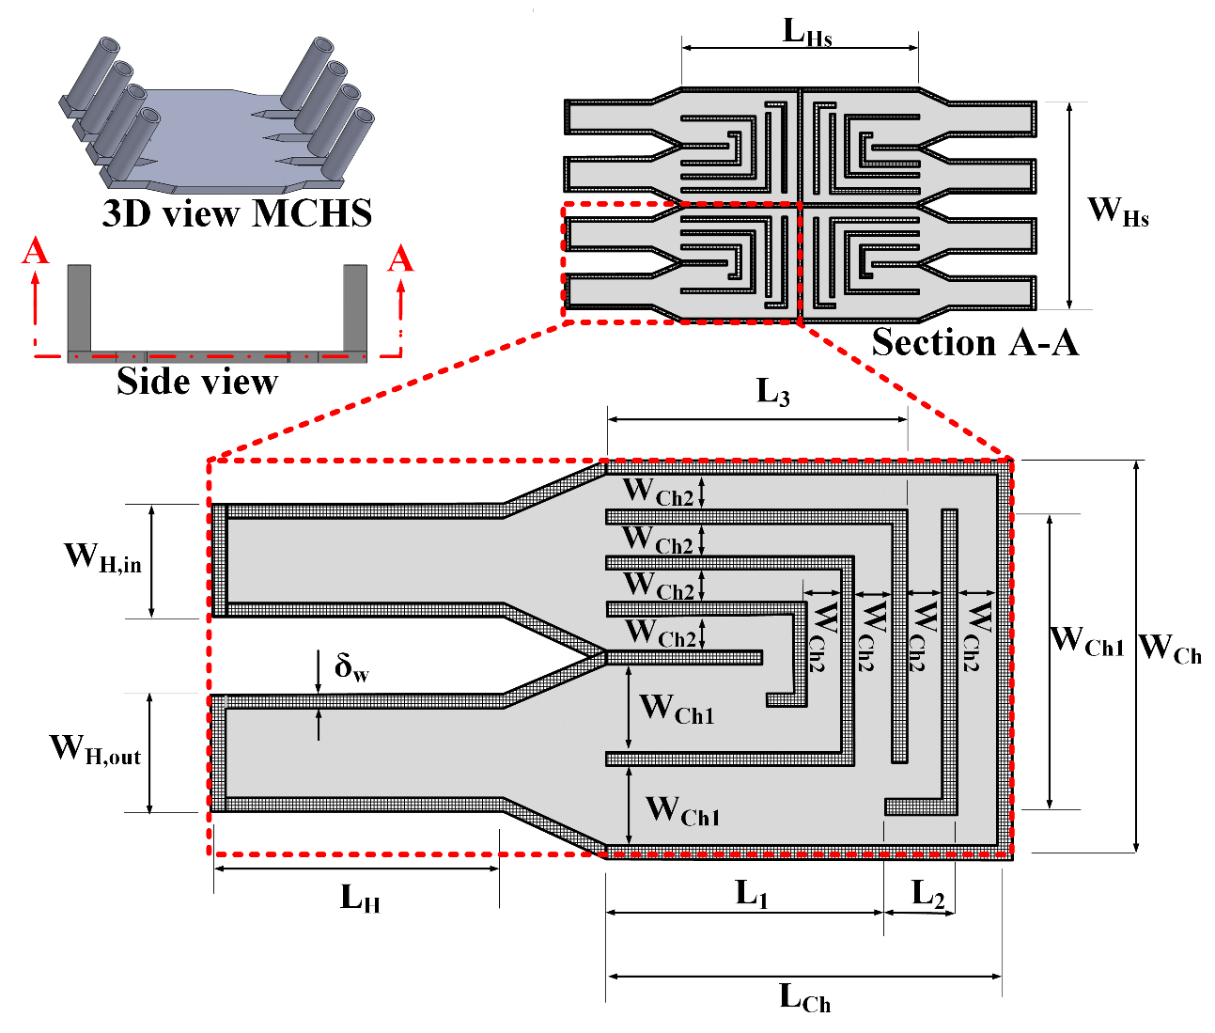
Fig. 1 Heat sink design and channels details
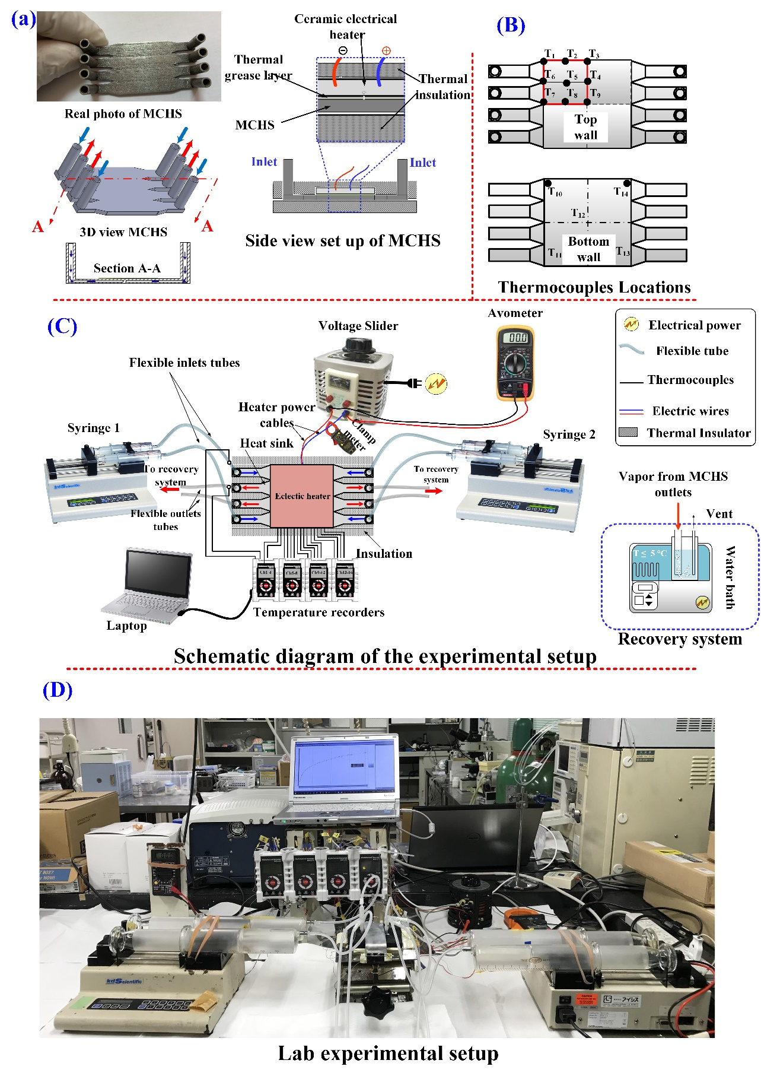
Fig. 2 Schematic graph of the test setup and specifics

Heat loss characterization
The heat flux supplied to the test section via the flow boiling process (q") was calculated as the following equation:
Where Q and Q_{loss} are the supplied power in watts and the heat loss to the ambient respectively. The I and V terms donate the electric current and voltage supplied to the heater respectively. The detailed heat loss characterization techniques described in [36–38] were used to determine the fraction of the heat losses to the ambient by natural convection, radiation, and conduction. The set up was operated without feeding any coolant (completely drained of coolants), then the heat loss could be calculated and correlated regarding the average wall (T_{wall,avg}) and ambient temperatures (T_{a}). It is observed that the heat loss changes linearly with the difference between the T_{wall,avg,} and T_{a} as shown in Fig. 3. The following equation was obtained by fitting the heat loss data vs the difference between T_{wall,avg,} and T_{a}.
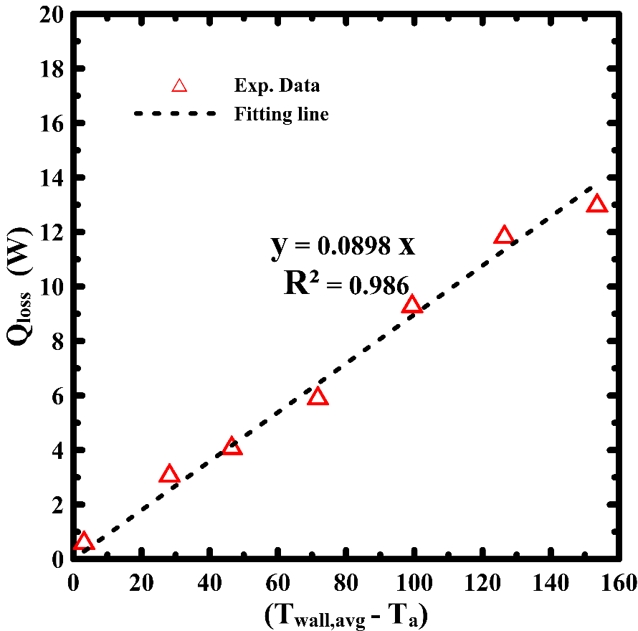
Fig. 3 Heat loss characteristic curve.

Data reduction and heat transfer
The effective heat flux reached to the coolant, after considering the heat loss, is given by the following equation:
Where A is the heat sink area and it calculated from as the following:
The coolants were pumped into the heat sink in a subcooled state (T_{f, in} < T_{sat}) for all test conditions. Consequently, the heat sink can be split up into different regions: firstly, a subcooled zone which mostly near to the inlets where heat transfer happened by single-phase forced convection. Secondly, a saturated flow boiling or nucleate boiling zone where heat transfer happened via forced convective evaporation (nucleate boiling dominates the heat transfer). Thirdly, when the heat flux exceeded the CHF the flow pattern may the dry out regions or single-phase vapor flow in that case crisis flow boiling happened.

Results and discussion
The experimental work was repeated for specific conditions at different times to confirm the repeatability of the setup. For instance, as shown in Fig. 4, the plots from the temperature repeatability tests, of single (q” = 127.6 W/cm²) and two-phase flow (q” = 626 W/cm²) under transient conditions for G = 20 ml/min and G = 40 ml/min respectively. The trends for both single and two-phase of readings are repeatable. Form the figure; the steady-state results were mostly obtained after 250 sec for both single and two phases.
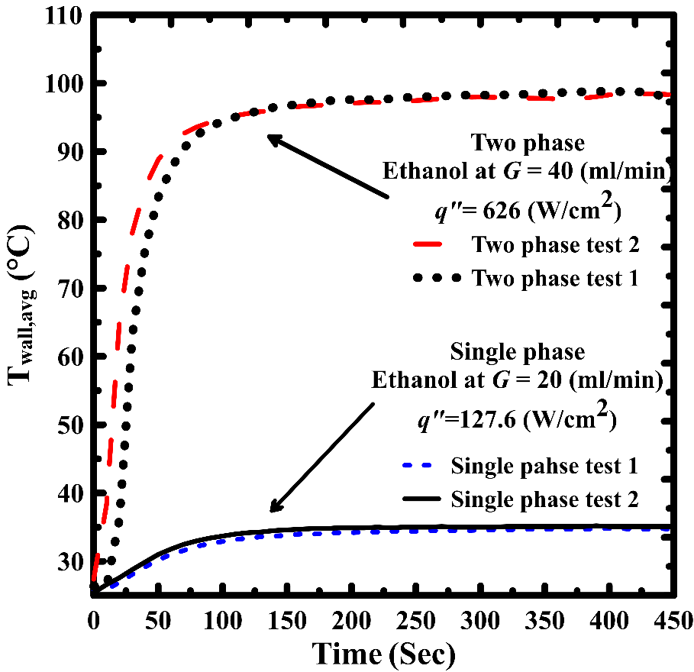
Fig. 4 Temperature data repeatability for single and two-phase flow under transient conditions
The boiling characteristics curves for the new heat sink at different inlet volumetric flow rates are discussed in this section in detail. G has a greater influence on boiling flow, for this reason, different values of total inlet volumetric flow rate (G) were examined. Fig. 5 and Fig. 6 show the average top wall temperature and effective heat flux plotted against G at low, medium, and high Q values to the heater for Ethanol, Acetone, and Novec-7000. From Fig. 5 (a) Fig. 6 (a) and qʺ_{eff} and T_{wall,avg} at Q = 8.7 W, it can be seen that: many mechanisms in subcooled flow boiling heat transfer occurred. At the lowest G values, bubble nucleation exists, and wall temperature was slightly higher than the saturation temperature.
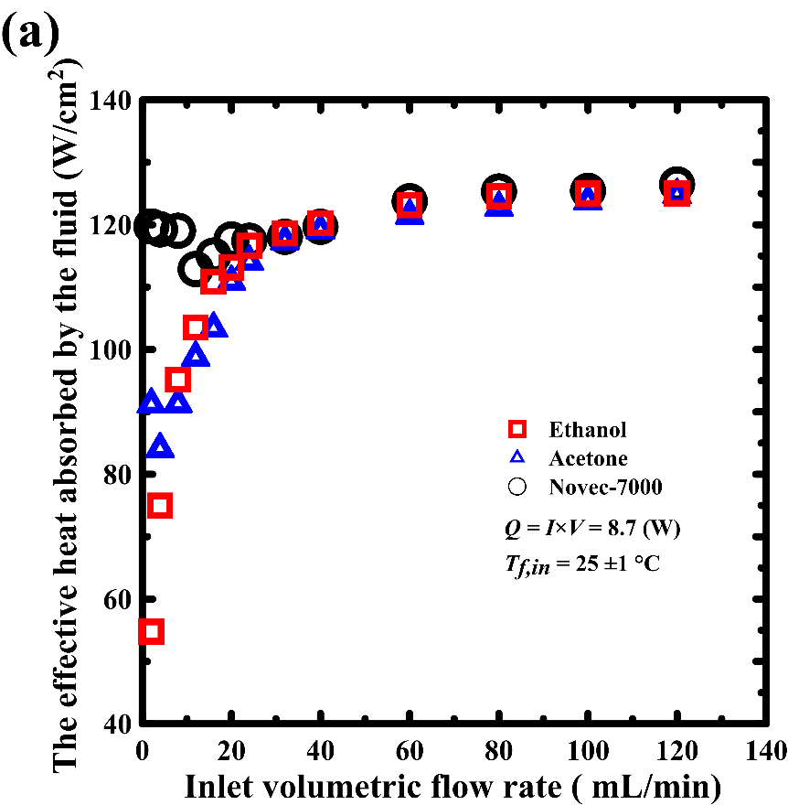 | 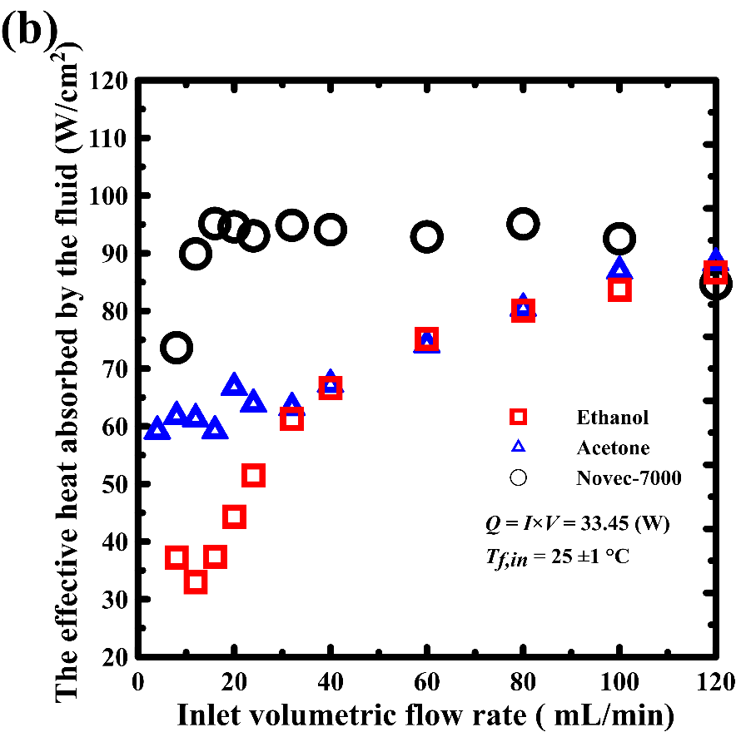
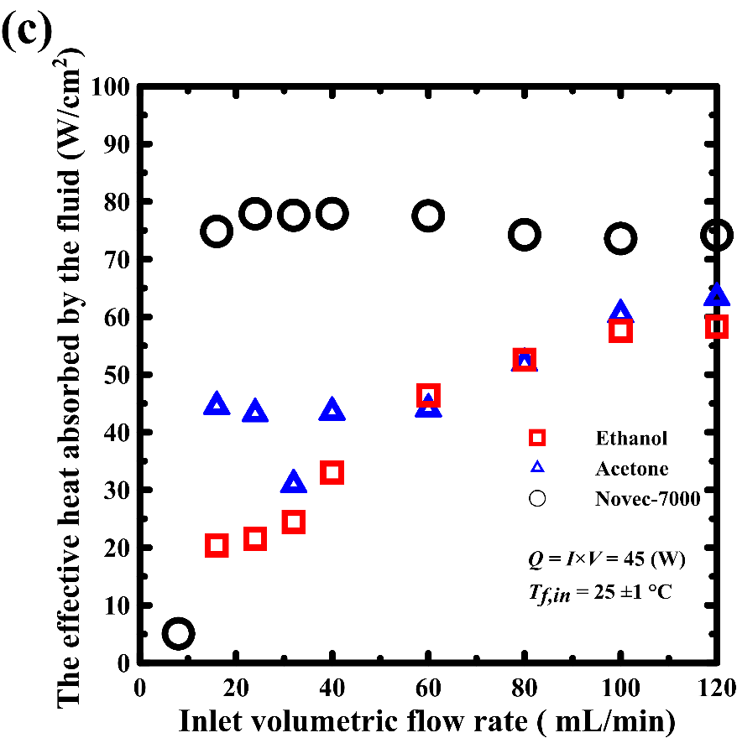
Fig. 5 Variation of effective heat flux with inlet volumetric flow rate
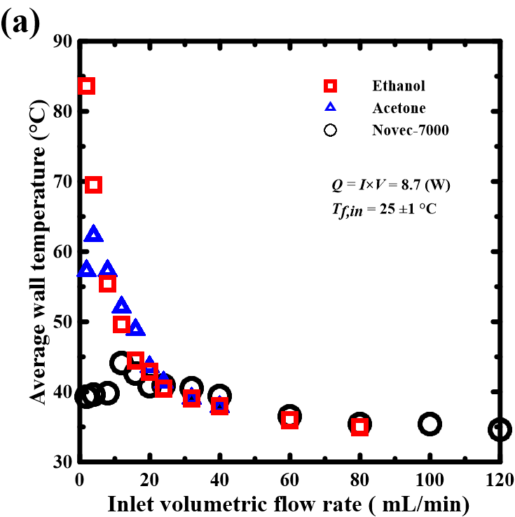 | 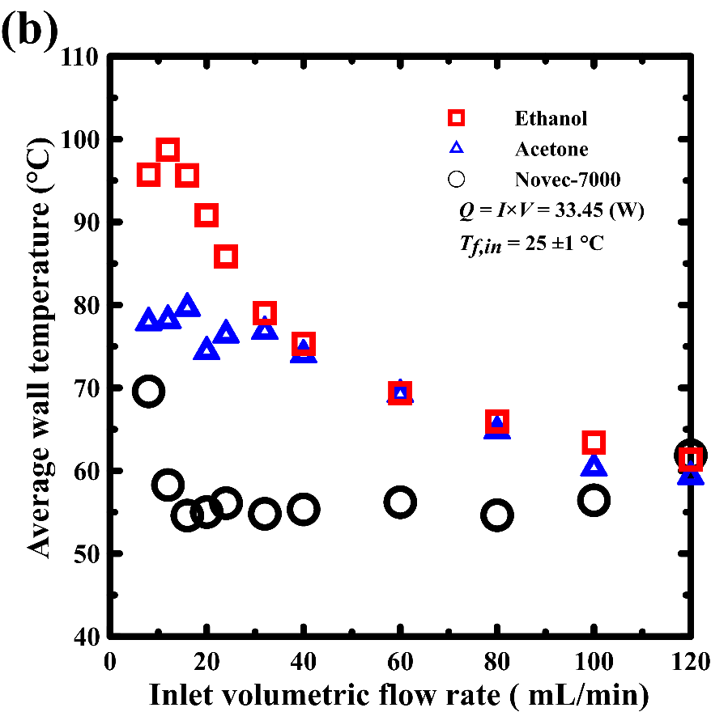
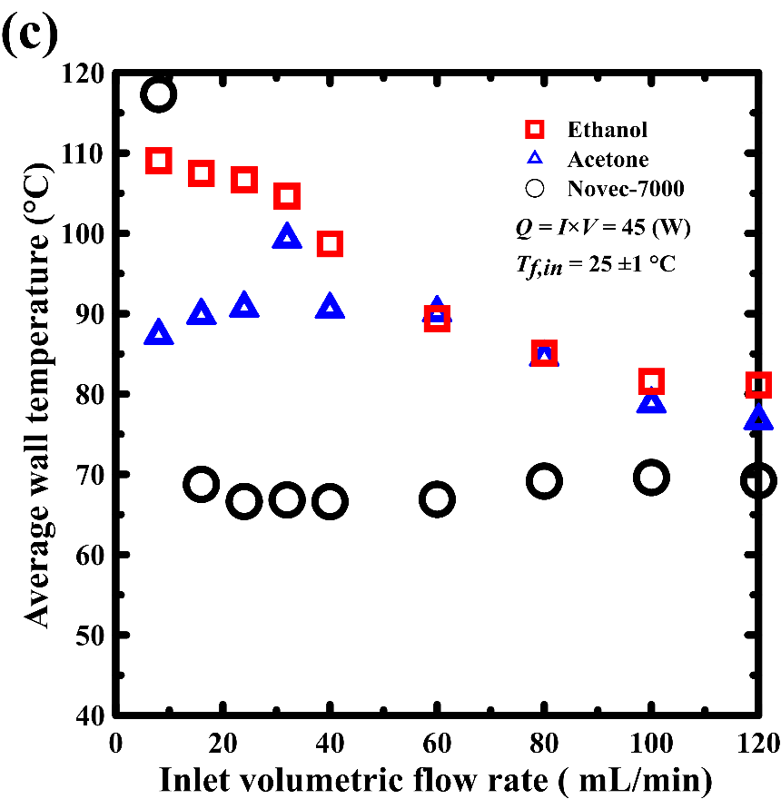
Fig. 6 Average wall temperature variation with the increase in the inlet volumetric flow rate
For more details, in the case of Novec-7000, it is obvious that the highly effective heat transfer and low wall temperature due to the flow boiling occurred. As the G increased the single-phase flow began to dominate and forced convection (FC) dominates under a single-phase heat transfer mechanism, when only liquid is present with the two-phase flow that appeared in some regions in the flow domain as will be discussed in detail later. Besides, the G value whence the average wall temperature attained saturation was observed under single-phase flow. This trend was also observed by several researchers assessing single-phase cooling approaches. There is a sudden decrease in qʺeff as the wall temperature suddenly increased. this is corresponding to the change from two-phase flow to single-phase liquid flow and the backpressure existed. The single-phase liquid flow and alternatively in the microchannels once G reached to a specific value. This trend is clearer when the Q values were increased as shown in Fig. 5 (b), Fig. 5 (c) Fig. 6 (b) and Fig. 6 (c). Fig. 6 (c) shows the dry out happened in the case of Novec-7000 under the lowest G value of 8 ml/min. The occurrence of CHF let to the excessive increase in wall superheat marks the point of CHF. Beyond the point of the beginning of nucleate boiling (ONB), the gradients of the effective heat dissipations were fairly constant, until a high value of G where the beginning of partial single-phase occurred. Then the saturated flow boiling dominated for all other cooling flow rates and wall temperatures are mostly the same. From the figures in obvious that the saturated flow boiling is an outstanding cooling technique and the boiling point of the coolant is a very important key parameter.
The local temperature contours for Ethanol, Acetone, and Novec-7000 are presented in Fig. 7, Fig. 8 and Fig. 9 respectively. The analysis of these contours reveals that a local dry out happened in some regions within the flow direction. Fig. 7 (a) and Fig. 8 (a) show that the lowest wall temperature detected near the inlet of the heat sink under where the coolant not evaporated, and not backpressure occurred as G and Q values are small. Moreover, the observed thermal energy yet is not enough to initiate two-phase flow. A thin vapor film may be formed at the central region of the heat sink as the wall temperature is higher than the saturation temperature of Ethanol and Acetone. The peaks shown in the contours confirm the formation of the vapor film near to the top wall then the high thermal resistance of vapor lets the high rise in wall temperature. The vapor film was created at the narrow regions of the device meanwhile the coolant streamed as a single-phase liquid over the bottom wall. The wall temperature grows as the liquid film becomes thinner and thinner due to evaporation in these regions. Near to the outlets, the local temperatures are low as the saturated boiling happens without the existence of backpressure. The fully developed and free expended two-phase flow near to the outlets yields a reduction of the local wall temperature. when the suppled thermal heat was increased, the flow is not still single phase nearby the channel inlet and the coolant began to boil early as obvious in figure Fig. 7 (b), Fig. 7 (c), Fig. 8 (b) and Fig. 8 (c).
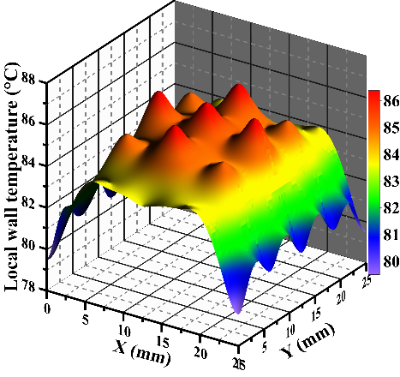 | 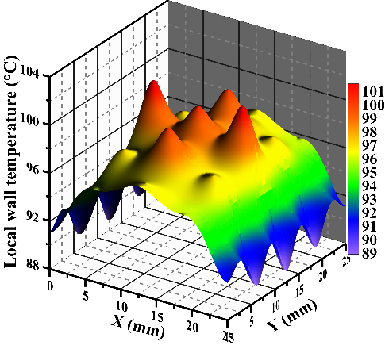 | 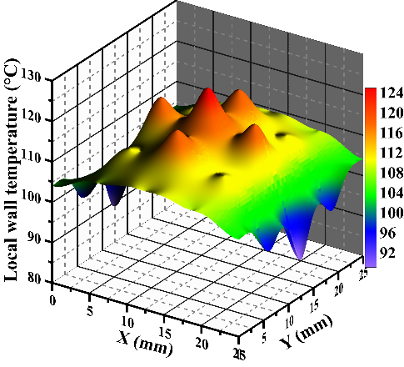
- Q = 8.7 W, q” = 54.8 W/Cm² and G = 2 mL/min | - Q = 33.5 W, q” = 37.3 W/Cm² and G =8 mL/min | - Q = 45 W, q” = 18.1 W/Cm² and G = 8 mL/min
Fig. 7 Ethanol local temperature contours

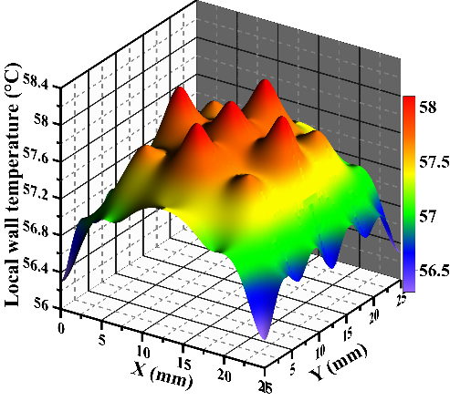 | 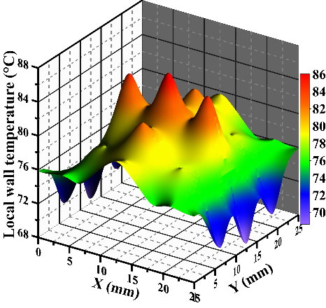 | 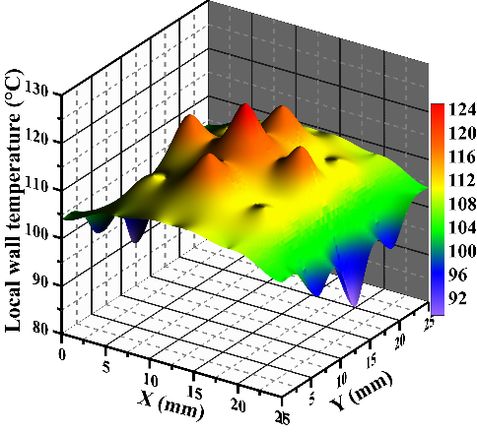
- Q = 8.7 W, q” = 91.2 W/Cm² and G = 2 mL/min | - Q = 33.5 W, q” = 61.7 W/Cm² and G =8 mL/min | - Q = 45 W, q” = 48.1 W/Cm² and G = 8 mL/min
Fig. 8 Acetone local temperature contours
Fig. 9 shows the local temperature contours for Novec-7000 for different G and Q values. It is obvious that all local temperature is higher and the two-phase flow developed immediately when the Novec-7000 reached to the heated section. The reduction of wall temperature occurred mainly as a result of both single- and two-phase flow. Similar to the previous discussion of Ethanol and Acetone, the single-phase liquid flow was occupied by the two-phase flow near to the outlets. Consequent to the change from single-phase flow to two-phase flow, the fluid and wall temperatures show this large reduction. From Fig. 9 (b) and (c), as the effective heat flux and coolant flow rate were increased, the contours of the boiling changed.

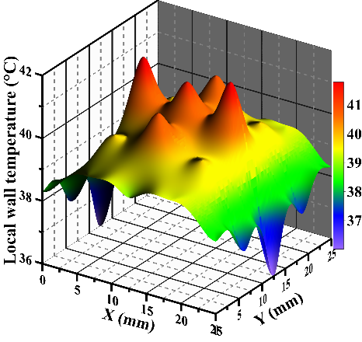 | 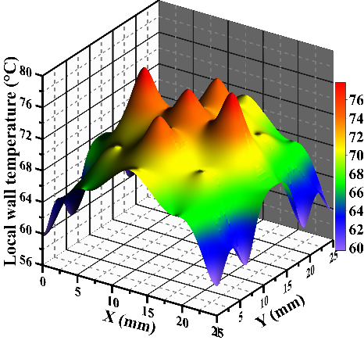 | 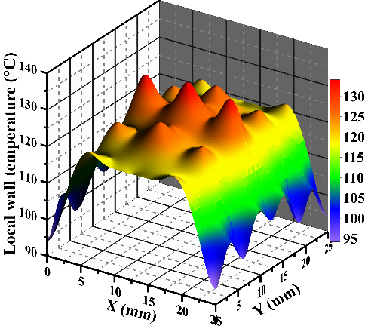
- Q =8.7, W, q” = 119.7 W/Cm² and G =2 mL/min | - Q = 33.5 W, q” = 73.63 W/Cm² , G =8 mL/min | - Q = 45 W, q” = 5.1 W/Cm² , G =8 mL/min
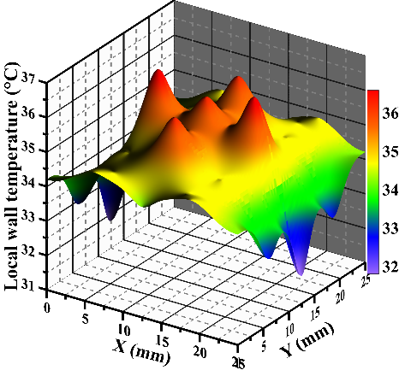 | 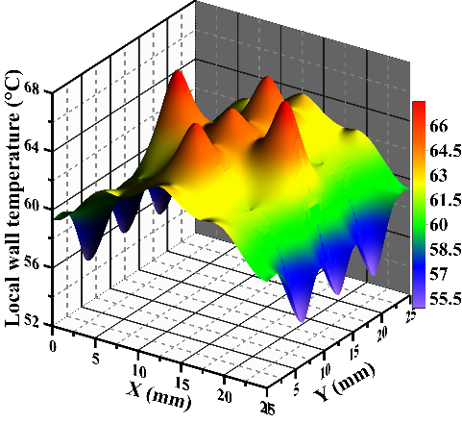 | 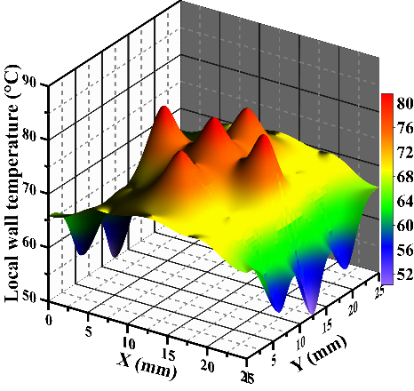
- Q =8.7, q” = 126.5 W/Cm² , G = 120 mL/min | - Q = 33.5 W, q” = 85 W/Cm² , G =120 mL/min | - Q = 45 W, q” = 74.2 W/Cm² , G = 120 mL/min
Fig. 9 Novec-7000 local temperature contours
A more quantitative investigation can be performed by tracking the temperature extracted data logger behavior versus time. Fig. 10 shows the temperature variation with time on the backside wall when operating with ethanol, Acetone, and Novec-7000 when Q and G were equal to 45 W and 120 respectively. it can still be observed that at a time of 250 sec, there is no significant
temperature variation and the steady-state was obtained for all coolants. No significant fluctuations or instability were observed. The liquid film over the bottom channel is confirmed as the bottom wall temperatures (T₁₀ to T14) were lower than the saturated temperature as discussed in the previous section. The film thickness decreases due to complete evaporation near the outlets.
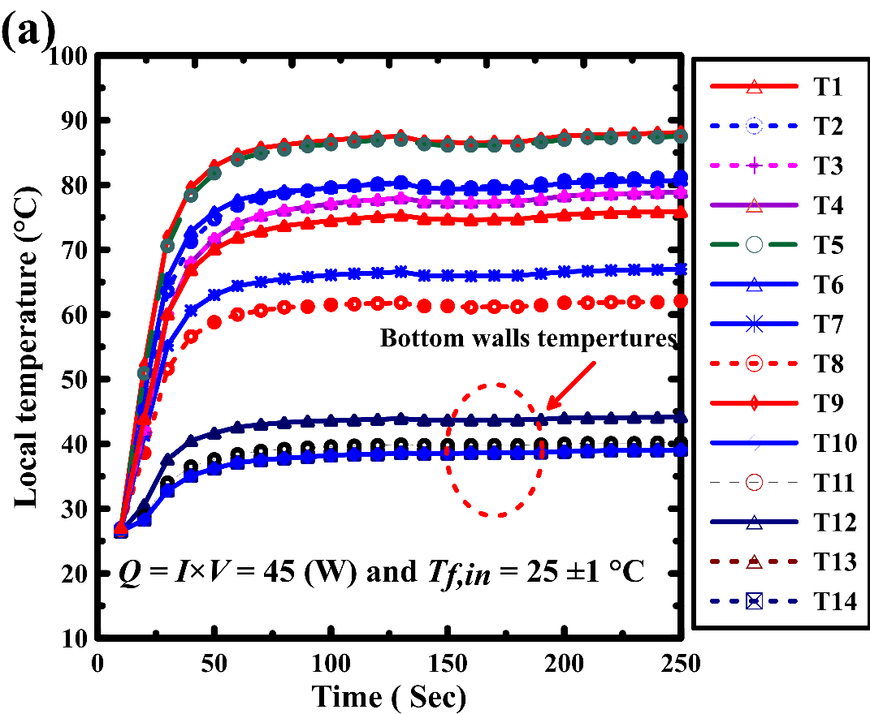 | 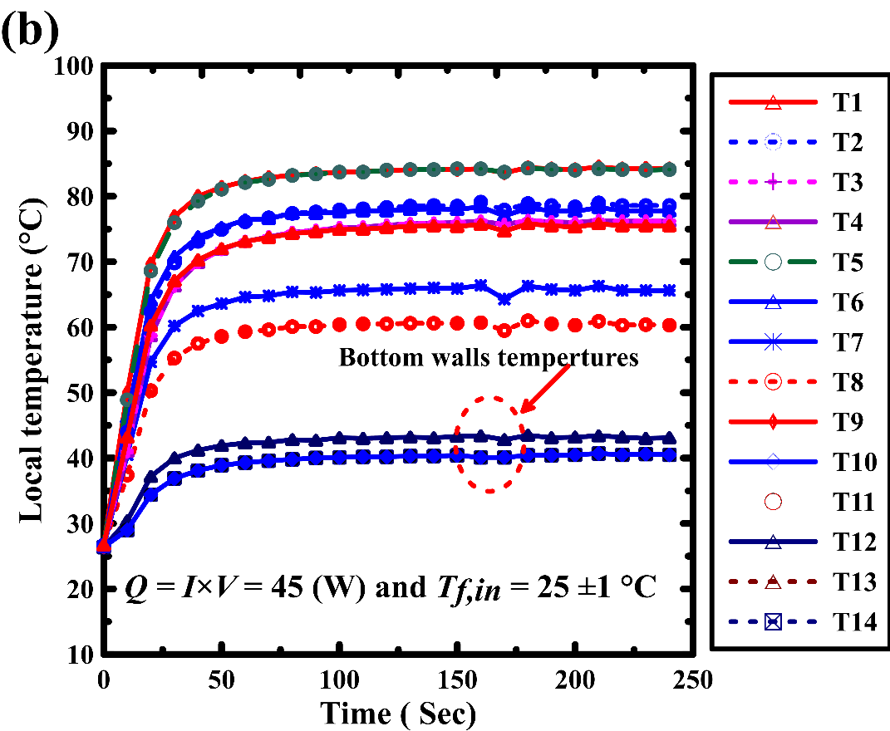
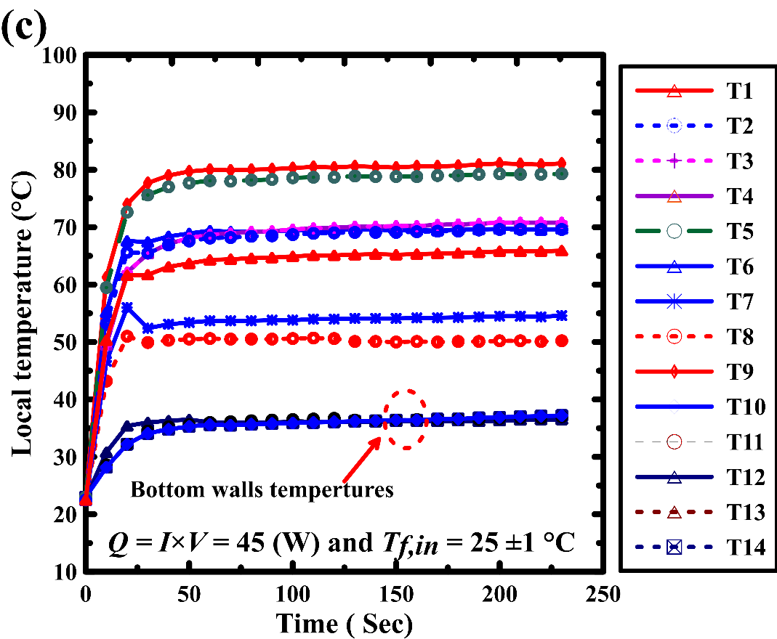
Fig. 10 Periodic variation of the local temperatures (a) using ethanol (b) Acetone and (c) Novec-7000 coolant
Analysis Fig. 10 (a) and (b), for Ethanol and Acetone, reveals that flow the existence of single and two-phase phases in the same region and the vapor film over the liquid film is responsible for the hot spots observed at the local temperature contours. On the other hand, in the case of Novec-7000 Fig. 10 (c), the saturated flow boiling occurred over the flow domain as all bottom wall temperatures were equal to T_{sat}. The effect of Graphite TIM was studied experimentally for only G = 100 ml/min and the Q value was changed between 8.7 up to 130 W. The TIM had different influence in flow boiling as the q”_{eff} slightly decreased in case of Ethanol which has a high boiling point. The q”_{eff} was decreased by 0.54 % with inserting the Graphite TIM as the thermal resistance was increased as shown in Fig. 11 (a). Conversely, it is obvious from Fig. 11 (b) and (c) that TIM improved the heat transfer process as the effective heat flux was increased in the case of Acetone and Novec-7000. The q”_{eff} increased by 0.62% and 1.62% in the case of Acetone and Novec-7000 respectively. This mainly because of the TIM improved the local temperature distribution consequently the overall heat dissipations process.
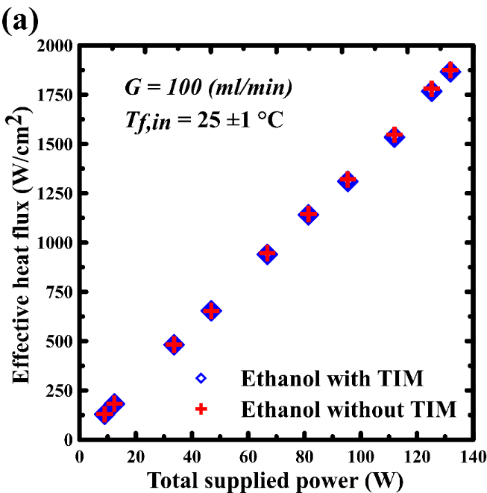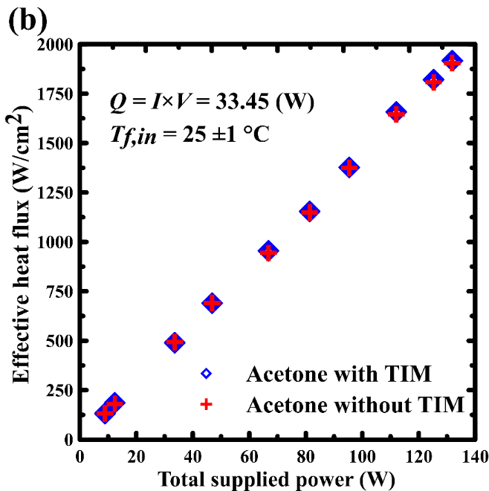
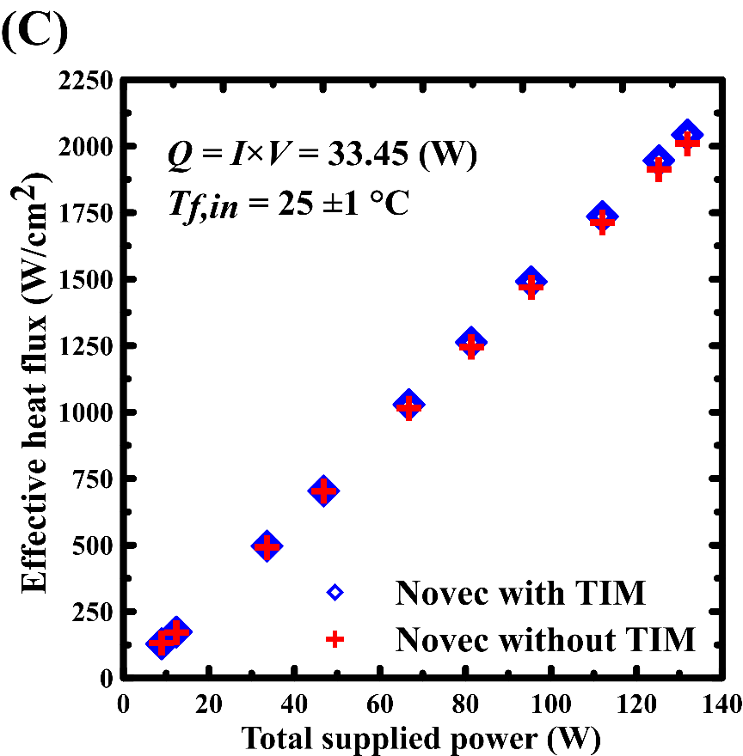
Fig. 11 Effective heat flux variation for heatsink with and without Thermal interface materials
Fig. 12 reveal the variation of local temperature non-uniformity with change the total supplied power. The TIM has a significant influence on the local temperature non-uniformity. The low boiling point of the coolant is a key parameter when the TIM materials are involved in the flow boiling. Moreover, the channel geometry has a considerable effect on that case.
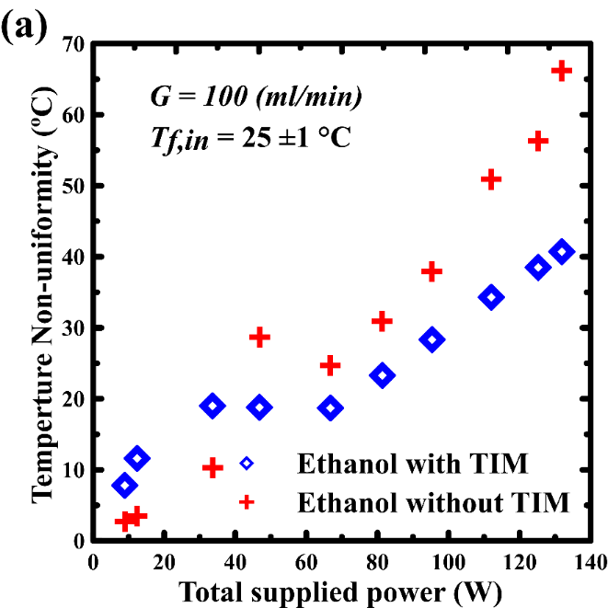 | 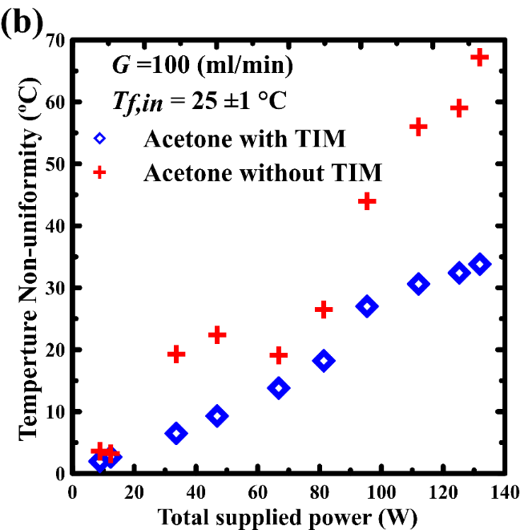
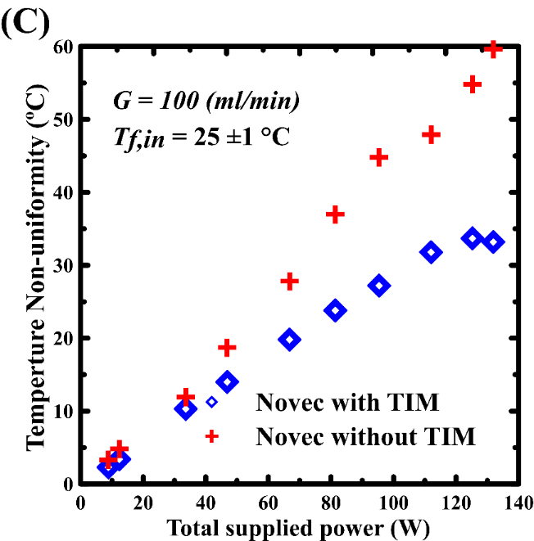
Fig. 12 Nonuniformity variation for heatsink with and without Thermal interface materials

Conclusions
Despite the huge number of experimental and mathematical studies of flow boiling in the open literature, several basic issues such as CHF and ONB are still not well understood, and this delays the move from the research in laboratory to industrial applications. In this study, the flow boiling was comprehensively studied for ethanol, acetone, and Novec-7000 as coolant. The effect of coolant inlet volumetric flow rate and supplied heat were comprehensively examined. The results showed that the wall superheat rises substantially with increasing heat flux in the experimental conditions. The total inlet volumetric flow rate showed a significant influence on the boiling flow. At the ver low values of the volumetric flow rate, the dry out happened. When the value of the volumetric flow rate was increased the saturated flow boiling occurred over the flow domain. Different cooling mechanisms in subcooled flow boiling heat transfer were observed. At the low total inlet volumetric flow rates, bubble nucleation existed, and the wall temperature was slightly higher than the saturation temperature for all coolants. Novec-7000 exhibited a highly effective heat transfer and low wall temperature due to the flow boiling. As the volumetric flow rate was increased, the single-phase flow started to dominate. Afterwards, the average wall temperature attained the saturation under single-phase flow condition. From the current results it is noticeable that the saturated flow boiling is an outstanding cooling technique and the boiling point of the coolant is a very important key parameter. Special attention must be paid to CHF, the geometrical parameters, heat transfer surface, and coolant characteristics. The local temperature contours revealed that a local dry out occurred in some regions. Involving the TIM enhanced the heat transfer process as the effective heat flux was increased in the case of acetone and Novec-7000, which attained q”eff improvement of 0.62% and 1.62%. Meanwhile, the TIM decreased the q”eff by 0.54% as ethanol has a high boiling temperature and the main function of TIM did not work in this case. The low boiling point of the coolant is a crucial factor when the TIM materials are involved in the flow boiling cooling. Moreover, the channel geometry has a considerable effect on the flow boling behavior.

Acknowledgments
Sincere gratitude and appreciation for the Egyptian Ministry of Higher Education (MOHE), EJUST University, and JICA for providing the opportunity and offering the financial support and computational tools for this manuscript. This work was supported by the Science and Technology Development Fund (Project ID: 33515).

References

[1] Bickley HD. Cooling of electronic equipment. Electron Power 1983;29:386. doi:10.1049/ep.1983.0178.
[2] Karayiannis TG, Mahmoud MM. Flow boiling in microchannels: Fundamentals and applications. Appl Therm Eng 2017;115:1372–97. doi:https://doi.org/10.1016/j.applthermaleng.2016.08.063.
[3] Zhang Y, Wang S, Ding P. Effects of channel shape on the cooling performance of hybrid micro-channel and slot-jet module. Int J Heat Mass Transf 2017;113:295–309. doi:https://doi.org/10.1016/j.ijheatmasstransfer.2017.05.092.
[4] Sidik NAC, Muhamad MNAW, Japar WMAA, Rasid ZA. An overview of passive techniques for heat transfer augmentation in microchannel heat sink. Int Commun Heat Mass Transf 2017. doi:10.1016/j.icheatmasstransfer.2017.08.009.
[5] Ling Z, Zhang Z, Shi G, Fang X, Wang L, Gao X, et al. Review on thermal management systems using phase change materials for electronic components, Li-ion batteries and photovoltaic modules. Renew Sustain Energy Rev 2014. doi:10.1016/j.rser.2013.12.017.
[6] Radwan A, Ookawara S, Mori S, Ahmed M. Uniform cooling for concentrator photovoltaic cells and electronic chips by forced convective boiling in 3D-printed monolithic double-layer microchannel heat sink. Energy Convers Manag 2018;166:356–71. doi:https://doi.org/10.1016/j.enconman.2018.04.037.
[7] Hosseinzadeh K, Alizadeh M, Tavakoli MH, Ganji DD. Investigation of phase change material solidification process in a LHTESS in the presence of fins with variable thickness and hybrid nanoparticles. Appl Therm Eng 2019. doi:10.1016/j.applthermaleng.2019.02.111.
[8] Erickson D, Li D. Integrated microfluidic devices. Anal Chim Acta 2004;507:11–26. doi:10.1016/j.aca.2003.09.019.
[9] Chen CH, Ding CY. Study on the thermal behavior and cooling performance of a nanofluid-cooled microchannel heat sink. Int J Therm Sci 2011. doi:10.1016/j.ijthermalsci.2010.04.020.
[10] Naqiuddin NH, Saw LH, Yew MC, Yusof F, Ng TC. Overview of micro-channel design for high heat fl ux application. Renew Sustain Energy Rev 2018;82:901–14. doi:10.1016/j.rser.2017.09.110.
[11] Khodabandeh E, Akbari OA, Toghraie D, Pour MS, Jönsson PG, Ersson M. Numerical investigation of thermal performance augmentation of nanofluid flow in microchannel heat sinks by using of novel nozzle structure: sinusoidal cavities and rectangular ribs. J Brazilian Soc Mech Sci Eng 2019;41:443. doi:10.1007/s40430-019-1952-z.
[12] Mudawar I, Anderson TM. Parametric investigation into the effects of pressure, subcooling, surface augmentation and choice of coolant on pool boiling in the design of cooling systems for high-power-density electronic chips. J Electron Packag Trans ASME 1990. doi:10.1115/1.2904392.
[13] Liang G, Mudawar I. Review of single-phase and two-phase nanofluid heat transfer in macro-channels and micro-channels. Int J Heat Mass Transf 2019;136:324–54. doi:https://doi.org/10.1016/j.ijheatmasstransfer.2019.02.086.
[14] Abo-Zahhad EM, Ookawara S, Radwan A, El-Shazly AH, ElKady MF. Thermal and structure analyses of high concentrator solar cell under confined jet impingement cooling. Energy Convers Manag 2018. doi:10.1016/j.enconman.2018.09.005.
[15] Kandlikar SG. Fundamental issues related to flow boiling in minichannels and microchannels. Exp Therm Fluid Sci 2002. doi:10.1016/S0894-1777(02)00150-4.
[16] Boure JA, Bergles AE, Tong LS. Review of two-phase flow instability. Nucl Eng Des 1973. doi:10.1016/0029-5493(73)90043-5.
[17] Thome JR. Boiling of new refrigerants: a state-of-the-art review. Int J Refrig 1996. doi:10.1016/s0140-7007(96)00004-7.
[18] Piasecka M, Maciejewska B. Heat transfer coefficient during flow boiling in a minichannel at variable spatial orientation. Exp Therm Fluid Sci 2015. doi:10.1016/j.expthermflusci.2015.05.005.
[19] Wang S, Gong MQ, Chen GF, Sun ZH, Wu JF. Two-phase heat transfer and pressure drop of propane during saturated flow boiling inside a horizontal tube. Int J Refrig 2014. doi:10.1016/j.ijrefrig.2013.03.019.
[20] Chu KH, Enright R, Wang EN. Microstructured surfaces for enhanced pool boiling heat transfer. ASME 2011 Int. Mech. Eng. Congr. Expo. IMECE 2011, 2011.
[21] Kumar V, Vikash, Nigam KDP. Multiphase fluid flow and heat transfer characteristics in microchannels. Chem Eng Sci 2017. doi:10.1016/j.ces.2017.01.018.
[22] Peng XF, Wang BX. Forced convection and flow boiling heat transfer for liquid flowing through microchannels. Int J Heat Mass Transf 1993;36:3421–7. doi:10.1016/0017-9310(93)90160-8.
[23] Fang X, Zhou Z, Wang H. Heat transfer correlation for saturated flow boiling of water. Appl Therm Eng 2015;76:147–56. doi:10.1016/j.applthermaleng.2014.11.024.
[24] BERGLES AE. Heat Transfer Enhancement—The Maturing of Second-Generation Heat Transfer Technology. Heat Transf Eng 1997;18:47–55. doi:10.1080/01457639708939889.
[25] Abadi GB, Moon C, Kim KC. Flow boiling visualization and heat transfer in metal-foam-filled mini tubes - Part I: Flow pattern map and experimental data. Int J Heat Mass Transf 2016;98:857–67. doi:10.1016/j.ijheatmasstransfer.2016.03.043.
[26] Diani A, Mancin S, Doretti L, Rossetto L. Low-GWP refrigerants flow boiling heat transfer in a 5 PPI copper foam. Int J Multiph Flow 2015;76:111–21. doi:10.1016/j.ijmultiphaseflow.2015.07.003.
[27] Wong KK, Leong KC. Nucleate flow boiling enhancement on engineered three-dimensional porous metallic structures in FC-72. Appl Therm Eng 2019;159:113846. doi:10.1016/j.applthermaleng.2019.113846.
[28] Fang C, David M, Rogacs A, Goodson K. Volume of Fluid Simulation of Boiling Two-Phase Flow in a Vapor-Venting Microchannel. Front Heat Mass Transf 2010;1. doi:10.5098/hmt.v1.1.3002.
[29] Zong L, Sun D, Xu J, Wang X. Numerical study of seed bubble-triggered evaporation heat transfer in a single microtube. Microfluid Nanofluidics 2014. doi:10.1007/s10404-013-1205-x.
[30] Sun D, Xu J, Chen Q. Modeling of the evaporation and condensation phase-change problems with FLUENT. Numer Heat Transf Part B Fundam 2014. doi:10.1080/10407790.2014.915681.
[31] Nabil M, Rattner AS. interThermalPhaseChangeFoam—A framework for two-phase flow simulations with thermally driven phase change. SoftwareX 2016. doi:10.1016/j.softx.2016.10.002.
[32] Lorenzini D, Joshi YK. Computational Fluid Dynamics Modeling of Flow Boiling in Microchannels With Nonuniform Heat Flux. J Heat Transfer 2018;140. doi:10.1115/1.4037343.
[33] Leela Vinodhan V, Rajan KS. Computational analysis of new microchannel heat sink configurations. Energy Convers Manag 2014;86:595–604. doi:10.1016/j.enconman.2014.06.038.
[34] Attaran M. The rise of 3-D printing: The advantages of additive manufacturing over traditional manufacturing. Bus Horiz 2017. doi:10.1016/j.bushor.2017.05.011.
[35] Radwan A, Ookawara S, Ahmed M. Thermal management of concentrator photovoltaic systems using two-phase flow boiling in double-layer microchannel heat sinks. Appl Energy 2019;241:404–19. doi:https://doi.org/10.1016/j.apenergy.2019.03.017.
[36] Ali R, Palm B, Martin-Callizo C, Maqbool MH. Study of flow boiling characteristics of a microchannel using high speed visualization. J Dyn Syst Meas Control Trans ASME 2013;135. doi:10.1115/1.4023879.
[37] Law M, Lee PS, Balasubramanian K. Experimental investigation of flow boiling heat transfer in novel oblique-finned microchannels. Int J Heat Mass Transf 2014;76:419–31. doi:10.1016/j.ijheatmasstransfer.2014.04.045.
[38] Radwan A, Ahmed M, Mori S, ookawara S. Uniform Cooling for Concentrator Photovoltaic Cells and Electronic Chips by Forced Convective Boiling in 3D-Printed Monolithic Double Layer Microchannel Heat Sink. Energy Convers Manag 2018. doi:10.1016/j.enconman.2018.04.037.

