G|A|M|E – n. 6/2017
Issue 6, 2017 – Hear the Music, Play the Game
Music and Game Design: Interplays and Perspectives
Edited by H. C. Rietveld & M. B. Carbone
https://www.gamejournal.it/game-n-62017/

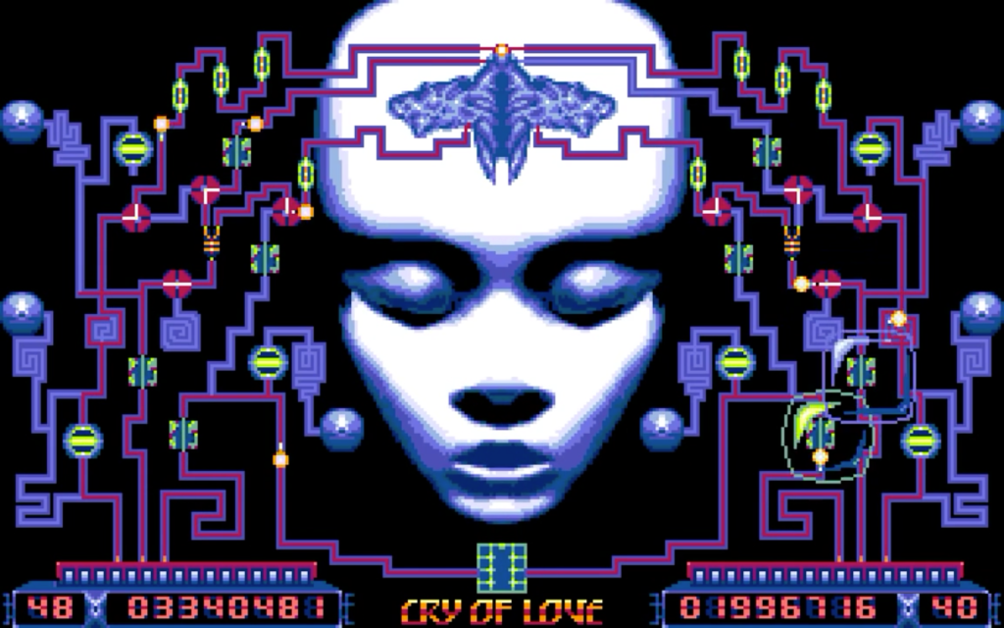
Cover Art: Extase – a music game designed by R. Herbulot; programmed by P. Dublanchet; graphics by M. Rho; head design by P. Ulrich; music by P. Eidel & A. Devos and the Bulgarian Voices, courtesy Virgin Musique; interactive music by S. Picq; Virgin Loisirs, France 1991.

Summary
Vol. 1 – Journal (peer-reviewed)
- H. C. Rietveld & M. B. Carbone – Introduction: Towards a Polyphonic Approach to Games and Music Studies
- R. Gallagher – “All the Other Players Want to Look at My Pad”: Grime, Gaming, and Digital Identity
- J. Newman – Driving the SID chip: Assembly Language, Composition, and Sound Design for the C64
- K. B. McAlpine – The Sound of 1-bit: Technical Constraint and Musical Creativity on the 48k Sinclair ZX Spectrum
- F. Peñate Domínguez – “Heute gehört uns die Galaxie” Music and Historical Credibility in Wolfenstein: The New Order’s Nazi Dystopia.

Vol. 2 – Critical notes (non-peer reviewed)
Playlist:
- K. Collins, Desert Island Diskettes: A Journey through Video Game Sound History
Article:
- Z. Hulme – Killing-off the Crossfade: Achieving Seamless Transitions with Imbricate Audio
- T. Langhorst –The Sound of a Serve Toss: An Informational View on the Gameworld Interface as Sonic Interface Design
Book Reviews:
- M. Austin – T. Summers (2016). Understanding Video Game Music. Cambridge: Cambridge University Press.
- H. C. Rietveld – M. Kamp, T. Summers & M. Sweeney (Eds) (2016). Ludomusicology: Approaches to Video Game Music. Bristol CT and Sheffield: Equinox Publishing; & M. Austin (Ed) (2016). Music Video Games: Performance, Politics and Play, London and New York: Bloomsbury.
Interviews:
- An interview with Mark Sweeney: The Ludomusicology Research Group.

