Biological Basis to Child Health: The Liver

Sam Archer RN (Child) BN (Hons)
Paediatric Site Practitioner
(Trainee Advanced Nurse Practitioner)
Child Health
King’s College Hospital Foundation Trust
London

Kate Davies RN (Child), Dip HE, BSc (Hons), MSc, PGCert, PGDip
Children’s Advanced Nurse Practitioner
Senior Lecturer in Non Medical Prescribing
London South Bank University

Abstract
This article follows on from the previous article which focused on the gastrointestinal system. The liver is the largest solid organ in the body, and sits under the ribs on the right side of the body, and has over 500 functions, including playing a role in digestion, combating infections, breaking down food and turning it into energy, and neutralising and destroying drugs and toxins. This article will enable the reader to have a richer understanding of the development and anatomy and physiology of the liver, and relate it to childhood liver disease.

Aims and intended learning outcomes

The aim of this article is to develop the readers understanding of liver disease in children and young people. After reading this article and completing the timeout activities the reader shall be able to;

- Outline the of gross and cellular liver anatomy.
- Summarise the embryological growth of the liver.
- Briefly explain the main functions of the liver.
- Summarise why liver dysfunction associated with more common diseases present as they do.
- Outline debates and developments associated with paediatric liver transplantation.

Liver disease in the UK

Every week, 20 children in the United Kingdom are diagnosed with a childhood liver condition. There are over 100 different liver conditions, the cause of which are mostly unknown (Childhood Liver Disease Foundation 2018). The centralization of Liver services for children have been focused at three tertiary centres within the UK since 1999; London’s Kings College Hospital, Birmingham Children’s Hospital and Leeds Children’s Hospital. This strategy was developed after the publication of a report focusing on the surgical care of infants with biliary atresia (Guy and Lynn 1996 and McKiernan et al 2000). They found that the 5-year survival was significantly higher in centres that performed more than 5 cases a year. They also advised that these children were better cared for in centres that were also paediatric liver transplant centres that offered paediatric intensive care.

TIMEOUT 1

How would you describe your knowledge of liver disease at this point? Why do you think it is important that nurses from a wider range of healthcare centres need some knowledge of paediatric liver disease?

Embryology

Around day 21, the liver begins to form once the gut tube grows. The gut tube forms when the yolk sac is pulled into the embryo and pinched off as the flat germ layers fold laterally and cephalocaudally (head to tail). From this tube, buds develop along its length which will eventually form organs (Moore 2003).

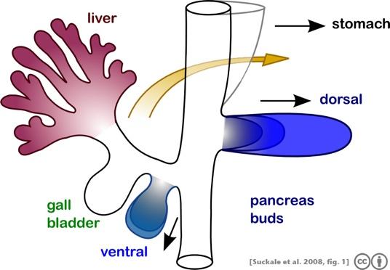

Figure 1: Liver embryology

All of the primitive foregut has the potential to express liver specific genes and to become liver tissues, but this expression is blocked by factors produced by surrounding tissues. However, primitive cardiac cells produce an inhibitor to these factors, allowing gut cells in the liver region to express liver specific genes (Sadler 2006). The liver bud grows rapidly during Week 4 (Webster and Wreede 2012).

By Week 10, the liver accounts for about 10% of the embryo’s weight, which reduces to around 5% at birth, although the weight itself is quite small (see figure 2) even late in gestation.

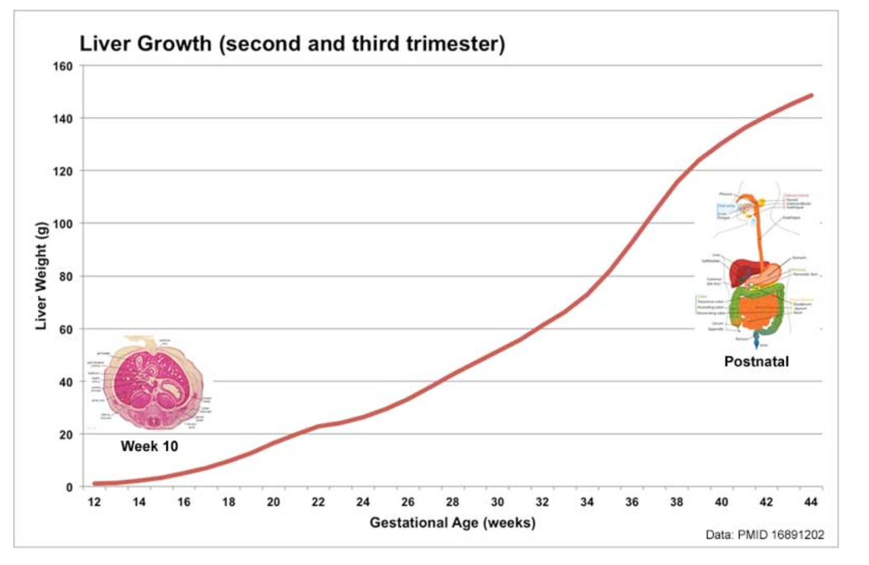

Figure 2: Liver growth during second and third trimesters (Archie et al, 2006)

The main embryological function of the liver is haematopoiesis, or the production of both red and white blood cells. (Webster and Wreede, 2012) By the 12th Week, bile is formed by hepatic cells, and as by then the gallbladder and bile duct have also formed, bile begins to enter the gut, giving its contents (meconium) its characteristic dark colouring. During the foetal period, the liver begins to actively synthesise and store glycogen for use in the neonatal period. It also begins to develop the system of enzymes involved in the metabolism of urea from protein breakdown. By birth, these enzymes have reached full function (Carlson 2009).

Anatomy of the Liver

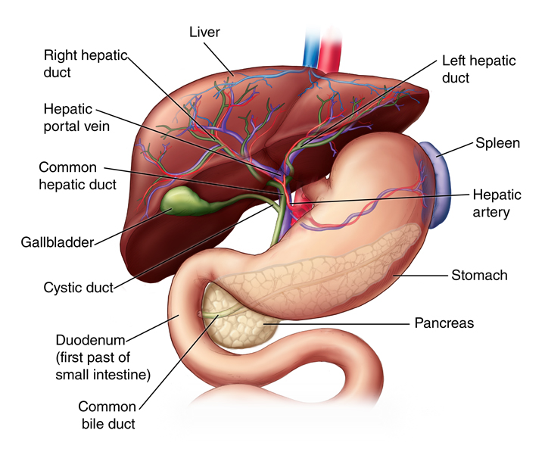

Figure 3: Anatomy of the Liver (to be redrawn)
The liver is the largest solid organ in the body comprised of two major lobes, the right being six times larger than the left, these, in turn, are divided into 8 segments. As figure 3 shows, the liver shares a similarity with the heart in that they are the only organs in the body that have a dual blood supply, both arterial and venous. The hepatic artery delivers 20% of the liver’s blood flow, with the remainder 80% coming from the hepatic portal vein (Peate and Gormley-Fleming, 2015). The liver is continuously making bile, and then stored in the gallbladder, which is a small, green, muscular sac that lies posterior to the liver. The mucosa contains folds that allow it to stretch in order to accommodate varying volumes of bile. (See article on Gastrointestinal System)

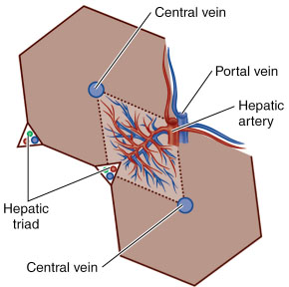

Figure 4: Hepatocytes

Hepatocytes are the liver’s parenchymal cells which make up approximately 60% of the liver, as shown in figure 4. They are hexagonal in shape and each point has a hepatic triad. The triads may be thought of as transit points, where blood and bile are kept in intimate contact with the paraenchymal cells. The triad consists of a bile duct, a portal venule and hepatic arteriole. The liver acinus is a volume of liver between a hepatic triad and the central hepatic venule, it has a diamond-like shape. As blood flows towards the central venule, the bile produced by the hepatocyte as a metabolic by-product moves in the opposite direction towards the bile duct. The acinus is divided into 3 zones, 1 closest to the triad, 3 closest to the venule and zone 2 is the portion between them. Zone 3 is the more susceptible to injury when the liver becomes damaged (Hill 2009, Outerridge 2015 and McErlean 2017). A child’s liver fully develops and reaches adult function at around 2 years of age (Beath 2003).

TIMEOUT 2

Pause for a moment to ponder the significance of; a) the large size of the liver and b), its widely disseminated functioning parenchymal cells with their own blood supply and bile outlet. What do you think the significance of this might be as regards describing the liver’s ability to sustain insult, disease or injury? In short, what might be the advantage of the liver’s anatomy?
Functions of the liver

Bile production

Bile is produced by the liver as both a transport solution for waste products and to aid in the digestion of dietary fats. Bile is stored in the gallbladder during periods of fasting, for example between meals and overnight, and is expelled into the duodenum after a meal. Bile emulsifies large lipid globules into a suspension of small lipid globules enhancing fat absorption in the bowel (Tortora and Derrickson 2014). If bile is not released, then enzymes from the pancreas can only work on the surface of the large globules, leading to not enough lipids being absorbed, resulting in the child not being able to gain weight properly, and not being able to absorb fat soluble vitamins (Peate and Gormley-Fleming, 2015).

Glucose control

The liver has a major role in generating glucose to be used as energy in cell metabolism. Excessive carbohydrates consumed in the diet are stored within the liver as glycogen, as storing glucose in a cell would dramatically alter the intracellular osmotic pressure leading to problems related to fluid balance both in and outside of the cell. Glycogen is readily converted into glucose for use during sudden strenuous activity, however, glycogen stores in the liver can become rapidly depleted if in constant use. Infants and children have higher metabolic rates, as a result of continuous growth, than adults, therefore have a higher demand for glucose. Hence why during times of liver dysfunction, hypoglycaemia is an early sign of disease (Han et al 2016). The pathophysiology of hypoglycemia in liver disease differs from that often seen in the neonatal period. Hypoglycemia is a common reason for admission to the neonatal unit, however this is due to a failure in the neonate’s adjustment to extra-uterine life. While in utero, the foetus is delivered a continuous supply of glucose from the placenta, however once the umbilical cord is cut, the infant then should decrease their insulin production to balance this new low-glucose state. If this system doesn’t occur normally, then the infant will become hypoglycaemic (Harding et al 2017). This differs from liver disease as neonates do not have an issue with glycose synthesis. (More is found on glucose control in the Biological Basis to Child Health: The Endocrine System)

Production of coagulation factors

The liver is the site of synthesis of almost all coagulation factors. The hepatocytes are involved in the synthesis of fibrinogen, prothrombin, factor V, VII, IX, X, XI, XII and antithrombin, whereas liver sinusoidal endothelial cells produce factor XIII and von Willebrand factor (Heinz and Braspenning 2014). These factors are necessary at every stage in the clotting cascade to form a clot and prevent further haemorrhage. Bleeding episodes in liver disease range from bruising and gum bleeding to life-threatening variceal bleeds. Liver disease also causes splenomegaly, associated with portal hypertension, contributing to platelet dysfunction which would usually trigger the coagulation cascade (Wicklund 2011 and Jairath 2015). Vitamin K is a key micronutrient required to synethesis clotting factors. In children with liver disease, they have chronic issues with nutritional malabsorption, resulting in a Vitamin K deficiency, therefore resulting in a coagulopathy with associated bruising and bleeding. This is worsened by the issue that the body has a limited capacity to store Vitamin K and these children are also treated with laxatives such as lactulose to manage developing encephalopathy, which will be discussed later, as lactulose reduces the intestinal bacteria from producing Vitamin K (Yang et al 2017). Neonates, specifically, are at risk of Vitamin K deficiency, due to inadequate prenatal storage, deficiency of Vitamin K in breastmilk (Ng, 2018) and also insufficient placental transfer (Sankar et al, 2016).
TIME OUT 3
Newborns in the UK are offered an injection of Vitamin K shortly after birth (NHS, 2019) in order to prevent Haemorrhagic Disease of the Newborn (HDNB), although there are some parents who refuse the injection for various reasons (Loyal, 2019). Discuss this with a colleague, and design a leaflet that could be distributed to expectant mothers in order to outline the benefits of Vitamin K.

Detoxification

As well as metabolising drugs, the liver also converts harmful waste products from metabolism and converts them into benign substances for either reabsorption or excretion from the body. In cirrhosis, the decreased functioning hepatocyte mass reduces detoxification and allows for a build-up of toxic metabolites, for example, bilirubin from the break down of red blood cells in the neonatal liver and ammonia from the digestion of dietary protein (Clayton 2009 and Walsh et al 2010). Other functions can be seen in Table 1:

Nutrition, growth and repair | Elimination
Metabolism of carbohydrates  Metabolism of lipids  Metabolism of proteins  Protein storage  Synthesis of bile salts  Storage of vitamins and minerals  Activation of Vitamin D  Iron storage  Clotting factors synthesis  Blood storage | Detoxification  Formation of Urea  Drug degradation, ie metabolism  Steroid catabolism  Hormone metabolism  Breakdown and excretion of red blood cells

Table 1: Functions of the Liver (Peate and Gormley-Fleming, 2015)

Understanding Liver Function Tests
Most children with abnormal liver function tests – ‘LFTs’ – are seen in children who are hospitalized: febrile illnesses, for example, caused by either bacterial or viral infection, is often accompanied by some type of liver dysfunction. It is important for the children’s nurse to have an understanding of the major tests for liver function (see Table 2)

Test | Normal Range | Description
Albumin | 35 – 50 g/L  <4 weeks: 25 – 45 g/L  4 weeks – 1 year: 30 – 45 g/L  1 – 16 years: 35 – 50 g/L | - The most important plasma protein  - Synthesis regulated by nutritional status and osmotic pressure  - Decreased in liver damage  - Can give false low values in nutritional deficient patient
ALT (Alanine aminotransferase) | 10 – 50 IU/L  0 – 12 months: 0 – 41 IU/L  1 – 2 years: 0 – 28 IU/L  3 – 6 years: 0 – 29 IU/L | - Cytoplasmic enzyme  - Found most commonly in hepatocytes  - Often raised in trauma, drug toxicity and viral hepatitis
Alkaline phosphatase | 25 – 115 IU/L  Neonate: 73- 391 IU/L  Infant: 59 – 425 IU/L  1 – 14 years: 76 – 308 IU/L  14 – 16 years: 49 – 242 IU/L | - Enzyme  - Most made in liver and bone (check Ca)  - Also found in kidney (check U&E) and the placenta (check age and gender)  - Postpubery, ALP is mostly liver in origin  - Increased in biliary tree dramage eg gallstones
Amylase | < 220 U/L | - Enzyme  - Raised in pancreatitis and pancreatic tumours
AST (Aspartate aminotransferase) | 10 – 40 IU/L  Neonate: 18 – 92 IU/L  Child: 8 – 60 IU/L | - In cytosol and mitochondria of cells  - Distributes to cardiac muscle, skeletal muscle, kidney, brain, pancreas, lung, leukocyte and erythrocytes  - Often raised in trauma, acute alcohol hepatitis and liver failure
Bilirubin | < 17 µmol/L  14 days – 16 years: < 21 µmol/L  (conjugated < 2 µmol/L) | - Marker of the ‘plumbing’ of the liver  - Increased in jaundice, usually due to pre, actual or post hepatic blockage
GGT (Gamma glutamyl transpeptidase) | 9 – 40 IU/L | - Enzyme  - On the cell membrane of hepatocyte and bile duct cell  - Raised following alcohol intake

Table 2: Liver function tests in Children (Kang, 2013; Basten, 2014; RCPCH, 2016)

Liver disease in children

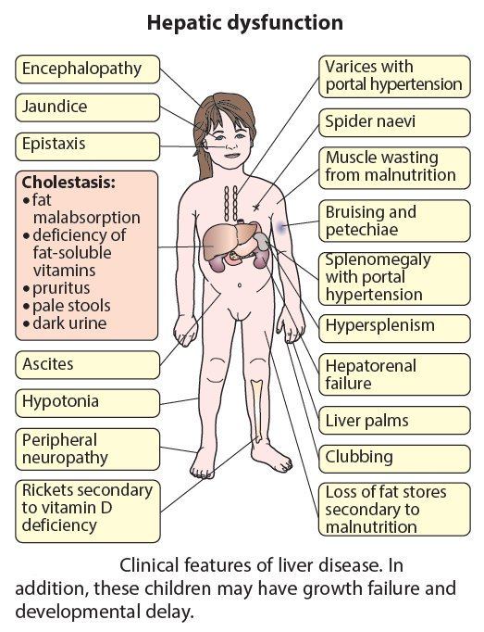

Figure 5: Hepatic Dysfunction in Children (Lissauer and Clayden, 2012)

Jaundice

Jaundice is the sign of liver disease most recognisable by nurses of all levels of experience (Santos Silva et al 2017). Bilirubin is a bile pigment produced by the breakdown of haemoglobin and gives patients with liver dysfunction the characteristic yellowing of the skin and eye sclera, usually only visible once the bilirubin has exceeded 50μmol/L. There are three forms of jaundice:

- Pre-hepatic
- Intra-hepatic
- Post-hepatic.
Unconjugated bilirubin, the direct by-product of haem break-down, is not water soluble and as a result is transported around the body attached to albumin proteins, unable to be excreted by the body and allowing it to cause damage. Most notably is Kernicterus, which is the avoidable brain damage caused by a toxic level of unconjugated bilirubin in the blood crossing the blood-brain-barrier (Boskabadi et al 2020). This is pre-hepatic jaundice and most usually seen during a time of extreme haemolysis, such as when neonates are converting from foetal to adult haemoglobin or in children with Crigler-Najjar syndrome, where they lack the key enzyme in their liver needed to conjugate bilirubin.

Around 50% of term infants and 80% of preterm infants will be affected by neonatal jaundice, this is compounded by dehydration experienced early in life as a result of limited fluid intake, colloquially referred to as ‘breastfeeding jaundice’. It usually appears on day 2-4 and self resolves by day 7-10. Both groups of patients may require phototherapy or exchange transfusions if the unconjugated bilirubin is too high, to avoid developing Kernicterus. Children with Crigler-Najjar syndrome (an inherited condition that affects the metabolism of bilirubin) require it life-long or until transplanted (Bortolussi, 2018) Phototherapy is the most commonly used therapy, involving placing the infant under blue/green lights maximally exposed with protective masks over their eyes. The light omitted by the phototherapy acts on the subcutaneous bilirubin and alters its form to a structure that is easily excreted (Ebbesen et al 2017). Once the liver has conjugated the bilirubin, it is no longer toxic and is water soluble and can be excreted in the bile, giving both bile, and stool, their characteristic colour.

Intra-hepatic jaundice is more common in liver disease. It is a result of hepatitis or inflammation of liver cells when the hepatocytes are less able to transport bilirubin from the blood into bile for excretion. As this bilirubin is conjugated, it does not pose the same damaging effects. Post-hepatic or cholestatic jaundice is when there is a biliary obstruction, reducing or preventing the flow of bile from the liver into the bowel, such as in biliary atresia or gall stones (Clayton 2009).

Biliary Atresia

Biliary atresia is a rare condition affecting the bile ducts and the flow of bile from the liver. It occurs in 1 in every 17,000 births and more prevalent in Caucasian infants. It is a congenital condition where the bile duct is blocked or damaged and as a result, bile cannot leave the liver, causing progressive damage. Without intervention, it is a life-threatening condition presenting in the first few weeks of life with characteristically pale stools and dark urine as no bile is reaching the bowel therefore the body tries to excrete bilirubin in through the kidneys. These infants are also usually small for age due to their reduced absorption of dietary fats. Infants diagnosed with biliary atresia will require a Kasai hepatoportoenterostomy before 10 weeks of age, a procedure where the biliary tree is removed and the bowel connected directly to the liver to aid bile flow. Even after corrective surgery, two thirds of these children will require liver transplantation at some point in their lifetime (Tyraskis et al 2018).

Pruritus
TIMEOUT 4

Imagine that you are a staff nurse in a children’s Emergency Department. You are assessing a 4 day old infant who is visibly jaundiced. The student nurse you are working with asks you why the baby has yellow sclera of their eyes. How would you explain this to them?

Pruritus has a significant impact on the quality of life of children with chronic liver diease. It can extremely disabling, can cause sleep disturbance and even suicidal ideation (Van Vaisberg et al 2019). Around 65% of patients with cholestatic liver disease, where their bile does not flow as it should, suffer from chronic pruritus, usually worse at night time affecting sleep (Bhalerao and Mannu, 2015). The exact aetiology is unknown however it may be due to increased bile salt deposits and endogenous opioid accumulation due to reduced clearance by the liver and central neurotransmission and peripherally acting pruritogens such as bile acids. Therefore, therapy is focussed on encouraging bile flow and reducing opioid effects, for example administering naloxone. This symptom can have a significant impact on the child’s quality of life and is recognised as an appropriate indication for transplantation without other liver decompensation (Jin and Khan 2016).

Progressive Familial Intrahepatic Cholestasis (PFIC) is one such condition where pruritus causes significant distress. PFIC is a rare genetic disease, around 1:50-100,000, that disrupts the ability of the hepatocyte to transport bile salts to the biliary ducts, causing a collection of bile within the liver (Erginel et al 2018).

Ascites

Of all the symptoms of liver disease, the pathophysiology of ascites is probably the most complex: the mechanism is responsible for the characteristic accumulation of fluid in the peritoneal cavity but also for the development of hepato-pulmonary and hepato-renal syndromes. Main contributing factors will include sodium retention, renal impairment and fluid redistribution, and hypoalbuminaemia. Treatment is with diuretics, sodium and fluid restriction (Lissauer and Clayden, 2012.)

In a healthy liver, endothelial cells that line the blood vessels constantly produce vasoactive mediators. Endothelin causes vasoconstriction and nitric oxide causes vasodilation. When the liver is diseased or in dysfunction, hepatocytes atrophy and the liver shrinks, endothelin production also increases, impairing blood delivery to the liver is impaired, leading to portal hypertension (Sen Sarma et al 2015). Due to this increased vasodilation, nitric oxide is produced in excess resulting in vasodilation of the vessels around the spleen. This abdominal vasodilation shifts blood away from the kidneys, who are very dependant on an adequate perfusion pressure. Therefore, the kidneys activate the Renin-Angiotensin-Aldosterone system, to improve the kidneys blood pressure. It does this by retaining water and sodium. However, vasodilation plus an increased blood volume causes the retained water to leak out of the vascular system and into the lymphatic system. When that water exceeds the body’s lymphatic draining capacity, it leaks into the peritoneal cavity (Fullwood and Purushothaman 2014).

As a result of this complex system, gross, or large, ascites does not present in patients with acute liver failure and is more common in patients with chronic liver failure. Such patients are those with Alagille’s syndrome, an autosomal dominant disease affecting the liver, heart, eyes, skeleton and facial features. It is diagnosed by a paucity of intrahepatic bile ducts and ‘butterfly’ vertebrae on X-ray. They also present with characteristic ‘Pixie’ facial features (Pati et al 2016).

Hepatic encephalopathy

Disorientation and confusion are common symptoms of both acute and chronic liver disease. Hepatic encephalopathy is a reversible reduction in cognitive function directly as a result of liver disease. While the exact pathophysiology is yet to be defined, hyperammonaemia is a popular theory. Ammonia is produced in the digestive tract by the bacterial degradation of amines, amino acids, purines and urea, or protein in short. The healthy liver usually converts ammonia to urea for easy excretion via the kidneys, however, this function is impaired in a diseased liver. Ammonia has numerous neurotoxic effects, it alters the transit of water and ions across the cell membrane of astrocytes leading to cerebral oedema (Walsh et al 2010).

Hepatic encephalopathy is sometimes difficult to assess in children as behavioural issues can sometimes present in similar ways, similarly, assessment of infants is also very difficult due to being non-verbal, therefore subtler clues are looked for. For example, excessive sleeping, reluctance to feed and irritability. The West Haven criteria (see Box 2) is routinely used to grade encephalopathy in order to escalate treatment, as once a patient develops Grade 2-3, there are at risk of losing the safety of their airway and therefore require intubation (Arya et al 2012).

Grade 1
Trivial lack of awareness, shortened attention span, sleep disturbance, altered mood, and slowing the ability to perform mental tasks. Asterixis (a mild tremor in the hands when the arms are outstretched) can be detected.
Grade 2
Lethargy or apathy, disorientation to time, amnesia of recent events, impaired simple computations, inappropriate behavior, slurred speech. Asterixis is present.
Grade 3
Somnolence (drowsiness), confusion, disorientation to place, bizarre behavior, clonus (involuntary rhythmic muscle contractions), nystagmus (involuntary movements of the eyes), and positive Babinski sign (when the sole of the foot is firmly stroked, the toes should curl down, a positive Babinski sign is when they move upwards). Asterixis usually absent.
Grade 4
Coma with or without response to painful stimuli.

Box 2: West Haven Criteria (Dharel and Bhajaj, 2015)

Wilson’s disease usually presents during adolescence with jaundice and a degree of encephalopathy. It is an autosomal recessive disorder characterised by a defect in hepatic copper excretion, leading to an accumulation over time that takes years to result in any liver dysfunction, hence why it is a common cause of acute liver failure in young people (Emmanuel and Inns 2011).

Portal hypertension

Portal hypertension is a common symptom in children with chronic liver failure. As the hepatocytes die, the liver becomes increasingly scarred. A healthy liver is soft and spongey, easily increasing in size to accommodate the volume of blood delivered in each heartbeat, a cirrhotic liver is not, it is stiff. Therefore, this causes congestion in the portal circulation system, resulting in the development of oesophageal and gastric varices, comparable to varicose veins often seen in legs. Portal hypertension with variceal bleeding is a major cause of morbidity and mortality for both adults and children with end-stage liver failure. A rupture of a varix, singular of varices, with the associated large volume of hematemesis, vomiting of blood, can be quite shocking for the child and family but also for the medical teams caring for these children if they are unfamiliar caring for children and young people with liver disease. In the acute phase a bleed can present as hematemesis, or a large vomit of fresh/clotted blood, or melena, passing fresh/old/black blood in the stool. This is a medical emergency and requires a complete systematic assessment and management. Fluid resuscitation is sometimes required until the child is stable enough to be transferred to a tertiary service with experienced gastroenterologists/hepatologists who can perform an endoscopy to band or inject the remaining varices. In some cases, the use of a Sengstaken tube, shown in Figure 6 and 7, is required to stem the bleeding, which is a large tube inserted orally with a balloon on the end and when traction is applied, it can tamponade (apply pressure to) gastric varices. Intubation and ventilation are required in this instance (Heathcote et al 2012), and it can be a life saving intervention in children, although it should be seen as temporary, with vascular shunt and liver transplantation procedures seen as definitive management (Jayakumar et al, 2015).
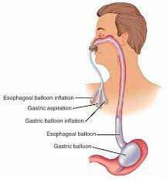

Figure 6: Sengstaken tube insertion (to be redrawn as a child)
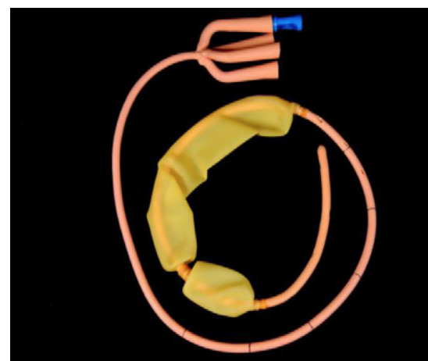
Figure 7: Sengstaken tube (Jayakumar et al, 2015)
Autoimmune liver disease is more prevalent in young people than children, in particular young women. This is characterized as an unresolving inflammation of the liver without a known cause. Diagnosis is usually made after eliminating other possible causes and diseases and is managed with immunosuppressant drugs and steroids to reduce the inflammation. Autoimmune liver disease can present as both acute and chronic liver failure (Czyoa 2015).
Poor nutritional status
Malabsorption and maldigestion of gastrointestinal nutrients frequently exist in patients with liver disease. As mentioned earlier, patients with cholestasis or reduction in bile flow into the bowel are more at risk of malnutrition as their fat absorption is greatly impaired. This poor fat absorption presents with steatorrhoea or loose, pale, floating stool with an offensive smell. Coupled with this is the poor absorption of fat-soluble vitamins, Vitamins A, D, E and K. So while the child may present with faltering growth, evidence of radiological Rickets from poor Vitamin D levels is not uncommon. Vitamin K is also vital for the synthesis of coagulation factors, so a child may be coagulopathic as a result of low Vitamin K coupled with liver dysfunction (Hamlin and Leaper 2009).
Alpha-1-antitrypsin deficiency is the lack of a protein that inhibits neutrophil elastase, which disrupts connective tissue. So without this protein, damage is caused in both the lungs, which presents between 30-50 years as emphysema, and the liver as the abnormal Alpha-1-antitrypsin accumulates in the liver causing damage. Transplantation may be required before significant lung injury develops (Hazari et al 2017).
Coagulopathy
Any dysfunction in the liver’s normal synthesis of coagulation factors, coupled with the reduction of Vit K absorbed from the diet, can result in a derangement of a child’s clotting ability (Jairath 2015). This is one of the red flags that alert medical professionals to the possibility that a child has liver disease. This is particularly indicative in children in acute liver failure as they may not have yet developed visible jaundice or noticeable encephalopathy. Acute liver failure can present with a dysfunction of any of the above-mentioned functions and any of the above-mentioned signs and symptoms. The definition of acute liver failure is the interval between the onset of jaundice and the development of encephalopathy between 8-28 days (Ratansi 2009).
The UK has some of the highest rates of paracetamol overdoses in Europe (Mayor, 2015). Due to the differences in drug metabolism between adults and children, toxic liver damage occurs much less frequently in children than it does in adults. This is because children metabolise paracetamol via the sulfation pathway as opposed to glucuronidation like adults, resulting in reduced toxic metabolites. They also have a great capacity to metabolise glutathione that adults and therefore are able to inactivate toxic metabolites more efficiently than adults (Tong et al 2017). Though 150mg/kg doses are considered hepatoxic, studies have shown that neither dose nor paracetamol level was a reliable predictor of outcome. A delayed presentation was one of the risk factors associated with hepatocellular damage, as was the grade of encephalopathy. While treatment with n-acetylcysteine, or the antidote for paracetamol, may be sufficient, liver transplantation for paracetamol overdose is a therapeutic option (Yoon et al, 2016)
Transplantation
Liver transplantation remains the only definitive treatment for end stage liver disease thanks to the improvements made in vascular surgery and immunosuppressive medications. The main indication for transplantation remains biliary atresia, followed by inborn errors of metabolism (Martin and Ong 2017). As well as acute or chronic end stage liver failure and some hepatic malignancies, other indications for transplantation in chronic failure include severe malnutrition which is not responding to intensive nutritional therapy, recurrent complications such as resistant ascites, failure of development and growth, and also poor quality of life (Lissaur and Clayden, 2012). Other indications are seen in Figure 8.
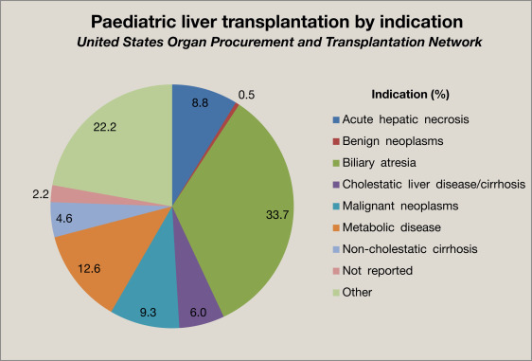
Figure 8: Liver transplants by indication in children (Martin and Ong, 2017)
Living related liver transplants were first performed in 1991 and has since provided an alternative for transplants from the limited deceased donor pool. Utilizing living related transplants, instead of relying solely on cadaveric donations, reduces the waiting times for some children, and therefore improves mortality. It also offers recipients better quality grafts from carefully screened donors. The survival of the 46 children transplanted in one major transplant centre was 95.7% at 5 years. Children being added to the waiting list increases year by year while donations remain static, the ability to offer living related transplants to children cuts waiting times significantly (Dattani et al 2014).
TIMEOUT 5

Liver disease in children may be associated with excess bleeding, jaundice and pruritus. Each of these signs and symptoms are distressing or even alarming for the parent. What essential explanation would you share about the function of the liver that might help a parent understand what is happening? Discuss with a colleague, and visit the support group website www.childliverdisease.org for further information

Conclusion
Paediatric liver disease is both a complex and varied area of nursing requiring a great deal of knowledge of both pathophysiology and the related symptoms. While most of these conditions are rare, it is important that the children's nurse is capable of identifying some of the key signs of liver disease and have the courage to communicate these to guide the multidisciplinary team towards a diagnosis. Knowledge of both the anatomy and physiology of the liver is key for every day practice within children’s nursing.

References
Archie, J. G., Collins, J. S. and Lebel, R. R. (20060 Quantitative Standards for Fetal and Neonatal Autopsy, American Journal of Clinical Pathology, Volume 126, Issue 2, August,, Pages 256–265, https://doi.org/10.1309/FK9D5WBA1UEPT5BB

Arya R, Gulati S and Deopujari S (2012) Management of hepatic encephalopathy in children. Postgraduate Medicine. 86, 34-41.
Basten, G. (2014) Blood Results in Clinical Practice M&K Publishing, Keswick
Beath, S.V. (2003) Hepatic function and physiology in the newborn. Seminars in fetal and neonatal medicine. 8 (5), pp 337-346.
Bhalerao, A. and Mannu, G. S. (2015) Management of pruritis in chronic liver disease Dermatol Res Prac March 10 pp.1 - 5
Bortolussi, G. & Muro, A. (2018) Advances in understanding disease mechanisms and potential treatments for Crigler–Najjar syndrome, Expert Opinion on Orphan Drugs, 6:7, 425-439, DOI: 10.1080/21678707.2018.1495558

Boskabadi, H., Sezavar, M. and Zakerihamidi, M. (2020) Evaluation of neonatal jaundice based on the severity of hyperbilirubinaemia. Journal of Clinical Neonatology. 9, 1, pp 46-51.
Carlson B M (2009) Human Embryology and Developmental Biology. Mosby Elsevier, Philadelphia.
Childhood Liver Disease Foundation (2018) About Us. Available at https://childliverdisease.org/about-us/ Accessed on 12/08/2018.

Clayton M (2009) Jaundice in Sargent. S. (Ed) Liver Disease: An essential guide for nurses and healthcare professionals. Wiley-Blackwell, Chichester, 32-43.

Czoya A J (2015) Autoimmune Hepatitis: diagnosis in McNally P R (Ed) GI/Liver Secrets Plus. Fifth edition. Elsevier Saunders, Philadelphia. 121-132.

Dattani N, Baker A, Quaglia A, Melendez H V, Rela M and Heaton N (2014) Clinical and histological outcomes following living-related liver transplantation in children. Clinics and Research in Hepatology and Gastroenterology. 38, 2, 164-171.

Davenport M, Ong E, Sharif K, Alizai N, McClean P, Hadzic N and Kelly D A (2011) Biliary atresia in England and Wales: results of centralization and new benchmark. Journal of Pediatric Surgery. 46, 9, 1689-1694

Dharel, N. and Bhajaj, J. S. (2015) Definition and nomenclature of hepatic encephalopathy Journal of Clinical and Experimental Hepatology 5 No. S1 S.37 – S.41

Ebbesen F, Hansen T W R and Maisels M J (2017) Update on phototherapy in jaundiced neonates. Current Pediatric Reviews. 13, 3, 176-180.
Emmanuel A and Inns S (2011) Gastroenterology and Hepatology. Wiley Blackwell, Oxford.

Erginel B, Soysal F G, Durmaz O, Celik A and Salman T (2018) Long term outcomes of six patients after partial internal biliary diversion for progressive familial intrahepatic cholestasis. Journal of Pediatric Surgery. 53, 3, 468-471.

Fullwood D and Purushothaman A (2014) Managing ascites in patients with chronic liver disease. Nursing Standard. 28, 23, 51-58.

Guy, M. and Lynn, R. (Eds.) (1996) British Paediatric Surveillance Unit 10th Annual Report 1995–1996. Royal College of Paediatrics and Child Health. Available from: https://www.rcpch.ac.uk/sites/default/files/2018-06/10th_annual_report.pdf [Accessed 28 April 2020].

Hamlin S and Leaper J (2009) Nutrition in liver disease in Sargent. S. (Ed) Liver Disease: An essential guide for nurses and healthcare professionals. Wiley-Blackwell, Chichester. 234-255.

Han H, Kang G, Kin J S, Choi B H and Koo S (2016) Regulation of glucose metabolism from and liver-centric perspective. Experimental and Molecular Medicine. 48, 3, e218.

Harding, J.E., Harris, D.L., Hegarty, J.E., Alsweiler, J.M. and McKinlay, C.J.D. (2017) An emerging evidence base for the management of neonatal hypoglycemia. Early human development. 104, pp 51-56.

Hazari Y M, Bashir A, Habib M, Bashir S, Habib H, Qasim M A, Shah N N, Haq E, Teckman J and Fazili K M (2017) Alpha-1-antitrypsin deficiency: Genetic variations, clinical manifestations and therapeutic interventions. Mutation Research. 773, 14-25.
Heathcote E J, Ling S and Kamath B M (2012) Management of complications of portal hypertension in adults and children: variceal haemorrhage in Heathcote E J (Ed) Hepatology Diagnosis and Clinical Management. Wiley Blackwell, Chichester. 63-79.

Heinz S., Braspenning J. (2015) Measurement of Blood Coagulation Factor Synthesis in Cultures of Human Hepatocytes. In: Vinken M., Rogiers V. (eds) Protocols in In Vitro Hepatocyte Research. Methods in Molecular Biology (Methods and Protocols), vol 1250. Humana Press, New York.

Hill C. (2009) Anatomy and Physiology in Sargent. S. (Ed) Liver Disease: An essential guide for nurses and healthcare professionals. Wiley-Blackwell, Chichester, 1-14.

Jairath V (2015) Coagulopathy and bleeding in liver disease. Medicine. 43, 11, 664-665.

Jayakumar, S., Odulaja, A., Patel, S., Davenport, M. and Ade-Ajayi, N. (2015) Surviving Sangstaken Journal of Pediatric Surgery 50 1142 - 1146

Jin X Y and Khan T M (2016) Quality of life among patients suffering from cholestatic liver disease-induced pruritus: a systematic review. Journal of the Formason Medical Association. 115, 9, 689-702.

Kang, K. S. (2013) Abnormality on Liver Function Test Pediatric Gastrenterology, Hepatology & Nutrition 16 (4) pp. 225 - 232

Lissauer, T. and Clayden, G. Liver Disorders in Illustrated Textbook of Paediatrics: 4th Edition Mosby-Elsevier Edinburgh Ch.20 pp. 355 - 364

Long M T and Friedman L S (2014) Hepatic Structure and Function in Reinus J F and Simon D (Eds) Gastrointestinal Anatomy and Physiology: The essentials. John Wiley & Sons, Chichester, 191-214.

Loyal, J., Weiss, T. R., Cheng, J. H., Kair, L. R. and Colson, E. (2019) Refusal of Vitamin K by parents of newborns: a qualitative study Academic Pediatrics 19: 7. September – October pp. 793 – 800

Martin, B. and Ong, E. (2017) Paediatric liver transplantation: an overview Paediatrics and Child Health 27 (12) 546 - 551

Mayor, S. (2015) Paracetamol induced liver failure varies widely across Europe, study finds British Medical Journal 350, May

McKirnan P J, Baker A J and Kelly D A (2000) The frequency and outcome of biliary atresia in the UK and Ireland. Lancet. 355, 9197, 25-29.

Moore K L and Persaud T V N (2003) The Developing Human 7th ed. Saunders, Philidelphia.

Ng, E. and Loewy, A. D. (2018) Guidelines for vitamin K prophylaxis in newborns Paediatrics & Child Health 23; 6, pp: 394 - 397

NHS Blood and Transplant (2017) Annual Report on Liver Transplantation.

NHS (2019) What happens straight after the birth? https://www.nhs.uk/conditions/pregnancy-and-baby/what-happens-straight-after-the-birth/

Outterridge, J. (2015) The Digestive System and Nutrition, in Peate, I. and Gormley-Fleming, E. (eds.) Fundamentals of children's anatomy and physiology [electronic resource] : a textbook for nursing and healthcare students. Chichester: Wiley Blackwell, pp. 701-756.

Pati G K, Singh A, Nath P, Narayan J, Padhi P K, Parida P K, Pattnak K, Panda C and Singh S P (2016) A 10 year old child presenting with syndromic paucity of bile ducts (Alagille Syndrome): a case report. Journal of Medical Case Reports. 10, 342.

Peate, I. and Gormley-Fleming, E. (2015) Fundamentals of Children’s Anatomy and Physiology: A Textbook for Nursing and Healthcare Students. Wiley-Blackwell, Chichester

Ratansi Z (2009) Acute liver failure in Sargent. S. (Ed) Liver Disease: An essential guide for nurses and healthcare professionals. Wiley-Blackwell, Chichester, 214-233.

RCPCH (2016) RCPCH Reference Ranges 2016 www.rcpch.ac.uk accessed 28.5.20 https://www.rcpch.ac.uk/sites/default/files/rcpch/HTWQv8.4/Normal%20ranges.pdf

Sadler T W (2006) Langman’s Medical Embryology 10th ed. Lippincott Williams & Wilkins, Baltimore.

Sankar, M. J., Chandrasekaran, A., Kumar, P., Thukral, A., Agarwal, R. and Paul, V. K. (2016) Vitamin K prophylaxis for prevention of vitamin K deficiency bleeding: a systematic review Journal of Perinatology 36 S29 – S34

Santos Silva E, Moreira Silva H, Azevedo Lijnzaat L, Melo C, Costa E, Martins E and Lopes A I (2017) Clinical practices among healthcare professionals concerns neonatal jaundice and pale stools. European Journal of Pediatrics 176 (3) pp361-369.

Sen Sarma, M., Yachha,. S.K., Bhatia, V., Srivstava, A. and Poddar, U. (2015) Safety, complications and outcome of large volume paracentesis with or without albumin therapy in children with severe ascites due to liver disease. Journal of Hepatology. 63, 5, pp1126-1132.

Tong, H.Y., Medrano, N., Borobia,. A.M., Ruiz,. J.A., Martinez,. A.M., Martin, J., Quintana, M., Garcia, S., Carcas, A.J. and Ramirez, E. (2017) Hepatotoxicity induced by acute and chronic paracetamol overdose in children: where do we stand? World Journal of Pediatrics. 13, 1, pp 76-83.

Tortora G J and Derrickson B (2014) Principles of Anatomy and Physiology. Fourteenth edition. John Wiley & Sons, Hoboken.

Tu C G, Khurana S, Couper R and Ford A W D (2015) Kasai hepatoportoenterostomy in South Australia: a case for ‘centralized decentralization’. ANZ Journal of Surgery. 85, 11, 865-868.

Tyraskis A, Parsons C and Davenport M (2018) Glucocorticoids for infant with biliary atresia with biliary atresia following Kasai portoenterostomy. Cochrane Database of Systematic Reviews. 5, CD008735.

Van Vaisberg, V., Tannuri, A.C.A., Lima, F.R. and Tannuri, U. (2019) Ileal exclusion for pruritis treatment in children with progressive familial intrahepatic cholestasis and other cholestatic diseases. Journal of Pediatric Surgery. pp 1-7.

Walsh A J, Buchel O C, Collier J and Travis S P L (2010) Oxford Case Histories in Gastroenterology and Hepatology. Oxford University Press, Oxford.

Webster S and Wreede R (2012) Embryology at a glance. Wiley Blackwell, Chichester.

Wicklund B M (2011) Bleeding and clotting disorders in paediatric liver disease. Hematology. 2011, 1, 170-177.

Yang, C.H., Perumpail, B.J., Yoo, E.R., Ahmed, A. and Kerner Jr, J.A. (2017) Nutritional needs and support for children with chronic liver disease. European Journal of Nutrition. 57, 2, pp731.

Yoon, E., Babar A., Choudhary, M., Kutner, M., and Pyrsopoulus, N. (2016) Acetaminophen induced hepatotoxicity: a comprehensive update Journal of Clinical and Translational Hepatology 4: pp.131 - 142

