The European Union will soon require thousands of large companies to actively look for and reduce human rights abuses and environmental damage in their supply chains. And although it’s an EU law, it will also cover foreign businesses – including American ones – that have operations in the region.
The European Parliament approved a draft of the new rules in June 2023, and now EU member states and the European Commission will negotiate to finalize the law, which is expected to begin rolling out in phases a few years from now.
We study the impacts of human rights disclosure and due diligence laws on businesses. In the past, governments have generally asked only that companies voluntarily comply with efforts to advance human rights. The EU law would be the biggest attempt yet to legally mandate compliance – with major implications for human rights and businesses around the world.
Human rights and big business
Human rights are those fundamental rights that all individuals hold simply by virtue of being human, such as rights to life and freedom of thought.
Fight back against disinformation. Get your news here, direct from experts
Get newsletter
Human rights usually inform laws that limit what governments can do – for example, by obliging them to refrain from torturing people. Increasingly, however, they are also informing business regulations, because powerful companies can have serious impacts on individuals’ human rights.
Businesses have a long history of human rights abuses, from the British East India Co.’s pivotal role in the slave trade and IBM’s complicity in the Holocaust to more recent deadly environmental disasters involving oil and mining companies.
More contemporary examples of this are children in the Democratic Republic of Congo mining cobalt destined for cellphones or forced labor being used in the production of cotton in China’s heavily Muslim Xinjiang region.
In 2011, the United Nations Human Rights Council took a step toward policing these abuses by unanimously adopting “guiding principles” on business and human rights. These principles urge governments to compel companies in their jurisdictions to respect human rights wherever they operate. Such an approach stands in contrast to more common voluntary standards, such as supplier codes of conduct, which some observers have suggested have been ineffective.
In 2017, France became the first country to actually mandate that companies police their supply chains for human rights abuses.
The EU’s human rights due diligence law, first drafted in 2022, builds on the French version – but goes a few steps further.
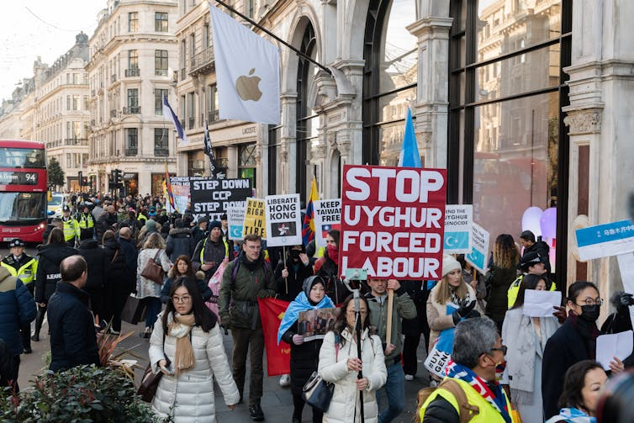
Apple is among the U.S.-based companies that would likely have to comply with the EU rules. Wiktor Szymanowicz/Anadolu Agency via Getty Images
Doing your due diligence
Human rights due diligence is a process by which companies are meant to map out, understand and address all potential human rights abuses that occur throughout their operations.
The term “due diligence” is borrowed from the common business practice of financial due diligence, wherein financial risks are investigated before any large investment. So just as businesses evaluate financial risks, human rights advocates argue companies should put similar effort into investigating the risk that an activity might violate someone’s human rights.
The EU law would mandate that all large companies that operate in the bloc conduct human rights due diligence among their suppliers – by, for example, making sure child or forced labor wasn’t involved – but also on how their products are used by consumers – such as when a piece of technology is used to surveil citizens.
The law would cover most human rights, including labor rights and environmental rights, past or present. In practice, that would mean companies would have to map any harmful impacts that have occurred or could occur and take action to remedy or prevent them.
The rules would also include provisions for enforcement and penalties for noncompliance through fines and other sanctions. And victims of abuse would be able to seek damages.
In its current form, the law would cover EU companies with at least 500 workers and 150 million euros US$162 million) in net revenue, but those thresholds fall to 250 workers and 40 million euros ($44.5 million) in sectors with a higher risk of abuse, such as clothing, footwear and agriculture. Non-European companies must comply if they have EU revenues that meet those thresholds. An estimated 13,000 EU companies and 4,000 based outside of Europe – including household names like Apple, Amazon and Nike – would be subject to the law.
If it works as intended, the EU law could be transformative in protecting human rights, including worker health and safety and workers’ free speech, around the world. According to a recent report by human rights scholars, it could be “particularly valuable in the context of transnational supply chains, where the fragmented nature of production has long presented formidable legal and practical barriers to efforts to secure greater corporate accountability for labor rights violations and poor working conditions.”
Bad for business?
While many companies have already endorsed mandatory due diligence rules, others worry this kind of government mandate would be too onerous.
A full map of risks in a company’s value chain – from raw materials to consumers – is difficult to establish when suppliers are separate companies operating on the other side of the world and global supply chains are frequently large and complex.
Some companies also strongly resist the idea of being held responsible for human rights violations that take place in their supply chains overseas.
Ripe for US rules
For this reason, the U.S. has so far preferred voluntary rules when it comes to pushing companies to respect human rights.
But that’s slowly beginning to change.
In 2012, California implemented the Supply Chain Transparency Act, which requires companies operating in the state to disclose their “efforts to eradicate human trafficking and slavery” in their global supply chains. And in 2021, Congress passed the Uyghur Forced Labor Prevention Act, which bans the importation of goods mined, produced or manufactured wholly or in part in the Xinjiang Uyghur Autonomous Region of China – home of the Uyghur people, who have been subjected to an intense program of state suppression since 2017.
Between these rules there is a clear trend developing of an increasing number of U.S. companies being obligated to implement some form of human rights due diligence. But these rules, unlike the developing European approach, are very narrowly tailored and don’t require companies to routinely undertake due diligence.
As a result, the U.S. companies that would be subject to the EU rules would be at a competitive disadvantage to many of their domestic rivals.
That’s why we believe the time may be ripe for Congress to consider its own more comprehensive human rights due diligence law, which would let the U.S. take the lead on the issue and have more of a say in these global standards. We believe that such a move would also be a major boon to protecting the human rights of marginalized groups across the world.

