Managerial framework for quality assurance of cross-border construction logistics and supply chain during pandemic and post-pandemic: lessons from COVID-19 in the world’s factory
Frank Ato Ghansahª and Weisheng Lu^{b}
ª Division of Construction, Property and Surveying; School of the Built Environment and Architecture, London South Bank University; London; United Kingdom.
^{b} Professor, Real Estate and Construction Department, Faculty of Architecture, The University of Hong Kong, Hong Kong

Abstract
Purpose: While the COVID-19 pandemic has impacted the construction industry, it is still unclear from prior studies about adequately positioning the quality assurance (QA) for the post-pandemic era and future pandemics, especially Cross-border Construction-Logistics-and-Supply Chain (Cb-CLSC). Thus, this study aims to develop a managerial framework to position the QA of Cb-CLSC during pandemics and post-pandemics by taking lessons from how COVID-19 has impacted the existing QA systems and has been managed successfully.
Methodology: This is achieved pragmatically through an embedded mixed-method design involving a literature review, survey, and interview from experts within the Hong Kong SAR-Mainland China links, typically known as the world’s factory. The design is further integrated with the partial least squares structural equation modelling (PLS-SEM) approach.
Findings: The study revealed 10 critical managerial practices (MPs) to position the QA to be adequate for the post-pandemic and during future pandemics, with the top three including “strict observance of government regulations (MP1)”, “planning ahead the period of quality assurance with the quarantine days in host countries (MP6)”, and “modification of contract to cater for uncertainties (MP4)”. This attained a relatively good percentage agreement of 53% between the industry and academia. However, the top four MPs regarded as very effective include “implementing digital collaborative inspections with subcontractors and trades (MP8)”, “implementing a digital centralized document and issue management system (MP7)”, “strict observance to government regulations, including vaccination of workers, social distancing, use of prescribed nose masks, etc. (MP1)”, and “planning ahead the period of quality assurance with the quarantine days in host countries (MP6)”. Two underlying components of the MPs were revealed as policy-process (PP)-related practices and people-technology-process (PTP)-related practices, and these can be modelled into a managerial framework capable of effectively positioning the QA to be adequate during pandemics through to the post-pandemic era.
Implications: The findings of this study depicted significant theoretical and practical contributions to the proactive management of QA activities during pandemics through to the post-pandemic era. It could empower organisations to pay attention to smartly and innovatively balancing people, processes, pandemic policy, and technology to inform decisions to effectively position the QA for the post-pandemic era and survive the risks of future pandemics.
Originality: The study contributes to the body of knowledge in that it develops a managerial framework to position the QA of Cb-CLSC during pandemics and post-pandemics by taking lessons from how COVID-19 has impacted the existing QA systems and has been managed successfully. It is original research with invaluable primary data in the form of surveys and interviews from experts within the Hong Kong SAR-Mainland China links, typically known as the world’s factory.
Keywords: COVID-19, Cross-border construction logistics and supply chain, Hong Kong SAR–Mainland China links, Managerial practices, Construction quality assurance

Introduction
Construction is time-honoured and an important industry in terms of scope and scale (Flanagan et al., 2007). Its market size is about US$ 10 trillion (Barbosa et al., 2017), related to goods and services, and contributes 13% of the global gross domestic product (GDP) every year (Ribeirinho et al., 2020). Cross-border construction logistics and supply chain (Cb-CLSC), which is a specific context of this study, encompasses interrelated processes engaging contractors, suppliers, or vendors between economies, such as performing construction work/services in other economies (Mawhinney, 2001). This is instrumental in promoting regional connectivity and achieving high-level goals related to a socio-economic character by connecting economies across economies to boost growth opportunities as they give rise to knowledge diffusion, technology transfer, and culture exchange. As such, performing quality assurance (QA) on projects has been critical as it assures confidence in the project to perform satisfactorily during the entire service life, as well as meeting pre-stated standards and requirements (International Organisation for Standardisation [ISO], 1994).
QA covers the set of systematic processes and procedural activities for determining that the construction projects meet quality requirements, including the client’s requirements, regulatory requirements and fit for the purpose (ISO, 1994; Project Management Body of Knowledge [PMBOK], 2021). Clear responsibilities and communication among all project staff are required to ensure consistent quality throughout the pre-construction and construction processes via inspection, audit checking and witnessing (Chung, 2002). This distinguishes QA from quality control, though the terms are occasionally used in tandem. QA is process-oriented and focuses on improving processes and methodologies to develop a quality project by engaging every member of an organisation toward defect avoidance. In contrast, quality control is product-oriented and focuses on improving end products by identifying and fixing defects, involving specific teams that test the products (ReQtest, 2016). As this study seeks to investigate the systematic process and the procedural activities in ensuring that construction project meets quality requirements, QA becomes the focus. Quality control may also be an important aspect of QA processes, where individual finished sub-works are examined and tested to verify quality before proceeding to the next sub-works (ASQ, 2015). However, by the very nature of involving two or more economies in Cb-CLSC, specific challenges do occur especially in the case of QA.
The challenges In QA have been exacerbated amid the current coronavirus (COVID-19) pandemic crisis. Industries have experienced disruptions that make them conform to the new term “new normal”. The established mitigation measures, including social distancing, lockdowns, travel restrictions, border control arrangements, the limited number of workers to be onsite, and the number of days for quarantine, have had a massive impact on the QA by decreasing physical connectivity around the world (Organization for Economic Co-operation and Development [OECD], 2020). The responsibility befalls all the relevant stakeholders in the construction industry, including governments, institutions, practitioners, and academia. Hence, academic researchers may investigate and discuss concerns to establish an adequate QA amid pandemics and the post-pandemic era.
Since the pandemic’s debut, there have been ongoing discourses about the pandemic. For instance, Onubi et al. (2023a) examined the impacts of the pandemic on health and safety management by moderating the effects of the project size on the relationship between the safety protocols and the economic performance of projects. Soliman et al. (2022) also examined the pandemic’s impact on workforce management by considering labour’s motivational factors and construction productivity. Regarding organisational resilience to COVID-19, Wulandhari et al. (2022) developed a framework to ensure resilience in the supply chain during the pandemic. However, the study was general without considering the specificity of the construction industry, which may differ from other industries. Sharma et al. (2022) also focused on the survivability of sustainable supply chains during the pandemic and post-pandemic by developing an enhancement framework. This study was also general without specific considerations of individual sectors, which may vary. Other varied studies have been conducted in areas including health and safety management (Kum et al., 2023; Sadeh et al., 2023), construction performance (Gumusburun Ayalp and Civici, 2023), and construction supply chain management (Sutterby et al., 2023). Considering the construction industry, specifically Cb-CLSC, prior studies have not focused on understanding how the pandemic has influenced QA practices. No attention has been paid to adequately positioning the QA for the post-pandemic era and future pandemics. Meanwhile, if investigated, this area can help develop a managerial framework to ensure adequate QA during future pandemics through to the post-pandemic by taking lessons from the COVID-19 pandemic.
Therefore, this study aims to develop a managerial framework to position the QA of Cb-CLSC during pandemics and post-pandemics by taking lessons from how COVID-19 has impacted the existing QA systems and has been managed successfully. The specific objectives are (1) to identify the critical managerial practices (MPs) towards a managerial framework to position QA during pandemic and post-pandemic, and (2) to validate the managerial framework by evaluating the effectiveness of the critical MPs on the QA. The specific objectives are achieved by adopting an embedded mixed-method design consisting of a literature review, survey, and interview from experts within the Hong Kong SAR-Mainland China links, typically known as the world’s factory (Bajpai, 2022). The design is further integrated with the partial least squares structural equation modelling (PLS-SEM) approach to understand the effectiveness of the critical MPs on the QA in the study’s context. The findings contribute to knowledge by developing a managerial framework to position QA adequately during pandemics and for the post-pandemic. The finding could guide practitioners and experts in providing confidence in assuring the quality of cross-border construction projects and even local projects during pandemics through to the post-pandemic era. The paper is structured as follows: introduction, literature review on QA of Cb-CLSC during the COVID-19 pandemic and potential management, research method, analysis and findings, discussion, “theoretical, practical and methodological contribution”, and conclusion.

2. QA of Cb-CLSC during the COVID-19
QA is any systematic process of determining whether a product or service meets specified requirements, and this is meant to increase customer confidence and a company’s credibility, while also improving work process and efficiency (World Health Organisation [WHO], 2021). In construction, QA covers the set of systematic processes and procedural activities for determining that construction projects meet quality requirements, including the client’s requirements, regulatory requirements and fit for the purpose (ISO, 1994; PMBOK, 2021). Clear responsibilities and communication among all project staff are required to ensure consistent quality throughout the pre-construction and construction processes via inspection, audit checking and witnessing (Chung, 2002). QA activities are also carried out by the government’s authorised persons and the client’s representative to verify and accept the quality of materials and construction workmanship (Lu et al., 2022), following the standards: ISO 9000/9001, contractual specifications, and government regulations. It is imperative that this study recognizes the important distinction between QA and quality control, which are typically used in tandem in the literature, considering a number of specific factors illustrated in Table 1. The study focuses on the QA as it investigates the systematic process and the procedural activities in ensuring that construction projects meet quality requirements. However, quality control may also be an important aspect of QA processes, where individual finished sub-works are examined and tested to verify quality before proceeding to the next sub-works (ASQ, 2015).

Table 1: Similarities and differences between QA and quality control (Ghansah et al., 2023)
Factor | QA | Quality Control
Definition | Implementation of processes, methodologies and standards that ensure that the product developed will be up to the required quality standards. | Set of activities that are carried out to verify the developed product meets the required standards.
Target | Focuses on the improvement of processes and methodologies used to develop a product. | Focuses on the improvement of the product by identifying the bugs and issues.
Orientation | Process-oriented. | Product-oriented.
Nature of process | A preventive process as it establishes the methods which prevent the bugs. | A corrective process as it focuses on identifying the bugs and getting them fixed.
Verification and validation | Verifies you are doing the right thing in the right manner. | Validates the product against the requirements.
Measurements | Creates the systems to measure and control quality to create confidence that quality products will be produced. | Measures the quality level of individual products and accepts/rejects them based on the criteria developed by QA.
Persons involved | All the persons involved in the project, starting from the requirements. | Responsibility of the quality control inspector or the testing team that finds the issues.
Tools and techniques | Defining processes, quality audit, selection of tools, and training.
Examples | Include process checklists, process standards, process documentation and project audit. | Include inspection, deliverable peer reviews and the software testing process.

Conducting QA of Cb-CLSC depends on the quality management systems of an organisation. This embraces the organisational structure, procedures and resources needed to assure the quality of construction products and services (ISO, 1994). The quality management system clarifies the authorities and responsibilities of the staff and their interrelations (Harrison and Lock, 2017). The quality management system standardises the administrative and production procedures and regulates verification activities. It generates permanent records showing that the prescribed verification activities have been performed and the required quality has been attained. Hence, after the planning phase, QA is essential to verify and accept the quality of building materials, components, and workmanship in compliance with building regulations and customer requirements before the project gets to the client. With QA integrated fully into the operations and construction processes of the organisations, it regulates the conduct of different processes and prevents side-stepping or deviation.
As concerted effort is central to QA, everyone in the organisation must know what they are expected to do and what their colleagues are doing. This denotes proper documentation and availability of a quality system in the workplace. Contractors have a role in supervising the QA by ensuring that qualified suppliers and appropriate materials are procured and that skilled labourers are engaged in executing cross-border projects (Thorpe and Sumner, 2017). The contractor can also ensure adequate training in construction works toward the execution of a project to meet the contractual requirements. The consultants and the government-authorised persons also play a role in QA by ensuring that the product meets the client’s requirements and statutory regulations (ASQ, 2015). In some cases, the consultant, the client representative, and the government-authorised persons would have to travel offshore to foresee the quality of construction products. Such a scenario has been the case of modular construction, especially between Hong Kong SAR and the Guangdong Province of Mainland China, where authorised persons and clients’ representatives from Hong Kong SAR are dispatched offshore to verify and accept the quality of construction components in Mainland China (Lu et al., 2022). Hence, this study focuses on the QA practices performed by the client representative and government-authorised persons who must travel to different economies for the nature of Cb-CLSC. The contractor’s QA activities, which may be internal services toward quality, may also be considered.
COVID-19 has considerably impacted construction projects, putting construction workers at a higher risk of severe infections than non-construction workers (Ghansah and Lu, 2023) due to the shared transmissions among countries (see Figure 1). In April 2020, Baker et al. (2020) reported that 8.3% of the 5.9 million construction workers during the pandemic were exposed once a month. Subsequently, this led to delays and suspension, cancellation of projects, creation of new risks, etc. This has raised a more significant consent on QA of Cb-CLSC, which engages contractors and other professionals between economies where one performs services in different economies. The pandemic mitigation measures, as much as they minimise the spread of the pandemic, have also affected construction activities (Ghansah et al., 2023).
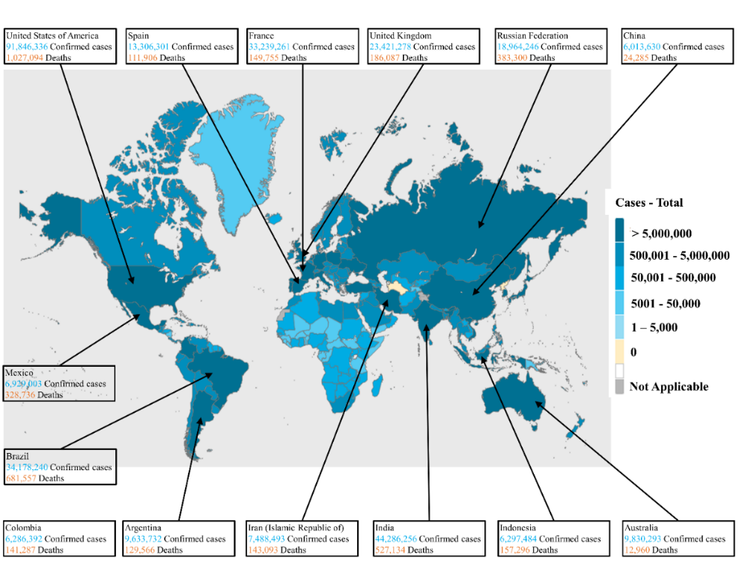
Figure 1: COVID-19 cases across economies (WHO, 2020)

3. Potential management of QA of Cb-CLSC during the COVID-19 crisis
With governments issuing mitigation measures, including the regular use of sanitisers, travelling restrictions, practising social distancing, quarantine or stay-at-home orders or isolation, and businesses close-down, a massive impact has been felt in the construction industry (CDC, 2017; Raoufi and Fayek, 2022). However, the pandemic has shown a new side to conducting construction QA with greater communication and collaboration between the relevant stakeholders.
Digital technologies have been the central point in managing quality during the pandemic. Though the construction sector has been regarded as sluggish in digital technology adoption (Sahamir et al., 2021), the sudden hit by COVID-19 has necessitated the need to involve digital technologies in activities to ensure the continuity of construction activities and processes. Academic researchers have investigated and recommended the applications of digital technologies to augment the construction processes and activities throughout the QA process. For instance, Elabd et al. (2020) integrated innovative digital technologies to propose a remote management framework to support remote monitoring of worksites, help firms track progress remotely, enhance social distancing, support the progress on the sites, and avoid project delays while maintaining worker safety. Goh et al. (2022) also proposed a computer vision-based smart monitoring system to detect workers breaching safe distancing rules automatically. Lu et al. (2022) developed an e-inspection 2.0 system for modular construction to enhance the QA system with efficient coordination of related stakeholders and achieve transparency in the data transmissions. These approaches have shown high potential in the continuation of QA tasks on construction works and services throughout the QA process whilst adhering to the COVID-19 protocols and applying other interventions, including work shifts (Araya, 2021), employing multi-skill-workers (Araya, 2022), and updated health and safety policies (Kum et al., 2023; Sadeh et al., 2023). Subsequently, this study identified the potential MPs capable of managing QA adequately amid complexities caused by the pandemic via a comprehensive literature review (see Appendix A) and evaluated with whitepapers from relevant websites such as CDC, International Labour Organisation (ILO), and Occupational Safety and Health Administration (OSHA). Ultimately, the MPs are centrally noted to be technology-enabled and pandemic policy-oriented.
Further evaluation is conducted by applying the People-Process-Technology (PPT) framework toward improving the QA during the COVID-19 pandemic. PPT originated from the concept of Leavitt’s Diamond Model, developed by Dr Harold Leavitt in 1964 (Witt, 2022). This framework works on the premise that organisations comprise people, processes, and organisations (Khan, 2022). Therefore, organisations must balance these three elements to achieve success. To an advantage, PPT framework can map the entire value streams of people, processes, and technology (Plutora, 2022). This provides full control and visibility into high-performing teams that can optimise operations and work faster. However, this framework is limited to only people, processes, and technology while neglecting other elements that may be important to achieve managerial efficiency. This includes policies and other external factors. In the construction industry, PPT has been adopted in areas such as offsite production and manufacturing for innovative construction (Deep et al., 2023) and lean construction (Zhan, 2022). However, the QA in the construction has not received a clear application of the PPT framework. In applying the PPT framework for this study, a new dimension, “policy (P)”, is introduced into the PPT framework; hence, arriving at the PPPT (People-Process-Policy-Technology) framework for managing QA adequately during pandemics. Subsequently, hypothesis (H_{F1}) is made below:
H_{F1}: The proposed managerial framework has a significant effect in effectively managing the QA of Cb-CLSC in the post-pandemic era and enduring risks of future pandemics.
The four elements of the proposed managerial framework are further explained to understand their potential influence in adequately positioning the QA during pandemics through to the post-pandemic era, as illustrated with the potential MPs in Appendix A.

3.1 People
“People” relates to the human resources available throughout the QA process, and they do the tasks prescribed in the quality requirement towards achieving the required project quality. This comprises quality engineers, managers, inspectors, supervisors, and other relevant skilled workers (Plutora, 2022). With the QA amid the pandemic, one key factor is getting the right experts or people for the work. Organisations need to engage the right skills, experience, and attitude for the work due to the restrictions and pressures imposed due to the pandemic. Organisations would have to employ key skilled experts to execute works to avoid reworks, which are liable for causing additional resources on both the clients and organisations. People, including experts, must be assigned clear roles and responsibilities, which may help in decision-making, technology selection, and process deployment throughout the QA process. Thus, ensuring the right and multiskilled experts or workers throughout the QA process with the right communication is critical during the pandemic.

3.2 Process
“Process” refers to the steps combined to produce a goal. For QA, the process defines how the tasks or works are executed to achieve the desired quality of a project, i.e., the “how” aspect. This extends to how the people are utilised to achieve the pre-stated quality requirement of a project. It involves repeatable actions that theoretically produce the same quality as pre-stated in the requirement, independent of who executes them. Amid the pandemic, a few actions must be considered throughout the QA process. For instance, it is important to understand the contract involved and how it can be modified or has been modified to cater for uncertainties created by the pandemic. This is because the pandemic may be regarded as force majeure due to its natural occurrence in the construction processes (Assaad and El-adaway, 2021; Khalef et al., 2022). The process, especial during the planning, may also incorporate the quarantine days as pronounced by the government of specific economies. Again, organisation-based approaches can be adopted to minimise costs throughout the QA process. This may include deploying the right multiskilled workers, cost-cutting, etc. Thus, organisations may need to plan, monitor, and evaluate the QA process to allow the delivery of high-quality projects, specifically cross-border construction.

3.3 Technology
“Technology” has the capability to help experts undertake QA activities effectively amid the pandemic. It helps automate some parts of the QA processes and facilitates expert coordination. Technology has had the most impact on the industry amid the pandemic (Ogunnusi et al., 2020), and this can be taken from the field of construction QA. However, organisations must ensure technology fits into the QA process with the right and skilled experts to execute projects based on the pre-stated quality requirement. Technology is nothing without experts following the right process to support it to assure quality. Thus, technology should be a consideration in the QA process with the experts during the pandemic, where experts may not be allowed to travel across regions to inspect, verify, and audit the quality of construction works. Technology may ensure the continuity of QA processes by facilitating inspections and “work auditing” remotely while achieving effective coordination. Such technologies may include BIM, drones, IoT, digital twins, blockchain, etc. (Wang et al., 2021; Lu et al., 2022; Lu et al., 2023).

3.4 Policy
“Policy” is a new element added to the framework by this study, consisting of the rules and regulations that must be followed throughout the QA processes. With the pandemic, policies have been established by governments and organisations and must be considered by experts throughout the QA processes. This may ensure an effective process throughout the QA processes whilst providing a safe working environment and conditions for experts. Government policies that must be considered throughout the QA process include wearing prescribed nose and face masks, social distancing, vaccination of experts, etc. (Onubi et al., 2023b; Yuan et al., 2022). Other policies may also regard the travelling from economy to economy or border to border, where the government may require experts to undertake quarantine. These actions create safe working conditions for experts and workers toward achieving the quality of a project. Organisation-based policies tighten an organisation’s safety protocol and management and ensure that workers and experts are provided with a safe environment. This includes the regular production of hand sanitisers, face masks, etc., and strict use of them onsite. The organisation-based policies complement the government policies to provide a safe environment for experts throughout the QA process. Thus, policies may be balanced with the people, processes, and technology to develop a managerial framework to position the QA adequately during pandemics and the post-pandemic era.

4. Research method
An embedded mixed method design is pragmatically adopted for this study by collecting both qualitative and quantitative data and analysing the data within a traditional quantitative research design (Creswell and Clark, 2017). This is a good approach due to the study’s limited time in taking the data, and it allows one method to lead the analysis, with the secondary method providing additional and complementary information (Edmond and Kennedy, 2017).
Subsequently, the PLS-SEM approach is integrated to examine and validate the effectiveness of the proposed managerial framework on the QA, supported by content analysis. This approach is successful in other domains in different contexts, such as operations management (Peng and Lai, 2012), hospitality and tourism (Usakli and Kucukergin, 2018). The approach measures and analyses the significant relationships between the observed and the latent variables following the five logical steps: specification, identification, parameter estimation, model evaluation, and model modification (Ghansah et al., 2022). This study meets the PLS-SEM criteria, including the exploratory stage of the study to explore the critical MPs, their underlying dimensions, and the formative and reflective relationship nature of the anticipated framework affecting the QA (Hair et al., 2019). Overall, the study follows four main steps, as illustrated in Figure 2.
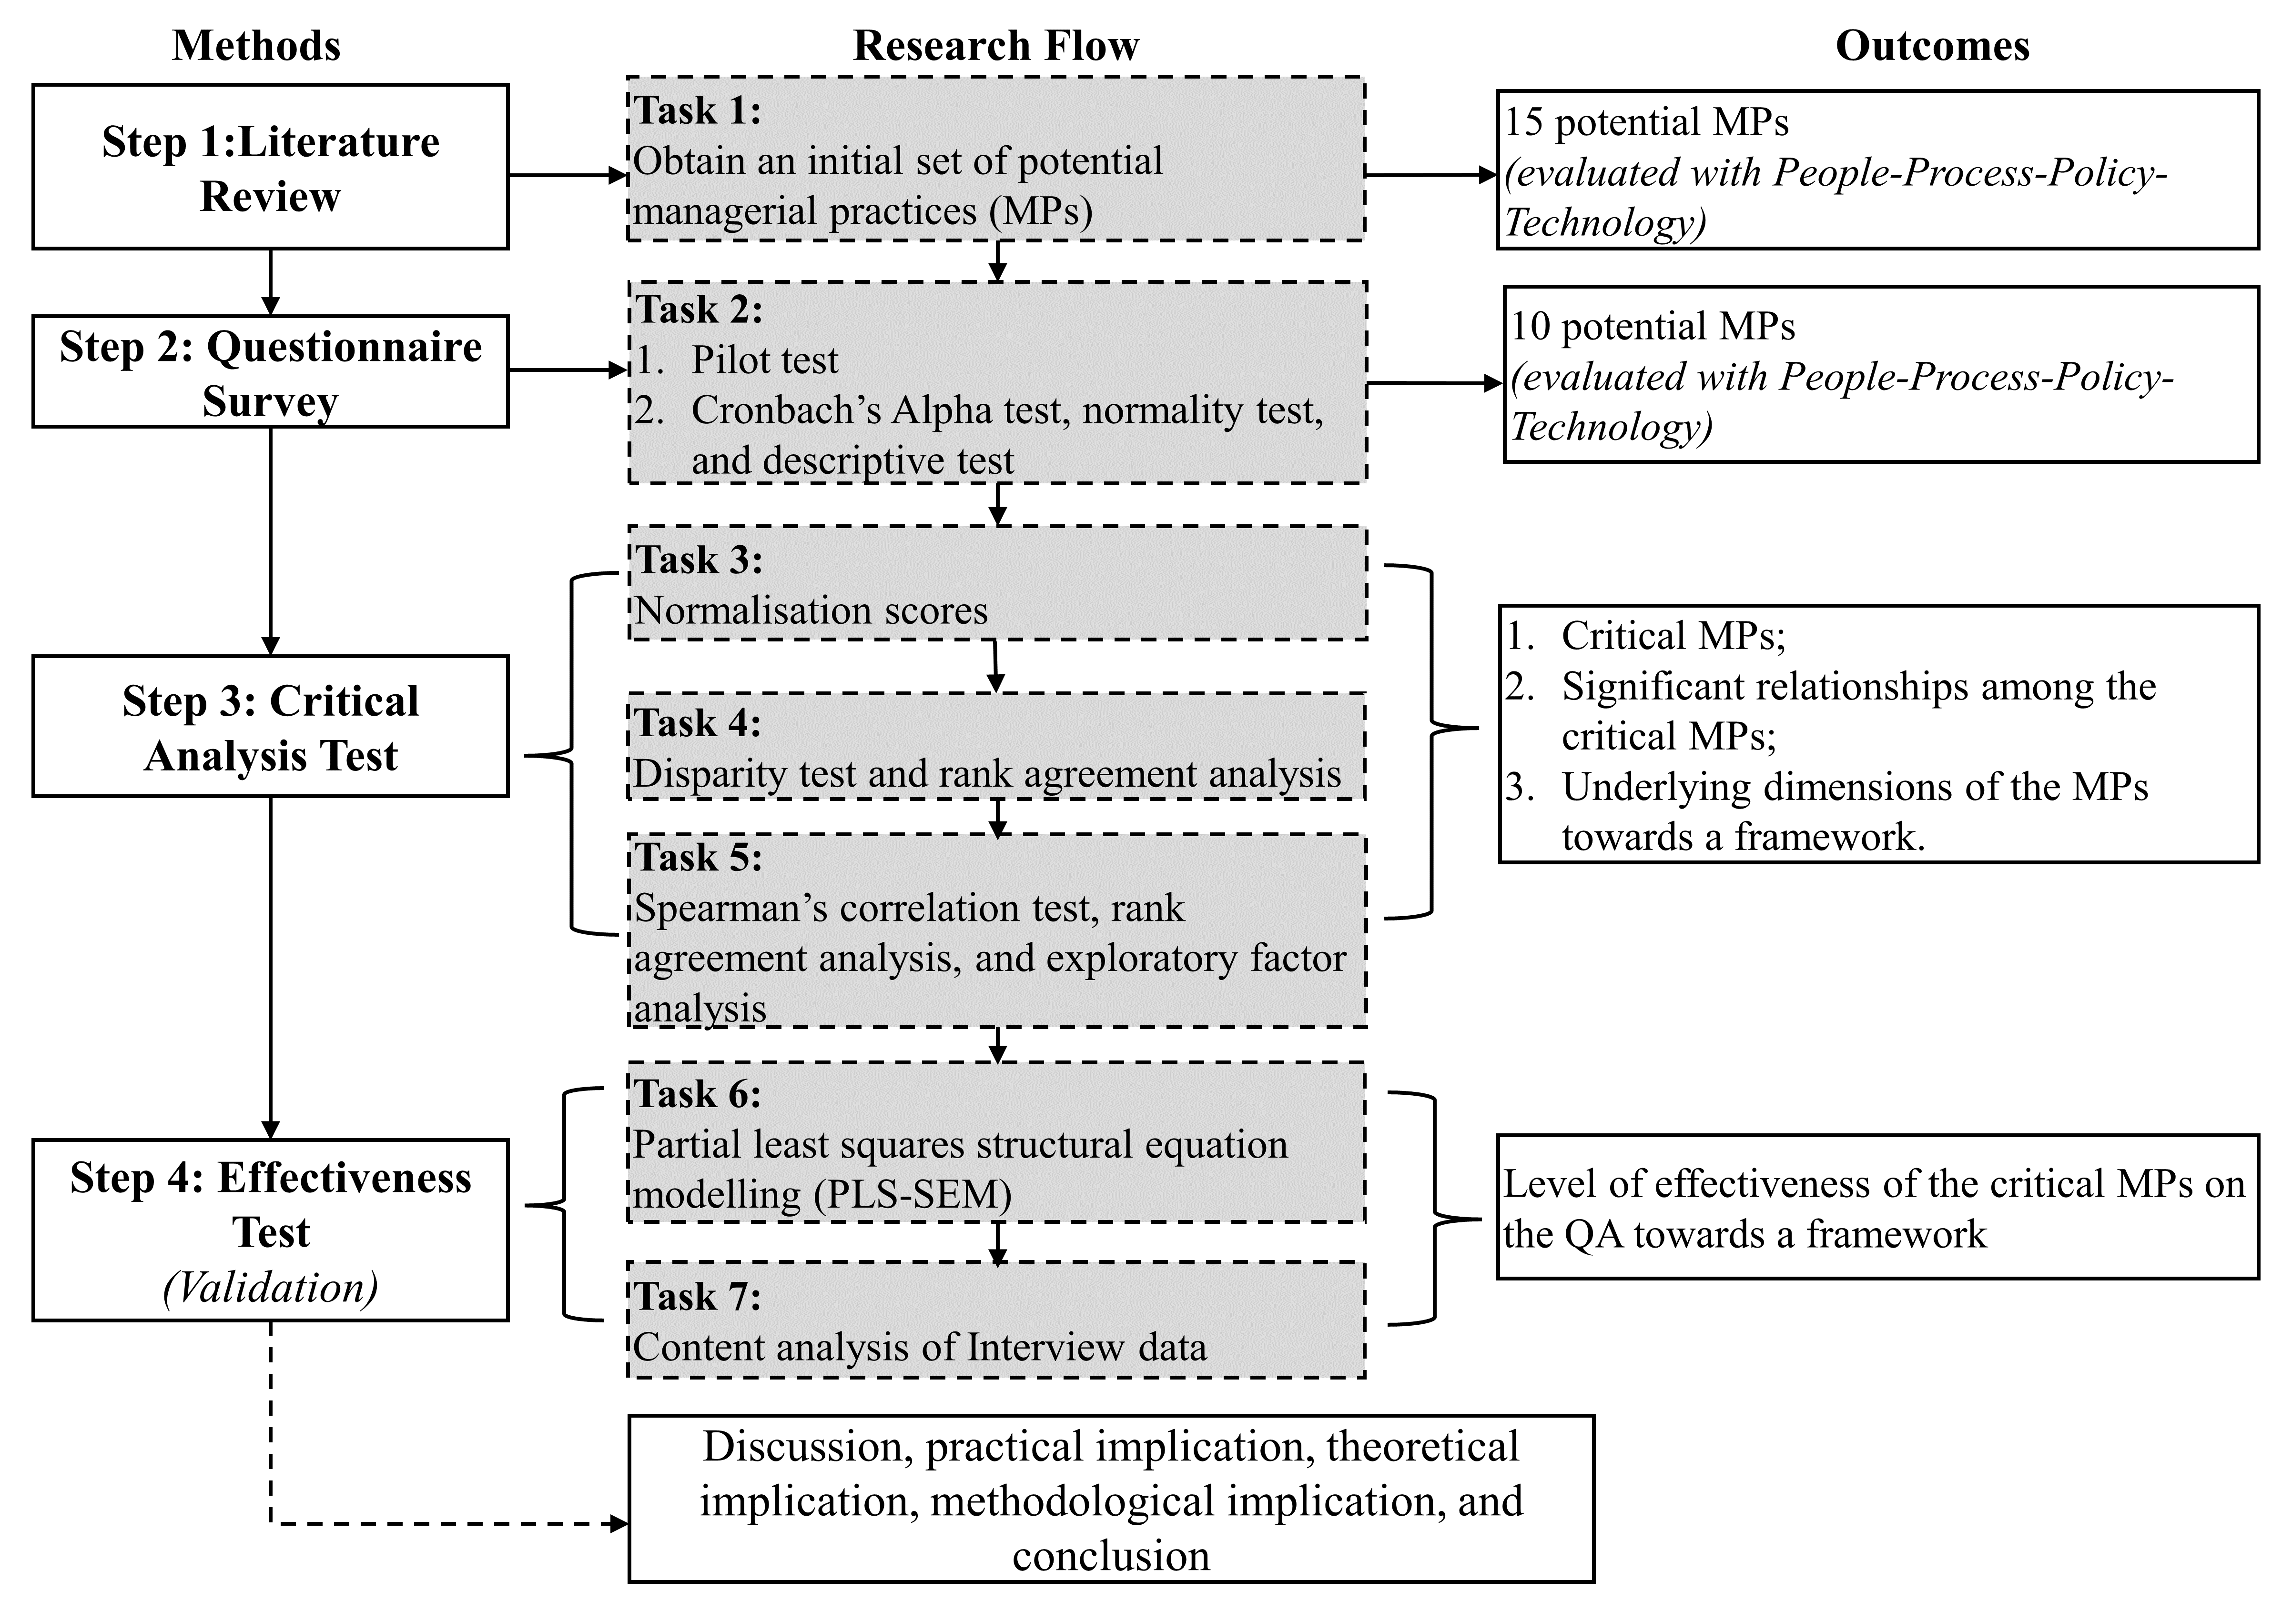
Figure 2: Flowchart of the research method (Source: Authors own work)

4.1 Identification of the potential MPs
A desk literature review was adopted for this study, and this involves an in-depth analysis of available literature on a particular research topic, including books, journals, conference articles, and other academic publications (Muheeb, 2021). This approach is done at a desk and is carried out through research rather than physical investigations (Designbuildings, 2021). The main objective is to identify relevant data sources and assess the quality of data. Compared to other literature approaches, the desk literature review is more focused on quickly identifying the relevant sources and assessing the available literature to identify key elements (Muheeb, 2021; Designbuildings, 2021). The desk literature approach is often a preliminary step in the research process (Designbuildings, 2021), and for this study, it followed two rounds.
First, keywords were entered to find relevant literature in Google Scholar, Scopus, Google Advance, and Web of Science databases. The keywords include “Managing construction activities”, “managing construction quality”, “COVID-19 pandemic”, “construction quality assurance”, and “manage quality activities during COVID-19”. Subsequently, 42 relevant academic documents were identified, including journal papers, conference papers, and white papers. Also, authentic and reliable web pages of organisations, such as the ILO, OSHA and CDC, were included. Lastly, to attain a comprehensive list of potential MPs, the variables were streamlined to reflect the potential MPs to position QA of Cb-CLSC to be adequate during pandemics and post-pandemic. Consequently, 15 potential MPs were proposed (see Appendix A), and these would be tested to identify the critical MPs and their level of effectiveness on the QA of Cb-CLSC based on experts’ views.

4.2 Data collection
An initial questionnaire on the potential MPs was prepared, and the intention was to identify the critical MPs toward framework development and evaluate their level of effectiveness on the QA by considering the experts’ opinions. The questionnaire allowed empirical data collection from the Hong Kong SAR– Mainland China links, guaranteeing experts’ anonymity and data confidentiality. The Likert scale was adopted due to the introduction of minimal response bias. As a result, the type of Likert scale adopted includes a level of agreement (1= Strongly disagree; 2=Disagree; 3=Neutral; 4=Agree; 5=Strongly agree) and the level of effectiveness [validation] (1=Not at all effective; 2=Slightly effective; 3=Moderately effective; 4=Very effective; 5= Extremely effective).
The study conducted a pilot study to check the comprehensiveness and relevance of the potential MPs by engaging valuable responses from five experts (three academicians and two quality inspectors [one from Hong Kong SAR and the other from Mainland China]). This took one month. The valuable comments helped modify the 15 CMMs to 10 (See Table 2 as evaluated with the PPPT framework), informing the final questionnaire (see Appendix D). Also, other variables were added based on the researcher’s understanding of the context. Alongside, QA activities were also examined to help quantify the level of effectiveness of the MPs on the QA (See Appendix D). The interview question was also piloted to have a well-refined question to interest experts’ participation in understanding the effectiveness of the MPs on QA during the COVID-19 pandemic (see Appendix E). The data collection was preceded with an informed consent form to ensure the right expert with the right experience participate, as illustrated in Appendix C.
Table 2: Potential MPs after the piloting (Source: Authors own work)
Code | Potential MPs | Proposed PPPT Framework | References#
MP1 | Strict observance of government regulations, including vaccination of workers, social distancing, use of prescribed nose masks, etc. | Policy | 1,2,3,4,5,6,7
MP2 | Adherence to updated adequate occupational health and safety policies to protect workers. | Policy | 8,9,10,11,12,13,14,15
MP3 | Smart remote monitoring, supervision, coordination and reviewing works from a remote location. | Technology/Process | 1,2,16,17,18,19,20,21,22,23,24
MP4 | Modification of contract to cater for uncertainties. | Process | 2,25,26,27
MP5 | Keeping up to date on travelling regulations and policies in host countries. | Policy | 29,30,31
MP6 | Planning ahead the period of quality assurance with the quarantine days in host countries. | Process | 32,33,34
MP7 | Implementing a digital centralised document and issue management system. | Technology | 23,24,35
MP8 | Implementing digital collaborative inspections with subcontractors and trades. | Technology | 24,36,37
MP9 | Assigning quality assurance tasks to multiskilled experts/workers to avoid frequent changes of persons on work. | People | 28,38,39
MP10 | Cost cutting | Process | 40,41,42
For detailed references#, see Appendix B.

The study population comprises construction QA experts from academia and industry possessing relevant experience within Hong Kong SAR–Mainland China. QA is a collective effort in a construction firm on a project. Hence, project managers and construction managers were also engaged as experts in this study, as defined by Cabaniss (2022). Also, non-probability sampling techniques, such as purposive and snowball sampling, were adopted by targeting experts with knowledge and experience in construction QA. This helped direct the researcher to potential experts.
The study considered specific experts if (1) they possess extensive experience and are theoretically proficient in the construction QA activities, (2) they possess direct hands-on experience in construction QA, and (3) they have at least been engaged in the QA process in the construction industry. The study identified academic experts from highly recognised peer-reviewed journals with high contributions to the field of construction QA, while the industry practitioners comprised experts from construction companies in Hong Kong SAR and Mainland China. Overall, the experts were also searched from professional associations via LinkedIn and direct company websites, giving access to retrieve contact email addresses of industry practitioners.
An online survey was adopted to distribute the questionnaires using “Qualtrics XM” through personalised emails to allow easy responses, LinkedIn, CNBR, WeChat, and WhatsApp messenger. This was conducted along with the interview session via online platforms, such as Zoom and WeChat. The duration of the data collection continued for five to six months (from 6 September 2022 to 28 February 2023). The experts were prompted with several reminders to remind the experts to respond to the survey and attend an interview session if available.
Due to the snowball sampling technique adopted for this study, the number of questionnaires distributed within Hong Kong SAR–Mainland China links was not determined. However, approximately 200 online questionnaires were administered. This is based on the targeted participants and their capability to share the questionnaires with their colleagues who are potential experts. This was verified after contacting a few on their ability to share, and the responses were positive. Finally, 52 responses were collected from the specific experts. A limitation of this approach is the accurate estimation of the response rate, as the respondents shared the survey with other potential experts. However, the 52 responses were justified with Idrus (2001) and Ott and Longnecker (2015) stating a minimum sample size of 30 is representative of any group and can be appropriate for analysis. This has been adopted to justify relevant studies in the construction industry, such as Adabre et al. (2020), Zhao et al. (2016), and Chan et al. (2017). Furthermore, 13 interviews were conducted to solidify and complement the survey findings, also meeting the minimum requirements for a qualitative study: 5-50 participants (Dworkin, 2012).

5. Data analysis and results
To begin the analysis, the dataset was initially cleansed to remove uncompleted responses. The study then adopted the Statistical Package for the Social Sciences (IBM–SPSS), version 27, for the data analysis.

5.1 Demographic profile of experts
Figure 3 details the profile of the experts engaged in the survey, whereas Table 3 presents the profile of the interviewees. Overall, in the Hong Kong SAR–Mainland China links, the experts constituted 44.23% from Mainland China and 55.77% from Hong Kong SAR. The response rate of experts from the academia was 23.09%, a good survey response reflecting the consent of the academia (Cleave, 2020), while the industry was 76.92%, across Hong Kong SAR–Mainland China links with specialities, such as academics, quality auditing, and quality engineering. It also engaged authorised persons from the governments, client representatives, and others. The “others” included other team members deemed essential in the QA process, i.e., project managers, construction managers, and site supervisors. Most experts had years of work experience from 1–10 years either by research or industry experience, and few had work experience from 11–20 years. With the interviewees, experts were noted to be highly qualified with academic certificates and work experience from two to ten years across Hong Kong SAR and Mainland China. The dataset was considered because the experts were noted to have at least two years of experience, and this could help in achieving the criticality of the MPs.
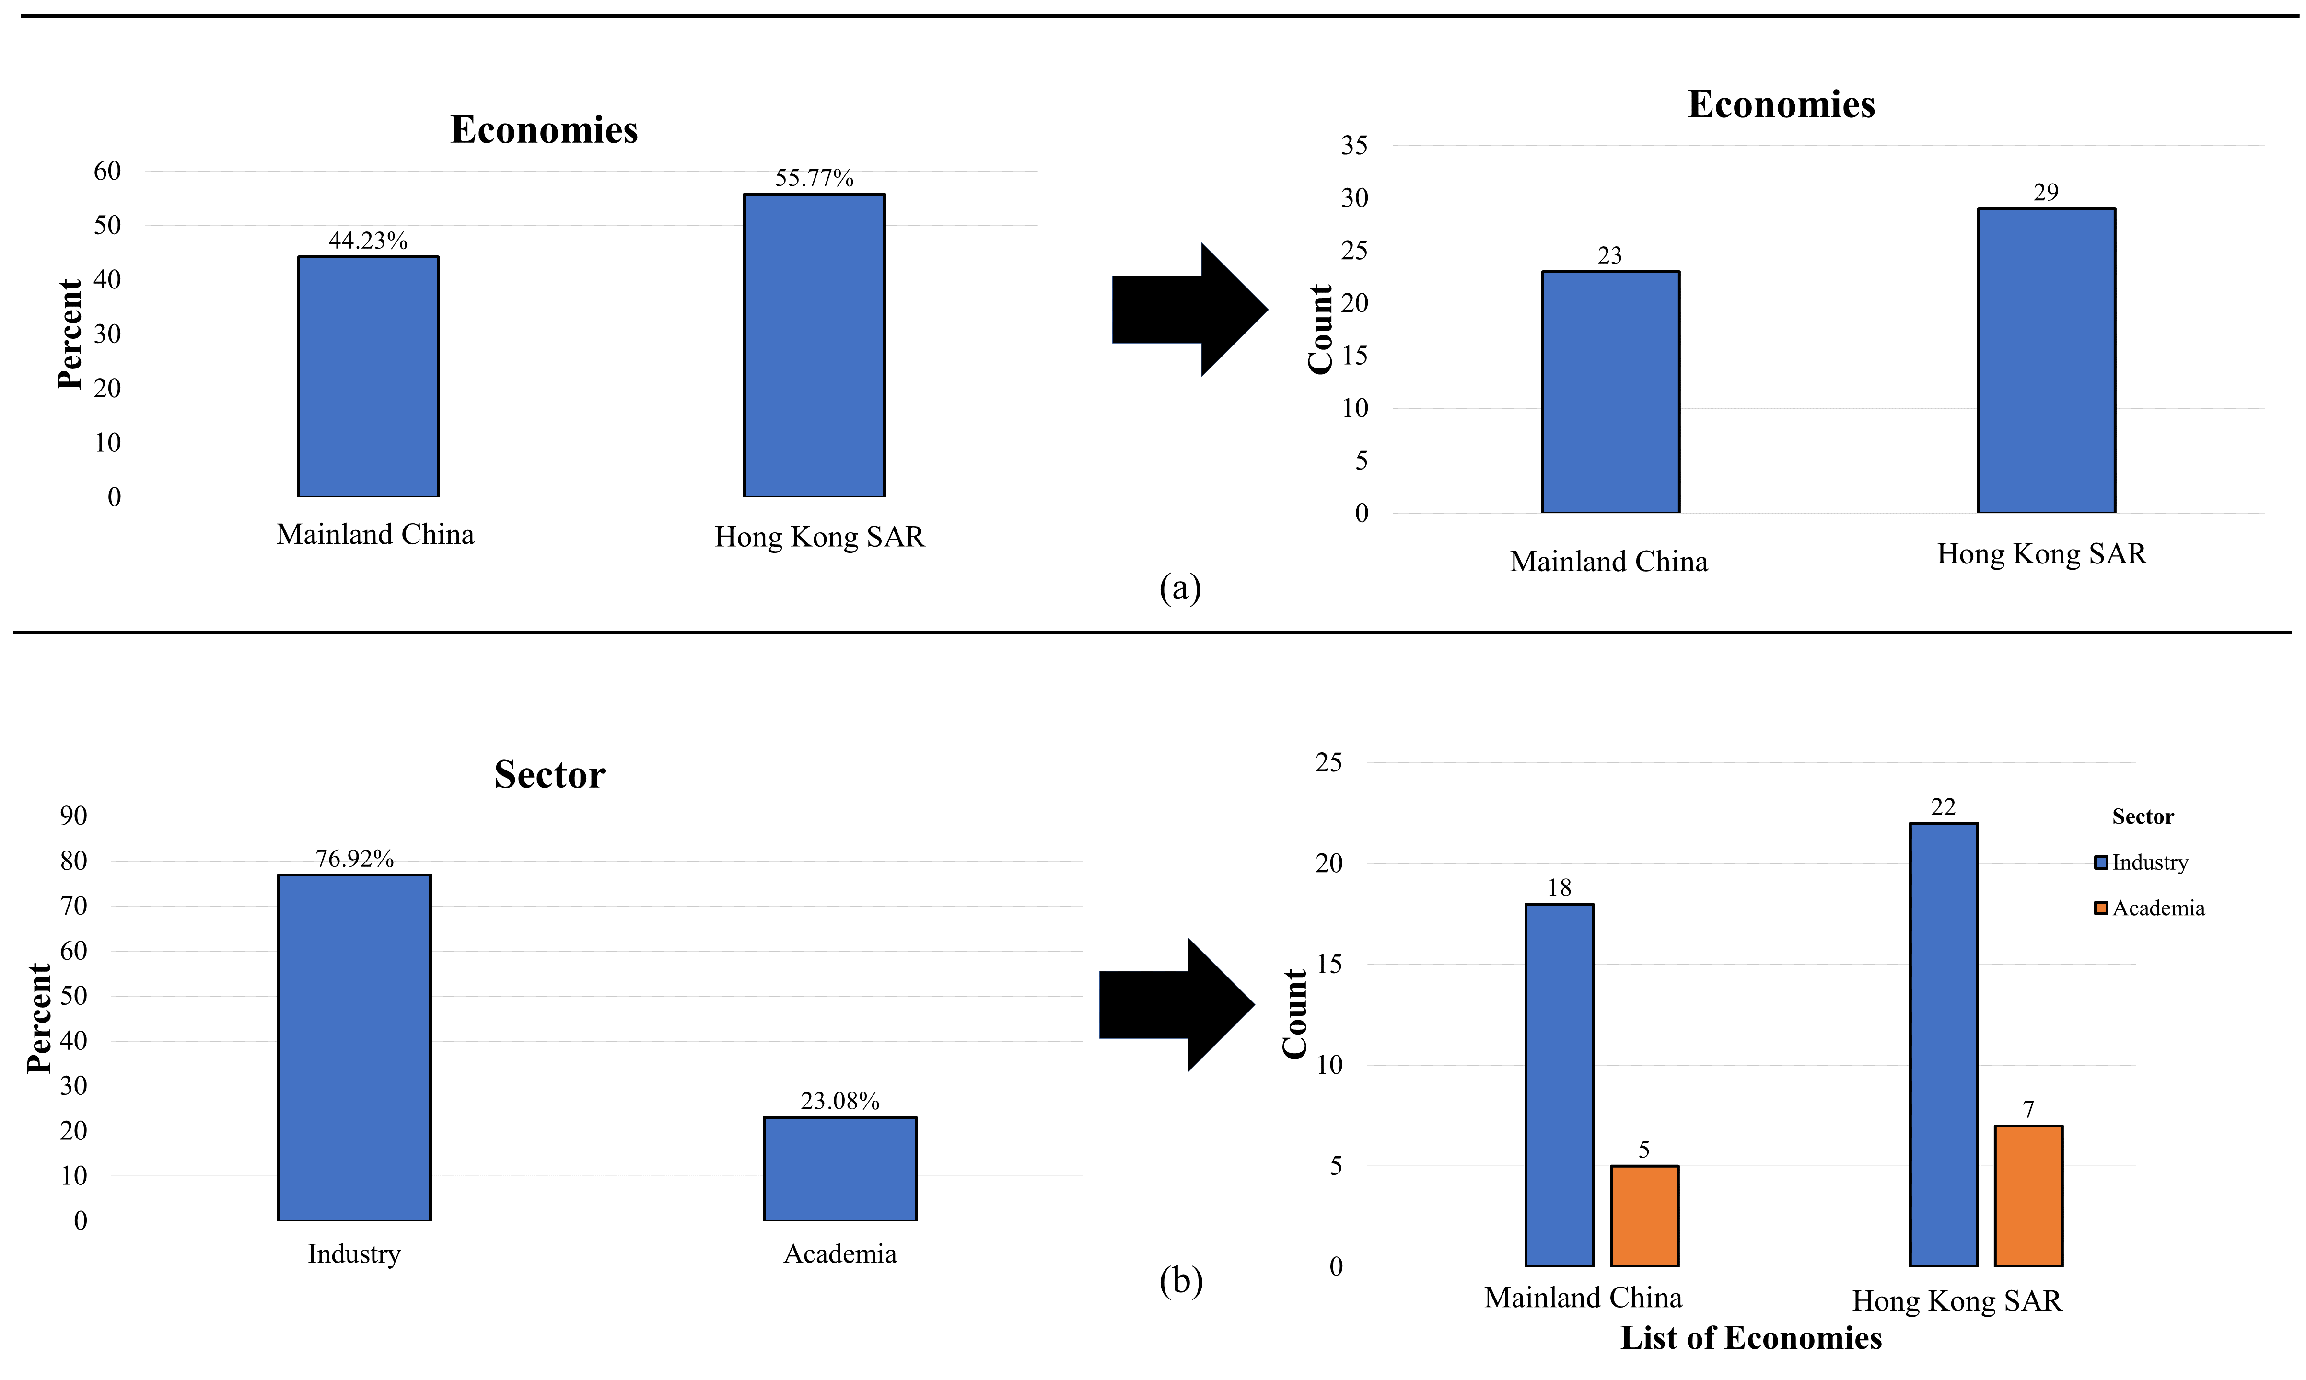
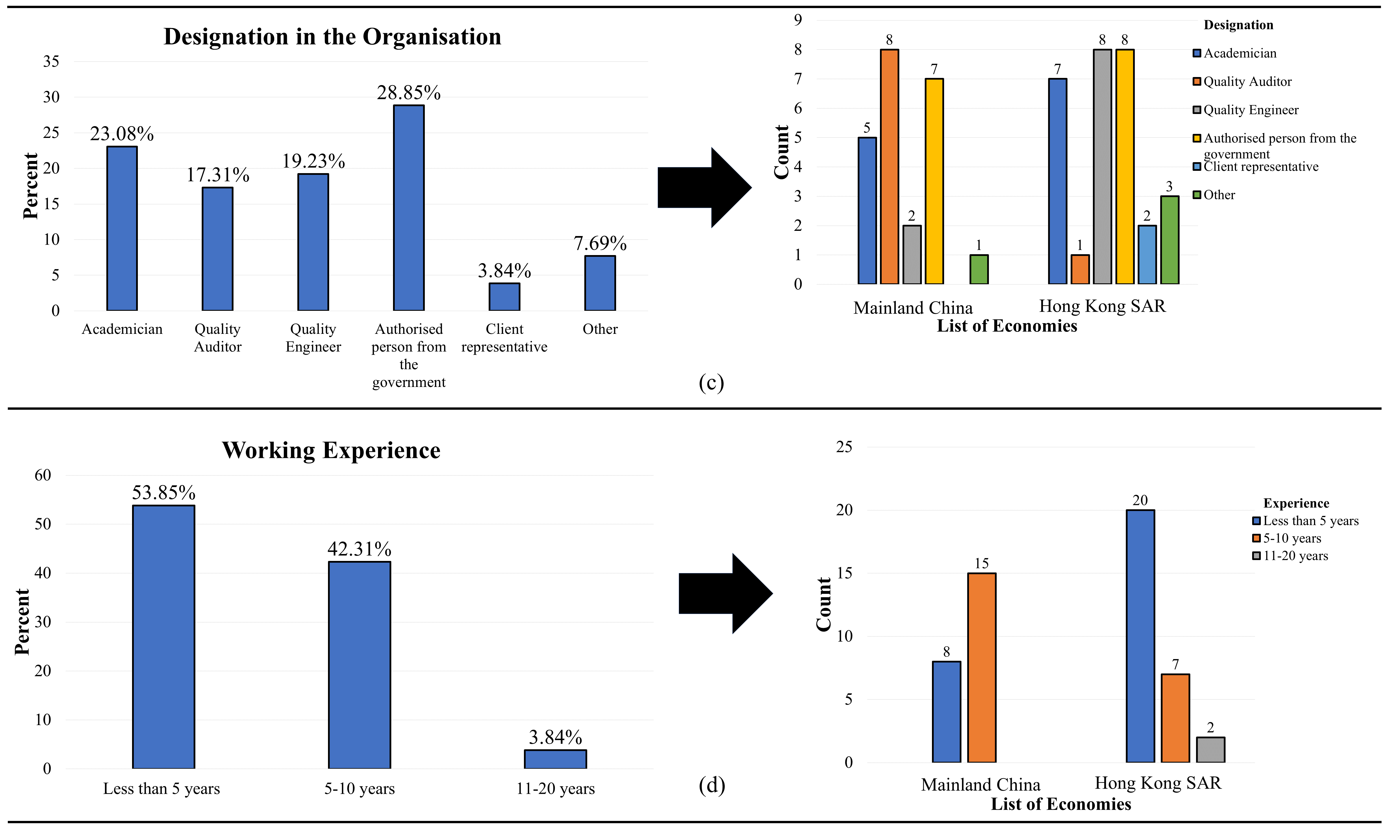
Figure 3: Experts’ profile (Source: Authors own work)

Table 3: Profile of interviewees (Source: Authors own work)
Interviewee | Designation | Qualification | Years of Experience | Economy
A | Quality inspection officer | BSc | 5 | Mainland China
B | Quality inspection officer | MSc | 2 | Hong Kong SAR
C | Quality engineer | BSc | 2 | Mainland China
D | Quality inspection officer | MSc | 5 | Mainland China
E | Quality manager | MSc | 4 | Hong Kong SAR
F | Quality inspection officer | MSc | 3 | Mainland China
G | Onsite quality inspection officer | BSc | 2 | Mainland China
H | Quality manager | MSc | 10 | Hong Kong SAR
I | Director of Quality Management System Department | MSc | 4 | Mainland China
J | Quality officer (in charge of logistics) | BSc | 2 | Mainland China
K | Supply chain manager | MSc | 6 | Mainland China
L | Quality engineer | BSc | 7 | Hong Kong SAR
M | Quality engineer | MSc | 3 | Hong Kong SAR

5.2 Cronbach’s Alpha (CA) test, normality test, and descriptive analysis
CA is adopted to check the internal consistency of the related dataset, which was noted as 0.902, denoting excellent internal consistency (Pallant, 2001). Hence, further analysis can be conducted. The Kolmogorov-Smirnov (K-S) test denoted the related dataset as not normally distributed, as illustrated in Appendix F. Therefore, the related dataset can be regarded as non-parametric. K-S test was adopted because of the anticipated sample size of more than 50 experts for this study, following the thumb rule: normally distributed if P≤0.050 (Mishra et al., 2019). This influences the type of inference analyses to adopt. The mean score analysis showed that the central tendency on the MPs was above 3.00, which signifies neutral agreement on the measurement scale, which the standard deviation (SD) showed satisfactorily. This depicts the experts fairly agreeing with all the variables to reflect as MPs for QA amid the pandemic. Comparative descriptive analysis with the two economies (Hong Kong SAR and Mainland China) showed the mean scores and the SD to be satisfactory. See Table 4 for the result of the descriptive analysis as well as the mean confidence level at 96% on the dataset.

Table 4: Results of the descriptive analysis (Source: Authors own work)
Code | Overall |  |  |  |  |  | Hong Kong SAR |  |  |  | Mainland China
 | Mean | SD | Ns | Rank | 95% Confidence level for mean
 |  |  |  |  | Lower bound | Upper bound | Mean | SD | Ns | Rank | Mean | SD | Ns | Rank
Policy
MP1 | 4.37 | 0.950 | 0.843 | 1 | 4.10 | 4.63 | 4.34 | 0.936 | 0.780 | 2 | 4.39 | 0.988 | 0.848 | 1
MP2 | 4.21 | 0.800 | 0.737 | 6 | 3.99 | 4.43 | 4.28 | 0.882 | 0.760 | 3 | 4.13 | 0.694 | 0.710 | 5
MP5 | 4.35 | 0.789 | 0.783 | 4 | 4.13 | 4.57 | 4.38 | 0.728 | 0.690 | 5 | 4.30 | 0.876 | 0.767 | 3
Process
MP4 | 4.15 | 0.916 | 0.788 | 3 | 3.90 | 4.41 | 4.31 | 0.806 | 0.655 | 8 | 3.96 | 1.022 | 0.740 | 4
MP6 | 4.38 | 0.796 | 0.793 | 2 | 4.16 | 4.61 | 4.41 | 0.780 | 0.803 | 1 | 4.35 | 0.832 | 0.783 | 2
MP10 | 3.79 | 1.035 | 0.698 | 9 | 3.50 | 4.08 | 3.79 | 1.146 | 0.597 | 10 | 3.78 | 0.902 | 0.695 | 6
People
MP9 | 4.06 | 0.978 | 0.687 | 10 | 3.79 | 4.08 | 4.17 | 1.002 | 0.723 | 4 | 3.91 | 0.949 | 0.637 | 8
Technology
MP3 | 4.19 | 0.793 | 0.730 | 8 | 3.97 | 4.41 | 4.38 | 0.775 | 0.690 | 6 | 3.96 | 0.767 | 0.653 | 7
MP7 | 4.48 | 0.542 | 0.740 | 5 | 4.33 | 4.63 | 4.66 | 0.484 | 0.660 | 7 | 4.26ª | 0.541ª | 0.630^{c} | 9
MP8 | 4.46 | 0.541 | 0.730 | 7 | 4.31 | 4.61 | 4.62 | 0.494 | 0.620 | 9 | 4.26ª | 0.541ª | 0.630^{c} | 9
Ns=Normalisation score= (actual mean–minimum mean)/ (maximum mean-minimum mean), only normalisation scores ≥0.5 are deemed critical by the experts; SD=Standard deviation; Rank based on Ns; ªEqual mean, ^{b}Equal SD wherein resultant impact with equal SD are ranked the same; also, MP with low SD is ranked higher; ^{c}Equal Ns.

5.3 Normalisation scores and disparity test
The criticality of the agreement levels is estimated by using normalisation scores (Ns) following the criteria: Ns is deemed highly critical if greater than 0.500 (Adabre et al., 2020) (see Table 4). A good level of criticality was noted among all MPs, including the overall agreement of both economies and individual economies. Also, the degree of association is again determined on the agreement level from the perspective of experts in academia and the industry within Hong Kong SAR–Mainland China links using the Mann-Whitney test, and this test was adopted due to the non-parametric nature of the dataset from two groups (academia and industry) (McClenaghan, 2022). A null hypothesis, H₀, is tested, which is:
“there is no significant disparity vis-à-vis the level of agreement on the managerial practices (MPs) for QA of Cb-CLSC among the two groups (academia and industry) amid the pandemic”.
The H₀ is again rejected if the related P-value is ≤0.050, which is the significant level of the two-tailed test. For the result of the disparity test as in the study’s context using the Mann-Witney test, see Appendix F.

5.4 Rank agreement analysis, Spearman’s correlation test, and exploratory factor analysis (EFA)

5.4.1 Rank agreement analysis
The study adopted the rank agreement analysis to determine the agreement rate between the industry and academia on the MPs. This approach has been adopted in construction management literature for similar situations (Zhang, 2005). The rank agreement is a quantitative method that uses the “rank agreement factor” (RAF). The RAF shows “the absolute difference in ranking factors between two groups” relating to the two groups of respondents: the academia (Group 1) and the industry practitioners (Group 2). Let the rank of an MP within group one be R_{i1} while the same MP within group two be R_{i2}. N is the number of MPs in each component, and the number of groups (which in this case is 2) is represented by k. Then, (Ri1-Ri2) of an MP is the difference in ranks obtained from the two groups – academia and industry. Ri of an MP is the sum of the ranks of the QA practices from academia and the industry. The following equations could be used to determine the RAF (Okpala and Aniekwu, 1988):
R_{i} = $\sum_{i=1}^{N}{Rij}$ (1)
Where R_{ij} = sum of the ranks given to QA practice by the two different groups.
The mean value of the total ranks (R_{j2}) is given by
R_{ij} = $\frac{1}{N}\sum_{i=1}^{N}{Rij}$ (2)
RAF = $\frac{\sum_{i=1}^{n}{∣\left(Ri1-Ri2\right)∣}}{N}$ (3)
The maximum rank agreement factor (RAF_{max}) is given by
RAF_{max} = $\frac{\sum_{i=1}^{n}{∣\left(Ri1-Rj2\right)∣}}{N}$ (4)
The percentage disagreement (PD) is given by
PD = $\frac{\sum_{i=1}^{n}{∣\left(Ri1-Ri2\right)∣}}{\sum_{i=1}^{n}{∣\left(Ri1-Rj2\right)∣}} 100$ (5)
The percentage agreement (PA) is given by
PA = 100 – PD (6)
For this study,
PD = $\frac{21}{45} 100$ = 46.667% = 47%
Therefore, PA = 53%

For The rank agreement analysis on the MPs in this study’s context, see Appendix G. Overall, the PA for the MPs in the study’s context is 53%, denoting a relatively good agreement between the academia and the industry in the Hong Kong SAR–Mainland China links.

5.4.2 Spearman’s correlation test
Spearman’s correlation test is again adopted to understand the correlation between the MPs based on the experts’ level of agreement by following the thumb rule as proposed by Sloan and Angell (2015): correlation coefficient falls between -1 and +1, where +1 denotes perfect positive correlation, and -1 denotes perfect negative correlation. This is situated at a statistical significance of P-value≤0.05. For the results of Spearman’s correlation test, see Appendix H.

5.4.3 Exploratory factor analysis (EFA)
The EFA is adopted to explore the underlying dimensions of the critical MPs. The suitability of using EFA is first determined by using the Kaiser-Meyer-Olkin (KMO) and Bartlett’s Test of Sphericity. The KMO is 0.747, hence, suitable since it meets the threshold of 0.500 (Chan et al., 2018) and the minimum sample size of 50 proposed by de-Winter et al. (2009). The value of Bartlett’s test was large (492.558) at a high-level significance (0.000). Therefore, the KMO and Bartlett’s test value shows the dataset’s appropriateness for the EFA. With the EFA, principal component analysis, with varimax rotation, was adopted to explore the underlying groups of the MPs based on the experts’ agreements. For the results of the EFA with the 10 MPs loaded with loadings >0.700, see Appendix I. Two underlying components were extracted, explaining 75.155% of the variances. Hence, the two underlying components could satisfy the creation of a framework for the QA amid the pandemic. The components were evaluated and named carefully following the common themes among the MPs depicting the modified PPPT framework (i.e., people-process-technology [PPT] framework and a new element, “policy” [P]). An excellent internal consistency, using CA, was denoted among the two components (see Appendix I).

5.5 Effectiveness test
The previous analysis has shown the level of criticality and agreement among the MPs for managing the QA amid the pandemic among the experts from the Hong Kong SAR–Mainland China links. Finally, a model of two underlying components (Policy-Process related [PP] and People-Technology-Process related [PTP]) is proposed. The proposed model is tested by checking the effectiveness of the MPs on QA amid the pandemic. This is achieved by allowing the experts to rank the MPs based on their level of effectiveness. The collected data is further analysed.

5.5.1 Cronbach’s Alpha (CA) test, normality test, and descriptive analysis
The internal consistency of the related dataset was noted to be excellent, with a CA value of 0.893 (Pallant, 2001). Hence allowing for further analysis. The Kolmogorov-Smirnov test then depicted the related dataset as not normally distributed (see Appendix J). Thus being non-parametric.
Descriptive analysis using the mean score and standard deviation (SD) showed the central tendency of the effectiveness of the MPs to be above 3.00 with satisfactory deviations, depicting moderate effects based on the adopted measurement scale. The criticality of the effectiveness of the MPs is determined by estimating the normalisation scores (Ns), following Adabre et al. (2020) when stated that variables are deemed critical with Ns ≥0.500. Thus, the effectiveness of the MPs was critical as all the Ns exceeded 0.500 (Adabre et al., 2020). For the results of the descriptive analysis, see Appendix J.

5.5.2 Disparity test
Using the Mann-Whitney test, the degree of association between the perspective of academia and the industry with the links between Hong Kong SAR and Mainland China is determined. A null hypothesis, H₀, is established as
“There is no significant disparity vis-à-vis the level of effectiveness of the MPs on the QA of Cb-CLSC among the two groups (academia and industry)”.
The H₀ is rejected if the P-value is ≤0.050, which is the significant level of the two-tailed test. For the results of the disparity test between academia and the industry regarding the effectiveness of the MPs for QA amid pandemics, see Appendix J.

5.5.3 PLS-SEM
PLS-SEM is adopted to test the framework’s effectiveness using the AMOS software by following the five logical steps: specification, identification, parameter estimation, model evaluation, and model modification (Kline, 2023). This analyses the causal relationships between several variables, hence, effective and efficient in conducting direct and indirect analysis of one or more independent variables on one or more dependent variables, compared to the traditional multiple regression (Bentler and Wu, 2005), showing the disparity between the error variance and true variance. It allows a simultaneous analysis to be performed on a complex model. PLS-SEM was adopted as the study’s sample size meet the thumb rule proposed by Barclay et al. (1995): the minimum sample size should be greater than ten times the largest number of inner model path directed at a particular construct in the inner model.

5.5.3.1 Hypothetical framework development
The two underlying components (PP and PTP) of the MPs for QA are evaluated with the critical areas of QA (QAPs) (Ghansah et al., 2023) as measured based on agreement levels of the experts via survey (see Appendix D). These were measured in the first order, reflecting the observed variables in SEM. The second order comprises a formation relationship of the two underlying components forming the managerial framework and the entire framework influencing QA. A two-step approach comprising measurement and structural modelling is then adopted, as proposed by Anderson and Gerbing (1988). Thus, this study combined the measurement and structural model to form an initial framework to be tested along with the proposed hypothesis (H_{F1}), as illustrated in Figure 4.

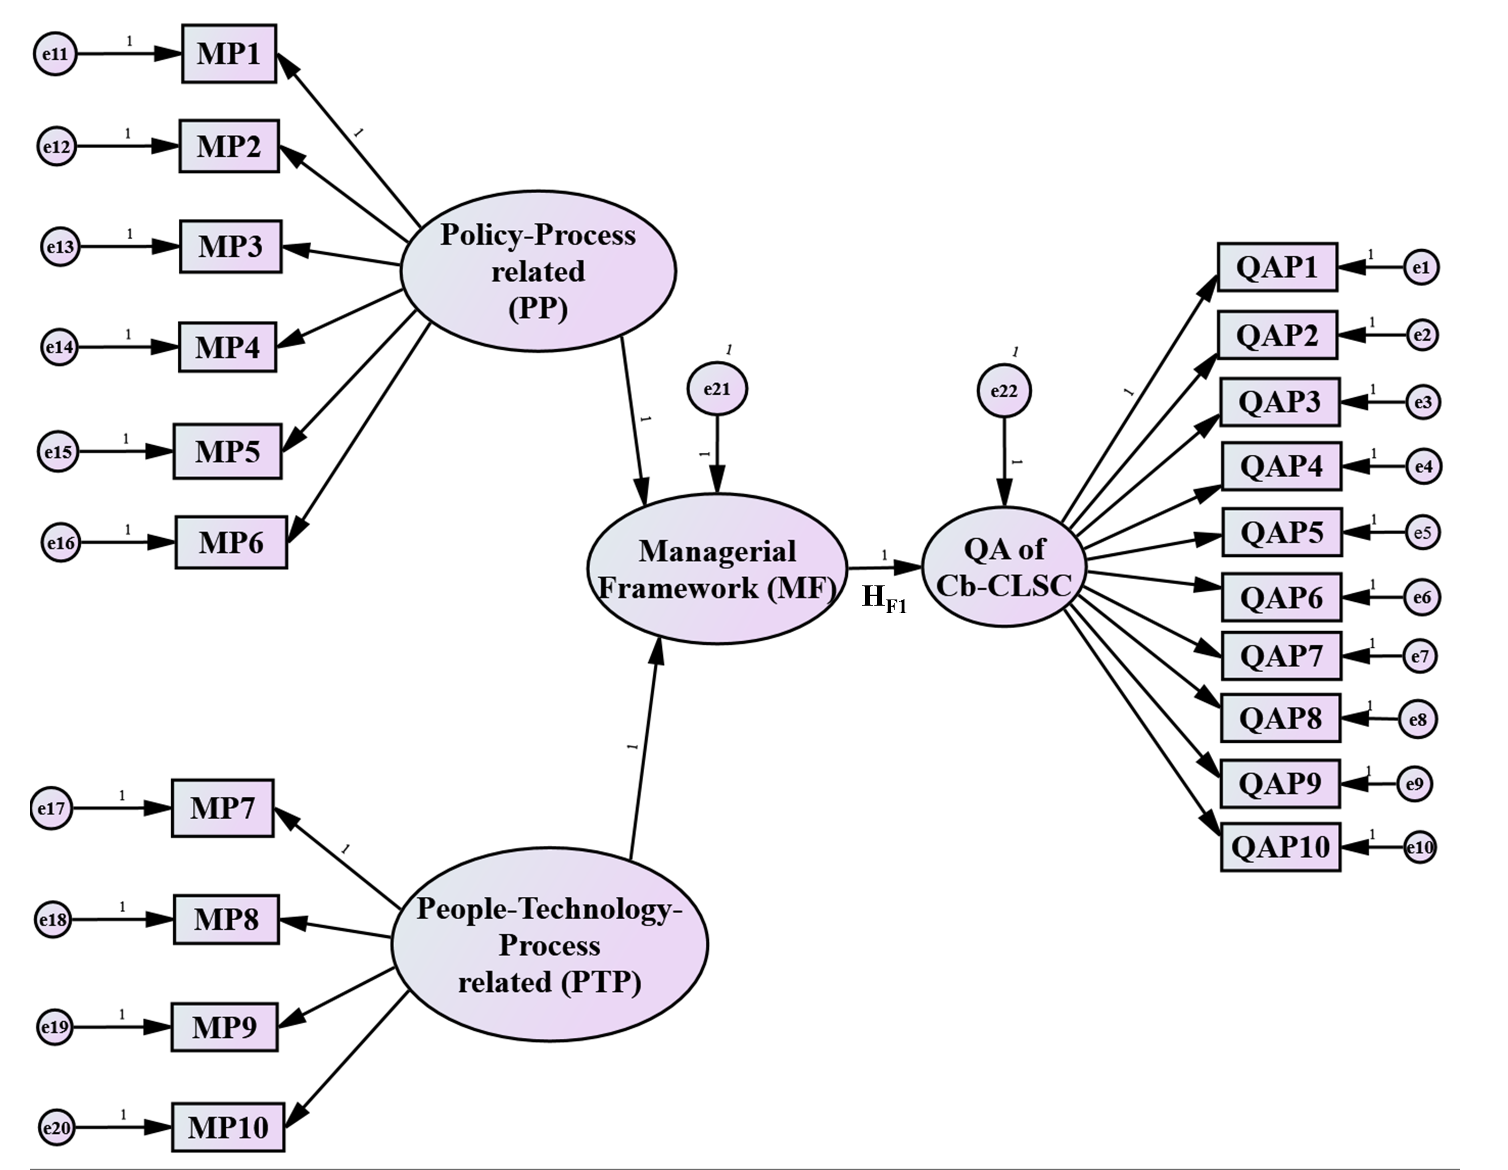
Figure 4: Hypothetical framework (Source: Authors own work)

5.5.3.2 Framework testing
The exploratory nature of the framework considered the factor loading less than 0.300 to be removed or suppressed (Field, 2013). The framework is considered a reflective measurement model; therefore, the average variance extracted (AVE) must be greater than 0.50 (Hair et al., 2010). However, no cross-loading was noted. For this study’s model, reliability assessment is checked by adopting composite reliability (CR), which is denoted as excellent as the CR value exceeds 0.700 (Hair et al., 2010) (see Table 5). The AVE showed acceptable values, except for the PTP construct, which showed slightly below the threshold of 0.5. However, due to the high value of the CR, the study regarded the model as reliable and consistent.
The path coefficient analysis of the framework is examined, and this denoted a strong positive correlation between the latent underlying components (PP and the PTP) based on the correlation threshold by Ratner (2009): between +/-1. Also, a significant path was revealed in the structural model in forming the managerial framework (MF) as the P-value for each underlying latent component was <0.050 using the bootstrapping technique (Anglim, 2014), and the MF also showed a positive influence on the QA. The measurement model exhibited a fairly strong positive correlation regarding the two underlying latent components of the framework. The measurement model of the latent QA of Cb-CLSC also showed a strong positive correlation. No multicollinearity issue was determined as the variance inflation factor (VIF) values were <10 (Salmeron Gomez et al., 2020). Overall, the MF explained 62.8% of the variance concerning the framework on effectively managing the QA amid the pandemic and being effective for the post-pandemic era, i.e., the coefficient of determination (R²) was 62.8%. Thus, the proposed H_{F1} is retained and confirmed with a strong significant positive correlation of 0.792 with a P-value<0.050. This is acceptable, as an appropriate R² ranges from 50% to 99% (Ozili, 2022). Table 5 and Figure 5 show the results after testing the framework using PLS-SEM.
Table 5: Maximum likelihood estimate and value of fit statistics (Source: Authors own work)
Relationship |  |  | CR | AVE | P-value | VIF | R²
- Measurement Model
PP |  | MP1 | 0.887 | 0.568 | 0.003 | - | 0.604
 |  | MP2 |  |  | 0.030 | - | 0.656
 |  | MP3 |  |  | 0.021 | - | 0.573
 |  | MP4 |  |  | 0.006 | - | 0.455
 |  | MP5 |  |  | 0.009 | - | 0.633
 |  | MP6 |  |  | 0.010 | - | 0.485
PTP |  | MP7 | 0.731 | 0.434 | 0.012 |  | 0.144
 |  | MP8 |  |  | 0.011 |  | 0.859
 |  | MP9 |  |  | 0.009 |  | 0.536
 |  | MP10 |  |  | 0.049 |  | 0.197
QAP |  | QAP1 | 0.963 | 0.727 | 0.018 | - | 0.715
 |  | QAP2 |  |  | 0.036 | - | 0.654
 |  | QAP3 |  |  | 0.011 | - | 0.830
 |  | QAP4 |  |  | 0.036 | - | 0.860
 |  | QAP5 |  |  | 0.033 | - | 0.250
 |  | QAP6 |  |  | 0.015 | - | 0.796
 |  | QAP7 |  |  | 0.008 | - | 0.861
 |  | QAP8 |  |  | 0.009 | - | 0.827
 |  | QAP9 |  |  | 0.041 | - | 0.729
 |  | QAP10 |  |  | 0.026 | - | 0.746
- Structural Model
PP |  | MF | - | - | 0.004 | 1.686 | 0.407
PTP |  | MF | - | - | 0.011
MF |  | QA | - | - | 0.008 | 2.688 | 0.628
*Significant at P≤0.050, CA=Composite reliability, CA=Cronbach’s Alpha, AVE=Average Variance Extracted, “-” = Not applicable, P-Value = Two-tailed significance level at 95% confidence level after bootstrapping, VIF = Variance inflation factor, R² = coefficient of determination.

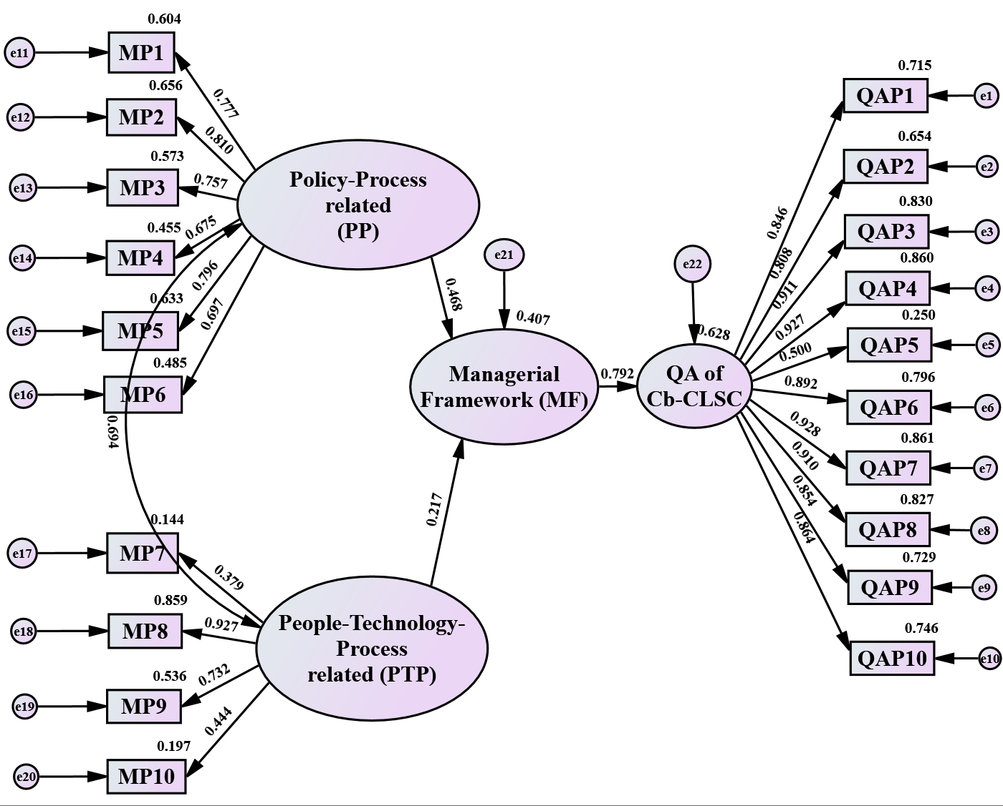
Figure 5: Managerial framework for QA of Cb-CLSC amid the pandemic (Simulation information: 12 iterations, Chi-square = 427.0, df = 170) (Source: Authors own work)

5.6 Further result validation
Content analysis is then conducted on the interview data to understand how the experts have been managing the QA amid COVID-19 concerning the study’s context by considering the experts from the Hong Kong SAR–Mainland China links. The findings are expected to complement and validate the results of the quantitative analysis on the MPs toward the developed framework. The interviewees’ responses are evaluated, and the key points arising show the model’s underlying components, which validate the developed managerial framework. The responses were evaluated with the PPPT framework and determined their alignment with the critical MPs (Appendix K).

6. Discussion

6.1 Criticality of the managerial practices (MPs)
The study revealed the critical MPs to position QA adequately during pandemics through to the post-pandemic era. The central agreement of the experts’ responses on the MPs denoted the three top MPs to consist of the “implementing a digital centralised document and issue management system (MP7) (4.48)”, “implementing digital collaborative inspections with subcontractors and trades (MP8) (4.46)”, and “planning ahead the period of quality assurance with the quarantine days in host countries (MP6) (4.38)”. However, the criticality of the MPs denoted a different set of top three MPs, except MP6, though all the ten MPs were revealed as being critical. The central tendency does not necessarily depict criticality. The top three critical MPs include “strict observance of government regulations (MP1) (0.843)”, “planning ahead the period of quality assurance with the quarantine days in host countries (MP6) (0.793)”, and “modification of contracts to cater for uncertainties (MP4) (0.788)”. The result shows that, in managing the QA activities, observing the government policies related to the pandemic (both host economy and home economy) is critical to ensure a safe environment for workers or experts and confidence in working according to the requirements. This includes adhering to social distancing at the workplace during work execution, observing quarantine, and wearing nose/face masks. The result also supports the mandatory policy of getting vaccinated during the pandemic era, especially for construction workers. This boosts the immune system of workers/experts to be healthy and fit in executing construction works and services efficiently (Yuan et al., 2022) according to quality requirements. The mandatory quarantine policies, which differ from economy to economy, can be incorporated into planning the QA activities to minimise the delays and extra costs which may unexpectedly occur in the QA process. With pandemic policy being critical in managing the QA, the study extends the PPT (people, process, and technology) managerial framework (Witt, 2022) to include policies related to pandemics to achieve effective management of QA during pandemics. This also strengthens safety management in construction as it encourages organisations to advance and reinforce their safety protocols to create a safe environment for workers. Therefore, in case of any future pandemic, organisations are encouraged to consider the policies governing a pandemic to plan adequately to ensure the continuity of QA activities along with the people, processes, and technology implementations.
Considering the economies involved in this study individually, MP6 is regarded as the most critical MP in Hong Kong SAR, while, in Mainland China, the most critical MP is MP1. Between the MP1 and the MP6, a strong positive correlation could be perceived due to their nature of being policy-oriented. This shows that, among the two economies, policies related to the pandemic are critical and are considered appropriately throughout the QA process. Nevertheless, all the 10 MPs were regarded as being critical by the two economies. This implies that experts in the two economies are actively engaging the MPs to ensure the continuity of the QA activities. These MPs have a higher potential of positioning the QA to be adequate for the post-pandemic era and endure the risks of future pandemics, as the results are based on experts’ responses in the field. Hence, the result can be considered by other nations.
No significant disparity was noted among the critical MPs based on the Mann-Whitney test, with a percentage agreement of 53% between the industry and the academia. Hence, the critical MPs can be perceived to reflect the context of this study. Assessing the interrelationships among the MPs also denoted positive correlations, with the majority being significant, at a p-value less than 0.01 or 0.05. This then denotes the MPs to be highly linked and, therefore, must be noted to inform decisions when implementing the MPs. For instance, observing the government regulations during the pandemic positively affects occupational health and safety policies by creating a safe environment for workers throughout the QA process. Another instance is that being current on the travelling regulations in host economies/locations can positively affect the effectiveness of planning QA activities considering the quarantine days. This may minimise the rate of delay and additional costs. The result also shows how the MPs are positively interrelated towards affecting the management of QA activities. The strongest significant correlation exists between “implementing a digital centralised document and issue management system (MP7)” and “implementing digital collaborative inspections with subcontractors and trades (MP8)”, and this may probably be to the adoption of digital technologies throughout the QA process. The result is consistent with Lu et al. (2022) when they developed an e-inspection 2.0 to decentralise inspection data from experts in Mainland China to experts in Hong Kong SAR without travelling physically in-between the borders due to the COVID-19 pandemic. The result can be extended to the positive interrelationship between people, process, policy, and technology in extensively managing the QA activities. This implies that the people, policies regarding the pandemic, processes, and technology are correlated positively towards effectively managing the QA activities. Hence, organisations are encouraged to holistically pay attention and consider the interrelationships between the MPs to inform decisions to effectively position the QA for the post-pandemic era and survive the risks of future pandemics, considering the study’s context.

6.2 Effectiveness of the MPs
The study revealed a good central agreement on the effectiveness of the MPs, as the mean score was above 3, which is noted as a moderate point for measuring the effectiveness in accordance with the measurement scale. Hence, all the MPs were noted to be effective, with the top effective MPs being “implementing digital collaborative inspections with subcontractors and trades (MP8) (4.10)”, followed by “implementing a digital centralised document and issue management system (MP7) (4.06)”, “strict observance to government regulations, including vaccination of workers, social distancing, use of prescribed nose masks, etc. (MP1) (4.06)”, and “planning ahead the period of quality assurance with the quarantine days in host countries (MP6) (4.04)”. However, the effectiveness of the MPs was denoted to be critical, with the top three being the same as the central agreement by the experts.
The result shows that the management of QA activities could be effective amid the pandemic by considering the application of digital technologies along with efficient planning during the period of QA, considering the quarantine days in the host locations. Applying digital technologies has been an effective way of continuing QA activities with minimal physical interactions without travelling to inspect works and service quality in a different location or economy. The effectiveness is achieved more with transparent data by a single source of truth (Lu et al., 2022). The effectiveness also boils up to the observance of government regulations and policies on COVID-19 and integrating them into effective planning of the QA activities (Elabd et al., 2020; Assaad and El-adaway, 2021). This creates a safe environment for workers to execute work and services when vaccinated and strictly adhere to nose/face mask wearing. Integrating regulations such as quarantine days, etc., could help plan against unnecessary delays and additional costs throughout the QA process. Overall, the study revealed no significant disparity among the effectiveness of the MPs based on the Mann-Whitney test. Hence, all the MPs can be truly perceived to be effective amid the pandemic to ensure the continuity of the QA activities. An effective managerial framework could be developed based on the effective MPs and the influence of the PPPT framework.

6.3 The Managerial framework and underlying component of the critical MPs
The study revealed that the critical MPs could be categorised into two main components using exploratory factor analysis based on the experts’ level of agreement. These include component 1: policy-process (PP)-related practices and component 2: people-technology-process (PTP)-related practices. The two components tend to explain 75.155% of the variance. Therefore, a framework with the two components could satisfy in positioning the QA adequately for the post-pandemic era and survive the risks of future pandemics. However, the effectiveness of the proposed framework depends on how effective the critical MPs are in managing the QA amid the pandemic. The study further revealed that the two underlying components (i.e., PP-related practices and PTP-related practices) could positively correlate toward developing a managerial framework that explains 62.8% of the variances in effectively managing the QA amid pandemics and may be adequate for the post-pandemic era. However, the interrelationship between the two components was revealed as 0.694, showing a relatively strong positive correlation. This implies that to effectively manage the QA activities amid the pandemic, the PP-related practices must effectively interact with the PTP-related practices. Consequently, the proposed hypothesis, HF1, is retained and confirmed with a strong significant positive correlation of 0.792 with a P-value<0.050. It is then worthwhile to understand the dynamics of each component and their relationships toward effectively managing the QA amid pandemics, which may transcend to the post-pandemic era.

6.3.1 Component 1: Policy-Process (PP)-Related Practices
Component 1 consists of six critical MPs reflecting the adherence to policies instigated and the work process within which the QA activities are carried out. These include strict observance of government regulations on the pandemic (MP1), adherence to updated occupational health and safety (MP2), smart monitoring of supervision, coordination, and work reviews (MP3), modification of contracts to cater for uncertainties (MP4), keeping up to date on travelling regulations and policies of host countries (MP5), and planning ahead the period of QA with the quarantine days (MP6). To examine the effectiveness, PP-related practices are reflected by MPs denoting R² ranging from 48.5% to 65.6% at P-values<0.050. Overall, PP-related practices effectively contribute to the formulation of the managerial framework with a significant path coefficient of 0.468. The result implies that, if handled appropriately, the PP-related practices have the potency to manage the QA activities effectively.
The continuation of QA activities amid pandemics requires effective management in accordance with the established pandemic policies. For instance, throughout the stages of Cb-CLSC, experts must be vaccinated to ensure they are fit, healthy and protected against the virus (Yuan et al. 2022) whilst executing services to meet quality requirements. This may also include ensuring social distancing among experts/workers and using prescribed nose/face masks to enable safe conditions during work execution (Assaad and El-adaway, 2021) and QA activities. This minimises the spread of the pandemic among the experts and workers at the workplaces. Amid the COVID-19 pandemic, health and safety management have been improved to protect experts and workers. Hence, strict adherence to the updated health and safety regarding the pandemic policies (Davies and Metzler, 2021) also contributes to creating a safe environment for workers and experts throughout the QA process.
Also, the processes of verifying the quality of services and works to achieve quality construction projects have improved through digital technologies. This tends to minimise the physical interactions onsite during the pandemic. As such, the quality of services and works in different locations can be monitored remotely and smartly to ensure that quality product is achieved (AlHanaee and AlHanaee, 2021; Lu et al., 2022). Other effective practices for involving the policies in the QA process amid the pandemic are modifying contracts to be flexible in catering for uncertainties like pandemics, experts keeping themselves updated with the current travelling regulations and policies of host locations, and lastly, planning ahead to be proactive with time and activities to minimise delays and additional costs. Overall, to position the QA to be adequate for the post-pandemic era and survive the risks of future pandemics, organisations must integrate the established policies on the pandemic into the QA processes, considering contract modifications due to the nature of pandemics, which could be force majeure. This may ensure safe environmental conditions for experts/workers to execute works and QA tasks with effective planning and proactiveness. Among the PP-related practices, the strongest significant positive correlation existed between MP1 and MP6, denoting the integration of the pandemic policies into the QA process, considering it from the planning stage. For instance, considering the number of quarantine days to be spent by experts at different host locations in the planning stage could be a good strategy to provide attendance to minimise unexpected future delays and cost additions throughout the QA process. Overall, the correlations among the MPs are all positive, also denoting how the related MPs would be coherent in managing the QA amid the pandemic.
The PP-related practices could especially be considered during pandemics, where organisations will need to integrate the pandemic-related policies into the planning of work and QA activities to minimise the emergent risks and create safe environmental conditions throughout the QA process. This may include updating the existing occupational health and safety policies with new items to create safe environments amid the pandemic (Sadeh et al., 2023; Kum et al., 2023). However, augmenting the health and safety policies due to the pandemic could improve safety management in the construction industry even after the pandemic. This could help ensure smooth management of QA activities of cross-border projects.

6.3.2 Component 2: People-Technology-Process (PTP)-Related Practices
Component 2 consists of practices that reflect how people, technology, and processes can coherently contribute to managing the QA amid the pandemic, position it for the post-pandemic era and survive the risks of future pandemics. These include implementing a digital centralised document and issue management system (MP7), implementing digital collaborative inspections with subcontractors and trades (MP8), assigning quality assurance tasks to multiskilled experts/workers to avoid the frequent change of persons on work (MP9), and cost-cutting (MP10). With the effectiveness of the MPs on QA, the study revealed the PTP-related practices to reflect by MPs denoting R² ranging from 14.4% to 85.9% at P-values<0.050. However, the PTP-related practices contribute to the managerial framework formulation with a significant path coefficient of 0.217.
PTP-related practices involve leveraging the adopted digital technologies to manage works and QA activities throughout the process, considering the experts involved. For instance, digital technologies, such as BIM, cloud computing, etc., can be used to centralise the accessibility of information to experts from different locations. This tends to minimise the travelling options during the pandemic, which is unethical. Hence, BIM can be adopted to ensure collaborative inspection among multiskilled experts and workers on sites from different remote locations. As data records are critical in the QA process, data transparency is important; hence, blockchain can be adopted (AlHanaee and AlHanaee, 2021; Lu et al., 2022) due to the technology’s tendency to check a single source of truth. Digital collaborative inspection among experts can assure effective collaboration and communication while minimising the physical interactions throughout the QA process (Yang et al., 2023; Yan and Li, 2023). Therefore, verification of works and services towards meeting quality requirements could be done remotely across economies. Another important aspect to consider in managing QA to be adequate considering this study’s context is the individual experts involved. This includes construction workers and quality front-liners, such as quality auditors, quality engineers, quality managers, etc. However, other construction workers who play an important role in ensuring the quality is met are included. This includes the construction manager, supervisor, and immediate site workers. This is because QA is process-oriented, and it is everyone’s responsibility, though there are front-liners to verify services and products. To make QA adequate during pandemic, tasks must be assigned to well-qualified and experienced multiskilled experts to avoid the frequency of change of experts/persons on work (Araya, 2022). This can minimise the reworks and quality verification rate that may require experts travelling across economies during pandemics. Engaging the multiskilled experts can transcend to the post-pandemic era in employing workers and experts who are multi-talented in performing services and works to reduce the rate of reworks.
Lastly, organisations may also involve activities that may reduce costs throughout the QA process in the study’s context. This may include the engagement of multiskilled workers and experts to reduce the rate of employing more experts/workers for the QA activities. This can also transcend to the post-pandemic era, where organisations will tend to have the most efficient workers/experts throughout the QA process to perform services and work to meet quality requirements. The study revealed the strongest significant correlation between MP7 and MP8 (0.964), which are related to the integration of digital technologies to manage QA activities. For instance, implementing a digital decentralised document and issue management system in the QA process tends to promote effective collaboration and communication among quality inspectors and workers on the field. This could be achieved by adopting and implementing BIM, the Internet of Things (IoT), etc., along with blockchain to ensure transparency and a single source of truth (Lu et al., 2022). Overall, positive correlations were all realised among all the MPs under component 2, denoting how consistent they could be in positioning the QA to be adequate for the post-pandemic era and endure the risks of future pandemics.
The PTP practices improve the QA activities in both the pandemic and post-pandemic era. In the pandemic era, balancing the multiskilled workers with the processes and the technologies adopted could ensure the continuity of the QA activities with minimal physical interactions, which may minimise the spread of the pandemic. However, for the post-pandemic era, balancing the PTP-related practices could still consistently improve the adequacy of the QA activities and work process. Therefore, it is worth noting that the anticipated managerial framework could still position the QA to be adequate even after the pandemic.

6.3.3 Revised managerial framework
The initial proposed managerial framework consisted of 15 individual MPs, categorised into four elements: people, process, policy, and technology, considering the influence of the PPT managerial framework. The new element added is the policy. As per the empirical evidence, which commenced from the pilot stage, only 10 MPs were verified and tested. The 10 MPs were still grouped into four elements, being consistent with elements, such as the people, process, policy, and technology. The reason behind the policy is linked to the pandemic measures established by the government and organisations to create a safe environment and protect workers. Based on the empirical result from the survey, the 10 MPs were confirmed as being critical and could effectively position the QA to be adequate in the pandemic era and survive the risks of future pandemics. Based on the experts’ level of agreement, the MPs were categorised into two underlying components (PP-related practices and PTP-related practices). Consequently, the framework is complemented and revised further with the interview data. This helped in redefining and validating the MPs in the managerial framework.
The specific interview responses from the experts were consistent with the proposed elements of the managerial framework (people, process, policy, and technology), which could be regrouped into PP-related practices and PTP-related practices. As such, the initial proposed framework is updated with new MPs, including real-time quality testing and inspection via intelligent systems and engaging extra skilled experts stationed in host economies to perform the quality checks/supervision. With “people”, the result reinstated the need for multiskilled and experienced persons to perform works, services, and QA activities throughout the phases of Cb-CLSC during the pandemic and post-pandemic era. The “process”, which may be a work process or a QA process, is also considered in that organisations need to effectively plan for the material and other resources to minimise the impact of the pandemic on production tasks (Gumusburun Ayalp and Civici, 2023; Li et al., 2023; Sutterby et al., 2023). This could be reasonably purchasing more raw materials for production purposes. This practice may transcend to the post-pandemic era by encouraging effective planning of QA activities, especially when it involves travelling in-between borders and procurement of raw materials from different economies.
Another consideration was focused on the “technology”, which received a high adoption rate amid the pandemic. Throughout the QA process, real-time quality testing through an intelligent system is promoted. As such, various digital technologies have been implemented to provide an online/virtual platform to enhance coordination and communication between economies and minimise the rate of physical interactions. The adoption of digital technologies is not only useful in the pandemic era but could also transcend to the post-pandemic era to reduce the rate of travelling cost, as well as assure high productivity concerning time. Again, one important element to consider is the “policy”, which relates to the pandemic regulations in minimising the spread of the pandemic and creating a safe environment for workers throughout the QA process. This could be government or organisation-based safety policy concerning the pandemic. Analysing the interview data denoted the relevance of adhering to the COVID-19 regulations. Experts reinstated that by hammering on incorporating the pandemic regulations into planning QA activities and regular onsite works. This practice has the potency of minimising unexpected delays and extra costs that may incur while encouraging proactiveness in QA. Adhering to pandemic-related policies greatly influences safety management in construction organisations, and this could also transcend to creating a safe environment to carry out QA activities in the post-pandemic era.
The revised managerial framework, therefore, acknowledges the significance and criticality of the MPs in influencing the critical areas of QA. Accordingly, the four elements, namely people, process, policy, and technology, are thus considered along with the two underlying components (PP-related practices and PTP-related practices). Interestingly, positive interrelationships were realised among all the MPs even when grouped under the four elements: people, process, policy, and technology. This depicts the coherence among the MPs towards formulating the managerial framework to position the QA to be adequate for the post-pandemic era and endure the risks of future pandemics. This considers the positive correlation between PP-related practices and PTP-related practices, strengthening the managerial framework to be relevant and reliable for the post-pandemic era and during future pandemics. The revised managerial framework is presented in Figure 6.
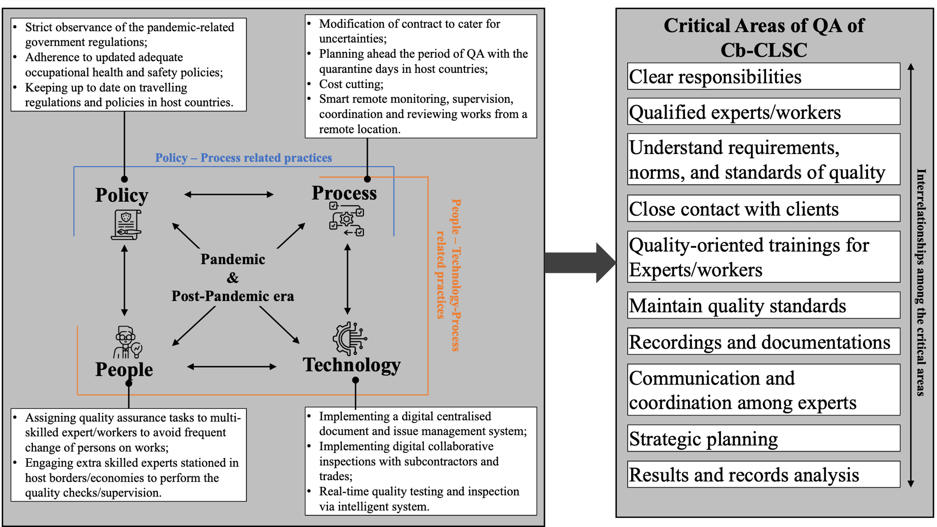
Figure 6: The revised managerial framework for adequate QA of Cb-CLSC during pandemics through to the post-pandemic era (Source: Authors own work)

7. Theoretical, practical, and methodological implications
From a theoretical perspective, the findings of this study enrich the extant literature on QA, Cb-CLSC, and the COVID-19 pandemic in the construction industry by identifying the critical MPs towards a managerial framework for positioning QA to be adequate amid pandemics and post-pandemic era. The framework developed by this study is anticipated to effectively position the QA adequately during pandemics through to the post-pandemic era by balancing the relationship between the multiskilled experts/workers, the QA/work process, established pandemic policies, and the adopted digital technologies. This is achieved by effectively and holistically considering the PP-related practices and PTP-related practices in managerial decision-making. The result could also direct researchers with management knowledge that can help to position the QA to be adequate for the post-pandemic era and endure the risks of future pandemics. The study again contributes to the effective approaches and theories in literature in ensuring adequate QA of cross-border construction projects amid pandemic crises and the post-pandemic era. Overall, the study contributes to the success of quality project management during pandemics.
Practically, the study provides valuable lessons from the COVID-19 pandemic and contributes to informing policies and decisions on adequately positioning QA amid pandemics. This is achieved by identifying the effective and critical MPs to ensure the continuity of QA activities of Cb-CLSC and their adequacy during pandemics and post-pandemic era. The originally innovative managerial framework developed by this study could guide practitioners and experts in providing confidence in assuring the quality of cross-border construction projects and even local projects in times of pandemics. The findings can guide practitioners to execute work and services to meet quality requirements effectively and monitor and inspect the quality of related project activities from a remote location during pandemics through to the post-pandemic era. The valuable insight from this study could also empower organisations to balance the technicality of the digital technologies being adopted for QA with the experts, the processes, and the pandemic policies in managing QA amid pandemics. This could be achieved by optimising the two main components (PP-related and PTP-related practices), as revealed by this study, to inform managerial decision-making on positioning the QA adequately during pandemics and the post-pandemic era.
From a methodological perspective, the study pragmatically combines methods, including the literature review, expert survey, and expert interviews in a compelling case study, and performing analysis using sentiment analysis, quantitative analysis, and content analysis via an embedded mixed method approach. The effectiveness of the approach is highlighted, where the quantitative data analysis integrated with PLS-SEM is supplemented with qualitative data to generate a comprehensive understanding of how to effectively position the QA of Cb-CLSC to be adequate for the post-pandemic and during future pandemics. Overall, the study enriches the literature by adding the adopted methodology in construction management, particularly in the field of project quality management.

8. Conclusion
The construction industry needs to strategise innovatively to ensure the continuity of QA activities with more adequacy during the pandemic through to the post-COVID-19 era. This study developed a managerial framework to position the QA of Cb-CLSC during pandemics and post-pandemics by taking lessons from how COVID-19 has impacted the existing QA systems and has been managed successfully. This was achieved through an embedded mixed-method design consisting of a literature review, survey, and interview from experts within the Hong Kong SAR-Mainland China links, typically known as the world’s factory. The design is further integrated with the PLS-SEM approach.
The study revealed 10 critical managerial practices (MPs) to position the QA to be adequate for the post-pandemic and during future pandemics, with the top three including “strict observance of government regulations (MP1)”, “planning ahead the period of quality assurance with the quarantine days in host countries (MP6)”, and “modification of contract to cater for uncertainties (MP4)”. However, positive correlations are noted among all the 10 critical MPs. Further revelations show that MPs are effective in positioning the QA to be adequate for the post-pandemic era and during pandemics, but the top four regarded as being very effective are “implementing digital collaborative inspections with subcontractors and trades (MP8)”, “implementing a digital centralized document and issue management system (MP7)”, “strict observance to government regulations, including vaccination of workers, social distancing, use of prescribed nose masks, etc. (MP1)”, and “planning ahead the period of quality assurance with the quarantine days in host countries (MP6)”. Two underlying components of the MPs are policy-process (PP)-related practices and people-technology-process (PTP)-related practices, and these can be modelled into a managerial framework capable of explaining 75.155% of the variance in positioning the QA to be adequate. The two underlying components positively correlate toward developing a managerial framework that explains 62.8% of the variances in effectively managing the QA during pandemics and during the post-pandemic era. Overall, the managerial framework to effectively position the QA to be adequate during a pandemic and post-pandemic is related to four elements: (1) people (multiskilled experts), (2) process (work/QA process), (3) policy (pandemic related policies), and (4) technology. These are further sub-categorised into policy-process (PP) related practices and people-technology-process (PTP) related practices.
The findings of this study depict significant theoretical and practical contributions to the proactive management of QA activities during pandemics through to the post-pandemic era. It could empower organisations to pay attention to smartly and innovatively balancing people, processes, pandemic policy, and technology to inform decisions to effectively position the QA for the post-pandemic era and survive the risks of future pandemics.
The study is associated with limitations worth mentioning in terms of the result generalisation and the interpretations. The findings relied on a relatively small sample size, and this could affect the generalisation of the findings. Also, the limitation can be attributed to the fact that many of the interview participants have 5 or less years of experience. However, due to the specific experts needed to participate in this study and the rigorous validations conducted, the researchers considered the sample size to be appropriate due to the mixed method adopted involving opinions of participants having experience of 5 – 10 years and 11 – 20 years of experience. Also, the study chose the case of the “world factory” engaging the Hong Kong SAR–Mainland China links, involving experts in the QA team consisting of the quality engineer, quality auditor, quality assurance officer, quality control officers, authorised government representative, project manager, related academicians, and other relevant participants that play an important role in the QA processes. Though the data is limited to Hong Kong SAR and Mainland China, the results are based on the viewpoint of experts in the field of construction QA. Hence, the findings could be reliable in guiding decisions and policymaking in other economic contexts concerning QA during the pandemic. However, studies from other economies can add insight from varied international perspectives taking inspiration and lessons from the Hong Kong SAR–Mainland China links; hence, future study is encouraged.

References
Adabre, M.A., Chan, A.P., Darko, A., Osei-Kyei, R., Abidoye, R. and Adjei-Kumi, T., 2020. Critical barriers to sustainability attainment in affordable housing: International construction professionals’ perspective. Journal of Cleaner Production, 253, p.119995.
AlHanaee, N. and AlHanaee, T. (2021). Smart Contract Using Blockchain in Construction and Infrastructure Sector in the COVID-19 Pandemic. In ISARC. Proceedings of the International Symposium on Automation and Robotics in Construction, 38, pp. 1018-1024). IAARC Publications.
Anderson, J.C. and Gerbing, D.W. (1988). Structural equation modelling in practice: A review and recommended two-step approach. Psychological Bulletin, 103(3), p.411.
Anglim, J. (2014). Rule of thumb for number of bootstrap samples, https://shorturl.at/aszBG.
Araya, F. (2021). Modelling working shifts in construction projects using an agent-based approach to minimize the spread of COVID-19. Journal of Building Engineering, 41, p.102413.
Araya, F. (2022). Modelling the influence of multiskilled construction workers in the context of the COVID-19 pandemic using an agent-based approach. Revista de la Construcción. Journal of Construction, 21(1), pp.105-117.
ASQ (2015) What is iso 9001:2015 – quality management systems? https://asq.org/quality-resources/iso-9001.
Assaad, R. and El-Adaway, I.H. (2021). Guidelines for responding to COVID-19 pandemic: Best practices, impacts, and future research directions. Journal of Management in Engineering, 37(3), p.06021001.
Bajpai, P. (2022), Why China Is “The World’s Factory”, Investopedia, https://www.investopedia.com/articles/investing/102214/why-china-worlds-factory.asp#:~:text=In%20addition%20to%20its%20low,duties%2C%20and%20competitive%20currency%20practices.
Baker, M.G., Peckham, T.K. and Seixas, N.S. (2020). Estimating the burden of United States workers exposed to infection or disease: a key factor in containing risk of COVID-19 infection. PloS one, 15(4), p.e0232452.
Barbosa, F., Woetzel, J. and Mischke, J. (2017). Reinventing construction: A route of higher productivity. McKinsey Global Institute.
Barclay, D.W., Higgins, C.A. and Thompson, R. (1995), The partial least squares approach to causal modeling: personal computer adoption and use as illustration, Technology Studies, 2(2), pp. 285-309.
Bentler, P.M. and Wu, E.J. (2005), EQS 6.1 for Windows, Multivariate Software, Encino, CA.
Cabaniss, K. (2002). Computer-related technology use by counselors in the new millennium: A Delphi study. Journal of Technology in Counseling, 2(2).
CDC (2017). Quarantine and isolation. 2017. https://www.cdc.gov/quarantine/index.html.
Chan, A.P.C., Darko, A. and Ameyaw, E.E. (2017). Strategies for promoting green building technologies adoption in the construction industry—An international study. Sustainability, 9(6), p.969.
Chung, H.W. (2002). Understanding quality assurance in construction: a practical guide to ISO 9000 for contractors. Routledge.
Cleave, P. 2020, What Is a Good Survey Response Rate? https://www.smartsurvey.co.uk/blog/what-is-a-good-survey-response-rate#:~:text=By%20contrast%2C%20a%20survey%20response,relationship%20between%20the%20business%20and.
Creswell, J. W., and Clark, V. L. P. (2017). Designing and conducting mixed methods research. Sage publications.
Deep, S., Joshi, R. and Patil, S. (2023), "Identifying the Contractor’s core competencies in post-COVID-19 scenario: developing a survey instrument", Engineering, Construction and Architectural Management, Vol. 30 No. 9, pp. 3781-3797.
de Winter, J.C., Dodou, D.I.M.I.T.R.A. and Wieringa, P.A. (2009). Exploratory factor analysis with small sample sizes. Multivariate Behavioral Research, 44(2), pp.147-181.
Designbuildings (2021). Desk Study, https://www.designingbuildings.co.uk/wiki/Desktop_study.
Dworkin, S.L. (2012). Sample size policy for qualitative studies using in-depth interviews. Archives of sexual behaviour, 41(6), pp.1319-1320.
Edmonds, W., and Kennedy, T. 2017. Embedded Approach. SAGE Publications, Inc, https://doi.org/10.4135/9781071802779.
Elabd, N.M., Mansour, Y.M. and Khodier, L.M. (2020). Social distancing in construction: investigating the role of technologies in supporting remote management. Journal Of Engineering and Applied Sciences, 67(8), pp.2073-2091.
Field, A. (2013). Discovering statistics using IBM SPSS statistics. 4th, London, sage.
Flanagan, R., Lu, W., Shen, L. and Jewell, C. (2007). Competitiveness in construction: a critical review of research. Construction Management and Economics, 25(9), pp.989-1000.
Ghansah, F.A. and Lu, W., (2023). Responses to the COVID-19 pandemic in the construction industry: a literature review of academic research. Construction Management and Economics, pp.1-23.
Ghansah, F.A., Lu, W. and Ababio, B.K. (2023) Quality assurance of cross-border construction logistics and supply chain during the COVID-19 pandemic: evidence from the Hong Kong–Mainland China links, International Journal of Logistics Research and Applications, https://doi.org/10.1080/13675567.2023.2221180.
Ghansah, F.A., Chen, J. and Lu, W., (2022). Developing a user perception model for smart living: A partial least squares structural equation modelling approach. Building and Environment, p.109399.
Goh, Y.M., Tian, J. and Chian, E.Y.T. (2022). Management of safe distancing on construction sites during COVID-19: A smart real-time monitoring system. Computers & Industrial Engineering, 163, p.107847.
Gumusburun Ayalp, G. and Çivici, T. (2023), "Factors affecting the performance of construction industry during the COVID-19 pandemic: a case study in Turkey", Engineering, Construction and Architectural Management, Vol. 30 No. 8, pp. 3160-3202.
Hair, J.F., Black, W.C., Balin, B.J., and Anderson, R.E. (2010), Multivariate Data Analysis, Maxwell Macmillan International Editions, https://doi.org/10.1007/978-3-642-04898-2_395.
Hair, J.F., Risher, J.J., Sarstedt, M. and Ringle, C.M., 2019. When to use and how to report the results of PLS-SEM. European Business Review, 31(1), pp.2-24.
Idrus, A.B. (2001). Development of a procedure and tool for evaluating and selecting concrete floor systems for concrete frame buildings (Doctoral dissertation, Imperial College London (University of London)).
Harrison, F. and Lock, D. (2017). Advanced project management: a structured approach. Routledge.
ISO (1994) Quality management and quality assurance—Vocabulary, International Organization for Standardization.
Khalef, R., Ali, G.G., El-adaway, I.H. and Gad, G.M. (2022). Managing construction projects impacted by the COVID-19 pandemic: a contractual perspective. Construction Management and Economics, 40(4), pp.313-330.
Khan, R. (2022). People, Process, Technology: The Framework for Workforce Management, https://www.allnewbusiness.com/people-process-technology/.
Kline, R.B. (2023). Principles and practice of structural equation modelling. 5th edition, Guilford publications, New York.
Kum, Y.T., Yap, J.B.H., Lew, Y.-L. and Lee, W.P. (2023), Transforming construction health and safety management during COVID-19 pandemic using innovative technologies: PLS-SEM approach, Engineering, Construction and Architectural Management, https://doi.org/10.1108/ECAM-08-2022-0780.
Li, Z., Jin, Y., Li, W., Meng, Q. and Hu, X. (2023), Impacts of COVID-19 on construction project management: a life cycle perspective, Engineering, Construction and Architectural Management, Vol. 30 No. 8, pp. 3357-3389.
Lu, W., Wu, L., Xu, J. and Lou, J. (2022). Construction E-Inspection 2.0 in the COVID-19 Pandemic Era: A Blockchain-Based Technical Solution. Journal of Management in Engineering, 38(4), p.04022032.
Lu, W., Lou, J. and Wu, L. (2023). Combining Smart Construction Objects–Enabled Blockchain Oracles and Signature Techniques to Ensure Information Authentication and Integrity in Construction. Journal of Computing in Civil Engineering, 37(6), p.04023031.
Mawhinney, M. (2008). International construction. John Wiley & Sons.
McClenaghan, E. (2022), Mann-Whitney U Test: Assumptions and Example, https://www.technologynetworks.com/informatics/articles/mann-whitney-u-test-assumptions-and-example-363425.
Muheeb, B. (2021), Literature Review / Desk Research: The Research Roadmap, https://www.linkedin.com/pulse/literature-review-desk-research-roadmap-bashir-muheeb.
OECD (2020), The territorial impact of COVID-19: Managing the crisis across levels of government, https://www.oecd.org/coronavirus/policy-responses/the-territorial-impact-of-covid-19-managing-the-crisis-across-levels-of-government-d3e314e1/.
Ogunnusi, M., Hamma-Adama, M., Salman, H. and Kouider, T. (2020). COVID-19 pandemic: the effects and prospects in the construction industry. International journal of real estate studies, 14(Special Issue 2).
Okpala, D.C. and Aniekwu, A.N. (1988). Causes of high costs of construction in Nigeria. Journal of Construction Engineering and Management, 114(2), pp.233-244.
Onubi, H.O., Yusof, N., Hassan, A.S. and Bahdad, A.A.S. (2023b), Forecasting the schedule performance resulting from the adoption of social distancing in construction projects, Engineering, Construction and Architectural Management, Vol. ahead-of-print No. ahead-of-print.
Onubi, H.O., Hassan, A.S., Yusof, N. and Bahdad, A.A.S. (2023a), Moderating effect of project size on the relationship between COVID-19 safety protocols and economic performance of construction projects, Engineering, Construction and Architectural Management, Vol. 30 No. 6, pp. 2206-2230.
Ott, R. L., and M. T. Longnecker. 2015. An introduction to statistical methods and data analysis. Toronto: Nelson Education.
Pallant, J. (2001). SPSS survival manual: A step-by-step guide to data analysis using SPSS for Windows (versions 10 and 11): SPSS student version 11.0 for Windows. Open University Press.
Peng, D.X. and Lai, F., 2012. Using partial least squares in operations management research: A practical guideline and summary of past research. Journal of Operations Management, 30(6), pp.467-480.
Plutora (2022). People, Process, Technology: The PPT Framework, Explained, https://www.plutora.com/blog/people-process-technology-ppt-framework-explained#:~:text=It%20helps%20to%20map%20the,optimize%20operations%20and%20ship%20faster.
PMBOK (2021), A Guide to the Project Management Body of Knowledge (PMBOK Guide) – and the Standard for Project Management, Project Management Institute, 7th Edition, Inc. USA.
Raoufi, M. and Fayek, A.R. (2022). New modes of operating for construction organizations during the COVID-19 pandemic: Challenges, actions, and future best practices. Journal of Management in Engineering, 38(2), p.04021091.
ReQtest (2016). Quality Assurance vs Quality Control: Know the Differences, https://reqtest.com/testing-blog/quality-assurance-vs-quality-control-differences-2/#:~:text=Quality%20assurance%20focuses%20on%20the,to%20the%20product%20being%20developed.
Ribeirinho, M. J., Mischke, J., Strube, G., Sjödin, E., Blanco, J. L., Palter, R., Biörck, J., Rockhill, D., and Andersson, T. (2020). The next normal in construction: How disruption is reshaping the world’s largest ecosystem, https://www.mckinsey.com/industries/capital-projects-and-infrastructure/ourinsights/the-next-normal-in-construction-how-disruption-is-reshaping-the-worlds-largest-ecosystem#.
Sadeh, H., Mirarchi, C., Shahbodaghlou, F. and Pavan, A. (2023), "Predicting the trends and cost impact of COVID-19 OSHA citations on US construction contractors using machine learning and simulation", Engineering, Construction and Architectural Management, Vol. 30 No. 8, pp. 3461-3479.
Sharma, M., Luthra, S., Joshi, S. and Kumar, A. (2022). Developing a framework for enhancing survivability of sustainable supply chains during and post-COVID-19 pandemic. International Journal of Logistics Research and Applications, 25(4-5), pp.433-453.
Sloan, L., and Angell, R. (2015). Learn about Spearman’s-order correlation coefficient in SPSS with data from the general social survey (2012): income and political influence. In SAGE Research Methods Datasets Part 1. SAGE Publications, Ltd.
Soliman, E., Al-Tabtabai, H., Almusalam, A. and Hussein, M. (2022). Impact of COVID-19 on labour’s motivational factors and construction productivity. International Journal of Construction Management, pp.1-10.
Sutterby, P., Wang, X., Li, H.X. and Ji, Y. (2023), "The impact of COVID-19 on construction supply chain management: an Australian case study", Engineering, Construction and Architectural Management, Vol. 30 No. 8, pp. 3098-3122.
Thorpe, B. and Sumner, P. (2017). Quality assurance in construction. Routledge.
Usakli, A. and Kucukergin, K.G. (2018). Using partial least squares structural equation modelling in hospitality and tourism: do researchers follow practical guidelines? International Journal of Contemporary Hospitality Management, 30(11), pp.3462-3512.
Wang, W., Gao, S., Mi, L., Xing, J., Shang, K., Qiao, Y., Fu, Y., Ni, G. and Xu, N., (2021). Exploring the adoption of BIM amidst the COVID-19 crisis in China. Building Research & Information, 49(8), pp.930-947.
WHO (2020). COVID-19 Dashboard. Geneva: World Health Organization, https://covid19.who.int/.
WHO (2021). WHO Quality assurance policy for the procurement of essential medicines and other health products, https://www.who.int/publications/i/item/9789240023789.
Witt, B. (2022). The Foundation of Successful WFM: People, Process, Technology, https://www.procore.com/jobsite/the-foundation-of-successful-wfm-people-process-technology/.
Wulandhari, N.B.I., Budhwar, P., Mishra, N., Akbar, S., Do, Q. and Milligan, G. (2022). Organisational resilience to supply chain risks during the COVID‐19 pandemic. British Journal of Management.
Yan, X. and Li, T. (2023), "Construction and application of urban digital infrastructure—practice of “Urban Brain” in facing COVID-19 in Hangzhou, China", Engineering, Construction and Architectural Management, Vol. 30 No. 8, pp. 3123-3141.
Yang, L., Lou, J., Zhou, J., Zhao, X. and Jiang, Z. (2023), "Complex network-based research on organization collaboration and cooperation governance responding to COVID-19", Engineering, Construction and Architectural Management, Vol. 30 No. 8, pp. 3749-3779.
Yuan, Z., Hsu, S.C., Cheung, C. and Asghari, V. (2022). Effectiveness of Interventions for Controlling COVID-19 Transmission between Construction Workers and Their Close Contacts. Journal of Management in Engineering, 38(3).
Zhan, S. (2022). Exploring synergies between lean construction theory and industry 4.0 technologies in the architectural, Engineering and Construction industry: A people, process, technology perspective. Results in Engineering, 14, p.100405.
Zhang, X. (2005). Critical success factors for public-private partnerships in infrastructure development. Journal of Construction Engineering and Management, 131(1), pp.3-14.
Zhao, X., Hwang, B.G. and Lee, H.N., 2016. Identifying critical leadership styles of project managers for green building projects. International Journal of Construction Management, 16(2), pp.150-160.

