Michael Sampson
A guide to airway management
British Journal of Cardiac Nursing, March 2021, Vol 16, No 3. https://doi.org/10.12968/bjca.2020.0093
This is the accepted manuscript version of a published work that appeared in final form in the British Journal of Cardiac Nursing, copyright (c) MA Healthcare, after technical editing by the publisher. To access the final edited and published work see https://www.magonlinelibrary.com/ https://doi.org/10.12968/bjca.2020.0093. Originally published March 2021.

Abstract
A patent airway linking the nose and mouth with the lungs is essential to life. Critically ill people often experience airway difficulties for reasons including alterations in consciousness, the use of sedating medications, and inflammatory changes within the airway. Airway management is therefore a core skill for any clinician caring for critically ill people. This article briefly reviews the anatomy and physiology of the airway before moving on to consider causes of airway obstruction. A look-listen-feel approach to airway assessment is described, followed by a discussion of techniques used to clear, open and maintain the airway. Commonly used airway devices including oropharyngeal, nasopharyngeal and supraglottic airways are evaluated, and their indications and insertion techniques discussed. The role of the endotracheal tube in the critically ill person is also considered.

Introduction
The term airway describes the anatomical structures that join the nose and mouth to the lungs (Marieb and Hoehne, 2016). A patent airway is essential to life; if air cannot reach the lungs, death occurs within minutes (Resuscitation Council UK, 2016). Problems with the airway are common in acute areas of care, and especially so when patients are critically ill. Patients in critical care areas are often at high risk of airway compromise due to changes in neurological function, the administration of sedative and analgesic drugs, and underlying disease processes (Ringdal and Gullick, 2019). They are also more likely to suffer cardiac arrest, or to require mechanical ventilation, both of which demand advanced airway management techniques.
In this article we evaluate key aspects of airway management relevant to critical care nursing. These include the principal causes of airway obstruction, simple manoeuvres that can restore air flow, and devices used to maintain airway patency. We start with a brief review of the anatomy and physiology of the airway, with a focus on those features relevant to airway management.

Anatomy and physiology
The airway can de divided into two parts: the upper and the lower (figures 1 and 2). The upper airway includes the oral and nasal cavities, the pharynx and the larynx, while the major parts of the lower airway are the trachea, bronchi, bronchioles and alveoli (Ball et al, 2019).
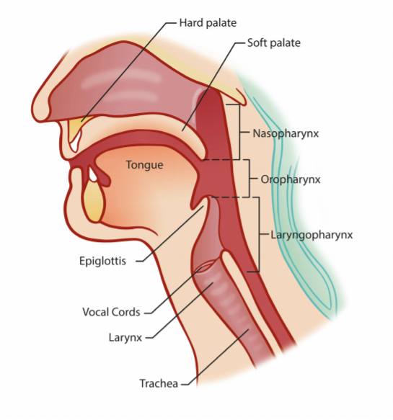
Figure 1. Anatomy of the upper airway

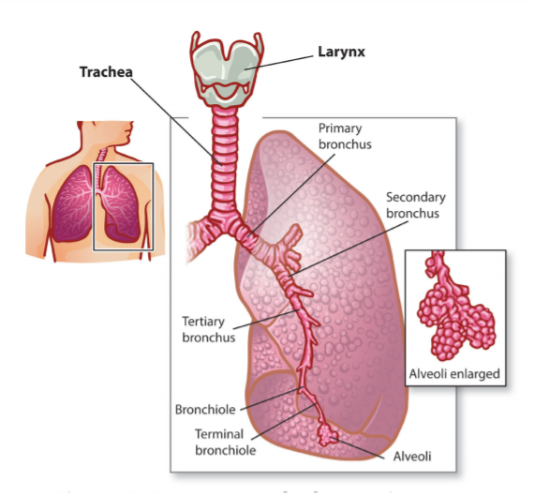
Figure 2. Anatomy of the lower airway

During normal quiet breathing, air is drawn in through the nostrils and passes through the nasal cavity into the pharynx (Marieb and Hoehne, 2016). The mucosa lining the cavity has a rich blood supply; as a result, the air is warmed and humidified as it flows across it. This effect is enhanced by the structure of the cavity, which is divided in two by the nasal septum, and has scroll-like projections called turbinates that protrude from its walls (Sahin-Yilmaz and Naclerio, 2011). These features increase the surface area of the nasal cavity, and promote turbulent airflow, increasing the contact between the air and the nasal mucosa (Tortora and Dickinson, 2017).
The nose also filters the air flowing through it (Marieb and Hoehne, 2016). Coarse hairs in the nostrils trap large particles, whilst dust and microorganisms are caught in mucous produced by the nasal mucosa. These cells are also ciliated; the cilia sweep the mucous backwards to the pharynx, where it is swallowed or expectorated (Marieb and Hoehne, 2016). Ciliated mucosa is found throughout the airway, and is an important feature protecting the lung from infection.
In normal health, the nose can sustain an air flow of 20 to 30 litres per minute (Sahin-Yilmaz and Naclerio, 2011). If the nose is blocked, for example by inflammation, or if greater air flow is required during exertion or illness, air is also drawn in through the mouth. Mouth breathing bypasses the warming, humidifying, filtering effects of the nose; as a result, colder, dryer, unfiltered air enters the pharynx. This has a desiccating effect on the airway and impairs the action of cilia; mucous clearance is reduced and the risk of pathogens reaching the lungs increases (Totora and Dickinson, 2017). Ventilation via an advanced airway such as an endotracheal tube has a similar effect unless measures are taken to filter and humidify inspired gases (Rose and Paulus, 2019).
From the nose and mouth, air enters the pharynx, a short muscular passageway that serves as a common route for air and food (Marieb and Hoehne, 2016). The pharynx is divided into three sections; the nasopharynx, oropharynx and laryngopharynx (figure 1). At the laryngopharynx, the common pathway divides into two; air is conducted anteriorly into the larynx, while food is routed posteriorly into the oesophagus.
The entrance to the larynx is guarded by the epiglottis, a spoon-shaped flap of elastic cartilage (Tortora and Dickinson, 2017). The epiglottis is normally open, but closes over the mouth of the larynx during swallowing. This ensures that foods and oral fluids pass into the oesophagus and not into the larynx. Pressure receptors within the wall of the larynx initiate gag and cough reflexes if anything other than air enters the airway (Ringdal and Gullick, 2019). They can also initiate laryngospasm, a reflex constriction of the smooth muscle in the airway wall that closes the lumen of the airway (Ball et al, 2019).
During unconsciousness, the epiglottis is open and protective airway reflexes are suppressed; there is therefore nothing to prevent secretions or regurgitated stomach contents from entering the larynx, and passing into the lungs (McPherson and Stephens, 2012). Aspiration of secretions and stomach contents are common causes of pneumonia; prevention of aspiration is therefore an important aim in airway management (Echevarria and Schwoebel, 2012).
The larynx contains the glottis, which comprises the vocal cords and the space between them. The vocal cords are essential to the production of speech and sound; they are also an important landmark during endotracheal intubation, during which a tube is passed through the cords and into the trachea (Rose and Paulus, 2019).
Below the larynx is the trachea, the first part of the lower airway (figure 2). Like the pharynx, its walls contain smooth muscle, however it is also reinforced with cartilage rings, making it resistant to external compression (Marieb and Hoehne, 2016). The trachea divides at the carina to form the right and left main bronchi.
The right main bronchus is wider, shorter and more vertical than the left (Ball et al, 2019). As a result, foreign bodies that are small enough to pass through the trachea will typically lodge in the right main bronchus, as will an endotracheal tube that has been advanced past the carina (Ringdal and Gullick, 2019). Each bronchus divides repeatedly to form smaller bronchi and ultimately the bronchioles, the smallest conducting tubes. The bronchioles terminate in the alveoli, the air sacs where gas exchange with the blood takes place (Tortora and Dickinson, 2017).
Airway obstruction
Airway obstruction can be partial or complete (McPherson and Stephens, 2012). In partial obstruction, the flow of air to the lungs is reduced and abnormal sounds such as snoring, gurgling or wheezing may be produced (Resuscitation Council UK, 2016). The patient may become hypoxic if there is inadequate air flow to the lungs.
In complete airway obstruction, no air reaches the alveoli. The chest is silent, breath sounds at the mouth are absent, and profound hypoxia occurs rapidly. Without intervention, the person will die within a few minutes (Perkins et al, 2015).
Preventing hypoxia is the most important aim in airway management. It requires an understanding of the causes of airway obstruction, accurate patient assessment, and a knowledge of simple interventions to open the airway and maintain its patency.

Causes of airway obstruction
Table 1 lists the common causes of airway obstruction. Of these, reduced consciousness level, fluid or other matter in the airway, and inflammation are the most commonly encountered (McPherson and Stephens, 2012).
During unconsciousness, muscles in the pharynx relax, allowing tissues such as the epiglottis, soft palate and tongue to collapse into the airway (Resuscitation Council UK, 2016). If the airway is partially occluded, the patient may snore; with complete obstruction there may be silence. Upper airway obstruction may be exacerbated by poor alignment of the head and neck, for example slumping forward with the head on the chest. Common causes of reduced consciousness in cardiac patients include hypotension, cerebral injury (for example stroke), and the use of anaesthetic, opiate or sedative drugs (Jevon, 2018).
Airway obstruction due to fluid, semi-solid or solid matter in the airway is also commonly encountered in critically ill people (McPherson and Stephens, 2012). Secretions, blood and vomit in the airway are common problems, and may produce gurgling sounds during breathing (Resuscitation Council UK, 2016). Food, oral fluids, dentures, pen lids and other small objects can also find their way into the airway, especially in people with impaired swallowing or neurological deficit (Wong and Tariq, 2011). Always consider airway obstruction in patients who become suddenly unwell while eating or drinking, especially if they are known to have impaired consciousness or swallowing. A large enough object may completely obstruct the airway, in which case respiratory sounds will be absent (Jevon, 2018).
Inflammation can affect any part of the airway (Resuscitation Council UK, 2016). In anaphylaxis, swelling of the tongue, pharynx and larynx may occlude the upper airway as well as constricting the bronchi and bronchioles (Reber et al, 2017). If the larynx is critically narrowed, a high-pitched crowing sound referred to as stridor may be heard. In acute asthma and chronic obstructive pulmonary disease (COPD), inflammatory changes may cause bronchoconstriction and the over-production of mucous, both of which contribute to lower airway obstruction. In these conditions, a wheeze may be heard as air is forced through the narrowed lower airways (Meredith and Massey, 2011). In life threatening asthma, the chest may become silent due to complete airway obstruction (Resuscitation Council UK, 2016).

Table 1. Common causes of airway obstruction
Reduced level of consciousness (obstruction by soft palate, epiglottis, tongue)
Vomit
Blood
Excessive secretions
Regurgitation of stomach contents
Airway trauma
Foreign body
Oedema due to burns, inflammation or anaphylaxis
Laryngospasm
Bronchospasm
Pulmonary oedema
External compression of the airway (tumour, haematoma, trauma)
Blocked tracheostomy tube

Assessment of the airway
A person who can talk in sentences, with no abnormal airway sounds, is likely to have a patent airway (Cathala and Morley, 2020). Speaking to the patient, and eliciting a response, is therefore a good initial assessment in the conscious patient. For individuals who are not fully conscious, or when there is doubt about the patency of the airway, a look-listen-feel approach is recommended (Resuscitation Council UK, 2016): -
- Look for chest movement and evaluate the work of breathing. If the airway is obstructed, the work of breathing may be increased, and the use of accessory muscles may be evident (box 1) (Jevon, 2018). Observe the movement of the chest and abdomen. In normal breathing the chest and abdomen rise together. If the airway is completely occluded, paradoxical breathing may be seen (box 2). If the person is wearing an oxygen mask, look for misting on the inside of the mask; if this is absent, no air is moving in and out of the airway.

- Listen for breath sounds at the mouth and nose. If the person is wearing an oxygen mask, you will need to remove it to do this. Normal breath sounds should be quiet and unlaboured. Noisy breathing, and especially snoring and gurgling, suggests partial airway obstruction (McPherson and Stephens, 2012). If no breath sounds can be heard, there may be complete airway obstruction. See table 2 for a list of abnormal airway sounds.

- Feel for breath on your cheek.

When assessing chest movement, you need to be able see both the chest and abdomen; ideally, place the patient in a supine position with their chest and abdomen exposed (Resuscitation Council UK, 2016). Listening and feeling for breath require that you place your face close to the patient’s mouth and nose. If there is a risk of airborne infection, you may need to adapt this approach; in patient’s suspected or known to have COVD-19, avoid getting close and rely on visual assessment alone (Resuscitation Council, 2020).
Box 1. Accessory muscles
During normal, quiet breathing, inspiration occurs when the diaphragm and external intercostal muscles contract, lifting the rib cage upwards and outwards and expanding the volume of the thorax (Marieb and Hoehne, 2016). During acute airway or breathing problems, additional muscles may be recruited in an attempt to further expand the lungs. These “accessory” muscles of inspiration include the sternocleidomastoid, scalenus and pectoralis muscles, however any muscle attached to the thoracic cage may be involved (Physiopedia, 2020).

Box 2. Paradoxical breathing
In paradoxical, or “see-saw” breathing, the chest is pulled inwards during attempted inspiration, while the abdomen is pushed out. The reverse is seen during attempted expiration, creating a “see-saw” effect (Saraya et al, 2016). Paradoxical breathing suggests that the airway is completely occluded; emergency intervention is required to open it.

Opening the airway
Opening the airway means positioning the head and neck so that the airway is as straight as possible, and lifting the jaw to move the tongue away from the back of the pharynx (McPherson and Stephens, 2012). Before this is attempted, any visible obstruction should be removed.
Start by opening the mouth and looking inside. If there are fluids or semi-solid matter in the mouth or pharynx, try to remove them using suction (Perkins et al, 2015). Note that suctioning the airway is an aerosol-generating procedure, so precautions must be taken to reduce the risk of airborne transmission of potentially infectious material. In the context of the current COVID-19 pandemic, this means wearing an FFP3 respirator or hood, eye/face protection, single use gown and single use gloves (Public Health England, 2020). Other airway procedures that are aerosol-generating include tracheal intubation and extubation, manual ventilation, non-invasive ventilation, and high-flow nasal oxygen.
If an obstruction in the mouth or pharynx is too solid to remove with suction, Magill’s forceps may be useful. These are usually found on the emergency trolley. Only reach back as far as you can see with a hard sucker or forceps; pushing further down the airway can result in trauma, worsening airway obstruction. A soft suction catheter is safer if you need to reach further into the pharynx (figure 3). If no suction is available, turn the patient’s head to the side or place them in a lateral position. You may be able to sweep liquid or semi-solid matter out of their cheek using a gloved finger; never put your fingers past their teeth in case of biting (Resuscitation Council UK, 2016).

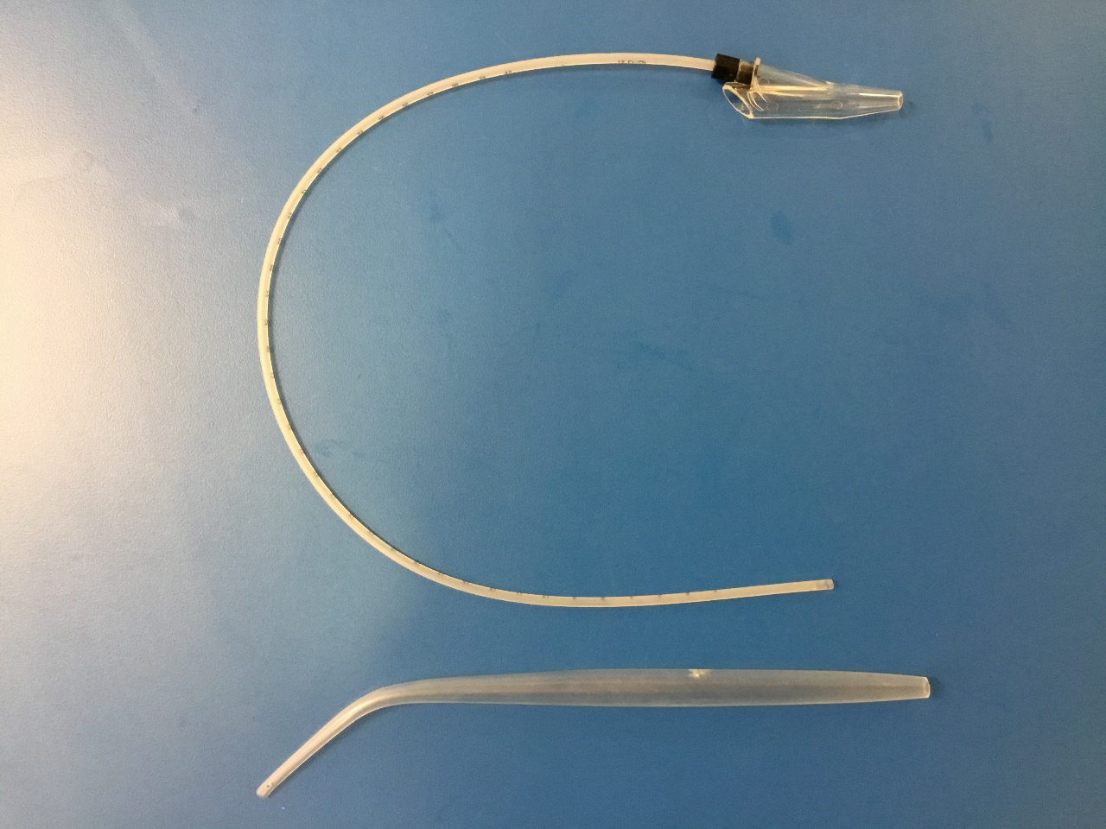
Figure 3. Soft suction catheters (top) can be advanced further into the airway. Hard suckers (bottom) should only be used within the oral cavity.

Once any visible obstruction has been cleared, open the airway using a head tilt-chin lift technique; place one hand on the forehead and tilt the head backwards while lifting the chin using two fingers placed beneath it (figure 4). Be careful not to compress the soft tissues of the throat. This simple intervention will often open the airway if malalignment or soft tissue obstruction of the pharynx are the problem (Resuscitation Council UK, 2016).
If spinal injury is suspected (for example in trauma patients), it is undesirable to flex the neck. In this case, use a jaw thrust instead, maintaining the head, neck and chest in neutral alignment (McPherson and Stephens, 2012). Place two fingers behind the angle of the jaw, and lift the jaw upwards and forwards, while using the thumbs to open the mouth (figure 5).

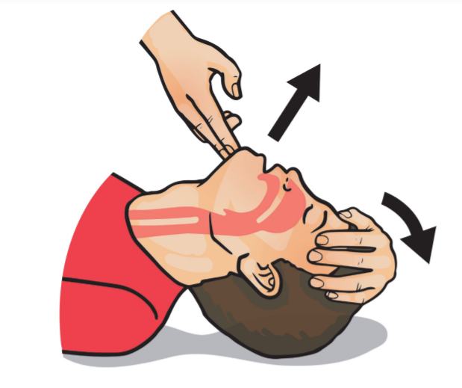
Figure 4. Head tilt chin lift.
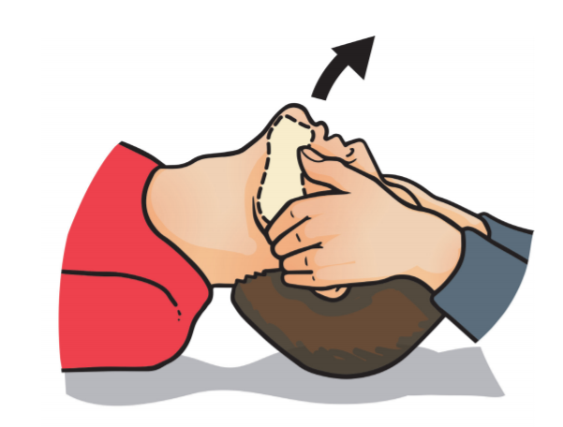

Figure 5. Jaw thrust

If these measures are successful in opening the airway, apply high-flow oxygen using a face mask with a reservoir bag and an oxygen flow rate of 15 litres/minute, and reassess the patient using an ABCDE approach (Resuscitation Council UK, 2016). If the airway remains occluded despite these simple manoeuvres, call for emergency help immediately (2222 in the hospital, 999 in the community) and consider whether there may be an obstruction further down the airway; always consider the possibility of choking (see box 3).
Box 3. Choking
Suspect choking if the person develops a persistent cough or sudden breathlessness during or after eating (Simpson, 2016). They may clutch at their neck and appear red in the face. If they are managing to draw breath in, and have a strong cough, encourage them to continue coughing (Jevon, 2018). If the cough is weak or absent, back blows or abdominal thrusts may clear the obstruction; see resuscitation guidelines for more details on how to deliver these interventions (Perkins et al, 2015).

Maintaining airway patency
Following successful opening of the airway, it may be necessary to use an airway device to maintain airway patency and/or to facilitate manual ventilation of the lungs with a bag-valve-mask (McPherson and Stephens, 2012). This is especially likely if the person is unconscious, or has suffered a cardiac arrest. Bear in mind that both manual ventilation and cardiopulmonary resuscitation are considered aerosol generating procedures.
Simple adjuncts such as oropharyngeal and nasopharyngeal airways help to maintain upper airway patency by keeping the tongue and soft tissues of the pharynx out of the airway (Rose and Paulus, 2019). This may keep the airway patent in the breathing patient, or improve the success of manual ventilation in the patient requiring bagging. Simple airway adjuncts have several important limitations; they do not prevent aspiration, and during cardiac arrest do not permit continuous chest compressions or the measurement of end-tidal CO2 (Resuscitation Council UK, 2016). They should not be fixed in place.
Advanced airway devices include supraglottic airway devices and endotracheal tubes; they are used when more definitive airway management is required in the unconscious patient (Almeida et al, 2016). Advanced airway devices provide a high degree of protection against aspiration, and facilitate continuous chest compressions and end-tidal CO2 monitoring during cardiopulmonary resuscitation (Resuscitation Council UK, 2016). They should be secured in place with ties or tapes.

Oropharyngeal airways
The oropharyngeal airway (OPA) is a curved, plastic tube shaped to fit over the top of the tongue, with one end between the lips and the other end in the oropharynx (Rose and Paulus, 2019). It is commonly described as a Guedel airway. A large range of sizes are available; for adults, sizes 3,4 and 5 are commonly used (figure 6). The OPA is sized by placing it vertically against the patient’s face; with the tip at the angle of the jaw, the integral bite-block should sit between the patient’s incisors.
An OPA is inserted into the mouth “upside down”, in other words with the end curving upwards towards the roof of the mouth (McPherson and Stephens, 2012). The airway is pushed inwards until it reaches the soft palate; at this point it is turned through 180° and advanced until the bite-block is between the incisors. This method of insertion helps to prevent the tongue being pushed back into the airway.
OPA tend to cause gagging unless the patient is profoundly unconscious (Resuscitation Council UK, 2016). If tolerance is a problem, a nasopharyngeal airway may be a better choice.

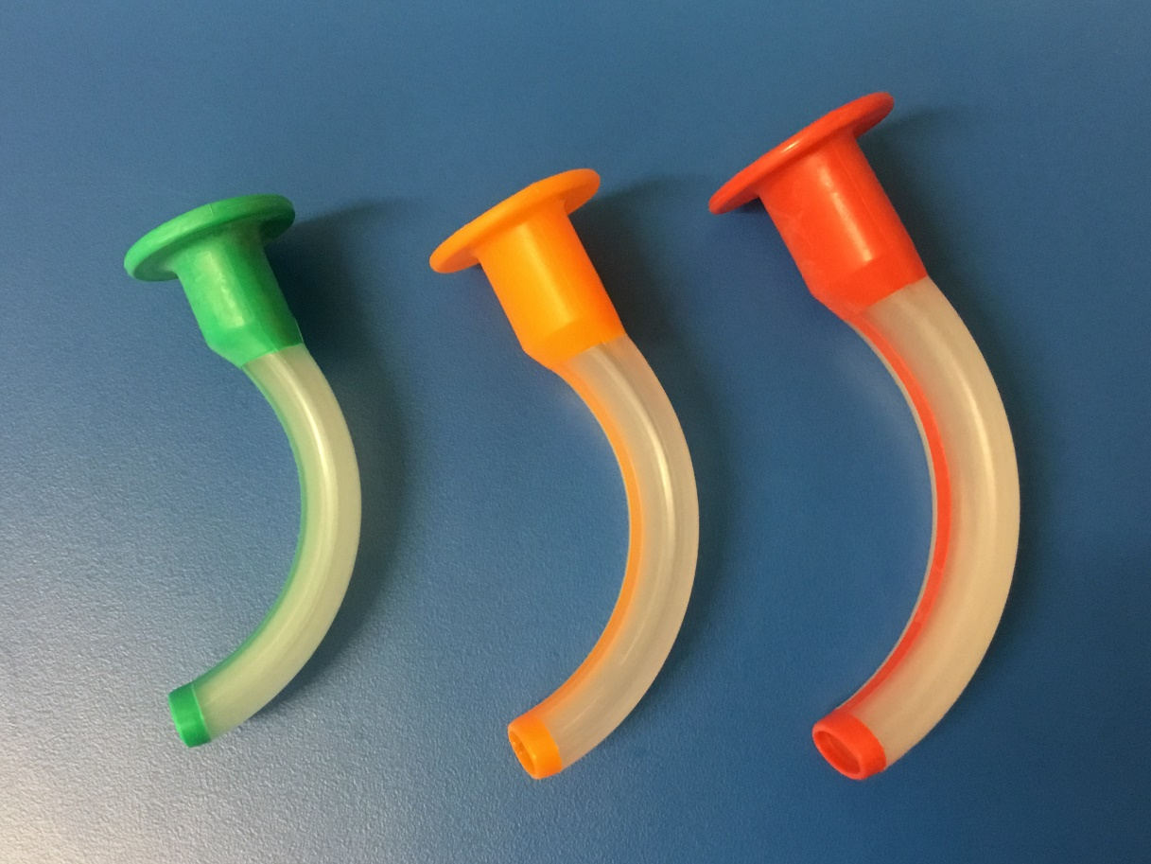
Figure 6. Oropharyngeal airways. From left to right, size 3 (green), 4 (orange) and 5 (red).

Nasopharyngeal airway
The nasopharyngeal airway (NPA) is a soft, flexible tube with a flange at one end (figure 7). It is inserted via the nose, with the end passing through the nasopharynx and into the oropharynx (McPherson and Stephens, 2012). The flange sits at the nostril to prevent the tube from being aspirated. A variety of sizes are available, although 6mm and 7mm tubes are commonly used in adults.
Traditional sizing methods for NPA are considered unreliable and are no longer recommended; provided the tube fits within the nostril and does not stimulate airway reflexes, it is the right size (Resuscitation Council UK, 2016). Insertion is simple; the airway is lubricated along the sides (but not the tip) with water-based lubricant and then gently twisted into the nostril; the right nostril is typically larger and straighter, resulting in easier insertion in most people (Boku et al, 2014). If insertion is difficult or complicated by bleeding, try the other nostril.
NPA are generally well-tolerated, even in patients who are conscious, but should not be used if there is suspected basal skull fracture (Rose and Paulus, 2019).

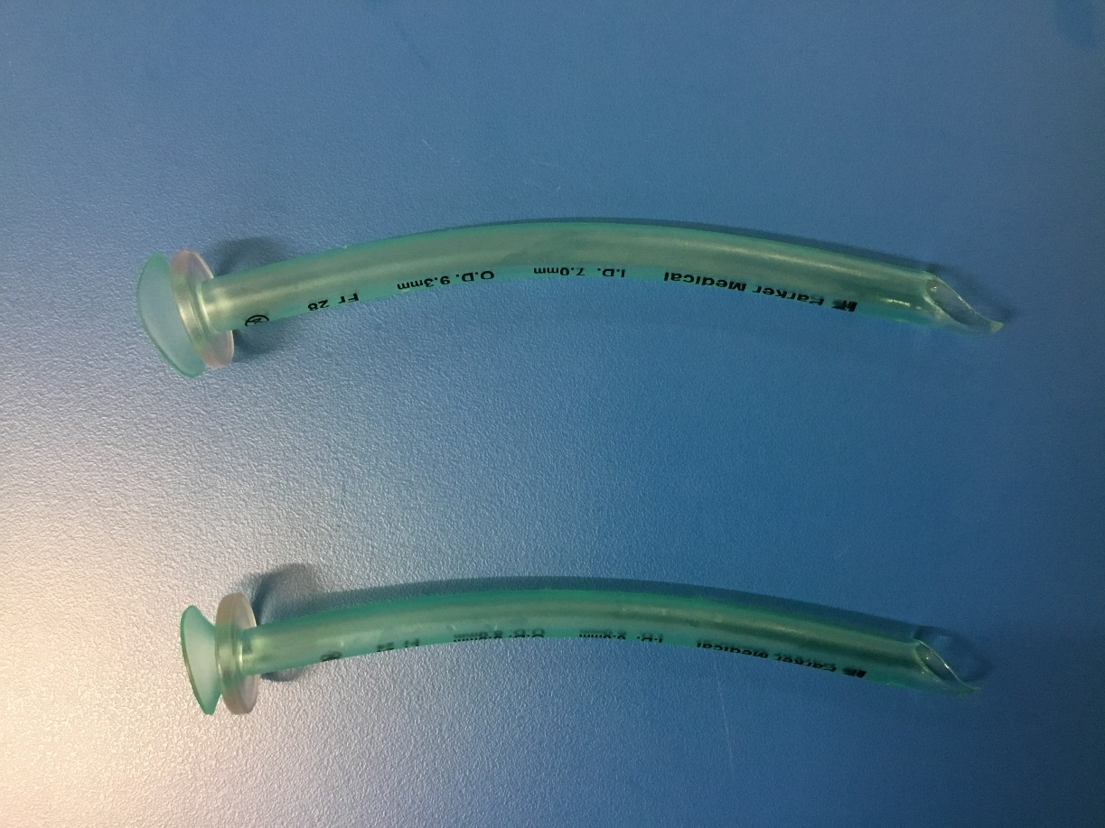
Figure 7. Nasopharyngeal airways

Supraglottic airway devices
Supraglottic airway devices (SAD) were developed as an alternative to endotracheal intubation during routine surgery, and are now widely used in this setting, as well as during cardiopulmonary resuscitation (Rose and Paulus, 2019).
The first widely used SAD was the laryngeal mask airway (LMA), which consists of an oval, inflatable cuff attached to a tube (figure 8). The cuff seals around the entrance to the larynx, thereby providing significant (though not absolute) protection against aspiration (Almeida et al, 2016). Various improvements to the LMA have been made over the past few decades, however in the UK it has been replaced in many centres by the i-Gel.
The i-Gel is a preshaped, cuffless SAD that sits in the same location as the LMA (figure 8). It is quicker and easier to insert than an LMA, and provides a similar level of protection against aspiration (Park et al 2015; Pournajafian et al, 2015). Its ease of insertion has led to its wide-spread adoption in resuscitation services as well as anaesthetic departments; nurses and other non-medical staff can be taught to insert it with minimal training (Resuscitation Council UK, 2016). Like the OPA, adult i-Gel sizes are 3, 4 and 5. A size 4 i-Gel fits most people, having a recommended weight range of 50-90Kg (Intersurgical Ltd, 2020). Size 3 is aimed at small adults (30-60Kg) and size 5 at larger individuals (≥90Kg).
Prior to i-Gel insertion, the patient should be positioned in a “sniffing the morning air position” and the sides and front of the airway lubricated with a water-based lubricant (Intersurgical Ltd, 2020). The airway should be held firmly by the intregral bite block, with the air outlet facing the patient’s chin. The airway should then be slid along the roof of the mouth and down into the pharynx until a definitive resistance is felt (Resuscitation Council UK, 2016). The integral bite-block should be between the patient’s incisors when it is in the correct position.

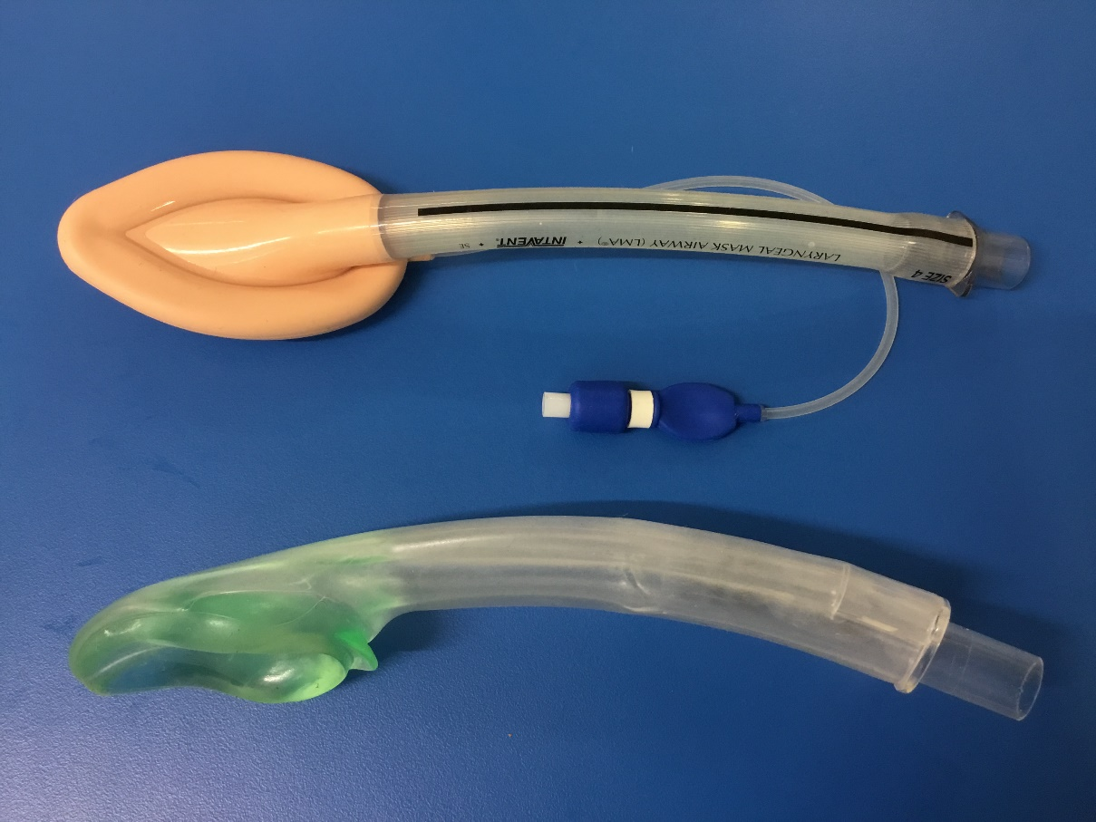
Figure 8. Laryngeal mask airway (top) and i-Gel (bottom)

Endotracheal tubes
The endotracheal tube (ETT) is considered the definitive airway device because it enters the larynx, passing through the vocal cords (Rose and Paulus, 2019). Most tubes have an inflatable cuff that forms a seal between the tube and the wall of the trachea (figure 9). This provides a higher degree of protection against aspiration than any other airway, although this does depend on the integrity and correct inflation of the cuff. Under-inflation can allow secretions or gastric contents to bypass the cuff, contributing to aspiration pneumonia (Gunasekera and Gratrix, 2016). In contrast, over-inflation can cause pressure damage to the tracheal mucosa (Nejla et al, 2017). Recommended cuff pressure is between 20 and 30cmH2O (Sole et al, 2011).
Intubation with an ETT takes place under direct visualisation using a laryngoscope; the procedure takes considerable training and practice to master. Misplacement of the tube in the oesophagus is a common complication, and if unrecognised leads to profound hypoxia and cardiac arrest (Resuscitation Council UK, 2016). Correct placement of the tube should always be confirmed using clinical assessment such as chest expansion and auscultation, alongside detection of exhaled carbon dioxide (CO2) using an end-tidal CO2 detector. Air that has passed in and out of the oesophagus will not contain a significant amount of CO2, unlike air that has ventilated the lungs. The presence of significant amounts of CO2 in exhaled air is therefore a reliable indicator of successful endotracheal intubation. Clinical assessment should be performed alongside this to confirm that air is entering both lungs as a tube that is advanced too far may be placed in the right main bronchus and therefore ventilate the right lung only.
The advantages of the ETT in terms of securing and protecting the airway have made it the airway of choice for patients admitted to the intensive care unit for mechanical ventilation (Rose and Paulus, 2019). In contrast, in acute resuscitation there has been a move away from ETT use, based on the realisation that intubation often results in considerable pauses in chest compressions, during which the patient receives no circulation (Kim et al, 2018). The Resuscitation Council (2016) suggests that the risks and benefits of endotracheal intubation must be weighed against the need for effective chest compressions.

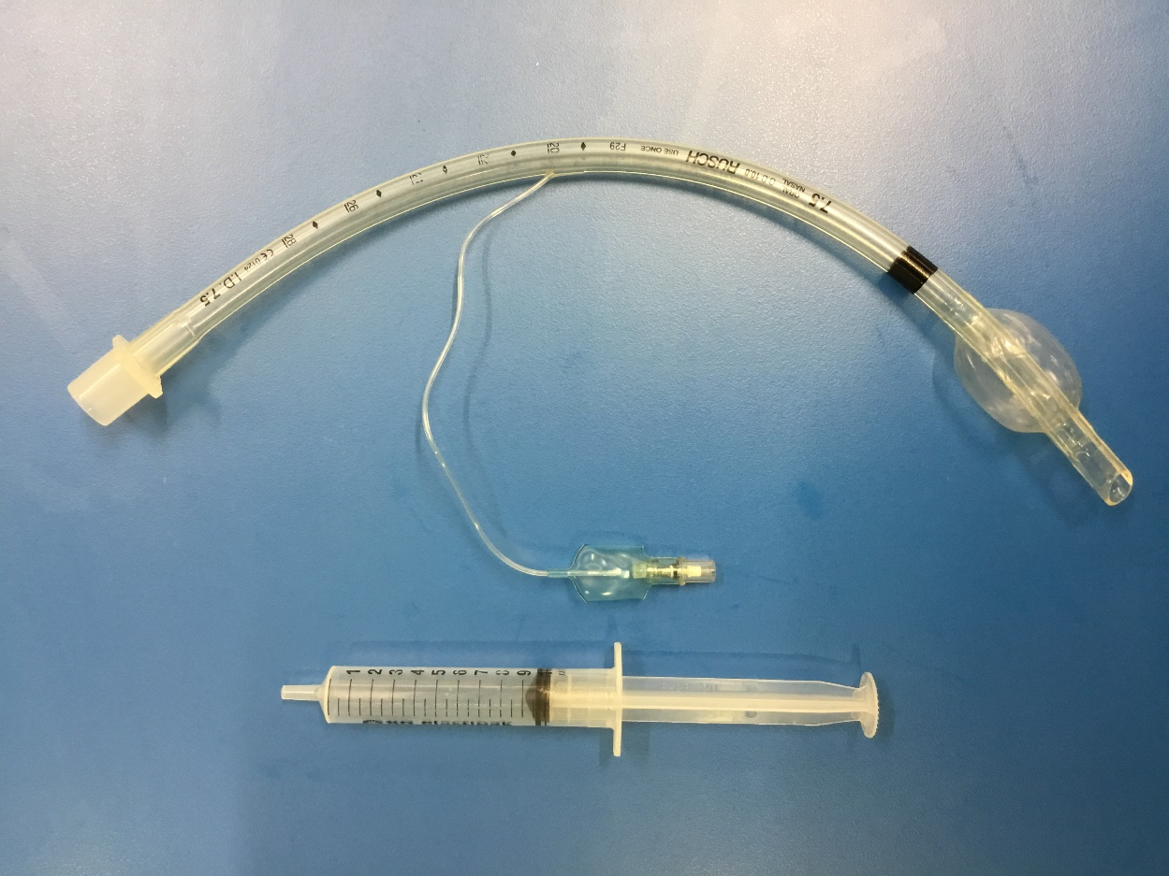
Figure 9. Endotracheal tube with cuff inflated.

Conclusion
Critically ill people often have multiple risk factors for airway compromise, making airway management a core skill for clinicians involved in their care. Recognising the patient at risk of airway compromise, and performing an accurate assessment using a look-listen-feel approach are key aspects of airway management. These skills must be supported by a knowledge of simple methods to clear the airway, and of devices that may be used to maintain airway patency. While this article has given an overview of the topic, further reading and practical training in airway management are recommended. Clinicians should also ensure that are up to date with current recommendations for infection control in the context of the current COVID-19 pandemic, as a number of airway interventions are aerosol generating.

References
Almeida G, Costa AC, Machado HS (2016) Supraglottic airway devices: a review in a new era of airway management, J Anesth Clin Res, 7(647):2.
Ball M, Hussain M and Padalia D (2019) Anatomy, airway. Statpearls, available at https://www.ncbi.nlm.nih.gov/books/NBK459258/ accessed 17/02/2020.
Boku A, Hanamoto H, Hirose Y, Kudo C, Morimoto Y, Sugimura M, Niwa H (2014) Which nostril should be used for nasotracheal intubation: the right or left? A randomized clinical trial. Journal of clinical anesthesia, 26(5):390-4.
Cathala X and Moorley C (2020) Performing an A-G patient assessment: a practical step-by-step guide. Nursing Times [online]; 116: 1, 53-55.
Echevarria IM and Schwoebel A (2012) Development of an Intervention Model for the Prevention of Aspiration Pneumonia in High-Risk Patients on a Medical-Surgical Unit, Medsurg Nursing, 21(5), 303-308.
Gunasekera P and Gratrix A (2016) Ventilator-associated pneumonia, BJA Education, 1;16(6):198-202.
Intersurgical Ltd (2020) i-Gel, available at https://www.intersurgical.com/info/igel#:~:text=Launched%20in%202007%20after%20years,between%202%2D90%2Bkg. accessed 11/06/2020.
Jevon P (2018) Choking 1: foreign-body airway obstruction in adults. Nursing Times, 114: 12, 24-26
Kim SY, Park SO, Kim JW, Sung J, Lee KR, Lee YH, Hong DY, Baek KJ (2018) How much experience do rescuers require to achieve successful tracheal intubation during cardiopulmonary resuscitation?. Resuscitation, 133:187-92.
Marieb, E. N. and Hoehn, K. (2016) Human Anatomy and Physiology. 10th ed. Harlow: Pearson Education Limited.
McPherson K and Stephens CM (2012) Managing airway obstruction, British Journal of Hospital Medicine, 73(10), C156-C160.
Meredith T and Massey D (2011) Respiratory assessment 2: More key skills to improve care, British Journal of Cardiac Nursing, 6(2), 63-68.
Nejla T, Habiba BS, Oussema J, Rim G, Nabil D, Mohamed FH, Souheil E (2017) Impact of Monitoring Endotracheal Cuff Pressure on Endoscopic Laryngo-Tracheal Injury: A Randomized Pilot Study. Journal of Advances in Medicine and Medical Research, 2:1-0.
Park SK, Choi GJ, Choi YS, Ahn EJ, Kang H (2015) Comparison of the i-Gel and the laryngeal mask airway proseal during general anesthesia: a systematic review and meta-analysis, PLoS One, 10: e0119469.
Perkins GD, Handley AJ, Koster RW et al (2015) European Resuscitation Council guidelines for resuscitation 2015: Section 2. Adult basic life support and automated external defibrillation, Resuscitation, 95, 81-99.
Physiopedia (2020) Muscles of Respiration, available at https://www.physio-pedia.com/Muscles_of_Respiration accessed 11/06/2020.
Pournajafian A, Alimian M, Rokhtabnak F, Ghodraty M, Mojri M (2015) Success rate of airway devices insertion: laryngeal mask airway versus supraglottic gel device, Anesth Pain Med, 5: e22068.
Public Health England (2020) COVID-19: Guidance for the remobilisation of services within health and care settings Infection prevention and control recommendations, available at https://assets.publishing.service.gov.uk/government/uploads/system/uploads/attachment_data/file/910885/COVID-19_Infection_prevention_and_control_guidance_FINAL_PDF_20082020.pdf accessed 09/11/2020.
Reber LL, Hernandez JD, Galli SJ (2017) The pathophysiology of anaphylaxis, Journal of Allergy and Clinical Immunology, 140(2):3
35-48.
Resuscitation Council (UK) (2016) Advanced Life Support. Seventh edition. RCUK, London
Resuscitation Council UK 2020 Resuscitation Council UK Statement on COVID-19 in relation to CPR and resuscitation in acute hospital settings, Resuscitation Council UK, available at https://www.resus.org.uk/media/statements/resuscitation-council-uk-statements-on-covid-19-coronavirus-cpr-and-resuscitation/covid-healthcare/ accessed 08/06/2020.
Ringdal M and Gullick J (2019) Respiratory Assessment and Monitoring, in Critical Care Nursing, 3rd edition, Chatswood: Elsevier Australia, pages 418-455.
Rose L and Paulus F (2019) Ventilation and Oxygenation Management, in Critical Care Nursing, 3rd edition, Chatswood: Elsevier Australia, pages 493-538.
Sahin-Yilmaz A and Naclerio RM (2011) Anatomy and Physiology of the Upper Airway, Proceedings of the American Thoracic Society, 8, 31–39.
Saraya T, Shimoda M, Hirata A, Takizawa (2016) Paradoxical respiration: “Seesaw” motion with massive pulmonary consolidation, BMJ Case Reports, bcr2015213449.
Simpson E (2016) How to manage a choking adult, Nursing Standard, 31, 3, 42-46.
Sole ML, Su X, Talbert S, Penoyer DA, Kalita S, Jimenez E, Ludy JE, Bennett M (2011) Evaluation of an intervention to maintain endotracheal tube cuff pressure within therapeutic range, American Journal of Critical Care, 20(2):109-18.
Tortora GJ and Derrickson BH (2017) Tortora’s Principles of Anatomy and physiology, 15th edition, Chichester; John Wiley and Sons Inc.
Wong SC, Tariq SM (2011) Cardiac arrest following foreign-body airway aspiration. Respiratory Care. 56, 4, 527-529.

