Investigations into impacts of fenestration and shading variation on ventilation and energy performance of an office in cooling and heating seasons
Xiaoyue YIª, Llewellyn Tang^{a*}, Siegfried Yeboah^{b}
a. Department of Real Estate and Construction, The University of Hong Kong, Pokfulam Road, Hong Kong SAR.
b. School of the Built Environment and Architecture, London South Bank University, 103 Borough Road, London, SE1 0AA, United Kingdom.
*Corresponding author & Joint first author

Abstracts
Consideration of reducing energy consumption and improving occupant comfort are crucial in sustainable building designs and retrofitting. In the built environment, fenestration and shading device (F&SD) installations are common strategies applied in buildings to minimize solar heat gains towards reducing cooling and overall energy. The influence of F&SD strategies on building performance is contingent upon their designs; however, existing research does not provide performance trends and distributions of F&SD with different configurations. This study investigated the influence of varied F&SD configurations on the ventilation and energy performance of an office unit in a building in Shanghai using brute-force parametric analysis and Monte Carlo sensitivity analysis. The evaluated strategies included window-facing orientation, window-to-wall ratio, shading device types, number of shadings, shading device depths, and shading tilt angles. The results show that changes in F&SD configurations resulted in reductions in solar gains, winter natural ventilation loss, and summer natural ventilation gains by up to 93.8%, 80.2%, and 75.6%, respectively. For all F&SD configurations investigated, the difference between the maximum and minimum zone temperatures for summer was 1.39ºC and for winter, 1.21ºC. Heating energy demands increased up to 0.75%; besides, cooling energy reductions were 3.03% and 2.7% for horizontal and vertical shading devices respectively. This study’s findings can aid building designers in comprehending the energy and ventilation performance of varied F&SD configurations and provide insights and references for sustainable design processes.

Keywords:
Fenestration system; shading devices; solar heat gains; ventilation; building energy performance.
Highlights
- Fenestration & shading devices influence building cooling and heating performance.
- Comparison of vertical and horizontal shading numbers, depths, and tilt angles.
- Zone solar gain and ventilation vary with varied fenestrations and shading devices.
- Brute-force parametric & Monte Carlo sensitivity studies of building performances.
Nomenclature
Abbreviation | Parameter description | Units
AGH | Annual glare hours | Hrs
BESTEST | Building Energy Simulation Test | -
CED | Cooling energy demand | kWh/m²
CEU | Cooling energy use | kWh/m²
C&HS | Cooling and heating seasons | -
CO₂ | Carbon dioxide | -
DI | Daylight illuminance | lux
DIr | Daylight illuminance at the reference point | lux
EEU | Electricity energy use | kWh/m²
F&SD | Fenestration and shading devices | -
HED | Heating energy demand | kWh/m²
HSD | Horizontal shading devices | -
IEA | International Energy Agency | -
IQR | Inter-quartile range | -
$${IQR}_{p}$$ | interquartile range of the results of the corresponding parameter results | -
LEU | Lighting energy use | kWh/m²
LHS | Latin Hypercube Sampling | -
MC | Monte Carlo | -
MRT | Mean radiant temperature | ºC
$$μ_{P@I}$$ | Average output value for each input parameter in parametric analysis | -
$$μ_{p}$$ | Mean of the result referring to a parameter in the sensitivity analysis | -
$$p$$ | Parameter input to simulation in sensitivity analysis | -
$$∆P_{p}\%$$ | Percentage changes compared to the baseline condition results in the sensitivity analysis | -
$$P_{p}$$ | Simulation result series for a certain parameter | -
$${P_{p}}^{baseline}$$ | Baseline model results | -
$$P_{@I}$$ | The simulation result for parameters at the input of I in parametric analysis | -
$$ρ_{pP_{p}}$$ | Pearson correlations of simulation inputs, p, and outputs, $P_{p}$ | -
$$Q_{3@p}$$ | The 3rd quartile of the corresponding sensitivity analysis results | -
$$Q_{1@p}$$ | The 1st quartile of the corresponding sensitivity analysis results | -
SD | Shading devices | -
SDA | Shading device tilt angles | º
SDD | Shading device depths | m
SDN | Number of shadings | -
SDT | Shading device type | -
SHG | Solar heat gains | W/m²
$$σ_{p}$$ | Standard deviation of p simulation results | -
TED | Total energy demands | kWh/m²
TEU | Total energy uses
VFR | Ventilation volume density flowrate | m³/s
VHG | Ventilation heat gains | kWh/m²
VHL | Ventilation heat losses | kWh/m²
VSD | Vertical shading devices | -
WFO | Window facing orientation | -
WWR | Window-to-wall ratio | -

1. Introduction
Buildings, as a key part of the built environment, impact both human life and the environment [1]. Typically, we spend approximately 90% of our time in buildings, hence a comfortable internal environment is beneficial to our work efficiency, and the avoidance of sick building syndrome [2–4]. Besides, the building sector accounts for a substantial portion of global energy consumption, contributing to 36% of global final energy, and it is associated with 39% of Carbon dioxide (CO₂) emissions [5]. This is partly because of the architectural diversity of the modern urban morphology which results in miscellaneous energy consumption patterns during cooling and heating seasons (C&HS) [3,6–8].
Passive techniques, such as the utilization of shading devices (SD) and natural ventilation, have traditionally been employed to decrease building energy demands while enhancing occupants’ comfort and well-being [9–11]. Fenestration and shading devices (F&SD), as two significant sustainable building strategies, have been widely used to passively control building zone solar heat gains (SHG), glare, and ventilation [6,12]. Valladares-Rendón et al. [13] found that varying window-to-wall ratio (WWR) can save building energy up to 75.57%. Additionally, several studies have shown that by incorporating SD in buildings, the reductions in energy consumption and summer indoor temperature can be up to about 19.70% and 1.5°C respectively [13–17]. However, F&SD systems are double-edged swords in terms of their thermal, ventilation, and energy performances across different seasons [18]. For instance, excessive SHG can be avoided by adding SDs or smaller windows for summer cooling while in winter these same strategies can block SHG hence increasing heating loads [19]. Furthermore, excessive use of SDs can block daylight and wind from reaching deeper zone areas and increase the reliance on artificial lighting and mechanical ventilation [6]. To enhance indoor air quality and ensure thermal comfort, ventilation induced by F&SD should be increased during summer and restricted during winter [19]. These above phenomena indicate the necessity of a thorough understanding of F&SD configurations to achieve high performance throughout the year from these passive strategies.
Parametric analysis aims at finding the influence of different input parameters on the problem solutions; sensitivity analysis emerges as a noteworthy practice to identify key inputs that greatly influence the outputs [20–22]. These two approaches prioritize inputs contributing the most to output variability, thereby facilitating the achievement of energy-saving goals or other building design/retrofit objectives. Several environmental and energy performance studies [23–28] have been conducted on F&SD using parametric and sensitivity analyses, focused on fenestration-related parameters such as WWR, window-facing orientation (WFO), SD-related parameters such as shading device tilt angles (SDA) and depths, and the influence of these parameters on zone thermal performances, daylight conditions, and energy performances, etc. For instance, Ghosh and Neogi [29] numerically investigated the effect of various WWRs, window positionings, and external shading types on a south-facing building’s heating, cooling, and lighting energy consumption in Kolkata, India, a cooling-dominated region. They found that WWR increase resulted in increased total energy use (TEU), while the use of horizontal shading devices (HSD) and vertical shading devices (VSD) resulted in a reduction of TEU by 3.0% and 1.83% respectively. Delgarm et al. [24] carried out a sensitivity analysis of a building’s F&SD performances on the annual cooling, heating, and lighting loads, as well as total electricity consumption. They focused on HSD and found that the window size (or WWR) was the prevailing parameter influencing the annual energy performance. Huo et al. [30] analyzed and optimized external Venetian blind shading for zero-energy buildings in 8 different climate zones in China. They found that the maximum potential energy savings per window area of SD were at 0° slat angle, west WFO, and lower WWR. Huo et al. [31] conducted sensitivity and regression analysis of the shading effect of external Venetian blinds to identify and prioritize the most influencing parameters, and found building shape factor, south WWR, and SDA, significantly contribute to cooling demand and shading performance. Singh et al. [27] analyzed the energy and visual performances of office buildings with external Venetian blind shading in hot-dry climates and found a large uncertainty in the lighting, HVAC, source energy consumptions, and useful daylight illuminance (DI). Liu et al. [15] investigated the impacts of SDA, depths, and number of HSD and VSD respectively on building energy performance with western-façade-installed SD. They found the energy saving increased by SDA variations for the VSD was comparatively higher than that for the HSD; however, the latter showed the capacity to achieve maximum energy saving with a smaller SD total area.
Existing literature on F&SD sensitivity analyses extensively explores energy performance and often focuses on thermal performance, daylighting, and cooling energy; however, the interactions between these parameters are not adequately considered. Meanwhile, a detailed evaluation of the influence of F&SD particularly on zone SHG and ventilation across seasons was found to be lacking, hence the need for thorough investigations of the impacts of F&SDs on building performance. For example, SHG, influenced by F&SDs, is desirable in winter but should be minimized in summer; however, the influence of F&SD impacts on building performance variations in both C&HS has not received much attention in recent literature. Most studies concentrated on cooling seasons or cooling energy usages, neglecting the heating energy usages/demands inclusions. Besides, most studies focused on horizontal SD and overlooked the comparison between VSD and HSD performances under a more comprehensive F&SD context, despite their significantly distinct environmental performances [9,32–34]. Furthermore, in densely populated areas with complex and diverse urban layouts, the building zone WWR, WFO, and SDs exhibit a greater variation with a larger range of possibilities [8]. However, current parametric research is primarily limited to four WFOs, namely east, west, south, and north, and has not explored the potential of additional WFOs such as south-east, south-west, etc. Additionally, although buildings function as intermediaries for the individuals who inhabit them; crucial aspects of occupant comfort, such as SHG, natural ventilation, daylight, and their combined impacts by F&SD configurations, have not been comprehensively discussed in existing studies. Considering all these observations, it is crucial to enhance the understanding of the key influential parameters in building design or retrofitting, particularly concerning SHG, ventilation, lighting, and energy performance in the context of F&SD under C&HS. To fill these research gaps, this study aims to investigate the impacts of the variation of F&SD configurations on the thermal, ventilation, and energy performance of buildings in C&HS. To achieve this aim, a brute-force parametric analysis, Monte Carlo sensitivity analysis, and simulations of an office unit model in Shanghai, China were conducted using EnergyPlus and jEplus. The model unit was simulated with varied F&SD at various façade orientations to evaluate the sustainable designs’ influence on zone solar heat gains, indoor temperature, ventilation performance, daylighting, and energy consumption. Shanghai is a typical region with demands for both heating and cooling representing a humid subtropical climate and has diverse urban plans with mixed building types [35,36], hence was selected as the region for this investigation.

2. Materials and Methods
As shown in the flow chart in Fig. 1, the methodology for this study involved three main steps. The first step was the creation of the building cell model as well as its various F&SD configurations through EnergyPlus. The second step involved a brute-force parametric analysis after 11,760 F&SD simulations using jEplus. The third step included a Monte Carlo sensitivity analysis of 2,500 groups of simulation results using EnergyPlus and jEplus.
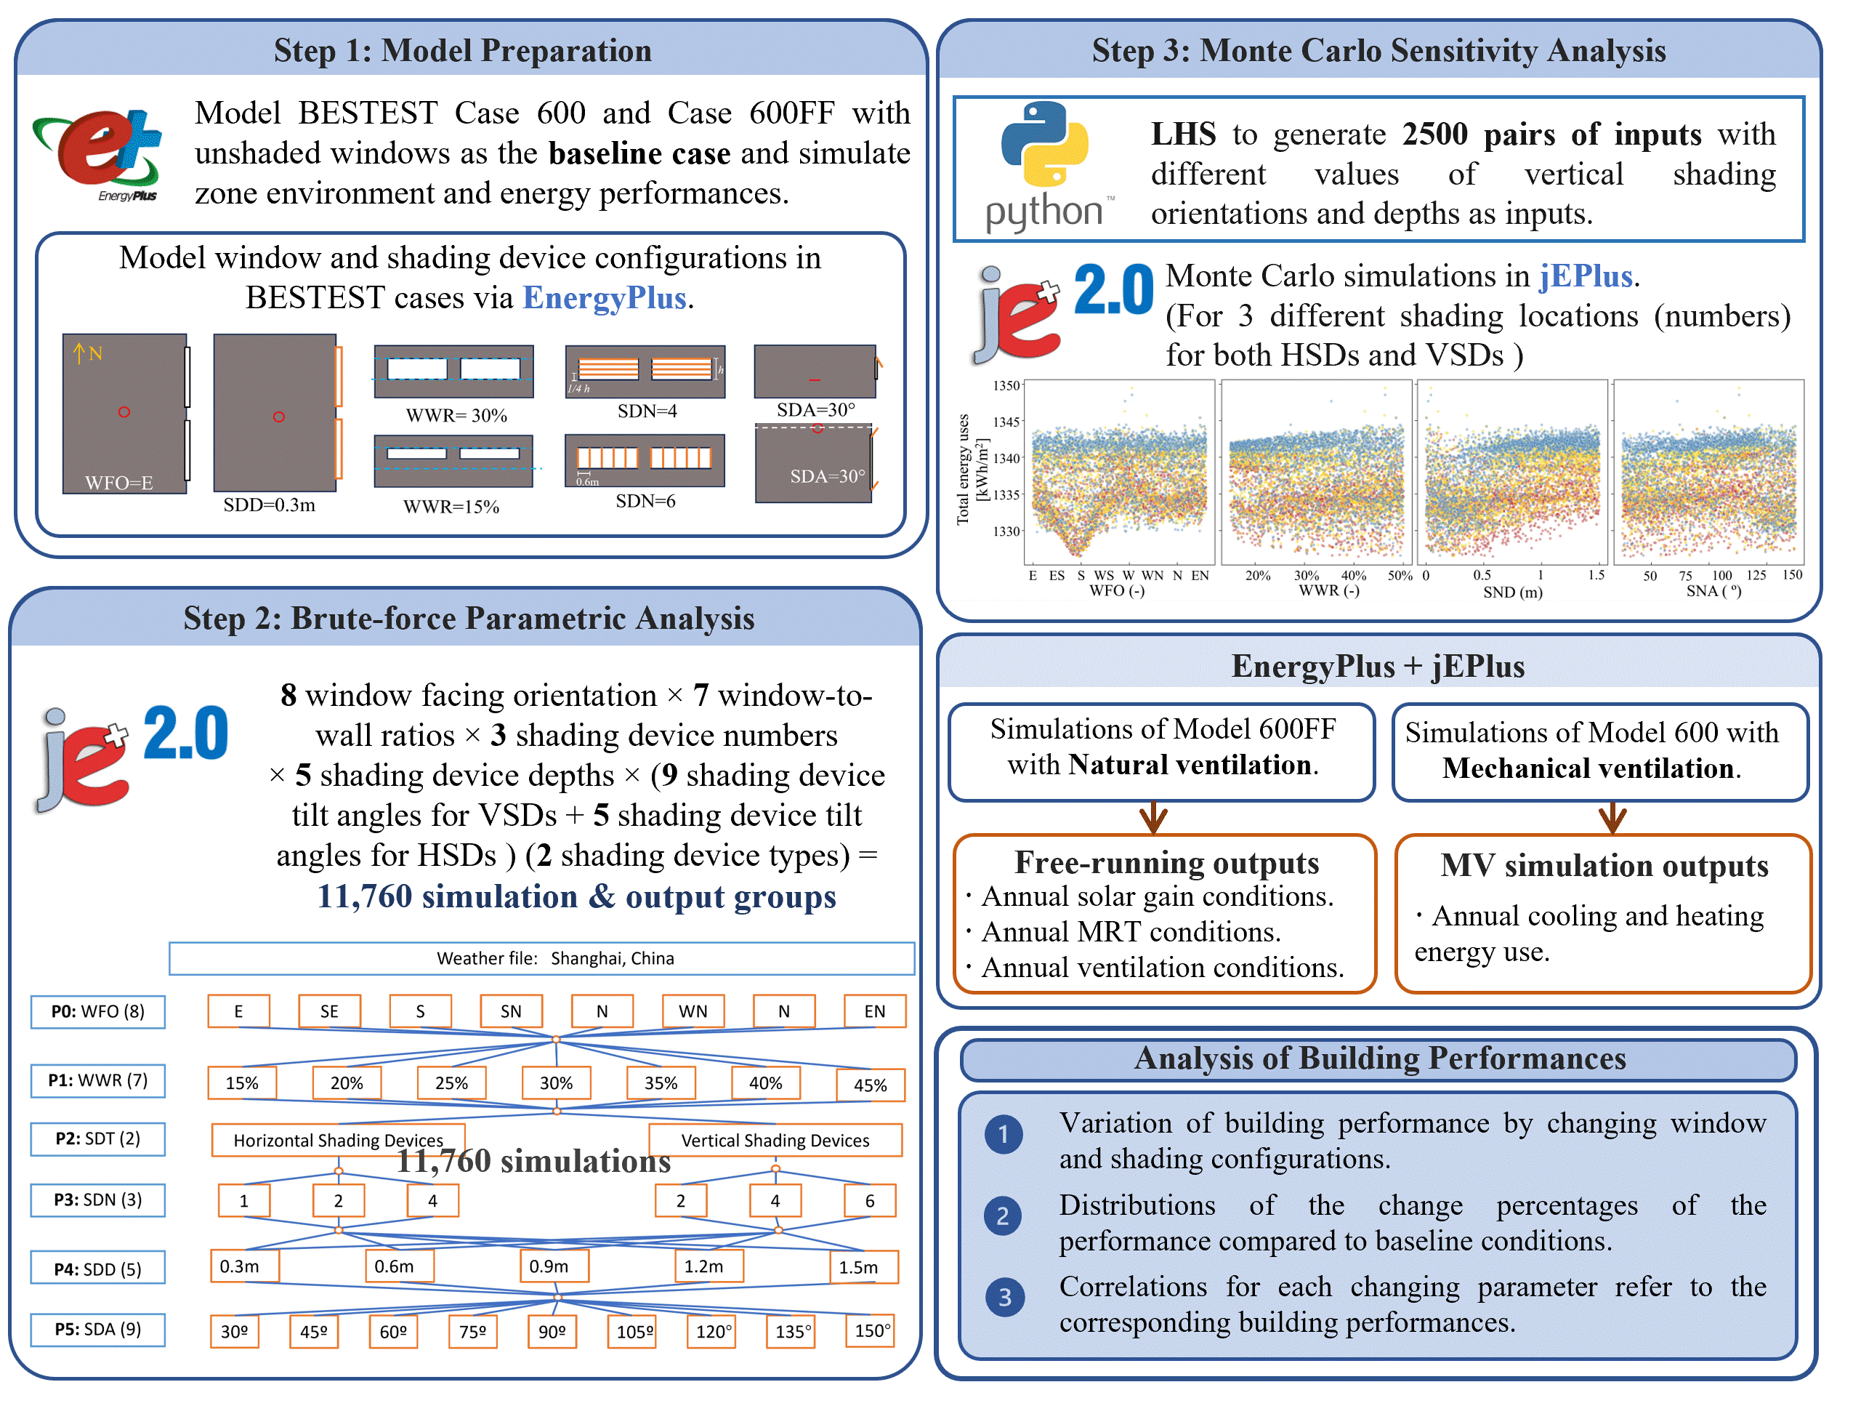
Fig. 1 Methodology flowchart

2.1 Modelling and Simulation Process

2.1.1 BESTEST Model and Assumptions

2.1.1.1 Baseline Condition Modelling in EnergyPlus
EnergyPlus, a popular program based on BLAST and DOE-2 [37], was employed as the modeling and simulation engine. This software program was already validated against results obtained through experiments or other simulation programs [38,39].
The International Energy Agency’s (IEA) Building Energy Simulation Test (BESTEST) offers benchmarks for testing building simulation programs in comparative tests with simple geometry to minimize deviations caused by unforeseen variables [40–42]. In this study, the free-running BESTEST Case 600FF was selected and was assumed to be a typical office unit in a building in densely populated Shanghai (see Fig.2) with its energy performance influenced by its F&SD and the local climate. The physical model was with the dimensions of 6m × 8m × 2.7m (length × width × height) and 2 windows located on one 8m × 2.7m façade as shown in Fig. 3. The baseline building model was assumed to be with un-shaded windows facing west and with 40% WWR. Table 1 shows the baseline F&SD configurations and the general building property simulation inputs including building façade U-value, window and glazing properties, internal heat gains, and lighting control strategies. The modeled building wall and window materials were set to meet the non-residential requirements in the China green building code, GB50189-2015 [43]. Each office unit was assumed to accommodate 6 people during working hours (9am-18pm) with constant heat gains from the office equipment. A daylight reference point was used in the simulation which was on a working plane height of 0.8m above the floor level (see the red circle in Figs. 3a and 3b). The artificial lighting was set to switch off by an on-off control logic when daylight at the reference point (DIr) exceeded 500lux [44]. The DI levels were simulated in EnergyPlus according to the unit model condition and the local sky and sun conditions provided in Shanghai’s weather file [37].
Table 1. Baseline F&SD configurations and the simulation inputs of general building property
Building properties in simulations |  | Values | Source / Data reference
Baseline F&SD | Shading devices | Un-shaded | -
 | Fenestration configurations | Windows facing west, 40% WWR
Façade properties | External wall U-value [W/m²K] | 0.021 | GB50189-2015 [43]
Window properties | Window type [-] | Triple-glazed windows | -
 | Window U-value [W/m²K] | 1.252 | GB50189-2015 [43]
 | Window solar heat gain coefficient [-] | 0.583 | Calculated by EnergyPlus
Glazing properties | Glazing conductivity [W/m·K] | 0.85 | EnergyPlus default numbers [37]
 | Glazing visible Transmittance [-] | 0.75
 | Glazing solar reflectance [-] | 0.071
 | Glazing solar transmittance [-] | 0.75
Internal heat gains | Occupant heat gains [W/m²] | 14 | CIBSE Guide A [6]
 | Equipment heat gains [W/person] | 35 | GB/T 51366-2019 [44]
 | Lighting heat gains [W/m²] | 11
Lighting control | On-off control strategy | Off, when DIr >= 500lux | GB/T 51366-2019 [44]
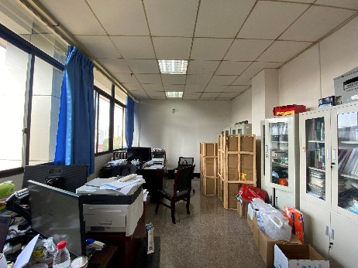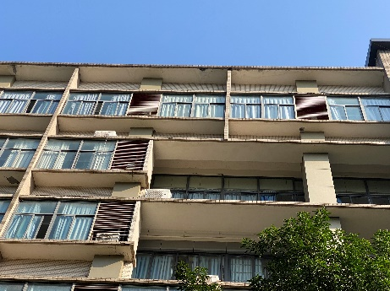
Fig. 2 (a) Inside of the typical office unit (b) Façade of the building containing the office unit.
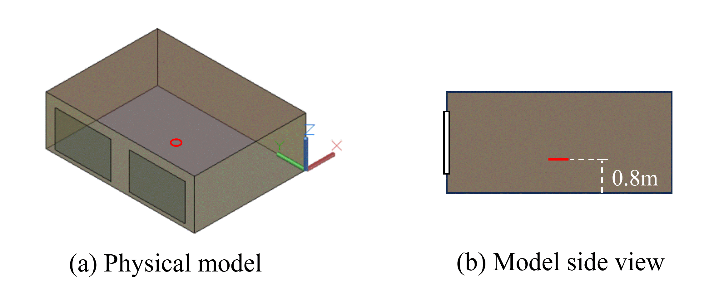
Fig. 3 (a) physical model with two windows on one 8m × 2.7m façade and (b) side view of the model showing working plane height

2.1.1.2 Location and Climate
Shanghai (31°13'N, 121°27'E) is a city with a hot and humid summer and cold winter climate, requiring significant cooling and heating over the respective seasons. The Shanghai daytime average temperature for summer and winter are respectively 28ºC and 5ºC with the summer maximum of 37ºC and the winter minimum of -3ºC [45,46]. The long-term average global irradiance in Shanghai is 191.4W/m². Its monthly average outdoor wind speed is 2.83m/s, indicating natural ventilation is suitable in Shanghai to improve indoor thermal comfort [47]. This densely populated area has complex and diverse urban layouts and exhibits large variations in building characteristics [8,48,49] and performances [35,36,50]. The weather data used in this investigation was from the Shanghai Typical Meteorological Year weather file on the EnergyPlus website [46]. Psychrometric charts depicting design strategies typical for summer and winter comfort conditions in Shanghai were generated using the Climate Consultant Tool [45], shown in Fig. 4 and Fig. 5 respectively. Cooling, natural ventilation, and SDs in summer, and the increase of SHG and heating in winter are indicated to potentially improve indoor thermal comfort.
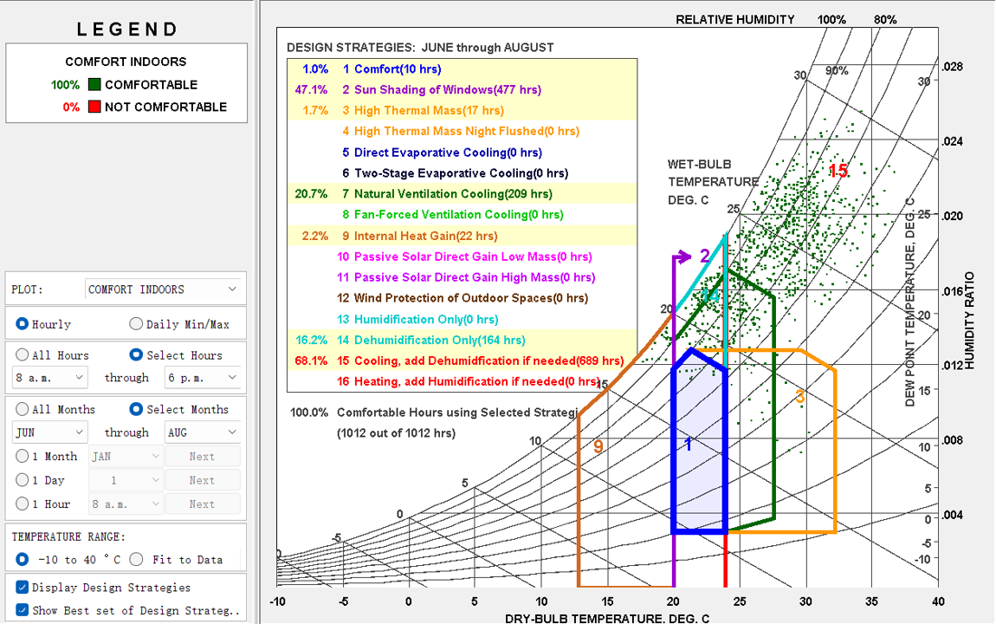
Fig. 4 Psychrometric chart showing comfort cooling strategies for Shanghai
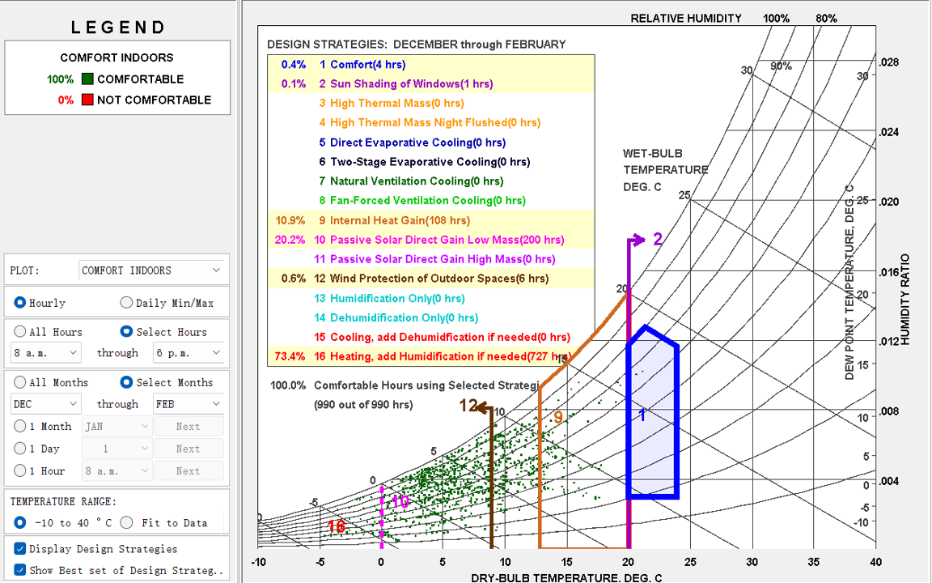
Fig. 5 Psychrometric chart showing comfort heating strategies for Shanghai

2.1.2 F&SD Configuration Modelling Methods in EnergyPlus
The selected F&SD configurations in this study were WFO, WWR, shading device types (SDT), number of shadings (SDN), shading device depths (SDD), and SDA in line with previous studies [11,15,33,34,51]. The corresponding parameters in EnergyPlus settings are shown in Table 2. Comprehensive F&SD input values for parametric and sensitivity analysis are presented in Section 2.2 (Table 3) and Section 2.3 (Table 4) respectively. Fig.6 and Fig. 7 show examples of the F&SD configurations used in the modeling process. Since the studied area is a unit in a building and the windows are installed on one façade, the variations of WFOs were achieved by orienting the building unit model in EnergyPlus (see Fig. 6 WFO examples). The WWRs were adjusted based on the area of the two modeled windows with a fixed width (3m) and varied heights. The SDTs, i.e. VSD and HSD, were modeled separately through EnergyPlus modules: “Shading: Overhang” and “Shading: Fin” (see Fig. 7 SD examples). The SDNs for VSDs were set as 2, 4, and 6 with the interval between vertical fins as 3m, 1m, and 0.6m respectively. The SDNs for HSDs were set as 1, 2, and 4, with intervals between overhangs separately as 1, 1/2, and 1/4 of the window height. The SDDs and SDAs were set based on previous studies [15,33]. The energy-related simulation outputs include free-running cooling energy demands (CED), heating energy demands (HED), total energy demands $\left(TED=CED+HED\right)$, and electricity energy use (EEU, lighting and equipment energy use). The environmental performance simulation outputs included zone SHG, zone mean radiance temperature (MRT), zone ventilation volume density flowrate (VFR), DIr, and annual glare hours (AGH).
Table 2. Investigated parameters and corresponding parameters/fields/objects settings in EnergyPlus.
Parameters | Corresponding parameters/fields/objects of settings in EnergyPlus
P0: window facing orientation (WFO) | Buildings / North Axis
P1: window-to-wall ratio (WWR) | / Fenestration Surface: Detailed /Vertex 2 Z-coordinate & Vertex 3 Z-coordinate  (By changing the heights of windows)
P2: shading device types (SDT) | HSD - /Shading: Overhang  VSD - /Shading: Fin
P3: number of shading devices (SDN) | HSD - / Shading: Overhang / Height above Window or Door  VSD -/ Shading: Fin / Right Tilt Angle from Window/Door  (By modeling more shading devices with relatively the same space.)
P4: shading device depths (SDD) | HSD - / Shading: Overhang / Depth  VSD - / Shading: Fin / Left Depth & Right Depth
P5: shading device tilt angles (SDA) | HSD - / Shading: Overhang / Tilt angle from Window/Door  VSD -/ Shading: Fin / Right Tilt Angle from Window/Door & Left Tilt Angle from Window/Door
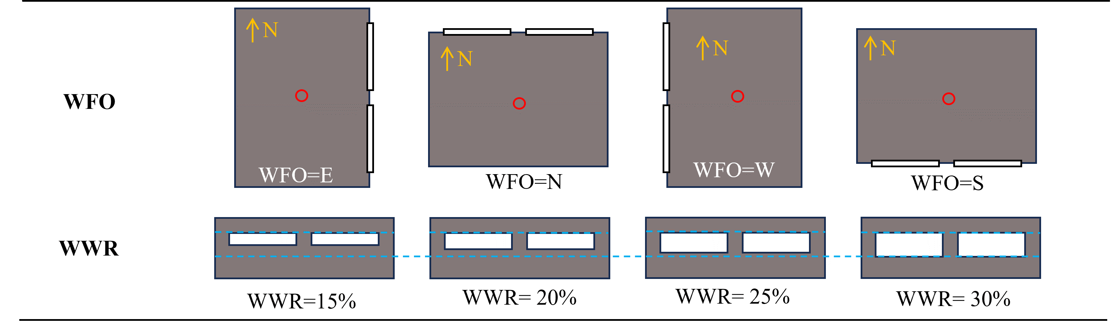
Fig. 6 Examples of Fenestration WFO and WWR configurations
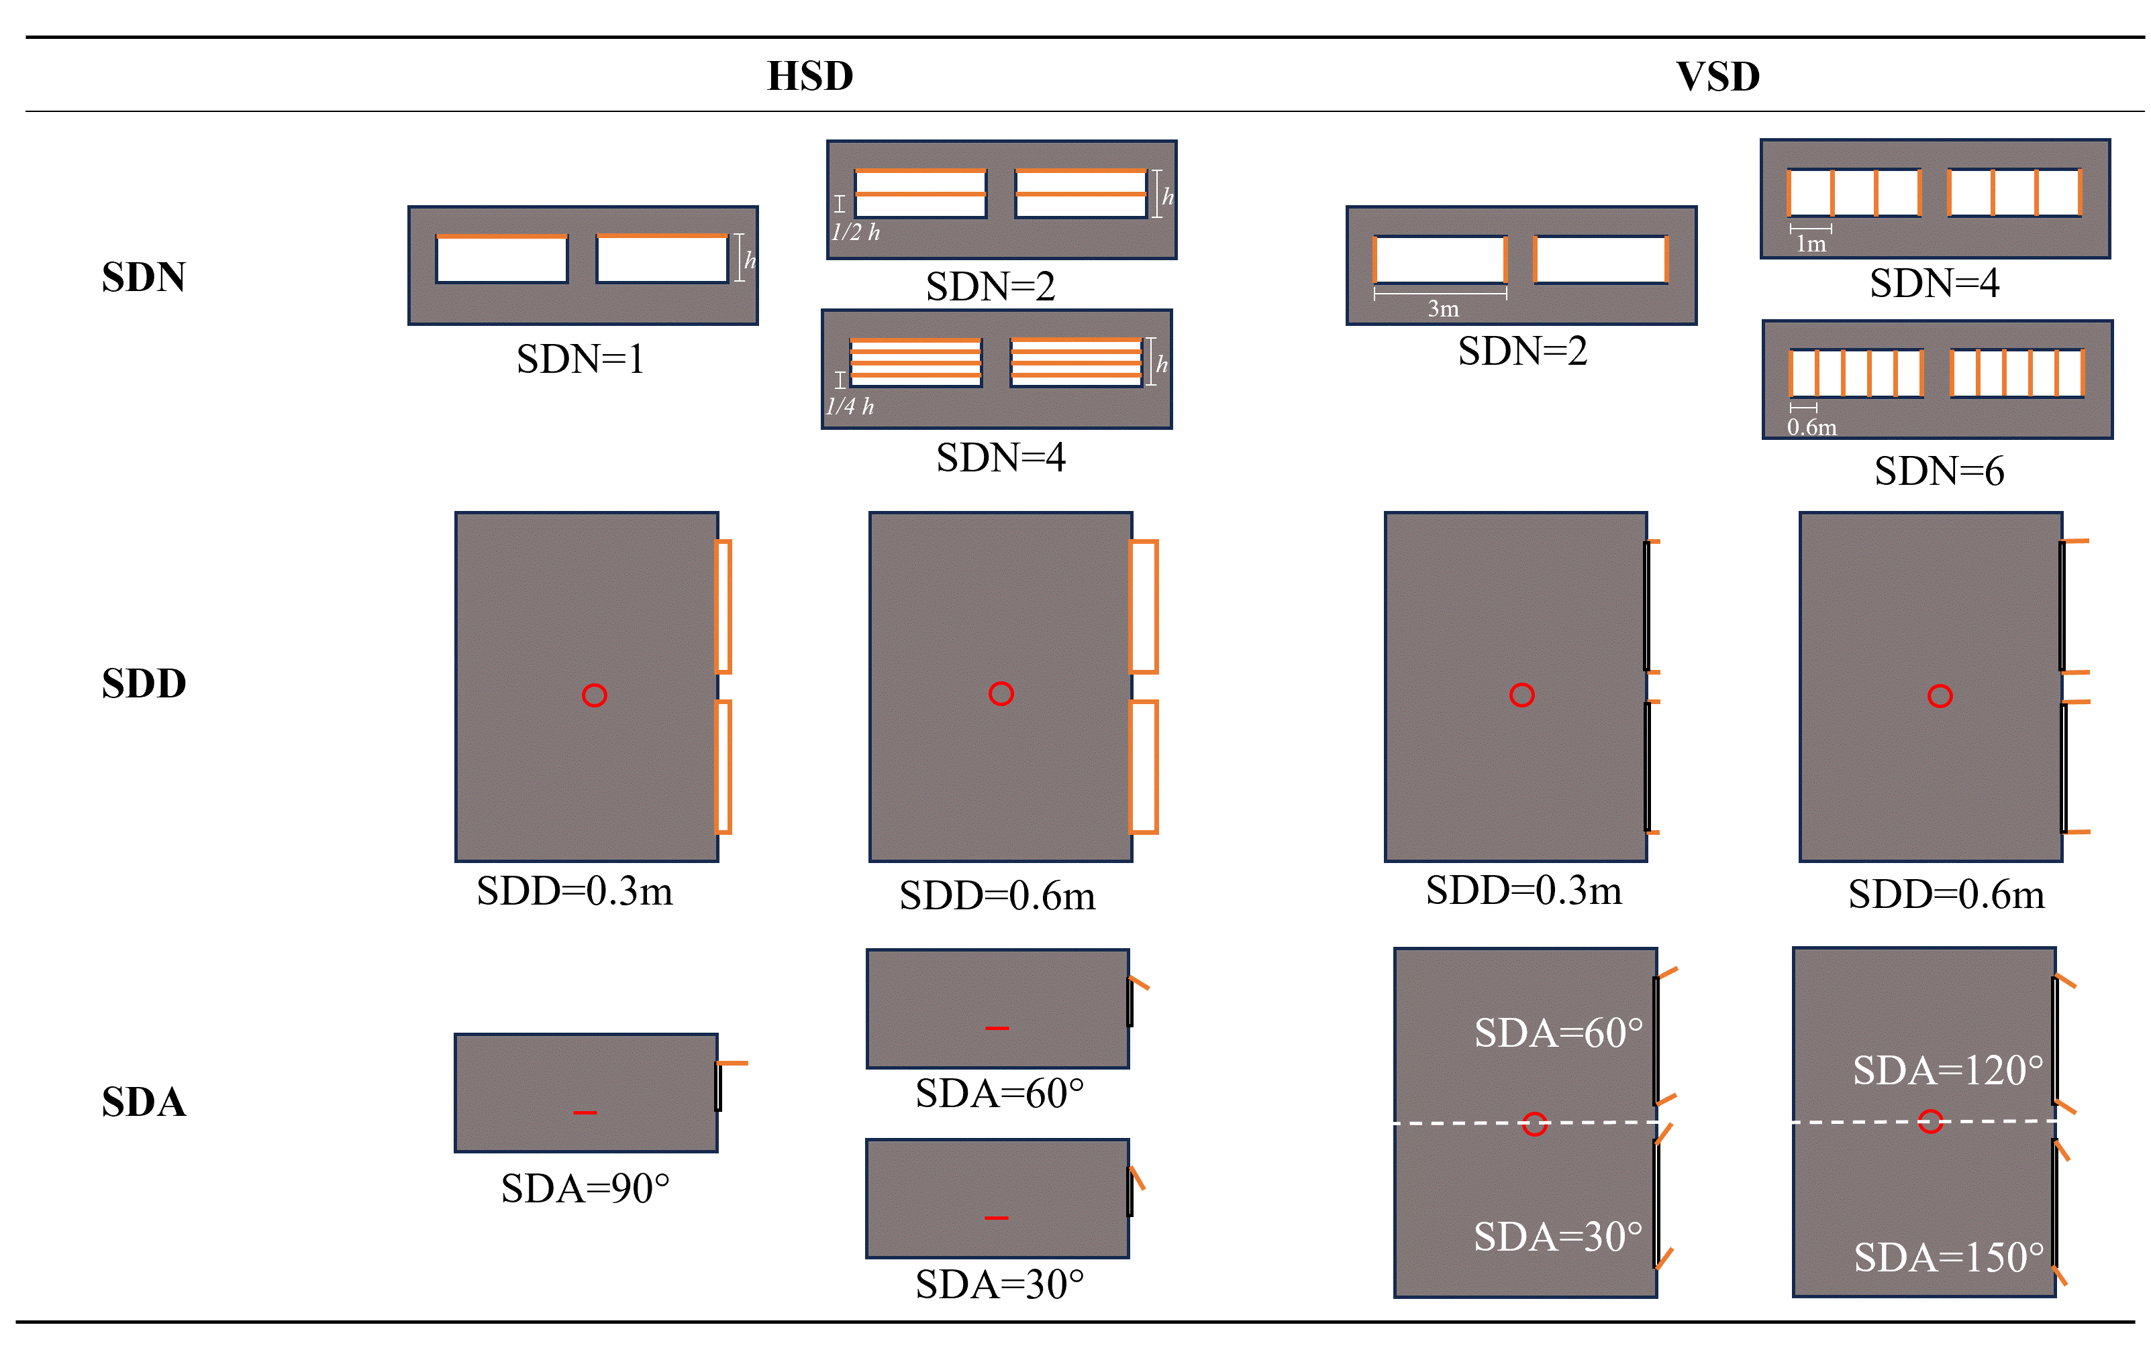
Fig. 7 Examples of SDN, SDD, and SDA configurations for HSD and VSD

2.1.3 Output Generation by jEPlus
jEPlus, a program designed to assist in setting up “parallel” simulation processes with EnergyPlus models [52], was employed to generate the parametric and sensitivity analysis simulation outputs from the inputs.

2.2 Brute-force Parametric Settings and Analysis
The brute-force method allows investigations of all possible combinations of the examined design variables [53,54], which is suitable for building sustainable strategy studies [53,55]. According to the settings in previous studies [11,15,33,34,51] and GB50189-2015 [43], the jEPlus F&SD parameter settings in this study were within acceptable ranges as presented in Table 3. The parameter inputs (see Table 3) included 8 WFO (P0), 7 WWR (P1), 2 SDT (P2), 3 SDN (P3) for each P2, 5 SDD (P4), and 5 and 9 SDA (P5) separately for HSD and VSD. A total of 11,760 simulations were carried out with 4,200 (8×7×3×5×5) for HSD and 7,560 (8×7×3×5×9) for VSD. After all these simulations were conducted, the results of the environmental and energy performance for each parameter input were compared and analyzed. The average output value ($μ_{P@I}$) for each input parameter was then calculated using Equation (1).
$$μ_{P@I}=\frac{\sum_{i=1}^{n}{P_{@I}}}{n} ……Equation (1)$$
Where, $μ_{P@I}$ is the average output with a certain input of I. $P_{@I}$ represents the simulation result for a parameter at the input of I.
Table 3. Settings of parameter inputs in EnergyPlus/jEPlus for Brute-force analysis
Parameters |  | Parameter inputs in EnergyPlus | Numbers of simulations
Fenestration-related parameters
P0: WFO [ º] |  | {0, 45, 90, 135, 180, 225, 270, 315}  [i.e. East (E), East-South (ES), South (S), West-South (WS), West (W), West-North (WN), North (N), East-north (EN)] | 8
P1: WWR [-] |  | {1.66,1.48,1.3,1.12,0.94,0.76,0.58}  [i.e. 15%, 20%, 25%, 30%, 35%, 40%, 45% WWR respectively] | 7
Shading Device-related parameters
P2: SDT  - for HSD | P3: SDN [-] | 1, 2, and 4 | 3
 | P4: SDD [m] | {0.3,0.6,0.9,1.2,1.5} | 5
 | P5: SDA [ º] | {90,105,120,135,150}  [i.e. 30º, 45º, 60º, 75º, 90º SDA respectively] | 5
P2: SDT  - for VSD | P3: SDN [-] | 2, 4, and 6 | 3
 | P4: SDD [m] | {0.3,0.6,0.9,1.2,1.5} | 5
 | P5: SDA [ º] | {30,45,60,75,90,105,120,135,150} | 9

2.3 Monte Carlo Sensitivity Settings and Analysis
The Monte Carlo (MC) technique evaluates multiple outputs with randomly sampled input values and then uses these evaluation results to determine the uncertainty in models [21], which quantifies the uncertainty of F&SD configurations associated with reaching each energy performance. Latin Hypercube Sampling (LHS), which can generate nearly random multidimensional parameter samples with specified probability distribution shapes [56], was applied to generate the simulation input samples. The SDT and SDN were modeled independently as discrete distributed inputs to the MC analysis; then, 2,500 samples of 4 experiments based on LHS with uniform distributions for WFO, WWR, SDD, and SDA. The distribution types and the ranges for the parameter inputs are shown in Table 4. The generated LHS samples were translated into model inputs based on the pre-setting distributions. The generated 2,500 groups of LHS results were further input into jEPlus. The MC simulations then proceeded with the generated 2,500 groups of results for each SDN of VSD and HSD. There was 1 fatal input for VSD, hence totally 14,997 (2,500×3 + 2,499×3) groups of MC simulation results were obtained.
After MC simulations, the results were compared to the baseline condition results, and percentage changes were calculated using Equation (2). The interquartile range (IQR) and upper and lower limits of the changing percentage for each parameter were also calculated using Equations (3)-(5) [57]. The mean and the standard deviation for each performance parameter were calculated with Equation (6) and Equation (7) respectively [57].
$$∆P_{p}\%=\left({P_{p}-{P_{p}}^{baseline}}/{{P_{p}}^{baseline}}\right)×100\%……Equation (2)$$
Where, $P_{p}$ represents the simulation result series of parameters, p; $∆P_{p}\%$ represents the change percentage of $P_{p}$ compared to the corresponding baseline model result, ${P_{p}}^{baseline}$ [$-$].
$${IQR}_{p}=Q_{3@p}-Q_{1@p}……Equation (3)$$
Upper limit @p = $Q_{3@p}+1.5×{IQR}_{p} ……Equation (4)$
Lower limit @p = $Q_{1@p}-1.5×{IQR}_{p} ……Equation (5)$
Where, $Q_{3@p}$ and $Q_{1@p}$ refer to the 3rd and 1st quartile of the corresponding parameter results.
$$μ_{p}=\frac{\sum_{i=1}^{m}{P_{i@p}}}{m} ……Equation (6)$$
$$σ_{p}=\frac{\sqrt{\sum_{i=1}^{m}{{(P_{i}-μ_{p})}^{2}}}}{m} ……Equation (7)$$
Where, $μ_{p}$ is the mean for certain parameter, p; $σ_{p}$ represents the standard deviation of p simulation results.
To ascertain the impact of configurations on performance, correlations between building performance and each parameter were obtained. Pearson correlations of parameter series p and P [58] were obtained using Equation (8) before ranking, analysis and comparison to show impacts of the configurations.
$$ρ_{pP_{p}}=\frac{\sum_{i=1}^{N}{(p_{i}-\overline{p})(P_{i@p }-μ_{p})}}{\sqrt{\sum_{i=1}^{N}{{(p_{i}-\overline{p})}^{2}}} \sqrt{\sum_{i=1}^{N}{{(P_{i@p}-μ_{p})}^{2}}}}…… Equation (8)$$
Where, $ρ_{pP_{p}}$ represents Pearson correlations of series p and $P_{p}$; $\overline{p}$ and $μ_{p}$ are the averages of series $p_{i}$ and $P_{i@p }$ respectively; N is the sequence number in the series. Larger $\left|ρ_{pP_{p}}\right|$ signifies larger correlations; $ρ_{pP_{p}}=0$ means no correlation.
Table 4. F&SD configuration inputs in jEPlus for MC sensitivity analysis
Parameters |  | Distribution | Number of samples | Input range
Fenestration-related parameters
P0: WFO [ º] |  | Uniform | 2500 | 0-360
P1: WWR [-] |  | Uniform | 2500 | 15%-55%
Shading Device-related parameters
P2: SDT - for HSD | P3: SDN [-] | Discrete | 3 | [1, 2, 4]
 | P4: SDD [m] | Uniform | 2500 | 0-1.5
 | P5: SDA [ º] | Uniform | 2500 | 90-150
P2: SDT - for VSD | P3: SDN [-] | Discrete | 3 | [2, 4, 6]
 | P4: SDD [m] | Uniform | 2499 (1 deviation) | 0-1.5
 | P5: SDA [ º] | Uniform | 2499 (1 deviation) | 30-150

2.4 Validation Process
The research findings were validated by comparing them to previously validated studies. In particular, Ghosh and Neogi [29]’s results and Shen and Tzempelikos [21]’s results were used to validate the parametric and the sensitivity analysis results respectively. To carry out the comparison, the simulation processes in this study were redone by using the same input parameters as their respective studies.

3. Result Analysis and Discussion
This section presents simulation results and thorough parametric and sensitivity analysis on the effect of varying F&SD performances along with discussions of performance trends, distributions, and correlations.

3.1 Parametric Analysis

3.1.1 Zone Solar Heat Gain Conditions
Fig. 8 displays the box and whisker matrix of the average summer, winter, and annual SHGs for the simulated cases. The results display different trends for the SHG with WFO in summer and winter. In summer, the highest SHGs were observed when WFOs were facing West with an average value of 8.04W/m², followed by East, North-West, and South-West. When the windows were oriented North, the summer, winter, and annual SHGs were minimal, with averages of 4.46W/m², 3.11W/m², and 3.8246W/m² respectively. In winter, the maximum SHGs were observed for WFO facing South to be $μ_{WFO@South}=$ 7.44W/m², followed by facing South-West and South-East, respectively. According to the Shanghai Sun-path diagram [46], the façades facing East and West receive the greatest exposure to sunlight in summer. While in winter, the sunlight primarily comes from the South, increasing the SHG on South-facing façades. The annual highest average SHGs for WFOs was observed at the South-West, to be 7.34W/m², indicating South-West and Western-facing windows should be more carefully protected from solar radiation, especially in summer.
Fig. 8 Summer, winter, and annual zone solar heat gains against the various F&SD configurations
With the increase in WWR and decrease in SDN, the SHGs under all conditions increased. Additionally, the HSD was observed to have a superior potential in decreasing the overall SHGs compared with VSD. Here, SHG differences of HSD and VSD averages in summer, winter, and annually were 3.05W/m², 2.81W/m², and 3.07W/m² respectively. Furthermore, with the SDA to windows increasing, the SHGs increased gradually. i.e. the closer the VSD SDA approached 90°, and as the HSD SDA approached a horizontal position, the less solar radiation was blocked from the zone. The results of the SDA performances were found to be similar to Huo et al.’s results [30].

3.1.2 Free-running Thermal Comfort-related Conditions.

3.1.2.1 Zone Mean Radiant Temperature (MRT)
Fig. 9 presents the MRT boxplot matrix with changing F&SD parameters. The lowest summer average MRT was observed in the North WFO (26.98ºC), and the highest average MRT achieved was detected for the South WFO in winter (8.24ºC). With decreasing WWR, decreasing SDN, increasing SDD, and decreasing SDA, the average MRTs were observed to decrease in both winter and summer. This indicates that increasing SD installations reduces winter SHG which negatively impacts building thermal performance. Based on the common influence of solar radiation, MRT profiles in Fig. 9 were similar to the SHG profiles in Fig.8. Hence, as SHGs increased, MRTs also increased, demonstrating the direct influence of the SHG on indoor temperature. For all F&SD configurations simulated, the difference between the maximum and minimum zone temperatures for summer was 1.39ºC and for winter, 1.21ºC.
Fig. 9 Summer and winter zone average MRT against the various F&SD configurations

3.1.2.2 Ventilation Volume Flowrate (VFR) Conditions
Fig. 10 demonstrates the changes in VFR conditions with varying F&SD configurations. The prevalent wind direction in Shanghai is from the East and South-East [46], and the average annual VFRs were witnessed to be higher in these orientations. This shows that the ventilation-related performances were influenced by ambient wind conditions. As shown in Fig 10., the VFRs increased with decreasing SDDs and SDNs. This might be because the increasing SDDs and SDNs increased friction between air and the SDs [59]. In addition, as WWRs and SDAs increased, the VFRs also increased. This might be caused by the increase in ventilation effective areas with rising WWR and SDA, inducing more wind into the zone [60]. Overall, with varying F&SD, VFRs ranged between 6.22746m³/s to 6.22836m³/s, implying that the compromise in ventilation with changing F&SD may be negligible compared to the likely variations in building energy consumption.
Fig. 10 Annual average zone ventilation volume flowrate against the various F&SD configurations

3.1.3 Daylight and Electricity Use Conditions
The boxplot matrix for annual average DIr, AGH, and EEU is illustrated in Fig. 11. The DIr and AGH performances were found to have similar trends to the SHG, which might be because more SHG denotes more sunlight into the zone [6]. Additionally, EEUs increased with decreasing SHG and DIr. The uppermost and the lowest DIr occurred when the WFOs were towards the South-West and North, respectively. It was also observed that the higher DIr occurred with higher WWR, lower SDD, higher SDA, and fewer SDN. For VSD, EEUs were observed to be lower with higher DIr and AGH.
Fig. 11 Annual electricity energy use, glare hour number, and average daylight illuminances against F&SD configurations

3.1.4 Energy Performance Conditions
The boxplot matrix of the annual free-running CED and HED is shown in Fig.12. The CEDs followed the same trends as SHGs (see Subsection 3.1.1). This might be because higher SHGs require additional energy consumption to reduce the zone temperature in summer [6]. The trends of HEDs, on the contrary, were opposite to those of the SHG. Besides, with the larger SHGs in the South WFO in winter, the HEDs at South WFO (694.5kWh/m² average) were comparatively lower than other WFOs. Additionally, the influences of SDN, SDD, SDA, and WWR on CED and HED were opposite in summer to winter, showing that the F&SDs had a different influencing mechanism on energy use in different seasons. When the SDDs were higher than 0.9m, the average CED stabilized at approximately 265.6kWh/m², and the average HED reached a near plateau of 696.4kWh/m².
Fig. 12 Annual cooling and heating loads against the various F&SD configurations

3.2 Sensitivity Analysis
Monte Carlo (MC) sensitivity analysis was conducted to investigate the variations in the building performances with F&SD. This section illustrates the MC sensitivity analysis results.

3.2.1 Assessments of Uncertainties

3.2.2.1 Scatter Matrix on Energy Performances
The scatter matrices of the annual average SHGs and energy performances against varied F&SD configurations for the VSD and HSD are respectively shown in Fig. 13 and Fig. 14. Here, the CED and HED trends were opposite, and the maximum CED and the lowest HED were observed for different WFOs. In addition, VSD showed a weaker relationship with energy performances than HSD. For both VSD and HSD, increasing WWRs and decreasing SDDs resulted in a gradual increase in CED and a gradual decrease in HED. For the HSD, increasing SDAs resulted in a plummet of CED; while for HED, there was a sudden rise at SDAs<40º due to the decreasing SHG. For the VSD, the changes in CED and HED with changing SDA were observed to be smoother than those of the HSD. With more SDN, the F&SD performances showed stronger relationships with HED.
Fig. 13 Scatter matrix of HSD energy performances against varied F&SD configurations
Fig. 14 Scatter matrix of VSD energy performances against varied F&SD configurations

3.2.2.2 Variations of Change Percentages
The variations in change percentages were calculated using Equation (2). The results of SHG calculations are presented in Table 5. It was observed that SHG can be reduced up to 93.8% by varying the building’s F&SD configuration. The mean reductions of SHG for HSD and VSD were roughly 60% and 40% respectively. The maximum SHG percentage reductions for HSD were 93.8% and slightly higher than the ones for the VSD, 89.7%. The upper limit of SHG for the VSD was higher than that of the HSD, showing that the ability of VSD to reduce SHG was lower. Furthermore, the $σ_{SHG}$ of VSD was found to be higher than that of HSD, showing an enormous variation of SHG caused by the HSD.
Table 5. Changing percentage distributions of zone solar heat gains with F&SD configuration variations
Parameters |  | SDT | Lower limit | Mean | Upper limit | Standard deviation | Boxplot of change percentages
Zone solar heat gains (SHG) | Summer | HSD | -93.5% | -73.3% | -34.1% | 18.2% | 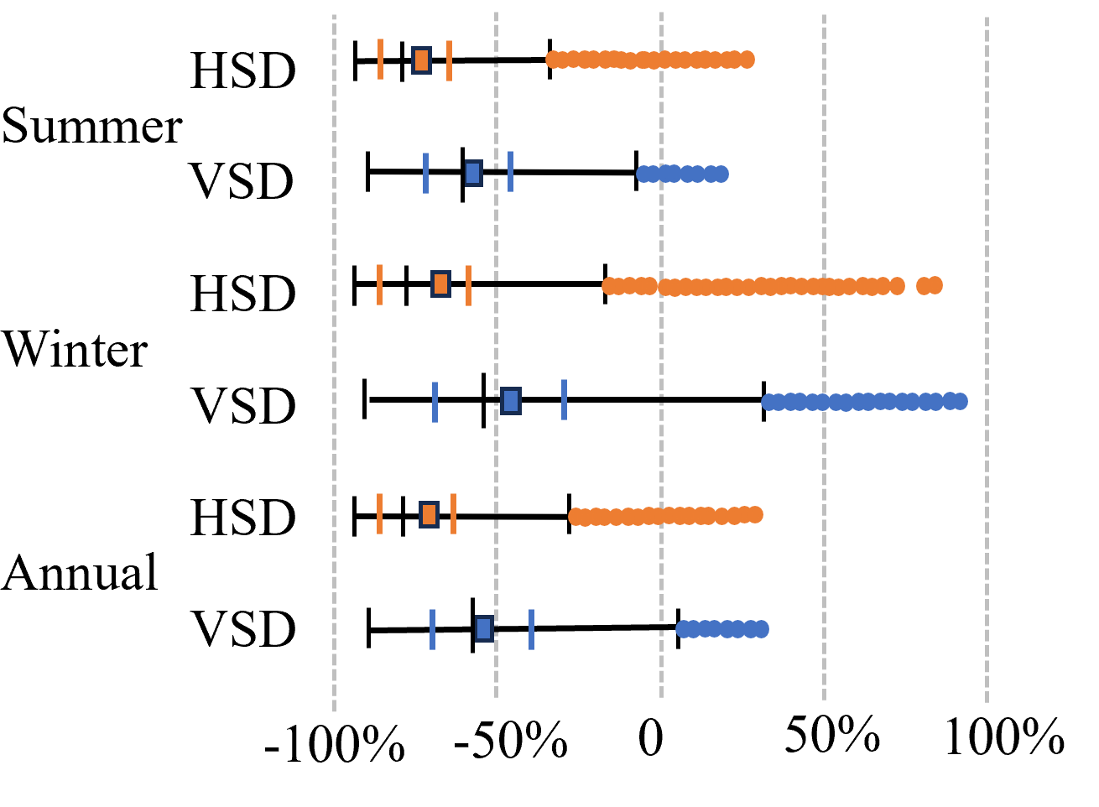
 |  | VSD | -89.4% | -56.7% | -6.7% | 19.8%
 | Winter | HSD | -93.8% | -67.4% | -17.1% | 27.9%
 |  | VSD | -89.7% | -45.2% | 31.5% | 32.4%
 | Annual | HSD | -93.8% | -71.5% | -27.5% | 21.0%
 |  | VSD | -89.6% | -52.8% | 5.4% | 22.7%
Table 6. Changing percentage distributions of free-running energy performances with F&SD configuration variations
Parameters | SDT | Lower limit | Mean | Upper limit | Standard deviation | Boxplot of change percentages
Cooling energy demands (CED) | HSD | -3.02% | -2.20% | -1.52% | 0.45%
 | VSD | -2.70% | -1.81% | -0.47% | 0.57%
Heating energy demands (HED) | HSD | 0.40% | 0.51% | 0.75% | 0.24%
 | VSD | -0.35% | 0.34% | 0.68% | 0.33%
Total energy demands (TED) | HSD | -1.40% | -0.37% | 0.57% | 0.31%
 | VSD | -1.24% | -0.47% | 0.31% | 0.27%
The variations of F&SD configurations on the free-running building energy performances are shown in Table 6. By varying different F&SD parameters, the lower limits of the CED were observed to be negative, with the minimum being -3.02% for the HSDs. The average values for the HED were positive after adding F&SD strategies, and the HSD showed a higher average than the VSD. The mean TED was negative for both HSD and VSD, indicating that after incorporating the F&SD strategies, the energy performances improved. The $σ_{CED}$ was around 0.5%, and the changes of $σ_{HED}$ and $σ_{TED}$ were around 0.3%. This shows that the variations of CED reduction percentages were larger than those of HED and TED.
Table 7 shows the changes in free-running ventilation heat gains (VHG) and ventilation heat losses (VHL) by altering F&SD configurations. The summer VHG increased with added F&SD, with the upper limit increasing by 145.2%, indicating increased summer VHG from the incorporation of the passive sustainable strategies. This might be because of the high ambient temperature in summer aiding convective heat transfer to increase the zone temperature [6]. In winter, the averages of VHG changes were less than 0%, indicating that adding SDs might induce more cooling effects from wind in winter. This might be because in winter ambient air temperatures are lower which cools the indoor environment. VHG ranged from around -40% to more than 100% in summer and -75% to 50% in winter. These large variations illustrate that although the VFR changes were merely 0.0001m³/s (see Section 3.1.2.2), the impact of F&SD on VHG can be comparatively large.
VHLs were reduced by adding the F&SD for all conditions (see Table 7). This showed that optimizing F&SD might result in VHL reductions in both summer and winter as the façade would not be exposed to uncontrolled wind flows. VHL in winter should be minimized to avoid more HED, showing that F&SDs assist in blocking ventilation in winter. The $σ_{VHG}$ and $σ_{VHL}$ changes for HSD were found to be higher than those for the VSD, which means HSD had a larger impact on ventilation heat exchanges.
Table 7. Changing percentage distributions of ventilation heat exchanges with F&SD configuration variations
Parameters |  | SDT | Lower limit | Mean | Upper limit | Standard deviation | Boxplot of change percentages
Zone ventilation heat gains (VHG) | Summer | HSD | -45.1% | 54.6% | 145.2% | 45.6%
 |  | VSD | -44.3% | 15.9% | 111.7% | 34.2%
 | Winter | HSD | -75.5% | -4.6% | 56.1% | 30.7%
 |  | VSD | -75.6% | -31.5% | 48.4% | 25.1%
Zone ventilation heat losses (VHL) | Summer | HSD | -59.9% | -48.5% | -33.4% | 10.0%
 |  | VSD | -55.6% | -38.8% | -9.6% | 12.1%
 | Winter | HSD | -80.2% | -76.0% | -72.0% | 4.5%
 |  | VSD | -78.5% | -72.7% | -59.3% | 6.0%
Table 8. Changing percentage distributions of daylighting performances with F&SD configuration variations
Parameters | SDT | Lower limit | Mean | Upper limit | Standard deviation | Boxplot of change percentages
Electricity energy uses (EEU) | HSD | -5.6% | 98.2% | 209.0% | 69.8%
 | VSD | -5.6% | 52.4% | 196.4% | 49.1%
Daylight illuminance at reference point (Dlr) | HSD | -100% | -66.8% | 12.1% | 37.1%
 | VSD | -100% | -43.6% | 11.9% | 34.7%
Annual glare hours (AGH) | HSD | -100% | -81.4% | -34.8% | 30.2%
 | VSD | -100% | -60.6% | 30.3% | 35.6%
Table 8 shows the changes of EEU, DIr, and AGH by altering F&SD. DIr and AGH mostly decreased after adding shading and changing WWR. The mean values for AGH reductions were 81.4% and 60.6% respectively for VSD and HSD, demonstrating the benefit of F&SD’s capacity to improve visual comfort. Additionally, HSD had a greater potential of decreasing DIr and AGH. Furthermore, the upper limits of EEU obtained were 209% and 196.4% respectively for HSD and VSD. This also indicates that zone SHG reduction potentially increased the EEU.

3.2.2 Assessments of Impacts
The correlation matrix for HSD and VSD parameters and their performances respectively are shown in Fig. 15 and Fig. 16. With regards to HSD in Fig. 15, the WWR showed relatively strong relationships with the CED, SHG, and VHG. WWR also had a medium impact on the winter SHG, VFR, and lighting heat gains. SDN and SDD had a medium impact on EEU and TED. The SDD for HSD on the other hand had a medium impact on VHG and DI. The WFO was observed to have a medium impact on the winter MRT. The HSD SDA showed low correlations with all the performances.
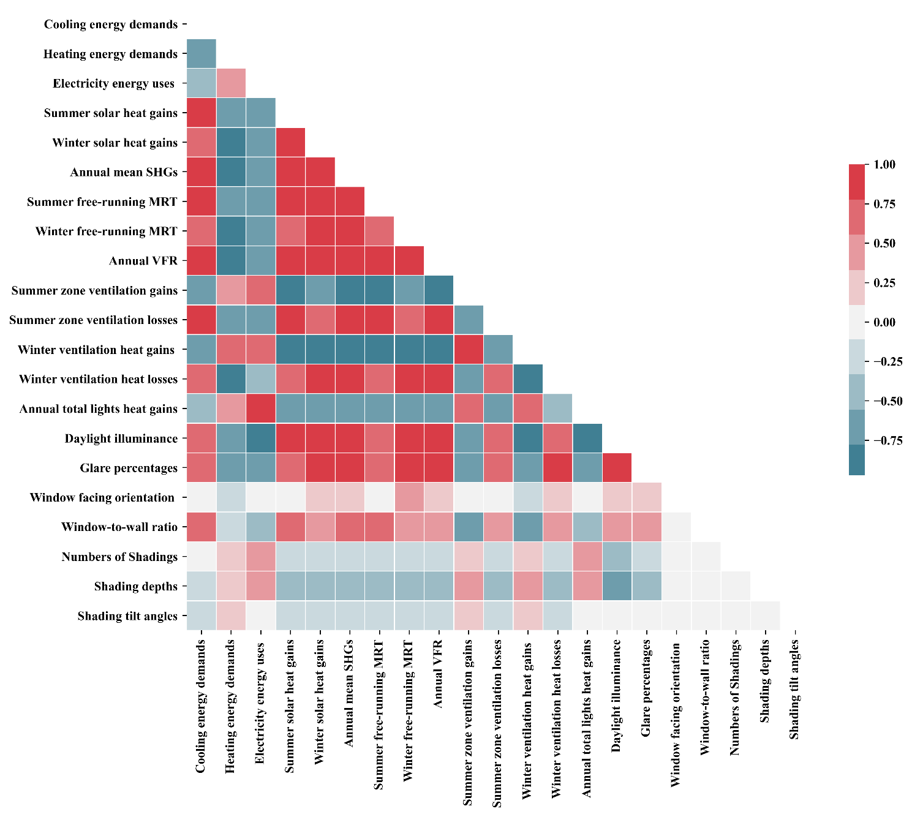
Fig. 15 Correlation matrix of HSD energy and environmental performances against different F&SD configurations
In terms of the VSD conditions in Fig. 16, WWR had medium to high impacts on the CED, SHG, MRT, ventilation performances, and daylight performances. WFO was found to have a high impact on winter SHG, winter MRT, and winter ventilation heat exchanges. SDN greatly impacted EEU. VSD SDA showed nearly no impact on all performances.
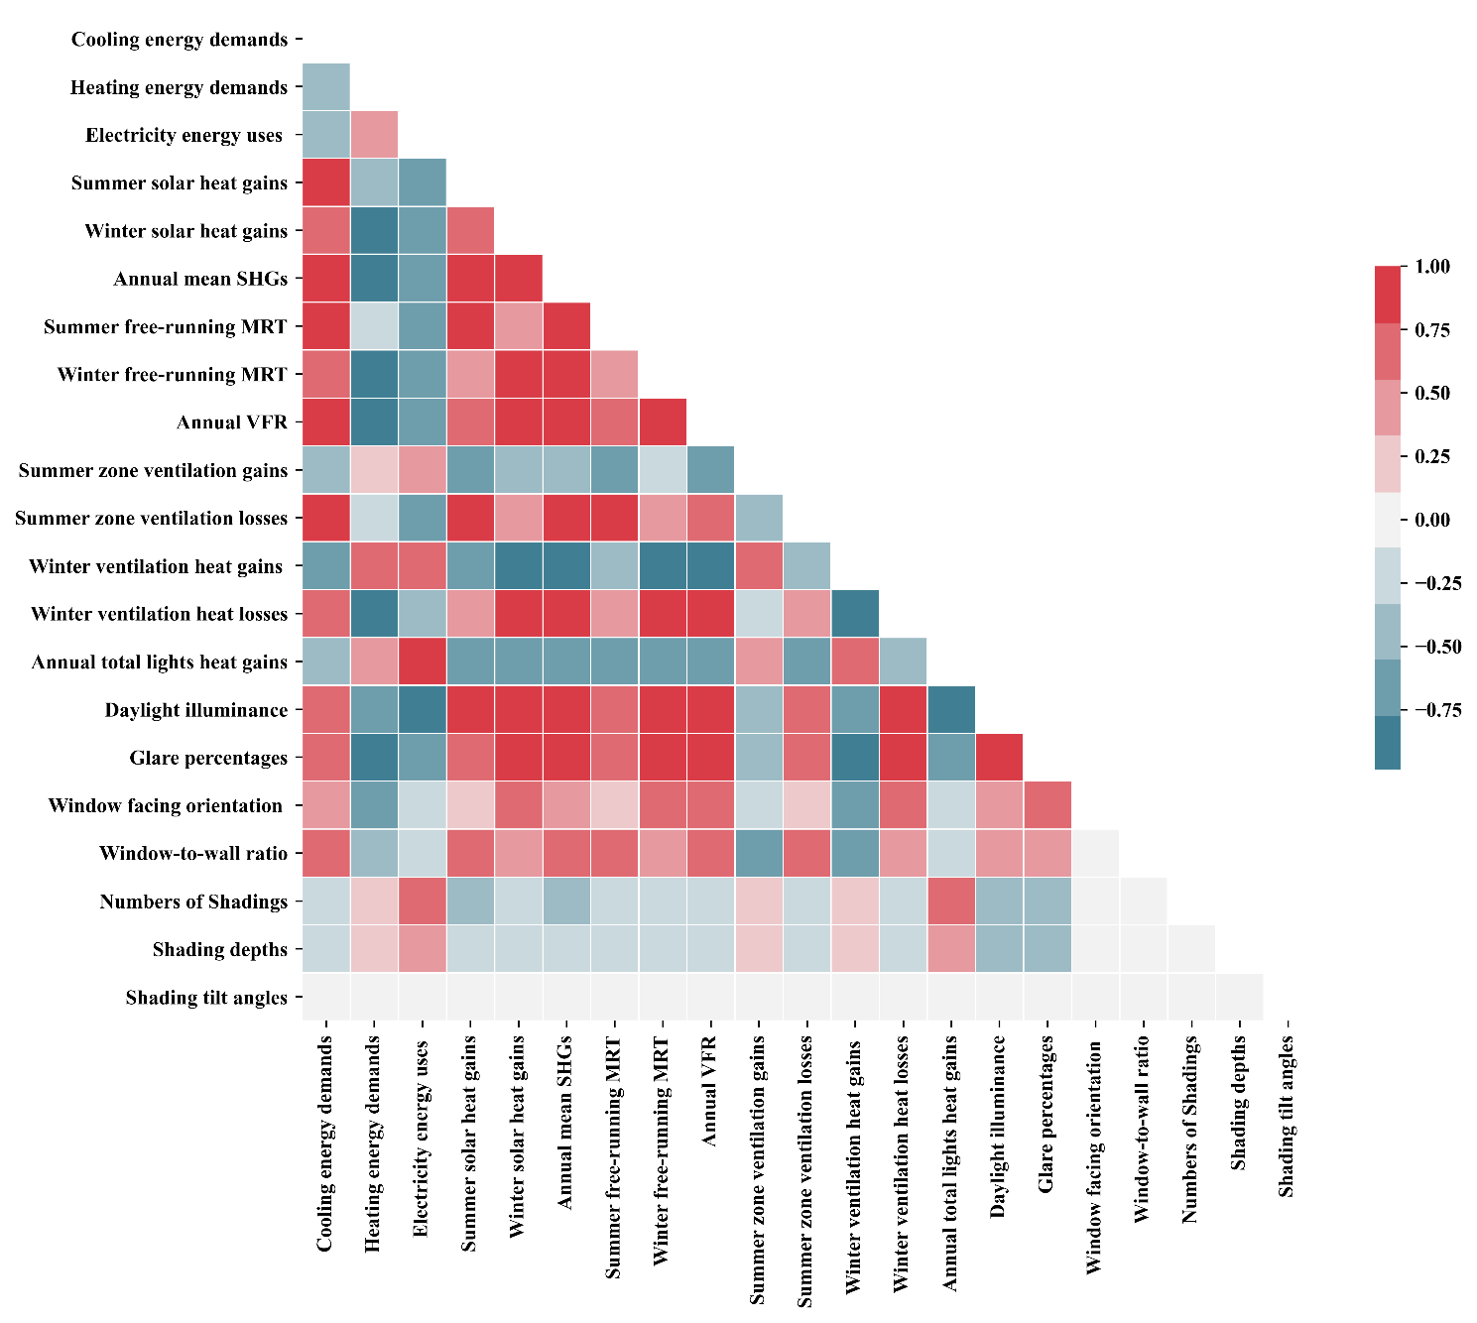
Fig. 16 Correlation matrix of VSD energy and environmental performances against varied F&SD configurations
Table 9. Rankings of correlations of parameters to the energy and environmental performances
Rankings | #1 |  | #2 |  | #3 |  | #4 |  | #5
Shading types | HSD | VSD | HSD | VSD | HSD | VSD | HSD | VSD | HSD | VSD
Cooling energy demands | P2 | P2 | P4 | P1 | P5 | P3 | P3 | P4 | P1 | P5
Heating energy demands | P4 | P1 | P1 | P2 | P2 | P3 | P3 | P4 | P5 | P5
Electricity energy uses | P4 | P3 | P3 | P4 | P2 | P2 | P1 | P1 | P5 | P5
Total energy demands | P4 | P3 | P3 | P4 | P1 | P2 | P2 | P1 | P5 | P5
Annual mean zone solar gains | P2 | P2 | P4 | P1 | P3 | P3 | P1 | P4 | P5 | P5
Summer free-running MRT | P2 | P2 | P4 | P3 | P3 | P4 | P5 | P1 | P1 | P5
Winter free-running MRT | P2 | P1 | P4 | P2 | P1 | P3 | P3 | P4 | P5 | P5
Annual ventilation volume flowrate | P2 | P2 | P4 | P1 | P3 | P3 | P1 | P4 | P5 | P5
Daylight illuminance | P4 | P3 | P2 | P1 | P3 | P4 | P1 | P2 | P5 | P5
Glare percentages | P4 | P1 | P2 | P3 | P1 | P4 | P3 | P2 | P5 | P5
Note: P1: Window facing orientation; P2: Window-to-wall ratio; P3: Shading depths; P4: Numbers of Shadings; P5: Shading tilt angles
Table 9 shows the rankings of the correlations for all building performances. Here, HSD, WWR, and SDN ranked the highest for most performances; VSD, WWR, and WFO ranked the highest for most conditions. Although WFO ranked second for HED for VSD, it ranked the lowest in most performances for HSD. It can be concluded that WWR is the main impacting factor for both VSD and HSD, hence should be carefully designed for optimized performance. In addition, the VSD performance was highly influenced by the WFO. For the HSD, adding shading numbers highly influences daylight performance.

3.3 Study Validation
Fig. 17 presents a comparison between the results of Ghosh and Neogi [29] and the current research, demonstrating that Cooling energy use (CEU) increases with higher WWR, and HSD results in lower CEU compared to VSD. Table 10 displays the sensitivity analysis result comparisons with Shen and Tzempelikos [21]’s study, highlighting a significant relationship between DI and CEU with WWR. The validation results indicate that our findings align with those of previously validated studies.
Fig. 17 Comparisons with Ghosh and Neogi [29]’s results against WWR (a) and SDT (b)
Table 10. Sensitivity index/correlations of the parameters and WWR
Sensitivity index/correlations | Shen and Tzempelikos [21]’s Results | Results generated in this research
Daylight illuminance | 0.75-0.91 | 0.99
Annual cooling demand | 0.7 | 0.88
Annual heating demand | 0.35-0.56 | 0.52

3.4 Discussion
Building sustainability design is multifaceted, and includes various strategies, which are components of the environment with excellent ecological/environmental credentials (e.g. achieving low energy use and addressing occupancy comfort by incorporating sustainable resources) [1]. Careful consideration of several factors, including reductions of solar heat gains, designing to enhance daylight availability and proper ventilation, etc. is imperative to achieve a thermal and visually comfortable environment, energy conservation, carbon emission reduction, and well-being. This study provides a comprehensive evaluation of the ventilation and energy performance of varied F&SD configurations for office space in a building in Shanghai. The findings provide solutions and considerations for F&SD designs and their related influence on SHG, zone temperatures, daylighting, glare, ventilation air flow rates, and energy demands/use.

3.4.1 Study Contributions
The findings of this study will provide insights into F&SD designs for designers, planners, and retrofitting engineers on the use of passive sustainable strategies in environments with the demands of heating and cooling. Optimal F&SD parameters are approaches toward improving the indoor environment, utilizing solar energy, optimizing building energy performance, and improving occupants’ thermal comfort and well-being for new building designs and building retrofits. The unique aspects and contributions of this study are:
- The inclusion of varied F&SD configurations and parameters in the performance evaluation provides detailed insights into those passive strategies and their influence on building performance in a heating and cooling-dominated diverse urban environment. This can offer a comprehensive understanding of strategy effectiveness for buildings in complex urban environments and climates such as that of Shanghai.
- The comparison of vertical and horizontal SDs with different shading numbers, depths, and tilt angles installed on varied WWR and WFO fenestrations. The comprehensive F&SD configuration inputs present vivid and detailed trends in performance variations towards comprehensive insights into various F&SD performances.
- The exploration of the effects of varied F&SD on solar heat gain and daylight conditions; the inclusion of natural ventilation and detailed solar gain analysis in F&SD sensitivity analysis. The analysis of the interactions between ventilation, daylight availability, and solar gains through changing F&SD provides new perspectives and significance to building environmental performance.
- This research used the brute-force parameter analysis method, which not only displays the trends but also includes the capability of the different configurations to improve or change the building performances. This approach offers a more comprehensive understanding of the impacts and mechanics of F&SD parameters on performance, making it an innovative research methodology.

3.4.2 Study Limitations and Future Research
The study limitations stemming from the assumptions made during the simulations, and potential areas for future studies include the following:
- The study did not incorporate building types, functions, space division, ambient urban conditions, or cultural considerations such as Fengshui. These factors play significant roles in building designs and retrofits and may be considered in future studies for a more holistic understanding.
- The impacts of F&SD strategies on overall indoor environmental quality and related impacts on occupants’ perceptions were not thoroughly examined in this study. Those aspects can be included in future studies.
- The internal zone temperature analysis relied on solar radiation and convection, neglecting the consideration of fabric/conduction heat transfer, which can be addressed in future studies.
- The study used EnergyPlus software with its inherent limitations [61], which could introduce uncertainties or constraints in the results. This makes it challenging to determine the margin of error between the simulations and the real-world conditions. Future studies should include on-site measurements to validate the theoretical results.
- The study did not use established benchmarks for comparison and design strategy optimization, because it focused on passive design strategies and their influences on energy demands instead of those on energy consumption with active strategies. Future studies can include multi-objective optimizations on the F&SD combined influences with active technologies and include benchmarks for analysis.

4. Conclusion
In this research, the impacts of varied configurations of F&SD-related parameters on SHG, ventilation, and energy performance of an office unit in a building in Shanghai have been investigated. The modeling of various F&SD configurations was determined through previous studies and local building design codes. Brute-force parameter analysis with 11,760 simulations and MC sensitivity analysis with 14,997 simulations were carried out to investigate the trends, distribution, and correlations of building performances with changing F&SD parameters. The relationship between F&SD parameter performance such as solar gains, MRTs, ventilation heat exchanges, and cooling, heating, and electricity energy demands have all been evaluated. The main findings from the analysis are:
- In summer, the highest SHG was observed when the window was oriented to face West. In winter, the highest SHG was witnessed when the window was South-facing. The SHG in cooling and heating seasons decreased with more SD and less window area. With increases in WWR and SDA, and decreases in SDN, the SHG under all conditions increased. The SHG can be reduced up to 93.8% by adding F&SD. Besides, the mean reductions of SHG for HSD and VSD were around 60% and 40% respectively. WWR had high correlations with SHG for both VSDs and HSDs.
- The lowest summer average MRT was observed in the North WFO (26.98ºC), and the highest average MRT achieved was for the South WFO in winter (8.24ºC). The average MRT decreased in both winter and summer as WWR and SDA decreased, and as SDD and SDA increased. For all F&SD configurations investigated, the difference between the maximum and minimum zone temperatures for summer was 1.39ºC and for winter, 1.21ºC. WWR and WFO were found to have medium-high correlations with MRT.
- For all variations of the F&SD, the average VFR varied only slightly, ranging between 6.22746m³/s to 6.22836m³/s. However, the ventilation gains mostly increased in summer to an upper limit of 145.2%. Simultaneously, the ventilation gains decreased in winter, and ventilation losses decreased in both winter and summer. This shows that for ventilation designs, the addition of SDs is beneficial for winter conditions. VHG showed weak-medium correlations with SDN and SDD. SDA for VSDs had no impact on ventilation heat exchanges.
- The uppermost and the lowest DIr occurred when the WFO was in the South-West and Southern orientations, respectively. The higher DIr and lower EEU occurred with higher WWR, lower SDD, higher SDA, and fewer SDN. The mean values for AGH reductions were 81.4% and 60.6%, respectively. Furthermore, EEU normally increased with F&SD, and the upper limits obtained were 209% and 196.4% respectively for HSD and VSD. SDN was the most influential factor for EEU.
- The CED follows the same trends as SHG, while the trend of HED was the opposite. By varying the different F&SD parameters, CED decreased with a lower limit of -3.02%. The negative impacts of F&SD on HED increased up to 0.75% in winter. WWR and WFO were the most influential factors respectively for CED; SDD and SND impacted the most on HED.
Overall, the study showed the interaction between F&SD and indoor environmental conditions, providing insights and references for sustainable building design in diverse urban environments with required heating and cooling. The trends identified can be incorporated into the designs of fenestration and vertical and horizontal sunshades with integrated solar energy, even renewable energy such as building integrated photovoltaic systems. Besides, the additions of sunshades were found to block the SHG while simultaneously possibly hindering natural ventilation, which might be carefully considered in future sustainable designs. The study's findings provide practical guidelines for passive building design in Shanghai, encompassing the heating period, cooling period, and overall performance. The findings of this study additionally align with established and extensively documented passive design strategies. For example, the large south-facing openings should be up to 30% of WWR [43], and with more SDD and SDN, more SHG will be blocked [11,15,33,34,51]. Future studies can include building-level parameters such as building types, building shape, space division, and Fengshui as well as address indoor environmental quality and occupants’ perceptions of indoor comfort. Multi-objective optimizations on the F&SD combined influences and benchmarking analysis with active strategies in different locations can also be considered in future studies.

Acknowledgments
The authors would like to express their deepest sense of gratitude to Dr. Yi Zhang from UCL for his support of jEPlus operation. Special thanks to Wei Guoyan and Xiao Chunze for their initial help and support, which played a vital role in the accomplishment of this research work.

Reference
[1] H. Huw, 101 Rules of Thumb for Sustainable Buildings and Cities (1st ed.), RIBA Publishing, London, 2019. https://doi.org/10.4324/9780429347511.
[2] C. Schweizer, R.D. Edwards, L. Bayer-Oglesby, W.J. Gauderman, V. Ilacqua, M. Juhani Jantunen, H.K. Lai, M. Nieuwenhuijsen, N. Künzli, Indoor time-microenvironment-activity patterns in seven regions of Europe, J. Expo. Sci. Environ. Epidemiol. 17 (2007) 170–181. https://doi.org/10.1038/sj.jes.7500490.
[3] ASHRAE, ASHRAE Handbook Fundamentals, Atlanta, 2017.
[4] WHO - CEPIS, Sick Building Syndrome Symptoms, Cent. Panam. Ing. Sanit. y Ciencias Del Ambient. (2008) 22. https://www.wondermakers.com/Portals/0/docs/Sick%20building%20syndrome%20by%20WHO.pdf (accessed April 2, 2024).
[5] United Nations Environment Programme (UNEP), 2021 Global Status Report for Buildings and Construction: Towards a Zero‑emission, Efficient and Resilient Buildings and Construction Sector, Nairobi, 2021.
[6] The Chartered Institution of Building Services Engineers (CIBSE), CIBSE Guide A Environmental design, CIBSE, London, 2017.
[7] S. Shareef, The impact of urban morphology and building’s height diversity on energy consumption at urban scale. The case study of Dubai, Build. Environ. 194 (2021). https://doi.org/10.1016/j.buildenv.2021.107675.
[8] Hong Kong Planning Department, Chapter 11: Urban Design Guidelines, Hong Kong Plan. Stand. Guidel. (2015) 56. https://www.pland.gov.hk/file/tech_doc/hkpsg/full/pdf/ch11.pdf (accessed January 15, 2024).
[9] A. Samanta, S. Saha, J. Biswas, A. Dutta, Evaluation of Impact of Shading Devices on Energy Consumption of Buildings in Tropical Regions, J. Energy Resour. Technol. 136 (2014). https://doi.org/10.1115/1.4027154.
[10] E. Krygiel, B. Nies, S. McDowell, Green BIM: Successful Sustainable Design with Building Information Modeling, Wiley Publishing, Indiana, 2008.
[11] C.P. Chou, The performance of daylighting with shading device in architecture design, Tamkang J. Sci. Eng. 7 (2004) 205–212.
[12] P. Glover, Building Surveys, Butterworth & Co., Devon, 2013.
[13] L.G. Valladares-Rendón, G. Schmid, S.L. Lo, Review on energy savings by solar control techniques and optimal building orientation for the strategic placement of façade shading systems, Energy Build. 140 (2017) 458–479. https://doi.org/10.1016/j.enbuild.2016.12.073.
[14] A.A.Y. Freewan, Impact of external shading devices on thermal and daylighting performance of offices in hot climate regions, Sol. Energy. 102 (2014) 14–30. https://doi.org/10.1016/j.solener.2014.01.009.
[15] S. Liu, Y.T. Kwok, K.K.L. Lau, P.W. Chan, E. Ng, Investigating the energy saving potential of applying shading panels on opaque façades: A case study for residential buildings in Hong Kong, Energy Build. 193 (2019) 78–91. https://doi.org/10.1016/j.enbuild.2019.03.044.
[16] N. Kunwar, K.S. Cetin, U. Passe, Calibration of energy simulation using optimization for buildings with dynamic shading systems, Energy Build. 236 (2021) 110787. https://doi.org/10.1016/j.enbuild.2021.110787.
[17] R. Amini, A. Ghaffarianhoseini, A. Ghaffarianhoseini, U. Berardi, Numerical investigation of indoor thermal comfort and air quality for a multi-purpose hall with various shading and glazing ratios, Therm. Sci. Eng. Prog. 22 (2021) 100812. https://doi.org/10.1016/j.tsep.2020.100812.
[18] M. Caitlin, Shading, Aust. Gov. (2013). https://www.yourhome.gov.au/passive-design/shading (accessed January 16, 2024).
[19] ASHRAE, ASHRAE 62.1-2019 Ventilation for Acceptable Indoor Air Quality, 2019.
[20] D. Maučec, M. Premrov, V.Ž. Leskovar, Use of sensitivity analysis for a determination of dominant design parameters affecting energy efficiency of timber buildings in different climates, Energy Sustain. Dev. 63 (2021) 86–102. https://doi.org/10.1016/j.esd.2021.06.003.
[21] H. Shen, A. Tzempelikos, Sensitivity analysis on daylighting and energy performance of perimeter offices with automated shading, Build. Environ. 59 (2013) 303–314. https://doi.org/10.1016/j.buildenv.2012.08.028.
[22] A. Saltelli, M. Ratto, T. Andres, F. Campolongo, J. Cariboni, D. Gatelli, M. Saisana, S. Tarantola, Global Sensitivity Analysis. The Primer, John Wiley & Sons, Ltd, West Sussex, 2008.
[23] Y. Zhou, V.W. Tam, K.N. Le, Sensitivity analysis of design variables in life-cycle environmental impacts of buildings, J. Build. Eng. 65 (2023) 105749. https://doi.org/10.1016/j.jobe.2022.105749.
[24] N. Delgarm, B. Sajadi, K. Azarbad, S. Delgarm, Sensitivity analysis of building energy performance: A simulation-based approach using OFAT and variance-based sensitivity analysis methods, J. Build. Eng. 15 (2018) 181–193. https://doi.org/10.1016/j.jobe.2017.11.020.
[25] H. Breesch, A. Janssens, Performance evaluation of passive cooling in office buildings based on uncertainty and sensitivity analysis, Sol. Energy. 84 (2010) 1453–1467. https://doi.org/10.1016/j.solener.2010.05.008.
[26] Y. Deng, Y. Zhou, H. Wang, C. Xu, W. Wang, T. Zhou, X. Liu, H. Liang, D. Yu, Simulation-based sensitivity analysis of energy performance applied to an old Beijing residential neighbourhood for retrofit strategy optimisation with climate change prediction, Energy Build. 294 (2023) 113284. https://doi.org/10.1016/j.enbuild.2023.113284.
[27] R. Singh, I.J. Lazarus, V.V.N. Kishore, Uncertainty and sensitivity analyses of energy and visual performances of office building with external venetian blind shading in hot-dry climate, Appl. Energy. 184 (2016) 155–170. https://doi.org/10.1016/j.apenergy.2016.10.007.
[28] L.G. Maltais, L. Gosselin, Daylighting ‘energy and comfort’ performance in office buildings: Sensitivity analysis, metamodel and pareto front, J. Build. Eng. 14 (2017) 61–72. https://doi.org/10.1016/j.jobe.2017.09.012.
[29] A. Ghosh, S. Neogi, Effect of fenestration geometrical factors on building energy consumption and performance evaluation of a new external solar shading device in warm and humid climatic condition, Sol. Energy. 169 (2018) 94–104. https://doi.org/10.1016/j.solener.2018.04.025.
[30] H. Huo, W. Xu, A. Li, Y. Lv, C. Liu, Analysis and optimization of external venetian blind shading for nearly zero-energy buildings in different climate regions of China, Sol. Energy. 223 (2021) 54–71. https://doi.org/10.1016/j.solener.2021.05.046.
[31] H. Huo, W. Xu, A. Li, J. Chu, Y. Lv, Sensitivity analysis and prediction of shading effect of external Venetian blind for nearly zero-energy buildings in China, J. Build. Eng. 41 (2021) 102401. https://doi.org/10.1016/j.jobe.2021.102401.
[32] P.J. Littlefair, Solar Shading of Buildings, IHS BRE Press, London, 2018.
[33] H.H. Alzoubi, A.H. Al-Zoubi, Assessment of building façade performance in terms of daylighting and the associated energy consumption in architectural spaces: Vertical and horizontal shading devices for southern exposure facades, Energy Convers. Manag. 51 (2010) 1592–1599. https://doi.org/10.1016/j.enconman.2009.08.039.
[34] M. Alwetaishi, H. Al-Khatri, O. Benjeddou, A. Shamseldin, M. Alsehli, S. Alghamdi, R. Shrahily, An investigation of shading devices in a hot region: A case study in a school building, Ain Shams Eng. J. 12 (2021) 3229–3239. https://doi.org/10.1016/j.asej.2021.02.008.
[35] D.K. Bhamare, M.K. Rathod, J. Banerjee, Passive cooling techniques for building and their applicability in different climatic zones—The state of art, Energy Build. 198 (2019) 467–490. https://doi.org/10.1016/j.enbuild.2019.06.023.
[36] Y. Chen, Z. Tong, Y. Zheng, H. Samuelson, L. Norford, Transfer learning with deep neural networks for model predictive control of HVAC and natural ventilation in smart buildings, J. Clean. Prod. 254 (2020) 119866. https://doi.org/10.1016/j.jclepro.2019.119866.
[37] U.S. Department of Energy, Documentation: Engineering Reference - EnergyPlus Version 22.1.0, (2022) 1774. https://energyplus.net/assets/nrel_custom/pdfs/pdfs_v22.1.0/EngineeringReference.pdf (accessed March 25, 2024).
[38] D.B. Crawley, L.K. Lawrie, F.C. Winkelmann, W.F. Buhl, Y.J. Huang, C.O. Pedersen, R.K. Strand, R.J. Liesen, D.E. Fisher, M.J. Witte, J. Glazer, EnergyPlus: Creating a new-generation building energy simulation program, Energy Build. 33 (2001) 319–331. https://doi.org/10.1016/S0378-7788(00)00114-6.
[39] R.H. Henninger, M.J. Witte, D.B. Crawley, Analytical and comparative testing of EnergyPlus using IEA HVAC BESTEST E100-E200 test suite, Energy Build. 36 (2004) 855–863. https://doi.org/10.1016/j.enbuild.2004.01.025.
[40] E. Orlando, L. Berkeley, EnergyPlus Testing with ANSI / ASHRAE Standard 140-2001 (BESTEST), 2001 (2002).
[41] J. Neymark, R. Judkoff, G. Knabe, H.T. Le, M. Dürig, A. Glass, G. Zweifel, Applying the building energy simulation test (BESTEST) diagnostic method to verification of space conditioning equipment models used in whole-building energy simulation programs, Energy Build. 34 (2002) 917–931. https://doi.org/10.1016/S0378-7788(02)00072-5.
[42] J. Neymark, R. Judkoff, I. Beausoleil-Morrison, A. Ben-Nakhi, M. Crowley, M. Deru, R. Henninger, H. Ribberink, J. Thornton, A. Wijsman, M. Witte, IEA BESTEST In-Depth in-depth diagnostic cases for ground coupled heat transfer related to slab-on-grade construction, IBPSA 2009 - Int. Build. Perform. Simul. Assoc. 2009. (2009) 1099–1106.
[43] W. Xu, Y. Zou, X. Chen, Design Standard for Energy Efficiency of Public Buildings (GB50189-2015), Constr. Sci. Technol. (2018).
[44] Ministry of Housing and Urban-Rural Development, Standard for building carbon emission calculation (GB/T 51366-2019), 2019.
[45] Society of Building Science Educators, Climate Concultant 6.0, (2021). https://www.sbse.org/resources/climate-consultant (accessed March 22, 2024).
[46] EnergyPlus, Weather Data, EnergyPlus. (2023). https://energyplus.net/weather (accessed December 24, 2023).
[47] S. Gou, V.M. Nik, J.L. Scartezzini, Q. Zhao, Z. Li, Passive design optimization of newly-built residential buildings in Shanghai for improving indoor thermal comfort while reducing building energy demand, Energy Build. 169 (2018) 484–506. https://doi.org/10.1016/j.enbuild.2017.09.095.
[48] B. Huang, Y. Zhou, Z. Li, Y. Song, J. Cai, W. Tu, Evaluating and characterizing urban vibrancy using spatial big data: Shanghai as a case study, Environ. Plan. B Urban Anal. City Sci. 47 (2020) 1543–1559. https://doi.org/10.1177/2399808319828730.
[49] R. Xu, G. Yang, Z. Qu, Y. Chen, J. Liu, L. Shang, S. Liu, Y. Ge, J. Chang, City components–area relationship and diversity pattern: towards a better understanding of urban structure, Sustain. Cities Soc. 60 (2020) 102272. https://doi.org/10.1016/j.scs.2020.102272.
[50] Y. Chen, P. Xu, J. Gu, F. Schmidt, W. Li, Energy & Buildings Measures to improve energy demand flexibility in buildings for demand response ( DR ): A review, Energy Build. 177 (2018) 125–139. https://doi.org/10.1016/j.enbuild.2018.08.003.
[51] N. Sun, Y. Cui, Y. Jiang, S. Li, Lighting and ventilation-based building sun-shading design and simulation case in cold regions, Energy Procedia. 152 (2018) 462–469. https://doi.org/10.1016/j.egypro.2018.09.254.
[52] J. Zhao, Y. Du, Multi-objective optimization design for windows and shading configuration considering energy consumption and thermal comfort: A case study for office building in different climatic regions of China, Sol. Energy. 206 (2020) 997–1017. https://doi.org/10.1016/j.solener.2020.05.090.
[53] R. Albertin, A. Prada, A. Gasparella, A novel efficient multi-objective optimization algorithm for expensive building simulation models, Energy Build. 297 (2023) 113433. https://doi.org/10.1016/j.enbuild.2023.113433.
[54] G. Aruta, F. Ascione, N. Bianco, T. Iovane, M. Mastellone, G. Maria Mauro, Optimizing the energy transition of social housing to renewable nearly zero-energy community: The goal of sustainability, Energy Build. 282 (2023) 112798. https://doi.org/10.1016/j.enbuild.2023.112798.
[55] D. Tuhus-Dubrow, M. Krarti, Comparative analysis of optimization approaches to design building envelope for residential buildings, ASHRAE Trans. 115 PART 2 (2009) 554–562.
[56] D.E. Huntington, C.S. Lyrintzis, Improvements to and limitations of Latin hypercube sampling, Probabilistic Eng. Mech. 13 (1998) 245–253. https://doi.org/10.1016/s0266-8920(97)00013-1.
[57] L. Wasserman, All of Statistics, Springer New York, New York, NY, 2004. https://doi.org/10.1007/978-0-387-21736-9.
[58] J.J. Berman, Data Simplification, 2016.
[59] S. Matheos, F. Allard, Natural Ventilation in Buildings: A Design Handbook, James & James (Science Publishers) Ltd, London, 1998.
[60] CIBSE, Natural ventilation in non-domestic buildings CIBSE Applications Manual AM10, The Chartered Institution of Building Services Engineers, London, 2005.
[61] A. Al-janabi, M. Kavgic, A. Mohammadzadeh, A. Azzouz, Comparison of EnergyPlus and IES to model a complex university building using three scenarios: Free-floating, ideal air load system, and detailed, J. Build. Eng. 22 (2019) 262–280. https://doi.org/10.1016/j.jobe.2018.12.022.

